## No. 4/2024 2 February 2024

# Summary of key issues

* In the week ending 31 January 2024 there were storms and heavy rainfall across Queensland and northern areas of Northern Territory and Western Australia. South Australia and much of southern Western Australia were generally dry.
* Over the coming days, the continued movement of Ex Tropical Cyclone Kirrily and troughs are expected to bring rain, showers, and thunderstorms over northern and western parts of Queensland extending into central New South Wales, the Northern Territory and Western Australia.
  + Rainfall where expected will support development of summer crops and pasture growth but dry conditions elsewhere, particularly in Western Australia, will continue to see a decline in soil moisture levels. Significant rainfall in autumn will be required in these areas to support the planting of winter crops.
* January rainfall has been above average across Australia, except for along coastal areas in Western Australia and in isolated parts of interior. This has further built-up soil moisture reserves following above average rainfall in December 2023, particularly in the eastern half of the country.
* Water storage levels in the Murray-Darling Basin (MDB) decreased between 25 January 2024 and 1 February 2024 by 133 gigalitres (GL). Current volume of water held in storage is 18 833 GL. This is 13 percent or 2753 GL less than at the same time last year.
* Allocation prices in the Victorian Murray below the Barmah Choke decreased from $62 on 25 January 2024 to $61 on 1 February 2024. Prices are lower in the Murrumbidgee, and regions above the Barmah choke due to the binding of the Murrumbidgee export limit, and the Barmah choke trade constraint.

## **Climate**

### Rainfall this week

For the week ending 31 January 2024, the passage and breakdown of Tropical Cyclone Kirrily brought heavy falls across Queensland. A high-pressure system kept South Australia and much of southern Western Australia generally dry. An active monsoon trough generated storms and heavy falls in northern areas of Northern Territory and Western Australia. Troughs over the interior of Western Australia and in the east brought showers and storms to central Western Australia, northeast New South Wales and southern Queensland. A front and trough brought showers to Victoria, Tasmania, southern South Australia and southeast New South Wales.

Across cropping regions, rainfall totals of up to 200 millimetres were recorded in Queensland, up to 100 millimetres in northern New South Wales, and up to 25 millimetres across parts of Victoria and South Australia. These falls will continue to support the ongoing growth and lift the yield potential of summer crops across eastern Australia. Additionally, these falls will help maintain soil moisture levels to support pasture growth and build reserves ahead of the upcoming winter cropping season. By contrast, Western Australia and much of central to southern New South Wales remained dry.

#### Rainfall for the week ending 31 January 2024

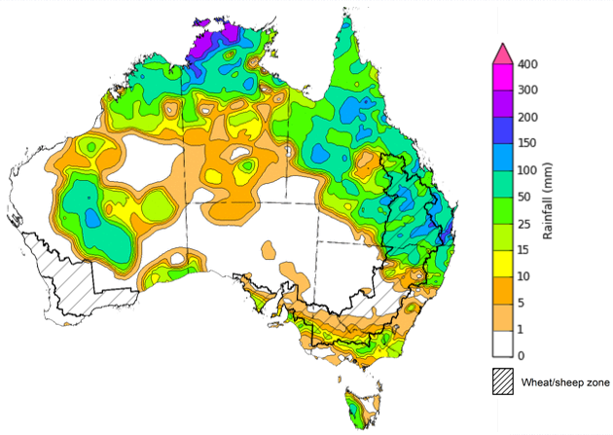

©Commonwealth of Australia 2024, Australian Bureau of Meteorology Issued: 31/01/2024

Note: The rainfall analyses and associated maps utilise data contained in the Bureau of Meteorology climate database, the Australian Data Archive for Meteorology (ADAM). The analyses are initially produced automatically from real-time data with limited [quality control](http://www.bom.gov.au/climate/headers/qc.shtml). They are intended to provide a general overview of rainfall across Australia as quickly as possible after the observations are received. For further information go to <http://www.bom.gov.au/climate/rainfall/>

### Rainfall forecast for the next eight days

Over the 8 days to 8 February 2024, the continued movement of ex-Tropical Cyclone Kirrily and troughs are expected to bring rain, showers and thunderstorms over northern and western parts of Queensland extending into northern New South Wales, the Northern Territory and Western Australia. Onshore flow is expected to generate showers across coastal New South Wales and northern Victoria.

Across cropping regions, rainfall totals up to 50 millimetres are forecast for central New South Wales. Rainfall up to 10 millimetres is forecast for Queensland, remainder of New South Wales and eastern Victoria. If realised, these falls will continue to benefit soil moisture levels for pasture growth and support summer crops. Little to no rainfall is expected across remaining cropping regions. Western Australian cropping regions continue to experience dry conditions and declining soil moisture levels and will require significant rainfall during autumn to support the planting of winter crops.

#### Total forecast rainfall for the period 1 February to 8 February 2024

©Commonwealth of Australia 2024, Australian Bureau of Meteorology Issued 01/02/2024

Note: This rainfall forecast is produced from computer models. As the model outputs are not altered by weather forecasters, it is important to check local forecasts and warnings issued by the Bureau of Meteorology.

### Monthly rainfall

Rainfall during January 2024 was average to extremely high for much of Australia. The main exceptions were in coastal areas of Western Australia and in isolated parts of interior where it was extremely low. This follows above average December 2023 rainfall across large areas of eastern and south-eastern Australia.

In cropping regions, January rainfall was largely average to above average with exceptions in northern parts of Western Australia where it was below average. Above average rainfall has provided a significant boost to soil moisture levels.

**Rainfall percentiles for January 2024**

Note: Rainfall for January 2024 is compared with rainfall recorded for that period during the historical record (1900 to present). For further information, go to <http://www.bom.gov.au/jsp/awap/>

Source: Bureau of Meteorology

## **Water**

### Water markets – current week

Water storage levels in the Murray-Darling Basin (MDB) decreased between 25 January 2024 and 1 February 2024 by 133 gigalitres (GL). Current volume of water held in storage is 18 833 GL. This is 13 percent or 2753 GL less than at the same time last year.

#### Water storages in the Murray-Darling Basin, 2013–2024

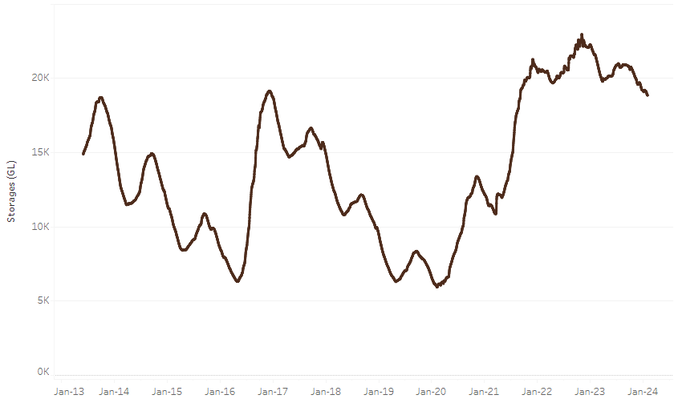

|  |
| --- |
| Water storage data is sourced from the Bureau of Meteorology. |

Allocation prices in the Victorian Murray below the Barmah Choke decreased from $62 on 25 January 2024 to $61 on 1 February 2024. Prices are lower in the Murrumbidgee, and regions above the Barmah choke due to the binding of the Murrumbidgee export limit, and the Barmah choke trade constraint.

|  |  |
| --- | --- |
| **Region** | **$/ML** |
| NSW Murray Above | 49 |
| NSW Murrumbidgee | 38 |
| VIC Goulburn-Broken | 52 |
| VIC Murray Below | 61 |

#### Surface water trade activity, Southern Murray–Darling Basin

|  |
| --- |
| The trades shown reflect estimated market activity and do not encompass all register trades. The price is shown for the VIC Murray below the Barmah choke. Historical prices (before 1 July 2019) are ABARES estimates after removing outliers from BOM water register data. Prices after 1 July 2019 and prior to the 30 October 2019 reflect recorded transaction prices as sourced from Ruralco. Prices after the 30 October 2019 are sourced from Waterflow. Data for volume traded is sourced from the BOM water register. Only the price data shown is current on 2 February 2024. |

To access the full, interactive, weekly water dashboard, which contains the latest and historical water storage, water market and water allocation information, please visit <https://www.agriculture.gov.au/abares/products/weekly_update/weekly-update-10224>

## **Commodities**

|  |  |  |  |  |  |  |  |
| --- | --- | --- | --- | --- | --- | --- | --- |
| **Indicator** | **Week ended** | **Unit** | **Latest Price** | **Previous Week** | **Weekly change** | **Price 12 months ago** | **Annual change** |
| **Selected world indicator prices** |  |  |  |  |  |  |  |
| AUD/USD Exchange rate | 31-Jan | A$/US$ | 0.66 | 0.66 | 0% | 0.69 | -5% |
| Wheat – US no. 2 hard red winter wheat, fob Gulf | 31-Jan | US$/t | 288 | 287 | 0% | 395 | -27% |
| Corn – US no. 2 yellow corn, fob Gulf | 31-Jan | US$/t | 197 | 197 | 0% | 301 | -35% |
| Canola – Rapeseed, Canada, fob Vancouver | 31-Jan | US$/t | 493 | 506 | -2% | 655 | -25% |
| Cotton – Cotlook 'A' Index | 31-Jan | USc/lb | 93 | 94 | -1% | 100 | -7% |
| Sugar – Intercontinental Exchange, nearby futures, no.11 contract | 31-Jan | USc/lb | 22.9 | 23.1 | -1% | 20 | 16% |
| Wool – Eastern Market Indicator | 31-Jan | Ac/kg clean | 1,171 | 1,186 | -1% | 1,256 | -7% |
| Wool – Western Market Indicator | 31-Jan | Ac/kg clean | 1,301 | 1,306 | 0% | 1,381 | -6% |
| **Selected Australian grain export prices** |  |  |  |  |  |  |  |
| Milling Wheat – APW, Port Adelaide, SA | 31-Jan | A$/t | 439 | 441 | -1% | 499 | -12% |
| Feed Wheat – ASW, Port Adelaide, SA | 31-Jan | A$/t | 415 | 417 | -1% | 488 | -15% |
| Feed Barley – Port Adelaide, SA | 31-Jan | A$/t | 378 | 379 | 0% | 413 | -9% |
| Canola – Kwinana, WA | 31-Jan | A$/t | 739 | 743 | -1% | 1,043 | -29% |
| Grain Sorghum – Brisbane, QLD | 31-Jan | A$/t | 472 | 472 | 0% | 492 | -4% |
| **Selected domestic livestock indicator prices** |  |  |  |  |  |  |  |
| Beef – Eastern Young Cattle Indicator | 31-Jan | Ac/kg cwt | 650 | 633 | 3% | 771 | -16% |
| Mutton – Mutton indicator (18–24 kg fat score 2–3), Vic | 31-Jan | Ac/kg cwt | 321 | 287 | 12% | 391 | -18% |
| Lamb – National Trade Lamb Indicator | 31-Jan | Ac/kg cwt | 715 | 704 | 2% | 796 | -10% |
| Pig – Eastern Seaboard (60.1–75 kg), average of buyers & sellers | 17-Jan | Ac/kg cwt | 411 | 403 | 2% | 367 | 12% |
| Goats – Eastern States (10.1–12 kg) | 27-Dec | Ac/kg cwt | 170 | 170 | 0% | 350 | -51% |
| Live cattle – Light steers to Indonesia | 31-Jan | Ac/kg lwt | 310 | 300 | 3% | 430 | -28% |
| **Global Dairy Trade (GDT) weighted average prices a** |  |  |  |  |  |  |  |
| Dairy – Whole milk powder | 17-Jan | US$/t | 3,353 | 3,290 | 2% | 3,208 | 5% |
| Dairy – Skim milk powder | 17-Jan | US$/t | 2,638 | 2,613 | 1% | 2,838 | -7% |
| Dairy – Cheddar cheese | 17-Jan | US$/t | 4,217 | 4,165 | 1% | 4,690 | -10% |
| Dairy – Anhydrous milk fat | 17-Jan | US$/t | 5,842 | 5,595 | 4% | 5,395 | 8% |
| **a** Global Dairy Trade prices are updated twice monthly on the first and third Tuesday of each month. | | | | | | | |

### Selected world indicator prices

### Selected domestic crop indicator prices

### Selected domestic livestock indicator prices

### Global Dairy Trade (GDT) weighted average prices

### Selected fruit and vegetable prices

### 3.6 Selected domestic fodder indicator prices

## **4. Data attribution**

### Climate

Bureau of Meteorology

* Weekly rainfall totals: www.bom.gov.au/climate/maps/rainfall/
* Monthly and last 3-month rainfall percentiles: [www.bom.gov.au/water/landscape/](http://www.bom.gov.au/water/landscape/)
* Temperature anomalies: [www.bom.gov.au/jsp/awap/temp/index.jsp](http://www.bom.gov.au/jsp/awap/temp/index.jsp)
* Rainfall forecast: [www.bom.gov.au/jsp/watl/rainfall/pme.jsp](http://www.bom.gov.au/jsp/watl/rainfall/pme.jsp)
* Seasonal outlook: [www.bom.gov.au/climate/outlooks/#/overview/summary/](http://www.bom.gov.au/climate/outlooks/#/overview/summary/)
* Climate drivers: <http://www.bom.gov.au/climate/enso/>
* Soil moisture: [www.bom.gov.au/water/landscape/](http://www.bom.gov.au/water/landscape/)

Other

* Pasture growth: [www.longpaddock.qld.gov.au/aussiegrass/](http://www.longpaddock.qld.gov.au/aussiegrass/)
* 3-month global outlooks: [Environment and Climate Change Canada](https://weather.gc.ca/saisons/image_e.html?img=s234pfe1p_cal&bc=prob), [NOAA Climate Prediction Center](https://www.cpc.ncep.noaa.gov/products/predictions/long_range/seasonal.php?lead=2), [EUROBRISA CPTEC/INPE](http://eurobrisa.cptec.inpe.br/), European Centre for Medium-Range Weather Forecasts, [Hydrometcenter of Russia](https://meteoinfo.ru/en/climate/seasonal-forecasts), [National Climate Center Climate System Diagnosis and Prediction Room (NCC)](https://cmdp.ncc-cma.net/pred/cs2gen.php?pred_elem=RAINP#pred_seasonal), [International Research Institute for Climate and Society](https://iri.columbia.edu/our-expertise/climate/forecasts/seasonal-climate-forecasts/)
* Global production: <https://ipad.fas.usda.gov/ogamaps/cropmapsandcalendars.aspx>
* Autumn break: Pook et al., 2009, <https://rmets-onlinelibrary-wiley-com.virtual.anu.edu.au/doi/epdf/10.1002/joc.1833>

### Water

Prices

* Waterflow: <https://www.waterflow.io/>
* Ruralco: <https://www.ruralcowater.com.au/>

Bureau of Meteorology:

* Allocation trade: <http://www.bom.gov.au/water/dashboards/#/water-markets/mdb/at>
* Storage volumes: <http://www.bom.gov.au/water/dashboards/#/water-storages/summary/drainage>

Trade constraints:

* Water NSW: <https://www.waternsw.com.au/customer-service/ordering-trading-and-pricing/trading/murrumbidgee>
* Victorian Water Register: <https://www.waterregister.vic.gov.au/TradingRules2019/>

### Commodities

Fruit and vegetables

* Datafresh: [www.freshstate.com.au](http://www.freshstate.com.au)

Pigs

* Australian Pork Limited: [www.australianpork.com.au](http://www.australianpork.com.au)

Dairy

* Global Dairy Trade: [www.globaldairytrade.info/en/product-results/](http://www.globaldairytrade.info/en/product-results/)

World wheat, canola

* International Grains Council

World coarse grains

* United States Department of Agriculture

World cotton

* Cotlook: [www.cotlook.com/](http://www.cotlook.com/)

World sugar

* New York Stock Exchange - Intercontinental Exchange

Wool

* Australian Wool Exchange: [www.awex.com.au/](http://www.awex.com.au/)

Domestic wheat, barley, sorghum, canola and fodder

* Jumbuk Consulting Pty Ltd: http://www.jumbukag.com.au/

Cattle, beef, mutton, lamb, goat and live export

* Meat and Livestock Australia: www.mla.com.au/Prices-and-market

© Commonwealth of Australia 2023

### Ownership of intellectual property rights

Unless otherwise noted, copyright (and any other intellectual property rights, if any) in this publication is owned by the Commonwealth of Australia (referred to as the Commonwealth).

### Creative Commons licence

All material in this publication is licensed under a [Creative Commons Attribution 4.0 International Licence](https://creativecommons.org/licenses/by/4.0/legalcode) except content supplied by third parties, logos and the Commonwealth Coat of Arms.

Inquiries about the licence and any use of this document should be emailed to [copyright@awe.gov.au](mailto:copyright@awe.gov.au).

https://www.agriculture.gov.au/sites/default/files/images/creative-commons-logo-small.png

### Cataloguing data

This publication (and any material sourced from it) should be attributed as:

ABARES 2023, Weekly Australian Climate, Water and Agricultural Update, Australian Bureau of Agricultural and Resource Economics and Sciences, Canberra, 1 February 2024. CC BY 4.0 DOI: <https://doi.org/10.25814/5f3e04e7d2503>

ISSN **2652-7561**

This publication is available at https://www.agriculture.gov.au/abares/products/weekly_update

Department of Agriculture, Fisheries and Forestry

GPO Box 858 Canberra ACT 2601

Telephone 1800 900 090

Web [agriculture.gov.au/abares](http://awe.gov.au/abares)

### Disclaimer

The Australian Government acting through the Department of Agriculture, Fisheries and Forestry, represented by the Australian Bureau of Agricultural and Resource Economics and Sciences, has exercised due care and skill in preparing and compiling the information and data in this publication. Notwithstanding, the Department of Agriculture, Fisheries and Forestry, ABARES, its employees and advisers disclaim all liability, including liability for negligence and for any loss, damage, injury, expense or cost incurred by any person as a result of accessing, using or relying on any of the information or data in this publication to the maximum extent permitted by law.

### Statement of Professional Independence

The views and analysis presented in ABARES publications, including this one, reflect ABARES professionally independent findings, based on scientific and economic concepts, principles, information and data. These views, analysis and findings may not reflect or be consistent with the views or positions of the Australian Government, or of organisations or groups who have commissioned ABARES reports or analysis. More information on [professional independence](https://www.agriculture.gov.au/abares/about/research-and-analysis#professional-independence) is provided on the ABARES website.

### Acknowledgements

This report was prepared by Kavina Dayal and Matthew Miller.