## No. 3/2024 25 January 2024

# Summary of key issues

* For the week ending 24 January 2024, severe thunderstorms associated with an active monsoon trough resulted in widespread heavy rainfall across northern Australia. Troughs and a low-pressure system generated showers in the east and across Tasmania.
  + These falls have provided significant boost to the soil moisture to support pasture growth and built reserves ahead of the upcoming winter cropping season.
* Over the coming days, tropical cyclone Kirrily is expected to strengthen as it tracks towards Queensland coast between Ingham and Ayr and generate heavy rainfall, which may lead to flash flooding. A monsoon trough will generate storms and heavy falls in the northern tropics and showers are expected from troughs over the west and interior and east.
  + Rainfall where expected will support development of summer crops and pasture growth, but dry conditions elsewhere, particularly in Western Australia, will continue to see a decline in soil moisture levels.
* An El Niño continues to weaken and the positive IOD is nearing end, shifting to neutral state.
  + February to April 2024 rainfall is likely to be below median for most of northern and western and some scattered parts of southern Australia.
* Water storage levels in the Murray-Darling Basin (MDB) decreased between 18 January 2024 and 25 January 2024 by 53 gigalitres (GL). Current volume of water held in storage is 19 046 GL. This is 12 percent or 2585 GL less than at the same time last year.
* Allocation prices in the Victorian Murray below the Barmah Choke increased from $41 on 18 January 2024 to $62 on 25 January 2024. Prices are lower in the Murrumbidgee, and regions above the Barmah choke, and Goulburn-Broken due to the binding of the Murrumbidgee export limit, and Barmah choke and Goulburn-Broken trade constraints.

## **Climate**

### Rainfall this week

* For the week ending 24 January 2024, severe thunderstorms associated with an active monsoon trough resulted in widespread heavy rainfall across northern Australia. Some areas of northern Queensland, Western Australia and the Northern Territory recorded rainfall totals in excess of 200 millimetres. Troughs across eastern Australia generated showers and storms over central and southern Queensland, New South Wales and parts of eastern Victoria. A low-pressure system generated heavy falls across Tasmania. A high-pressure system kept South Australia and much of southern Western Australia generally dry.
* Across cropping regions, rainfall totals of up to 100 millimetres were recorded in the eastern states with exception of South Australia and western Victoria which remained dry. These falls will continue to support the ongoing growth and lift the yield potential of summer crops across eastern Australia. Additionally, these falls will help maintain soil moisture levels to support pasture growth and build reserves ahead of the upcoming winter cropping season.

#### Rainfall for the week ending 24 January 2024

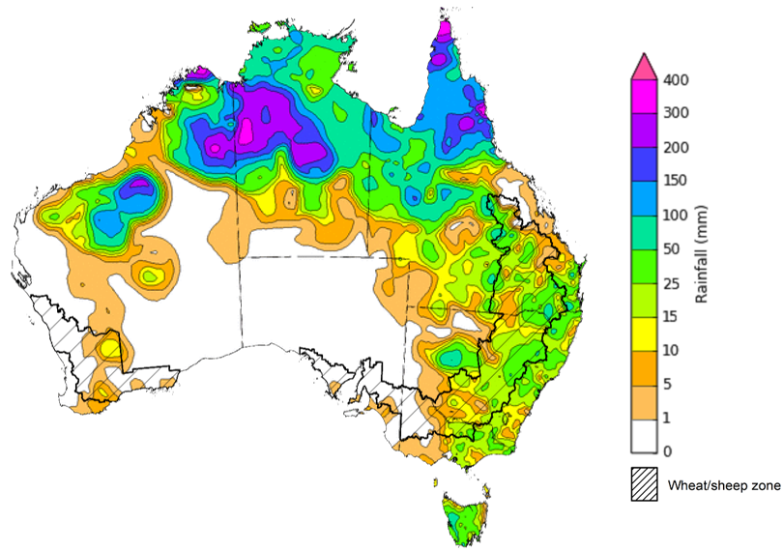

©Commonwealth of Australia 2024, Australian Bureau of Meteorology Issued: 24/01/2024

Note: The rainfall analyses and associated maps utilise data contained in the Bureau of Meteorology climate database, the Australian Data Archive for Meteorology (ADAM). The analyses are initially produced automatically from real-time data with limited [quality control](http://www.bom.gov.au/climate/headers/qc.shtml). They are intended to provide a general overview of rainfall across Australia as quickly as possible after the observations are received. For further information go to <http://www.bom.gov.au/climate/rainfall/>

### Northern Australia rainfall onset

The timing of Northern Australia rainfall onset is important indicator for seasonal pasture growth and potential livestock production. The rainfall onset gives an indication of the accumulation of at least 50 millimetres of rainfall after 1 September to stimulate plant growth after the northern dry season.

Since 1 September 2023, large areas of northern Australia have received at least 50 millimetres of rainfall. North-western Australia normally doesn’t accumulate this first 50 millimetres of rainfall until late February and is typically delayed further in El Niño years. Northern parts of Western Australia, Northern Territory and across large areas of eastern Queensland have recorded onset later than usual. Rainfall in northern Australia for this time of the year is important for pasture and feed availability. Much of the rainfall in excess of 600 millimetres have accumulated from tropical lows in the northern parts of Western Australia and Northern Territory, and tropical cyclone Jasper in the northern Queensland.

#### Northern rainfall totals from 1 September 2023

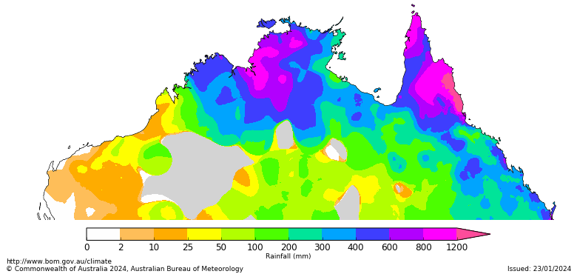

### Rainfall forecast for the next eight days

* Tropical cyclone Kirrily is expected to strengthen today (25th January 2024) as it tracks towards Queensland coast and is expected to make landfall overnight just north of Townsville, generating destructive winds and heavy rainfall which may lead to flash flooding. This may impact the horticultural and sugarcane crops in the affected areas. During Friday, the system is expected to become a tropical low and heavy rainfall is expected across the northern interior and western Queensland into the weekend as the system tracks inland, which is likely to ultimately benefit pasture growth and beef cattle production.
* Over the 8 days to 1 February 2024, an active monsoon trough is expected to generate storms and heavy falls in the northern tropics and a trough over the west and interior will generate showers in Western Australia, Northern Territory and South Australia. A trough in the east will bring showers and storms to northeast New South Wales and southern Queensland. A front and trough will bring gusty showers to Victoria, Tasmania and southeast New South Wales.
* Across cropping regions, rainfall totals up to 100 millimetres are forecast for Queensland and northern New South Wales. Rainfall up to 15 millimetres is forecast for South Australia and Victoria. These falls will benefit soil moisture levels for pasture growth and support summer crops. Little to no rainfall is expected across remaining cropping regions. Western Australian cropping regions continue to experience dry conditions and declining soil moisture levels and will require significant rainfall during autumn to allow for the timely planting of winter crops.

#### Total forecast rainfall for the period 25 January to 1 February 2024

©Commonwealth of Australia 2024, Australian Bureau of Meteorology Issued 25/01/2024

Note: This rainfall forecast is produced from computer models. As the model outputs are not altered by weather forecasters, it is important to check local forecasts and warnings issued by the Bureau of Meteorology.

### Climate Drivers

* Throughout Australia’s summer period the climate drivers with the largest potential impact on Australia’s climate patterns are the El Niño–Southern Oscillation (ENSO), the Southern Annular Mode (SAM), and the Madden-Julian Oscillation (MJO). These climate drivers are likely to influence the growth and development of summer crops in northern growing regions and pasture growth across northern Australia with the onset of the northern wet season. The Indian Ocean Dipole (IOD) is another climate driver that has an effect on Australian climate but has little impact during summer.
* An El Niño continues with decreasing strength. The influence of El Niño on Australian rainfall usually reduces during summer, especially across eastern Australia; however, below median rainfall is still often observed in north-eastern Australia. Additionally, high-impact rainfall events can occur during El Niño years, particularly during October to April when severe storm frequency peaks. Climate models suggest that sea surface temperatures in the central Pacific will remain above El Niño thresholds up until the southern hemisphere autumn 2024. However, some of the atmospheric components have weakened over past weeks. The positive IOD is nearing the end and is forecast to return to neutral in coming weeks.

#### ENSO and IOD forecast

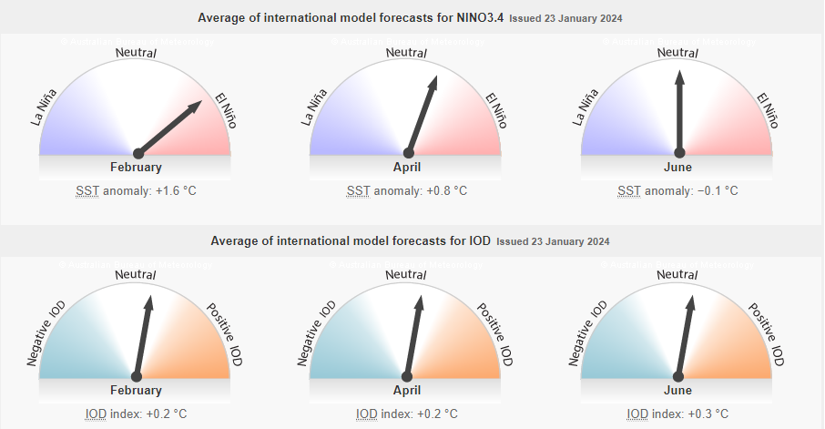

©Commonwealth of Australia 2024, Australian Bureau of Meteorology Issued: 23/01/2024

* The SAM is forecast to be at neutral levels over next fortnight. SAM has been positive for much of December and January and has likely contributed to the rainfall received in the southeastern Australia. During summer, a positive SAM historically increases the chance of above average rainfall for parts of eastern New South Wales, south-eastern Queensland, eastern Victoria, and north-east Tasmania, but increases the chance of below average rainfall for western Tasmania. Rainfall increases are due to the positive SAM shifting westerly winds further south, increasing onshore flow over south-east Australia.

#### Southern Annual Mode (SAM) daily index

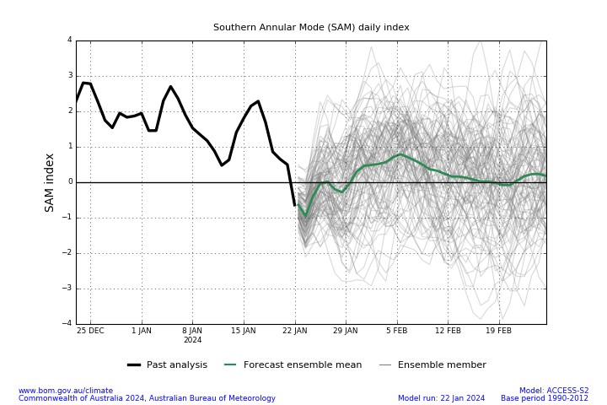

* A pulse of MJO is currently over the Maritime Continent. At this time of year, when the MJO is in the western Maritime Continent, the chance of above average rainfall typically increases across central Australia. When the MJO is in the eastern parts of the Maritime Continent, the chance of above average rainfall typically increases across northern Australia and provides a favourable environment for the onset of the monsoon in Darwin.

#### Daily Madden-Julian Oscillation (MJO)

### National Climate Outlook

The Bureau of Meteorology’s latest rainfall outlook for February 2024 indicates that rainfall is likely (60 to 80% chance) to be below median for most of Northern Territory, Western Australia and South Australia, and western parts of Victoria, New South Wales and Queensland. Close to median rainfall is likely to very likely elsewhere.

The Bureau of Meteorology’s climate model suggests that for February 2024, there is a 75% chance of rainfall totals being over 25 millimetres across coastal east and northern Australia, as well as in western Tasmania. Rainfall totals in excess of 100 millimetres are expected in northern Queensland and Northern Territory and in parts of coastal east.

Across cropping regions, there is at least a 75% chance of rainfall totals above 10 millimetres in New South Wales and Queensland. February rainfall totals are expected to be below 10 millimetres for the remaining cropping regions.

If realised these forecast rainfall totals for February will provide some useful follow-up falls for dryland summer crop production as well as pasture growth across eastern and northern Australia. Dry conditions elsewhere is expected to see a decline in soil moisture levels.

**Rainfall totals that have a 75% chance of occurring in February 2024**

©Commonwealth of Australia 2024, Australian Bureau of Meteorology Issued: 18/01/2024

* The rainfall outlook for February to April 2024 suggests that below average rainfall is likely (60 to 80% chance) for most of the northern half of Australia, western parts of Western Australia, parts of South Australia, western and central Victoria, and eastern Tasmania.
* Across cropping regions, close to median rainfall is likely in the New South Wales and much of Queensland while below median rainfall is likely in the remaining cropping regions.

**Chance of exceeding the median rainfall** **February to April 2024**

©Commonwealth of Australia 2024, Australian Bureau of Meteorology Issued: 18/01/2024

The outlook for February to April 2024 suggests there is at least a 75% chance of rainfall totals above 25 millimetres across much of Australia. The main exceptions being large areas of the interior and western coast where below 25 millimetres of rainfall are expected. Rainfall totals in excess of 200 millimetres are likely across tropical northern Australia, eastern coast and western Tasmania during this period.

Across cropping regions, there is at least a 75% chance of receiving above 50 millimetres across New South Wales and Queensland.

If realised, these falls will likely be sufficient to support summer pasture growth across eastern and northern Australia. These falls are also likely to be sufficient to support the establishment and growth of additional plantings of summer crops during the later planting window during early to mid-summer.

**

©Commonwealth of Australia 2024, Australian Bureau of Meteorology Issued: 18/01/2024

## **Water**

### Water markets – current week

Water storage levels in the Murray-Darling Basin (MDB) decreased between 18 January 2024 and 25 January 2024 by 53 gigalitres (GL). Current volume of water held in storage is 19 046 GL. This is 12 percent or 2585 GL less than at the same time last year.

#### Water storages in the Murray-Darling Basin, 2013–2024

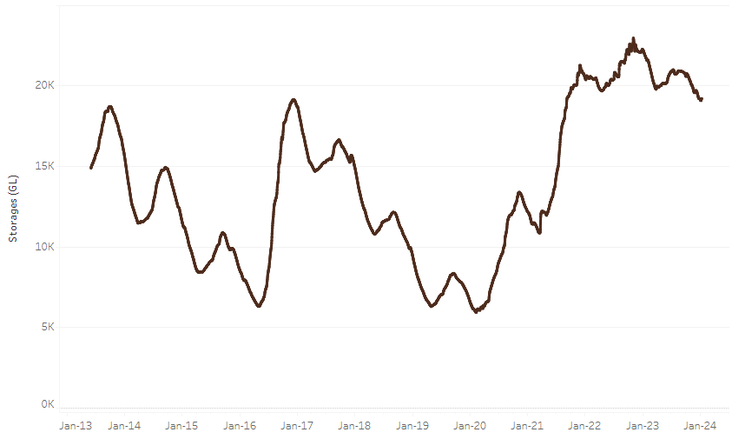

|  |
| --- |
| Water storage data is sourced from the Bureau of Meteorology. |

Allocation prices in the Victorian Murray below the Barmah Choke increased from $41 on 18 January 2024 to $62 on 25 January 2024. Prices are lower in the Murrumbidgee, and regions above the Barmah choke, and Goulburn-Broken due to the binding of the Murrumbidgee export limit, and Barmah choke and Goulburn-Broken trade constraints.

|  |  |
| --- | --- |
| **Region** | **$/ML** |
| NSW Murray Above | 55 |
| NSW Murrumbidgee | 35 |
| VIC Goulburn-Broken | 56 |
| VIC Murray Below | 62 |

#### Surface water trade activity, Southern Murray–Darling Basin

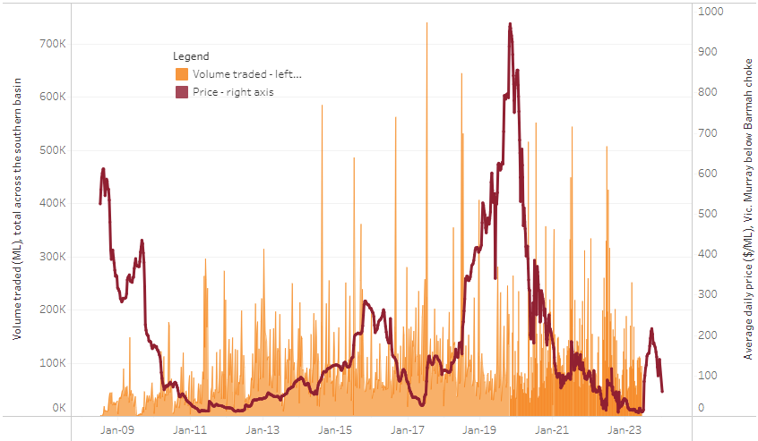

|  |
| --- |
| The trades shown reflect estimated market activity and do not encompass all register trades. The price is shown for the VIC Murray below the Barmah choke. Historical prices (before 1 July 2019) are ABARES estimates after removing outliers from BOM water register data. Prices after 1 July 2019 and prior to the 30 October 2019 reflect recorded transaction prices as sourced from Ruralco. Prices after the 30 October 2019 are sourced from Waterflow. Data for volume traded is sourced from the BOM water register. Only the price data shown is current on 25 January 2024. |

To access the full, interactive, weekly water dashboard, which contains the latest and historical water storage, water market and water allocation information, please visit <https://www.agriculture.gov.au/abares/products/weekly_update/weekly-update-250124>

## **Commodities**

|  |  |  |  |  |  |  |  |
| --- | --- | --- | --- | --- | --- | --- | --- |
| **Indicator** | **Week ended** | **Unit** | **Latest Price** | **Previous Week** | **Weekly change** | **Price 12 months ago** | **Annual change** |
| **Selected world indicator prices** |  |  |  |  |  |  |  |
| AUD/USD Exchange rate | 24-Jan | A$/US$ | 0.66 | 0.66 | 0% | 0.71 | -7% |
| Wheat – US no. 2 hard red winter wheat, fob Gulf | 24-Jan | US$/t | 283 | 278 | 2% | 392 | -28% |
| Corn – US no. 2 yellow corn, fob Gulf | 24-Jan | US$/t | 197 | 195 | 1% | 304 | -35% |
| Canola – Rapeseed, Canada, fob Vancouver | 24-Jan | US$/t | 513 | 506 | 1% | 673 | -24% |
| Cotton – Cotlook 'A' Index | 24-Jan | USc/lb | 94 | 92 | 2% | 101 | -8% |
| Sugar – Intercontinental Exchange, nearby futures, no.11 contract | 24-Jan | USc/lb | 22.9 | 22.3 | 3% | 20 | 13% |
| Wool – Eastern Market Indicator | 24-Jan | Ac/kg clean | 1,186 | 1,196 | -1% | 1,232 | -4% |
| Wool – Western Market Indicator | 24-Jan | Ac/kg clean | 1,306 | 1,317 | -1% | 1,394 | -6% |
| **Selected Australian grain export prices** |  |  |  |  |  |  |  |
| Milling Wheat – APW, Port Adelaide, SA | 24-Jan | A$/t | 443 | 449 | -1% | 505 | -12% |
| Feed Wheat – ASW, Port Adelaide, SA | 24-Jan | A$/t | 419 | 429 | -2% | 457 | -8% |
| Feed Barley – Port Adelaide, SA | 24-Jan | A$/t | 378 | 373 | 2% | 415 | -9% |
| Canola – Kwinana, WA | 24-Jan | A$/t | 743 | 743 | 0% | 1,060 | -30% |
| Grain Sorghum – Brisbane, QLD | 24-Jan | A$/t | 471 | 481 | -2% | 476 | -1% |
| **Selected domestic livestock indicator prices** |  |  |  |  |  |  |  |
| Beef – Eastern Young Cattle Indicator | 24-Jan | Ac/kg cwt | 628 | 604 | 4% | 782 | -20% |
| Mutton – Mutton indicator (18–24 kg fat score 2–3), Vic | 24-Jan | Ac/kg cwt | 283 | 284 | 0% | 353 | -20% |
| Lamb – National Trade Lamb Indicator | 24-Jan | Ac/kg cwt | 701 | 743 | -6% | 808 | -13% |
| Pig – Eastern Seaboard (60.1–75 kg), average of buyers & sellers | 10-Jan | Ac/kg cwt | 403 | 397 | 2% | 367 | 10% |
| Goats – Eastern States (10.1–12 kg) | 27-Dec | Ac/kg cwt | 170 | 170 | 0% | 350 | -51% |
| Live cattle – Light steers to Indonesia | 20-Dec | Ac/kg lwt | 290 | 290 | 0% | 510 | -43% |
| **Global Dairy Trade (GDT) weighted average prices a** |  |  |  |  |  |  |  |
| Dairy – Whole milk powder | 17-Jan | US$/t | 3,353 | 3,290 | 2% | 3,208 | 5% |
| Dairy – Skim milk powder | 17-Jan | US$/t | 2,638 | 2,613 | 1% | 2,838 | -7% |
| Dairy – Cheddar cheese | 17-Jan | US$/t | 4,217 | 4,165 | 1% | 4,690 | -10% |
| Dairy – Anhydrous milk fat | 17-Jan | US$/t | 5,842 | 5,595 | 4% | 5,395 | 8% |
| **a** Global Dairy Trade prices are updated twice monthly on the first and third Tuesday of each month. | | | | | | | |

### Selected world indicator prices

### Selected domestic crop indicator prices

### Selected domestic livestock indicator prices

### Global Dairy Trade (GDT) weighted average prices

### Selected fruit and vegetable prices

### 3.6 Selected domestic fodder indicator prices

## **4. Data attribution**

### Climate

* Bureau of Meteorology
* Weekly rainfall totals: www.bom.gov.au/climate/maps/rainfall/
* Monthly and last 3-month rainfall percentiles: [www.bom.gov.au/water/landscape/](http://www.bom.gov.au/water/landscape/)
* Temperature anomalies: [www.bom.gov.au/jsp/awap/temp/index.jsp](http://www.bom.gov.au/jsp/awap/temp/index.jsp)
* Rainfall forecast: [www.bom.gov.au/jsp/watl/rainfall/pme.jsp](http://www.bom.gov.au/jsp/watl/rainfall/pme.jsp)
* Seasonal outlook: [www.bom.gov.au/climate/outlooks/#/overview/summary/](http://www.bom.gov.au/climate/outlooks/#/overview/summary/)
* Climate drivers: <http://www.bom.gov.au/climate/enso/>
* Soil moisture: [www.bom.gov.au/water/landscape/](http://www.bom.gov.au/water/landscape/)
* Other
* Pasture growth: [www.longpaddock.qld.gov.au/aussiegrass/](http://www.longpaddock.qld.gov.au/aussiegrass/)
* 3-month global outlooks: [Environment and Climate Change Canada](https://weather.gc.ca/saisons/image_e.html?img=s234pfe1p_cal&bc=prob), [NOAA Climate Prediction Center](https://www.cpc.ncep.noaa.gov/products/predictions/long_range/seasonal.php?lead=2), [EUROBRISA CPTEC/INPE](http://eurobrisa.cptec.inpe.br/), European Centre for Medium-Range Weather Forecasts, [Hydrometcenter of Russia](https://meteoinfo.ru/en/climate/seasonal-forecasts), [National Climate Center Climate System Diagnosis and Prediction Room (NCC)](https://cmdp.ncc-cma.net/pred/cs2gen.php?pred_elem=RAINP#pred_seasonal), [International Research Institute for Climate and Society](https://iri.columbia.edu/our-expertise/climate/forecasts/seasonal-climate-forecasts/)
* Global production: <https://ipad.fas.usda.gov/ogamaps/cropmapsandcalendars.aspx>
* Autumn break: Pook et al., 2009, <https://rmets-onlinelibrary-wiley-com.virtual.anu.edu.au/doi/epdf/10.1002/joc.1833>

### Water

Prices

* Waterflow: <https://www.waterflow.io/>
* Ruralco: <https://www.ruralcowater.com.au/>
* Bureau of Meteorology:
* Allocation trade: <http://www.bom.gov.au/water/dashboards/#/water-markets/mdb/at>
* Storage volumes: <http://www.bom.gov.au/water/dashboards/#/water-storages/summary/drainage>
* Trade constraints:
* Water NSW: <https://www.waternsw.com.au/customer-service/ordering-trading-and-pricing/trading/murrumbidgee>
* Victorian Water Register: <https://www.waterregister.vic.gov.au/TradingRules2019/>

### Commodities

* Fruit and vegetables
* Datafresh: [www.freshstate.com.au](http://www.freshstate.com.au)
* Pigs
* Australian Pork Limited: [www.australianpork.com.au](http://www.australianpork.com.au)
* Dairy
* Global Dairy Trade: [www.globaldairytrade.info/en/product-results/](http://www.globaldairytrade.info/en/product-results/)
* World wheat, canola
* International Grains Council
* World coarse grains
* United States Department of Agriculture
* World cotton
* Cotlook: [www.cotlook.com/](http://www.cotlook.com/)
* World sugar
* New York Stock Exchange - Intercontinental Exchange
* Wool
* Australian Wool Exchange: [www.awex.com.au/](http://www.awex.com.au/)
* Domestic wheat, barley, sorghum, canola and fodder
* Jumbuk Consulting Pty Ltd: http://www.jumbukag.com.au/
* Cattle, beef, mutton, lamb, goat and live export
* Meat and Livestock Australia: www.mla.com.au/Prices-and-market

© Commonwealth of Australia 2023

### Ownership of intellectual property rights

Unless otherwise noted, copyright (and any other intellectual property rights, if any) in this publication is owned by the Commonwealth of Australia (referred to as the Commonwealth).

### Creative Commons licence

All material in this publication is licensed under a [Creative Commons Attribution 4.0 International Licence](https://creativecommons.org/licenses/by/4.0/legalcode) except content supplied by third parties, logos and the Commonwealth Coat of Arms.

Inquiries about the licence and any use of this document should be emailed to [copyright@awe.gov.au](mailto:copyright@awe.gov.au).

https://www.agriculture.gov.au/sites/default/files/images/creative-commons-logo-small.png

### Cataloguing data

This publication (and any material sourced from it) should be attributed as:

ABARES 2023, Weekly Australian Climate, Water and Agricultural Update, Australian Bureau of Agricultural and Resource Economics and Sciences, Canberra, 11 January 2024. CC BY 4.0 DOI: <https://doi.org/10.25814/5f3e04e7d2503>

ISSN **2652-7561**

This publication is available at https://www.agriculture.gov.au/abares/products/weekly_update

Department of Agriculture, Fisheries and Forestry

GPO Box 858 Canberra ACT 2601

Telephone 1800 900 090

Web [agriculture.gov.au/abares](http://awe.gov.au/abares)

### Disclaimer

The Australian Government acting through the Department of Agriculture, Fisheries and Forestry, represented by the Australian Bureau of Agricultural and Resource Economics and Sciences, has exercised due care and skill in preparing and compiling the information and data in this publication. Notwithstanding, the Department of Agriculture, Fisheries and Forestry, ABARES, its employees and advisers disclaim all liability, including liability for negligence and for any loss, damage, injury, expense or cost incurred by any person as a result of accessing, using or relying on any of the information or data in this publication to the maximum extent permitted by law.

### Statement of Professional Independence

The views and analysis presented in ABARES publications, including this one, reflect ABARES professionally independent findings, based on scientific and economic concepts, principles, information and data. These views, analysis and findings may not reflect or be consistent with the views or positions of the Australian Government, or of organisations or groups who have commissioned ABARES reports or analysis. More information on [professional independence](https://www.agriculture.gov.au/abares/about/research-and-analysis#professional-independence) is provided on the ABARES website.

### Acknowledgements

This report was prepared by Kavina Dayal and Matthew Miller.