## No. 2/2024 18 January 2024

# Summary of key issues

* For the week ending 17 January 2024, an active monsoon trough combined with a tropical low brought heavy rainfall in tropical parts of the country. Severe thunderstorms brought rainfall to southeast Australia.
  + These falls have provided significant boost to the soil moisture to support pasture growth and built reserves ahead of the upcoming winter cropping season.
* Over the coming week, the active monsoon trough and tropical low will continue to bring heavy rain, in excess of 150 millimetres in parts, to far northern Australia. Troughs across eastern Australia will generate showers and storms over Queensland and northeast New South Wales.
  + Rainfall where expected will support development of summer crops and pasture growth, but dry conditions elsewhere will see a decline in soil moisture levels.
* In December 2023, rainfall was variable for the world’s major grain-producing and oilseed-producing regions.
  + Northern hemisphere received generally average to above average, with exception of some parts of Canada and the United States where rainfall was below average.
  + Southern hemisphere rainfall was below average for southern half of Brazil and northern Paraguay, and across much of western half of Australia. Above average rainfall was recorded for eastern Argentina and south-eastern Australia. Close to average rainfall across the remainder of major grain-producing and oilseed-producing regions.
* February to April 2024 rainfall is expected to be average to above average and snowpack will prevent winterkill in the northern hemisphere grain and oilseed growing regions. Generally average rainfall is expected in southern hemisphere cropping regions.
* Water storage levels in the Murray-Darling Basin (MDB) decreased between 11 January 2024 and 18 January 2024 by 66 gigalitres (GL). Current volume of water held in storage is 19 108 GL. This is 12 percent or 2702 GL less than at the same time last year.
* Allocation prices in the Victorian Murray below the Barmah Choke decreased from $60 on 11 January 2024 to $41 on 18 January 2024. Prices are lower in regions above the Barmah choke due to the binding of the Barmah choke trade constraint.

## **Climate**

### Rainfall this week

For the week ending 17 January 2024, a broad band of cloud and severe thunderstorms, associated with a low-pressure system, moved across south-eastern Australia bringing significant rainfall. An active monsoon trough combined with a tropical low brought rainfall in excess of 200 millimetres in tropical parts of the country.

Across cropping regions, rainfall totals of up to 100 millimetres were recorded in New South Wales, Victoria and in parts of Queensland. Meanwhile, falls of up to 50 millimetres were recorded in parts of South Australia and Western Australia. These falls will support the ongoing growth and lift the yield potential of summer crops across eastern Australia. Additionally, these falls have provided significant boost to the soil moisture to support pasture growth and built reserves ahead of the upcoming winter cropping season.

#### Rainfall for the week ending 17 January 2024

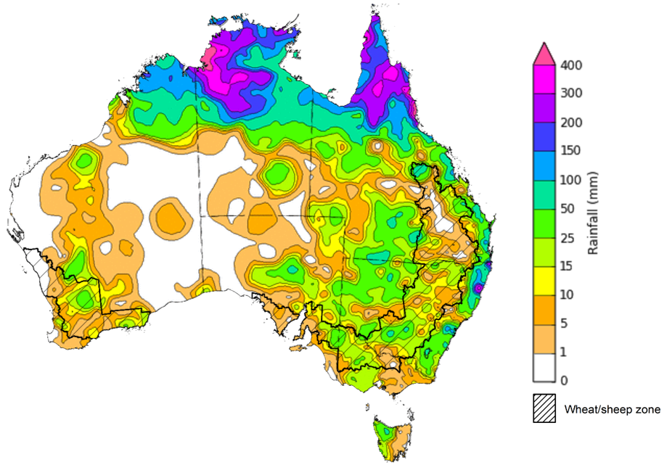

©Commonwealth of Australia 2024, Australian Bureau of Meteorology Issued: 17/01/2024

Note: The rainfall analyses and associated maps utilise data contained in the Bureau of Meteorology climate database, the Australian Data Archive for Meteorology (ADAM). The analyses are initially produced automatically from real-time data with limited [quality control](http://www.bom.gov.au/climate/headers/qc.shtml). They are intended to provide a general overview of rainfall across Australia as quickly as possible after the observations are received. For further information go to <http://www.bom.gov.au/climate/rainfall/>

### Rainfall forecast for the next eight days

Over the 8 days to 25 January 2024, the active monsoon trough and tropical low will continue to bring heavy rain, in excess of 150 millimetres, to northern parts of the country. Troughs across eastern Australia will generate showers and storms over Queensland and northeast New South Wales. A low-pressure system will generate heavy falls in Tasmania.

Across cropping regions, rainfall totals up to 50 millimetres are forecast for Queensland and northern New South Wales. These falls will benefit soil moisture levels for pasture growth and support summer crops. Little to no rainfall is expected across remaining summer cropping regions.

#### Total forecast rainfall for the period 18 January to 25 January 2024

©Commonwealth of Australia 2024, Australian Bureau of Meteorology Issued 18/01/2024

Note: This rainfall forecast is produced from computer models. As the model outputs are not altered by weather forecasters, it is important to check local forecasts and warnings issued by the Bureau of Meteorology.

### Global production conditions and climate outlook

Crop production is affected by long-term trends in average rainfall and temperature, interannual climate variability, shocks during specific growth stages, and extreme weather events. Some crops are more tolerant than others to certain types of stresses, and at each growth stage, different types of stresses affect each crop species in different ways.

The precipitation anomalies and outlooks presented here give an indication of the current and future state of production conditions for the major grain and oilseed producing countries which are responsible for over 80% of global production. This is an important input to assessing the global grain supply outlook.

**December precipitation percentiles and current production conditions**

As of the end of December 2023, rainfall was variable for the world’s major grain-producing and oilseed-producing regions.

In the northern hemisphere, precipitation was generally average to above average, with exception of some parts of Canada and the United States where precipitation was below average.

In the southern hemisphere, December precipitation was below average for southern half of Brazil and northern Paraguay, and across much of western half of Australia. Above average precipitation was recorded for eastern Argentina and south-eastern Australia. Precipitation was close to average across the remainder of major grain-producing and oilseed-producing regions.

#### Global precipitation percentiles, December 2023

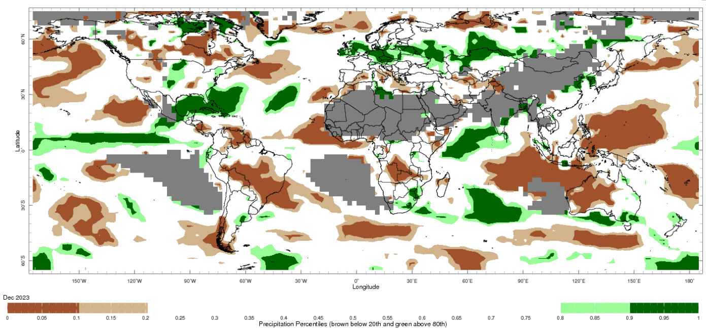

Note: The world precipitation percentiles indicate a ranking of precipitation for December, with the driest (0th percentile) being 0 on the scale and the wettest (100th percentile) being 1 on the scale. Percentiles are based on precipitation estimates from the NOAA Climate Prediction Center's [Climate Anomaly Monitoring System Outgoing Precipitation Index](https://iridl.ldeo.columbia.edu/maproom/Global/Precipitation/Percentiles.html) dataset. Precipitation estimates for December 2023 are compared with rainfall recorded for that period during the 1991 to 2020 base period.

Source: International Research Institute for Climate and Society

The global climate outlook for February to April 2024 indicates that variable rainfall conditions are expected for the world's major grain-producing and oilseed-producing regions. Outlooks and potential production impacts for the major grain and oilseed producing countries are presented in the table.

**Rainfall outlook and potential impact on the future state of production conditions between February to April 2024**

|  |  |  |
| --- | --- | --- |
| **Region** | **February to April rainfall outlook** | **Potential impact on production** |
| **Argentina** | Generally average rainfall is likely across much of Argentina with an exception in eastern areas where below average rainfall is likely. | Average rainfall is likely to support flowering of soybeans, sorghum, rice, and millet in the February and increase yield potentials of those crops. |
| **Black Sea Region** | Average rainfall is likely for Turkey, Kazakhstan, Ukraine and Russian Federation. | The average rainfall conditions are likely to support the development of winter wheat and canola, and planting of corn, cotton and sunflower across Russia. |
| **Brazil** | Average rainfall is expected across southern half of Brazil. | Average rainfall will benefit the development of soybeans, cotton, rice, sorghum, millet, sunflower, peanuts, and corn prior to the harvesting of some crops beginning in March 2024. |
| **Canada** | Generally average rainfall is likely with exception in isolated areas in central areas where below average rainfall is likely. | Through to March, winter wheat and canola will progress from dormant to heading. Average rainfall will likely provide sufficient snowpack to prevent winterkill of winter wheat and canola and support vegetative growth and heading. |
| **China** | Average to above average rainfall is expected across China. | Through January and February, winter wheat and canola will remain dormant. Average to above average rainfall may minimise the risk of winterkill through snowpack during winter. |
| **Europe** | Average rainfall is likely for most of Europe. | Average rainfall may support snowpack, minimising the risk of winterkill for winter wheat and canola. Average rainfall in southern Europe should provide favourable conditions for winter wheat. |
| **South Asia (India)** | Above average rainfall is expected in far northern areas while average rainfall is expected across the rest of India. | Average rainfall across much of India may support vegetative growth and heading of winter wheat and canola between January and February. In the far south, winter crops would be expected to benefit from average rainfall. |
| **Southeast Asia (SEA)** | Above average rainfall is likely across much of SEA. | Above average rainfall in SEA likely supports vegetative growth for corn and rice throughout January to February. However, excessive rainfall may result in flooding and crop damage. |
| **The United States of America** | Above average rainfall is more likely for the southeastern areas, below average rainfall in southern areas and average rainfall across rest of the United States. | Average rainfall through winter is expected to protect wheat and canola through dormancy. Below average rainfall may adversely impact crop development and planting in the southern areas. |

## **Water**

### Water markets – current week

Water storage levels in the Murray-Darling Basin (MDB) decreased between 11 January 2024 and 18 January 2024 by 66 gigalitres (GL). Current volume of water held in storage is 19 108 GL. This is 12 percent or 2702 GL less than at the same time last year.

#### Water storages in the Murray-Darling Basin, 2013–2024

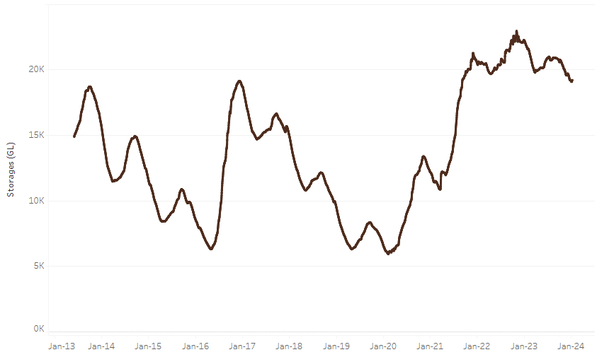

|  |
| --- |
| Water storage data is sourced from the Bureau of Meteorology. |

Allocation prices in the Victorian Murray below the Barmah Choke decreased from $60 on 11 January 2024 to $41 on 18 January 2024. Prices are lower in regions above the Barmah choke due to the binding of the Barmah choke trade constraint.

|  |  |
| --- | --- |
| **Region** | **$/ML** |
| NSW Murray Above | 58 |
| NSW Murrumbidgee | 39 |
| VIC Goulburn-Broken | 47 |
| VIC Murray Below | 41 |

#### Surface water trade activity, Southern Murray–Darling Basin

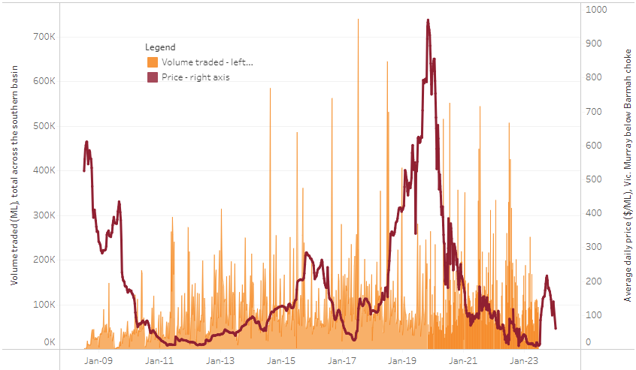

|  |
| --- |
| The trades shown reflect estimated market activity and do not encompass all register trades. The price is shown for the VIC Murray below the Barmah choke. Historical prices (before 1 July 2019) are ABARES estimates after removing outliers from BOM water register data. Prices after 1 July 2019 and prior to the 30 October 2019 reflect recorded transaction prices as sourced from Ruralco. Prices after the 30 October 2019 are sourced from Waterflow. Data for volume traded is sourced from the BOM water register. Only the price data shown is current on 11 January 2024. |

To access the full, interactive, weekly water dashboard, which contains the latest and historical water storage, water market and water allocation information, please visit <https://www.agriculture.gov.au/abares/products/weekly_update/weekly-update-180124>

## **Commodities**

|  |  |  |  |  |  |  |  |
| --- | --- | --- | --- | --- | --- | --- | --- |
| **Indicator** | **Week ended** | **Unit** | **Latest Price** | **Previous Week** | **Weekly change** | **Price 12 months ago** | **Annual change** |
| **Selected world indicator prices** |  |  |  |  |  |  |  |
| AUD/USD Exchange rate | 17-Jan | A$/US$ | 0.66 | 0.67 | -1% | 0.71 | -6% |
| Wheat – US no. 2 hard red winter wheat, fob Gulf | 17-Jan | US$/t | 279 | 283 | -1% | 379 | -27% |
| Corn – US no. 2 yellow corn, fob Gulf | 17-Jan | US$/t | 195 | 197 | -1% | 304 | -36% |
| Canola – Rapeseed, Canada, fob Vancouver | 17-Jan | US$/t | 507 | 502 | 1% | 653 | -22% |
| Cotton – Cotlook 'A' Index | 17-Jan | USc/lb | 92 | 91 | 1% | 102 | -10% |
| Sugar – Intercontinental Exchange, nearby futures, no.11 contract | 17-Jan | USc/lb | 22.1 | 21.6 | 2% | 20 | 9% |
| Wool – Eastern Market Indicator | 10-Jan | Ac/kg clean | 1,213 | 1,212 | 0% | 1,352 | -10% |
| Wool – Western Market Indicator | 10-Jan | Ac/kg clean | 1,325 | 1,343 | -1% | 1,469 | -10% |
| **Selected Australian grain export prices** |  |  |  |  |  |  |  |
| Milling Wheat – APW, Port Adelaide, SA | 17-Jan | A$/t | 449 | 444 | 1% | 501 | -10% |
| Feed Wheat – ASW, Port Adelaide, SA | 17-Jan | A$/t | 428 | 424 | 1% | 452 | -5% |
| Feed Barley – Port Adelaide, SA | 17-Jan | A$/t | 372 | 373 | 0% | 416 | -10% |
| Canola – Kwinana, WA | 17-Jan | A$/t | 745 | 740 | 1% | 1,041 | -28% |
| Grain Sorghum – Brisbane, QLD | 17-Jan | A$/t | 482 | 484 | 0% | 475 | 1% |
| **Selected domestic livestock indicator prices** |  |  |  |  |  |  |  |
| Beef – Eastern Young Cattle Indicator | 17-Jan | Ac/kg cwt | 599 | 580 | 3% | 781 | -23% |
| Mutton – Mutton indicator (18–24 kg fat score 2–3), Vic | 17-Jan | Ac/kg cwt | 283 | 230 | 23% | 310 | -8% |
| Lamb – National Trade Lamb Indicator | 17-Jan | Ac/kg cwt | 760 | 773 | -2% | 790 | -4% |
| Pig – Eastern Seaboard (60.1–75 kg), average of buyers & sellers | 03-Jan | Ac/kg cwt | 397 | 397 | 0% | 376 | 6% |
| Goats – Eastern States (10.1–12 kg) | 27-Dec | Ac/kg cwt | 170 | 170 | 0% | 350 | -51% |
| Live cattle – Light steers to Indonesia | 20-Dec | Ac/kg lwt | 290 | 290 | 0% | 510 | -43% |
| **Global Dairy Trade (GDT) weighted average prices a** |  |  |  |  |  |  |  |
| Dairy – Whole milk powder | 17-Jan | US$/t | 3,353 | 3,290 | 2% | 3,208 | 5% |
| Dairy – Skim milk powder | 17-Jan | US$/t | 2,638 | 2,613 | 1% | 2,838 | -7% |
| Dairy – Cheddar cheese | 17-Jan | US$/t | 4,217 | 4,165 | 1% | 4,690 | -10% |
| Dairy – Anhydrous milk fat | 17-Jan | US$/t | 5,842 | 5,595 | 4% | 5,395 | 8% |
| **a** Global Dairy Trade prices are updated twice monthly on the first and third Tuesday of each month. | | | | | | | |

### Selected world indicator prices

### Selected domestic crop indicator prices

### Selected domestic livestock indicator prices

### Global Dairy Trade (GDT) weighted average prices

### Selected fruit and vegetable prices

### 3.6 Selected domestic fodder indicator prices

## **4. Data attribution**

### Climate

Bureau of Meteorology

* Weekly rainfall totals: www.bom.gov.au/climate/maps/rainfall/
* Monthly and last 3-month rainfall percentiles: [www.bom.gov.au/water/landscape/](http://www.bom.gov.au/water/landscape/)
* Temperature anomalies: [www.bom.gov.au/jsp/awap/temp/index.jsp](http://www.bom.gov.au/jsp/awap/temp/index.jsp)
* Rainfall forecast: [www.bom.gov.au/jsp/watl/rainfall/pme.jsp](http://www.bom.gov.au/jsp/watl/rainfall/pme.jsp)
* Seasonal outlook: [www.bom.gov.au/climate/outlooks/#/overview/summary/](http://www.bom.gov.au/climate/outlooks/#/overview/summary/)
* Climate drivers: <http://www.bom.gov.au/climate/enso/>
* Soil moisture: [www.bom.gov.au/water/landscape/](http://www.bom.gov.au/water/landscape/)

Other

* Pasture growth: [www.longpaddock.qld.gov.au/aussiegrass/](http://www.longpaddock.qld.gov.au/aussiegrass/)
* 3-month global outlooks: [Environment and Climate Change Canada](https://weather.gc.ca/saisons/image_e.html?img=s234pfe1p_cal&bc=prob), [NOAA Climate Prediction Center](https://www.cpc.ncep.noaa.gov/products/predictions/long_range/seasonal.php?lead=2), [EUROBRISA CPTEC/INPE](http://eurobrisa.cptec.inpe.br/), European Centre for Medium-Range Weather Forecasts, [Hydrometcenter of Russia](https://meteoinfo.ru/en/climate/seasonal-forecasts), [National Climate Center Climate System Diagnosis and Prediction Room (NCC)](https://cmdp.ncc-cma.net/pred/cs2gen.php?pred_elem=RAINP#pred_seasonal), [International Research Institute for Climate and Society](https://iri.columbia.edu/our-expertise/climate/forecasts/seasonal-climate-forecasts/)
* Global production: <https://ipad.fas.usda.gov/ogamaps/cropmapsandcalendars.aspx>
* Autumn break: Pook et al., 2009, <https://rmets-onlinelibrary-wiley-com.virtual.anu.edu.au/doi/epdf/10.1002/joc.1833>

### Water

Prices

* Waterflow: <https://www.waterflow.io/>
* Ruralco: <https://www.ruralcowater.com.au/>

Bureau of Meteorology:

* Allocation trade: <http://www.bom.gov.au/water/dashboards/#/water-markets/mdb/at>
* Storage volumes: <http://www.bom.gov.au/water/dashboards/#/water-storages/summary/drainage>

Trade constraints:

* Water NSW: <https://www.waternsw.com.au/customer-service/ordering-trading-and-pricing/trading/murrumbidgee>
* Victorian Water Register: <https://www.waterregister.vic.gov.au/TradingRules2019/>

### Commodities

Fruit and vegetables

* Datafresh: [www.freshstate.com.au](http://www.freshstate.com.au)

Pigs

* Australian Pork Limited: [www.australianpork.com.au](http://www.australianpork.com.au)

Dairy

* Global Dairy Trade: [www.globaldairytrade.info/en/product-results/](http://www.globaldairytrade.info/en/product-results/)

World wheat, canola

* International Grains Council

World coarse grains

* United States Department of Agriculture

World cotton

* Cotlook: [www.cotlook.com/](http://www.cotlook.com/)

World sugar

* New York Stock Exchange - Intercontinental Exchange

Wool

* Australian Wool Exchange: [www.awex.com.au/](http://www.awex.com.au/)

Domestic wheat, barley, sorghum, canola and fodder

* Jumbuk Consulting Pty Ltd: http://www.jumbukag.com.au/

Cattle, beef, mutton, lamb, goat and live export

* Meat and Livestock Australia: www.mla.com.au/Prices-and-market

© Commonwealth of Australia 2023

### Ownership of intellectual property rights

Unless otherwise noted, copyright (and any other intellectual property rights, if any) in this publication is owned by the Commonwealth of Australia (referred to as the Commonwealth).

### Creative Commons licence

All material in this publication is licensed under a [Creative Commons Attribution 4.0 International Licence](https://creativecommons.org/licenses/by/4.0/legalcode) except content supplied by third parties, logos and the Commonwealth Coat of Arms.

Inquiries about the licence and any use of this document should be emailed to [copyright@awe.gov.au](mailto:copyright@awe.gov.au).

https://www.agriculture.gov.au/sites/default/files/images/creative-commons-logo-small.png

### Cataloguing data

This publication (and any material sourced from it) should be attributed as:

ABARES 2023, Weekly Australian Climate, Water and Agricultural Update, Australian Bureau of Agricultural and Resource Economics and Sciences, Canberra, 11 January 2024. CC BY 4.0 DOI: <https://doi.org/10.25814/5f3e04e7d2503>

ISSN **2652-7561**

This publication is available at https://www.agriculture.gov.au/abares/products/weekly_update

Department of Agriculture, Fisheries and Forestry

GPO Box 858 Canberra ACT 2601

Telephone 1800 900 090

Web [agriculture.gov.au/abares](http://awe.gov.au/abares)

### Disclaimer

The Australian Government acting through the Department of Agriculture, Fisheries and Forestry, represented by the Australian Bureau of Agricultural and Resource Economics and Sciences, has exercised due care and skill in preparing and compiling the information and data in this publication. Notwithstanding, the Department of Agriculture, Fisheries and Forestry, ABARES, its employees and advisers disclaim all liability, including liability for negligence and for any loss, damage, injury, expense or cost incurred by any person as a result of accessing, using or relying on any of the information or data in this publication to the maximum extent permitted by law.

### Statement of Professional Independence

The views and analysis presented in ABARES publications, including this one, reflect ABARES professionally independent findings, based on scientific and economic concepts, principles, information and data. These views, analysis and findings may not reflect or be consistent with the views or positions of the Australian Government, or of organisations or groups who have commissioned ABARES reports or analysis. More information on [professional independence](https://www.agriculture.gov.au/abares/about/research-and-analysis#professional-independence) is provided on the ABARES website.

### Acknowledgements

This report was prepared by Kavina Dayal and Matthew Miller.