## No. 1/2024 11 January 2024

# Summary of key issues

* For the week ending 10 January 2024, troughs generated widespread rainfall across much of eastern, southern, central and northern Australia. Severe thunderstorms resulted in locally intense rainfall of up to 200 millimetres in areas of eastern and northern Australia. Western parts of the country were mainly dry.
* Over the coming week, monsoon troughs and tropical lows will result in heavy rainfall of more than 150 millimetres in northern Australia. Onshore winds will bring showers of up to 25 millimetres across summer cropping regions in New South Wales and Queensland.
  + Rainfall where expected will support development of summer crops and pasture growth, but dry conditions elsewhere will see a decline in soil moisture levels.
* December 2023 rainfall totals were 2% below the national long-term average.
  + The above average rainfall across southern and eastern Australia have resulted in average to above average levels of upper- and lower-layer soil moisture.
  + Upper- and lower-layer soil moisture levels are still very much below average across large areas of Western Australia and will require more rainfall to build up reserves for next winter’s crops.
* An El Niño and a weakening positive IOD event are still active.
  + February to April 2024 rainfall is likely to be above median across New South Wales and southern areas of Queensland and Western Australia.
* Water storage levels in the Murray-Darling Basin (MDB) increased between 4 January 2024 and 11 January 2024 by 100 gigalitres (GL). Current volume of water held in storage is 19 180 GL. This is 13 percent or 2814 GL less than at the same time last year.
* Allocation prices in the Victorian Murray below the Barmah Choke decreased from $140 on 14 December 2023 to $60 on 11 January 2024. Prices are lower in regions above the Barmah choke due to the binding of the Barmah choke trade constraint.

## **Climate**

### Rainfall this week

For the week ending 10 January 2024, troughs generated widespread rainfall across much of eastern, southern, central and northern Australia. Severe thunderstorms resulted in locally intense rainfall of up to 200 millimetres in areas of eastern and northern Australia. Western parts of the country were mainly dry.

Across cropping regions, rainfall totals of up to 100 millimetres were recorded in New South Wales and Victoria. Meanwhile, falls of up to 50 millimetres were recorded in Queensland and South Australia and in parts of southern Western Australia. These falls will have provided significant boost to the soil moisture reserves to support the ongoing growth of summer crops and upcoming winter crops.

#### Rainfall for the week ending 10 January 2024

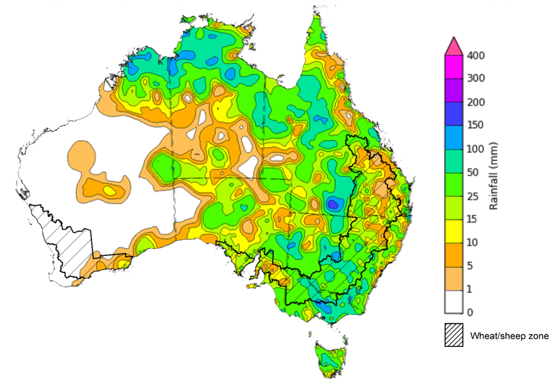

©Commonwealth of Australia 2024, Australian Bureau of Meteorology Issued: 10/01/2024

Note: The rainfall analyses and associated maps utilise data contained in the Bureau of Meteorology climate database, the Australian Data Archive for Meteorology (ADAM). The analyses are initially produced automatically from real-time data with limited [quality control](http://www.bom.gov.au/climate/headers/qc.shtml). They are intended to provide a general overview of rainfall across Australia as quickly as possible after the observations are received. For further information go to <http://www.bom.gov.au/climate/rainfall/>

### Rainfall forecast for the next eight days

Over the 8 days to 18 January 2024, monsoon troughs and tropical lows are expected to bring heavy rain, in excess of 150 millimetres, in the northern parts of the country. Onshore winds around the high-pressure system are expected to bring showers to coastal New South Wales and Queensland.

Across cropping regions, rainfall totals up to 25 millimetres are forecast for New South Wales and Queensland. These falls will benefit soil moisture levels for pasture growth and will support summer crops. Little to no rainfall is expected elsewhere, and evaporation due to high temperatures will see soil moisture levels in these areas decline.

#### Total forecast rainfall for the period 11 January to 18 January 2024

©Commonwealth of Australia 2024, Australian Bureau of Meteorology Issued 11/01/2024

Note: This rainfall forecast is produced from computer models. As the model outputs are not altered by weather forecasters, it is important to check local forecasts and warnings issued by the Bureau of Meteorology.

### Monthly rainfall

Rainfall during December 2023 was 2% below average for Australia as a whole. This follows above average rainfall recorded in November 2023. Rainfall in December was above average for much of northern, eastern and south-western Queensland, most of Victoria and South Australia, parts of southern New South Wales, and areas in south-eastern Western Australia and the western Top End in the Northern Territory. By contrast, December rainfall was below average for large parts of western and northern Western Australia, Northern Territory and north-western Queensland, and for an area of western New South Wales extending into eastern South Australia.

In cropping regions, December rainfall was largely average to above average in Queensland, New South Wales, Victoria and South Australia, while generally average to below average in Western Australia. While December rains may have delayed the harvest of winter crop in southern areas, and likely led to grain quality downgrade, the build-up of soil moisture reserves across the nation will benefit pasture growth and summer crop production.

**Rainfall percentiles for December 2023**

Note: Rainfall for December 2023 is compared with rainfall recorded for that period during the historical record (1900 to present). For further information, go to <http://www.bom.gov.au/jsp/awap/>

Source: Bureau of Meteorology

### Monthly soil moisture

Generally, upper layer soil moisture for December 2023 was variable geographically between the east and the west. Extremely low upper soil moisture was modelled for western and central Australia. Extremely high upper layer moisture was evident across large areas of South Australia and Victoria, southern New South Wales, southern and eastern Queensland and in isolated areas of northern Territory, eastern Western Australia and Tasmania.

At this time of year, upper layer soil moisture is important for late planted summer crops in northern New South Wales and Queensland and for pasture growth across northern Australia since plant germination and establishment utilise this moisture. It is also an important indicator of the ability to access paddocks for winter crop harvesting and summer crop planting activities.

Upper layer soil moisture was average to above average for this time of year across most cropping regions in Queensland, New South Wales, Victoria and South Australia, while average to below average in Western Australia. Average to above average soil moisture would have encouraged crop planting and germination for northern cropping regions.

**Modelled upper layer soil moisture for December 2023**

Note: This map shows the levels of modelled upper layer soil moisture (0 to 10 centimetres) during December 2023. This map shows how modelled soil conditions during December 2023 compare with December conditions modelled over the reference period (1911 to 2016). Dark blue areas on the maps were much wetter in December 2023 than during the reference period. The bulk of plant roots occur in the top 20 centimetres of the soil profile. Soil moisture in the upper layer of the soil profile is therefore useful indicator of the availability of water, particularly for germinating seed.

Source: Bureau of Meteorology ([Australian Water Resources Assessment Landscape model](http://www.bom.gov.au/water/landscape/))

Lower layer soil moisture for December 2023 was of similar pattern as the upper layer soil moisture but at notably extreme levels of either direction.

Lower layer soil moisture will be important to support summer crops and pasture growth during the peak growth period. In Australian cropping regions, lower layer soil moisture was average to extremely high across much of New South Wales, Queensland, Victoria, and South Australia. Lower layer soil moisture was average to extremely low in Western Australia. High levels of lower layer soil moisture will continue to support above average yield prospects for summer crops and above average pasture growth for this time of year across New South Wales and southern Queensland.

**Modelled lower layer soil moisture for December 2023**

Note: This map shows the levels of modelled lower layer soil moisture (10 to 100 centimetres) during December 2023. This map shows how modelled soil conditions during December 2023 compare with December conditions modelled over the reference period (1911 to 2016). Dark blue areas on the maps were much wetter in December 2023 than during the reference period. The dark red areas were much drier than during the reference period. The bulk of plant roots occur in the top 20 centimetres of the soil profile. The lower layer soil moisture is a larger, deeper store that is slower to respond to rainfall and tends to reflect accumulated rainfall events over longer time periods.

Source: Bureau of Meteorology ([Australian Water Resources Assessment Landscape model](http://www.bom.gov.au/water/landscape/))

### Northern Australia rainfall onset

The timing of Northern Australia rainfall onset is important indicator for seasonal pasture growth and potential livestock production. The rainfall onset gives an indication of the accumulation of at least 50 millimetres of rainfall after 1 September to stimulate plant growth after the northern dry season.

Since 1 September 2023, large areas of northern Australia have received at least 50 millimetres of rainfall. Western parts normally accumulate first 50 millimetres of rainfall by late February and is typically delayed further in El Niño years. Northern parts of Western Australia, Northern Territory and across large areas of eastern Queensland have recorded onset later than usual. Rainfall in northern Australia for this time of the year is important for pasture and feed availability.

#### Northern rainfall totals from 1 September 2023

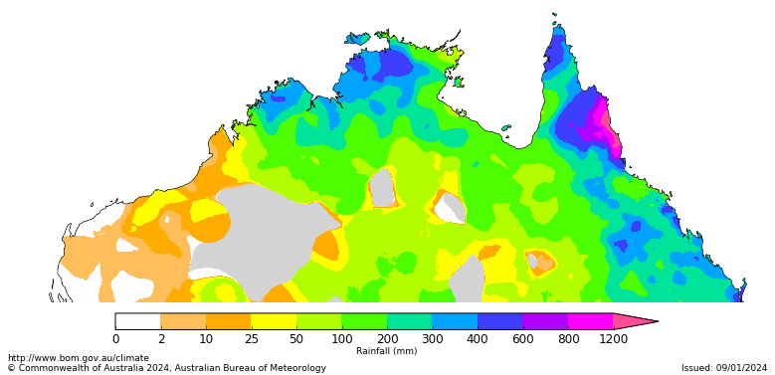

### Climate Drivers

Throughout Australia’s summer period the climate drivers with the largest potential impact on Australia’s climate patterns are the El Niño–Southern Oscillation (ENSO), the Southern Annular Mode (SAM), and the Madden-Julian Oscillation (MJO). These climate drivers are likely to influence the growth and development of summer crops in northern growing regions and pasture growth across northern Australia with the onset of the northern wet season. The Indian Ocean Dipole (IOD) is another climate driver that has an effect on Australian climate but has little impact during summer.

An El Niño is currently active and the positive IOD continues to weaken. The influence of El Niño on Australian rainfall usually reduces during summer, especially across eastern Australia; however, below median rainfall is still often observed in north-east Australia. Additionally, high-impact rainfall events can occur during El Niño years, particularly during October to April when severe storm frequency peaks. The climate models suggest the oceanic components to remain above El Niño threshold through to southern hemisphere autumn 2024. However, some of the atmospheric components have weakened over past three weeks.

#### ENSO and IOD forecast

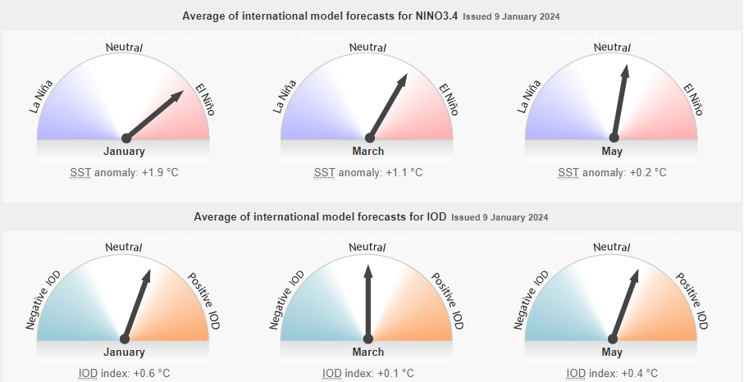

©Commonwealth of Australia 2024, Australian Bureau of Meteorology Issued: 9/01/2024

The SAM is currently in the positive phase and is forecast to remain near positive for next fortnight. During summer, a positive SAM historically increases the chance of above average rainfall for parts of eastern New South Wales, south-eastern Queensland, eastern Victoria, and north-east Tasmania, but increases the chance of below average rainfall for western Tasmania. Rainfall increases are due to the positive SAM shifting westerly winds further south, increasing onshore flow over south-east Australia.

#### Southern Annual Mode (SAM) daily index

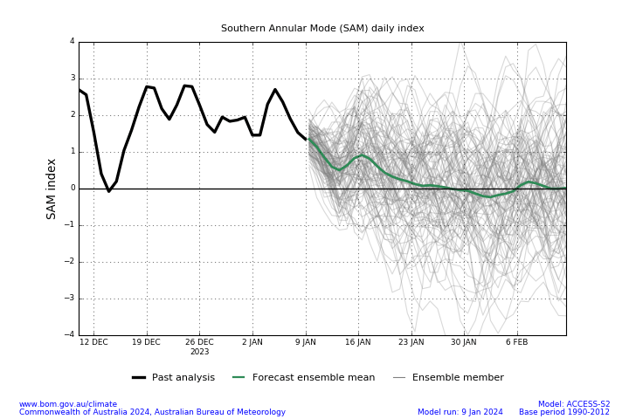

A pulse of MJO is currently over the Indian Ocean and is forecast to move across the Maritime Continent in the next fortnight. At this time of year, when the MJO is in the western Maritime Continent, the chance of above average rainfall typically increases across central Australia. When the MJO is in the eastern parts of the Maritime Continent, the chance of above average rainfall typically increases across northern Australia and provides a favourable environment for the onset of the monsoon in Darwin.

#### Daily Madden-Julian Oscillation (MJO)

### National Climate Outlook

The Bureau of Meteorology’s latest rainfall outlook for February 2024 indicates that rainfall is likely (60 to 80% chance) to be above median for most of New South Wales, southern and eastern parts of Queensland and in parts of southern Western Australia. Below median rainfall is likely to very likely (60% to greater than 80% chance) elsewhere.

The Bureau of Meteorology’s climate model suggests that for February 2024, there is a 75% chance of rainfall totals being over 25 millimetres across coastal east and northern Australia, as well as in western Tasmania. Rainfall totals in excess of 100 millimetres are expected northern Queensland and Northern Territory and in parts of coastal east.

Across cropping regions, there is at least a 75% chance of rainfall totals above 10 millimetres in New South Wales and Queensland. February rainfall totals are expected to be below 10 millimetres for the remaining cropping regions.

If realised these forecast rainfall totals for February will provide some useful follow-up falls for dryland summer crop production as well as pasture growth across eastern and northern Australia. Dry conditions elsewhere will see a decline in soil moisture levels.

**Rainfall totals that have a 75% chance of occurring in February 2024**

©Commonwealth of Australia 2024, Australian Bureau of Meteorology Issued: 11/01/2024

The rainfall outlook for February to April 2024 suggests that there is least a 50% chance of exceeding median rainfall across south-eastern Australia, and less than a 50% chance of exceeding median rainfall in parts of southern and across much of the north and western parts of Australia.

Across cropping regions, above median rainfall is likely in the New South Wales and Queensland while below median rainfall is likely in the remaining cropping regions.

**Chance of exceeding the median rainfall** **February to April 2024**

©Commonwealth of Australia 2024, Australian Bureau of Meteorology Issued: 11/01/2024

The outlook for February to April 2024 suggests there is at least a 75% chance of rainfall totals above 25 millimetres across much of Australia. The main exceptions being large areas of the interior and western coast where below 25 millimetres of rainfall are expected. Rainfall totals in excess of 200 millimetres are likely across tropical northern Australia, eastern coast and western Tasmania during this period.

Across cropping regions, there is at least a 75% chance of receiving above 50 millimetres across New South Wales and Queensland.

If realised, these falls will likely be sufficient to support summer pasture growth across eastern and northern Australia. While the dry start to spring limited the early planting of summer crops, if realised these forecast falls are likely to be sufficient to support the establishment and growth of crops planted at the end of spring and allow for the additional planting of summer crops in the later planting window during early summer.

**

©Commonwealth of Australia 2024, Australian Bureau of Meteorology Issued: 11/01/2024

## **Water**

### Water markets – current week

Water storage levels in the Murray-Darling Basin (MDB) increased between 4 January 2024 and 11 January 2024 by 100 gigalitres (GL). Current volume of water held in storage is 19 180 GL. This is 13 percent or 2814 GL less than at the same time last year.

#### Water storages in the Murray-Darling Basin, 2013–2024

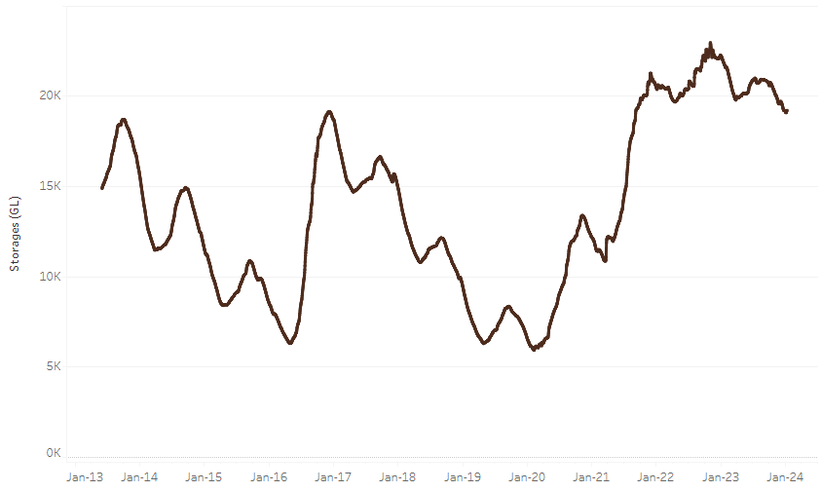

|  |
| --- |
| Water storage data is sourced from the Bureau of Meteorology. |

Allocation prices in the Victorian Murray below the Barmah Choke decreased from $140 on 14 December 2023 to $60 on 11 January 2024. Prices are lower in regions above the Barmah choke due to the binding of the Barmah choke trade constraint.

|  |  |
| --- | --- |
| **Region** | **$/ML** |
| NSW Murray Above | 58 |
| NSW Murrumbidgee | 51 |
| VIC Goulburn-Broken | 84 |
| VIC Murray Below | 60 |

#### Surface water trade activity, Southern Murray–Darling Basin

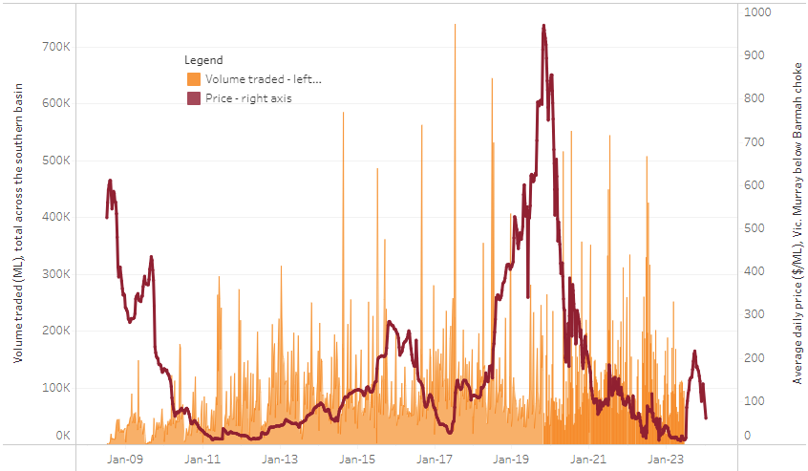

|  |
| --- |
| The trades shown reflect estimated market activity and do not encompass all register trades. The price is shown for the VIC Murray below the Barmah choke. Historical prices (before 1 July 2019) are ABARES estimates after removing outliers from BOM water register data. Prices after 1 July 2019 and prior to the 30 October 2019 reflect recorded transaction prices as sourced from Ruralco. Prices after the 30 October 2019 are sourced from Waterflow. Data for volume traded is sourced from the BOM water register. Only the price data shown is current on 11 January 2024. |

To access the full, interactive, weekly water dashboard, which contains the latest and historical water storage, water market and water allocation information, please visit <https://www.agriculture.gov.au/abares/products/weekly_update/weekly-update-11124>

## **Commodities**

|  |  |  |  |  |  |  |  |
| --- | --- | --- | --- | --- | --- | --- | --- |
| **Indicator** | **Week ended** | **Unit** | **Latest Price** | **Previous Week** | **Weekly change** | **Price 12 months ago** | **Annual change** |
| **Selected world indicator prices** |  |  |  |  |  |  |  |
| AUD/USD Exchange rate | 13-Dec | A$/US$ | 0.66 | 0.66 | -1% | 0.67 | -2% |
| Wheat – US no. 2 hard red winter wheat, fob Gulf | 13-Dec | US$/t | 292 | 297 | -2% | 385 | -24% |
| Corn – US no. 2 yellow corn, fob Gulf | 13-Dec | US$/t | 204 | 206 | -1% | 303 | -33% |
| Canola – Rapeseed, Canada, fob Vancouver | 13-Dec | US$/t | 532 | 529 | 1% | 677 | -21% |
| Cotton – Cotlook 'A' Index | 13-Dec | USc/lb | 92 | 90 | 2% | 101 | -9% |
| Sugar – Intercontinental Exchange, nearby futures, no.11 contract | 13-Dec | USc/lb | 22.2 | 24.0 | -8% | 19 | 15% |
| Wool – Eastern Market Indicator | 06-Dec | Ac/kg clean | 1,177 | 1,166 | 1% | 1,323 | -11% |
| Wool – Western Market Indicator | 06-Dec | Ac/kg clean | 1,305 | 1,289 | 1% | 1,363 | -4% |
| **Selected Australian grain export prices** |  |  |  |  |  |  |  |
| Milling Wheat – APW, Port Adelaide, SA | 13-Dec | A$/t | 462 | 451 | 2% | 538 | -14% |
| Feed Wheat – ASW, Port Adelaide, SA | 13-Dec | A$/t | 442 | 431 | 3% | 492 | -10% |
| Feed Barley – Port Adelaide, SA | 13-Dec | A$/t | 389 | 383 | 2% | 432 | -10% |
| Canola – Kwinana, WA | 13-Dec | A$/t | 769 | 766 | 0% | 1,058 | -27% |
| Grain Sorghum – Brisbane, QLD | 13-Dec | A$/t | 498 | 498 | 0% | 480 | 4% |
| **Selected domestic livestock indicator prices** |  |  |  |  |  |  |  |
| Beef – Eastern Young Cattle Indicator | 13-Dec | Ac/kg cwt | 561 | 569 | -1% | 892 | -37% |
| Mutton – Mutton indicator (18–24 kg fat score 2–3), Vic | 13-Dec | Ac/kg cwt | 198 | 199 | 0% | 541 | -63% |
| Lamb – National Trade Lamb Indicator | 13-Dec | Ac/kg cwt | 613 | 559 | 10% | 755 | -19% |
| Pig – Eastern Seaboard (60.1–75 kg), average of buyers & sellers | 29-Nov | Ac/kg cwt | 396 | 386 | 3% | 376 | 5% |
| Goats – Eastern States (10.1–12 kg) | 13-Dec | Ac/kg cwt | 170 | 170 | 0% | 367 | -54% |
| Live cattle – Light steers to Indonesia | 29-Nov | Ac/kg lwt | 280 | 270 | 4% | 520 | -46% |
| **Global Dairy Trade (GDT) weighted average prices a** |  |  |  |  |  |  |  |
| Dairy – Whole milk powder | 06-Dec | US$/t | 3,104 | 3,027 | 3% | 3,397 | -9% |
| Dairy – Skim milk powder | 06-Dec | US$/t | 2,671 | 2,622 | 2% | 3,057 | -13% |
| Dairy – Cheddar cheese | 06-Dec | US$/t | 3,986 | 3,637 | 10% | 4,746 | -16% |
| Dairy – Anhydrous milk fat | 06-Dec | US$/t | 5,573 | 5,544 | 1% | 5,711 | -2% |
| **a** Global Dairy Trade prices are updated twice monthly on the first and third Tuesday of each month. | | | | | | | |

### Selected world indicator prices

### Selected domestic crop indicator prices

### Selected domestic livestock indicator prices

### Global Dairy Trade (GDT) weighted average prices

### Selected fruit and vegetable prices

### 3.6 Selected domestic fodder indicator prices

## **4. Data attribution**

### Climate

Bureau of Meteorology

* Weekly rainfall totals: www.bom.gov.au/climate/maps/rainfall/
* Monthly and last 3-month rainfall percentiles: [www.bom.gov.au/water/landscape/](http://www.bom.gov.au/water/landscape/)
* Temperature anomalies: [www.bom.gov.au/jsp/awap/temp/index.jsp](http://www.bom.gov.au/jsp/awap/temp/index.jsp)
* Rainfall forecast: [www.bom.gov.au/jsp/watl/rainfall/pme.jsp](http://www.bom.gov.au/jsp/watl/rainfall/pme.jsp)
* Seasonal outlook: [www.bom.gov.au/climate/outlooks/#/overview/summary/](http://www.bom.gov.au/climate/outlooks/#/overview/summary/)
* Climate drivers: <http://www.bom.gov.au/climate/enso/>
* Soil moisture: [www.bom.gov.au/water/landscape/](http://www.bom.gov.au/water/landscape/)

Other

* Pasture growth: [www.longpaddock.qld.gov.au/aussiegrass/](http://www.longpaddock.qld.gov.au/aussiegrass/)
* 3-month global outlooks: [Environment and Climate Change Canada](https://weather.gc.ca/saisons/image_e.html?img=s234pfe1p_cal&bc=prob), [NOAA Climate Prediction Center](https://www.cpc.ncep.noaa.gov/products/predictions/long_range/seasonal.php?lead=2), [EUROBRISA CPTEC/INPE](http://eurobrisa.cptec.inpe.br/), European Centre for Medium-Range Weather Forecasts, [Hydrometcenter of Russia](https://meteoinfo.ru/en/climate/seasonal-forecasts), [National Climate Center Climate System Diagnosis and Prediction Room (NCC)](https://cmdp.ncc-cma.net/pred/cs2gen.php?pred_elem=RAINP#pred_seasonal), [International Research Institute for Climate and Society](https://iri.columbia.edu/our-expertise/climate/forecasts/seasonal-climate-forecasts/)
* Global production: <https://ipad.fas.usda.gov/ogamaps/cropmapsandcalendars.aspx>
* Autumn break: Pook et al., 2009, <https://rmets-onlinelibrary-wiley-com.virtual.anu.edu.au/doi/epdf/10.1002/joc.1833>

### Water

Prices

* Waterflow: <https://www.waterflow.io/>
* Ruralco: <https://www.ruralcowater.com.au/>

Bureau of Meteorology:

* Allocation trade: <http://www.bom.gov.au/water/dashboards/#/water-markets/mdb/at>
* Storage volumes: <http://www.bom.gov.au/water/dashboards/#/water-storages/summary/drainage>

Trade constraints:

* Water NSW: <https://www.waternsw.com.au/customer-service/ordering-trading-and-pricing/trading/murrumbidgee>
* Victorian Water Register: <https://www.waterregister.vic.gov.au/TradingRules2019/>

### Commodities

Fruit and vegetables

* Datafresh: [www.freshstate.com.au](http://www.freshstate.com.au)

Pigs

* Australian Pork Limited: [www.australianpork.com.au](http://www.australianpork.com.au)

Dairy

* Global Dairy Trade: [www.globaldairytrade.info/en/product-results/](http://www.globaldairytrade.info/en/product-results/)

World wheat, canola

* International Grains Council

World coarse grains

* United States Department of Agriculture

World cotton

* Cotlook: [www.cotlook.com/](http://www.cotlook.com/)

World sugar

* New York Stock Exchange - Intercontinental Exchange

Wool

* Australian Wool Exchange: [www.awex.com.au/](http://www.awex.com.au/)

Domestic wheat, barley, sorghum, canola and fodder

* Jumbuk Consulting Pty Ltd: http://www.jumbukag.com.au/

Cattle, beef, mutton, lamb, goat and live export

* Meat and Livestock Australia: www.mla.com.au/Prices-and-market

© Commonwealth of Australia 2023

### Ownership of intellectual property rights

Unless otherwise noted, copyright (and any other intellectual property rights, if any) in this publication is owned by the Commonwealth of Australia (referred to as the Commonwealth).

### Creative Commons licence

All material in this publication is licensed under a [Creative Commons Attribution 4.0 International Licence](https://creativecommons.org/licenses/by/4.0/legalcode) except content supplied by third parties, logos and the Commonwealth Coat of Arms.

Inquiries about the licence and any use of this document should be emailed to [copyright@awe.gov.au](mailto:copyright@awe.gov.au).

https://www.agriculture.gov.au/sites/default/files/images/creative-commons-logo-small.png

### Cataloguing data

This publication (and any material sourced from it) should be attributed as:

ABARES 2023, Weekly Australian Climate, Water and Agricultural Update, Australian Bureau of Agricultural and Resource Economics and Sciences, Canberra, 11 January 2024. CC BY 4.0 DOI: <https://doi.org/10.25814/5f3e04e7d2503>

ISSN **2652-7561**

This publication is available at https://www.agriculture.gov.au/abares/products/weekly_update

Department of Agriculture, Fisheries and Forestry

GPO Box 858 Canberra ACT 2601

Telephone 1800 900 090

Web [agriculture.gov.au/abares](http://awe.gov.au/abares)

### Disclaimer

The Australian Government acting through the Department of Agriculture, Fisheries and Forestry, represented by the Australian Bureau of Agricultural and Resource Economics and Sciences, has exercised due care and skill in preparing and compiling the information and data in this publication. Notwithstanding, the Department of Agriculture, Fisheries and Forestry, ABARES, its employees and advisers disclaim all liability, including liability for negligence and for any loss, damage, injury, expense or cost incurred by any person as a result of accessing, using or relying on any of the information or data in this publication to the maximum extent permitted by law.

### Statement of Professional Independence

The views and analysis presented in ABARES publications, including this one, reflect ABARES professionally independent findings, based on scientific and economic concepts, principles, information and data. These views, analysis and findings may not reflect or be consistent with the views or positions of the Australian Government, or of organisations or groups who have commissioned ABARES reports or analysis. More information on [professional independence](https://www.agriculture.gov.au/abares/about/research-and-analysis#professional-independence) is provided on the ABARES website.

### Acknowledgements

This report was prepared by Kavina Dayal and Matthew Miller.