## A picture containing text Description automatically generatedNo. 49/2023

## 14 December 2023

This is the last weekly Climate Update for 2023.

# The next Update will be published on 11 January 2024.

# Summary of key issues

* For the week ending 13 December 2023, troughs generated rainfall totals of up to 150 millimetres across tropical Northern Australia and South Australia. The movement of Tropical Cyclone Jasper brought rainfall in northeast Queensland.
* Over the coming week, Tropical Cyclone Jasper should weaken to a low but will still result in heavy rain and damaging winds. Troughs will generate showers and storms in Northern Territory and eastern Australia. A cold front will bring showers to Tasmania.
  + Rainfall where expected will support development of summer crops and pasture growth, but dry conditions elsewhere will see a decline in soil moisture levels.
* An El Niño and a weakening positive IOD event are still active.
  + January to March 2024 rainfall is likely to be around average for much of the eastern cropping areas, but below average across much of the north and west, and parts of southern Australia.
* Water storage levels in the Murray-Darling Basin (MDB) decreased between 7 December 2023 and 14 December 2023 by 56 gigalitres (GL). Current volume of water held in storage is 15 921 GL. This is 8 percent or 1328 GL less than at the same time last year.
* Allocation prices in the Victorian Murray below the Barmah Choke increased from $110 on 7 December 2023 to $140 on 14 December 2023. Prices are lower in the Goulburn-Broken and regions above the Barmah choke due to the binding of the Goulburn intervalley trade limit and the Barmah choke trade constraint.

## **Climate**

### Rainfall this week

For the week ending 13 December 2023, troughs generated rainfall totals of up to 150 millimetres across tropical Northern Australia and South Australia. The movement of Tropical Cyclone Jasper towards northeast Queensland brought rainfall ahead of it making landfall, with significant totals recorded as it crossed the coast on 13 and 14 December.

Across eastern cropping regions, rainfall totals of up to 50 millimetres were recorded in parts of southern New South Wales and Victoria and up to 150 millimetres across South Australia. These falls will have further boosted soil moisture reserves, supporting late season pasture growth. This will likely result in a reduced reliance on supplementary fodder to maintain the production of livestock and livestock products.

#### Rainfall for the week ending 13 December 2023

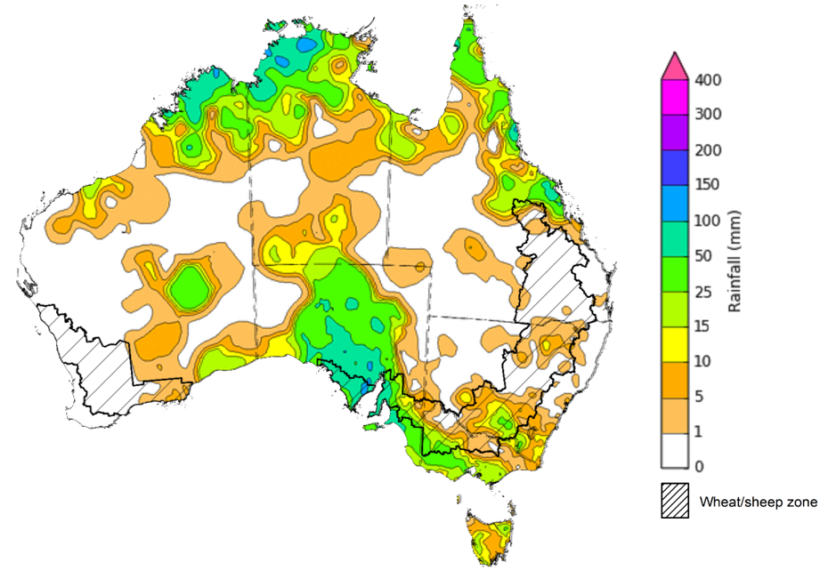

©Commonwealth of Australia 2023, Australian Bureau of Meteorology Issued: 13/12/2023

Note: The rainfall analyses and associated maps utilise data contained in the Bureau of Meteorology climate database, the Australian Data Archive for Meteorology (ADAM). The analyses are initially produced automatically from real-time data with limited [quality control](http://www.bom.gov.au/climate/headers/qc.shtml). They are intended to provide a general overview of rainfall across Australia as quickly as possible after the observations are received. For further information go to <http://www.bom.gov.au/climate/rainfall/>

### Northern Australia rainfall onset

The timing of Northern Australia rainfall onset is important indicator for seasonal pasture growth and potential livestock production. The rainfall onset gives an indication of the accumulation of at least 50 millimetres of rainfall after 1 September to stimulate plant growth after the northern dry season.

Since 1 September 2023, large areas of northern Australia have received at least 50 millimetres of rainfall. Northern parts of Western Australia, Northern Territory and across large areas of eastern Queensland have recorded onset later than usual. Rainfall in northern Australia for this time of the year is important for pasture and feed availability.

#### Northern rainfall totals from 1 September

### Climate Drivers

The climate drivers with the largest potential impact on Australia’s climate patterns are the El Niño–Southern Oscillation (ENSO), Madden-Julian Oscillation (MJO), Indian Ocean Dipole (IOD) and Southern Annular Mode (SAM). These climate drivers are likely to influence pasture growth across southern Australia and the growth and yield prospects for winter crops.

The SAM is currently in neutral phase and is forecast to remain neutral for next fortnight. A neutral SAM is associated with average climate conditions in southern Australia.

A strong pulse of MJO is forecast to be in the western Pacific Ocean in the next fortnight and is expected to result in increased rainfall over northern and central Australia.

An El Niño and a positive IOD event are currently active. The influence of El Niño on Australian rainfall usually reduces during summer, especially across eastern Australia; however, below median rainfall is still often observed in north-east Australia. Additionally, high-impact rainfall events can occur during El Niño years, particularly during October to April when severe storm frequency peaks. Additionally, during El Niño, the onset of the North Australian Monsoon tends to be delayed. The El Niño is expected to persist till early autumn 2024 while positive IOD has weakened and is expected to ease in December 2023.

#### ENSO and IOD forecast

©Commonwealth of Australia 2023, Australian Bureau of Meteorology Issued: 5/12/2023

### National Climate Outlook

The Bureau of Meteorology’s latest rainfall outlook for January 2024 indicates that there is a near equal chance of above or below average rainfall for much of Australia. However, below median rainfall is likely to very likely (60 to 80% chance) for Far North Queensland, the north of the Northern Territory and the west of Western Australia. Meanwhile, above average rainfall is more likely for south-east areas of Queensland and north-east New South Wales.

The Bureau of Meteorology’s climate model suggests that for January 2024, there is a 75% chance of rainfall totals being over 25 millimetres across eastern and northern Australia, as well as in Tasmania. Rainfall totals in excess of 100 millimetres are expected across western Tasmania, northern Western Australia and Northern Territory and coastal east.

Across cropping regions, there is a 75% chance of rainfall totals of between 25 and 100 millimetres in New South Wales and Queensland. January rainfall totals are expected to be below 25 millimetres for the remaining cropping regions.

Given the above average rainfall recorded across southern Queensland and north-eastern New South Wales during November and early December, if realised these forecast rainfall totals for January will provide some useful follow-up falls for dryland summer crop production as well as pasture growth across eastern and northern Australia.

**Rainfall totals that have a 75% chance of occurring in January 2024**

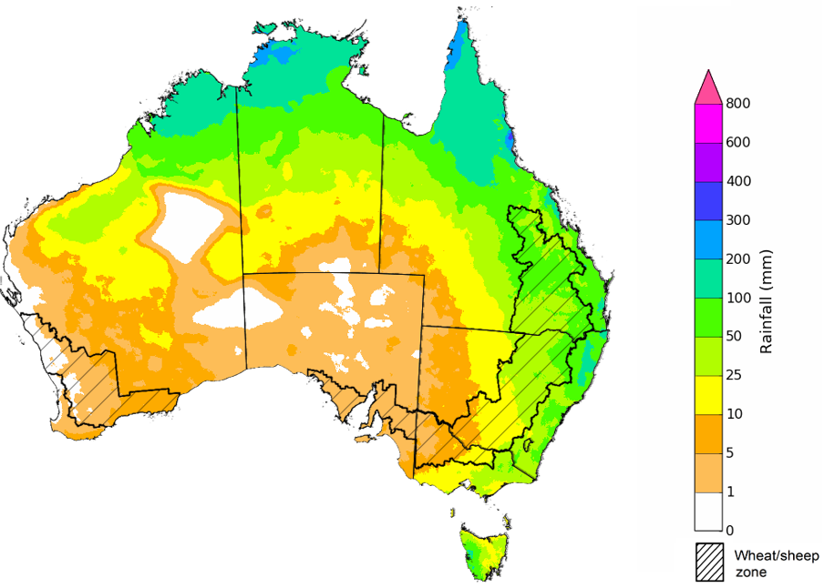

©Commonwealth of Australia 2023, Australian Bureau of Meteorology Issued: 14/12/2023

The rainfall outlook for January to March 2024 suggests that there is close to equal chances of above or below median rainfall for much of central and eastern Australia, while below median rainfall is more likely elsewhere. In contrast for parts of northern New South Wales there is an increased chance of receiving above median rainfall.

Across summer cropping regions, there is no strong tendency towards either above or below median rainfall across Queensland and New South Wales. Close to median rainfall in Queensland and northern New South Wales will benefit summer crop production during this period.

**Chance of exceeding the median rainfall** **January to March 2024**

©Commonwealth of Australia 2023, Australian Bureau of Meteorology Issued: 14/12/2023

The outlook for January to March 2024 suggests there is a 75% chance of rainfall totals between 25 and 200 millimetres across much of Australia. The main exceptions being large areas of South Australia and western and central parts of Western Australia where below 25 millimetres of rainfall are expected. Rainfall totals in excess of 200 millimetres are expected across tropical northern Australia, coastal New South Wales and western Tasmania during this period.

Across summer cropping regions, there is a 75% chance of receiving between 50 and 200 millimetres across New South Wales, Queensland.

If realised, these falls will likely be sufficient to support summer pasture growth across eastern and northern Australia. While the dry start to spring has limited the early planting of summer crops, if realised these forecast falls are likely to be sufficient to support the establishment and growth of crops planted at the end of spring and allow for the additional planting of summer crops in the later planting window during early summer.

**Rainfall totals that have a 75% chance of occurring** **January to March 2024** 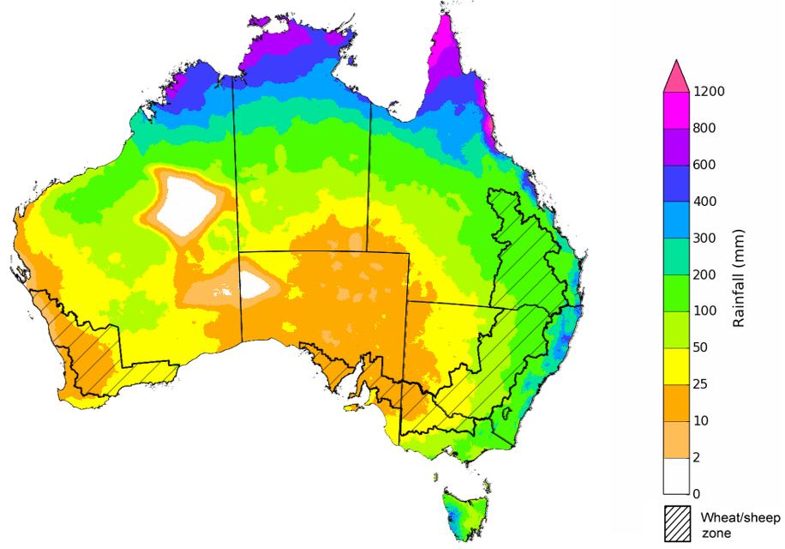

©Commonwealth of Australia 2023, Australian Bureau of Meteorology Issued: 14/12/2023

### Rainfall forecast for the next eight days

Over the 8 days to 21 December 2023, Tropical Cyclone Jasper should weaken to a low in north Queensland but will still result in heavy rain and damaging winds. Troughs will generate showers and storms in Northern Territory and eastern Australia. A cold front will bring showers to Tasmania.

While the severity of impact remains unknown, the strong winds and heavy rain from Tropical Cyclone Jasper presents a high risk to the production of horticultural and other high value crops such as sugarcane.

Across cropping regions, rainfall totals up to 50 millimetres are forecast for northern New South Wales and up to 25 millimetres for Queensland. These falls will benefit soil moisture levels for pasture growth and will support summer crops. Little to no rainfall is expected elsewhere, and evaporation due to high temperatures will see soil moisture levels in these areas decline.

#### Total forecast rainfall for the period 14 December to 2023 to 21 December 2023

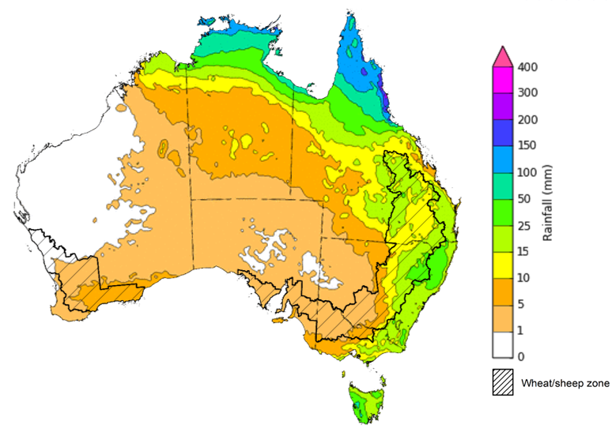

©Commonwealth of Australia 2023, Australian Bureau of Meteorology Issued 13/12/2023

Note: This rainfall forecast is produced from computer models. As the model outputs are not altered by weather forecasters, it is important to check local forecasts and warnings issued by the Bureau of Meteorology.

## **Water**

### Water markets – current week

Water storage levels in the Murray-Darling Basin (MDB) decreased between 7 December 2023 and 14 December 2023 by 56 gigalitres (GL). Current volume of water held in storage is 15 921 GL. This is 8 percent or 1328 GL less than at the same time last year.

#### Water storages in the Murray-Darling Basin, 2013–2023

|  |
| --- |
| Water storage data is sourced from the Bureau of Meteorology. |

Allocation prices in the Victorian Murray below the Barmah Choke increased from $110 on 7 December 2023 to $140 on 14 December 2023. Prices are lower in the Goulburn-Broken and regions above the Barmah choke due to the binding of the Goulburn intervalley trade limit and the Barmah choke trade constraint.

|  |  |
| --- | --- |
| **Region** | **$/ML** |
| NSW Murray Above | 69 |
| NSW Murrumbidgee | 156 |
| VIC Goulburn-Broken | 108 |
| VIC Murray Below | 140 |

#### Surface water trade activity, Southern Murray–Darling Basin

|  |
| --- |
| The trades shown reflect estimated market activity and do not encompass all register trades. The price is shown for the VIC Murray below the Barmah choke. Historical prices (before 1 July 2019) are ABARES estimates after removing outliers from BOM water register data. Prices after 1 July 2019 and prior to the 30 October 2019 reflect recorded transaction prices as sourced from Ruralco. Prices after the 30 October 2019 are sourced from Waterflow. Data for volume traded is sourced from the BOM water register. Only the price data shown is current on 14 December 2023. |

To access the full, interactive, weekly water dashboard, which contains the latest and historical water storage, water market and water allocation information, please visit <https://www.agriculture.gov.au/abares/products/weekly_update/weekly-update-141223>

## **Commodities**

|  |  |  |  |  |  |  |  |
| --- | --- | --- | --- | --- | --- | --- | --- |
| **Indicator** | **Week ended** | **Unit** | **Latest Price** | **Previous Week** | **Weekly change** | **Price 12 months ago** | **Annual change** |
| **Selected world indicator prices** |  |  |  |  |  |  |  |
| AUD/USD Exchange rate | 13-Dec | A$/US$ | 0.66 | 0.66 | -1% | 0.67 | -2% |
| Wheat – US no. 2 hard red winter wheat, fob Gulf | 13-Dec | US$/t | 292 | 297 | -2% | 385 | -24% |
| Corn – US no. 2 yellow corn, fob Gulf | 13-Dec | US$/t | 204 | 206 | -1% | 303 | -33% |
| Canola – Rapeseed, Canada, fob Vancouver | 13-Dec | US$/t | 532 | 529 | 1% | 677 | -21% |
| Cotton – Cotlook 'A' Index | 13-Dec | USc/lb | 92 | 90 | 2% | 101 | -9% |
| Sugar – Intercontinental Exchange, nearby futures, no.11 contract | 13-Dec | USc/lb | 22.2 | 24.0 | -8% | 19 | 15% |
| Wool – Eastern Market Indicator | 06-Dec | Ac/kg clean | 1,177 | 1,166 | 1% | 1,323 | -11% |
| Wool – Western Market Indicator | 06-Dec | Ac/kg clean | 1,305 | 1,289 | 1% | 1,363 | -4% |
| **Selected Australian grain export prices** |  |  |  |  |  |  |  |
| Milling Wheat – APW, Port Adelaide, SA | 13-Dec | A$/t | 462 | 451 | 2% | 538 | -14% |
| Feed Wheat – ASW, Port Adelaide, SA | 13-Dec | A$/t | 442 | 431 | 3% | 492 | -10% |
| Feed Barley – Port Adelaide, SA | 13-Dec | A$/t | 389 | 383 | 2% | 432 | -10% |
| Canola – Kwinana, WA | 13-Dec | A$/t | 769 | 766 | 0% | 1,058 | -27% |
| Grain Sorghum – Brisbane, QLD | 13-Dec | A$/t | 498 | 498 | 0% | 480 | 4% |
| **Selected domestic livestock indicator prices** |  |  |  |  |  |  |  |
| Beef – Eastern Young Cattle Indicator | 13-Dec | Ac/kg cwt | 561 | 569 | -1% | 892 | -37% |
| Mutton – Mutton indicator (18–24 kg fat score 2–3), Vic | 13-Dec | Ac/kg cwt | 198 | 199 | 0% | 541 | -63% |
| Lamb – National Trade Lamb Indicator | 13-Dec | Ac/kg cwt | 613 | 559 | 10% | 755 | -19% |
| Pig – Eastern Seaboard (60.1–75 kg), average of buyers & sellers | 29-Nov | Ac/kg cwt | 396 | 386 | 3% | 376 | 5% |
| Goats – Eastern States (10.1–12 kg) | 13-Dec | Ac/kg cwt | 170 | 170 | 0% | 367 | -54% |
| Live cattle – Light steers to Indonesia | 29-Nov | Ac/kg lwt | 280 | 270 | 4% | 520 | -46% |
| **Global Dairy Trade (GDT) weighted average prices a** |  |  |  |  |  |  |  |
| Dairy – Whole milk powder | 06-Dec | US$/t | 3,104 | 3,027 | 3% | 3,397 | -9% |
| Dairy – Skim milk powder | 06-Dec | US$/t | 2,671 | 2,622 | 2% | 3,057 | -13% |
| Dairy – Cheddar cheese | 06-Dec | US$/t | 3,986 | 3,637 | 10% | 4,746 | -16% |
| Dairy – Anhydrous milk fat | 06-Dec | US$/t | 5,573 | 5,544 | 1% | 5,711 | -2% |
| **a** Global Dairy Trade prices are updated twice monthly on the first and third Tuesday of each month. | | | | | | | |

### Selected world indicator prices

### Selected domestic crop indicator prices

### Selected domestic livestock indicator prices

### Global Dairy Trade (GDT) weighted average prices

### Selected fruit and vegetable prices

### 3.6 Selected domestic fodder indicator prices

## **4. Data attribution**

### Climate

Bureau of Meteorology

* Weekly rainfall totals: www.bom.gov.au/climate/maps/rainfall/
* Monthly and last 3-month rainfall percentiles: [www.bom.gov.au/water/landscape/](http://www.bom.gov.au/water/landscape/)
* Temperature anomalies: [www.bom.gov.au/jsp/awap/temp/index.jsp](http://www.bom.gov.au/jsp/awap/temp/index.jsp)
* Rainfall forecast: [www.bom.gov.au/jsp/watl/rainfall/pme.jsp](http://www.bom.gov.au/jsp/watl/rainfall/pme.jsp)
* Seasonal outlook: [www.bom.gov.au/climate/outlooks/#/overview/summary/](http://www.bom.gov.au/climate/outlooks/#/overview/summary/)
* Climate drivers: <http://www.bom.gov.au/climate/enso/>
* Soil moisture: [www.bom.gov.au/water/landscape/](http://www.bom.gov.au/water/landscape/)

Other

* Pasture growth: [www.longpaddock.qld.gov.au/aussiegrass/](http://www.longpaddock.qld.gov.au/aussiegrass/)
* 3-month global outlooks: [Environment and Climate Change Canada](https://weather.gc.ca/saisons/image_e.html?img=s234pfe1p_cal&bc=prob), [NOAA Climate Prediction Center](https://www.cpc.ncep.noaa.gov/products/predictions/long_range/seasonal.php?lead=2), [EUROBRISA CPTEC/INPE](http://eurobrisa.cptec.inpe.br/), European Centre for Medium-Range Weather Forecasts, [Hydrometcenter of Russia](https://meteoinfo.ru/en/climate/seasonal-forecasts), [National Climate Center Climate System Diagnosis and Prediction Room (NCC)](https://cmdp.ncc-cma.net/pred/cs2gen.php?pred_elem=RAINP#pred_seasonal), [International Research Institute for Climate and Society](https://iri.columbia.edu/our-expertise/climate/forecasts/seasonal-climate-forecasts/)
* Global production: <https://ipad.fas.usda.gov/ogamaps/cropmapsandcalendars.aspx>
* Autumn break: Pook et al., 2009, <https://rmets-onlinelibrary-wiley-com.virtual.anu.edu.au/doi/epdf/10.1002/joc.1833>

### Water

Prices

* Waterflow: <https://www.waterflow.io/>
* Ruralco: <https://www.ruralcowater.com.au/>

Bureau of Meteorology:

* Allocation trade: <http://www.bom.gov.au/water/dashboards/#/water-markets/mdb/at>
* Storage volumes: <http://www.bom.gov.au/water/dashboards/#/water-storages/summary/drainage>

Trade constraints:

* Water NSW: <https://www.waternsw.com.au/customer-service/ordering-trading-and-pricing/trading/murrumbidgee>
* Victorian Water Register: <https://www.waterregister.vic.gov.au/TradingRules2019/>

### Commodities

Fruit and vegetables

* Datafresh: [www.freshstate.com.au](http://www.freshstate.com.au)

Pigs

* Australian Pork Limited: [www.australianpork.com.au](http://www.australianpork.com.au)

Dairy

* Global Dairy Trade: [www.globaldairytrade.info/en/product-results/](http://www.globaldairytrade.info/en/product-results/)

World wheat, canola

* International Grains Council

World coarse grains

* United States Department of Agriculture

World cotton

* Cotlook: [www.cotlook.com/](http://www.cotlook.com/)

World sugar

* New York Stock Exchange - Intercontinental Exchange

Wool

* Australian Wool Exchange: [www.awex.com.au/](http://www.awex.com.au/)

Domestic wheat, barley, sorghum, canola and fodder

* Jumbuk Consulting Pty Ltd: http://www.jumbukag.com.au/

Cattle, beef, mutton, lamb, goat and live export

* Meat and Livestock Australia: www.mla.com.au/Prices-and-market

© Commonwealth of Australia 2023

### Ownership of intellectual property rights

Unless otherwise noted, copyright (and any other intellectual property rights, if any) in this publication is owned by the Commonwealth of Australia (referred to as the Commonwealth).

### Creative Commons licence

All material in this publication is licensed under a [Creative Commons Attribution 4.0 International Licence](https://creativecommons.org/licenses/by/4.0/legalcode) except content supplied by third parties, logos and the Commonwealth Coat of Arms.

Inquiries about the licence and any use of this document should be emailed to [copyright@awe.gov.au](mailto:copyright@awe.gov.au).

https://www.agriculture.gov.au/sites/default/files/images/creative-commons-logo-small.png

### Cataloguing data

This publication (and any material sourced from it) should be attributed as:

ABARES 2023, Weekly Australian Climate, Water and Agricultural Update, Australian Bureau of Agricultural and Resource Economics and Sciences, Canberra, 14 December 2023. CC BY 4.0 DOI: <https://doi.org/10.25814/5f3e04e7d2503>

ISSN **2652-7561**

This publication is available at https://www.agriculture.gov.au/abares/products/weekly_update

Department of Agriculture, Fisheries and Forestry

GPO Box 858 Canberra ACT 2601

Telephone 1800 900 090

Web [agriculture.gov.au/abares](http://awe.gov.au/abares)

### Disclaimer

The Australian Government acting through the Department of Agriculture, Fisheries and Forestry, represented by the Australian Bureau of Agricultural and Resource Economics and Sciences, has exercised due care and skill in preparing and compiling the information and data in this publication. Notwithstanding, the Department of Agriculture, Fisheries and Forestry, ABARES, its employees and advisers disclaim all liability, including liability for negligence and for any loss, damage, injury, expense or cost incurred by any person as a result of accessing, using or relying on any of the information or data in this publication to the maximum extent permitted by law.

### Statement of Professional Independence

The views and analysis presented in ABARES publications, including this one, reflect ABARES professionally independent findings, based on scientific and economic concepts, principles, information and data. These views, analysis and findings may not reflect or be consistent with the views or positions of the Australian Government, or of organisations or groups who have commissioned ABARES reports or analysis. More information on [professional independence](https://www.agriculture.gov.au/abares/about/research-and-analysis#professional-independence) is provided on the ABARES website.

### Acknowledgements

This report was prepared by Kavina Dayal and Matthew Miller.