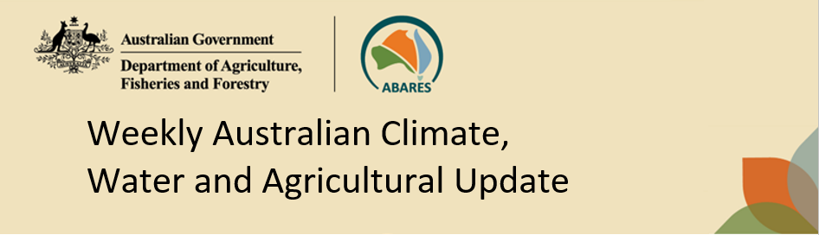
No. 45/2023 16 November 2023

Summary of key issues
- For the week ending 15 November 2023, troughs and lows resulted in showers and thunderstorms over eastern New South Wales and Victoria, northern and southern Western Australia, southern Queensland, and across Northern Territory.
  - Rainfall totals of up to 50 millimetres were recorded northern New South Wales and Western Australian cropping regions.
  - While welcomed, these falls are unlikely to have been sufficient to spark widespread sowing of dryland summer crops in northern New South Wales.
  - Across parts of Western Australia, rainfall and hail has brought an abrupt halt to harvest activities and are likely to result in crop losses and grain quality downgrades in the worst affected areas.
- Over the coming week, troughs will generate showers across eastern, central and northern Australia.
  - Rainfall totals up to 100 millimetres are forecast for Queensland and northern New South Wales and are likely to give some growers confidence to plant summer crops such as sorghum.
  - Dry conditions in Victoria, South Australia and Western Australia should allow for the harvest to continue without delay.
- Globally, variable rainfall during October has led to mixed crop production prospects.
  - Global production conditions were generally favourable for maize and soybeans, but variable for wheat and rice.
  - Global production conditions have deteriorated compared to those used to formulate ABARES forecasts of global grain supplies and world prices in its September 2023 edition of the Agricultural Commodities Report. As a result, global grain and oilseed production is likely to be lower than that forecast in September.
- Water storage levels in the Murray-Darling Basin (MDB) decreased between 9 November 2023 and 16 November 2023 by 65 gigalitres (GL). Current volume of water held in storage is 19 933 GL. This is 12 percent or 2603 GL less than at the same time last year.
- Allocation prices in the Victorian Murray below the Barmah Choke decreased from $158 on 9 November 2023 to $146 on 16 November 2023. Prices are lower in the Goulburn-Broken due to the binding of the Goulburn intervalley trade limit.

Climate

Rainfall this week
For the week ending 15 November 2023, troughs and lows resulted in showers and thunderstorms over parts of eastern New South Wales and Victoria, northern and southern Western Australia, northern and southern Queensland, southern Tasmania, and large areas of the Northern Territory.
Across cropping regions, rainfall totals of up to 50 millimetres were recorded in northern New South Wales and Western Australia. With the early sorghum-planting window now closing across much of northern New South Wales these falls, while welcomed, are unlikely to have been sufficient to spark widespread sowing of dryland summer crops. Some producers who recorded 50 millimetres or more may plant the occasional dryland paddock to add to what has already gone in under irrigation. Many producers will likely wait to see if the widespread rainfall for the next 8-days eventuates as forecast.
Across parts of Western Australia, rainfall and hail has brought an abrupt halt to harvest activities. There have been reports of a completely wipeout of unharvested crops on affected properties and the concern of grain quality downgrades in the worst affect areas.
Little to no rainfall recorded across remaining cropping areas. The dry conditions across remaining cropping regions would have allowed for the uninterrupted harvest of winter crops.

Rainfall for the week ending 15 November 2023
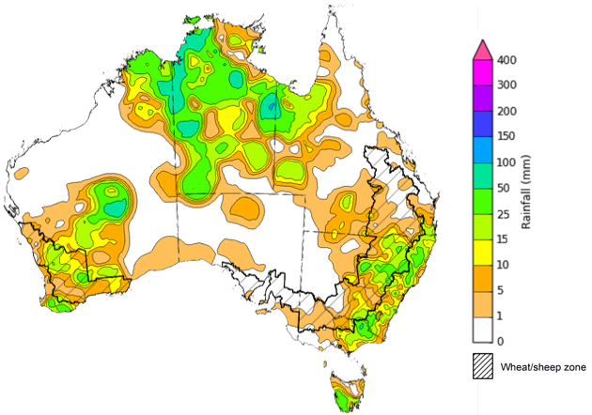
©Commonwealth of Australia 2023, Australian Bureau of Meteorology Issued: 15/11/2023
Note: The rainfall analyses and associated maps utilise data contained in the Bureau of Meteorology climate database, the Australian Data Archive for Meteorology (ADAM). The analyses are initially produced automatically from real-time data with limited quality control. They are intended to provide a general overview of rainfall across Australia as quickly as possible after the observations are received. For further information go to http://www.bom.gov.au/climate/rainfall/

Rainfall forecast for the next eight days
Over the 8 days to 23 November 2023, troughs will generate showers across eastern, central and northern Australia, with rainfall in excess of 50 millimetres in north-eastern New South Wales and south-eastern Queensland.
Across cropping regions, rainfall totals up to 100 millimetres are forecast for Queensland and northern New South Wales. This rainfall is likely to give some growers confidence to plant summer crops such as sorghum. The dry expected conditions in the Victoria, South Australia and Western Australian cropping regions will allow for the uninterrupted harvest of winter crops.

Total forecast rainfall for the period 16 November 2023 to 23 November 2023
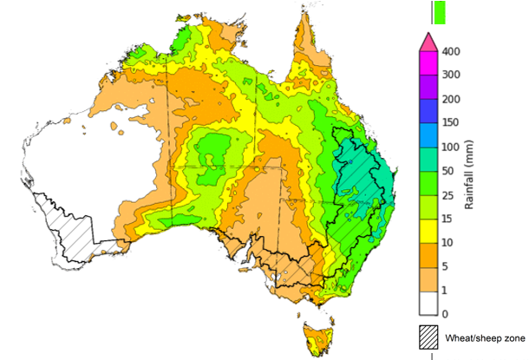

©Commonwealth of Australia 2023, Australian Bureau of Meteorology Issued 15/11/2023
Note: This rainfall forecast is produced from computer models. As the model outputs are not altered by weather forecasters, it is important to check local forecasts and warnings issued by the Bureau of Meteorology.

Global production conditions and climate outlook
Crop production is affected by long-term trends in average rainfall and temperature, interannual climate variability, shocks during specific growth stages, and extreme weather events. Some crops are more tolerant than others to certain types of stresses, and at each growth stage, different types of stresses affect each crop species in different ways.
The precipitation anomalies and outlooks presented here give an indication of the current and future state of production conditions for the major grain and oilseed producing countries which are responsible for over 80% of global production. This is an important input to assessing the global grain supply outlook.
October precipitation percentiles and current production conditions
As of the end of October 2023, precipitation was highly variable for the world’s major grain-producing and oilseed-producing regions.
In the northern hemisphere, precipitation was generally average to above average across major grain and oilseed producing regions, except for some areas in Canada, much of southern India, and north-eastern China where precipitation was below average.
In the southern hemisphere, October precipitation across Brazil was variable ranging from below average in the north-western to average to above average in the south. Argentina recorded generally average precipitation in October. In Australia, October precipitation was generally below average, except for parts in the southeast where it was above average.

Global precipitation percentiles, October 2023
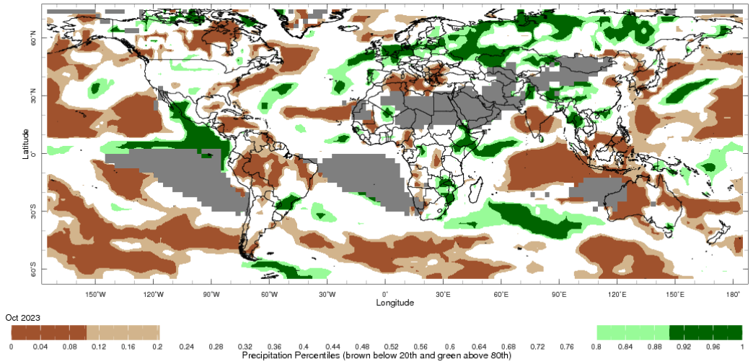
Note: The world precipitation percentiles indicate a ranking of precipitation for October, with the driest (0th percentile) being 0 on the scale and the wettest (100th percentile) being 1 on the scale. Percentiles are based on precipitation estimates from the NOAA Climate Prediction Center's Climate Anomaly Monitoring System Outgoing Precipitation Index dataset. Precipitation estimates for October 2023 are compared with rainfall recorded for that period during the 1981 to 2010 base period.
Source: International Research Institute for Climate and Society
As of 28 October 2023, global production conditions were generally favourable for maize and soybeans, but variable for wheat and rice. In the northern hemisphere, recent dry conditions have affected planting and crop establishment in Ukraine and the Russian Federation, but October rains have established favourable soil moisture for sowing and germination in Türkiye, UK and China. In the southern hemisphere, the area affected by dry conditions continues to expand in Argentina and Australia.
Wheat: in the southern hemisphere, dryness persists in parts of Australia and Argentina as winter harvest begins. In the northern hemisphere, 2024–25 winter crop planting continues under mixed conditions.
Maize: in the northern hemisphere, harvest is nearing completion with improvement in parts of the Russian Federation, US, and Mexico. Planting is ramping up in the southern hemisphere with expanding dryness in Argentina.
Rice: in China, harvesting conditions are favourable for both single and late-season crops. In India, Kharif conditions remain favourable except in the south. In Southeast Asia, poor wet-season outcomes are expected in Thailand, and limited rains are impacting planting in Indonesia.
Soybeans: in the northern hemisphere, harvesting is nearing completion under generally favourable conditions. However, poor crop outcomes are expected in parts of Nigeria, Romania, Ukraine, and the U.S.

Crop conditions, AMIS countries, 28 October 2023 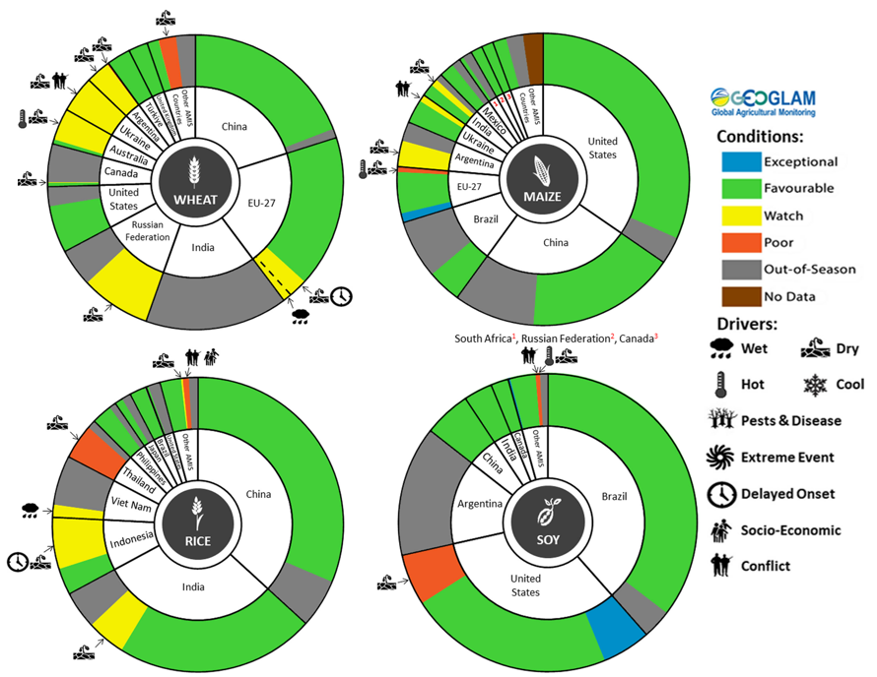
AMIS Agricultural Market Information System. Source: AMIS

The global climate outlook for December 2023 to February 2024 indicates that variable rainfall conditions are expected for the world's major grain-producing and oilseed-producing regions. Outlooks and potential production impacts for the major grain and oilseed producing countries are presented in the table.
Rainfall outlook and potential impact on the future state of production conditions between December 2023 to February 2024
Region | December 2023 – February 2024 rainfall outlook | Potential impact on production
Argentina | Above average rainfall is likely through February 2024 across much of the east, including the major producing regions. This pattern is typical during El Niño events. | Above average rainfall is likely to support the silking, flowering, and grain filling of corn, as well as the flowering of cotton, ground nuts, soybeans, and sunflowers. The wet conditions mays also support the planting and vegetative growth of millet, rice, and sorghum.
Black Sea Region | Average to above average rainfall is more likely in Ukraine, Kazakhstan and the Russian Federation. | Winter wheat and canola will remain dormant throughout December to February across the Black Sea Region. Above average rainfall in many parts may provide sufficient snowpack to protect crops from winterkill.
Brazil | Through February 2024, below average rainfall is expected across much of the north and northeast, above average rainfall is likely across the centre and south. This is a typical El Niño pattern. | Above average rainfall in southern Brazil may disrupt harvesting of wheat in December but provide favourable conditions for flowering of corn, cotton, groundnuts, and soybeans, as well as the grain filling of corn in January. Below average rainfall in northern and central Brazil will likely affect the growth, flowering, and filling of soybeans and the early planted (smaller crop) of corn.
Canada | Average rainfall is more likely for much of Canada, especially across major production regions. | Average rainfall in Canada is likely to provide favourable conditions for winter wheat sowing and will likely provide sufficient snowpack to prevent winterkill of winter wheat and canola through December and January.
China | Average to above average rainfall is more likely across China. | Through December, January and February, winter wheat and canola will remain dormant. Average to above average rainfall is likely to decrease the risk of winterkill due to sufficient snowpack.
Europe | Average to above average rainfall is more likely across much of Europe. | Above average rainfall in central and northern Europe is likely to provide an adequate snowpack to limit the risk of winterkill for winter wheat and canola. Above average rainfall in southern Europe should provide favourable conditions for winter wheat crops.
South Asia (India) | Average to above average rainfall is more likely across India. | Average rainfall across much of India will support the harvesting of corn, cotton, groundnuts, millet, rice, sorghum, and sunflower. Above average rainfall in parts of central and northern India may support the vegetative growth and heading of winter wheat and canola.
Southeast Asia (SEA) | Generally average to above average rainfall is more likely. | Average to above average rainfall in SEA likely supports vegetative growth for corn and rice production throughout December to February. However, excessive rainfall may result in flooding and crop damage.
The United States | Above average rainfall is expected through February across much of the US. | Above average precipitation conditions expected across the northern US are likely to provide sufficient snow cover through winter to protect wheat and canola through dormancy.

Water

Water markets – current week
Water storage levels in the Murray-Darling Basin (MDB) decreased between 9 November 2023 and 16 November 2023 by 65 gigalitres (GL). Current volume of water held in storage is 19 933 GL. This is 12 percent or 2603 GL less than at the same time last year.

Water storages in the Murray-Darling Basin, 2013–2023
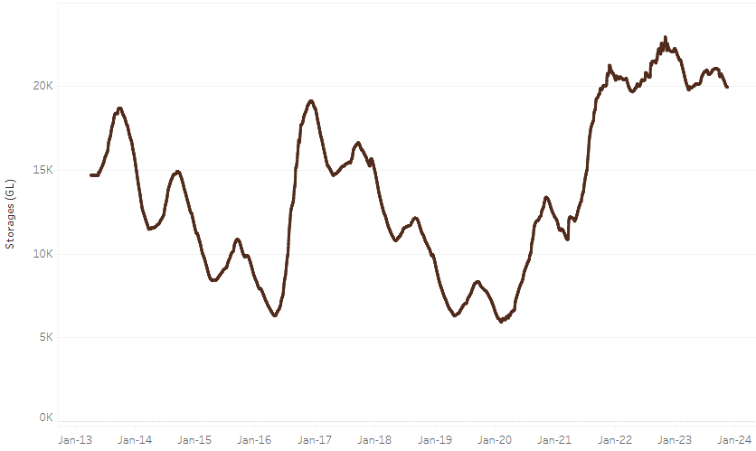
Allocation prices in the Victorian Murray below the Barmah Choke decreased from $158 on 9 November 2023 to $146 on 16 November 2023. Prices are lower in the Goulburn-Broken due to the binding of the Goulburn intervalley trade limit.
Water storage data is sourced from the Bureau of Meteorology.

Region | $/ML
NSW Murray Above | 92
NSW Murrumbidgee | 200
VIC Goulburn-Broken | 132
VIC Murray Below | 146

Surface water trade activity, Southern Murray–Darling Basin
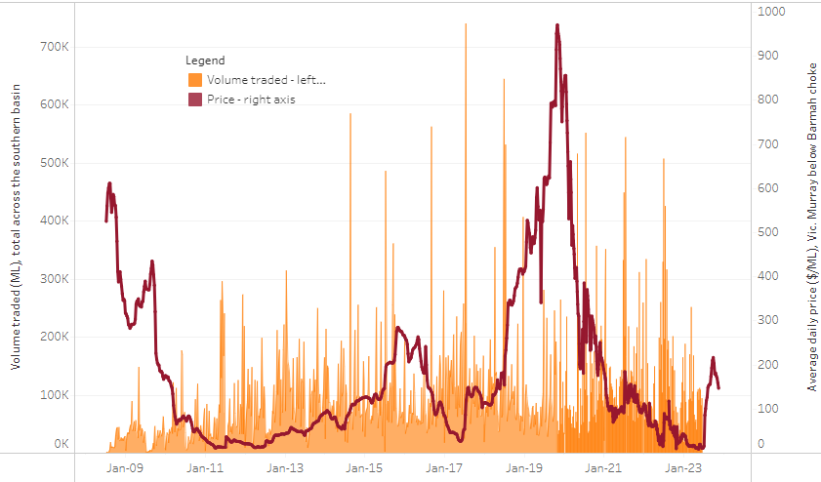
The trades shown reflect estimated market activity and do not encompass all register trades. The price is shown for the VIC Murray below the Barmah choke. Historical prices (before 1 July 2019) are ABARES estimates after removing outliers from BOM water register data. Prices after 1 July 2019 and prior to the 30 October 2019 reflect recorded transaction prices as sourced from Ruralco. Prices after the 30 October 2019 are sourced from Waterflow. Data for volume traded is sourced from the BOM water register. Only the price data shown is current on 16 November 2023.

To access the full, interactive, weekly water dashboard, which contains the latest and historical water storage, water market and water allocation information, please visit https://www.agriculture.gov.au/abares/products/weekly_update/weekly-update-161123

Commodities
Indicator | Week ended | Unit | Latest Price | Previous Week | Weekly change | Price 12 months ago | Annual change
Selected world indicator prices
AUD/USD Exchange rate | 15-Nov | A$/US$ | 0.64 | 0.64 | 0% | 0.67 | -4%
Wheat – US no. 2 hard red winter wheat, fob Gulf | 15-Nov | US$/t | 287 | 289 | -1% | 415 | -31%
Corn – US no. 2 yellow corn, fob Gulf | 15-Nov | US$/t | 213 | 212 | 0% | 311 | -31%
Canola – Rapeseed, Canada, fob Vancouver | 15-Nov | US$/t | 538 | 545 | -1% | 666 | -19%
Cotton – Cotlook 'A' Index | 15-Nov | USc/lb | 89 | 90 | -1% | 101 | -12%
Sugar – Intercontinental Exchange, nearby futures, no.11 contract | 15-Nov | USc/lb | 26.8 | 27.6 | -3% | 19 | 44%
Wool – Eastern Market Indicator | 15-Nov | Ac/kg clean | 1,151 | 1,128 | 2% | 1,255 | -8%
Wool – Western Market Indicator | 15-Nov | Ac/kg clean | 1,294 | 1,267 | 2% | 1,447 | -11%
Selected Australian grain export prices
Milling Wheat – APW, Port Adelaide, SA | 15-Nov | A$/t | 448 | 456 | -2% | 567 | -21%
Feed Wheat – ASW, Port Adelaide, SA | 15-Nov | A$/t | 428 | 436 | -2% | 510 | -16%
Feed Barley – Port Adelaide, SA | 15-Nov | A$/t | 390 | 394 | -1% | 432 | -10%
Canola – Kwinana, WA | 15-Nov | A$/t | 775 | 785 | -1% | 1,076 | -28%
Grain Sorghum – Brisbane, QLD | 15-Nov | A$/t | 505 | 510 | -1% | 476 | 6%
Selected domestic livestock indicator prices
Beef – Eastern Young Cattle Indicator | 15-Nov | Ac/kg cwt | 414 | 382 | 9% | 1,022 | -59%
Mutton – Mutton indicator (18–24 kg fat score 2–3), Vic | 15-Nov | Ac/kg cwt | 102 | 97 | 6% | 513 | -80%
Lamb – National Trade Lamb Indicator | 15-Nov | Ac/kg cwt | 453 | 472 | -4% | 795 | -43%
Pig – Eastern Seaboard (60.1–75 kg), average of buyers & sellers | 01-Nov | Ac/kg cwt | 376 | 376 | 0% | 376 | 0%
Goats – Eastern States (12.1–16 kg) | 15-Nov | Ac/kg cwt | 190 | 190 | 0% | 485 | -61%
Live cattle – Light steers to Indonesia | 08-Nov | Ac/kg lwt | 270 | 275 | -2% | 520 | -48%
Global Dairy Trade (GDT) weighted average prices ª
Dairy – Whole milk powder | 08-Nov | US$/t | 2,971 | 3,059 | -3% | 3,421 | -13%
Dairy – Skim milk powder | 08-Nov | US$/t | 2,724 | 2,659 | 2% | 3,250 | -16%
Dairy – Cheddar cheese | 08-Nov | US$/t | 4,042 | 3,858 | 5% | 4,769 | -15%
Dairy – Anhydrous milk fat | 08-Nov | US$/t | 5,489 | 5,310 | 3% | 5,661 | -3%
a Global Dairy Trade prices are updated twice monthly on the first and third Tuesday of each month.

Selected world indicator prices
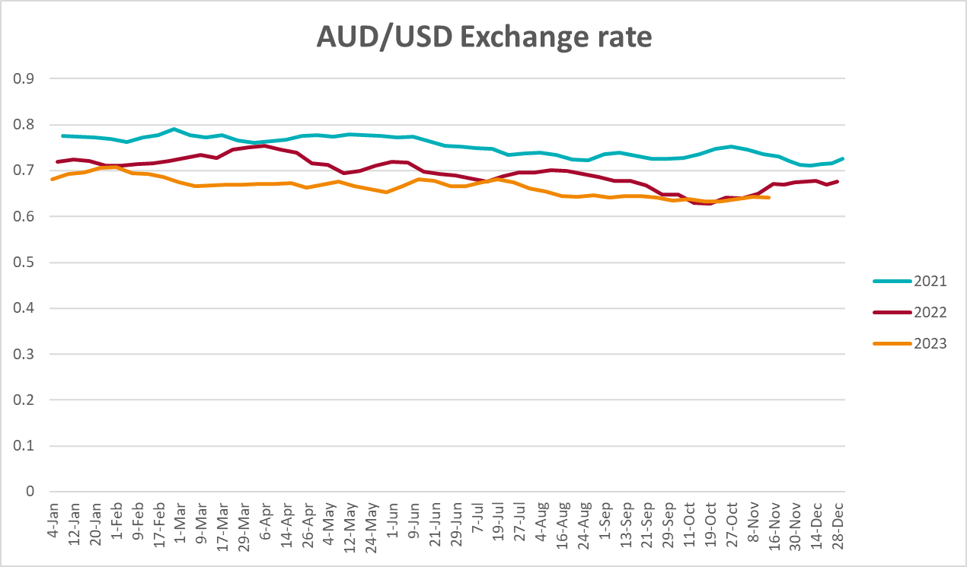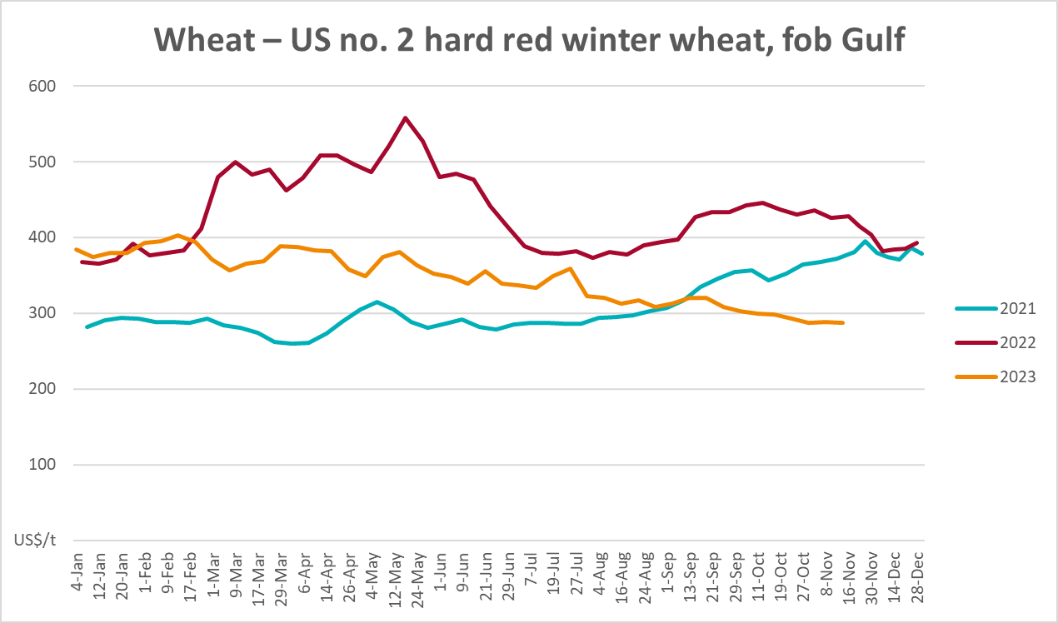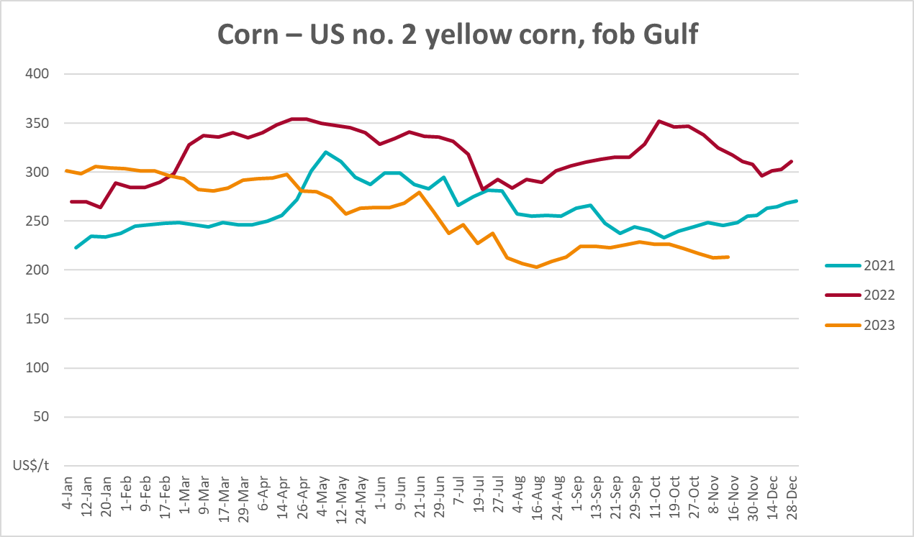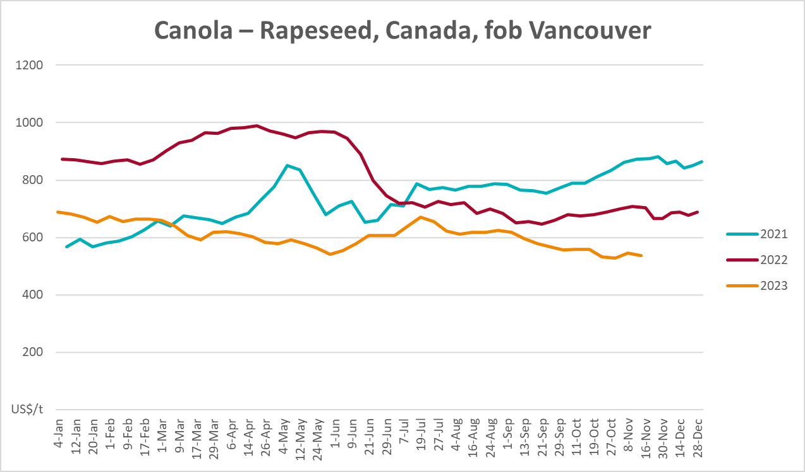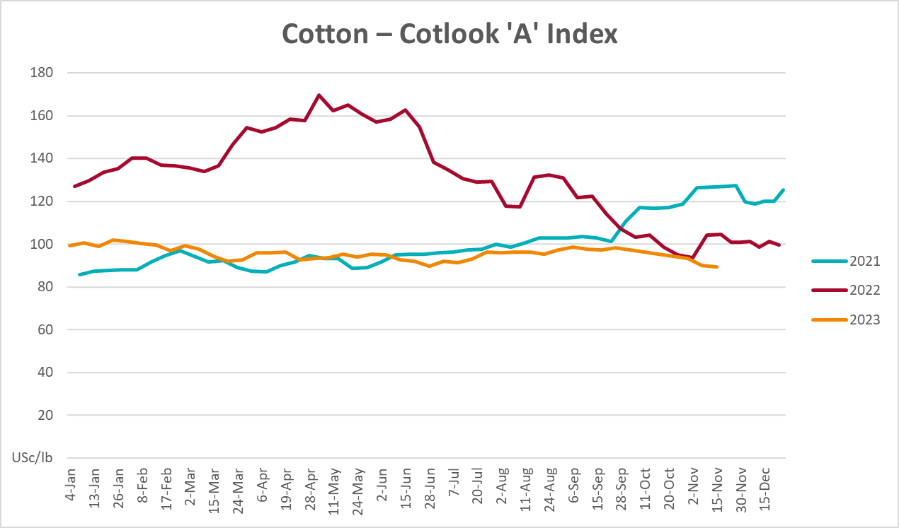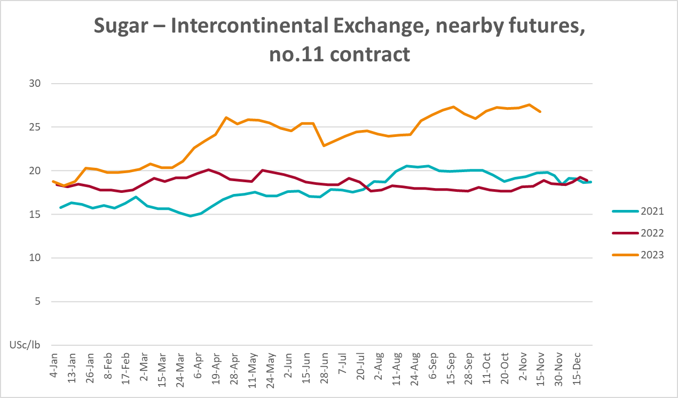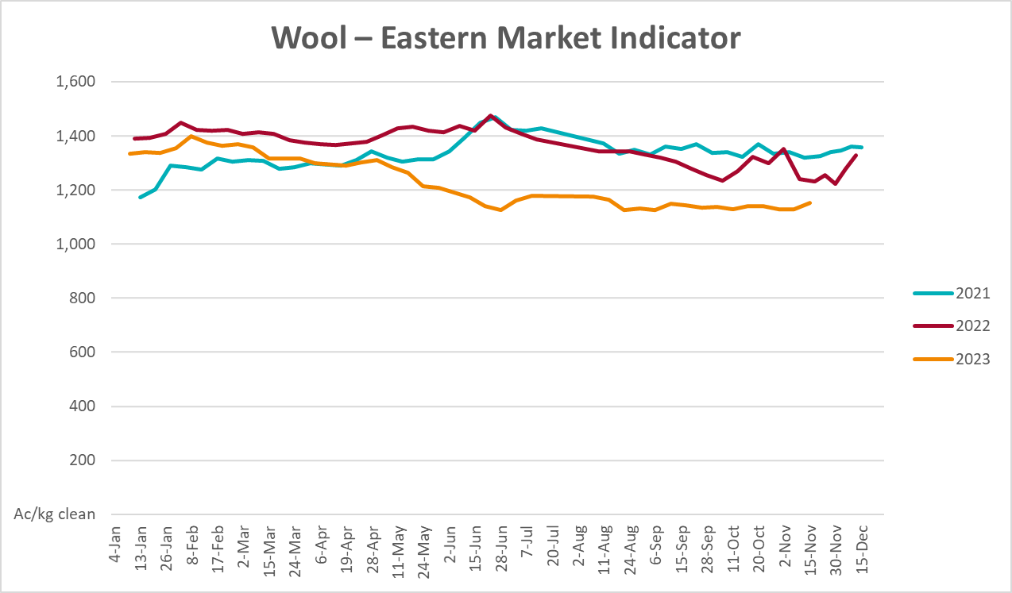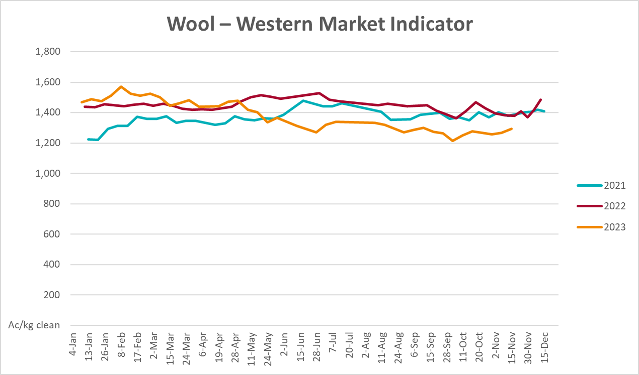

Selected domestic crop indicator prices
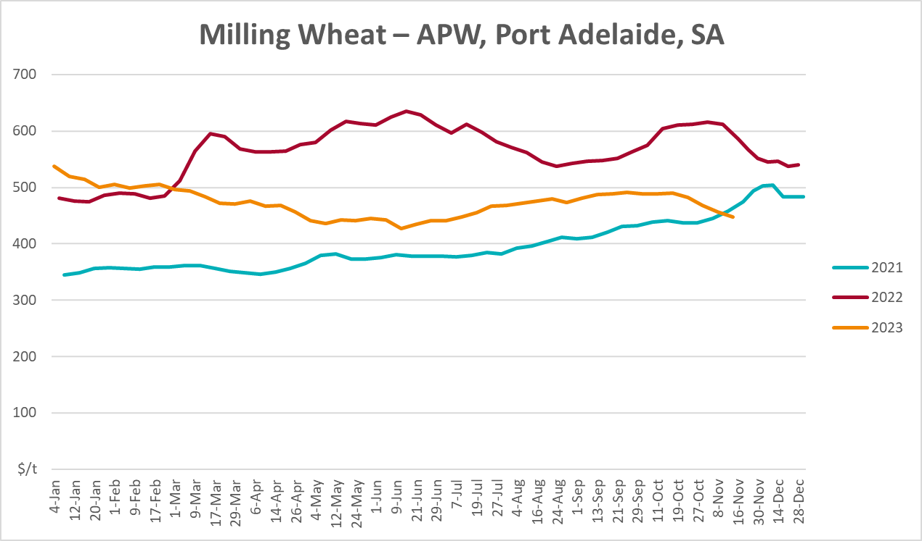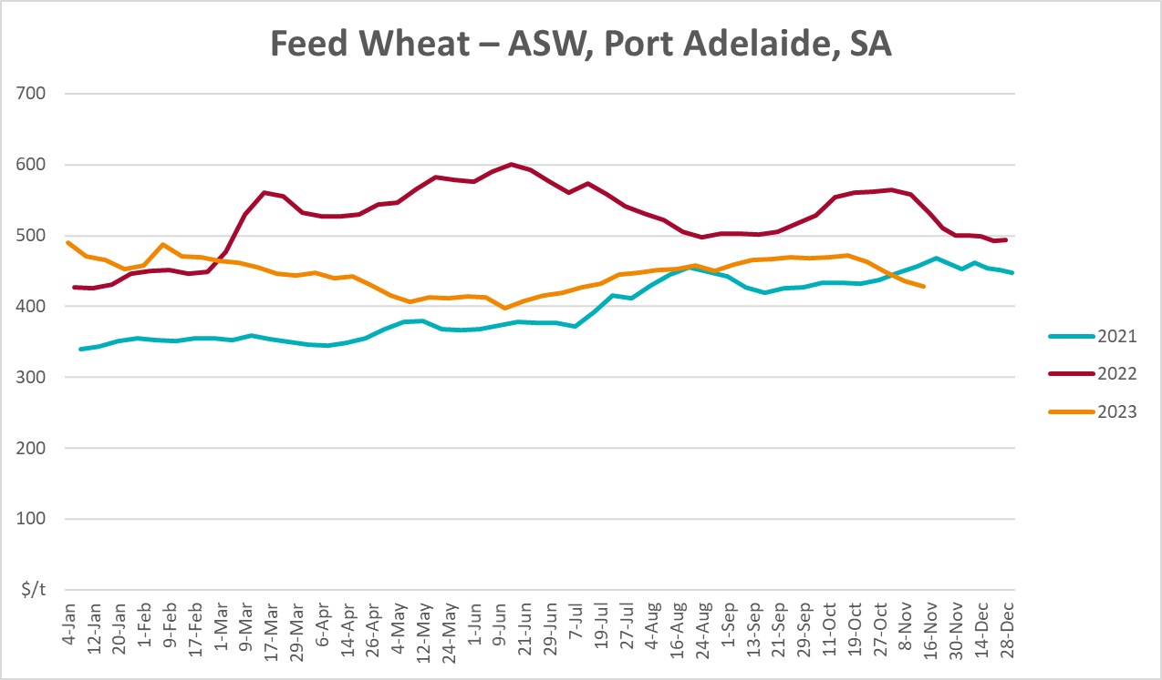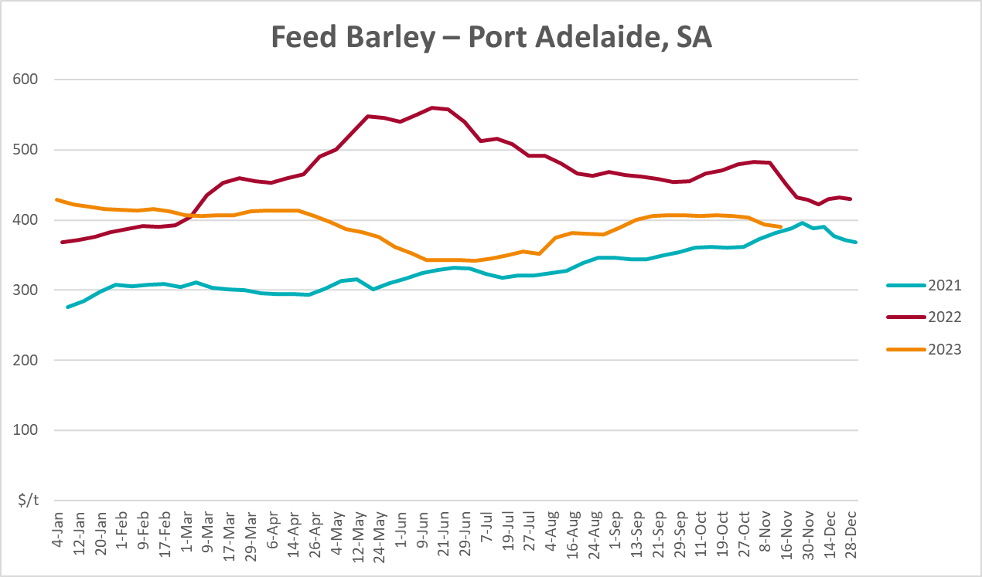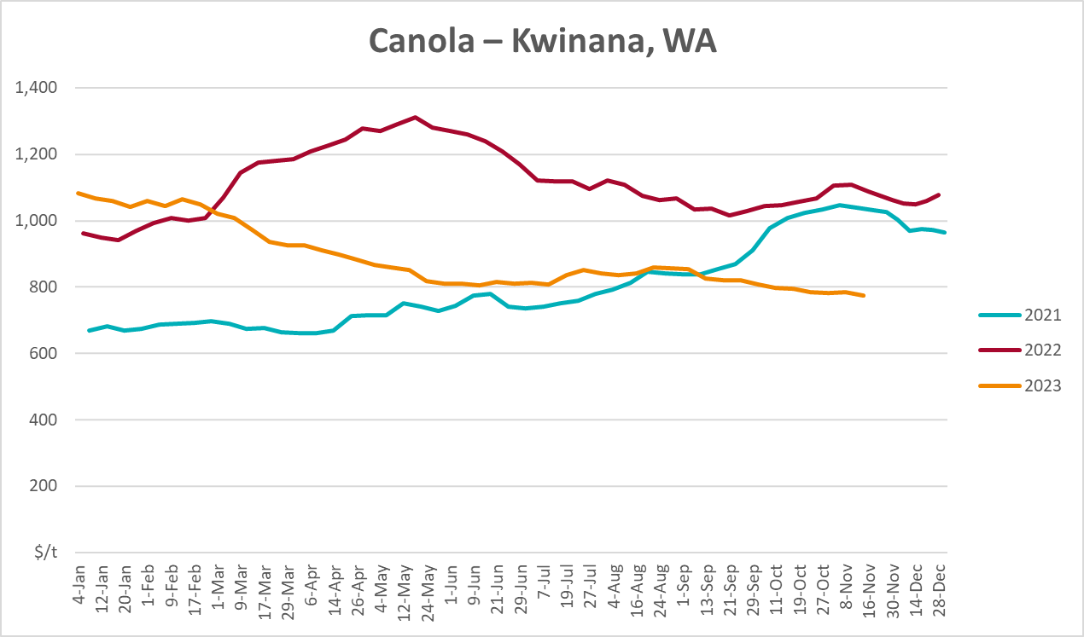
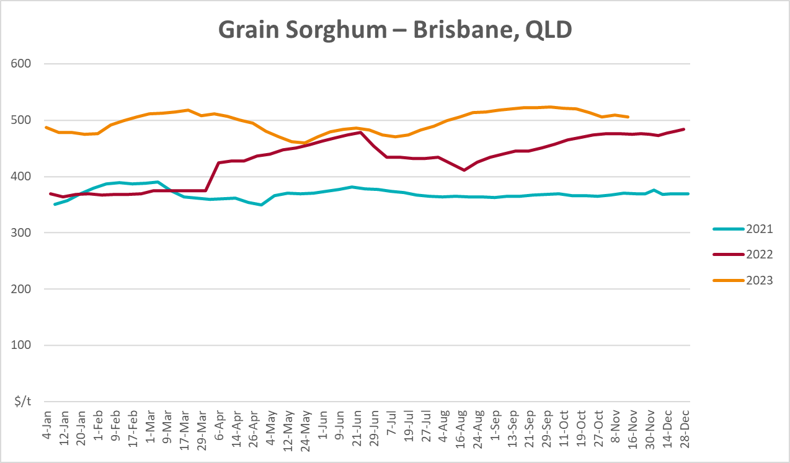

Selected domestic livestock indicator prices
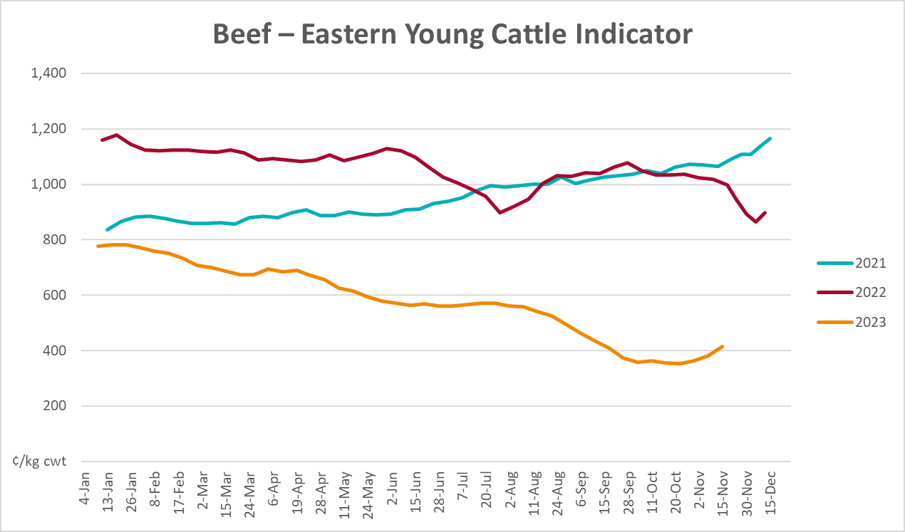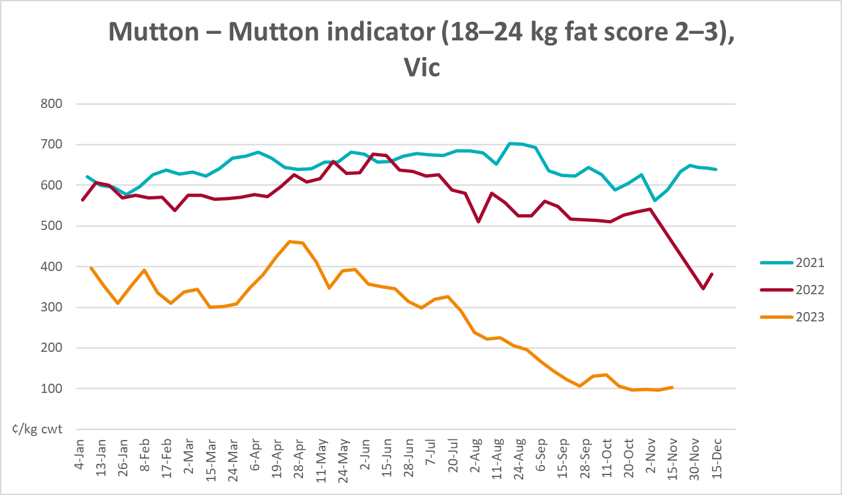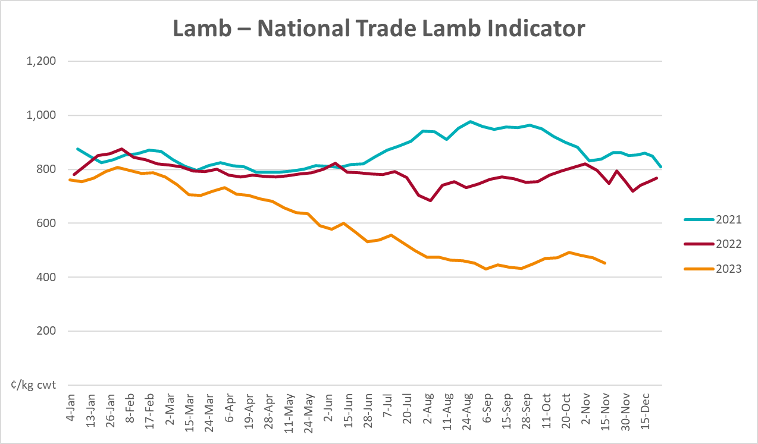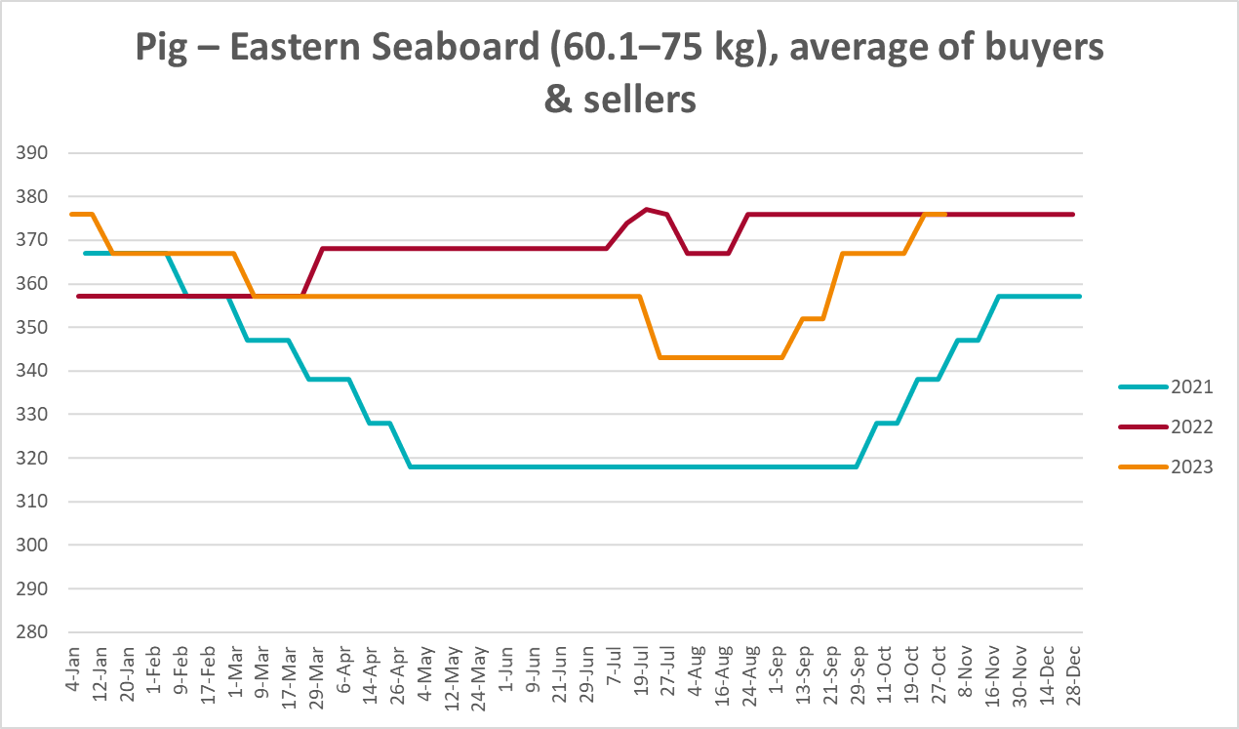
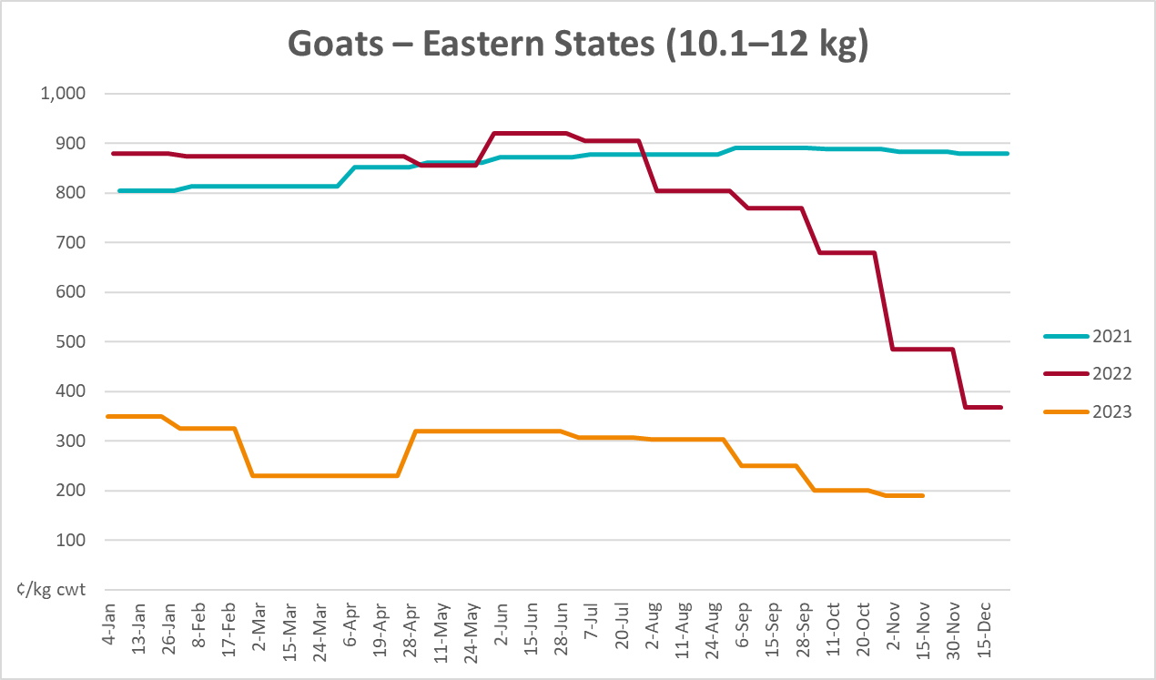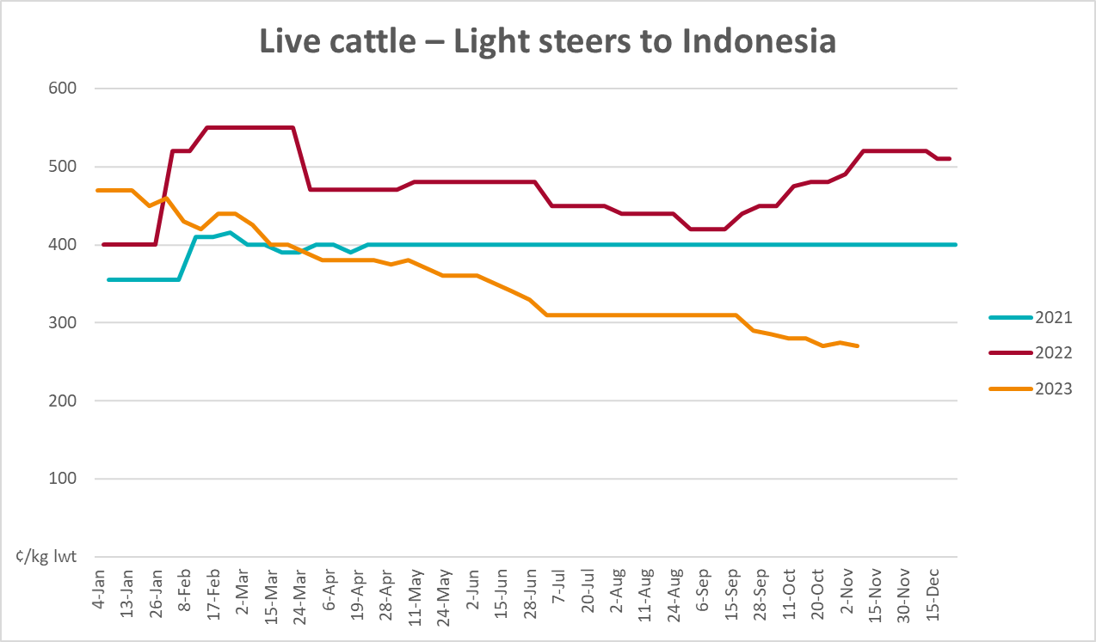

Global Dairy Trade (GDT) weighted average prices
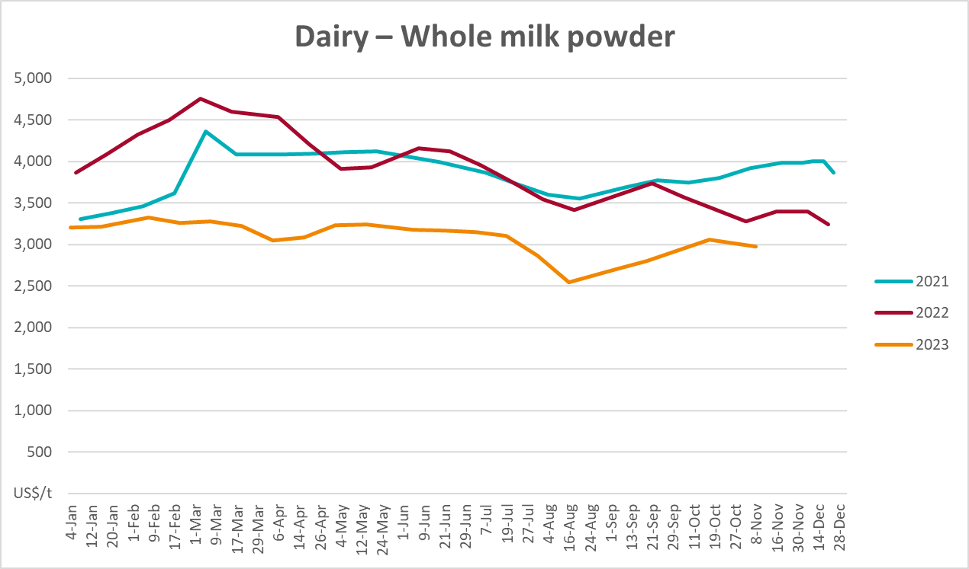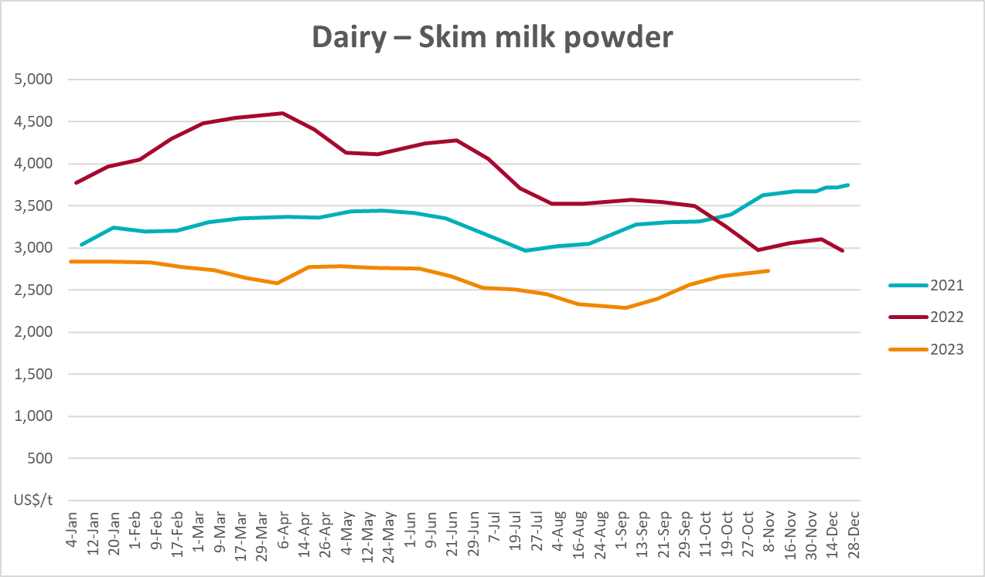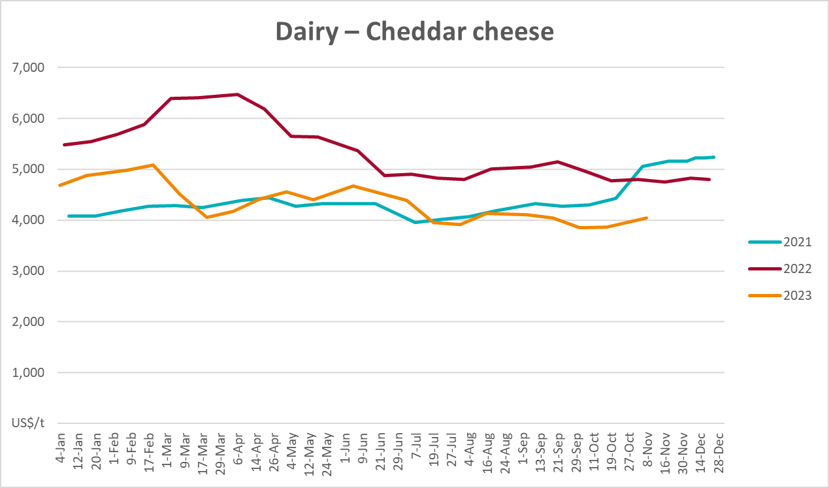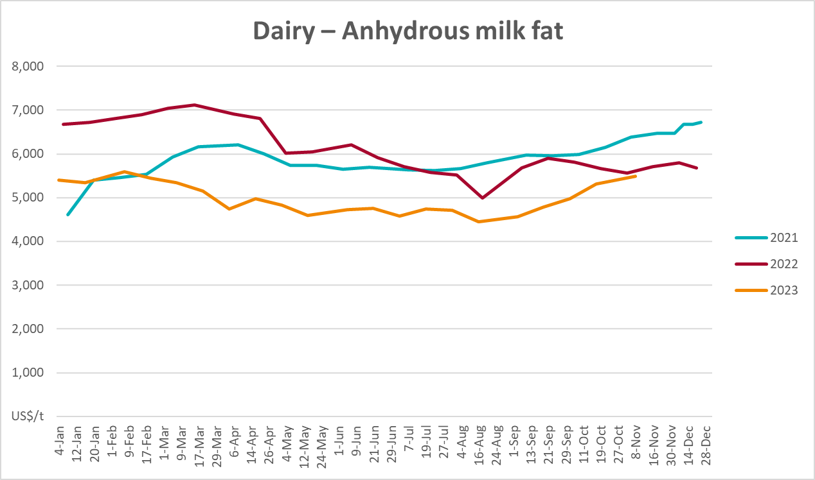

Selected fruit and vegetable prices
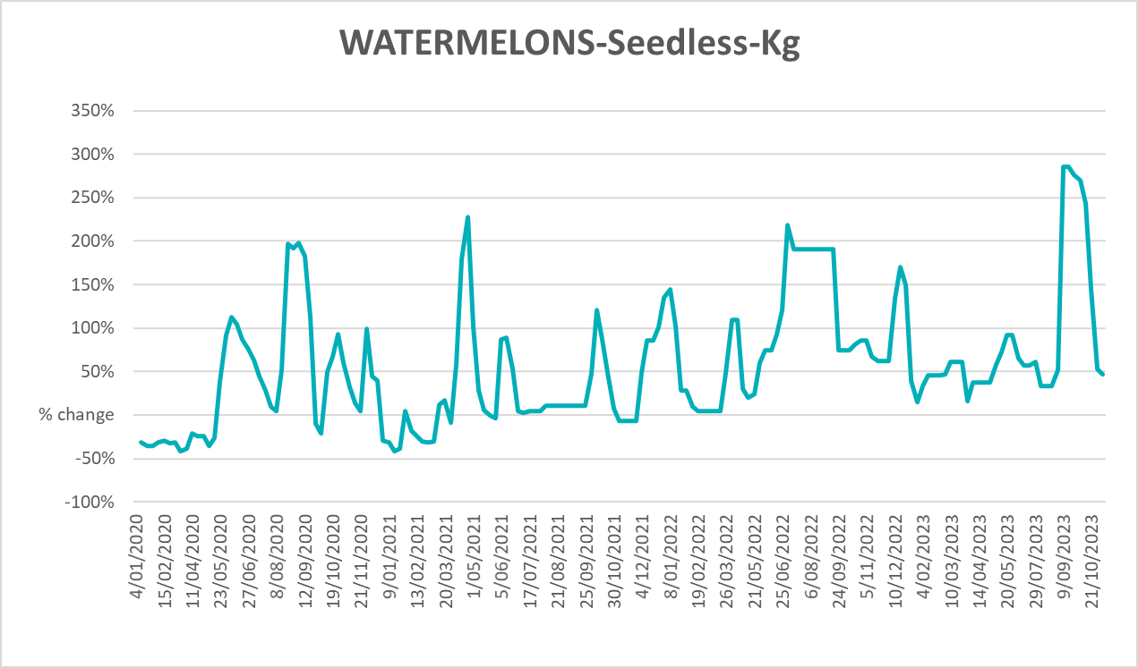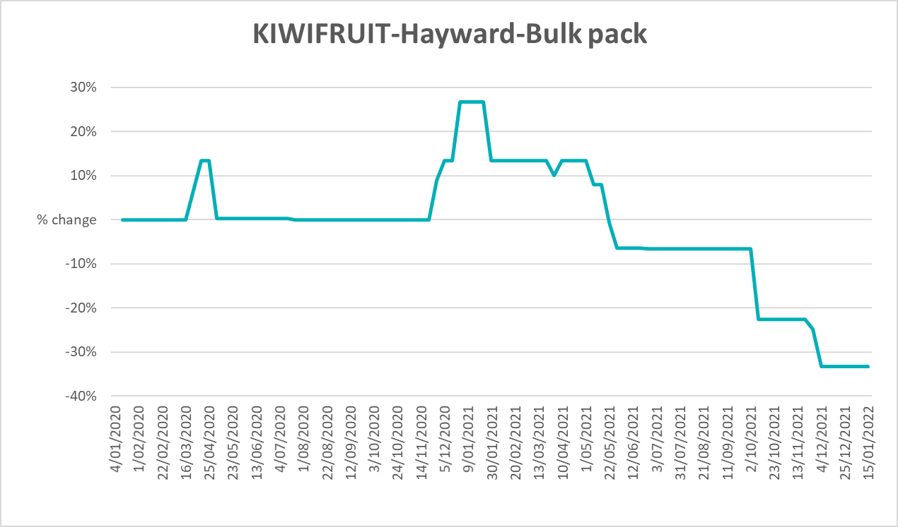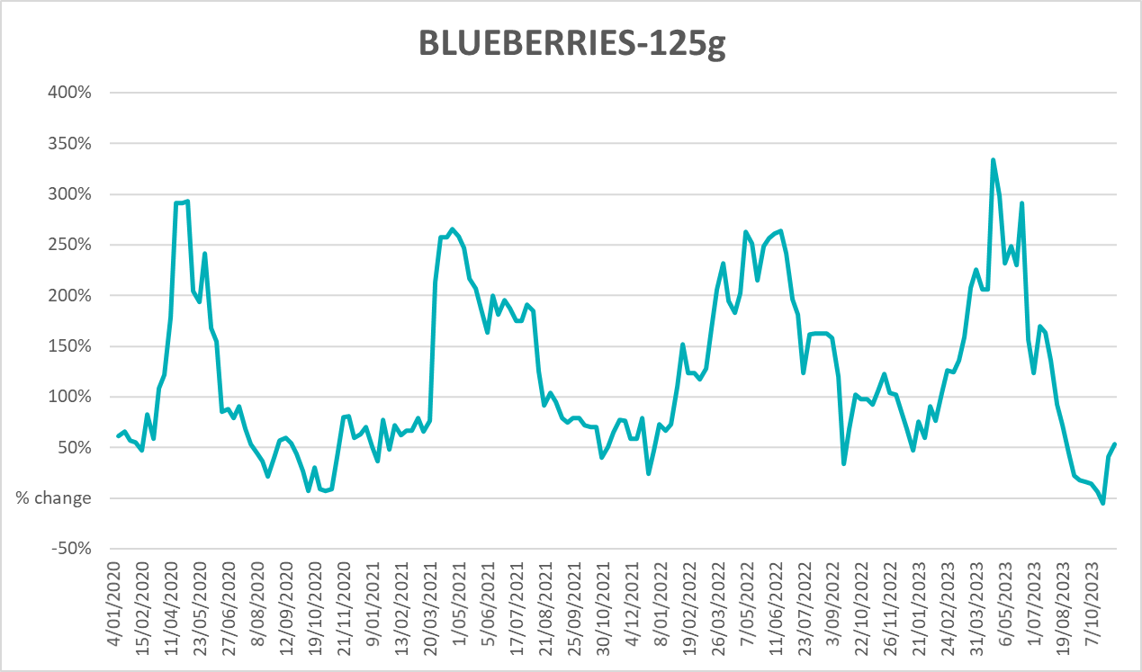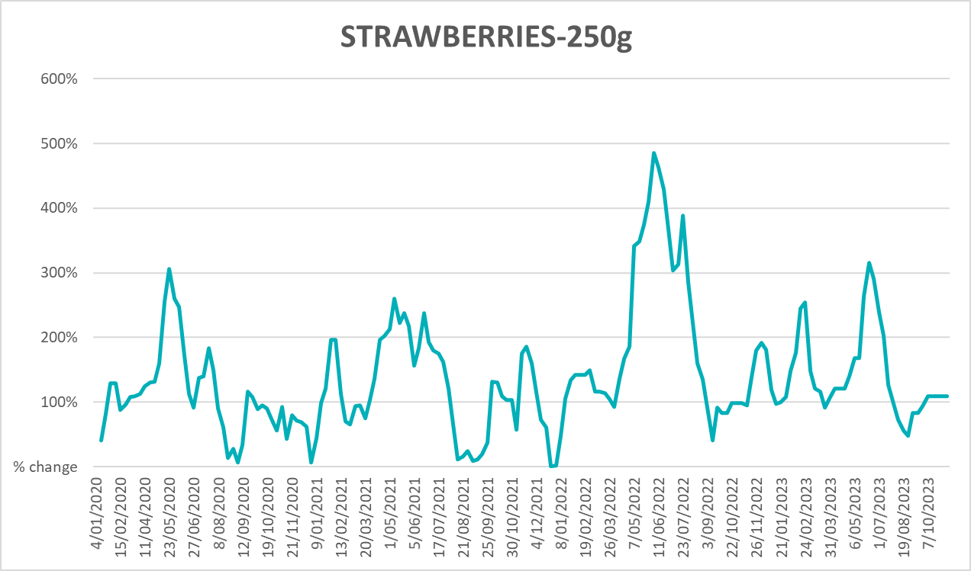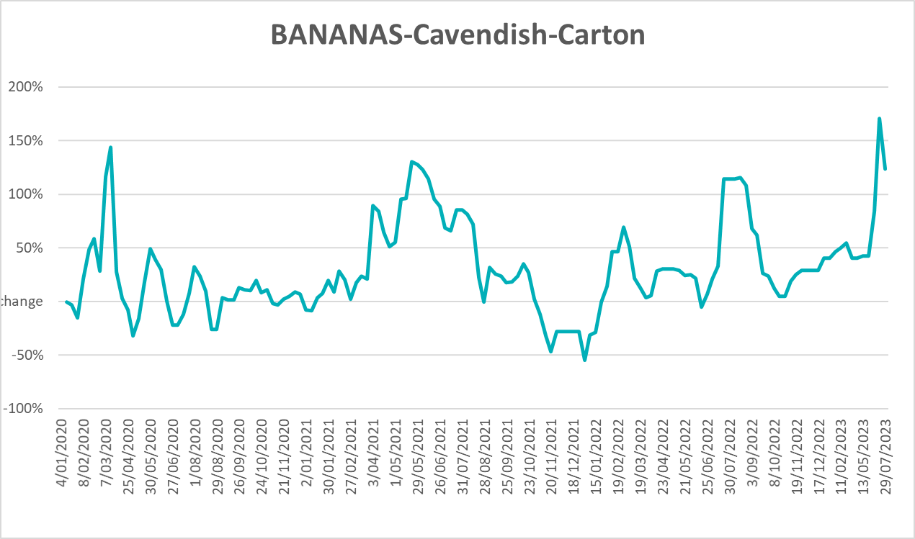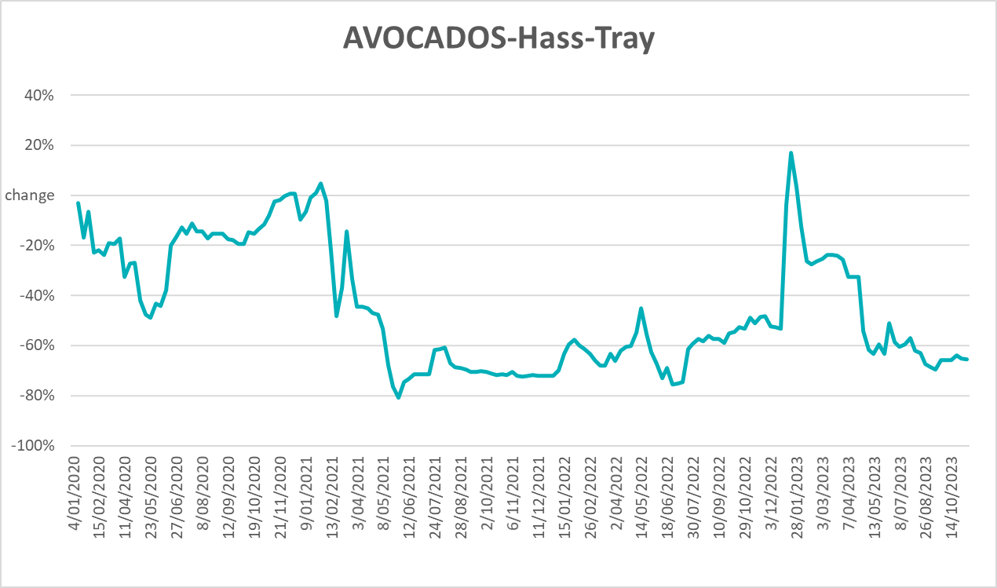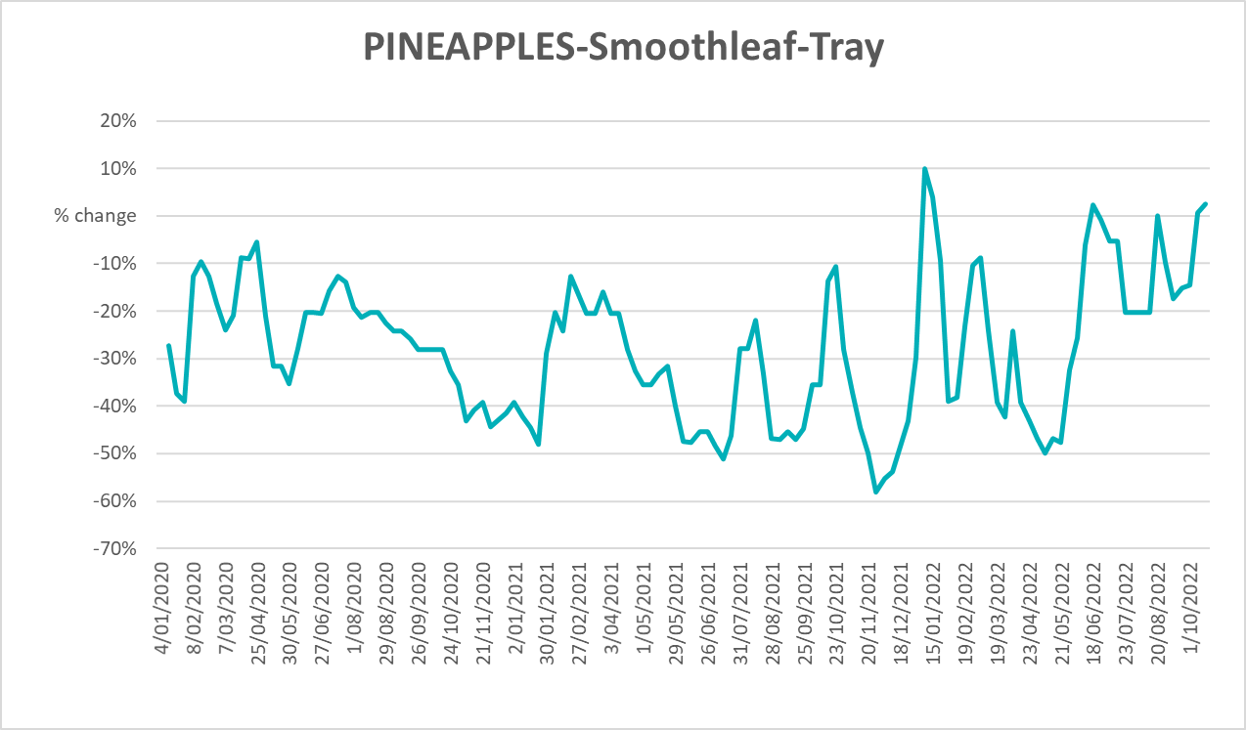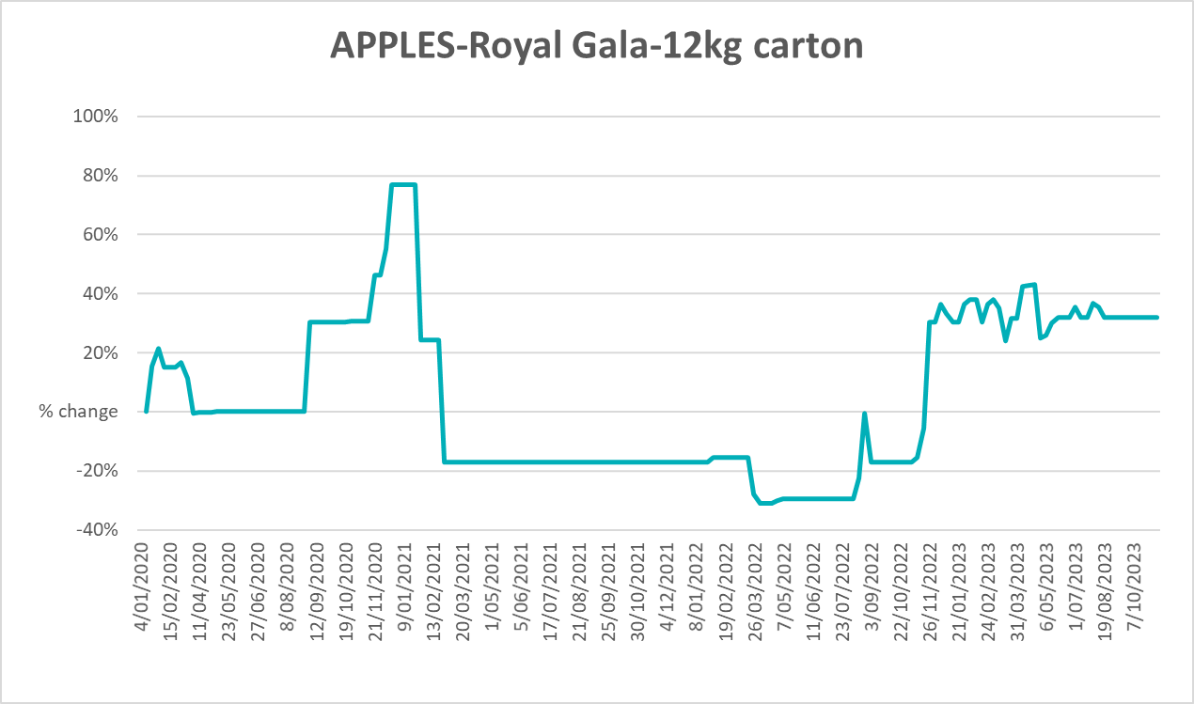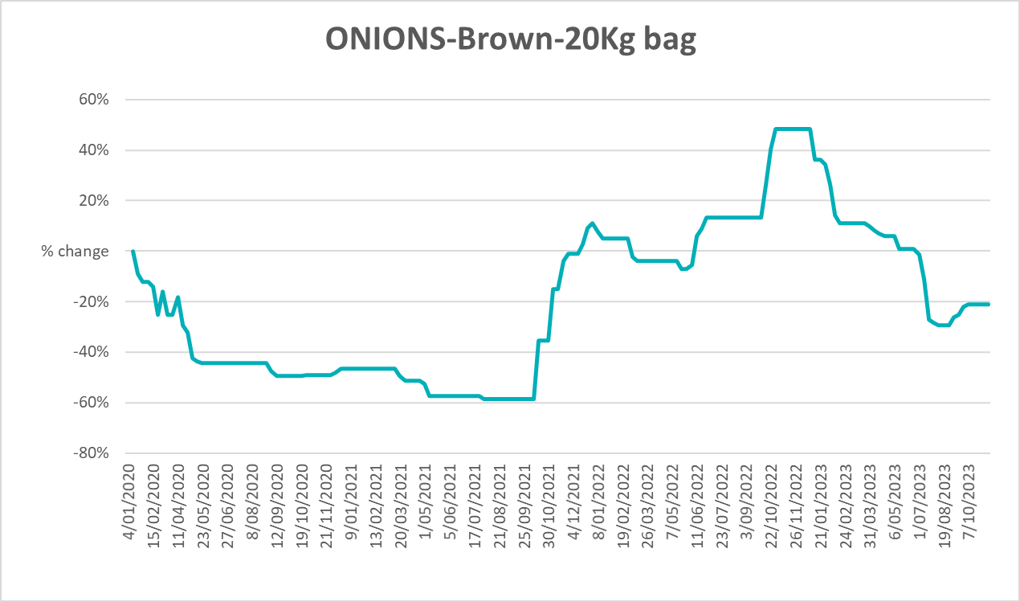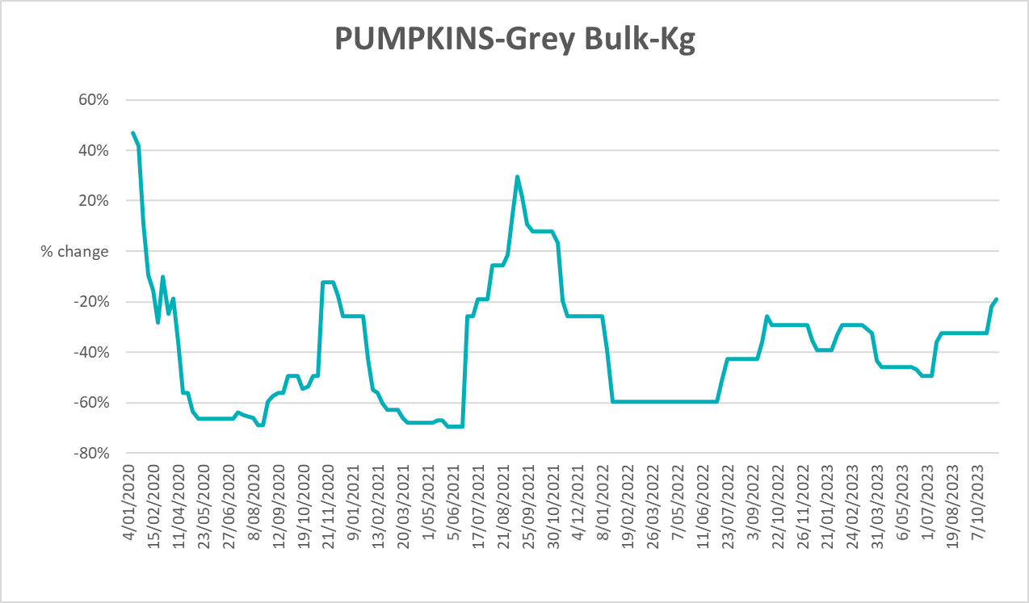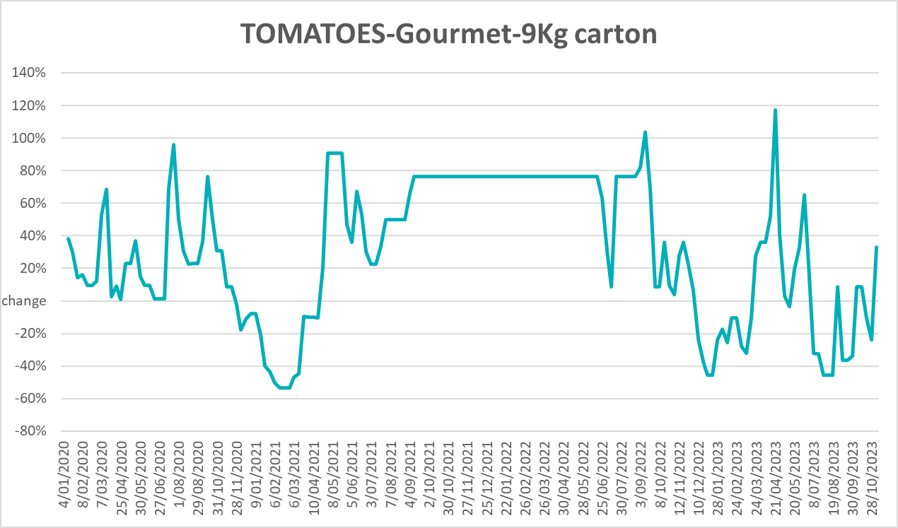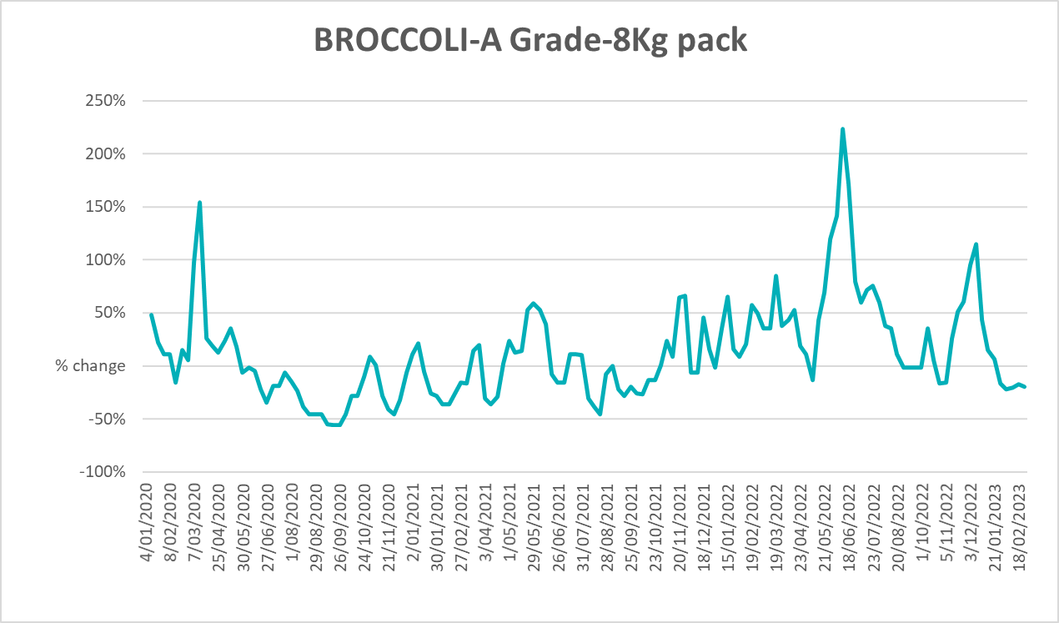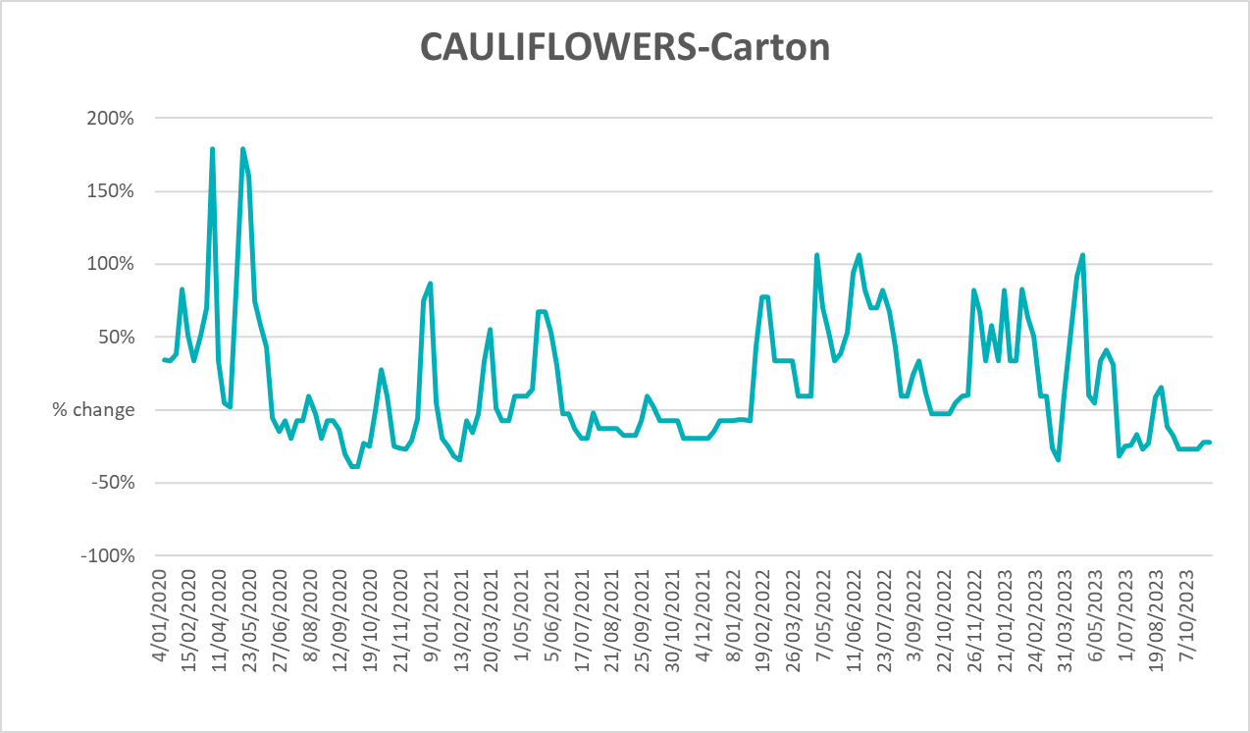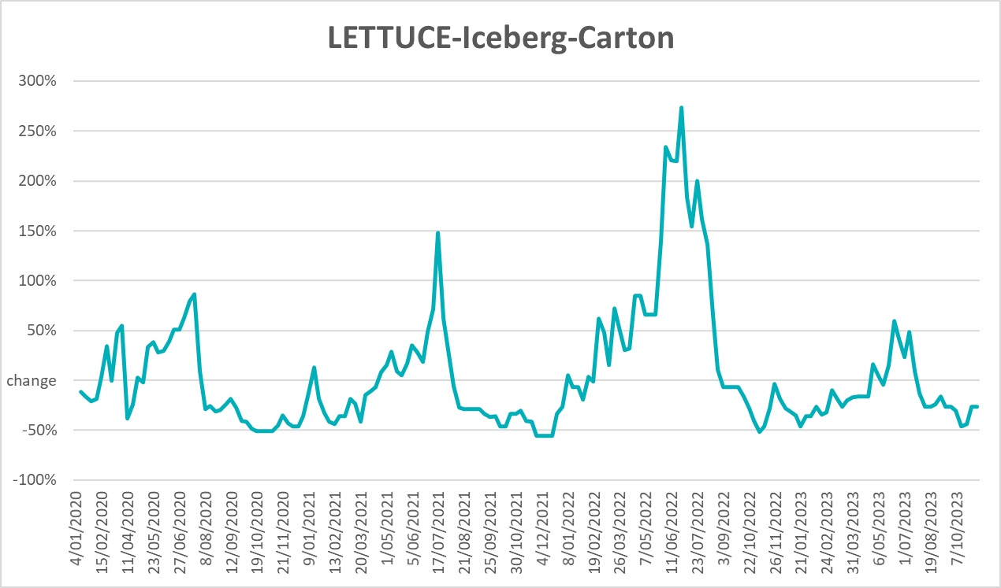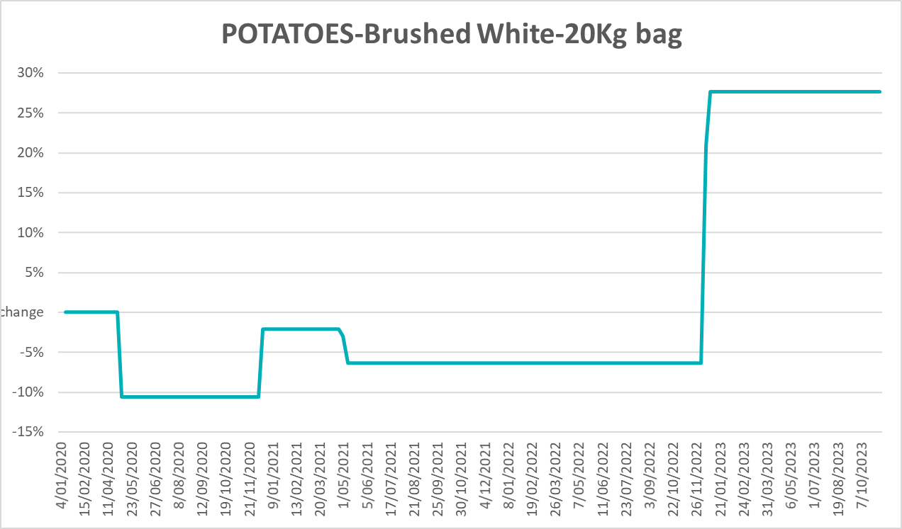

3.6 Selected domestic fodder indicator prices

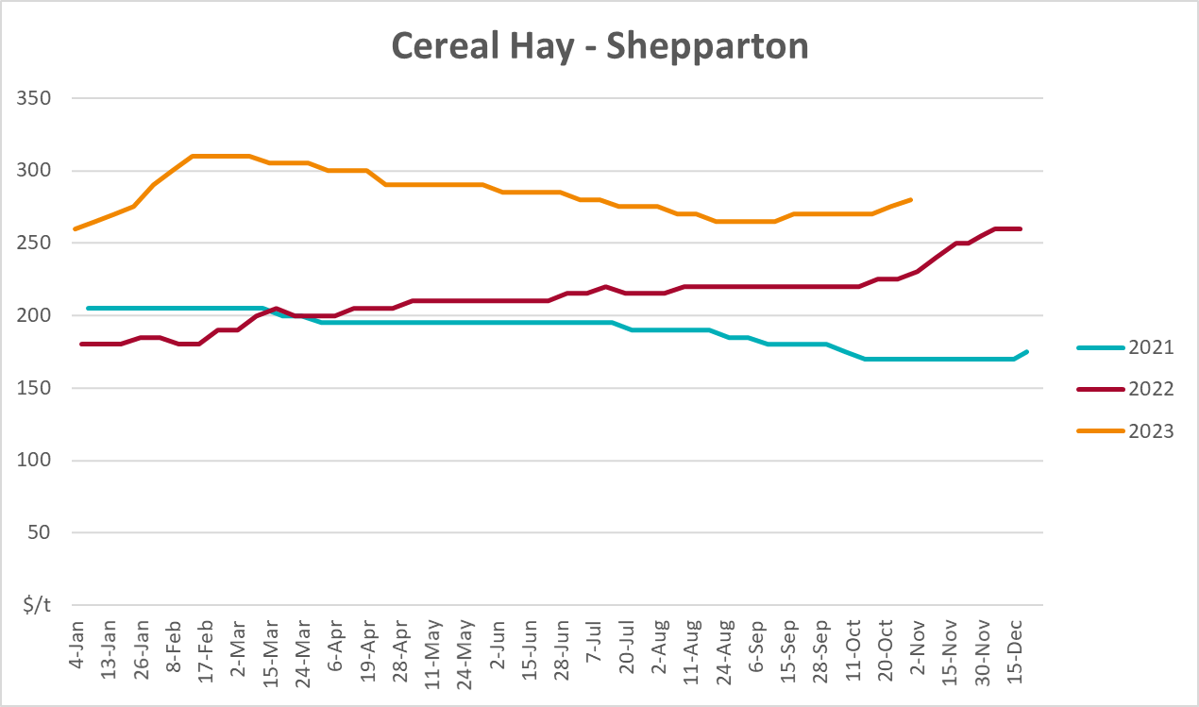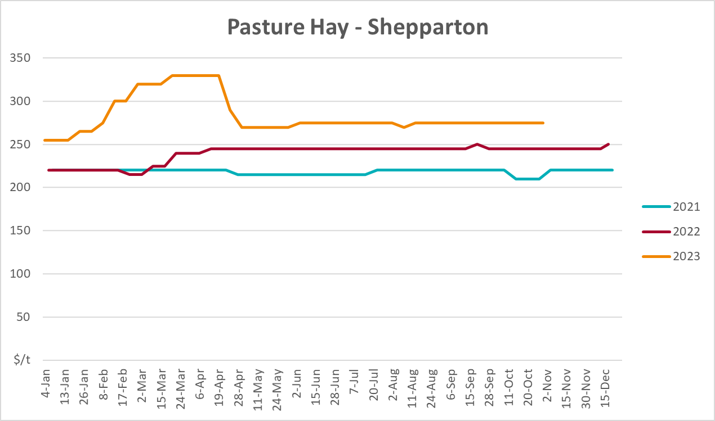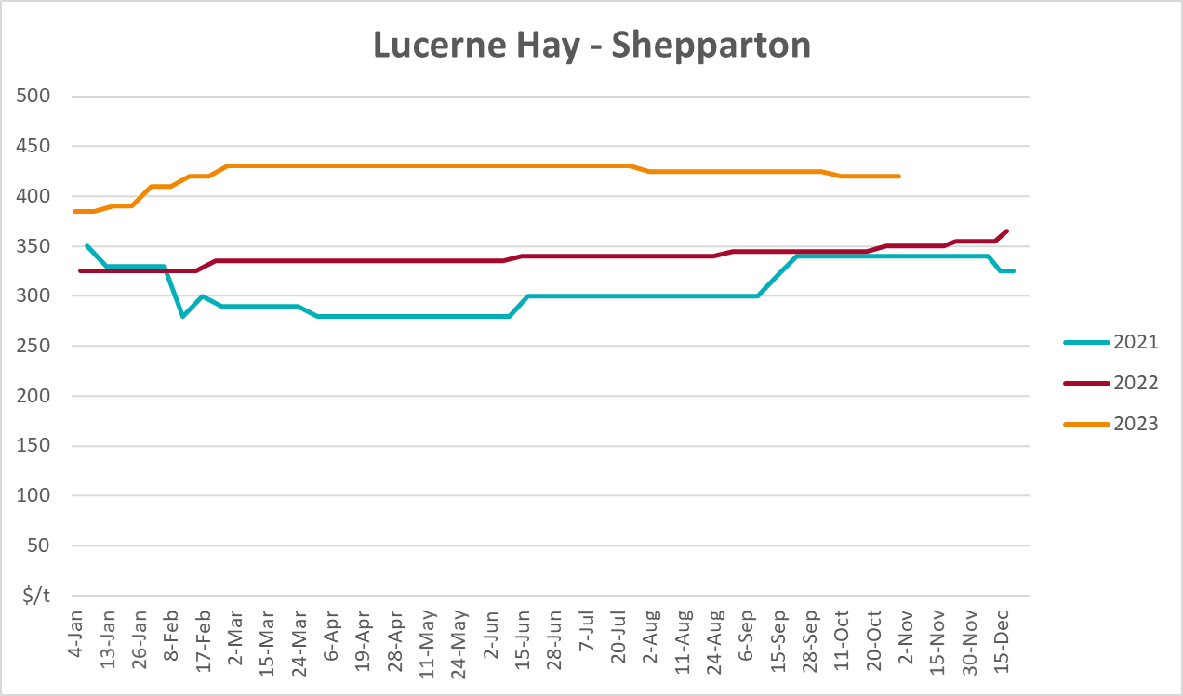

4. Data attribution

Climate
Bureau of Meteorology
- Weekly rainfall totals: www.bom.gov.au/climate/maps/rainfall/
- Monthly and last 3-month rainfall percentiles: www.bom.gov.au/water/landscape/
- Temperature anomalies: www.bom.gov.au/jsp/awap/temp/index.jsp
- Rainfall forecast: www.bom.gov.au/jsp/watl/rainfall/pme.jsp
- Seasonal outlook: www.bom.gov.au/climate/outlooks/#/overview/summary/
- Climate drivers: http://www.bom.gov.au/climate/enso/
- Soil moisture: www.bom.gov.au/water/landscape/
Other
- Pasture growth: www.longpaddock.qld.gov.au/aussiegrass/
- 3-month global outlooks: Environment and Climate Change Canada, NOAA Climate Prediction Center, EUROBRISA CPTEC/INPE, European Centre for Medium-Range Weather Forecasts, Hydrometcenter of Russia, National Climate Center Climate System Diagnosis and Prediction Room (NCC), International Research Institute for Climate and Society
- Global production: https://ipad.fas.usda.gov/ogamaps/cropmapsandcalendars.aspx
- Autumn break: Pook et al., 2009, https://rmets-onlinelibrary-wiley-com.virtual.anu.edu.au/doi/epdf/10.1002/joc.1833

Water
Prices
- Waterflow: https://www.waterflow.io/
- Ruralco: https://www.ruralcowater.com.au/
Bureau of Meteorology:
- Allocation trade: http://www.bom.gov.au/water/dashboards/#/water-markets/mdb/at
- Storage volumes: http://www.bom.gov.au/water/dashboards/#/water-storages/summary/drainage
Trade constraints:
- Water NSW: https://www.waternsw.com.au/customer-service/ordering-trading-and-pricing/trading/murrumbidgee
- Victorian Water Register: https://www.waterregister.vic.gov.au/TradingRules2019/

Commodities
Fruit and vegetables
- Datafresh: www.freshstate.com.au
Pigs
- Australian Pork Limited: www.australianpork.com.au
Dairy
- Global Dairy Trade: www.globaldairytrade.info/en/product-results/
World wheat, canola
- International Grains Council
World coarse grains
- United States Department of Agriculture
World cotton
- Cotlook: www.cotlook.com/
World sugar
- New York Stock Exchange - Intercontinental Exchange
Wool
- Australian Wool Exchange: www.awex.com.au/
Domestic wheat, barley, sorghum, canola and fodder
- Jumbuk Consulting Pty Ltd: http://www.jumbukag.com.au/
Cattle, beef, mutton, lamb, goat and live export
- Meat and Livestock Australia: www.mla.com.au/Prices-and-market
© Commonwealth of Australia 2023

Ownership of intellectual property rights
Unless otherwise noted, copyright (and any other intellectual property rights, if any) in this publication is owned by the Commonwealth of Australia (referred to as the Commonwealth).

Creative Commons licence
All material in this publication is licensed under a Creative Commons Attribution 4.0 International Licence except content supplied by third parties, logos and the Commonwealth Coat of Arms.
Inquiries about the licence and any use of this document should be emailed to copyright@awe.gov.au.


Cataloguing data
This publication (and any material sourced from it) should be attributed as:
ABARES 2023, Weekly Australian Climate, Water and Agricultural Update, Australian Bureau of Agricultural and Resource Economics and Sciences, Canberra, 16 November 2023. CC BY 4.0 DOI: https://doi.org/10.25814/5f3e04e7d2503
ISSN 2652-7561
This publication is available at https://www.agriculture.gov.au/abares/products/weekly_update
Department of Agriculture, Fisheries and Forestry
GPO Box 858 Canberra ACT 2601
Telephone 1800 900 090
Web agriculture.gov.au/abares

Disclaimer
The Australian Government acting through the Department of Agriculture, Fisheries and Forestry, represented by the Australian Bureau of Agricultural and Resource Economics and Sciences, has exercised due care and skill in preparing and compiling the information and data in this publication. Notwithstanding, the Department of Agriculture, Fisheries and Forestry, ABARES, its employees and advisers disclaim all liability, including liability for negligence and for any loss, damage, injury, expense or cost incurred by any person as a result of accessing, using or relying on any of the information or data in this publication to the maximum extent permitted by law.

Statement of Professional Independence
The views and analysis presented in ABARES publications, including this one, reflect ABARES professionally independent findings, based on scientific and economic concepts, principles, information and data. These views, analysis and findings may not reflect or be consistent with the views or positions of the Australian Government, or of organisations or groups who have commissioned ABARES reports or analysis. More information on professional independence is provided on the ABARES website.

Acknowledgements
This report was prepared by Kavina Dayal and Matthew Miller.

