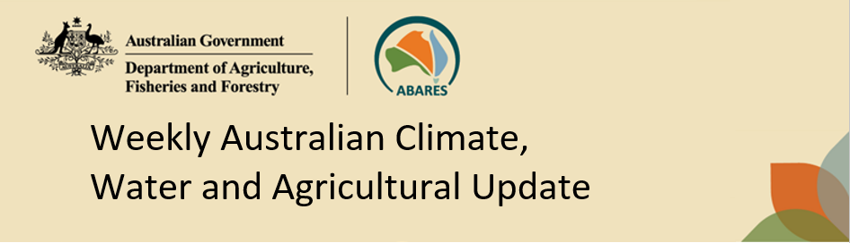
No. 43/2023 2 November 2023

Summary of key issues
- For the week ending 1 November 2023, a high-pressure system kept much of Australia dry. A cold front brought showers in Tasmania and southern Victoria and then moved northward bringing showers to eastern parts of New South Wales.
  - Across cropping regions, rainfall would have provided some relief to dwindling soil moisture levels, but it is likely that it would not have been sufficient to allow for the opportunity to plant dry land summer crops, such as, cotton and sorghum.
  - The dry conditions elsewhere would have allowed for the uninterrupted harvest of early planted crops.
- Over the next 8 days, troughs will bring widespread showers and trigger storms in southern Queensland and eastern New South Wales and in country’s northwest.
  - The expected rainfall would boost soil moisture levels and benefit the development of early-planted summer crops and late spring pasture production. Dry forecast conditions elsewhere will allow for a largely uninterrupted harvest of winter crops.
- Rainfall in October was severely deficient to below average for most of Australia.
  - Rapid decline soil moisture levels present an elevated downside production risk for dry land summer crops and for spring/summer pasture production across much of northern and central Australia.
- October recorded many days with below 11°C (cold shock) in the southern country.
  - High number of cold shock days has inhibited germination and led to poor cotton establishment and plant growth, which has prompted many producers to either replant or switch to other options like maize for cattle feed.
- Water storage levels in the Murray-Darling Basin (MDB) decreased between 26 October 2023 and 2 November 2023 by 16 gigalitres (GL). Current volume of water held in storage is 20 607 GL. This is 10 percent or 2254 GL less than at the same time last year.
- Allocation prices in the Victorian Murray below the Barmah Choke decreased from $174 on 26 October 2023 to $169 on 2 November 2023. Prices are lower in the Goulburn-Broken and regions above the Barmah choke due to the binding of the Goulburn intervalley trade limit and Barmah choke trade constraint.

Climate

Rainfall this week
For the week ending 1 November 2023, a high-pressure system brought mainly dry conditions to much of mainland Australia. A cold front brought showers in Tasmania and southern Victoria and then moved northward bringing showers to eastern parts of New South Wales.
Across cropping regions, rainfall totals of up to 25 millimetres were recorded in far north-eastern parts of New South Wales and up to 15 millimetres in an isolated part of northern Queensland. While this rainfall would have provided some relief to dwindling soil moisture levels it is likely that it would not have been sufficient to allow for the opportunity to plant dry land summer crops, such as, cotton and sorghum. Little to no rainfall was recorded across remaining cropping areas. The dry conditions across most cropping regions would have allowed for the uninterrupted harvest of early planted winter crops.

Rainfall for the week ending 1 November 2023
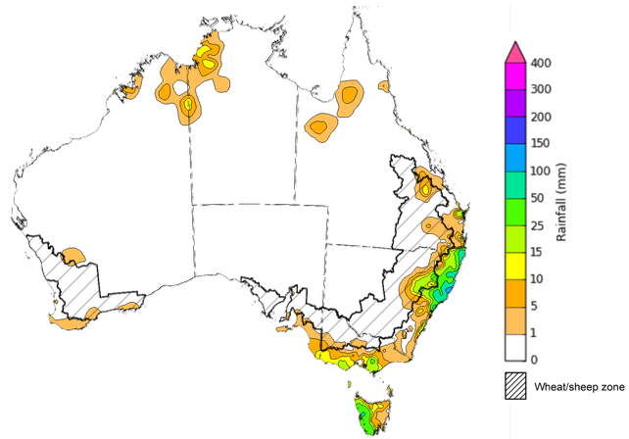
©Commonwealth of Australia 2023, Australian Bureau of Meteorology Issued: 1/11/2023
Note: The rainfall analyses and associated maps utilise data contained in the Bureau of Meteorology climate database, the Australian Data Archive for Meteorology (ADAM). The analyses are initially produced automatically from real-time data with limited quality control. They are intended to provide a general overview of rainfall across Australia as quickly as possible after the observations are received. For further information go to http://www.bom.gov.au/climate/rainfall/

Monthly rainfall
October 2023 was the driest October since 2002 with total rainfall 65% below long-term average, nationally. Rainfall was severely deficient to below average for most of Australia, with exceptions being central and eastern Victoria extending to adjacent parts of New South Wales and isolated part in southern Queensland and northern Western Australia where rainfall was above average.
In cropping regions, October rainfall was highly variable ranging from extremely low in Queensland and Westen Australia to well above average in parts of New South Wales and Victoria. While the lack of rainfall would have allowed for an uninterrupted harvest of winter crops, a rapid decline soil moisture levels present an elevated downside production risk for dry land summer crops and for spring/summer pasture production across much of northern and central Australia.

Rainfall percentiles for October 2023
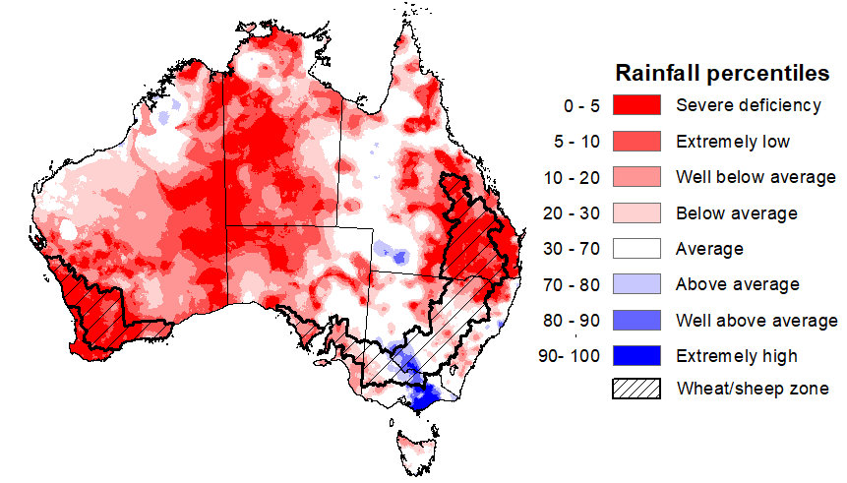
Note: Rainfall for October 2023 is compared with rainfall recorded for that period during the historical record (1900 to present). For further information, go to http://www.bom.gov.au/jsp/awap/
Source: Bureau of Meteorology

Monthly temperature
Rainfall and cooler than normal temperature during October have aided winter crop prospects across the far southeast of the country. The boost in soil moisture levels and cool temperatures stabilised yield potential in winter cereal and is likely to benefit oil content in canola.

Meanwhile, these cooler than normal temperatures, particularly night-time temperatures, has not been all good news for irrigated summer crop producers. With cotton planting well underway across southern New South Wales since early September, those producers who were able to plant early their crops are tracking well, with germination occurring under ideal warm conditions in September.

However, many producers didn’t plant until after the widespread rainfall in early October. This rainfall brought a significant change in weather patterns and temperatures. Through October there have been many nights (in excess of 20 in some areas) where the night-time temperature dropped below 11°C, across major cotton growing regions in southern New South Wales. Night-time temperatures this low are typically referred to as cold-shock days. This high number of cold-shock days has inhibited germination and led to poor cotton establishment and plant growth, which has prompted many producers to either replant or switch to other options like maize for cattle feed.

Number of cold shock (minimum temperature < 11°C) days in October 2023

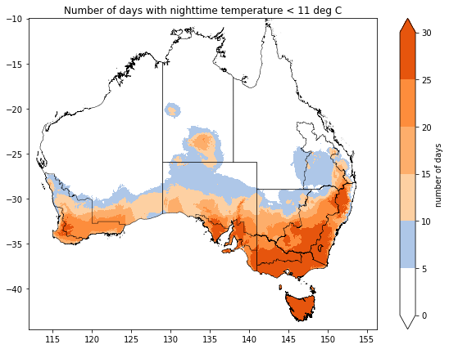

©Commonwealth of Australia 2023, Australian Bureau of Meteorology; ABARES

Rainfall forecast for the next eight days
Over the 8 days to 9 November 2023, troughs are expected to bring widespread showers and trigger storms in southern Queensland and eastern New South Wales and in country’s northwest.
Across cropping regions, rainfall totals up to 50 millimetres are forecast for Queensland and northern New South Wales, while little to no rainfall is expected elsewhere. This expected rainfall would boost soil moisture levels and benefit the development of early-planted summer crops and late spring pasture production. Meanwhile the dry forecast conditions elsewhere will allow for a largely uninterrupted harvest of winter crops.

Total forecast rainfall for the period 2 November 2023 to 9 November 2023
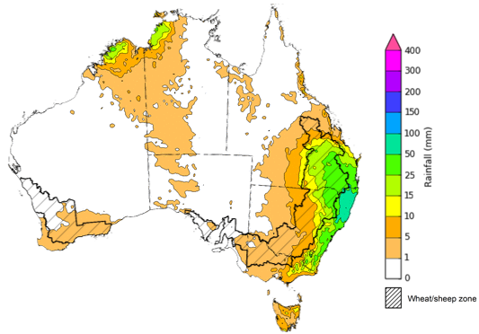

©Commonwealth of Australia 2023, Australian Bureau of Meteorology Issued 1/11/2023
Note: This rainfall forecast is produced from computer models. As the model outputs are not altered by weather forecasters, it is important to check local forecasts and warnings issued by the Bureau of Meteorology.

Water

Water markets – current week
Water storage levels in the Murray-Darling Basin (MDB) decreased between 26 October 2023 and 2 November 2023 by 16 gigalitres (GL). Current volume of water held in storage is 20 607 GL. This is 10 percent or 2254 GL less than at the same time last year.

Water storages in the Murray-Darling Basin, 2013–2023
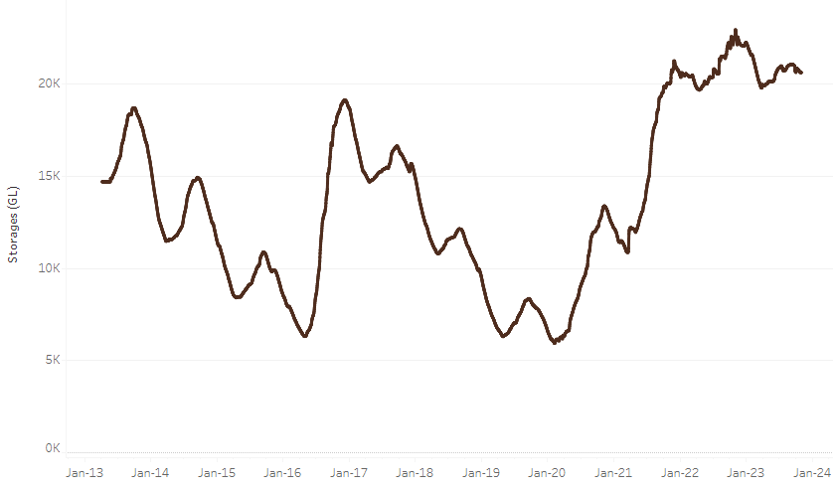
Allocation prices in the Victorian Murray below the Barmah Choke decreased from $174 on 26 October 2023 to $169 on 2 November 2023. Prices are lower in the Goulburn-Broken and regions above the Barmah choke due to the binding of the Goulburn intervalley trade limit and Barmah choke trade constraint.
Water storage data is sourced from the Bureau of Meteorology.

Region | $/ML
NSW Murray Above | 107
NSW Murrumbidgee | 194
VIC Goulburn-Broken | 145
VIC Murray Below | 169

Surface water trade activity, Southern Murray–Darling Basin
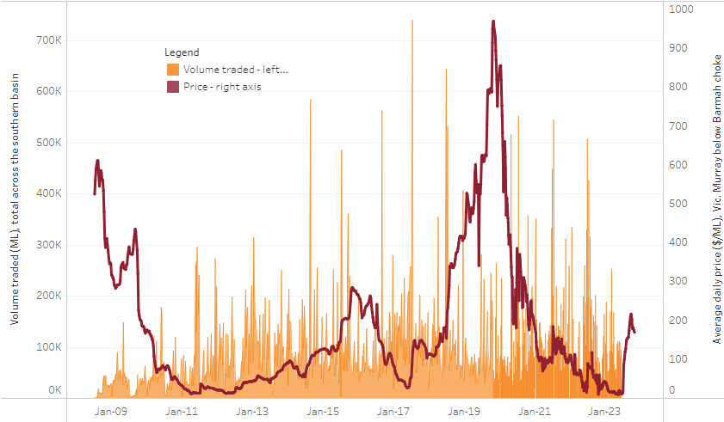
The trades shown reflect estimated market activity and do not encompass all register trades. The price is shown for the VIC Murray below the Barmah choke. Historical prices (before 1 July 2019) are ABARES estimates after removing outliers from BOM water register data. Prices after 1 July 2019 and prior to the 30 October 2019 reflect recorded transaction prices as sourced from Ruralco. Prices after the 30 October 2019 are sourced from Waterflow. Data for volume traded is sourced from the BOM water register. Only the price data shown is current on 2 November 2023.

To access the full, interactive, weekly water dashboard, which contains the latest and historical water storage, water market and water allocation information, please visit https://www.agriculture.gov.au/abares/products/weekly_update/weekly-update-21123

Commodities
Indicator | Week ended | Unit | Latest Price | Previous Week | Weekly change | Price 12 months ago | Annual change
Selected world indicator prices
AUD/USD Exchange rate | 01-Nov | A$/US$ | 0.63 | 0.63 | 0% | 0.65 | -2%
Wheat – US no. 2 hard red winter wheat, fob Gulf | 01-Nov | US$/t | 286 | 293 | -2% | 426 | -33%
Corn – US no. 2 yellow corn, fob Gulf | 01-Nov | US$/t | 217 | 222 | -2% | 325 | -33%
Canola – Rapeseed, Canada, fob Vancouver | 01-Nov | US$/t | 520 | 532 | -2% | 708 | -27%
Cotton – Cotlook 'A' Index | 01-Nov | USc/lb | 94 | 94 | 0% | 104 | -10%
Sugar – Intercontinental Exchange, nearby futures, no.11 contract | 01-Nov | USc/lb | 26.9 | 27.1 | -1% | 18 | 48%
Wool – Eastern Market Indicator | 01-Nov | Ac/kg clean | 1,129 | 1,139 | -1% | 1,306 | -14%
Wool – Western Market Indicator | 01-Nov | Ac/kg clean | 1,255 | 1,266 | -1% | 1,459 | -14%
Selected Australian grain export prices
Milling Wheat – APW, Port Adelaide, SA | 01-Nov | A$/t | 471 | 482 | -2% | 612 | -23%
Feed Wheat – ASW, Port Adelaide, SA | 01-Nov | A$/t | 451 | 463 | -3% | 558 | -19%
Feed Barley – Port Adelaide, SA | 01-Nov | A$/t | 406 | 406 | 0% | 481 | -16%
Canola – Kwinana, WA | 01-Nov | A$/t | 785 | 784 | 0% | 1,109 | -29%
Grain Sorghum – Brisbane, QLD | 01-Nov | A$/t | 506 | 513 | -1% | 476 | 6%
Selected domestic livestock indicator prices
Beef – Eastern Young Cattle Indicator | 01-Nov | Ac/kg cwt | 362 | 353 | 2% | 1,034 | -65%
Mutton – Mutton indicator (18–24 kg fat score 2–3), Vic | 01-Nov | Ac/kg cwt | 98 | 97 | 1% | 516 | -81%
Lamb – National Trade Lamb Indicator | 01-Nov | Ac/kg cwt | 481 | 491 | -2% | 795 | -39%
Pig – Eastern Seaboard (60.1–75 kg), average of buyers & sellers | 18-Oct | Ac/kg cwt | 367 | 367 | 0% | 376 | -2%
Goats – Eastern States (12.1–16 kg) | 27-Sep | Ac/kg cwt | 207 | 255 | -19% | 857 | -76%
Live cattle – Light steers to Indonesia | 01-Nov | Ac/kg lwt | 275 | 270 | 2% | 520 | -47%
Global Dairy Trade (GDT) weighted average prices ª
Dairy – Whole milk powder | 18-Oct | US$/t | 3,059 | 2,931 | 4% | 3,573 | -14%
Dairy – Skim milk powder | 18-Oct | US$/t | 2,659 | 2,558 | 4% | 3,497 | -24%
Dairy – Cheddar cheese | 18-Oct | US$/t | 3,858 | 3,853 | 0% | 4,966 | -22%
Dairy – Anhydrous milk fat | 18-Oct | US$/t | 5,310 | 4,979 | 7% | 5,811 | -9%
a Global Dairy Trade prices are updated twice monthly on the first and third Tuesday of each month.

Selected world indicator prices
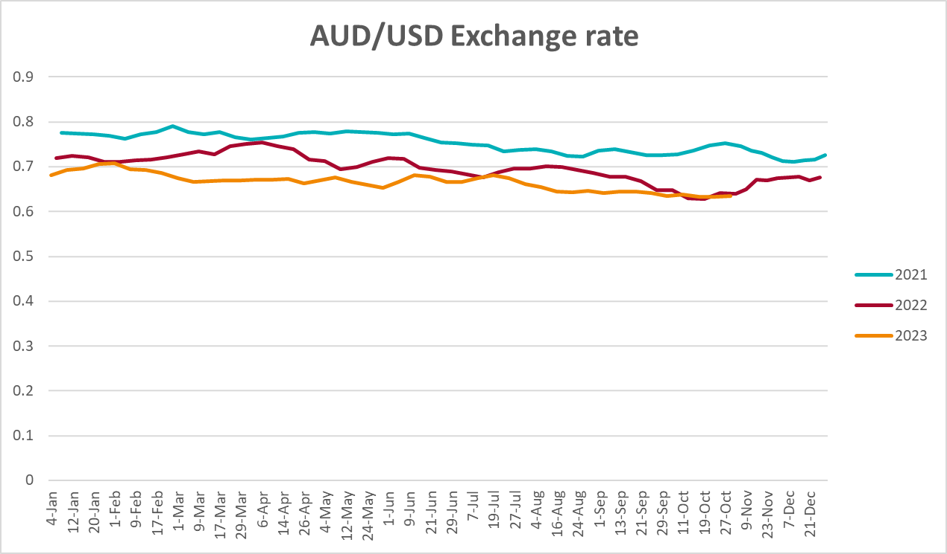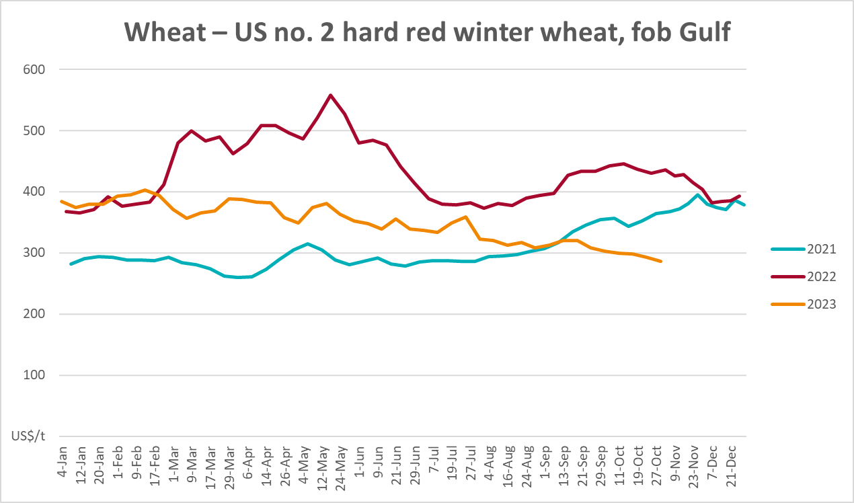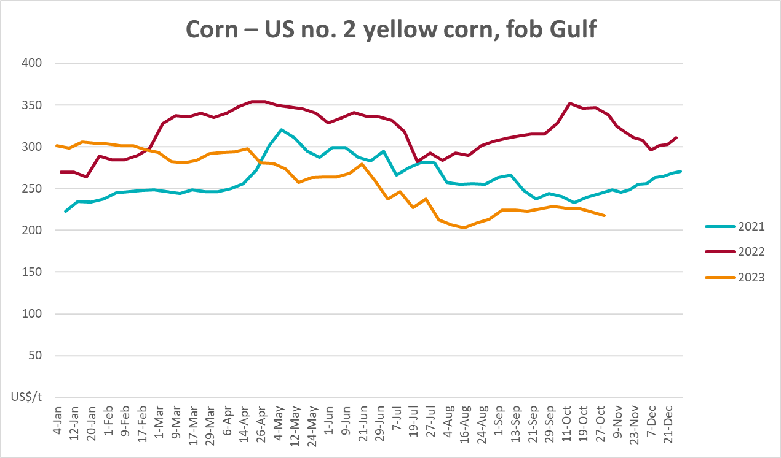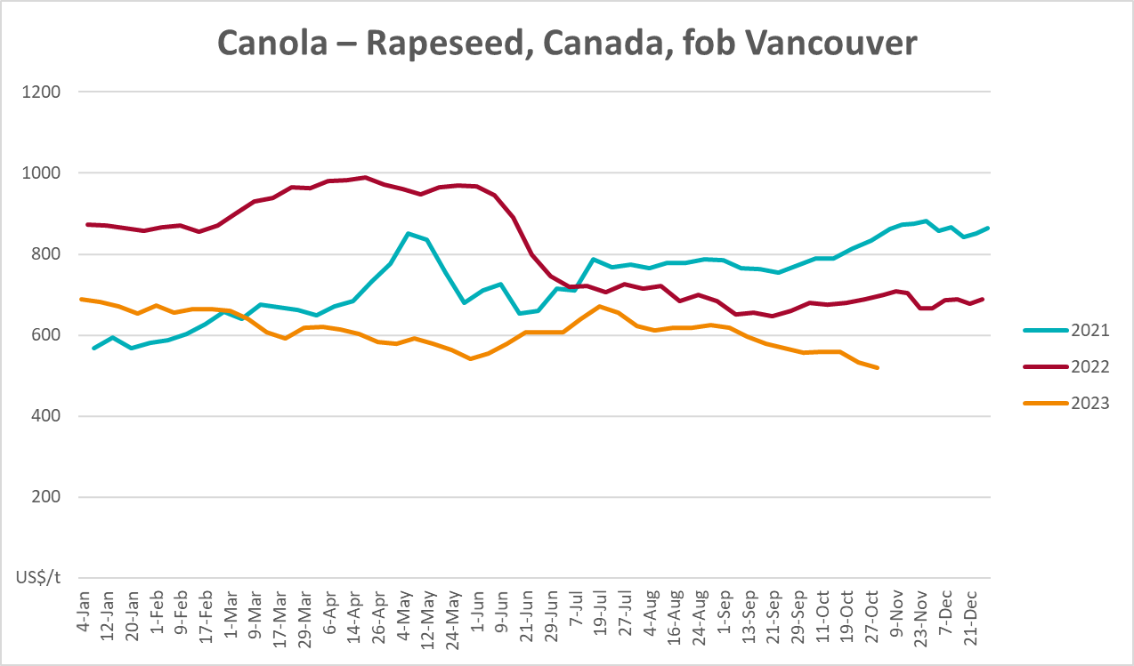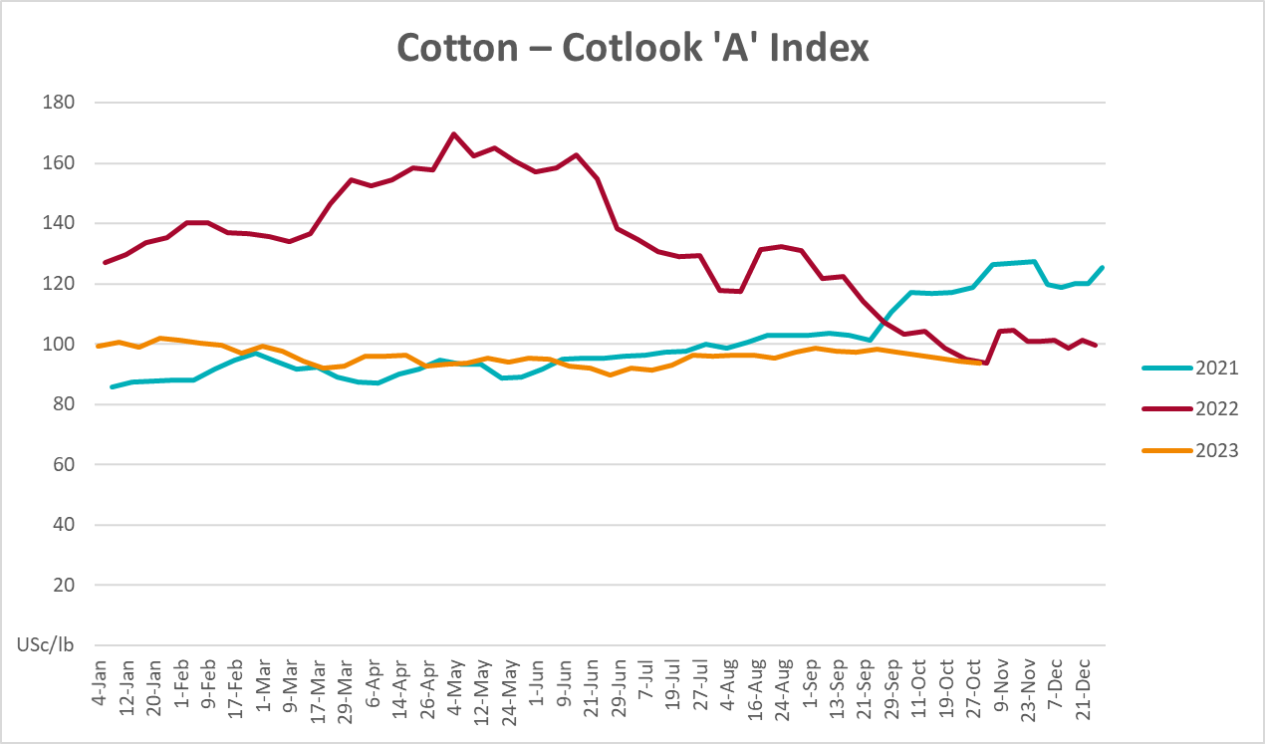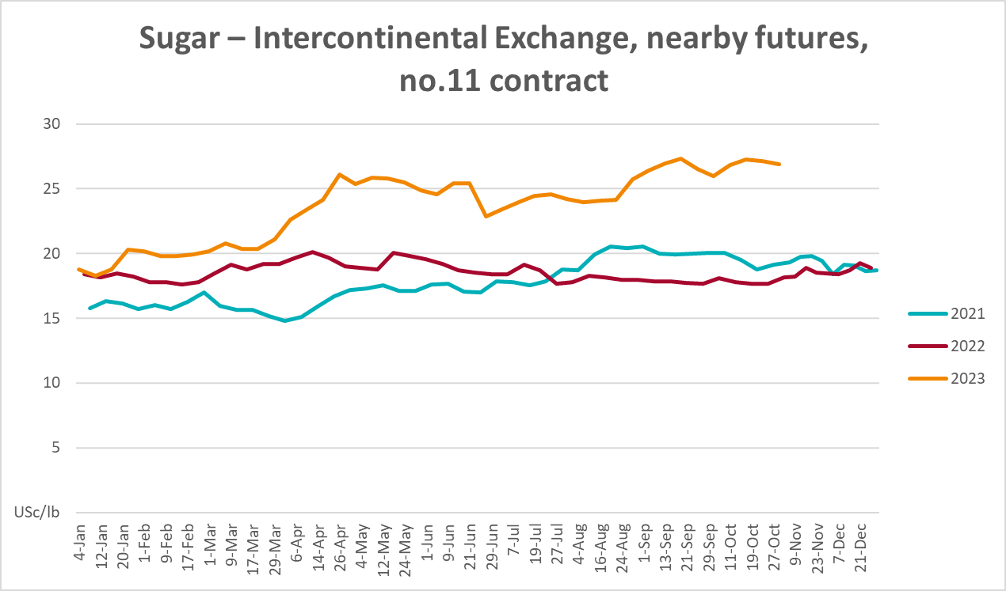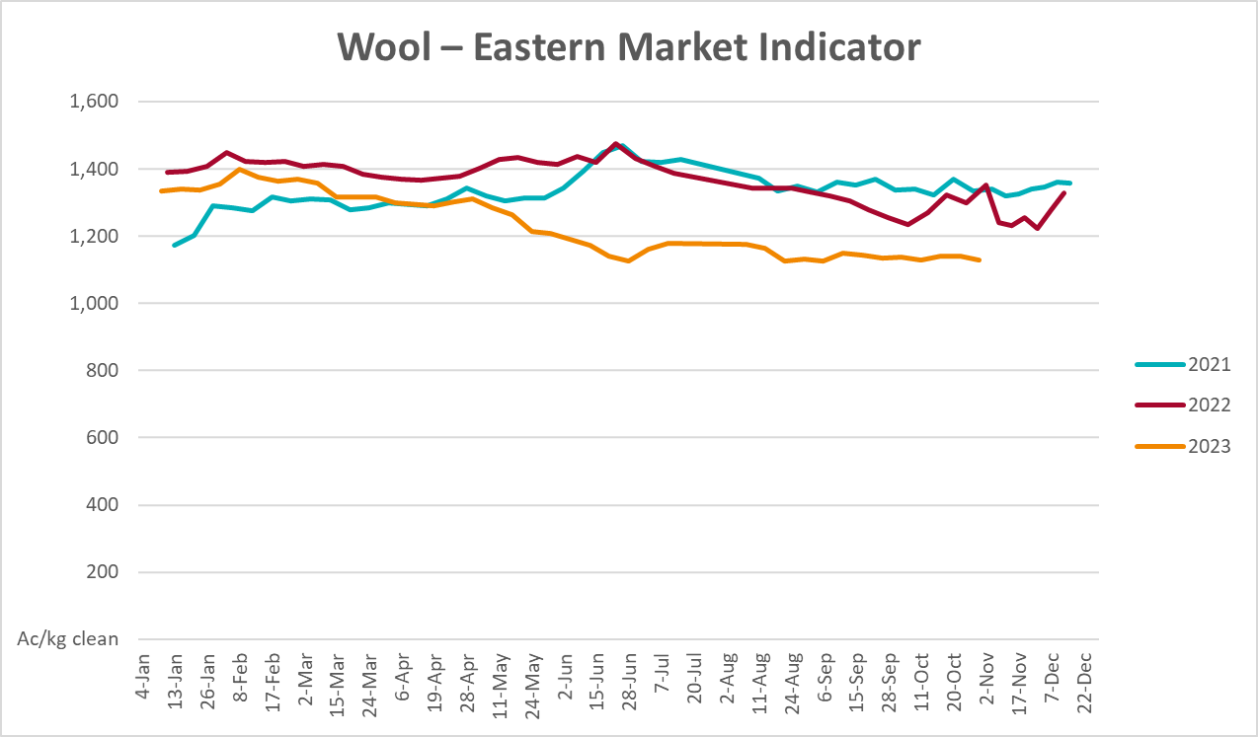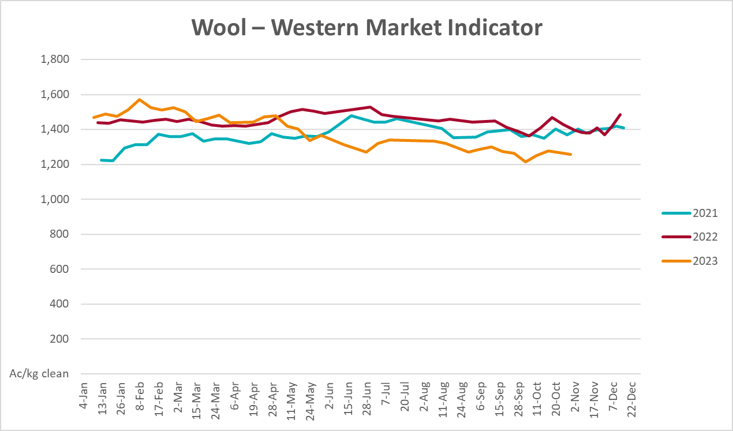

Selected domestic crop indicator prices
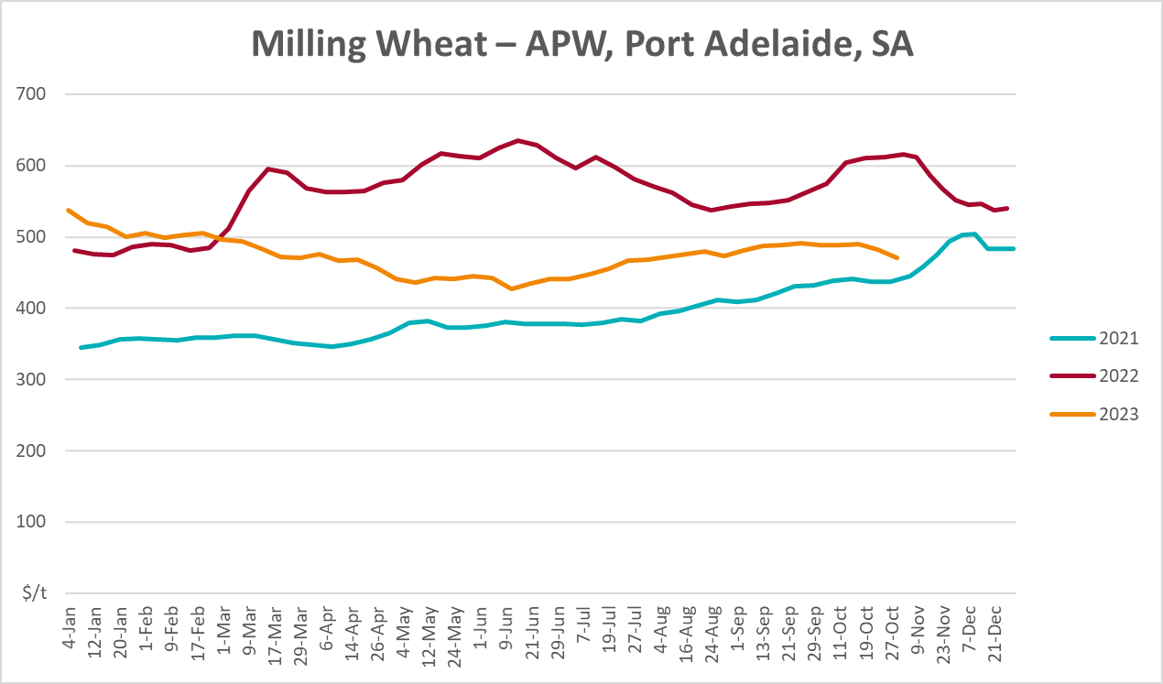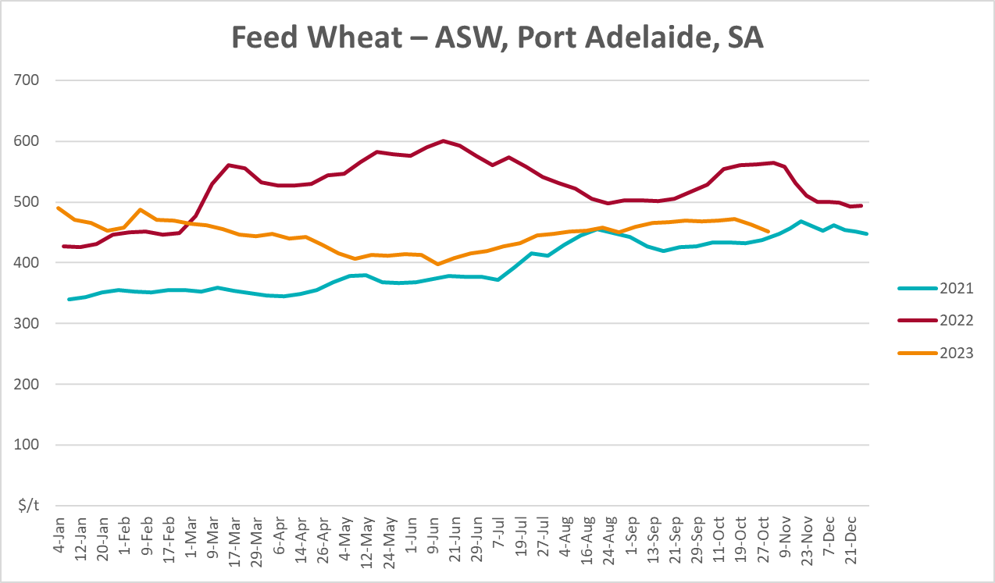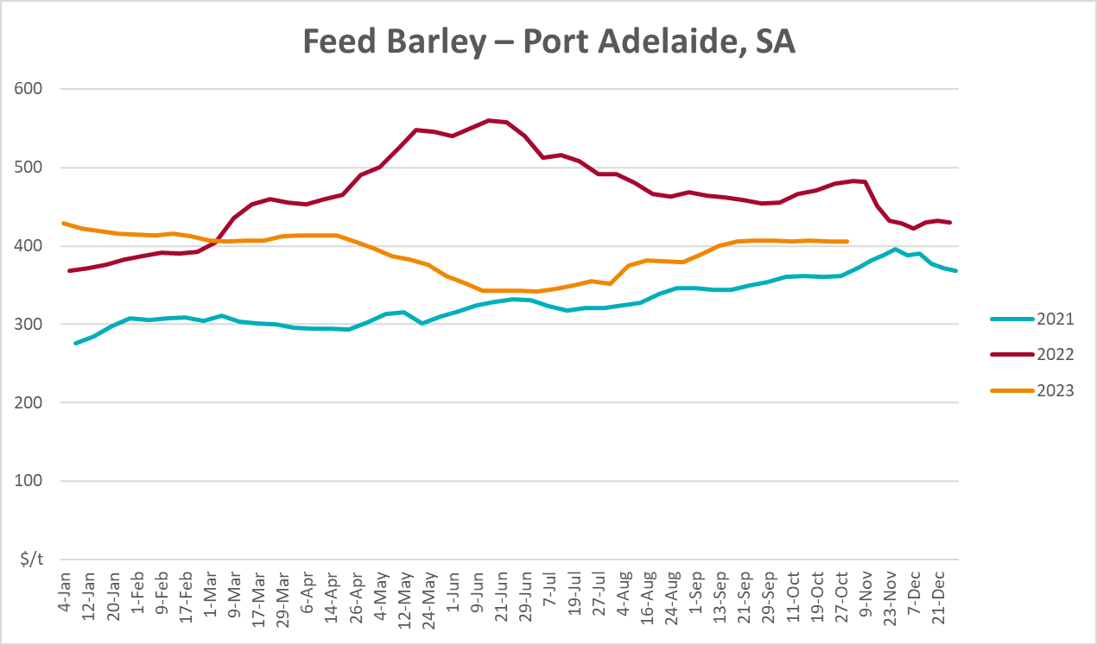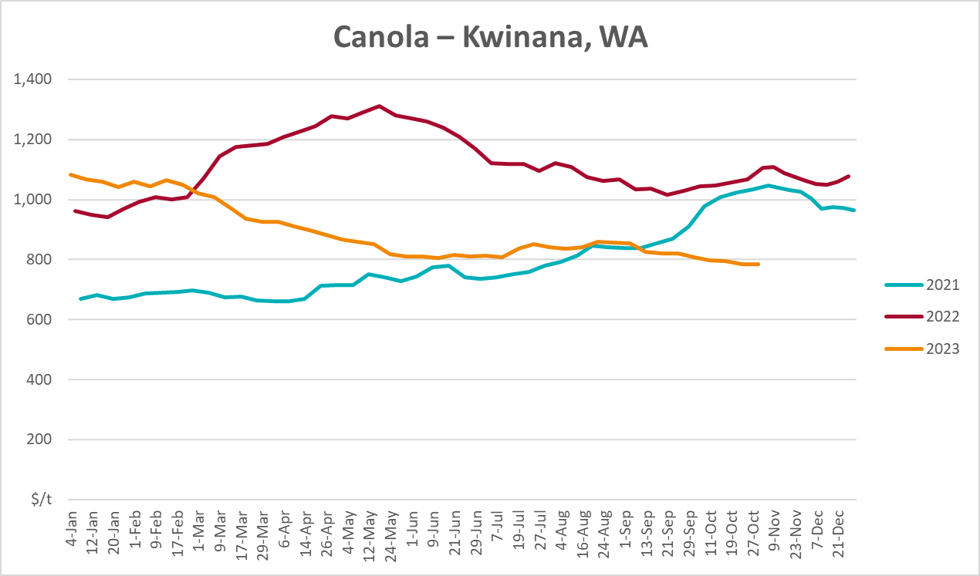
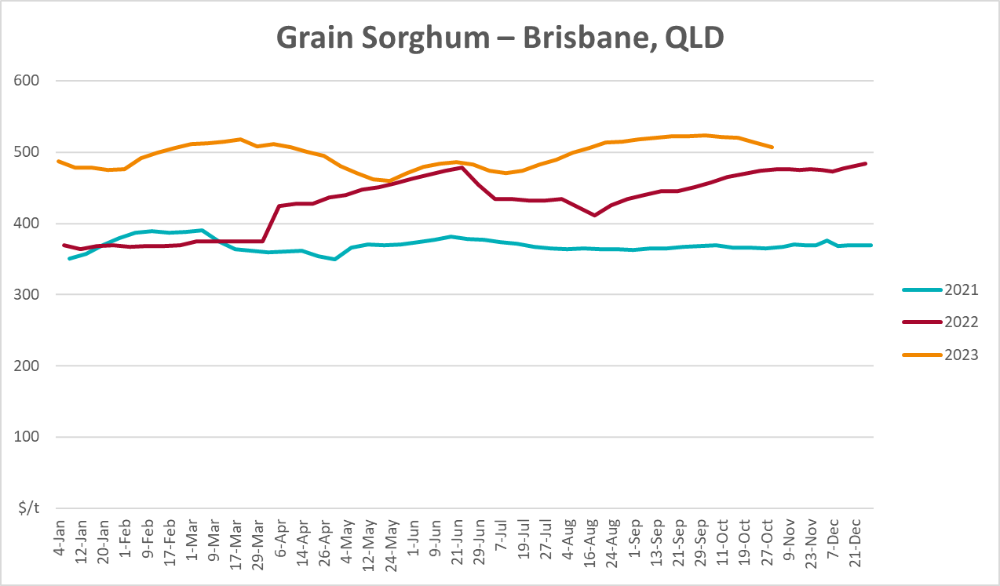

Selected domestic livestock indicator prices
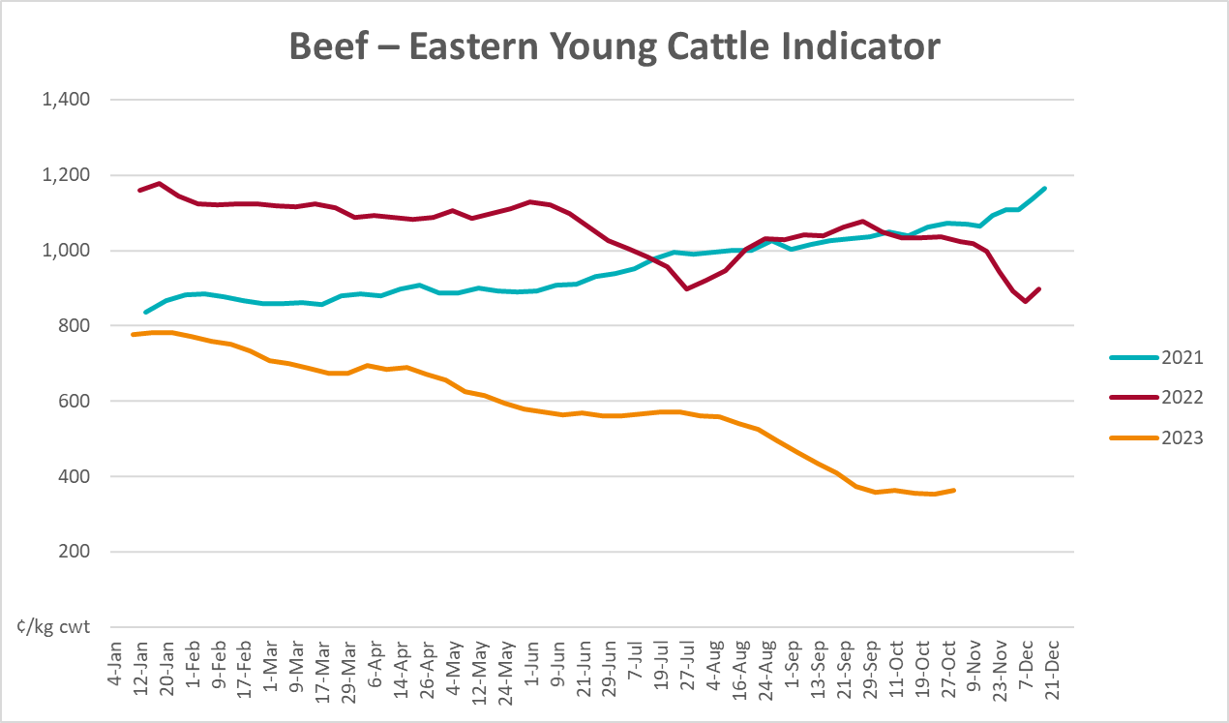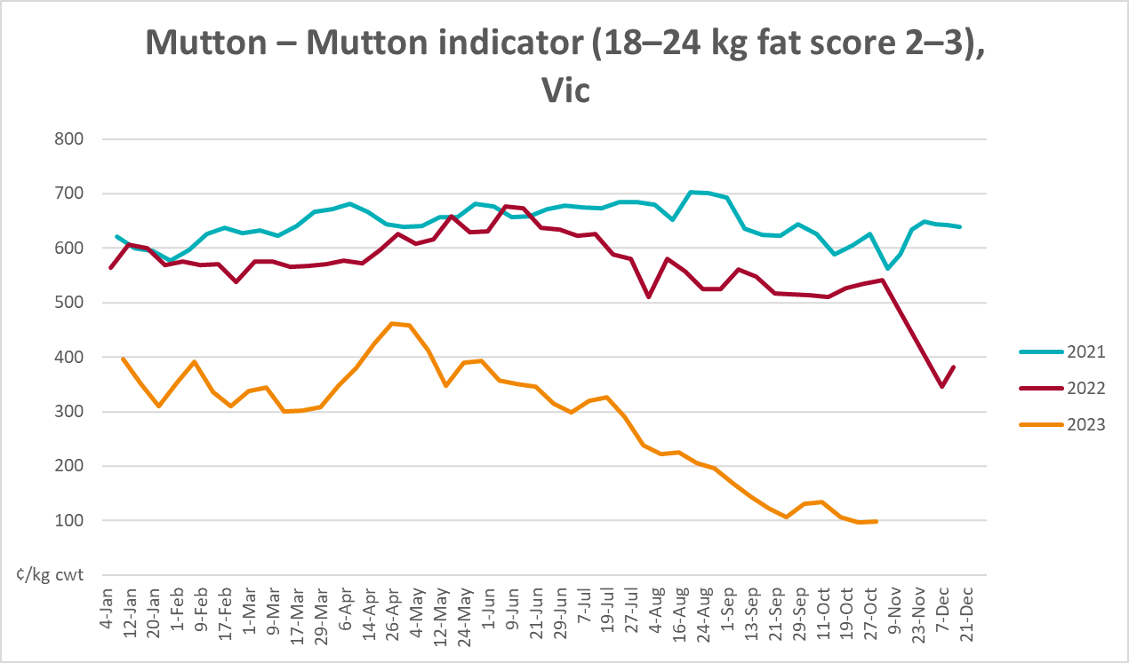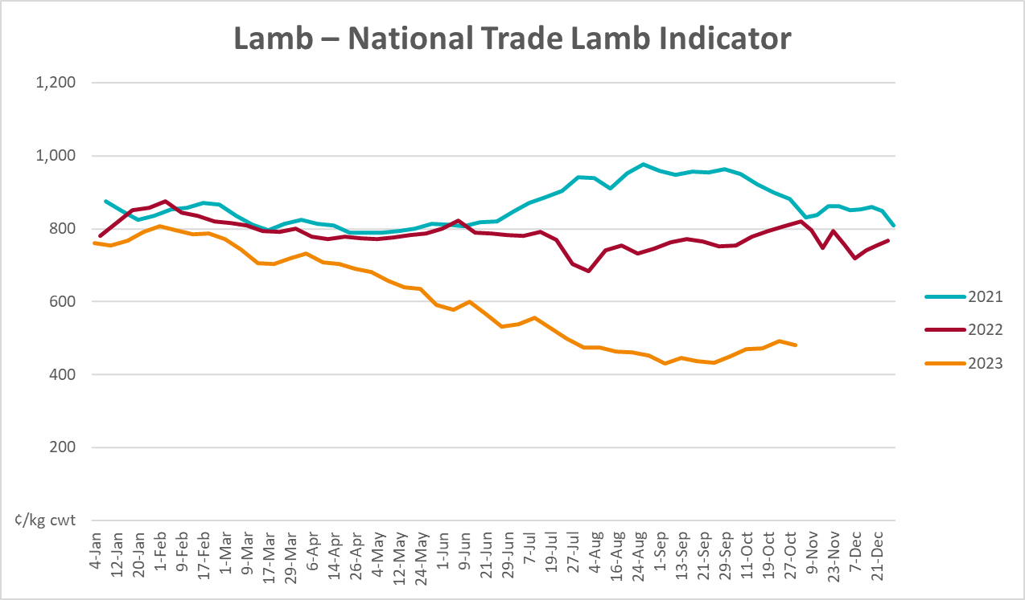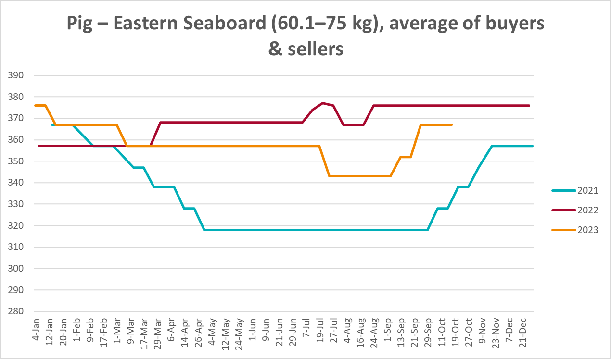
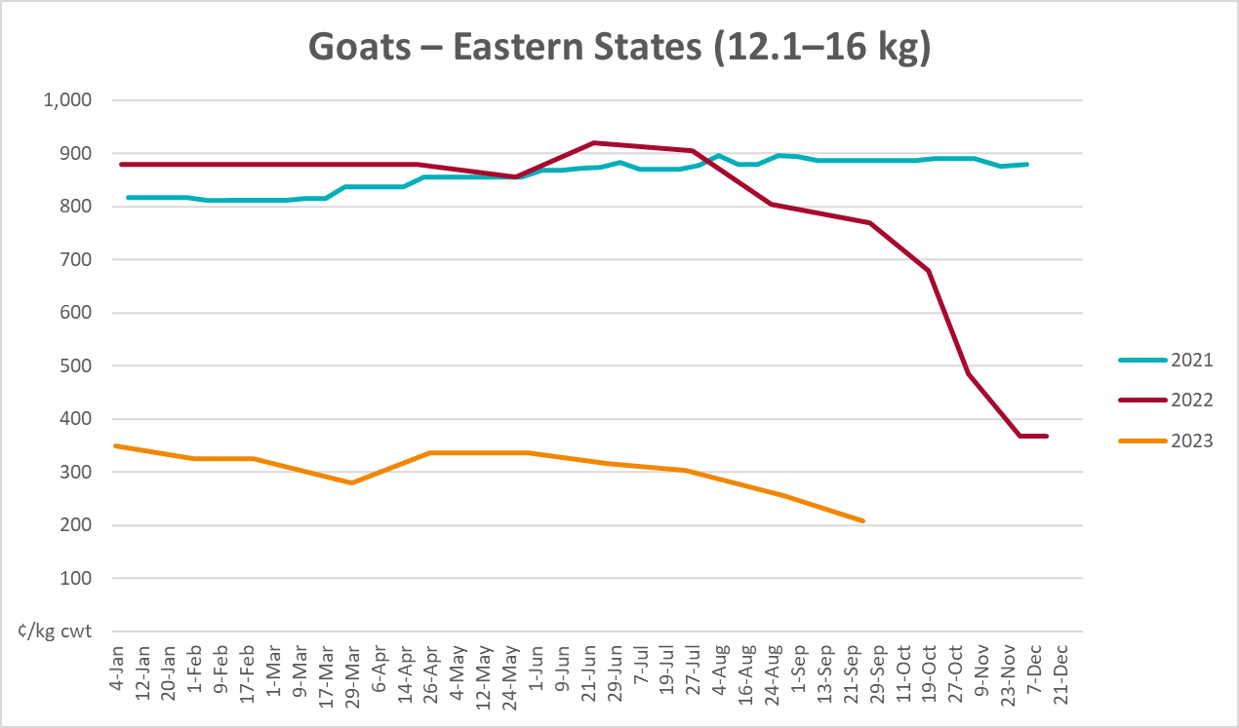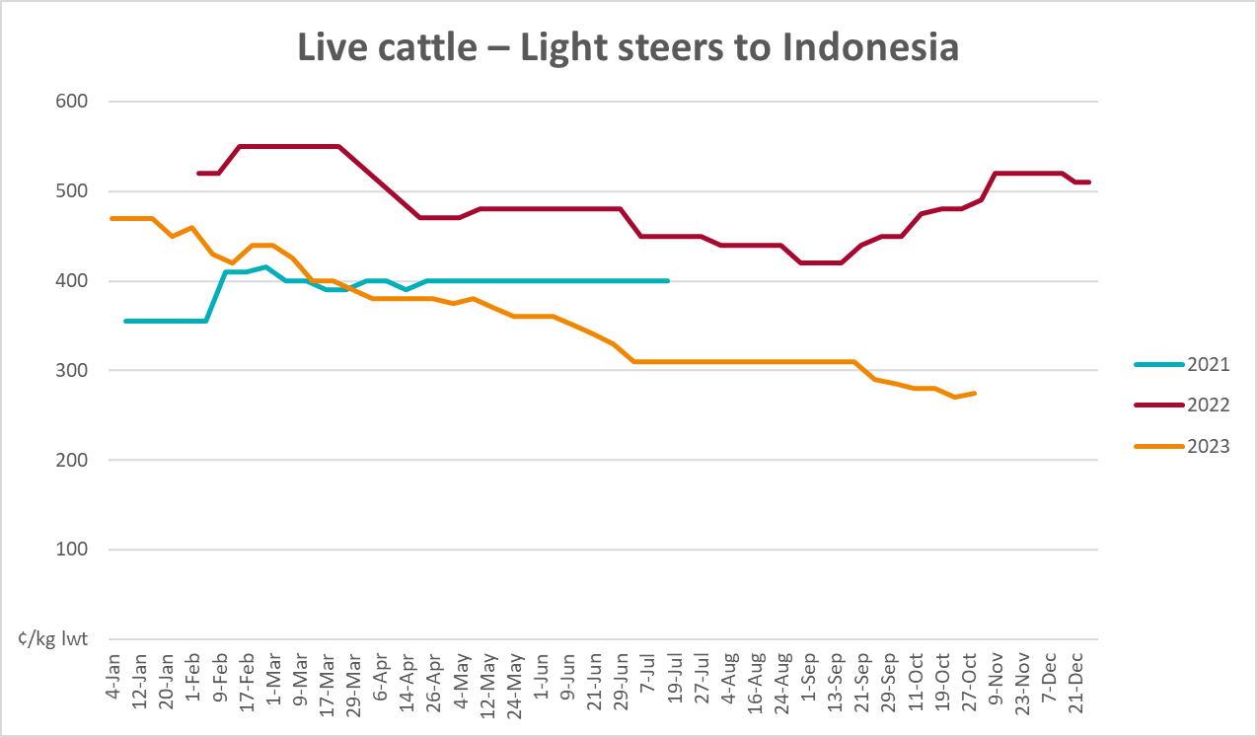

Global Dairy Trade (GDT) weighted average prices
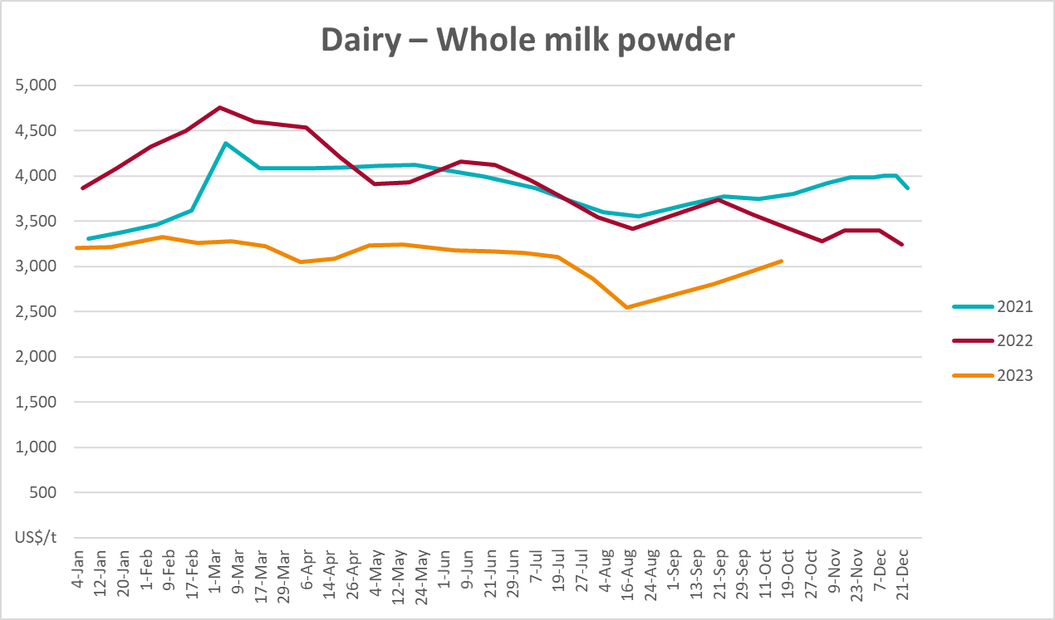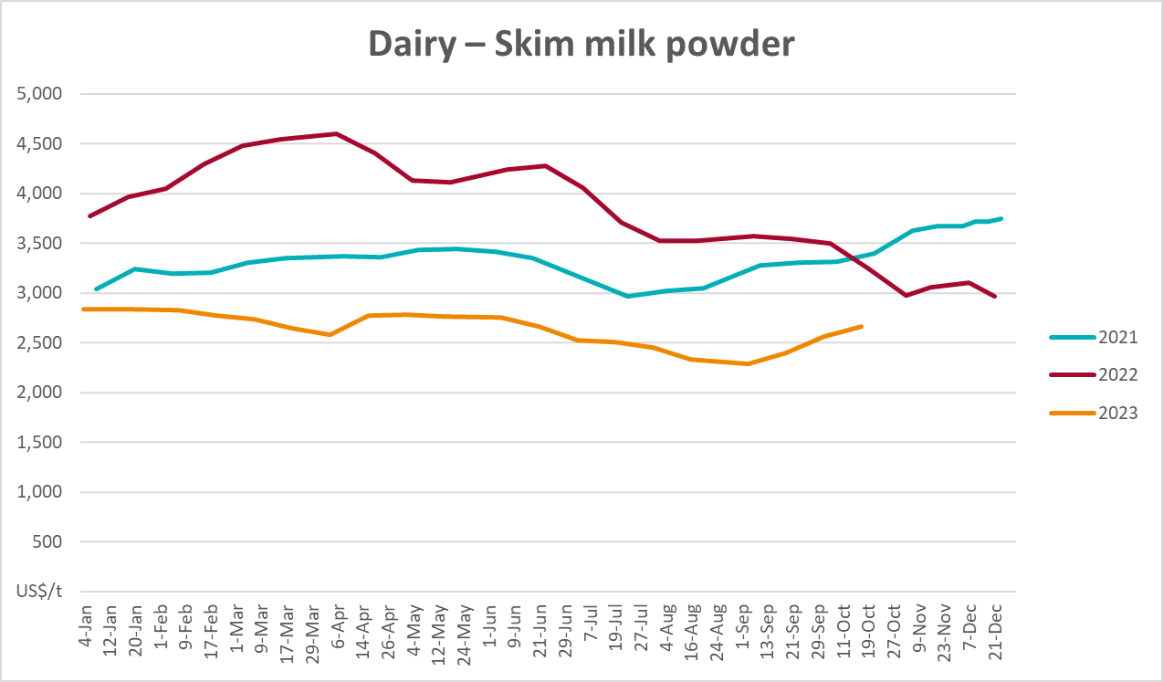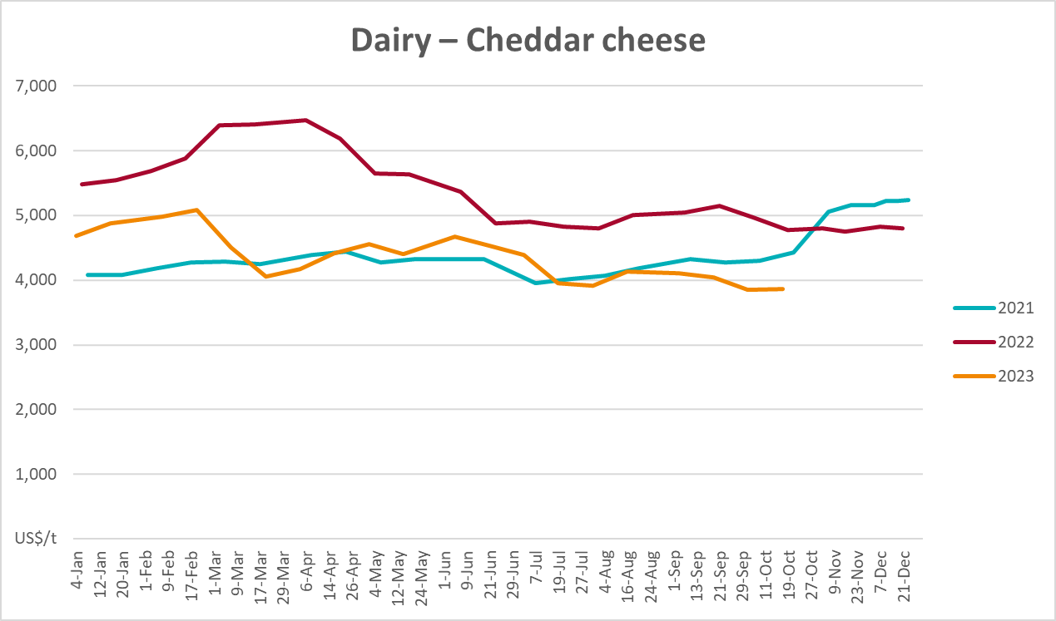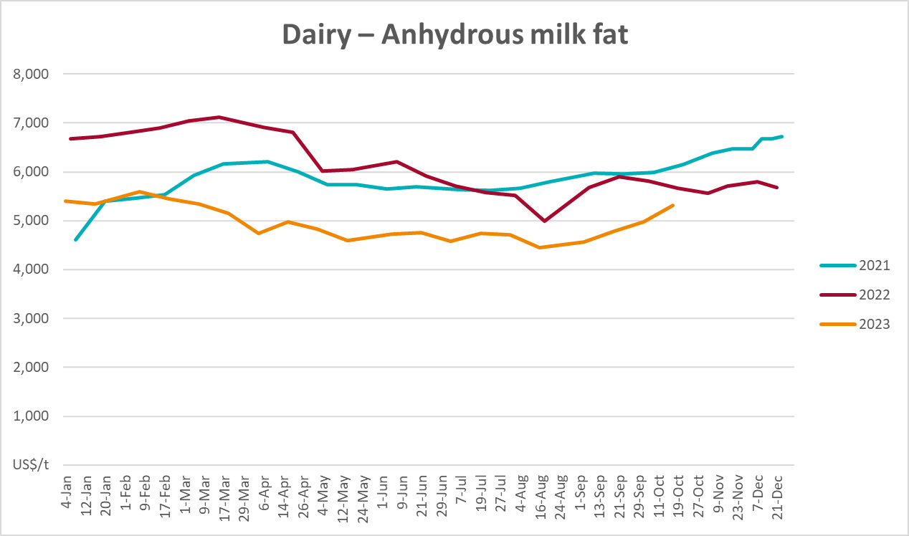

Selected fruit and vegetable prices
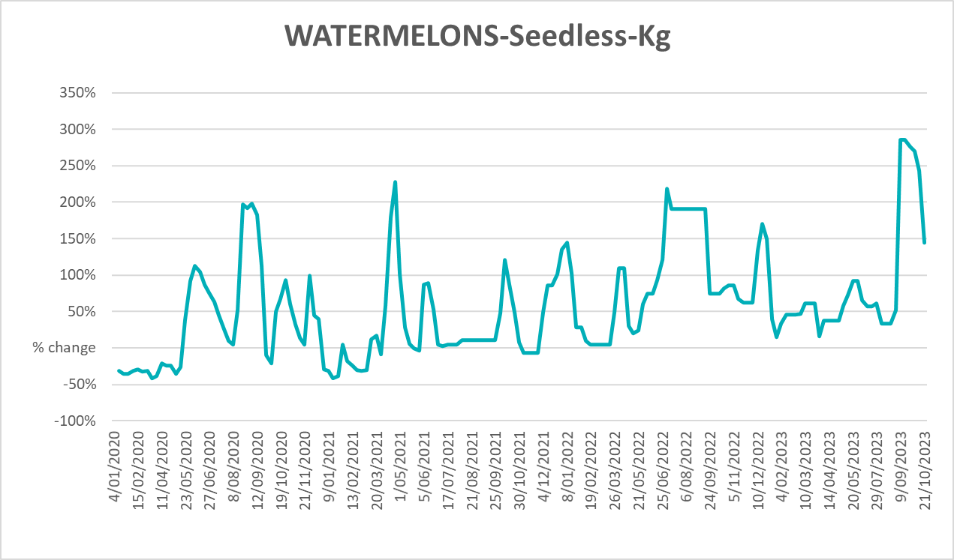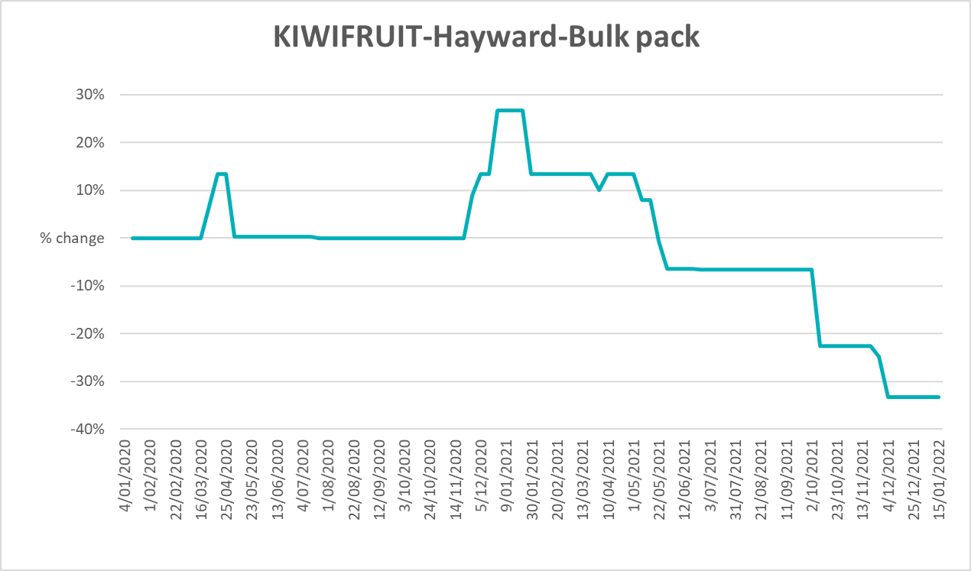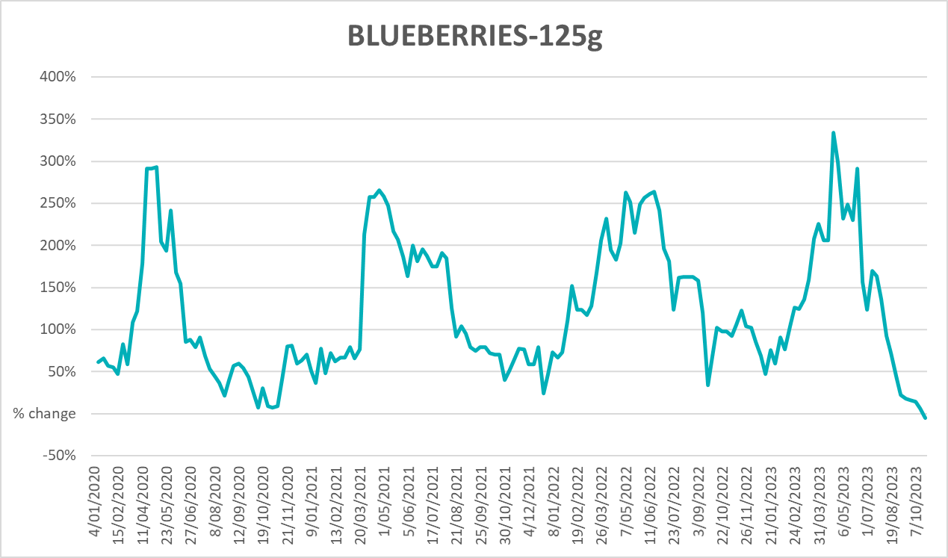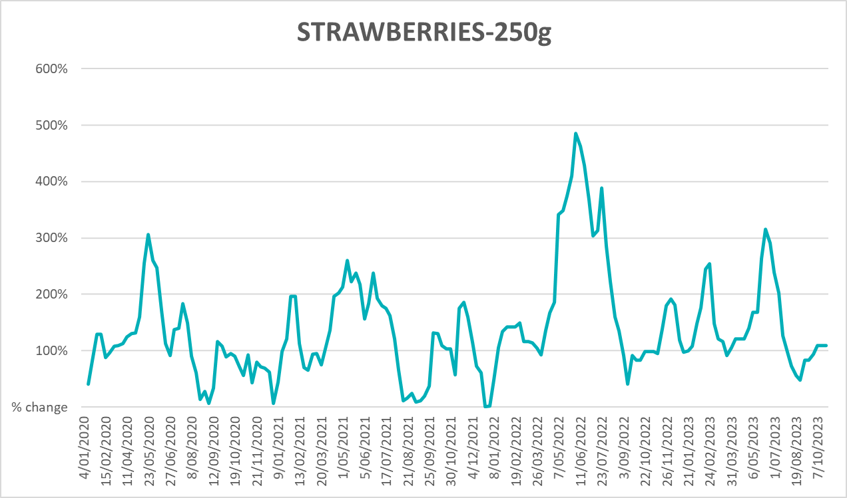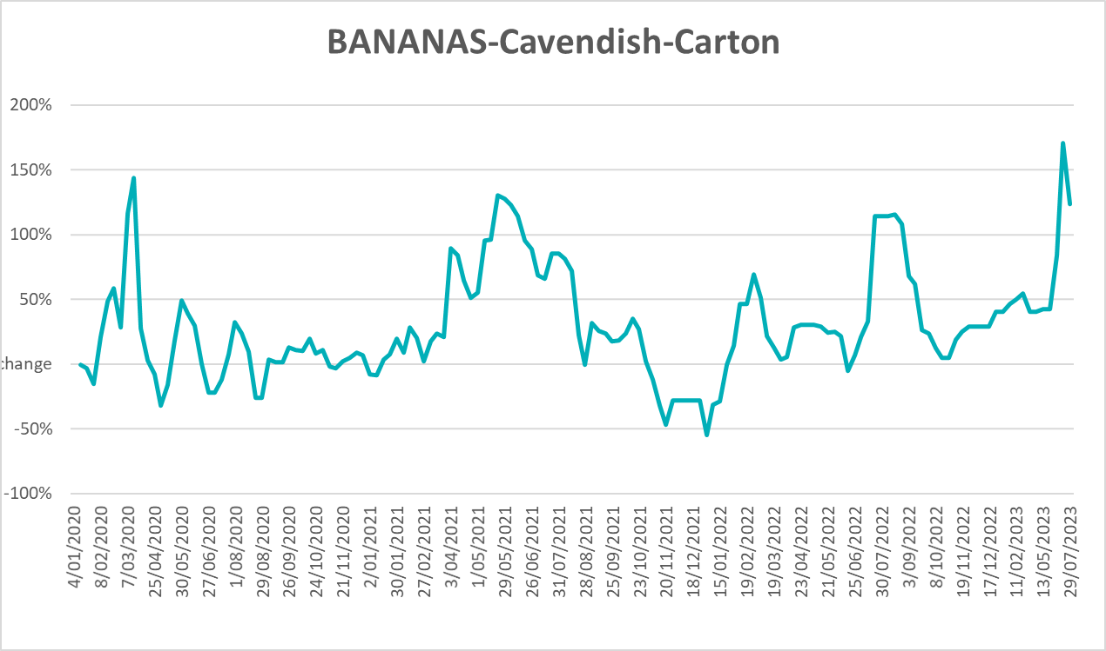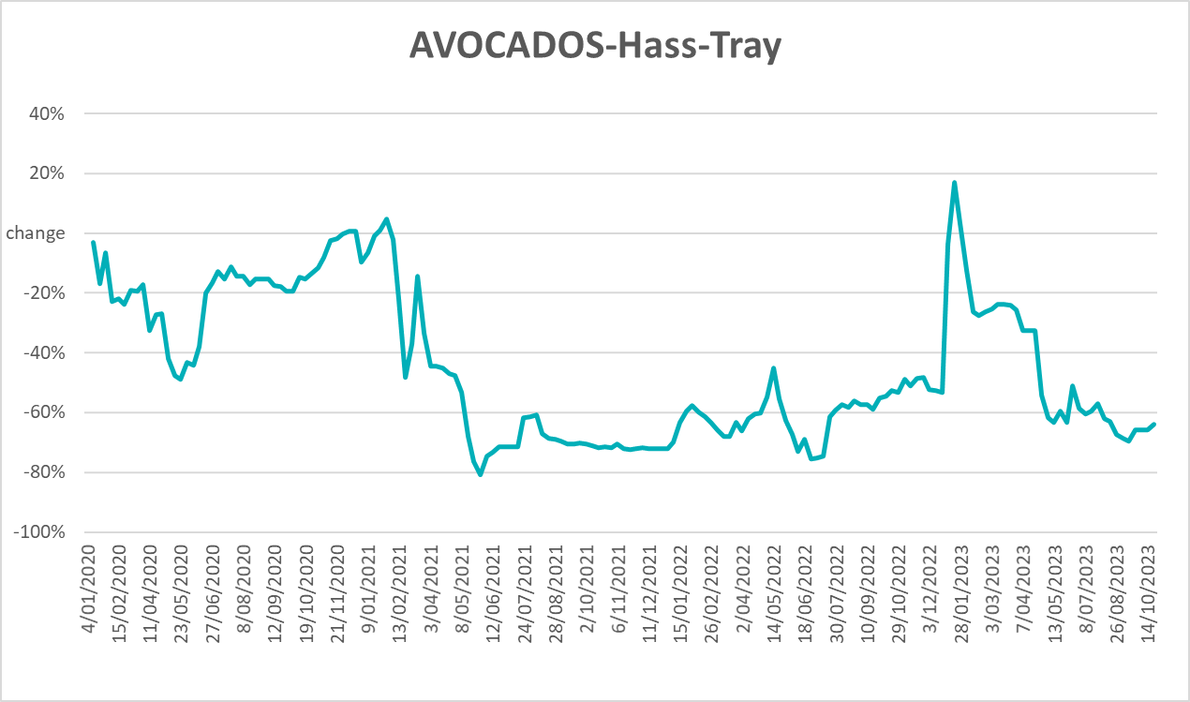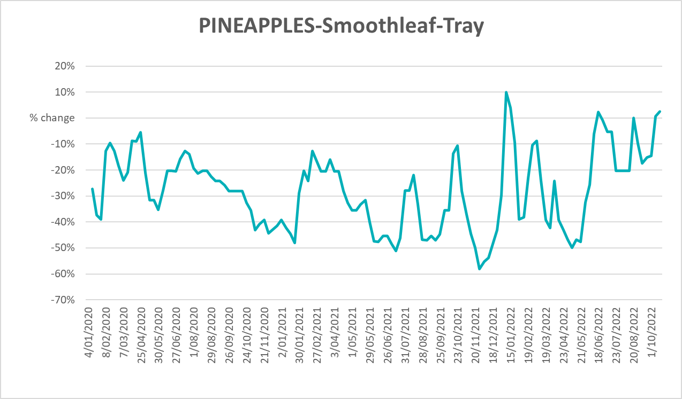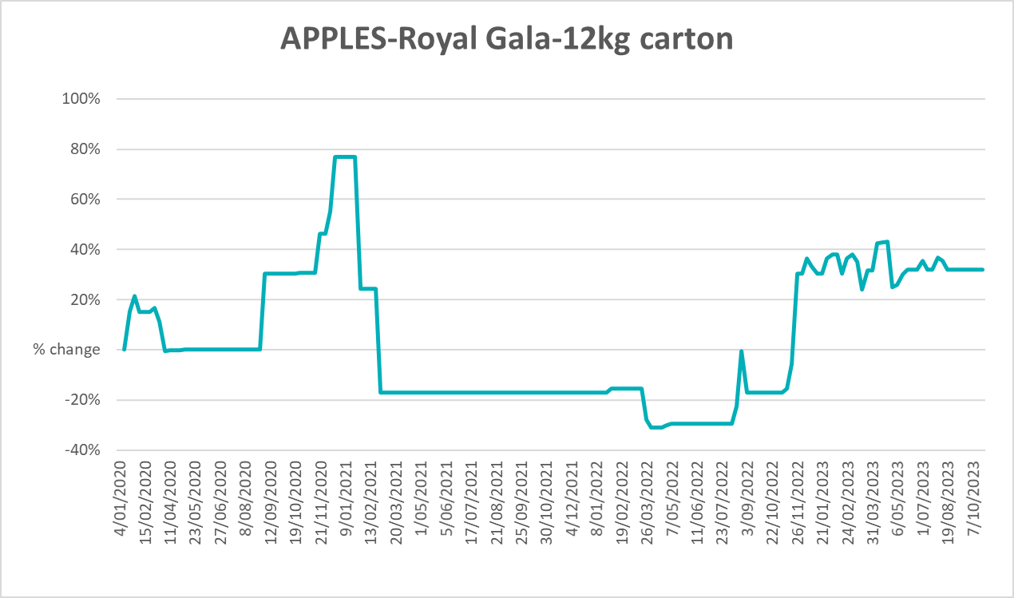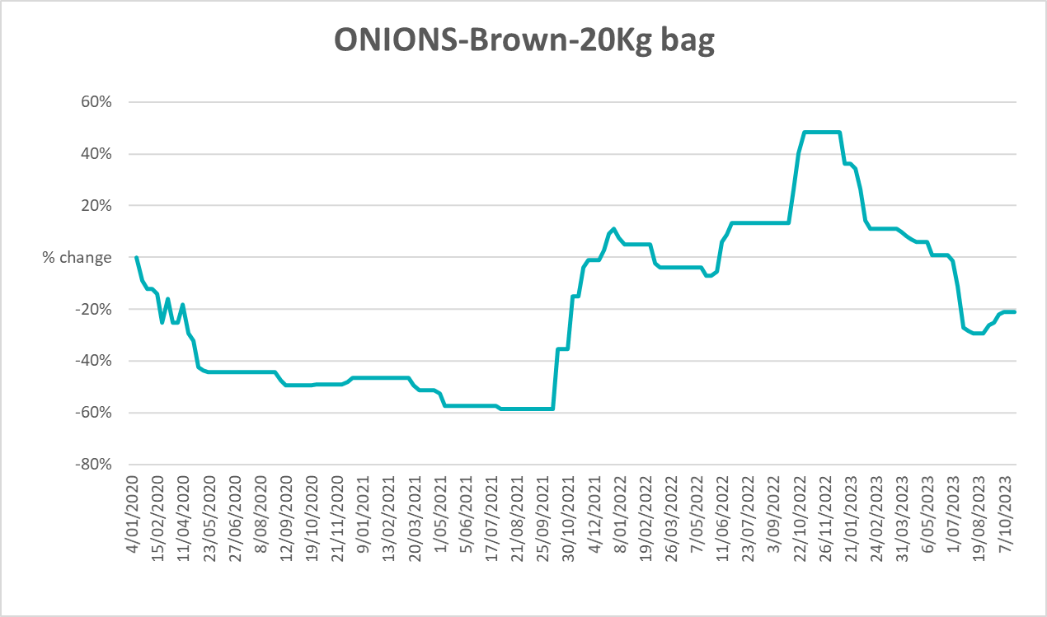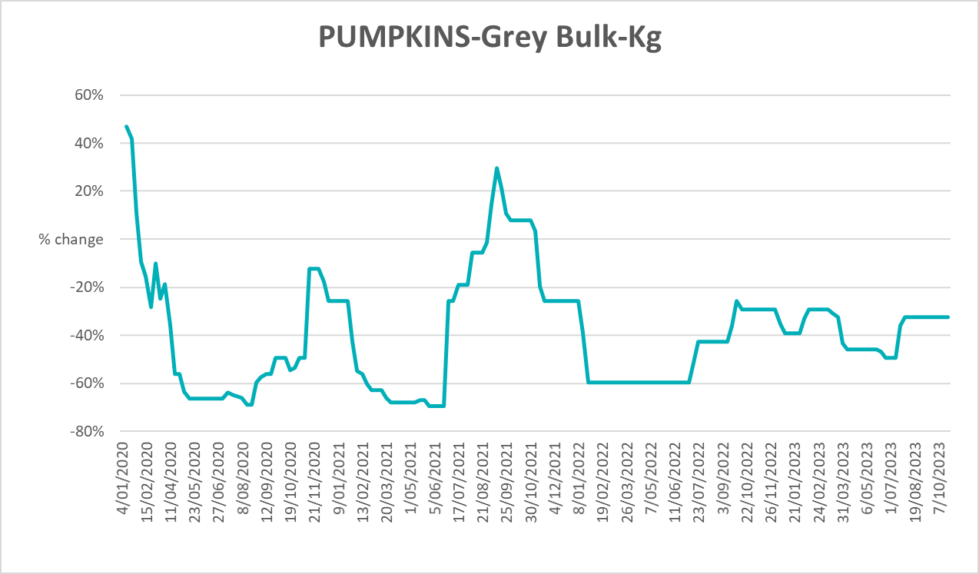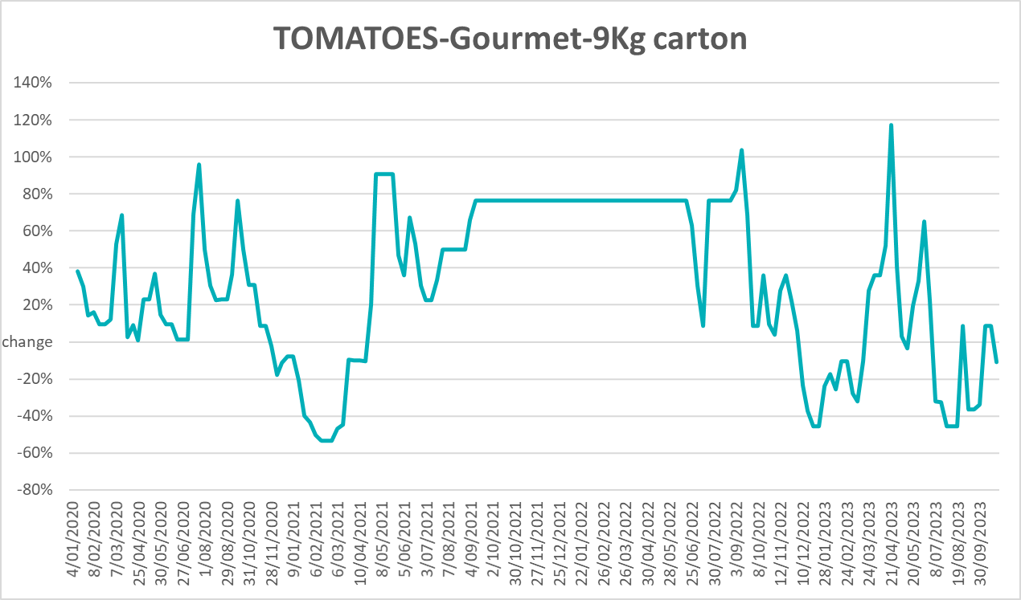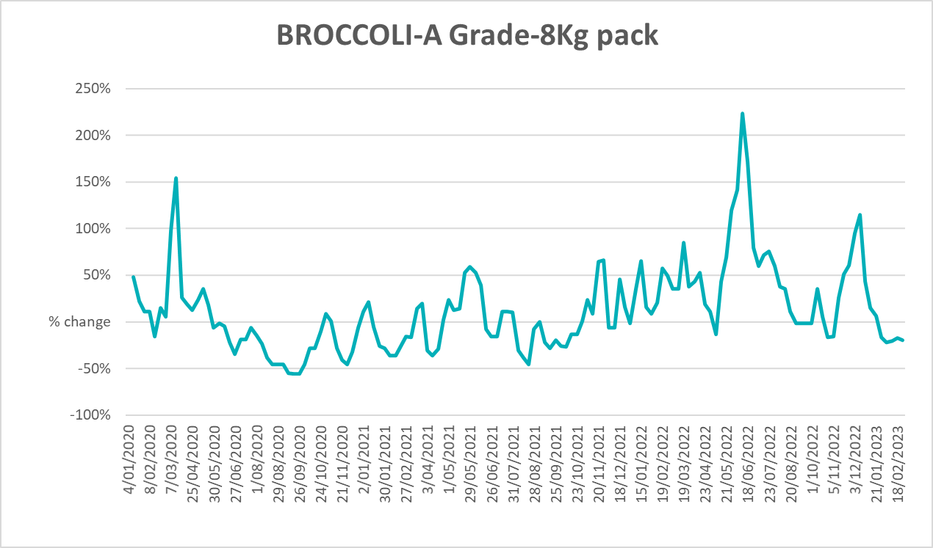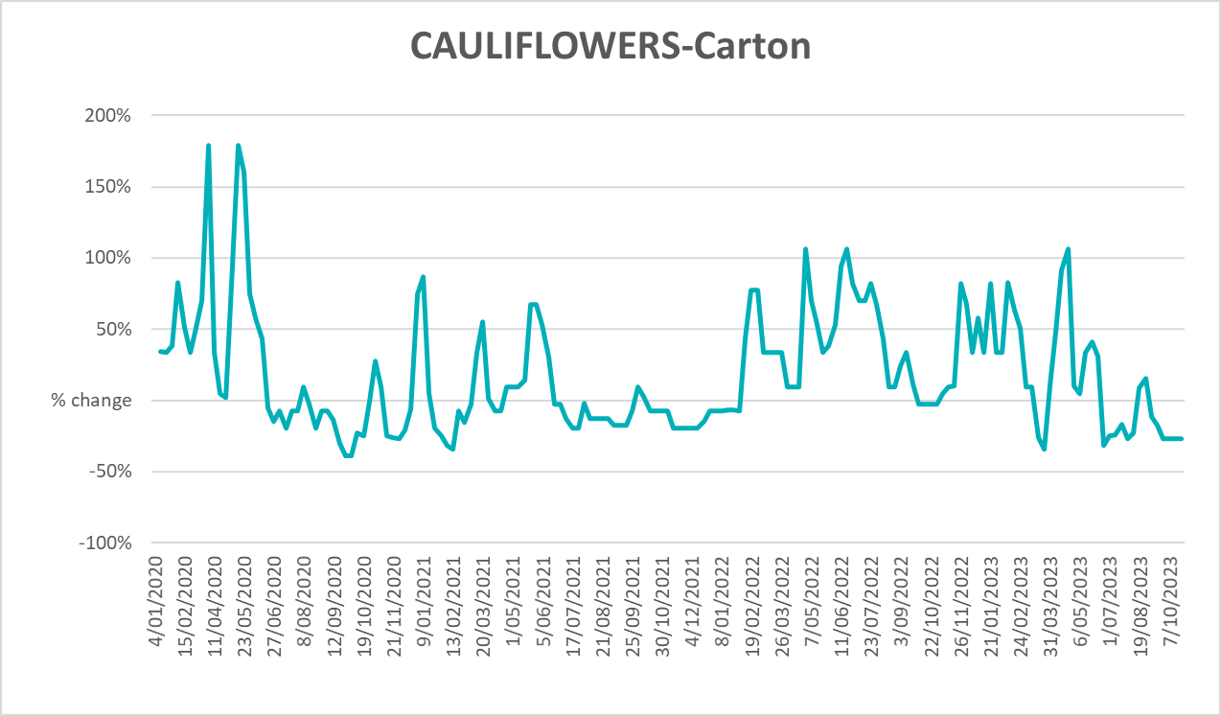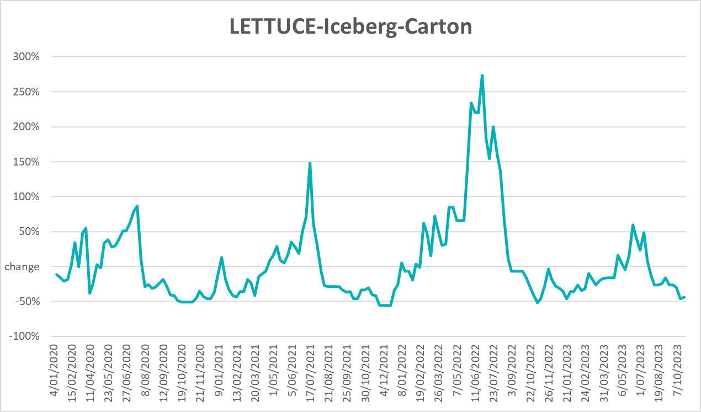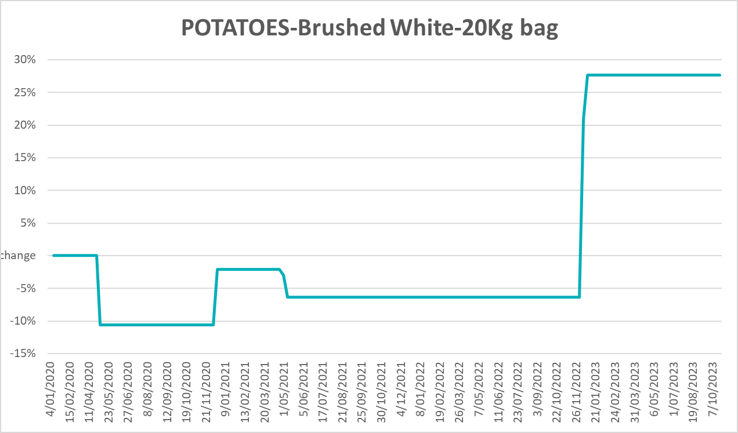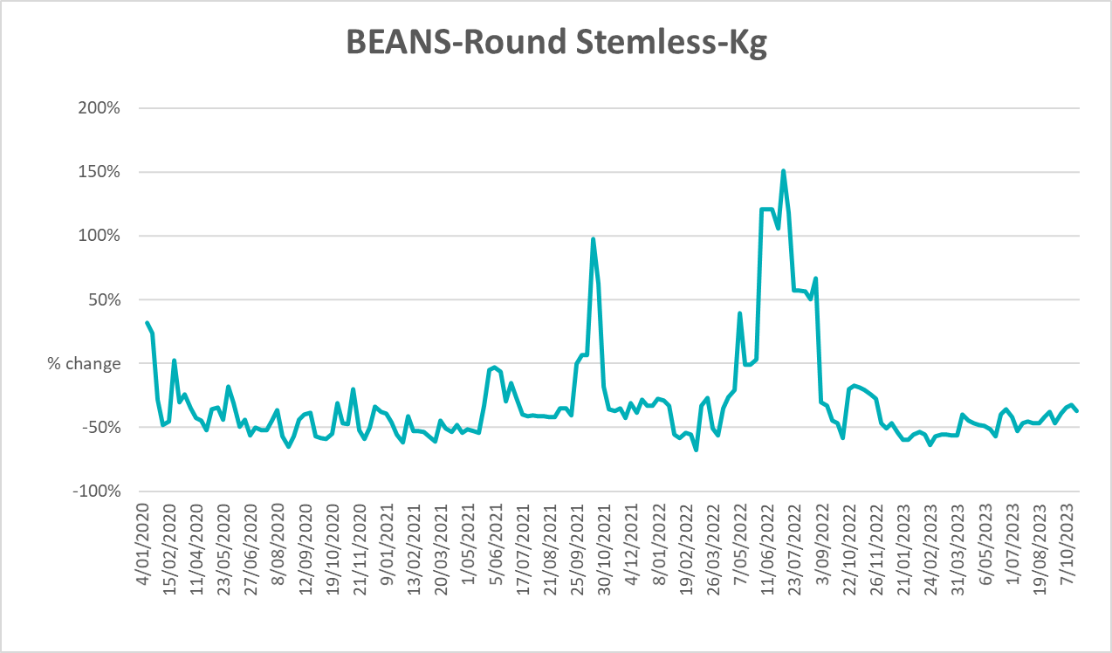

3.6 Selected domestic fodder indicator prices

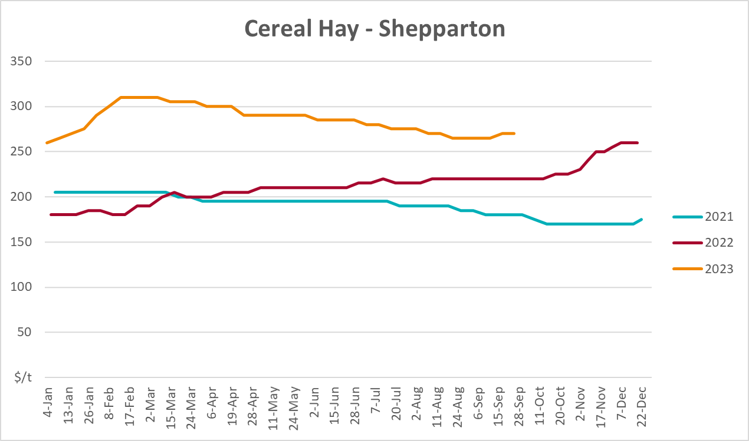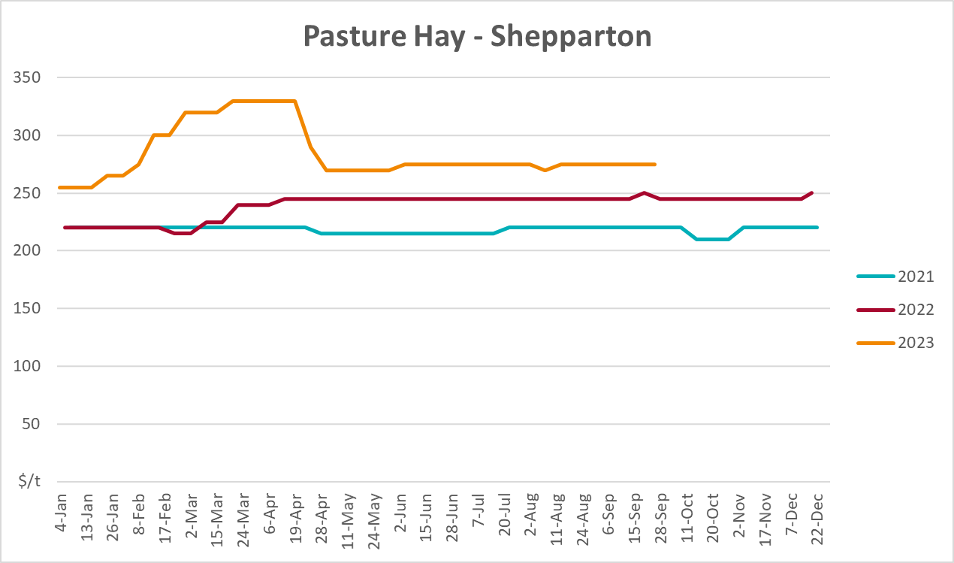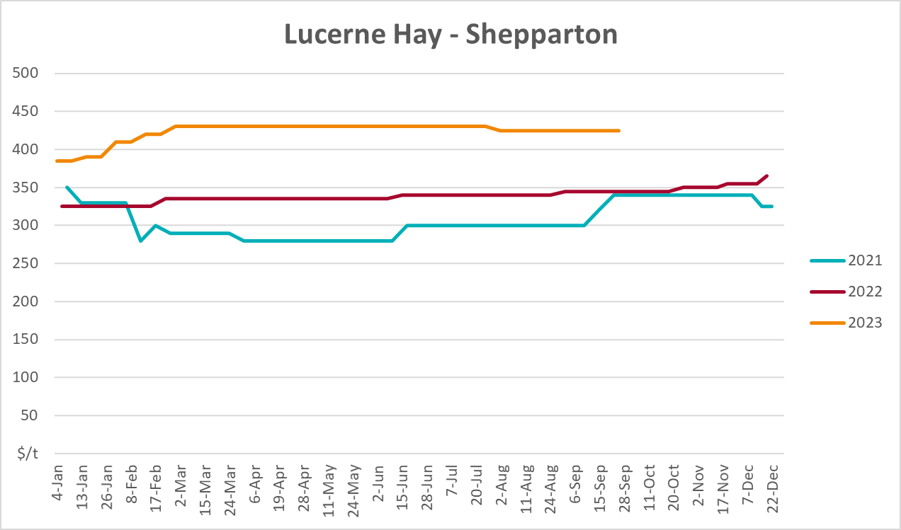

4. Data attribution

Climate
Bureau of Meteorology
- Weekly rainfall totals: www.bom.gov.au/climate/maps/rainfall/
- Monthly and last 3-month rainfall percentiles: www.bom.gov.au/water/landscape/
- Temperature anomalies: www.bom.gov.au/jsp/awap/temp/index.jsp
- Rainfall forecast: www.bom.gov.au/jsp/watl/rainfall/pme.jsp
- Seasonal outlook: www.bom.gov.au/climate/outlooks/#/overview/summary/
- Climate drivers: http://www.bom.gov.au/climate/enso/
- Soil moisture: www.bom.gov.au/water/landscape/
Other
- Pasture growth: www.longpaddock.qld.gov.au/aussiegrass/
- 3-month global outlooks: Environment and Climate Change Canada, NOAA Climate Prediction Center, EUROBRISA CPTEC/INPE, European Centre for Medium-Range Weather Forecasts, Hydrometcenter of Russia, National Climate Center Climate System Diagnosis and Prediction Room (NCC), International Research Institute for Climate and Society
- Global production: https://ipad.fas.usda.gov/ogamaps/cropmapsandcalendars.aspx
- Autumn break: Pook et al., 2009, https://rmets-onlinelibrary-wiley-com.virtual.anu.edu.au/doi/epdf/10.1002/joc.1833

Water
Prices
- Waterflow: https://www.waterflow.io/
- Ruralco: https://www.ruralcowater.com.au/
Bureau of Meteorology:
- Allocation trade: http://www.bom.gov.au/water/dashboards/#/water-markets/mdb/at
- Storage volumes: http://www.bom.gov.au/water/dashboards/#/water-storages/summary/drainage
Trade constraints:
- Water NSW: https://www.waternsw.com.au/customer-service/ordering-trading-and-pricing/trading/murrumbidgee
- Victorian Water Register: https://www.waterregister.vic.gov.au/TradingRules2019/

Commodities
Fruit and vegetables
- Datafresh: www.freshstate.com.au
Pigs
- Australian Pork Limited: www.australianpork.com.au
Dairy
- Global Dairy Trade: www.globaldairytrade.info/en/product-results/
World wheat, canola
- International Grains Council
World coarse grains
- United States Department of Agriculture
World cotton
- Cotlook: www.cotlook.com/
World sugar
- New York Stock Exchange - Intercontinental Exchange
Wool
- Australian Wool Exchange: www.awex.com.au/
Domestic wheat, barley, sorghum, canola and fodder
- Jumbuk Consulting Pty Ltd: http://www.jumbukag.com.au/
Cattle, beef, mutton, lamb, goat and live export
- Meat and Livestock Australia: www.mla.com.au/Prices-and-market
© Commonwealth of Australia 2023

Ownership of intellectual property rights
Unless otherwise noted, copyright (and any other intellectual property rights, if any) in this publication is owned by the Commonwealth of Australia (referred to as the Commonwealth).

Creative Commons licence
All material in this publication is licensed under a Creative Commons Attribution 4.0 International Licence except content supplied by third parties, logos and the Commonwealth Coat of Arms.
Inquiries about the licence and any use of this document should be emailed to copyright@awe.gov.au.


Cataloguing data
This publication (and any material sourced from it) should be attributed as:
ABARES 2023, Weekly Australian Climate, Water and Agricultural Update, Australian Bureau of Agricultural and Resource Economics and Sciences, Canberra, 2 November 2023. CC BY 4.0 DOI: https://doi.org/10.25814/5f3e04e7d2503
ISSN 2652-7561
This publication is available at https://www.agriculture.gov.au/abares/products/weekly_update
Department of Agriculture, Fisheries and Forestry
GPO Box 858 Canberra ACT 2601
Telephone 1800 900 090
Web agriculture.gov.au/abares

Disclaimer
The Australian Government acting through the Department of Agriculture, Fisheries and Forestry, represented by the Australian Bureau of Agricultural and Resource Economics and Sciences, has exercised due care and skill in preparing and compiling the information and data in this publication. Notwithstanding, the Department of Agriculture, Fisheries and Forestry, ABARES, its employees and advisers disclaim all liability, including liability for negligence and for any loss, damage, injury, expense or cost incurred by any person as a result of accessing, using or relying on any of the information or data in this publication to the maximum extent permitted by law.

Statement of Professional Independence
The views and analysis presented in ABARES publications, including this one, reflect ABARES professionally independent findings, based on scientific and economic concepts, principles, information and data. These views, analysis and findings may not reflect or be consistent with the views or positions of the Australian Government, or of organisations or groups who have commissioned ABARES reports or analysis. More information on professional independence is provided on the ABARES website.

Acknowledgements
This report was prepared by Kavina Dayal and Matthew Miller.

