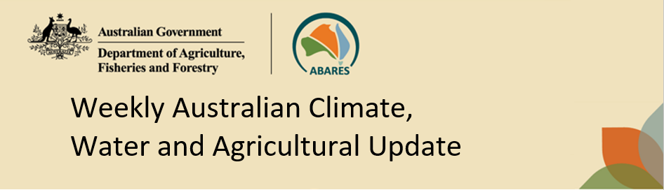
No. 41/2023 19 October 2023

Summary of key issues
- For the week ending 18 October 2023, a cold front and trough brought showers to southeastern parts of the country. A high-pressure system kept the remainder of the country dry (see Section 1.1).
- Across cropping regions, rainfall totals of up to 15 millimetres were recorded in southern New South Wales and up to 10 millimetres in Victoria and South Australia. Given the lack of rainfall across most cropping regions and continuous decline in soil moisture reserves, there continues to be an increased risk of reductions in crop yields at harvest. The dry condition across most cropping regions across northern New South Wales, Queensland and Western Australia would have allowed for the uninterrupted harvest of early planted crops (see Section 1.1).
- Highly variable rainfall globally during September has led to mixed crop production prospects. Global production conditions were highly variable for wheat, but generally favourable for maize, soybeans and rice. In the northern hemisphere, drought is affecting several areas. In the southern hemisphere, the area affected by dry conditions continues to expand in Argentina and Australia. Global production conditions have continued to deteriorate compared to those used to formulate ABARES forecasts of global grain supplies and world prices in its September 2023 edition of the Agricultural Commodities Report. As a result, global grain and oilseed production is likely to be lower than that forecast in September (see Section 1.2).
- Over the next 8-days to 26 October 2023, a dry condition is expected across much of the country. A front and a low are likely to bring cooler conditions to southern Australia, but only parts of southern Victoria and Tasmania will benefit from any useful rainfall (see Section 1.3).
- Across cropping regions, rainfall totals up to 5 millimetres are forecast for southern Victoria and Western Australia while little to no rainfall is expected elsewhere. The dry expected condition across most cropping regions will likely do little to arrest recent declines in yield but will support allow for the uninterrupted harvest of early planted crops (see Section 1.3).
- Water storage levels in the Murray-Darling Basin (MDB) increased between 12 October 2023 and 19 October 2023 by 31 gigalitres (GL). Current volume of water held in storage is 20 81 GL. This is 6 percent or 1 413 GL less than at the same time last year.
- Allocation prices in the Victorian Murray below the Barmah Choke increased from $178 on 12 October 2023 to $181 on 19 October 2023. Prices are lower in the Goulburn-Broken and regions above the Barmah choke due to the binding of the Goulburn intervalley trade limit and Barmah choke trade constraint.

Climate

Rainfall this week
For the week ending 18 October 2023, a cold front and trough brought showers to southeastern parts of the country. A high-pressure system kept the remainder of the country dry.
Across cropping regions, rainfall totals of up to 15 millimetres were recorded in southern New South Wales and up to 10 millimetres in Victoria and South Australia. Given the lack of rainfall across most cropping regions and continuous decline in soil moisture reserves, there continues to be an increased risk of reductions in crop yields at harvest. The dry condition across most cropping regions across northern New South Wales, Queensland and Western Australia would have allowed for the uninterrupted harvest of early planted crops.

Rainfall for the week ending 18 October 2023
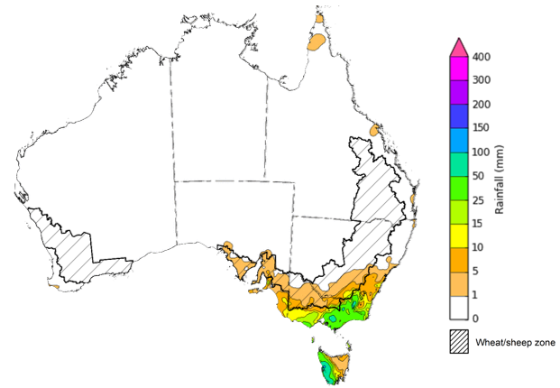
©Commonwealth of Australia 2023, Australian Bureau of Meteorology Issued: 18/10/2023
Note: The rainfall analyses and associated maps utilise data contained in the Bureau of Meteorology climate database, the Australian Data Archive for Meteorology (ADAM). The analyses are initially produced automatically from real-time data with limited quality control. They are intended to provide a general overview of rainfall across Australia as quickly as possible after the observations are received. For further information go to http://www.bom.gov.au/climate/rainfall/

Global production conditions and climate outlook
Crop production is affected by long-term trends in average rainfall and temperature, interannual climate variability, shocks during specific growth stages, and extreme weather events. Some crops are more tolerant than others to certain types of stresses, and at each growth stage, different types of stresses affect each crop species in different ways.
The precipitation anomalies and outlooks presented here give an indication of the current and future state of production conditions for the major grain and oilseed producing countries which are responsible for over 80% of global production. This is an important input to assessing the global grain supply outlook.
September precipitation percentiles and current production conditions
As of the end of September 2023, precipitation was highly variable for the world’s major grain-producing and oilseed-producing regions.
In the northern hemisphere, precipitation was generally average to below average across Canada. In the United States (US), precipitation was average to above average, except for eastern areas where it was below average. Precipitation was average to above average in India, the United Kingdom, the European Union (EU), China, and the Russian Federation. September precipitation was generally average across the remainder of the major grain-producing and oilseed-producing regions in the northern hemisphere.
In the southern hemisphere, September precipitation was generally average in South America, with southern and northern parts of Brazil being the main exception, where it was above average and below average, respectively. In Australia, September precipitation was below average.

Global precipitation percentiles, September 2023
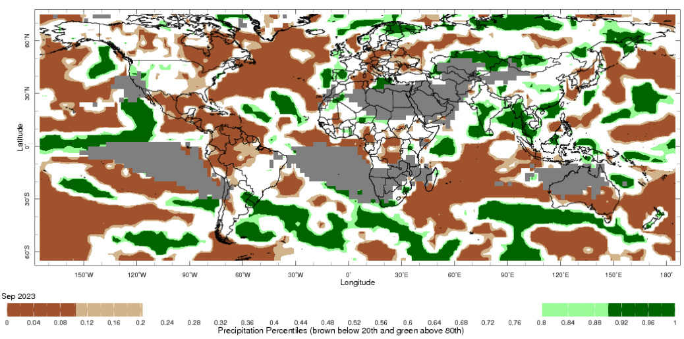
Note: The world precipitation percentiles indicate a ranking of precipitation for August, with the driest (0th percentile) being 0 on the scale and the wettest (100th percentile) being 1 on the scale. Percentiles are based on precipitation estimates from the NOAA Climate Prediction Center's Climate Anomaly Monitoring System Outgoing Precipitation Index dataset. Precipitation estimates for September 2023 are compared with rainfall recorded for that period during the 1981 to 2010 base period.
Source: International Research Institute for Climate and Society
As of 28 September 2023, global production conditions were highly variable for wheat, but generally favourable for maize, soybeans and rice. In the northern hemisphere, drought is affecting several areas. In the southern hemisphere, the area affected by dry conditions continues to expand in Argentina and Australia.
For wheat, spring wheat harvesting is wrapping up under poor conditions in the US, China and parts of Canada. Ongoing dry conditions continues to affect wheat crops in the southern hemisphere.
For maize, production conditions are generally favourable for most major growing regions, with exceptional conditions are being recorded in Brazil. Dryness is causing some production concerns across parts of the US, the EU, Ukraine, Mexico and India.
For rice, China is experiencing improved conditions after recent rains in the south and southwest. Harvesting of Kharif has begun in India with concerns for below-average monsoonal rains in the south. Harvest conditions are generally favourable in Southeast Asia, except for Thailand where dry conditions persists.
For soybeans, harvesting has begun under generally favourable conditions, with hot and dry weather during the growing season causing some production concerns across parts of the US, China, and Russian Federation.
Crop conditions, AMIS countries, 28 September 2023 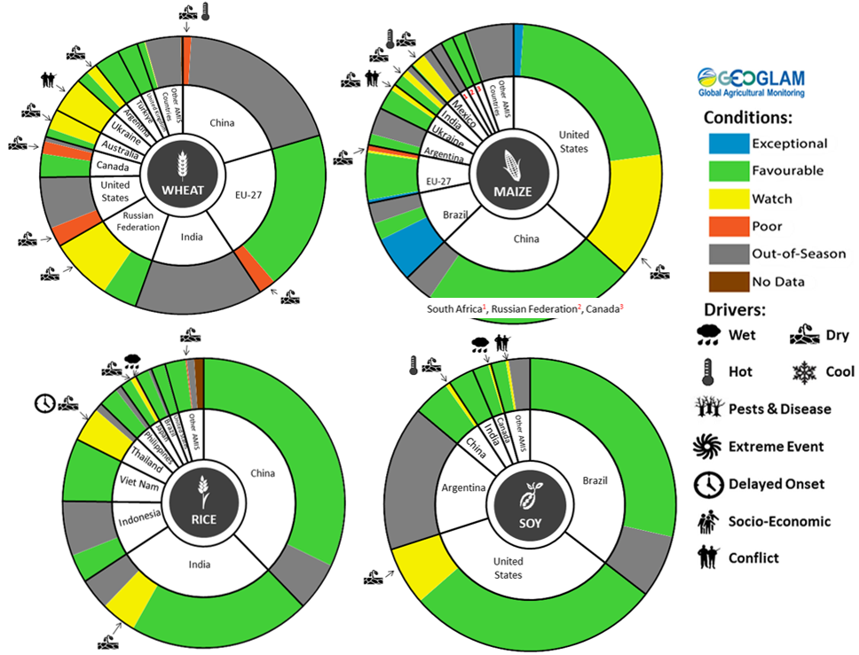
AMIS Agricultural Market Information System. Source: AMIS
The global climate outlook for November 2023 to January 2024 indicates that variable rainfall conditions are expected for the world's major grain-producing and oilseed-producing regions. Outlooks and potential production impacts for the major grain and oilseed producing countries are presented in the table.
Rainfall outlook and potential impact on the future state of production conditions between November 2023 to January 2024
Region | November 2023 – January 2024 rainfall outlook | Potential impact on production
Argentina | Average rainfall is likely across the west and above average rainfall is more likely across the rest of Argentina. This pattern is typical during El Niño events. | Average rainfall is likely to support the silking, flowering and grain filling of corn, as well as the flowering of cotton, ground nuts, soybeans and sunflowers. The wet conditions mays also support the planting and vegetative growth of millet, rice and sorghum.
Black Sea Region | Average to above average rainfall is more likely in Ukraine, Kazakhstan and the Russian Federation. | Winter wheat and canola will remain dormant throughout November to January across the Black Sea Region. Average to above average rainfall in many parts may provide sufficient snowpack to protect crops from winterkill.
Brazil | Well below average rainfall is more likely across much of Brazil except for the far south where above average rainfall is likely, which is a typical El Niño pattern. | Above average rainfall in parts of southern Brazil may adversely affect the harvesting of wheat in November. Meanwhile, below average rainfall is likely to adversely affect flowering of corn, cotton, groundnuts and soybeans, as well as the grain filling on corn in January. Below average rainfall in northern and central Brazil will likely adversely affect the growth, flowering and filling of soybeans.
Canada | Average to above average rainfall is more likely for much of Canada, especially across major production regions. | Average to above average rainfall in parts of Canada may delay harvesting and cause grain quality concerns for corn, soybean and sunflower in November. Average to above average rainfall is also likely to provide sufficient snowpack to prevent winterkill of winter wheat and canola through December and January.
China | Average to above average rainfall is more likely across China. | Above average rainfall in northern, western and south-eastern China is likely to benefit the harvesting of cotton, corn, sorghum, soybean, sunflower and groundnuts. Wet conditions across northern and western China may boost snowpack, lowering the risk of winterkill for winter wheat and canola.
Europe | Average to above average rainfall is more likely across much of Europe. | Above average rainfall may boost snowpack in parts of central Europe, increasing the risk of winterkill for winter wheat and canola. Meanwhile, close to average rainfall through November to January should provide sufficient snowpack for dormant crops in northern Europe.
South Asia (India) | Average to above average rainfall is more likely across India. | Average to above average rainfall across much of India will support the harvesting of corn, cotton, groundnuts, millet, rice, sorghum and sunflower. Above average rainfall in parts of northern India will support the vegetative growth and heading of winter wheat and canola.
Southeast Asia (SEA) | Generally average to below average rainfall is more likely. | Above average rainfall in SEA is likely to benefit the growth and development of dry-season rice throughout November to January.
The United States | Generally average rainfall is likely across most of the US. | Average rainfall across southern US is likely to support harvesting of corn, sorghum and soybeans in November. Average rainfall conditions expected across the northern US is likely to provide sufficient snow cover through December and January to protect winter wheat and canola through dormancy.

Rainfall forecast for the next eight days
Over the 8-days to 26 October 2023, a dry condition is expected across much of the country. A front and a low are likely to bring cooler conditions to southern Australia, but only parts of southern Victoria and Tasmania will benefit from any useful rainfall.
Across cropping regions, rainfall totals up to 5 millimetres are forecast for southern Victoria and Western Australia while little to no rainfall is expected elsewhere. The dry expected condition across most cropping regions will likely do little to arrest recent declines in yield but will support allow for the uninterrupted harvest of early planted crops.

Total forecast rainfall for the period 19 October 2023 to 26 October 2023
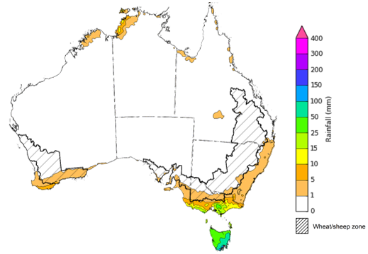

©Commonwealth of Australia 2023, Australian Bureau of Meteorology Issued 18/10/2023
Note: This rainfall forecast is produced from computer models. As the model outputs are not altered by weather forecasters, it is important to check local forecasts and warnings issued by the Bureau of Meteorology.

Water

Water markets – current week
Water storage levels in the Murray-Darling Basin (MDB) increased between 12 October 2023 and 19 October 2023 by 31 gigalitres (GL). Current volume of water held in storage is 20 810 GL. This is 6 percent or 1 413 GL less than at the same time last year.

Water storages in the Murray-Darling Basin, 2013–2023
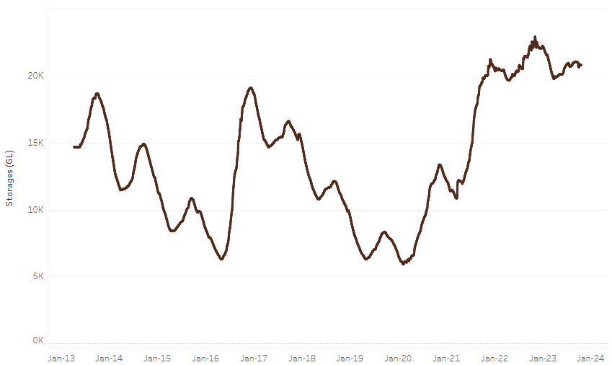
Allocation prices in the Victorian Murray below the Barmah Choke increased from $178 on 12 October 2023 to $181 on 19 October 2023. Prices are lower in the Goulburn-Broken and regions above the Barmah choke due to the binding of the Goulburn intervalley trade limit and Barmah choke trade constraint.
Water storage data is sourced from the Bureau of Meteorology.

Region | $/ML
NSW Murray Above | 111
NSW Murrumbidgee | 297
VIC Goulburn-Broken | 156
VIC Murray Below | 181

Surface water trade activity, Southern Murray–Darling Basin
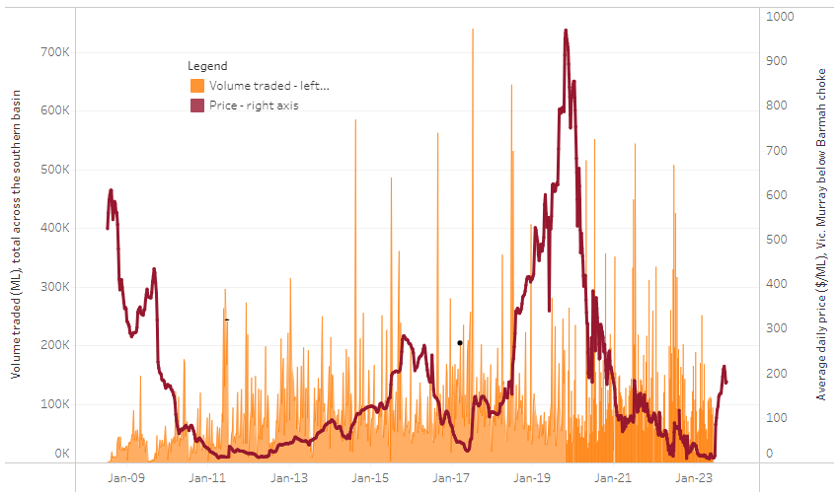
The trades shown reflect estimated market activity and do not encompass all register trades. The price is shown for the VIC Murray below the Barmah choke. Historical prices (before 1 July 2019) are ABARES estimates after removing outliers from BOM water register data. Prices after 1 July 2019 and prior to the 30 October 2019 reflect recorded transaction prices as sourced from Ruralco. Prices after the 30 October 2019 are sourced from Waterflow. Data for volume traded is sourced from the BOM water register. Only the price data shown is current on 19 October 2023.

To access the full, interactive, weekly water dashboard, which contains the latest and historical water storage, water market and water allocation information, please visit https://www.agriculture.gov.au/abares/products/weekly_update/weekly-update-121023

Commodities
Indicator | Week ended | Unit | Latest Price | Previous Week | Weekly change | Price 12 months ago | Annual change
Selected world indicator prices
AUD/USD Exchange rate | 18-Oct | A$/US$ | 0.64 | 0.64 | -1% | 0.64 | -1%
Wheat – US no. 2 hard red winter wheat, fob Gulf | 18-Oct | US$/t | 298 | 300 | -1% | 431 | -31%
Corn – US no. 2 yellow corn, fob Gulf | 18-Oct | US$/t | 225 | 226 | -1% | 347 | -35%
Canola – Rapeseed, Canada, fob Vancouver | 18-Oct | US$/t | 567 | 559 | 2% | 688 | -18%
Cotton – Cotlook 'A' Index | 18-Oct | USc/lb | 96 | 96 | 0% | 95 | 1%
Sugar – Intercontinental Exchange, nearby futures, no.11 contract | 18-Oct | USc/lb | 27.3 | 26.8 | 2% | 18 | 54%
Wool – Eastern Market Indicator | 18-Oct | Ac/kg clean | 1,139 | 1,128 | 1% | 1,330 | -14%
Wool – Western Market Indicator | 18-Oct | Ac/kg clean | 1,276 | 1,251 | 2% | 1,473 | -13%
Selected Australian grain export prices
Milling Wheat – APW, Port Adelaide, SA | 18-Oct | A$/t | 490 | 489 | 0% | 612 | -20%
Feed Wheat – ASW, Port Adelaide, SA | 18-Oct | A$/t | 471 | 469 | 0% | 562 | -16%
Feed Barley – Port Adelaide, SA | 18-Oct | A$/t | 407 | 406 | 0% | 480 | -15%
Canola – Kwinana, WA | 18-Oct | A$/t | 792 | 797 | -1% | 1,066 | -26%
Grain Sorghum – Brisbane, QLD | 18-Oct | A$/t | 518 | 521 | -1% | 474 | 9%
Selected domestic livestock indicator prices
Beef – Eastern Young Cattle Indicator | 18-Oct | Ac/kg cwt | 357 | 364 | -2% | 1,049 | -66%
Mutton – Mutton indicator (18–24 kg fat score 2–3), Vic | 18-Oct | Ac/kg cwt | 111 | 134 | -17% | 561 | -80%
Lamb – National Trade Lamb Indicator | 18-Oct | Ac/kg cwt | 463 | 470 | -2% | 807 | -43%
Pig – Eastern Seaboard (60.1–75 kg), average of buyers & sellers | 04-Oct | Ac/kg cwt | 367 | 367 | 0% | 376 | -2%
Goats – Eastern States (12.1–16 kg) | 27-Sep | Ac/kg cwt | 207 | 255 | -19% | 857 | -76%
Live cattle – Light steers to Indonesia | 20-Sep | Ac/kg lwt | 310 | 310 | 0% | 450 | -31%
Global Dairy Trade (GDT) weighted average prices ª
Dairy – Whole milk powder | 18-Oct | US$/t | 3,059 | 2,931 | 4% | 3,573 | -14%
Dairy – Skim milk powder | 18-Oct | US$/t | 2,659 | 2,558 | 4% | 3,497 | -24%
Dairy – Cheddar cheese | 18-Oct | US$/t | 3,858 | 3,853 | 0% | 4,966 | -22%
Dairy – Anhydrous milk fat | 18-Oct | US$/t | 5,310 | 4,979 | 7% | 5,811 | -9%
a Global Dairy Trade prices are updated twice monthly on the first and third Tuesday of each month.

Selected world indicator prices
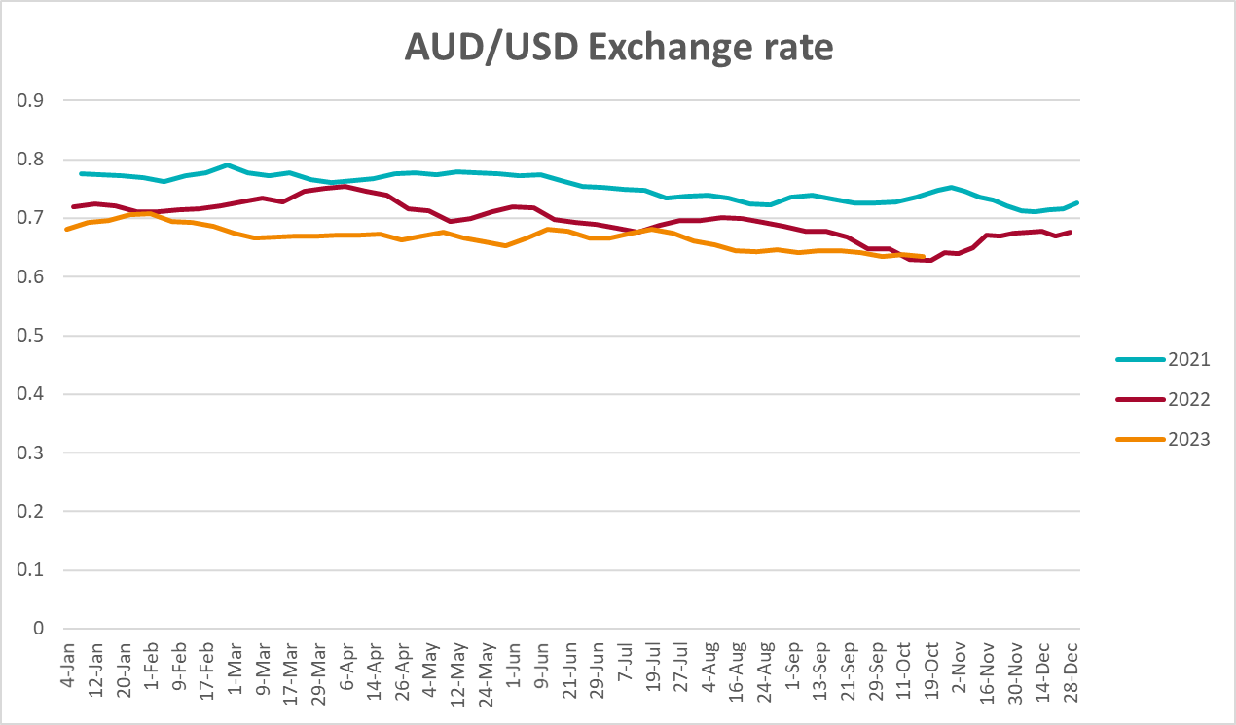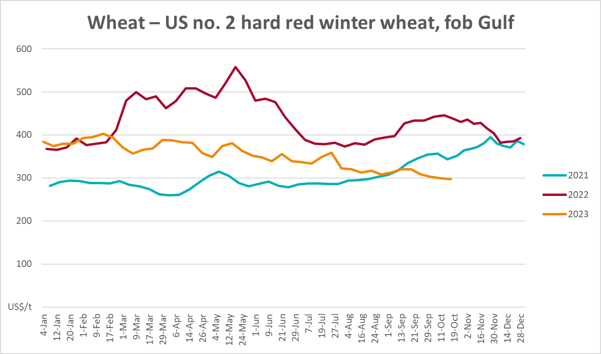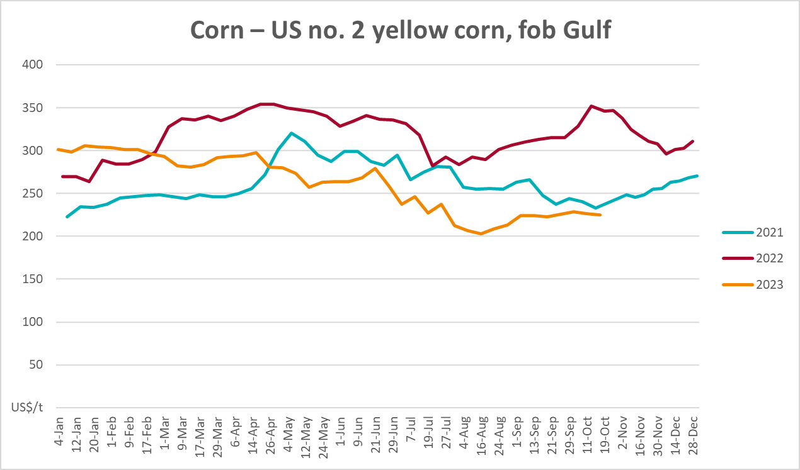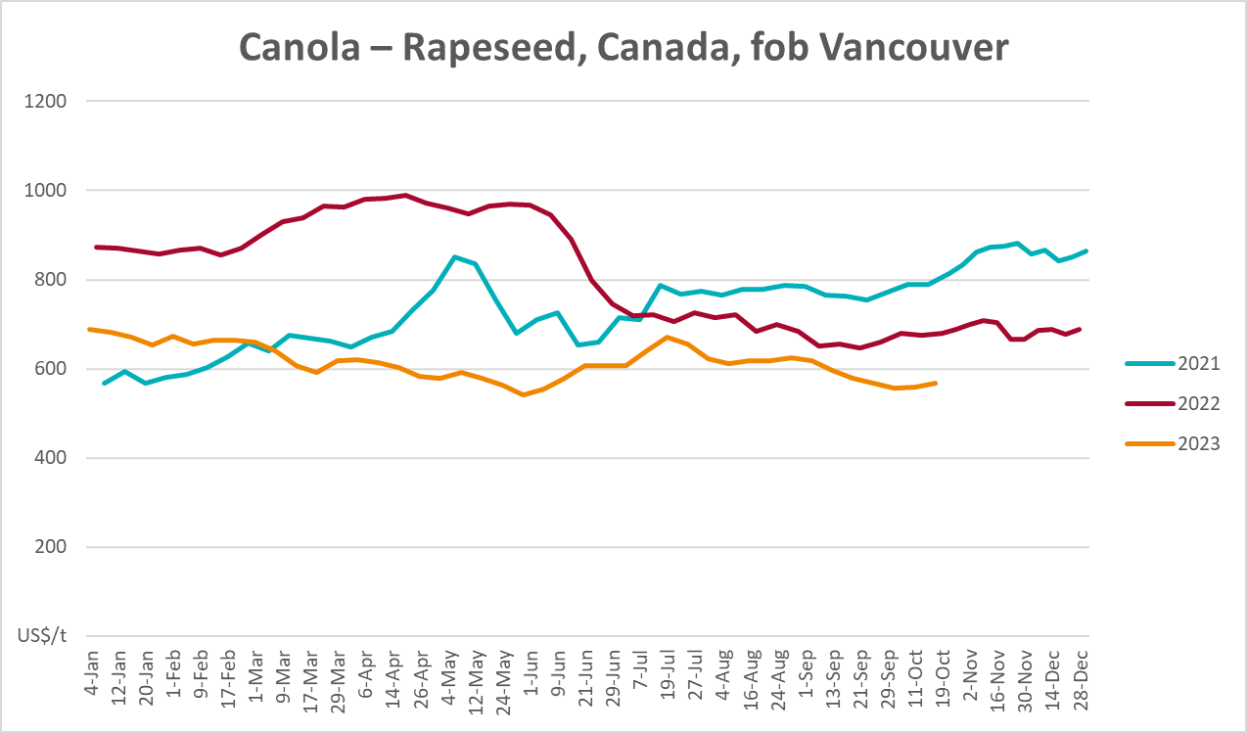
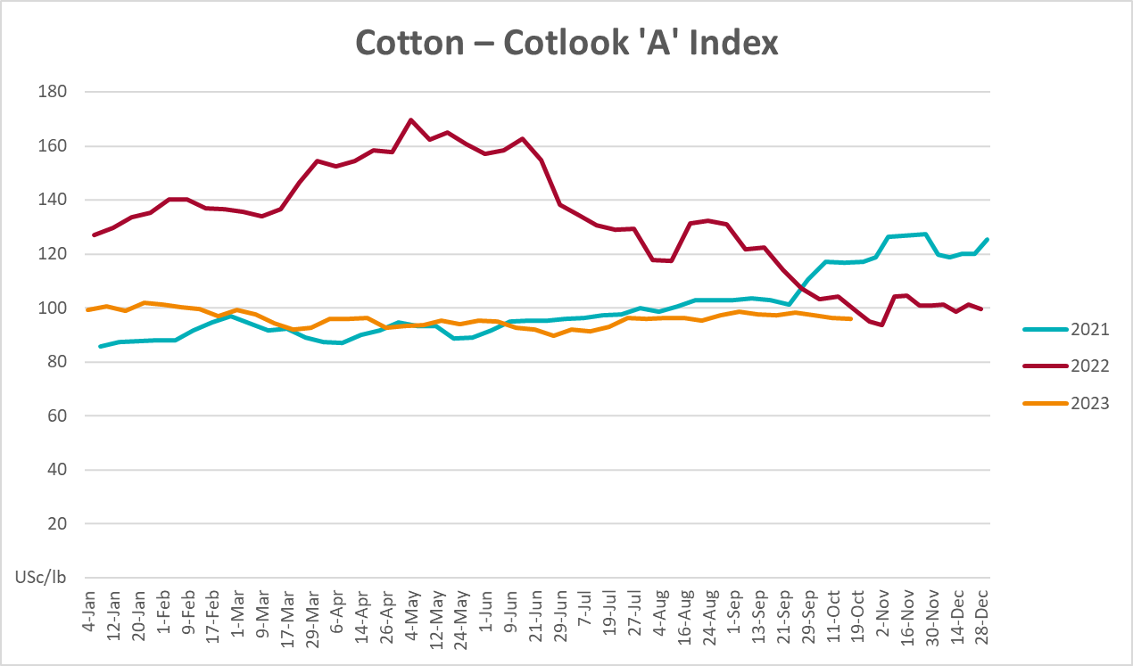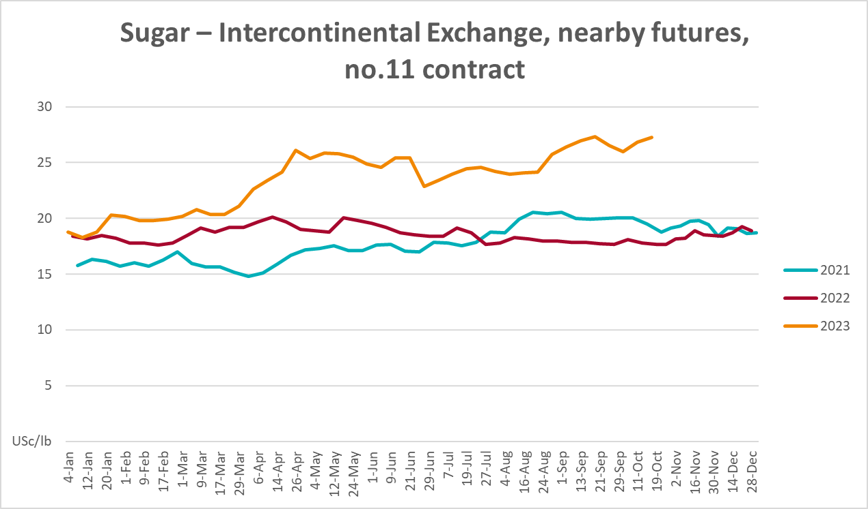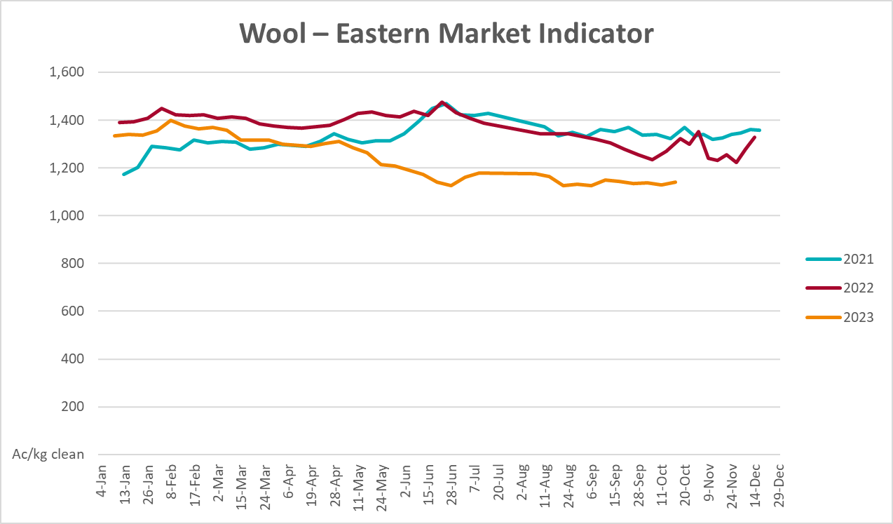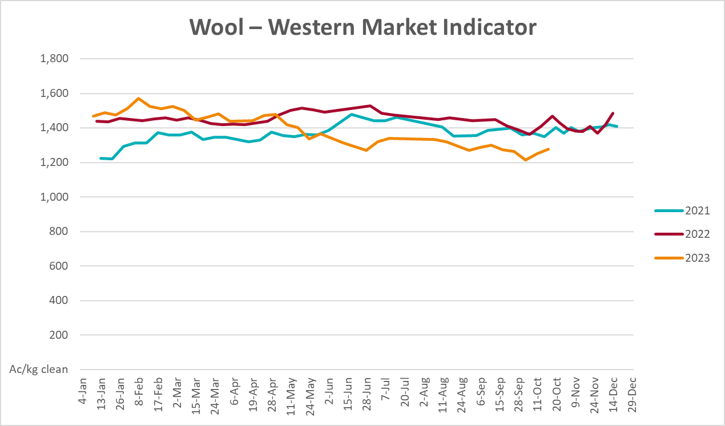

Selected domestic crop indicator prices
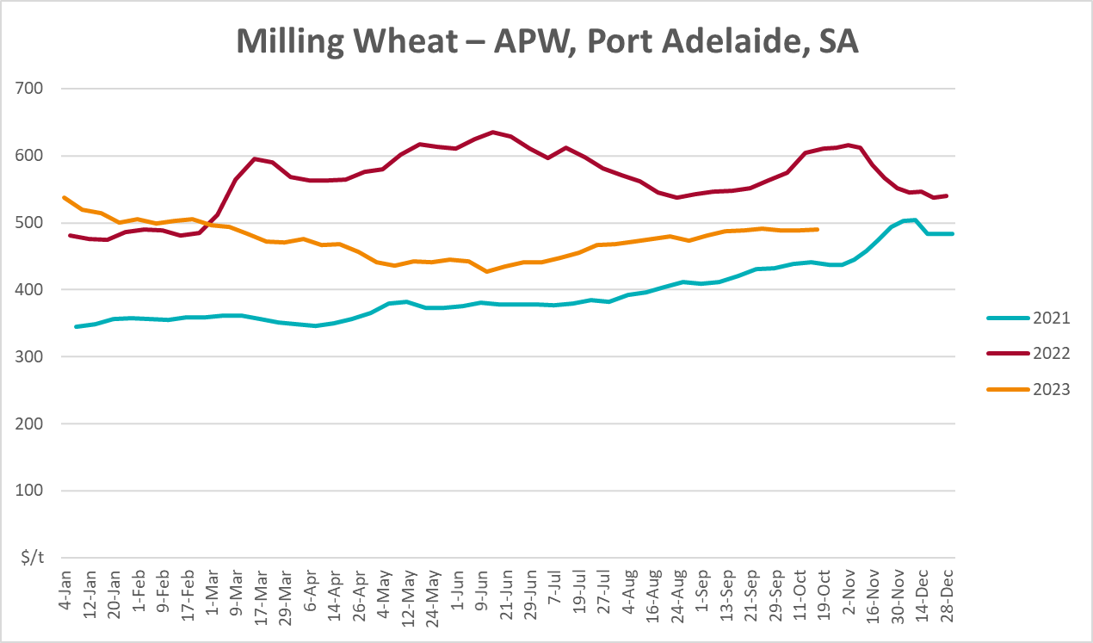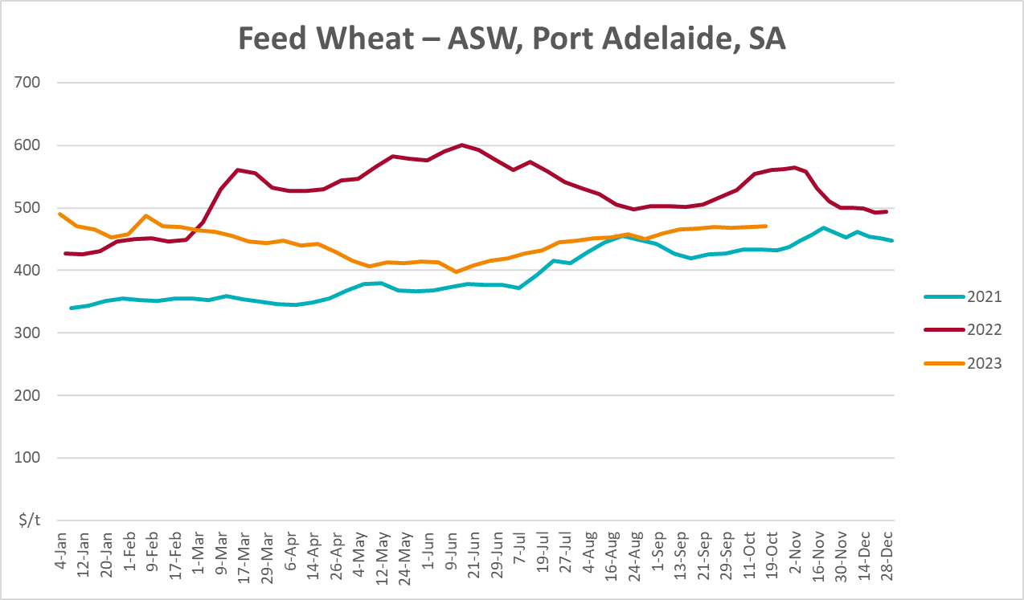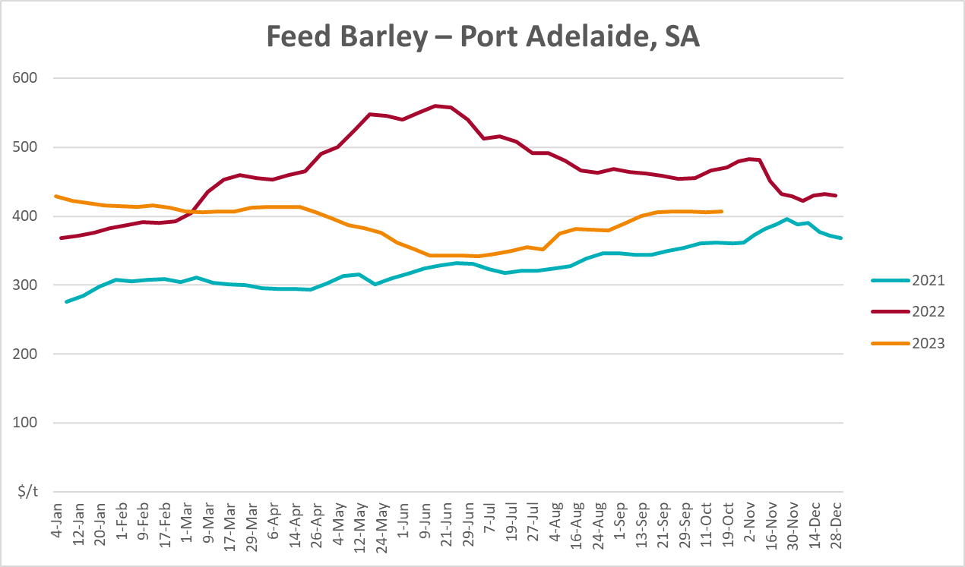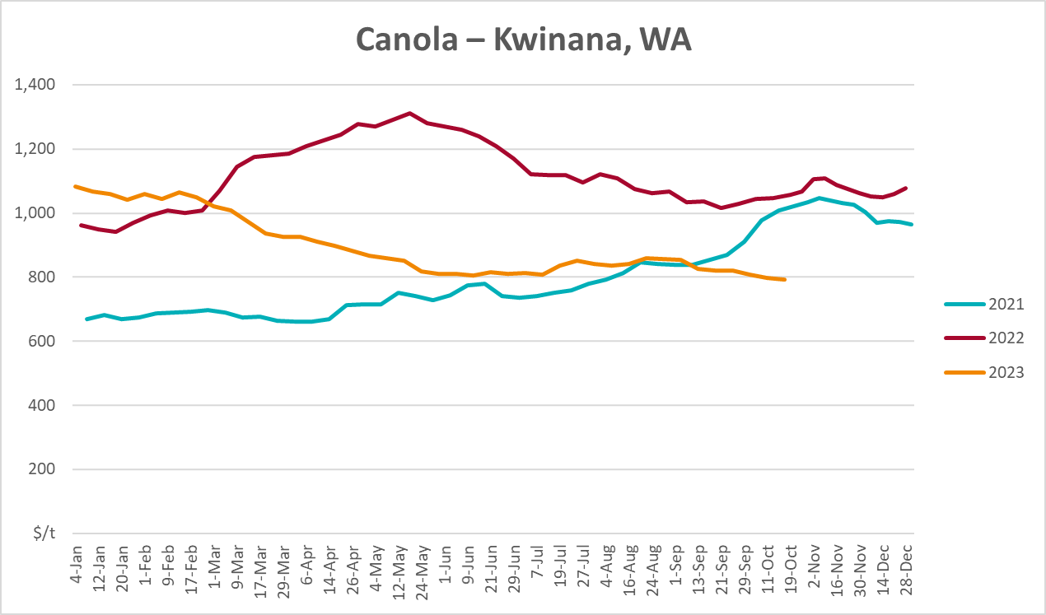
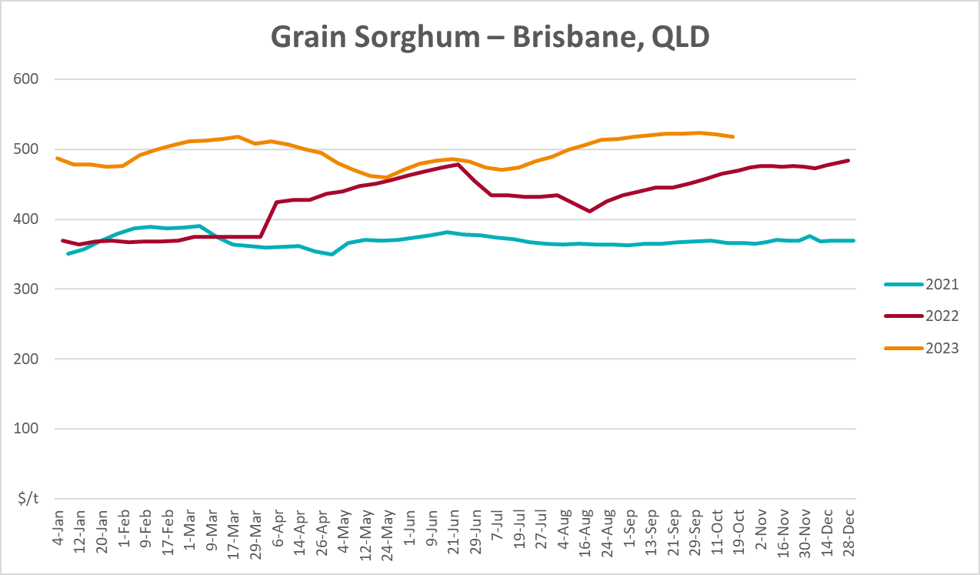

Selected domestic livestock indicator prices
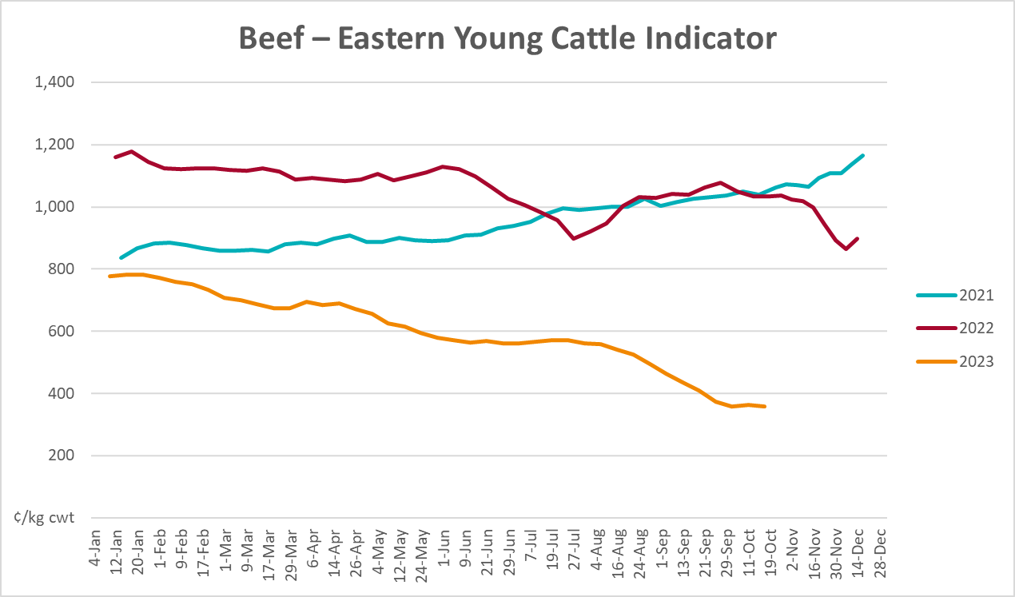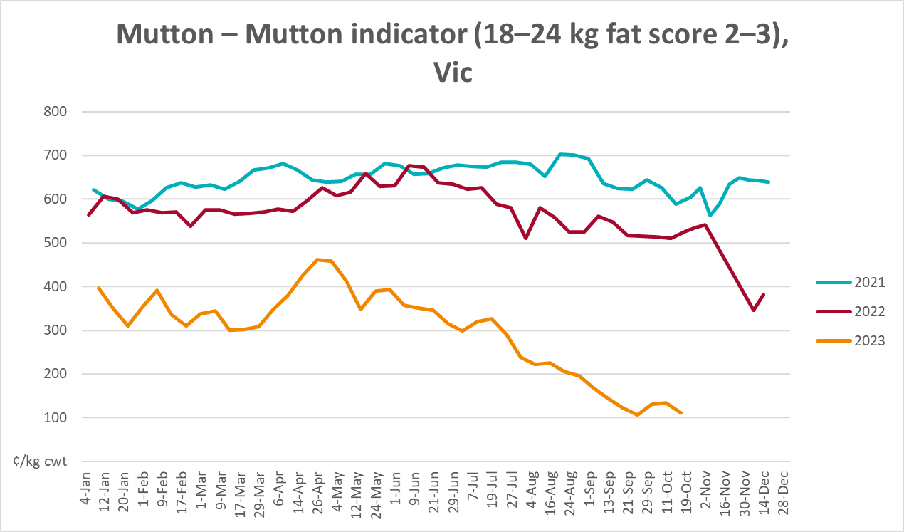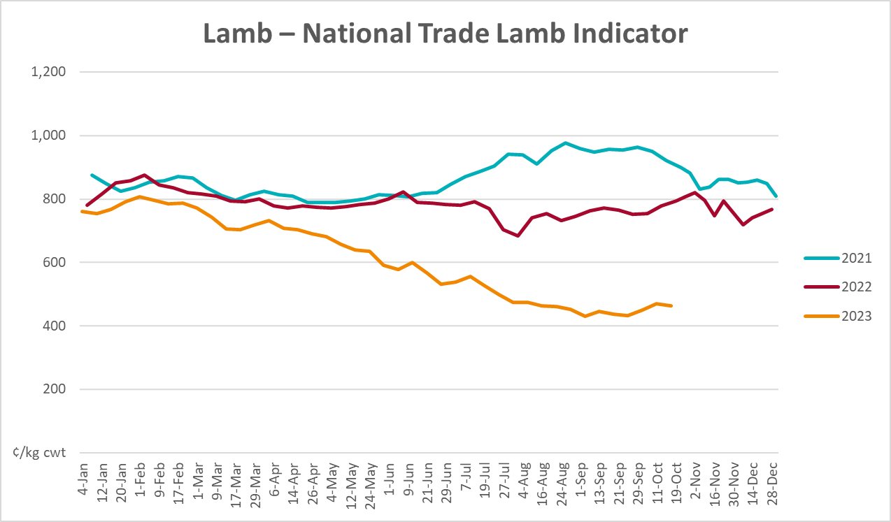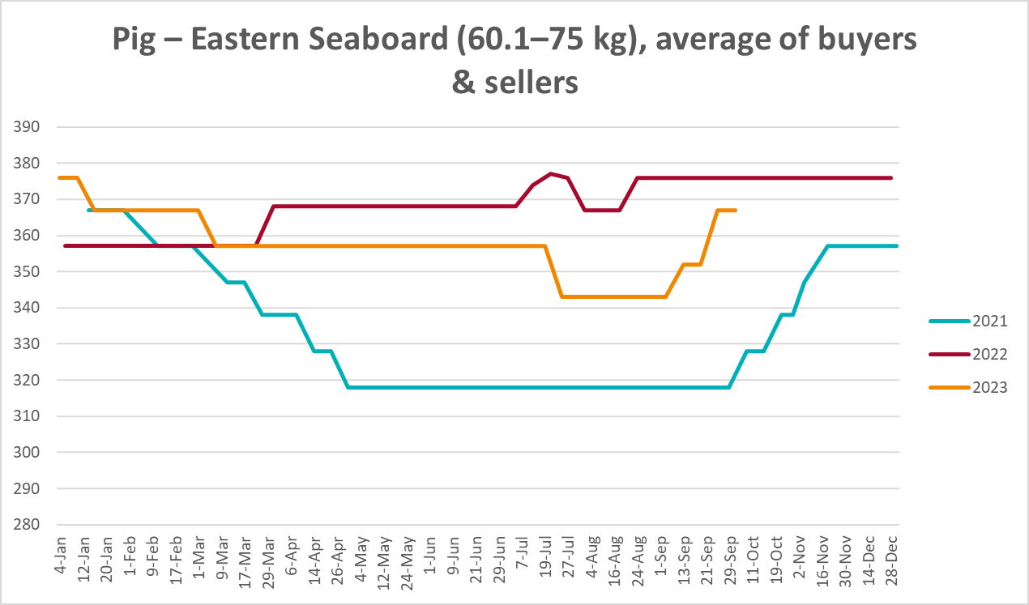
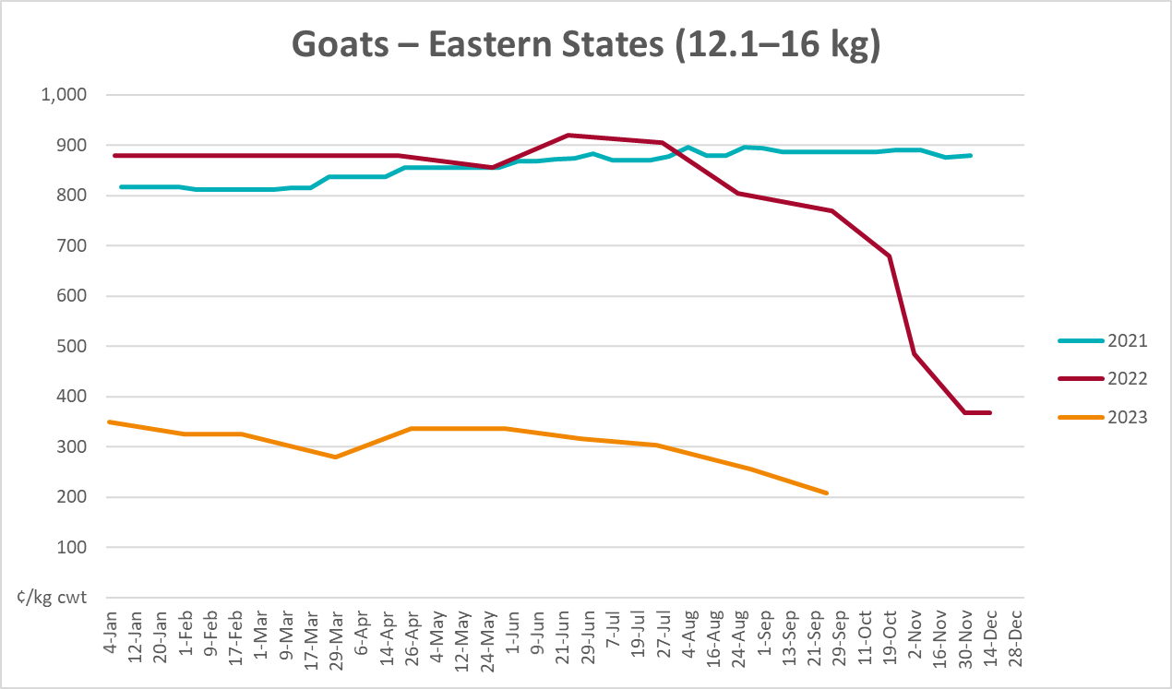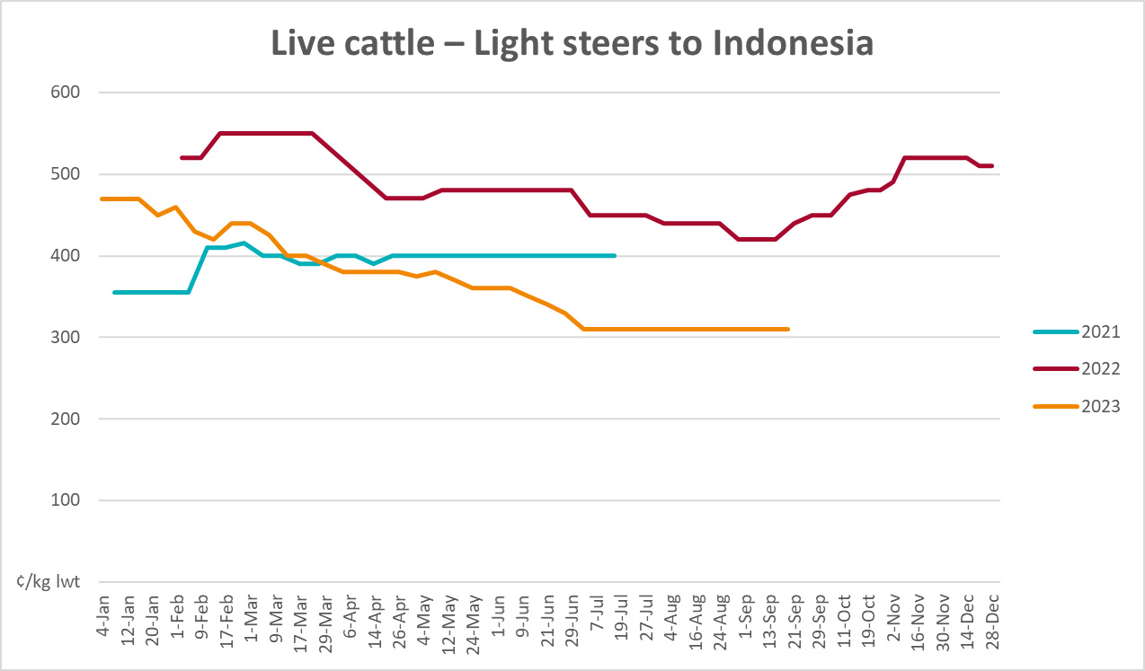

Global Dairy Trade (GDT) weighted average prices
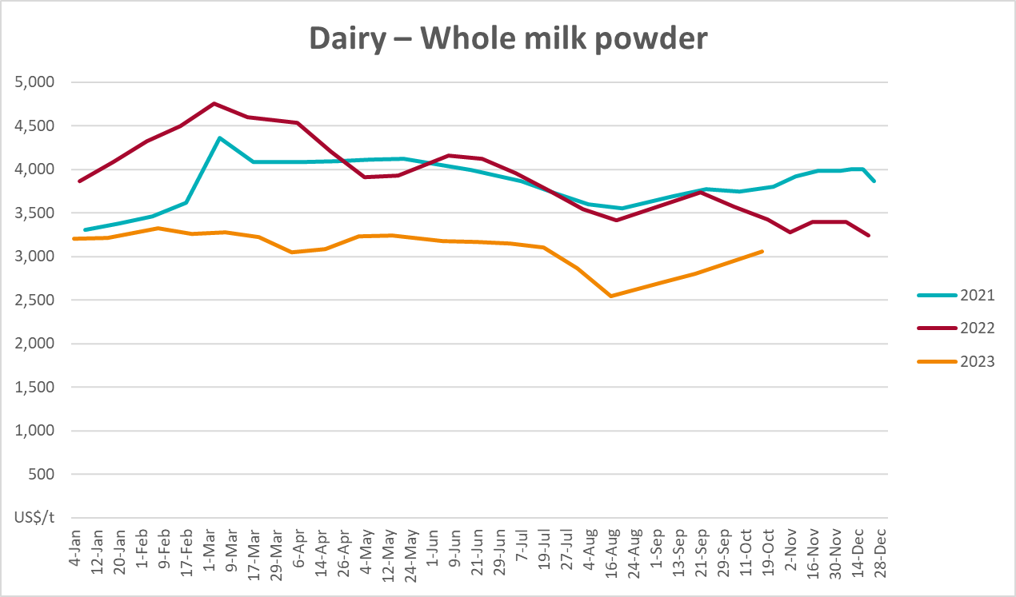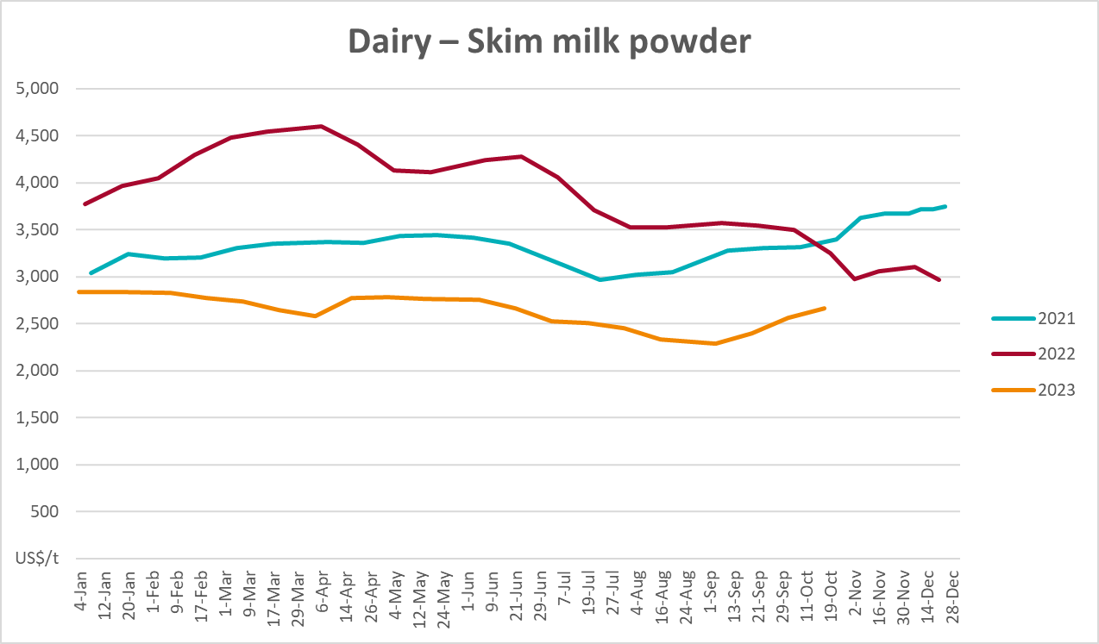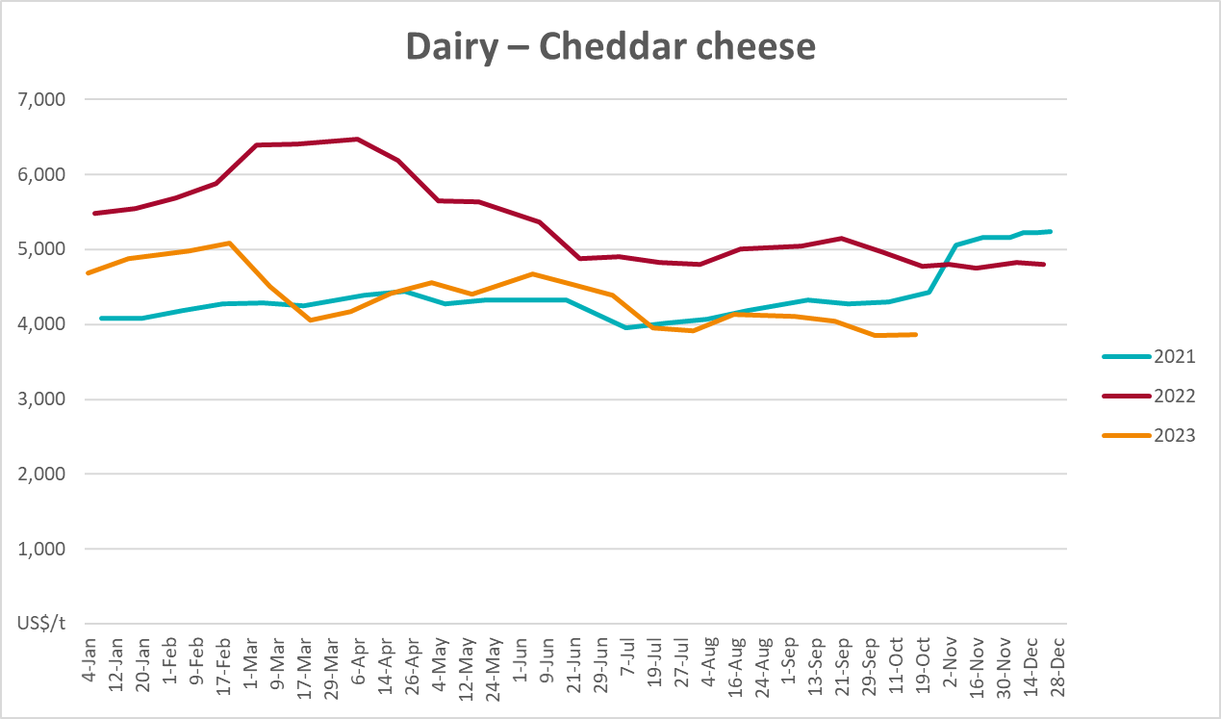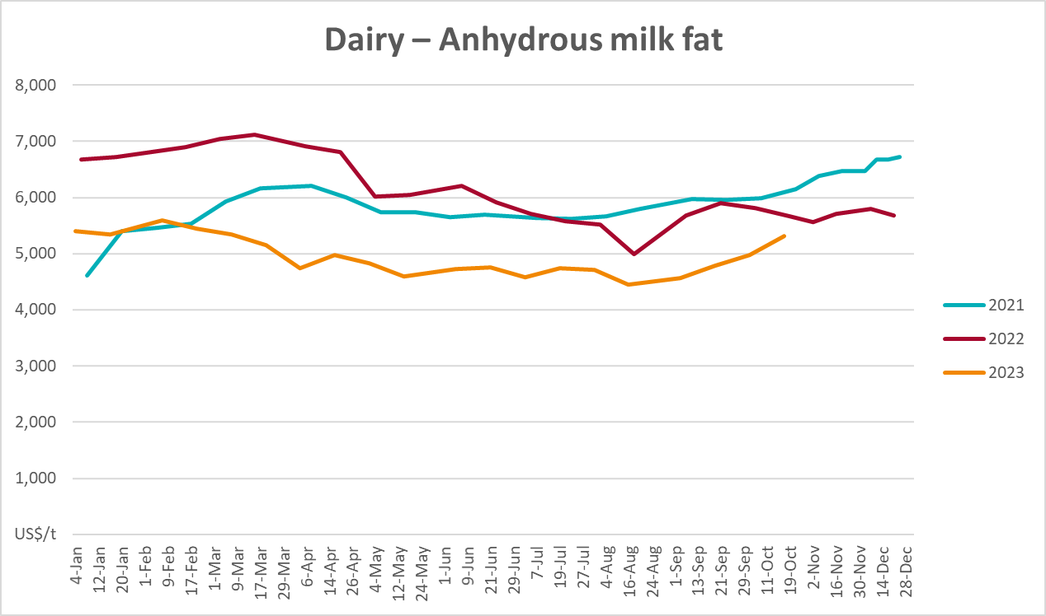

Selected fruit and vegetable prices
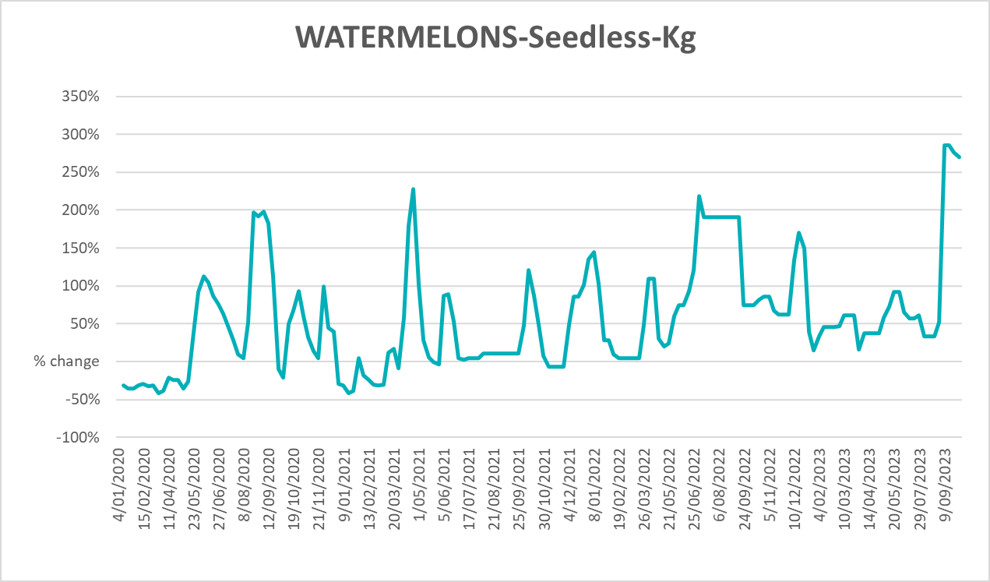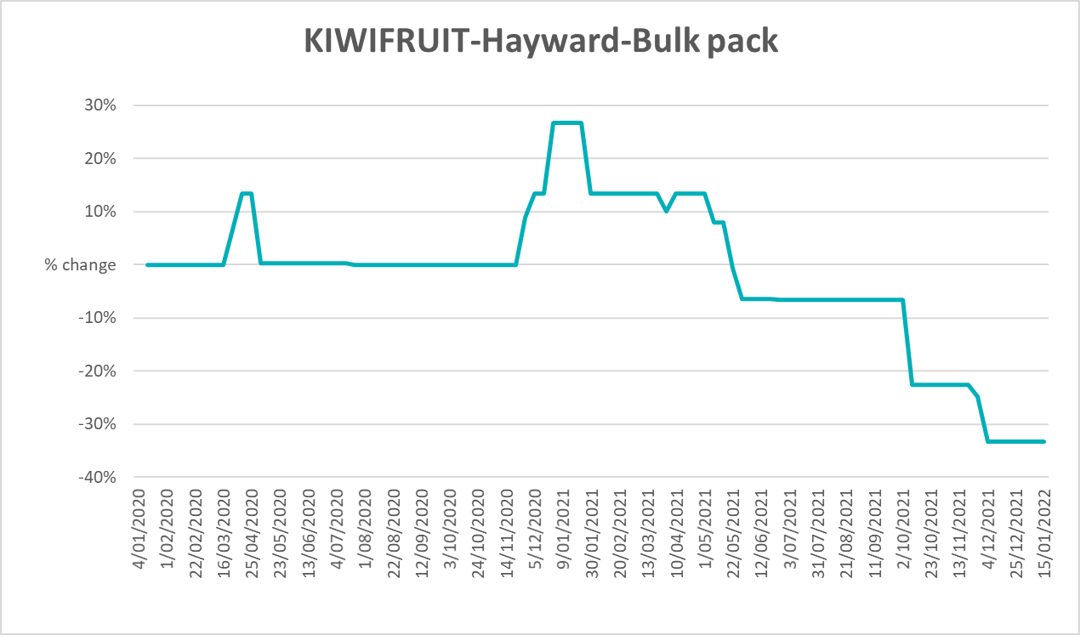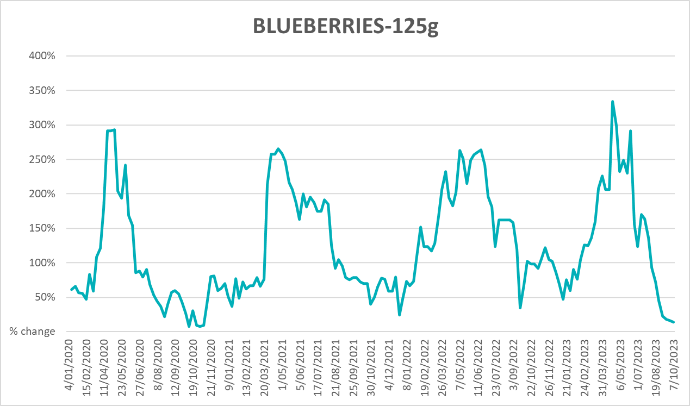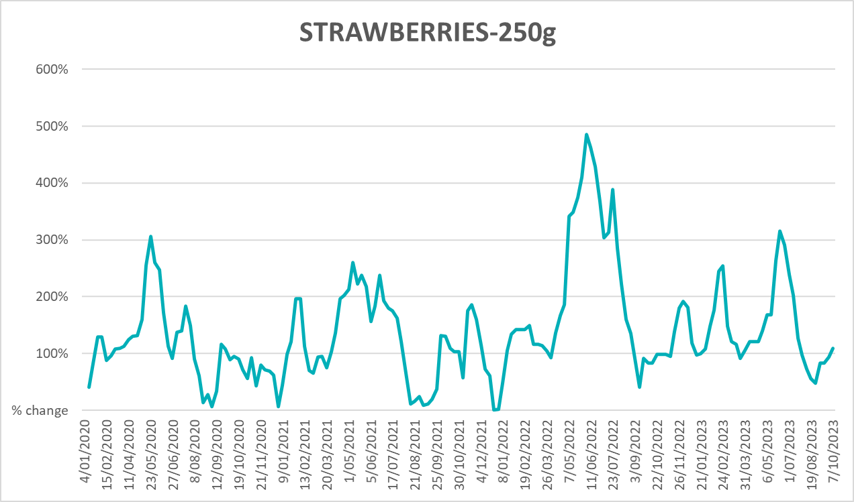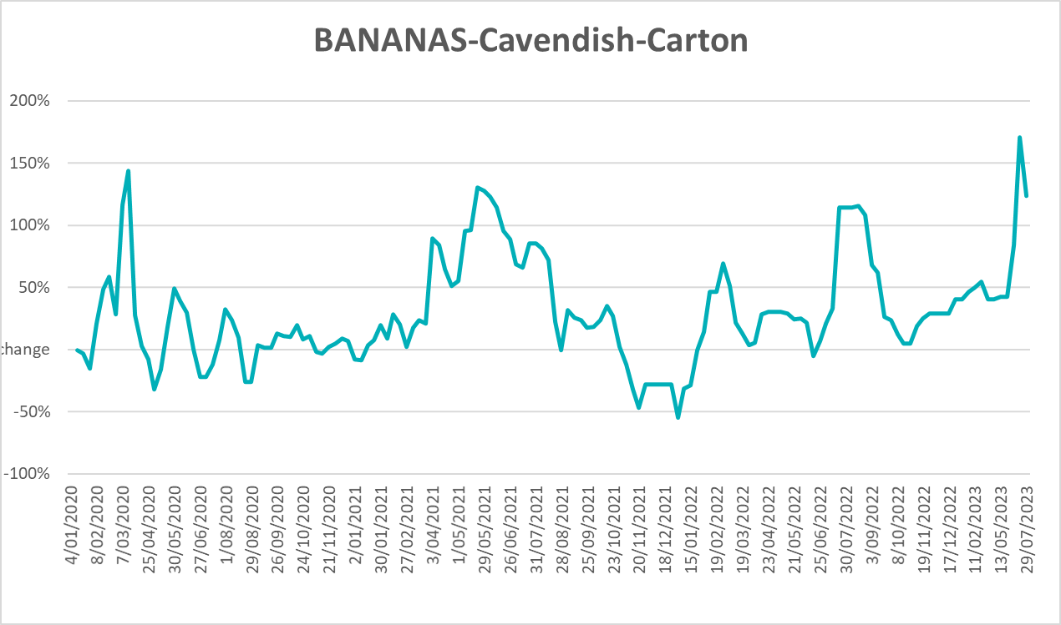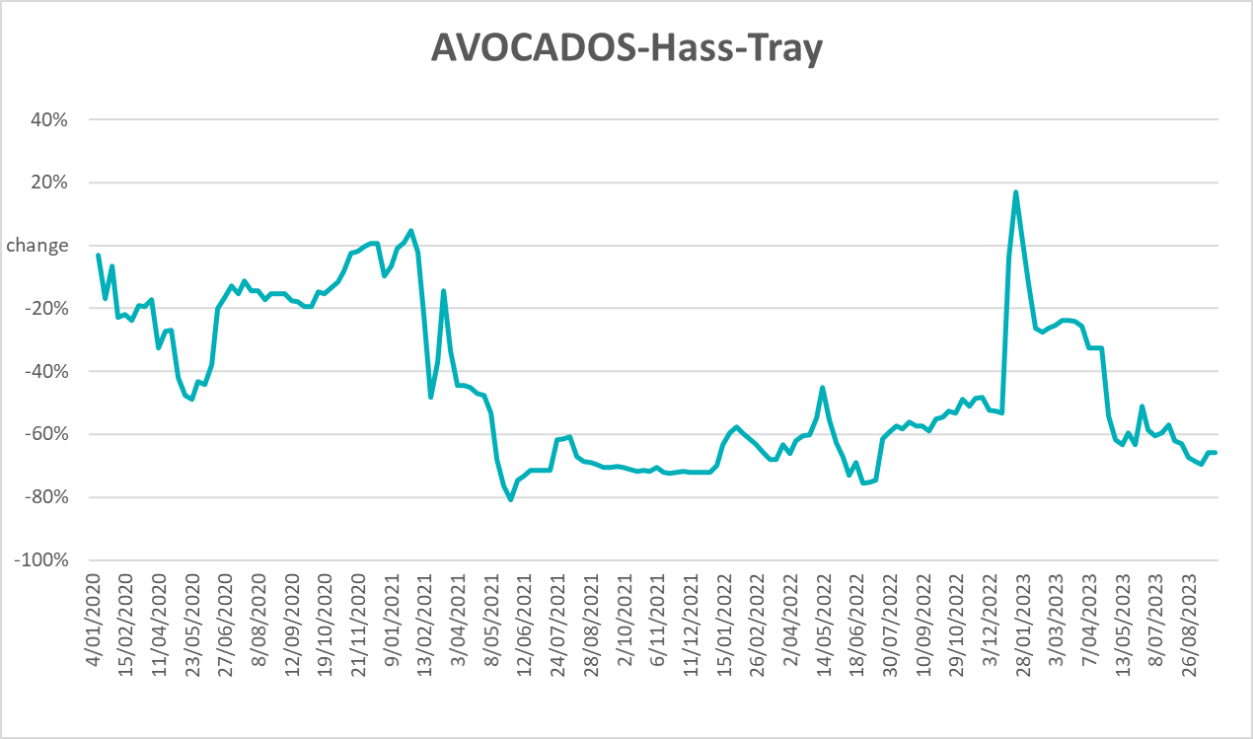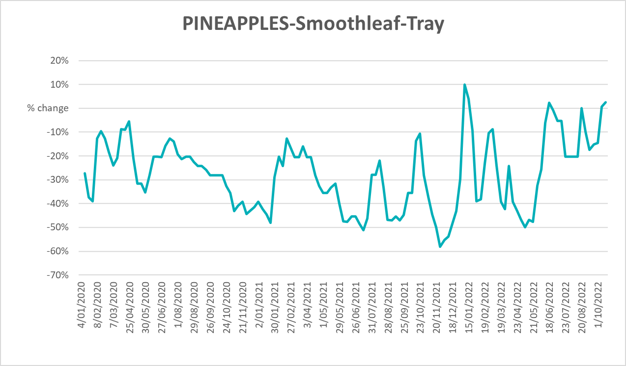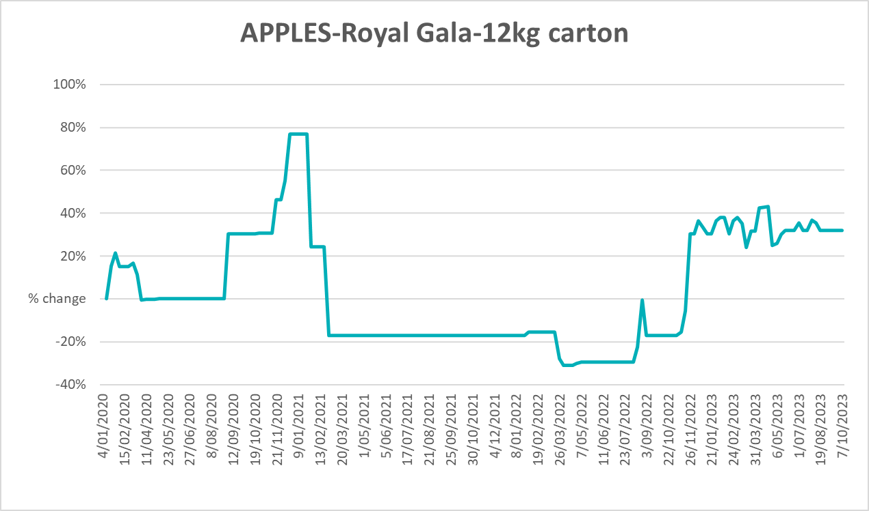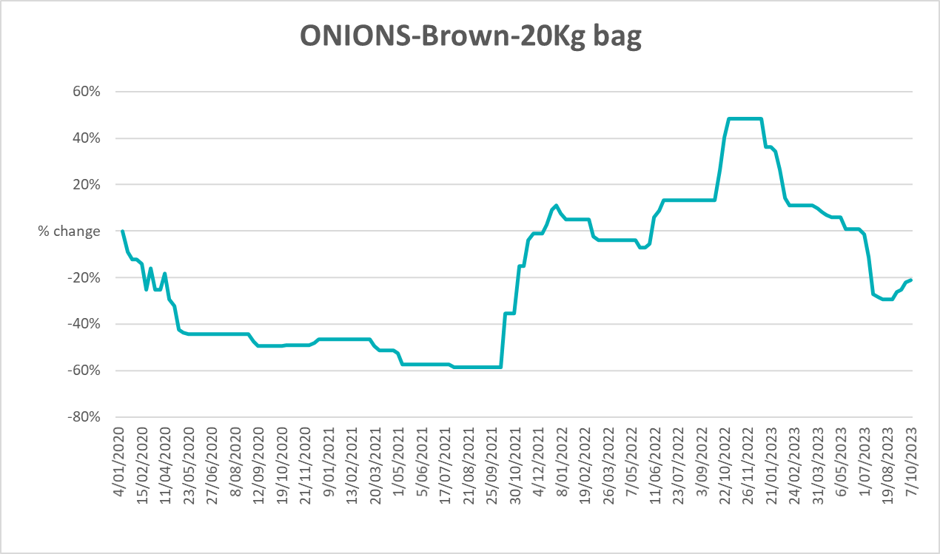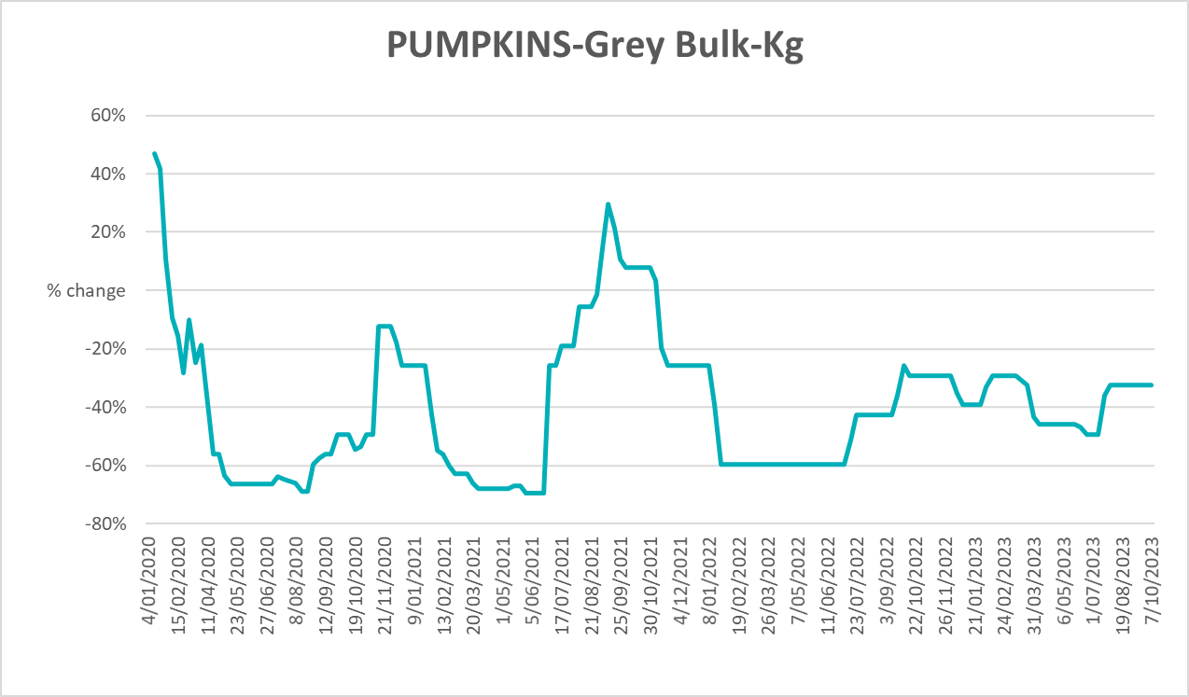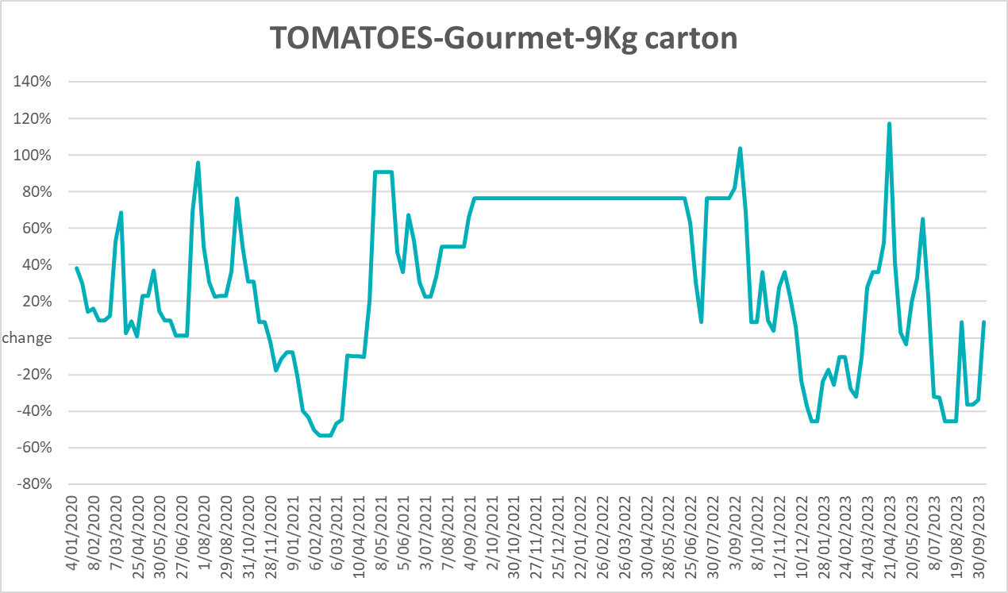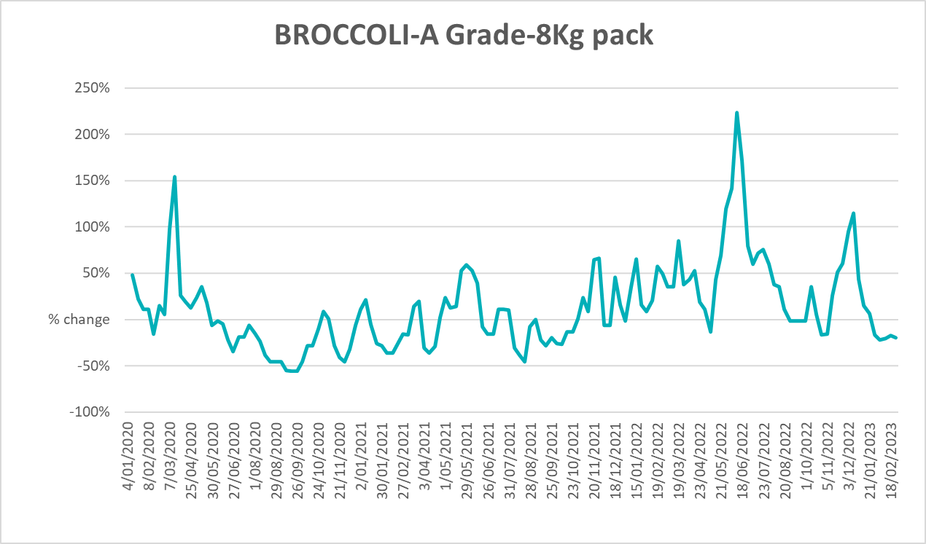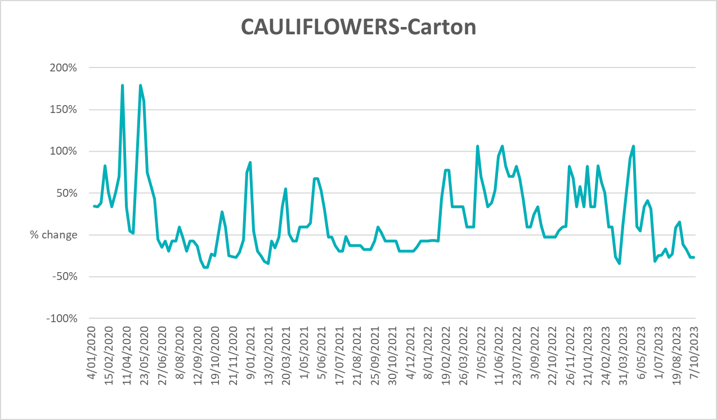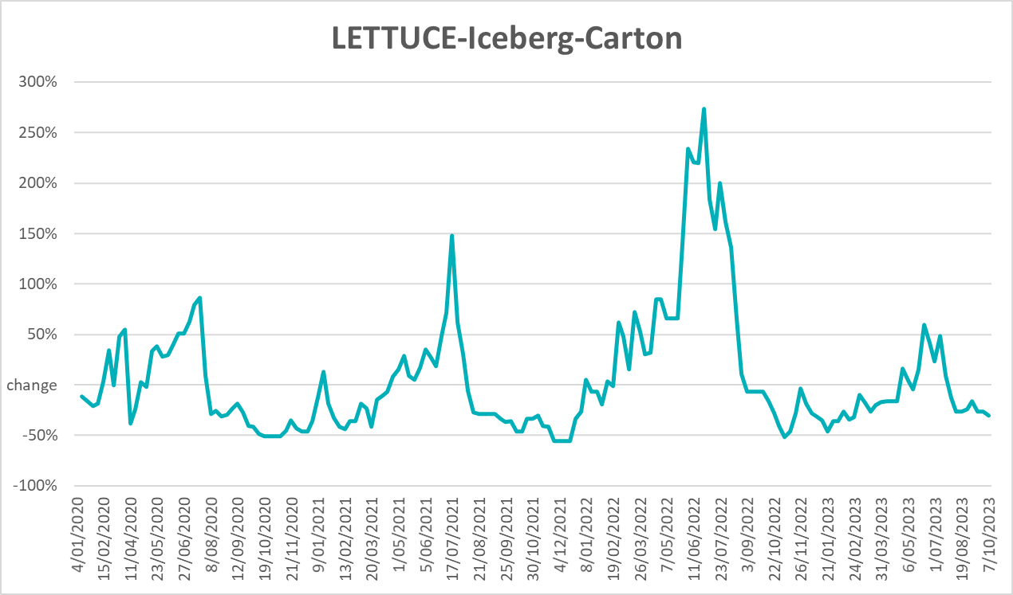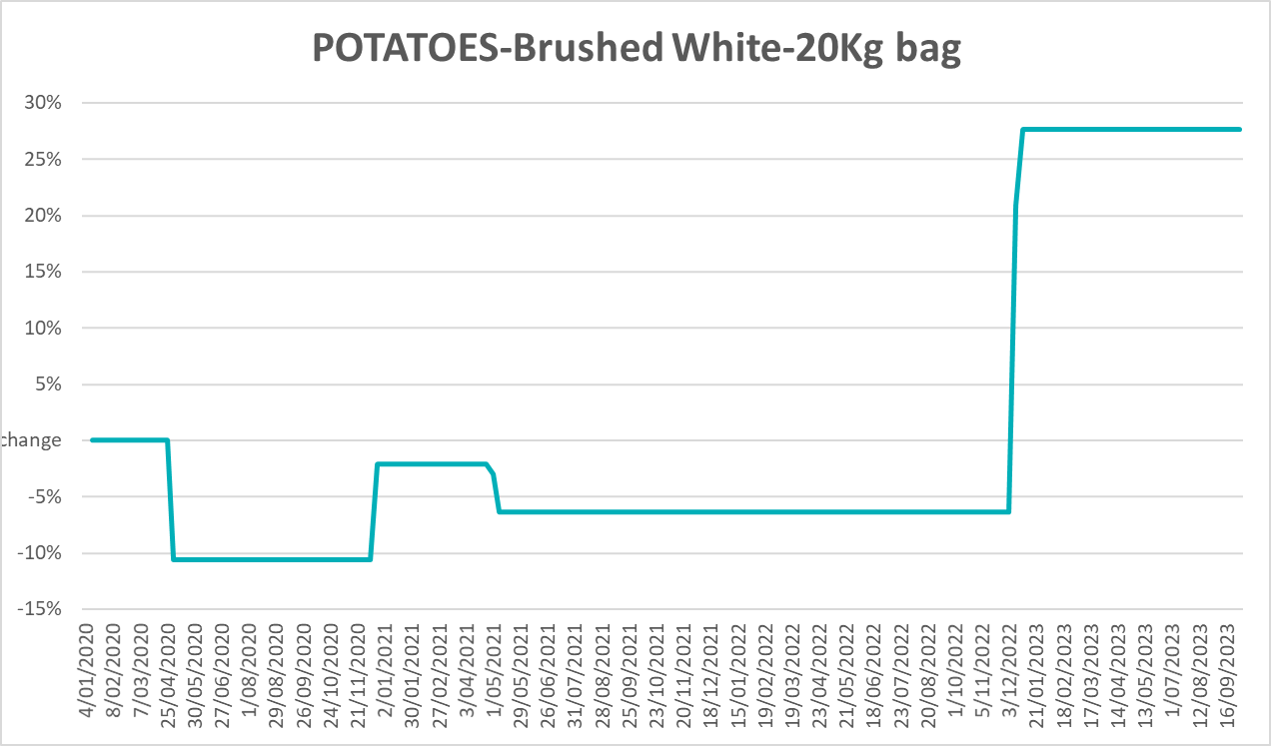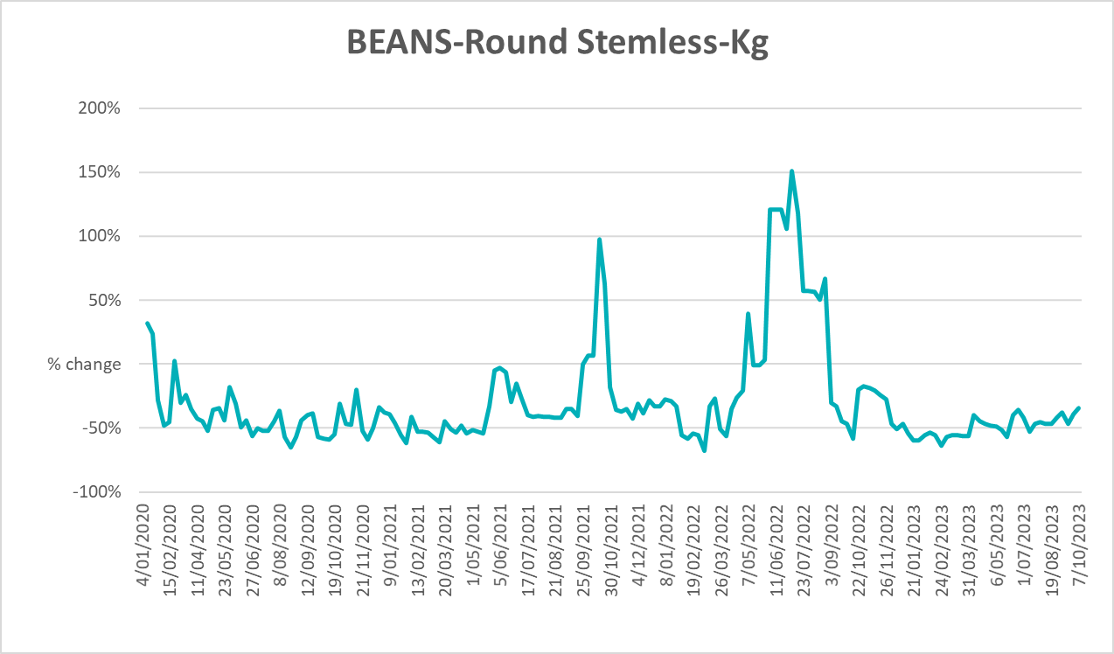

3.6 Selected domestic fodder indicator prices
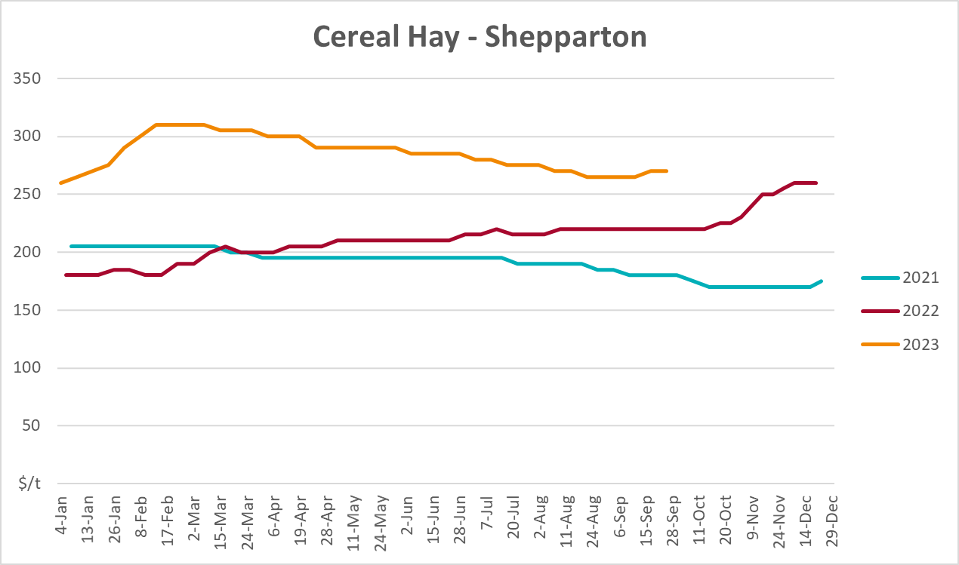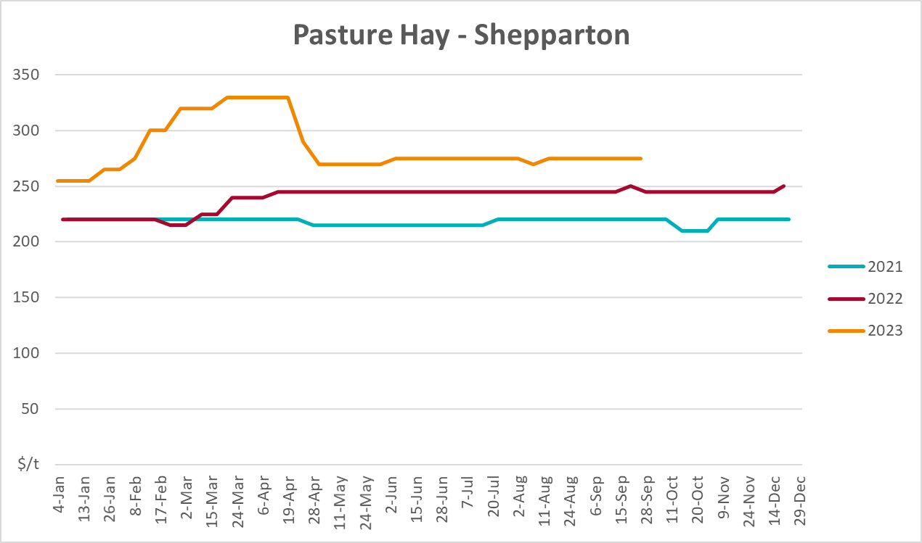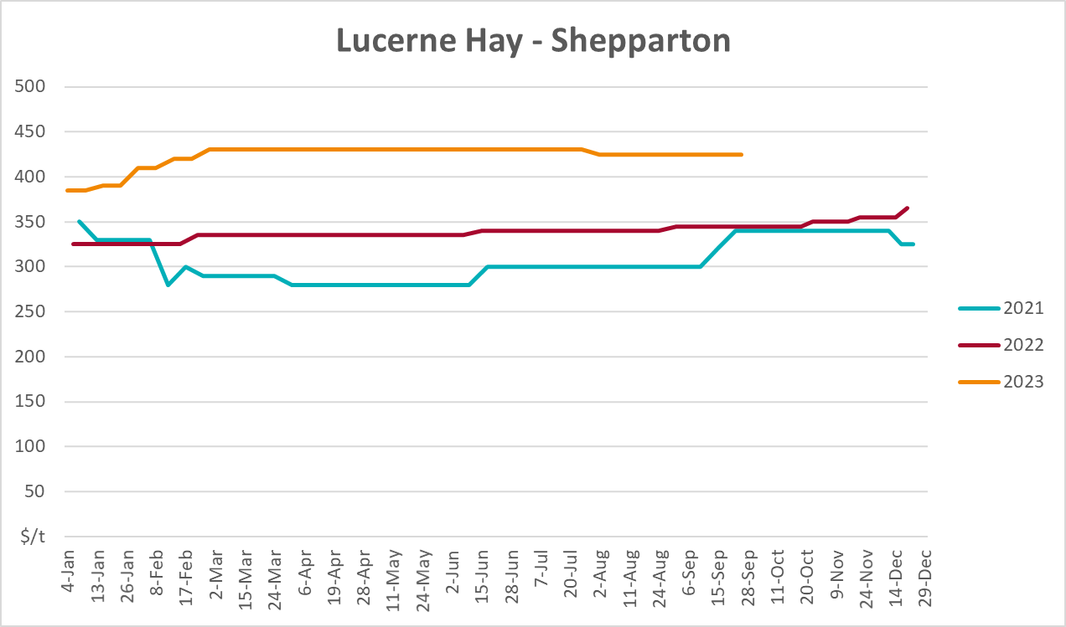

4. Data attribution

Climate
Bureau of Meteorology
- Weekly rainfall totals: www.bom.gov.au/climate/maps/rainfall/
- Monthly and last 3-month rainfall percentiles: www.bom.gov.au/water/landscape/
- Temperature anomalies: www.bom.gov.au/jsp/awap/temp/index.jsp
- Rainfall forecast: www.bom.gov.au/jsp/watl/rainfall/pme.jsp
- Seasonal outlook: www.bom.gov.au/climate/outlooks/#/overview/summary/
- Climate drivers: http://www.bom.gov.au/climate/enso/
- Soil moisture: www.bom.gov.au/water/landscape/
Other
- Pasture growth: www.longpaddock.qld.gov.au/aussiegrass/
- 3-month global outlooks: Environment and Climate Change Canada, NOAA Climate Prediction Center, EUROBRISA CPTEC/INPE, European Centre for Medium-Range Weather Forecasts, Hydrometcenter of Russia, National Climate Center Climate System Diagnosis and Prediction Room (NCC), International Research Institute for Climate and Society
- Global production: https://ipad.fas.usda.gov/ogamaps/cropmapsandcalendars.aspx
- Autumn break: Pook et al., 2009, https://rmets-onlinelibrary-wiley-com.virtual.anu.edu.au/doi/epdf/10.1002/joc.1833

Water
Prices
- Waterflow: https://www.waterflow.io/
- Ruralco: https://www.ruralcowater.com.au/
Bureau of Meteorology:
- Allocation trade: http://www.bom.gov.au/water/dashboards/#/water-markets/mdb/at
- Storage volumes: http://www.bom.gov.au/water/dashboards/#/water-storages/summary/drainage
Trade constraints:
- Water NSW: https://www.waternsw.com.au/customer-service/ordering-trading-and-pricing/trading/murrumbidgee
- Victorian Water Register: https://www.waterregister.vic.gov.au/TradingRules2019/

Commodities
Fruit and vegetables
- Datafresh: www.freshstate.com.au
Pigs
- Australian Pork Limited: www.australianpork.com.au
Dairy
- Global Dairy Trade: www.globaldairytrade.info/en/product-results/
World wheat, canola
- International Grains Council
World coarse grains
- United States Department of Agriculture
World cotton
- Cotlook: www.cotlook.com/
World sugar
- New York Stock Exchange - Intercontinental Exchange
Wool
- Australian Wool Exchange: www.awex.com.au/
Domestic wheat, barley, sorghum, canola and fodder
- Jumbuk Consulting Pty Ltd: http://www.jumbukag.com.au/
Cattle, beef, mutton, lamb, goat and live export
- Meat and Livestock Australia: www.mla.com.au/Prices-and-market
© Commonwealth of Australia 2023

Ownership of intellectual property rights
Unless otherwise noted, copyright (and any other intellectual property rights, if any) in this publication is owned by the Commonwealth of Australia (referred to as the Commonwealth).

Creative Commons licence
All material in this publication is licensed under a Creative Commons Attribution 4.0 International Licence except content supplied by third parties, logos and the Commonwealth Coat of Arms.
Inquiries about the licence and any use of this document should be emailed to copyright@awe.gov.au.


Cataloguing data
This publication (and any material sourced from it) should be attributed as:
ABARES 2023, Weekly Australian Climate, Water and Agricultural Update, Australian Bureau of Agricultural and Resource Economics and Sciences, Canberra, 19 October 2023. CC BY 4.0 DOI: https://doi.org/10.25814/5f3e04e7d2503
ISSN 2652-7561
This publication is available at https://www.agriculture.gov.au/abares/products/weekly_update
Department of Agriculture, Fisheries and Forestry
GPO Box 858 Canberra ACT 2601
Telephone 1800 900 090
Web agriculture.gov.au/abares

Disclaimer
The Australian Government acting through the Department of Agriculture, Fisheries and Forestry, represented by the Australian Bureau of Agricultural and Resource Economics and Sciences, has exercised due care and skill in preparing and compiling the information and data in this publication. Notwithstanding, the Department of Agriculture, Fisheries and Forestry, ABARES, its employees and advisers disclaim all liability, including liability for negligence and for any loss, damage, injury, expense or cost incurred by any person as a result of accessing, using or relying on any of the information or data in this publication to the maximum extent permitted by law.

Statement of Professional Independence
The views and analysis presented in ABARES publications, including this one, reflect ABARES professionally independent findings, based on scientific and economic concepts, principles, information and data. These views, analysis and findings may not reflect or be consistent with the views or positions of the Australian Government, or of organisations or groups who have commissioned ABARES reports or analysis. More information on professional independence is provided on the ABARES website.

Acknowledgements
This report was prepared by Kavina Dayal and Matthew Miller.

