
No. 38/2023 28 September 2023

Summary of key issues
- For the week ending 27 September 2023, cold fronts brought showers to south-eastern parts of the country, mostly to western Tasmania. An easterly onshore airflow brought showers to parts of the Queensland northeast coast. A high-pressure system kept the remainder of the country dry.
- Across cropping regions, rainfall totals of up to 50 millimetres were recorded in southern Western Australia. Little to no rainfall was received in the remaining cropping areas. Given the lack of rainfall across most cropping regions and continuous decline in soil moisture reserves, there is an increased risk of reductions in crop yields (see Section 1.1).
- The El Niño and positive Indian Ocean Dipole are currently active, and their drying effect in Australia is typically stronger and more widespread.
- Drier than normal conditions are expected in October for large areas of Australia. Across cropping regions, during October there is a 75% chance of rainfall totals of between 10 and 25 millimetres across eastern margins of New South Wales, eastern Queensland, and southern Western Australia. October rainfall totals are expected to be below 10 millimetres for the remaining cropping regions. Given the lack of rainfall in recent weeks and declining soil moisture levels across large areas of eastern and southern Australia, expected low rainfall totals continues represent a significant downside production risk for both winter and summer crop production as well as pasture growth (see Section 1.3).
- Maximum temperature predictions for the week ending 8 October 2023 indicates warmer than average conditions are expected across much of southern Australia, with the highest maximum temperature anomalies expected across south-eastern parts of the country. Across cropping regions, much of New South Wales and parts of southern Queensland and northern Victoria are expected to experience maximum temperature up to 5°C above average for this time of year. With lack of rainfall recently, declining soil moisture levels and a lack of forecast rainfall, these high temperatures will likely contribute to increase moisture stress to the winter crops and spring pastures (see Section 1.4).
- Over the next 8-days, a cut-off low pressure system is expected to bring wet conditions to much of Victoria, Tasmania and southern New South Wales with up to 100 millimetres of rainfall (see Section 1.5).
- Across most cropping regions, rainfall totals of up to 50 millimetres are expected in Victoria and southern New South Wales, up to 15 millimetres in eastern South Australia and less than 10 millimetres in the remaining areas. Crops and pasture regions in Queensland, northern New South Wales, parts of South Australia, and Western Australia have experienced a dry start in September and declining soil moisture. These regions will be disposed to heat and moisture stress, negatively affecting production potential (see Section 1.5).
- Water storage levels in the Murray-Darling Basin (MDB) decreased between 21 September 2023 and 28 September 2023 by 32 gigalitres (GL). Current volume of water held in storage is 20 973 GL. This is 6 percent or 1230 GL less than at the same time last year.
- Allocation prices in the Victorian Murray below the Barmah Choke increased from $209 on 21 September 2023 to $216 on 28 September 2023. Prices are lower in the Goulburn-Broken and regions above the Barmah choke due to the binding of the Goulburn intervalley trade limit and Barmah choke trade constraint.

Climate

Rainfall this week
For the week ending 27 September 2023, cold fronts brought showers to south-eastern parts of the country, mostly to western Tasmania. An easterly onshore airflow brought showers to parts of the Queensland northeast coast. A high-pressure system kept the remainder of the country dry.
Across cropping regions, rainfall totals of up to 50 millimetres were recorded in southern Western Australia. Little to no rainfall was received in the remaining cropping areas. Given the lack of rainfall across most cropping regions and continuous decline in soil moisture reserves, there is an increased risk of further reductions in crop yields.

Rainfall for the week ending 27 September 2023
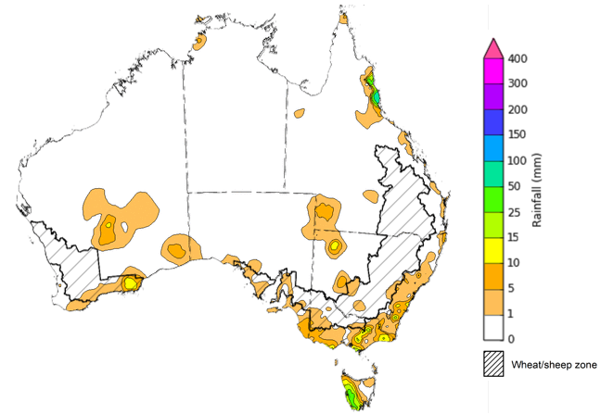
©Commonwealth of Australia 2023, Australian Bureau of Meteorology Issued: 27/9/2023
Note: The rainfall analyses and associated maps utilise data contained in the Bureau of Meteorology climate database, the Australian Data Archive for Meteorology (ADAM). The analyses are initially produced automatically from real-time data with limited quality control. They are intended to provide a general overview of rainfall across Australia as quickly as possible after the observations are received. For further information go to http://www.bom.gov.au/climate/rainfall/

Climate Drivers
The climate drivers with the largest potential impact on Australia’s climate patterns are the El Niño–Southern Oscillation (ENSO), Madden-Julian Oscillation (MJO), Indian Ocean Dipole (IOD) and Southern Annular Mode (SAM). These climate drivers are likely to influence pasture growth across southern Australia and the growth and yield prospects for winter crops.
An El Niño is currently active. The sea surface temperature continues to warm over the tropical Pacific and remains above El Niño thresholds. The atmosphere is also responding to the warm sea surface temperature, which is demonstrating the characteristics of a typical El Niño event. Climate models surveyed by the Bureau of Meteorology indicate this El Niño is likely to persist until at least the end of February. El Niño typically leads to reduced spring and early summer rainfall for eastern Australia, and warmer days for the southern two-thirds of the country. The warmer and drier conditions are expected across southern and eastern Australia from October to December.
The positive Indian Ocean Dipole (IOD) is also active and continues to strengthen where its intensity is currently consistent with that of the major 2019 positive IOD event. It’s effect, combined with an El Niño, is already being experienced with suppressed rainfall across broad regions in Australia, particularly in the central and south-eastern Australia.

Weekly sea surface temperature anomaly

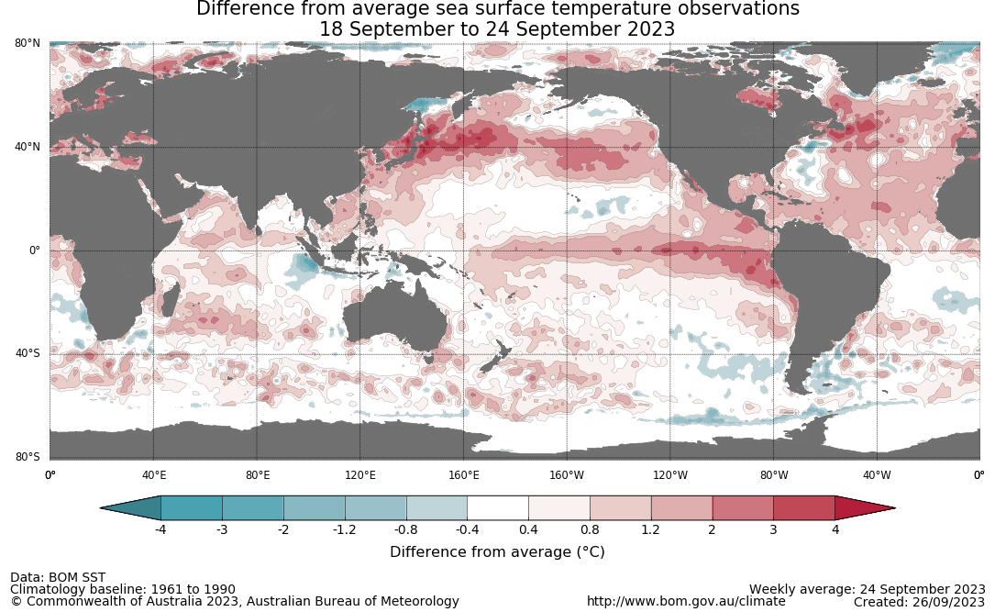

National Climate Outlook
These climate outlooks are generated by ACCESS–S (Australian Community Climate Earth-System Simulator–Seasonal). ACCESS–S is the Bureau of Meteorology's dynamic (physics-based) weather and climate model used for monthly, seasonal, and longer-lead climate outlooks. For further information, go to http://www.bom.gov.au/climate/ahead/about/.
The Bureau of Meteorology’s latest rainfall outlook for October 2023 indicates drier than average conditions are expected across large areas of northern, eastern and southern Australia.
The ACCESS-S climate model suggests that for October 2023, there is a 75% chance of rainfall totals between 10 and 50 millimetres across eastern New South Wales, southeast Queensland, and southern Victoria and Western Australia. Rainfall totals in excess of 50 millimetres are expected across western Tasmania and alpine regions of Victoria.
Across cropping regions, there is a 75% chance of rainfall totals of between 10 and 25 millimetres across eastern margins of New South Wales, eastern Queensland, and southern Western Australia. October rainfall totals are expected to be below 10 millimetres for the remaining cropping regions.
These relatively low expected rainfall totals continue to represent a significant downside production risk for both winter and summer crop production as well as pasture growth, particularly given the lack of rainfall in recent weeks and declining soil moisture levels across large areas of eastern and southern Australia.
Rainfall totals that have a 75% chance of occurring in October 2023
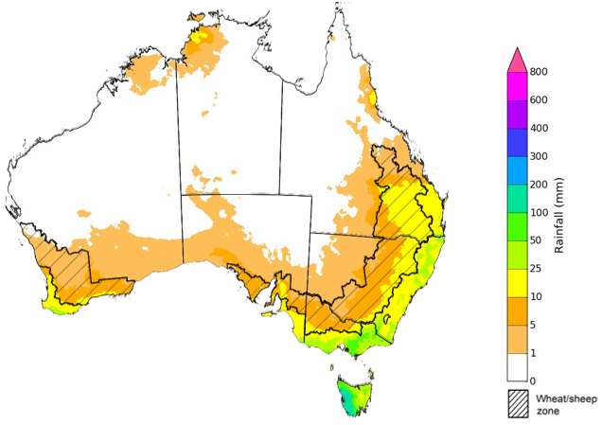
©Commonwealth of Australia 2023, Australian Bureau of Meteorology Issued: 28/09/2023

The rainfall outlook for October to December 2023 suggests that there is close to equal chances of above or below median rainfall for the central of Western Australia, and parts of western Tasmania and coastal New South Wales. However, below median rainfall is more likely across much of the remainder of the country.
Across cropping regions, below median rainfall is more likely for most areas through the October to December period.
Chance of exceeding the median rainfall October to December 2023
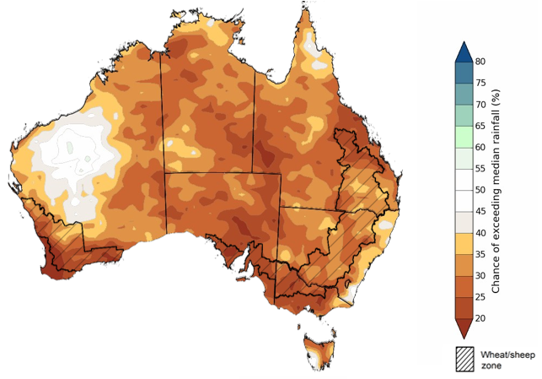
©Commonwealth of Australia 2023, Australian Bureau of Meteorology Issued: 28/09/2023

The outlook for October to December 2023 suggests there is a 75% chance of rainfall totals between 25 and 200 millimetres across much of New South Wales, Queensland, Victoria, Tasmania and the Northern Territory, and across parts of South Australia and Western Australia. Rainfall totals in excess of 200 millimetres are forecast for alpine regions of Victoria, coastal New South Wales, western Tasmania and the tropical north of the Northern Territory.
There is a 75% chance of receiving between 25 and 200 millimetres across most winter cropping regions, except for northern and central cropping regions in Western Australia where falls are expected to be below 25 millimetres. If the falls are realised where expected, it may be sufficient to support close to average plant growth, in areas with average or better levels of soil moisture.
Rainfall totals that have a 75% chance of occurring October to December 2023 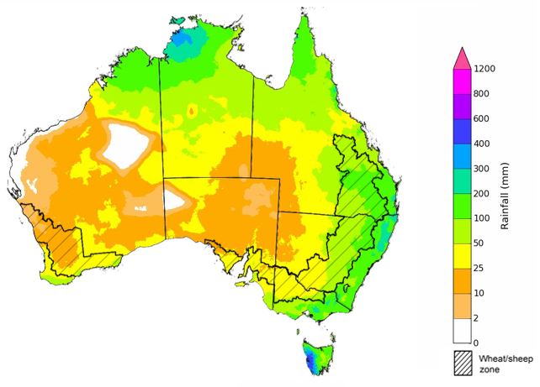
©Commonwealth of Australia 2023, Australian Bureau of Meteorology Issued: 28/09/2023

Weekly predicted temperature anomalies
Maximum temperature predictions for the week ending 8 October 2023 indicates warmer than average conditions are expected across much of southern Australia, with the highest maximum temperature anomalies expected across south-eastern parts of the country. Across cropping regions, much of New South Wales and parts of southern Queensland and northern Victoria and Western Australia are expected to experience maximum temperature up to 5°C above average for this time of year.
These well above average predicted temperatures, in addition to the lack of recent rainfall, declining soil moisture levels and a lack of forecast rainfall (see Section 1.5) will likely contribute to increase moisture stress to the winter crops and spring pastures. The combination of reduced crop prospects and strong fodder prices may be providing producers in regions with declining grain yield potentials with a strong incentive to cut some crops that were planted for grain production for hay. In some regions, particularly in Queensland and northern New South Wales, some crops may not have produced sufficient biomass to warrant fodder conservation and may instead be used for grazing to allow for economic return to some farmers as they replace some of their grain feeding with the grazing matter.
Predicted maximum temperature anomaly for 2 to 8 October 2023
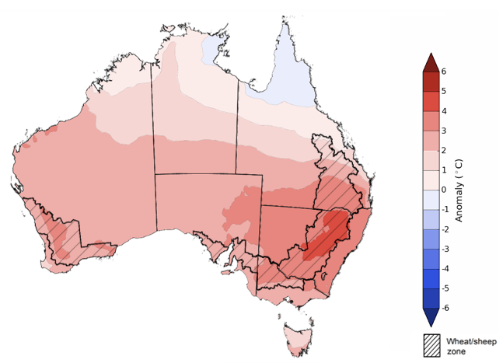
©Commonwealth of Australia 2023, Australian Bureau of Meteorology Issued: 28/09/2023

Rainfall forecast for the next eight days
Over the 8-days to 5 October 2023, a cut-off low pressure system is expected to bring wet conditions to much of Victoria, Tasmania and southern New South Wales with up to 100 millimetres of rainfall.
Across cropping regions, rainfall totals of up to 50 millimetres are expected in Victoria and southern New South Wales, up to 15 millimetres in eastern South Australia and less than 10 millimetres in the remaining areas. Crops and pasture regions in Queensland, northern New South Wales, parts of South Australia, and Western Australia have experienced a dry start in September and declining soil moisture. These regions will be disposed to heat and moisture stress, negatively affecting production potential.

Total forecast rainfall for the period 28 September 2023 to 5 October 2023
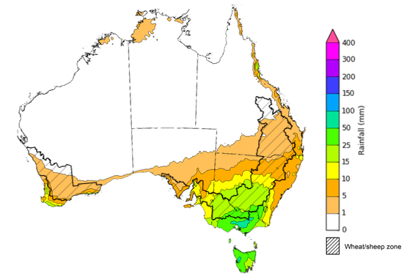

©Commonwealth of Australia 2023, Australian Bureau of Meteorology Issued 28/9/2023
Note: This rainfall forecast is produced from computer models. As the model outputs are not altered by weather forecasters, it is important to check local forecasts and warnings issued by the Bureau of Meteorology.

Water

Water markets – current week
Water storage levels in the Murray-Darling Basin (MDB) decreased between 21 September 2023 and 28 September 2023 by 32 gigalitres (GL). Current volume of water held in storage is 20 973 GL. This is 6 percent or 1230 GL less than at the same time last year.

Water storages in the Murray-Darling Basin, 2013–2023
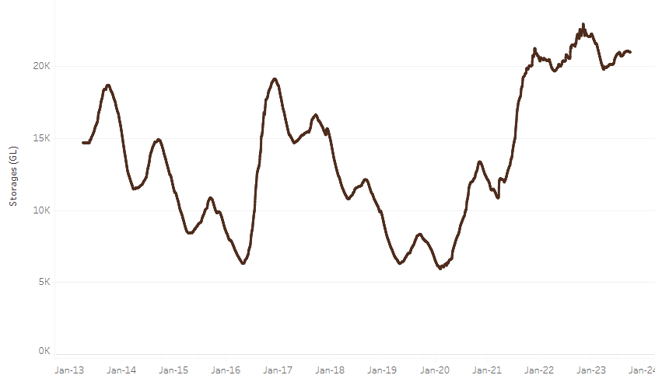
Allocation prices in the Victorian Murray below the Barmah Choke increased from $209 on 21 September 2023 to $216 on 28 September 2023. Prices are lower in the Goulburn-Broken and regions above the Barmah choke due to the binding of the Goulburn intervalley trade limit and Barmah choke trade constraint.
Water storage data is sourced from the Bureau of Meteorology.

Region | $/ML
NSW Murray Above | 131
NSW Murrumbidgee | 242
VIC Goulburn-Broken | 171
VIC Murray Below | 216

Surface water trade activity, Southern Murray–Darling Basin
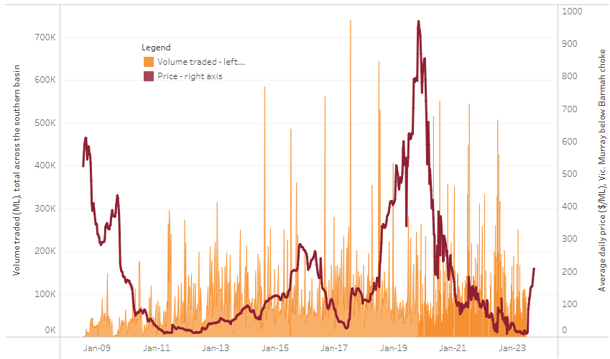
The trades shown reflect estimated market activity and do not encompass all register trades. The price is shown for the VIC Murray below the Barmah choke. Historical prices (before 1 July 2019) are ABARES estimates after removing outliers from BOM water register data. Prices after 1 July 2019 and prior to the 30 October 2019 reflect recorded transaction prices as sourced from Ruralco. Prices after the 30 October 2019 are sourced from Waterflow. Data for volume traded is sourced from the BOM water register. Only the price data shown is current on 28 September 2023.

To access the full, interactive, weekly water dashboard, which contains the latest and historical water storage, water market and water allocation information, please visit https://www.agriculture.gov.au/abares/products/weekly_update/weekly-update-28923

Commodities
Indicator | Week ended | Unit | Latest Price | Previous Week | Weekly change | Price 12 months ago | Annual change
Selected world indicator prices
AUD/USD Exchange rate | 27-Sep | A$/US$ | 0.64 | 0.64 | -1% | 0.65 | -1%
Wheat – US no. 2 hard red winter wheat, fob Gulf | 27-Sep | US$/t | 315 | 320 | -2% | 442 | -29%
Corn – US no. 2 yellow corn, fob Gulf | 27-Sep | US$/t | 223 | 223 | 0% | 328 | -32%
Canola – Rapeseed, Canada, fob Vancouver | 27-Sep | US$/t | 563 | 578 | -3% | 679 | -17%
Cotton – Cotlook 'A' Index | 27-Sep | USc/lb | 97 | 97 | 0% | 103 | -6%
Sugar – Intercontinental Exchange, nearby futures, no.11 contract | 27-Sep | USc/lb | 26.4 | 27.4 | -3% | 18 | 46%
Wool – Eastern Market Indicator | 13-Sep | Ac/kg clean | 1,144 | 1,148 | 0% | 1,342 | -15%
Wool – Western Market Indicator | 13-Sep | Ac/kg clean | 1,272 | 1,299 | -2% | 1,504 | -15%
Selected Australian grain export prices
Milling Wheat – APW, Port Adelaide, SA | 27-Sep | A$/t | 492 | 488 | 1% | 575 | -14%
Feed Wheat – ASW, Port Adelaide, SA | 27-Sep | A$/t | 470 | 466 | 1% | 528 | -11%
Feed Barley – Port Adelaide, SA | 27-Sep | A$/t | 408 | 405 | 1% | 455 | -10%
Canola – Kwinana, WA | 27-Sep | A$/t | 820 | 820 | 0% | 1,044 | -21%
Grain Sorghum – Brisbane, QLD | 27-Sep | A$/t | 524 | 522 | 0% | 458 | 14%
Selected domestic livestock indicator prices
Beef – Eastern Young Cattle Indicator | 27-Sep | Ac/kg cwt | 381 | 408 | -7% | 1,040 | -63%
Mutton – Mutton indicator (18–24 kg fat score 2–3), Vic | 27-Sep | Ac/kg cwt | 107 | 122 | -12% | 557 | -81%
Lamb – National Trade Lamb Indicator | 27-Sep | Ac/kg cwt | 433 | 437 | -1% | 755 | -43%
Pig – Eastern Seaboard (60.1–75 kg), average of buyers & sellers | 20-Sep | Ac/kg cwt | 352 | 352 | 0% | 376 | -6%
Goats – Eastern States (12.1–16 kg) | 20-Sep | Ac/kg cwt | 255 | 255 | 0% | 887 | -71%
Live cattle – Light steers to Indonesia | 05-Jul | Ac/kg lwt | 310 | 330 | -6% | 450 | -31%
Global Dairy Trade (GDT) weighted average prices ª
Dairy – Whole milk powder | 20-Sep | US$/t | 2,799 | 2,702 | 4% | 3,610 | -22%
Dairy – Skim milk powder | 20-Sep | US$/t | 2,400 | 2,286 | 5% | 3,575 | -33%
Dairy – Cheddar cheese | 20-Sep | US$/t | 4,044 | 4,102 | -1% | 5,046 | -20%
Dairy – Anhydrous milk fat | 20-Sep | US$/t | 4,787 | 4,561 | 5% | 5,677 | -16%
a Global Dairy Trade prices are updated twice monthly on the first and third Tuesday of each month.

Selected world indicator prices
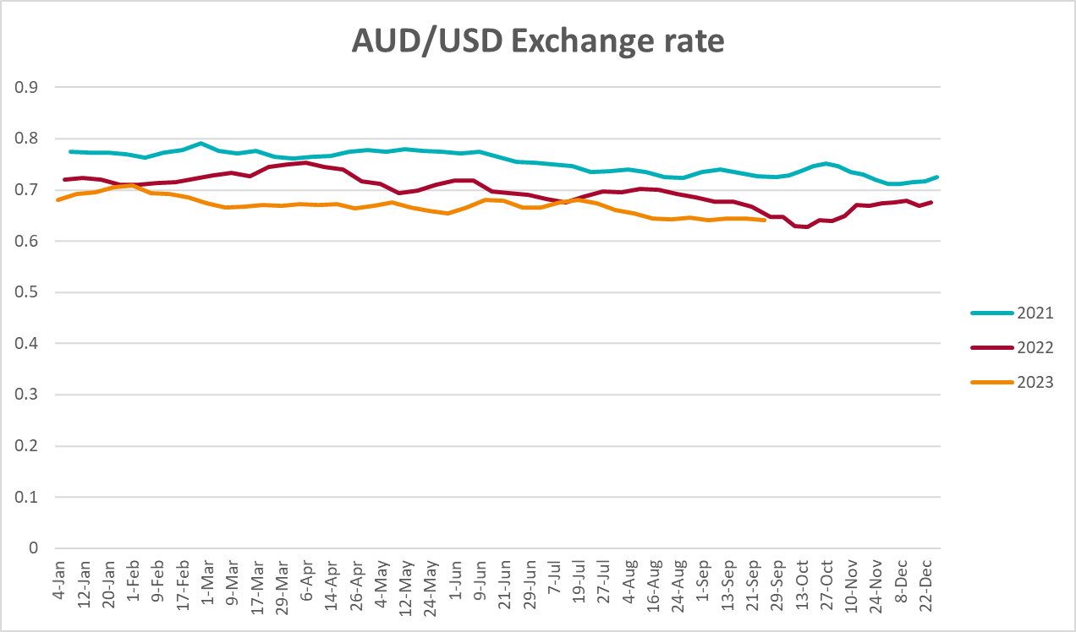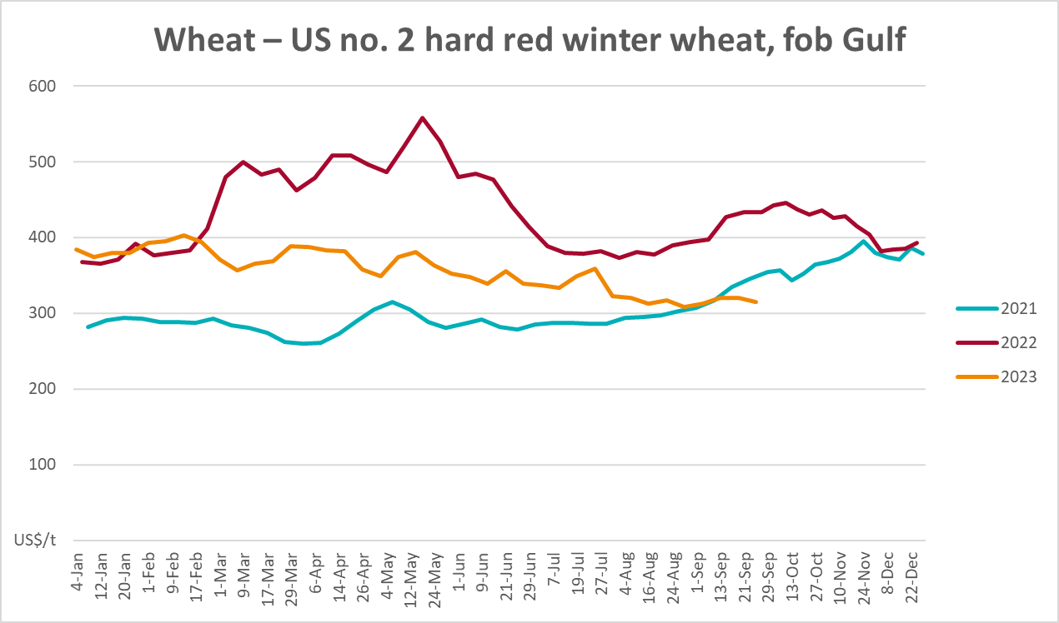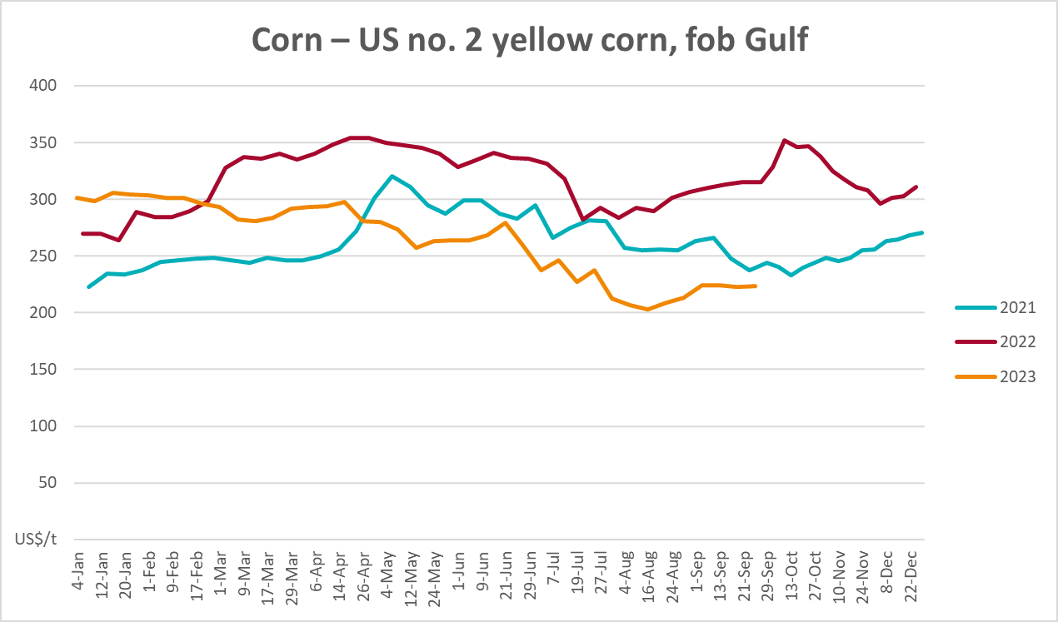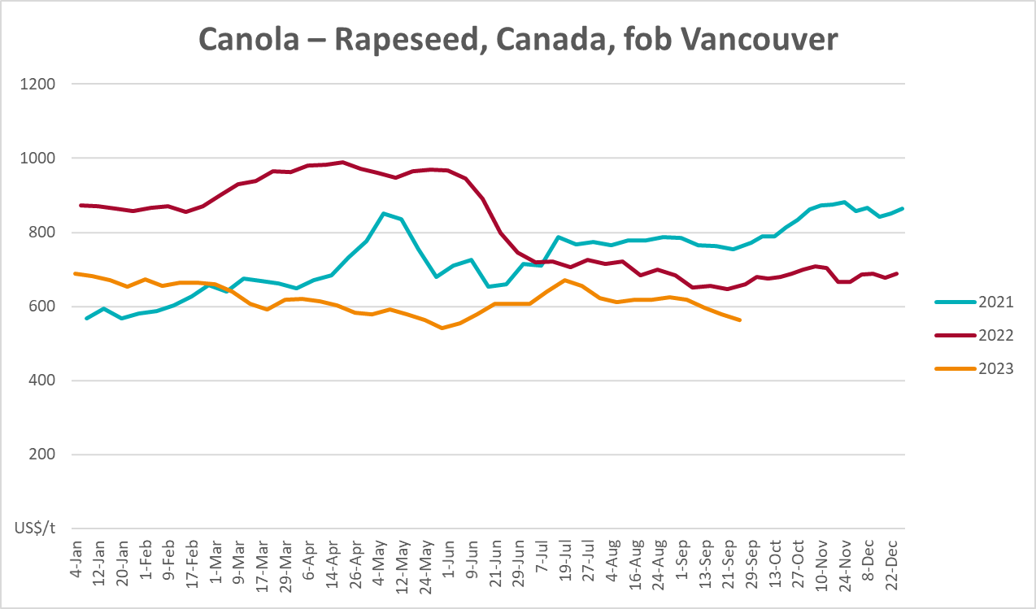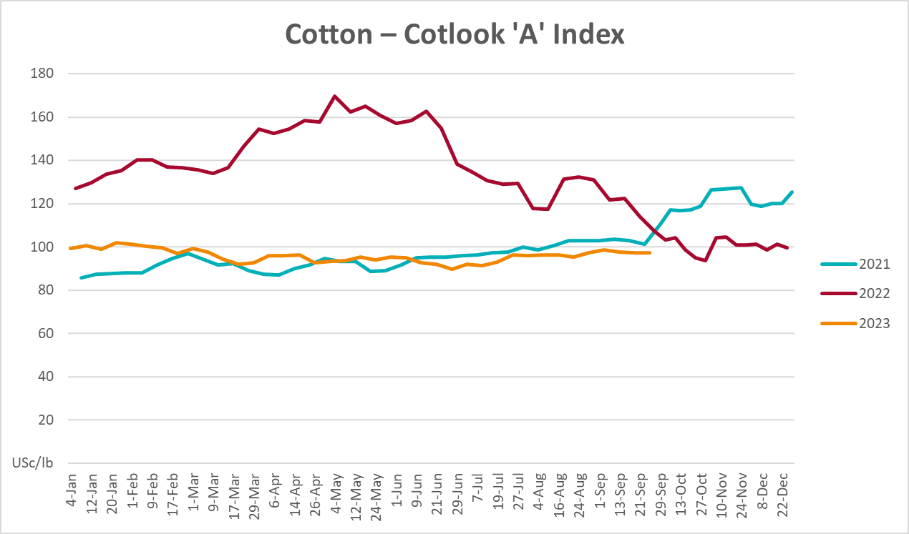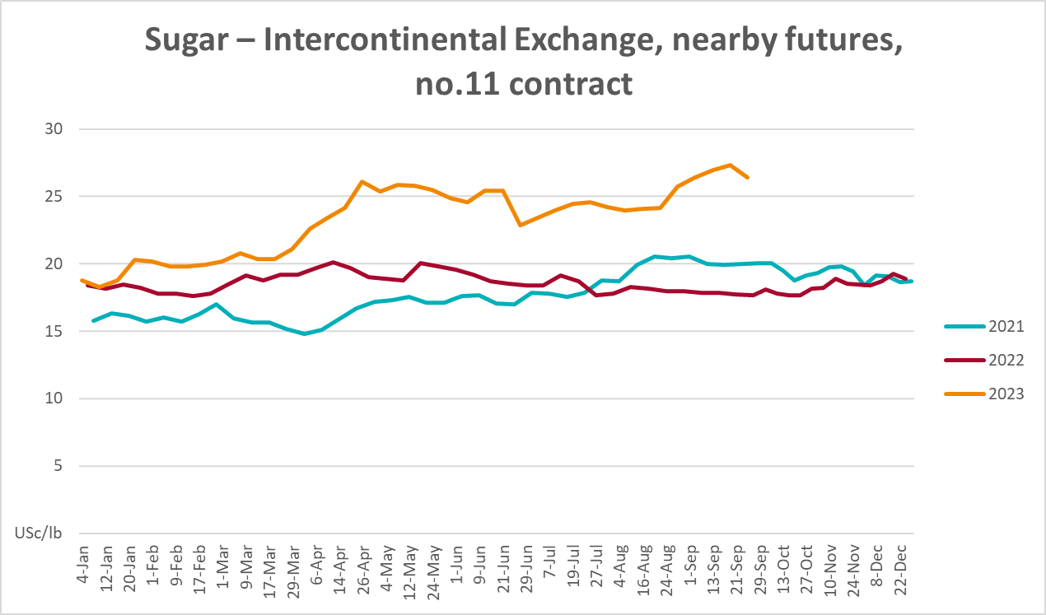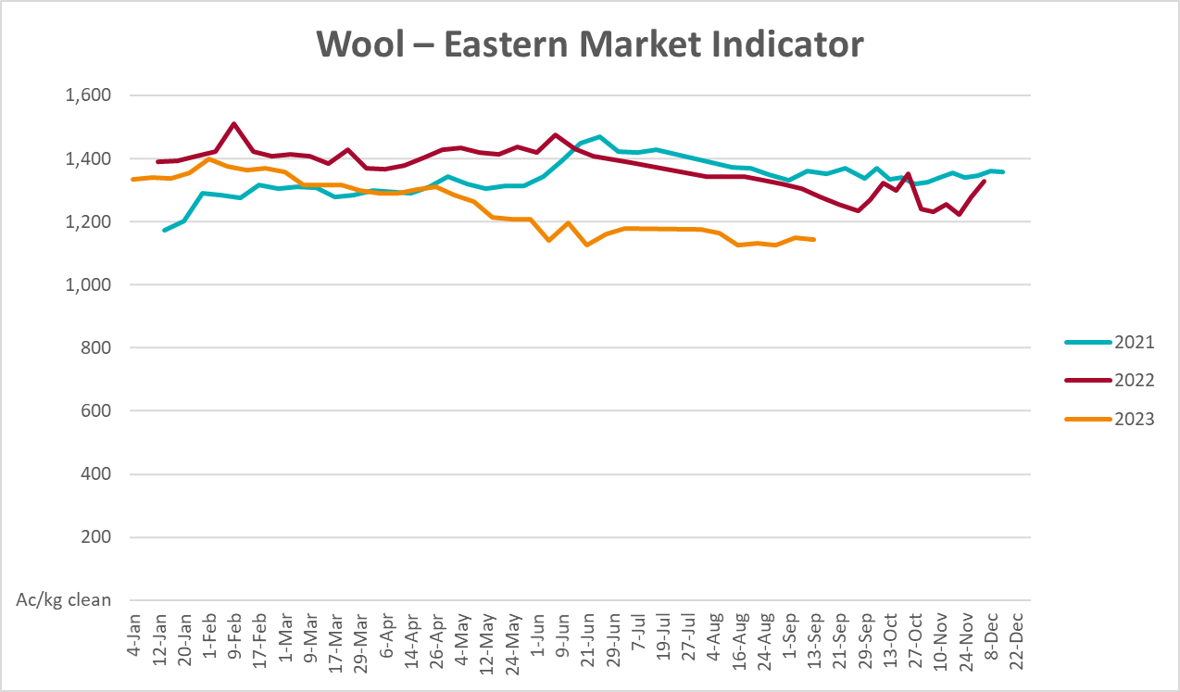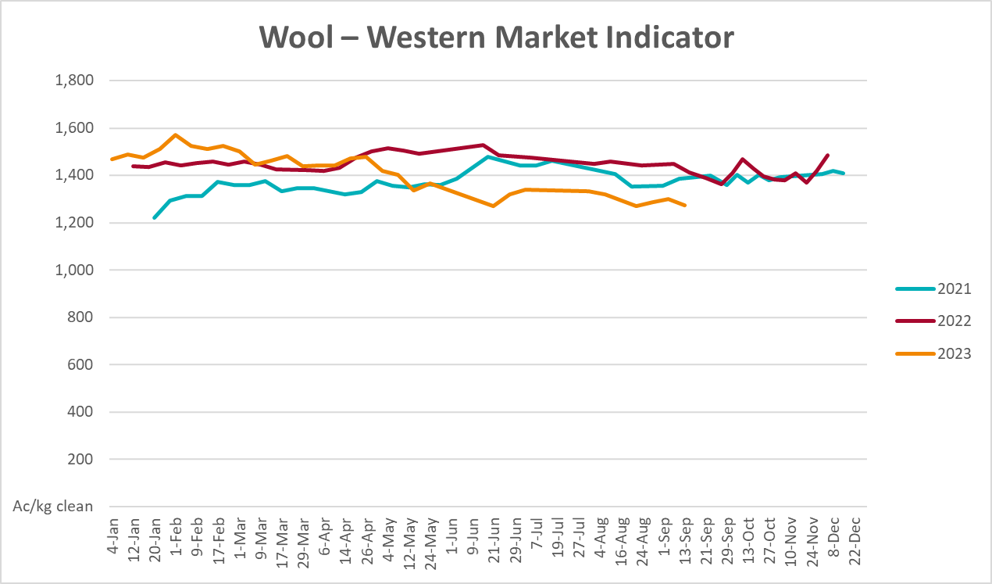

Selected domestic crop indicator prices
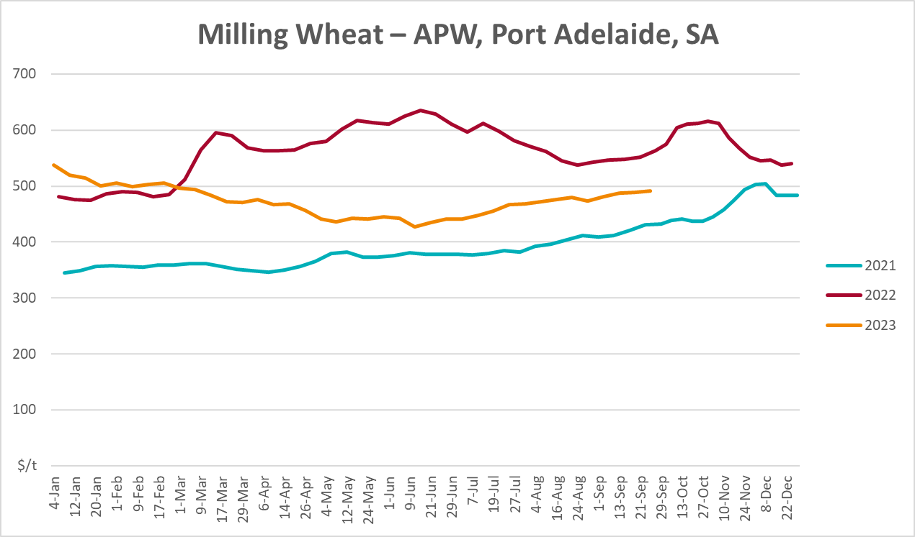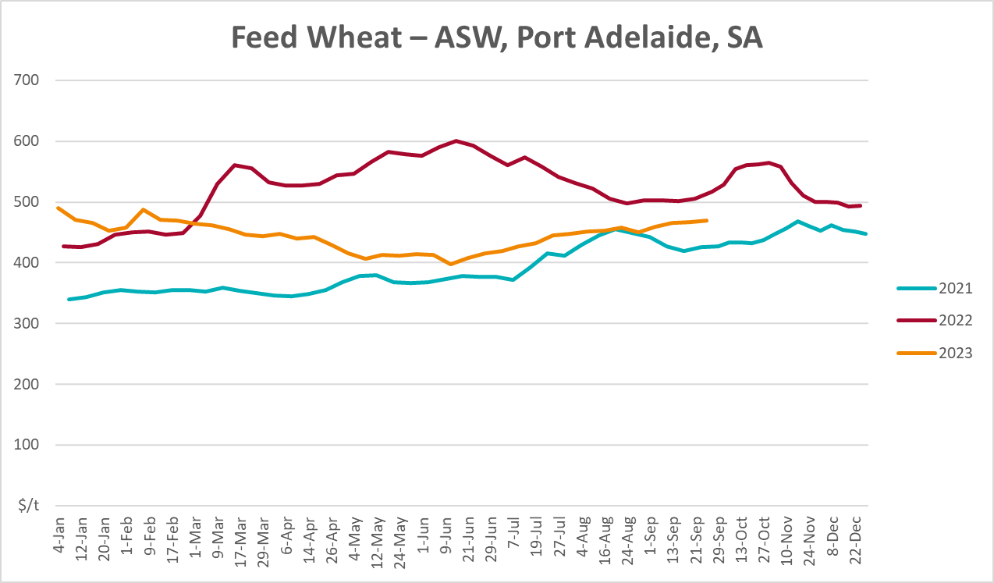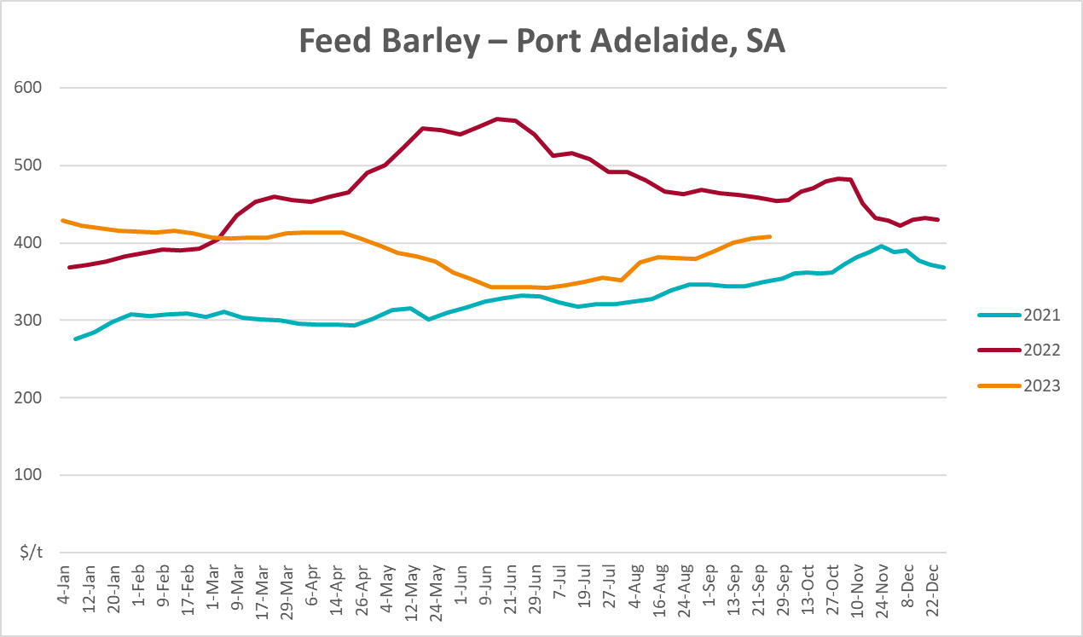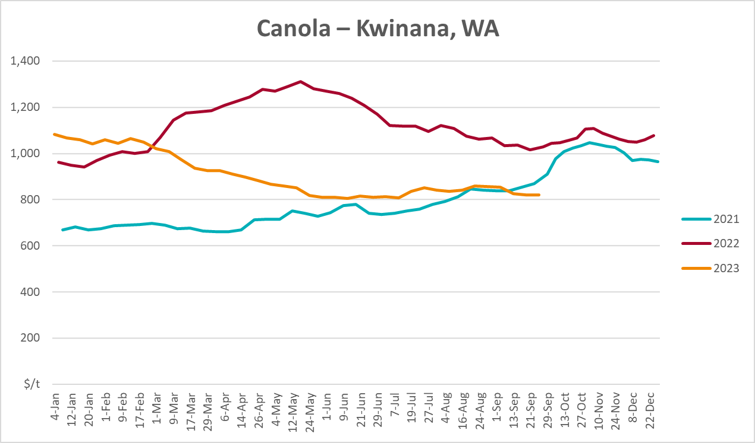
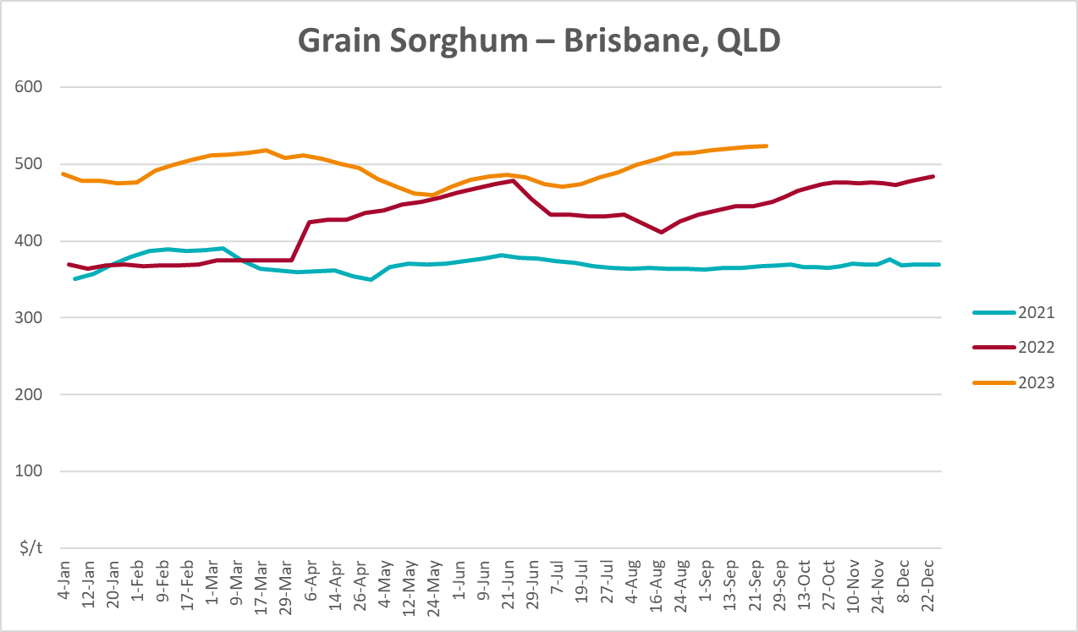

Selected domestic livestock indicator prices
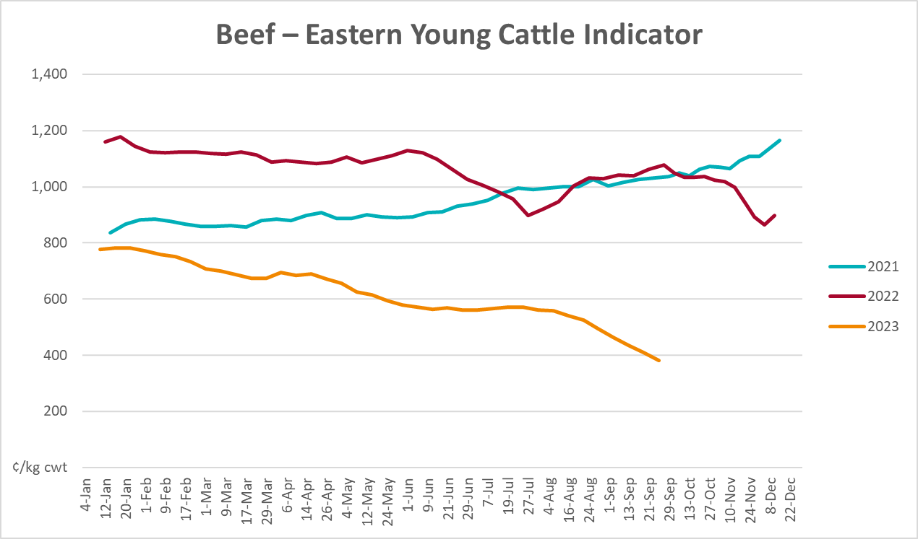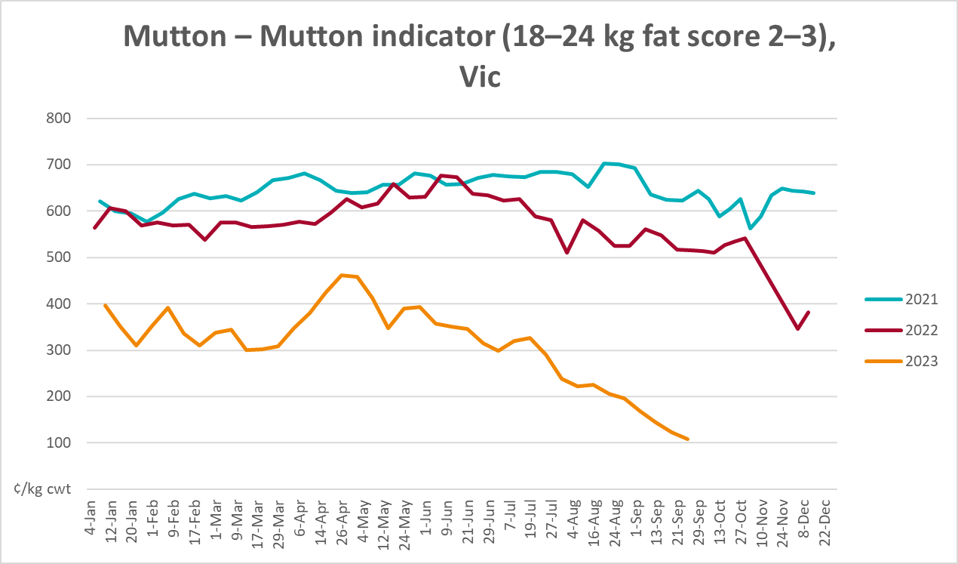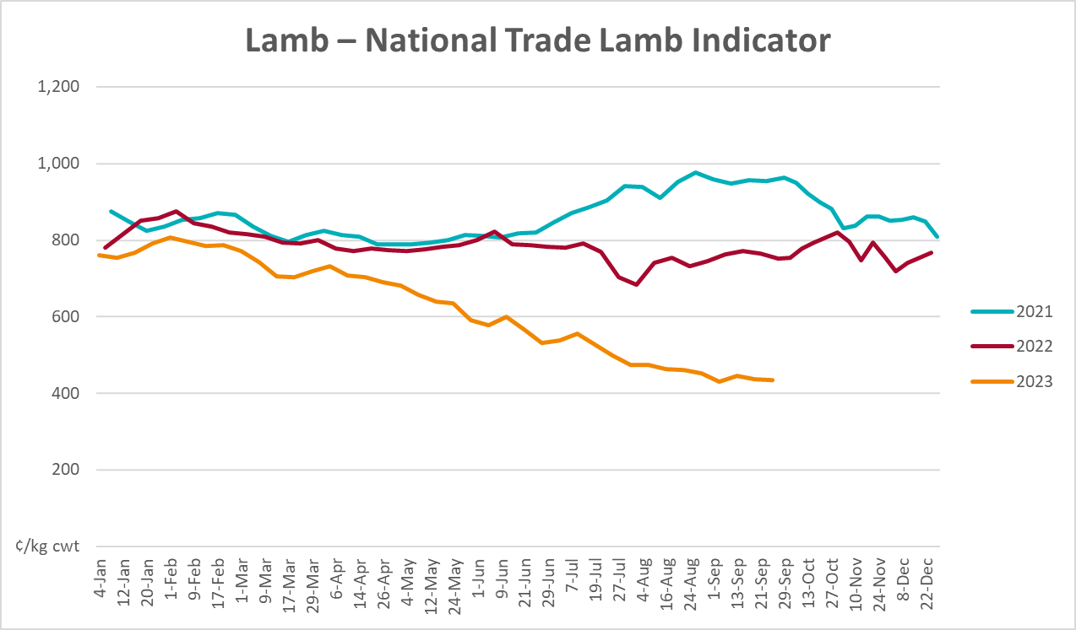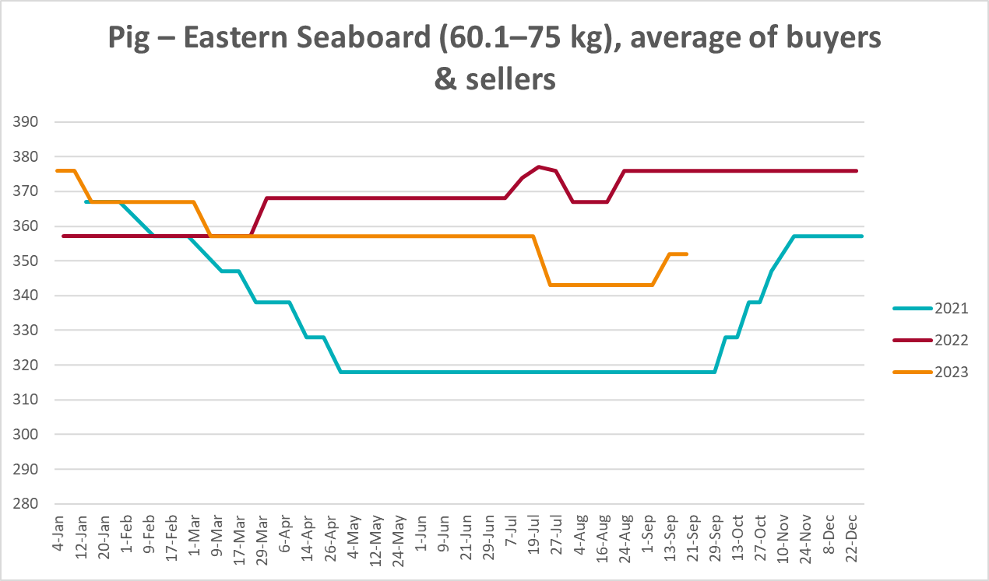
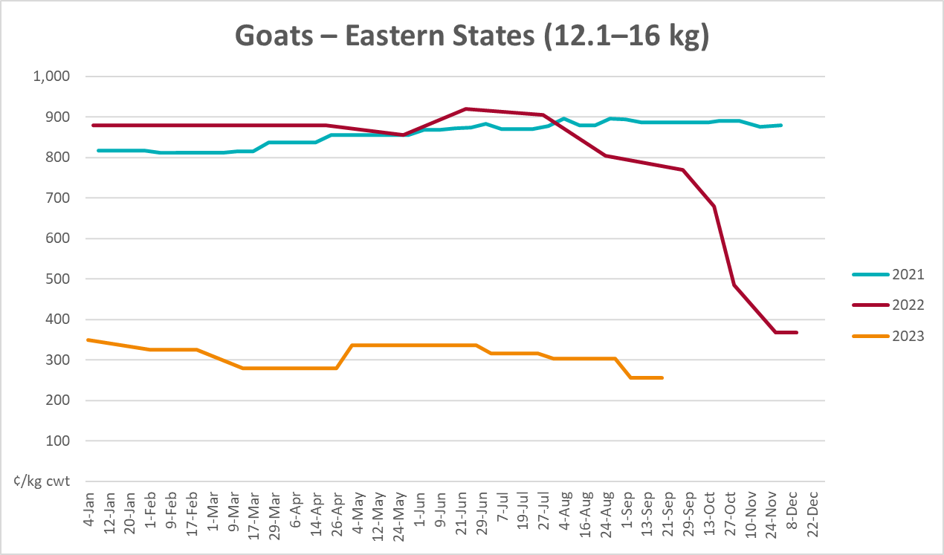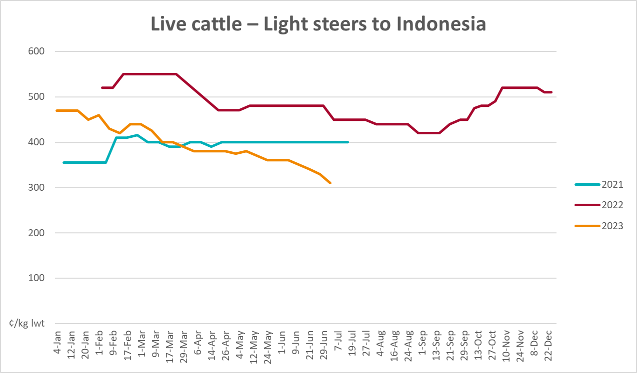

Global Dairy Trade (GDT) weighted average prices
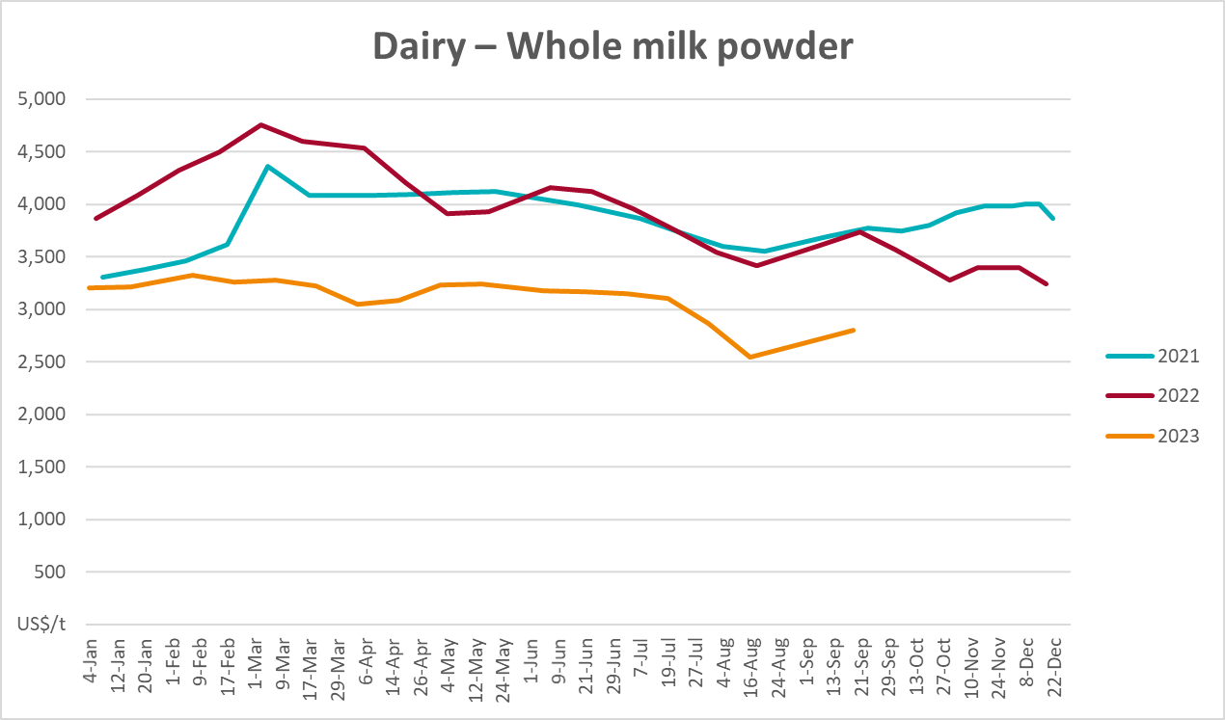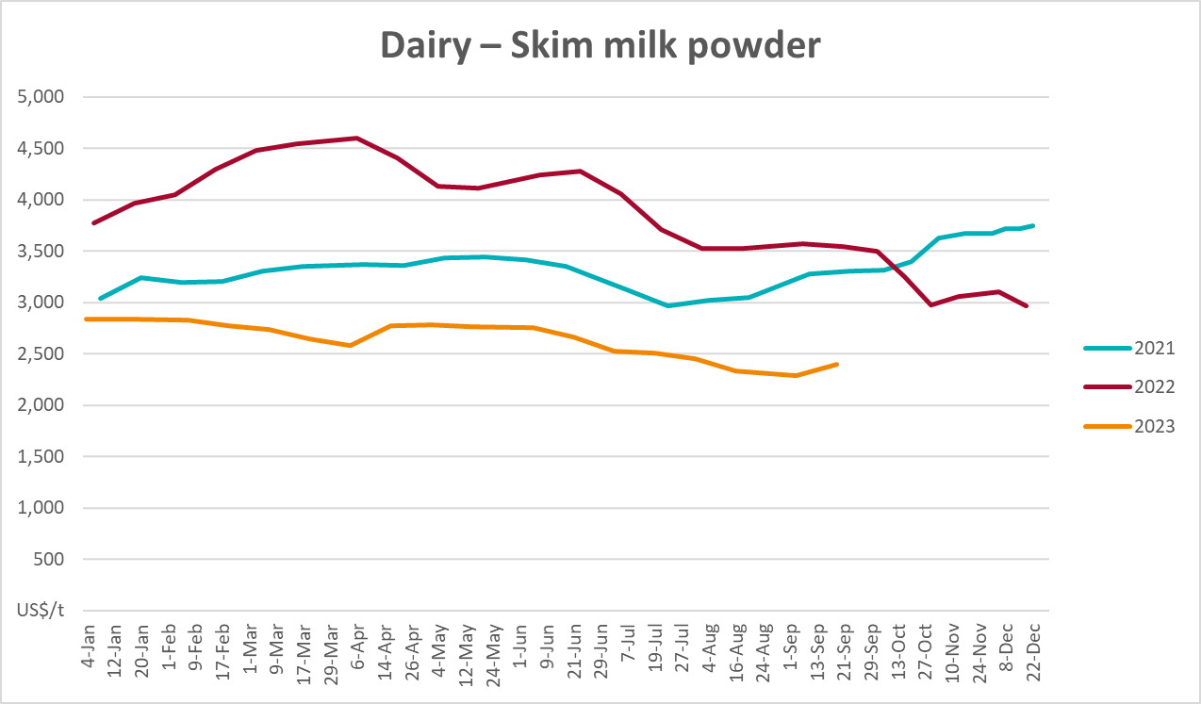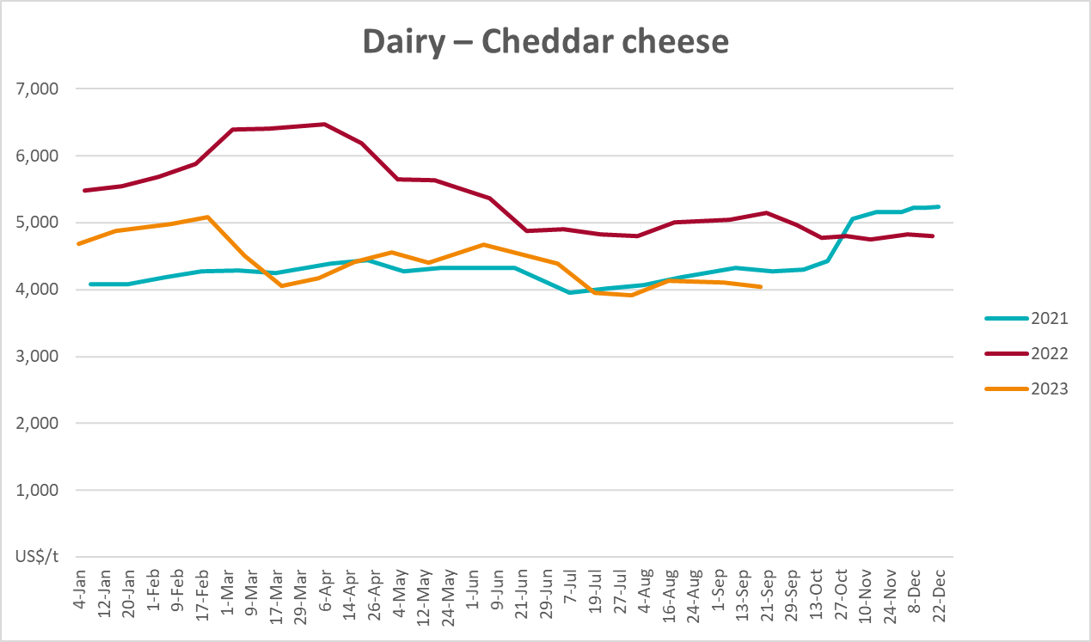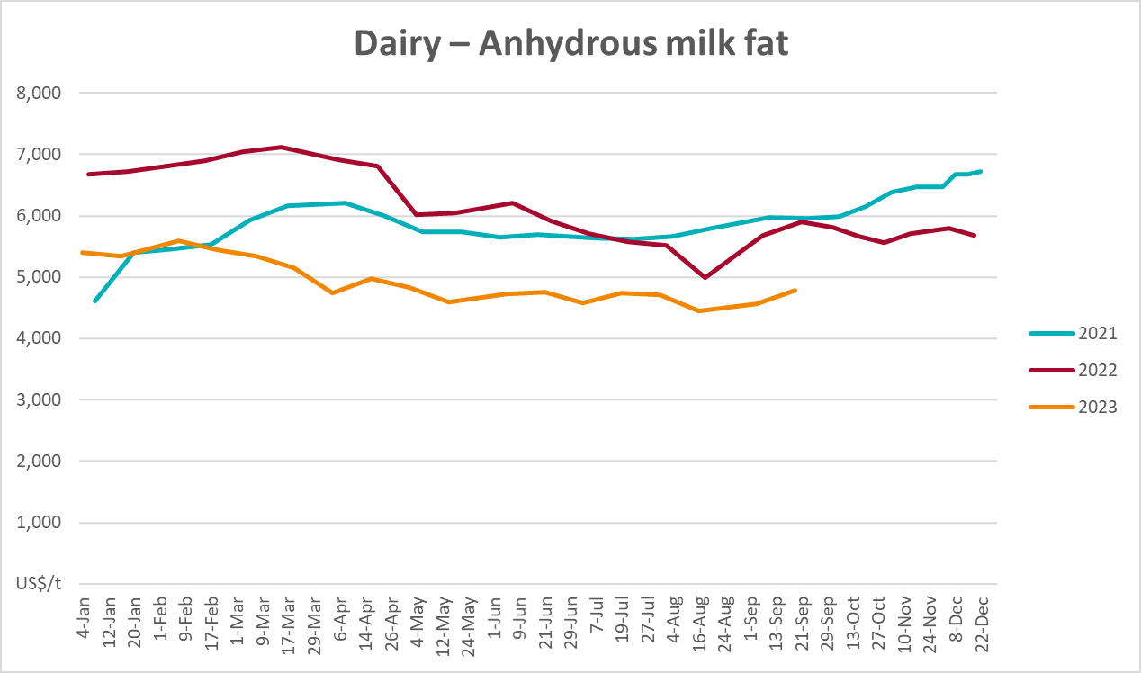

Selected fruit and vegetable prices
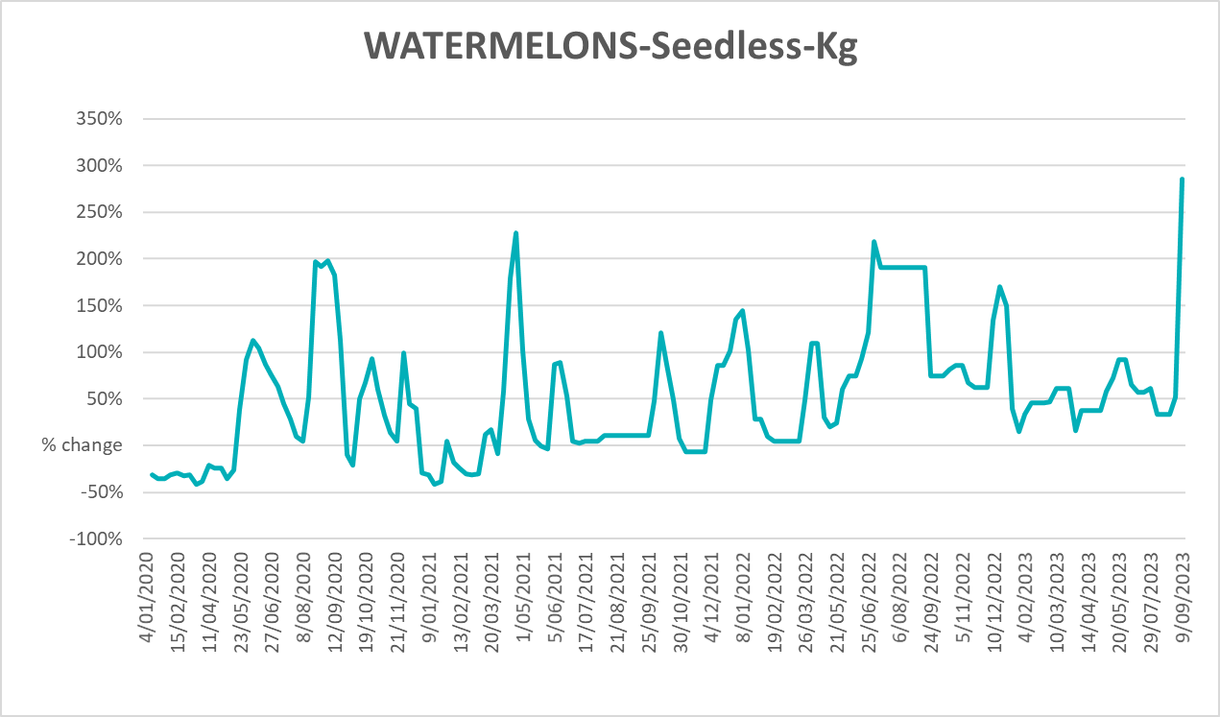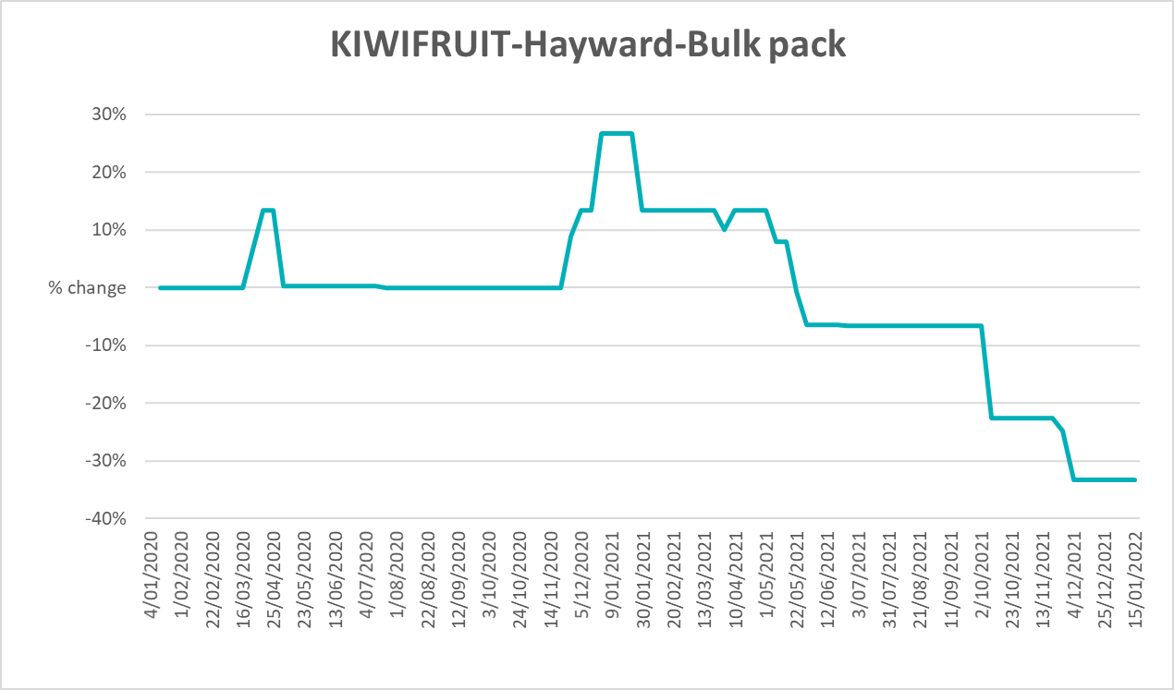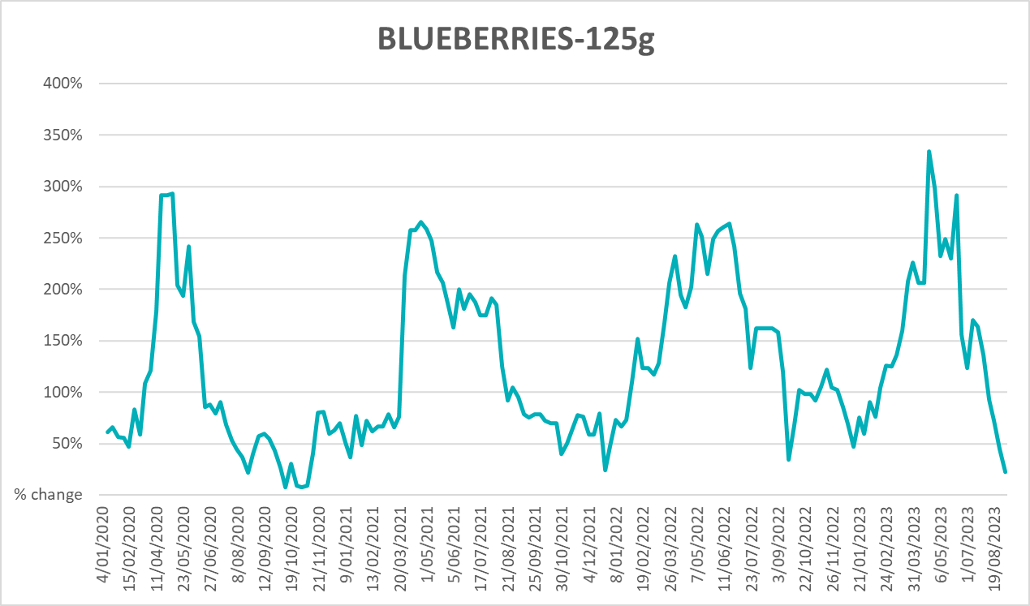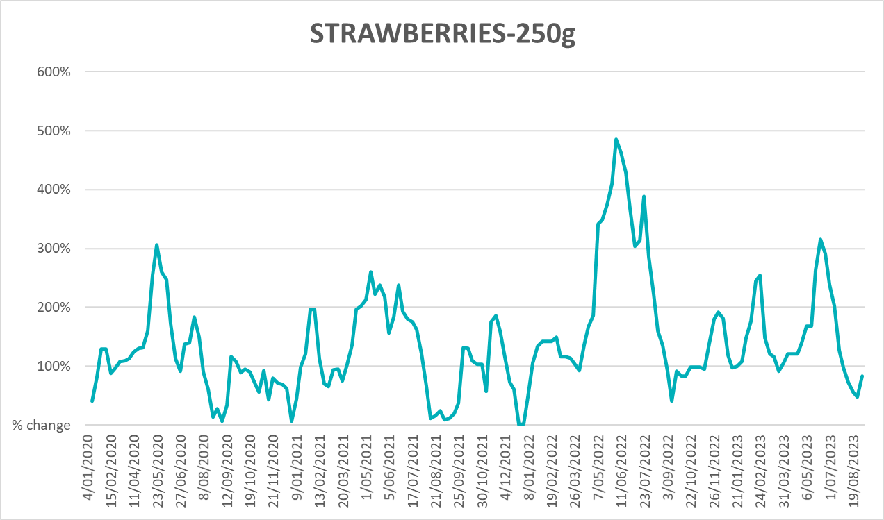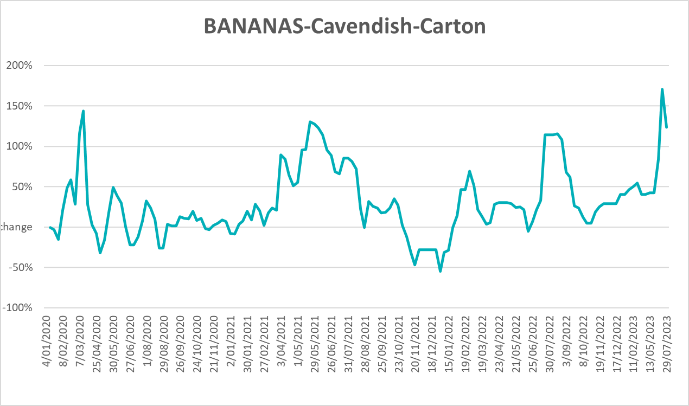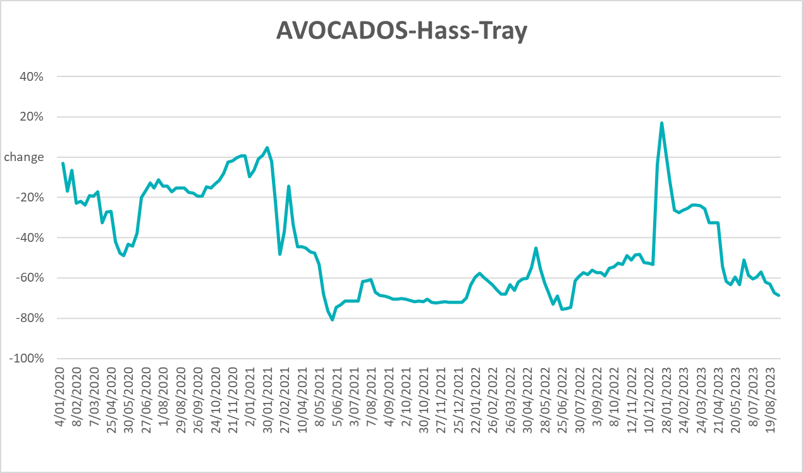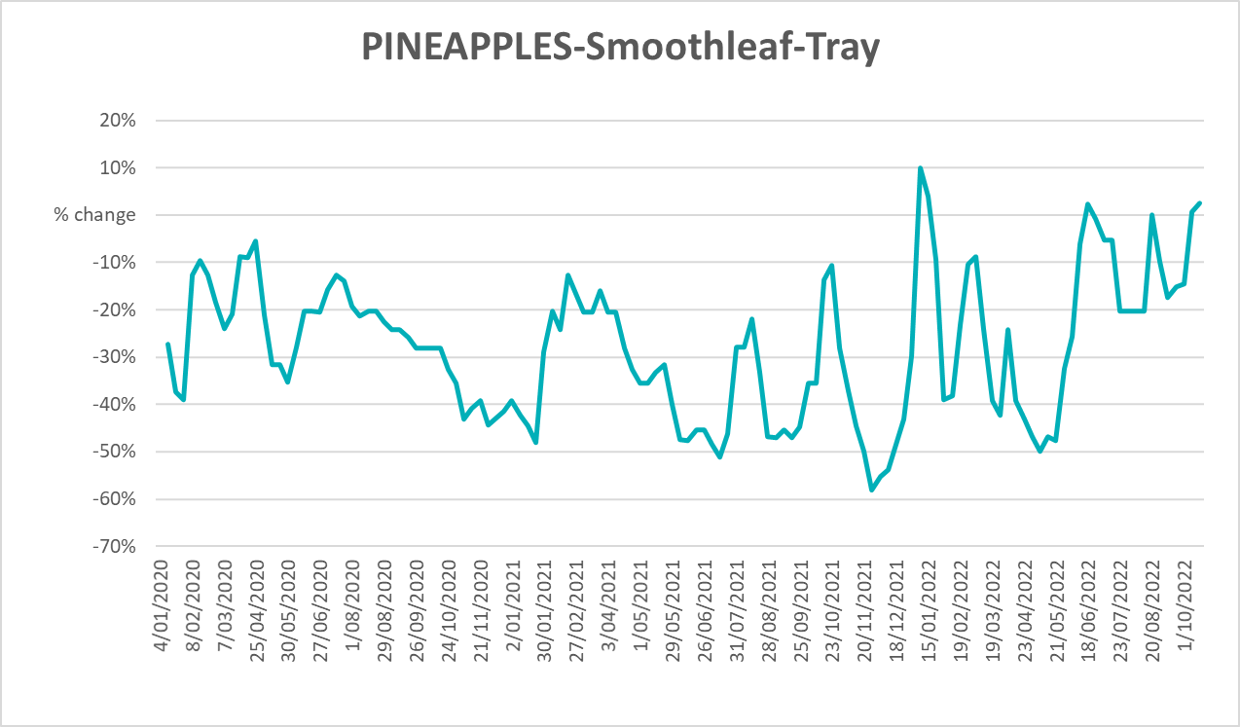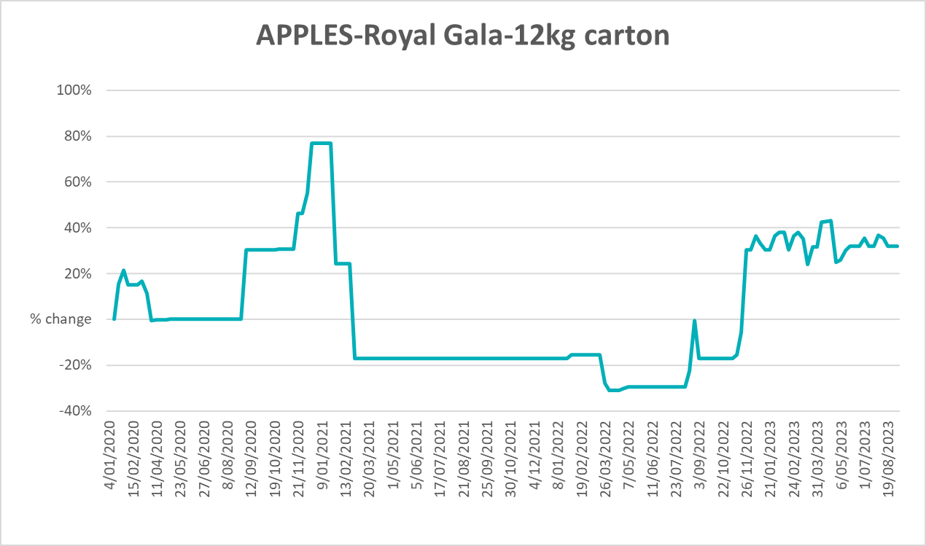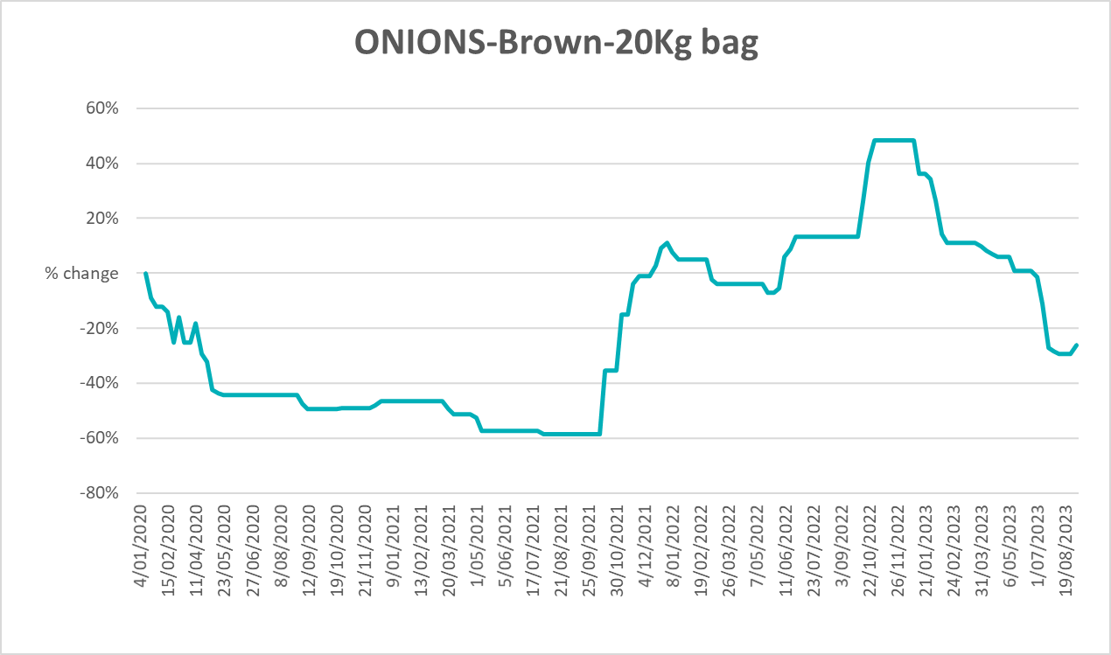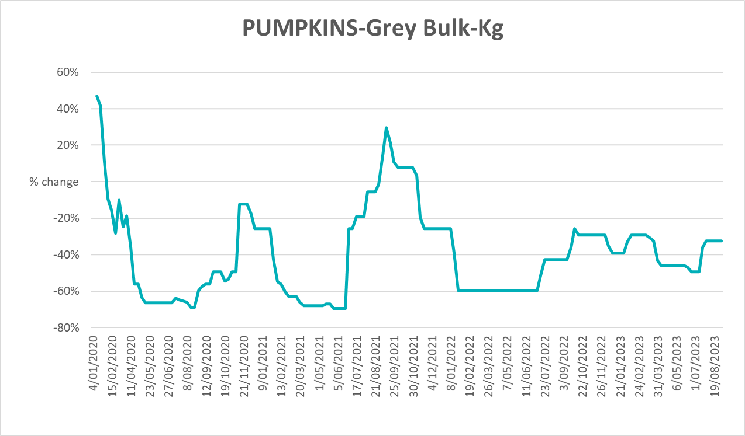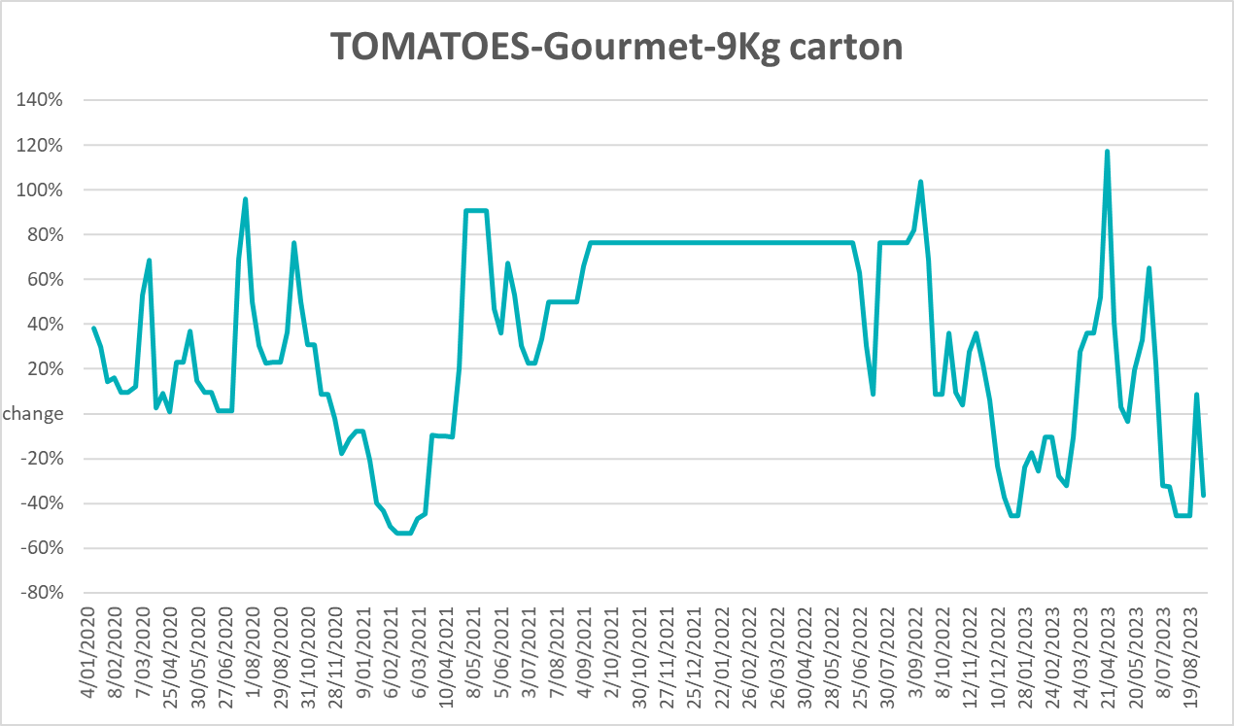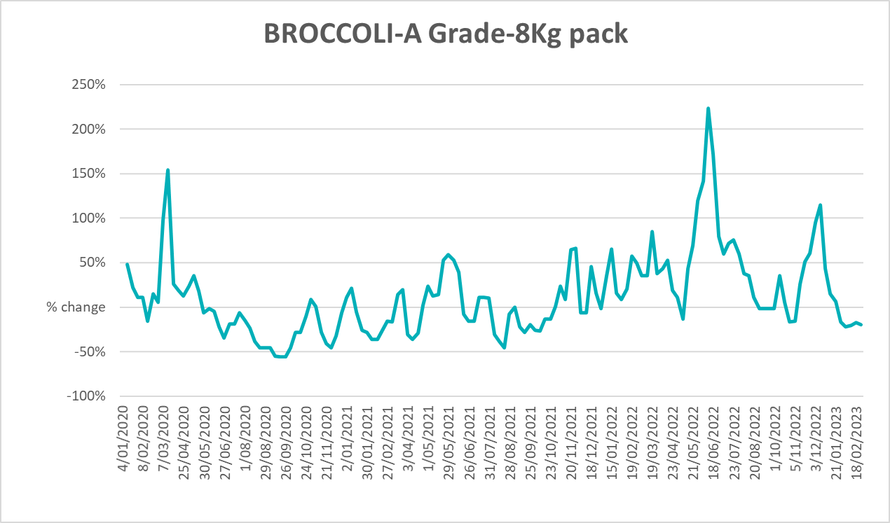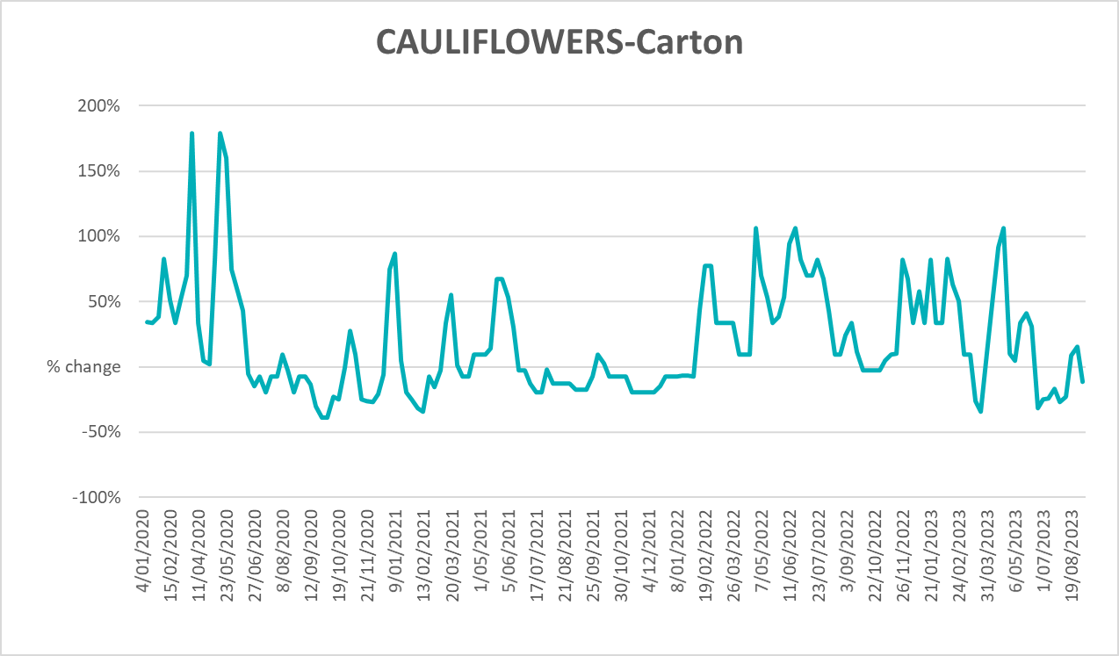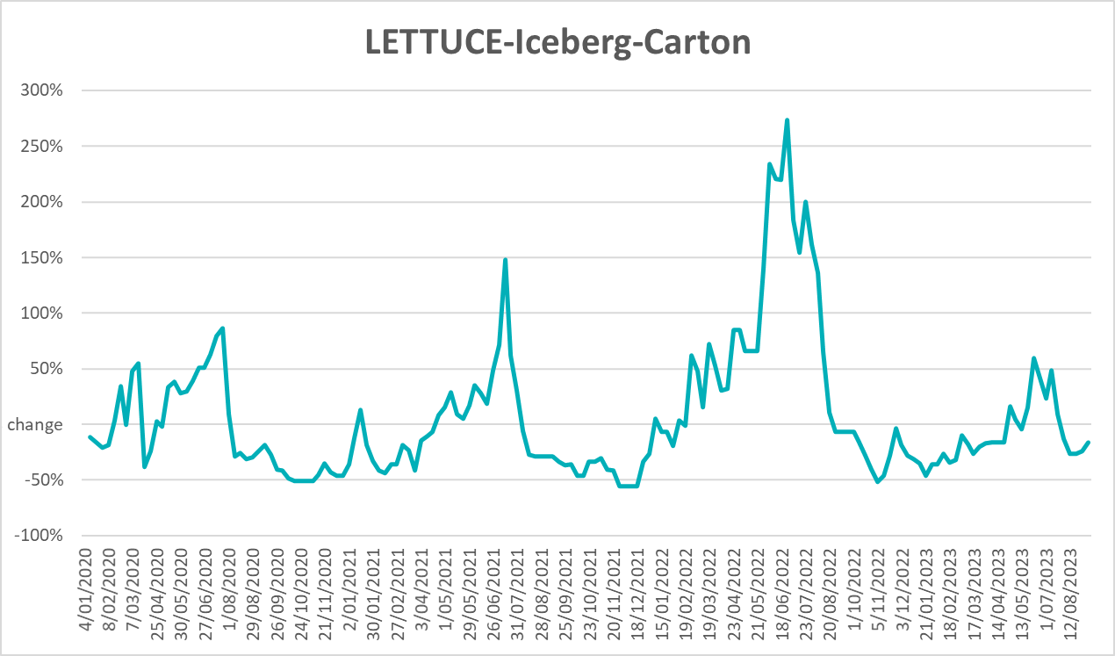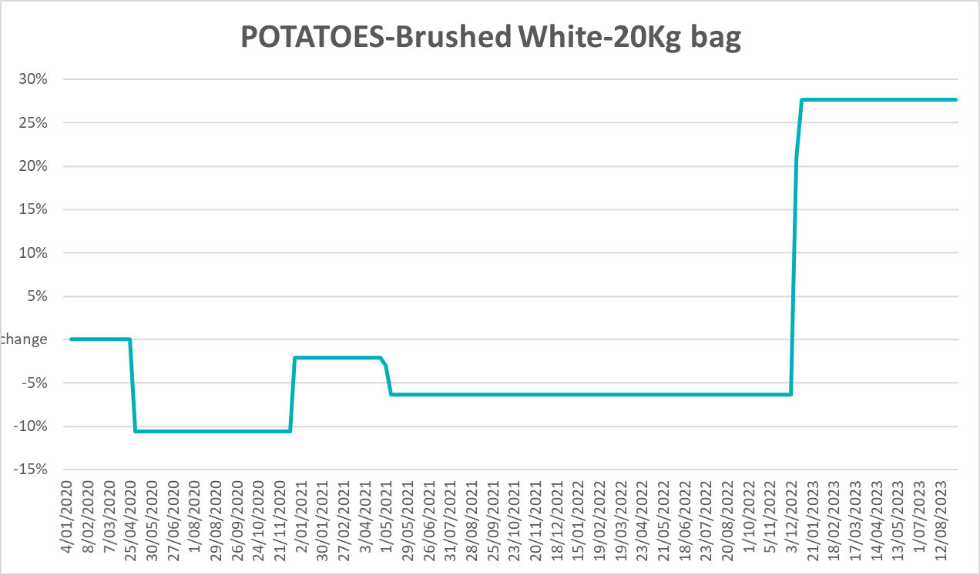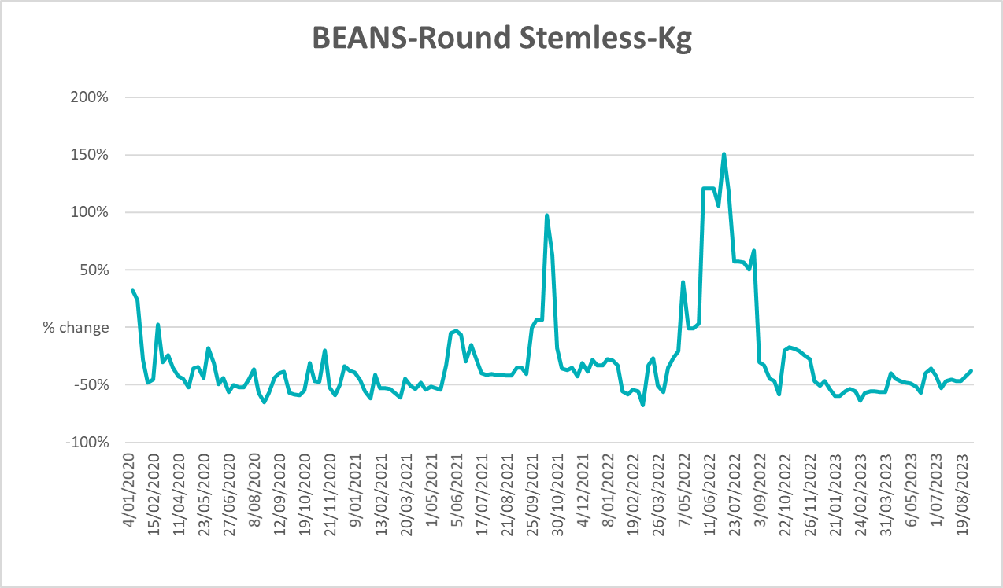

3.6 Selected domestic fodder indicator prices

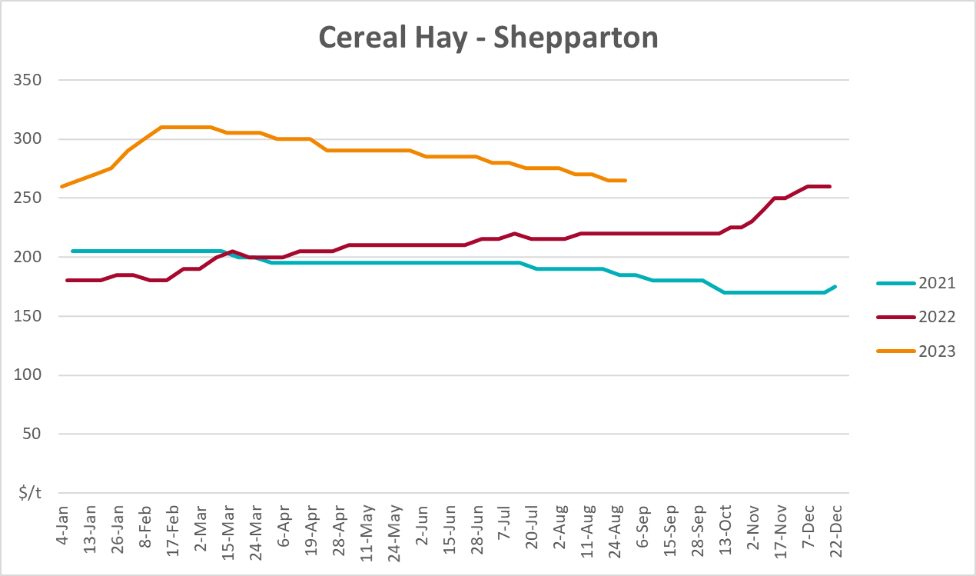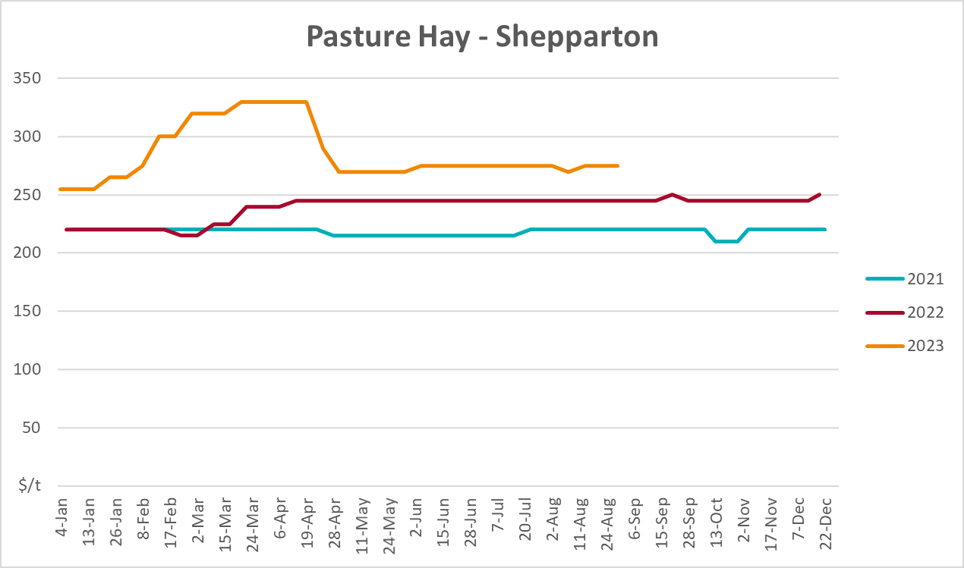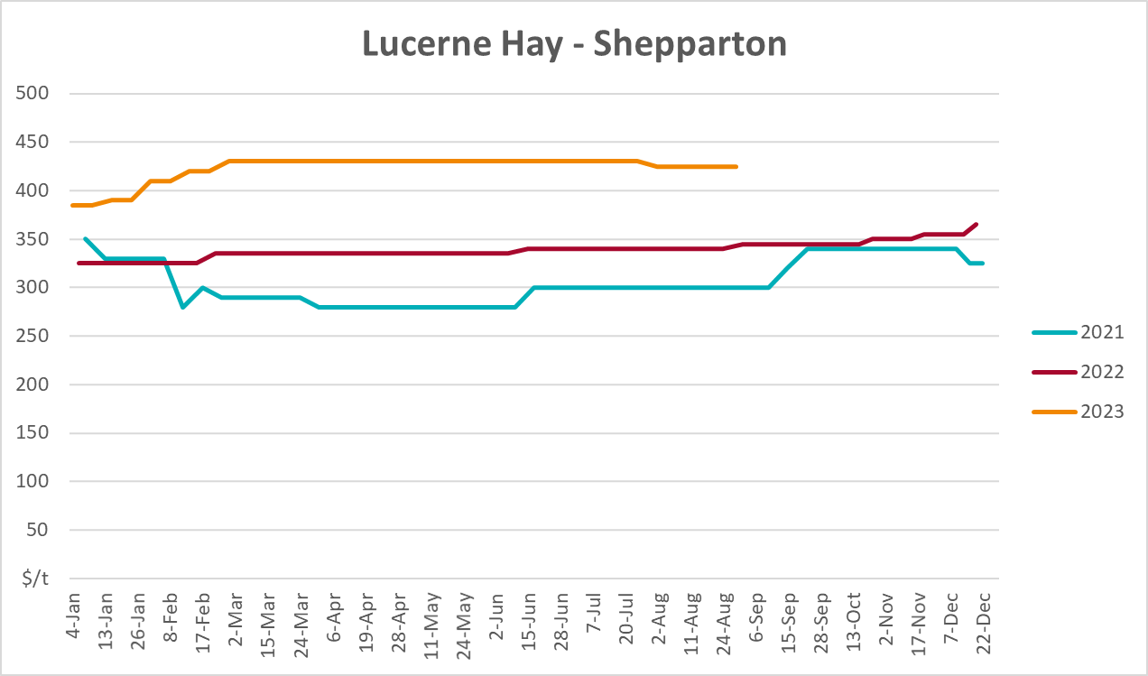

4. Data attribution

Climate
Bureau of Meteorology
- Weekly rainfall totals: www.bom.gov.au/climate/maps/rainfall/
- Monthly and last 3-month rainfall percentiles: www.bom.gov.au/water/landscape/
- Temperature anomalies: www.bom.gov.au/jsp/awap/temp/index.jsp
- Rainfall forecast: www.bom.gov.au/jsp/watl/rainfall/pme.jsp
- Seasonal outlook: www.bom.gov.au/climate/outlooks/#/overview/summary/
- Climate drivers: http://www.bom.gov.au/climate/enso/
- Soil moisture: www.bom.gov.au/water/landscape/
Other
- Pasture growth: www.longpaddock.qld.gov.au/aussiegrass/
- 3-month global outlooks: Environment and Climate Change Canada, NOAA Climate Prediction Center, EUROBRISA CPTEC/INPE, European Centre for Medium-Range Weather Forecasts, Hydrometcenter of Russia, National Climate Center Climate System Diagnosis and Prediction Room (NCC), International Research Institute for Climate and Society
- Global production: https://ipad.fas.usda.gov/ogamaps/cropmapsandcalendars.aspx
- Autumn break: Pook et al., 2009, https://rmets-onlinelibrary-wiley-com.virtual.anu.edu.au/doi/epdf/10.1002/joc.1833

Water
Prices
- Waterflow: https://www.waterflow.io/
- Ruralco: https://www.ruralcowater.com.au/
Bureau of Meteorology:
- Allocation trade: http://www.bom.gov.au/water/dashboards/#/water-markets/mdb/at
- Storage volumes: http://www.bom.gov.au/water/dashboards/#/water-storages/summary/drainage
Trade constraints:
- Water NSW: https://www.waternsw.com.au/customer-service/ordering-trading-and-pricing/trading/murrumbidgee
- Victorian Water Register: https://www.waterregister.vic.gov.au/TradingRules2019/

Commodities
Fruit and vegetables
- Datafresh: www.freshstate.com.au
Pigs
- Australian Pork Limited: www.australianpork.com.au
Dairy
- Global Dairy Trade: www.globaldairytrade.info/en/product-results/
World wheat, canola
- International Grains Council
World coarse grains
- United States Department of Agriculture
World cotton
- Cotlook: www.cotlook.com/
World sugar
- New York Stock Exchange - Intercontinental Exchange
Wool
- Australian Wool Exchange: www.awex.com.au/
Domestic wheat, barley, sorghum, canola and fodder
- Jumbuk Consulting Pty Ltd: http://www.jumbukag.com.au/
Cattle, beef, mutton, lamb, goat and live export
- Meat and Livestock Australia: www.mla.com.au/Prices-and-market
© Commonwealth of Australia 2023

Ownership of intellectual property rights
Unless otherwise noted, copyright (and any other intellectual property rights, if any) in this publication is owned by the Commonwealth of Australia (referred to as the Commonwealth).

Creative Commons licence
All material in this publication is licensed under a Creative Commons Attribution 4.0 International Licence except content supplied by third parties, logos and the Commonwealth Coat of Arms.
Inquiries about the licence and any use of this document should be emailed to copyright@awe.gov.au.


Cataloguing data
This publication (and any material sourced from it) should be attributed as:
ABARES 2023, Weekly Australian Climate, Water and Agricultural Update, Australian Bureau of Agricultural and Resource Economics and Sciences, Canberra, 28 September 2023. CC BY 4.0 DOI: https://doi.org/10.25814/5f3e04e7d2503
ISSN 2652-7561
This publication is available at https://www.agriculture.gov.au/abares/products/weekly_update
Department of Agriculture, Fisheries and Forestry
GPO Box 858 Canberra ACT 2601
Telephone 1800 900 090
Web agriculture.gov.au/abares

Disclaimer
The Australian Government acting through the Department of Agriculture, Fisheries and Forestry, represented by the Australian Bureau of Agricultural and Resource Economics and Sciences, has exercised due care and skill in preparing and compiling the information and data in this publication. Notwithstanding, the Department of Agriculture, Fisheries and Forestry, ABARES, its employees and advisers disclaim all liability, including liability for negligence and for any loss, damage, injury, expense or cost incurred by any person as a result of accessing, using or relying on any of the information or data in this publication to the maximum extent permitted by law.

Statement of Professional Independence
The views and analysis presented in ABARES publications, including this one, reflect ABARES professionally independent findings, based on scientific and economic concepts, principles, information and data. These views, analysis and findings may not reflect or be consistent with the views or positions of the Australian Government, or of organisations or groups who have commissioned ABARES reports or analysis. More information on professional independence is provided on the ABARES website.

Acknowledgements
This report was prepared by Kavina Dayal and Matthew Miller.

