
No. 37/2023 21 September 2023

Summary of key issues
- For the week ending 20 September 2023, frontal systems brought showers to south-western Western Australia and much of Tasmania. An easterly airflow brought showers to parts of the Queensland coast. A slow-moving high-pressure system kept the remainder of the country largely dry and warmer than normal.
- Across cropping regions, rainfall totals of up to 50 millimetres were recorded in Western Australia. No rainfall was received in the remaining cropping areas. Given the lack of rainfall across most eastern cropping regions, these regions are continuing to see declines in soil moisture reserves. This represents an increased risk of further reductions in crop yields if follow-up rainfall is not received in the next few weeks (see Section 1.1).
- Maximum temperatures for the week ending 19 September 2023 were warmer than average across much of southern Australia, with the highest temperature anomalies recorded across south-eastern parts of the country. Across cropping regions, much of New South Wales, Victoria and South Australia, and parts of southern Queensland experienced maximum temperature up to 12°C above average for this time of year. With a lack of rainfall recently and declining soil moisture levels, these high temperatures will likely have contributed to increased moisture stress to the winter crops and spring pastures (see Section 1.2).
- On 19th September 2023, Bureau of Meteorology declared an El Niño and positive Indian Ocean Dipole are underway. This declaration reinforces the long-range rainfall and temperature forecasts, which continue to predict warmer and drier conditions for much of Australia over the next three months.
- Highly variable rainfall globally during August has led to mixed production prospects for wheat, maize, soybeans and rice. Below average rainfall and above average temperatures in recent months have negatively affected corn production across parts of Argentina, Brazil, the European Union and the United States. Global production conditions have continued to deteriorate compared to those used to formulate ABARES forecasts of global grain supplies and world prices in its September 2023 edition of the Agricultural Commodities Report. As a result, global grain and oilseed production is likely to be lower than that forecast in September (see Section 1.3).
- Over the next 8-days to 28 September 2023, a high-pressure system is expected to bring mainly dry conditions to much of the country. Southerly winds associated with high-pressure will bring light showers in Victoria, New South Wales and Tasmania (see Section 1.4).
- Across most cropping regions, minimal rainfall totals of up to 5 millimetres are expected in Victoria and southern New South Wales. Crops and pasture regions in Queensland, New South Wales and parts of South Australia, Victoria and Western Australia have experienced a dry start in September and declining soil moisture. These regions will be disposed to heat and moisture stress, negatively affecting production potential (see Section 1.4).
- Water storage levels in the Murray-Darling Basin (MDB) decreased between 14 September 2023 and 21 September 2023 by 6 gigalitres (GL). Current volume of water held in storage is 21 047 GL. This is 5 percent or 1004 GL less than at the same time last year.
- Allocation prices in the Victorian Murray below the Barmah Choke increased from $192 on 14 September 2023 to $209 on 21 September 2023. Prices are lower in the Goulburn-Broken and regions above the Barmah choke due to the binding of the Goulburn intervalley trade limit and Barmah choke trade constraint.

Climate

Rainfall this week
For the week ending 20 September 2023, frontal systems brought showers to south-western Western Australia and much of Tasmania. An easterly airflow brought showers to parts of the Queensland coast. A slow-moving high-pressure system kept the remainder of the country largely dry and warmer than normal.
Across cropping regions, rainfall totals of up to 50 millimetres were recorded in Western Australia. No rainfall was received in the remaining cropping areas. Given the lack of rainfall across most eastern cropping regions, these regions are continuing to see declines in soil moisture reserves. This represents an increased risk of further reductions in crop yields if follow-up rainfall is not received in the next few weeks.

Rainfall for the week ending 20 September 2023
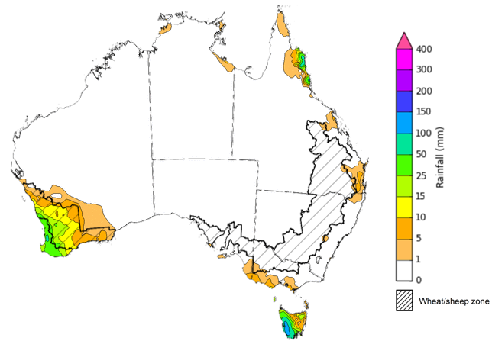
©Commonwealth of Australia 2023, Australian Bureau of Meteorology Issued: 20/9/2023
Note: The rainfall analyses and associated maps utilise data contained in the Bureau of Meteorology climate database, the Australian Data Archive for Meteorology (ADAM). The analyses are initially produced automatically from real-time data with limited quality control. They are intended to provide a general overview of rainfall across Australia as quickly as possible after the observations are received. For further information go to http://www.bom.gov.au/climate/rainfall/

Weekly temperature anomalies
The maximum temperatures for the week ending 19 September 2023 were warmer than average across much of southern Australia, with the highest temperature anomalies recorded across south-eastern parts of the country. Across cropping regions, much of New South Wales, Victoria and South Australia, and parts of southern Queensland experienced maximum temperature up to 12°C above average for this time of year.
These well above average day time temperatures, in addition to the lack of recent rainfall and declining soil moisture levels will likely have contributed to increased moisture stress to the winter crops and spring pastures. The combination of reduced crop prospects and strong fodder prices may be providing producers in regions with declining grain yield potentials with a strong incentive to cut some crops that were planted for grain production for hay. In some regions, particularly in Queensland and northern New South Wales, some crops may not have produced sufficient biomass to warrant fodder conservation and may instead be grazed off to allow for economic return to some farmers.
Maximum temperature anomaly for the week ending 19 September 2023
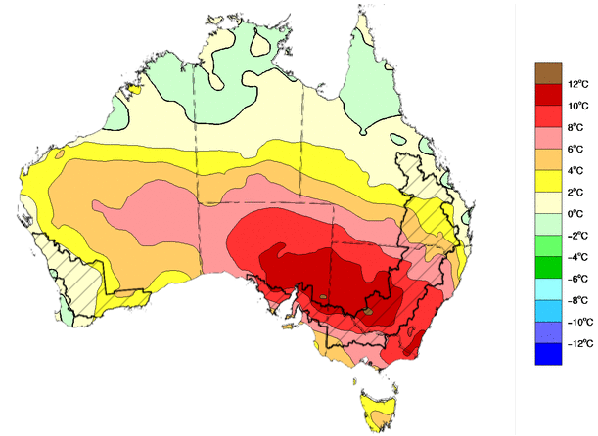
©Commonwealth of Australia 2023, Australian Bureau of Meteorology Issued: 20/09/2023

Global production conditions and climate outlook
Crop production is affected by long-term trends in average rainfall and temperature, interannual climate variability, shocks during specific growth stages, and extreme weather events. Some crops are more tolerant than others to certain types of stresses, and at each growth stage, different types of stresses affect each crop species in different ways.
The precipitation anomalies and outlooks presented here give an indication of the current and future state of production conditions for the major grain and oilseed producing countries which are responsible for over 80% of global production. This is an important input to assessing the global grain supply outlook.
August precipitation percentiles and current production conditions
As of the end of August 2023, precipitation was highly variable for the world’s major grain-producing and oilseed-producing regions.
In the northern hemisphere, precipitation was generally average across Canada, except for some western and eastern production regions where it was below average. In the United States, precipitation was average to above average, except for southern areas where it was below average. Precipitation was average to above average in UK, Europe, China and the Russian Federation and parts of Kazakhstan and average to below average in India. August precipitation was generally average across the remainder of the major grain-producing and oilseed-producing regions in the northern hemisphere.
In the southern hemisphere, August precipitation was generally average in South America, with eastern and northern parts of Brazil being the main exception, where it was above average and below average, respectively. In Australia, August precipitation was average to below average. Precipitation was generally average to above average across the remainder of major grain-producing and oilseed-producing regions in the southern hemisphere.

Global precipitation percentiles, August 2023
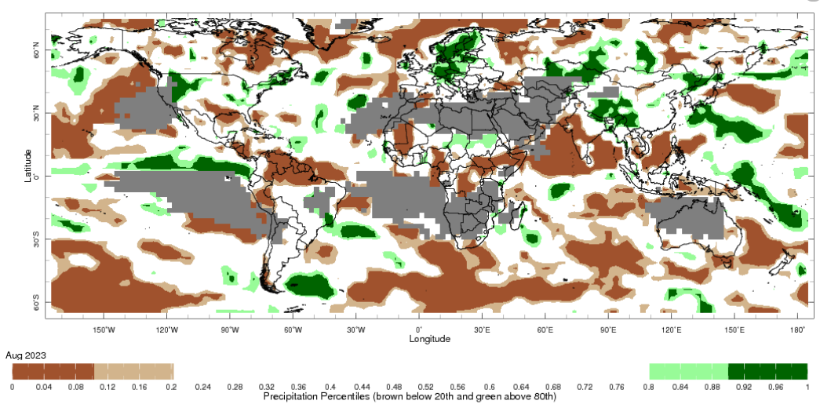
Note: The world precipitation percentiles indicate a ranking of precipitation for August, with the driest (0th percentile) being 0 on the scale and the wettest (100th percentile) being 1 on the scale. Percentiles are based on precipitation estimates from the NOAA Climate Prediction Center's Climate Anomaly Monitoring System Outgoing Precipitation Index dataset. Precipitation estimates for August 2023 are compared with rainfall recorded for that period during the 1981 to 2010 base period.
Source: International Research Institute for Climate and Society
As of 28 August 2023, global production conditions were variable for wheat, maize, soybeans and rice. In the northern hemisphere, drought is affecting several areas. In the southern hemisphere, the expanding dry conditions continue in Argentina and Australia.
For wheat, winter and spring wheat harvesting is wrapping up under mixed conditions with drought in several areas in northern hemisphere and continuing dry conditions are impacting wheat conditions in Argentina and Australia.
For maize, exceptional conditions are being recorded in Brazil while Argentina is expecting poor production due to persistent drought. Conditions remains mixed in the northern hemisphere.
For rice, China is experiencing dry and hot conditions that may affect the overall production, while Kharif crops have recovered from delayed rains in the east in India. Conditions are generally favourable in Southeast Asia, except for Thailand where dry conditions persists.
For soybeans, crops are developing under mixed conditions in the northern hemisphere with some improvements from recent rains in the west.
Crop conditions, AMIS countries, 28 August 2023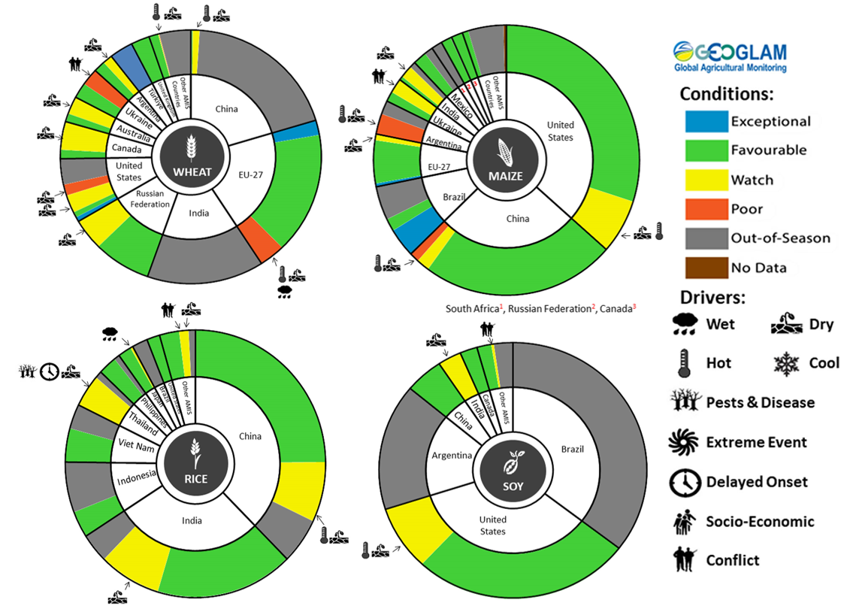
AMIS Agricultural Market Information System. Source: AMIS
The global climate outlook for October 2023 to December 2023 indicates that variable rainfall conditions are expected for the world's major grain-producing and oilseed-producing regions. Outlooks and potential production impacts for the major grain and oilseed producing countries are presented in the table.
Rainfall outlook and potential impact on the future state of production conditions between October 2023 to December 2023
Region | October - December rainfall outlook | Potential impact on production
Argentina | Average rainfall is likely across the country except for the northern parts where below average rainfall is more likely and eastern parts where extremely high rainfall is more likely, this pattern is typical during El Niño events. | Below average rainfall in northern areas is likely to adversely affect the heading and grain development of wheat and the planting and establishment of cotton and late-planted corn in October. These conditions may also adversely impact early corn silking, and the flowering of cotton and late corn in November and December. More favourable production conditions are expected across the remainder of the country
Black Sea Region | Average to above average rainfall is more likely in Ukraine, Kazakhstan and the Russian Federation. | Average rainfall is likely to support boll development and grain filling for cotton, corn and sunflower, as well as the development of winter wheat and canola in October. In November and December winter wheat and canola will enter dormancy, and average rainfall is likely to provide sufficient snowpack to prevent winterkill.
Brazil | Well below average rainfall is more likely across much of Brazil except for the far south where above average rainfall is likely, which is a typical El Niño pattern. | Above average rainfall in parts of southern Brazil may disrupt harvesting of wheat in October and November. However, below average rainfall is likely to adversely affect flowering of corn and soybeans in December and will affect the planting and growth of soybeans and first crop corn in northern and central Brazil.
Canada | Average rainfall is more likely for much of Canada, especially across major production regions. | Average rainfall may favour harvesting and reduce grain quality concerns for canola, corn, soybean, spring wheat and sunflower in October and November. Average rainfall is also likely to provide sufficient snowpack to prevent winterkill of winter wheat in December.
China | Average to above average rainfall is more likely across China. | Above average rainfall in China is likely to disrupt the harvesting of cotton, corn, sorghum, soybean, sunflower, groundnuts and single rice. However, these conditions will likely benefit grain filling of late-sown rice in October and November.
Europe | Average to above average rainfall is more likely. | Above average rainfall may disrupt harvesting of corn, cotton, sorghum, soybean and sunflower in south-eastern and south-western Europe. Average rainfall across the remainder of Europe is likely to benefit the planting of canola and winter wheat.
South Asia (India) | Average rainfall is more likely across India except for some parts in the east where below average rainfall is likely. | Average rainfall is likely to benefit cotton boll formation in the south during October and the planting of canola and winter wheat in November. However, these conditions may impede harvesting of corn, sorghum, rice, millet, groundnuts and sunflower.
Southeast Asia (SEA) | Generally average to below average rainfall is more likely. | Average rainfall in SEA is likely to favour corn and rice harvesting in October.
The United States of America | Generally average to above average rainfall is more likely for the US. | Average rainfall across central, southern and eastern US is likely to support harvesting of soybeans, sunflower, millet, cotton, rice, corn, sorghum and groundnuts in October and November. The average rainfall conditions expected across the northern US is likely to support establishment and growth of canola and winter wheat, as well as provide sufficient snow cover in December.

Rainfall forecast for the next eight days
Over the 8-days to 28 September 2023, a high-pressure system is expected to bring mainly dry conditions to much of the country. Southerly winds associated with high-pressure will bring light showers in Victoria, southern and eastern New South Wales and Tasmania.
Across cropping regions, minimal rainfall totals of up to 5 millimetres are expected in Victoria and southern New South Wales. Crops and pasture regions in Queensland, New South Wales and parts of South Australia, Victoria and Western Australia have experienced a dry start in September and declining soil moisture. These regions will be disposed to heat and moisture stress, negatively affecting production potential.

Total forecast rainfall for the period 21 September 2023 to 28 September 2023
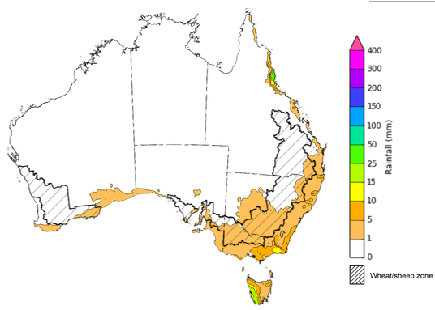

©Commonwealth of Australia 2023, Australian Bureau of Meteorology Issued 21/9/2023
Note: This rainfall forecast is produced from computer models. As the model outputs are not altered by weather forecasters, it is important to check local forecasts and warnings issued by the Bureau of Meteorology.

Water

Water markets – current week
Water storage levels in the Murray-Darling Basin (MDB) decreased between 14 September 2023 and 21 September 2023 by 6 gigalitres (GL). Current volume of water held in storage is 21 047 GL. This is 5 percent or 1004 GL less than at the same time last year.

Water storages in the Murray-Darling Basin, 2013–2023
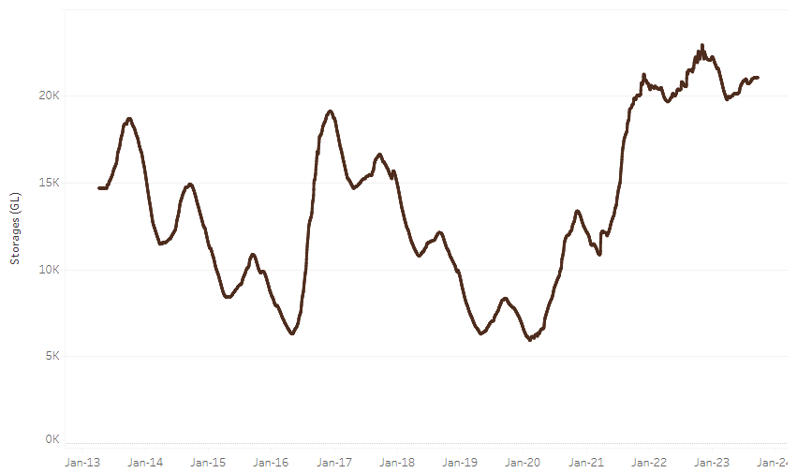
Allocation prices in the Victorian Murray below the Barmah Choke increased from $192 on 14 September 2023 to $209 on 21 September 2023. Prices are lower in the Goulburn-Broken and regions above the Barmah choke due to the binding of the Goulburn intervalley trade limit and Barmah choke trade constraint.
Water storage data is sourced from the Bureau of Meteorology.

Region | $/ML
NSW Murray Above | 125
NSW Murrumbidgee | 207
VIC Goulburn-Broken | 164
VIC Murray Below | 209

Surface water trade activity, Southern Murray–Darling Basin
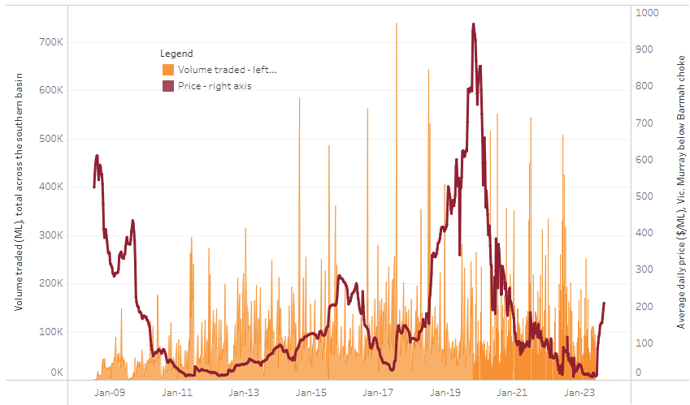
The trades shown reflect estimated market activity and do not encompass all register trades. The price is shown for the VIC Murray below the Barmah choke. Historical prices (before 1 July 2019) are ABARES estimates after removing outliers from BOM water register data. Prices after 1 July 2019 and prior to the 30 October 2019 reflect recorded transaction prices as sourced from Ruralco. Prices after the 30 October 2019 are sourced from Waterflow. Data for volume traded is sourced from the BOM water register. Only the price data shown is current on 21 September 2023.

To access the full, interactive, weekly water dashboard, which contains the latest and historical water storage, water market and water allocation information, please visit https://www.agriculture.gov.au/abares/products/weekly_update/weekly-update-21923

Commodities
Indicator | Week ended | Unit | Latest Price | Previous Week | Weekly change | Price 12 months ago | Annual change
Selected world indicator prices
AUD/USD Exchange rate | 20-Sep | A$/US$ | 0.64 | 0.64 | 0% | 0.65 | 0%
Wheat – US no. 2 hard red winter wheat, fob Gulf | 20-Sep | US$/t | 323 | 320 | 1% | 434 | -26%
Corn – US no. 2 yellow corn, fob Gulf | 20-Sep | US$/t | 223 | 224 | 0% | 315 | -29%
Canola – Rapeseed, Canada, fob Vancouver | 20-Sep | US$/t | 583 | 595 | -2% | 660 | -12%
Cotton – Cotlook 'A' Index | 20-Sep | USc/lb | 97 | 98 | 0% | 107 | -9%
Sugar – Intercontinental Exchange, nearby futures, no.11 contract | 20-Sep | USc/lb | 27.5 | 26.9 | 2% | 18 | 56%
Wool – Eastern Market Indicator | 13-Sep | Ac/kg clean | 1,144 | 1,148 | 0% | 1,342 | -15%
Wool – Western Market Indicator | 13-Sep | Ac/kg clean | 1,272 | 1,299 | -2% | 1,504 | -15%
Selected Australian grain export prices
Milling Wheat – APW, Port Adelaide, SA | 20-Sep | A$/t | 488 | 487 | 0% | 563 | -13%
Feed Wheat – ASW, Port Adelaide, SA | 20-Sep | A$/t | 466 | 465 | 0% | 517 | -10%
Feed Barley – Port Adelaide, SA | 20-Sep | A$/t | 405 | 400 | 1% | 454 | -11%
Canola – Kwinana, WA | 20-Sep | A$/t | 820 | 826 | -1% | 1,029 | -20%
Grain Sorghum – Brisbane, QLD | 20-Sep | A$/t | 522 | 520 | 0% | 451 | 16%
Selected domestic livestock indicator prices
Beef – Eastern Young Cattle Indicator | 20-Sep | Ac/kg cwt | 413 | 436 | -5% | 1,040 | -60%
Mutton – Mutton indicator (18–24 kg fat score 2–3), Vic | 20-Sep | Ac/kg cwt | 126 | 143 | -12% | 580 | -78%
Lamb – National Trade Lamb Indicator | 20-Sep | Ac/kg cwt | 437 | 444 | -2% | 752 | -42%
Pig – Eastern Seaboard (60.1–75 kg), average of buyers & sellers | 13-Sep | Ac/kg cwt | 352 | 343 | 3% | 376 | -6%
Goats – Eastern States (12.1–16 kg) | 13-Sep | Ac/kg cwt | 255 | 255 | 0% | 887 | -71%
Live cattle – Light steers ex Darwin to Indonesia | 05-Jul | Ac/kg lwt | 310 | 330 | -6% | 450 | -31%
Global Dairy Trade (GDT) weighted average prices ª
Dairy – Whole milk powder | 20-Sep | US$/t | 2,799 | 2,702 | 4% | 3,610 | -22%
Dairy – Skim milk powder | 20-Sep | US$/t | 2,400 | 2,286 | 5% | 3,575 | -33%
Dairy – Cheddar cheese | 20-Sep | US$/t | 4,044 | 4,102 | -1% | 5,046 | -20%
Dairy – Anhydrous milk fat | 20-Sep | US$/t | 4,787 | 4,561 | 5% | 5,677 | -16%
Selected world indicator prices
a Global Dairy Trade prices are updated twice monthly on the first and third Tuesday of each month.

Selected world indicator prices
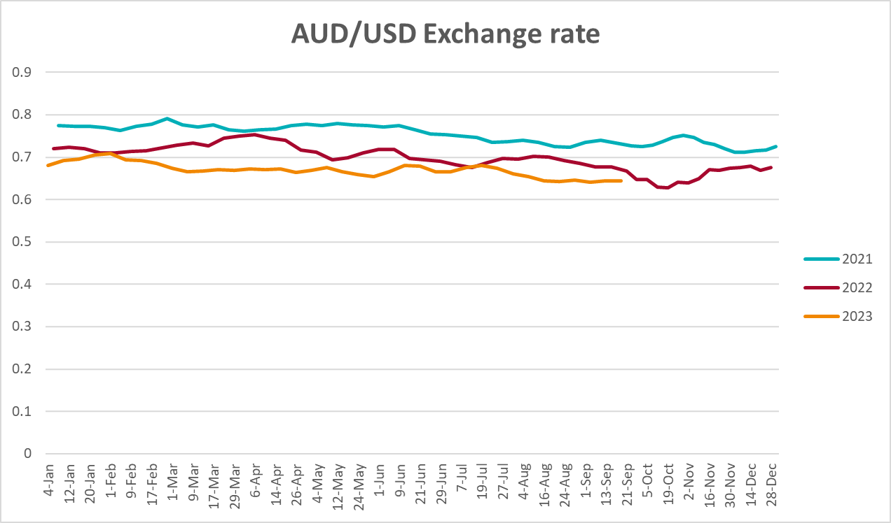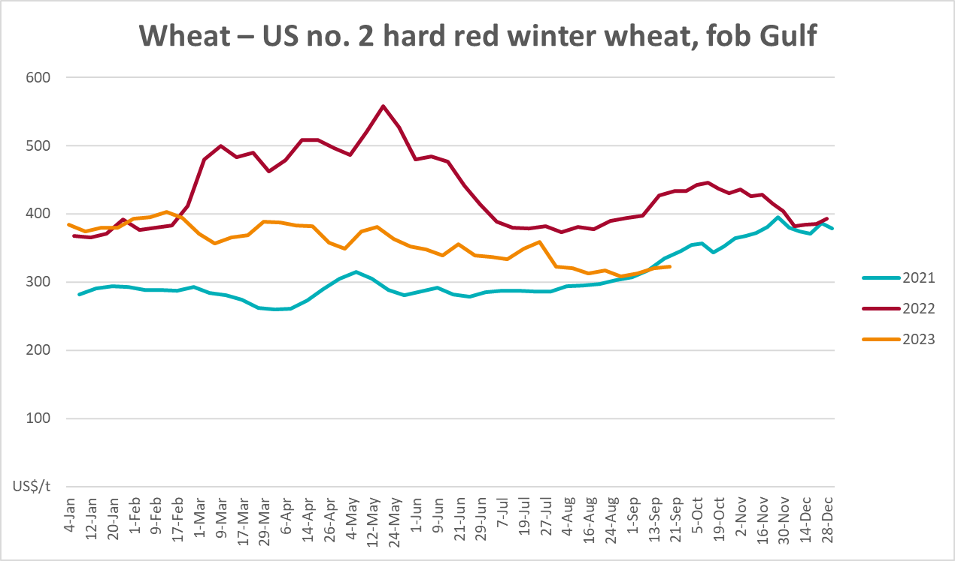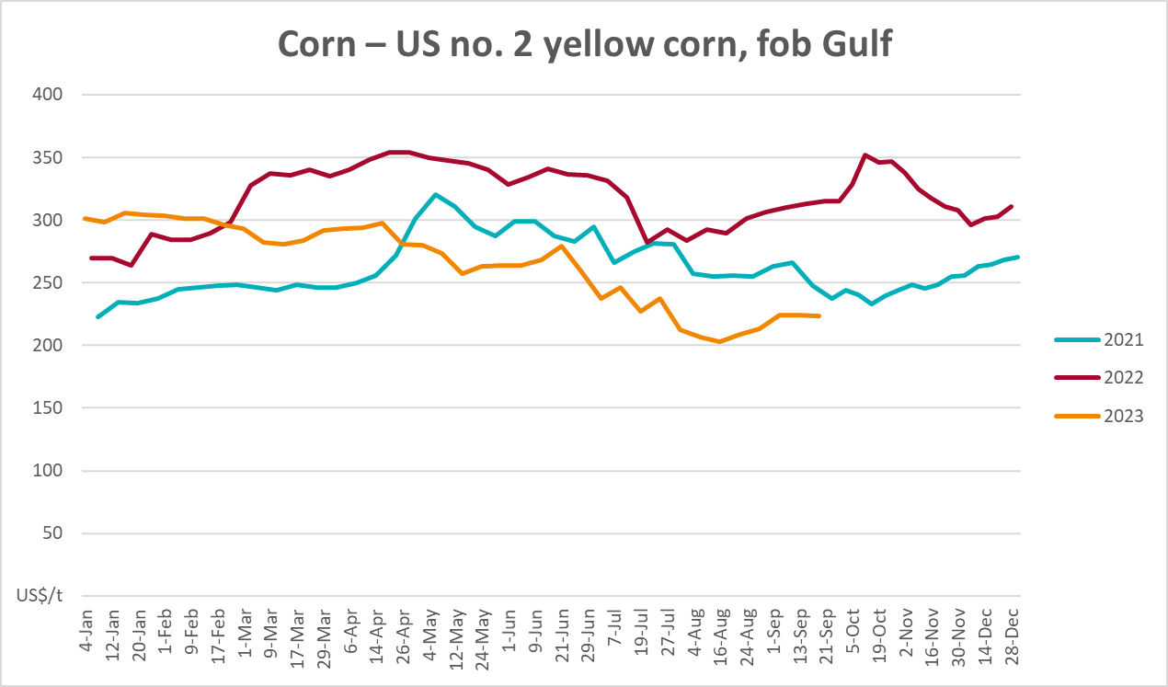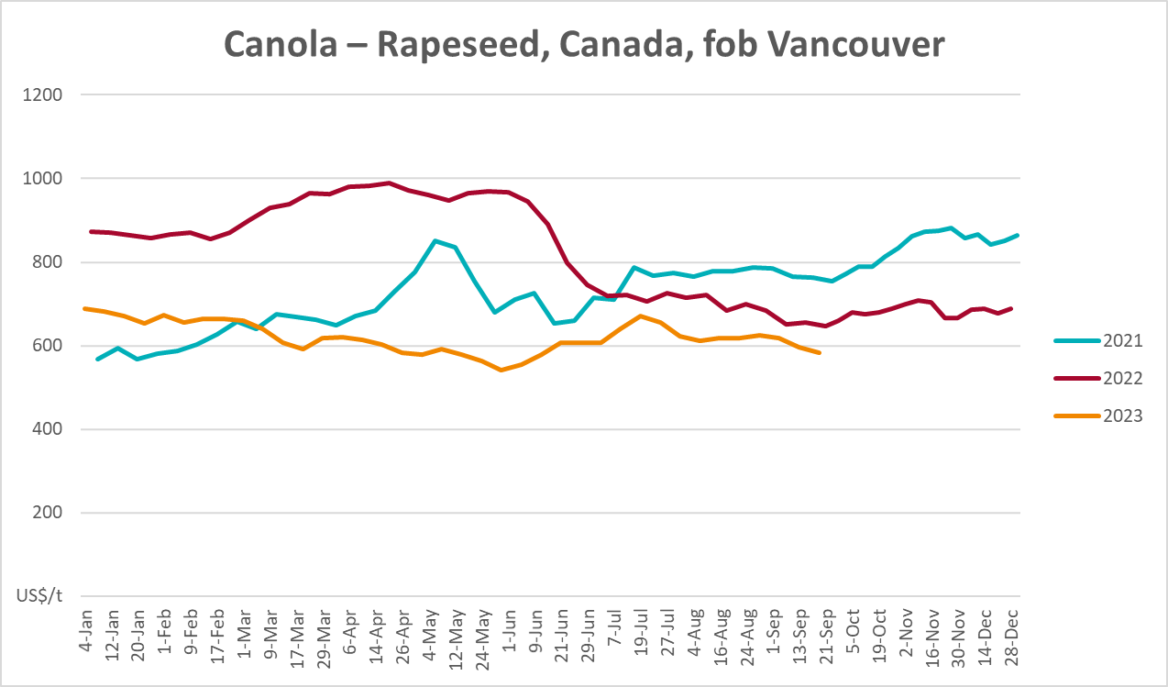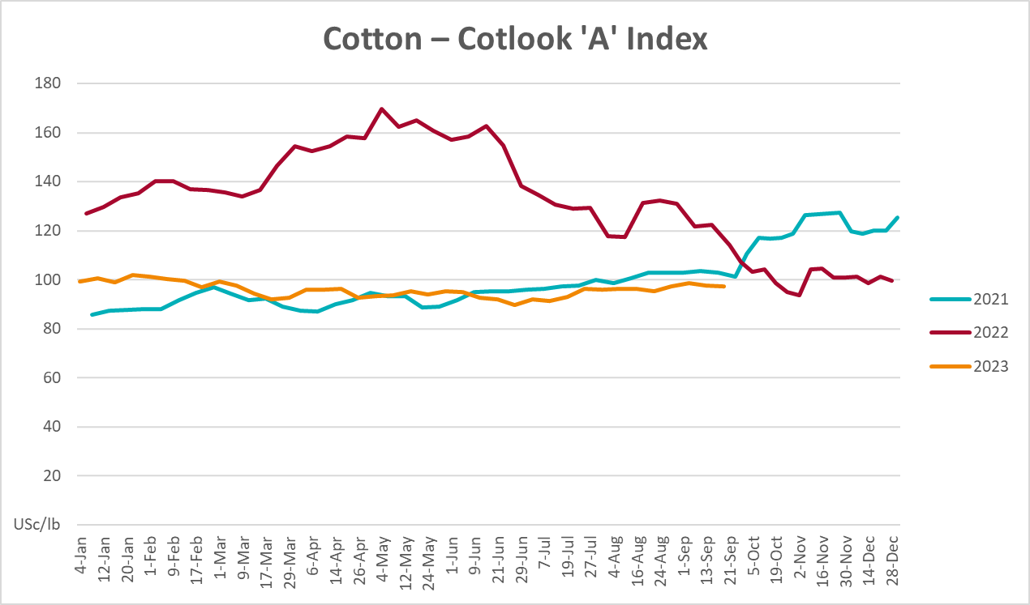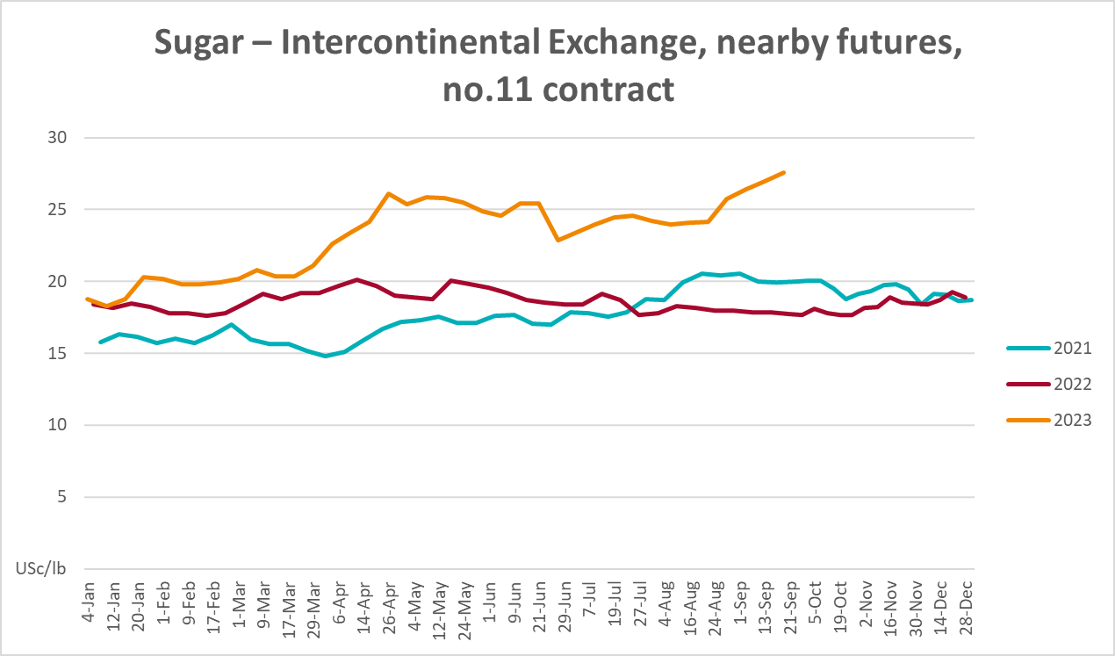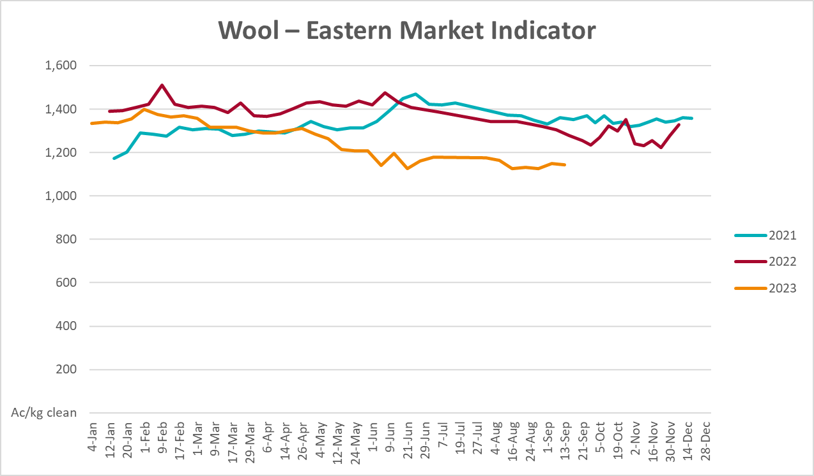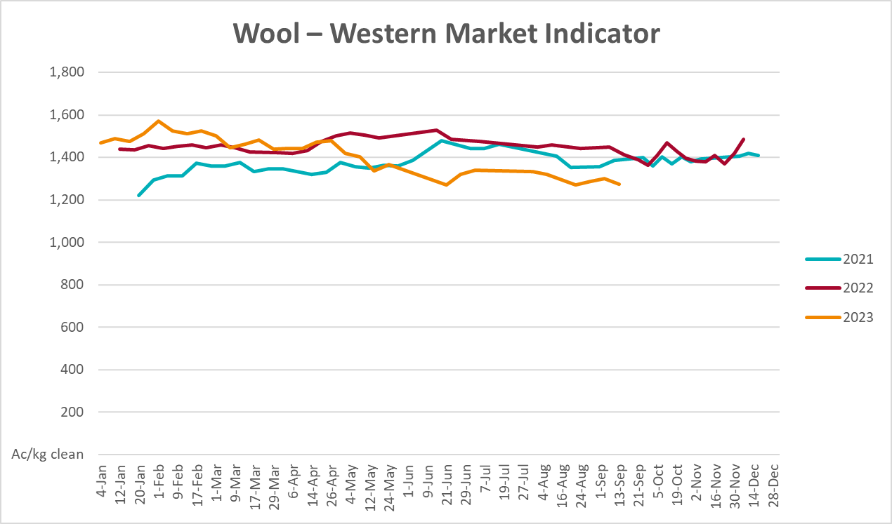

Selected domestic crop indicator prices
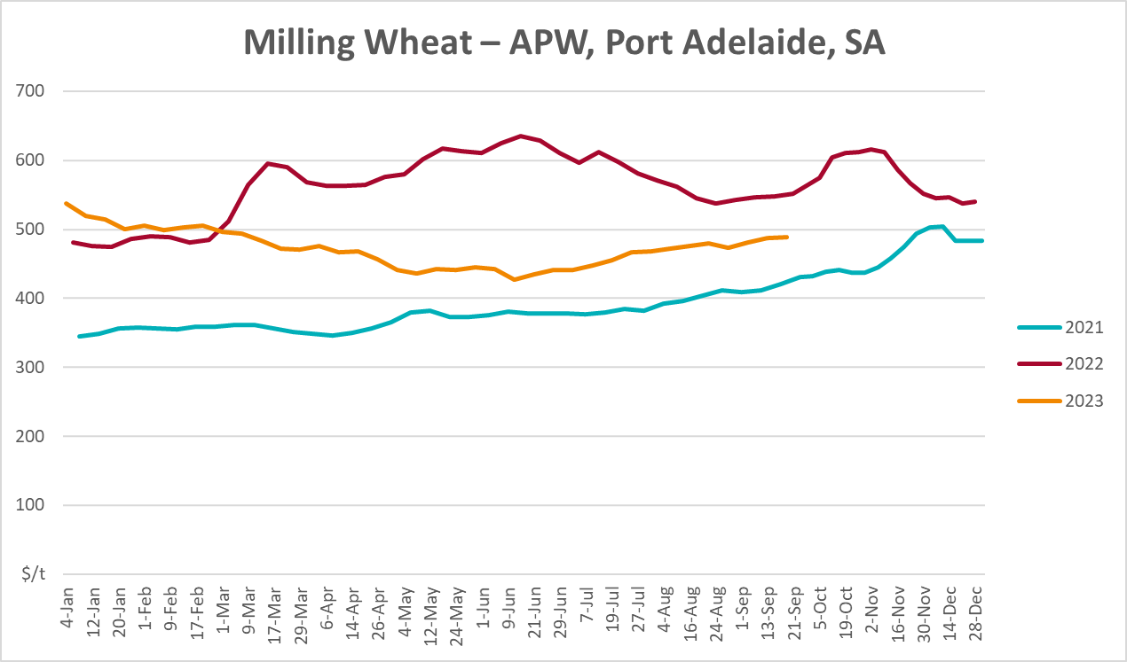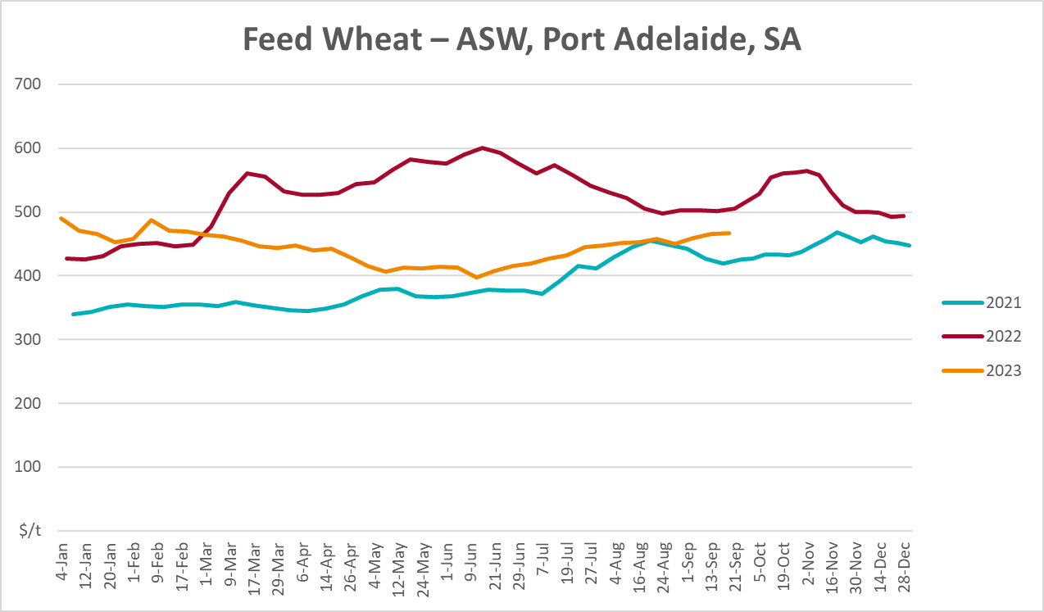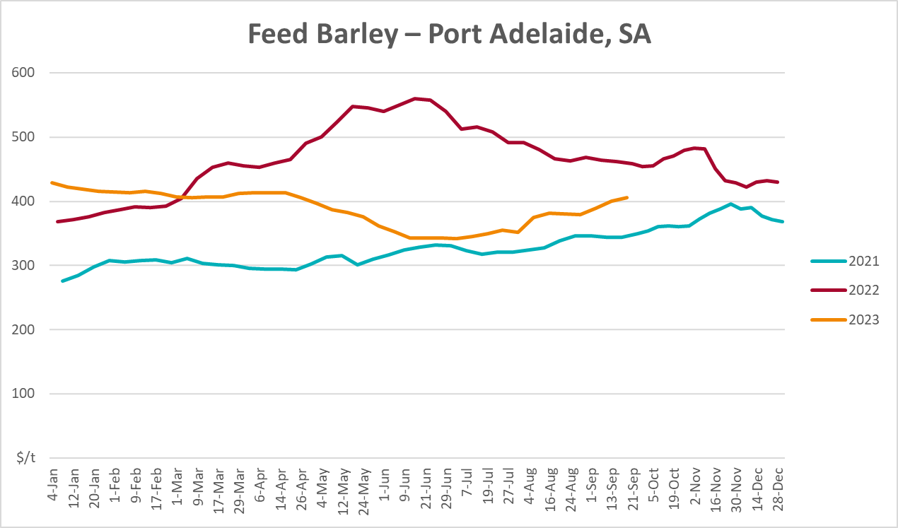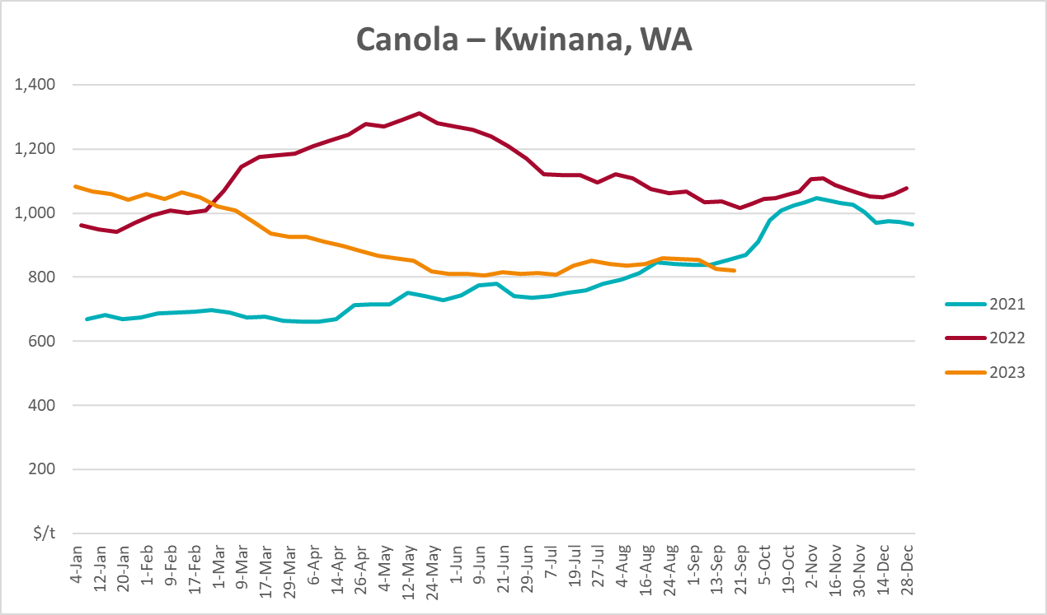
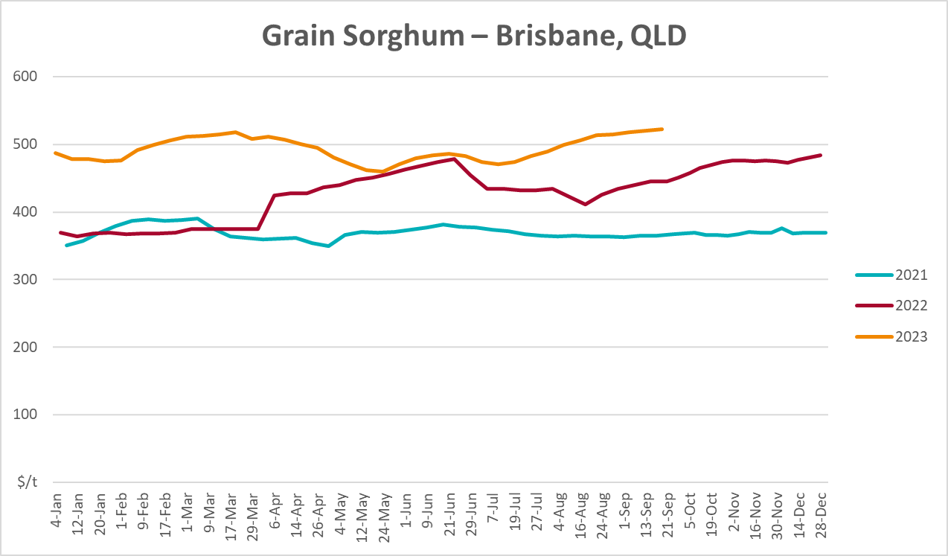

Selected domestic livestock indicator prices
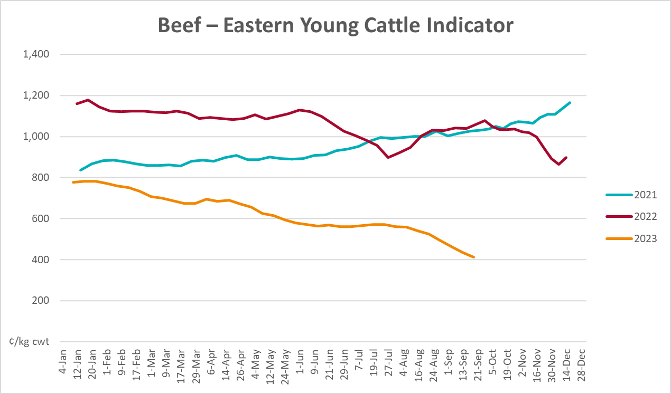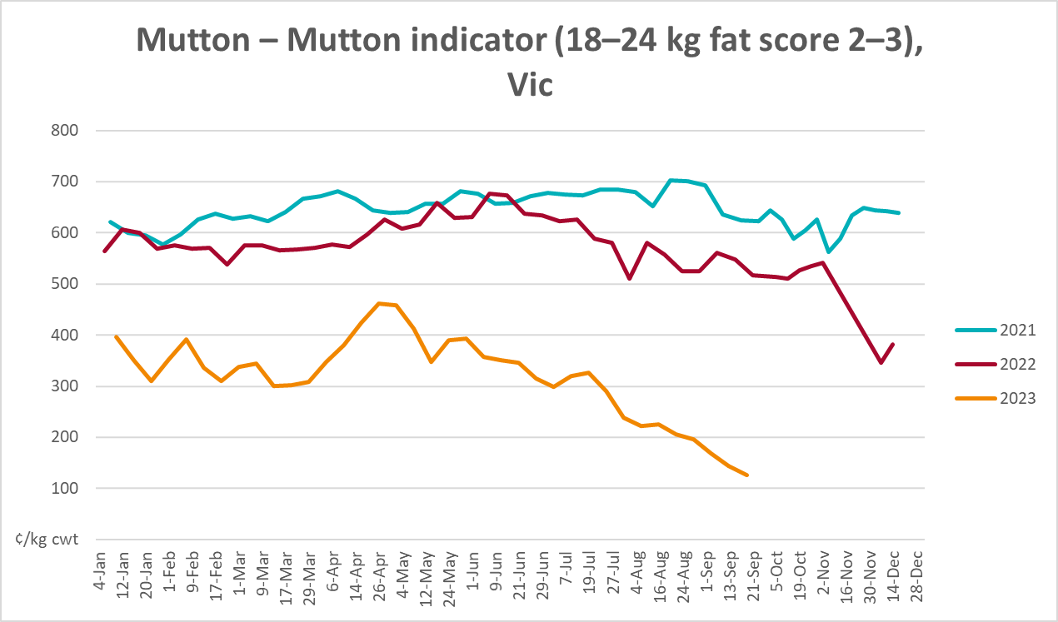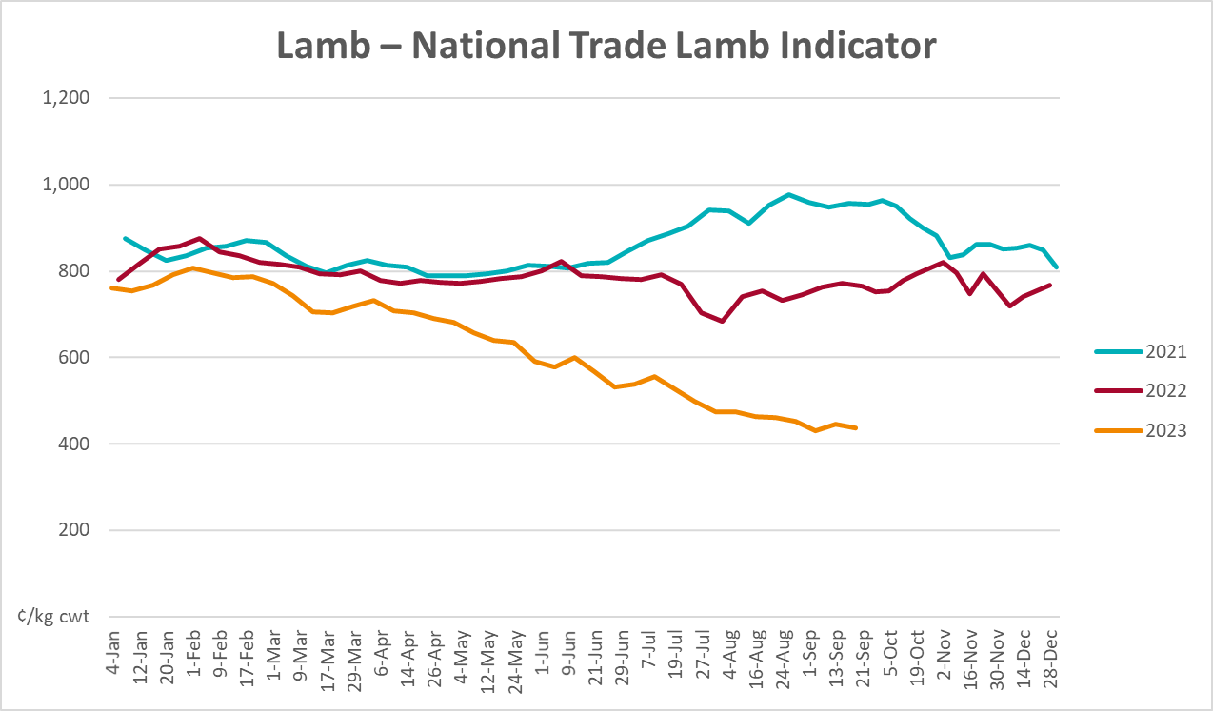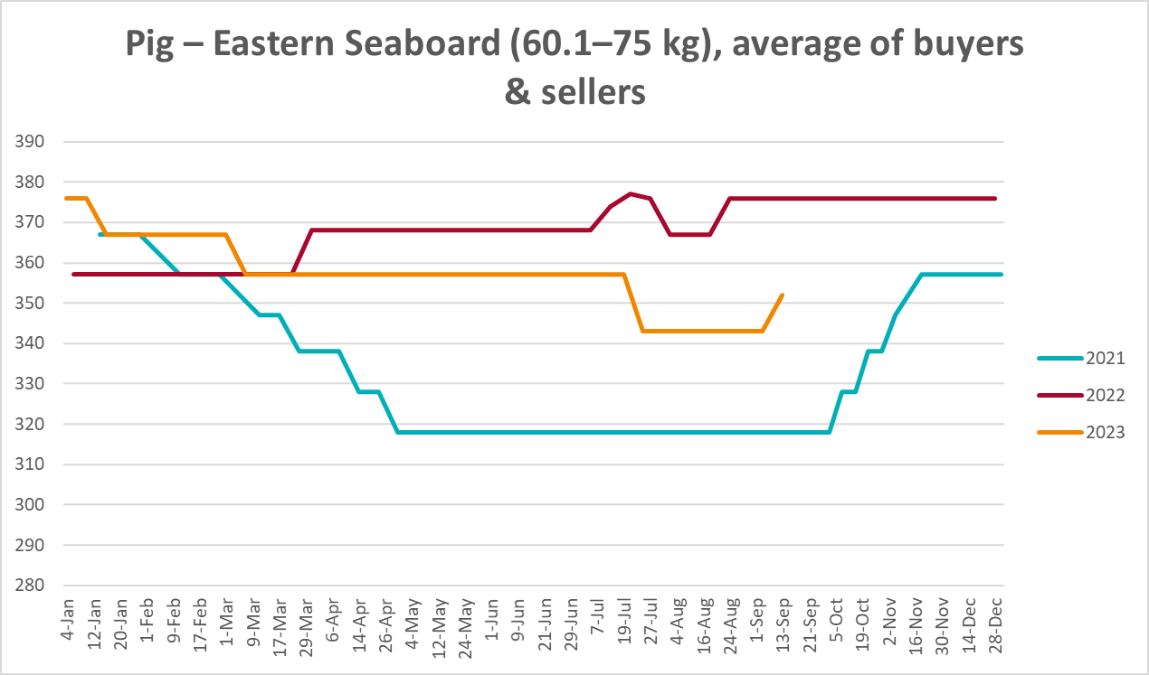
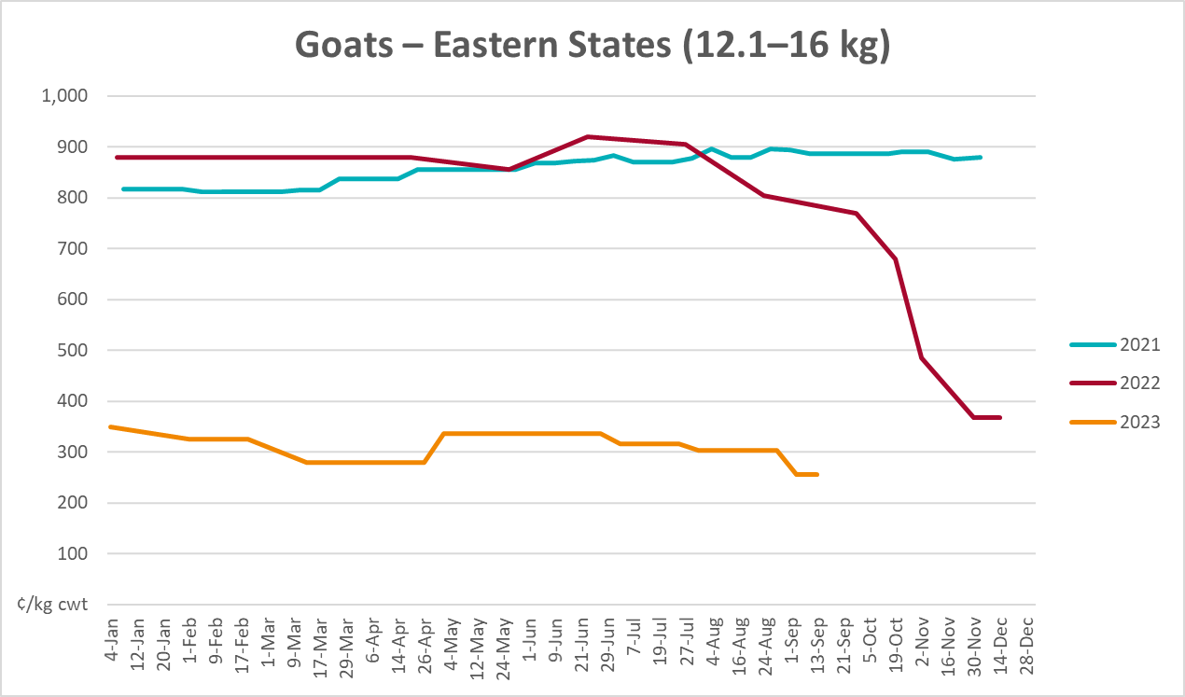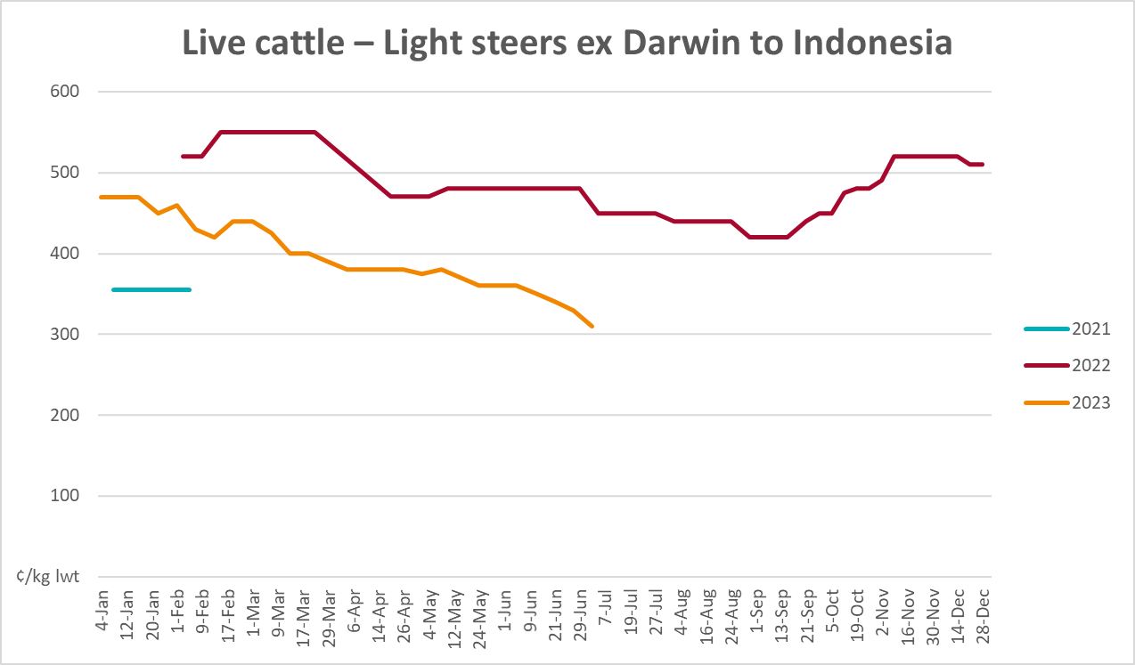

Global Dairy Trade (GDT) weighted average prices
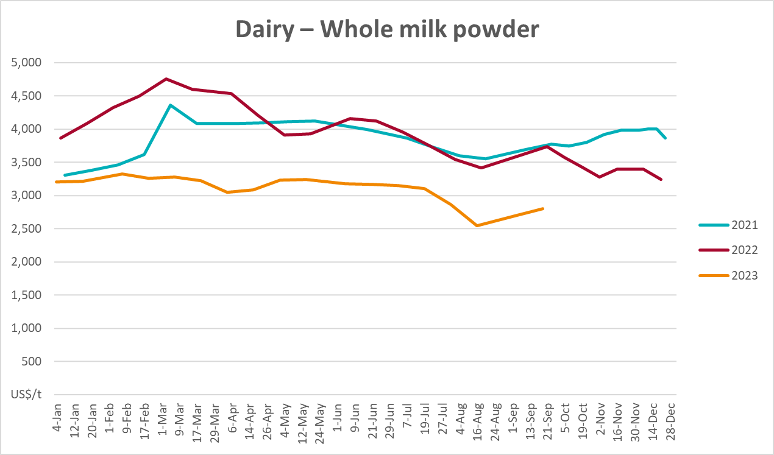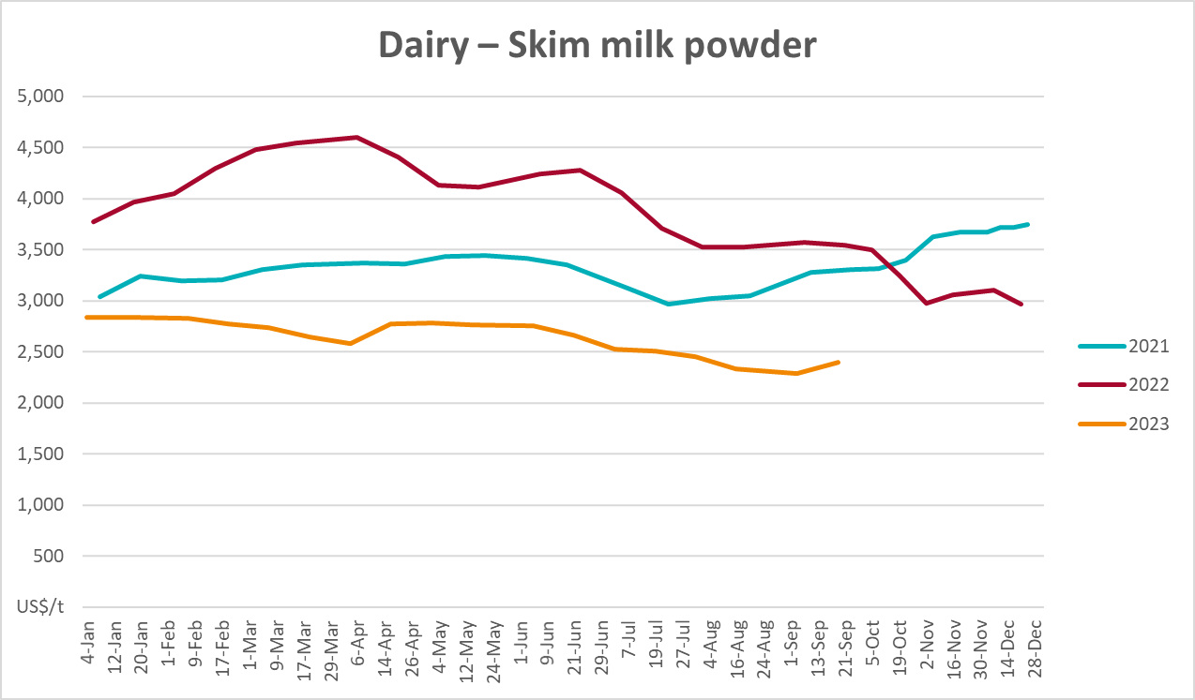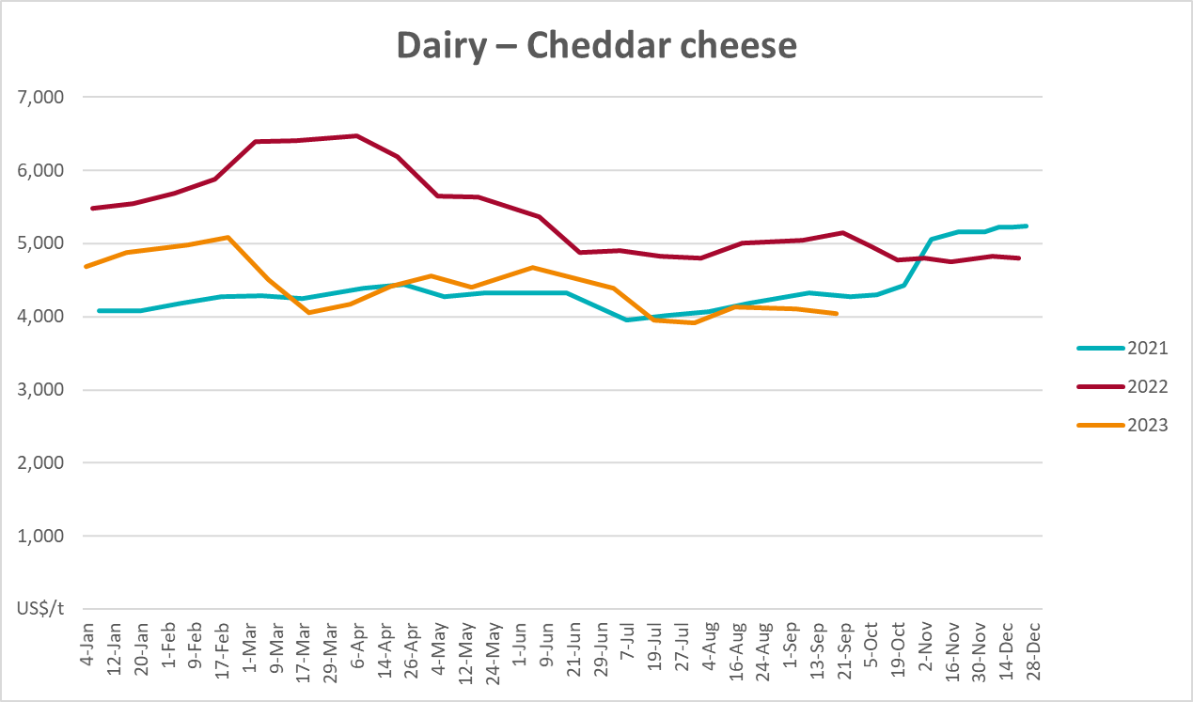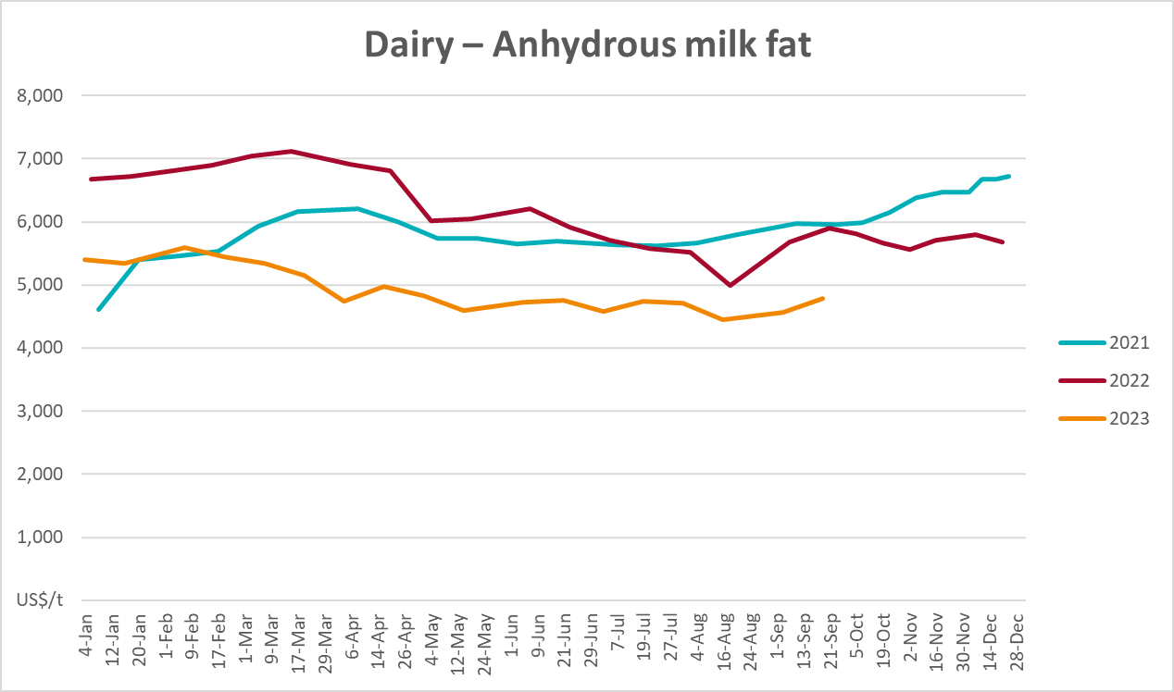

Selected fruit and vegetable prices
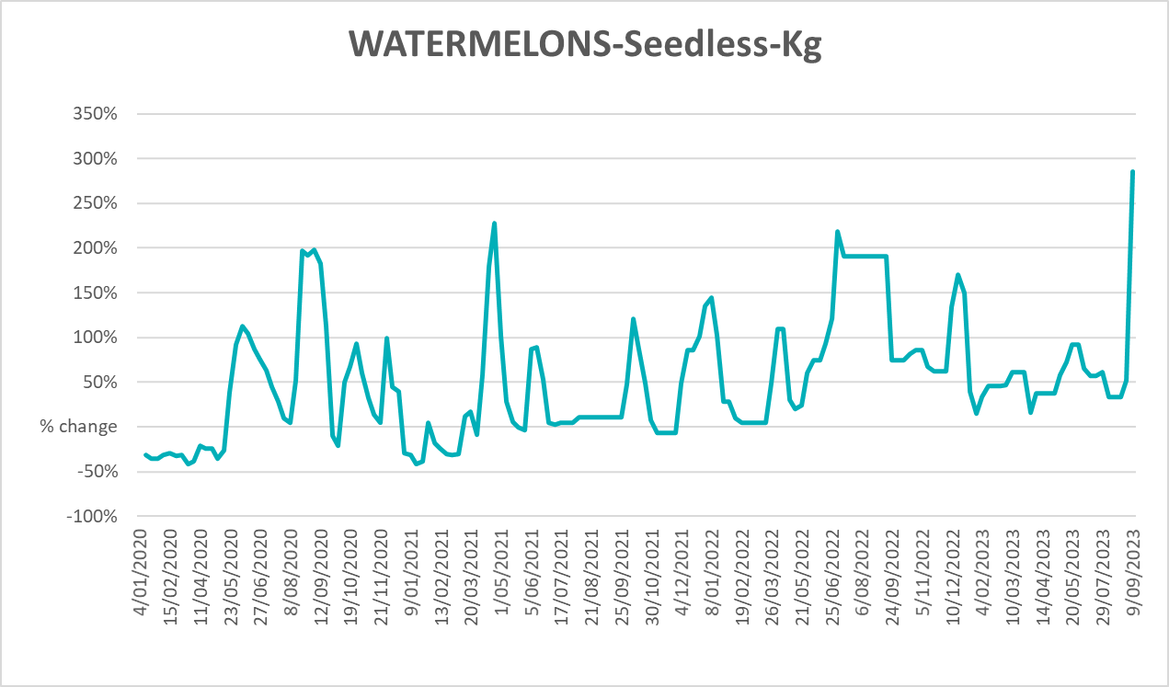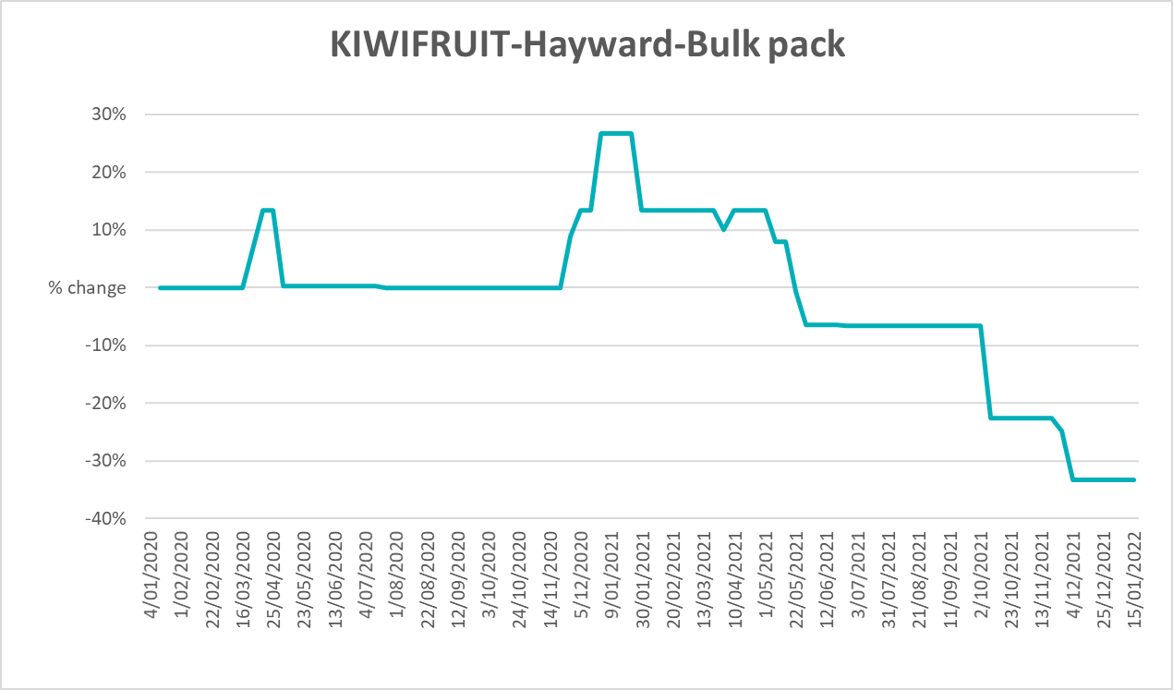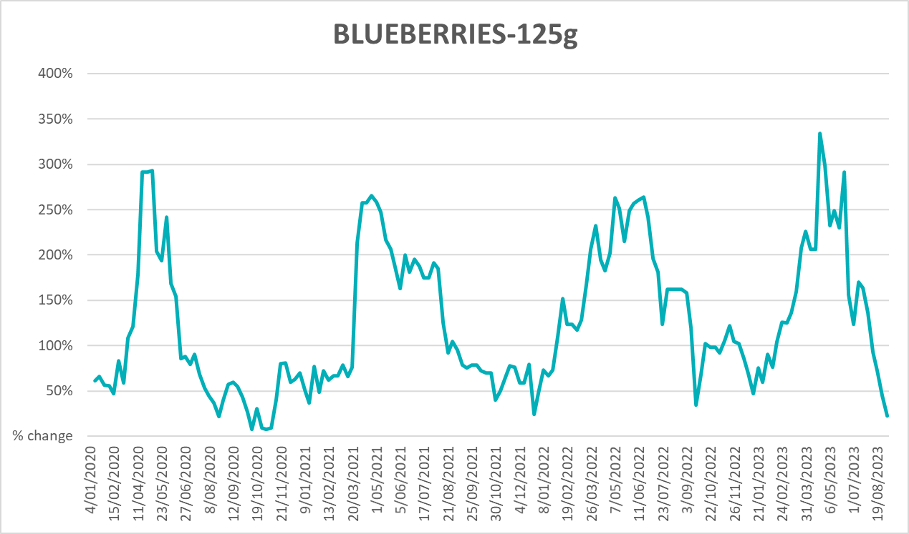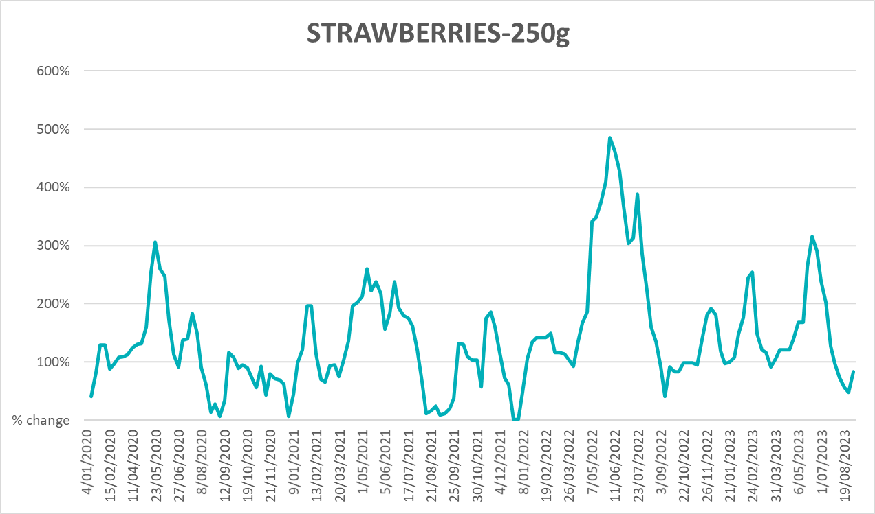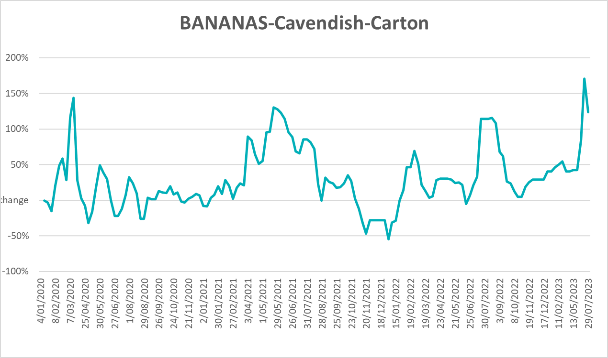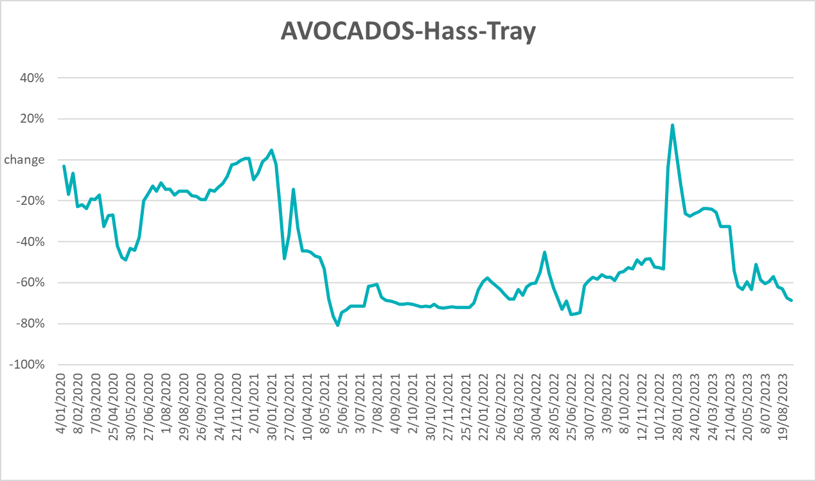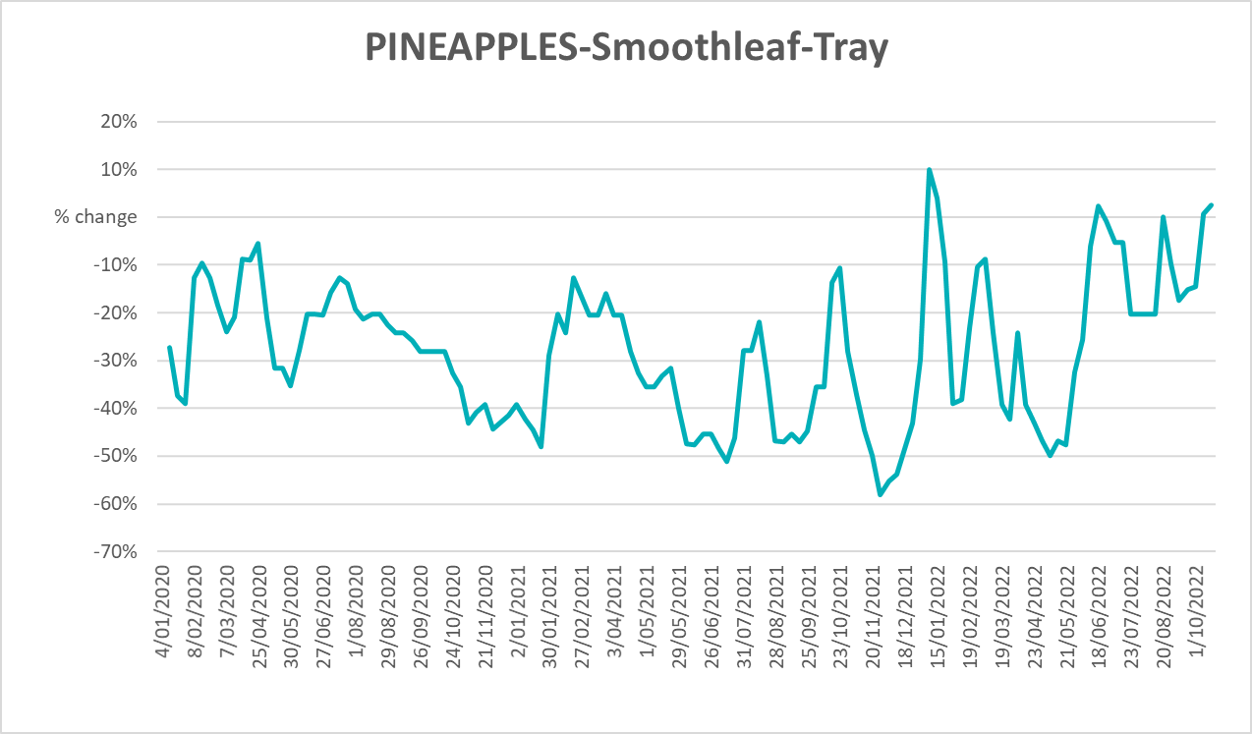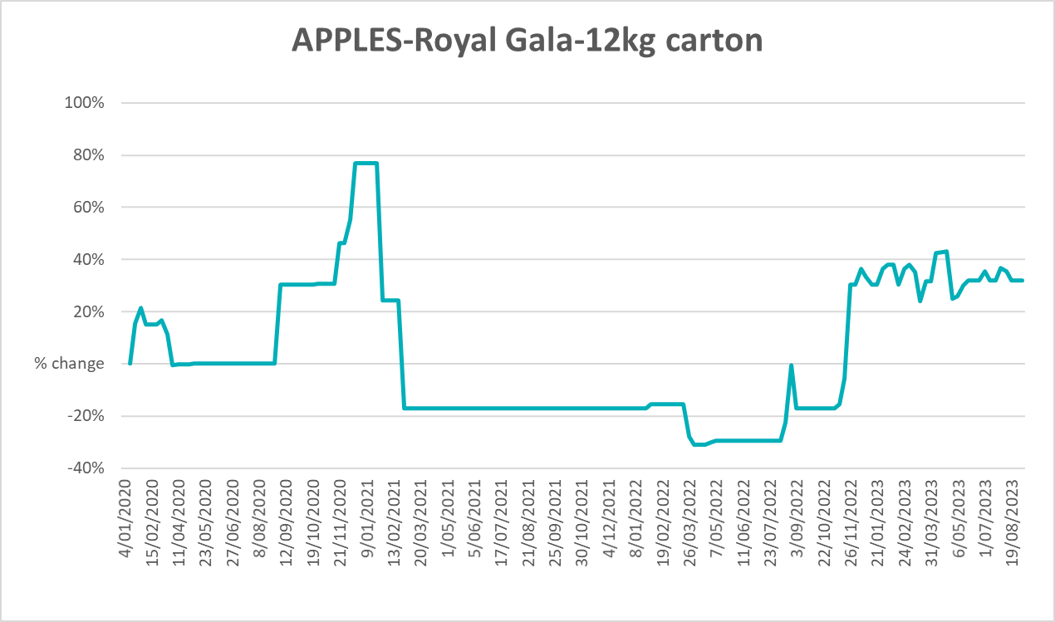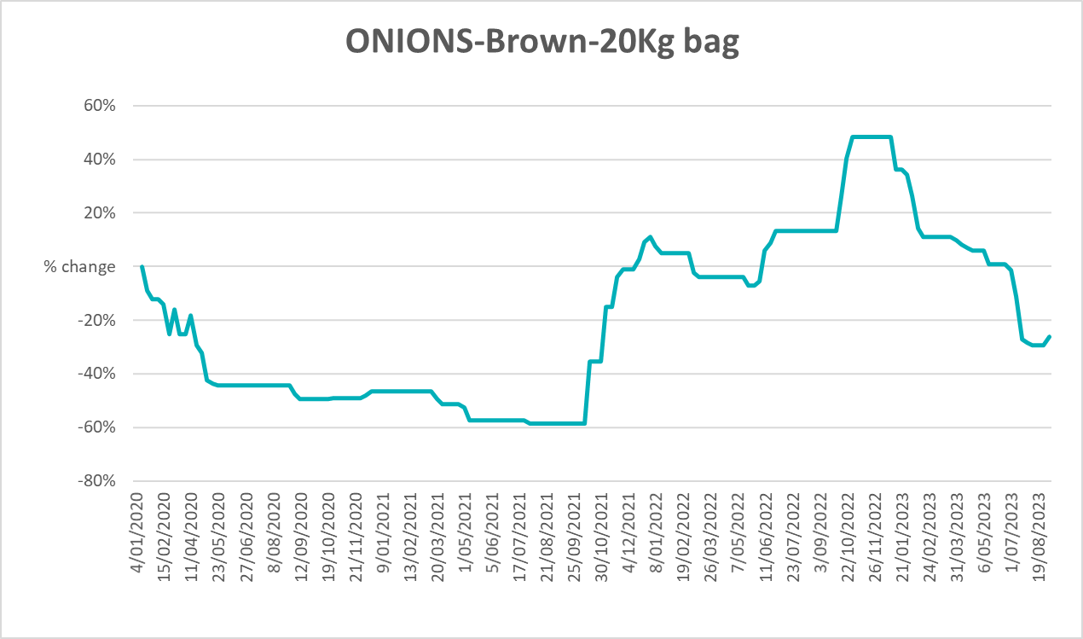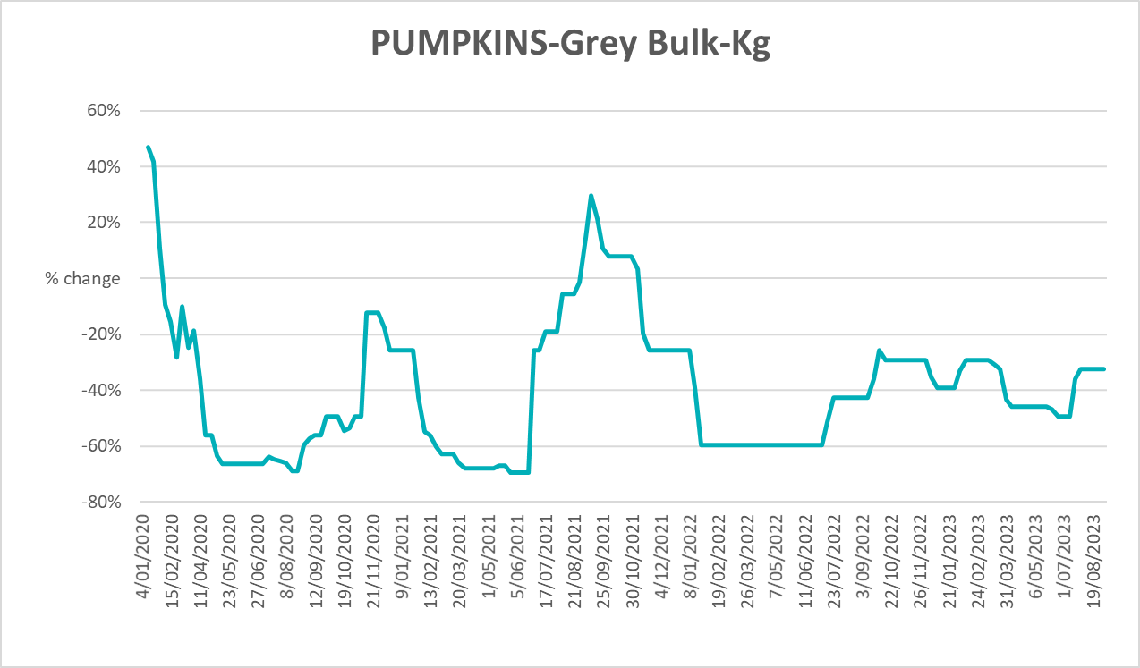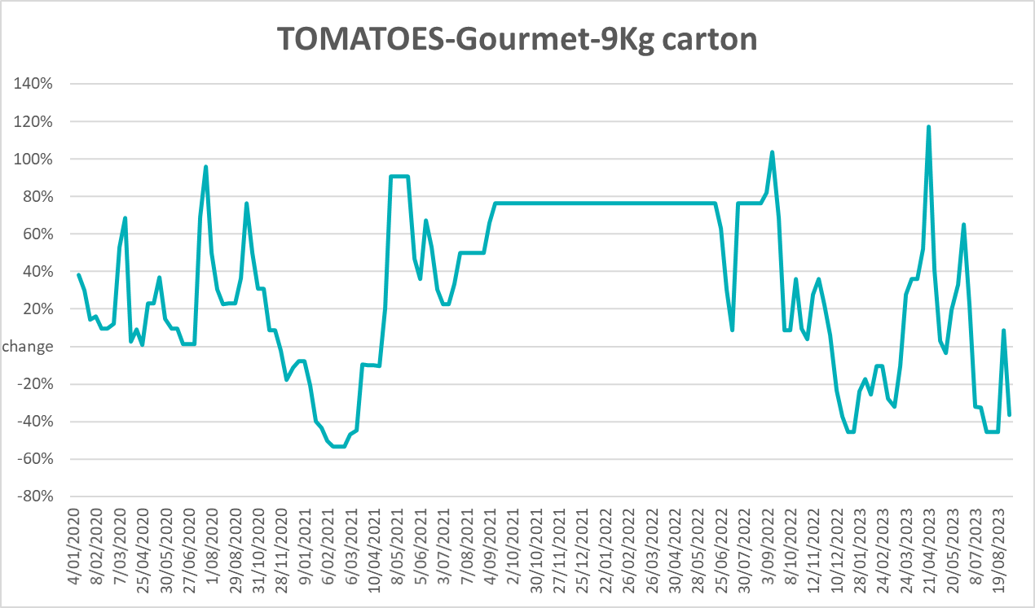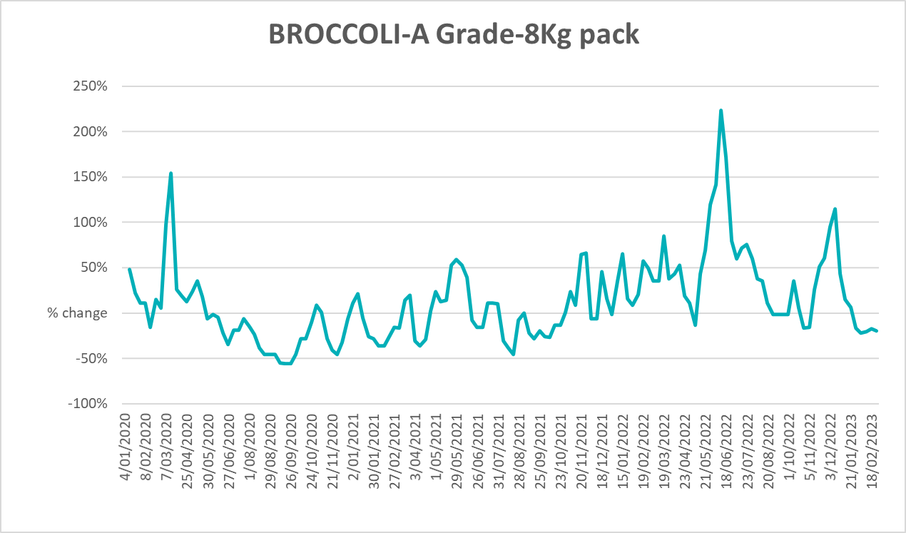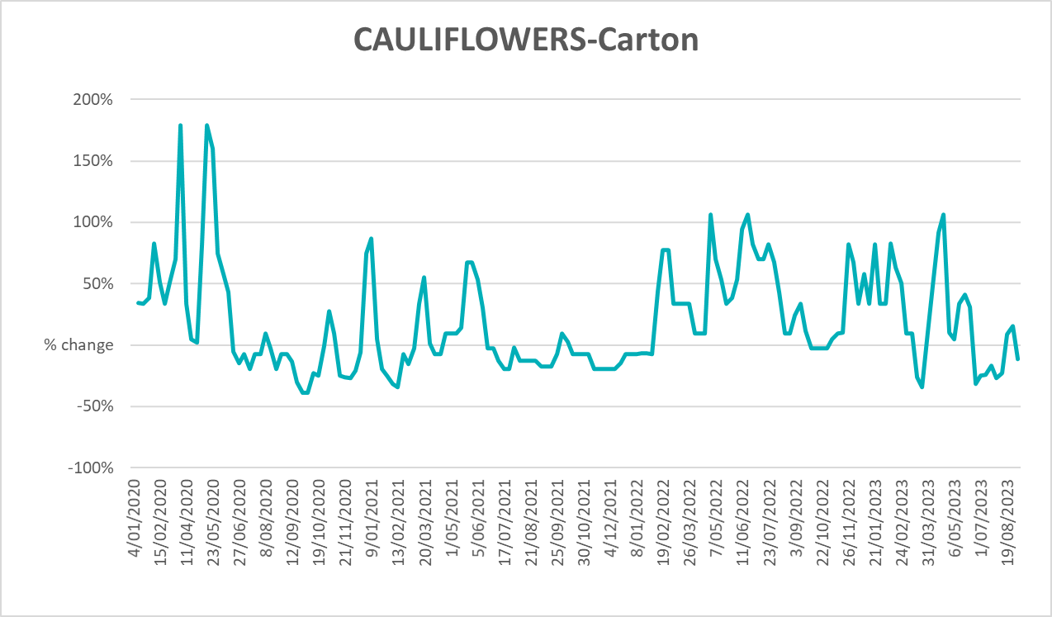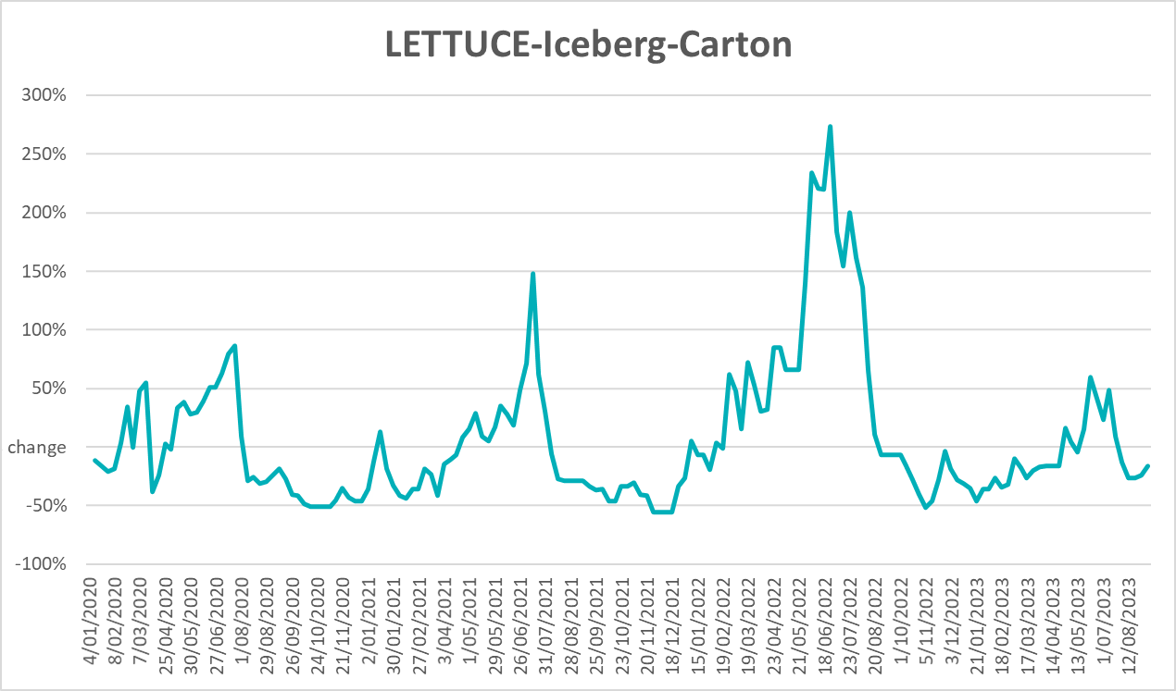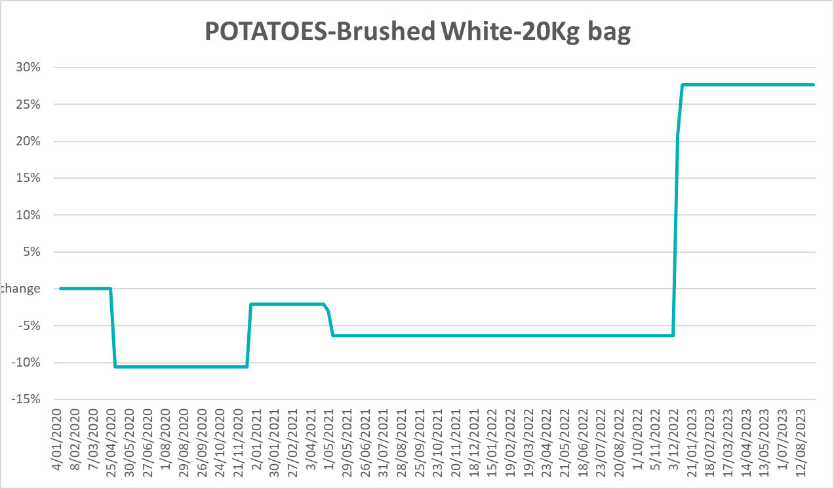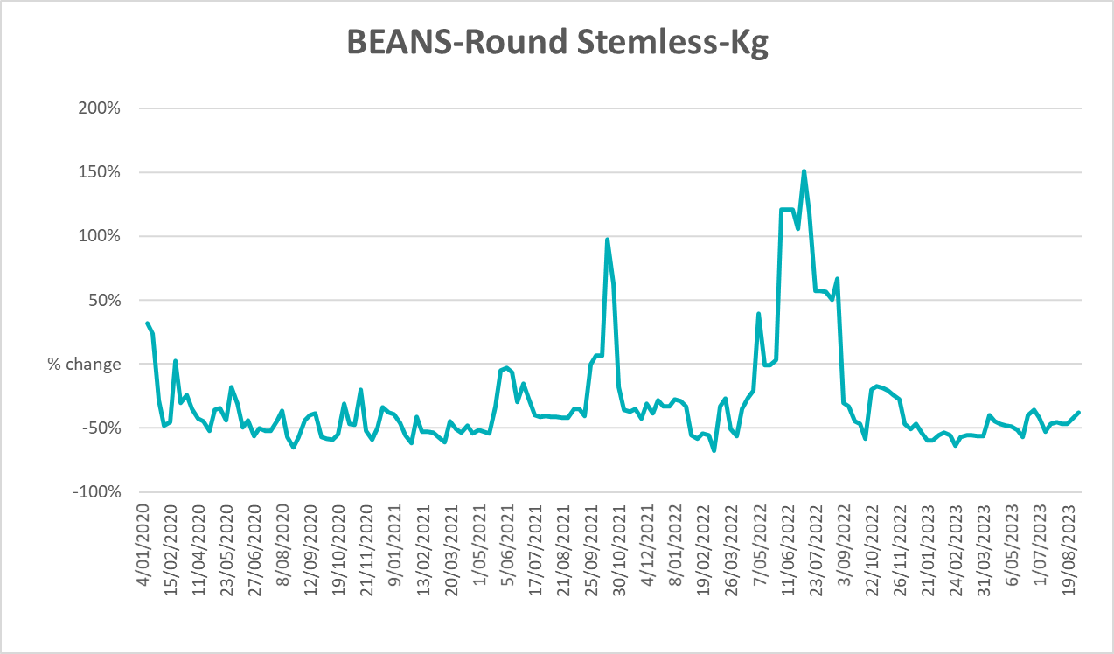

3.6 Selected domestic fodder indicator prices

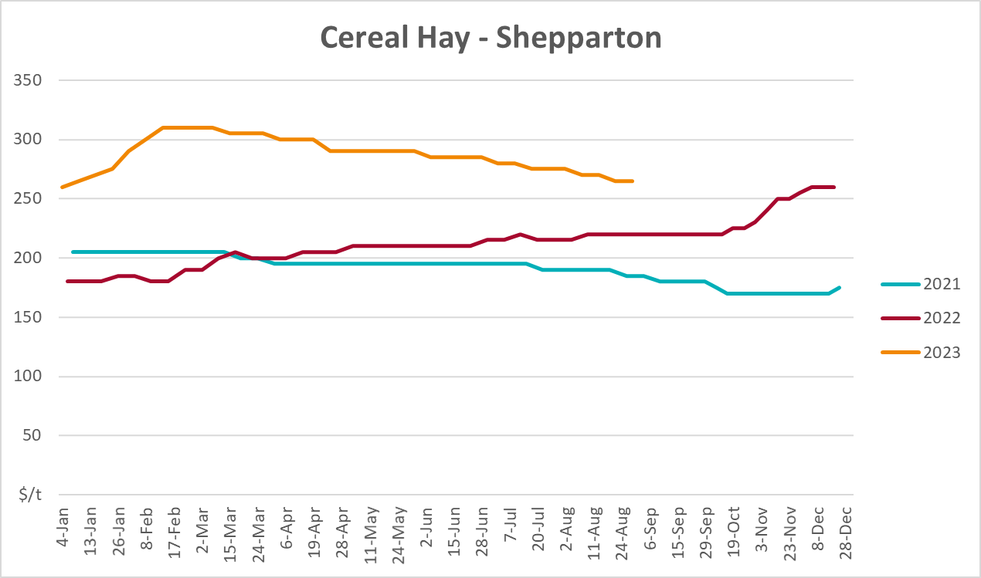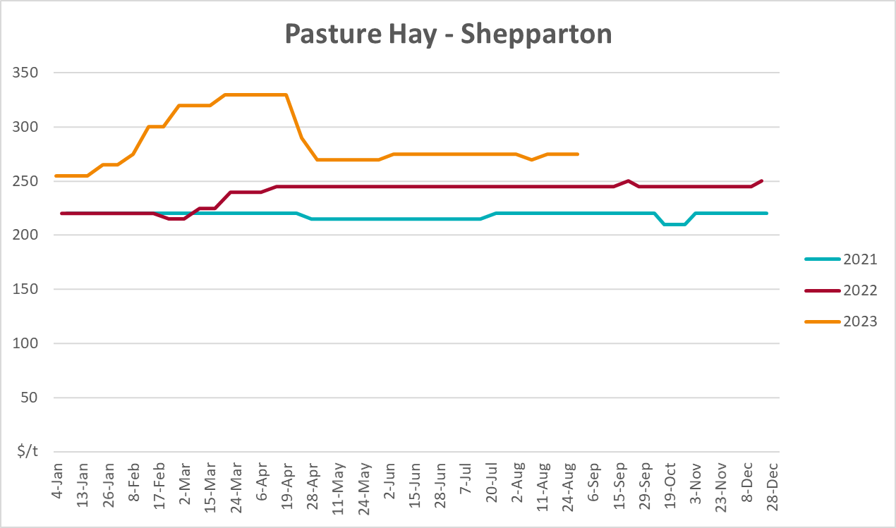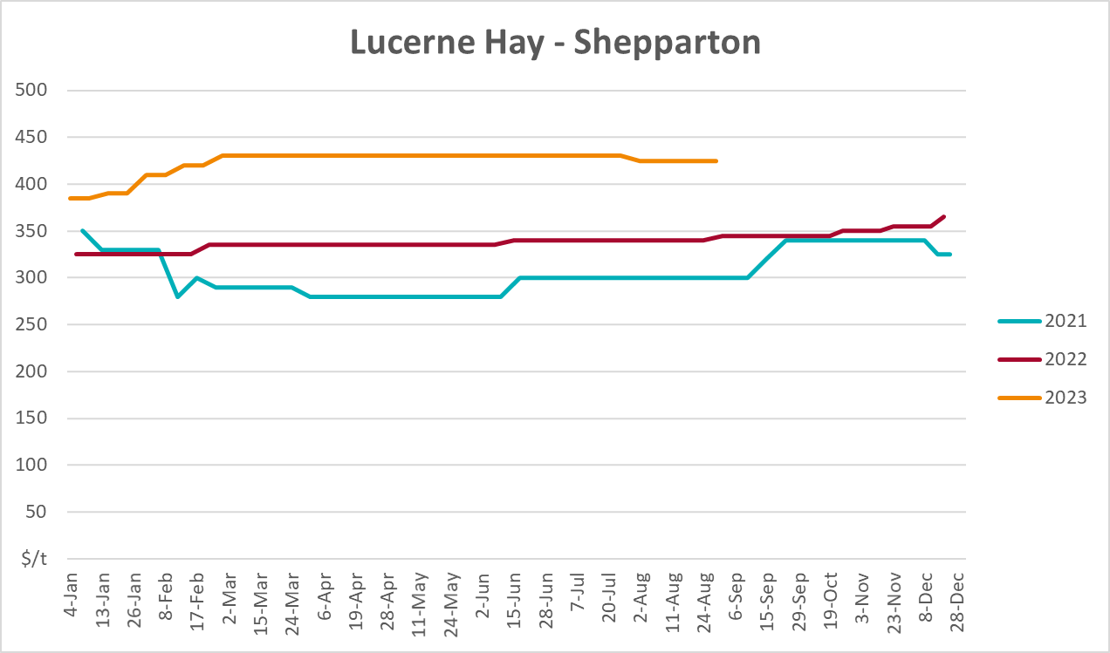

4. Data attribution

Climate
Bureau of Meteorology
- Weekly rainfall totals: www.bom.gov.au/climate/maps/rainfall/
- Monthly and last 3-month rainfall percentiles: www.bom.gov.au/water/landscape/
- Temperature anomalies: www.bom.gov.au/jsp/awap/temp/index.jsp
- Rainfall forecast: www.bom.gov.au/jsp/watl/rainfall/pme.jsp
- Seasonal outlook: www.bom.gov.au/climate/outlooks/#/overview/summary/
- Climate drivers: http://www.bom.gov.au/climate/enso/
- Soil moisture: www.bom.gov.au/water/landscape/
Other
- Pasture growth: www.longpaddock.qld.gov.au/aussiegrass/
- 3-month global outlooks: Environment and Climate Change Canada, NOAA Climate Prediction Center, EUROBRISA CPTEC/INPE, European Centre for Medium-Range Weather Forecasts, Hydrometcenter of Russia, National Climate Center Climate System Diagnosis and Prediction Room (NCC), International Research Institute for Climate and Society
- Global production: https://ipad.fas.usda.gov/ogamaps/cropmapsandcalendars.aspx
- Autumn break: Pook et al., 2009, https://rmets-onlinelibrary-wiley-com.virtual.anu.edu.au/doi/epdf/10.1002/joc.1833

Water
Prices
- Waterflow: https://www.waterflow.io/
- Ruralco: https://www.ruralcowater.com.au/
Bureau of Meteorology:
- Allocation trade: http://www.bom.gov.au/water/dashboards/#/water-markets/mdb/at
- Storage volumes: http://www.bom.gov.au/water/dashboards/#/water-storages/summary/drainage
Trade constraints:
- Water NSW: https://www.waternsw.com.au/customer-service/ordering-trading-and-pricing/trading/murrumbidgee
- Victorian Water Register: https://www.waterregister.vic.gov.au/TradingRules2019/

Commodities
Fruit and vegetables
- Datafresh: www.freshstate.com.au
Pigs
- Australian Pork Limited: www.australianpork.com.au
Dairy
- Global Dairy Trade: www.globaldairytrade.info/en/product-results/
World wheat, canola
- International Grains Council
World coarse grains
- United States Department of Agriculture
World cotton
- Cotlook: www.cotlook.com/
World sugar
- New York Stock Exchange - Intercontinental Exchange
Wool
- Australian Wool Exchange: www.awex.com.au/
Domestic wheat, barley, sorghum, canola and fodder
- Jumbuk Consulting Pty Ltd: http://www.jumbukag.com.au/
Cattle, beef, mutton, lamb, goat and live export
- Meat and Livestock Australia: www.mla.com.au/Prices-and-market
© Commonwealth of Australia 2023

Ownership of intellectual property rights
Unless otherwise noted, copyright (and any other intellectual property rights, if any) in this publication is owned by the Commonwealth of Australia (referred to as the Commonwealth).

Creative Commons licence
All material in this publication is licensed under a Creative Commons Attribution 4.0 International Licence except content supplied by third parties, logos and the Commonwealth Coat of Arms.
Inquiries about the licence and any use of this document should be emailed to copyright@awe.gov.au.


Cataloguing data
This publication (and any material sourced from it) should be attributed as:
ABARES 2023, Weekly Australian Climate, Water and Agricultural Update, Australian Bureau of Agricultural and Resource Economics and Sciences, Canberra, 21 September 2023. CC BY 4.0 DOI: https://doi.org/10.25814/5f3e04e7d2503
ISSN 2652-7561
This publication is available at https://www.agriculture.gov.au/abares/products/weekly_update
Department of Agriculture, Fisheries and Forestry
GPO Box 858 Canberra ACT 2601
Telephone 1800 900 090
Web agriculture.gov.au/abares

Disclaimer
The Australian Government acting through the Department of Agriculture, Fisheries and Forestry, represented by the Australian Bureau of Agricultural and Resource Economics and Sciences, has exercised due care and skill in preparing and compiling the information and data in this publication. Notwithstanding, the Department of Agriculture, Fisheries and Forestry, ABARES, its employees and advisers disclaim all liability, including liability for negligence and for any loss, damage, injury, expense or cost incurred by any person as a result of accessing, using or relying on any of the information or data in this publication to the maximum extent permitted by law.

Statement of Professional Independence
The views and analysis presented in ABARES publications, including this one, reflect ABARES professionally independent findings, based on scientific and economic concepts, principles, information and data. These views, analysis and findings may not reflect or be consistent with the views or positions of the Australian Government, or of organisations or groups who have commissioned ABARES reports or analysis. More information on professional independence is provided on the ABARES website.

Acknowledgements
This report was prepared by Kavina Dayal and Matthew Miller.

