
No. 35/2023 7 September 2023

Summary of key issues
- For the week ending 6 September 2023, thunderstorms brought showers to the east coast and a front brought showers to southern parts of the country.
- Across cropping regions, rainfall totals of up to 10 millimetres were recorded in the eastern fringes of Queensland and New South Wales, southern Victoria, northern and central Western Australia and across South Australia, while southern areas Western Australia received up to 50 millimetres. Given the lack of rainfall across most cropping regions in New South Wales and Queensland, these regions are continuing to see a gradual decline in soil moisture reserves. This represents an increased risk of declines in crop yields if follow-up rainfall is not received in the next few weeks (see Section 1.1).
- Rainfall during August 2023 was around 50% below the long-term average at a national level. In cropping regions, August rainfall was extremely low to below average in western and northern parts of Western Australia, across large areas of South Australia and Queensland, northern New South Wales and southern Victoria. With a continuous decline in the sub-soil moisture seen across numerous regions and above average day-and nighttime temperatures, the below average August rainfall has exposed crops to increased moisture stress (see Section 1.2).
- For the 3 months to August 2023 pasture growth was above average to extremely high across large areas of western New South Wales, central Victoria, eastern Tasmania, and in scattered areas of South Australia, central and northern Western Australia, and southern Northern Territory. This growth is likely to enable farmers to maintain stock numbers. In contrast, modelled pasture growth was extremely low to below average across scattered areas of western and southern Western Australia and in eastern Queensland and New South Wales. These below average levels of pasture growth have likely seen a shift from maintaining livestock number to a period of destocking (see Section 1.4).
- Over the next 8-days, isolated showers are expected to bring some rainfall to southern parts of the country, elsewhere the next 8-days is expected to be mainly dry conditions (see Section 1.6).
- Across most cropping regions, rainfall totals of up to 15 millimetres are expected in Western Australia, Victoria and New South Wales, with up to 25 millimetres in South Australia. The falls in southern areas are expected to benefit to crops and pastures. Following a dry August and given the current well below average levels of soil moisture, crops and pastures in Queensland, northern New South Wales and northern Western Australia will be disposed to heat and moisture stress, negatively affecting production potential (see Section 1.6).
- Water storage levels in the Murray-Darling Basin (MDB) increased between 31 August 2023 and 7 September 2023 by 32 gigalitres (GL). Current volume of water held in storage is 20 705 GL. This is 3 percent or 664 GL less than at the same time last year.
- Allocation prices in the Victorian Murray below the Barmah Choke increased from $155 on 31 August 2023 to $173 on 7 September 2023. Prices are lower in the Goulburn-Broken due to the binding of the Goulburn intervalley trade limit.

Climate

Rainfall this week
For the week ending 7 September 2023, thunderstorms brought showers to the east coast and a front brought showers to southern parts of the country. A high-pressure system kept the remainder of the country dry and clear.
Across cropping regions, rainfall totals of up to 10 millimetres were recorded in the eastern fringes of Queensland and New South Wales, southern Victoria, northern and central Western Australia and across South Australia, while southern areas Western Australia received up to 50 millimetres. Given the lack of rainfall across most cropping regions in New South Wales and Queensland, these regions are continuing to see a gradual decline in soil moisture reserves. This represents an increased risk of declines in crop yields if follow-up rainfall is not received in the next few weeks.

Rainfall for the week ending 6 September 2023
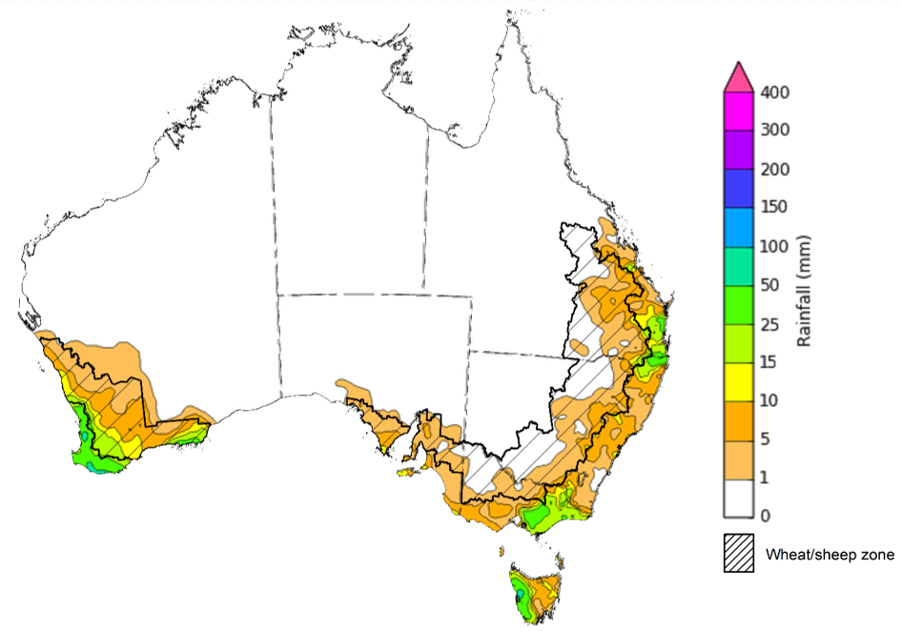
©Commonwealth of Australia 2023, Australian Bureau of Meteorology Issued: 6/9/2023
Note: The rainfall analyses and associated maps utilise data contained in the Bureau of Meteorology climate database, the Australian Data Archive for Meteorology (ADAM). The analyses are initially produced automatically from real-time data with limited quality control. They are intended to provide a general overview of rainfall across Australia as quickly as possible after the observations are received. For further information go to http://www.bom.gov.au/climate/rainfall/

Monthly rainfall
Rainfall during August 2023 was highly variable and close to 50% below the long-term average at a national level and 10th driest on record for the month of August. It was below average for the lower two-thirds of Queensland, most of New South Wales, Victoria and Tasmania, parts of South Australia, southern Northern Territory, and parts of eastern and south-western Western Australia.
In cropping regions, August rainfall was extremely low to below average in western and northern parts of Western Australia, across large areas of South Australia and Queensland, northern New South Wales and southern Victoria. Average rainfall was recorded in parts of southern New South Wales, northern Victoria and southern Western Australia. With a continuous decline in the sub-soil moisture seen across numerous regions and above average day-and nighttime temperatures, below average August rainfall has exposed crops to increased moisture stress.

Rainfall percentiles for August 2023
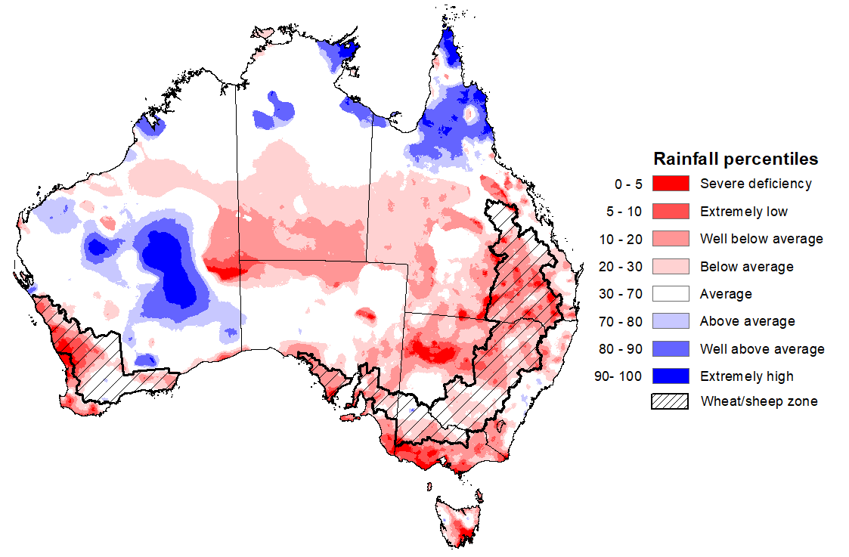
Note: Rainfall for August 2023 is compared with rainfall recorded for that period during the historical record (1900 to present). For further information, go to http://www.bom.gov.au/jsp/awap/
Source: Bureau of Meteorology

Monthly Soil Moisture
Upper layer soil moisture in August 2023 was above average to extremely high for the tropical north of Australia and central Western Australia. It was extremely low to below average for southwestern Western Australia, isolated areas in South Australia, large areas in northern New South Wales, southern Queensland and southern Victoria, as well as in eastern Tasmania. August upper layer relative soil moisture levels were generally average in the remaining areas.
At this time of year, upper layer soil moisture is less critical for well-established winter crops. However, upper layer soil moisture will be critical for supporting the germination and establishment of summer crops in the coming months. In cropping regions, upper layer soil moisture was generally below average to extremely low. However, it was close to average across southern New South Wales, much of Victoria and parts of eastern South Australia and eastern and southern Western Australia. Average levels to above average of soil moisture would have supported winter crops crop yield potential especially in those areas that have seen a decline in lower layer soil moisture in recent months. However, extremely low upper layer soil moisture across northern New South Wales and much of Queensland present a significant production risk to summer crops and pasture growth.

Modelled upper layer soil moisture for August 2023
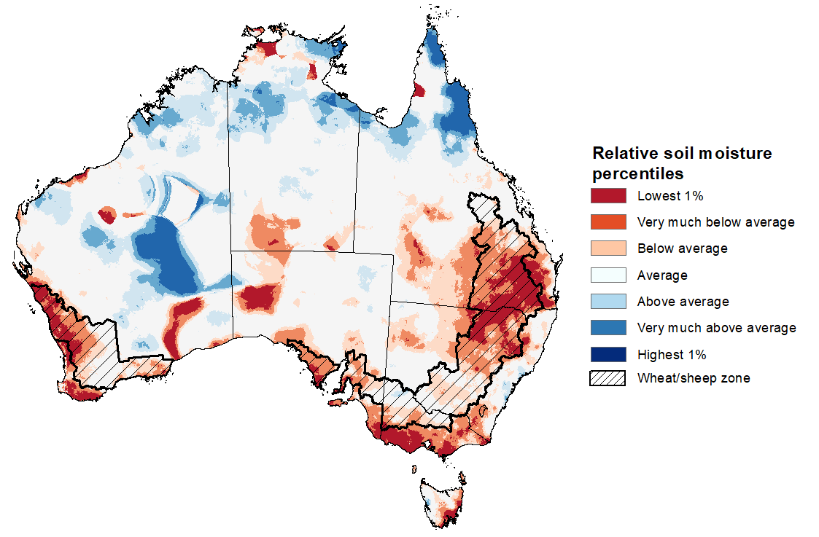
Note: This map shows the levels of modelled upper layer soil moisture (0 to 10 centimetres) during August 2023. This map shows how modelled soil conditions during August 2023 compare with the August conditions modelled over the reference period (1911 to 2016). Dark blue areas on the maps were much wetter in August 2023 than during the reference period. The bulk of plant roots occur in the top 20 centimetres of the soil profile. Soil moisture in the upper layer of the soil profile is therefore useful indicator of the availability of water, particularly for germinating seed.
Source: Bureau of Meteorology (Australian Water Resources Assessment Landscape model)

Relative lower layer soil moisture for August 2023 was highly variable across Australia. It was above average across most of northern and central Australia. Relative lower layer soil moisture was very much below average for much of south-eastern Queensland, north-eastern and coastal New South Wales, western and south-eastern Western Australia, southern South Australia, and in eastern Victoria and Tasmania. Relative lower layer soil moisture was average elsewhere.
Lower layer soil moisture is a larger, deeper store that is slower to respond to seasonal conditions and tends to reflect the accumulated effects of events that have occurred over longer periods. Lower layer soil moisture will be important for winter crops as they enter flowering and grain filling over the coming months, particularly given the warm and dry spring rainfall outlook. In cropping regions, lower layer soil moisture was extremely low to below average across much of Queensland, northern and central Western Australia and most of South Australia. It was generally average in Victoria, southern Western Australia and southern New South Wales and in eastern South Australia. Areas with below average levels of lower layer soil moisture will be highly dependent on timely and sufficient in-season rainfall to support current levels of winter crop production. A lack of lower layer moisture will also weigh on crop and livestock producers’ decision-making as we enter the spring and summer crop planting season and peak pasture growth period.
Modelled lower layer soil moisture for August 2023
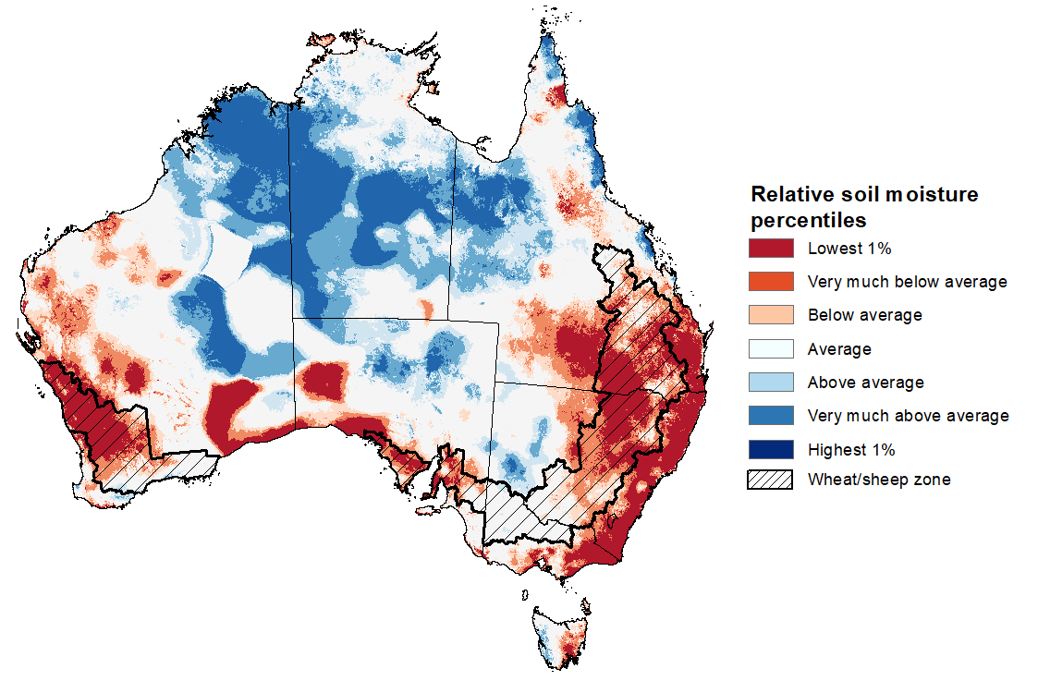
Note: This map shows the levels of modelled lower layer soil moisture (10 to 100 centimetres) during August 2023. This map shows how modelled soil conditions during August 2023 compare with August conditions modelled over the reference period (1911 to 2016). Dark blue areas on the maps were much wetter in August 2023 than during the reference period. The dark red areas were much drier than during the reference period. The bulk of plant roots occur in the top 20 centimetres of the soil profile. The lower layer soil moisture is a larger, deeper store that is slower to respond to rainfall and tends to reflect accumulated rainfall events over longer time periods.
Source: Bureau of Meteorology (Australian Water Resources Assessment Landscape model)

Pasture Growth
Pasture growth during the June to August period is low across large areas of central and northern Australia as it enters a seasonally low growth period due to typically cooler temperatures and little to no rainfall. Across southern Australia, June to August pasture growth influences the number of livestock than can be supported without supplementary feeding over winter and the level of reliance on hay and grain during this period.
Modelled pasture growth was above average to extremely high across large areas of western New South Wales, central Victoria, eastern Tasmania, and in scattered areas of South Australia, central and northern Western Australia, and southern Northern Territory. This growth is likely to enable farmers to continue to maintain stock numbers and provide opportunities to replenish fodder supplies during spring.
In contrast, modelled pasture growth was extremely low to below average across large areas of western and southern Western Australia and in eastern Queensland and eastern New South Wales. These below average levels of pasture growth have likely seen a shift from maintaining livestock number to a period of destocking. Given a relatively dry winter season, livestock producers in areas with below average pasture availability will require substantial rainfalls through spring to build soil moisture level and encourage pasture growth during the springtime peak, or switch to an extensive supplementary feeding program to maintain current stock numbers and avoid further destocking.
Relative pasture growth for 3-months ending August 2023 (1 June 2023 to 31 August 2023)
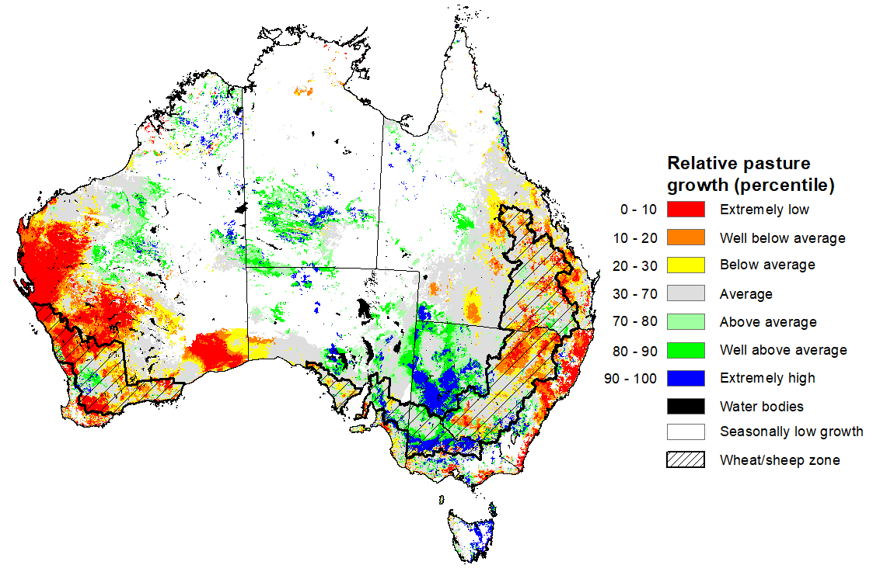
Notes: AussieGRASS pasture growth estimates are relative to the long-term record and shown in percentiles. Percentiles rank data on a scale of zero to 100. This analysis ranks pasture growth for the selected period against average pasture growth for the long-term record (1957 to 2016). Pasture growth is modelled at 5km2 grid cells.
Source: Queensland Department of Science, Information Technology, and Innovation.

1.5 Potential Frost
Frost occurs on clear nights during winter and early spring when the air temperature drops to 2°C or less and is most pronounced in the southern and eastern agricultural regions. The weather events that typically generate damaging frosts is from the passage of cold fronts, followed by cold southerly winds and a high-pressure ridge. The severity and extent of subsequent damage is variable across the landscape. Crop damage from frost may occur at any stage of development but is most damaging around flowering and grain filling in spring. In August, crops are in the flowering stage and are at high risk of frost damage.
Severe frosts (minimum temperatures below -2°C) can cause freezing damage to crop when there is rapid ice crystal formation form within the tissue. The ice crystals physically rupture cell walls and membranes within the cells causing physical damage. Damage can be seen once thawed as dark green water-soaked areas. Ten days after a frost event bleached leaves, stems and reproductive tissue might be evident depending on the growth stage of the crop.
Based on the 30-year (1993-2022) climatology for August, much of the southern Australia records less than 10 days of frosty conditions. In eastern Australia, up to 25 days of frost events can be seen in the eastern New South Wales, Victoria and Tasmania, up to 15 days in southern Queensland and in scattered areas of eastern South Australia. Over 25 days of frost events can be expected in southern New South Wales and eastern Victoria alpine regions and in central Tasmania. Across cropping regions, on average there are up to 15 frost events, except for along the eastern margins of New South Wales and isolated parts of southern and western Queensland where it can experience up to 20 frost events.
During August 2023, fewer than average potential frost events were recorded across cropping regions in Queensland, Victoria and northern New South Wales, while twice the average number of potential frost events were recorded in central New South Wales. Depending on the growth stage of crops and the severity and length of time crops were subjected to frost, this presents a localised risk to crop production potential in these areas.
Number of days with minimum temperature below 2°C in August
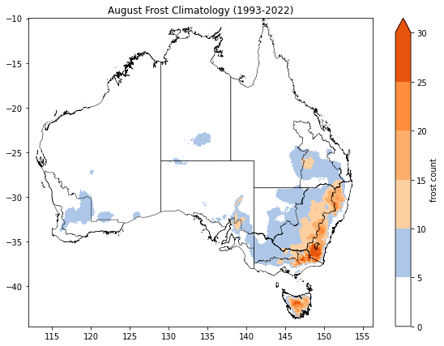 | 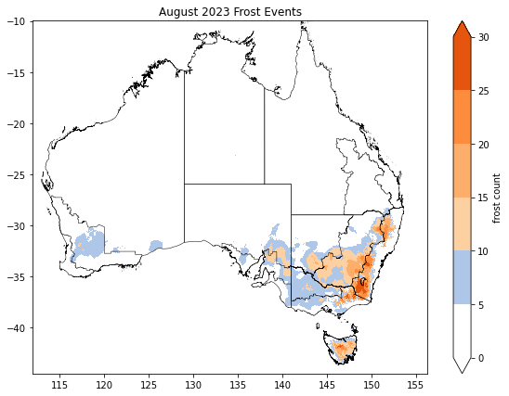
©Commonwealth of Australia 2023, Australian Bureau of Meteorology
Note: Based on standard 30-year climatology (1993-2022)

1.6 Rainfall forecast for the next eight days
Over the 8-days to 14 September 2023, fronts and troughs are expected to bring isolated showers to southern parts of the country. A high-pressure system is expected to bring mainly dry conditions to the remainder of the country.
Across cropping regions, rainfall totals of up to 15 millimetres are expected in Western Australia, Victoria and New South Wales, with up to 25 millimetres in parts of South Australia. Minimal rainfall is expected in Queensland over the next 8-days. The expected falls in southern areas will be of some benefit to crops and pastures. However, following a dry August, and given the current well below average levels of soil moisture, crops and pastures in Queensland, northern New South Wales and northern Western Australia will be disposed to heat and moisture stress, negatively affecting production potential.

Total forecast rainfall for the period 7 September 2023 to 14 September 2023
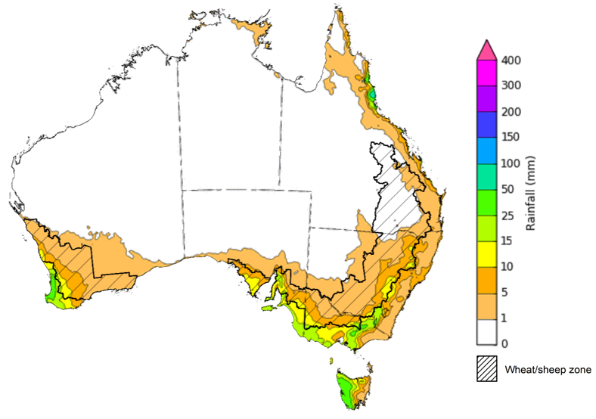

©Commonwealth of Australia 2023, Australian Bureau of Meteorology Issued 7/9/2023
Note: This rainfall forecast is produced from computer models. As the model outputs are not altered by weather forecasters, it is important to check local forecasts and warnings issued by the Bureau of Meteorology.

Water

Water markets – current week
Water storage levels in the Murray-Darling Basin (MDB) increased between 31 August 2023 and 7 September 2023 by 32 gigalitres (GL). Current volume of water held in storage is 20 705 GL. This is 3 percent or 664 GL less than at the same time last year.

Water storages in the Murray-Darling Basin, 2013–2023
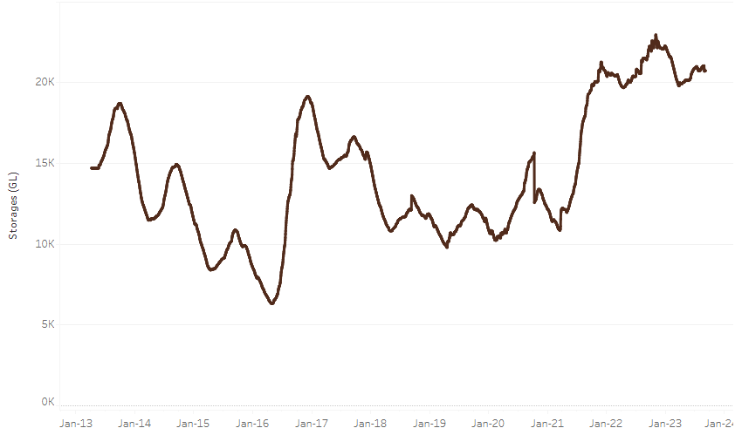
Allocation prices in the Victorian Murray below the Barmah Choke increased from $155 on 31 August 2023 to $173 on 7 September 2023. Prices are lower in the Goulburn-Broken due to the binding of the Goulburn intervalley trade limit.
Water storage data is sourced from the Bureau of Meteorology.

Region | $/ML
NSW Murray Above | 70
NSW Murrumbidgee | 155
VIC Goulburn-Broken | 120
VIC Murray Below | 155

Surface water trade activity, Southern Murray–Darling Basin
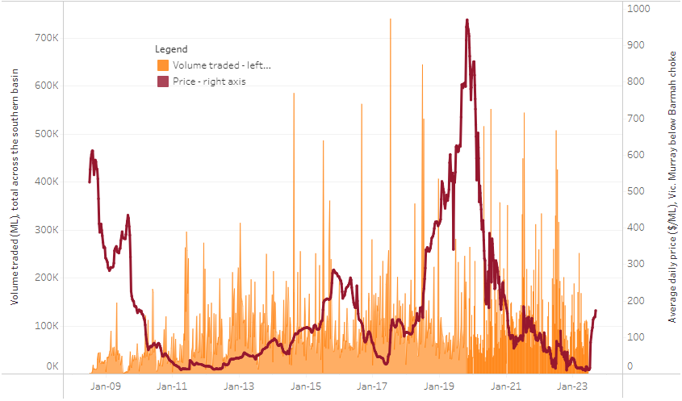
The trades shown reflect estimated market activity and do not encompass all register trades. The price is shown for the VIC Murray below the Barmah choke. Historical prices (before 1 July 2019) are ABARES estimates after removing outliers from BOM water register data. Prices after 1 July 2019 and prior to the 30 October 2019 reflect recorded transaction prices as sourced from Ruralco. Prices after the 30 October 2019 are sourced from Waterflow. Data for volume traded is sourced from the BOM water register. Only the price data shown is current on 7 September 2023.

To access the full, interactive, weekly water dashboard, which contains the latest and historical water storage, water market and water allocation information, please visit https://www.agriculture.gov.au/abares/products/weekly_update/weeakly-update-7923

Commodities
Indicator | Week ended | Unit | Latest Price | Previous Week | Weekly change | Price 12 months ago | Annual change
Selected world indicator prices
AUD/USD Exchange rate | 06-Sep | A$/US$ | 0.64 | 0.65 | -1% | 0.68 | -5%
Wheat – US no. 2 hard red winter wheat, fob Gulf | 06-Sep | US$/t | 309 | 309 | 0% | 427 | -28%
Corn – US no. 2 yellow corn, fob Gulf | 06-Sep | US$/t | 223 | 213 | 5% | 313 | -29%
Canola – Rapeseed, Canada, fob Vancouver | 06-Sep | US$/t | 625 | 625 | 0% | 656 | -5%
Cotton – Cotlook 'A' Index | 06-Sep | USc/lb | 100 | 97 | 3% | 122 | -18%
Sugar – Intercontinental Exchange, nearby futures, no.11 contract | 06-Sep | USc/lb | 26.4 | 25.7 | 2% | 18 | 47%
Wool – Eastern Market Indicator | 30-Aug | Ac/kg clean | 1,127 | 1,131 | 0% | 1,388 | -19%
Wool – Western Market Indicator | 30-Aug | Ac/kg clean | 1,285 | 1,270 | 1% | 1,502 | -14%
Selected Australian grain export prices
Milling Wheat – APW, Port Adelaide, SA | 06-Sep | A$/t | 477 | 473 | 1% | 548 | -13%
Feed Wheat – ASW, Port Adelaide, SA | 06-Sep | A$/t | 455 | 451 | 1% | 502 | -9%
Feed Barley – Port Adelaide, SA | 06-Sep | A$/t | 385 | 379 | 2% | 462 | -17%
Canola – Kwinana, WA | 06-Sep | A$/t | 856 | 856 | 0% | 1,037 | -17%
Grain Sorghum – Brisbane, QLD | 06-Sep | A$/t | 517 | 515 | 0% | 445 | 16%
Selected domestic livestock indicator prices
Beef – Eastern Young Cattle Indicator | 06-Sep | Ac/kg cwt | 471 | 494 | -5% | 1,031 | -54%
Mutton – Mutton indicator (18–24 kg fat score 2–3), Vic | 06-Sep | Ac/kg cwt | 175 | 196 | -11% | 580 | -70%
Lamb – Eastern States Trade Lamb Indicator | 30-Aug | Ac/kg cwt | 419 | 434 | -3% | 680 | -38%
Pig – Eastern Seaboard (60.1–75 kg), average of buyers & sellers | 23-Aug | Ac/kg cwt | 343 | 343 | 0% | 376 | -9%
Goats – Eastern States (12.1–16 kg) | 16-Aug | Ac/kg cwt | 303 | 303 | 0% | 895 | -66%
Live cattle – Light steers ex Darwin to Indonesia | 17-Aug-22 | Ac/kg lwt | 420 | 480 | -13% | 320 | 31%
Live sheep – Live wethers (Muchea WA saleyard) to Middle East | 14-Sep-22 | $/head | 93 | 113 | -18% | 114 | -18%
Global Dairy Trade (GDT) weighted average prices ª
Dairy – Whole milk powder | 06-Sep | US$/t | 2,702 | 2,548 | 6% | 3,417 | -21%
Dairy – Skim milk powder | 06-Sep | US$/t | 2,286 | 2,333 | -2% | 3,524 | -35%
Dairy – Cheddar cheese | 06-Sep | US$/t | 4,102 | 4,127 | -1% | 5,005 | -18%
Dairy – Anhydrous milk fat | 06-Sep | US$/t | 4,561 | 4,452 | 2% | 4,990 | -9%
a Global Dairy Trade prices are updated twice monthly on the first and third Tuesday of each month.

Selected world indicator prices
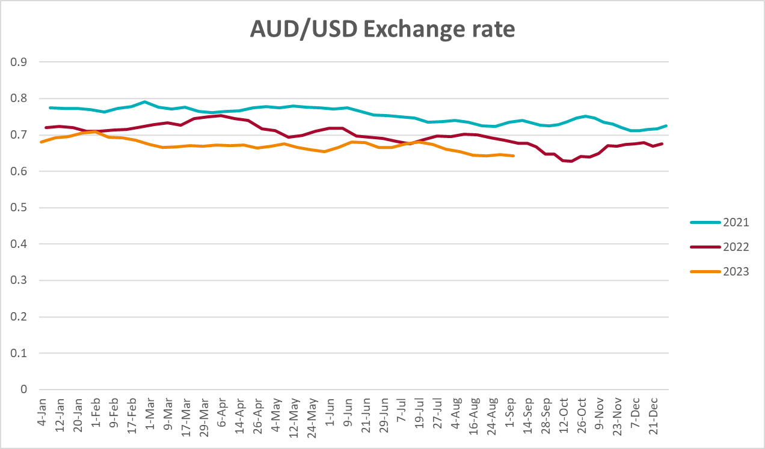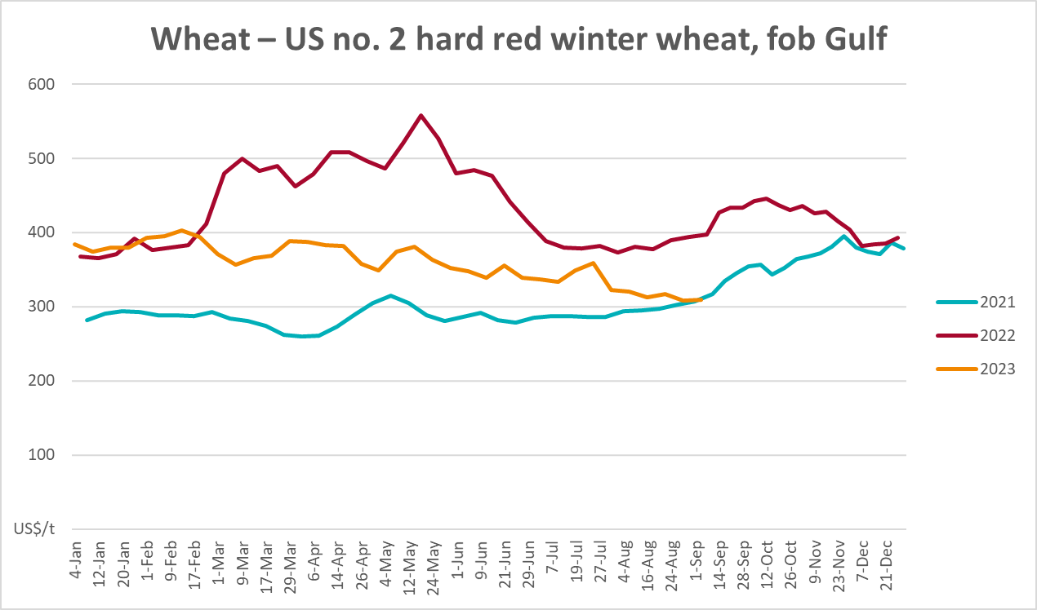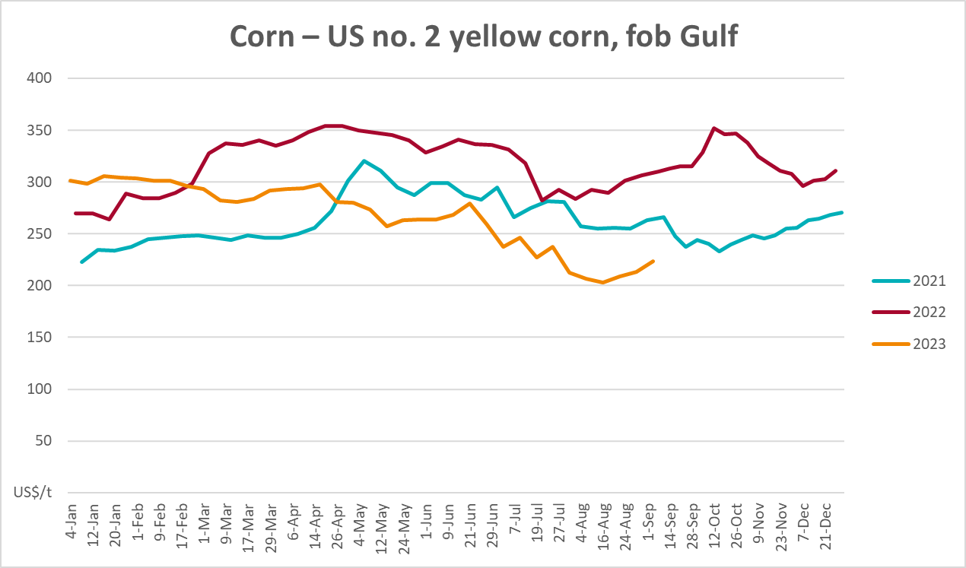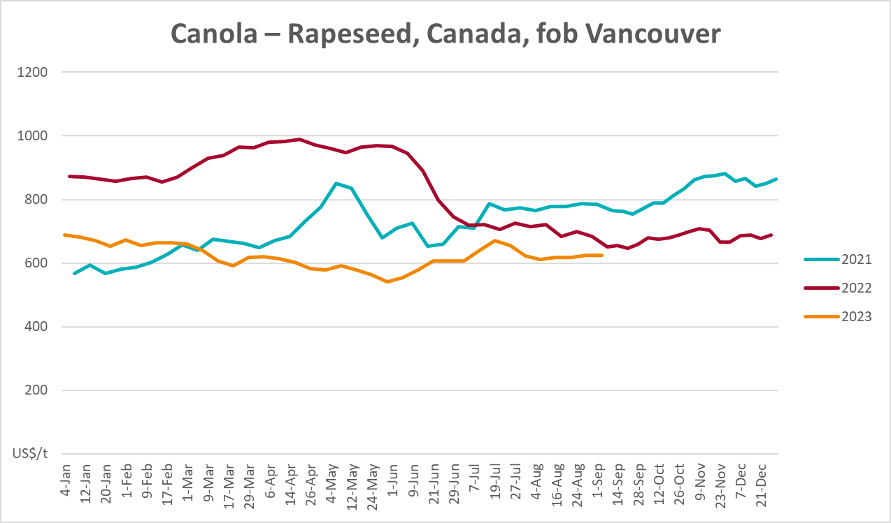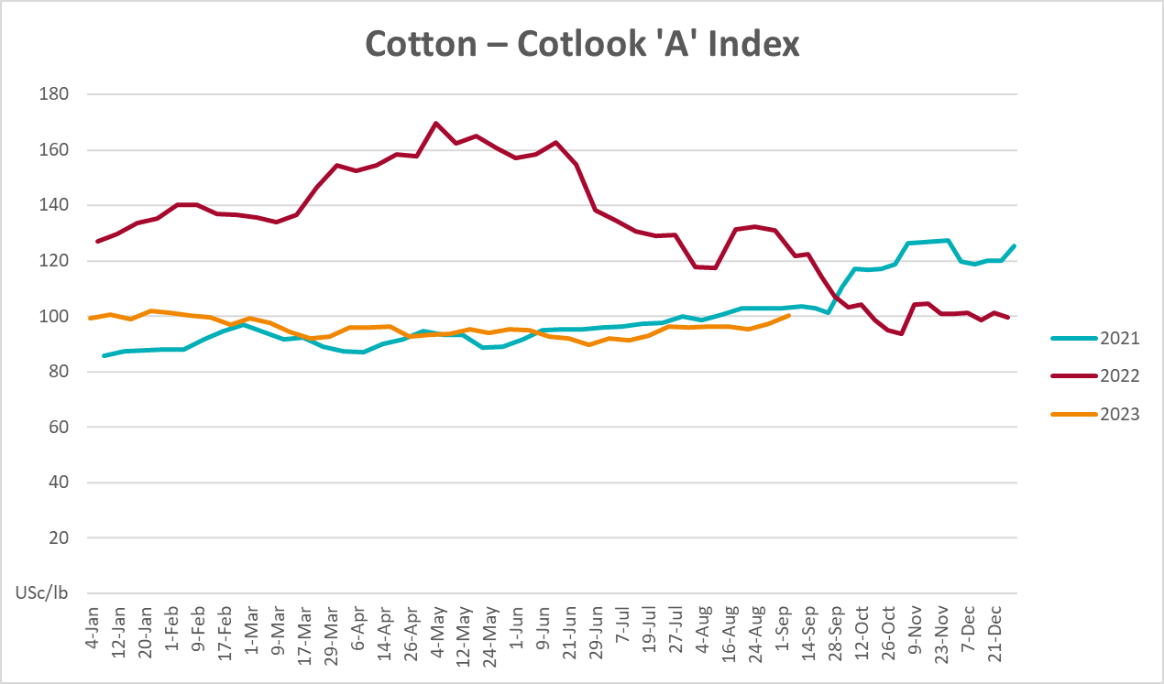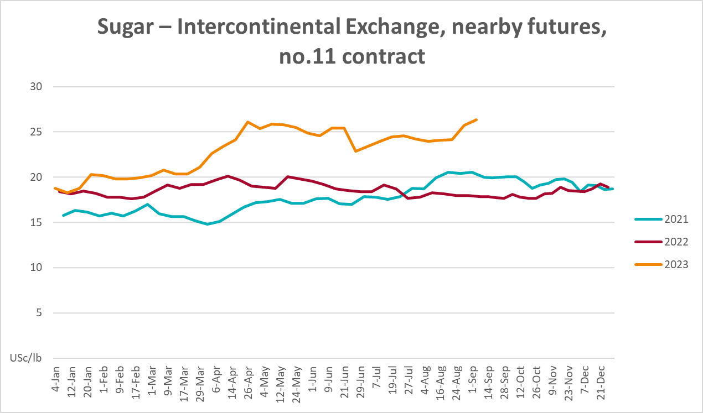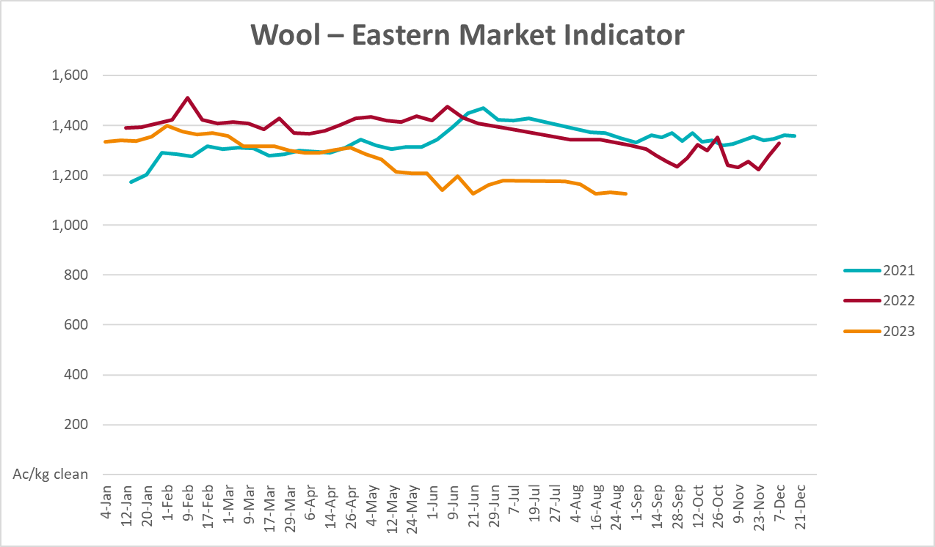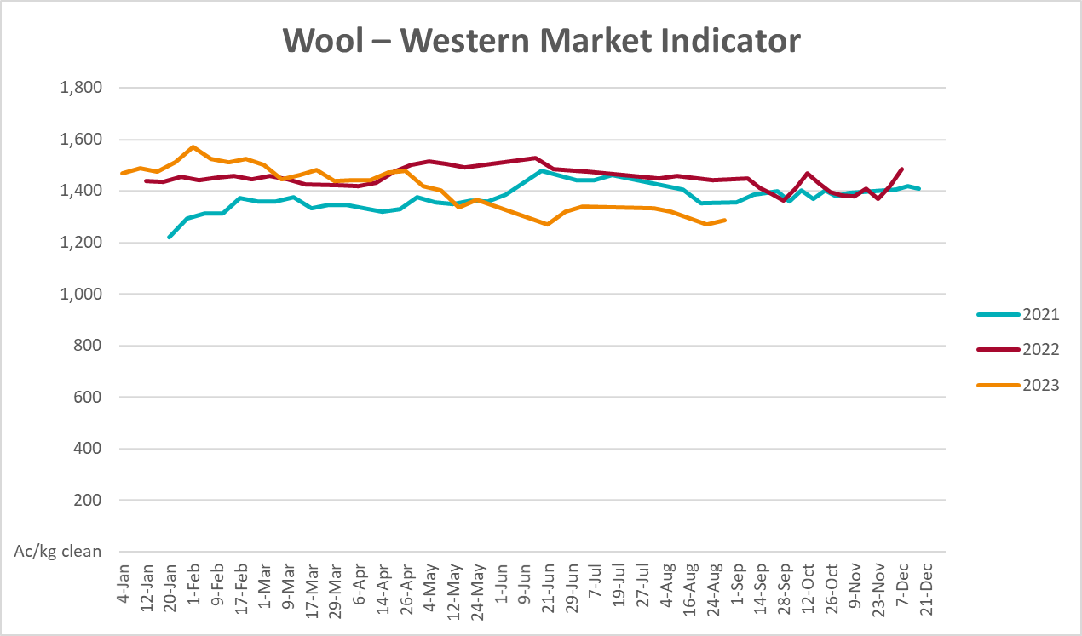

Selected domestic crop indicator prices
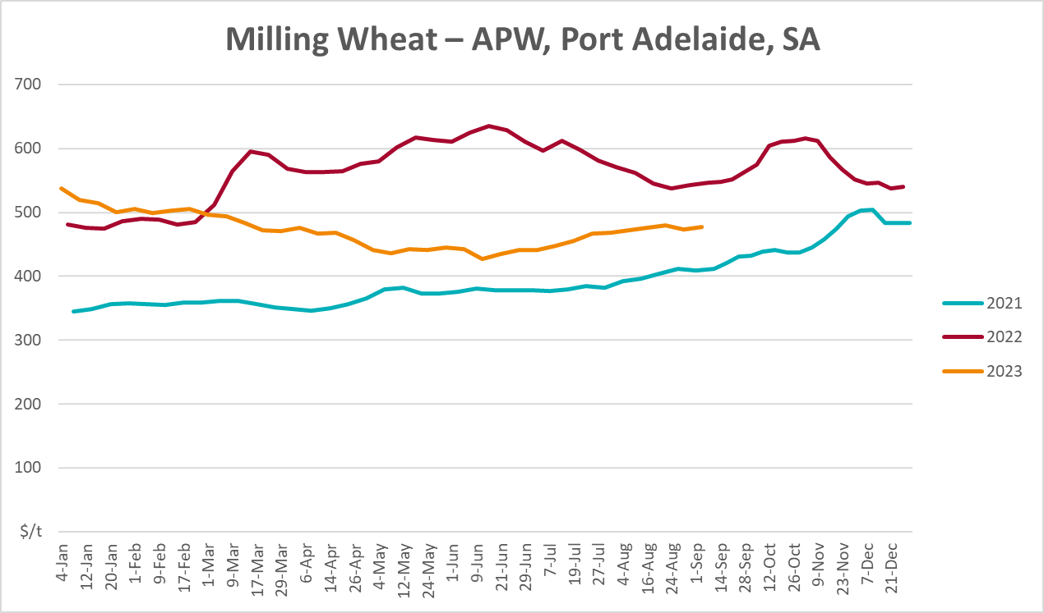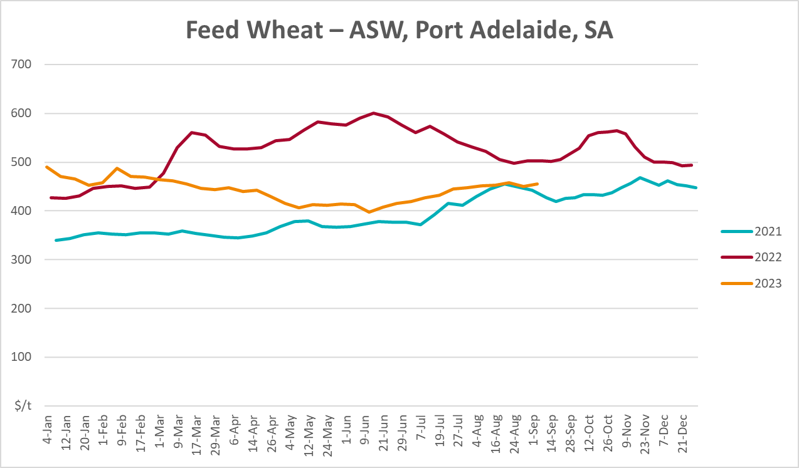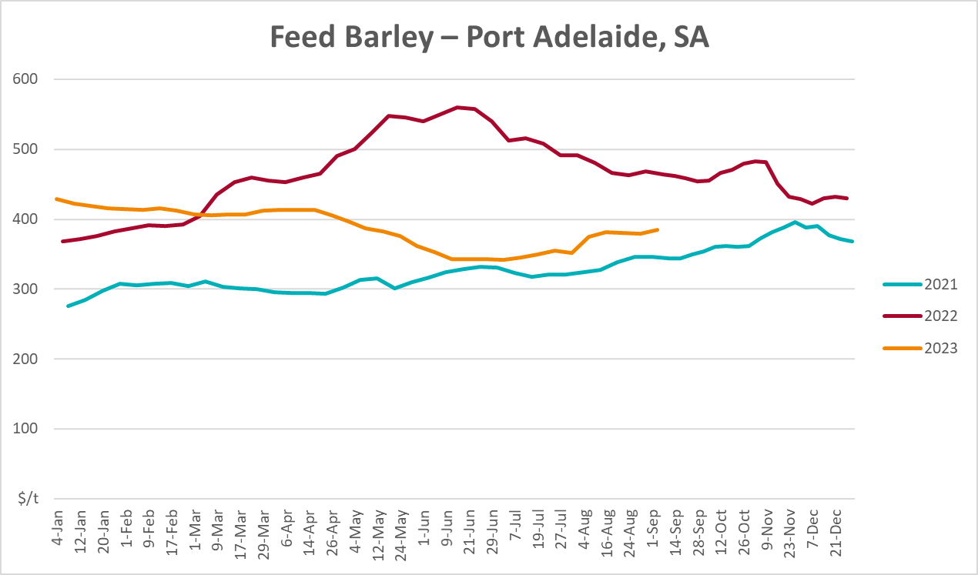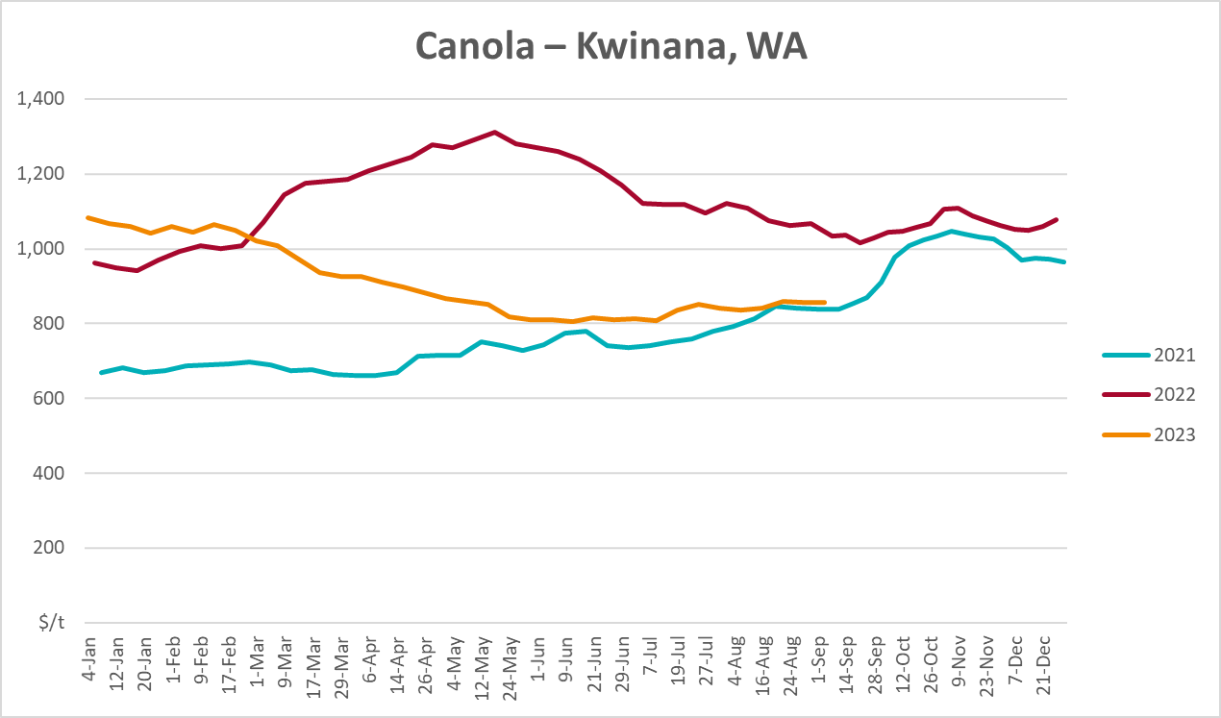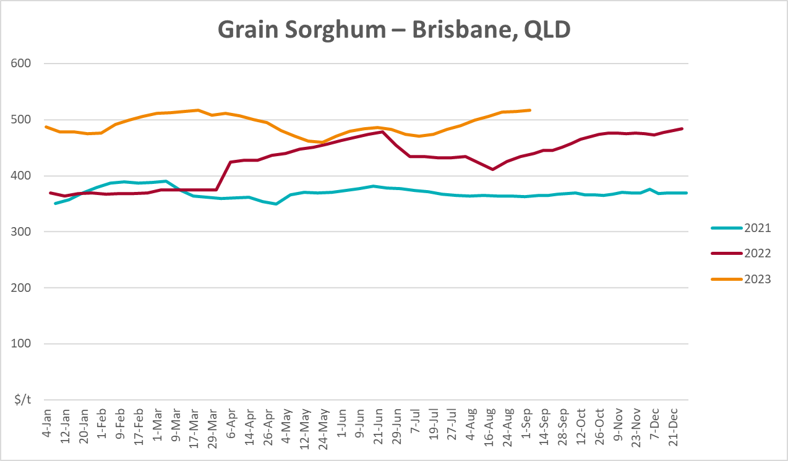

Selected domestic livestock indicator prices
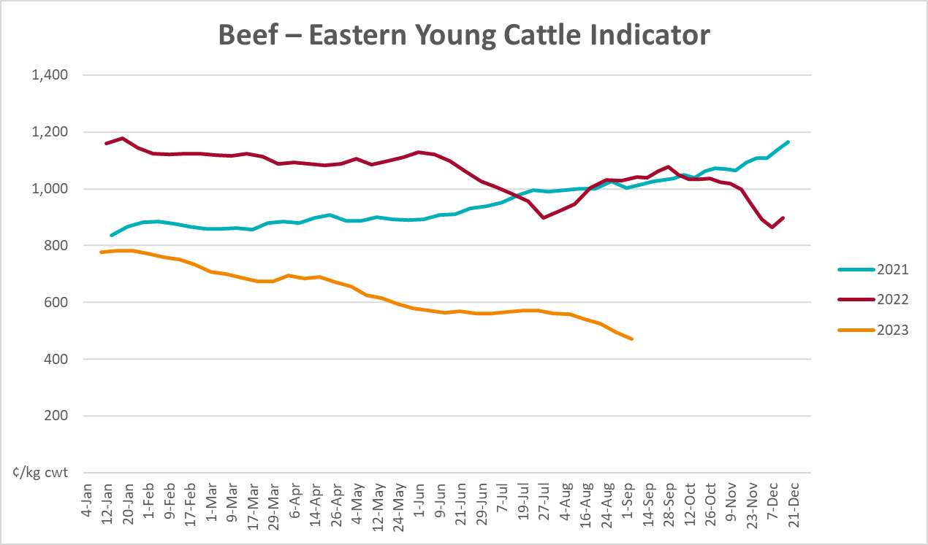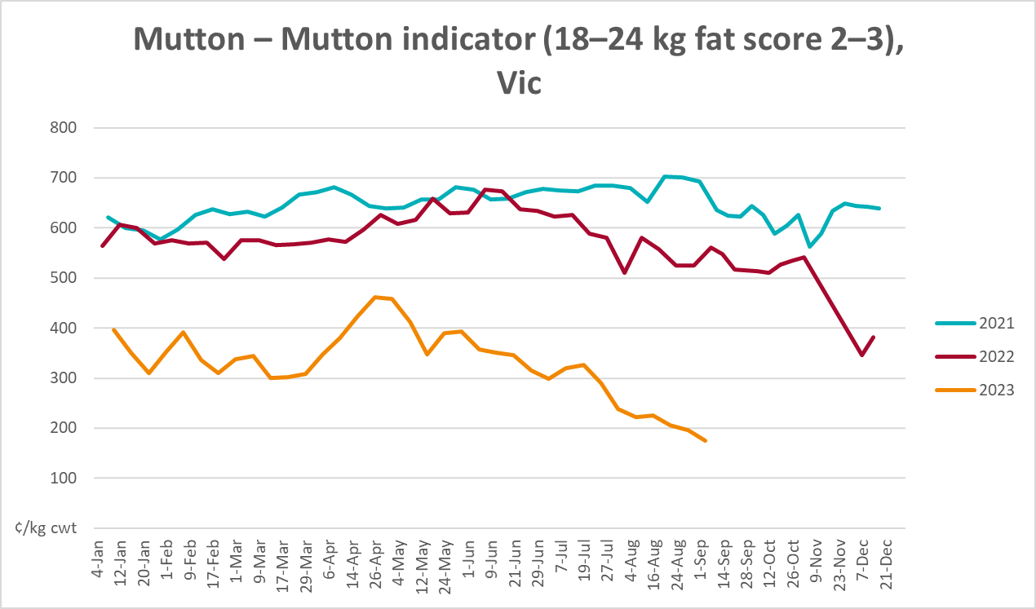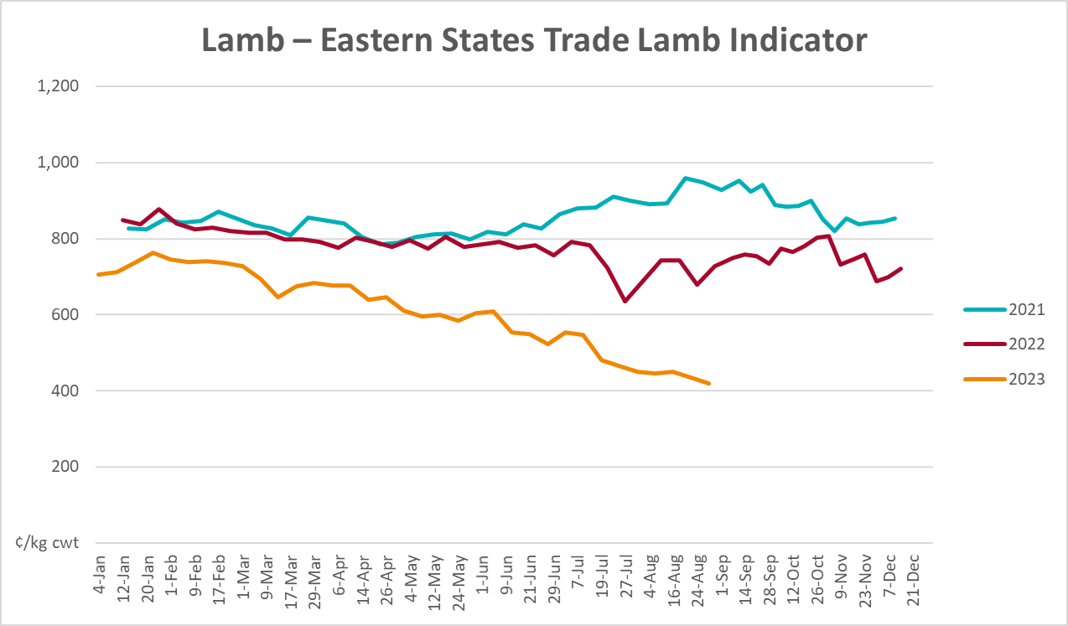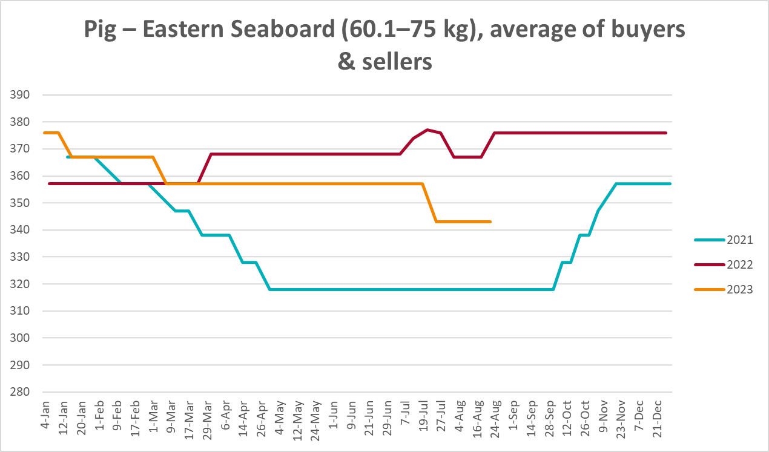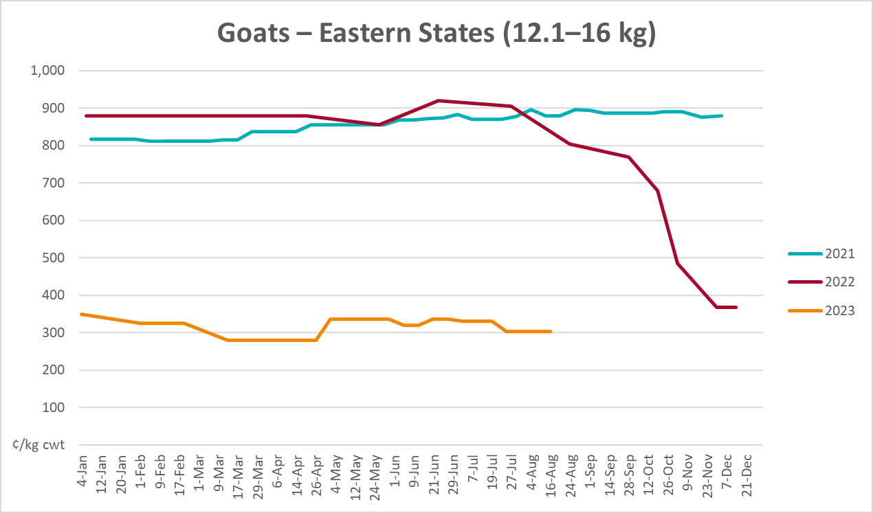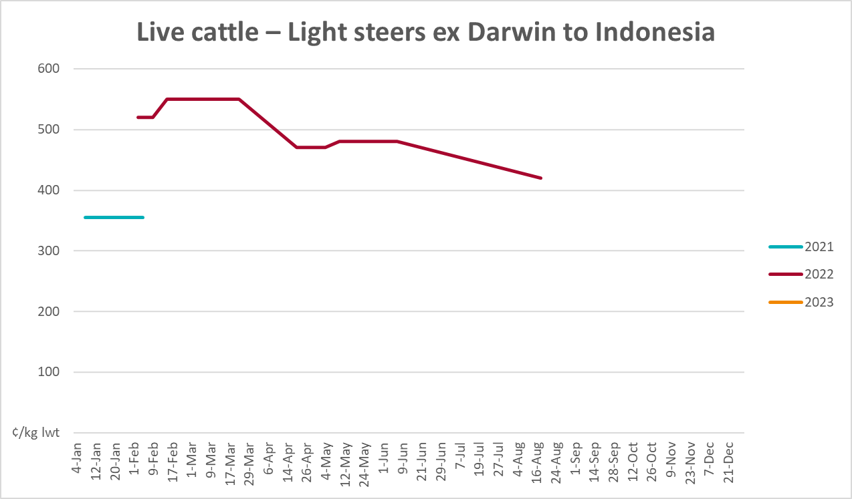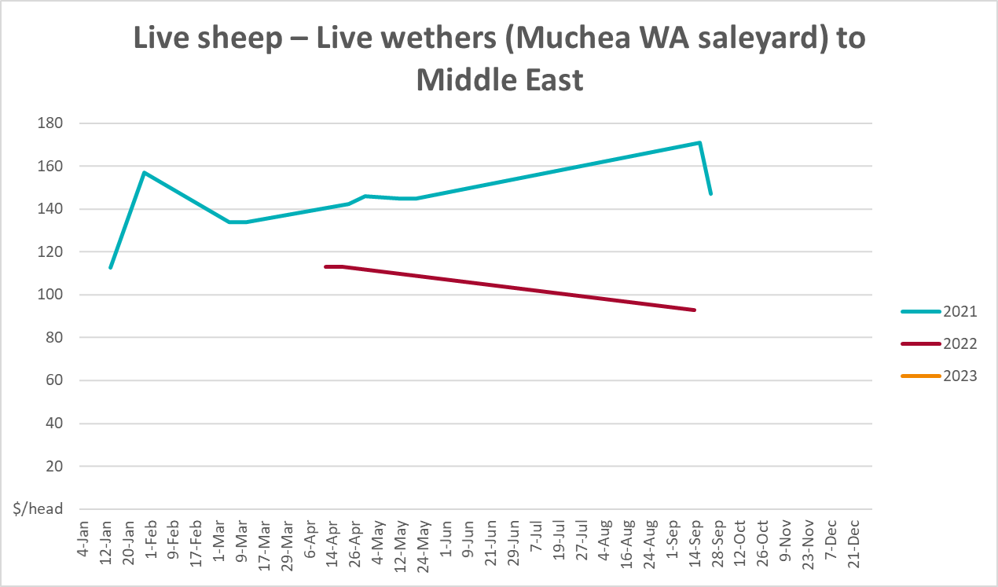

Global Dairy Trade (GDT) weighted average prices
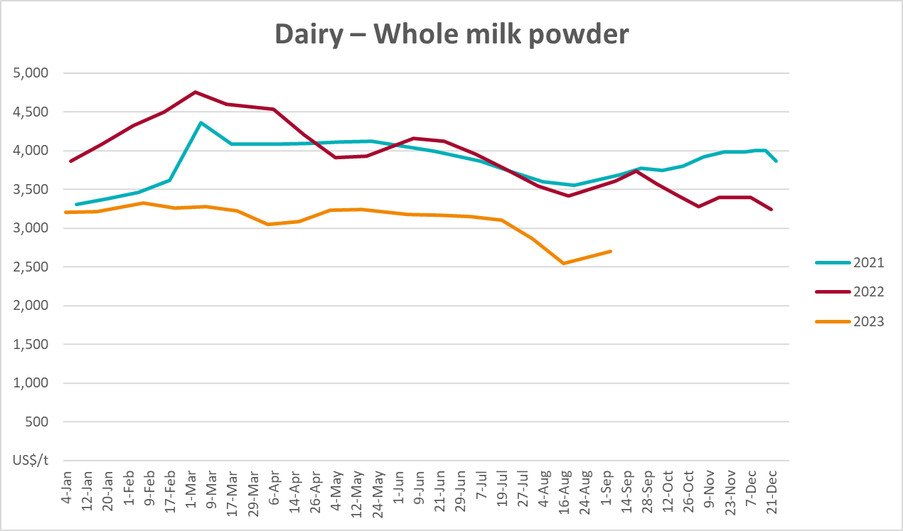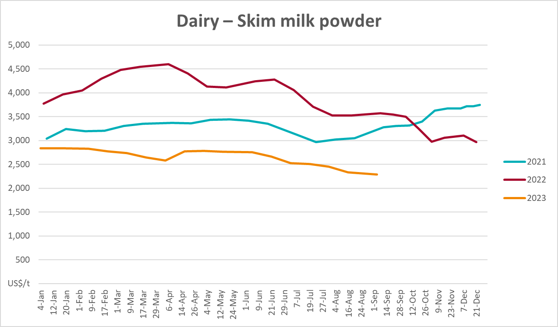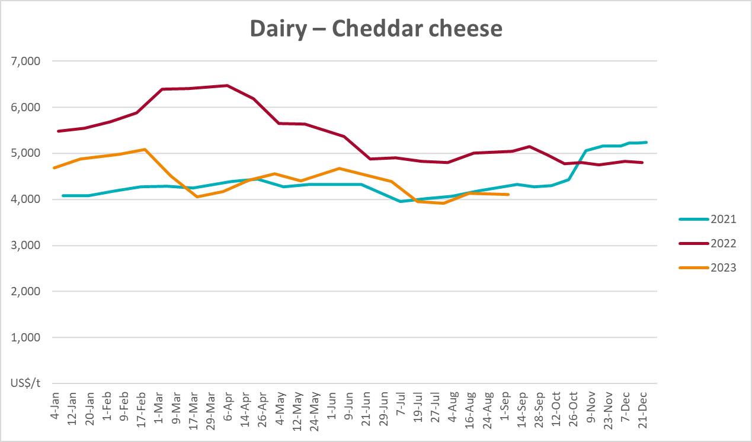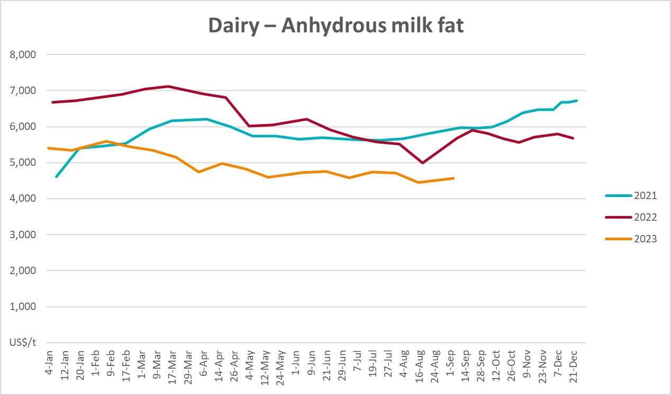

Selected fruit and vegetable prices
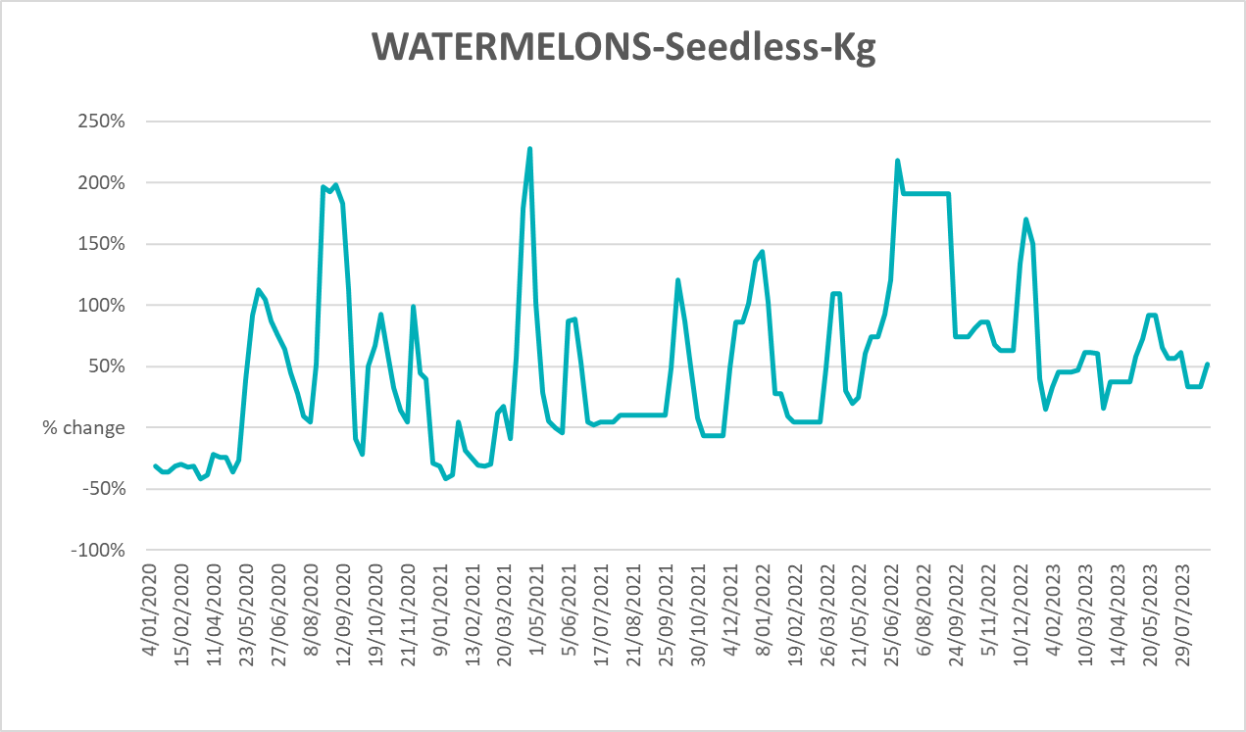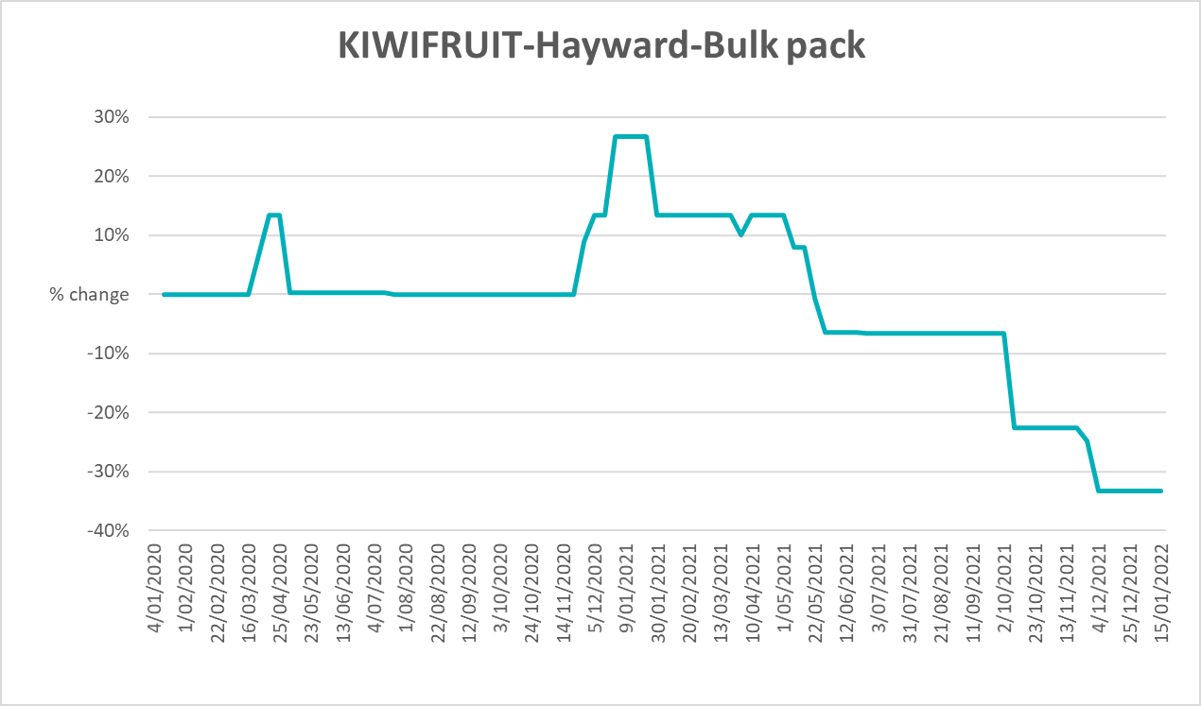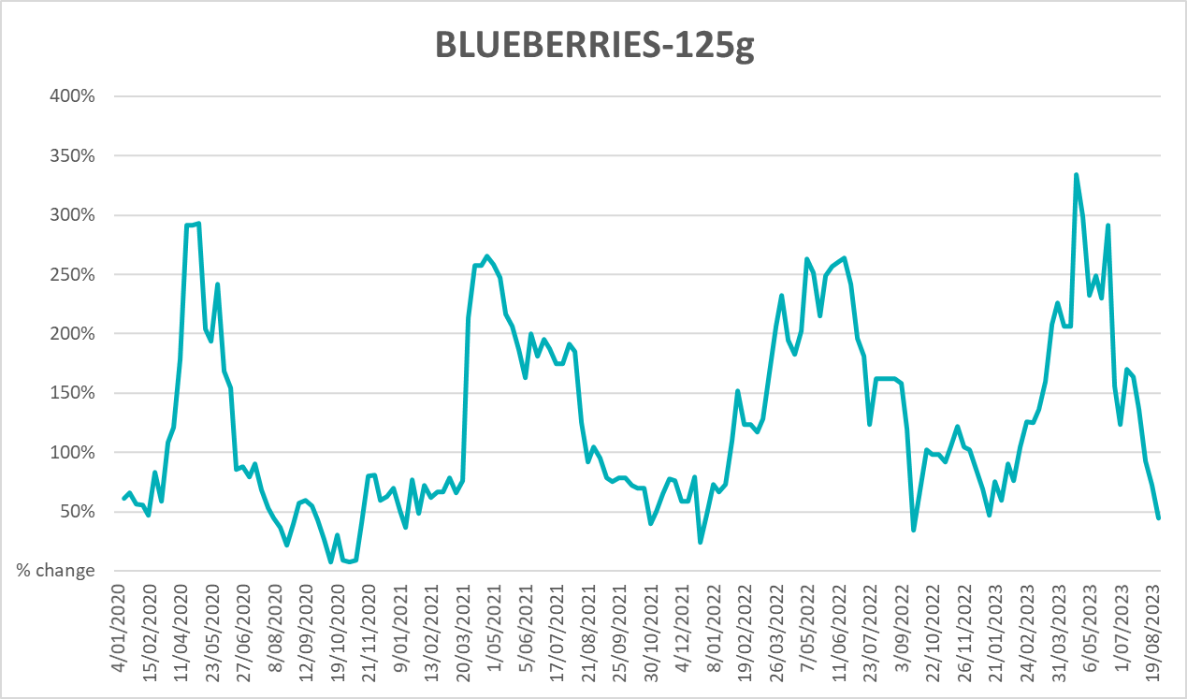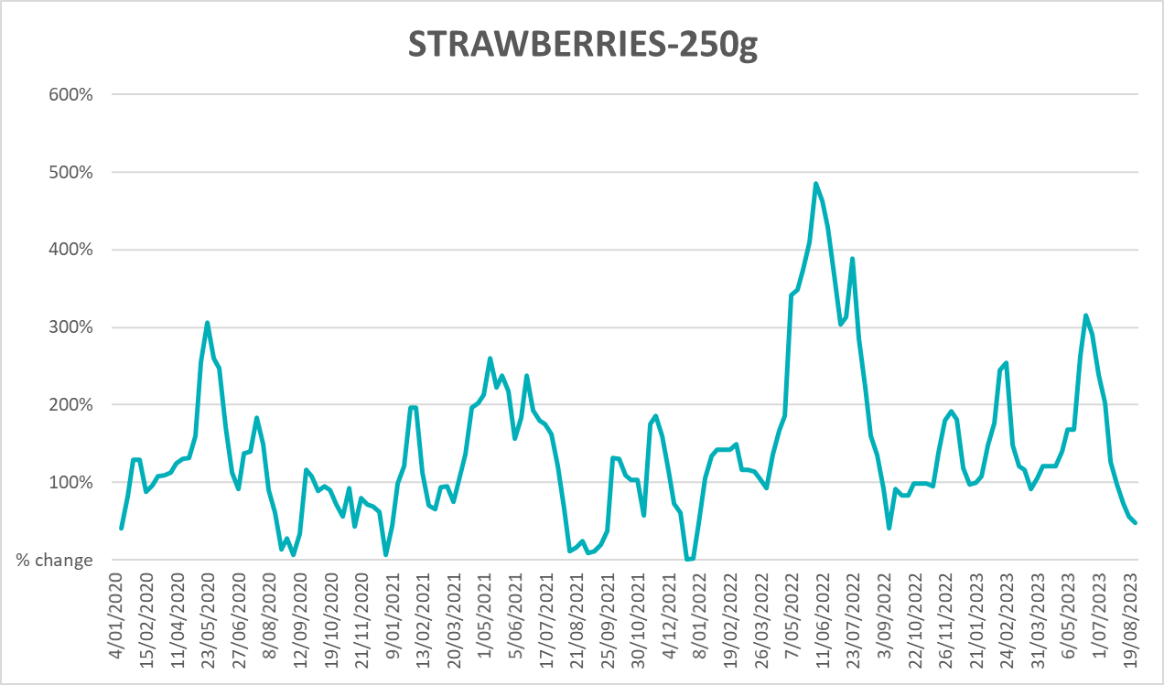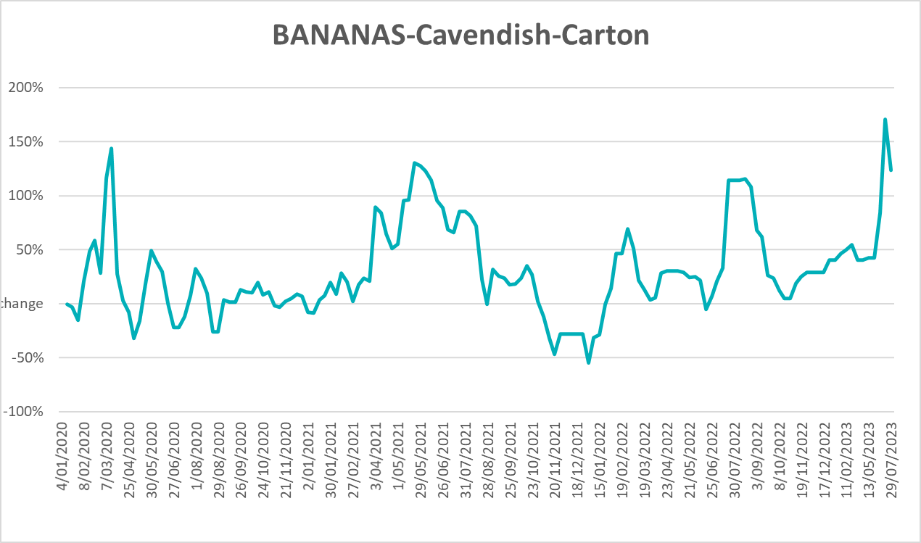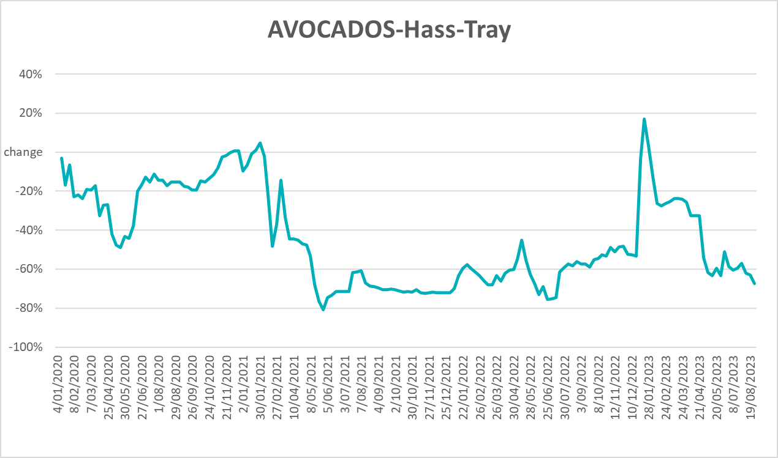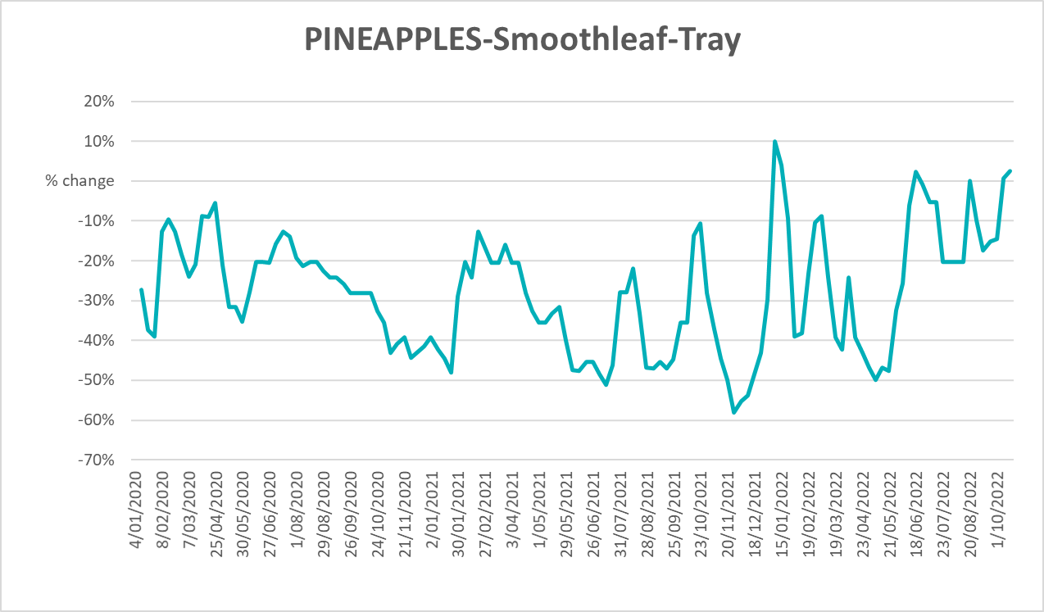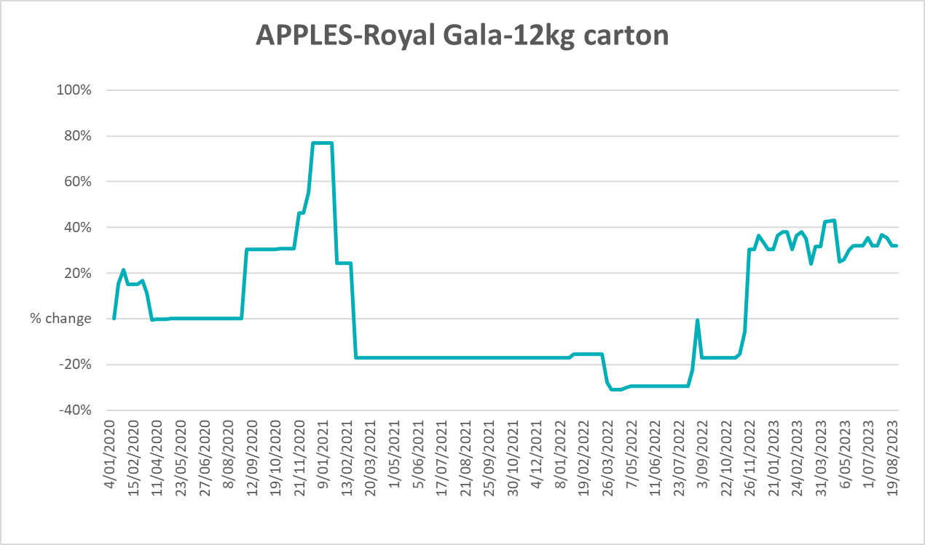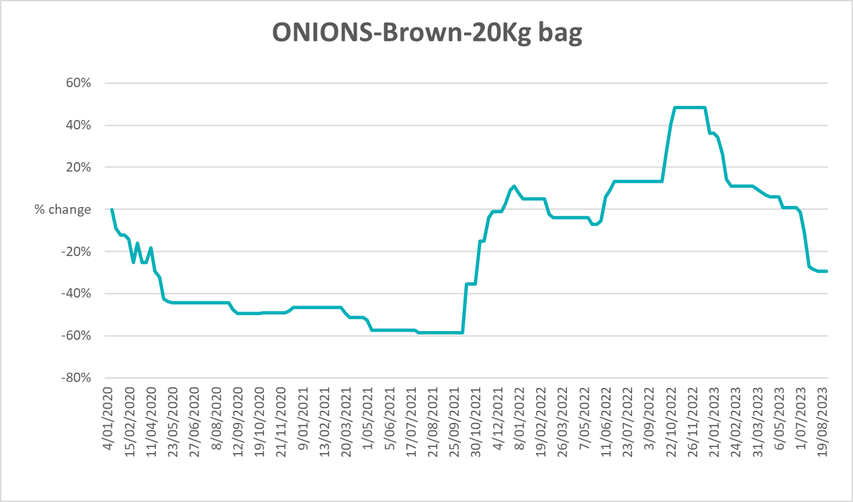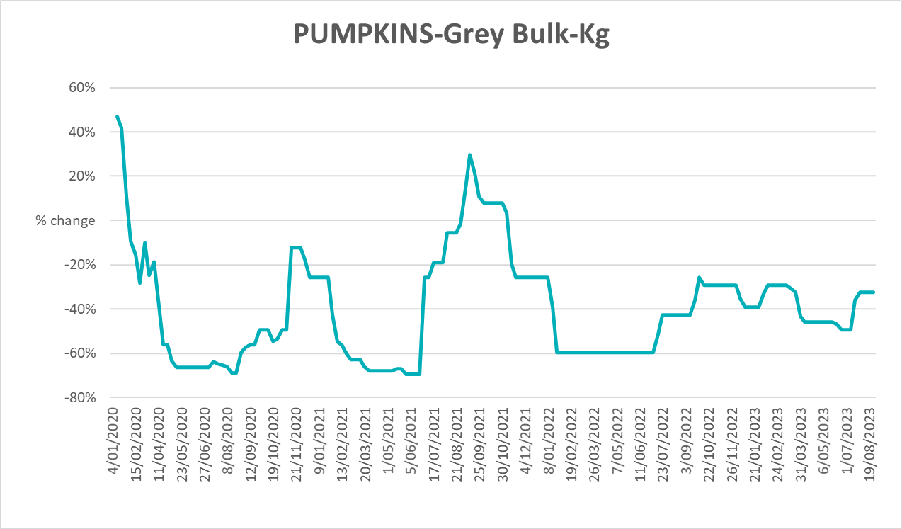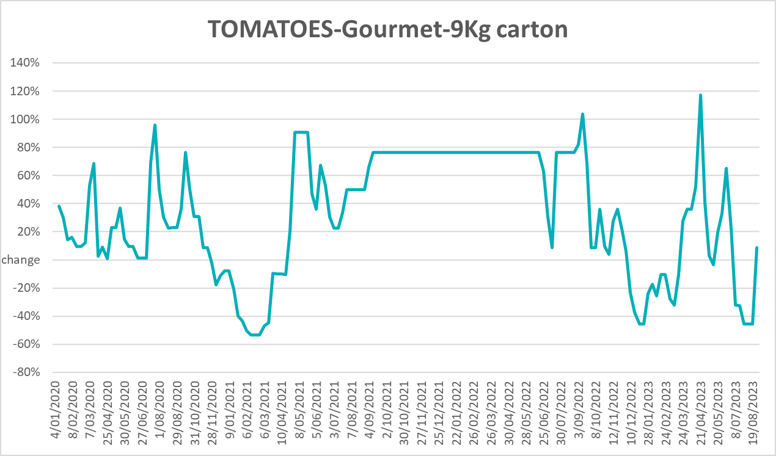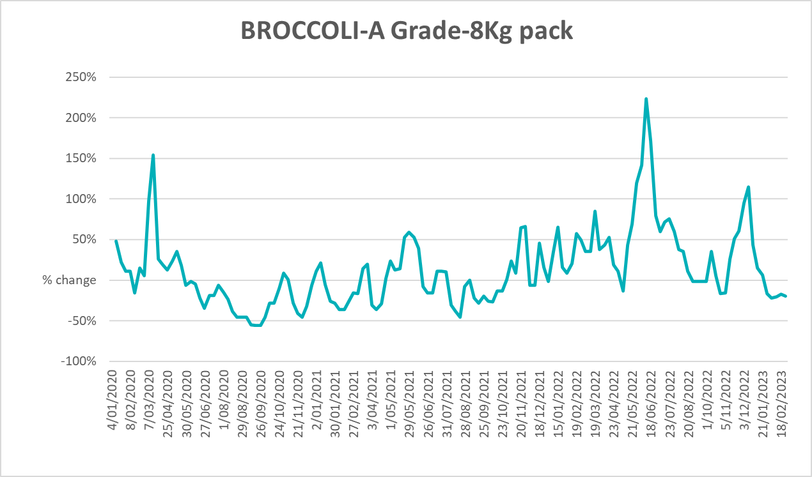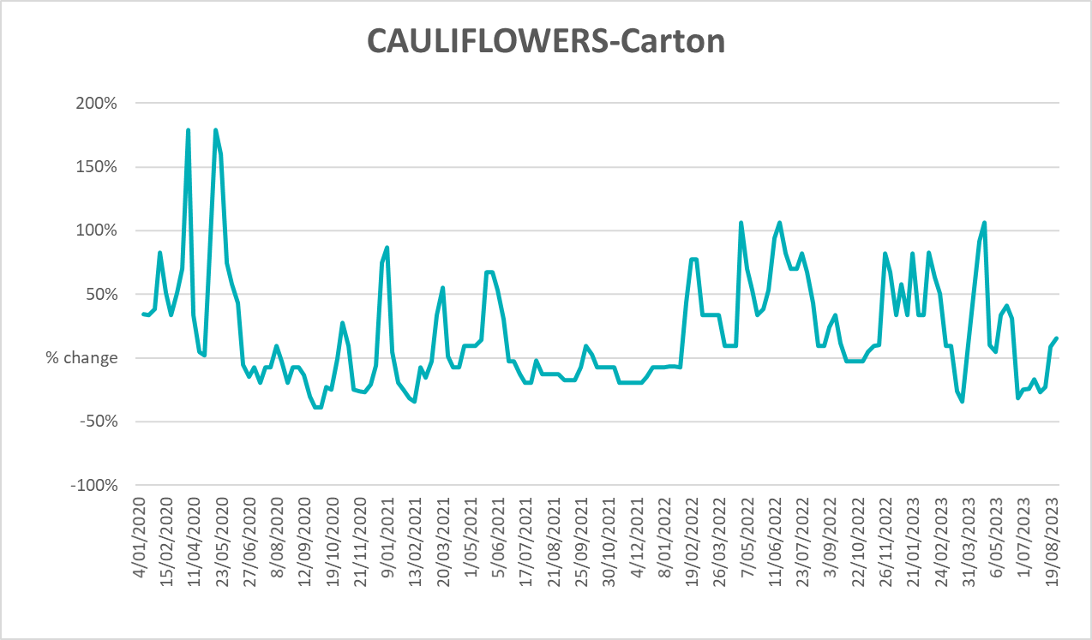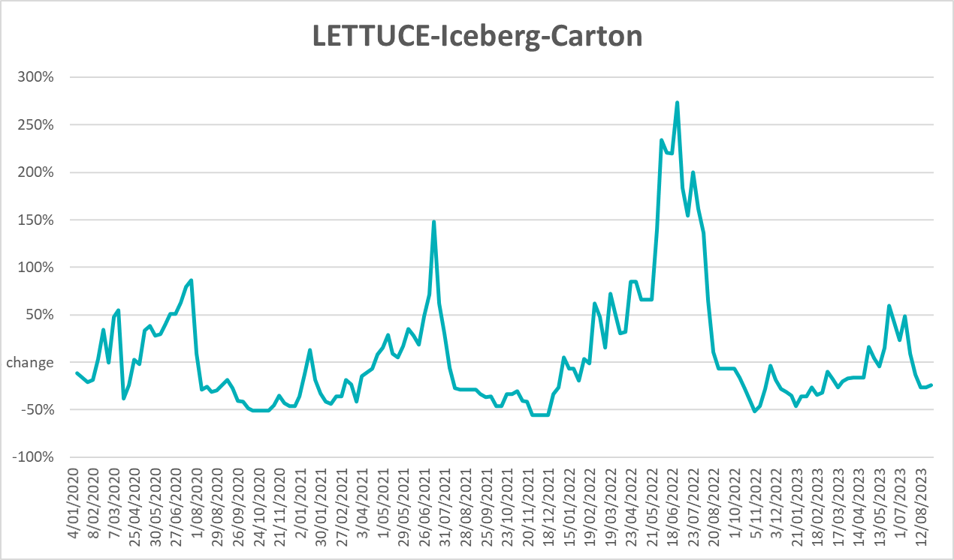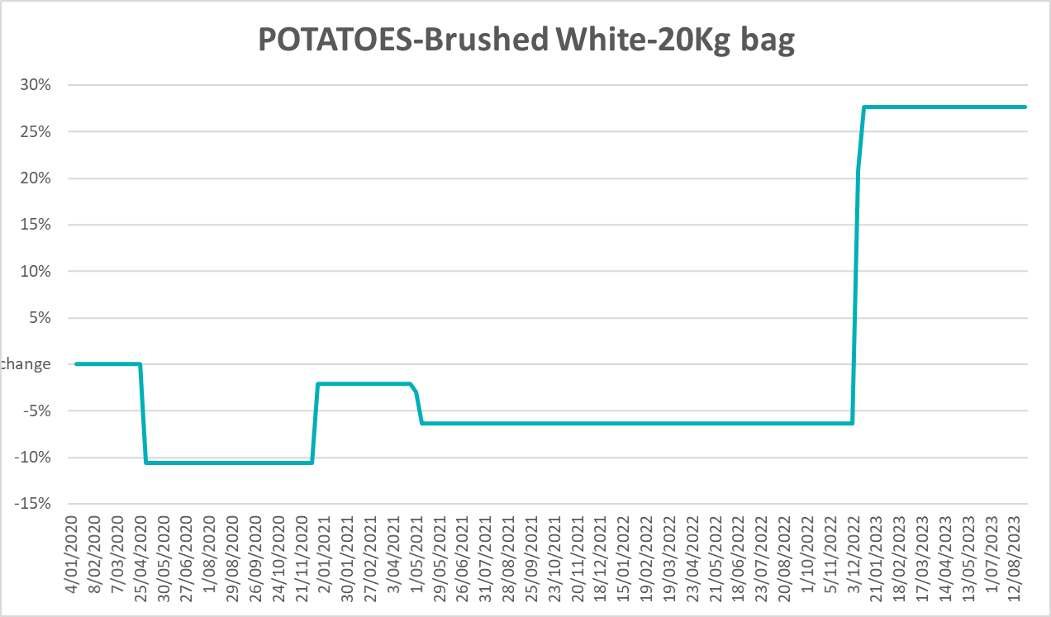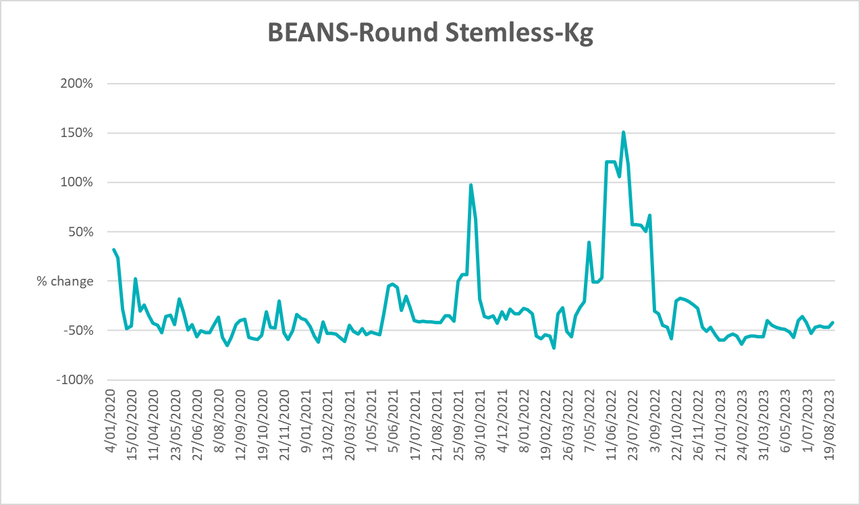

3.6 Selected domestic fodder indicator prices

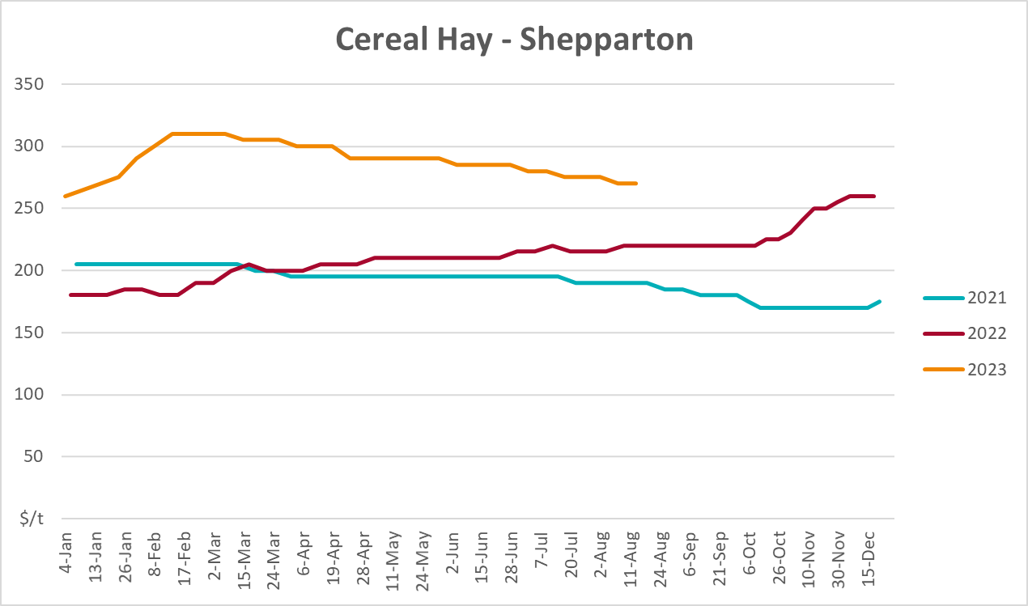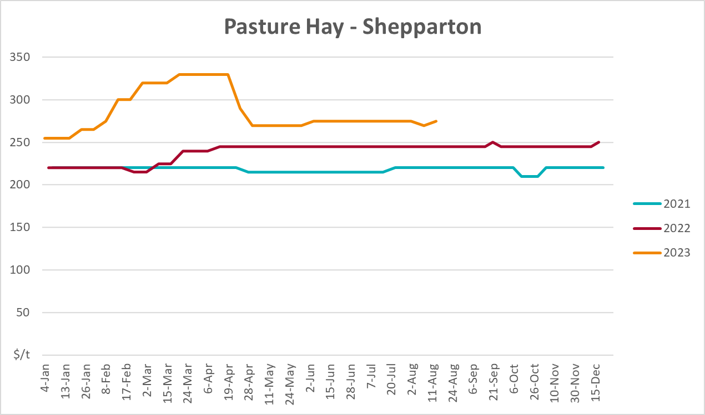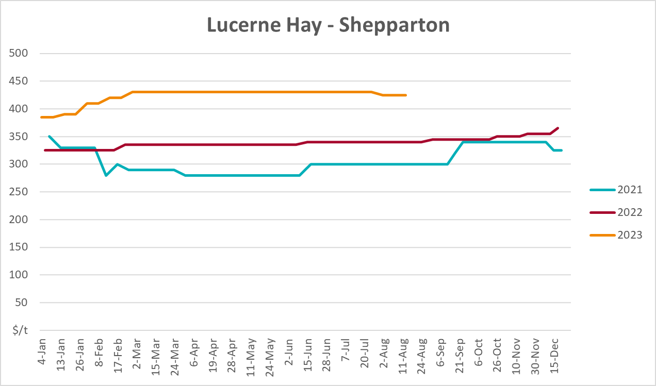

4. Data attribution

Climate
Bureau of Meteorology
- Weekly rainfall totals: www.bom.gov.au/climate/maps/rainfall/
- Monthly and last 3-month rainfall percentiles: www.bom.gov.au/water/landscape/
- Temperature anomalies: www.bom.gov.au/jsp/awap/temp/index.jsp
- Rainfall forecast: www.bom.gov.au/jsp/watl/rainfall/pme.jsp
- Seasonal outlook: www.bom.gov.au/climate/outlooks/#/overview/summary/
- Climate drivers: http://www.bom.gov.au/climate/enso/
- Soil moisture: www.bom.gov.au/water/landscape/
Other
- Pasture growth: www.longpaddock.qld.gov.au/aussiegrass/
- 3-month global outlooks: Environment and Climate Change Canada, NOAA Climate Prediction Center, EUROBRISA CPTEC/INPE, European Centre for Medium-Range Weather Forecasts, Hydrometcenter of Russia, National Climate Center Climate System Diagnosis and Prediction Room (NCC), International Research Institute for Climate and Society
- Global production: https://ipad.fas.usda.gov/ogamaps/cropmapsandcalendars.aspx
- Autumn break: Pook et al., 2009, https://rmets-onlinelibrary-wiley-com.virtual.anu.edu.au/doi/epdf/10.1002/joc.1833

Water
Prices
- Waterflow: https://www.waterflow.io/
- Ruralco: https://www.ruralcowater.com.au/
Bureau of Meteorology:
- Allocation trade: http://www.bom.gov.au/water/dashboards/#/water-markets/mdb/at
- Storage volumes: http://www.bom.gov.au/water/dashboards/#/water-storages/summary/drainage
Trade constraints:
- Water NSW: https://www.waternsw.com.au/customer-service/ordering-trading-and-pricing/trading/murrumbidgee
- Victorian Water Register: https://www.waterregister.vic.gov.au/TradingRules2019/

Commodities
Fruit and vegetables
- Datafresh: www.freshstate.com.au
Pigs
- Australian Pork Limited: www.australianpork.com.au
Dairy
- Global Dairy Trade: www.globaldairytrade.info/en/product-results/
World wheat, canola
- International Grains Council
World coarse grains
- United States Department of Agriculture
World cotton
- Cotlook: www.cotlook.com/
World sugar
- New York Stock Exchange - Intercontinental Exchange
Wool
- Australian Wool Exchange: www.awex.com.au/
Domestic wheat, barley, sorghum, canola and fodder
- Jumbuk Consulting Pty Ltd: http://www.jumbukag.com.au/
Cattle, beef, mutton, lamb, goat and live export
- Meat and Livestock Australia: www.mla.com.au/Prices-and-market
© Commonwealth of Australia 2023

Ownership of intellectual property rights
Unless otherwise noted, copyright (and any other intellectual property rights, if any) in this publication is owned by the Commonwealth of Australia (referred to as the Commonwealth).

Creative Commons licence
All material in this publication is licensed under a Creative Commons Attribution 4.0 International Licence except content supplied by third parties, logos and the Commonwealth Coat of Arms.
Inquiries about the licence and any use of this document should be emailed to copyright@awe.gov.au.


Cataloguing data
This publication (and any material sourced from it) should be attributed as:
ABARES 2023, Weekly Australian Climate, Water and Agricultural Update, Australian Bureau of Agricultural and Resource Economics and Sciences, Canberra, 7 September 2023. CC BY 4.0 DOI: https://doi.org/10.25814/5f3e04e7d2503
ISSN 2652-7561
This publication is available at https://www.agriculture.gov.au/abares/products/weekly_update
Department of Agriculture, Fisheries and Forestry
GPO Box 858 Canberra ACT 2601
Telephone 1800 900 090
Web agriculture.gov.au/abares

Disclaimer
The Australian Government acting through the Department of Agriculture, Fisheries and Forestry, represented by the Australian Bureau of Agricultural and Resource Economics and Sciences, has exercised due care and skill in preparing and compiling the information and data in this publication. Notwithstanding, the Department of Agriculture, Fisheries and Forestry, ABARES, its employees and advisers disclaim all liability, including liability for negligence and for any loss, damage, injury, expense or cost incurred by any person as a result of accessing, using or relying on any of the information or data in this publication to the maximum extent permitted by law.

Statement of Professional Independence
The views and analysis presented in ABARES publications, including this one, reflect ABARES professionally independent findings, based on scientific and economic concepts, principles, information and data. These views, analysis and findings may not reflect or be consistent with the views or positions of the Australian Government, or of organisations or groups who have commissioned ABARES reports or analysis. More information on professional independence is provided on the ABARES website.

Acknowledgements
This report was prepared by Kavina Dayal and Matthew Miller.

