
No. 32/2023 17 August 2023

Summary of key issues
- For the week ending 16 August 2023, frontal systems and a trough brought showers to southern parts of Australia. Up to 50 millimetres of rainfall was recorded in parts of Western Australia, eastern New South Wales and in western Tasmania. A high-pressure system kept the remainder of the country dry and clear.
- Across cropping regions, rainfall totals of up to 25 millimetres were recorded in central New South Wales and southern and central parts of Western Australia. Little to no rainfall was recorded in the remaining cropping regions and these regions will require sufficient and timely rain in the coming weeks and months to maintain current levels of winter crop production, following a gradual decline in soil moisture reserves (see Section 1.1).
- Highly variable rainfall globally during July has led to mixed production prospects for wheat, maize, soybeans and rice. Below average rainfall and above average temperatures in recent months have also negatively affected corn production across parts of Argentina, Brazil, the European Union and the United States. Global production conditions have deteriorated compared to those used to formulate ABARES forecasts of global grain supplies and world prices in its June 2023 edition of the Agricultural Commodities Report. As a result, global grain and oilseed production is likely to be lower than that forecast in June (see Section 1.2).
- Over the 8-days to 24 August 2023, fronts and troughs are expected to bring showers to south-eastern parts of the country. A high-pressure system is expected to bring mainly dry conditions to the remainder of the country (see Section 1.3).
- Across cropping regions, rainfall totals of up to 25 millimetres are expected central South Australia and southern and eastern margins of Victoria and New South Wales, while falls of up to 15 millimetres are expected in parts of South Australia, much of Victoria and southeastern New South Wales. Little to no rainfall is expected in northern New South Wales, Queensland and Western Australia. Following a dry August so far in Queensland and northern New South Wales and given the current well below average levels of soil moisture, crops and pasture is these areas will be prone to heat and moisture stress, negatively affecting production prospects (see Section 1.3).
- Water storage levels in the Murray-Darling Basin (MDB) increased between 10 August 2023 and 17 August 2023 by 94 gigalitres (GL). Current volume of water held in storage is 20 899 GL. This is 3 percent or 575 GL less than at the same time last year.
- Allocation prices in the Victorian Murray below the Barmah Choke increased from $148 on 10 August 2023 to $152 on 17 August 2023. Prices are lower in the Goulburn-Broken and regions above the Barmah choke due to the binding of the Goulburn intervalley trade limit and Barmah choke trade constraint.

Climate

Rainfall this week
For the week ending 16 August 2023, frontal systems and a trough brought showers to southern parts of Australia. Up to 50 millimetres of rainfall was recorded in parts of Western Australia, eastern New South Wales and in western Tasmania. A high-pressure system kept the remainder of the country dry and clear.
Across cropping regions, rainfall totals of up to 25 millimetres were recorded in central New South Wales and southern and central parts of Western Australia. Little to no rainfall was recorded in the remaining cropping regions and these regions will require sufficient and timely rain in the coming weeks and months to maintain current levels of winter crop production, following a gradual decline in soil moisture reserves.

Rainfall for the week ending 16 August 2023
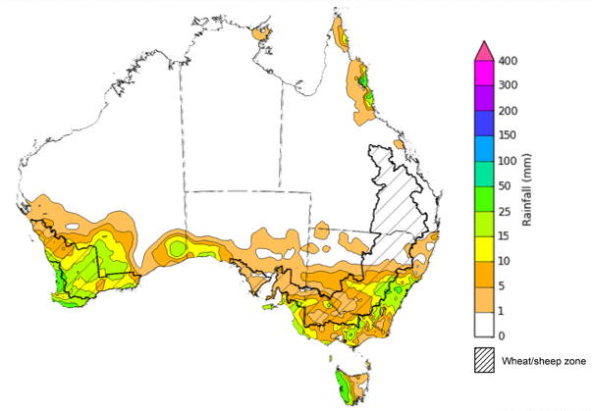
©Commonwealth of Australia 2023, Australian Bureau of Meteorology Issued: 16/8/2023
Note: The rainfall analyses and associated maps utilise data contained in the Bureau of Meteorology climate database, the Australian Data Archive for Meteorology (ADAM). The analyses are initially produced automatically from real-time data with limited quality control. They are intended to provide a general overview of rainfall across Australia as quickly as possible after the observations are received. For further information go to http://www.bom.gov.au/climate/rainfall/

Global production conditions and climate outlook
Crop production is affected by long-term trends in average rainfall and temperature, interannual climate variability, shocks during specific growth stages, and extreme weather events. Some crops are more tolerant than others to certain types of stresses, and at each growth stage, different types of stresses affect each crop species in different ways.
The precipitation anomalies and outlooks presented here give an indication of the current and future state of production conditions for the major grain and oilseed producing countries which are responsible for over 80% of global production. This is an important input to assessing the global grain supply outlook.
July precipitation percentiles and current production conditions
As of the end of July 2023, precipitation was highly variable for the world’s major grain-producing and oilseed-producing regions.
In the northern hemisphere, precipitation was generally average across Canada, except for some southern production regions where it was below average. In the United States, precipitation was highly variable, ranging from above average in the northeast to well below average in the west and north. Precipitation was average to above average in UK, Europe, India, China and the Russian Federation and parts of Kazakhstan. July precipitation was generally average across the remainder of the major grain-producing and oilseed-producing regions in the northern hemisphere.
In the southern hemisphere, July precipitation was generally average in South America, with western parts of Argentina being the main exception, where it was below average. In Australia, July precipitation was well below average across western and southern cropping regions while it was average for Queensland and New South Wales. Precipitation was generally average to above average across the remainder of major grain-producing and oilseed-producing regions in the southern hemisphere.

Global precipitation percentiles, July 2023
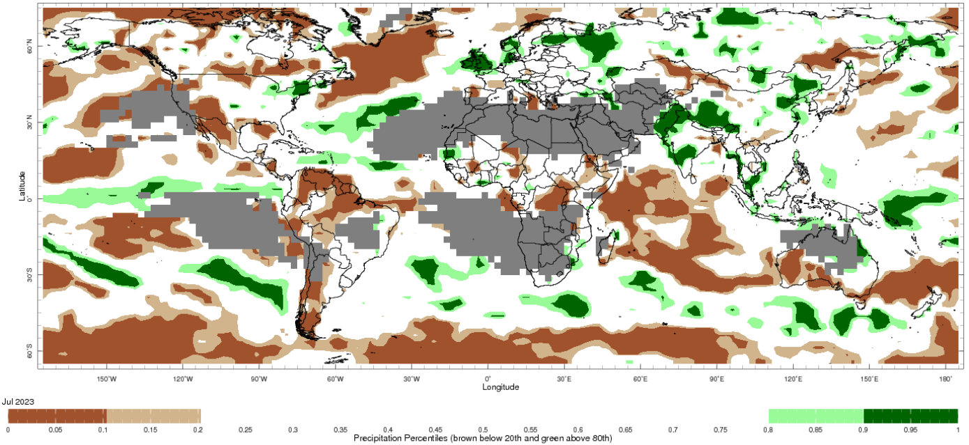
Note: The world precipitation percentiles indicate a ranking of precipitation for July, with the driest (0th percentile) being 0 on the scale and the wettest (100th percentile) being 1 on the scale. Percentiles are based on precipitation estimates from the NOAA Climate Prediction Center's Climate Anomaly Monitoring System Outgoing Precipitation Index dataset. Precipitation estimates for July 2023 are compared with rainfall recorded for that period during the 1981 to 2010 base period.
Source: International Research Institute for Climate and Society
As of 28 July 2023, global production conditions were variable for wheat, maize, soybeans and rice.
In the northern hemisphere, harvesting of winter wheat and the development of spring wheat is continuing under mixed conditions in Canada, the US, the Russian Federation and in Ukraine away from the war zone. In China, the EU, the UK and Türkiye conditions are generally favourable, except for Spain where harvesting continues with poor yields. In the southern hemisphere, July rains have improved conditions in some cropping areas in Australia and South America.
For maize, production conditions were generally mixed in the US, Mexico, northern China and central Ukraine due to dryness, but July rains and lower temperatures have improved conditions in parts of the eastern and far western Corn Belt in the US. In the EU, conditions are generally favourable as the dryness in Spain is balanced out by higher yield expectations in central and eastern Europe. In Brazil, the harvest for the summer-planted crop is underway with record yields in central west regions. In Argentina, harvest is underway for the summer-planted crop under poor conditions due to dryness throughout the season.
Conditions are mixed for rice production in India and Thailand due to late arrival of monsoonal rain. In China, harvesting of early-season crop is wrapping up and sowing of late-season crop is continuing under favourable conditions. Similarly, the sowing of dry- and harvesting of wet-season rice is wrapping up in Indonesia under favourable conditions. In Vietnam, harvesting of dry-season rice is wrapping up and sowing of wet-season rice in the south is beginning under favourable conditions. In the US, conditions are favourable with an increase in sown area compared to last year.
For soybeans, harvest of both early- and late planted crops wrapped up in Argentina with poor yields due to dry conditions throughout the growing season. In the US, an extremely dry spring and June has reduced yield prospects across much of main growing areas, but July rains have improved conditions in the eastern Corn Belt. In China, conditions have improved from July rains. In India, sowing of majority of crops have been completed after initial delays.
Crop conditions, AMIS countries, 28 July 2023
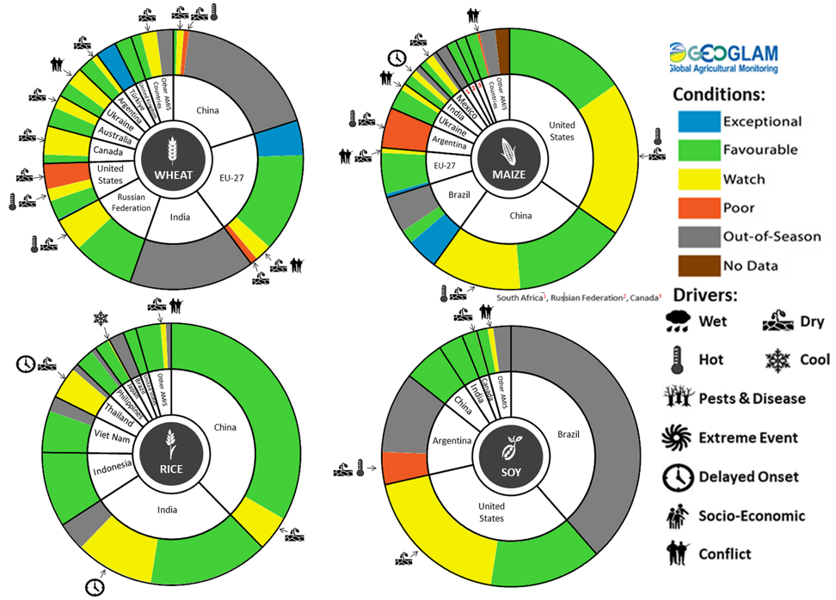
AMIS Agricultural Market Information System. Source: AMIS
The global climate outlook for September 2023 to November 2023 indicates that variable rainfall conditions are expected for the world's major grain-producing and oilseed-producing regions. Outlooks and potential production impacts for the major grain and oilseed producing countries are presented in the table.
Rainfall outlook and potential impact on the future state of production conditions between September 2023 to November 2023
Region | August - October rainfall outlook | Potential impact on production
Argentina | Average to above average rainfall is likely except for the northern parts where below average rainfall is likely. | Above average rainfall is likely to benefit the heading and filling of wheat and the planting of corn, cotton and soybeans. These conditions may also be benefiting early corn silking, and the planting of soybeans, sunflower, rice, sorghum and millet in November. However, below average rainfall across parts of northern Argentina is likely adversely corn and soybean planting and development through the September to November period..
Black Sea Region | Average rainfall is more likely in Ukraine, Kazakhstan and the Russian Federation. | Average rainfall is likely to support spring wheat harvesting in the north-east of Russia and early cotton harvesting in southern regions. Average rainfall across Kazakhstan and Ukraine is likely to support winter wheat and rapeseed planting in September, and corn and sunflower filling in September and October.
Brazil | Extremely below average rainfall is likely across much of Brazil except for the far south where above average rainfall is likely. | Below average rainfall across much of Brazil is likely adversely corn and soybean planting and development in October and November. Above average rainfall in parts of southern Brazil is likely to benefit wheat filling leading up to harvest in October, as well as corn and soybean planting and development in September and October.
Canada | Average rainfall is more likely for much of Canada, especially across major production regions. | Average rainfall is unlikely to be sufficient to increase the yield potential of corn, soybeans and sunflower at the grain filling and maturing stage through September and October.
China | Average to above average rainfall is more likely across China. | Average rainfall is likely to benefit the development and harvest of cotton, corn, sorghum, soybean, sunflower, groundnuts and spring wheat across north-eastern, southern and western China. In central China, above average rainfall is likely to support the planting of winter wheat and rapeseed in October.
Europe | Average to above average rainfall is more likely. | Average rainfall may benefit the development and harvest of corn, cotton and sorghum in western and central Europe. Average rainfall may also benefit winter wheat and rapeseed planting in parts of western and central Europe during October and November.
South Asia (India) | Average rainfall is more likely across India except for some parts in the central and southwest where below rainfall is likely. | Average rainfall is likely to benefit cotton blooming in the south during September. It will also assist corn, sorghum, rice, millet, groundnuts and sunflower filling in September leading up to harvest in October and November, and winter wheat and rapeseed planting in November.
Southeast Asia (SEA) | Generally average to below average rainfall is more likely. | Below average rainfall in SEA is likely to affect corn and rice maturing during September leading up to harvest in October.
The United States of America | Generally average to above average rainfall is more likely for the US. | Average rainfall is likely to adversely affect the filling and maturing of soybeans, sunflower, millet, cotton, rice, corn, sorghum and groundnuts in September leading up to harvest in October and November.

1.4. Rainfall forecast for the next eight days
Over the 8-days to 24 August 2023, fronts and troughs are expected to bring showers to south-eastern parts of the country. A high-pressure system is expected to bring mainly dry conditions to the remainder of the country.
Across cropping regions, rainfall totals of up to 25 millimetres are expected central South Australia and southern and eastern margins of Victoria and New South Wales, while falls of up to 15 millimetres are expected in parts of South Australia, much of Victoria and south-eastern New South Wales. Little to no rainfall is expected in northern New South Wales, Queensland and Western Australia.
Following a dry August so far in Queensland and northern New South Wales and given the current well below average levels of soil moisture, crops and pastures is these areas will be disposed to heat and moisture stress, negatively affect production potential.

Total forecast rainfall for the period 17 August 2023 to 24 August 2023
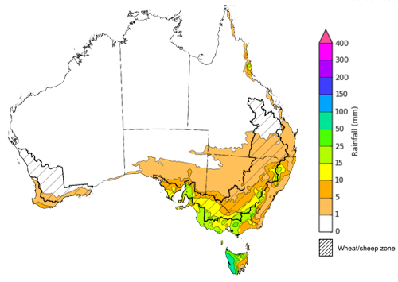

©Commonwealth of Australia 2023, Australian Bureau of Meteorology Issued 17/8/2023
Note: This rainfall forecast is produced from computer models. As the model outputs are not altered by weather forecasters, it is important to check local forecasts and warnings issued by the Bureau of Meteorology.

Water

Water markets – current week
Water storage levels in the Murray-Darling Basin (MDB) increased between 10 August 2023 and 17 August 2023 by 94 gigalitres (GL). Current volume of water held in storage is 20 899 GL. This is 3 percent or 575 GL less than at the same time last year.

Water storages in the Murray-Darling Basin, 2013–2023
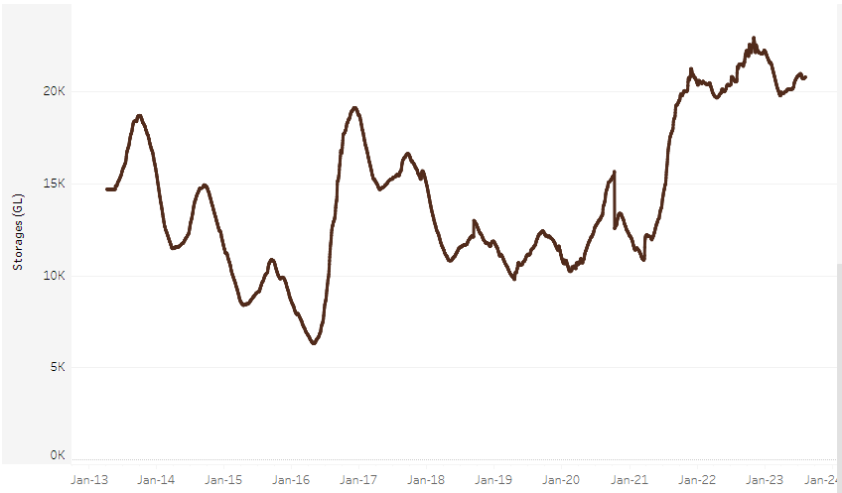
Allocation prices in the Victorian Murray below the Barmah Choke increased from $148 on 10 August 2023 to $152 on 17 August 2023. Prices are lower in the Goulburn-Broken and regions above the Barmah choke due to the binding of the Goulburn intervalley trade limit and Barmah choke trade constraint.
Water storage data is sourced from the Bureau of Meteorology.

Region | $/ML
NSW Murray Above | 61
NSW Murrumbidgee | 156
VIC Goulburn-Broken | 108
VIC Murray Below | 152

Surface water trade activity, Southern Murray–Darling Basin
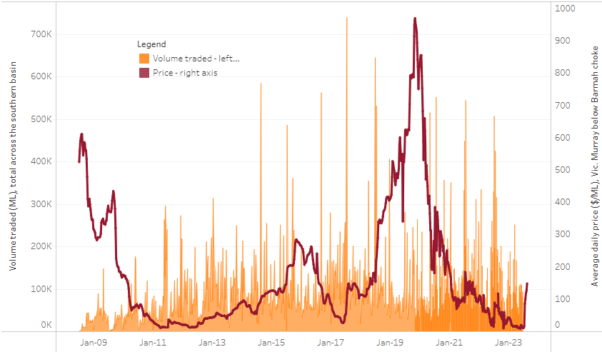
The trades shown reflect estimated market activity and do not encompass all register trades. The price is shown for the VIC Murray below the Barmah choke. Historical prices (before 1 July 2019) are ABARES estimates after removing outliers from BOM water register data. Prices after 1 July 2019 and prior to the 30 October 2019 reflect recorded transaction prices as sourced from Ruralco. Prices after the 30 October 2019 are sourced from Waterflow. Data for volume traded is sourced from the BOM water register. Only the price data shown is current on 17 August 2023.

To access the full, interactive, weekly water dashboard, which contains the latest and historical water storage, water market and water allocation information, please visit https://www.agriculture.gov.au/abares/products/weekly_update/weeakly-update-17823

Commodities
Indicator | Week ended | Unit | Latest Price | Previous Week | Weekly change | Price 12 months ago | Annual change
Selected world indicator prices
AUD/USD Exchange rate | 16-Aug | A$/US$ | 0.65 | 0.65 | -1% | 0.69 | -7%
Wheat – US no. 2 hard red winter wheat, fob Gulf | 16-Aug | US$/t | 312 | 320 | -2% | 388 | -20%
Corn – US no. 2 yellow corn, fob Gulf | 16-Aug | US$/t | 202 | 206 | -2% | 301 | -33%
Canola – Rapeseed, Canada, fob Vancouver | 16-Aug | US$/t | 598 | 611 | -2% | 700 | -15%
Cotton – Cotlook 'A' Index | 16-Aug | USc/lb | 98 | 96 | 2% | 133 | -27%
Sugar – Intercontinental Exchange, nearby futures, no.11 contract | 16-Aug | USc/lb | 23.9 | 24.0 | 0% | 18 | 34%
Wool – Eastern Market Indicator | 09-Aug | Ac/kg clean | 1,163 | 1,176 | -1% | 1,420 | -18%
Wool – Western Market Indicator | 09-Aug | Ac/kg clean | 1,320 | 1,332 | -1% | 1,430 | -8%
Selected Australian grain export prices
Milling Wheat – APW, Port Adelaide, SA | 16-Aug | A$/t | 471 | 472 | 0% | 534 | -12%
Feed Wheat – ASW, Port Adelaide, SA | 16-Aug | A$/t | 449 | 452 | -1% | 494 | -9%
Feed Barley – Port Adelaide, SA | 16-Aug | A$/t | 382 | 375 | 2% | 459 | -17%
Canola – Kwinana, WA | 16-Aug | A$/t | 831 | 835 | -1% | 1,049 | -21%
Grain Sorghum – Brisbane, QLD | 16-Aug | A$/t | 503 | 500 | 1% | 420 | 20%
Selected domestic livestock indicator prices
Beef – Eastern Young Cattle Indicator | 16-Aug | Ac/kg cwt | 543 | 557 | -3% | 947 | -43%
Mutton – Mutton indicator (18–24 kg fat score 2–3), Vic | 16-Aug | Ac/kg cwt | 224 | 222 | 1% | 510 | -56%
Lamb – Eastern States Trade Lamb Indicator | 09-Aug | Ac/kg cwt | 445 | 450 | -1% | 723 | -38%
Pig – Eastern Seaboard (60.1–75 kg), average of buyers & sellers | 02-Aug | Ac/kg cwt | 343 | 343 | 0% | 367 | -7%
Goats – Eastern States (12.1–16 kg) | 07-Jun | Ac/kg cwt | 324 | 330 | -2% | 838 | -61%
Live cattle – Light steers ex Darwin to Indonesia | 17-Aug-22 | Ac/kg lwt | 420 | 480 | -13% | 320 | 31%
Live sheep – Live wethers (Muchea WA saleyard) to Middle East | 14-Sep-22 | $/head | 93 | 113 | -18% | 114 | -18%
Global Dairy Trade (GDT) weighted average prices ª
Dairy – Whole milk powder | 16-Aug | US$/t | 2,548 | 2,864 | -11% | 3,544 | -28%
Dairy – Skim milk powder | 16-Aug | US$/t | 2,333 | 2,454 | -5% | 3,524 | -34%
Dairy – Cheddar cheese | 16-Aug | US$/t | 4,127 | 3,910 | 6% | 4,798 | -14%
Dairy – Anhydrous milk fat | 16-Aug | US$/t | 4,452 | 4,705 | -5% | 5,518 | -19%
a Global Dairy Trade prices are updated twice monthly on the first and third Tuesday of each month.

Selected world indicator prices
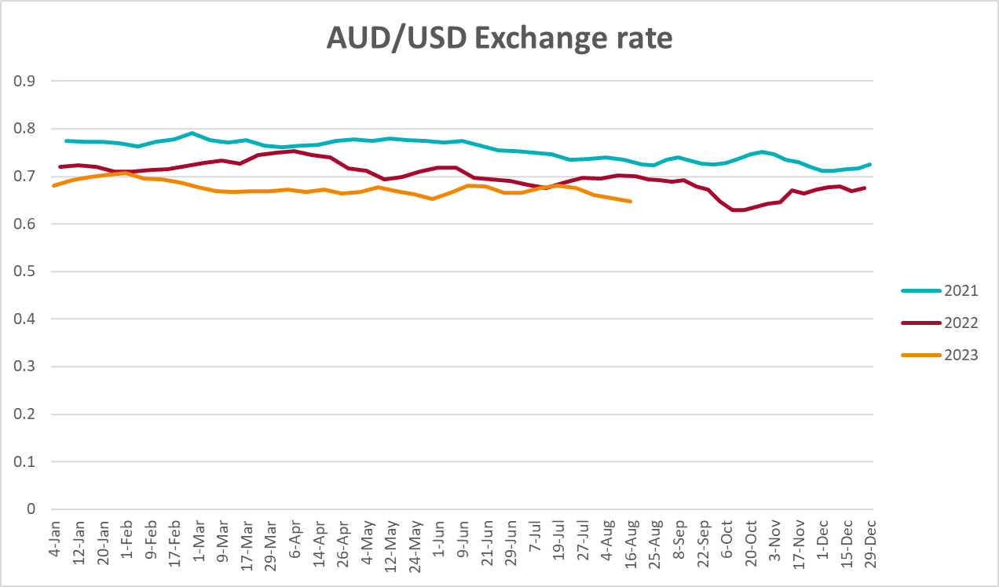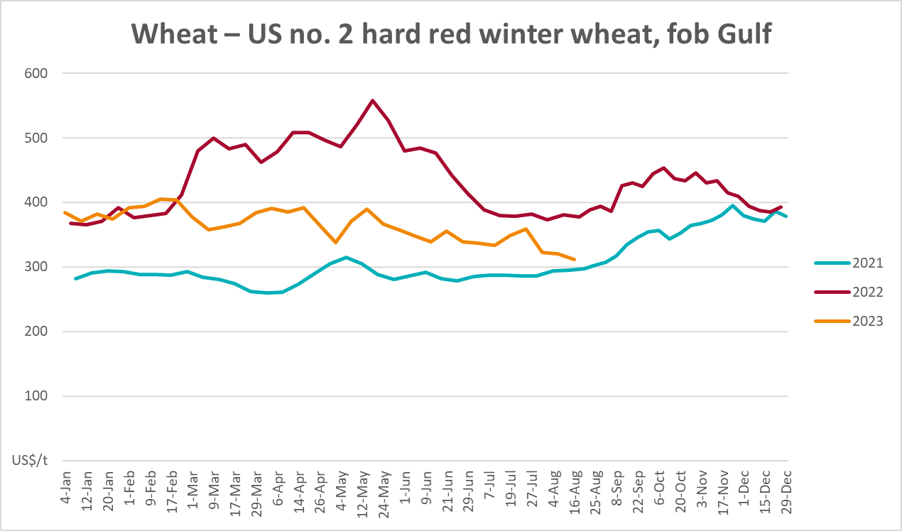
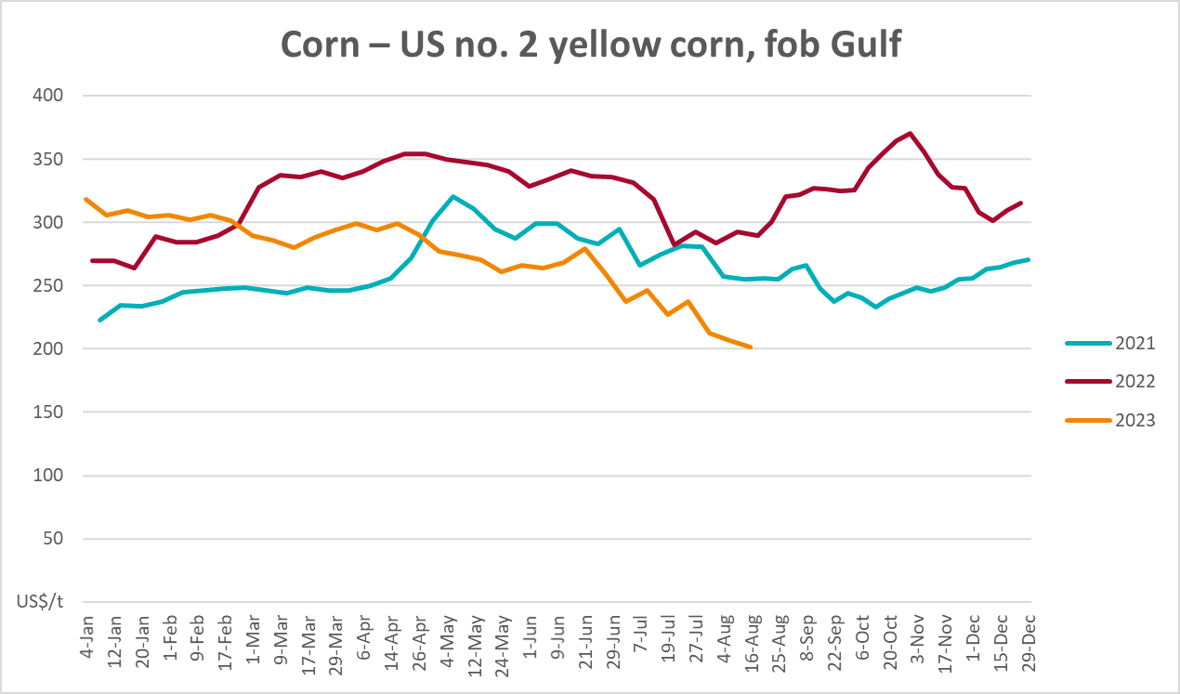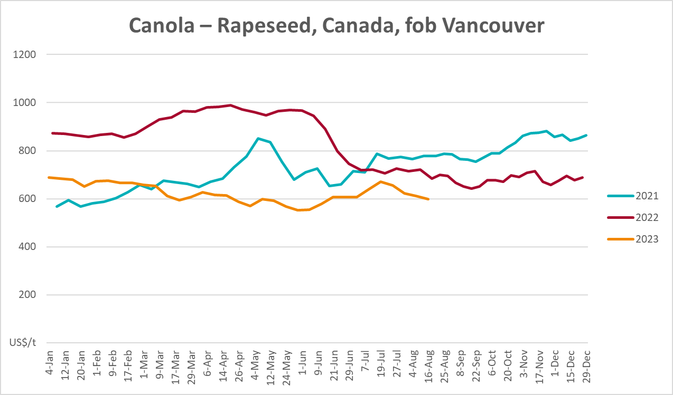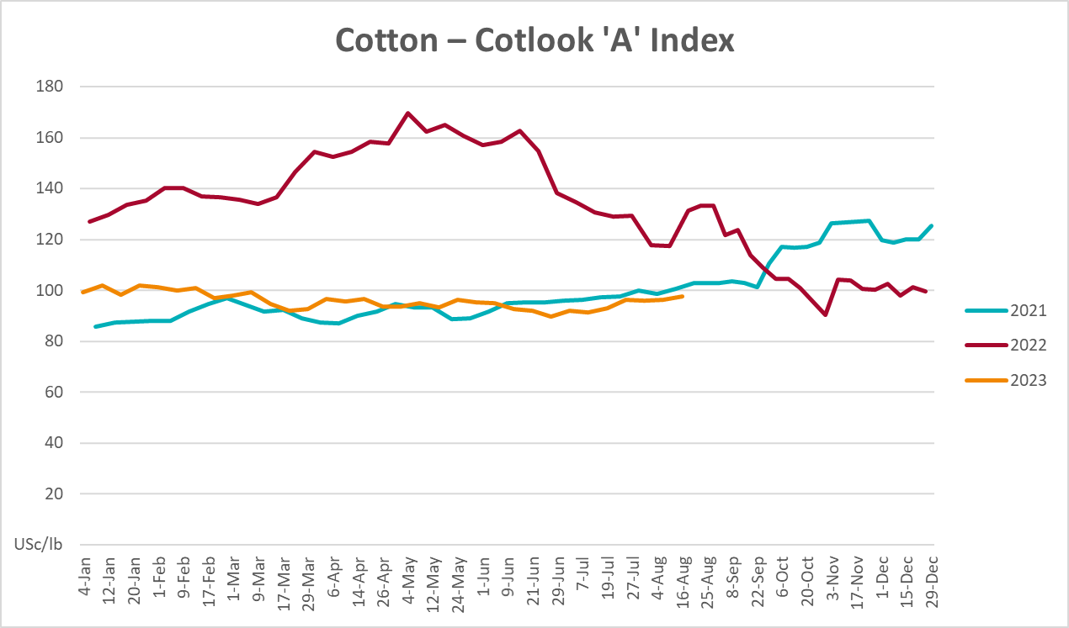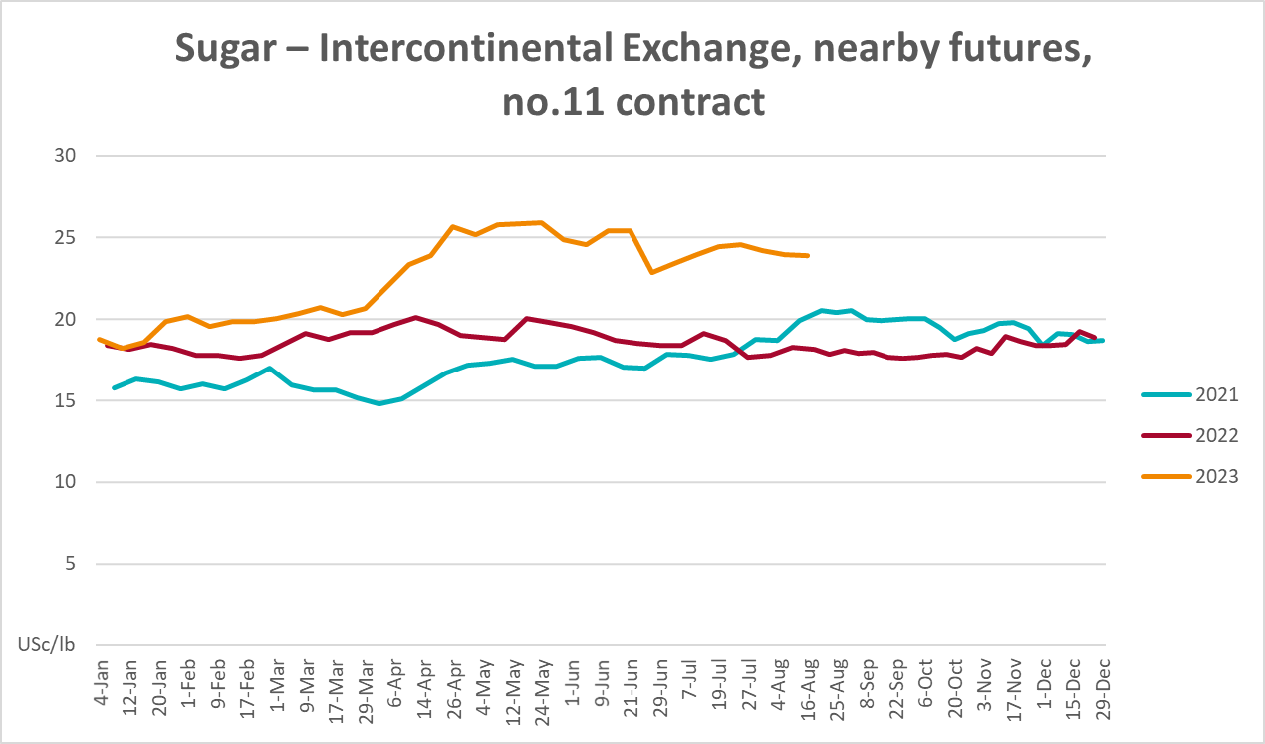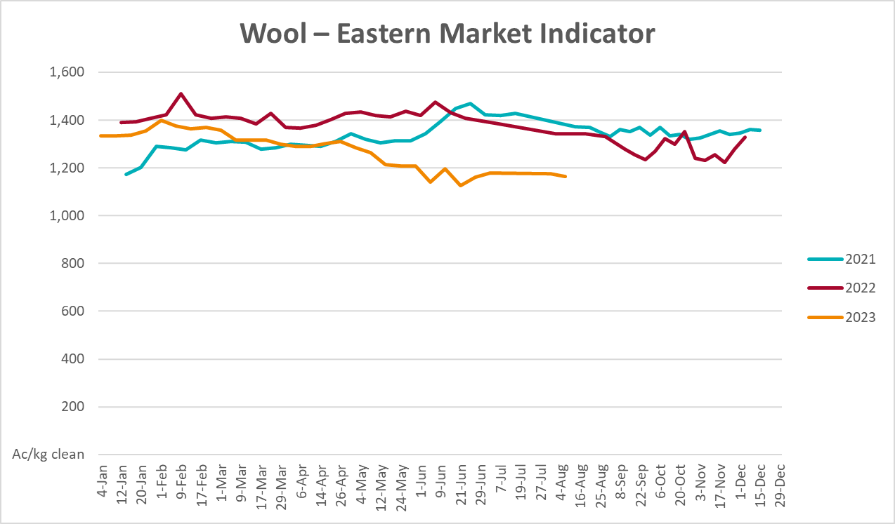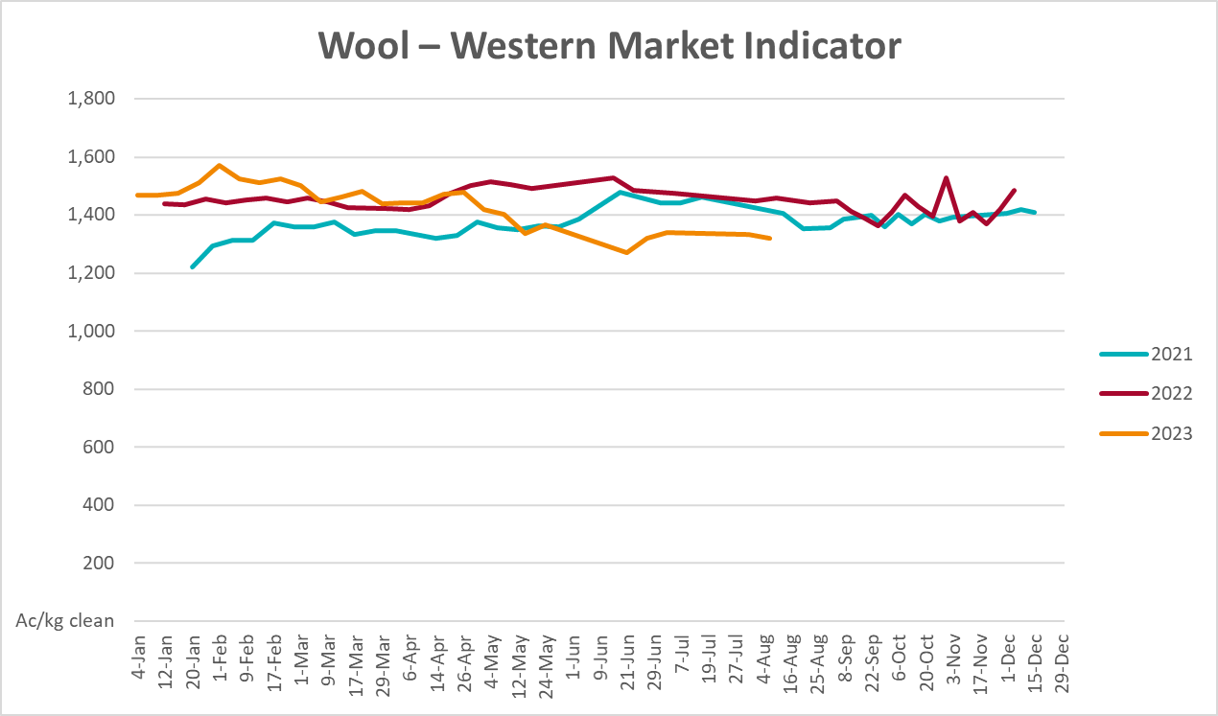

Selected domestic crop indicator prices
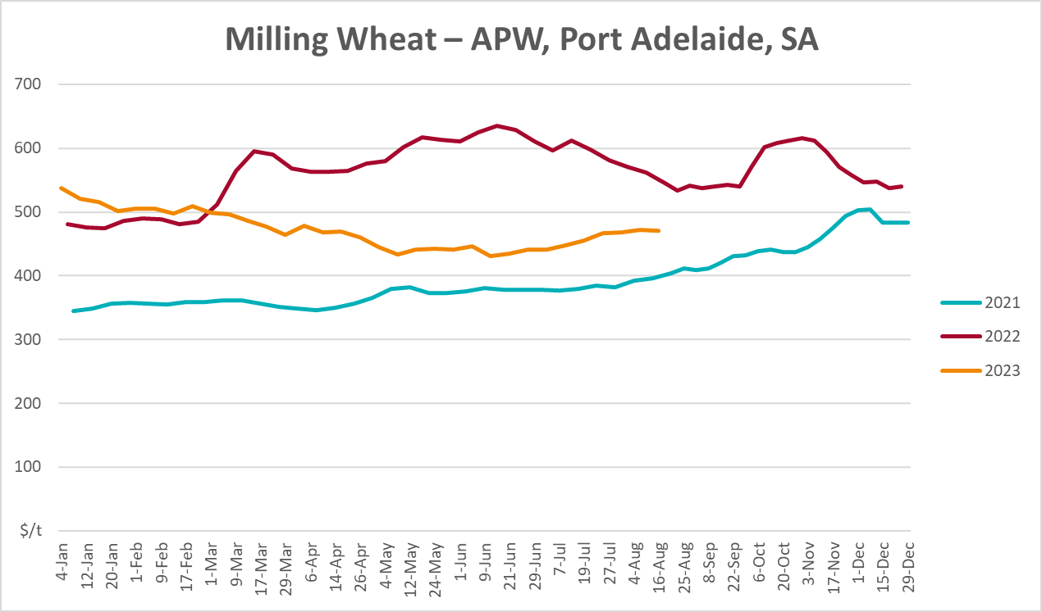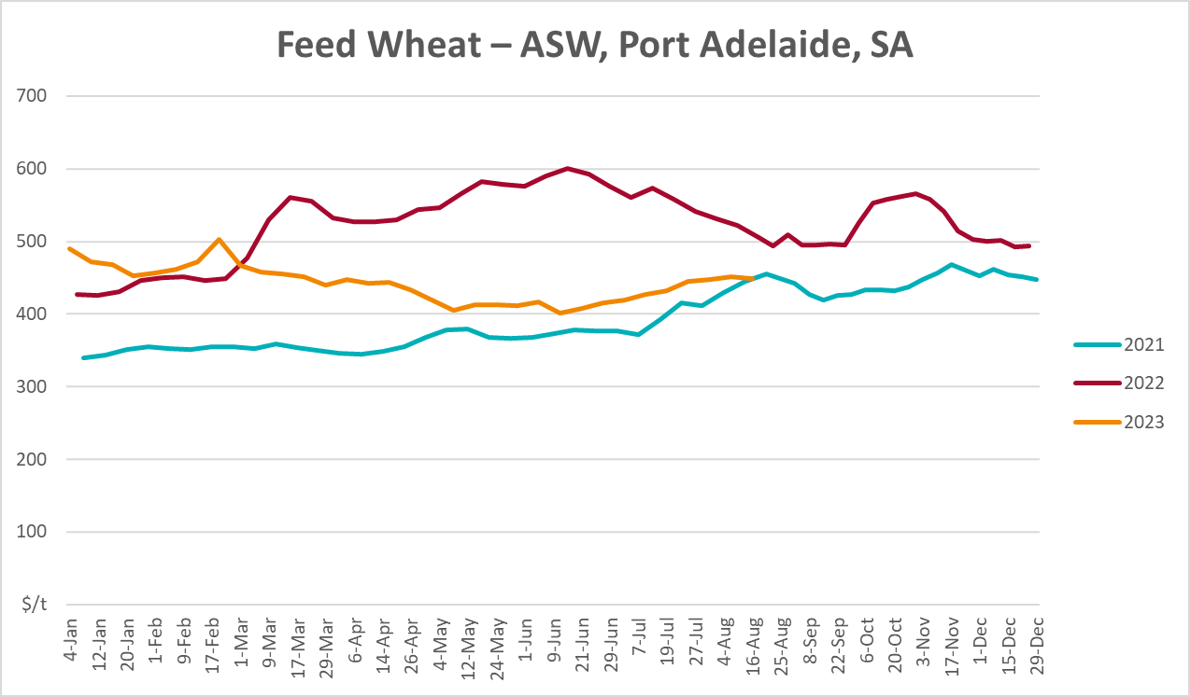
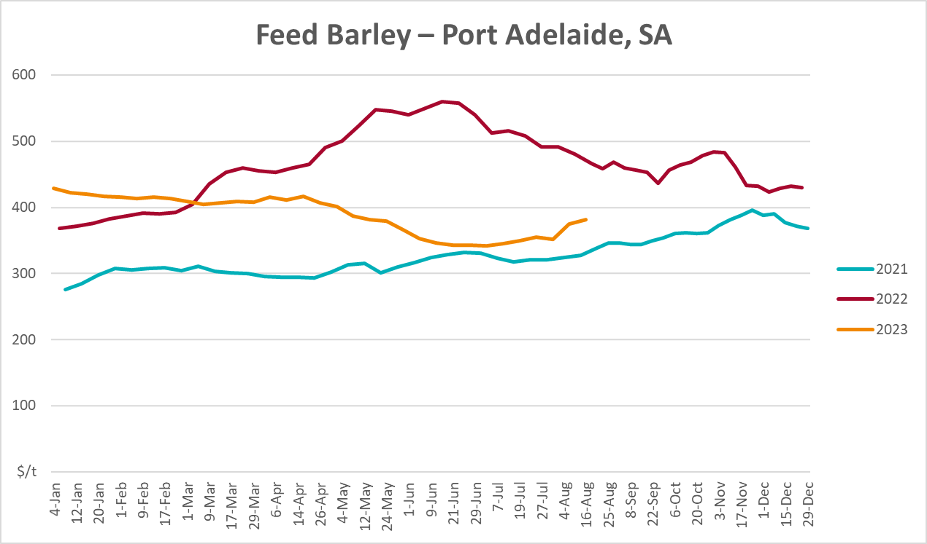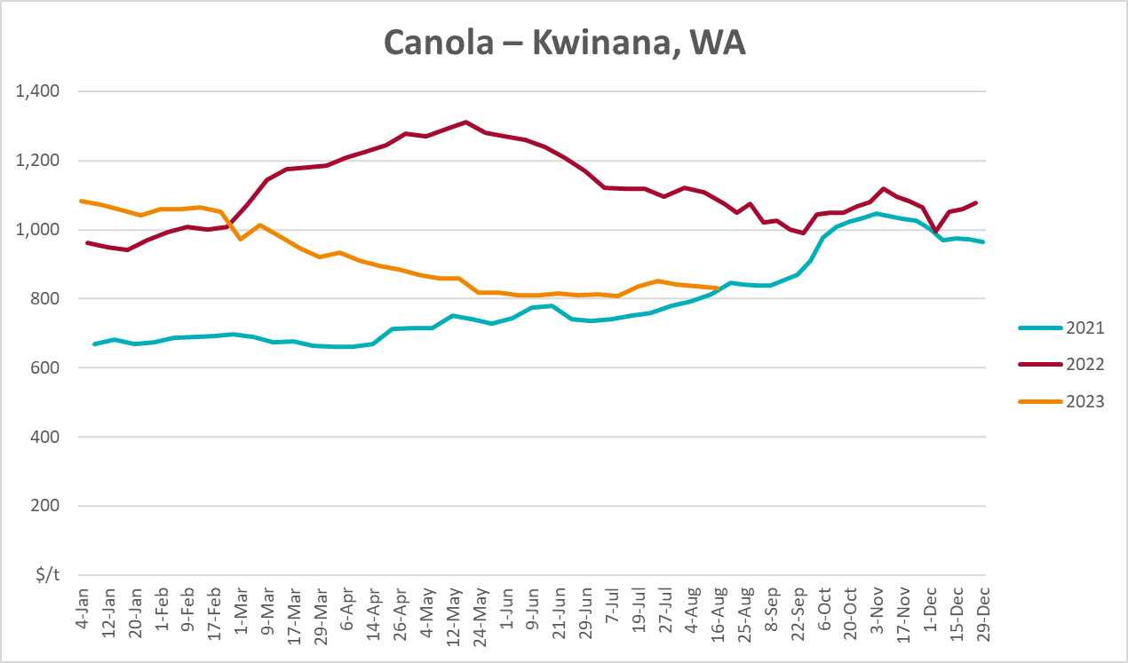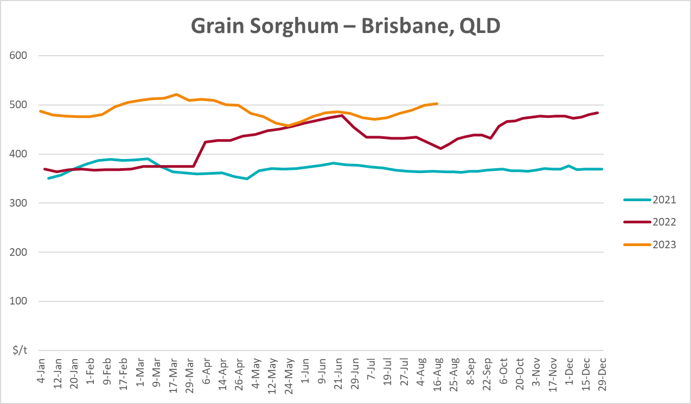

Selected domestic livestock indicator prices
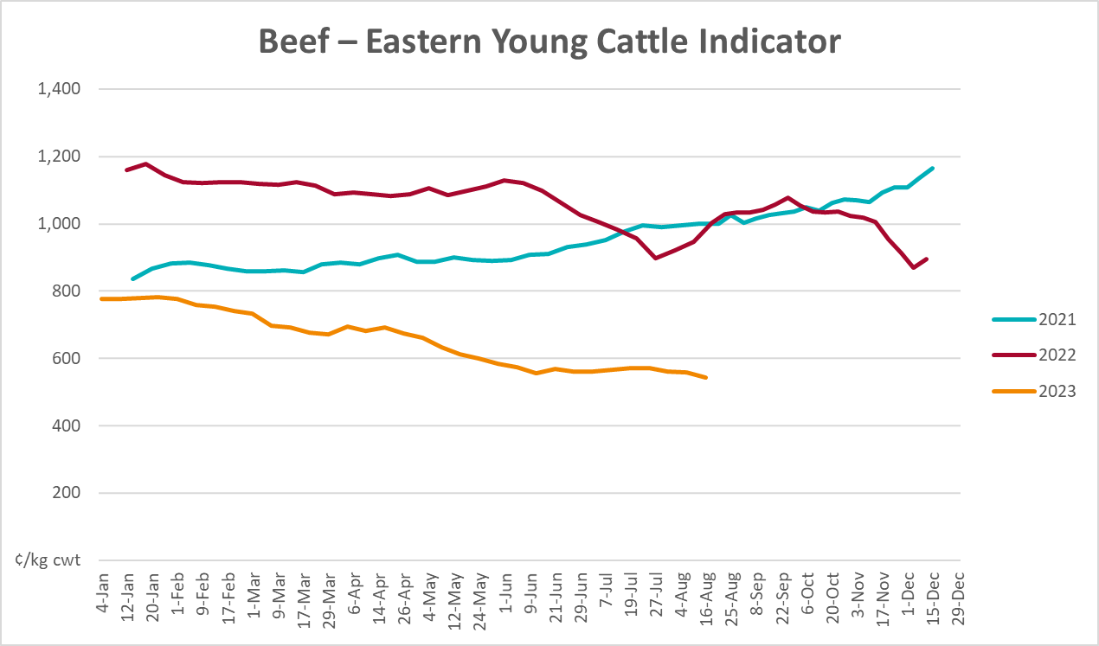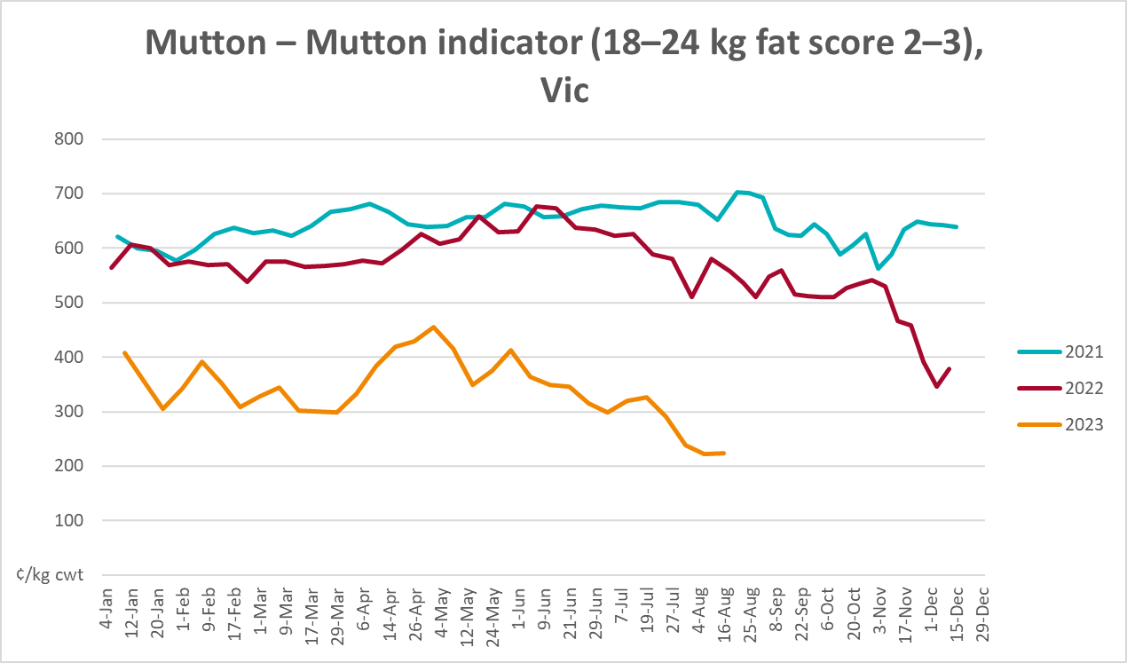
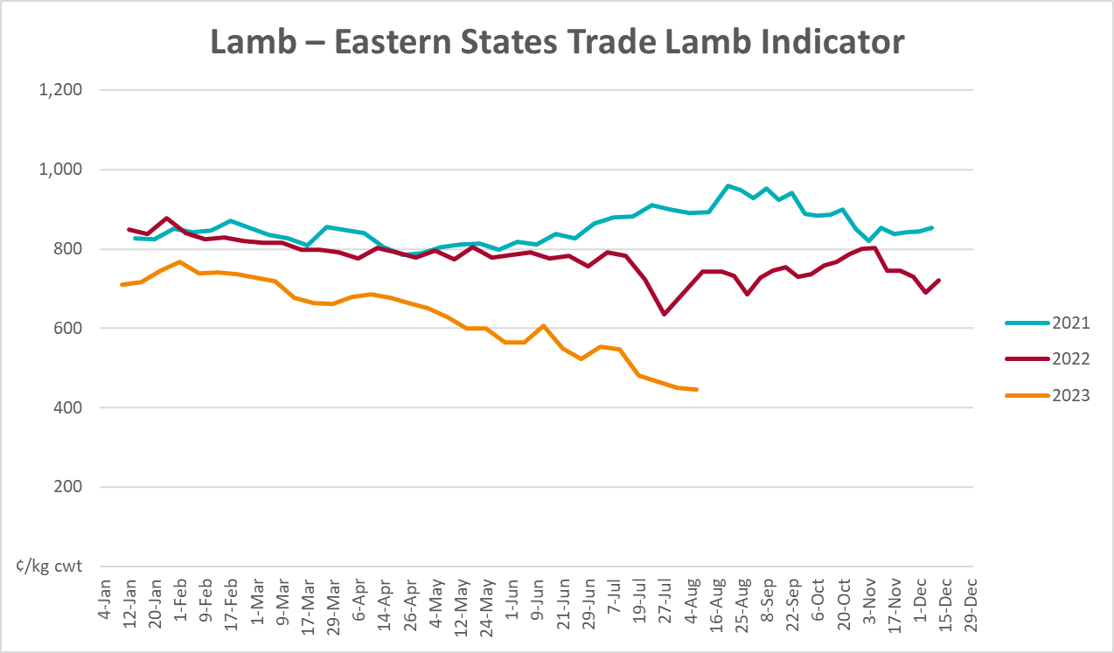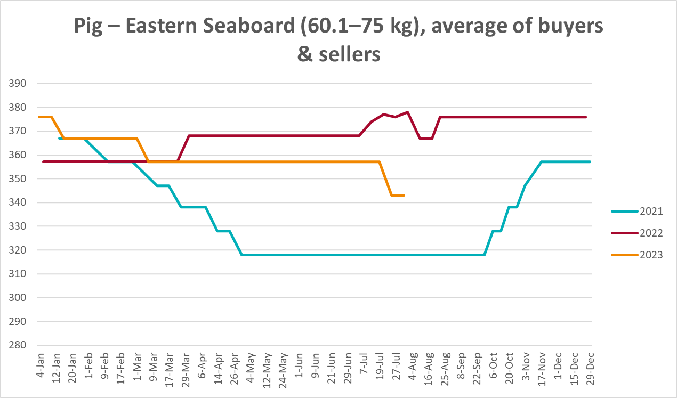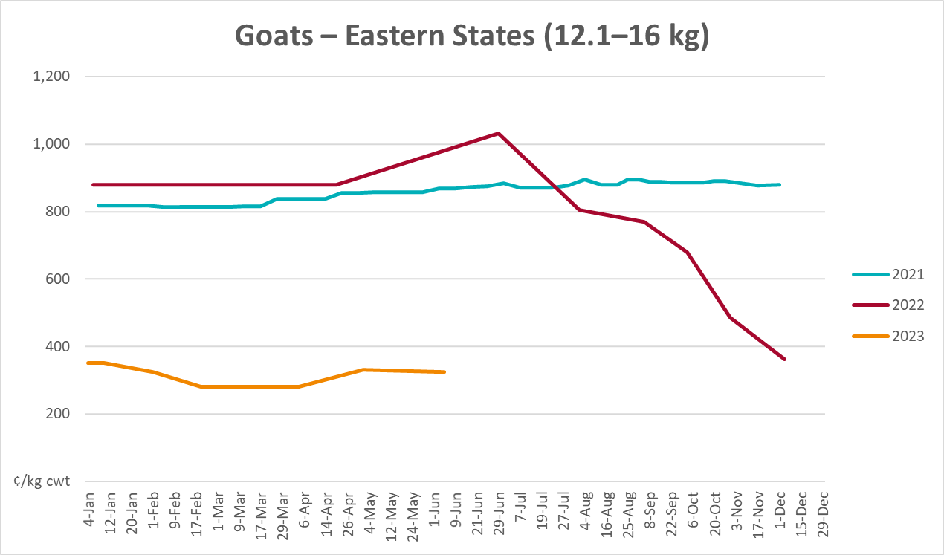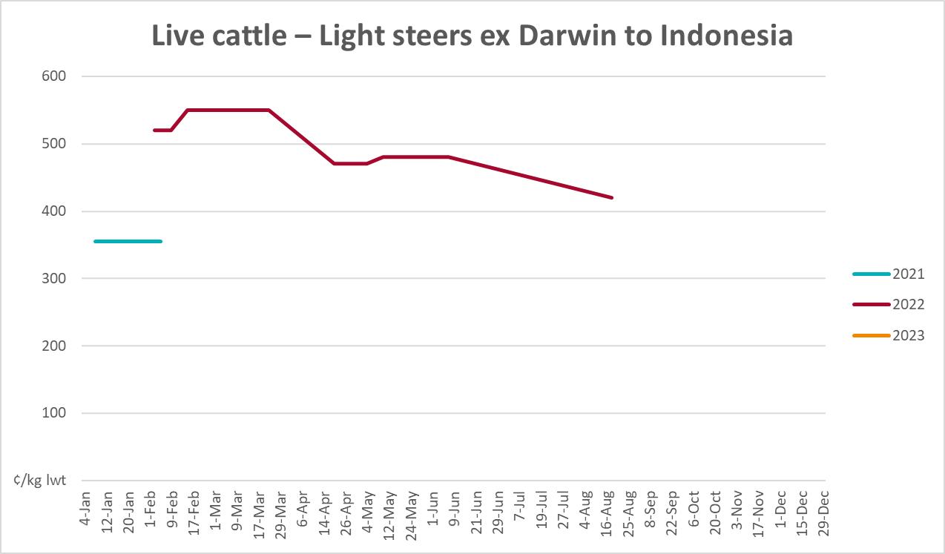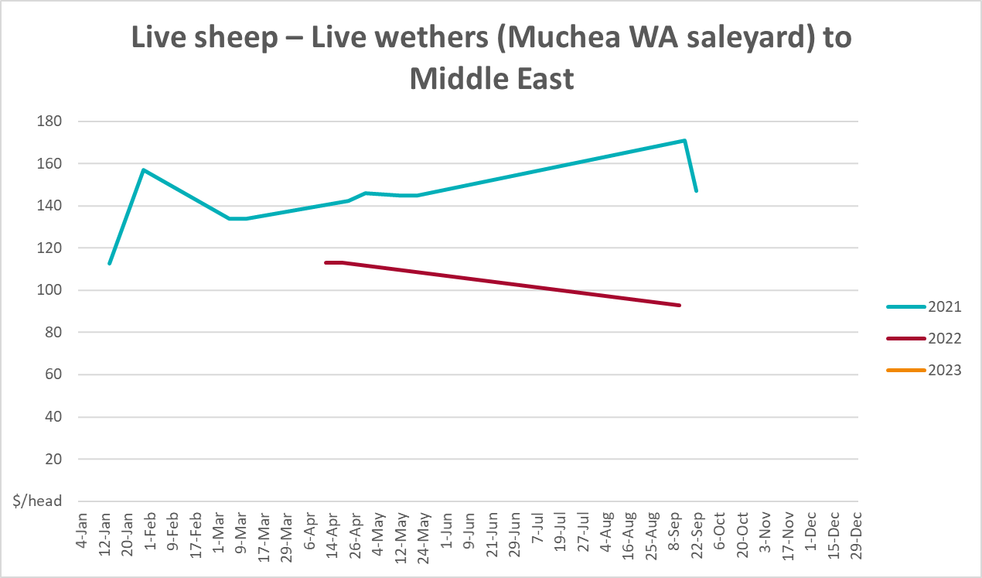

Global Dairy Trade (GDT) weighted average prices
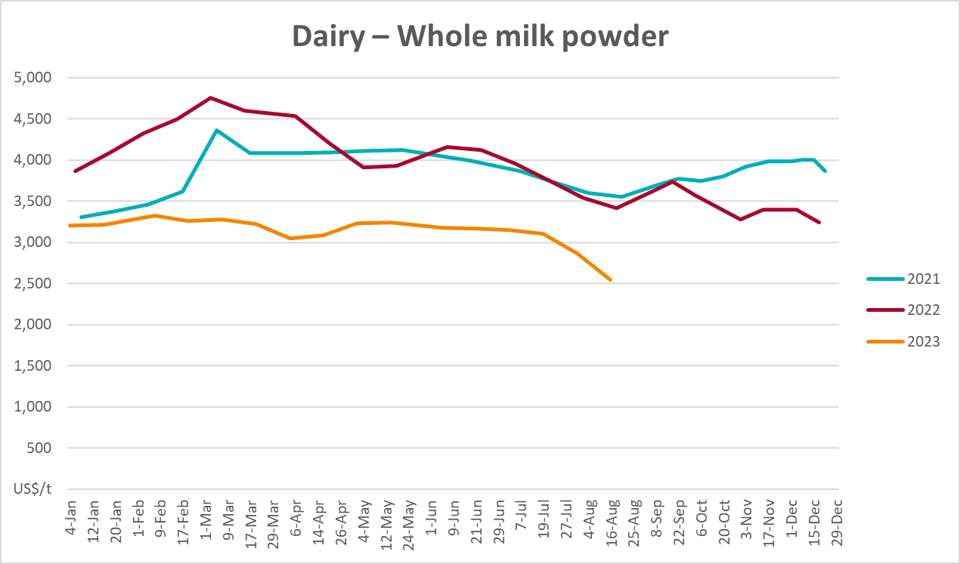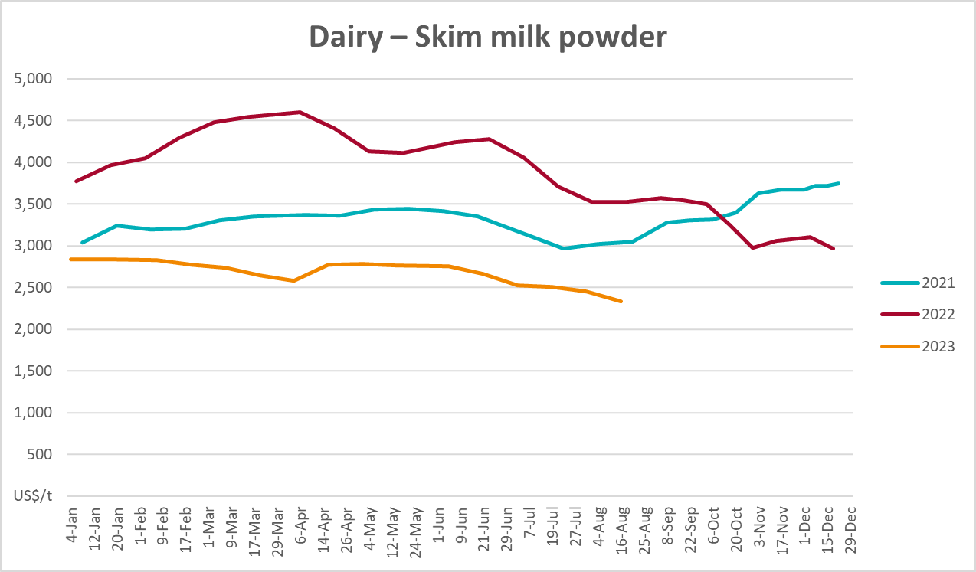
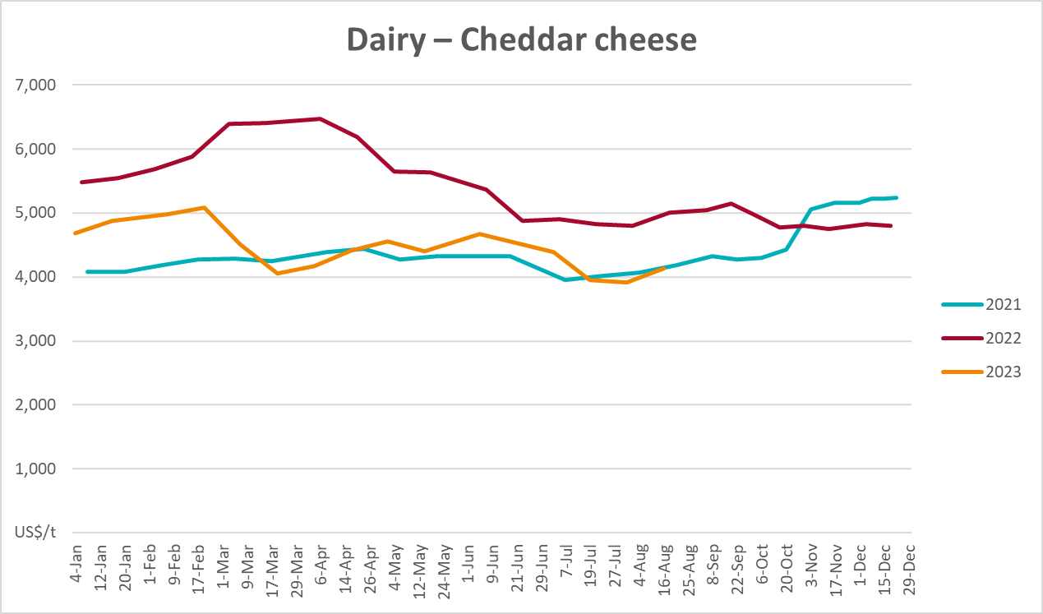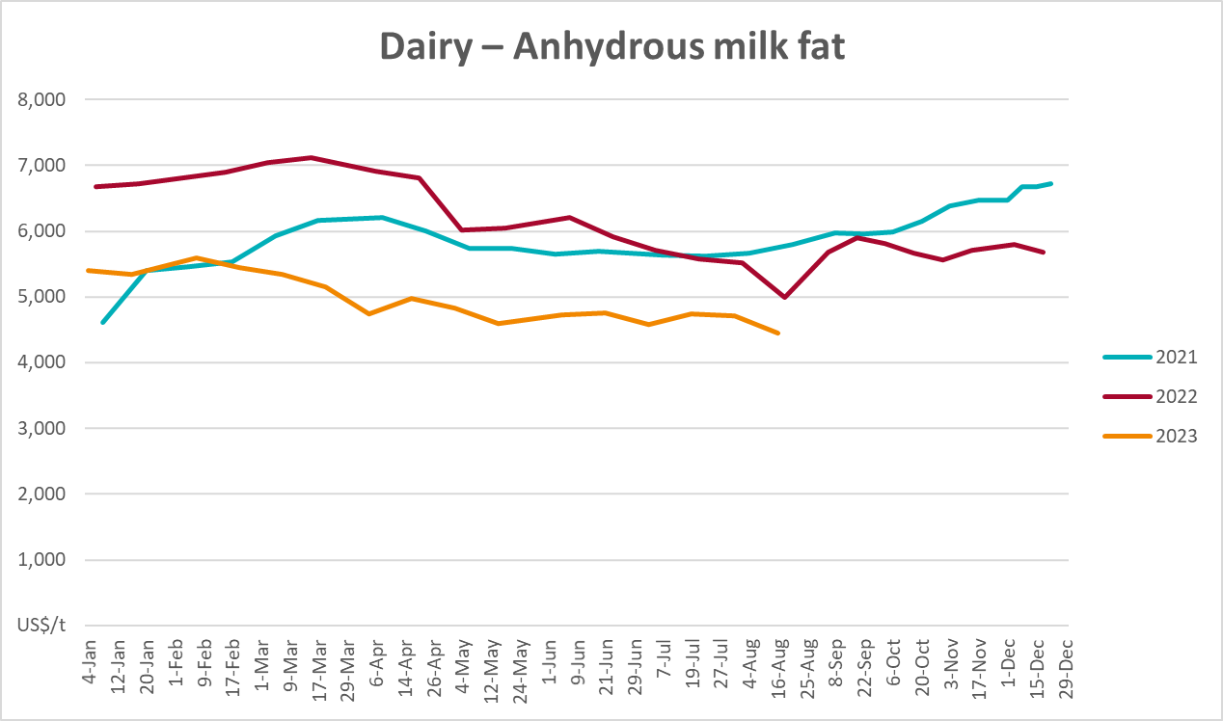

Selected fruit and vegetable prices
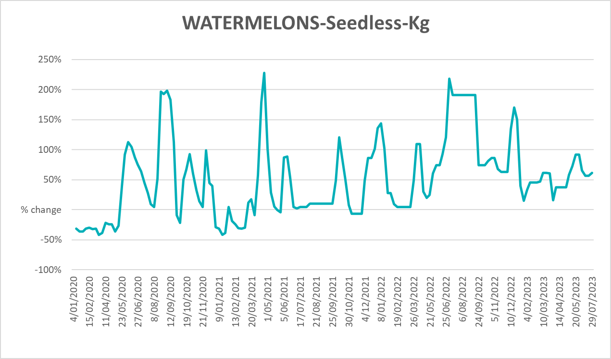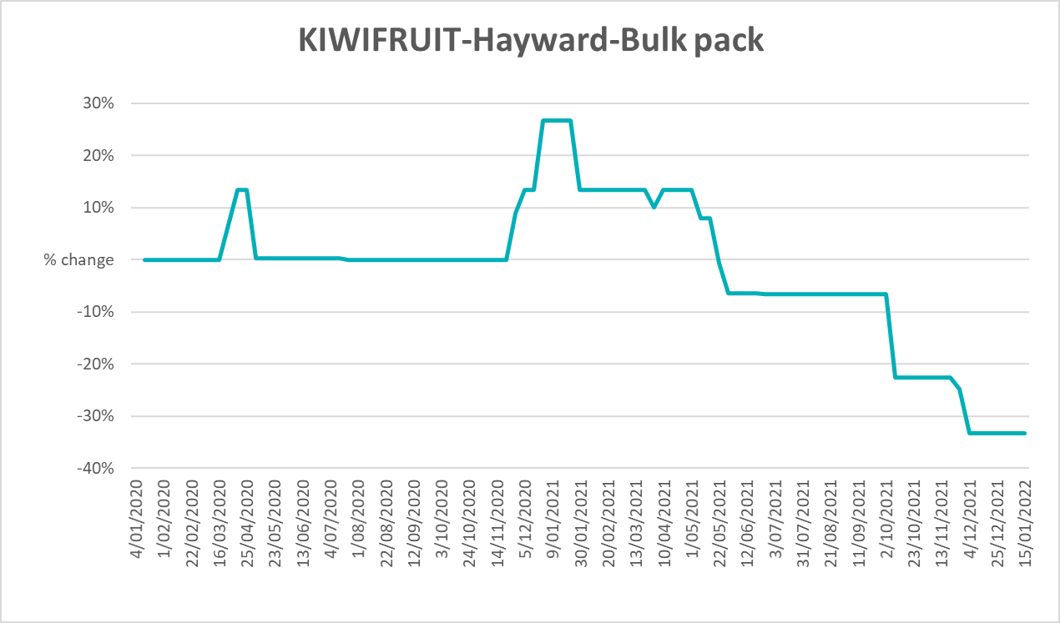
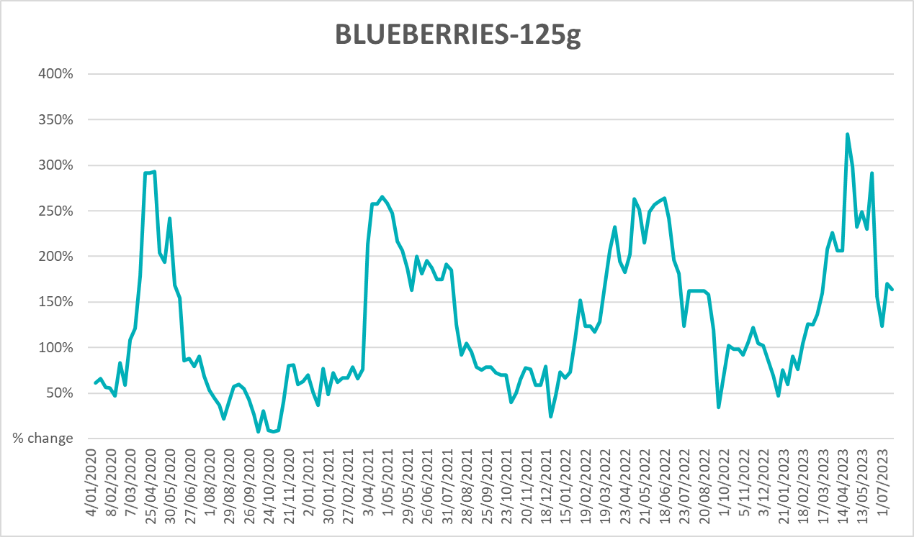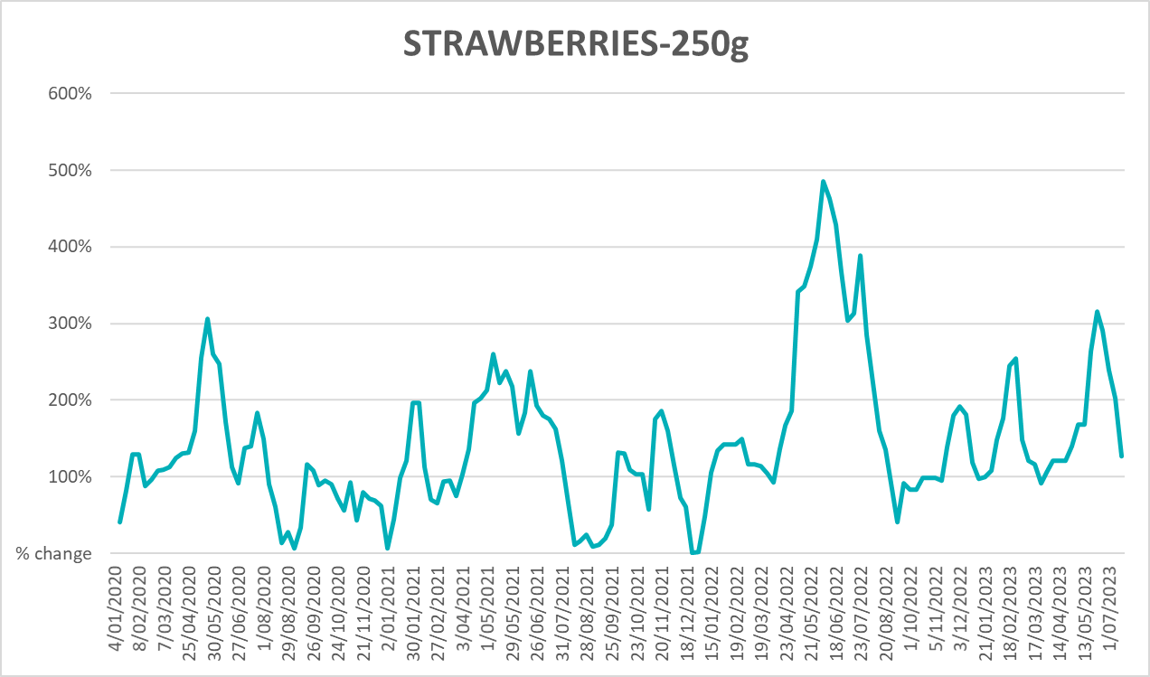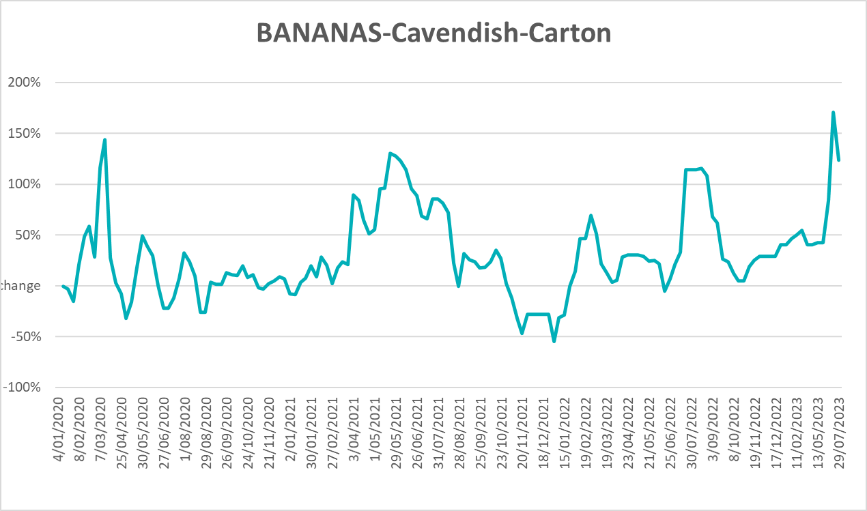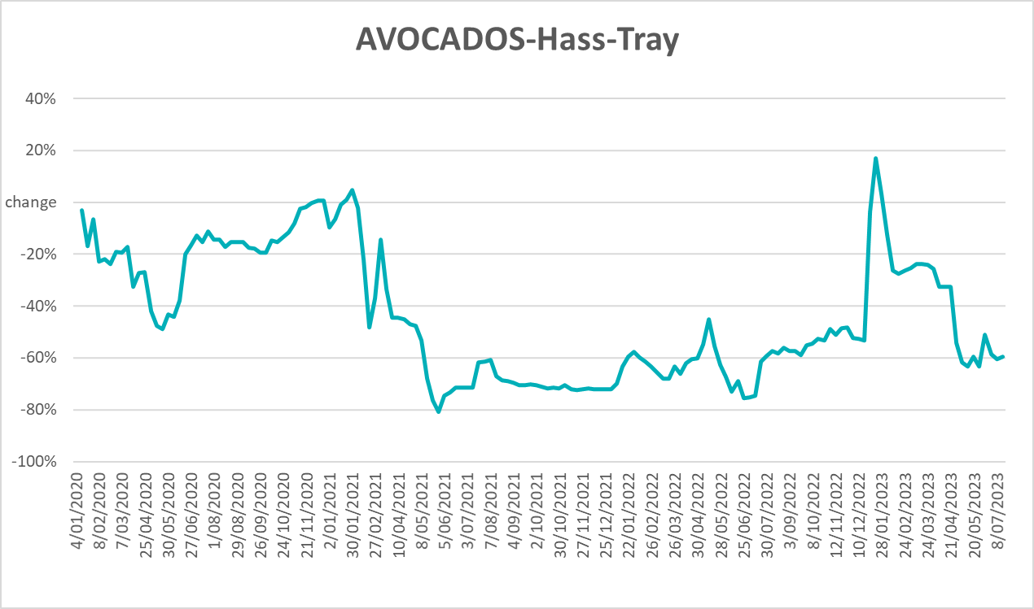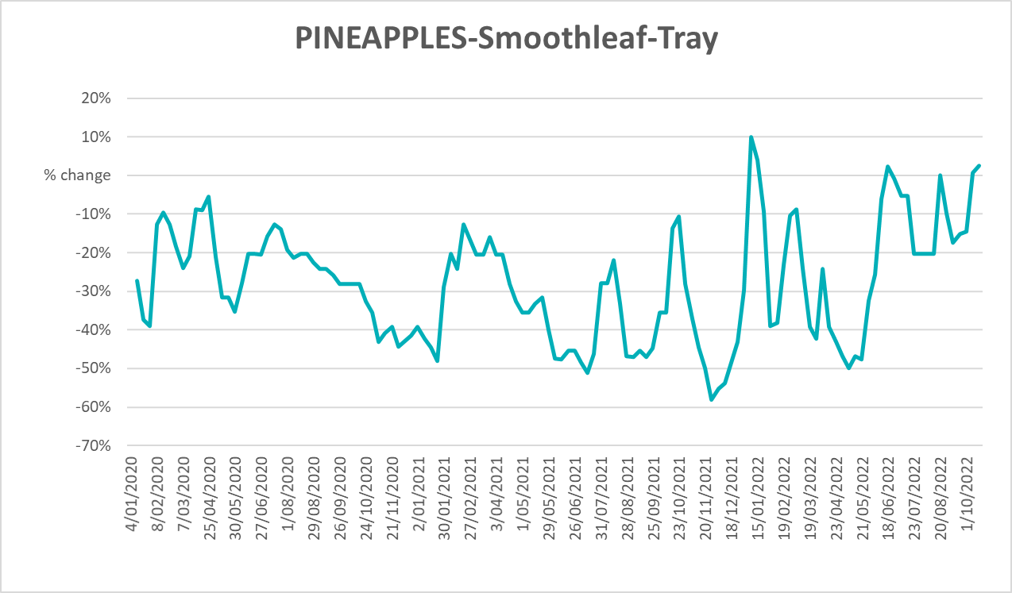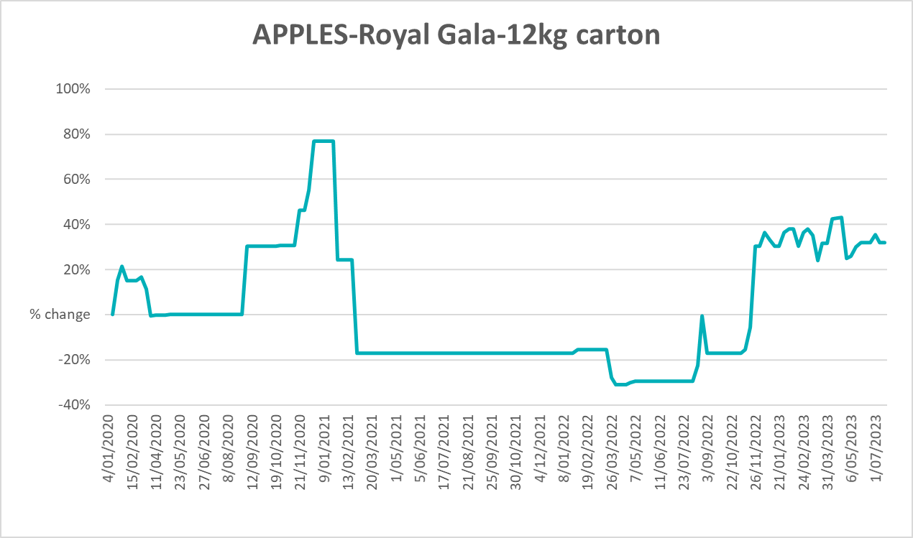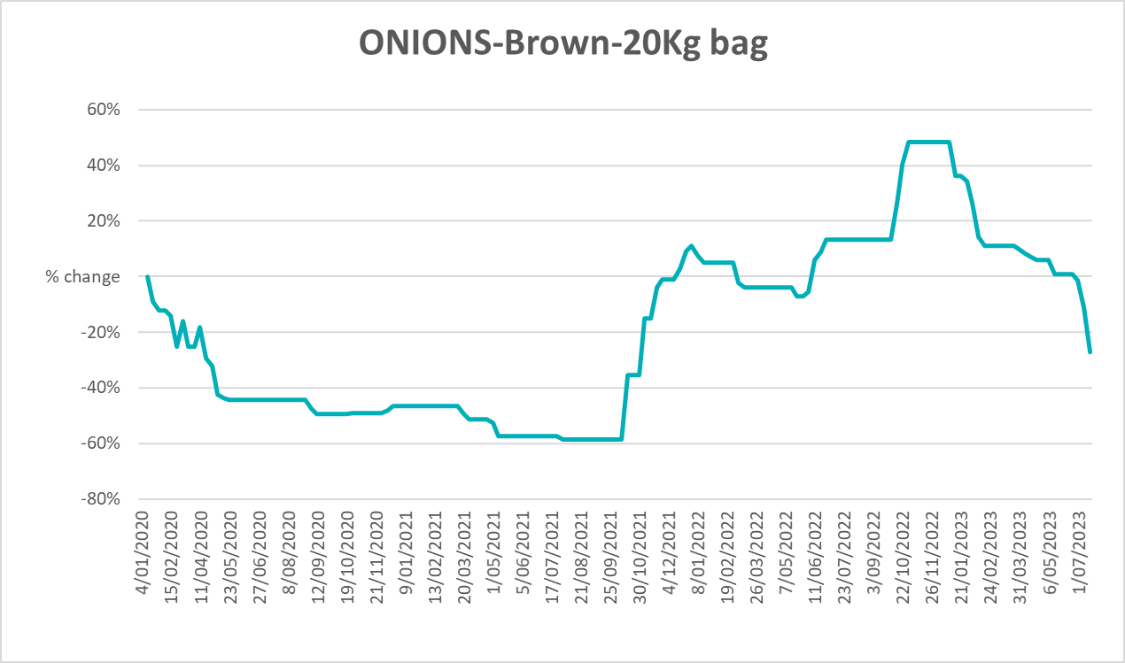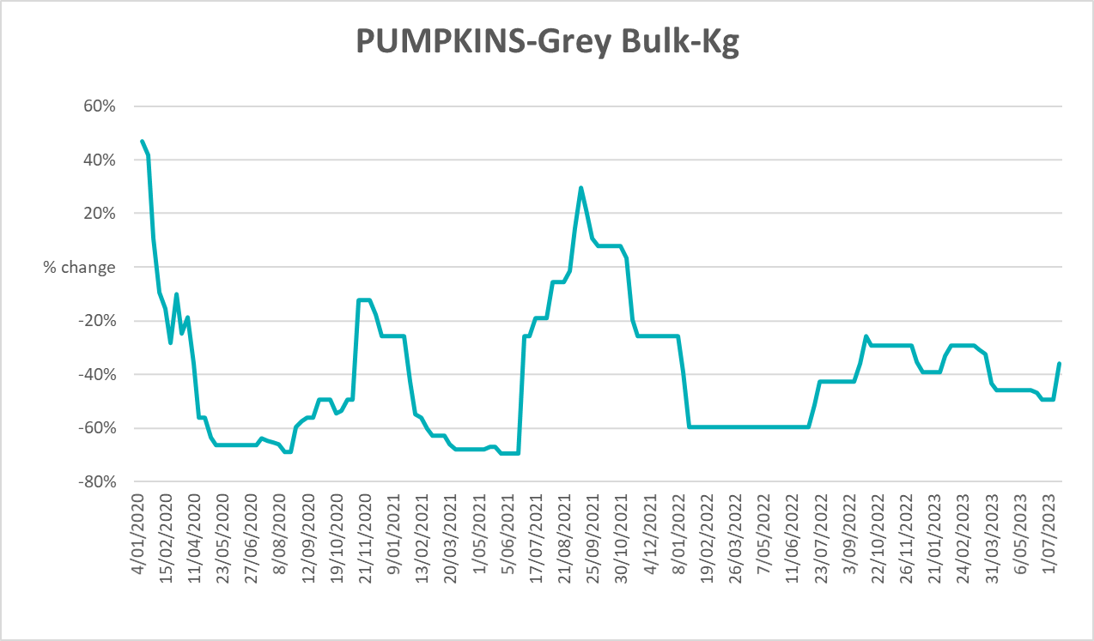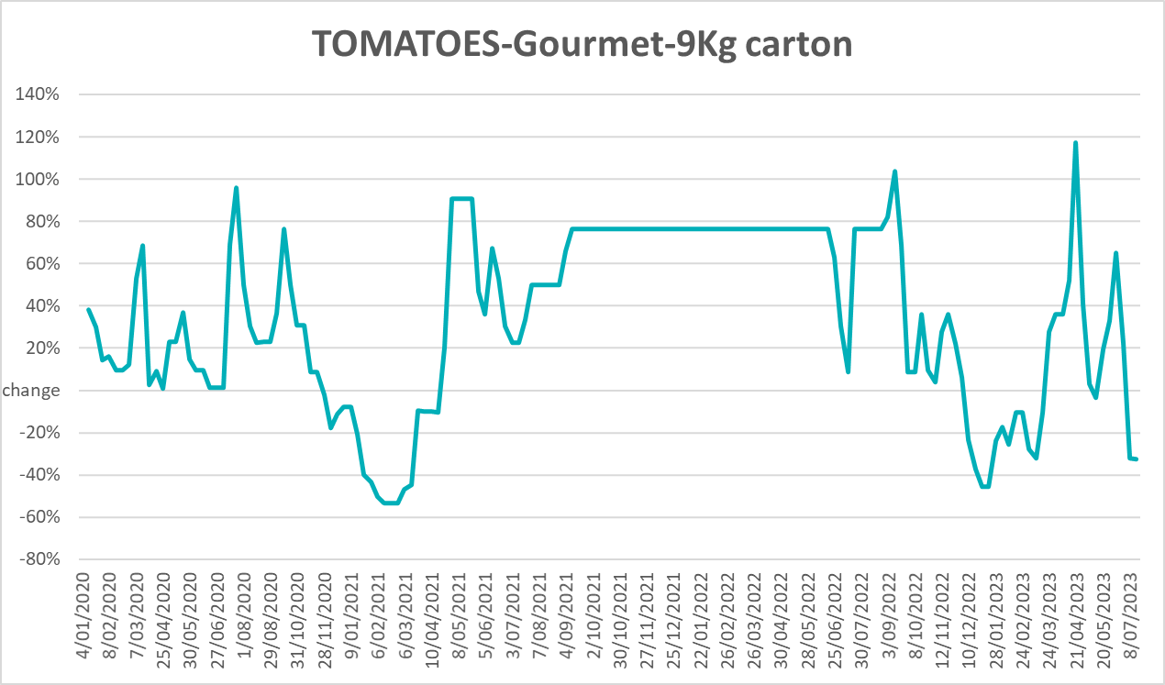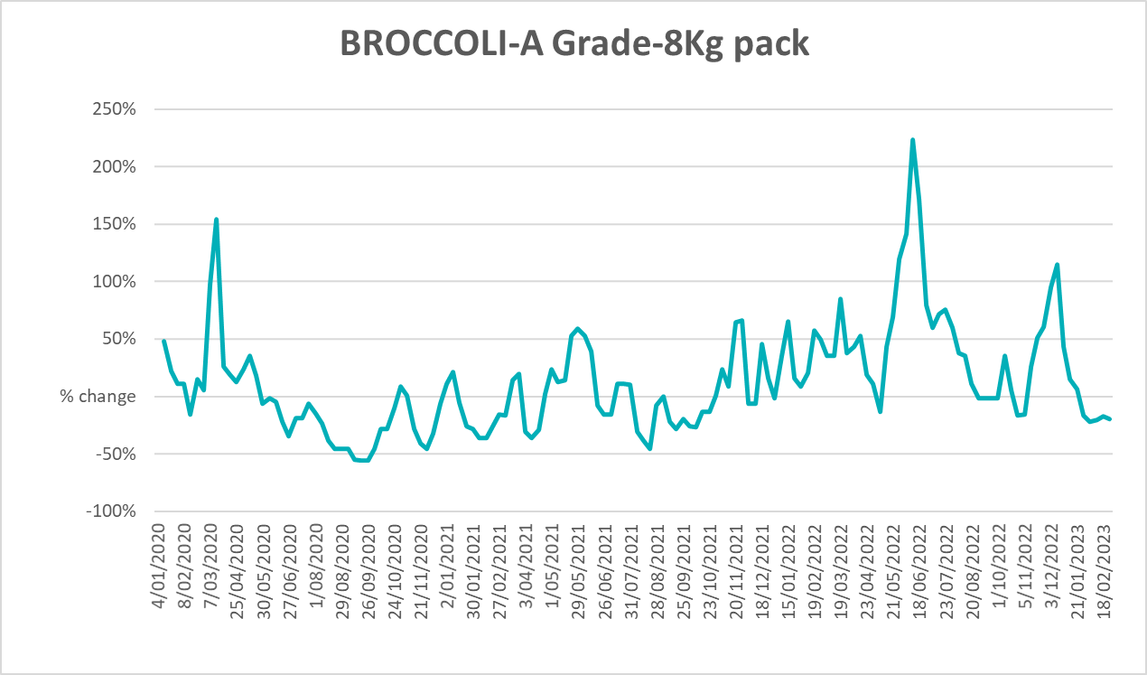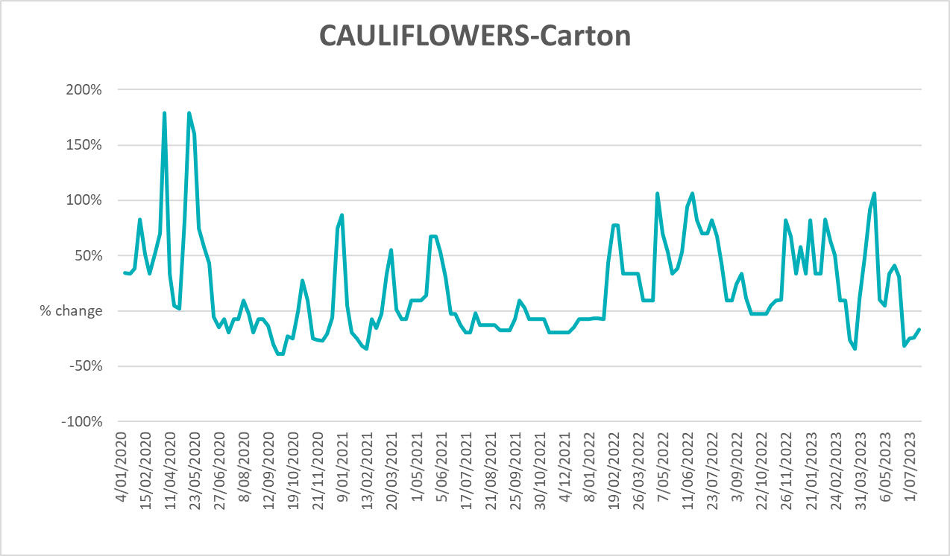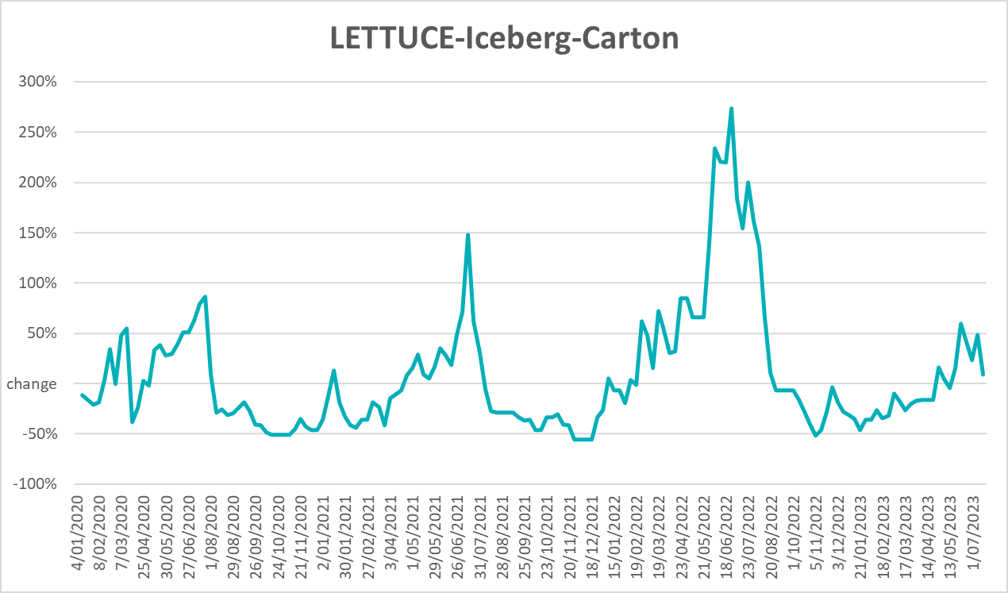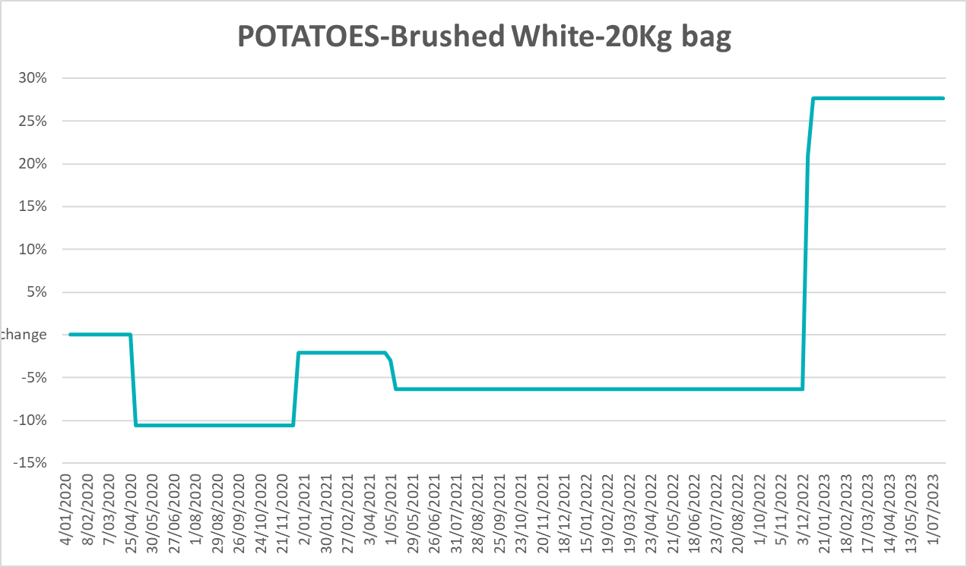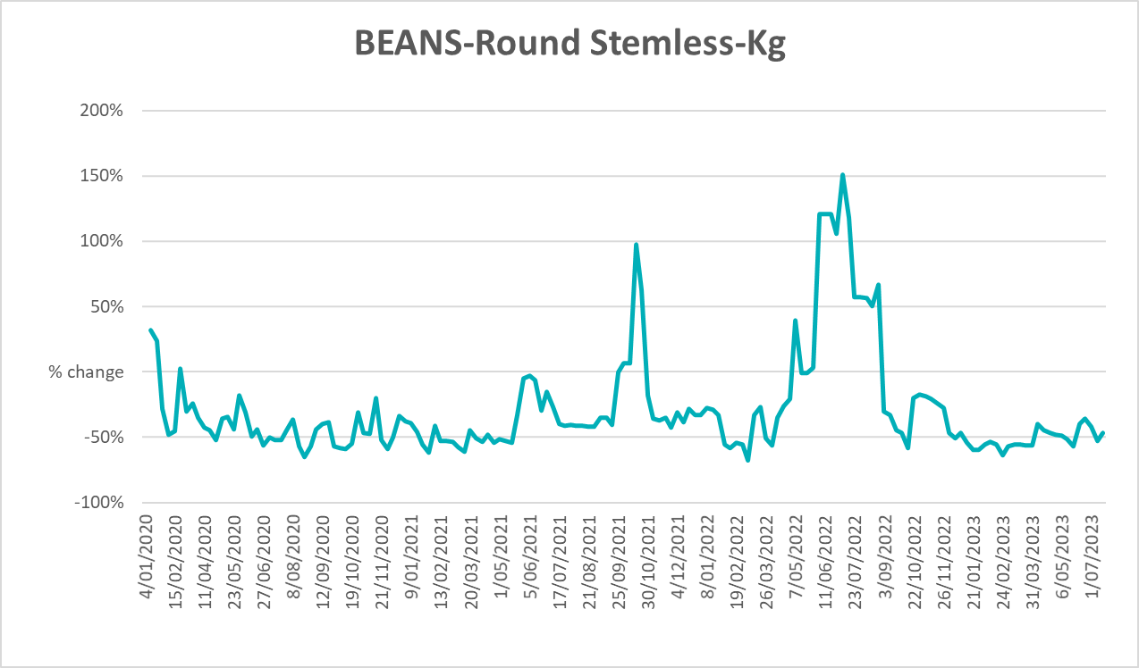

3.6 Selected domestic fodder indicator prices
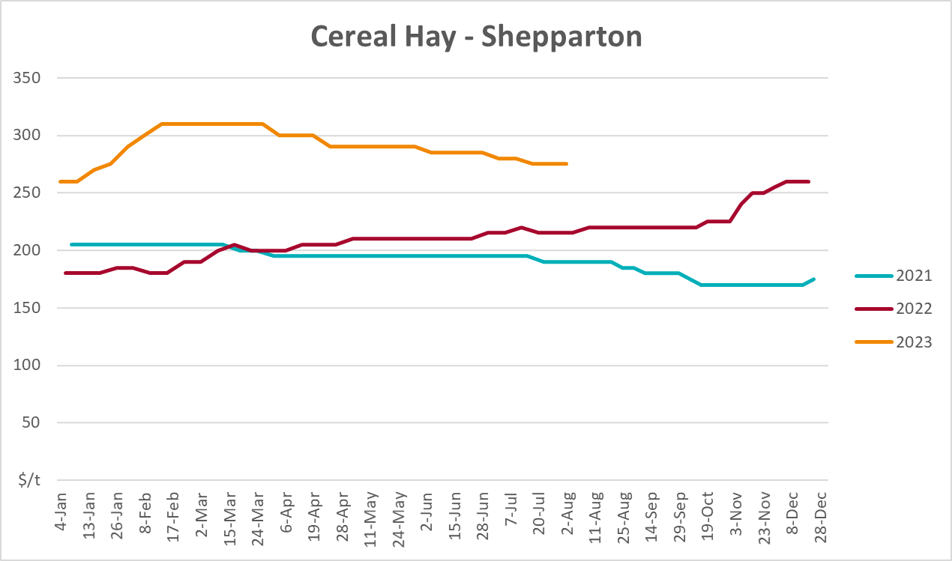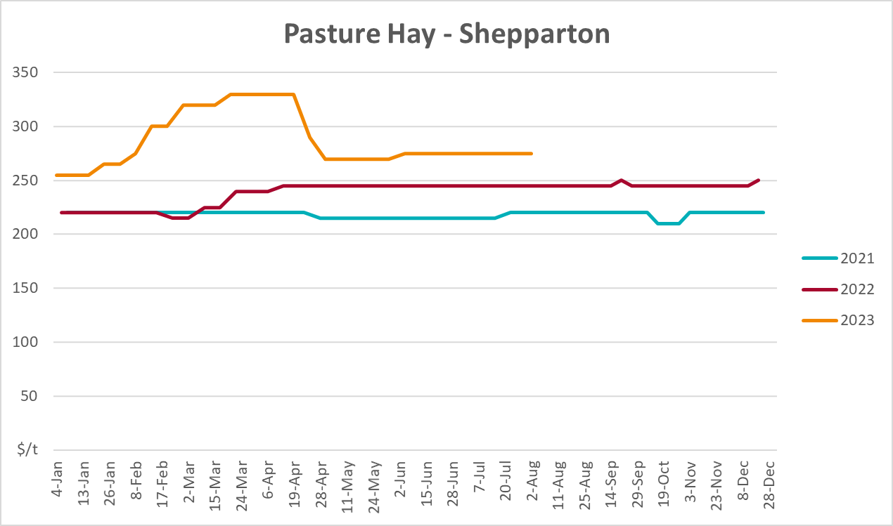
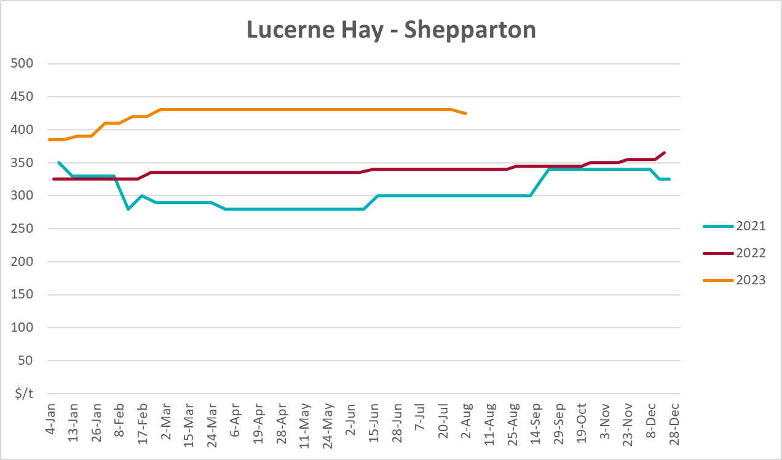

4. Data attribution

Climate
Bureau of Meteorology
- Weekly rainfall totals: www.bom.gov.au/climate/maps/rainfall/
- Monthly and last 3-month rainfall percentiles: www.bom.gov.au/water/landscape/
- Temperature anomalies: www.bom.gov.au/jsp/awap/temp/index.jsp
- Rainfall forecast: www.bom.gov.au/jsp/watl/rainfall/pme.jsp
- Seasonal outlook: www.bom.gov.au/climate/outlooks/#/overview/summary/
- Climate drivers: http://www.bom.gov.au/climate/enso/
- Soil moisture: www.bom.gov.au/water/landscape/
Other
- Pasture growth: www.longpaddock.qld.gov.au/aussiegrass/
- 3-month global outlooks: Environment and Climate Change Canada, NOAA Climate Prediction Center, EUROBRISA CPTEC/INPE, European Centre for Medium-Range Weather Forecasts, Hydrometcenter of Russia, National Climate Center Climate System Diagnosis and Prediction Room (NCC), International Research Institute for Climate and Society
- Global production: https://ipad.fas.usda.gov/ogamaps/cropmapsandcalendars.aspx
- Autumn break: Pook et al., 2009, https://rmets-onlinelibrary-wiley-com.virtual.anu.edu.au/doi/epdf/10.1002/joc.1833

Water
Prices
- Waterflow: https://www.waterflow.io/
- Ruralco: https://www.ruralcowater.com.au/
Bureau of Meteorology:
- Allocation trade: http://www.bom.gov.au/water/dashboards/#/water-markets/mdb/at
- Storage volumes: http://www.bom.gov.au/water/dashboards/#/water-storages/summary/drainage
Trade constraints:
- Water NSW: https://www.waternsw.com.au/customer-service/ordering-trading-and-pricing/trading/murrumbidgee
- Victorian Water Register: https://www.waterregister.vic.gov.au/TradingRules2019/

Commodities
Fruit and vegetables
- Datafresh: www.freshstate.com.au
Pigs
- Australian Pork Limited: www.australianpork.com.au
Dairy
- Global Dairy Trade: www.globaldairytrade.info/en/product-results/
World wheat, canola
- International Grains Council
World coarse grains
- United States Department of Agriculture
World cotton
- Cotlook: www.cotlook.com/
World sugar
- New York Stock Exchange - Intercontinental Exchange
Wool
- Australian Wool Exchange: www.awex.com.au/
Domestic wheat, barley, sorghum, canola and fodder
- Jumbuk Consulting Pty Ltd: http://www.jumbukag.com.au/
Cattle, beef, mutton, lamb, goat and live export
- Meat and Livestock Australia: www.mla.com.au/Prices-and-market
© Commonwealth of Australia 2023

Ownership of intellectual property rights
Unless otherwise noted, copyright (and any other intellectual property rights, if any) in this publication is owned by the Commonwealth of Australia (referred to as the Commonwealth).

Creative Commons licence
All material in this publication is licensed under a Creative Commons Attribution 4.0 International Licence except content supplied by third parties, logos and the Commonwealth Coat of Arms.
Inquiries about the licence and any use of this document should be emailed to copyright@awe.gov.au.


Cataloguing data
This publication (and any material sourced from it) should be attributed as:
ABARES 2023, Weekly Australian Climate, Water and Agricultural Update, Australian Bureau of Agricultural and Resource Economics and Sciences, Canberra, 17 August 2023. CC BY 4.0 DOI: https://doi.org/10.25814/5f3e04e7d2503
ISSN 2652-7561
This publication is available at https://www.agriculture.gov.au/abares/products/weekly_update
Department of Agriculture, Fisheries and Forestry
GPO Box 858 Canberra ACT 2601
Telephone 1800 900 090
Web agriculture.gov.au/abares

Disclaimer
The Australian Government acting through the Department of Agriculture, Fisheries and Forestry, represented by the Australian Bureau of Agricultural and Resource Economics and Sciences, has exercised due care and skill in preparing and compiling the information and data in this publication. Notwithstanding, the Department of Agriculture, Fisheries and Forestry, ABARES, its employees and advisers disclaim all liability, including liability for negligence and for any loss, damage, injury, expense or cost incurred by any person as a result of accessing, using or relying on any of the information or data in this publication to the maximum extent permitted by law.

Statement of Professional Independence
The views and analysis presented in ABARES publications, including this one, reflect ABARES professionally independent findings, based on scientific and economic concepts, principles, information and data. These views, analysis and findings may not reflect or be consistent with the views or positions of the Australian Government, or of organisations or groups who have commissioned ABARES reports or analysis. More information on professional independence is provided on the ABARES website.

Acknowledgements
This report was prepared by Kavina Dayal and Matthew Miller.

