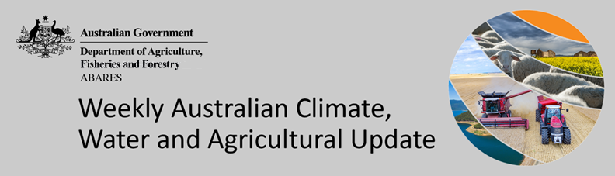
No. 45/2022

17 November 2022

Summary of key issues
- For the week ending 16 November 2022, a combination of low-pressure systems, surface troughs and northerly flow brought rainfall to parts of northern, eastern and southern Australia. Weekly rainfall totals exceeding 50 millimetres were observed across New South Wales, as well as parts of Queensland, Victoria, South Australia, the Northern Territory and Tasmania (see Section 1.1).
- Heavy rainfall across large areas of New South Wales and Victoria has caused further flooding across several river catchments. The flooding events are expected to damage agricultural and transport infrastructure as well as cause significant crop losses for some growers. However, the full extent of damage continues to remain unknown. Cooler than normal conditions and a late start to the winter cropping season across large parts of southern Australia mean that many crops have yet to mature, giving crops an opportunity to recover from recent inundation and avoid grain quality downgrades (see Section 1.1).
- Below average rainfall globally during October is likely to result in lower-than-expected wheat production potential in Argentina, and adversely affected planting of winter wheat in the United States, while excessive rainfall across parts of the Russian Federation has delayed winter wheat planting. Further, the conflict in Ukraine continues to generate uncertainty around wheat, corn and sunflower production for 2022 and 2023. Below average rainfall and above average temperatures in recent months have also negatively affected corn production across parts of Argentina, Brazil, the European Union and the United States. Global production conditions have deteriorated compared to those used to formulate ABARES forecasts of global grain supplies and world prices in its September 2022 edition of the Agricultural Commodities Report. As a result, global grain and oilseed production is likely to be lower than that forecast earlier in September (see Section 1.2).
- Over the 8-days to 24 November 2022, high-pressure systems over southern Australia are forecast to bring limited rainfall across much of central, eastern and western Australia. Meanwhile, a trough is forecast to bring moderate rainfall to northern parts of Queensland, the Northern Territory and Western Australia. Low-pressure systems and frontal activity are forecast to bring moderate rainfall to parts of southern Australia. The slight easing of wet conditions across flood-affected cropping regions of eastern Australia will likely allow floodwaters to recede and reduce the risk of further waterlogging and reductions in yield potential. The forecast drier conditions are also expected to provide an opportunity for soils to drain and allow improved access to fields for harvest (see Section 1.3).
- Water storage levels in the Murray-Darling Basin (MDB) decreased between 9 November 2022 and 16 November 2022 by 104 gigalitres (GL). Current volume of water held in storage is 23 956 GL which represents 95 per cent of total capacity. This is 6 percent or 1281 GL more than at the same time last year (see Section 2.1).
- Allocation prices in the Victorian Murray below the Barmah Choke increased from $24 per ML on 10 November to $25 per ML on 17 November 2022. Prices are lower in the Goulburn-Broken due to the binding of the Goulburn intervalley trade limit (see Section 2.1).

Climate

Rainfall this week
For the week ending 16 November 2022, a combination of low-pressure systems, surface troughs and northerly flow brought rainfall to parts of northern, eastern and southern Australia. South-eastern Australia received particularly heavy rainfall towards the end of the week. Weekly rainfall totals exceeding 50 millimetres were observed across large parts of New South Wales, as well as isolated parts of Queensland, Victoria, South Australia, the Northern Territory and Tasmania. Meanwhile, weak low-pressure systems and high-pressure systems resulted in mostly dry conditions in much of Western Australia and parts of South Australia.
In Australian cropping regions, rainfall totals of between 15 and 100 millimetres were recorded across much of New South Wales, Victoria and South Australia, as well as isolated parts of south-western Queensland and southern parts of Western Australian. Little to no rainfall was recorded in remaining cropping regions of Queensland, the west of South Australia and much of Western Australia for the week ending 16 November 2022.
Heavy rainfall across large areas of New South Wales and Victoria has caused further flooding across several river catchments. The flooding events are expected to damage agricultural and transport infrastructure as well as cause significant crop losses for some growers. However, the full extent of damage continues to remain unknown. Cooler than normal conditions and a late start to the winter cropping season across large parts of southern Australia mean that many crops have yet to mature, giving crops an opportunity to recover from recent inundation and avoid grain quality downgrades.
Harvesting activity in Western Australia is beginning to gather pace, with rainfall and some hail damage in recent weeks causing minor interruptions. The continued wet conditions across southern parts of the state are likely to delay harvesting further. In South Australia, recent rainfall is expected to delay harvesting activity, but favourable conditions throughout the season are expected to deliver a large winter crop. A couple of weeks of dry conditions across southern Queensland has allowed harvesting of winter crops and the planting of summer crops to expand considerably.

Rainfall for the week ending 17 November 2022
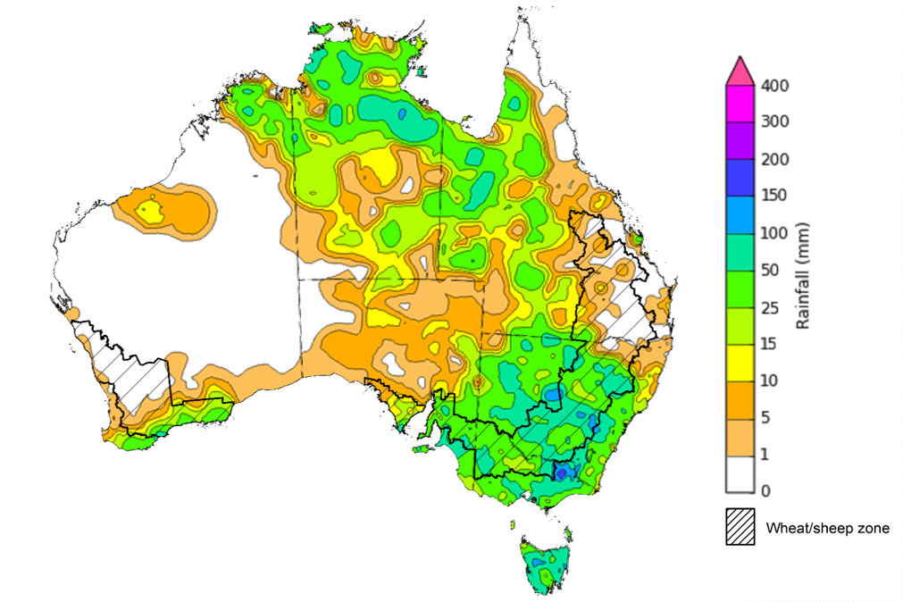
©Commonwealth of Australia 2022, Australian Bureau of Meteorology Issued: 16/11/2022
Note: The rainfall analyses and associated maps utilise data contained in the Bureau of Meteorology climate database, the Australian Data Archive for Meteorology (ADAM). The analyses are initially produced automatically from real-time data with limited quality control. They are intended to provide a general overview of rainfall across Australia as quickly as possible after the observations are received. For further information go to http://www.bom.gov.au/climate/rainfall/

Global production conditions and climate outlook
Crop production is affected by long-term trends in average rainfall and temperature, interannual climate variability, shocks during specific growth stages, and extreme weather events (IPCC 2012). Some crops are more tolerant than others to certain types of stresses, and at each growth stage, different types of stresses affect each crop species in different ways.
The precipitation anomalies and outlooks presented here give an indication of the current and future state of production conditions for the major grain and oilseed producing countries which are responsible for over 80% of global production. This is an important input to assessing the global grain supply outlook.

October precipitation percentiles and current production conditions
As of the end of October 2022, rainfall was below average across several of the world’s major grain-producing and oilseed-producing regions.
In the northern hemisphere, precipitation was below average across parts of central and north-eastern United States, much of Canada and Europe, and southern China. Precipitation was above average for eastern and south-western parts of the Russian Federation, as well as much of northern India, and south-western and northern parts of China. Precipitation was close to average across the remainder of the major grain-producing and oilseed-producing regions in the northern hemisphere.
In the southern hemisphere, October precipitation was below average for much of Argentina and parts of central and eastern Africa. Precipitation was above average for much of eastern Australia, and isolated parts of southern Africa. Precipitation was close to average across the remainder of major grain-producing and oilseed-producing regions in the southern hemisphere.

Global precipitation percentiles, October 2022

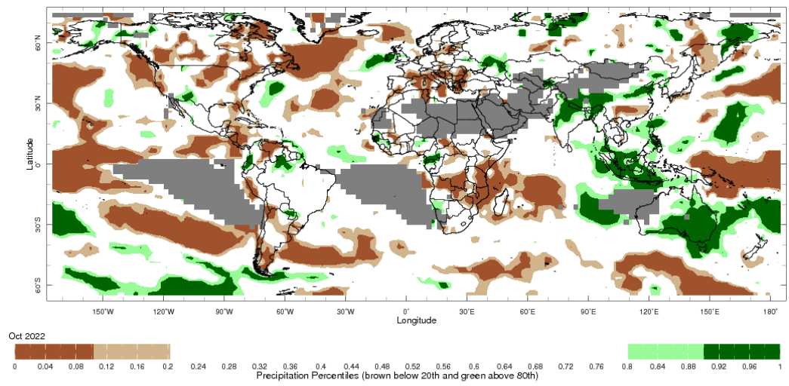
Note: The world precipitation percentiles indicate a ranking of precipitation for October, with the driest (0th percentile) being 0 on the scale and the wettest (100th percentile) being 1 on the scale. Percentiles are based on precipitation estimates from the NOAA Climate Prediction Center's Climate Anomaly Monitoring System Outgoing Precipitation Index dataset. Precipitation estimates for October 2022 are compared with rainfall recorded for that period during the 1981 to 2010 base period.
Source: International Research Institute for Climate and Society
As of 28 October 2022, global production conditions were generally favourable for soybeans, but quite variable for the production of wheat, corn, and rice.
In the northern hemisphere sowing of winter wheat is progressing under highly variable production conditions. In the Russian Federation heavy rainfall has delayed sowing activities, particularly in the southern and central districts. In the United States, winter wheat sowing is continuing under dry conditions in the southern and central Great Plains. In Ukraine, sowing is continuing under difficult conditions due to the ongoing war and areas of dryness in the south. Sowing of winter wheat is progressing well under generally favourable conditions across China, Turkey, Canada and the European Union. In the southern hemisphere, production conditions are exceptionally good in parts of Australia, but excessively wet conditions are impacting harvesting and quality of wheat in some eastern regions. In Argentina, poor growing conditions have persisted in the main producing areas. Harvesting has begun in the north with poor yields expected.
In Argentina, sowing of early-planted corn has been delayed significantly by extremely dry conditions and area-planted may be reduced in some regions. The sowing of spring-planted corn is progressing under favourable conditions in both Brazil and South Africa. In Mexico, harvesting of the spring-summer corn crop has begun under favourable conditions. In the European Union, drought conditions have resulted in a poor yield outlook for corn across the region. Hot, dry conditions have also negatively impacted yield prospects in the western and southern Corn Belt, while conditions in east and north remain very favourable. Across Indian growing regions, harvesting of the Kharif crop is ongoing under favourable conditions. In Ukraine, heavy rainfall during early spring delayed crop maturation and harvest in some parts, however, harvesting is now underway.
Harvesting of single-season rice is wrapping up across China, where extremely dry conditions in the lower Yangtze River region may have impacted rice crop yields. In the Philippines and Thailand, growth of wet-season rice is continuing under generally favourable conditions. In Vietnam, harvesting of wet-season rice is underway in the north and is wrapping up in the south. Sowing of wet-season rice has begun in Indonesia, while harvesting of dry-season rice continues under favourable conditions. In India, conditions for the Kharif crop have been favourable across growing regions, and harvesting has begun in the northern states. In Japan the rice harvest is wrapping up in the south and central regions and is continuing under favourable conditions in the north.
In the United States, harvesting of soybean is wrapping up under variable conditions. Hot and dry conditions in the mid-west have negatively impacted yields, while parts of the eastern corn belt are harvesting above-average yields. Harvest is wrapping up in Canada under exceptional conditions. Conditions have been largely favourable across China and India this growing season, with harvesting now drawing to a close. In Ukraine, the war continues to bring uncertainties for soybean production in eastern and southern areas. Outside the conflict zone the soybean harvest has passed the half-way mark under generally favourable conditions. Sowing of soybean is progressing under favourable conditions in Brazil, thanks in large part to good soil moisture availability.
Crop conditions, AMIS countries, 28 October 2022
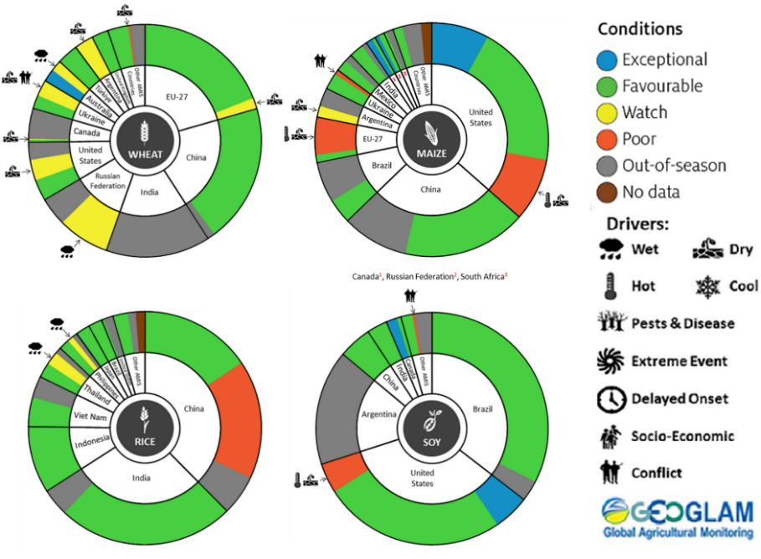
AMIS Agricultural Market Information System.
Source: AMIS
The global climate outlook for November 2022 to January 2023 indicates that variable rainfall conditions are expected for the world's major grain-producing and oilseed-producing regions. Outlooks and potential production impacts for the major grain and oilseed producing countries are presented in the table.
Rainfall outlook and potential impact on the future state of production conditions between November 2022 to January 2023
Region | November to January rainfall outlook | Potential impact on production
Argentina | Below average rainfall is expected across most of Argentina between November 2022 to January 2023. | Below average rainfall is likely to adversely affect the silking, flowering, and grain filling of corn, as well as the flowering of cotton, ground nuts, soybeans, and sunflowers. The dry conditions mays also negatively impact the planting and vegetative growth of millet, rice, and sorghum.
Black Sea Region | Below average rainfall is forecast for much of the Black Sea Region, including southern Kazakhstan, eastern Ukraine, southern parts of the Russian Federation and Turkey. | Winter wheat and canola will remain dormant throughout November to January across the Black Sea Region. Below average rainfall in many parts may provide insufficient snowpack to protect crops from winterkill.
Brazil | Above average rainfall is more likely in northern and central parts of Brazil, while below average rainfall is more likely across the south of Brazil. | Below average rainfall in parts of southern Brazil will provide favourable conditions for harvesting of wheat in November. However, below average rainfall is likely to adversely affect flowering of corn, cotton, groundnuts, and soybeans, as well as the grain filling of corn in January. Above average rainfall in northern and central Brazil will benefit the growth, flowering, and filling of soybeans.
Canada | Above average rainfall is possible across parts of Alberta, Ontario, and Saskatchewan. Otherwise, there is no strong tendency towards below or above average rainfall across remaining parts of Canada between November 2022 to January 2023. | Average to slightly above average rainfall in parts of Canada is likely to provide favourable conditions for winter wheat sowing and will likely provide sufficient snowpack to prevent winterkill of winter wheat and canola through December and January.
China | Above average rainfall is likely in parts of central China and below average across northern, western, and south-eastern China in November 2022 to January 2023. | Below average rainfall in northern, western, and south-eastern China is likely to benefit the harvesting of cotton, sunflower, groundnuts, and late-season rice. However, dry conditions across northern and western China may impact sowing and establishment of winter wheat and barley during November, and may limit snowpack during winter, increasing the risk of winterkill.
Europe | Below average rainfall is more likely for parts of central and eastern Europe, while above average rainfall is expected in parts of southern Europe between November 2022 to January 2023. | Below average rainfall may limit snowpack in parts of central Europe, increasing the risk of winterkill for winter wheat and canola. Meanwhile, above average rainfall in southern Europe should provide favourable conditions for winter wheat crops.
South Asia (India) | Close to average rainfall is forecast for much of India, with above average rainfall in southern India and below average rainfall expected in parts of central and northern India. | Close to average rainfall across much of India will support the harvesting of corn, cotton, groundnuts, millet, rice, sorghum, and sunflower. However, below average rainfall in parts of central and northern India may negatively impact the vegetative growth and heading of winter wheat and canola.
Southeast Asia (SEA) | Above average rainfall is forecast across much of SEA between November 2022 to January 2023, except for parts of Indonesia, Malaysia, and northern Vietnam and Laos. | Above average rainfall in SEA is likely to benefit the growth and development of soybean, corn and rice throughout November to January. Below average rainfall in Malaysia, Indonesia, and northern Vietnam and Laos may impact the establishment of rice crops during a critical growth period.
The United States of America | Above average rainfall is likely for parts of the north-west and mid-west US and below average rainfall is more likely across much of the west, south-west and south-east of the US. | Below average rainfall across southern US is likely to support harvesting of corn and soybeans in November. Average to above average rainfall conditions expected across the northern US is likely to provide sufficient snow cover through winter to protect wheat and canola through dormancy.

Rainfall forecast for the next eight days
Over the 8-days to 24 November 2022, high-pressure systems over southern Australia are forecast to bring limited rainfall across much of central, eastern and western Australia. Meanwhile, a trough is forecast to bring moderate rainfall to northern parts of Queensland, the Northern Territory and Western Australia. Low-pressure systems and frontal activity are forecast to bring moderate rainfall to parts of southern Australia.
In Australian cropping regions, rainfall totals of between 10 to 25 millimetres are expected across much of Victoria and South Australia, as well as isolated parts southern of New South Wale, eastern Western Australia, and northern Queensland. Little to no rainfall is forecast for remaining cropping regions during the next 8-days.
The slight easing of wet conditions across flood-affected cropping regions of eastern Australia will likely allow floodwaters to recede and reduce the risk of further waterlogging and reductions in yield potential. The forecast drier conditions are also expected to provide an opportunity for soils to drain and allow improved access to fields for harvest.
Yield potentials for crops not impacted by flooding in south-eastern Australia remain very favourable. If this rainfall forecast is realised, it should allow for the harvesting of winter crops and provide ideal conditions for planting of summer crops across Queensland and New South Wales in the coming weeks.
The outlook for winter crops across South Australia and Western Australia remains very promising, as ideal conditions for the season to-date have established strong yield potentials. With little rainfall forecast for cropping regions in Western Australia over the next week, this should provide favourable conditions for crop maturation and harvesting activities.

Total forecast rainfall (mm) for the period 17 November to 24 November 2022
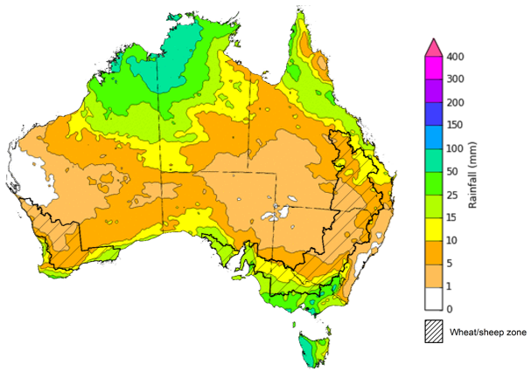
©Commonwealth of Australia 2022, Australian Bureau of Meteorology Issued 17/11/2022

Water
Note: This rainfall forecast is produced from computer models. As the model outputs are not altered by weather forecasters, it is important to check local forecasts and warnings issued by the Bureau of Meteorology.

Water markets – current week
Water storage levels in the Murray-Darling Basin (MDB) decreased between 9 November 2022 and 16 November 2022 by 104 gigalitres (GL). Current volume of water held in storage is 23 956 GL which represents 95 per cent of total capacity. This is 6 percent or 1281 GL more than at the same time last year.
Water storages in the Murray-Darling Basin, 2013–2022
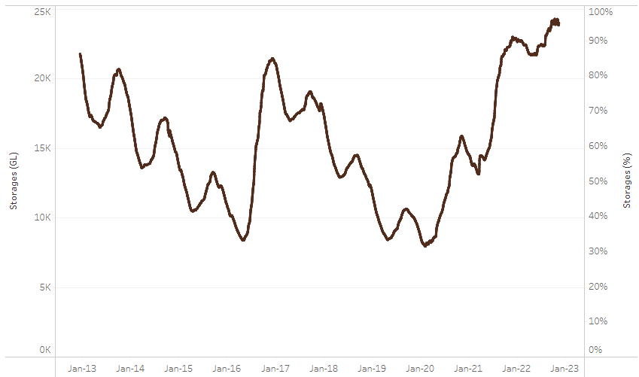
Allocation prices in the Victorian Murray below the Barmah Choke increased from $24 per ML on 10 November to $25 per ML on 17 November 2022. Prices are lower in the Goulburn-Broken due to the binding of the Goulburn intervalley trade limit
Water storage data is sourced from the Bureau of Meteorology.
Region | $/ML
NSW Murray Above | 30
NSW Murrumbidgee | 32
VIC Goulburn-Broken | 20
VIC Murray Below | 25

Surface water trade activity, Southern Murray–Darling Basin

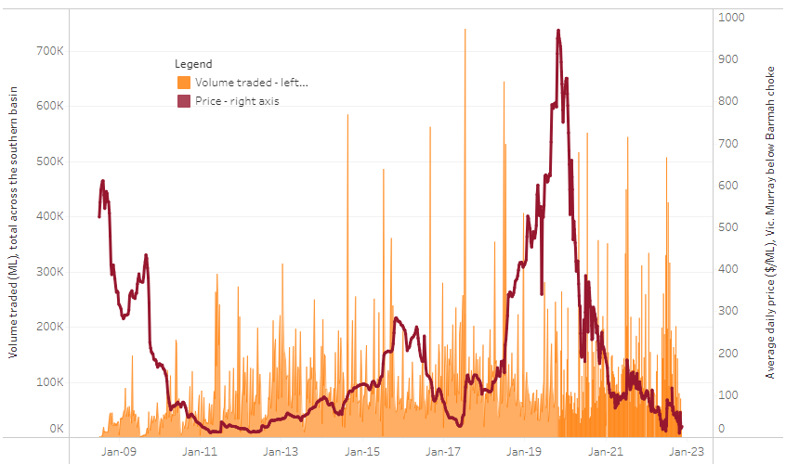
To access the full, interactive, weekly water dashboard, which contains the latest and historical water storage, water market and water allocation information, please visit http://www.agriculture.gov.au/abares/products/weekly_update/weekly-update-171122
The trades shown reflect estimated market activity and do not encompass all register trades. The price is shown for the VIC Murray below the Barmah choke. Historical prices (before 1 July 2019) are ABARES estimates after removing outliers from BOM water register data. Prices after 1 July 2019 and prior to the 30 October 2019 reflect recorded transaction prices as sourced from Ruralco. Prices after the 30 October 2019 are sourced from Waterflow. Data for volume traded is sourced from the BOM water register. Data shown is current at 17 November 2022.

Commodities

Indicator | Week ended | Unit | Latest price | Previous week | Weekly change | Price 12 months ago | Annual change
Selected world indicator prices
AUD/USD Exchange rate | 16-Nov | A$/US$ | 0.67 | 0.65 | 4% | 0.72 | -7%
Wheat – US no. 2 hard red winter wheat, fob Gulf | 16-Nov | US$/t | 433 | 430 | 1% | 395 | 10%
Corn – US no. 2 yellow corn, fob Gulf | 16-Nov | US$/t | 338 | 356 | -5% | 255 | 32%
Canola – Rapeseed, Canada, fob Vancouver | 16-Nov | US$/t | 715 | 708 | 1% | 881 | -19%
Cotton – Cotlook 'A' Index | 16-Nov | USc/lb | 104 | 104 | 0% | 127 | -18%
Sugar – Intercontinental Exchange, nearby futures, no.11 contract | 16-Nov | USc/lb | 19.0 | 17.9 | 6% | 19 | -2%
Wool – Eastern Market Indicator | 09-Nov | Ac/kg clean | 1,232 | 1,241 | -1% | 1,368 | -10%
Wool – Western Market Indicator | 09-Nov | Ac/kg clean | 1,379 | 1,526 | -10% | 1,442 | -4%
Selected Australian grain export prices
Milling Wheat – APW, Port Adelaide, SA | 16-Nov | A$/t | 594 | 612 | -3% | 494 | 20%
Feed Wheat – ASW, Port Adelaide, SA | 16-Nov | A$/t | 541 | 558 | -3% | 460 | 18%
Feed Barley – Port Adelaide, SA | 16-Nov | A$/t | 461 | 482 | -4% | 396 | 16%
Canola – Kwinana, WA | 16-Nov | A$/t | 1,095 | 1,119 | -2% | 1,026 | 7%
Grain Sorghum – Brisbane, QLD | 16-Nov | A$/t | 476 | 478 | 0% | 369 | 29%
Selected domestic livestock indicator prices
Beef – Eastern Young Cattle Indicator | 16-Nov | Ac/kg cwt | 1,006 | 1,018 | -1% | 1,070 | -6%
Mutton – Mutton indicator (18–24 kg fat score 2–3), Vic | 16-Nov | Ac/kg cwt | 467 | 530 | -12% | 588 | -21%
Lamb – Eastern States Trade Lamb Indicator | 16-Nov | Ac/kg cwt | 746 | 803 | -7% | 885 | -16%
Pig – Eastern Seaboard (60.1–75 kg), average of buyers & sellers | 26-Oct | Ac/kg cwt | 376 | 376 | 0% | 318 | 18%
Goats – Eastern States (12.1–16 kg) | 02-Nov | Ac/kg cwt | 485 | 680 | -29% | 818 | -41%
Live cattle – Light steers ex Darwin to Indonesia | 17-Aug | Ac/kg lwt | 420 | 480 | -13% | 320 | 31%
Live sheep – Live wethers (Muchea WA saleyard) to Middle East | 14-Sep | $/head | 93 | 113 | -18% | 114 | -18%

Indicator | Week ended | Unit | Latest price | Previous week | Weekly change | Price 12 months ago | Annual change
Global Dairy Trade (GDT) weighted average prices ª
Dairy – Whole milk powder | 16-Nov | US$/t | 3,397 | 3,279 | 4% | 3,037 | 12%
Dairy – Skim milk powder | 16-Nov | US$/t | 3,057 | 2,972 | 3% | 2,851 | 7%
Dairy – Cheddar cheese | 16-Nov | US$/t | 4,746 | 4,802 | -1% | 3,803 | 25%
Dairy – Anhydrous milk fat | 16-Nov | US$/t | 5,711 | 5,562 | 3% | 4,110 | 39%
a Global Dairy Trade prices are updated twice monthly on the first and third Tuesday of each month.

Selected world indicator prices
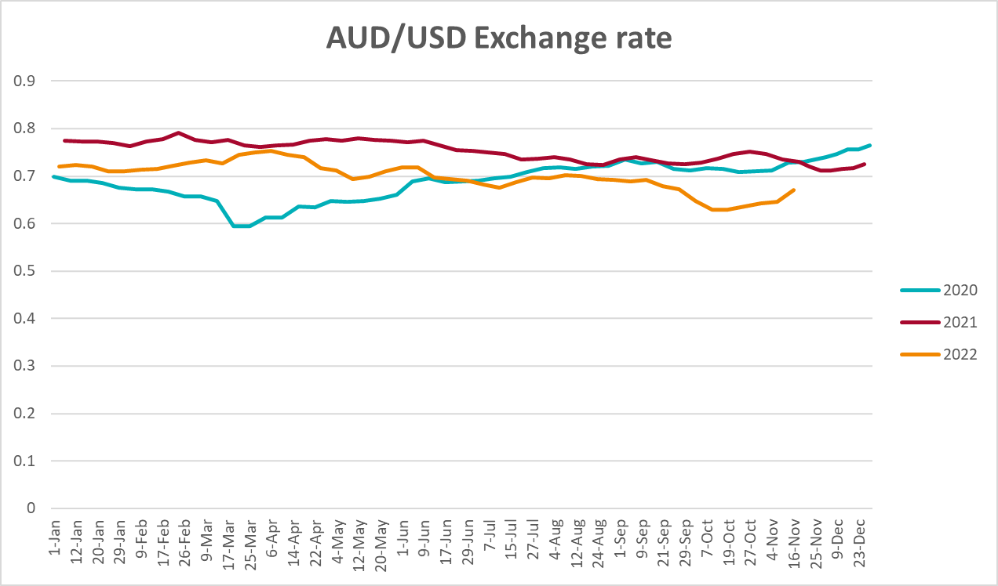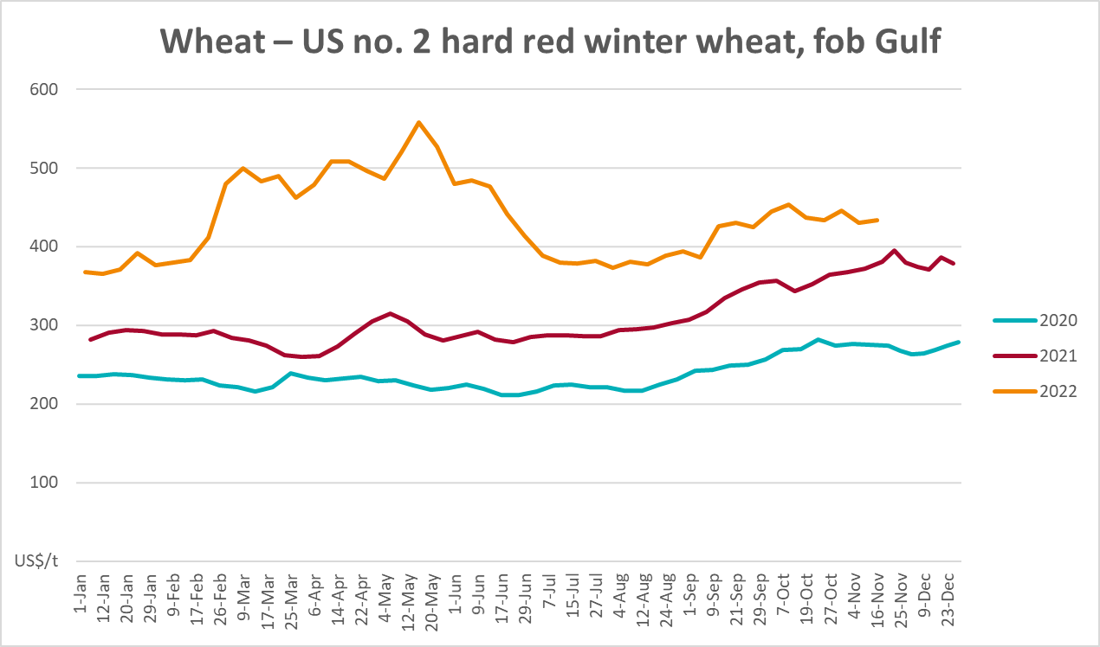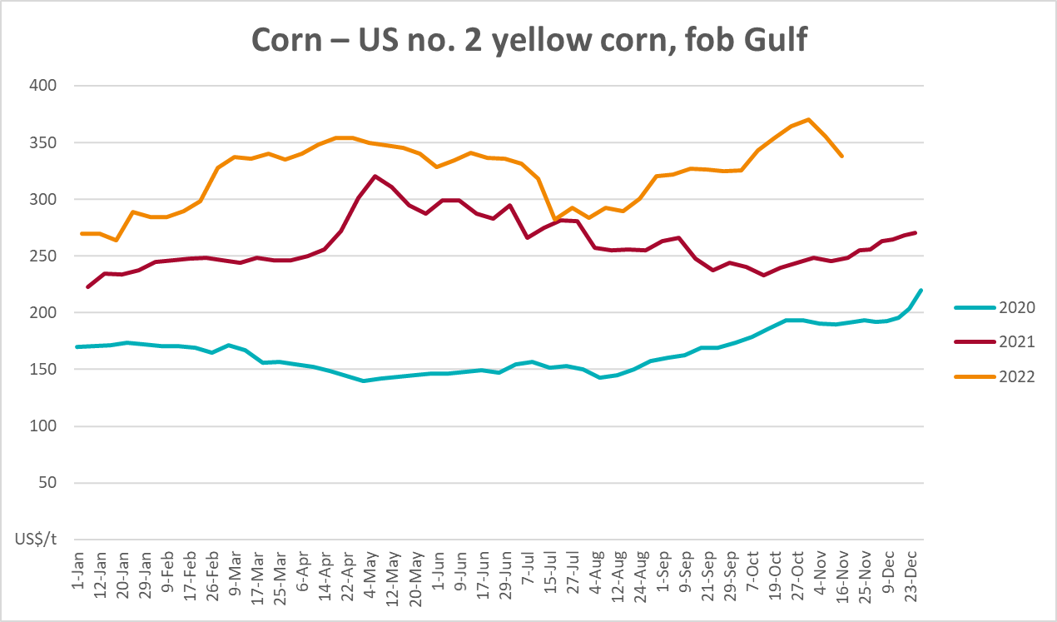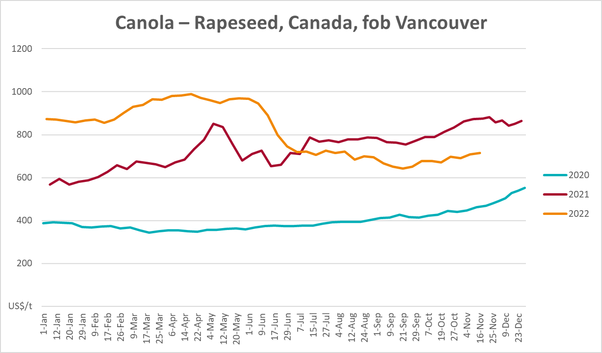

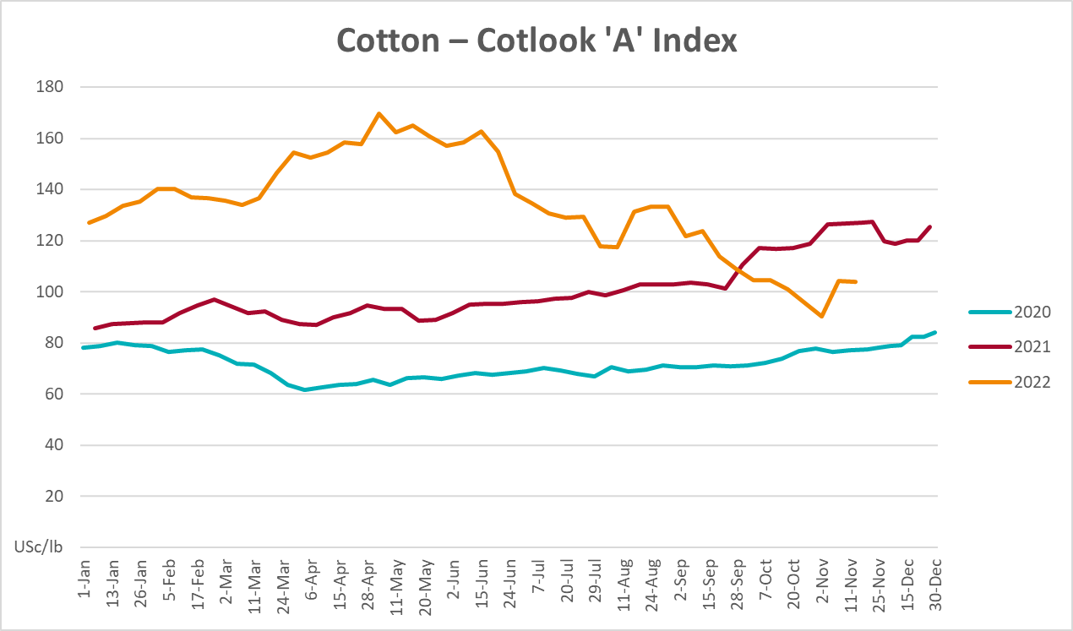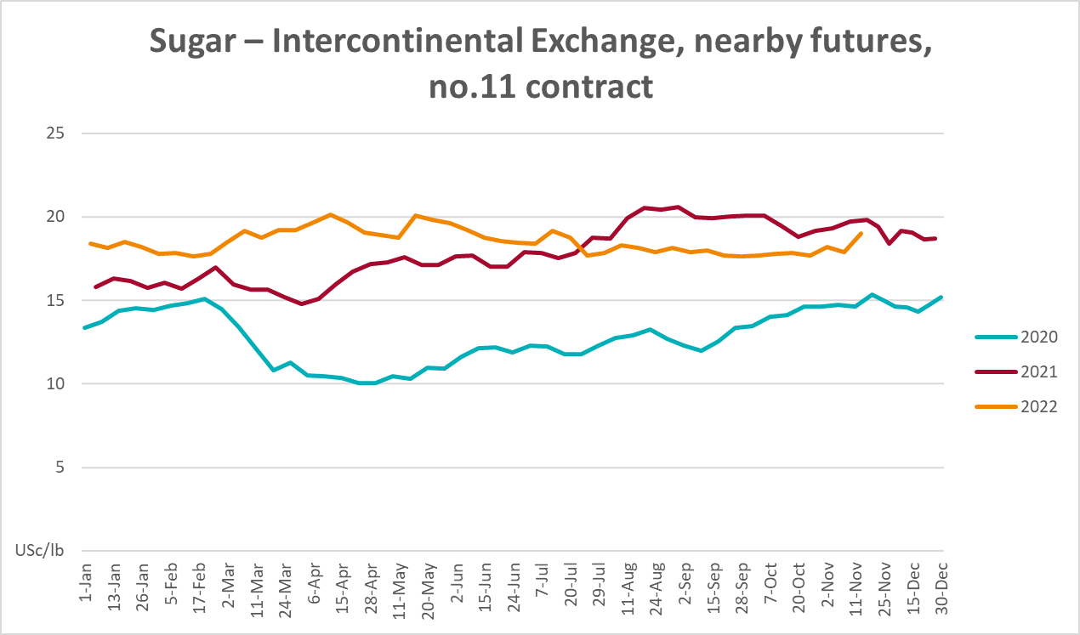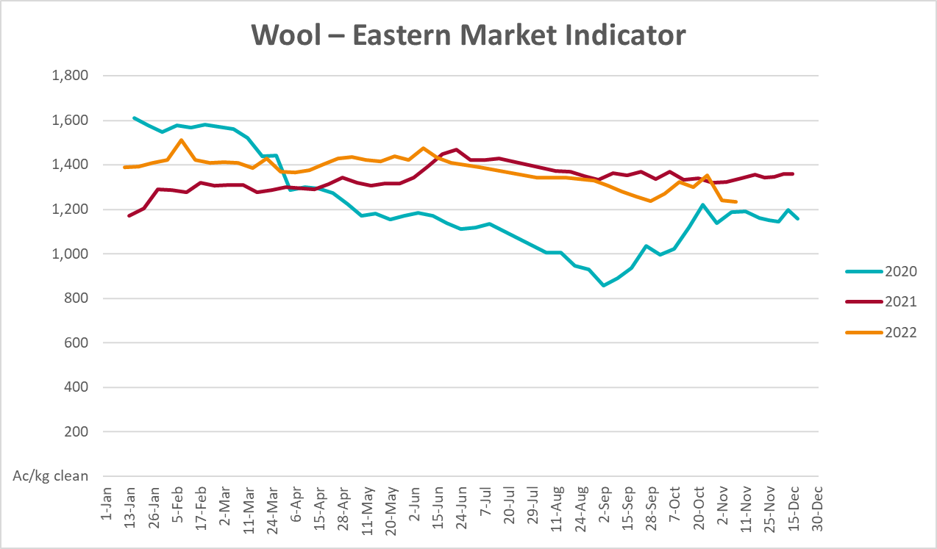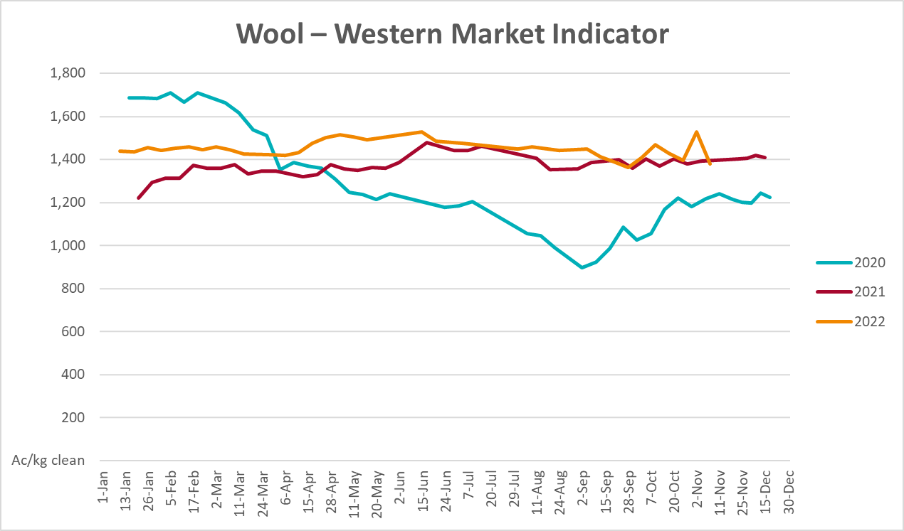

Selected domestic crop indicator prices
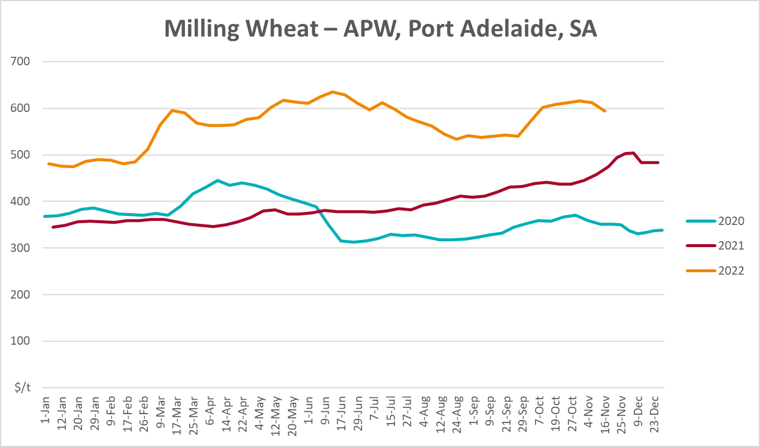
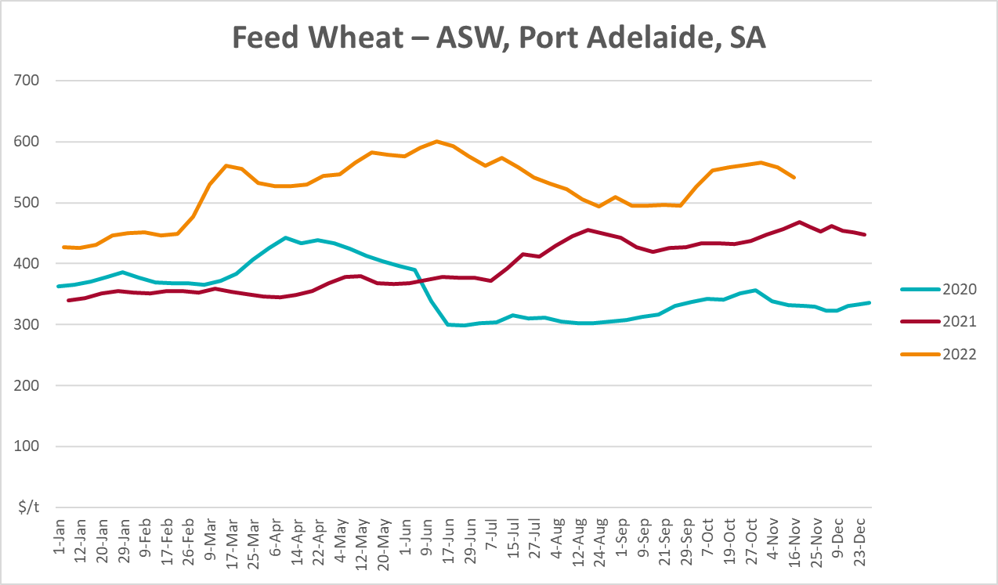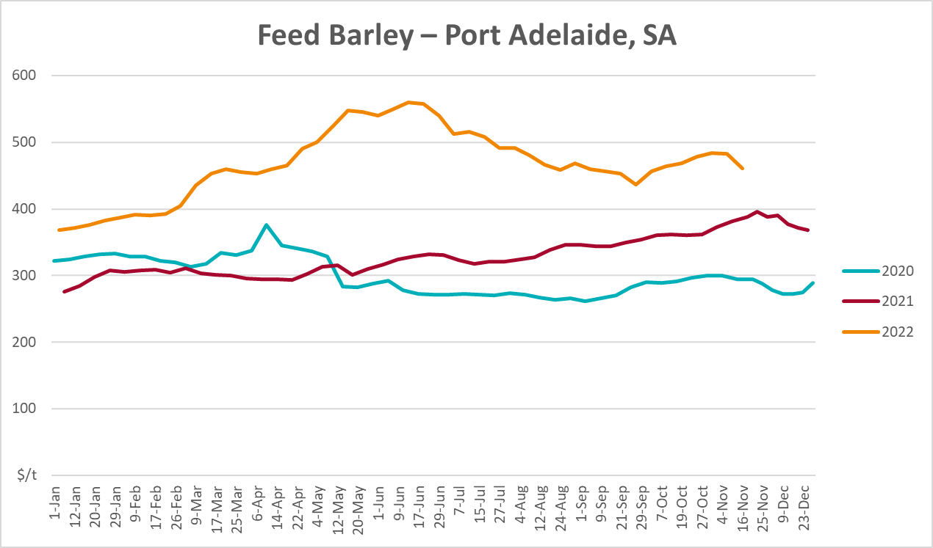
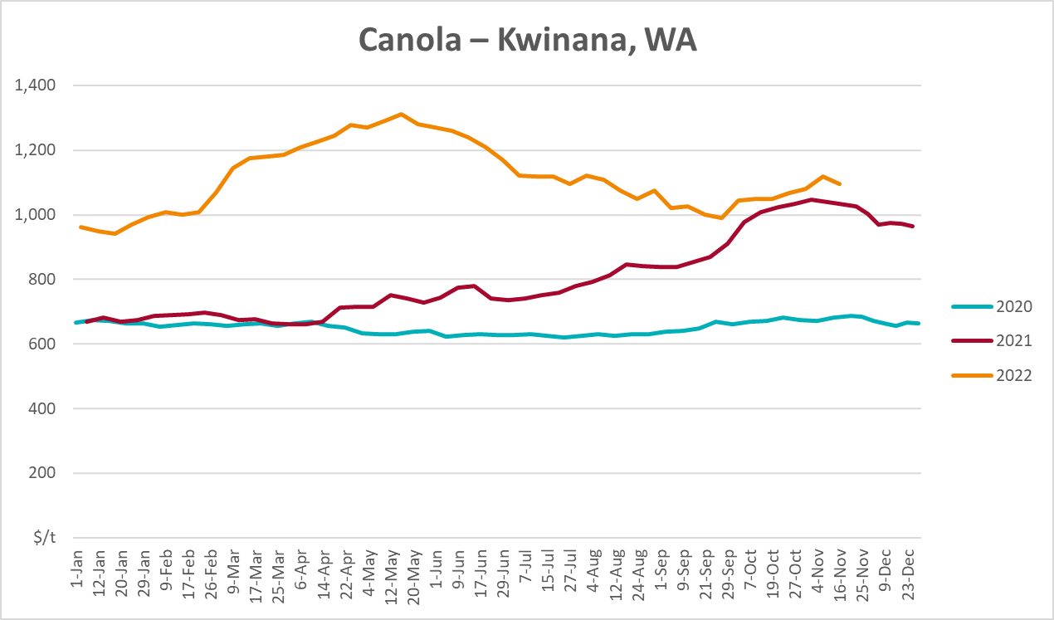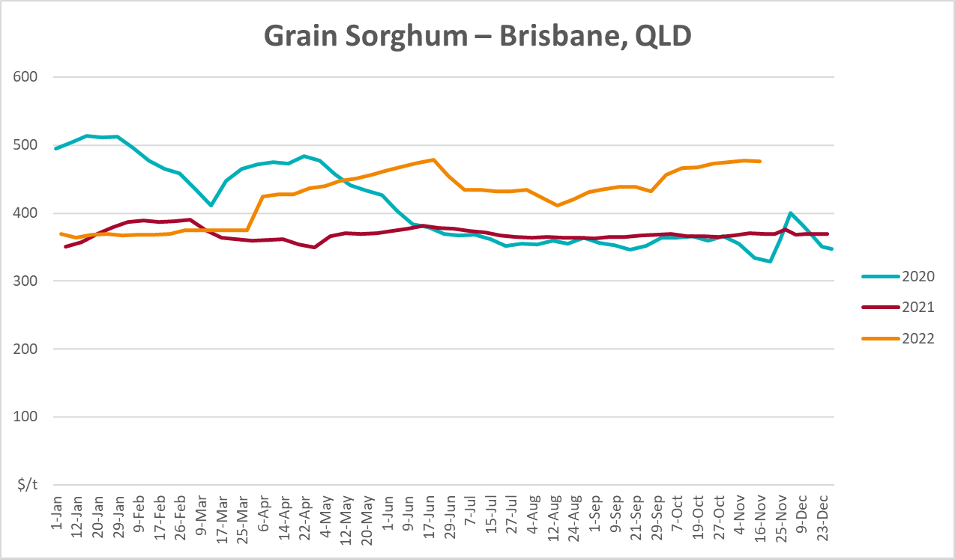

Selected domestic livestock indicator prices
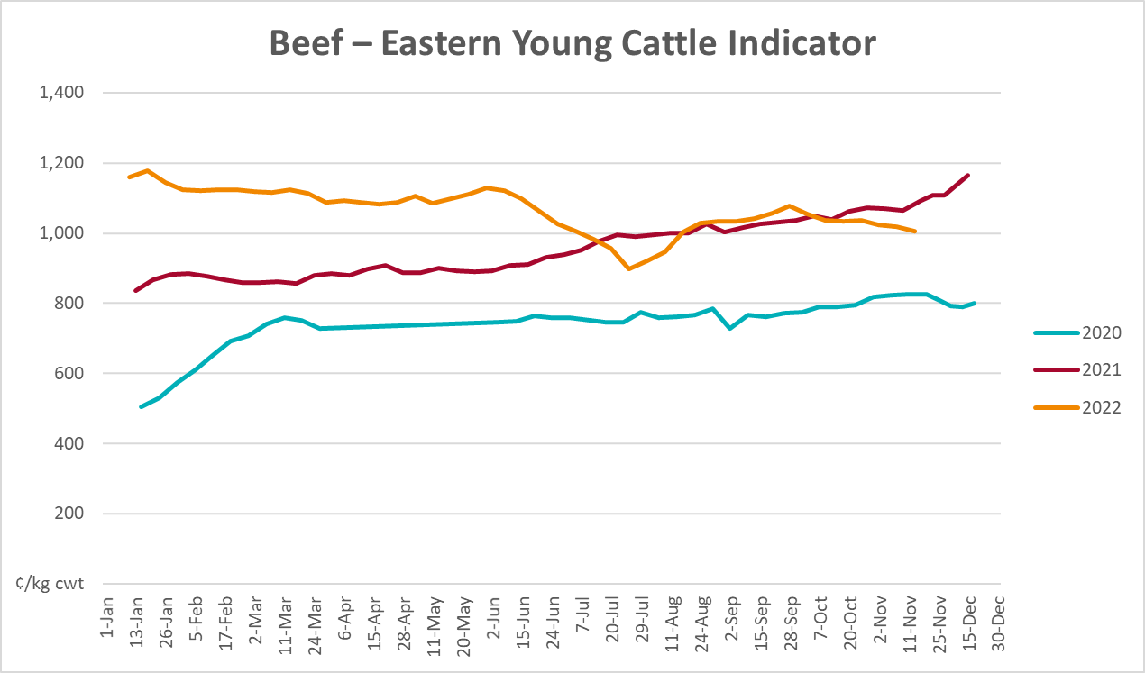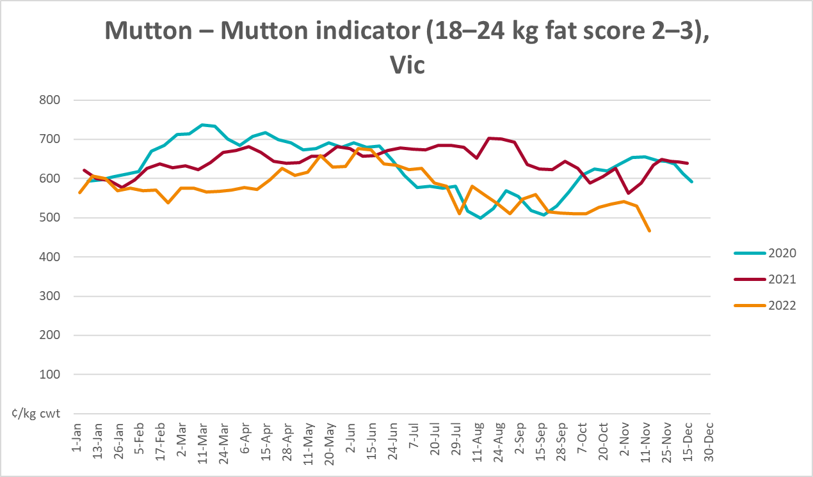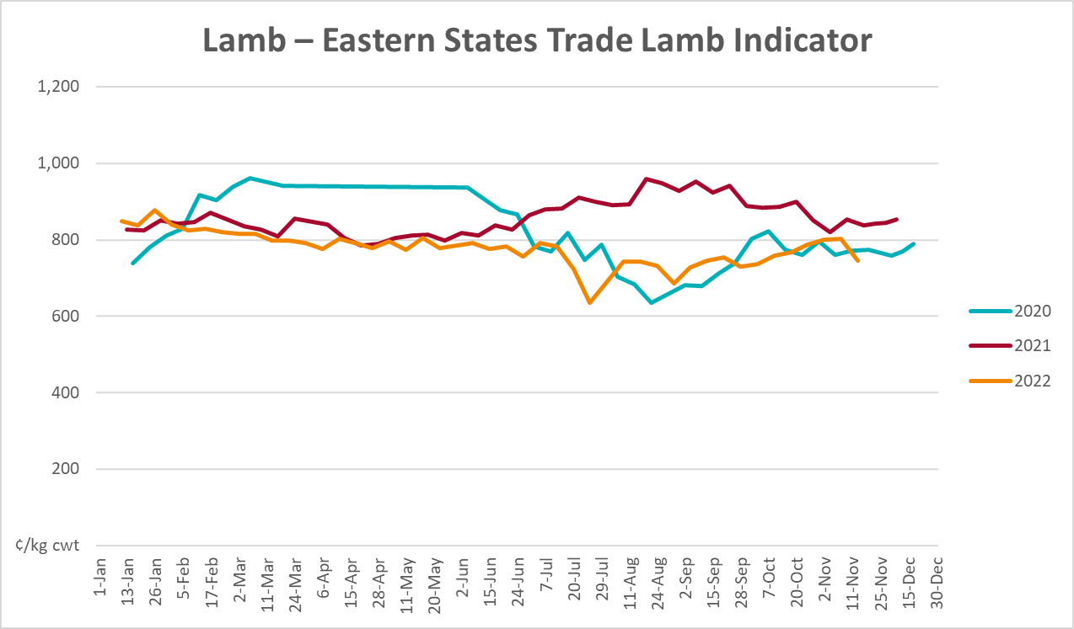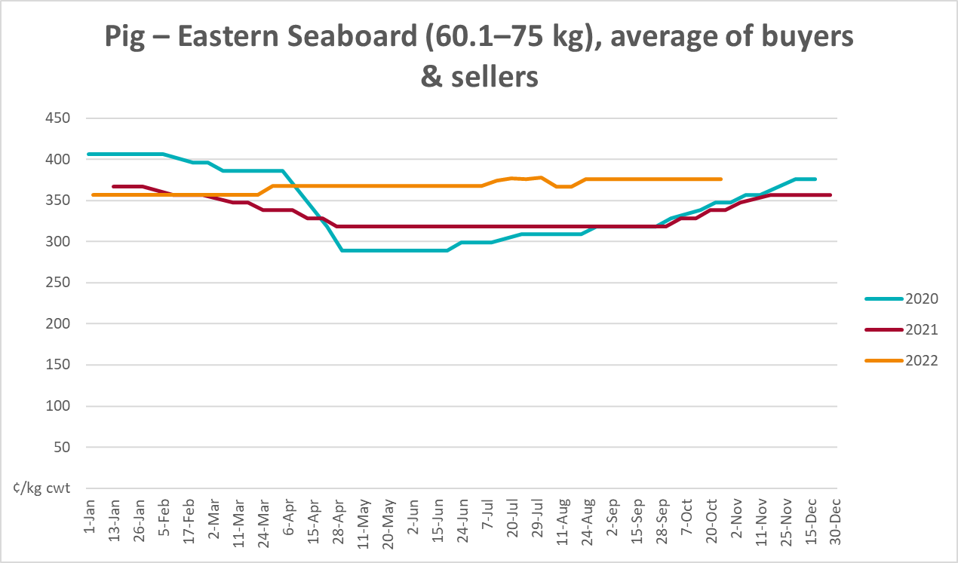
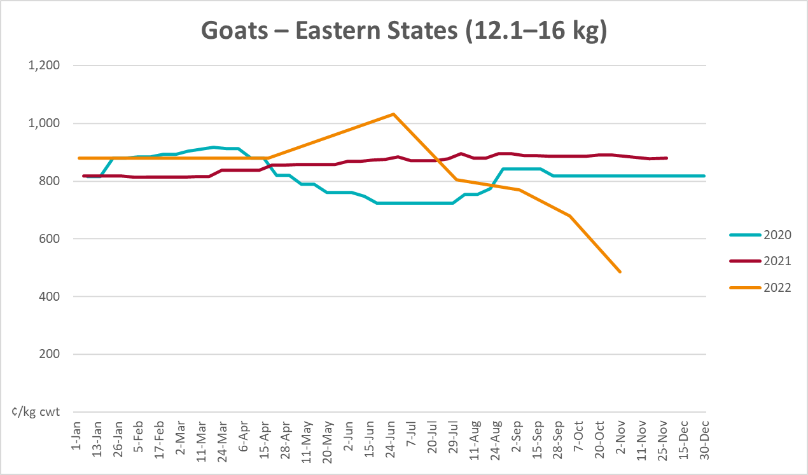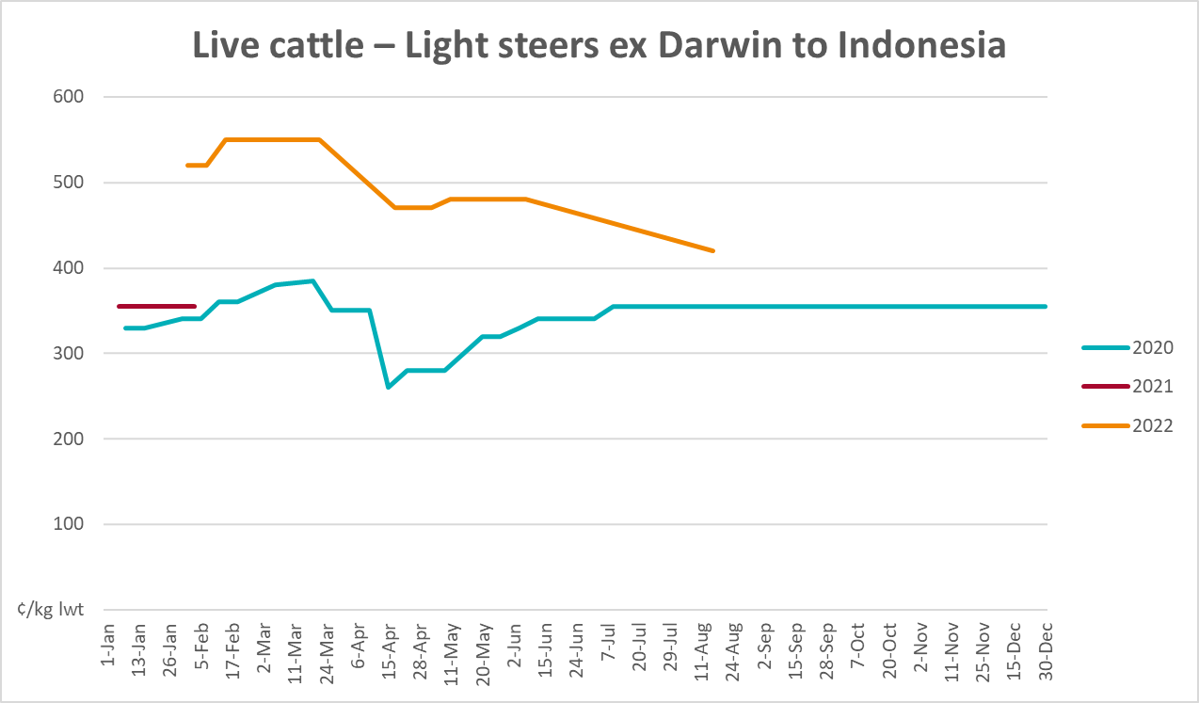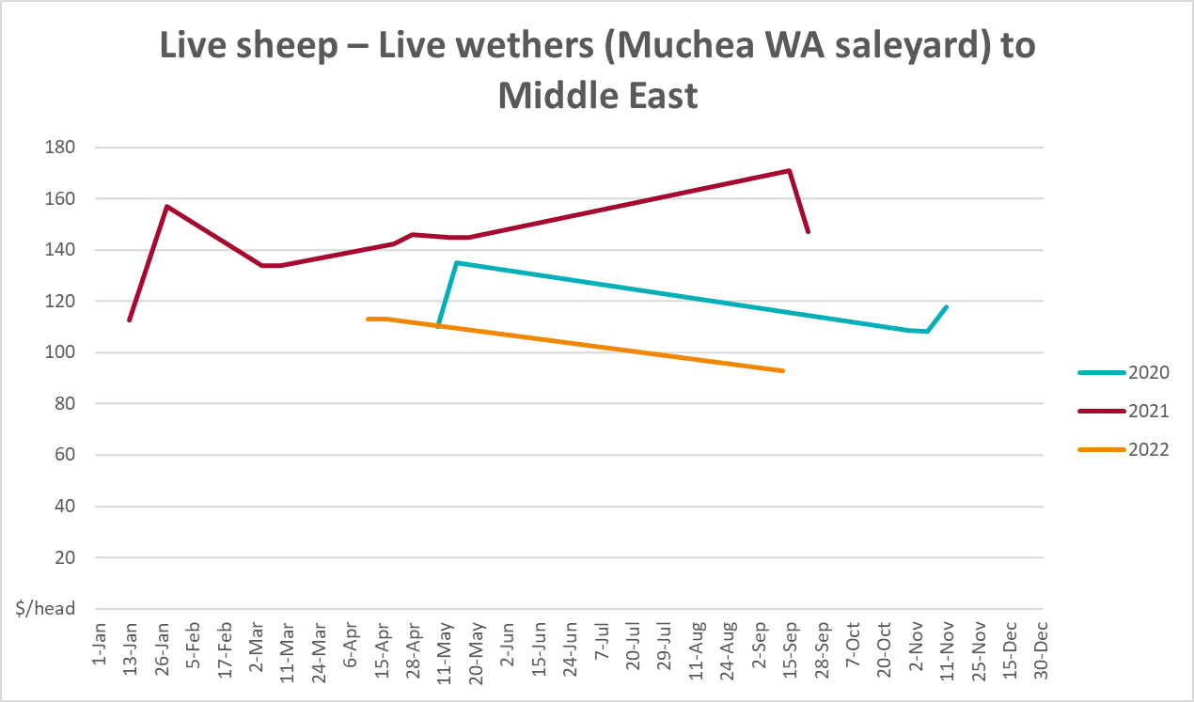

Global Dairy Trade (GDT) weighted average prices
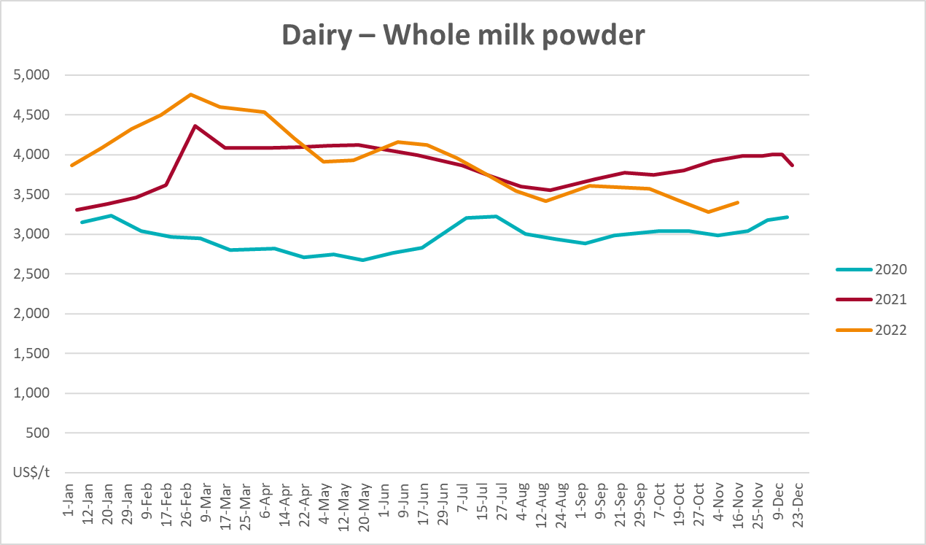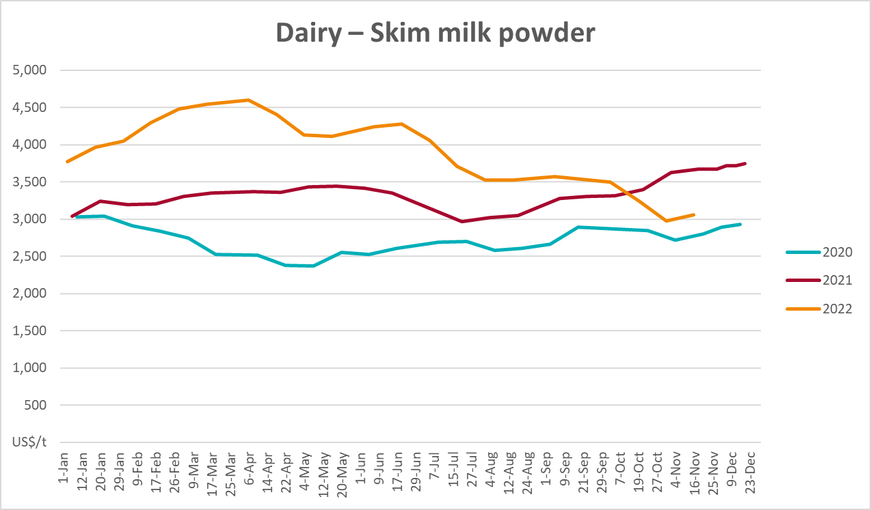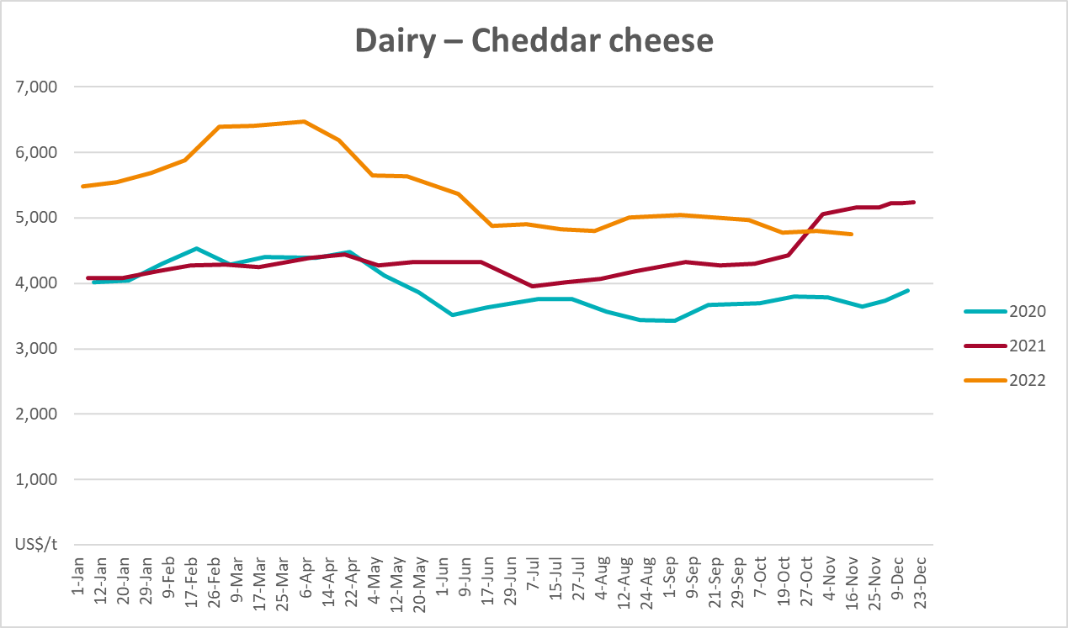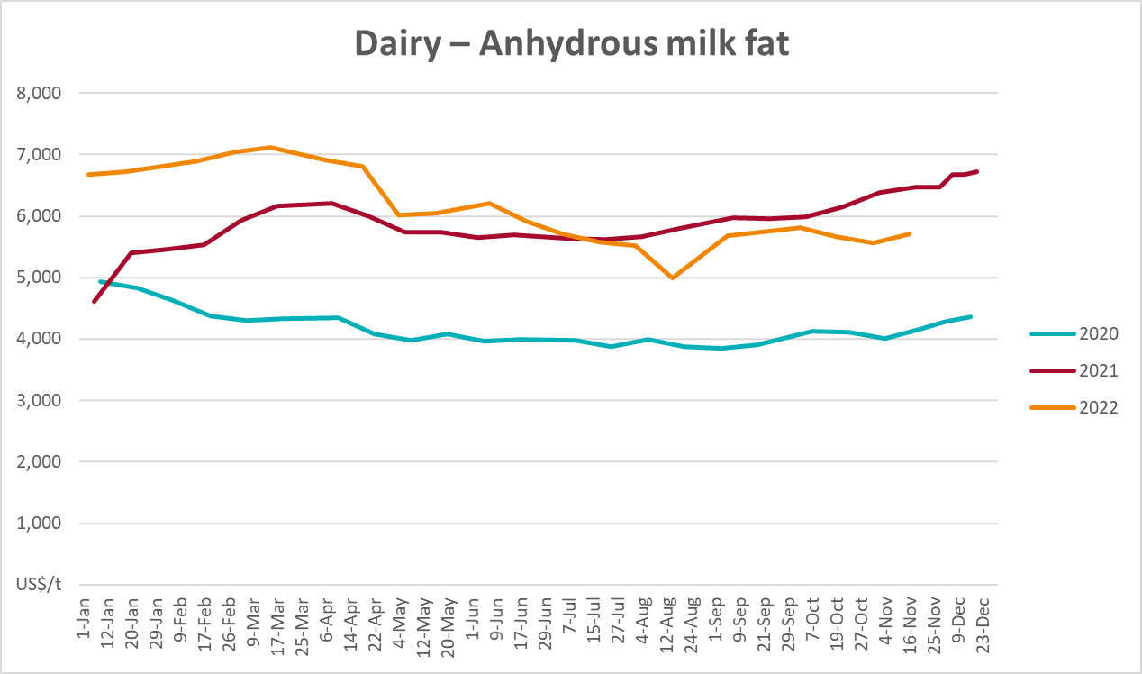

Selected fruit and vegetable prices
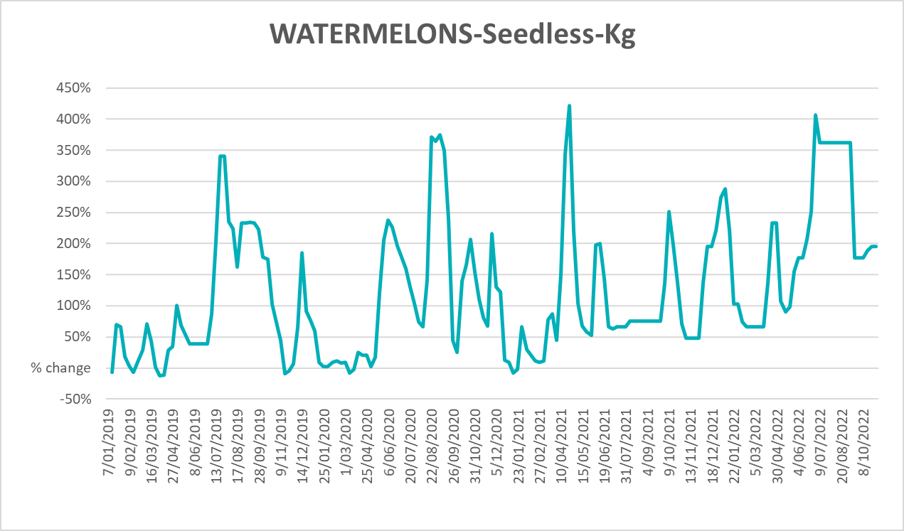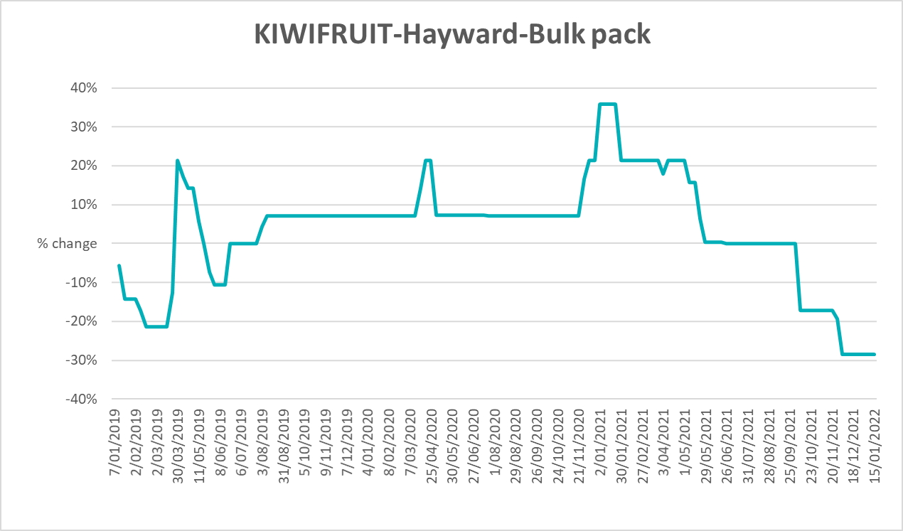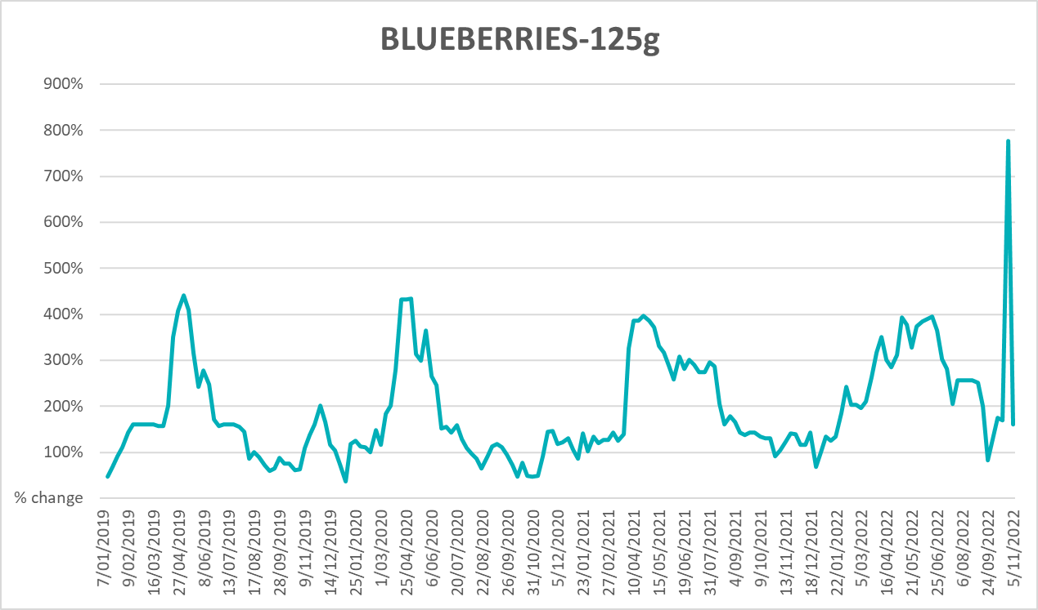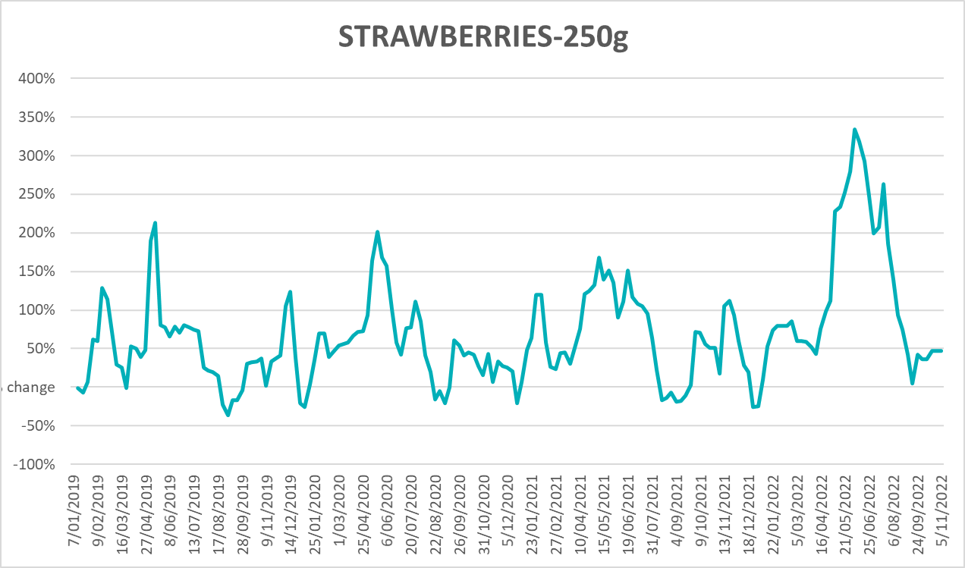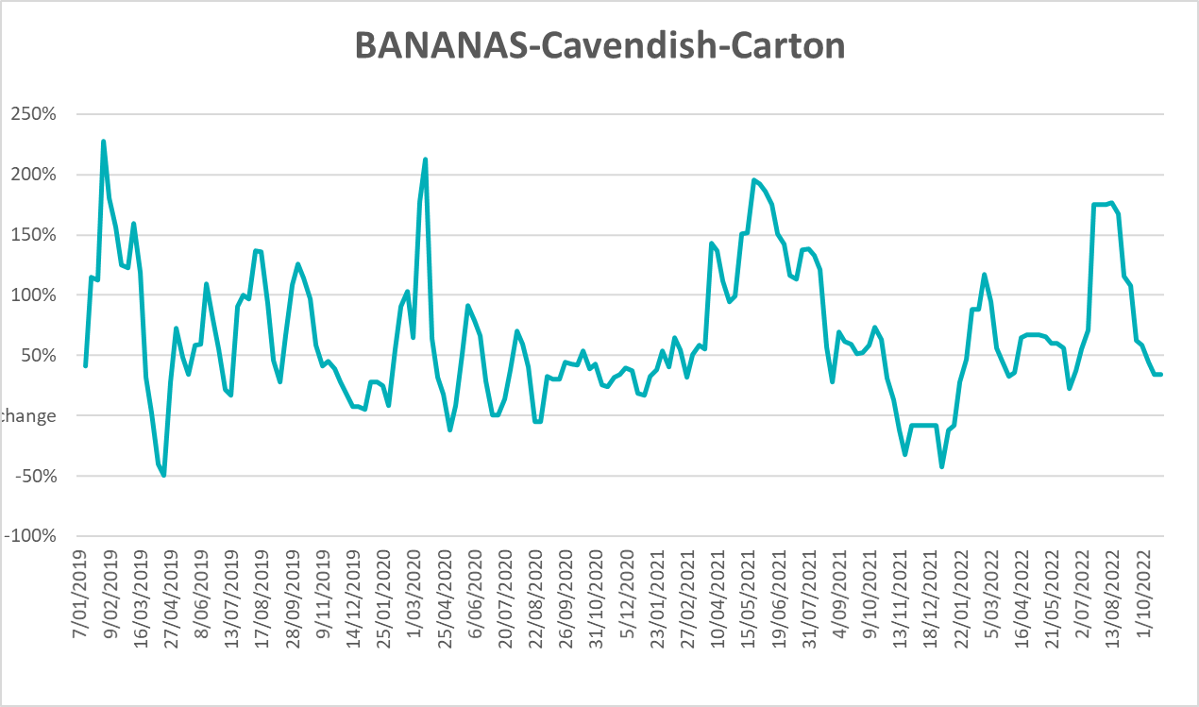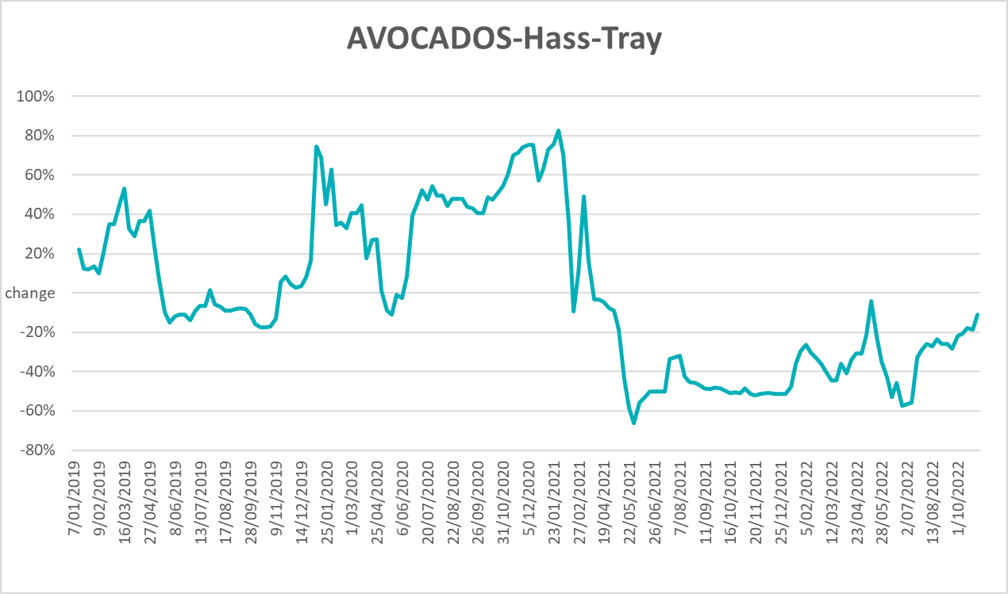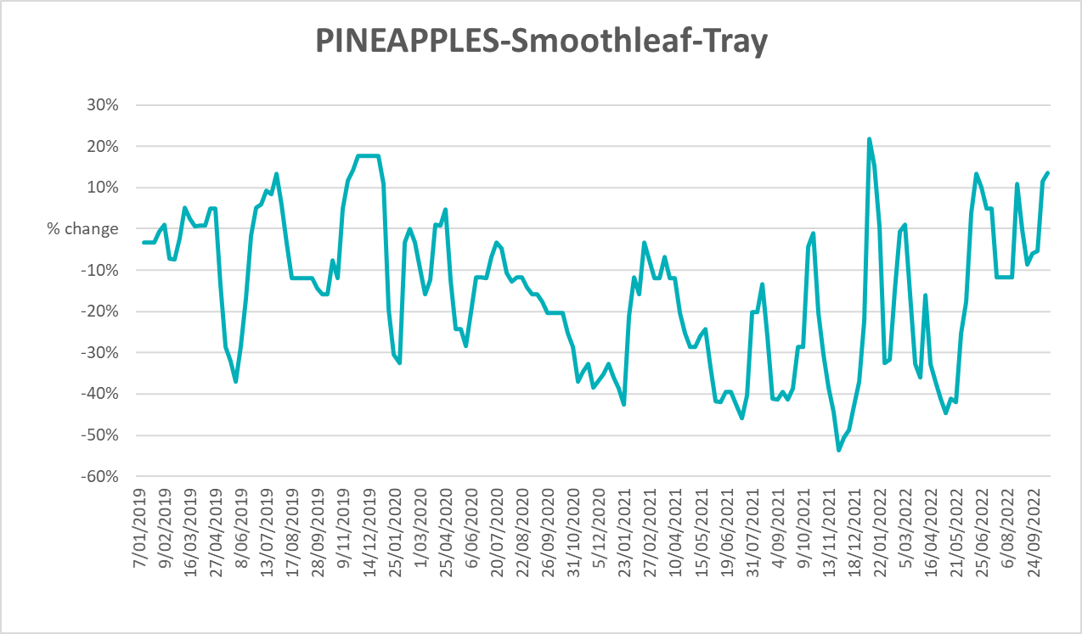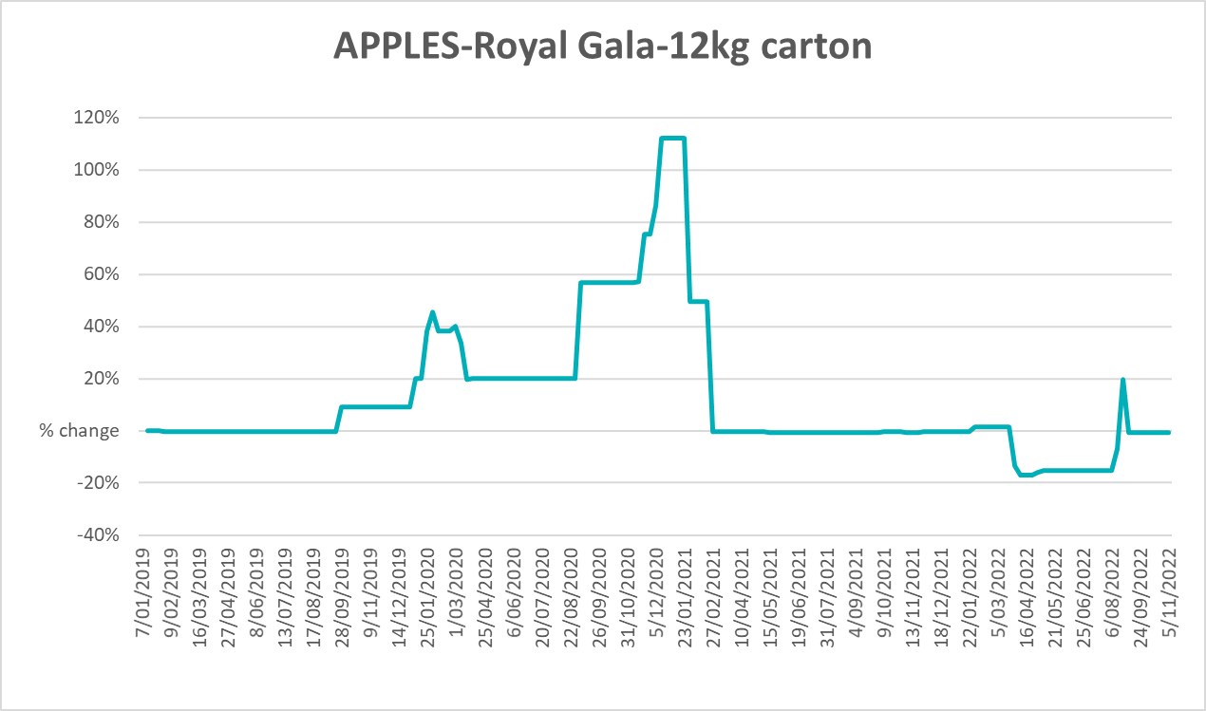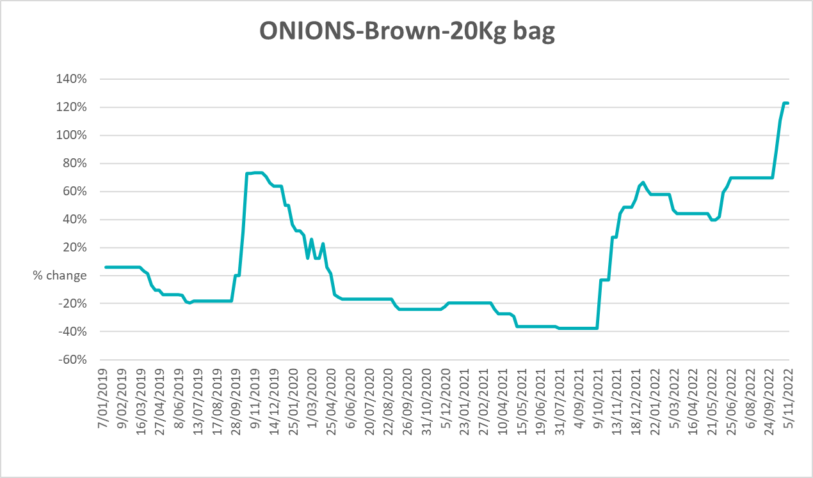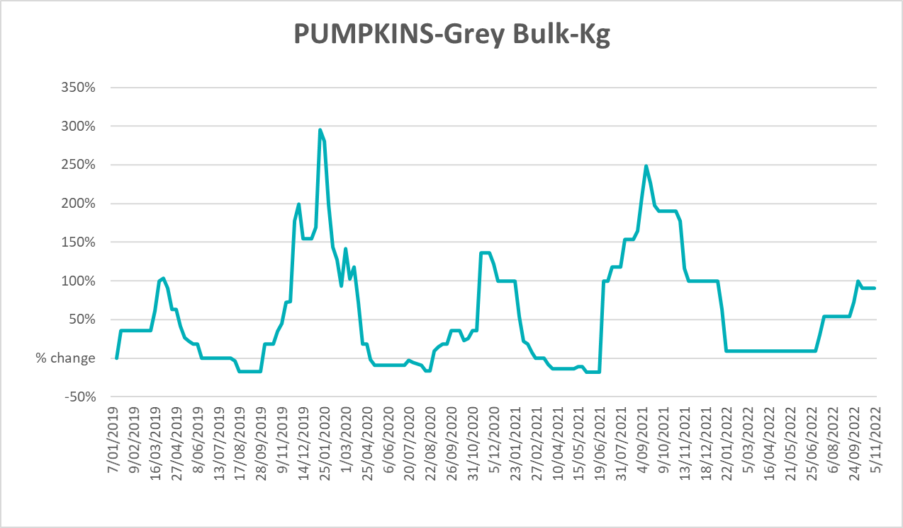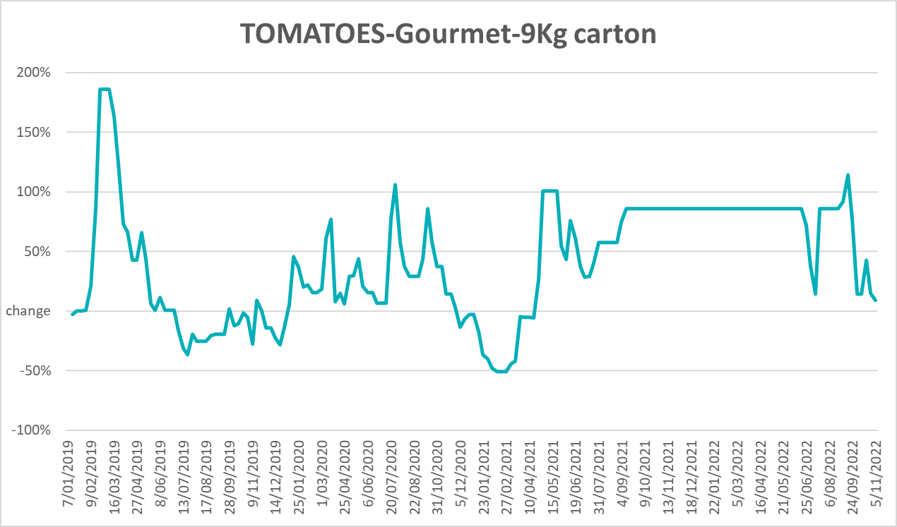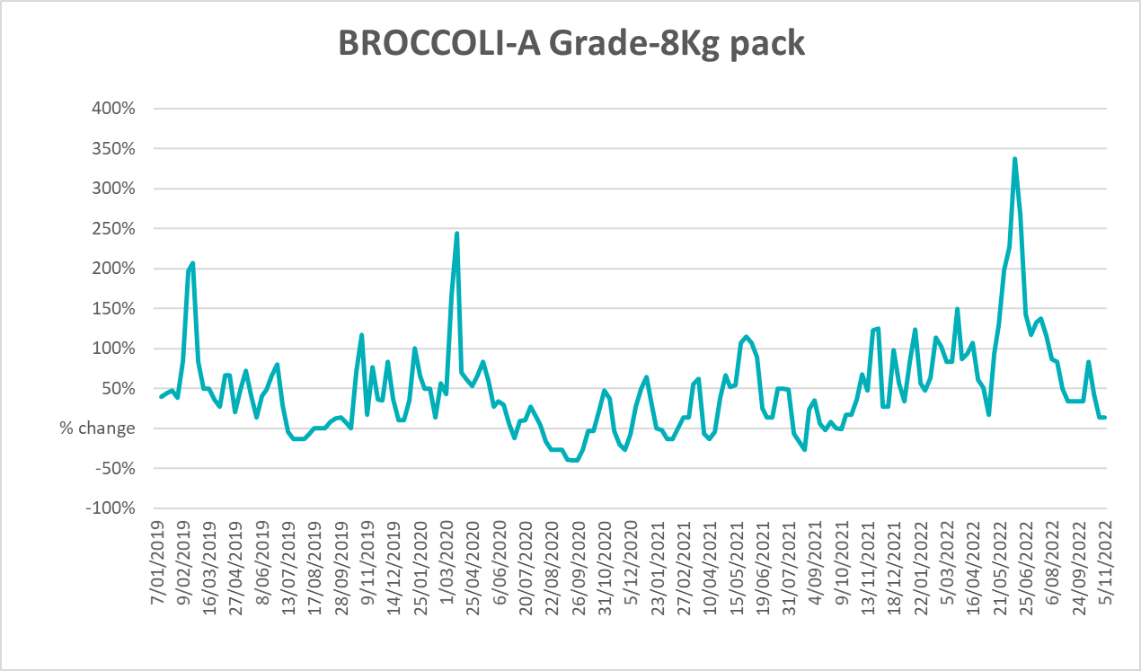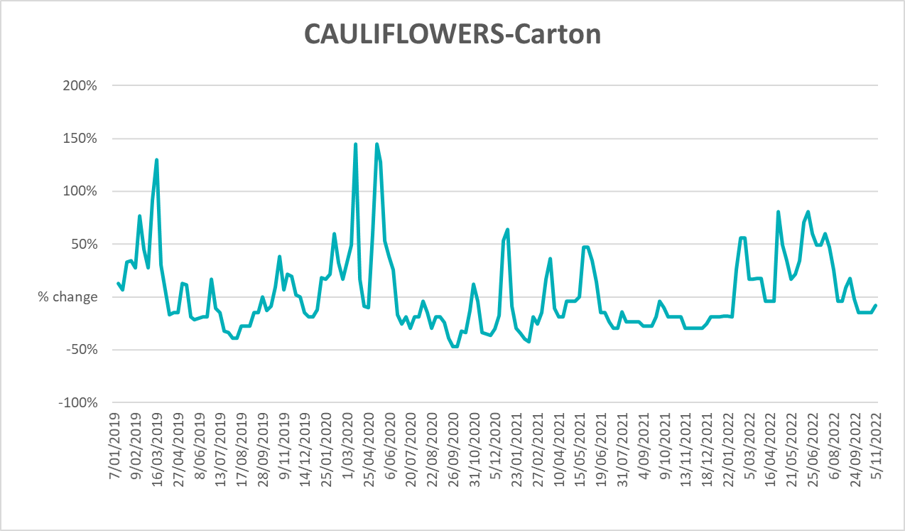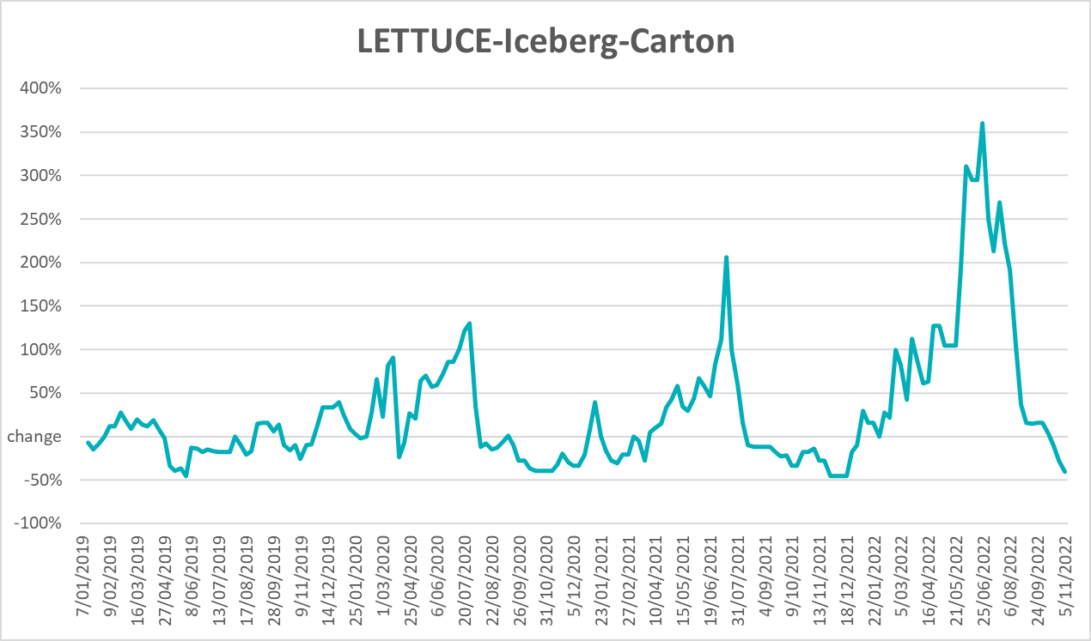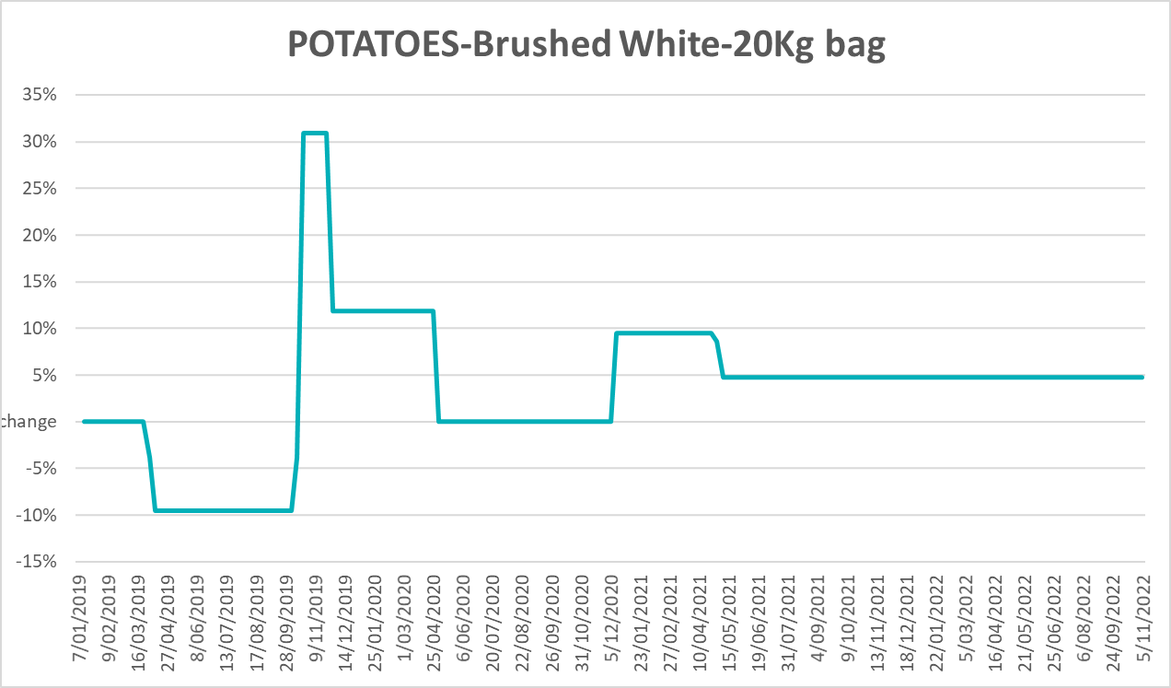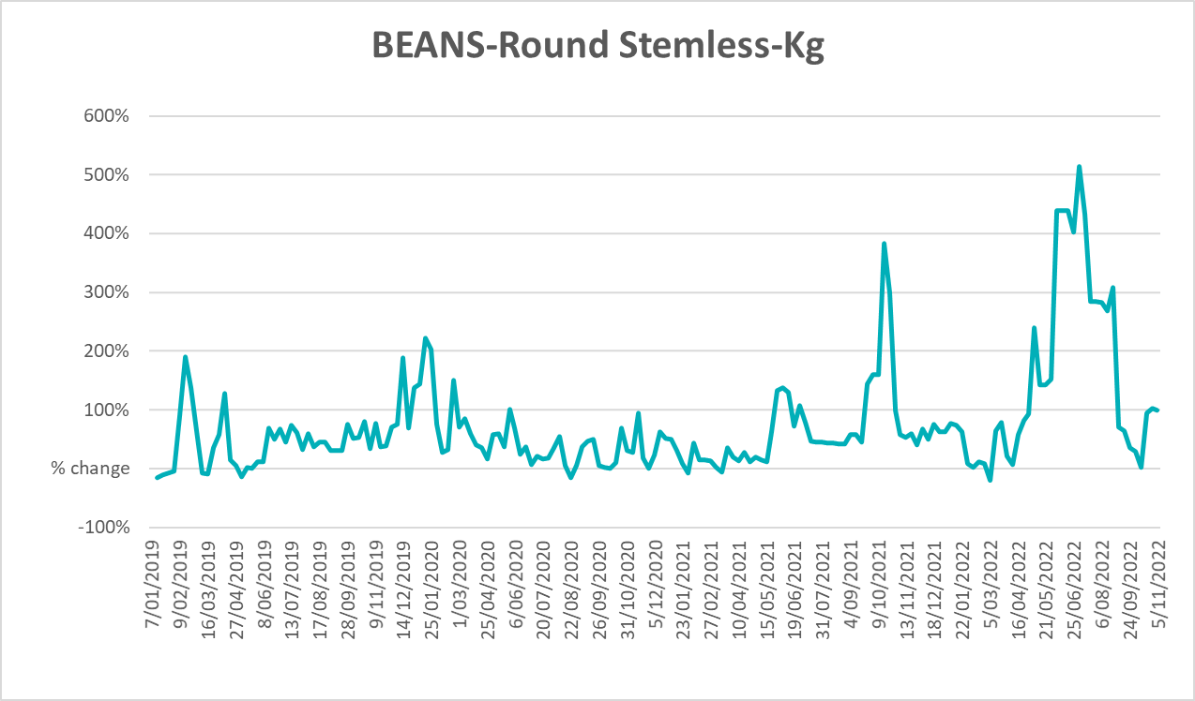

Selected domestic fodder indicator prices
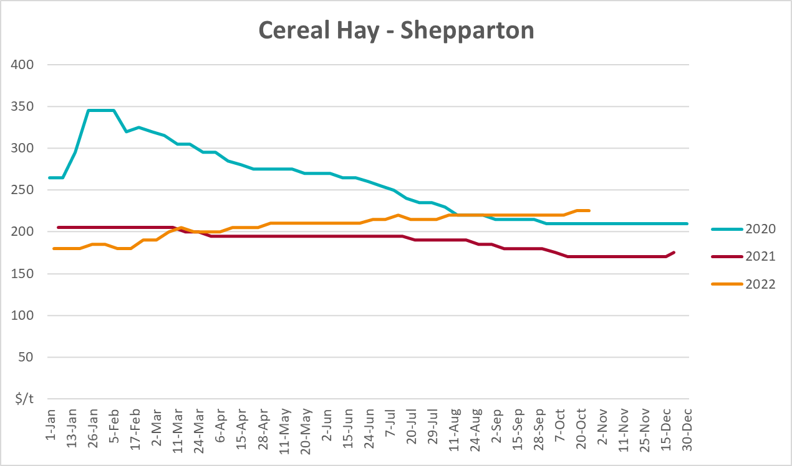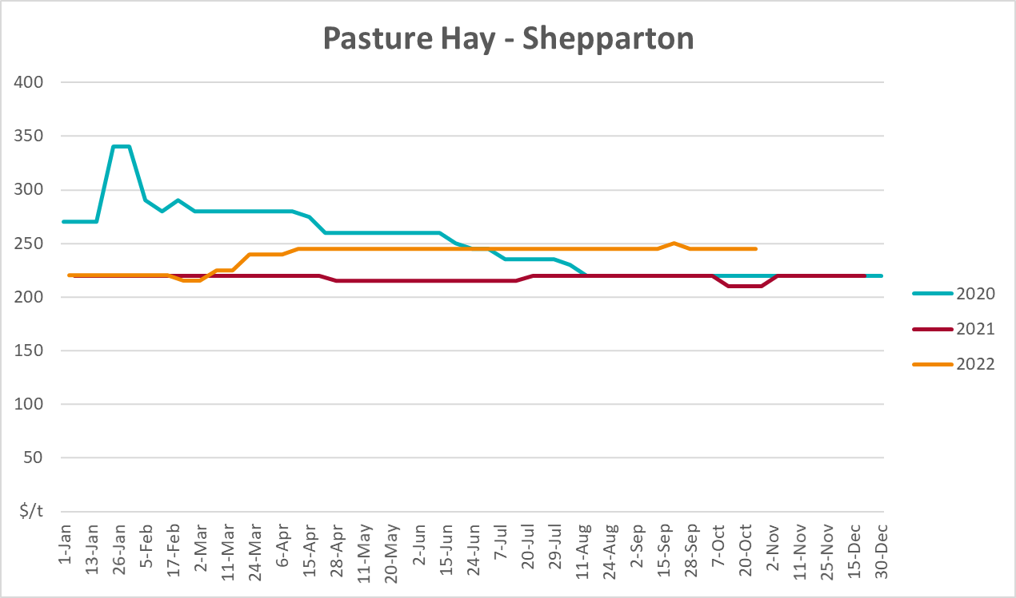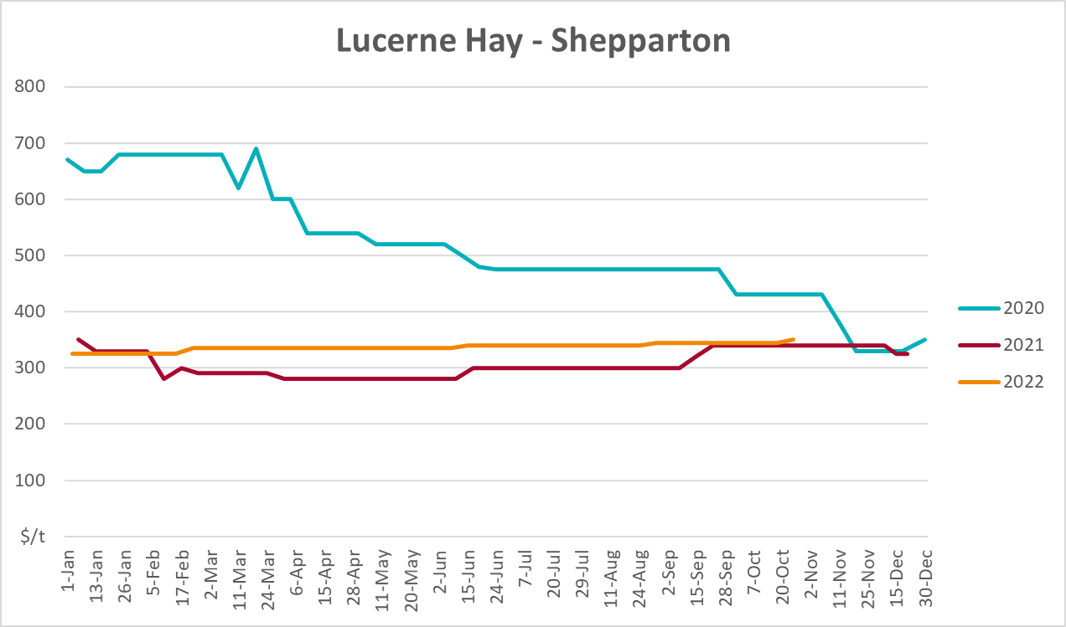

Data attribution

Climate
Bureau of Meteorology
- Weekly rainfall totals: www.bom.gov.au/climate/maps/rainfall/
- Monthly and last 3-month rainfall percentiles: www.bom.gov.au/water/landscape/
- Temperature anomalies: www.bom.gov.au/jsp/awap/temp/index.jsp
- Rainfall forecast: www.bom.gov.au/jsp/watl/rainfall/pme.jsp
- Seasonal outlook: www.bom.gov.au/climate/outlooks/#/overview/summary/
- Climate drivers: http://www.bom.gov.au/climate/enso/
- Soil moisture: www.bom.gov.au/water/landscape/
Other
- Pasture growth: www.longpaddock.qld.gov.au/aussiegrass/
- 3-month global outlooks: Environment and Climate Change Canada, NOAA Climate Prediction Center, EUROBRISA CPTEC/INPE, European Centre for Medium-Range Weather Forecasts, Hydrometcenter of Russia, National Climate Center Climate System Diagnosis and Prediction Room (NCC), International Research Institute for Climate and Society
- Global production: https://ipad.fas.usda.gov/ogamaps/cropmapsandcalendars.aspx
- Autumn break: Pook et al., 2009, https://rmets-onlinelibrary-wiley-com.virtual.anu.edu.au/doi/epdf/10.1002/joc.1833

Water
Prices
- Waterflow: https://www.waterflow.io/
- Ruralco: https://www.ruralcowater.com.au/
Bureau of Meteorology:
- Allocation trade: http://www.bom.gov.au/water/dashboards/#/water-markets/mdb/at
- Storage volumes: http://www.bom.gov.au/water/dashboards/#/water-storages/summary/drainage
Trade constraints:
- Water NSW: https://www.waternsw.com.au/customer-service/ordering-trading-and-pricing/trading/murrumbidgee
- Victorian Water Register: https://www.waterregister.vic.gov.au/TradingRules2019/

Commodities
Fruit and vegetables
- Datafresh: www.freshstate.com.au
Pigs
- Australian Pork Limited: www.australianpork.com.au
Dairy
- Global Dairy Trade: www.globaldairytrade.info/en/product-results/
World wheat, canola
- International Grains Council
World coarse grains
- United States Department of Agriculture
World cotton
- Cotlook: www.cotlook.com/
World sugar
- New York Stock Exchange - Intercontinental Exchange
Wool
- Australian Wool Exchange: www.awex.com.au/
Domestic wheat, barley, sorghum, canola and fodder
- Jumbuk Consulting Pty Ltd: http://www.jumbukag.com.au/
Cattle, beef, mutton, lamb, goat and live export
- Meat and Livestock Australia: www.mla.com.au/Prices-and-market
© Commonwealth of Australia 2022

Ownership of intellectual property rights
Unless otherwise noted, copyright (and any other intellectual property rights, if any) in this publication is owned by the Commonwealth of Australia (referred to as the Commonwealth).

Creative Commons licence
All material in this publication is licensed under a Creative Commons Attribution 4.0 International Licence except content supplied by third parties, logos and the Commonwealth Coat of Arms.
Inquiries about the licence and any use of this document should be emailed to copyright@awe.gov.au.


Cataloguing data
This publication (and any material sourced from it) should be attributed as:
ABARES 2022, Weekly Australian Climate, Water and Agricultural Update, Australian Bureau of Agricultural and Resource Economics and Sciences, Canberra, 17 November 2022. CC BY 4.0 DOI: https://doi.org/10.25814/5f3e04e7d2503
ISSN 2652-7561
This publication is available at https://www.agriculture.gov.au/abares/products/weekly_update
Department of Agriculture, Fisheries and Forestry
GPO Box 858 Canberra ACT 2601
Telephone 1800 900 090
Web agriculture.gov.au/abares

Disclaimer
The Australian Government acting through the Department of Agriculture, Fisheries and Forestry, represented by the Australian Bureau of Agricultural and Resource Economics and Sciences, has exercised due care and skill in preparing and compiling the information and data in this publication. Notwithstanding, the Department of Agriculture, Fisheries and Forestry, ABARES, its employees and advisers disclaim all liability, including liability for negligence and for any loss, damage, injury, expense or cost incurred by any person as a result of accessing, using or relying on any of the information or data in this publication to the maximum extent permitted by law.

Statement of Professional Independence
The views and analysis presented in ABARES publications, including this one, reflect ABARES professionally independent findings, based on scientific and economic concepts, principles, information and data. These views, analysis and findings may not reflect or be consistent with the views or positions of the Australian Government, or of organisations or groups who have commissioned ABARES reports or analysis. More information on professional independence is provided on the ABARES website.

Acknowledgements
This report was prepared by Katia Taylor, Cameron Van-Lane and Matthew Miller.

