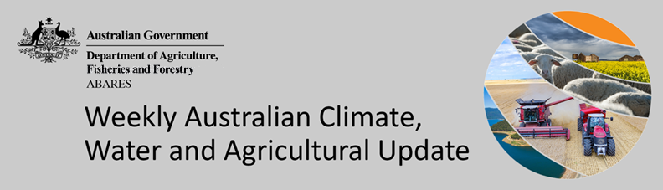

No. 49/2022

15 December 2022
This week’s Update will be the last for 2022.

The next Update will be published on 12 January 2023.

Summary of key issues
- For the week ending 14 December 2022, high-pressure systems brought a third consecutive week of relatively dry conditions to much of Australia. In Australian cropping regions, rainfall totals of between 15 and 100 millimetres were recorded across northern and south-eastern Queensland, central and eastern New South Wales and south-eastern Western Australia. Little to no rainfall was recorded in remaining cropping regions for the week ending 14 December 2022 (see Section 1.1).
- Three consecutive weeks of little to no rainfall across cropping regions of Victoria, South Australia and Western Australia would have continued to support the harvesting of winter crops. Across parts of southern Queensland and northern New South Wales, little rainfall would have allowed for field access to finalise the sowing of summer and harvesting of winter crops.
- Below average rainfall globally during November is likely to result in lower-than-expected wheat production potential in Argentina, and adversely affected planting and establishment of winter wheat across parts of the United States, the European Union, Turkey, and the Russian Federation. Further, the conflict in Ukraine continues to generate uncertainty around wheat, corn and soybean production in 2022 and 2023. Below average rainfall and above average temperatures in recent months have also negatively affected corn production across parts of Argentina and the European Union. Global production conditions have deteriorated compared to those used to formulate ABARES forecasts of global grain supplies and world prices in its December 2022 edition of the Agricultural Commodities Report. As a result, global grain and oilseed production is likely to be lower than that forecast earlier in December (see Section 1.2).
- Over the 8-days to 22 December 2022, little to no rainfall is forecast across most of Australian cropping regions. The continuation of dry conditions is expected to provide some relief to flood-affected cropping regions of south-eastern Australia and will likely further allow saturated soil to drain, however, a flooding risk remains to some areas as flood waters make their way further downstream. Little to no rainfall forecast across most cropping regions is likely to provide favourable conditions for winter crop harvesting and summer crop planting (see Section 1.1).
- Water storage levels in the Murray-Darling Basin (MDB) increased between 7 December 2022 and 14 December 2022 by 24 gigalitres (GL). Current volume of water held in storage is 24 043 GL which represents 95 percent of total capacity. This is 5 percent or 1183 GL more than at the same time last year.
- Allocation prices in the Victorian Murray below the Barmah Choke increased from $40 per ML on 8 December to $42 per ML on 15 December 2022. Prices are lower in the Murrumbidgee and regions above the Barmah choke due to the binding of the Murrumbidgee export limit and Barmah choke trade constraint (see Section 2).

Climate

Rainfall this week
For the week ending 14 December 2022, high-pressure systems brought a third consecutive week of relatively dry conditions to much of Australia. Weekly rainfall totals exceeding 50 millimetres were observed across scattered areas of south-eastern New South Wales, Victoria and Queensland, as well as the far north of the Northern Territory and much of Tasmania.
In Australian cropping regions, rainfall totals of between 15 and 100 millimetres were recorded across northern and south-eastern Queensland, central and eastern New South Wales and south-eastern Western Australia. Little to no rainfall was recorded in remaining cropping regions for the week ending 14 December 2022.
Three consecutive weeks of little to no rainfall across cropping regions of Victoria, South Australia and Western Australia would have continued to support the harvesting of winter crops. Across parts of southern Queensland and northern New South Wales, little rainfall would have allowed for field access to finalise the sowing of summer and harvesting of winter crops.

Rainfall for the week ending 14 December 2022
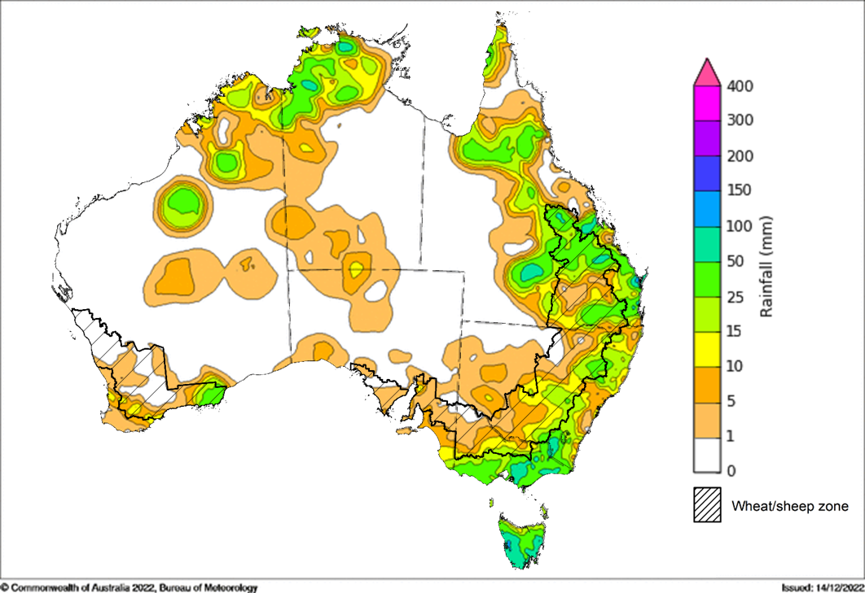
©Commonwealth of Australia 2022, Australian Bureau of Meteorology Issued: 14/12/2022
Note: The rainfall analyses and associated maps utilise data contained in the Bureau of Meteorology climate database, the Australian Data Archive for Meteorology (ADAM). The analyses are initially produced automatically from real-time data with limited quality control. They are intended to provide a general overview of rainfall across Australia as quickly as possible after the observations are received. For further information go to http://www.bom.gov.au/climate/rainfall/

Global production conditions and climate outlook
Crop production is affected by long-term trends in average rainfall and temperature, interannual climate variability, shocks during specific growth stages, and extreme weather events (IPCC 2012). Some crops are more tolerant than others to certain types of stresses, and at each growth stage, different types of stresses affect each crop species in different ways.
The precipitation anomalies and outlooks presented here give an indication of the current and future state of production conditions for the major grain and oilseed producing countries which are responsible for over 80% of global production. This is an important input to assessing the global grain supply outlook.
November precipitation percentiles and current production conditions
As of the end of November 2022, rainfall was below average across several of the world’s major grain-producing and oilseed-producing regions.
In the northern hemisphere, precipitation was below average across parts of central United States, eastern and south-western Canada, central Europe, and south-western China. Precipitation was above average for much of United Kingdom and Kazakhstan, parts of the Russian Federation, eastern China and Southeast Asia. Precipitation was close to average across the remainder of the major grain-producing and oilseed-producing regions in the northern hemisphere.
In the southern hemisphere, November precipitation was below average for central and eastern South America and parts of Angola. Precipitation was above average for parts of southern Australia, and small area of central and south-eastern Africa, as well as parts of northern and north-eastern Brazil. Precipitation was close to average across the remainder of major grain-producing and oilseed-producing regions in the southern hemisphere.

Global precipitation percentiles, November 2022

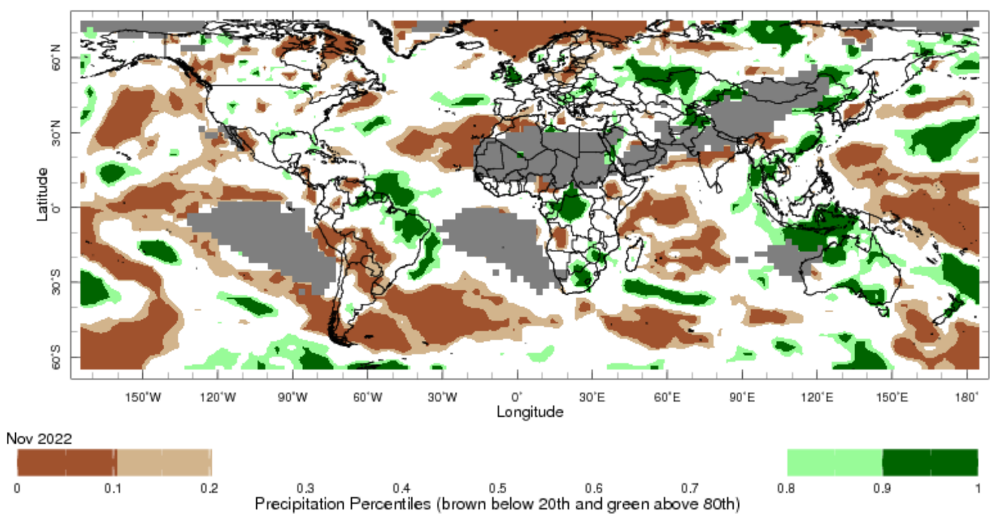
Note: The world precipitation percentiles indicate a ranking of precipitation for November, with the driest (0th percentile) being 0 on the scale and the wettest (100th percentile) being 1 on the scale. Percentiles are based on precipitation estimates from the NOAA Climate Prediction Center's Climate Anomaly Monitoring System Outgoing Precipitation Index dataset. Precipitation estimates for November 2022 are compared with rainfall recorded for that period during the 1991 to 2020 base period.
Source: International Research Institute for Climate and Society
As of 28 November, 2022, global production conditions were quite variable for the production of wheat, corn, rice and soybean.
In the northern hemisphere winter wheat is going into winter dormancy under highly variable production conditions. In the European Union, production conditions are generally favourable although low soil moisture delayed sowing activities in the southern countries. In Turkey, sowing activities are wrapping up with dry conditions in the west. In Ukraine, production conditions are generally favourable, however there has been persistent dryness in Odessa and disruptions/security concerns in the southern and eastern regions due to the ongoing war. In the Russian Federation winter wheat sowing is also well underway under generally favourable conditions except for dryness in the southern Caucasus. In the US dry conditions across the Great Plains from South Dakota to Texas continues to be a concern going into winter. In China, Canada and India, conditions are favourable for winter wheat due to ample soil moisture. In the southern hemisphere, production conditions are exceptionally good in most areas of Australia, despite ongoing flooding in parts of eastern Australia. In Argentina, harvest is continuing in the north and beginning in the main producing areas, but with poor yields expected due to ongoing drought.
Conditions are favourable for ongoing sowing of corn in Brazil and South Africa, while conditions are favourable for ongoing harvest activities of corn in Mexico, US and Canada. In Ukraine, harvesting activities are slowly progressing with just over half the crop collected so far and hence many crops will likely be harvested during the winter or early spring. In the European Union, droughts and heatwaves have resulted in a below-average yield outlook for corn across most growing regions. In Argentina, sowing of the early-planted crop continues at a slow pace due to dryness.
Harvesting of late rice is wrapping up across China under variable conditions due to persistent extremely heat and dry weather in the Yangtze River during the flowering period. India is transitioning from Kharif rice to Rabi rice. In Southeast Asia, wet-season rice harvesting is at its peak under mixed conditions in northern countries while Indonesia wraps up dry-season rice harvesting. Brazil is wrapping up rice sowing with a reduction in the total sown area as well.
Soybean harvesting is wrapping up in Canada under exceptional conditions in Ontario, Manitoba, and Quebec. In Ukraine harvest is wrapping up under generally favourable conditions except the occupied territories. In India, harvesting is wrapping up in the major producing states under favourable conditions. In Brazil, sowing is progressing under favourable conditions despite earlier delays due to adverse weather. In Argentina, sowing activities are beginning in the main producing areas of Buenos Aires, Entre Ríos, Santa Fe, and Córdoba, as recent rains improved soil moisture conditions. However, the lack of surface soil moisture might impact the sowing progress, with southern Santa Fe and northern Buenos Aires being the most affected regions.
Crop conditions, AMIS countries, 28 Novembers 2022
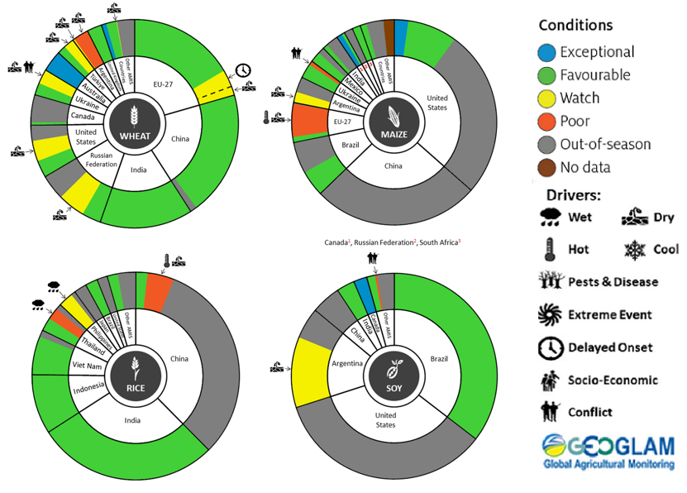
AMIS Agricultural Market Information System.
Source: AMIS
The global climate outlook for December 2022 to February 2023 indicates that variable rainfall conditions are expected for the world's major grain-producing and oilseed-producing regions. Outlooks and potential production impacts for the major grain and oilseed producing countries are presented in the table.
Rainfall outlook and potential impact on the future state of production conditions between December 2022 to February 2023
Region | December to February rainfall outlook | Potential impact on production
Argentina | Below average rainfall is expected in north-eastern and central Argentina between December 2022 to February 2023. | Below average rainfall is likely to adversely affect flowering and grain filling of corn, cotton, peanuts, soybeans, and sunflowers. The dry conditions may also negatively impact yield potentials of those crops.
Black Sea Region | Below average precipitation is forecast for eastern Ukraine, Turkey and small areas of western Kazakhstan. However, above average precipitation is expected across eastern and north-eastern parts of the Russian Federation between December 2022 and February 2023. | Winter wheat and canola will remain dormant throughout December to February across the Black Sea Region. The above average rainfall conditions are likely to provide sufficient snowpack to prevent winterkill from freezing temperatures across most regions. However, below average precipitation in many parts may increase the risk of winterkill due to below average snowpack.
Brazil | Above average rainfall is expected in northern Brazil and parts of the central west between December 2022 to February 2023. Parts of southern Brazil are expected to receive below-average rainfall. | Below average rainfall in much of southern Brazil is likely to adversely affect flowering and yield potential of corn and soybeans in December, cotton and peanuts flowering and grain filling for southern growing regions in January. Above average rainfall in central Brazil will benefit the flowering and filling of soybeans.
Canada | Above average precipitation is possible across much of Canada between December 2022 to February 2023. | Through December, January and February, winter wheat and canola will remain dormant. Above average rainfall will likely provide sufficient snowpack to prevent winterkill of winter wheat and canola.
China | Below average rainfall is more likely in parts of central, south-eastern and south-western China in December 2022 to February 2023. | Through December, January and February, winter wheat and canola will remain dormant. Below average rainfall may increase the risk of winterkill due to limited snowpack during winter.
Europe | Below average precipitation is likely for most of Europe while above average precipitation is expected in Norway, Finland and north-west tips of Sweden between December 2022 to February 2023. | Below average rainfall may limit snowpack in parts of central Europe, increasing the risk of winterkill for winter wheat and canola. Meanwhile, above average rainfall in southern Europe should provide favourable conditions for winter wheat crops.
South Asia (India) | Close to average rainfall is forecast for much of India, with above average rainfall in far southern India and below average rainfall expected in central-eastern and north-eastern India. | Close to average rainfall across much of India will support the harvest of corn, cotton, peanuts, millet, rice, sorghum, and sunflowers in December. However, below average rainfall in central and north-eastern India may negatively impact vegetative growth and heading of winter wheat and canola between December and February. In the far south, winter crops may benefit from above average rainfall.
Southeast Asia (SEA) | Above average rainfall is likely across much of maritime SEA between December 2022 to February 2023, particularly in the Philippines. Northern mainland SEA will likely experience below average rainfall. | Above average rainfall in SEA likely supports vegetative growth for corn and rice production throughout December to February. However, excessive rainfall may result in flooding and crop damage. Below average rainfall for northern mainland SEA may negatively impact germination and establishment of spring rice.
The United States of America | Above average precipitation is more likely for the north-western and north-eastern US and below average precipitation is more likely across much of the southern half the US. | Above average precipitation conditions expected across the northern US are likely to provide sufficient snow cover through winter to protect wheat and canola through dormancy.

Rainfall forecast for the next eight days
Over the 8-days to 22 December 2022, rainfall is expected across most of Australia. For the first 4 days, a broad trough and a cold front are forecasted to bring moderate rainfall to parts of north-western and central Australia and the north-eastern tip of Queensland and south-eastern Victoria, as well as eastern Tasmania. However, high pressure systems will provide clear, mostly dry conditions across much of Australia except far north of Australia for the next four days.
Rainfall totals of between 10 and 50 millimetres are expected for much of northern and central Australia, as well as a small area of eastern Victoria. Rainfall in excess of 50 millimetres is expected in scattered areas of far north-western Northern Territory, north-eastern Queensland and central Australia.
Little to no rainfall is forecast across most of Australian cropping regions for the next eight days. The main exception being central and western South Australia where rainfall totals of between 10 to 15 millimetres are expected.
The continuation of dry conditions is expected to provide some relief to flood-affected cropping regions of south-eastern Australia and will likely further allow saturated soil to drain, however, a flooding risk remains to some areas as flood waters make their way further downstream. Little to no rainfall forecast across most cropping regions will provide favourable conditions for winter crop harvesting and summer crop planting following three relatively dry weeks.

Total forecast rainfall for the period 15 December to 22 December 2022
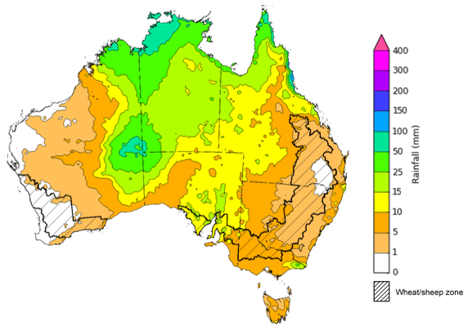
©Commonwealth of Australia 2022, Australian Bureau of Meteorology Issued 15/12/2022
Note: This rainfall forecast is produced from computer models. As the model outputs are not altered by weather forecasters, it is important to check local forecasts and warnings issued by the Bureau of Meteorology.

Water

Water markets – current week

Water storage levels in the Murray-Darling Basin (MDB) increased between 7 December 2022 and 14 December 2022 by 24 gigalitres (GL). Current volume of water held in storage is 24 043 GL which represents 95 percent of total capacity. This is 5 percent or 1183 GL more than at the same time last year.

Water storages in the Murray-Darling Basin, 2013–2022
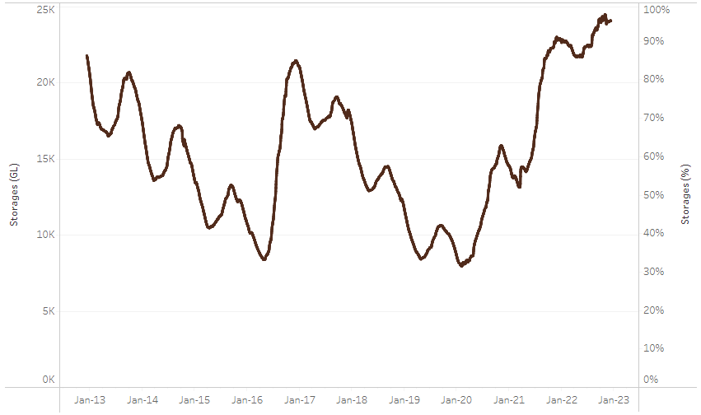
Allocation prices in the Victorian Murray below the Barmah Choke increased from $40 per ML on 8 December to $42 per ML on 15 December 2022. Prices are lower in the Murrumbidgee and regions above the Barmah choke due to the binding of the Murrumbidgee export limit and Barmah choke trade constraint.
Water storage data is sourced from the Bureau of Meteorology.
Region | $/ML
NSW Murray Above | 16
NSW Murrumbidgee | 20
VIC Goulburn-Broken | 36
VIC Murray Below | 42

Surface water trade activity, Southern Murray–Darling Basin

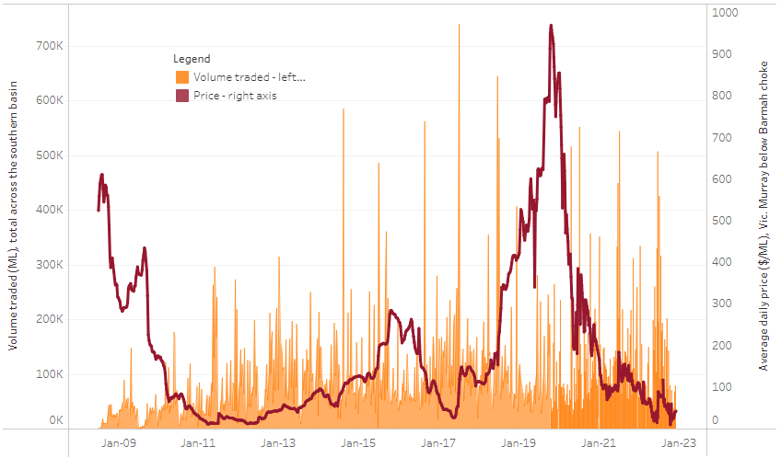
To access the full, interactive, weekly water dashboard, which contains the latest and historical water storage, water market and water allocation information, please visit http://www.agriculture.gov.au/abares/products/weekly_update/weekly-update-151222
The trades shown reflect estimated market activity and do not encompass all register trades. The price is shown for the VIC Murray below the Barmah choke. Historical prices (before 1 July 2019) are ABARES estimates after removing outliers from BOM water register data. Prices after 1 July 2019 and prior to the 30 October 2019 reflect recorded transaction prices as sourced from Ruralco. Prices after the 30 October 2019 are sourced from Waterflow. Data for volume traded is sourced from the BOM water register. Data shown is current at 15 December 2022.

Commodities

Indicator | Week ended | Unit | Latest price | Previous week | Weekly change | Price 12 months ago | Annual change
Selected world indicator prices
AUD/USD Exchange rate | 14-Dec | A$/US$ | 0.68 | 0.68 | 0% | 0.72 | -5%
Wheat – US no. 2 hard red winter wheat, fob Gulf | 14-Dec | US$/t | 387 | 394 | -2% | 387 | 0%
Corn – US no. 2 yellow corn, fob Gulf | 14-Dec | US$/t | 301 | 308 | -2% | 268 | 12%
Canola – Rapeseed, Canada, fob Vancouver | 14-Dec | US$/t | 694 | 674 | 3% | 852 | -18%
Cotton – Cotlook 'A' Index | 14-Dec | USc/lb | 98 | 103 | -5% | 120 | -18%
Sugar – Intercontinental Exchange, nearby futures, no.11 contract | 14-Dec | USc/lb | 18.5 | 18.4 | 0% | 19 | -1%
Wool – Eastern Market Indicator | 23-Nov | Ac/kg clean | 1,224 | 1,256 | -3% | 1,369 | -11%
Wool – Western Market Indicator | 16-Nov | Ac/kg clean | 1,408 | 1,379 | 2% | 1,462 | -4%
Selected Australian grain export prices
Milling Wheat – APW, Port Adelaide, SA | 14-Dec | A$/t | 548 | 547 | 0% | 483 | 13%
Feed Wheat – ASW, Port Adelaide, SA | 14-Dec | A$/t | 501 | 500 | 0% | 451 | 11%
Feed Barley – Port Adelaide, SA | 14-Dec | A$/t | 428 | 424 | 1% | 371 | 15%
Canola – Kwinana, WA | 14-Dec | A$/t | 1,051 | 995 | 6% | 972 | 8%
Grain Sorghum – Brisbane, QLD | 14-Dec | A$/t | 475 | 473 | 0% | 369 | 29%
Selected domestic livestock indicator prices
Beef – Eastern Young Cattle Indicator | 14-Dec | Ac/kg cwt | 894 | 870 | 3% | 1,109 | -19%
Mutton – Mutton indicator (18–24 kg fat score 2–3), Vic | 14-Dec | Ac/kg cwt | 378 | 346 | 9% | 642 | -41%
Lamb – Eastern States Trade Lamb Indicator | 07-Dec | Ac/kg cwt | 689 | 730 | -6% | 821 | -16%
Pig – Eastern Seaboard (60.1–75 kg), average of buyers & sellers | 16-Nov | Ac/kg cwt | 376 | 376 | 0% | 328 | 15%
Goats – Eastern States (12.1–16 kg) | 07-Dec | Ac/kg cwt | 361 | 485 | -26% | 818 | -56%
Live cattle – Light steers ex Darwin to Indonesia | 17-Aug | Ac/kg lwt | 420 | 480 | -13% | 320 | 31%
Live sheep – Live wethers (Muchea WA saleyard) to Middle East | 14-Sep | $/head | 93 | 113 | -18% | 114 | -18%

Indicator | Week ended | Unit | Latest price | Previous week | Weekly change | Price 12 months ago | Annual change
Global Dairy Trade (GDT) weighted average prices ª
Dairy – Whole milk powder | 07-Dec | US$/t | 3,400 | 3,397 | 0% | 3,037 | 12%
Dairy – Skim milk powder | 07-Dec | US$/t | 3,102 | 3,057 | 1% | 2,799 | 11%
Dairy – Cheddar cheese | 07-Dec | US$/t | 4,826 | 4,746 | 2% | 3,641 | 33%
Dairy – Anhydrous milk fat | 07-Dec | US$/t | 5,797 | 5,711 | 2% | 4,175 | 39%
a Global Dairy Trade prices are updated twice monthly on the first and third Tuesday of each month.

Selected world indicator prices
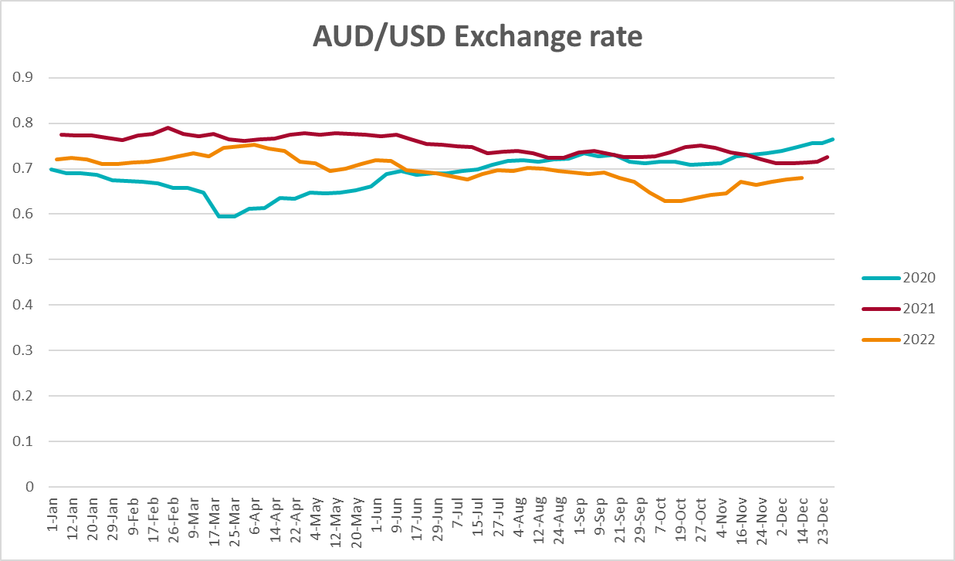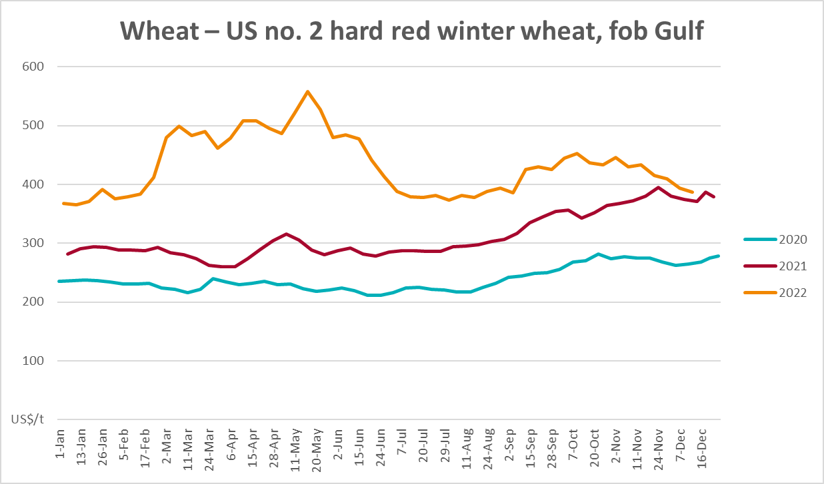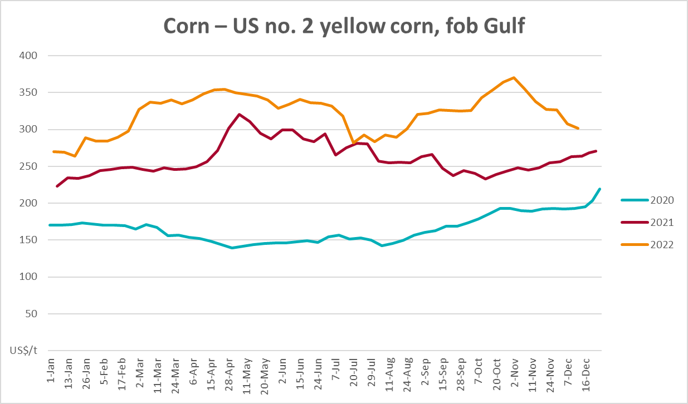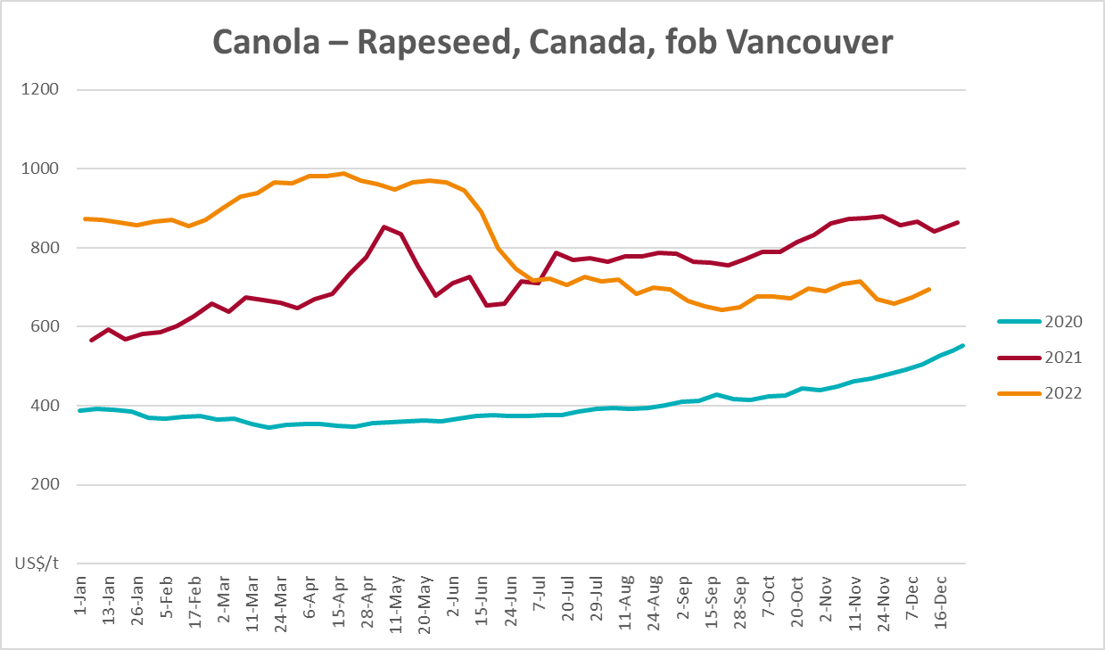
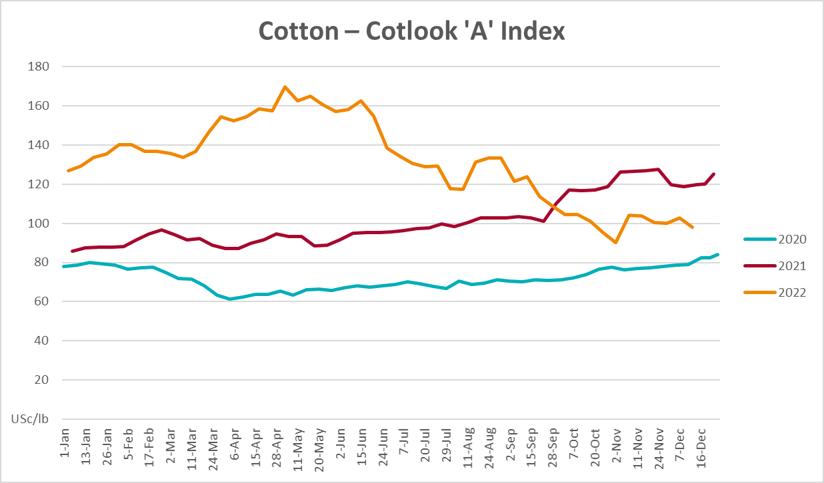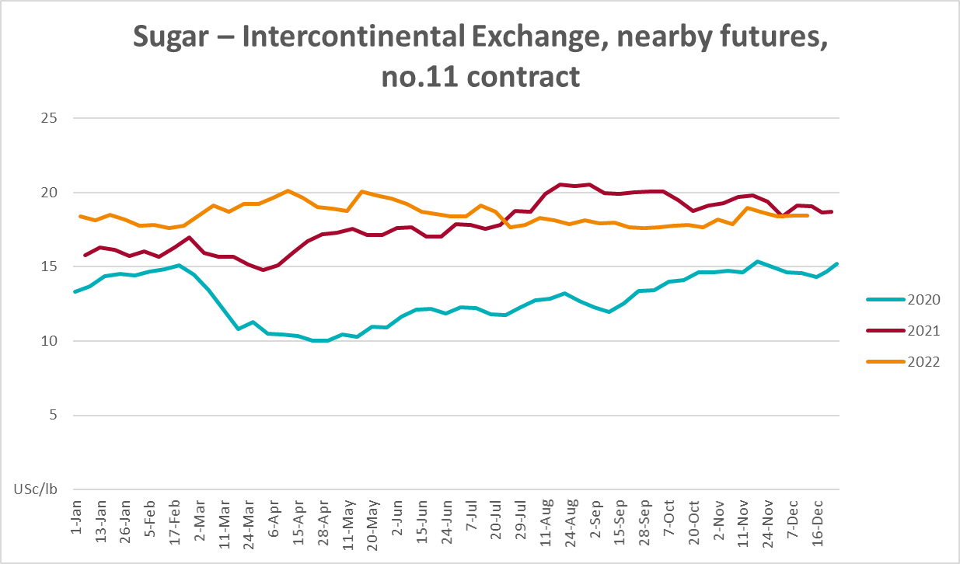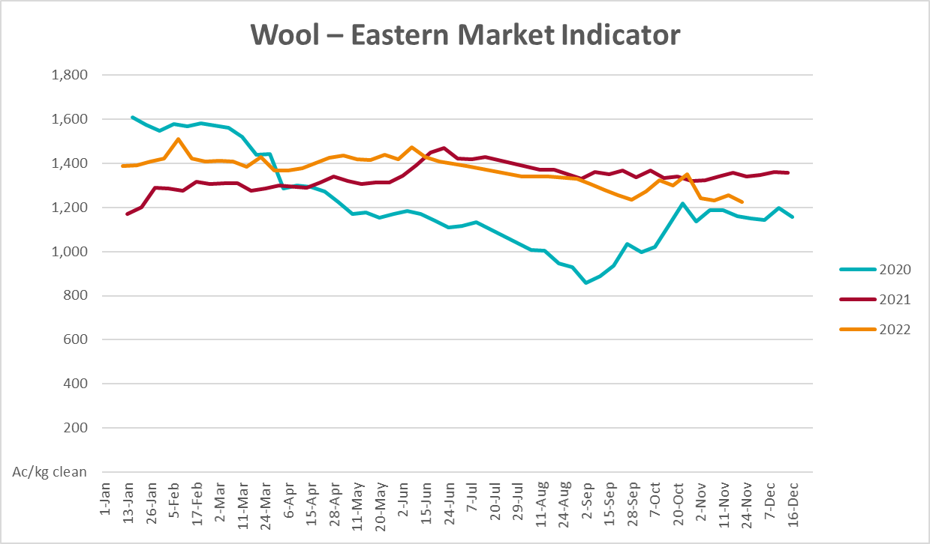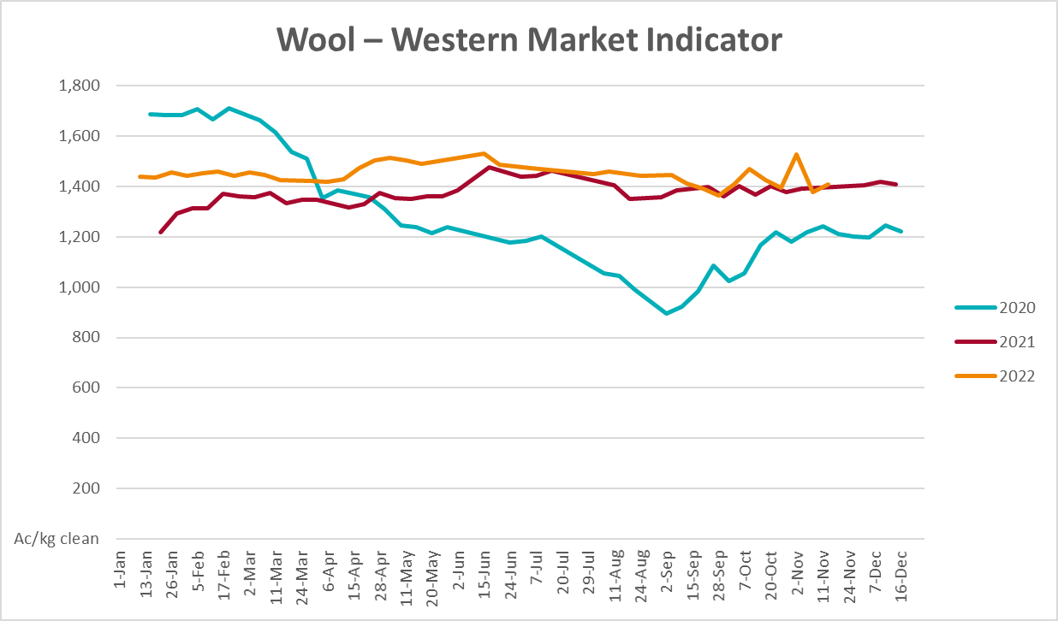

Selected domestic crop indicator prices
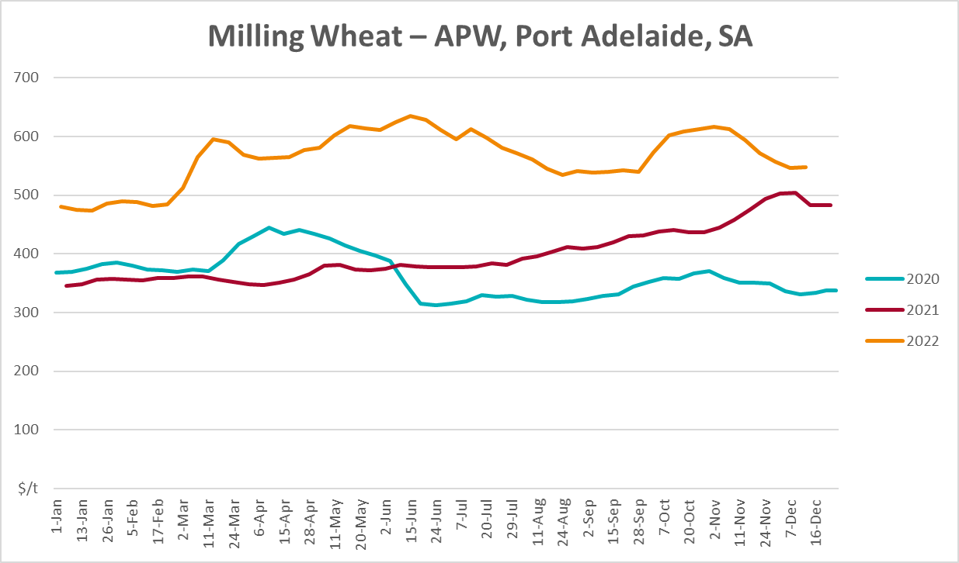
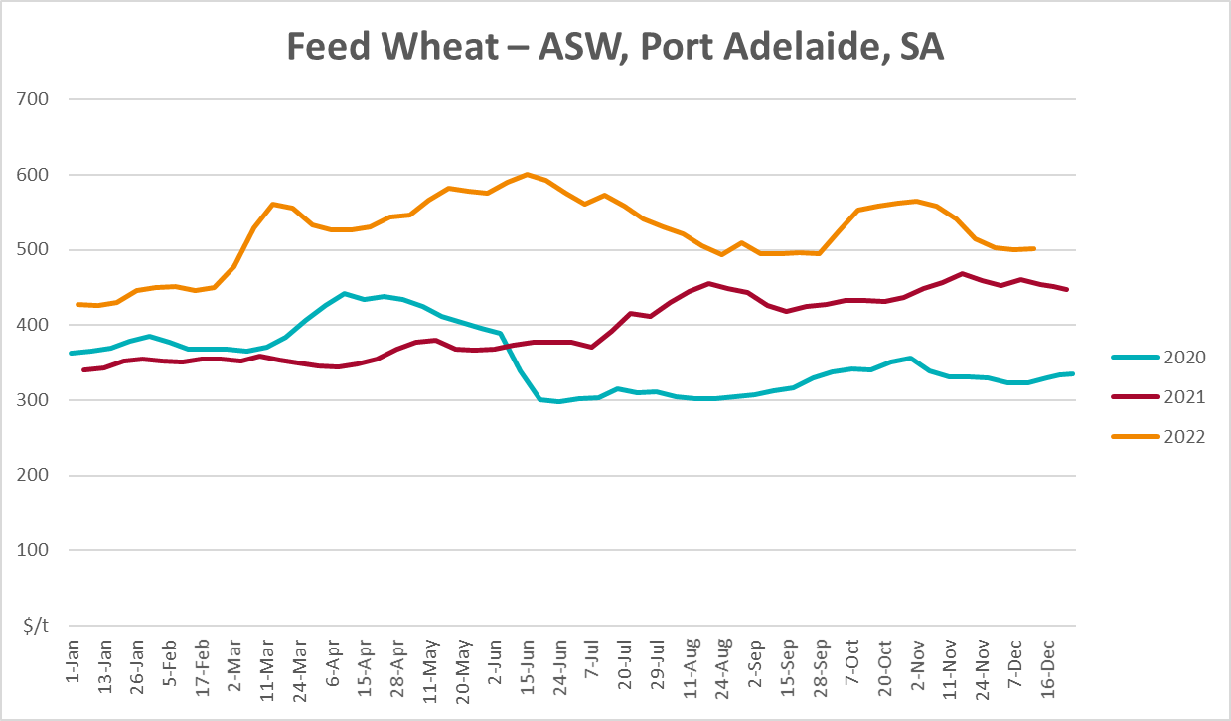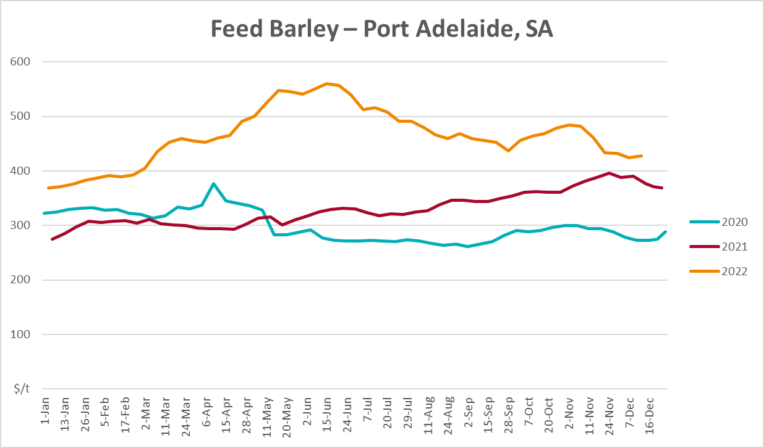
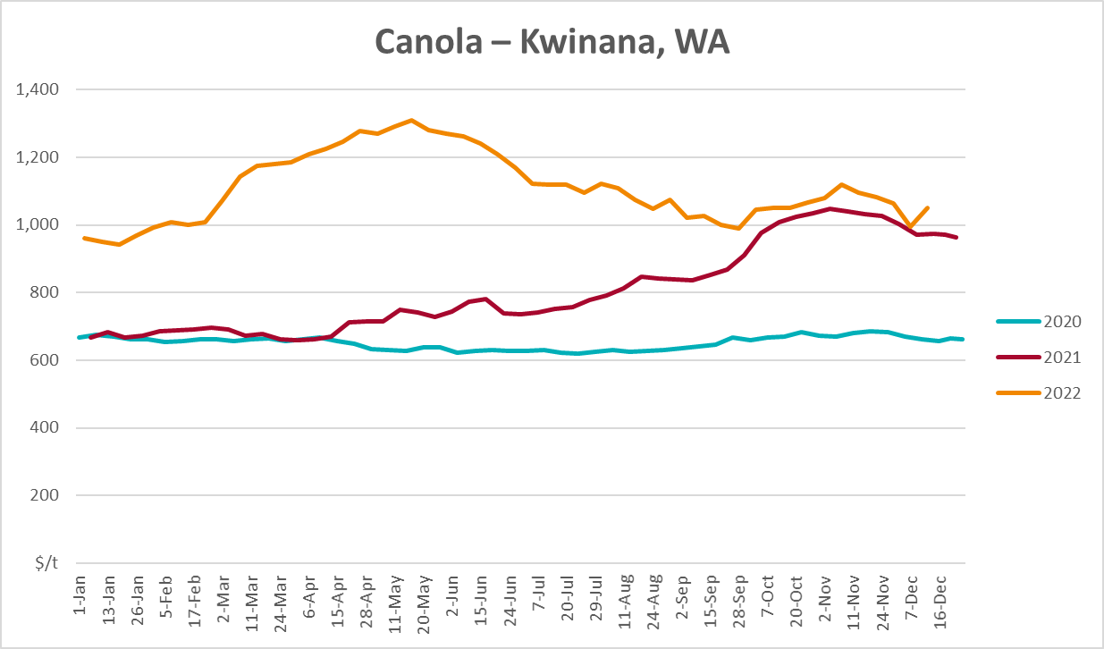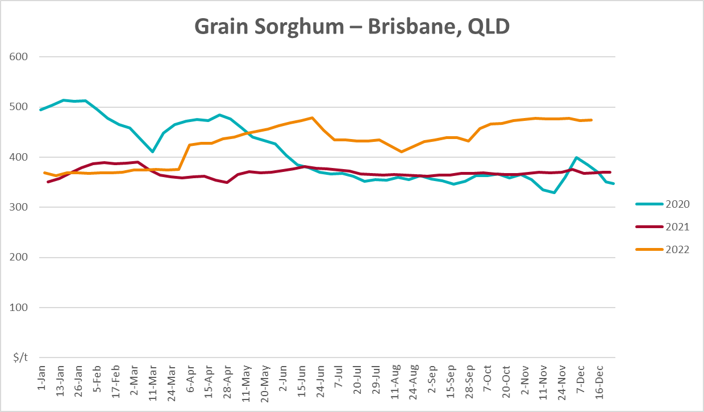

Selected domestic livestock indicator prices
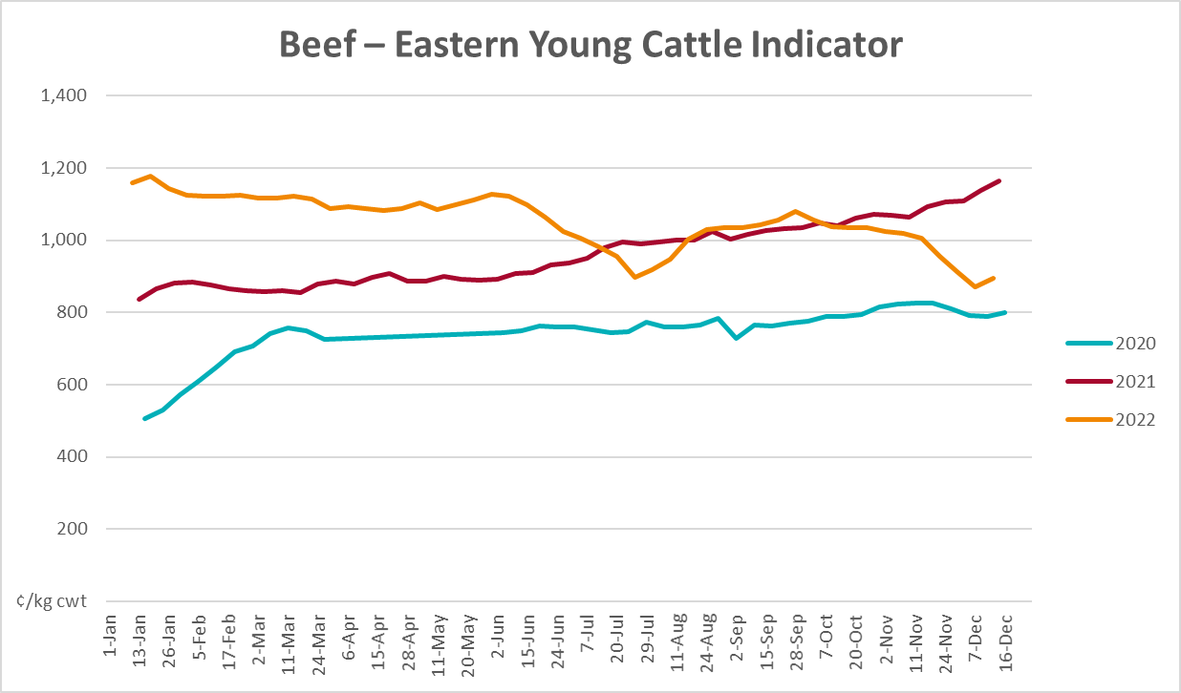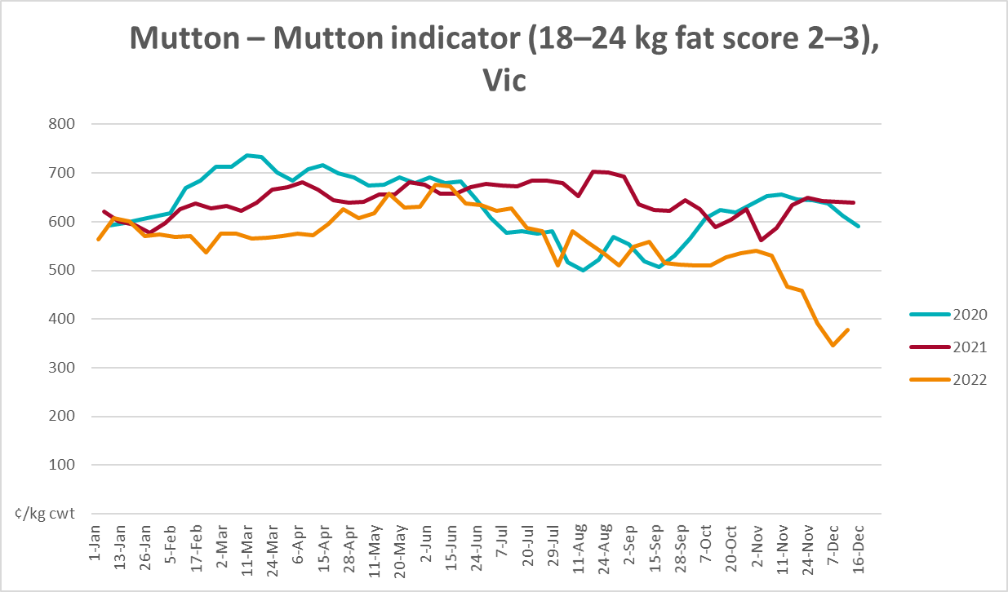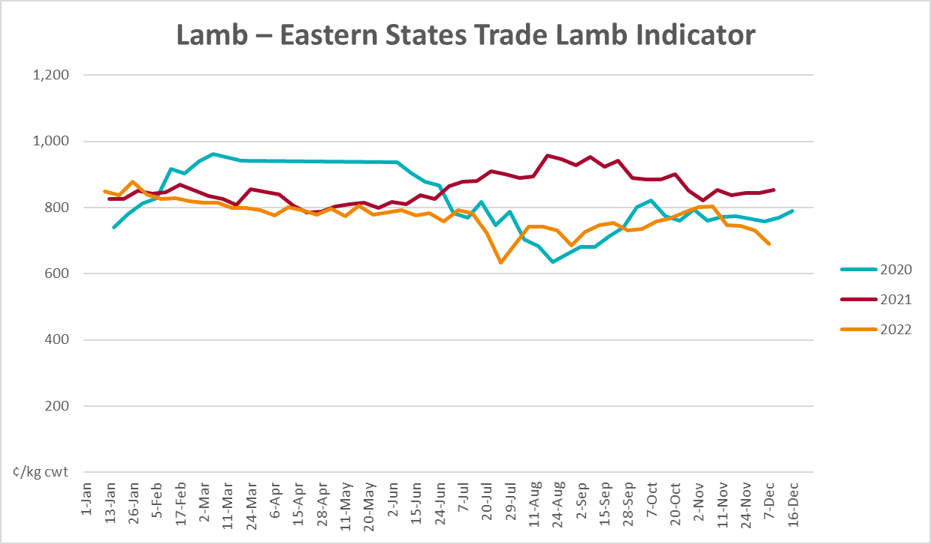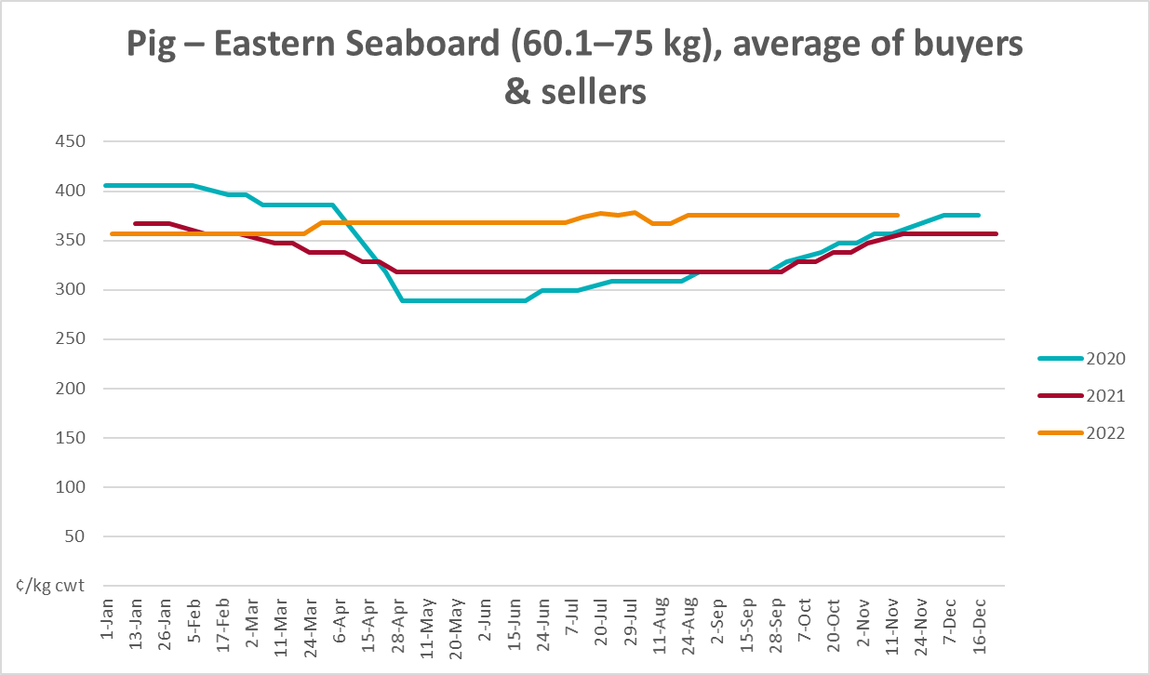
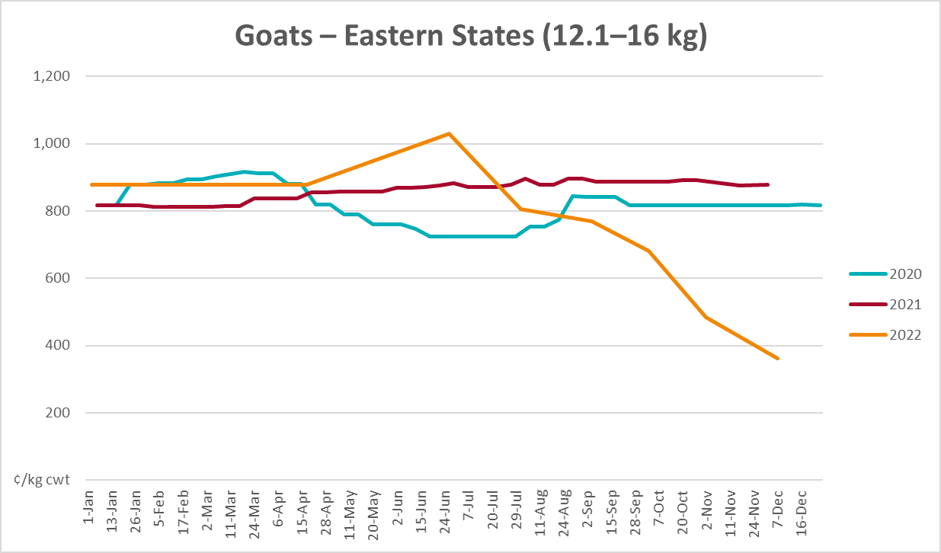
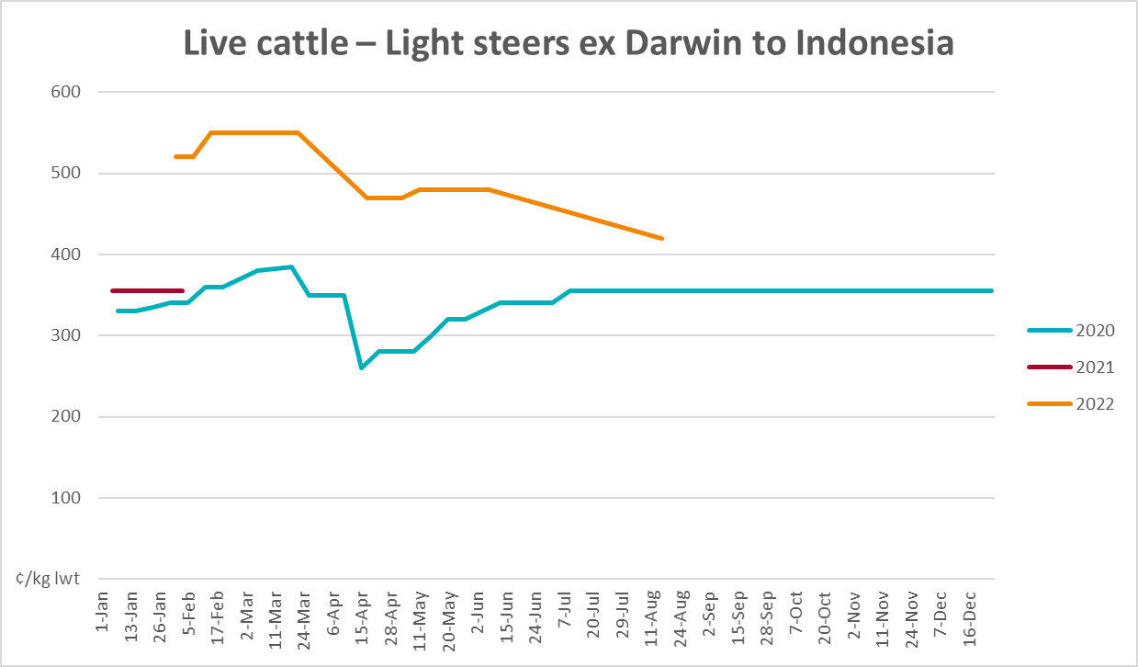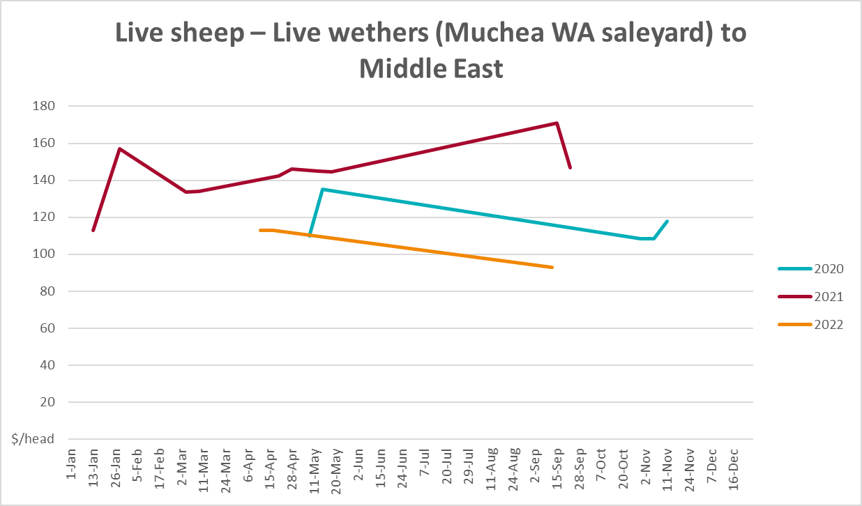

Global Dairy Trade (GDT) weighted average prices
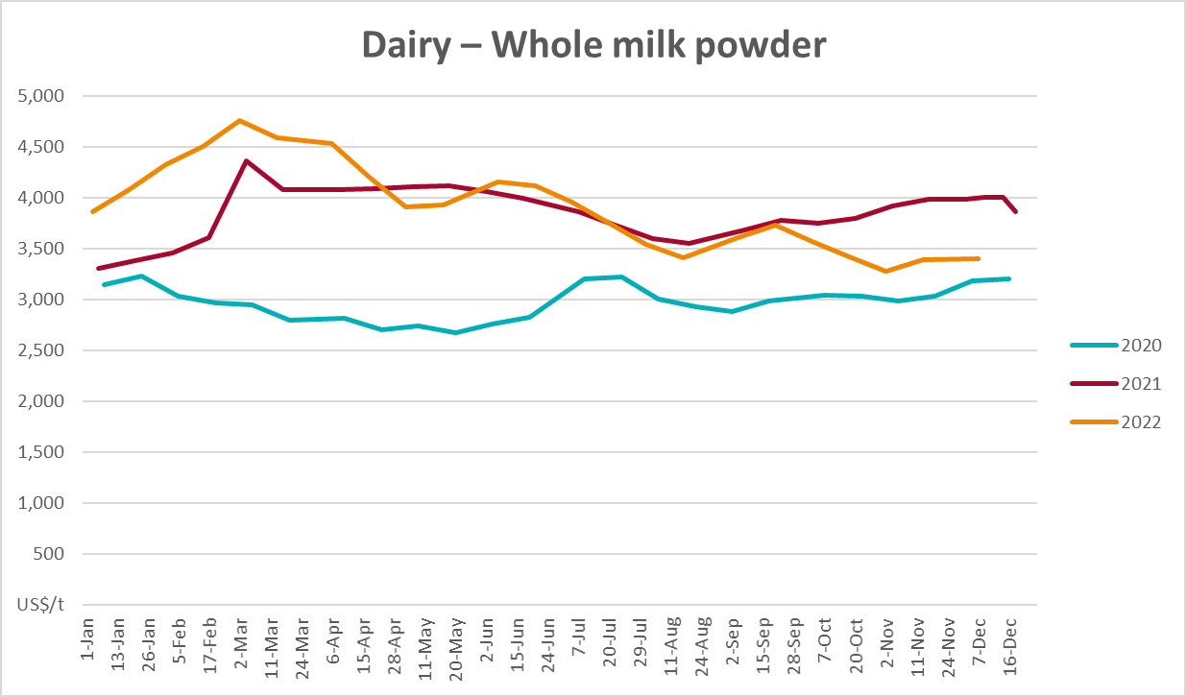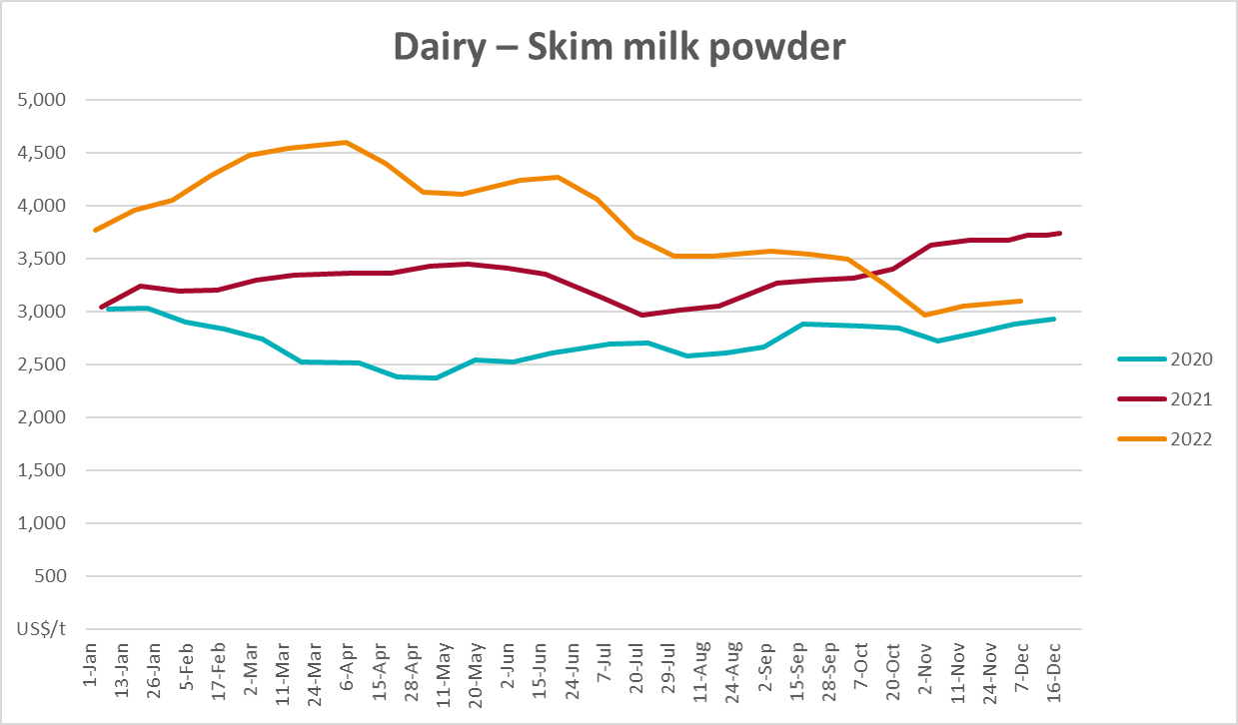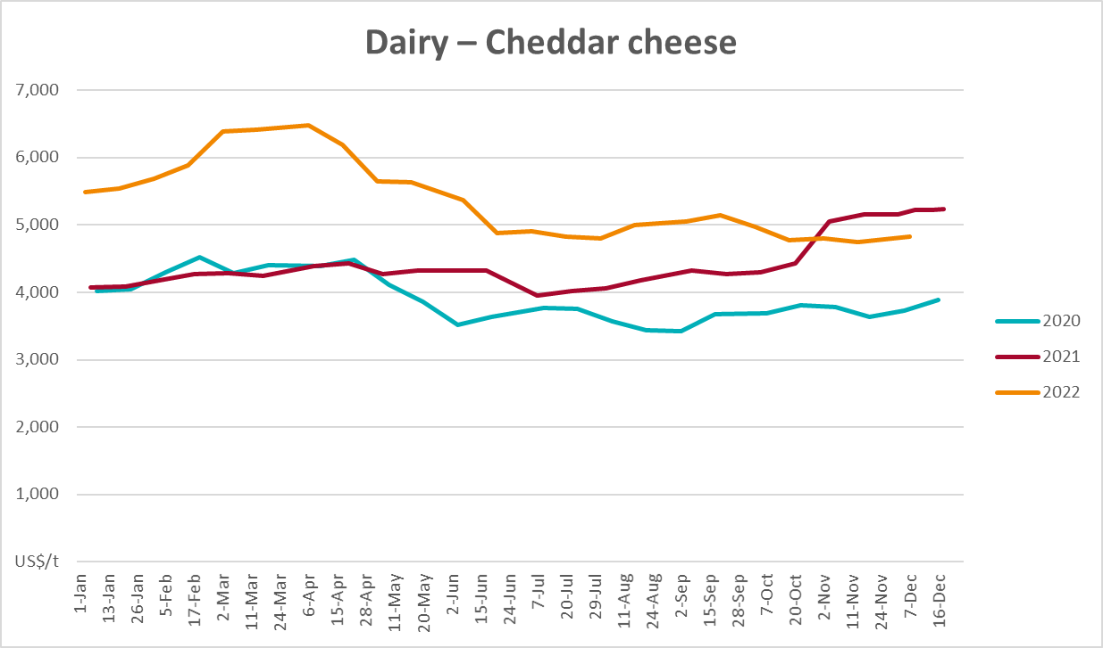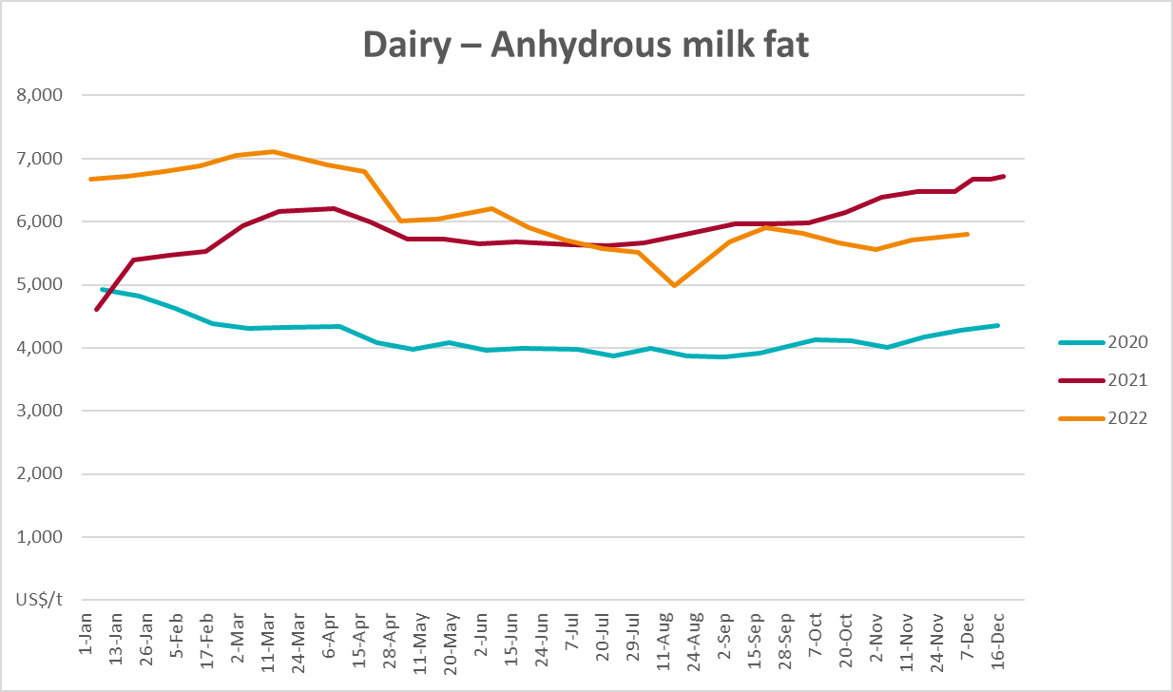

Selected fruit and vegetable prices
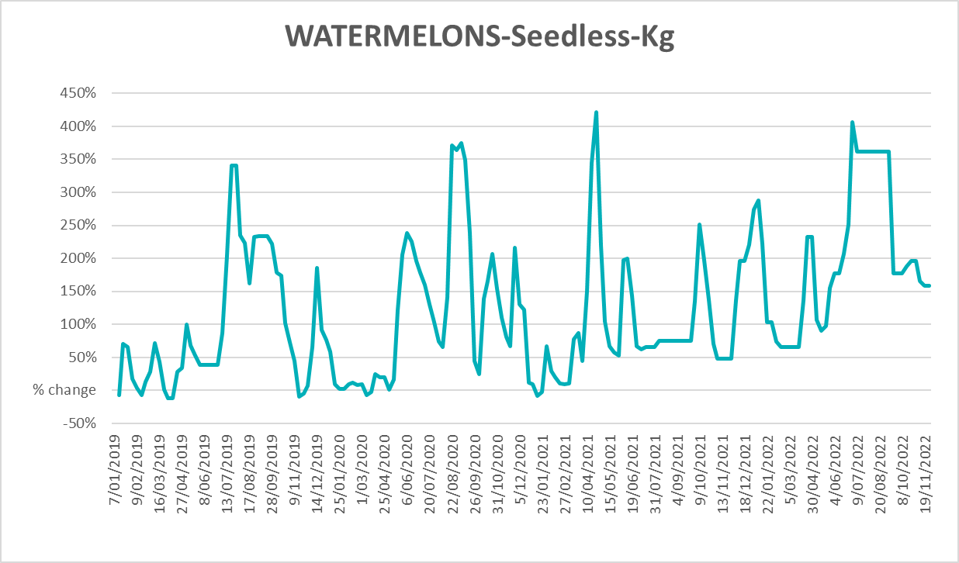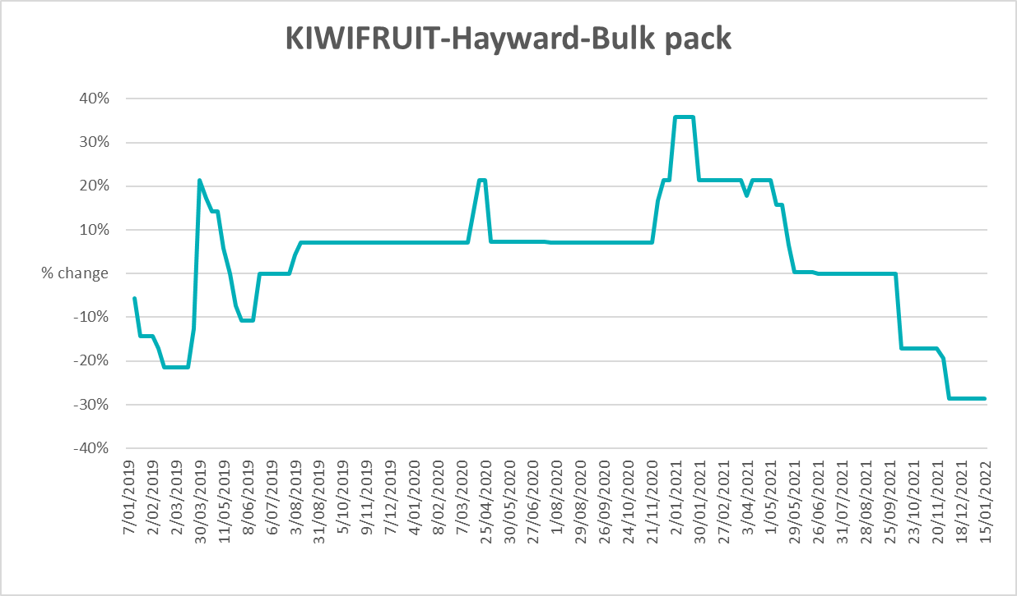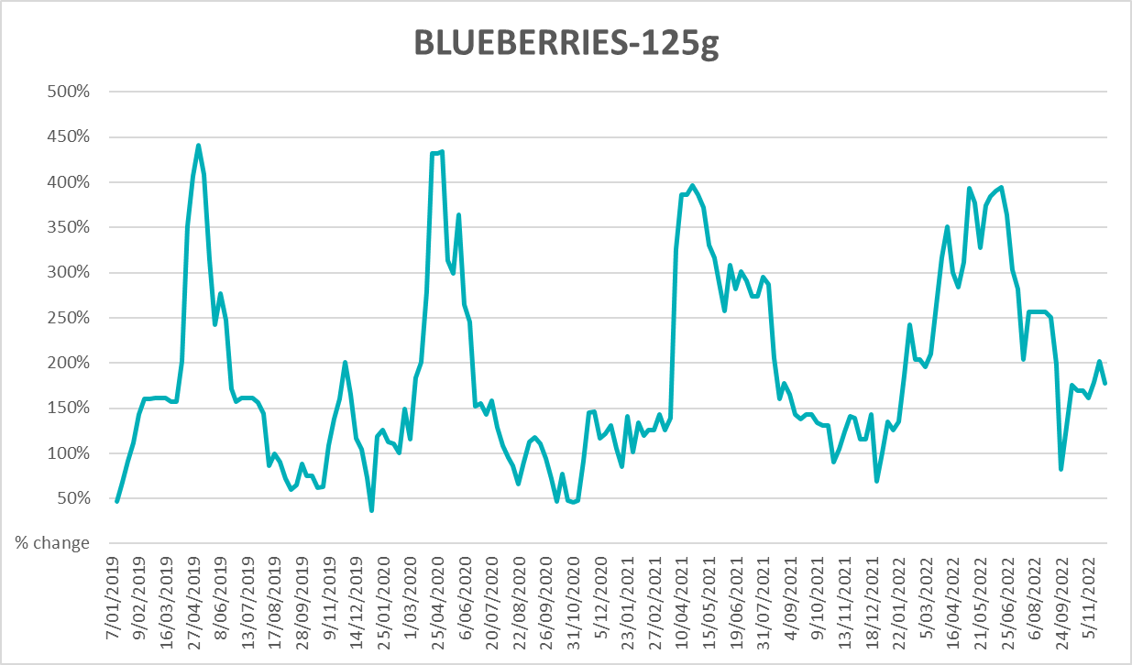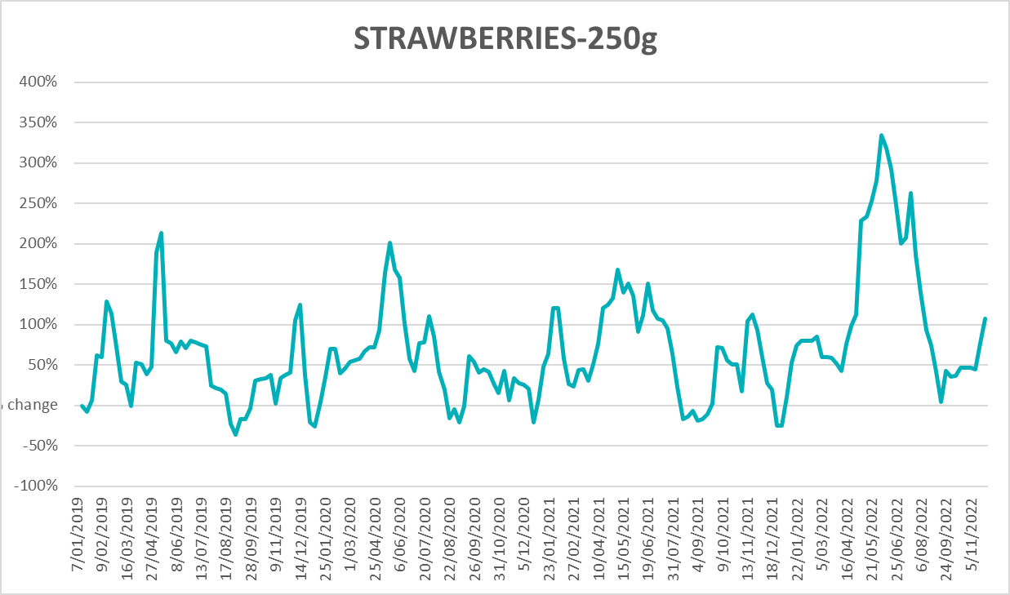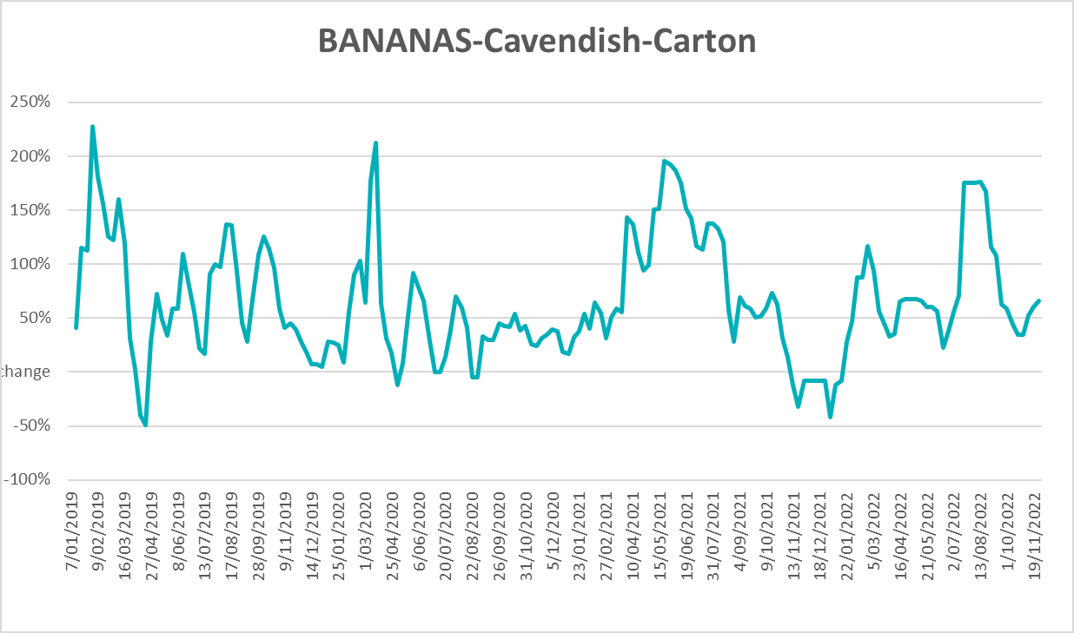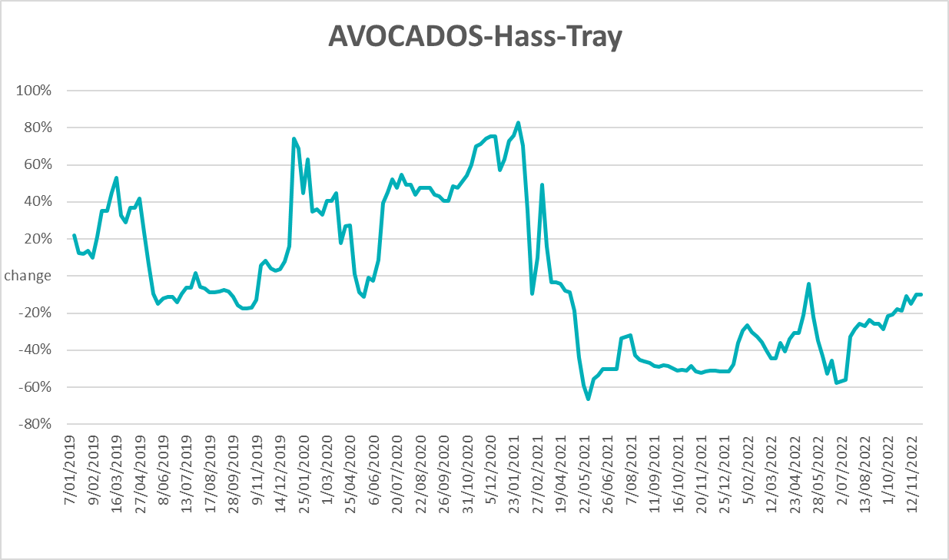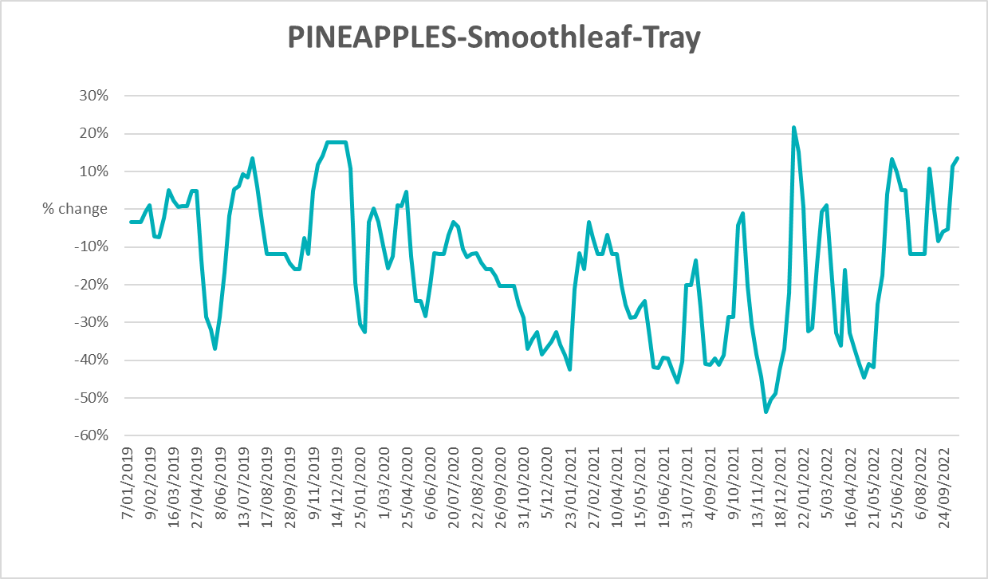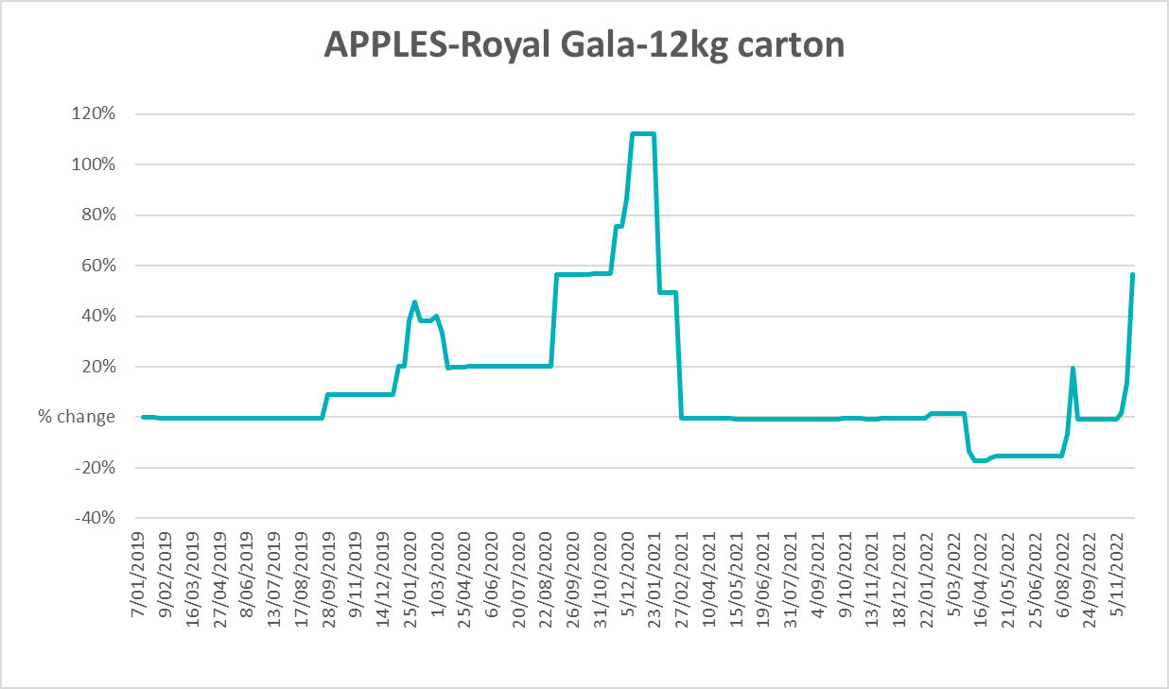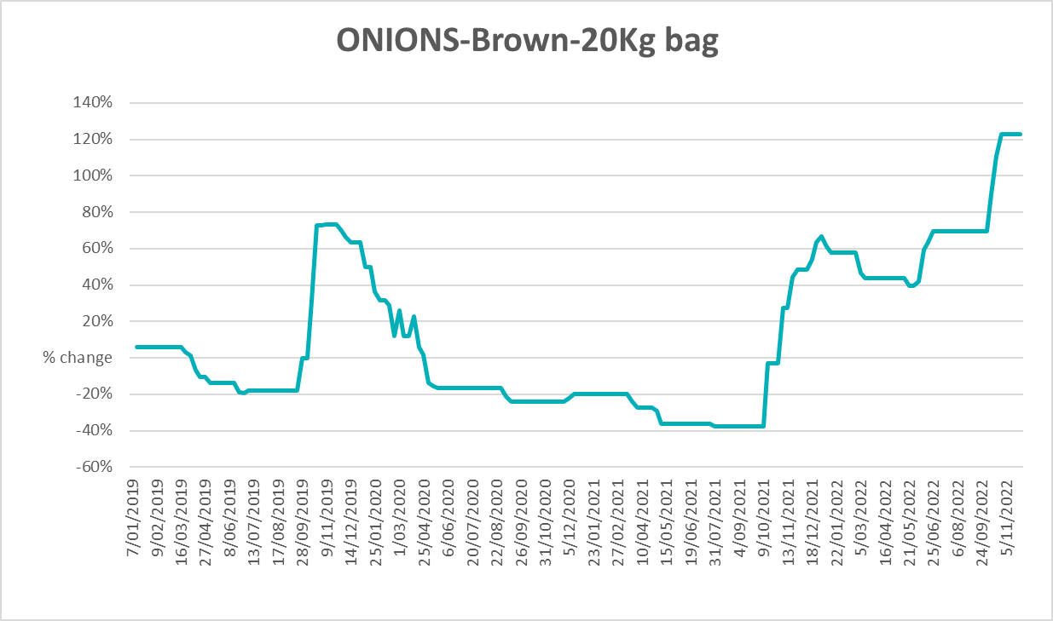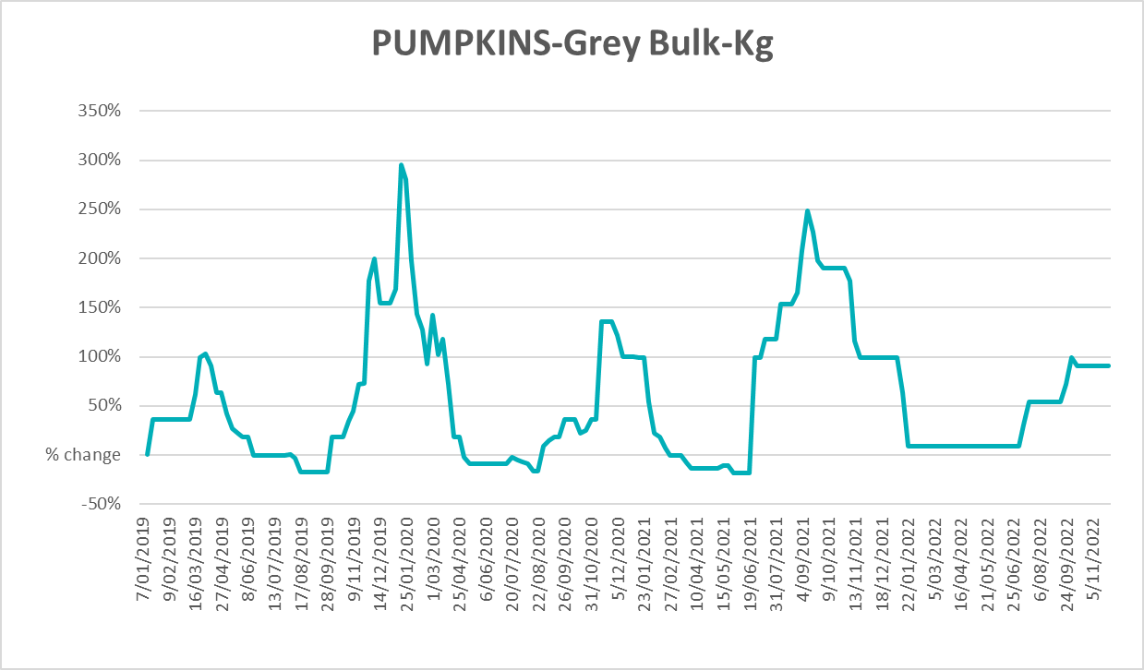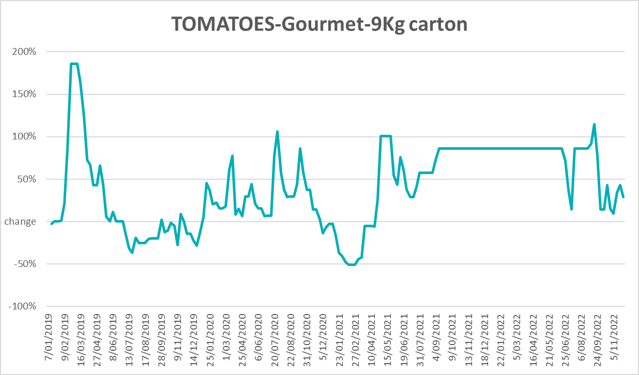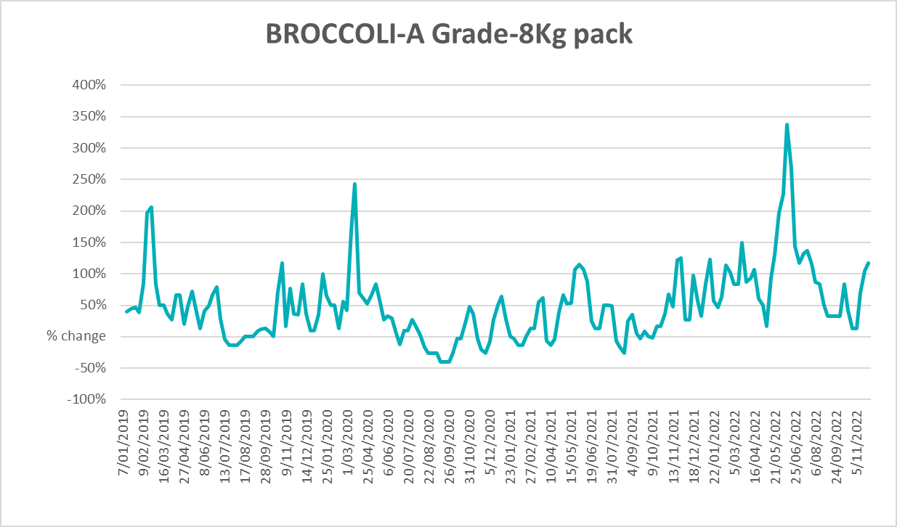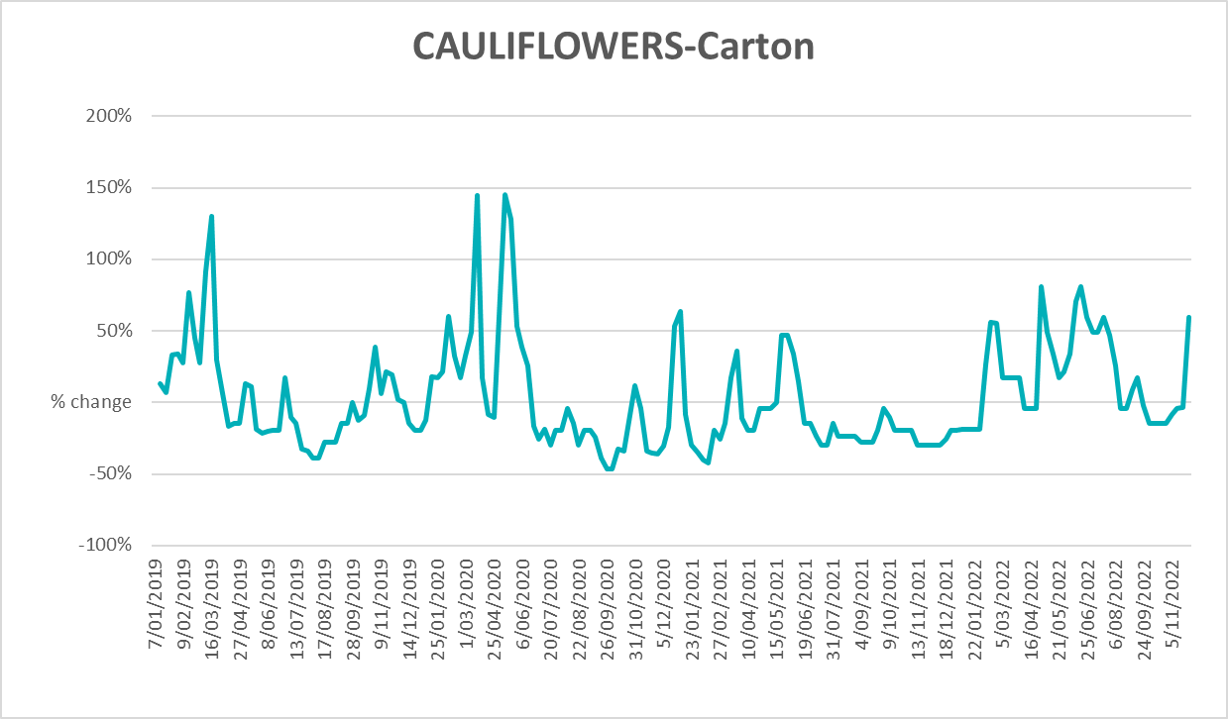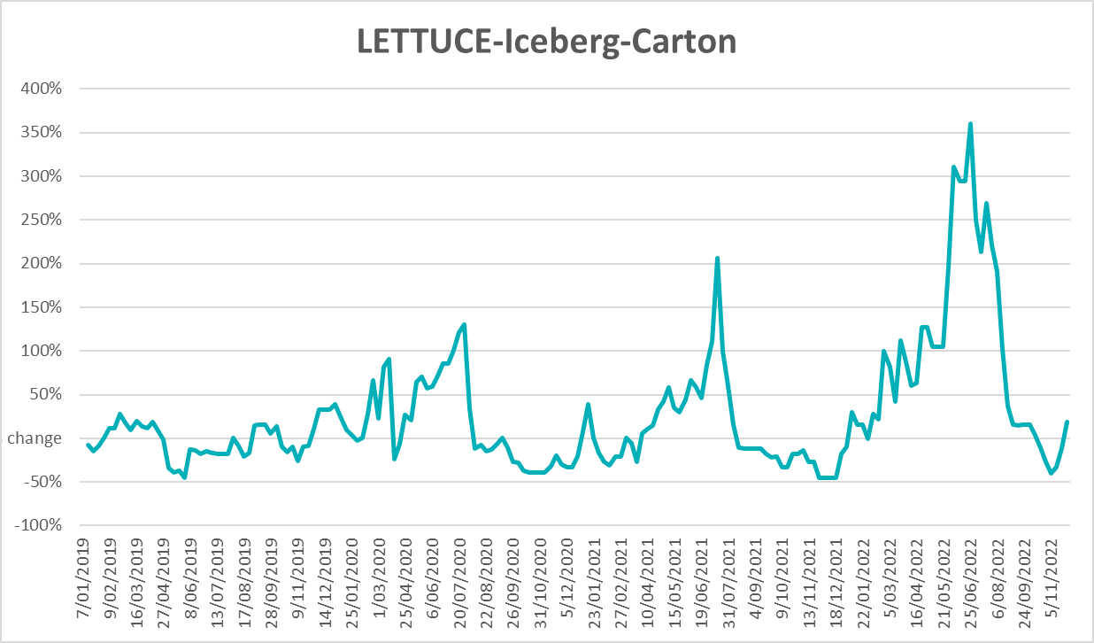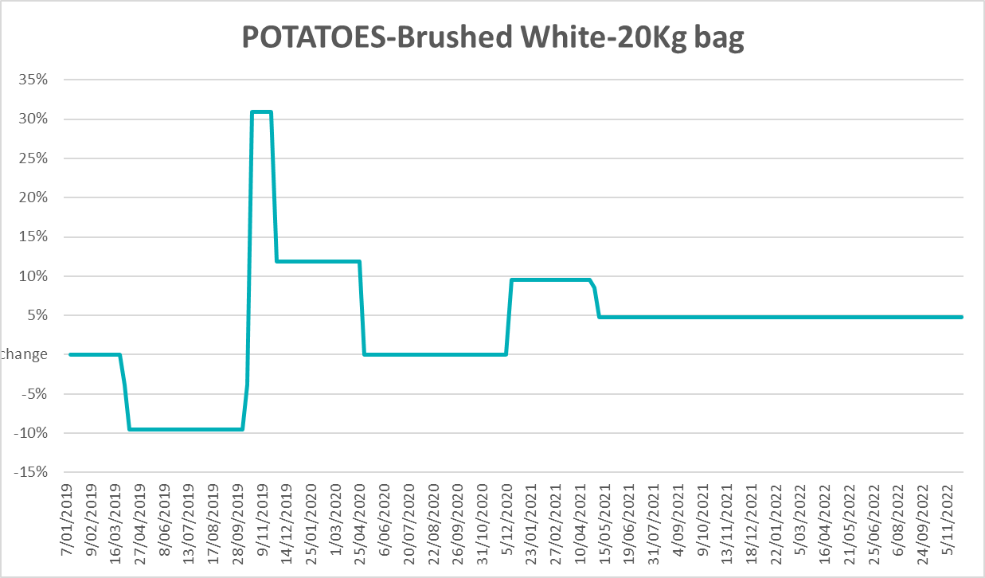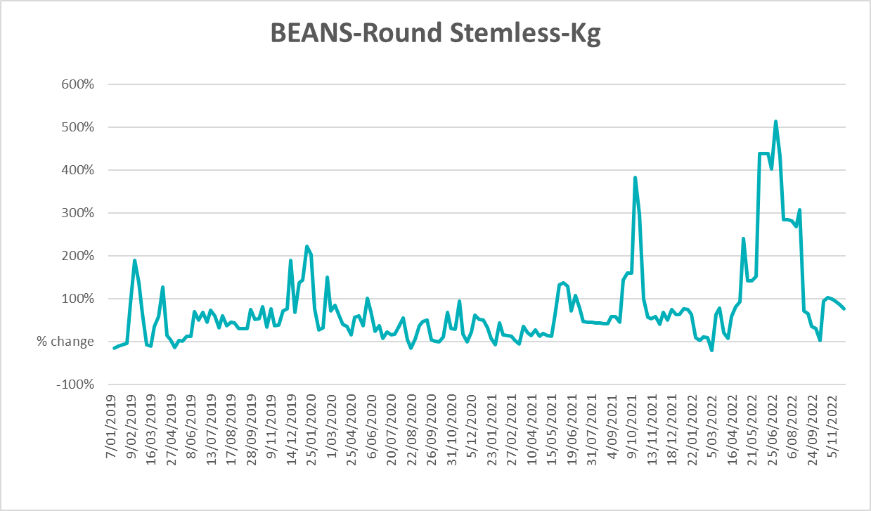

Selected domestic fodder indicator prices
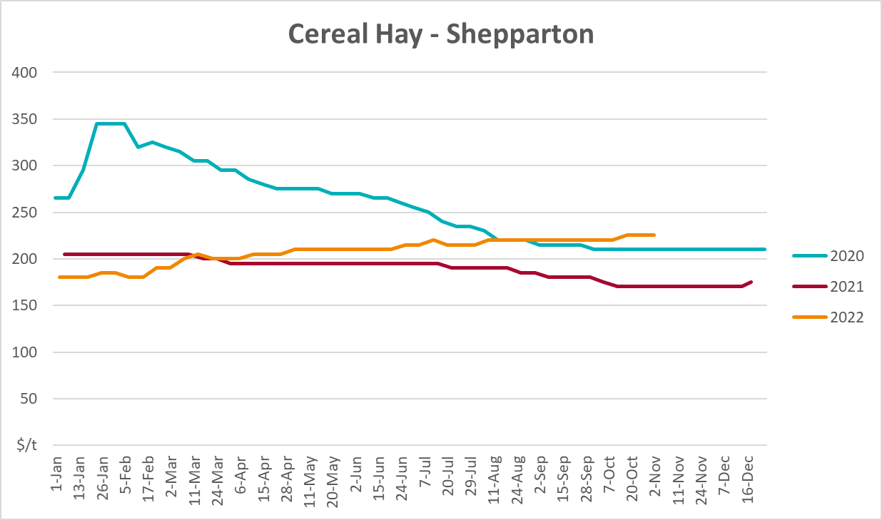
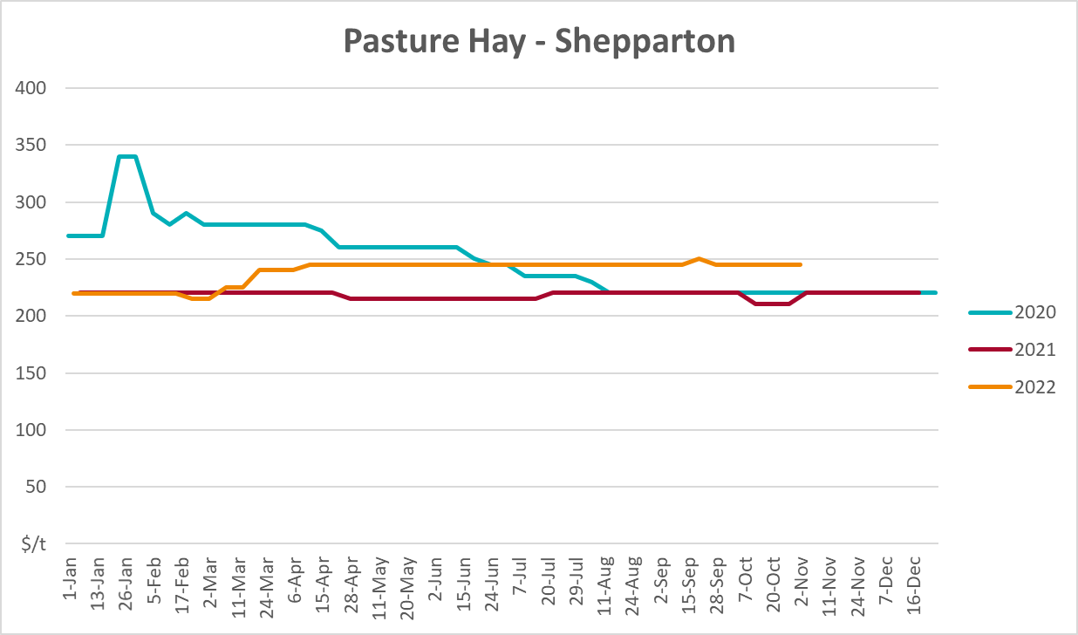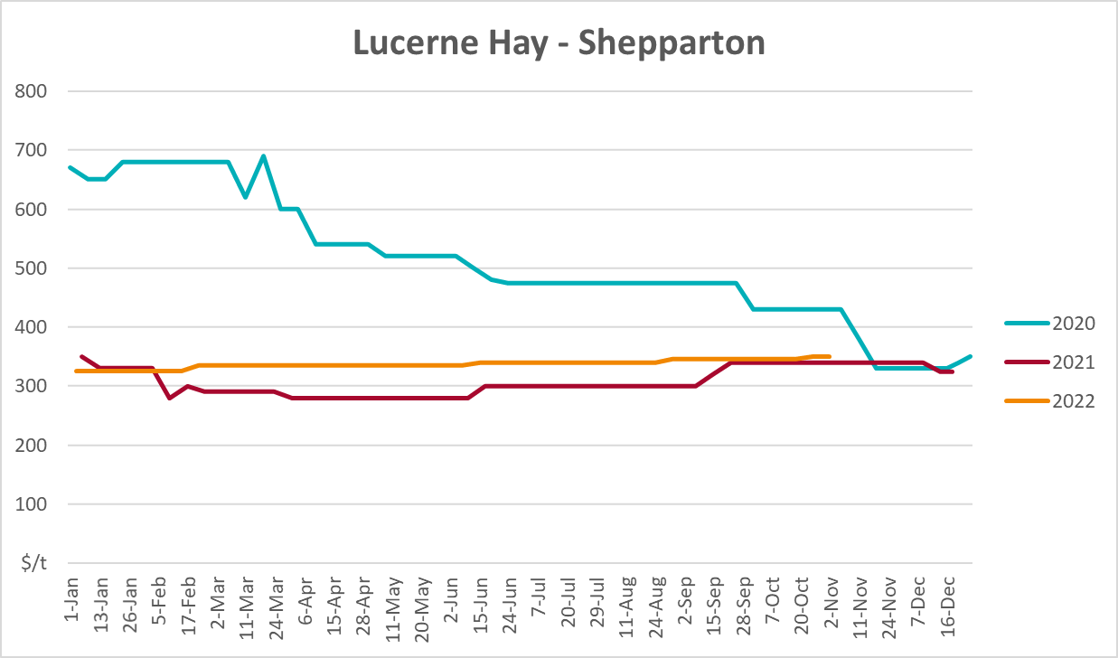

Data attribution

Climate
Bureau of Meteorology
- Weekly rainfall totals: www.bom.gov.au/climate/maps/rainfall/
- Monthly and last 3-month rainfall percentiles: www.bom.gov.au/water/landscape/
- Temperature anomalies: www.bom.gov.au/jsp/awap/temp/index.jsp
- Rainfall forecast: www.bom.gov.au/jsp/watl/rainfall/pme.jsp
- Seasonal outlook: www.bom.gov.au/climate/outlooks/#/overview/summary/
- Climate drivers: http://www.bom.gov.au/climate/enso/
- Soil moisture: www.bom.gov.au/water/landscape/
Other
- Pasture growth: www.longpaddock.qld.gov.au/aussiegrass/
- 3-month global outlooks: Environment and Climate Change Canada, NOAA Climate Prediction Center, EUROBRISA CPTEC/INPE, European Centre for Medium-Range Weather Forecasts, Hydrometcenter of Russia, National Climate Center Climate System Diagnosis and Prediction Room (NCC), International Research Institute for Climate and Society
- Global production: https://ipad.fas.usda.gov/ogamaps/cropmapsandcalendars.aspx
- Autumn break: Pook et al., 2009, https://rmets-onlinelibrary-wiley-com.virtual.anu.edu.au/doi/epdf/10.1002/joc.1833

Water
Prices
- Waterflow: https://www.waterflow.io/
- Ruralco: https://www.ruralcowater.com.au/
Bureau of Meteorology:
- Allocation trade: http://www.bom.gov.au/water/dashboards/#/water-markets/mdb/at
- Storage volumes: http://www.bom.gov.au/water/dashboards/#/water-storages/summary/drainage
Trade constraints:
- Water NSW: https://www.waternsw.com.au/customer-service/ordering-trading-and-pricing/trading/murrumbidgee
- Victorian Water Register: https://www.waterregister.vic.gov.au/TradingRules2019/

Commodities
Fruit and vegetables
- Datafresh: www.freshstate.com.au
Pigs
- Australian Pork Limited: www.australianpork.com.au
Dairy
- Global Dairy Trade: www.globaldairytrade.info/en/product-results/
World wheat, canola
- International Grains Council
World coarse grains
- United States Department of Agriculture
World cotton
- Cotlook: www.cotlook.com/
World sugar
- New York Stock Exchange - Intercontinental Exchange
Wool
- Australian Wool Exchange: www.awex.com.au/
Domestic wheat, barley, sorghum, canola and fodder
- Jumbuk Consulting Pty Ltd: http://www.jumbukag.com.au/
Cattle, beef, mutton, lamb, goat and live export
- Meat and Livestock Australia: www.mla.com.au/Prices-and-market
© Commonwealth of Australia 2022

Ownership of intellectual property rights
Unless otherwise noted, copyright (and any other intellectual property rights, if any) in this publication is owned by the Commonwealth of Australia (referred to as the Commonwealth).

Creative Commons licence
All material in this publication is licensed under a Creative Commons Attribution 4.0 International Licence except content supplied by third parties, logos and the Commonwealth Coat of Arms.
Inquiries about the licence and any use of this document should be emailed to copyright@awe.gov.au.


Cataloguing data
This publication (and any material sourced from it) should be attributed as:
ABARES 2022, Weekly Australian Climate, Water and Agricultural Update, Australian Bureau of Agricultural and Resource Economics and Sciences, Canberra, 15 December 2022. CC BY 4.0 DOI: https://doi.org/10.25814/5f3e04e7d2503
ISSN 2652-7561
This publication is available at https://www.agriculture.gov.au/abares/products/weekly_update
Department of Agriculture, Fisheries and Forestry
GPO Box 858 Canberra ACT 2601
Telephone 1800 900 090
Web agriculture.gov.au/abares

Disclaimer
The Australian Government acting through the Department of Agriculture, Fisheries and Forestry, represented by the Australian Bureau of Agricultural and Resource Economics and Sciences, has exercised due care and skill in preparing and compiling the information and data in this publication. Notwithstanding, the Department of Agriculture, Fisheries and Forestry, ABARES, its employees and advisers disclaim all liability, including liability for negligence and for any loss, damage, injury, expense or cost incurred by any person as a result of accessing, using or relying on any of the information or data in this publication to the maximum extent permitted by law.

Statement of Professional Independence
The views and analysis presented in ABARES publications, including this one, reflect ABARES professionally independent findings, based on scientific and economic concepts, principles, information and data. These views, analysis and findings may not reflect or be consistent with the views or positions of the Australian Government, or of organisations or groups who have commissioned ABARES reports or analysis. More information on professional independence is provided on the ABARES website.

Acknowledgements
This report was prepared by Matthew Miller and Ruirui Zhu.

