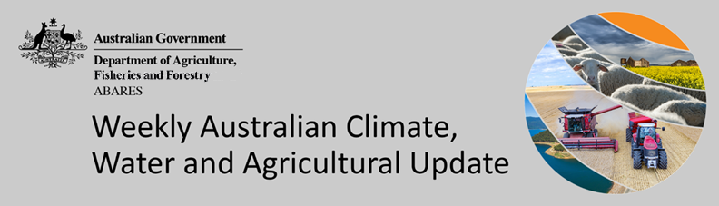
No. 42/2022

27 October 2022

Summary of key issues
- For the week ending 26 October 2022, a low-pressure system and associated cold front over inland Australia brought extensive rainfall to eastern Australia and southern parts of Western Australia. Weekly rainfall totals exceeding 50 millimetres were observed in much of Queensland, New South Wales, Victoria and Tasmania as well as parts of South Australia and the Northern Territory. Heavy rain across New South Wales, Victoria, Queensland and Tasmania has led to major flooding events across several river catchments. The flooding in low-lying areas has caused damage to agricultural and transport infrastructure and is expected to cause significant crop losses for some growers (see Section 1.1).
- Atmospheric and oceanic indicators underpin the recent establishment of a third consecutive La Niña event in the tropical Pacific Ocean. Cool sea surface temperature (SST) anomalies have strengthened in the central and eastern equatorial Pacific Ocean in recent weeks, while warmer temperatures persist across the Maritime Continent and to the north-east of Australia (see Section 1.2).
- For November 2022, the outlook across cropping regions indicates a 75% chance of rainfall totals of between 25 and 100 millimetres across much of New South Wales, Queensland, south-eastern Victoria and isolated parts of South Australia. There is a 75% chance of less than 25 millimetres of rainfall for remaining parts of New South Wales, Victoria and South Australia, as well as the cropping regions of Western Australia. Given above average soil moisture levels across most growing regions in eastern Australia, this forecast rainfall is unlikely to further benefit winter crop yields but will promote better pasture growth potential (see Section 1.3).
- Over the 8-days to 3 November 2022, low-pressure systems, associated troughs and cold fronts are forecast to bring significant rainfall to eastern, central and southern Australia. Meanwhile, little to no rainfall is expected across much of Western Australia. Continued rainfall across south-eastern Australia is likely to exacerbate waterlogging and fungal disease pressure and maintain flooding in some low-lying areas. If this forecast rainfall is realised it is expected to cause further delays to the harvesting of winter crops and delay the planting of summer crop across Queensland and New South Wales. The outlook for winter crops across South Australia and Western Australia remains very promising (see Section 1.4).
- Water storage in the Murray–Darling Basin (MDB) decreased by 156 gigalitres (GL) between 17 October 2022 and 24 October 2022. The current volume of water held in storage is 23,995 GL, which represents 95% of total capacity. This is 8% or 1,716 GL more than at the same time last year.
- Allocation prices in the Victorian Murray below the Barmah Choke increased from $35 per ML on 14 October to $59 per ML on 21 October 2022. Prices are lower in the Murrumbidgee and regions above the Barmah choke due to the binding of the Murrumbidgee export limit and the Barmah choke trade constraint.

Climate

Rainfall this week
For the week ending 26 October 2022, a low-pressure system and associated cold front over inland Australia brought extensive rainfall to eastern Australia and southern parts of Western Australia. Weekly rainfall totals exceeding 50 millimetres were observed in much of Queensland, New South Wales, Victoria and Tasmania as well as parts of South Australia and the Northern Territory. High-pressure systems over western and northern parts of the country resulted in mostly dry conditions in much of Western Australia, the Northern Territory and western regions of Queensland.
In Australian cropping regions, rainfall totals of between 25 and 150 millimetres were recorded across New South Wales, Queensland, Victoria, as well as the south-east of South Australia and the southern half of the Western Australian wheatbelt. Little to no rainfall was recorded in remaining cropping regions of South Australia and Western Australia for the week ending 26 October 2022.
Heavy rain across New South Wales, Victoria, Queensland and Tasmania has led to major flooding events across several river catchments. The flooding in low-lying areas has caused damage to agricultural and transport infrastructure and is expected to cause significant crop losses for some growers. However, the full extent of damage is yet unknown. The wet conditions have also increased susceptibility to fungal diseases, especially for pulse crops across southern New South Wales and western Victoria, which is likely to negatively impact yields and crop quality. For winter crops not impacted by prolonged waterlogging and fungal diseases, yield potentials remain very favourable.
Moderate to heavy rainfall across cropping regions in eastern Australia has interrupted the harvesting of winter crops and the sowing of summer crops. Meanwhile, yield prospects remain very favourable for parts of Western Australia and South Australia, where recent rainfall will have supported strong yield development in later maturing crops.

Rainfall for the week ending 26 October 2022
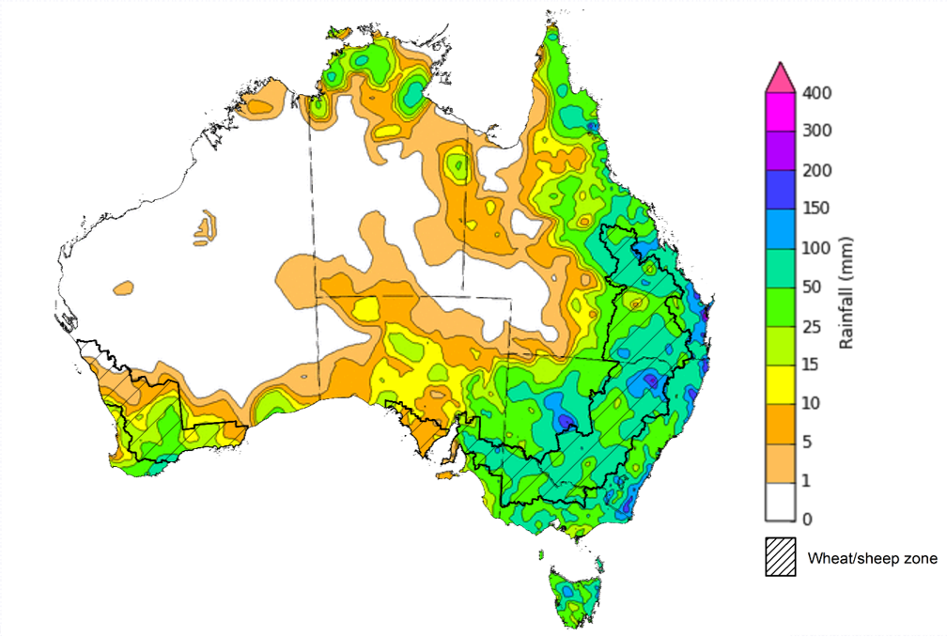
©Commonwealth of Australia 2022, Australian Bureau of Meteorology Issued:26/10/2022
Note: The rainfall analyses and associated maps utilise data contained in the Bureau of Meteorology climate database, the Australian Data Archive for Meteorology (ADAM). The analyses are initially produced automatically from real-time data with limited quality control. They are intended to provide a general overview of rainfall across Australia as quickly as possible after the observations are received. For further information go to http://www.bom.gov.au/climate/rainfall/

Climate Drivers
Throughout Australia’s late spring/early summer period the climate drivers with the largest potential impact on Australia’s climate patterns are the El Niño–Southern Oscillation (ENSO), the Indian Ocean Dipole (IOD), the Southern Annular Mode (SAM), and the Madden-Julian Oscillation (MJO). These climate drivers are likely to influence pasture growth across southern Australia, grain quality prospects and harvest conditions for winter crops, as well as the planting and establishment of summer crops across northern cropping regions.
Atmospheric and oceanic indicators underpin the recent establishment of a third consecutive La Niña event in the tropical Pacific Ocean. Cool sea surface temperature (SST) anomalies have strengthened in the central and eastern equatorial Pacific Ocean in recent weeks, while warmer temperatures persist across the Maritime Continent and to the north-east of Australia. Trade winds have been stronger than average in the western Pacific and cloudiness has also remained below average around the Date Line, which reflect the ongoing La Niña event.
A negative IOD event continues in the tropical Indian Ocean, with above average SSTs continuing in the east and below average SSTs observed in the north-west of the basin. The temperature gradient established across the tropical Indian Ocean reflects the ongoing negative IOD event.
The SAM is currently neutral but is expected to return to positive values throughout spring and early summer. In recent weeks, an MJO of moderate strength developed over the Pacific Ocean and is expected to continue moving eastwards over the coming fortnight. Given current and expected conditions, including the La Niña event, the negative IOD event, and the return to a positive SAM, above average rainfall is expected to persist across eastern Australia over the coming weeks.

Difference from average sea surface temperature observations 17 October to 23 October 2022
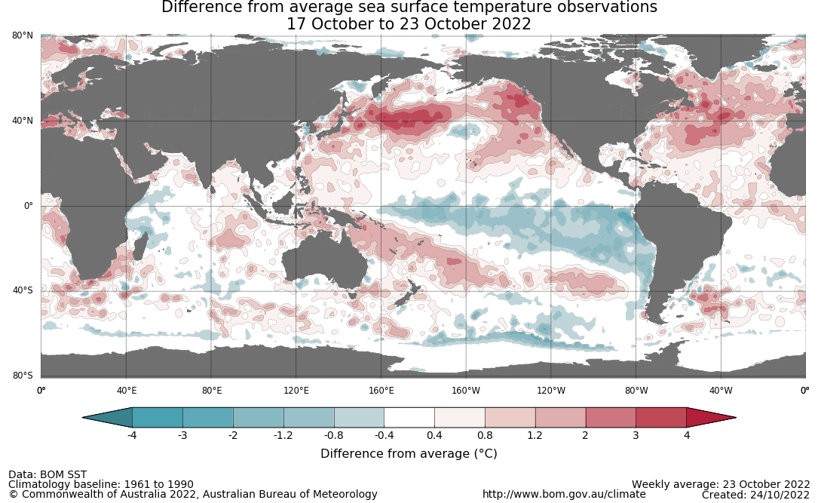

International climate model outlooks for the NINO 3.4 region in December 2022
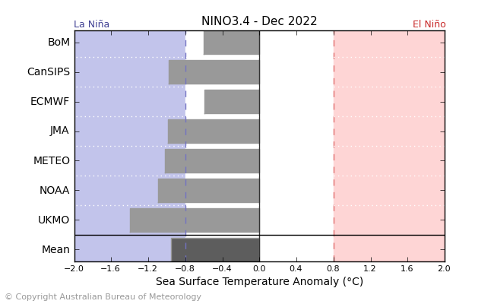
©Commonwealth of Australia 2022, Australian Bureau of Meteorology Issued: 25/10/2021
The La Niña event currently underway in the Pacific Ocean is expected to persist through the end of 2022 but rapidly decay in early 2023. Five of the seven international models surveyed predict the La Niña event to remain active in December, but all models expect the La Niña event to dissipate by February 2023. For the period ending 23 October, the 30-day Southern Oscillation Index (SOI) value was +19.0 and the 90-day value for the period ending 23 October was +15.7, both of which are above the La Niña threshold of +7. La Niña events are associated with above average rainfall across eastern and northern Australia through spring and summer.

30-day Southern Oscillation Index (SOI) values ending 23 October 2021
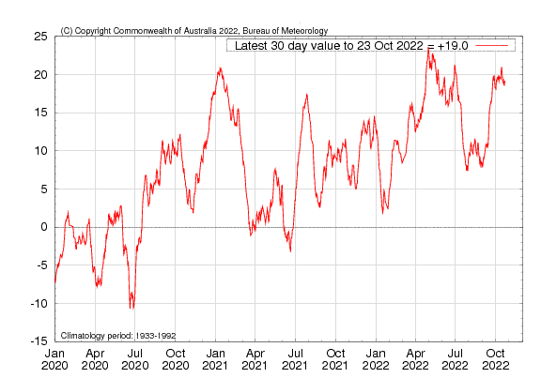

A negative IOD event persists in the Indian Ocean, with values exceeding the negative IOD threshold (−0.4 °C) since mid-June. Below average sea surface temperatures in western parts of the Indian Ocean, near the Horn of Africa, and warmer than average temperatures to the north-west of Australia tends to result in above average rainfall across southern Australia and the far north throughout spring. It is also associated with the early onset of northern Australia rainfall.
As at 25 October 2022, the Indian Ocean Dipole (IOD) weekly value was -0.73°C. All international climate models surveyed by the Bureau of Meteorology predict the negative IOD event to persist throughout spring. However, the negative IOD event is expected to decline rapidly towards the end of spring, returning to neutral by early summer.

Monthly sea surface temperature anomalies for IOD region
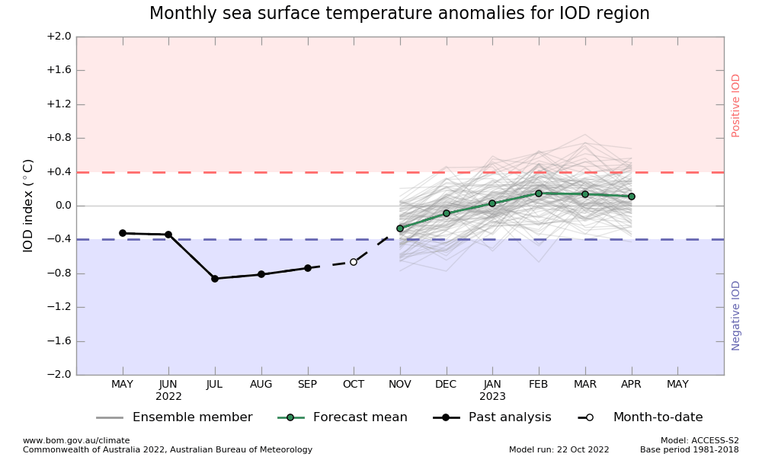

International climate model outlooks for the IOD in December 2022
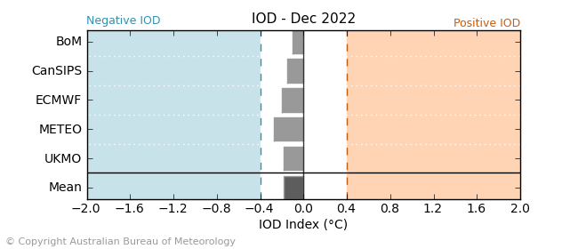
©Commonwealth of Australia 2022, Australian Bureau of Meteorology Issued: 25/10/2021

The Southern Annular Mode (SAM) is currently neutral but is expected to return to positive values during November and remain positive during early summer. The SAM refers to the north-south shift of the band of rain-bearing westerly winds and weather systems in the Southern Ocean compared to the usual position. A positive SAM in spring is associated with increased rainfall for parts of eastern New South Wales and Victoria as well as southern Queensland. It is also associated with decreased rainfall for parts of south-western and south-eastern Australia.

Southern Annular Mode (SAM) daily index
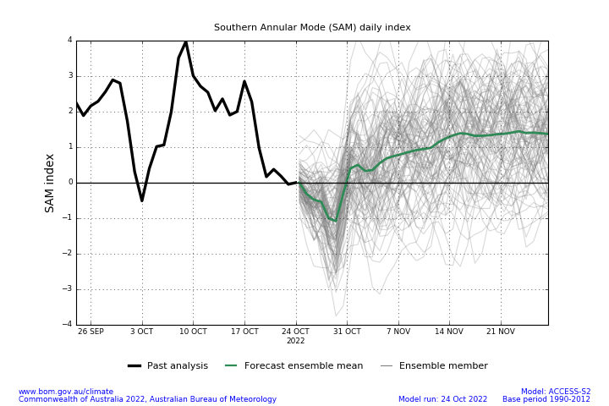

As at 23 October 2022 the Madden–Julian Oscillation (MJO) is at moderate strength over the western Pacific Ocean and is expected to move eastwards across the western Pacific region over the coming fortnight. The MJO is a pulse of cloud and rainfall that moves eastward along the equator. An active MJO in the Pacific at this time of year increases the chance of above average rainfall over the eastern half of Australia.

Madden–Julian Oscillation (MJO) daily index
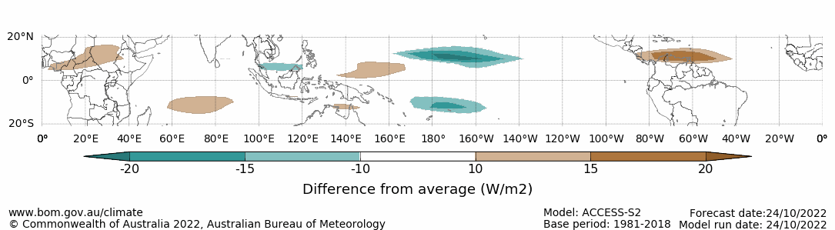

Note: This map displays the forecast outgoing longwave radiation (OLR) difference from expected cloudiness to identify convective rain clouds and the position of the Madden–Julian Oscillation (MJO). The blue shading indicates higher than normal, active or enhanced tropical weather and the brown shading indicates lower than normal clouds or suppressed conditions.

National Climate Outlook
These climate outlooks are generated by ACCESS–S (Australian Community Climate Earth-System Simulator–Seasonal). ACCESS–S is the Bureau of Meteorology's dynamic (physics-based) weather and climate model used for monthly, seasonal and longer-lead climate outlooks.
For further information, go to http://www.bom.gov.au/climate/ahead/about/
The Bureau of Meteorology’s latest rainfall outlook for November indicates wetter than average conditions are expected across parts of Australia. The ACCESS-S climate model suggests there is a 60% to 80% chance of exceeding median rainfall for parts of eastern and northern Australia, with a 40% chance of below median rainfall for northern and central parts of Western Australia.
The outlook for November 2022 indicates that there is a 75% chance of rainfall totals between 10 and 100 millimetres across much of New South Wales, Queensland, Victoria, the northern tip of Western Australia, Tasmania, as well as much of the Northern Territory. For most areas in South Australia and Western Australia rainfall totals are not expected to exceed 25 millimetres. Rainfall totals in excess of 100 millimetres are expected across isolated areas of alpine New South Wales and Victoria, north-eastern New South Wales and Queensland, the north of the Northern Territory, as well as western Tasmania.
Across cropping regions there is a 75% chance of rainfall totals of between 25 and 100 millimetres across much of New South Wales, Queensland, south-eastern Victoria and isolated parts of South Australia. There is a 75% chance of less than 25 millimetres of rainfall for remaining parts of New South Wales, Victoria and South Australia, as well as the cropping regions of Western Australia. Given above average to well above average soil moisture level across most growing regions in eastern Australia this forecast rainfall is unlikely to further benefit winter crop yields but will allow for average or better pasture growth potential. Given the current wet conditions and an expectation for above average rainfall for the coming months, we are likely to see a drawn-out 2022 winter crop harvest and a late start to summer crop planting in many regions.
Rainfall totals that have a 75% chance of occurring November 2022
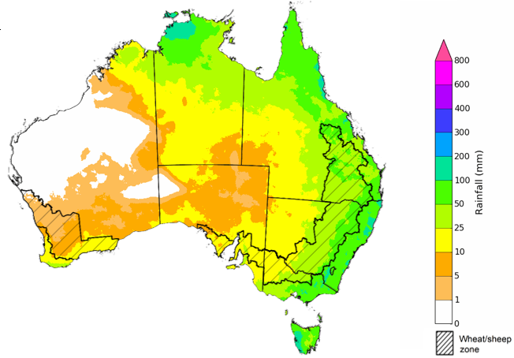
©Commonwealth of Australia 2022, Australian Bureau of Meteorology Issued: 20/10/2022
The rainfall outlook for November 2022 to January 2023 suggests there is a greater than 65% chance of exceeding median rainfall across most of Victoria, New South Wales, eastern Queensland, Tasmania, and parts of the south-east of South Australia, and north-east of the Northern Territory. For remaining regions of Australia, there is no strong tendency towards above or below median rainfall, except for parts of north-eastern and central Western Australia where below median rainfall is likely between November to January (Bureau of Meteorology ‘National Climate Outlook’, 20 October 2022).
Bureau of Meteorology rainfall outlooks for November to January have greater than 55% past accuracy across most of Australia. Outlook accuracy is greater than 65% across most of New South Wales, Victoria, and Tasmania, as well as parts of Queensland, South Australia and the Northern Territory. Past accuracy is low (less than 50%) for isolated parts of Western Australia, Queensland, and South Australia.
Chance of exceeding the median rainfall November 2022 to January 2023
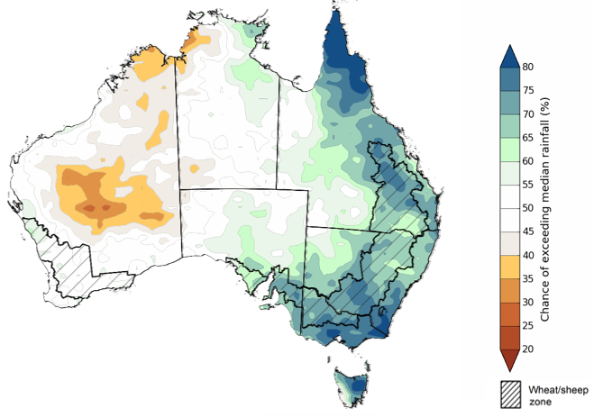
©Commonwealth of Australia 2022, Australian Bureau of Meteorology Issued: 20/10/2022
The outlook for November 2022 to January 2023 suggests there is a 75% chance of rainfall totals between 50 and 200 millimetres across Victoria, most of New South Wales, Queensland and the Northern Territory, south-eastern parts of South Australia, the north of Western Australia, and Tasmania. Rainfall totals in excess of 200 millimetres are forecast for large parts of coastal and alpine New South Wales and Victoria, as well as parts of eastern and northern Queensland, the north of Western Australia and the Northern Territory, and parts of western and north-eastern Tasmania.
Across cropping regions, there is a 75% chance of receiving between 25 and 100 millimetres across much of south-western New South Wales, Victoria, South Australia and isolated pockets of south-eastern Western Australia. Totals of between 100 and 300 millimetres are expected across much of the New South Wales and Queensland cropping regions. Rainfall totals are not expected to exceed 25 millimetres for the north-western parts of Western Australian cropping regions.
Through late spring and early summer, winter crop grain quality, crop abandonment and the inability to plant summer crops are major risk factors associated with excessive moisture. Above average rainfall through late spring also increases the risk of waterlogging, negatively impacting crop development.
In central and northern New South Wales and southern Queensland, winter cropping has already been heavily impacted by excessive moisture. As crops in these regions mature, a continuation of wet conditions may cause quality downgrades and delay harvesting. Moreover, the wet conditions are likely to continue to interrupt the planting of summer crops. While parts of southern New South Wales and Victoria are currently waterlogged and recovering from recent flooding, a return to average rainfall over the coming months will likely give soils a chance to drain and allow for improved field access as we approach the winter crop harvest. In Western Australia, below average rainfall is likely to allow the harvesting of winter crops to progress with minimal interruption.
Rainfall totals that have a 75% chance of occurring November 2022 to January 2023
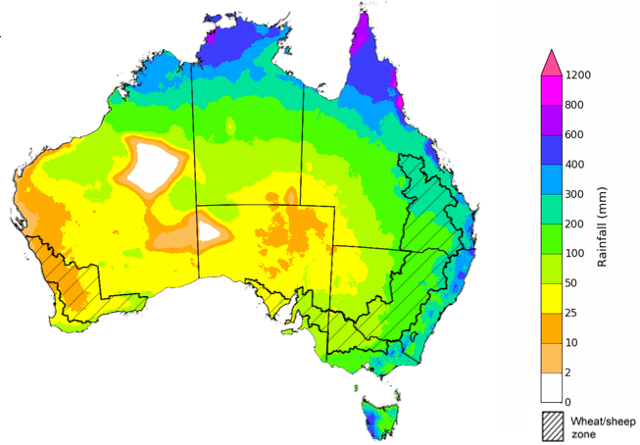
©Commonwealth of Australia 2022, Australian Bureau of Meteorology Issued: 20/10/2022
The temperature outlook for November 2022 to January 2023 indicates that maximum temperatures across most of Australia are likely to be close to the 1990-2012 average (the difference in the range of - 1°C to +1°C), with slightly lower than average maximum temperatures across eastern New South Wales and south-eastern Queensland. Minimum temperatures are expected to be slightly above average for isolated areas of north-eastern Australia and Tasmania, and close to average for the rest of Australia (Bureau of Meteorology ‘National Climate Outlook’, 20 October 2022).
Predicted maximum temperature anomaly for November 2022 to January 2023

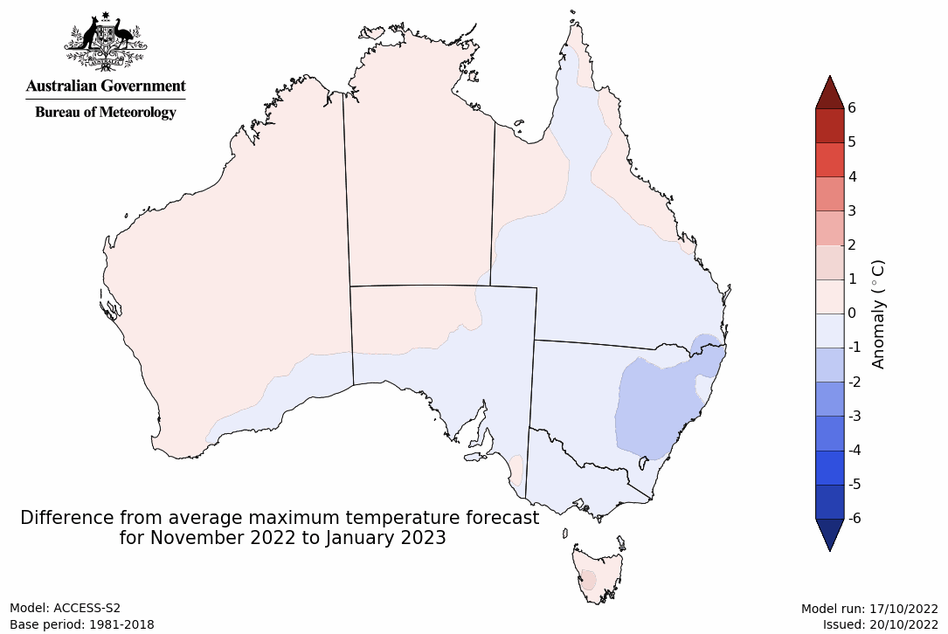
Predicted minimum temperature anomaly for November 2022 to January 2023
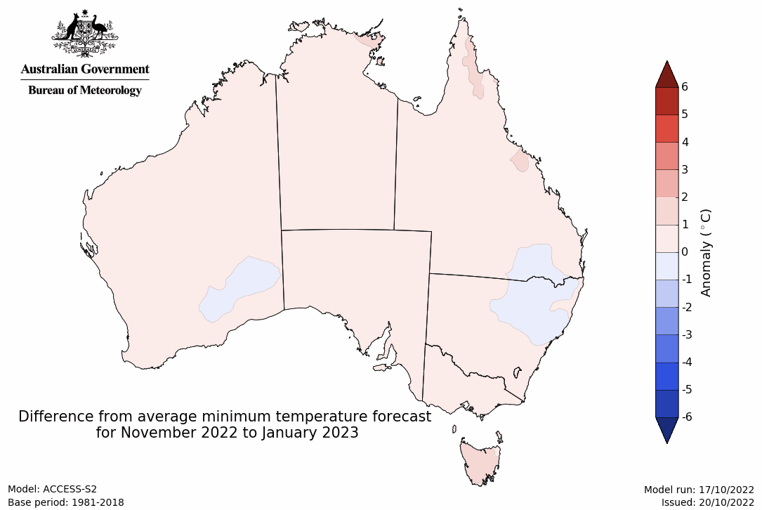

Rainfall forecast for the next eight days
Over the 8-days to 3 November 2022, low-pressure systems, associated troughs and cold fronts are forecast to bring significant rainfall to eastern, central and southern Australia. Meanwhile, little to no rainfall is expected across much of Western Australia.
In Australian cropping regions, rainfall totals of between 10 and 50 millimetres are expected across New South Wales, Queensland, Victoria, South Australia, and much of the southern half of the Western Australian wheatbelt. Little to no rainfall is forecast for remaining cropping regions in Western Australia during the next 8-days.
Continued rainfall across south-eastern Australia is likely to exacerbate waterlogging and fungal disease pressure and maintain flooding in some low-lying areas. Prolonged inundation will increase the risk of winter crop abandonment as well as quality downgrades. Yield potentials for crops not impacted by flooding in south-eastern Australia remain very favourable. However, soil moisture levels are well above average, and the forecast rainfall is unlikely to benefit yields further. In contrast, the forecast wet conditions will further increase disease pressure for winter crops while limiting field access for disease management.
If this forecast rainfall is realised it is expected to cause further delays to the harvesting of winter crops and delay the planting of summer crop across Queensland and New South Wales. The wet conditions and associated cooler than normal temperatures will also delay the maturation of winter crops and the start of harvesting activities for remaining regions of eastern Australia.
The outlook for winter crops across South Australia and Western Australia remains very promising. Light to moderate rainfall across parts of South Australia may increase disease pressure slightly, but ideal conditions for the season to-date have established strong yield potentials. Likewise, another large winter crop is expected in Western Australia as conditions remain favourable for crop maturation.

Total forecast rainfall (mm) for the period 27 October to 3 November 2022
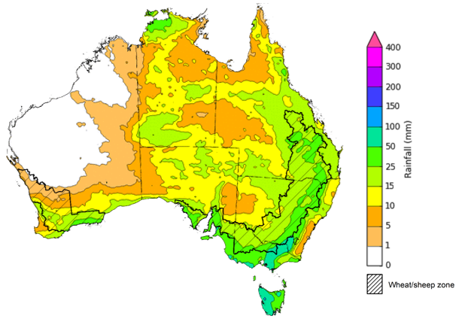
©Commonwealth of Australia 2022, Australian Bureau of Meteorology Issued 27/10/2022

Water
Note: This rainfall forecast is produced from computer models. As the model outputs are not altered by weather forecasters, it is important to check local forecasts and warnings issued by the Bureau of Meteorology.

Water markets – current week
Water storage in the Murray–Darling Basin (MDB) decreased by 156 gigalitres (GL) between 17 October 2022 and 24 October 2022. The current volume of water held in storage is 23,995 GL, which represents 95% of total capacity. This is 8% or 1,716 GL more than at the same time last year.

Water storages in the Murray-Darling Basin, 2013–2022
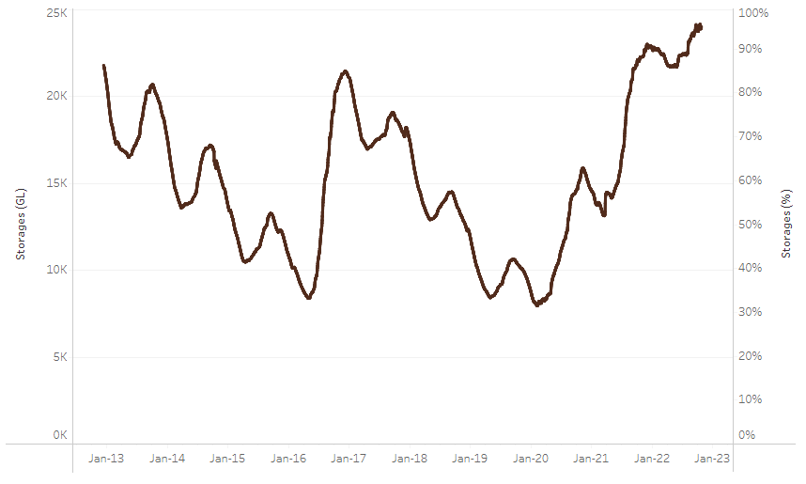
Allocation prices in the Victorian Murray below the Barmah Choke increased from $35 per ML on 14 October to $59 per ML on 21 October 2022. Prices are lower in the Murrumbidgee and regions above the Barmah choke due to the binding of the Murrumbidgee export limit and the Barmah choke trade constraint.
Water storage data is sourced from the Bureau of Meteorology.

Region | $/ML
NSW Murray Above | 11
NSW Murrumbidgee | 35
VIC Goulburn-Broken | 108
VIC Murray Below | 59

Surface water trade activity, Southern Murray–Darling Basin

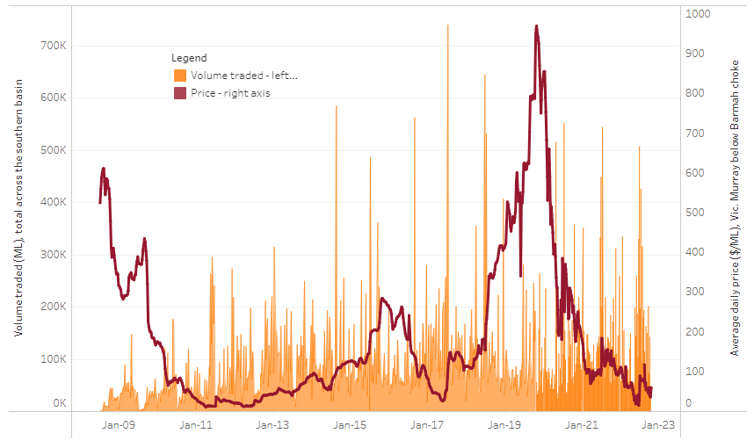
To access the full, interactive, weekly water dashboard, which contains the latest and historical water storage, water market and water allocation information, please visit http://www.agriculture.gov.au/abares/products/weekly_update/weekly-update-271022
The trades shown reflect estimated market activity and do not encompass all register trades. The price is shown for the VIC Murray below the Barmah choke. Historical prices (before 1 July 2019) are ABARES estimates after removing outliers from BOM water register data. Prices after 1 July 2019 and prior to the 30 October 2019 reflect recorded transaction prices as sourced from Ruralco. Prices after the 30 October 2019 are sourced from Waterflow. Data for volume traded is sourced from the BOM water register. Data shown is current at 27 October 2022.

Commodities

Indicator | Week ended | Unit | Latest price | Previous week | Weekly change | Price 12 months ago | Annual change
Selected world indicator prices
AUD/USD Exchange rate | 26-Oct | A$/US$ | 0.64 | 0.63 | 1% | 0.75 | -15%
Wheat – US no. 2 hard red winter wheat, fob Gulf | 26-Oct | US$/t | 433 | 437 | -1% | 368 | 18%
Corn – US no. 2 yellow corn, fob Gulf | 26-Oct | US$/t | 347 | 354 | -2% | 248 | 40%
Canola – Rapeseed, Canada, fob Vancouver | 26-Oct | US$/t | 696 | 672 | 4% | 862 | -19%
Cotton – Cotlook 'A' Index | 26-Oct | USc/lb | 95 | 101 | -5% | 126 | -24%
Sugar – Intercontinental Exchange, nearby futures, no.11 contract | 26-Oct | USc/lb | 17.7 | 17.8 | -1% | 19 | -9%
Wool – Eastern Market Indicator | 19-Oct | Ac/kg clean | 1,300 | 1,323 | -2% | 1,332 | -2%
Wool – Western Market Indicator | 19-Oct | Ac/kg clean | 1,427 | 1,469 | -3% | 1,385 | 3%
Selected Australian grain export prices
Milling Wheat – APW, Port Adelaide, SA | 26-Oct | A$/t | 612 | 608 | 1% | 445 | 38%
Feed Wheat – ASW, Port Adelaide, SA | 26-Oct | A$/t | 562 | 558 | 1% | 448 | 26%
Feed Barley – Port Adelaide, SA | 26-Oct | A$/t | 478 | 468 | 2% | 372 | 28%
Canola – Kwinana, WA | 26-Oct | A$/t | 1,067 | 1,049 | 2% | 1,047 | 2%
Grain Sorghum – Brisbane, QLD | 26-Oct | A$/t | 473 | 468 | 1% | 365 | 30%
Selected domestic livestock indicator prices
Beef – Eastern Young Cattle Indicator | 26-Oct | Ac/kg cwt | 1,031 | 1,035 | 0% | 1,039 | -1%
Mutton – Mutton indicator (18–24 kg fat score 2–3), Vic | 12-Oct | Ac/kg cwt | 510 | 515 | -1% | 626 | -19%
Lamb – Eastern States Trade Lamb Indicator | 26-Oct | Ac/kg cwt | 786 | 766 | 3% | 942 | -17%
Pig – Eastern Seaboard (60.1–75 kg), average of buyers & sellers | 28-Sep | Ac/kg cwt | 376 | 376 | 0% | 318 | 18%
Goats – Eastern States (12.1–16 kg) | 29-Jun | Ac/kg cwt | 1,030 | 879 | 17% | 818 | 26%
Live cattle – Light steers ex Darwin to Indonesia | 17-Aug | Ac/kg lwt | 420 | 480 | -13% | 320 | 31%
Live sheep – Live wethers (Muchea WA saleyard) to Middle East | 14-Sep | $/head | 93 | 113 | -18% | 114 | -18%

Indicator | Week ended | Unit | Latest price | Previous week | Weekly change | Price 12 months ago | Annual change
Global Dairy Trade (GDT) weighted average prices ª
Dairy – Whole milk powder | 19-Oct | US$/t | 3,421 | 3,573 | -4% | 2,985 | 15%
Dairy – Skim milk powder | 19-Oct | US$/t | 3,250 | 3,497 | -7% | 2,889 | 12%
Dairy – Cheddar cheese | 19-Oct | US$/t | 4,769 | 4,966 | -4% | 3,674 | 30%
Dairy – Anhydrous milk fat | 19-Oct | US$/t | 5,661 | 5,811 | -3% | 3,910 | 45%
a Global Dairy Trade prices are updated twice monthly on the first and third Tuesday of each month.

Selected world indicator prices
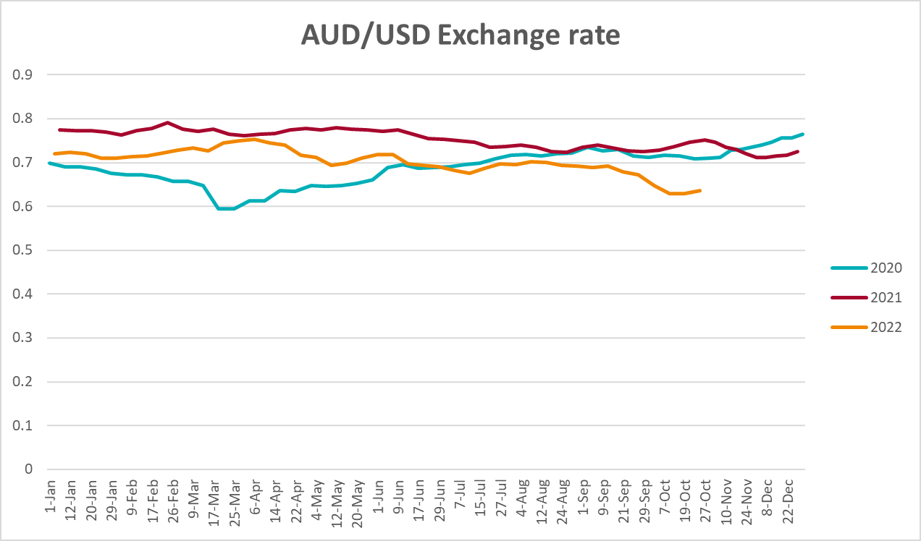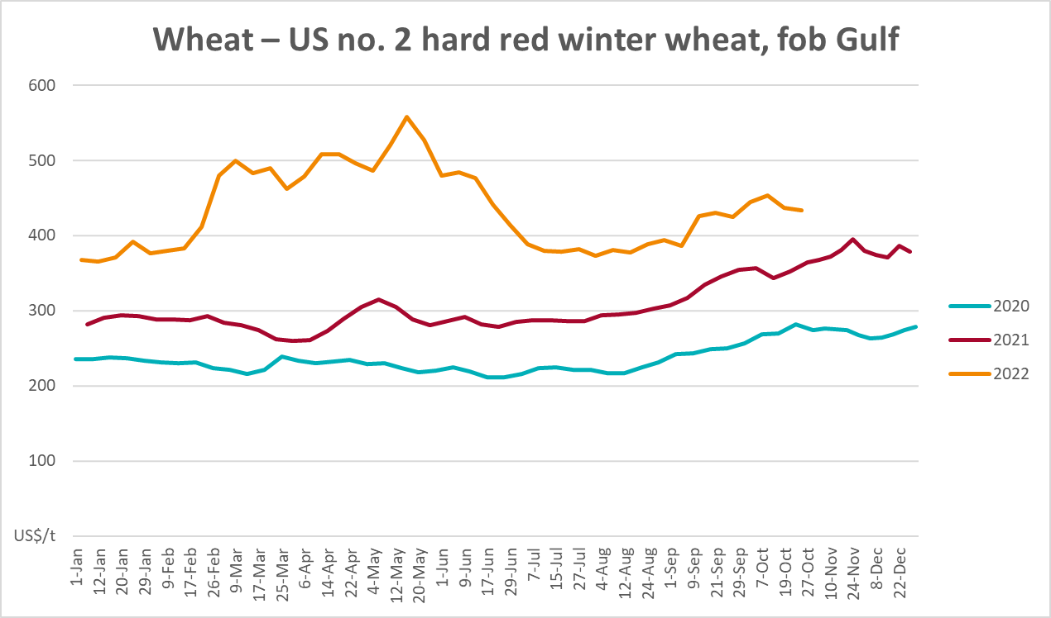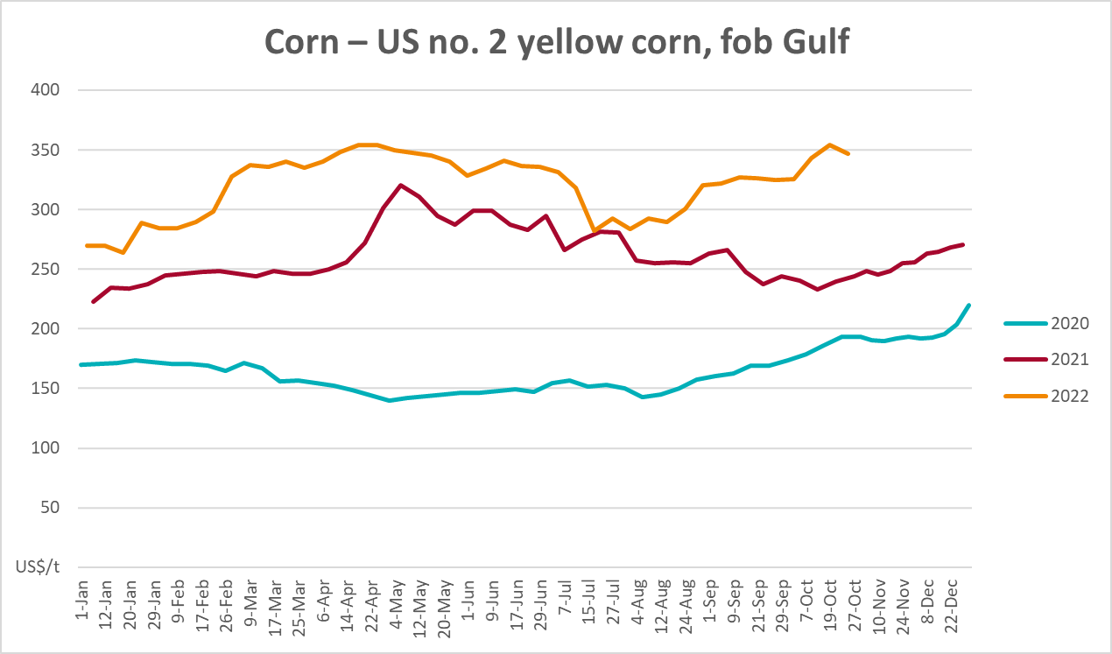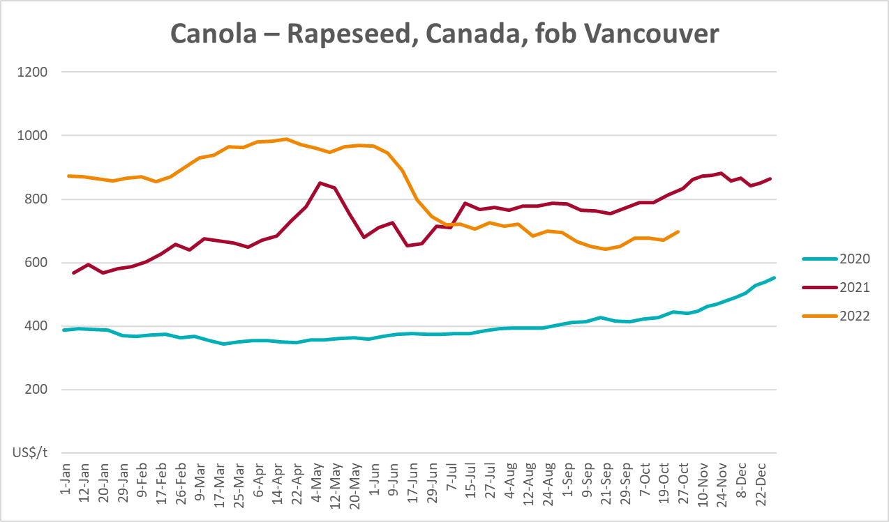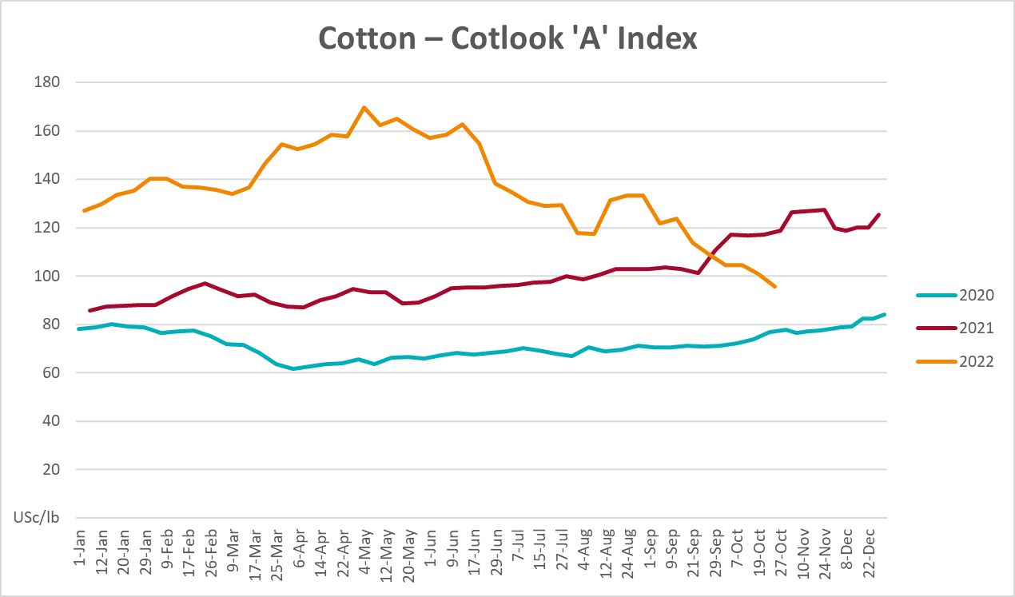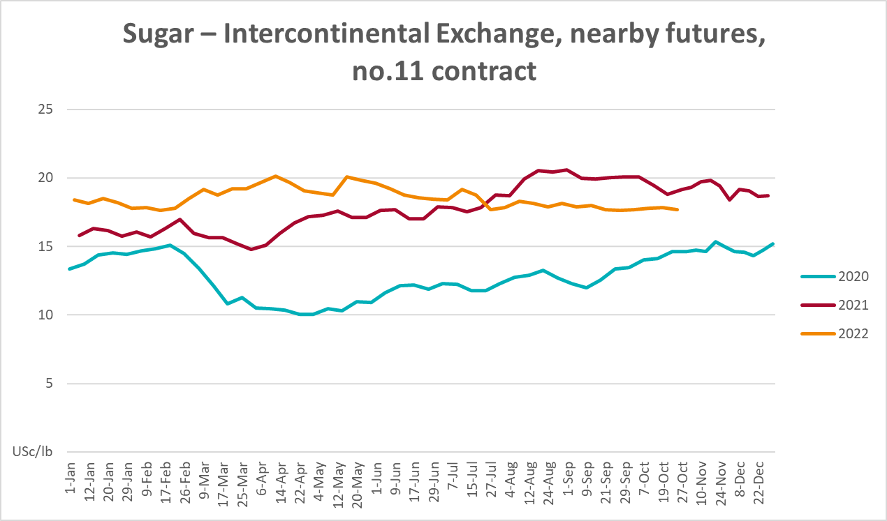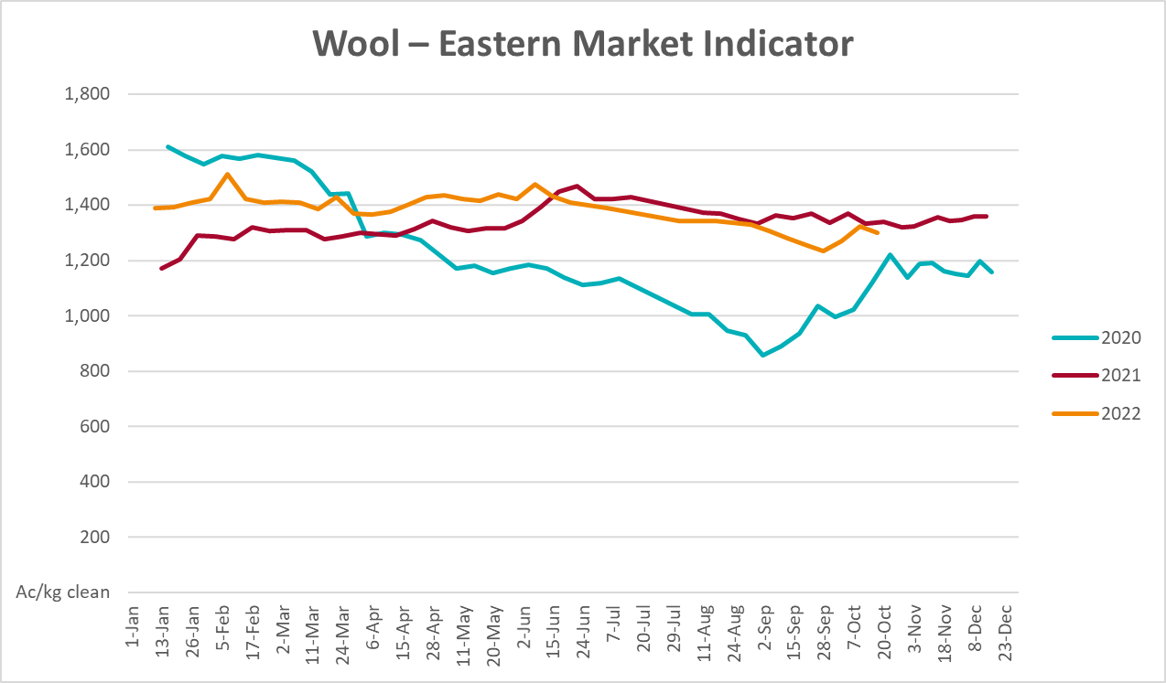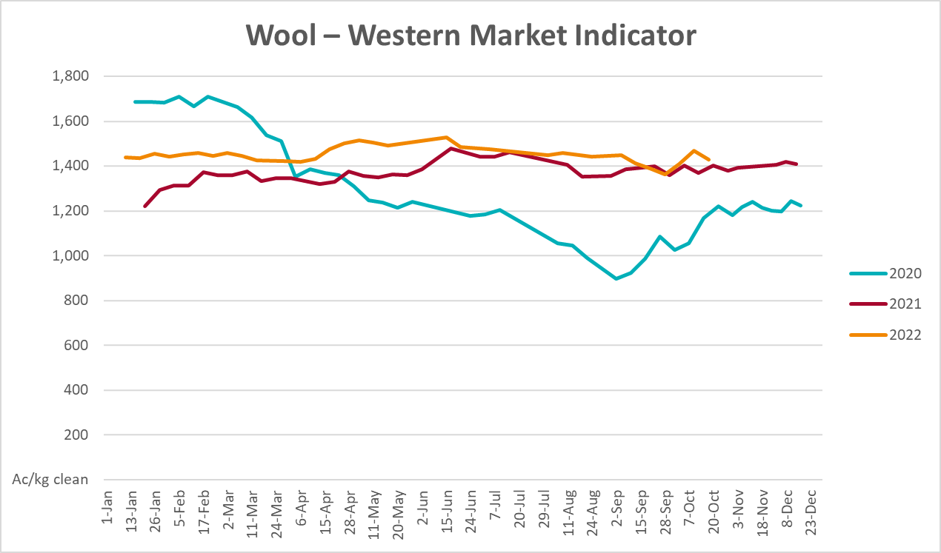

Selected domestic crop indicator prices
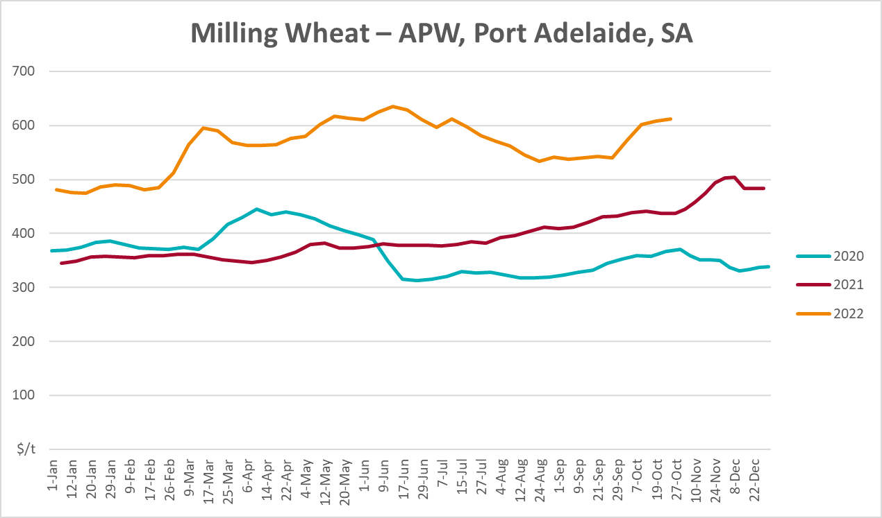
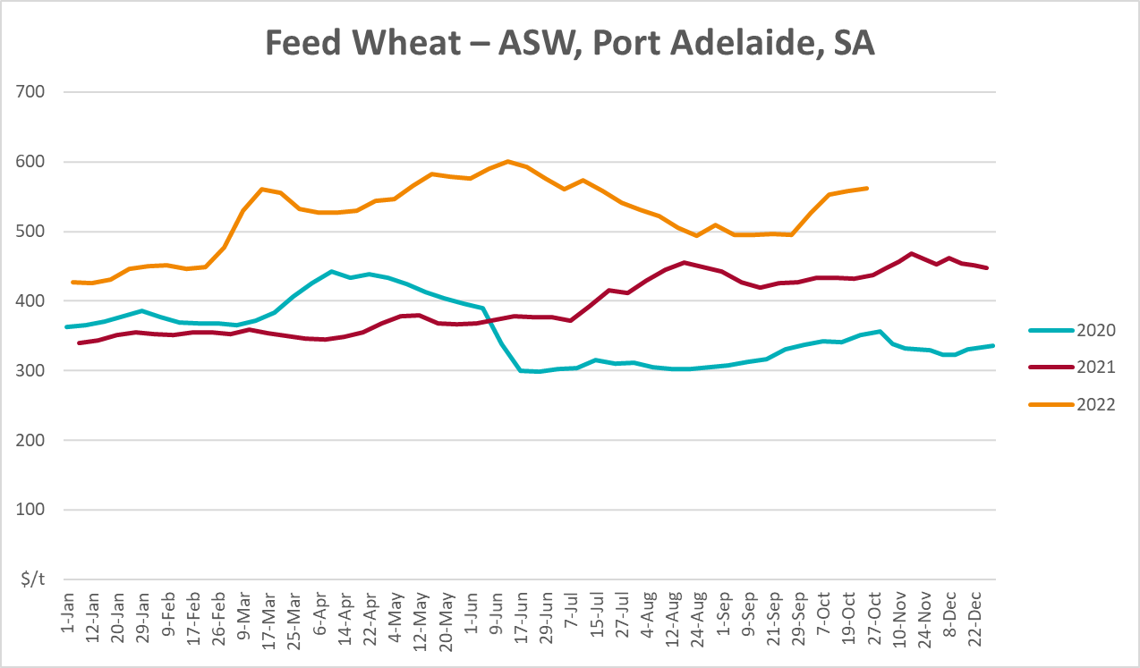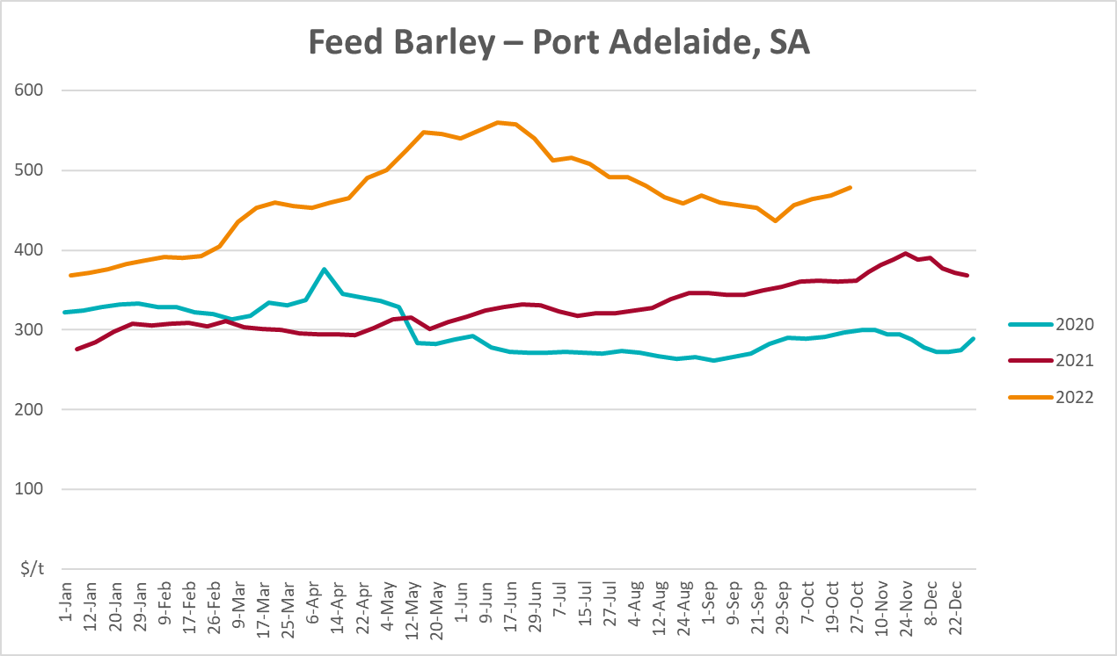
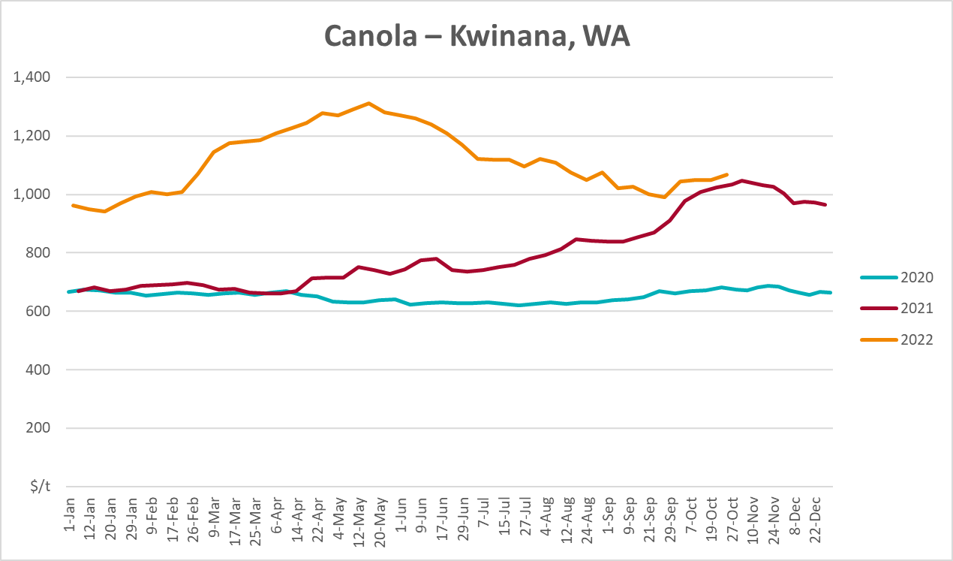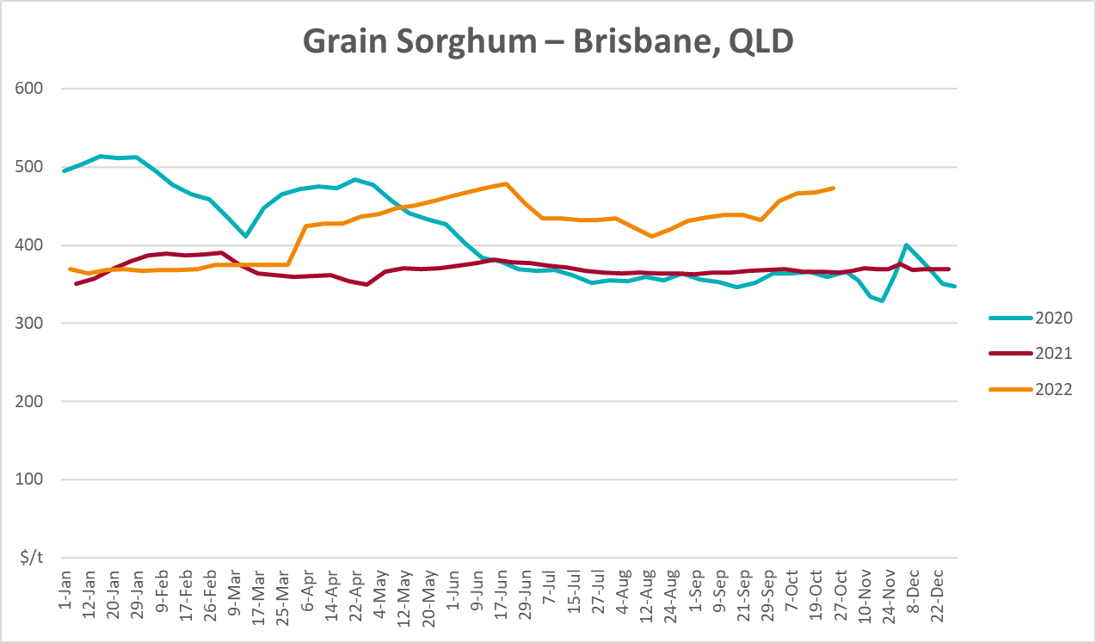

Selected domestic livestock indicator prices
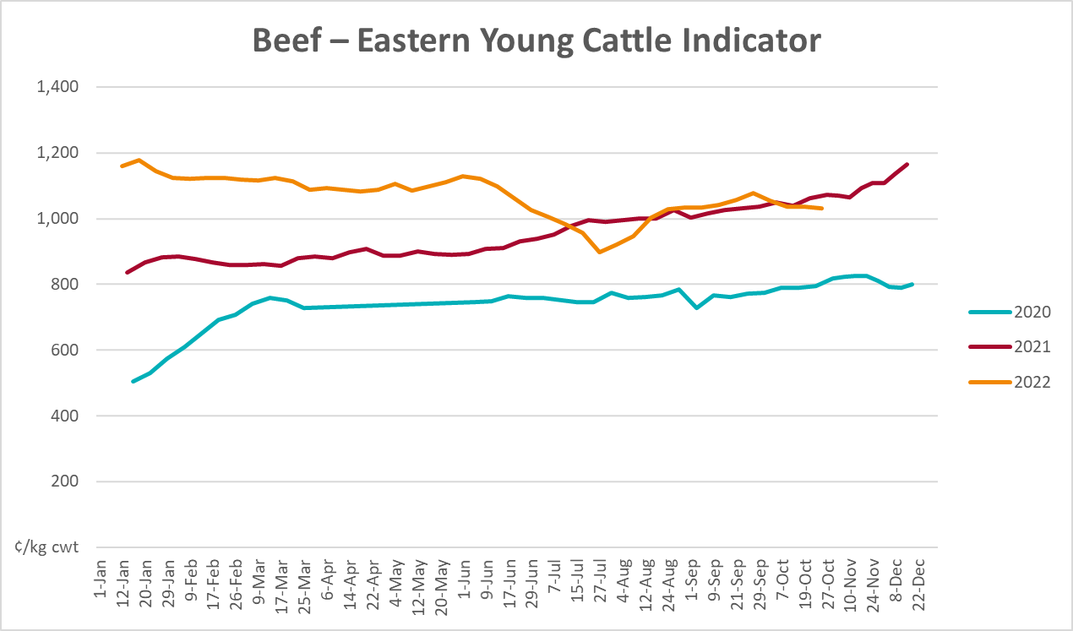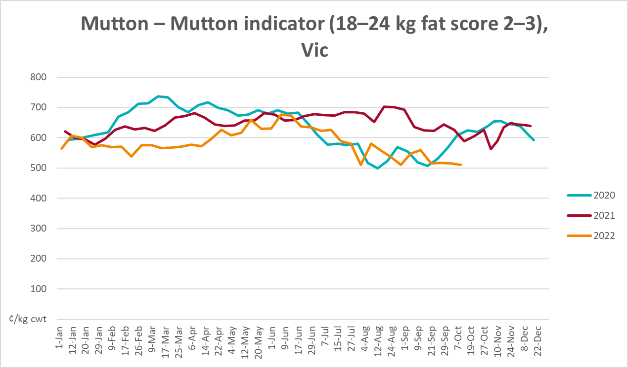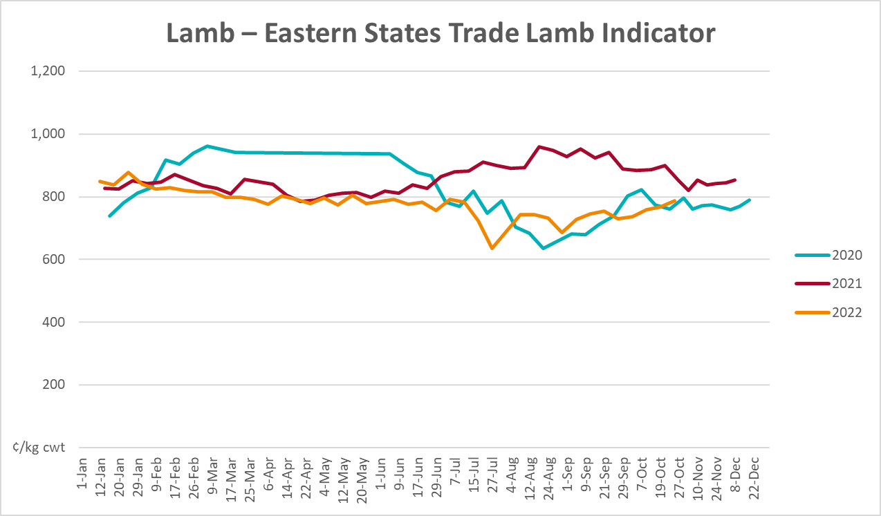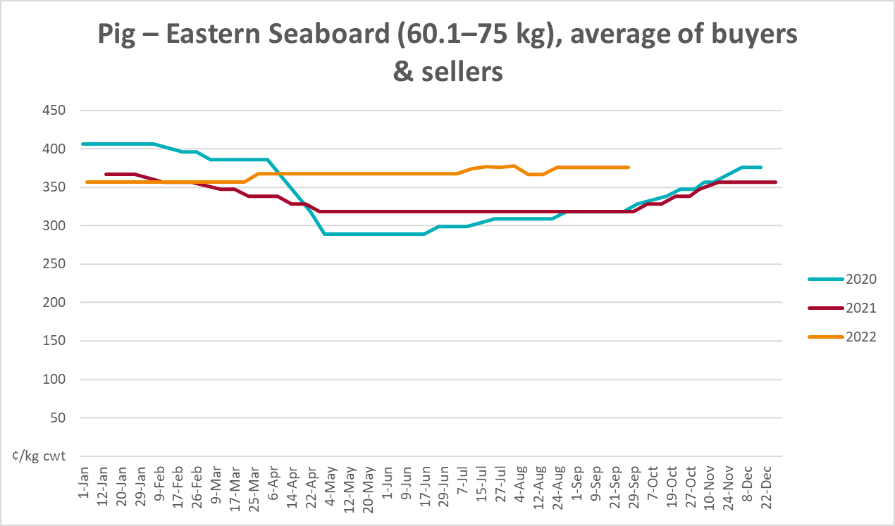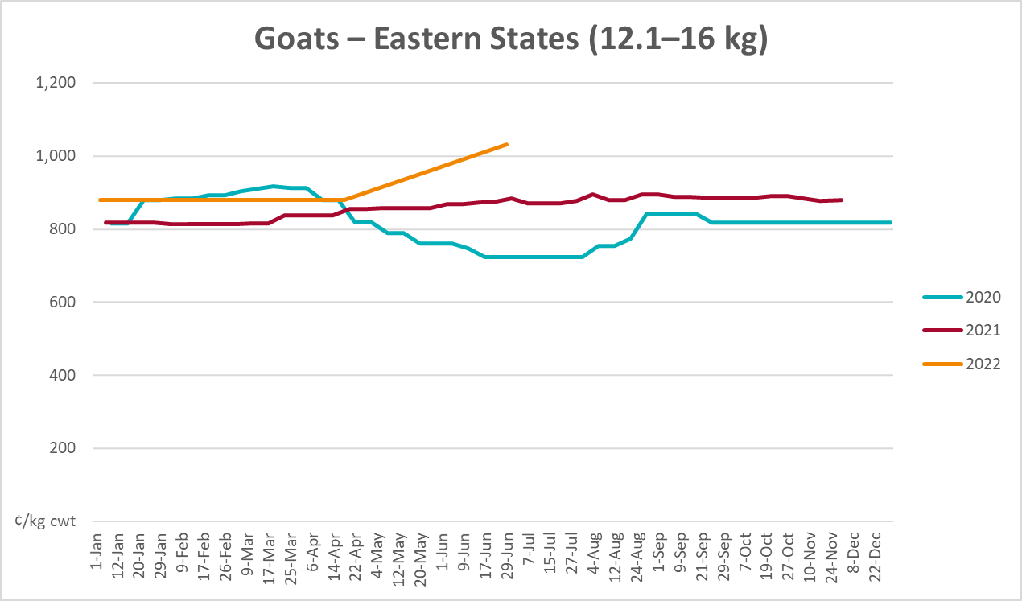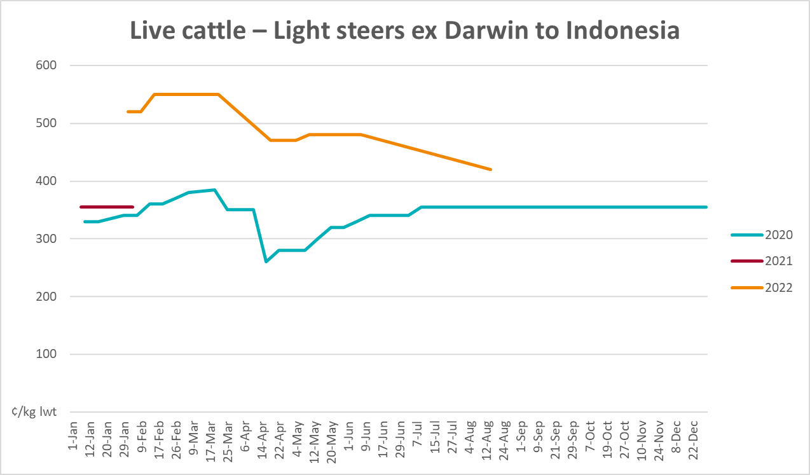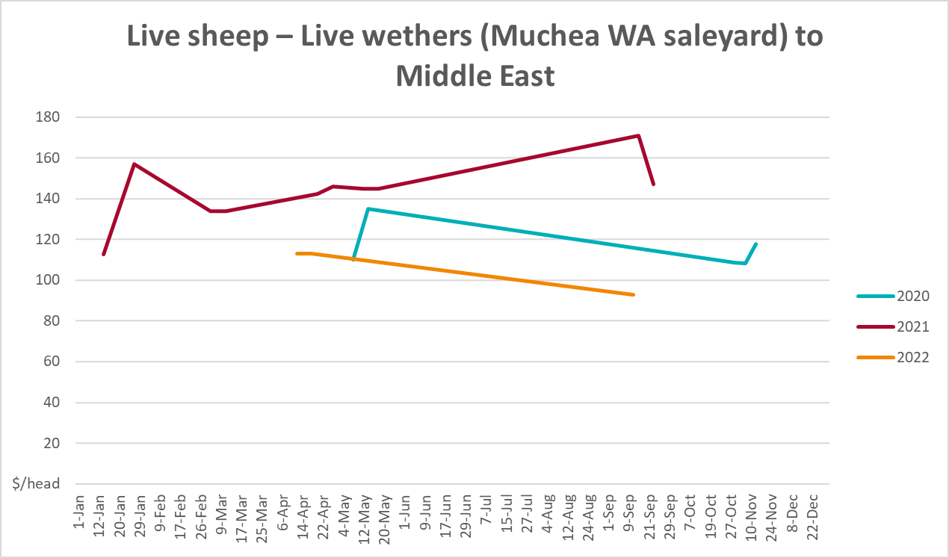

Global Dairy Trade (GDT) weighted average prices
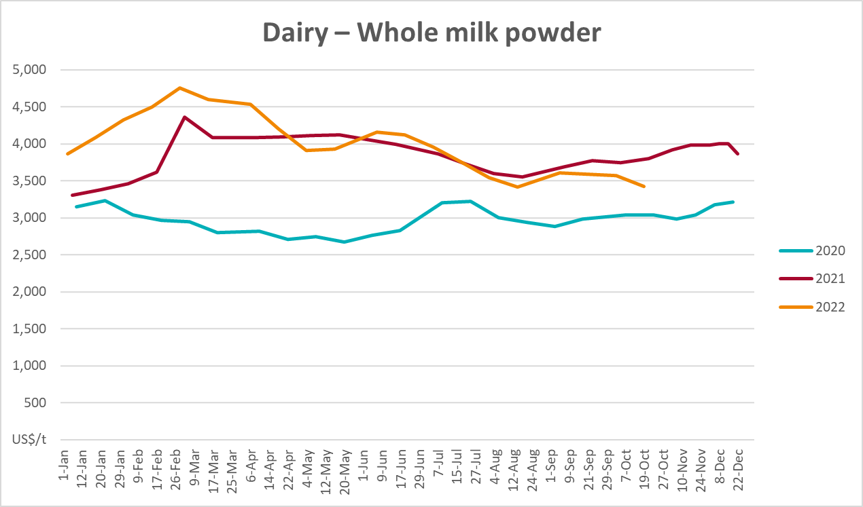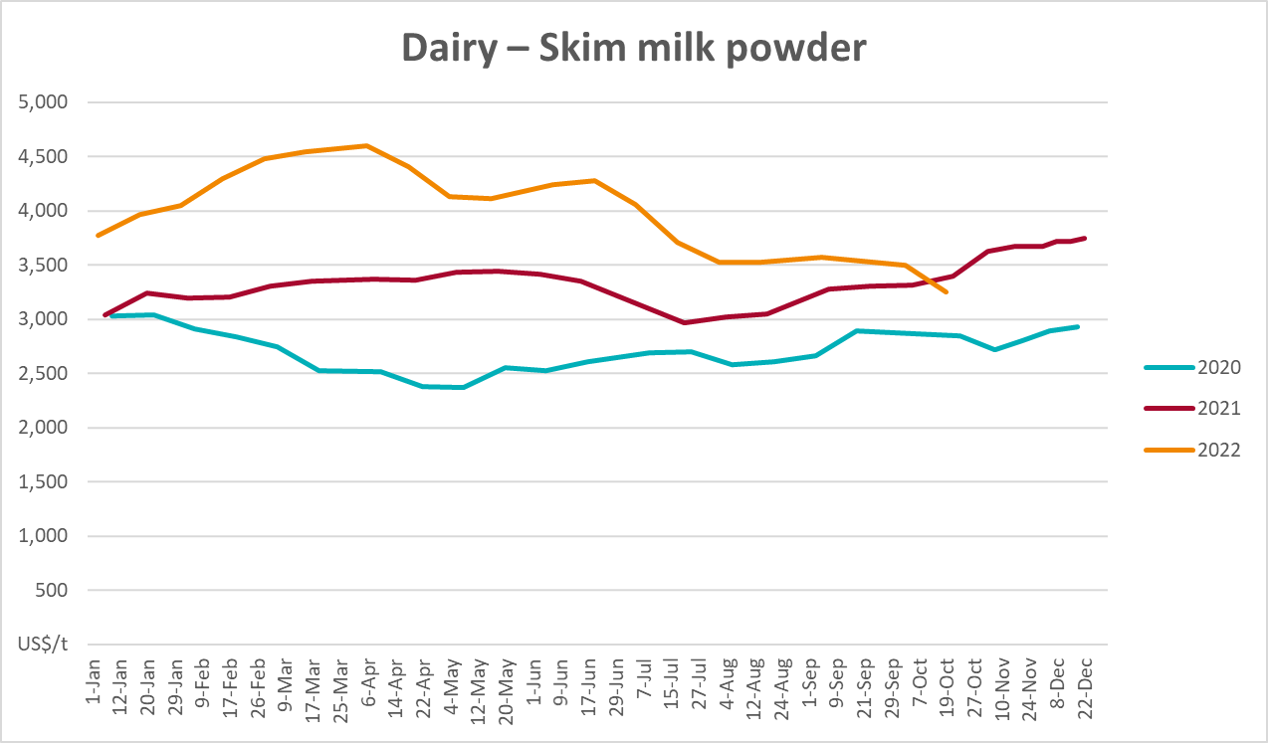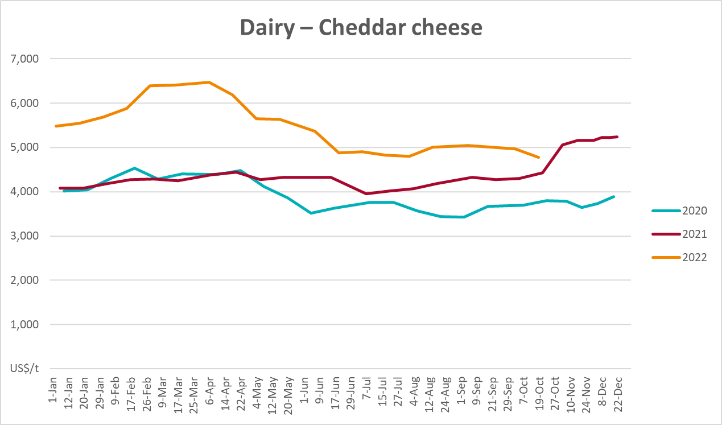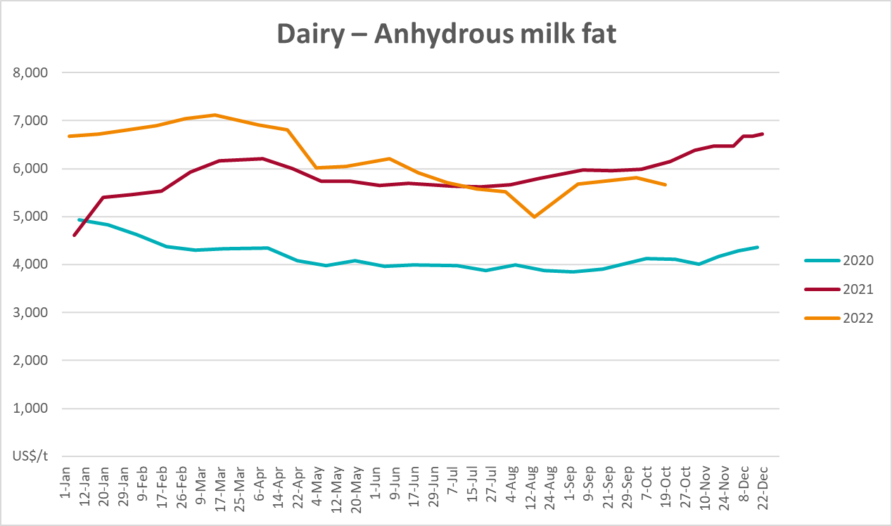

Selected fruit and vegetable prices
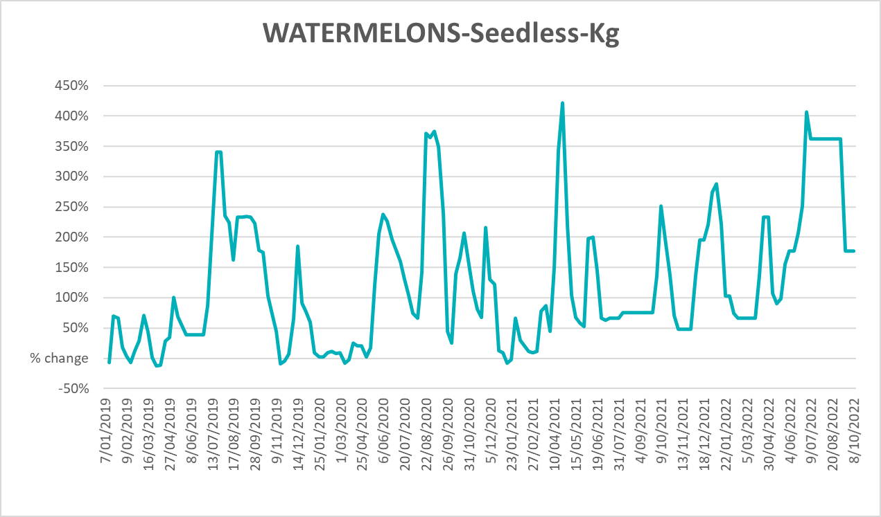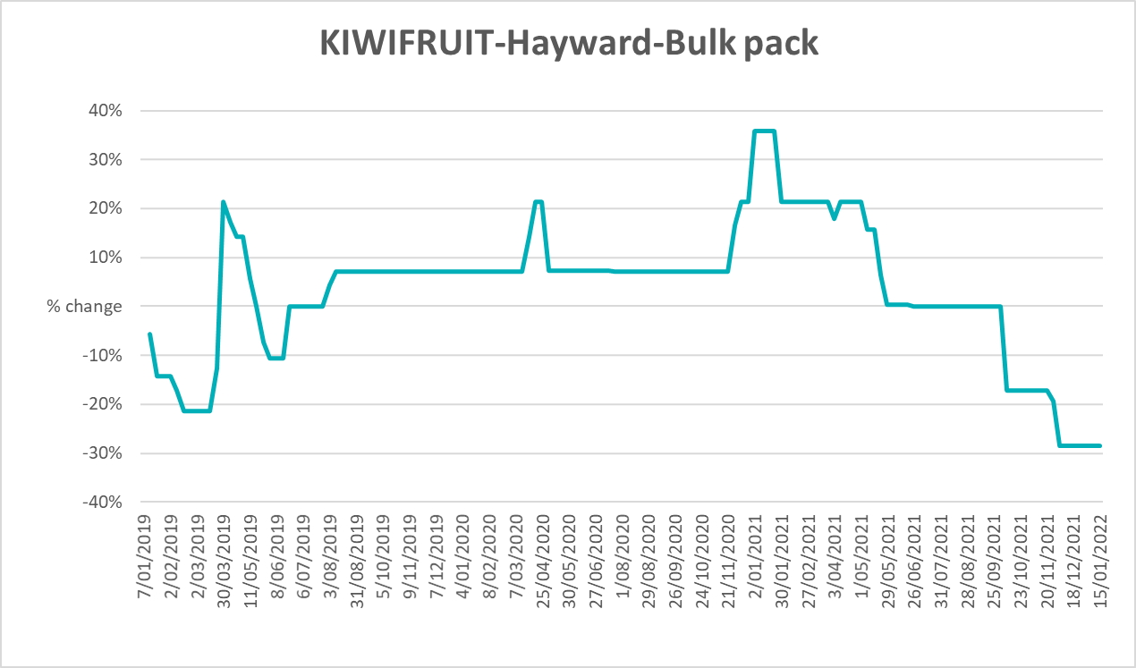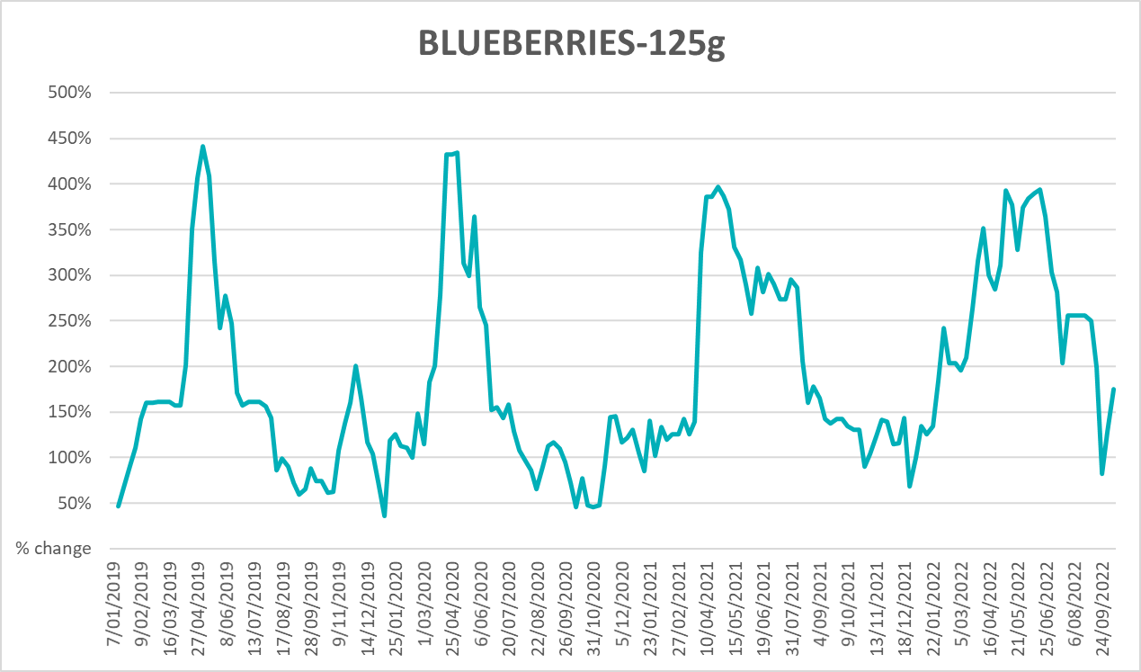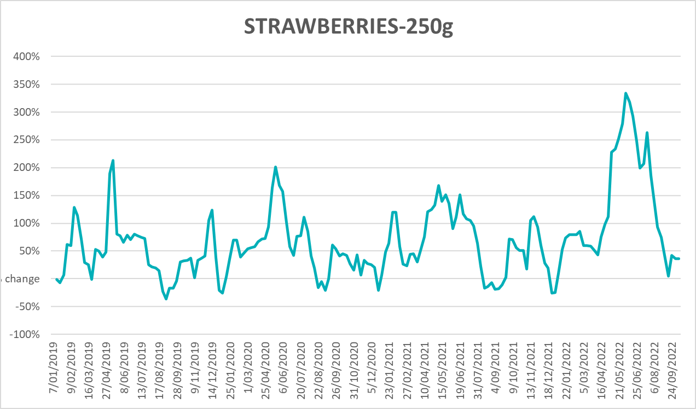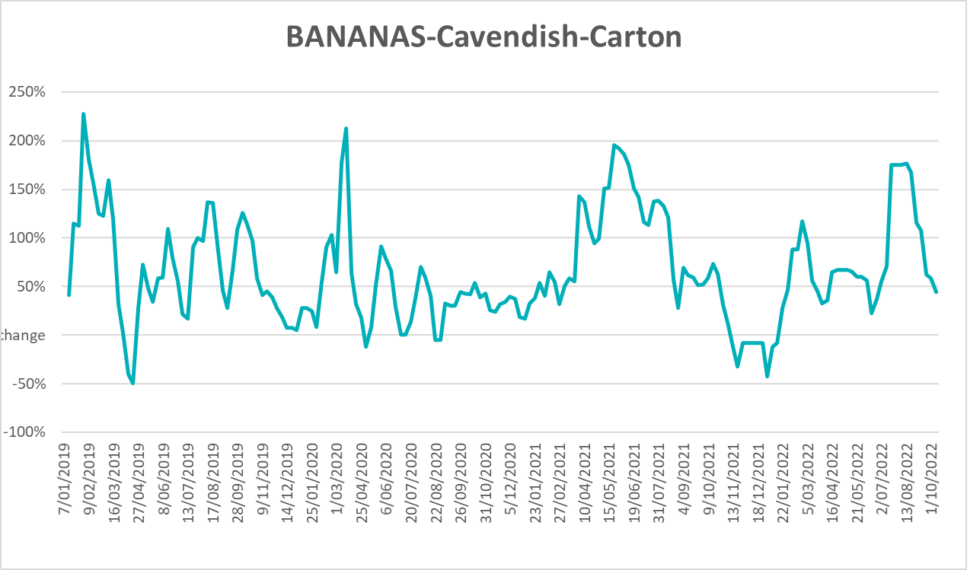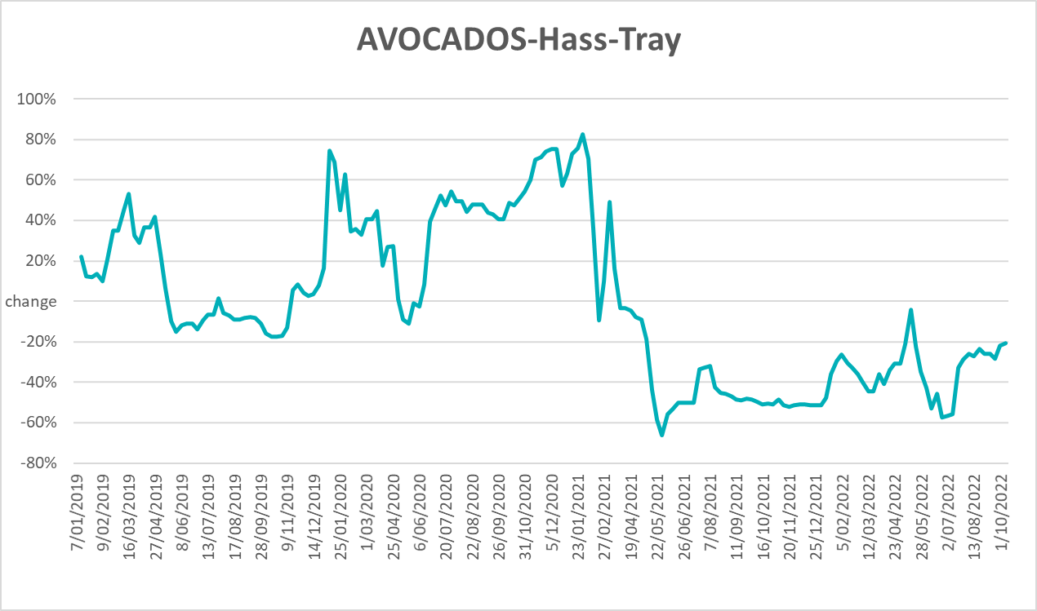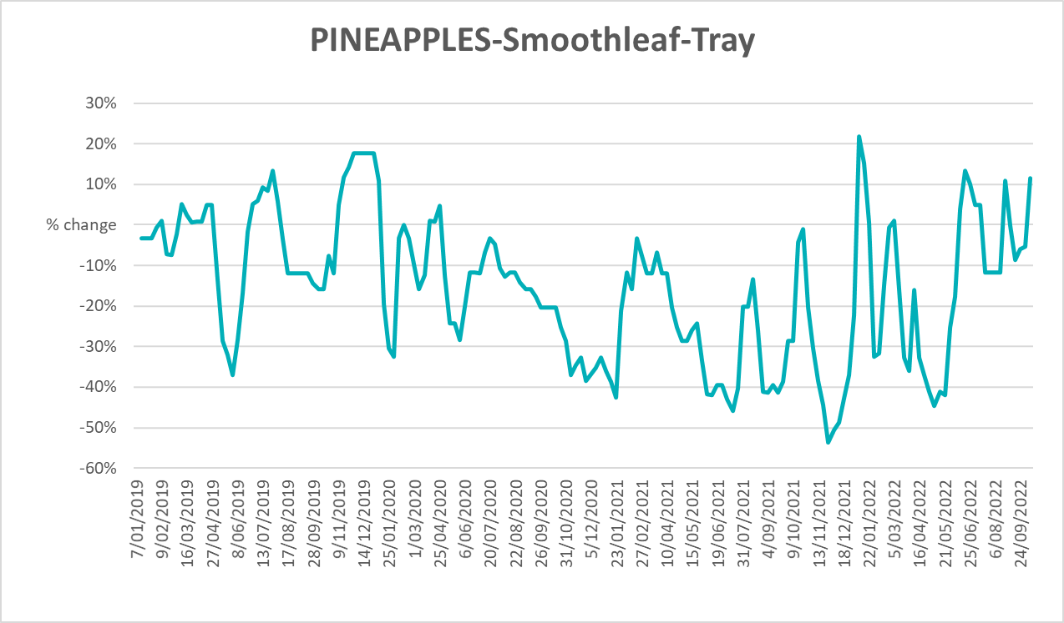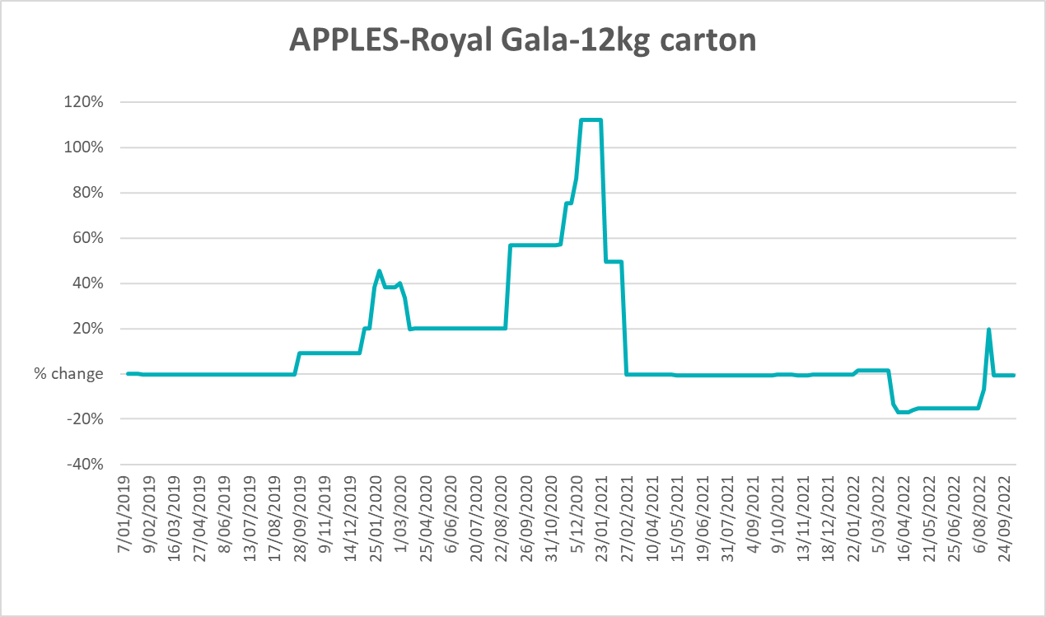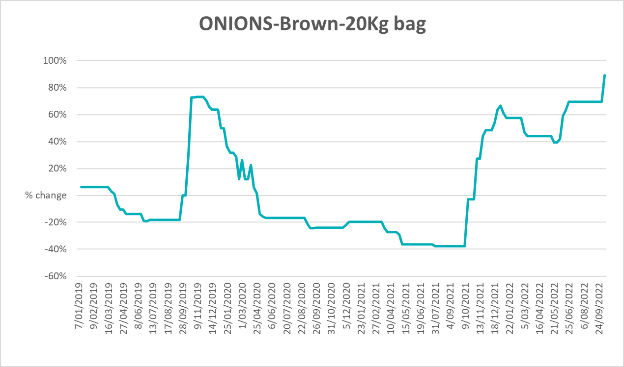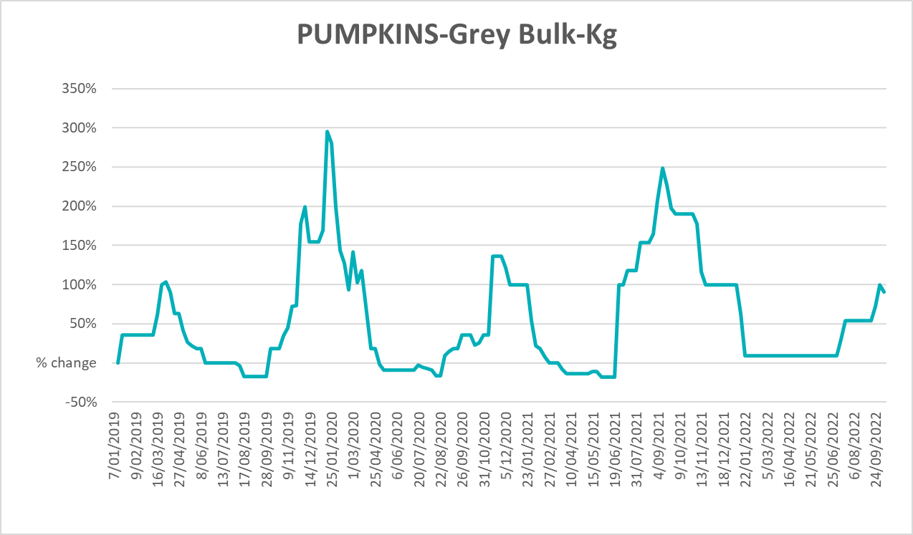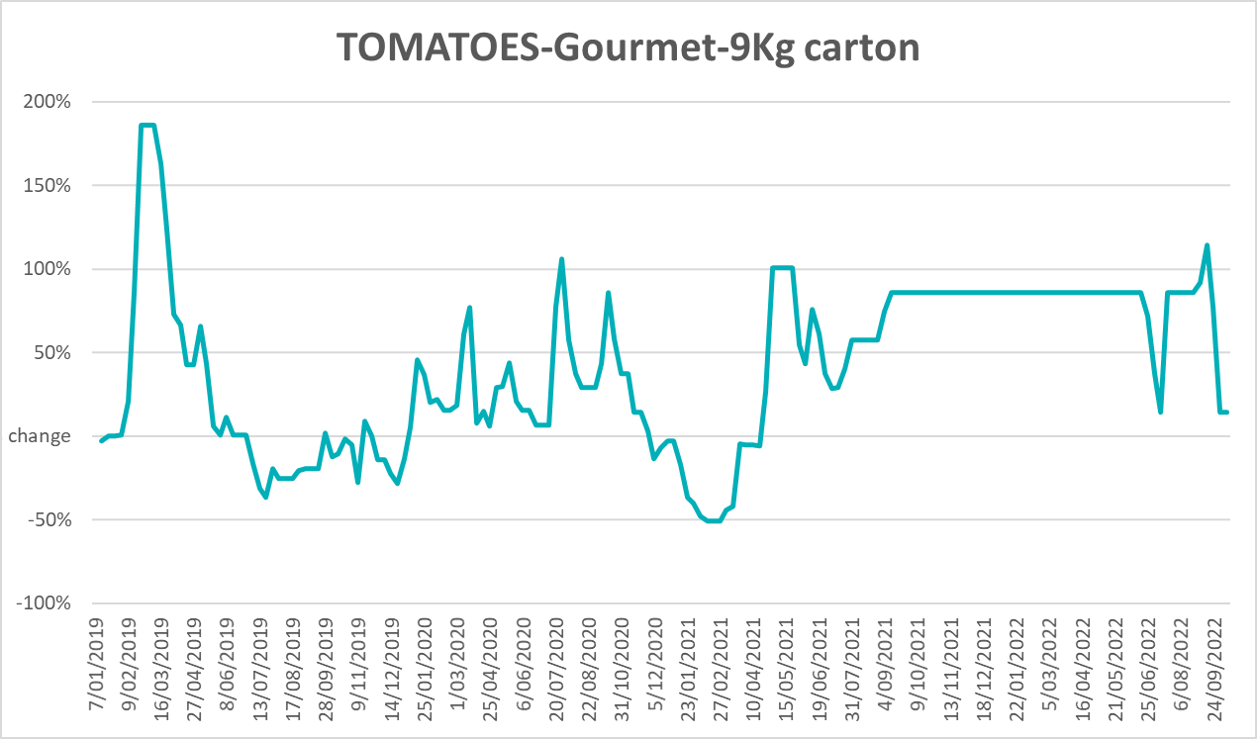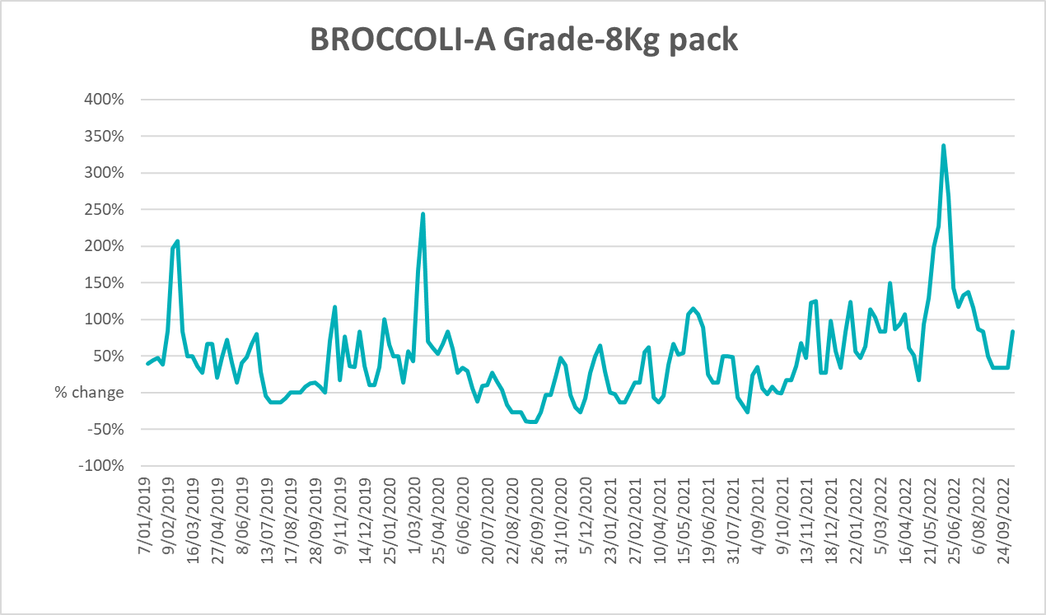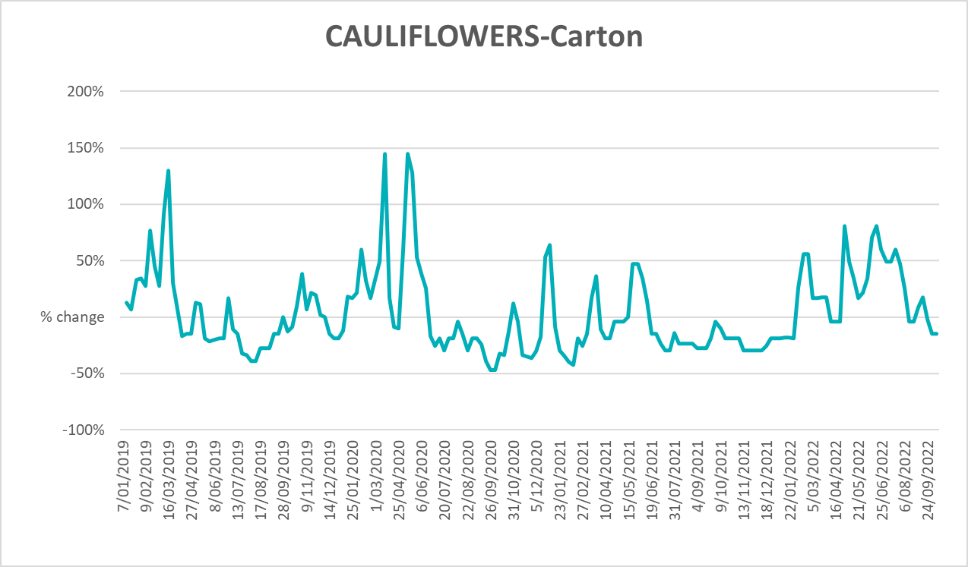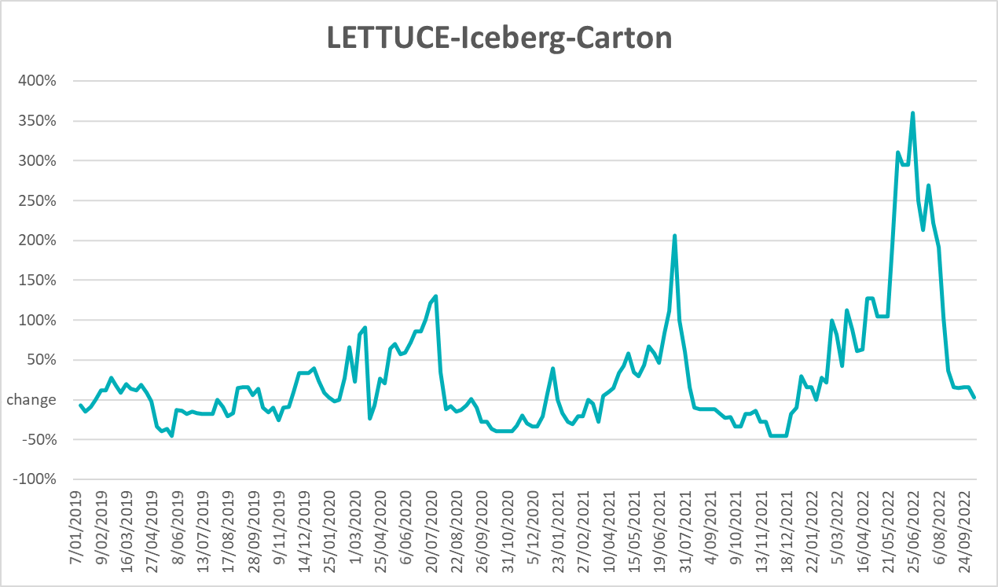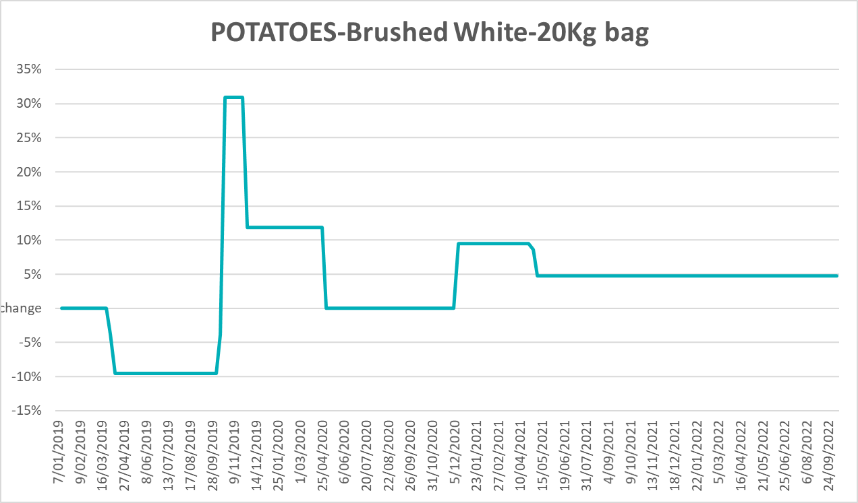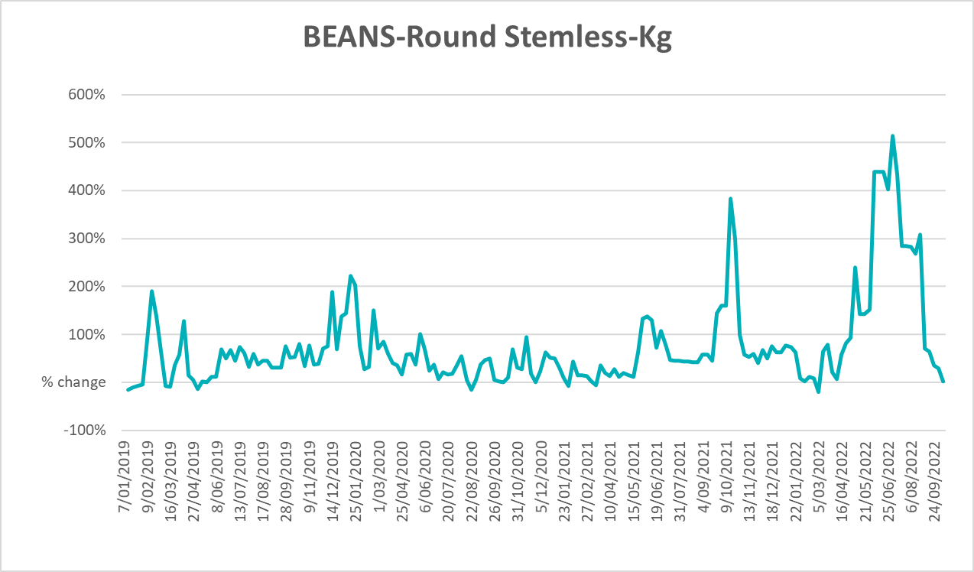

Selected domestic fodder indicator prices
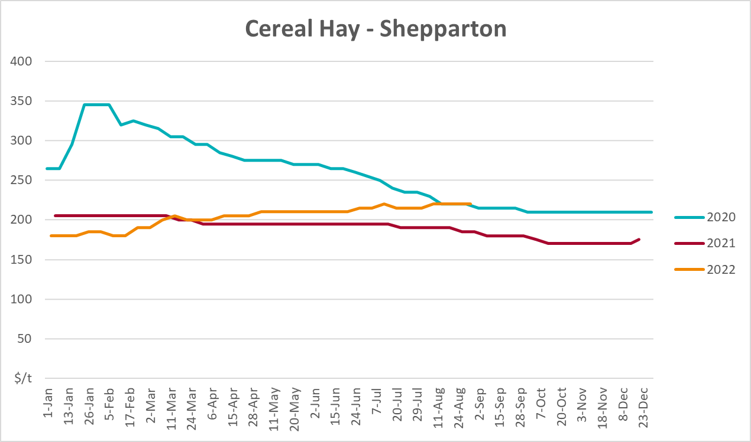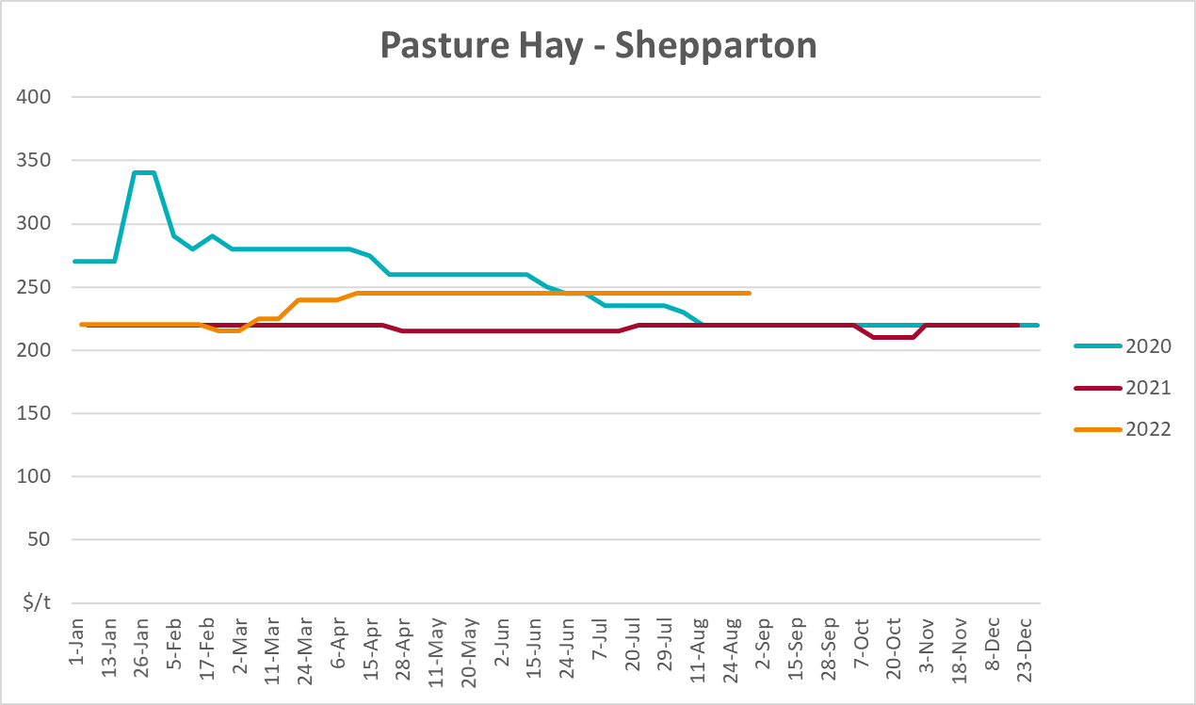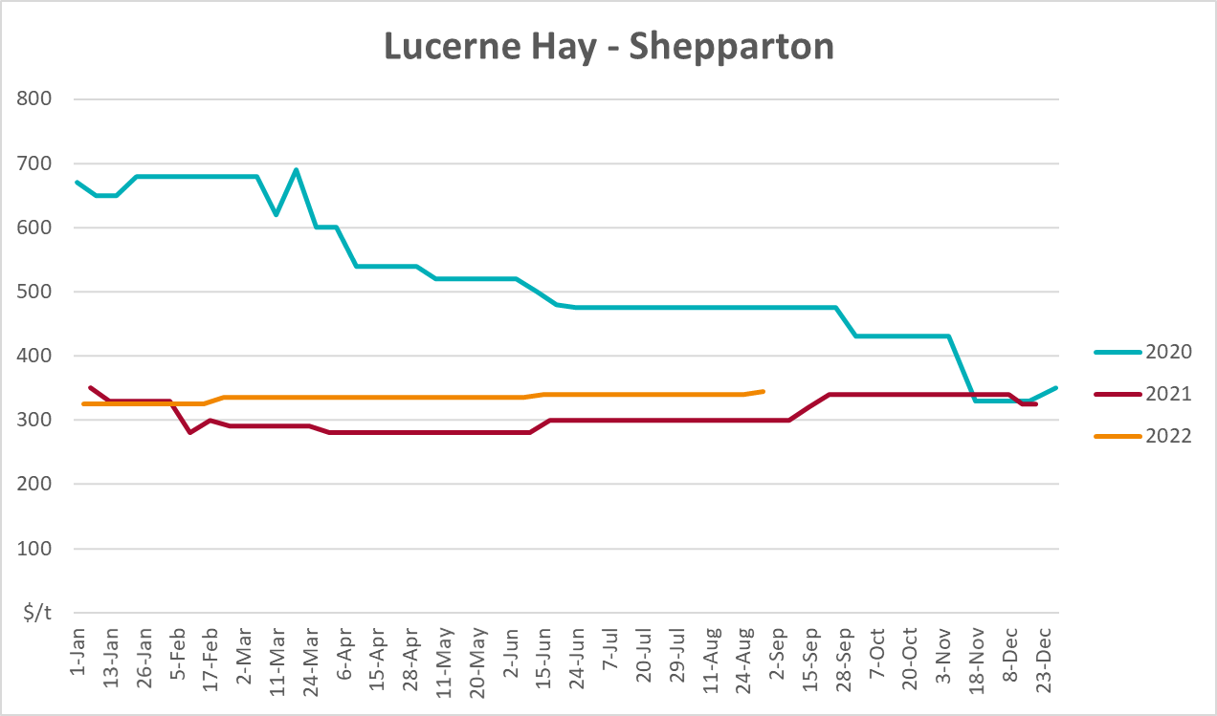

Data attribution

Climate
Bureau of Meteorology
- Weekly rainfall totals: www.bom.gov.au/climate/maps/rainfall/
- Monthly and last 3-month rainfall percentiles: www.bom.gov.au/water/landscape/
- Temperature anomalies: www.bom.gov.au/jsp/awap/temp/index.jsp
- Rainfall forecast: www.bom.gov.au/jsp/watl/rainfall/pme.jsp
- Seasonal outlook: www.bom.gov.au/climate/outlooks/#/overview/summary/
- Climate drivers: http://www.bom.gov.au/climate/enso/
- Soil moisture: www.bom.gov.au/water/landscape/
Other
- Pasture growth: www.longpaddock.qld.gov.au/aussiegrass/
- 3-month global outlooks: Environment and Climate Change Canada, NOAA Climate Prediction Center, EUROBRISA CPTEC/INPE, European Centre for Medium-Range Weather Forecasts, Hydrometcenter of Russia, National Climate Center Climate System Diagnosis and Prediction Room (NCC), International Research Institute for Climate and Society
- Global production: https://ipad.fas.usda.gov/ogamaps/cropmapsandcalendars.aspx
- Autumn break: Pook et al., 2009, https://rmets-onlinelibrary-wiley-com.virtual.anu.edu.au/doi/epdf/10.1002/joc.1833

Water
Prices
- Waterflow: https://www.waterflow.io/
- Ruralco: https://www.ruralcowater.com.au/
Bureau of Meteorology:
- Allocation trade: http://www.bom.gov.au/water/dashboards/#/water-markets/mdb/at
- Storage volumes: http://www.bom.gov.au/water/dashboards/#/water-storages/summary/drainage
Trade constraints:
- Water NSW: https://www.waternsw.com.au/customer-service/ordering-trading-and-pricing/trading/murrumbidgee
- Victorian Water Register: https://www.waterregister.vic.gov.au/TradingRules2019/

Commodities
Fruit and vegetables
- Datafresh: www.freshstate.com.au
Pigs
- Australian Pork Limited: www.australianpork.com.au
Dairy
- Global Dairy Trade: www.globaldairytrade.info/en/product-results/
World wheat, canola
- International Grains Council
World coarse grains
- United States Department of Agriculture
World cotton
- Cotlook: www.cotlook.com/
World sugar
- New York Stock Exchange - Intercontinental Exchange
Wool
- Australian Wool Exchange: www.awex.com.au/
Domestic wheat, barley, sorghum, canola and fodder
- Jumbuk Consulting Pty Ltd: http://www.jumbukag.com.au/
Cattle, beef, mutton, lamb, goat and live export
- Meat and Livestock Australia: www.mla.com.au/Prices-and-market
© Commonwealth of Australia 2022

Ownership of intellectual property rights
Unless otherwise noted, copyright (and any other intellectual property rights, if any) in this publication is owned by the Commonwealth of Australia (referred to as the Commonwealth).

Creative Commons licence
All material in this publication is licensed under a Creative Commons Attribution 4.0 International Licence except content supplied by third parties, logos and the Commonwealth Coat of Arms.
Inquiries about the licence and any use of this document should be emailed to copyright@awe.gov.au.


Cataloguing data
This publication (and any material sourced from it) should be attributed as:
ABARES 2022, Weekly Australian Climate, Water and Agricultural Update, Australian Bureau of Agricultural and Resource Economics and Sciences, Canberra, 27 October 2022. CC BY 4.0 DOI: https://doi.org/10.25814/5f3e04e7d2503
ISSN 2652-7561
This publication is available at https://www.agriculture.gov.au/abares/products/weekly_update
Department of Agriculture, Fisheries and Forestry
GPO Box 858 Canberra ACT 2601
Telephone 1800 900 090
Web agriculture.gov.au/abares

Disclaimer
The Australian Government acting through the Department of Agriculture, Fisheries and Forestry, represented by the Australian Bureau of Agricultural and Resource Economics and Sciences, has exercised due care and skill in preparing and compiling the information and data in this publication. Notwithstanding, the Department of Agriculture, Fisheries and Forestry, ABARES, its employees and advisers disclaim all liability, including liability for negligence and for any loss, damage, injury, expense or cost incurred by any person as a result of accessing, using or relying on any of the information or data in this publication to the maximum extent permitted by law.

Statement of Professional Independence
The views and analysis presented in ABARES publications, including this one, reflect ABARES professionally independent findings, based on scientific and economic concepts, principles, information and data. These views, analysis and findings may not reflect or be consistent with the views or positions of the Australian Government, or of organisations or groups who have commissioned ABARES reports or analysis. More information on professional independence is provided on the ABARES website.

Acknowledgements
This report was prepared by Katia Taylor and Matthew Miller.

