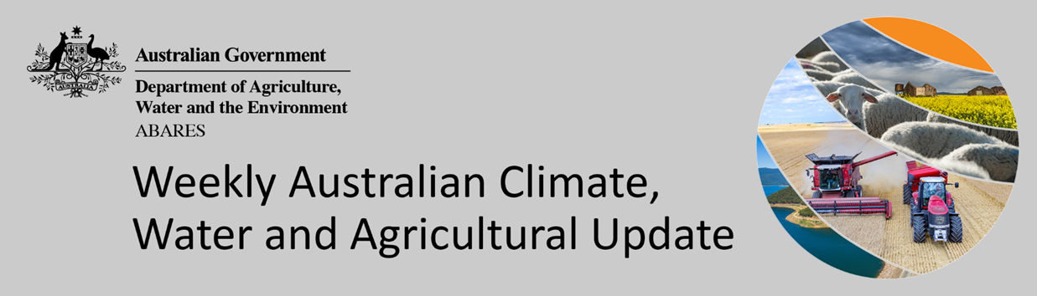
No. 22/2022

9 June 2022

Summary of key issues
- For the week ending 8 June 2022, low-pressure systems and cold fronts brought rainfall to southern and eastern parts of the country, while a north-west cloud band resulted in rainfall for north-western and central Australia. High-pressure systems dominated south-western Australia bringing clear, dry conditions (see Section 1.1).
- Planting of winter crops is well-advanced across most southern growing regions, with rainfall across south-eastern Australia this week supporting the germination and establishment of crops. However, this rainfall has likely prevented field access for remaining planting activity and post emergent weed management. Despite the dry conditions across northern New South Wales and Queensland last week, this week’s rainfall coupled with above average to very much above average soil moisture levels, has likely prevented growers from completing the harvest of summer crops and planting of winter crops.
- The 2021–22 La Niña event is slowly weakening in the tropical Pacific, with oceanic indicators, particularly in the western half of the tropical Pacific, returning to near-average values. La Niña events are typically associated with above average rainfall across large parts of eastern Australia during winter. The IOD is currently neutral. All international climate models surveyed by the Bureau of Meteorology indicate a negative IOD event could develop during early to mid-winter. A negative IOD increases the chances of above average winter–spring rainfall for much of Australia (see Section 1.2).
- The outlook for July 2022 indicates that there is a 75% chance of rainfall totals between 10 and 50 millimetres across New South Wales, south-east Queensland, Victoria, southern South Australia, the southwest of Western Australia and Tasmania. Rainfall totals in excess of 100 millimetres are expected across alpine regions of New South Wales and Victoria, as well as the far southwest of Western Australia and western Tasmania (see Section 1.3).
- Over the 8-days to 16 June 2022, a trough and nearby low-pressure system in the south-west, along with cold onshore winds in the south-east, are forecast to bring light to moderate rainfall. Meanwhile, high pressure systems are expected to bring mostly dry conditions to remaining parts of the country. If realised, the forecast rainfall for Western Australia follows a number of weeks without rainfall, with soil moisture levels beginning to drop to below average for this time of year (see Section 1.4).
- Water storage in the Murray–Darling Basin (MDB) increased by 287 gigalitres (GL) between 1 June 2022 and 8 June 2022. The current volume of water held in storage is 21,783 GL, which represents 86 of total capacity. This is 45% or 6,701 GL more than at the same time last year.
- Allocation prices in the Victorian Murray below the Barmah Choke increased from $18 per ML on 27 May 2022 to $21 per ML on 3 June 2022. Prices are lower in the Murrumbidgee and regions above the Barmah choke due to the binding of the Murrumbidgee export limit and Barmah choke trade constraint.

Climate

Rainfall this week
For the week ending 8 June 2022, low-pressure systems and cold fronts brought rainfall to southern and eastern parts of the country, while a north-west cloud band resulted in rainfall for north-western and central Australia. High-pressure systems dominated south-western Australia bringing clear, dry conditions.
Rainfall totals of between 10 and 50 millimetres were recorded across parts of southern and northern New South Wales and South Australia, most of Victoria, northern and far southern parts of Western Australia, large area of southern and parts of northern Queensland, parts of the south of the Northern Territory and eastern Tasmania. Rainfall totals in excess of 50 millimetres were recorded in alpine areas of New South Wales and Victoria, isolates areas of the far south of South Australia, the north-west of Western Australia and much of Tasmania. Remaining parts of Australia received little to no rainfall.
In cropping regions, rainfall totals of between 10 and 50 millimetres were recorded across southern and northern New South Wales, southern and eastern Victoria, central and western South Australia, and most of Queensland. Little to no rainfall was recorded across remaining cropping regions in New South Wales, north-western Victoria, eastern South Australia and most of Western Australia.
Planting of winter crops is well-advanced across most southern growing regions, with rainfall across south-eastern Australia this week supporting the germination and establishment of crops. As a result of the back-to-back rainfall events, soil moisture levels across many cropping regions in the south-east remain above average to well-above average. This rainfall has likely prevented field access for remaining planting activity and post emergent weed management. Despite the dry conditions across northern New South Wales and Queensland last week, this week’s rainfall coupled with above average to very much above average soil moisture levels, has likely prevented growers from completing the harvest of summer crops and planting of winter crops.

Rainfall for the week ending 8 June 2022

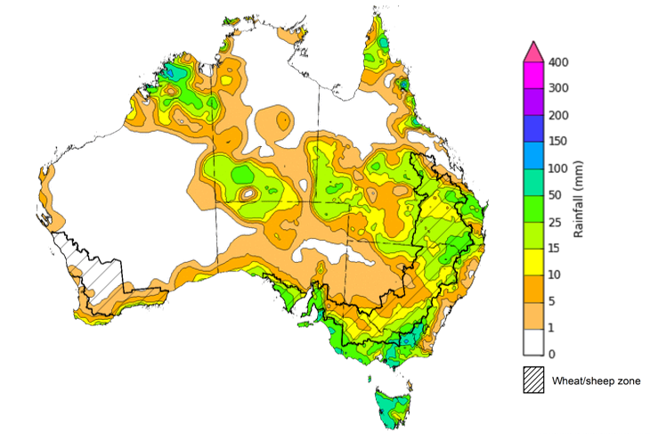

©Commonwealth of Australia 2022, Australian Bureau of Meteorology Issued: 8/6/2022
Note: The rainfall analyses and associated maps utilise data contained in the Bureau of Meteorology climate database, the Australian Data Archive for Meteorology (ADAM). The analyses are initially produced automatically from real-time data with limited quality control. They are intended to provide a general overview of rainfall across Australia as quickly as possible after the observations are received. For further information go to http://www.bom.gov.au/climate/rainfall/

Climate Drivers
Throughout winter, the climate drivers with the largest potential impact on Australia’s climate patterns are the El Niño–Southern Oscillation (ENSO), the Indian Ocean Dipole (IOD) and the Southern Annular Mode (SAM). These climate drivers are likely to influence pasture growth across southern Australia and the germination and growth for winter crops.
The 2021–22 La Niña event is slowly weakening in the tropical Pacific, with oceanic indicators, particularly in the western half of the tropical Pacific, returning to near-average values. However, some atmospheric indicators remain above La Niña thresholds, meaning La Niña's influence continues. La Niña events are typically associated with above average rainfall across large parts of eastern Australia during winter. Even as the event weakens, it is expected to continue influencing climate patterns in Australia over the coming months.
The IOD is currently neutral. All international climate models surveyed by the Bureau of Meteorology indicate a negative IOD event could develop during early to mid-winter. A negative IOD increases the chances of above average winter–spring rainfall for much of Australia.
The Southern Annular Mode (SAM) index is currently positive but is expected to return to neutral values for at least the next two weeks. Neutral SAM conditions typically has little influence on Australian rainfall.
Compared to two weeks ago, tropical Pacific Ocean sea surface temperatures (SST) have warmed, particularly in the western half of the tropical Pacific, returning to near-average values. Meanwhile, warm SST anomalies throughout the Maritime Continent have strengthened slightly. Warmer than average sea surface temperatures around much of Australia are likely to be contributing to wetter outlooks over the coming months, and the forecast sea surface temperature pattern in the tropical Pacific still favours average to above average winter rainfall for eastern Australia.

Difference from average sea surface temperature observations 30 May to 5 June 2022
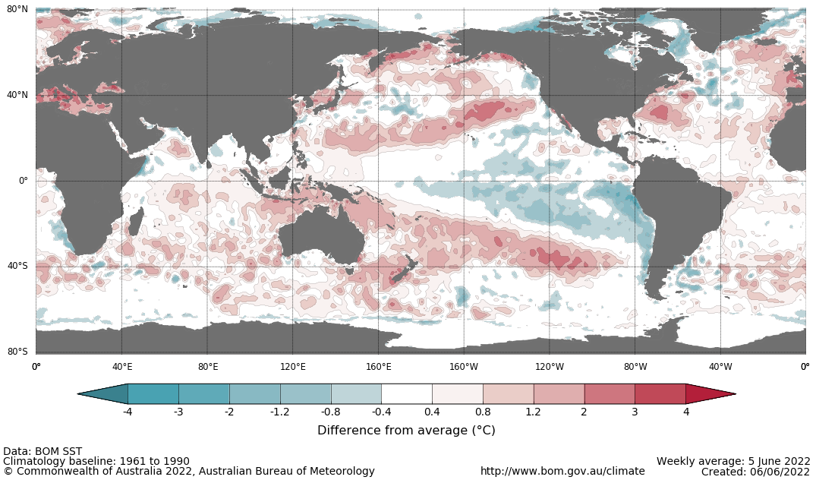

International climate model outlooks for the NINO 3.4 region in July 2022
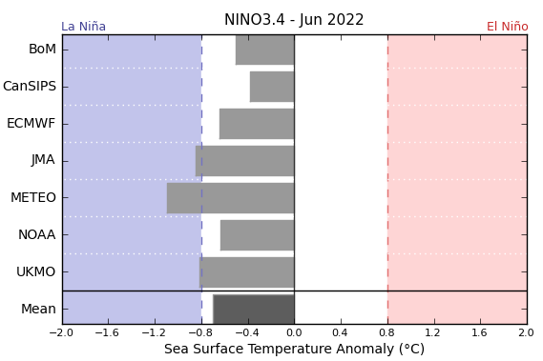
©Commonwealth of Australia 2022, Australian Bureau of Meteorology Issued: 7/6/2022
Most climate models surveyed by the Bureau of Meteorology indicate a return to neutral ENSO conditions (neither El Niño nor La Niña) during the southern hemisphere winter. Two models suggest La Niña values could persist throughout winter and into spring, but the majority maintain neutral-ENSO through to at least September. ENSO events are usually most active throughout spring and summer, then decay and return to neutral conditions in autumn. For the period ending 5 June 2022, the 30-day SOI value was +18.6 and the 90-day SOI value was +17.4, both well above the La Niña threshold of +7. While trade winds have returned to average strength in the Pacific, cloudiness near the Date Line remains below average. These indications are consistent with the ongoing La Niña event.

30-day Southern Oscillation Index (SOI) values ending 6 June 2022
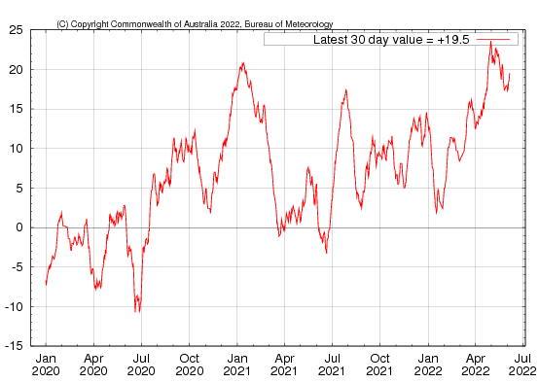

The Indian Ocean Dipole (IOD) is currently neutral. However, the IOD index has been below zero for the last four weeks with two of those weeks being around or below the negative IOD threshold (−0.4 °C). The latest IOD index value for the week ending 6 June 2022 was −0.30 °C. Over recent weeks cool anomalies have emerged near the Horn of Africa, while warm anomalies have persisted across waters to the north and north-west of Australia. The establishment of a clear gradient in the temperature anomalies across the Indian Ocean is consistent with a developing negative Indian Ocean Dipole pattern.
All international climate models surveyed by the Bureau of Meteorology indicate a negative IOD event could develop during early to mid-winter, with several forecasting strong negative values of the IOD index by August.

International climate model outlooks for the IOD index in July 2022
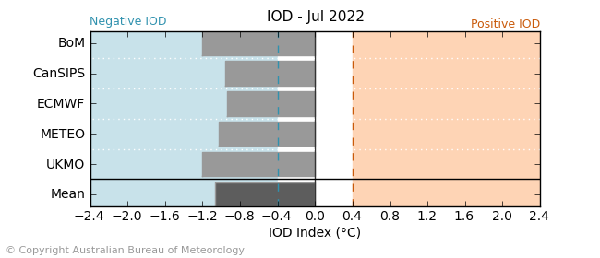

National Climate Outlook
These climate outlooks are generated by ACCESS–S (Australian Community Climate Earth-System Simulator–Seasonal). ACCESS–S is the Bureau of Meteorology's dynamical (physics-based) weather and climate model used for monthly, seasonal and longer-lead climate outlooks.
For further information, go to http://www.bom.gov.au/climate/ahead/about/
The Bureau of Meteorology’s latest rainfall outlook indicates wetter than average conditions are expected across the majority of Australia during July. The ACCESS-S climate model suggests there is close to a 65% chance of exceeding median for most of Australia, while the south-west and far south-east of Australia have roughly equal chances of being above or below median.
The outlook for July 2022 indicates that there is a 75% chance of rainfall totals between 10 and 50 millimetres across New South Wales, south-east Queensland, Victoria, southern South Australia, the southwest of Western Australia and Tasmania. Rainfall totals in excess of 100 millimetres are expected across alpine regions of New South Wales and Victoria, as well as the far southwest of Western Australia and western Tasmania.
Across cropping regions there is a 75% chance of rainfall totals of between 25 and 50 millimetres across most of New South Wales, Victoria, South Australia and Western Australia. There is a 75% chance of rainfall less than 25 millimetres for northwest Victoria, parts of eastern South Australia, most of Queensland, and eastern cropping regions in Western Australia.
Rainfall totals that have a 75% chance of occurring July 2022
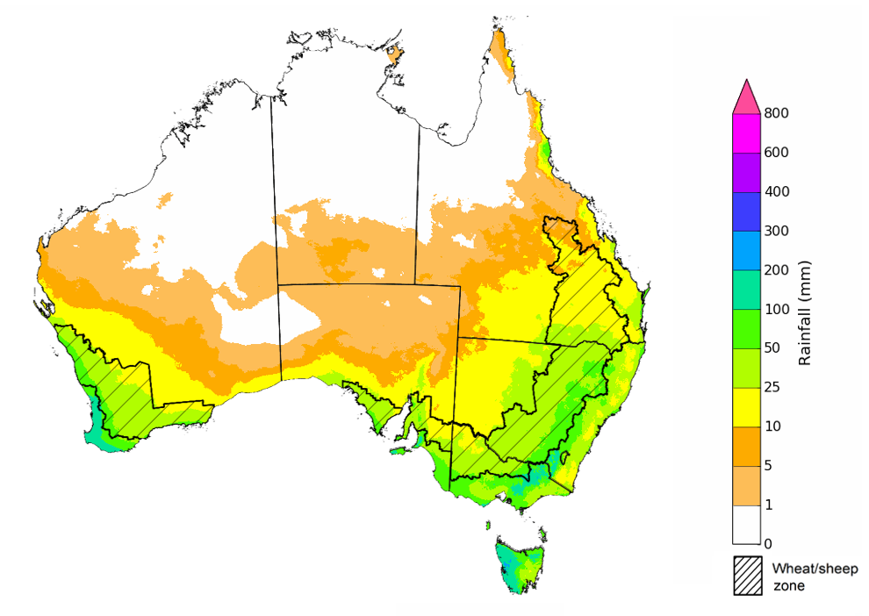
©Commonwealth of Australia 2022, Australian Bureau of Meteorology Issued: 02/06/2022

The rainfall outlook for July to September 2022 suggests there is a greater than 80% chance of exceeding median rainfall across most of New South Wales, Queensland, South Australia, northern Victoria, the north of Western Australia, as well as the Northern Territory. For remaining regions of Australia, there is roughly an equal chance of above and below median rainfall between July to September 2022 (Bureau of Meteorology ‘National Climate Outlook’, 2 June 2022).
Bureau of Meteorology rainfall outlooks for July to September have greater than 55% past accuracy across most of Australia. Outlook accuracy is greater than 65% across large areas of western and eastern Australia.
Chance of exceeding the median rainfall July to September 2022
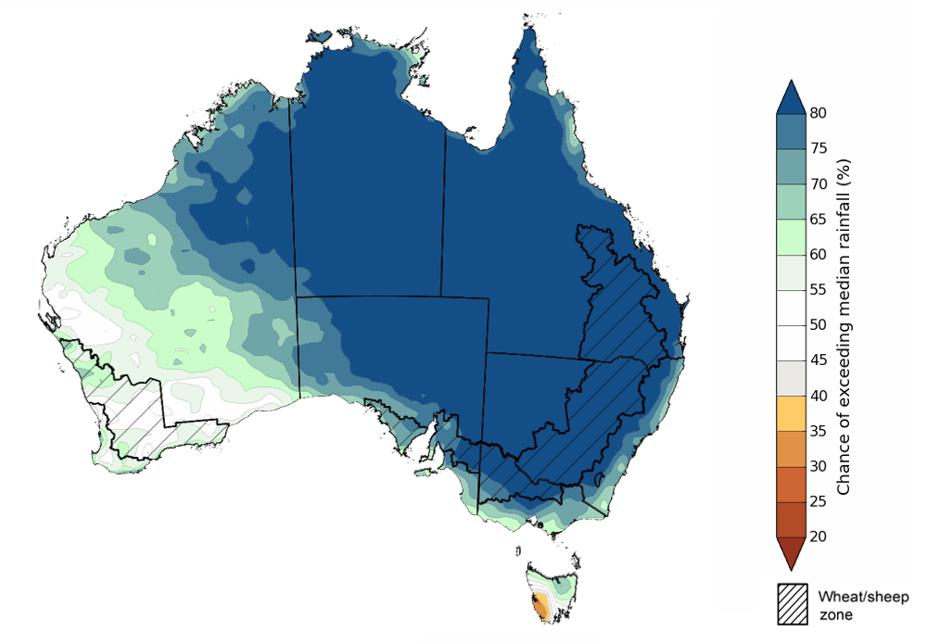
©Commonwealth of Australia 2022, Australian Bureau of Meteorology Issued: 02/06/2022

The outlook for July to September 2022 suggests there is a 75% chance of rainfall totals between 50 and 200 millimetres across much of New South Wales, south-eastern Queensland, Victoria, southern parts of South Australia, the south-west of Western Australia and Tasmania. Rainfall totals in excess of 200 millimetres are forecast for alpine regions of New South Wales and Victoria, the far southwest of Victoria, the far southeast of South Australia, the far south-west of Western Australia, and western and northern Tasmania.
Across cropping regions, there is a 75% chance of receiving between 50 and 100 millimetres across much of Queensland, northern Victoria, parts of eastern South Australia and the east of Western Australia. Totals of between 100 and 200 millimetres are expected across much of New South Wales, parts of southern Queensland, much of Victoria, central and western South Australia and western and southern Western Australia.
Root zone soil moisture levels are average to above average across much of the Wheat/sheep zone but below average to average across parts of Western Australia. There is a high—75%—chance that forecast rainfall totals across Western Australian cropping regions will be sufficient to support the establishment and growth of winter crops during the July to September period. In remaining cropping regions, the expectation of above average rainfall over the next three months increases the risk of waterlogging adversely affecting crop growth and development, particularly in areas with above average soil moisture levels for this time of year.
Rainfall totals that have a 75% chance of occurring July to September 2022
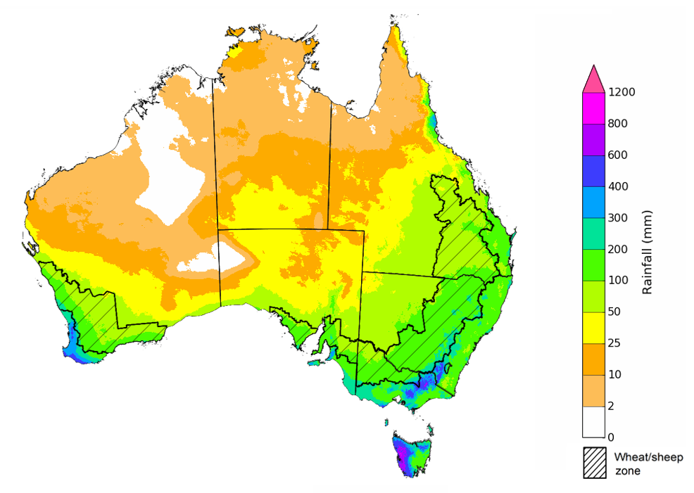
©Commonwealth of Australia 2022, Australian Bureau of Meteorology Issued: 02/06/2022

The temperature outlook for July to September 2022 indicates that maximum temperatures across most of Australia are likely to be close to the 1990-2012 average (- 1°C to 1°C), with slightly higher than average temperatures across the tropical north and slightly lower than average for a region straddling the New South Wales/ Queensland border. Minimum temperatures are expected to be slightly above average for much of the northern and eastern Australia, and close to average for the rest of Australia (Bureau of Meteorology ‘National Climate Outlook’, 2 June 2022).
Predicted maximum temperature anomaly for July to September 2022

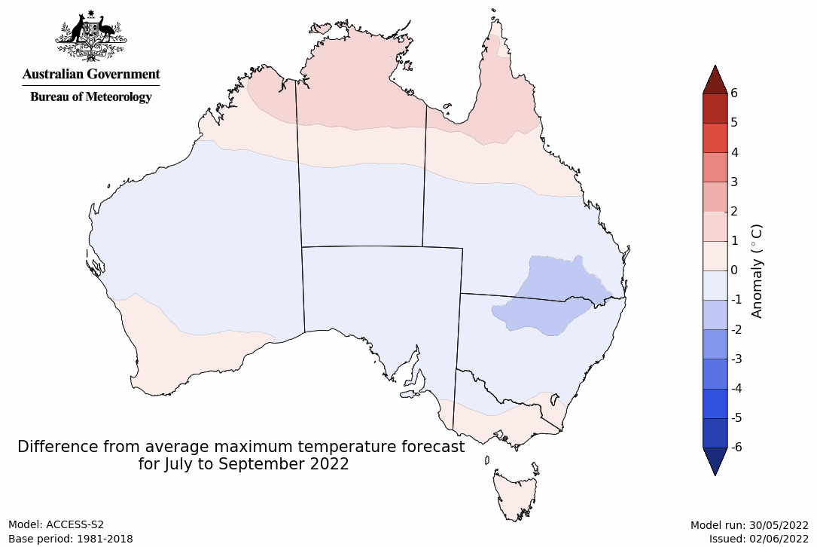
Predicted minimum temperature anomaly for July to September 2022
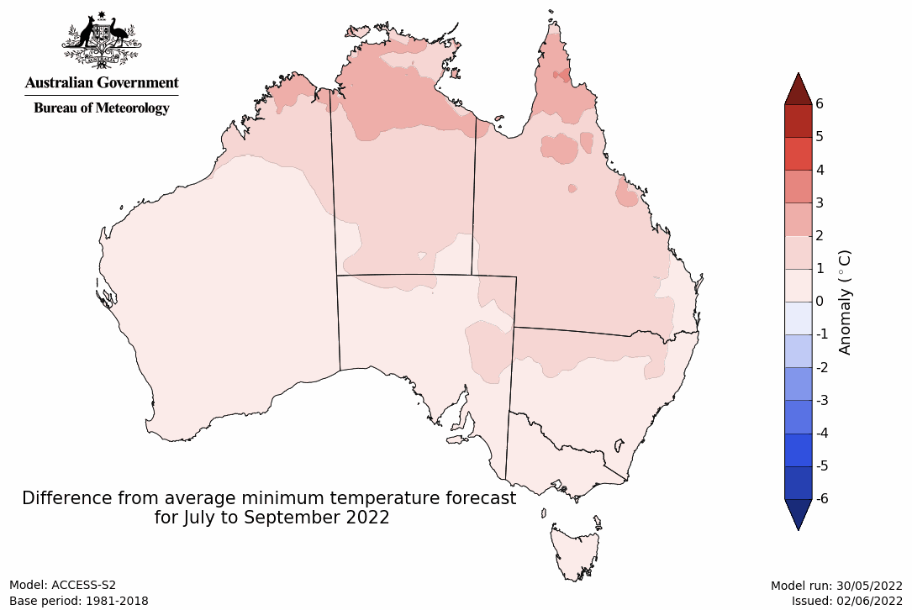

Rainfall forecast for the next eight days
Over the 8-days to 16 June 2022, a trough and nearby low-pressure system in the south-west, along with cold onshore winds in the south-east, are forecast to bring light to moderate rainfall. Meanwhile, high pressure systems are expected to bring mostly dry conditions to remaining parts of the country.
Rainfall totals of between 10 and 50 millimetres are forecast for the south-west of Western Australia, parts of southern and eastern Victoria, alpine areas of New South Wales and western Tasmania. Rainfall in excess of 50 millimetres is expected in the far south-west of Western Australia and western Tasmania.
In Australian cropping regions, rainfall totals of between 10 and 50 millimetres are expected across Western Australia. Little to no rainfall is forecast for all remaining cropping regions during the next 8-days.
If realised, the forecast rainfall for Western Australia follows a number of weeks without rainfall, with soil moisture levels beginning to drop to below average for this time of year. Soil moisture levels across cropping regions of eastern Australia remain well above average to extremely high. The forecast dry conditions for northern New South Wales and Queensland will allow soils to begin to drain again from their current saturated levels, following moderate to heavy rainfall this week. The dry conditions will also allow unharvested summer crops to dry. And if dry conditions persist, growers will be able to access fields to complete summer harvesting and sowing of winter crops.
A substantial proportion of summer crops in some areas are yet to be harvested. Likewise, the wet conditions have prevented growers from undertaking winter planting programs. The prolonged wet conditions and high wheat and canola prices have led some farmers to look for innovative ways to get crops planted, with the adoption of aerial sowing of the valuable crops across central and north-west New South Wales and into southern Queensland.

Total forecast rainfall (mm) for the period 9 June to 16 June 2022
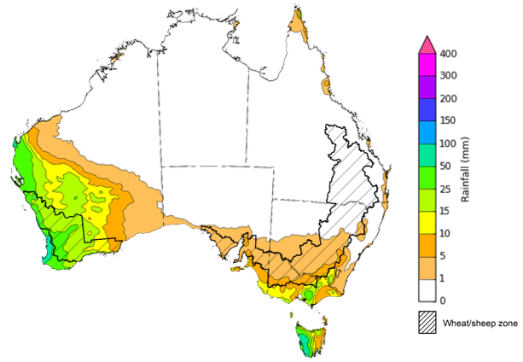
©Commonwealth of Australia 2022, Australian Bureau of Meteorology Issued:9/6/2022

Water
Note: This rainfall forecast is produced from computer models. As the model outputs are not altered by weather forecasters, it is important to check local forecasts and warnings issued by the Bureau of Meteorology.

Water markets – current week
Water storage in the Murray–Darling Basin (MDB) increased by 287 gigalitres (GL) between 1 June 2022 and 8 June 2022. The current volume of water held in storage is 21,783 GL, which represents 86 of total capacity. This is 45% or 6,701 GL more than at the same time last year.

Water storages in the Murray-Darling Basin, 2013–2022
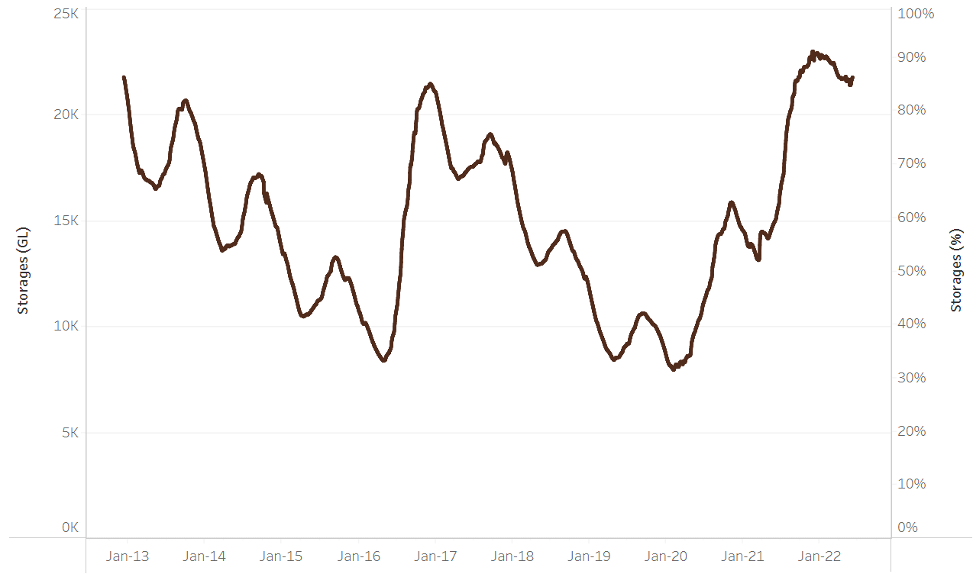
Allocation prices in the Victorian Murray below the Barmah Choke increased from $18 per ML on 27 May 2022 to $21 per ML on 3 June 2022. Prices are lower in the Murrumbidgee and regions above the Barmah choke due to the binding of the Murrumbidgee export limit and Barmah choke trade constraint.
Water storage data is sourced from the Bureau of Meteorology.

Region | $/ML
NSW Murray Above | 2
NSW Murrumbidgee | 1
VIC Goulburn-Broken | 21
VIC Murray Below | 21

Surface water trade activity, Southern Murray–Darling Basin

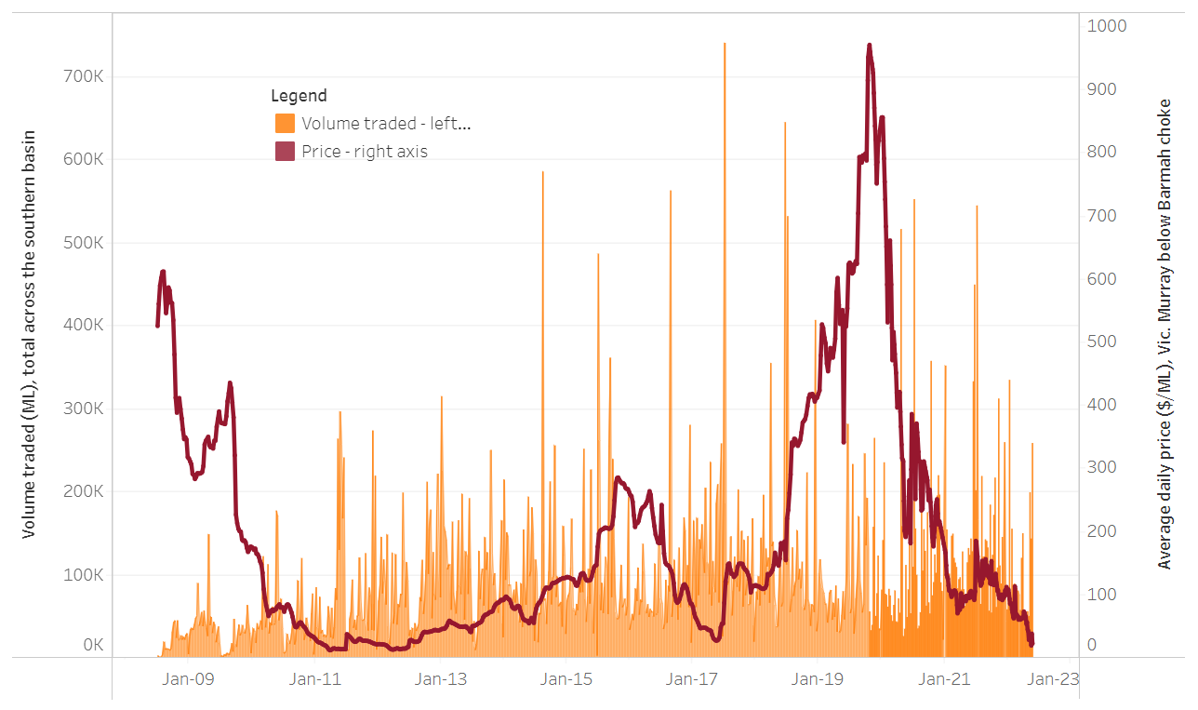
To access the full, interactive, weekly water dashboard, which contains the latest and historical water storage, water market and water allocation information, please visit http://www.agriculture.gov.au/abares/products/weekly_update/weekly-update-090622
The trades shown reflect estimated market activity and do not encompass all register trades. The price is shown for the VIC Murray below the Barmah choke. Historical prices (before 1 July 2019) are ABARES estimates after removing outliers from BOM water register data. Prices after 1 July 2019 and prior to the 30 October 2019 reflect recorded transaction prices as sourced from Ruralco. Prices after the 30 October 2019 are sourced from Waterflow. Data for volume traded is sourced from the BOM water register. Data shown is current at 9 June 2022.

Commodities

Indicator | Week ended | Unit | Latest price | Previous week | Weekly change | Price 12 months ago | Annual change
Selected world indicator prices
AUD/USD Exchange rate | 08-Jun | A$/US$ | 0.71 | 0.71 | 0% | 0.77 | -8%
Wheat – US no. 2 hard red winter wheat, fob Gulf | 08-Jun | US$/t | 485 | 523 | -7% | 290 | 67%
Corn – US no. 2 yellow corn, fob Gulf | 08-Jun | US$/t | 330 | 342 | -3% | 290 | 14%
Canola – Rapeseed, Canada, fob Vancouver | 08-Jun | US$/t | 956 | 969 | -1% | 654 | 46%
Cotton – Cotlook 'A' Index | 08-Jun | USc/lb | 156 | 161 | -3% | 96 | 63%
Sugar – Intercontinental Exchange, nearby futures, no.11 contract | 08-Jun | USc/lb | 19.5 | 19.8 | -1% | 17 | 13%
Wool – Eastern Market Indicator | 08-Jun | Ac/kg clean | 1,400 | 1,420 | -1% | 1,342 | 4%
Wool – Western Market Indicator | 06-Apr | Ac/kg clean | 1,417 | 1,421 | 0% | 1,222 | 16%
Selected Australian grain export prices
Milling Wheat – APW, Port Adelaide, SA | 08-Jun | A$/t | 629 | 615 | 2% | 381 | 65%
Feed Wheat – ASW, Port Adelaide, SA | 08-Jun | A$/t | 593 | 580 | 2% | 374 | 59%
Feed Barley – Port Adelaide, SA | 08-Jun | A$/t | 554 | 546 | 1% | 328 | 69%
Canola – Kwinana, WA | 08-Jun | A$/t | 1,272 | 1,281 | -1% | 787 | 62%
Grain Sorghum – Brisbane, QLD | 08-Jun | A$/t | 471 | 458 | 3% | 380 | 24%
Selected domestic livestock indicator prices
Beef – Eastern Young Cattle Indicator | 08-Jun | Ac/kg cwt | 1,122 | 1,105 | 2% | 890 | 26%
Mutton – Mutton indicator (18–24 kg fat score 2–3), Vic | 01-Jun | Ac/kg cwt | 621 | 673 | -8% | 663 | -6%
Lamb – Eastern States Trade Lamb Indicator | 08-Jun | Ac/kg cwt | 813 | 800 | 2% | 798 | 2%
Pig – Eastern Seaboard (60.1–75 kg), average of buyers & sellers | 30-Mar | Ac/kg cwt | 368 | 357 | 3% | 347 | 6%
Goats – Eastern States (12.1–16 kg) | 12-Jan | Ac/kg cwt | 879 | 879 | 0% | 818 | 8%
Live cattle – Light steers ex Darwin to Indonesia | 01-Jun | Ac/kg lwt | 480 | 480 | 0% | 320 | 50%
Live sheep – Live wethers (Muchea WA saleyard) to Middle East | 20-Apr | $/head | 113 | 113 | 0% | 122 | -7%

Indicator | Week ended | Unit | Latest price | Previous week | Weekly change | Price 12 months ago | Annual change
Global Dairy Trade (GDT) weighted average prices ª
Dairy – Whole milk powder | 08-Jun | US$/t | 4,158 | 3,934 | 6% | 2,707 | 54%
Dairy – Skim milk powder | 08-Jun | US$/t | 4,240 | 4,116 | 3% | 2,380 | 78%
Dairy – Cheddar cheese | 08-Jun | US$/t | 5,365 | 5,635 | -5% | 4,480 | 20%
Dairy – Anhydrous milk fat | 08-Jun | US$/t | 6,201 | 6,043 | 3% | 4,083 | 52%
a Global Dairy Trade prices are updated twice monthly on the first and third Tuesday of each month.

Selected world indicator prices
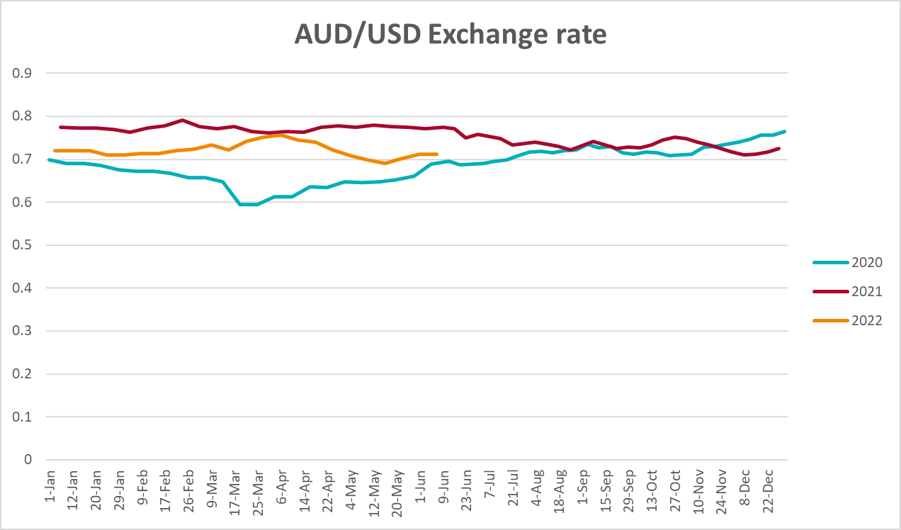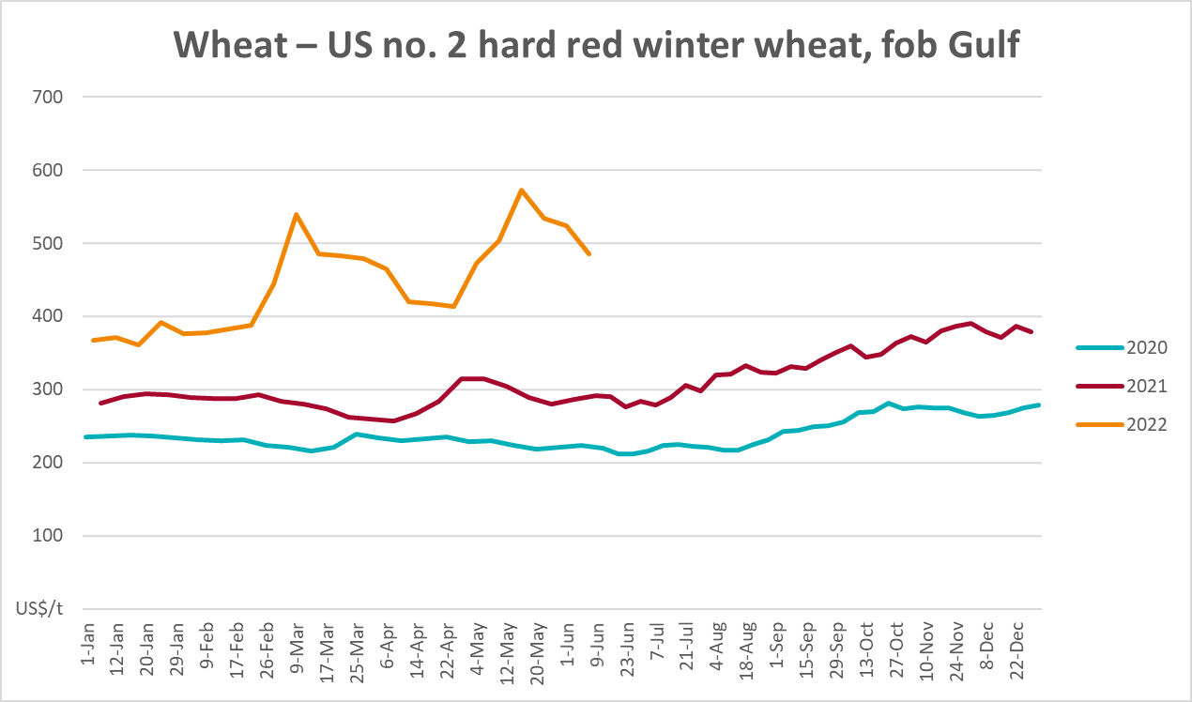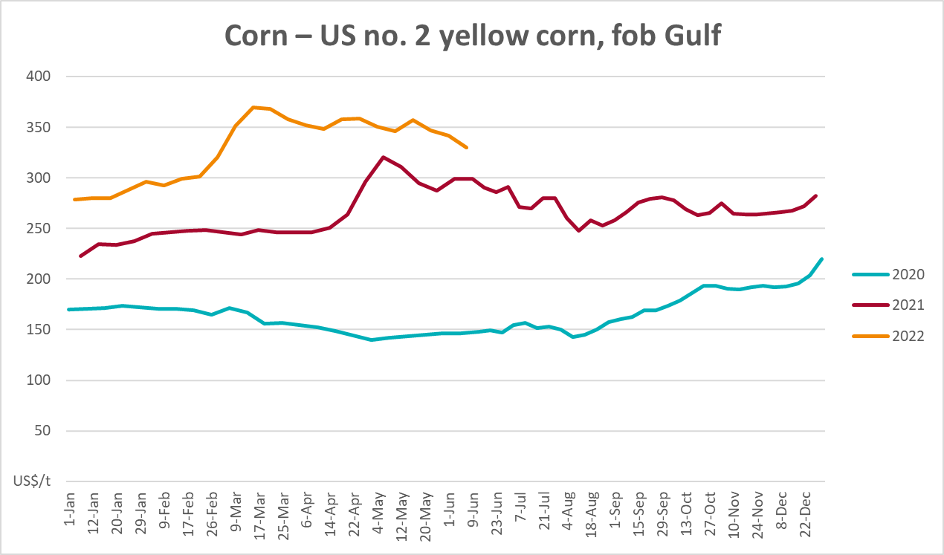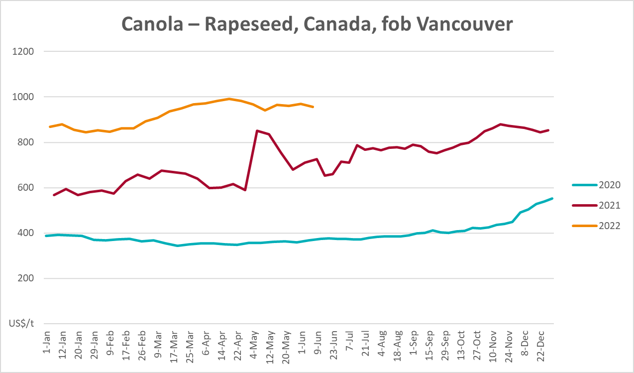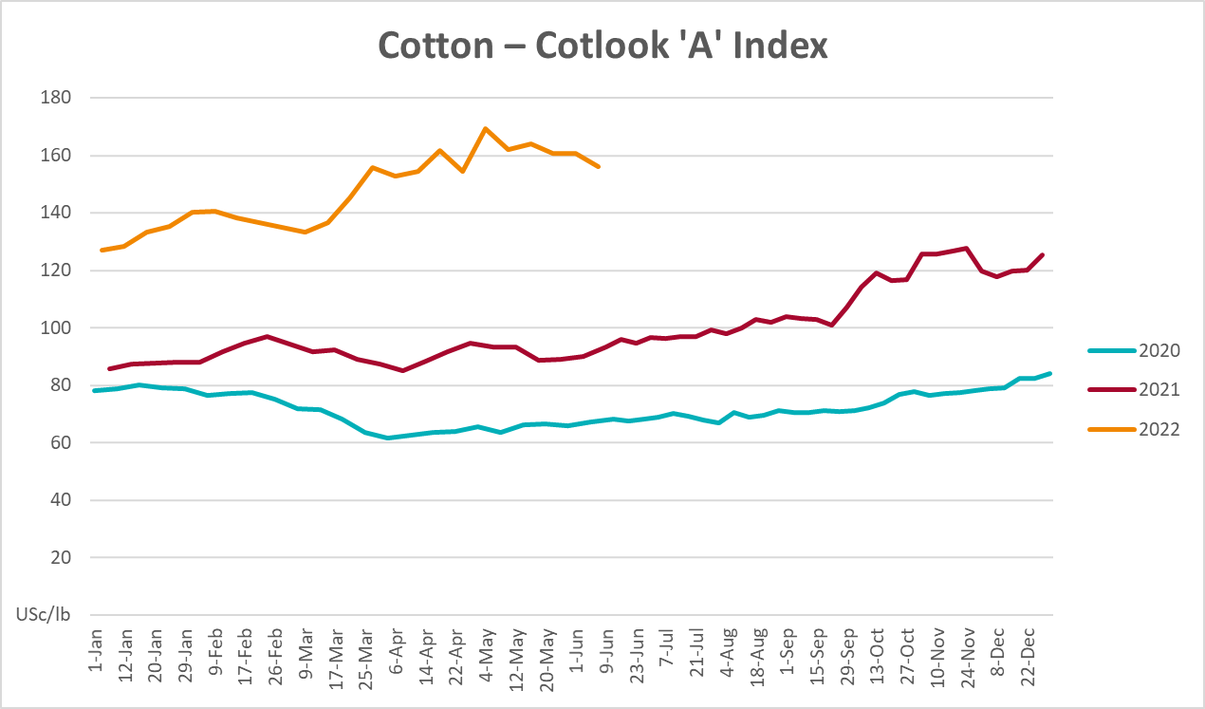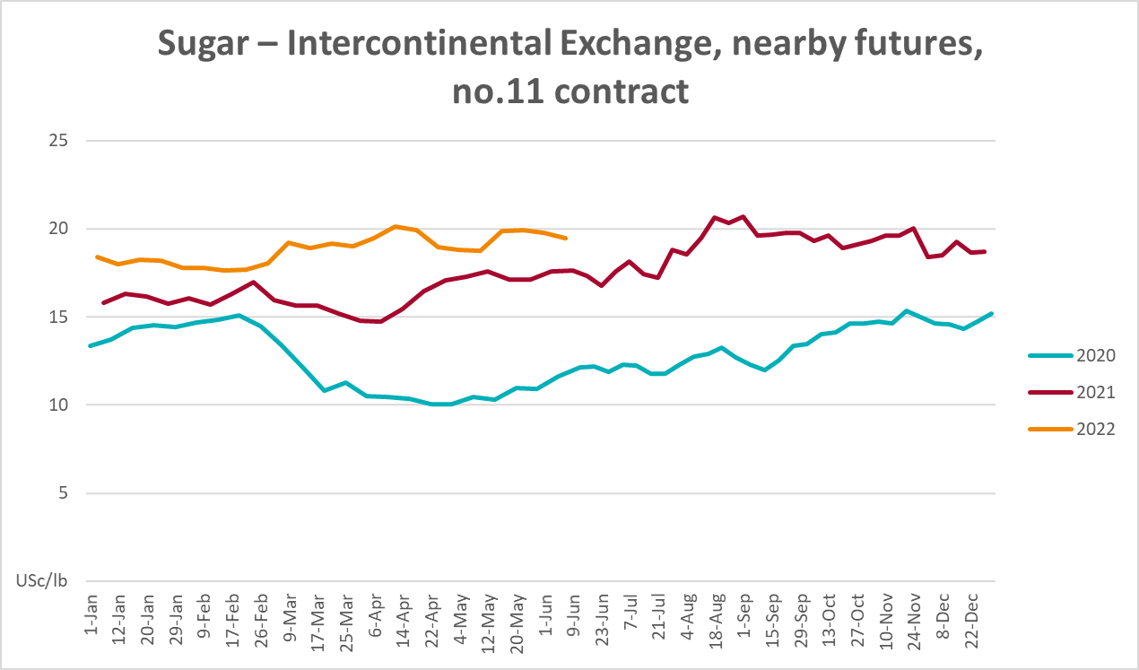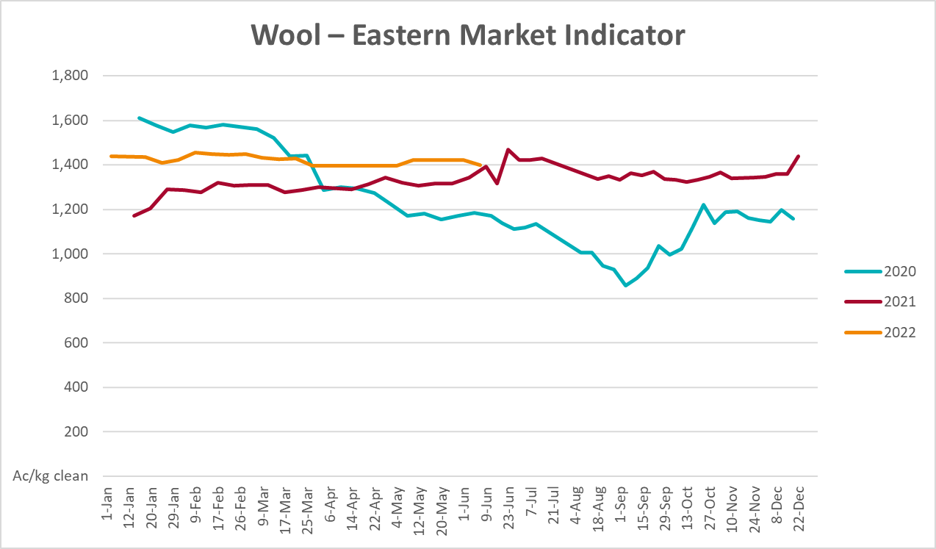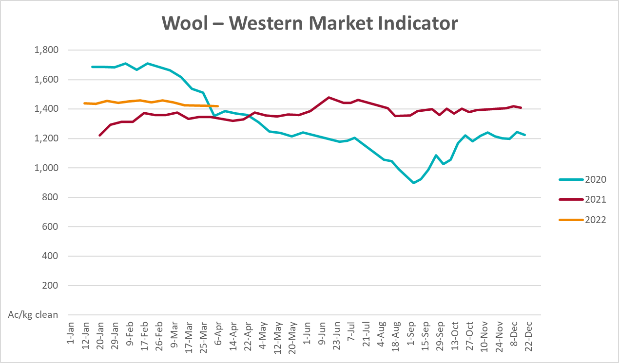

Selected domestic crop indicator prices
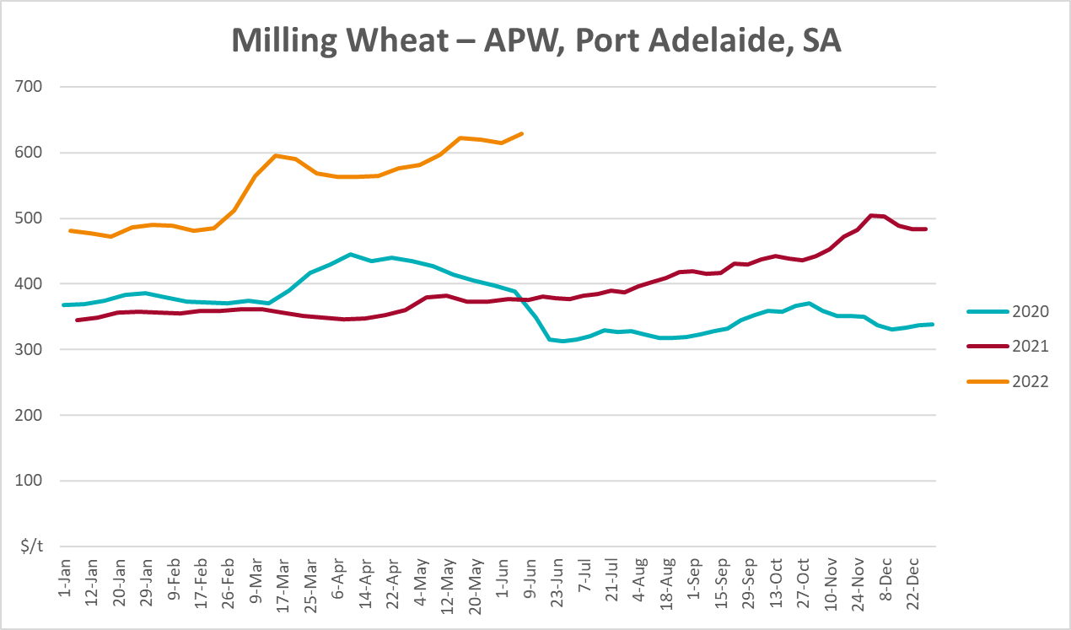
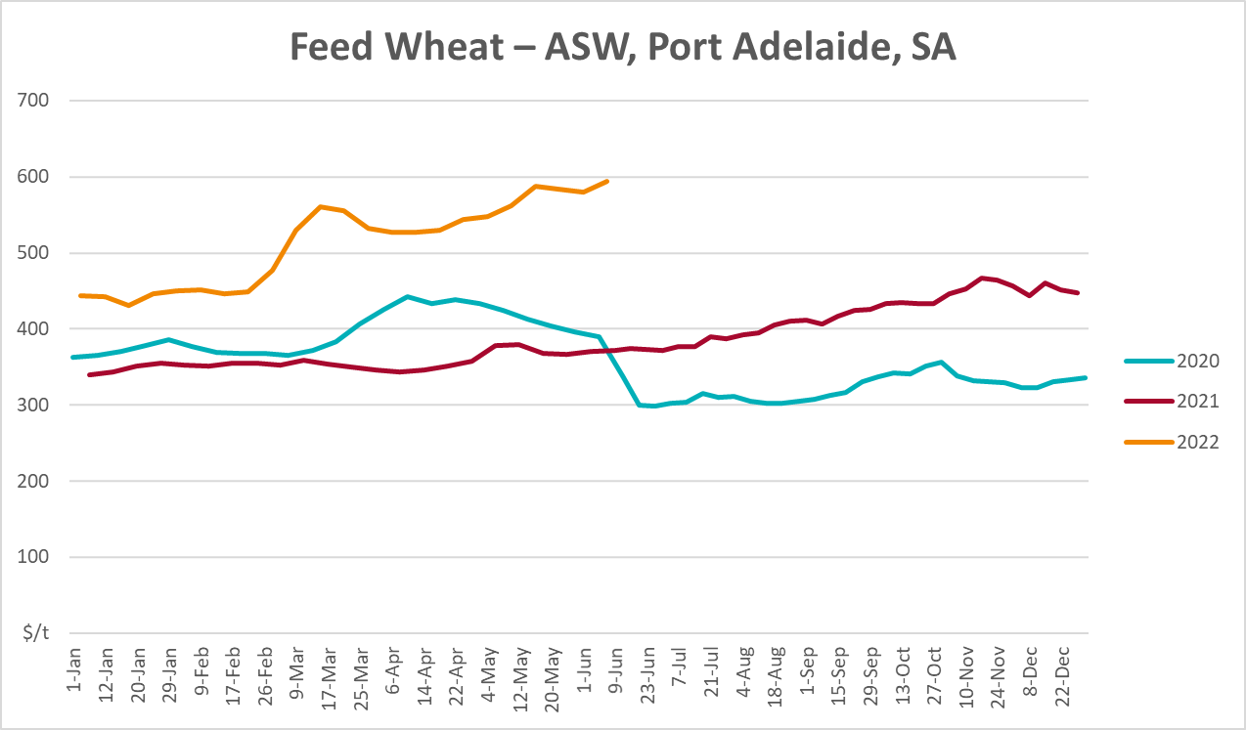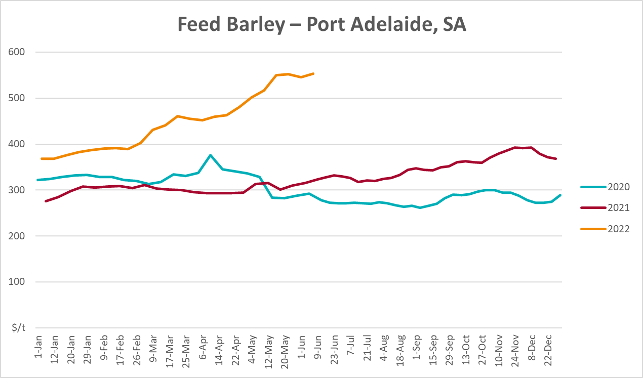
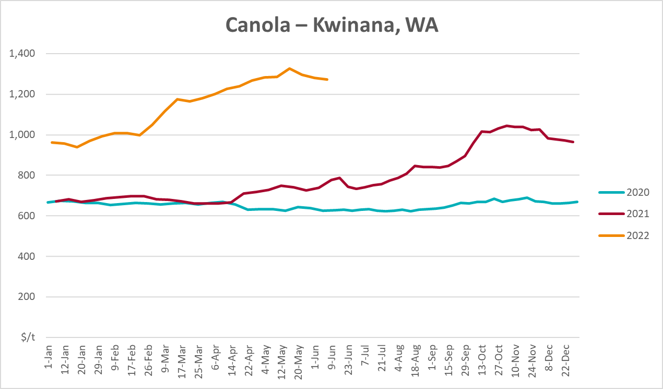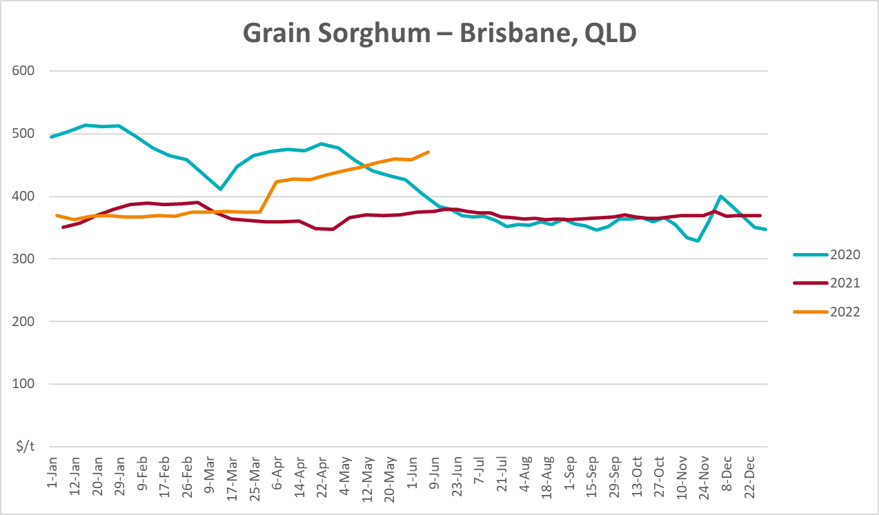

Selected domestic livestock indicator prices
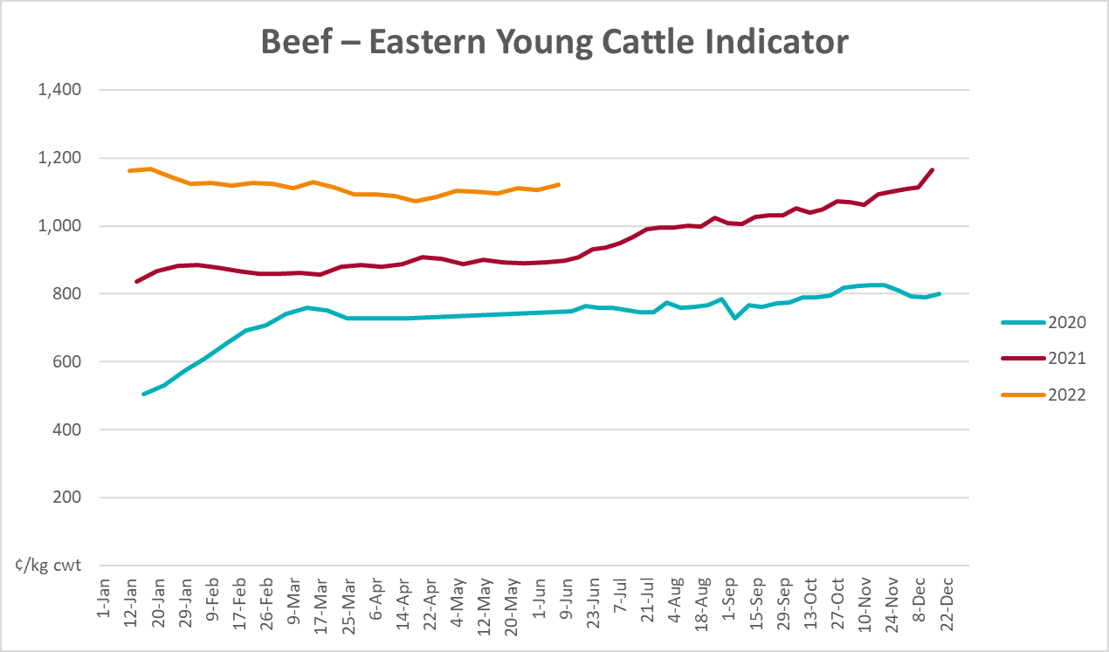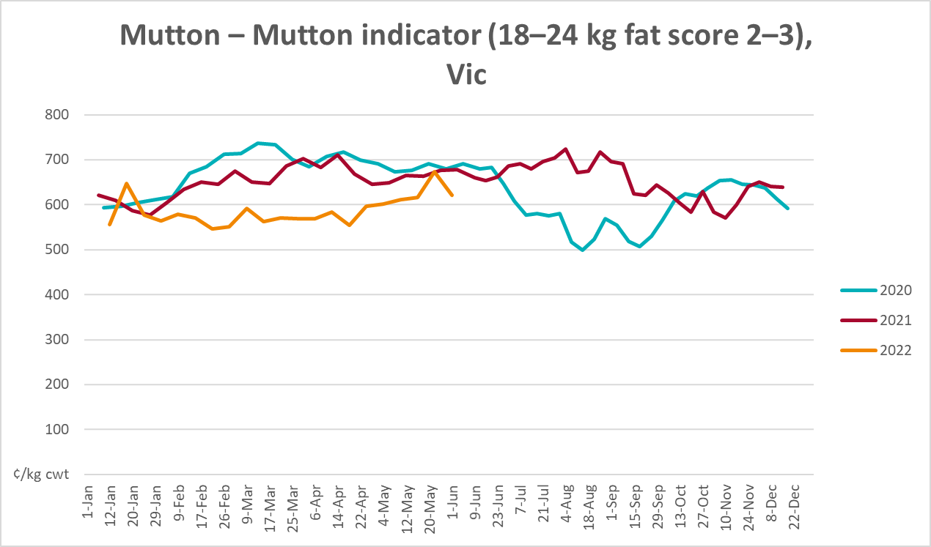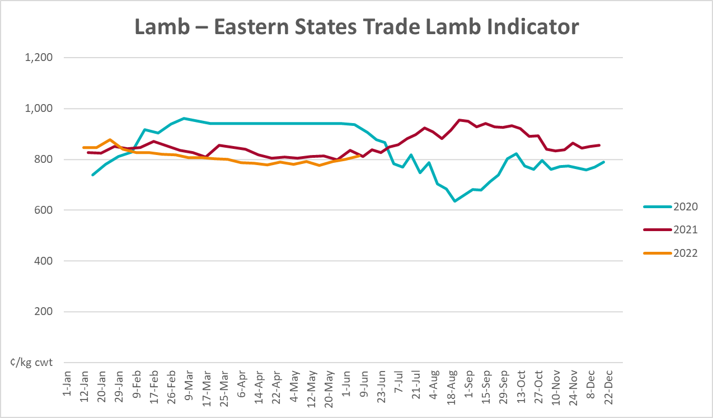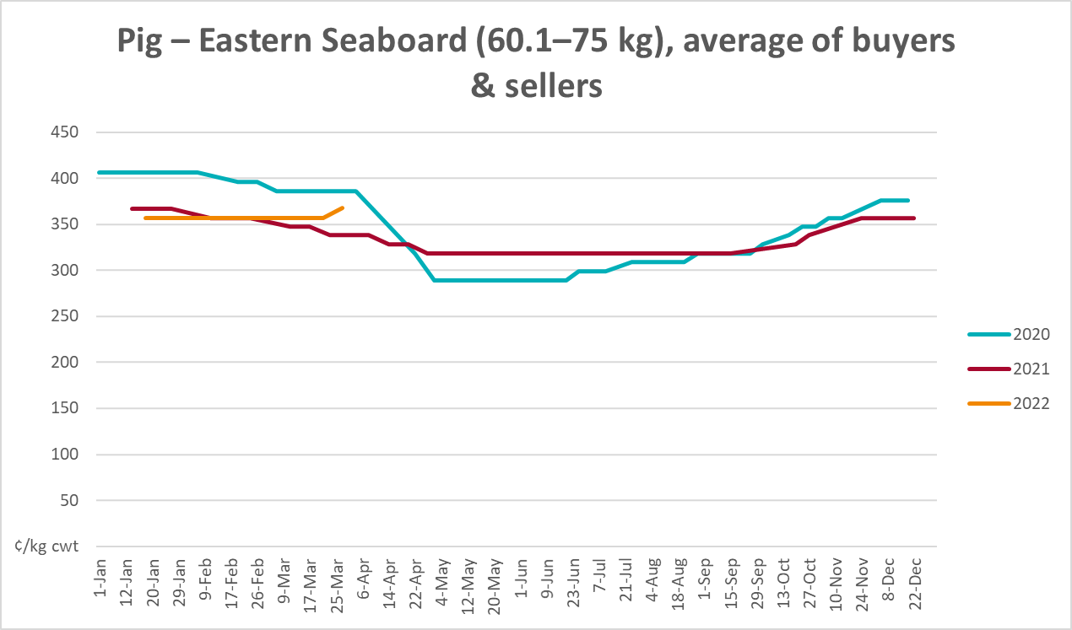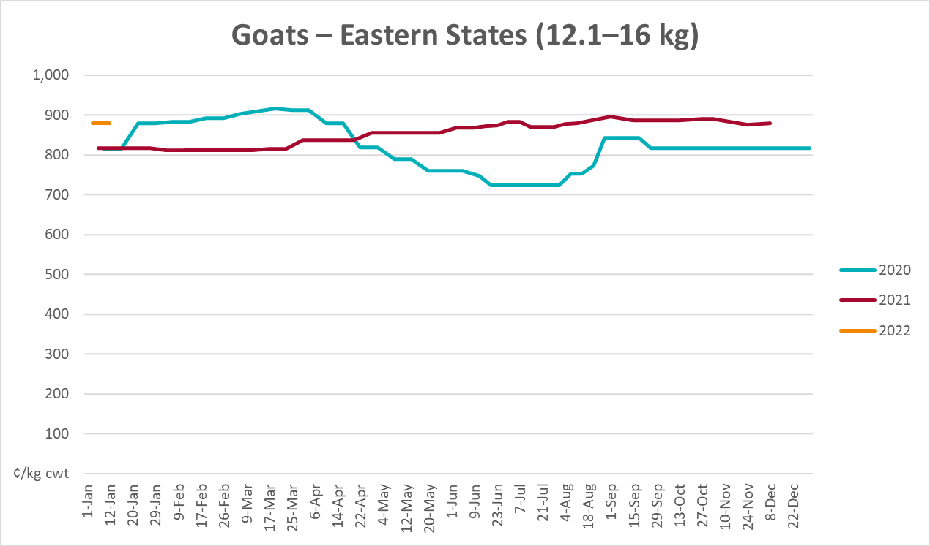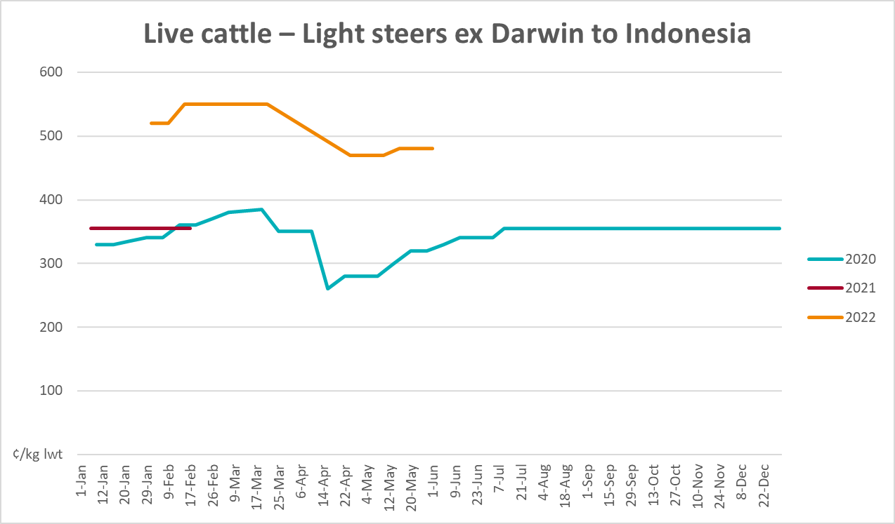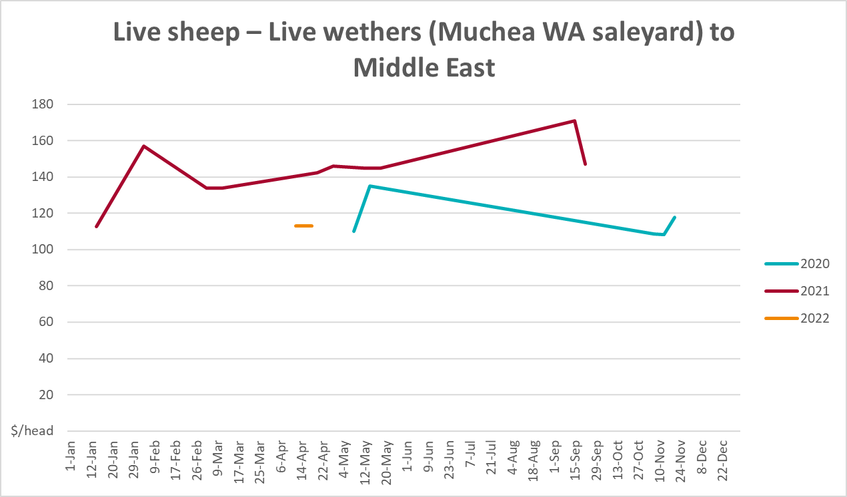

Global Dairy Trade (GDT) weighted average prices
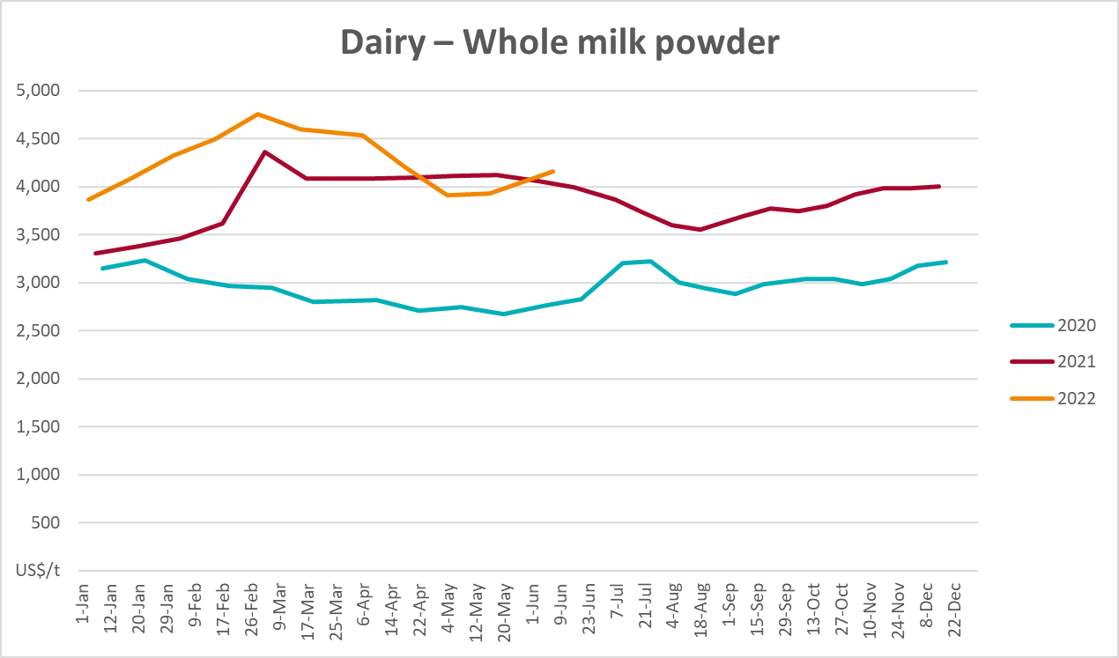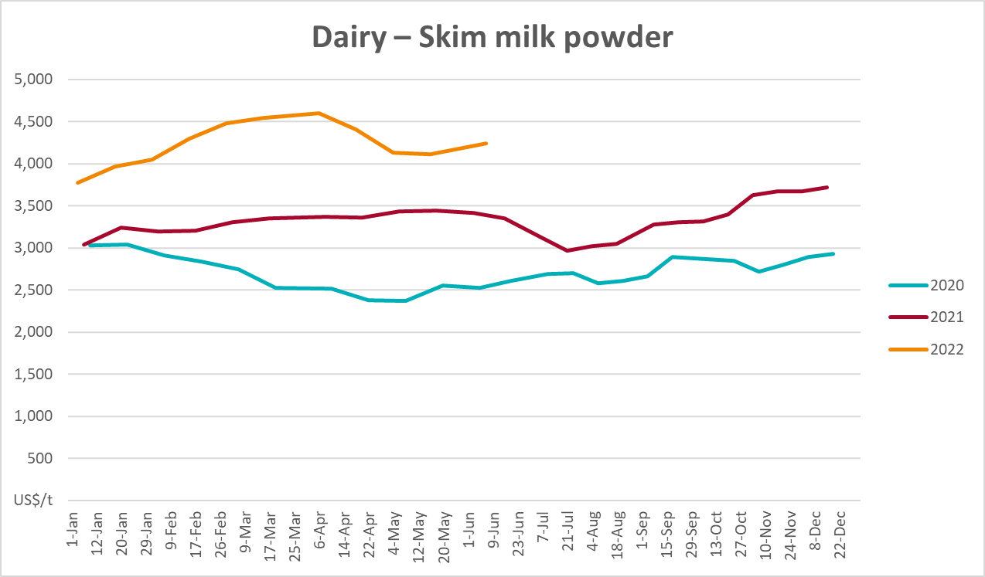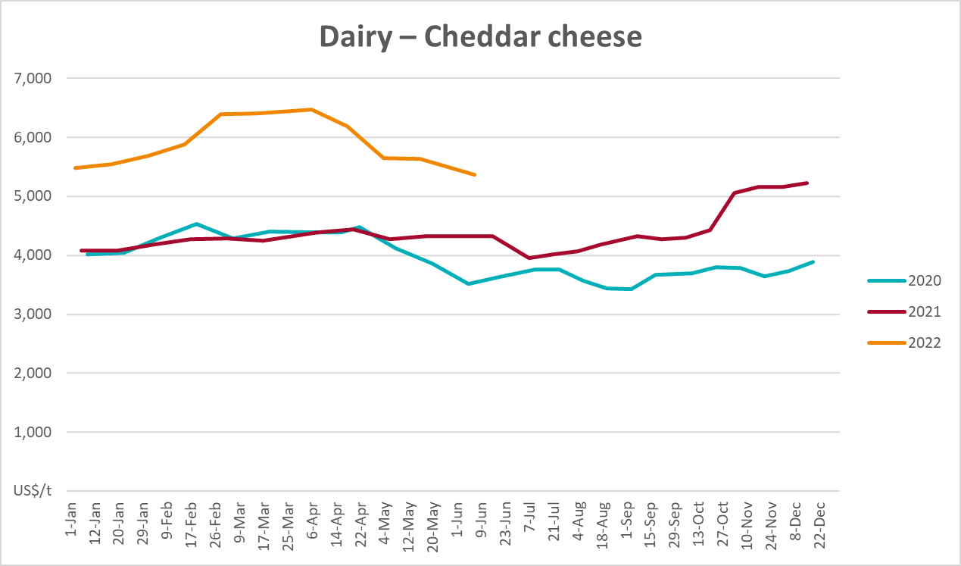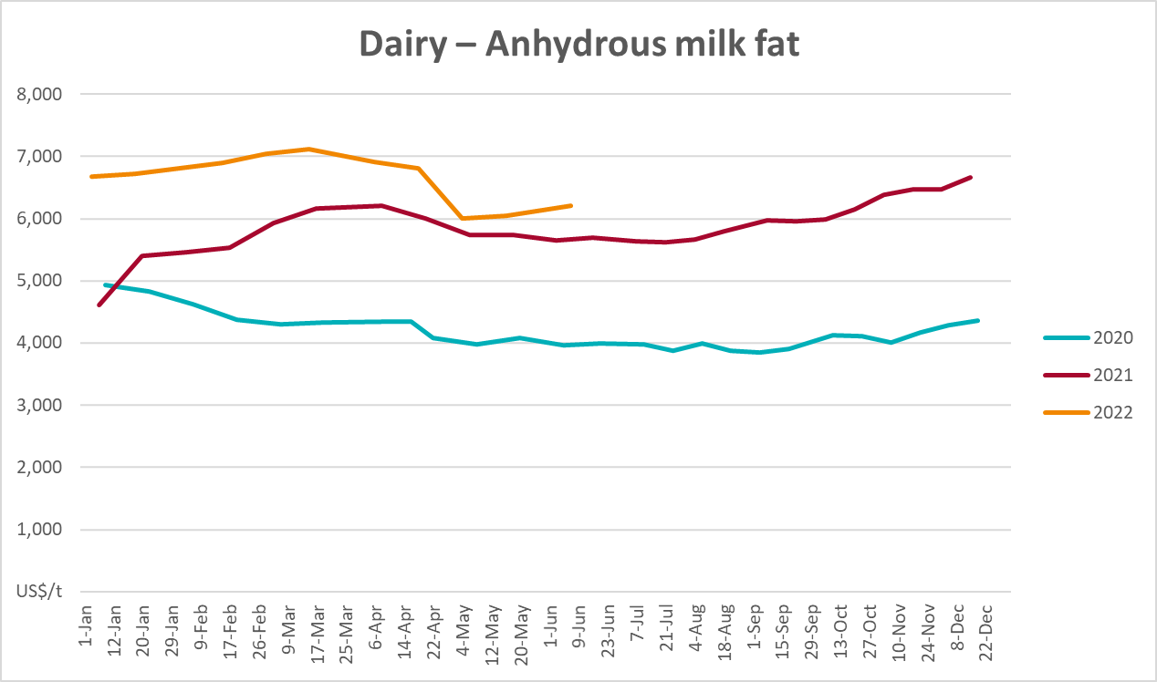

Selected fruit and vegetable prices
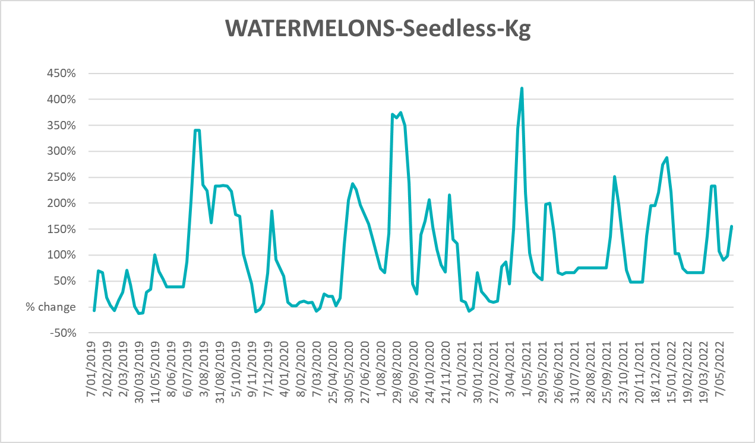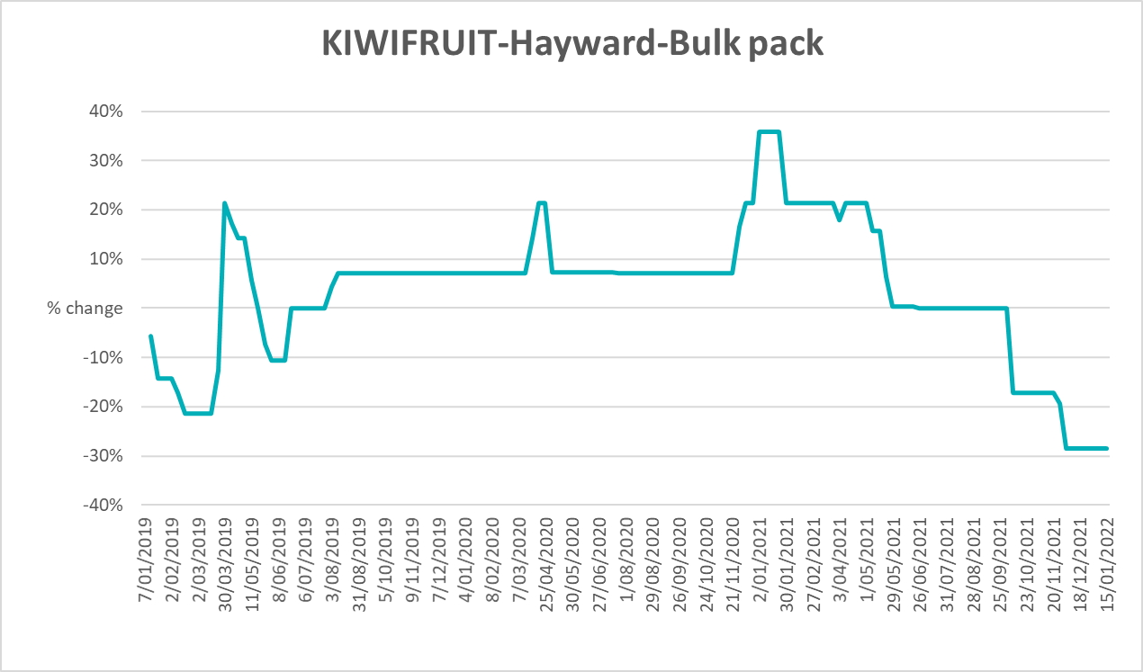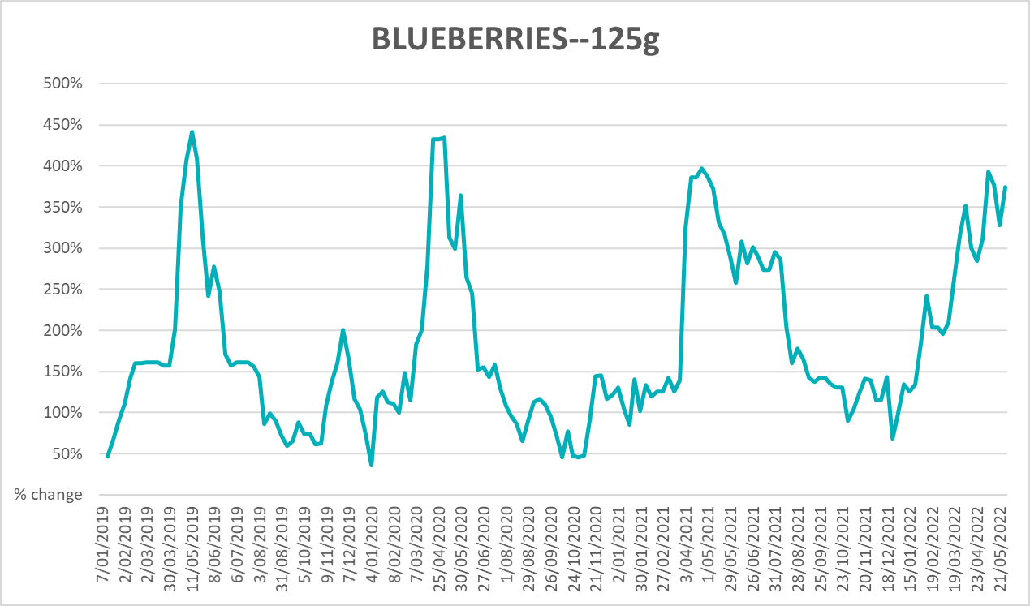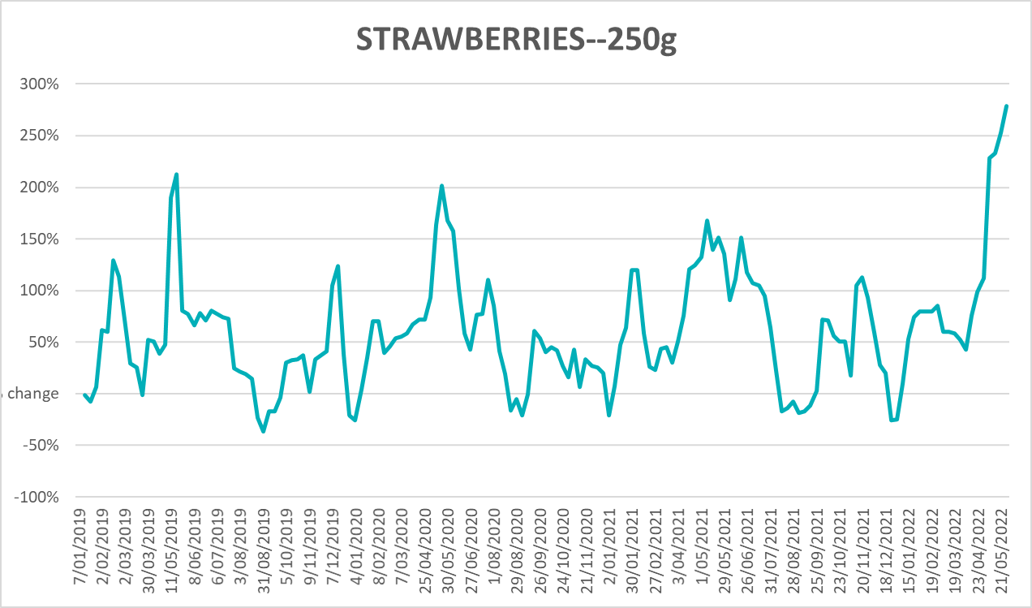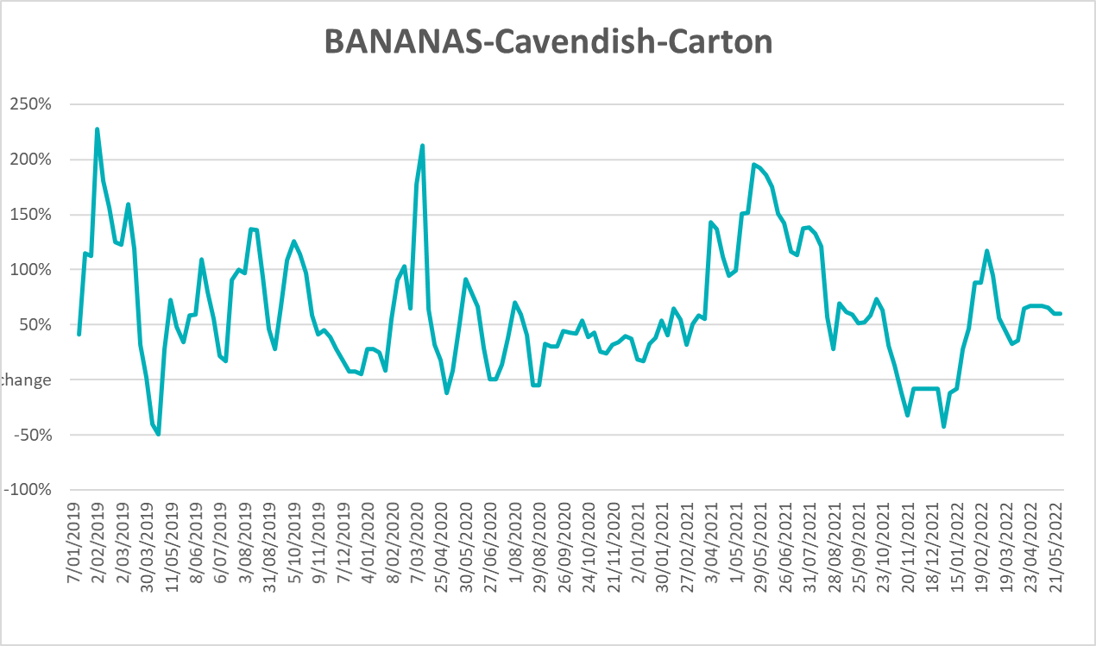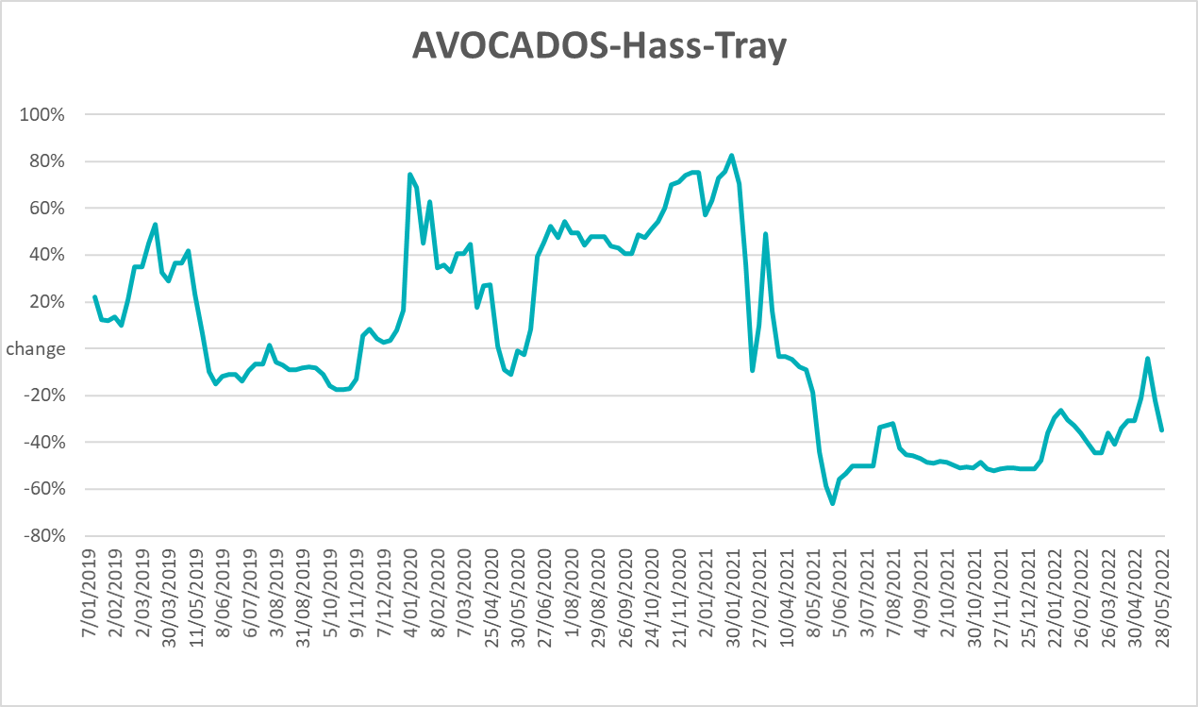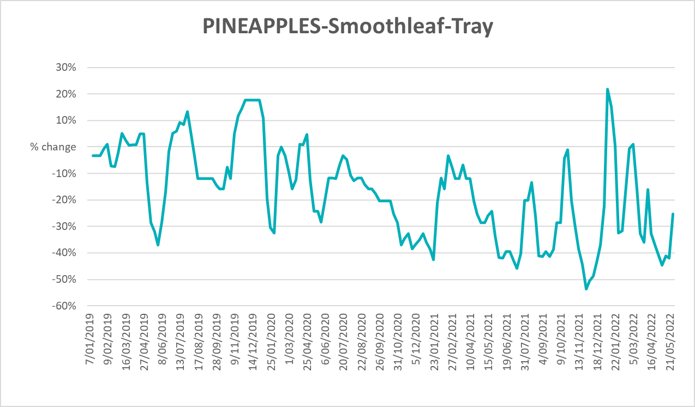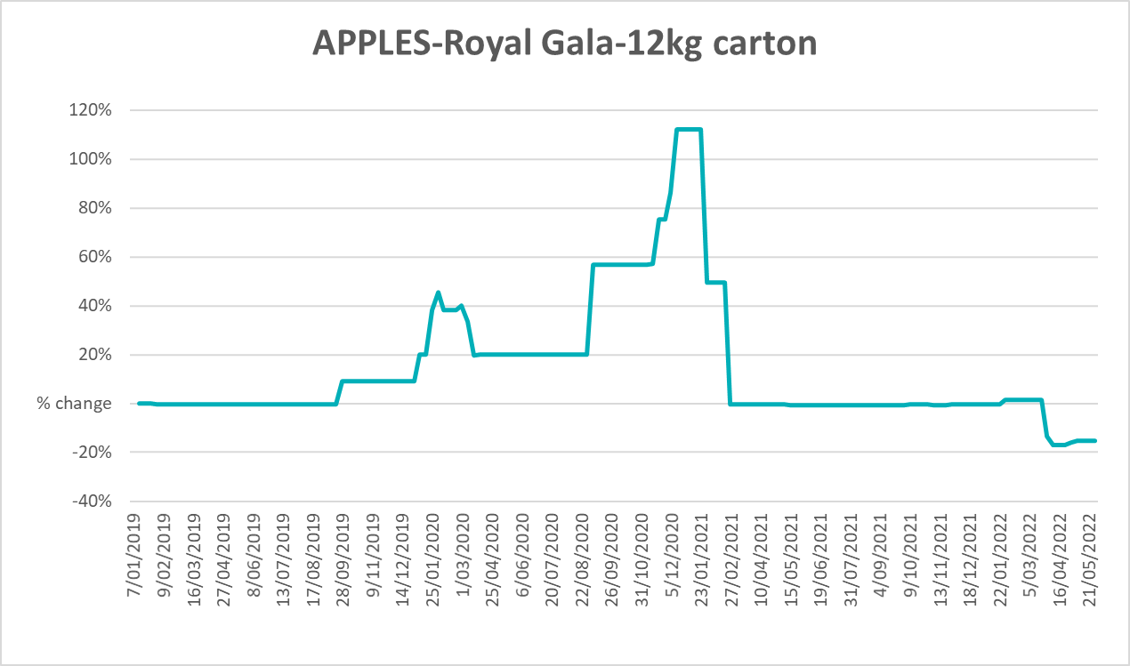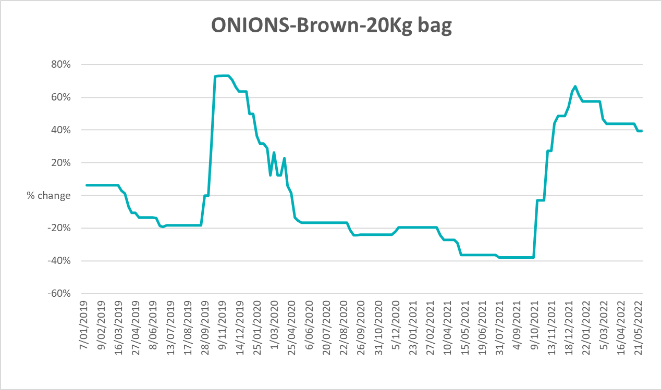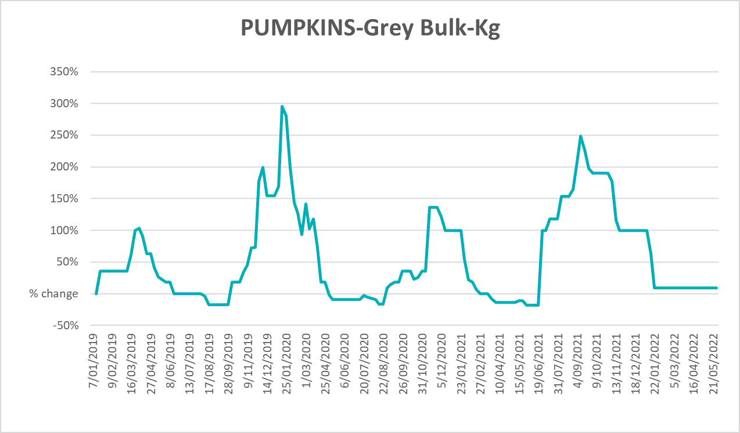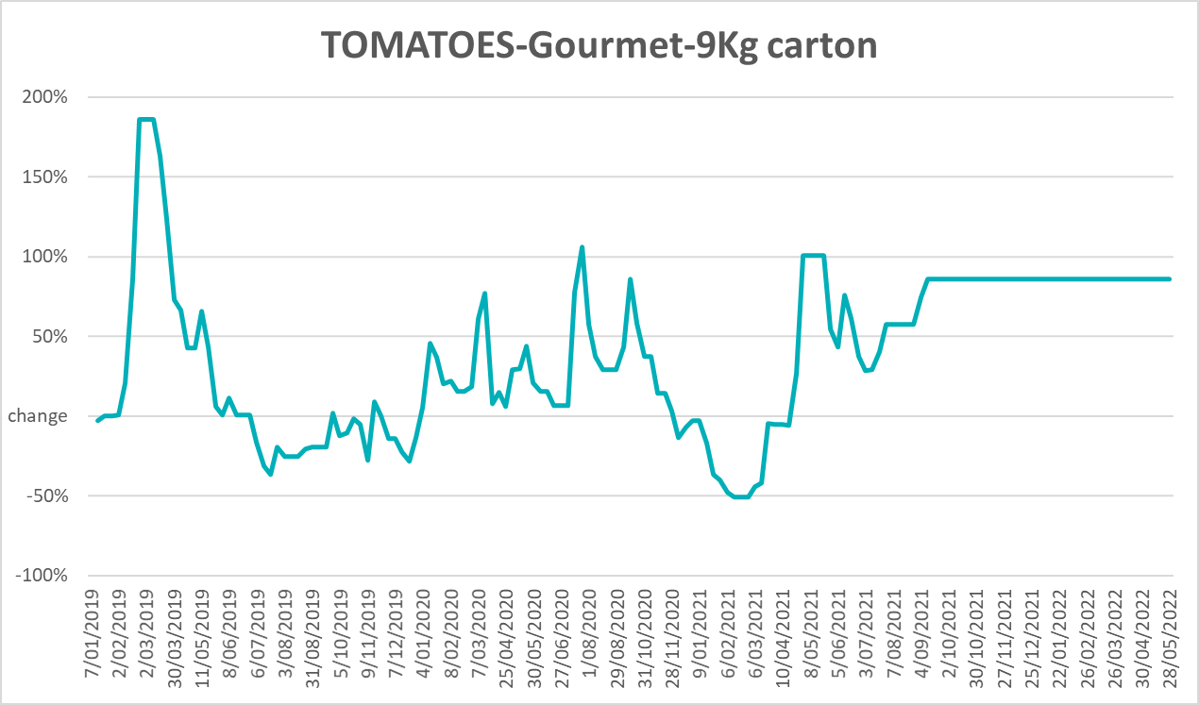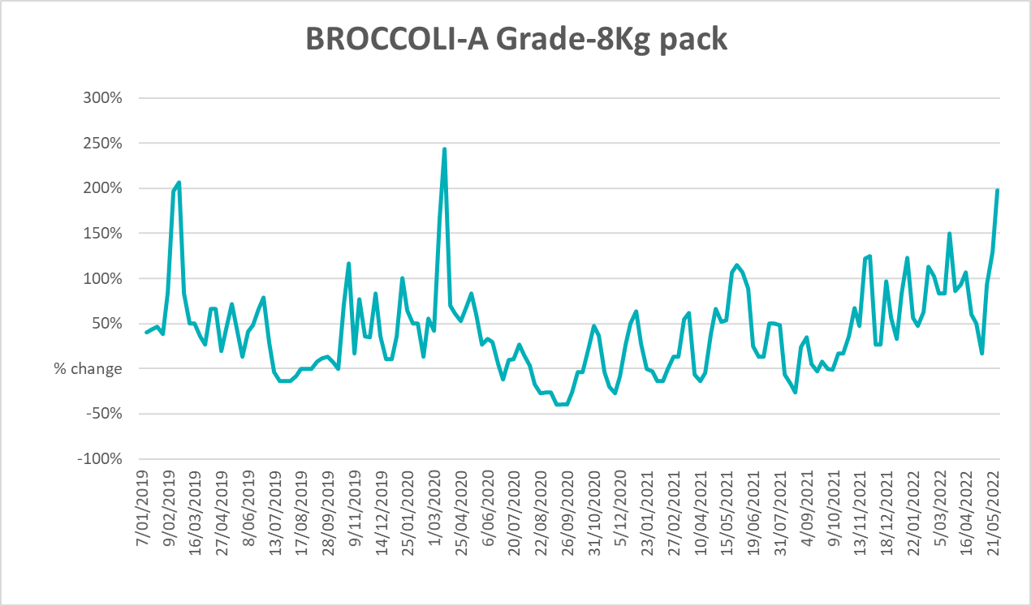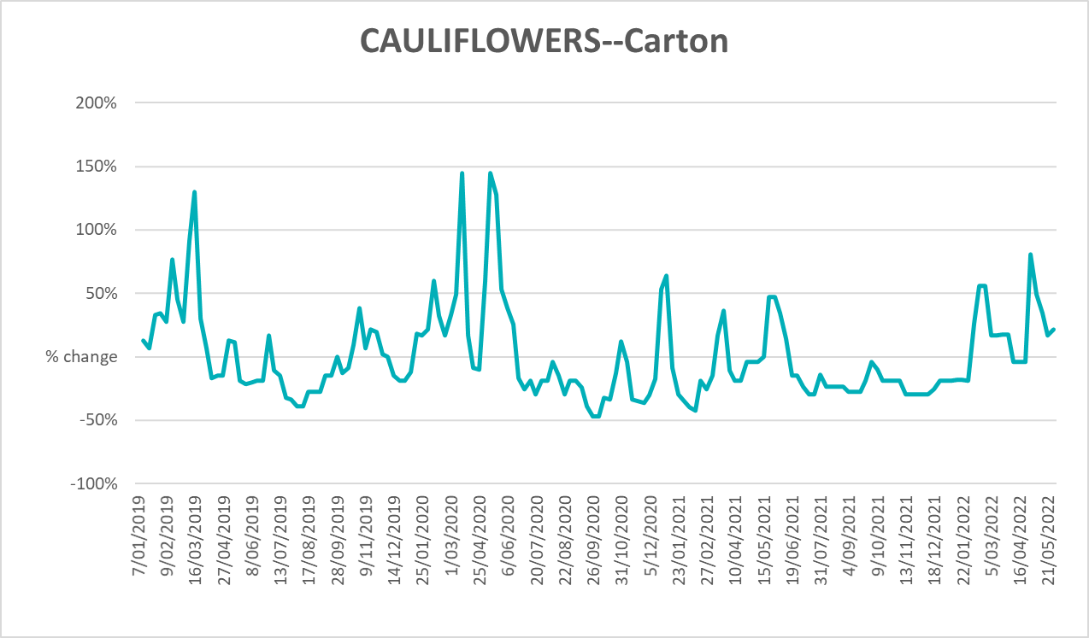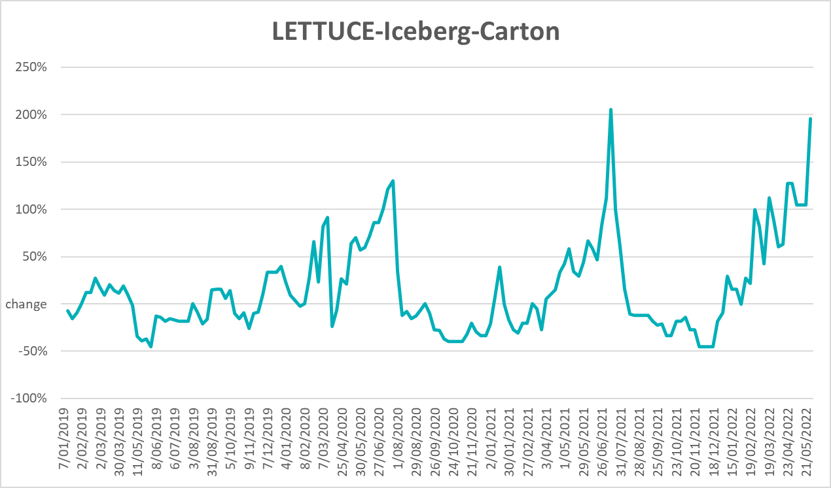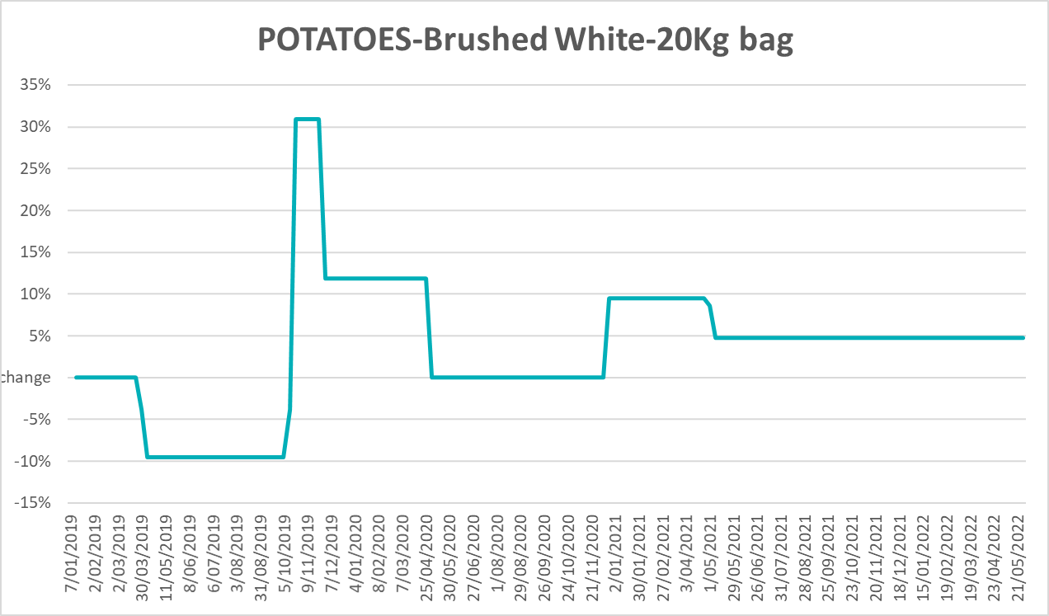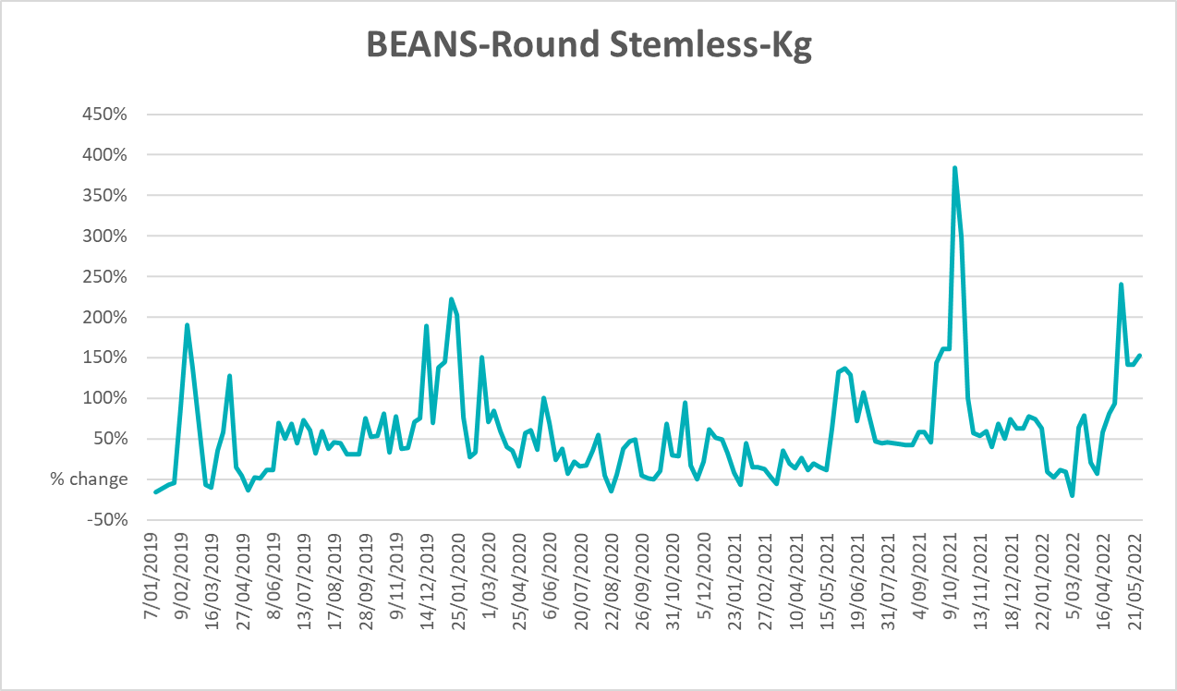

Selected domestic fodder indicator prices
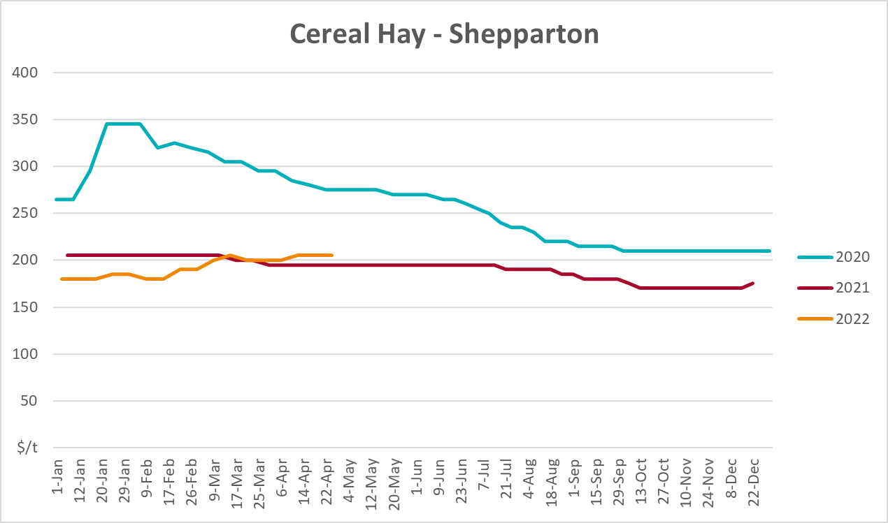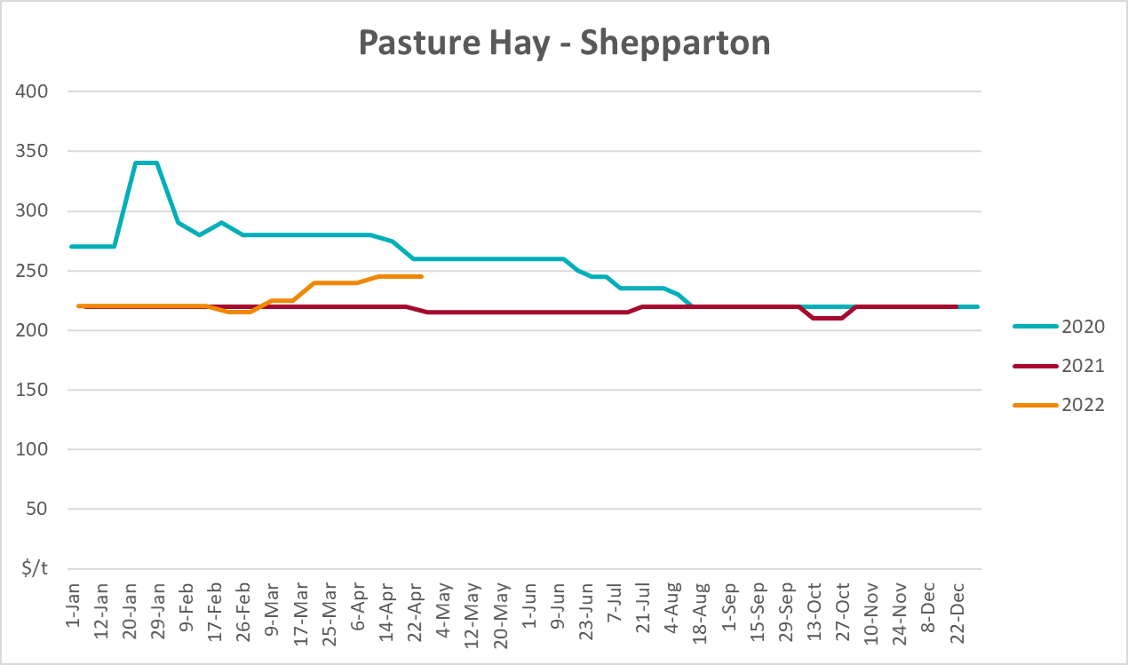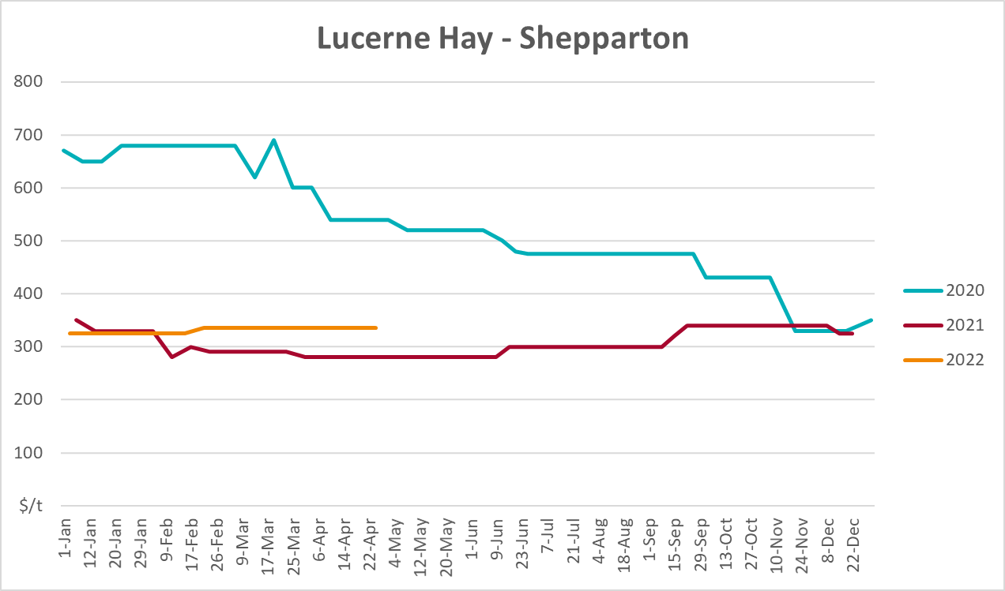

Data attribution

Climate
Bureau of Meteorology
- Weekly rainfall totals: www.bom.gov.au/climate/maps/rainfall/
- Monthly and last 3-month rainfall percentiles: www.bom.gov.au/water/landscape/
- Temperature anomalies: www.bom.gov.au/jsp/awap/temp/index.jsp
- Rainfall forecast: www.bom.gov.au/jsp/watl/rainfall/pme.jsp
- Seasonal outlook: www.bom.gov.au/climate/outlooks/#/overview/summary/
- Climate drivers: http://www.bom.gov.au/climate/enso/
- Soil moisture: www.bom.gov.au/water/landscape/
Other
- Pasture growth: www.longpaddock.qld.gov.au/aussiegrass/
- 3-month global outlooks: Environment and Climate Change Canada, NOAA Climate Prediction Center, EUROBRISA CPTEC/INPE, European Centre for Medium-Range Weather Forecasts, Hydrometcenter of Russia, National Climate Center Climate System Diagnosis and Prediction Room (NCC), International Research Institute for Climate and Society
- Global production: https://ipad.fas.usda.gov/ogamaps/cropmapsandcalendars.aspx
- Autumn break: Pook et al., 2009, https://rmets-onlinelibrary-wiley-com.virtual.anu.edu.au/doi/epdf/10.1002/joc.1833

Water
Prices
- Waterflow: https://www.waterflow.io/
- Ruralco: https://www.ruralcowater.com.au/
Bureau of Meteorology:
- Allocation trade: http://www.bom.gov.au/water/dashboards/#/water-markets/mdb/at
- Storage volumes: http://www.bom.gov.au/water/dashboards/#/water-storages/summary/drainage
Trade constraints:
- Water NSW: https://www.waternsw.com.au/customer-service/ordering-trading-and-pricing/trading/murrumbidgee
- Victorian Water Register: https://www.waterregister.vic.gov.au/TradingRules2019/

Commodities
Fruit and vegetables
- Datafresh: www.freshstate.com.au
Pigs
- Australian Pork Limited: www.australianpork.com.au
Dairy
- Global Dairy Trade: www.globaldairytrade.info/en/product-results/
World wheat, canola
- International Grains Council
World coarse grains
- United States Department of Agriculture
World cotton
- Cotlook: www.cotlook.com/
World sugar
- New York Stock Exchange - Intercontinental Exchange
Wool
- Australian Wool Exchange: www.awex.com.au/
Domestic wheat, barley, sorghum, canola and fodder
- Jumbuk Consulting Pty Ltd: http://www.jumbukag.com.au/
Cattle, beef, mutton, lamb, goat and live export
- Meat and Livestock Australia: www.mla.com.au/Prices-and-market
© Commonwealth of Australia 2022

Ownership of intellectual property rights
Unless otherwise noted, copyright (and any other intellectual property rights, if any) in this publication is owned by the Commonwealth of Australia (referred to as the Commonwealth).

Creative Commons licence
All material in this publication is licensed under a Creative Commons Attribution 4.0 International Licence except content supplied by third parties, logos and the Commonwealth Coat of Arms.
Inquiries about the licence and any use of this document should be emailed to copyright@awe.gov.au.


Cataloguing data
This publication (and any material sourced from it) should be attributed as:
ABARES 2021, Weekly Australian Climate, Water and Agricultural Update, Australian Bureau of Agricultural and Resource Economics and Sciences, Canberra, 9 June 2022. CC BY 4.0 DOI: https://doi.org/10.25814/5f3e04e7d2503
ISSN 2652-7561
This publication is available at https://www.awe.gov.au/abares/products/weekly_update
Department of Agriculture, Water and the Environment
GPO Box 858 Canberra ACT 2601
Telephone 1800 900 090
Web awe.gov.au/abares

Disclaimer
The Australian Government acting through the Department of Agriculture, Water and the Environment, represented by the Australian Bureau of Agricultural and Resource Economics and Sciences, has exercised due care and skill in preparing and compiling the information and data in this publication. Notwithstanding, the Department of Agriculture, Water and the Environment, ABARES, its employees and advisers disclaim all liability, including liability for negligence and for any loss, damage, injury, expense or cost incurred by any person as a result of accessing, using or relying on any of the information or data in this publication to the maximum extent permitted by law.

Statement of Professional Independence
The views and analysis presented in ABARES publications, including this one, reflect ABARES professionally independent findings, based on scientific and economic concepts, principles, information and data. These views, analysis and findings may not reflect or be consistent with the views or positions of the Australian Government, or of organisations or groups who have commissioned ABARES reports or analysis. More information on professional independence is provided on the ABARES website.

Acknowledgements
This report was prepared by Matthew Miller and Cameron Van-Lane.

