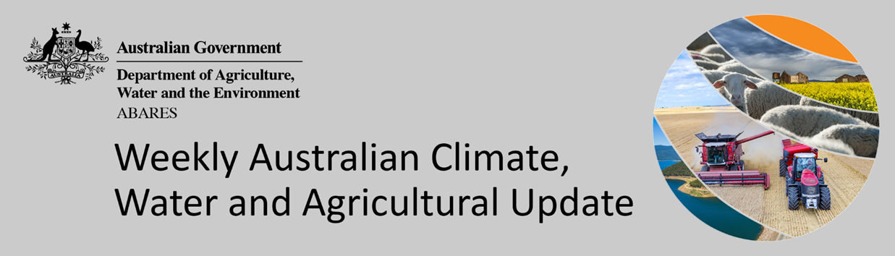
No. 21/2022

2 June 2022

Summary of key issues
- For the week ending 1 June 2022, low-pressure systems and cold fronts brought rainfall to southern and south-eastern parts of the country. Meanwhile, a cloud band across north-western Australia resulted in moderate to heavy falls. High-pressure systems dominated central and north-eastern Australia bringing clear, dry conditions (see Section 1.1).
- Planting of winter crops is well-advanced across southern growing regions, with rainfall across south-eastern Australia this week supporting the germination and establishment of crops. As a consequence, soil moisture levels across cropping regions in the south-east are above average to well-above average. However, the rainfall has likely prevented field access for remaining planting activity. Despite the dry conditions across northern New South Wales and Queensland, soil moisture levels remain above average to very much above average, which has likely prevented growers from completing the harvest of summer crops and planting of winter crops.
- Rainfall during May 2022 was 40% above average for Australia as a whole. Rainfall was above average to extremely high for much of the eastern Australia, parts of the north and central Western Australia, and parts of South Australia. However, rainfall was extremely low to below average for parts of southern Victoria and Western Australia, and large areas of the Northern Territory (see Section 1.2).
- Autumn 2022 rainfall was 4% above average for Australia as a whole, but significant differences were observed between regions and months. The persistence of a La Niña event throughout autumn contributed to above average rainfall for parts of eastern Australia, with New South Wales recording its 7th wettest autumn on record. However, high pressure systems and weaker than average westerly winds to the south led to below average rainfall for Tasmania and parts of southern Australia (see Section 1.3).
- Over the 8-days to 9 June 2022, low-pressure troughs in the north-west and east of Australia, along with cold fronts in the south-east, are forecast to bring light to moderate rainfall. Meanwhile, high pressure systems are expected to bring mostly dry conditions to remaining parts of the country. The forecast rainfall for northern New South Wales and southern Queensland will further delay access to fields, as well as the harvesting of summer crops and planting of winter crops. However, the forecast dry conditions in Western Australia follows a week without rainfall and soil moisture levels are beginning to drop to below average for this time of year (see Section 1.6).
- Water storage in the Murray–Darling Basin (MDB) increased by 18 gigalitres (GL) between 25 May 2022 and 1 June 2022. The current volume of water held in storage is 21,390 GL, which represents 85 of total capacity. This is 44% or 6,506 GL more than at the same time last year.
- Allocation prices in the Victorian Murray below the Barmah Choke decreased from $27 per ML on 21 May 2022 to $18 per ML on 27 May 2022. Prices are lower in the Murrumbidgee and regions above the Barmah choke due to the binding of the Murrumbidgee export limit and Barmah choke trade constraint.

Climate

Rainfall this week
For the week ending 1 June 2022, low-pressure systems and cold fronts brought rainfall to southern and south-eastern parts of the country. Meanwhile, a cloud band across north-western Australia resulted in moderate to heavy falls. High-pressure systems dominated central and north-eastern Australia bringing clear, dry conditions.
Rainfall totals of between 10 and 50 millimetres were recorded across southern and central New South Wales and South Australia, most of Victoria, north-western, central and far southern parts of Western Australia, as well as isolated parts of Queensland, the Northern Territory and western Tasmania. Rainfall totals in excess of 100 millimetres were recorded in isolated parts of New South Wales and South Australia, the north-west of Western Australia and Tasmania. Remaining parts of Australia received little to no rainfall.
In cropping regions, rainfall totals of between 10 and 50 millimetres were recorded across southern and central New South Wales, Victoria, South Australia, as well as isolated parts of Queensland and Western Australia. Rainfall in excess of 50 millimetres was recorded in isolated cropping regions of southern New South Wales and South Australia. Little to no rainfall was recorded across remaining cropping regions in New South Wales, Queensland and Western Australia.
Planting of winter crops is well-advanced across southern growing regions, with rainfall across south-eastern Australia this week supporting the germination and establishment of crops. As a consequence, soil moisture levels across cropping regions in the south-east are above average to well-above average. However, the rainfall has likely prevented field access for remaining planting activity. Despite the dry conditions across northern New South Wales and Queensland, soil moisture levels remain above average to very much above average, which has likely prevented growers from completing the harvest of summer crops and planting of winter crops.

Rainfall for the week ending 1 June 2022

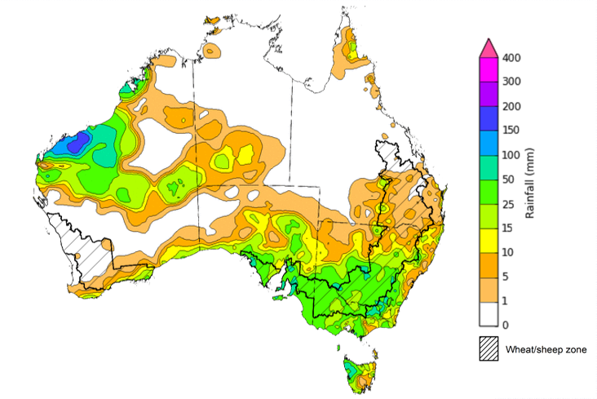

©Commonwealth of Australia 2022, Australian Bureau of Meteorology Issued: 1/6/2022
Note: The rainfall analyses and associated maps utilise data contained in the Bureau of Meteorology climate database, the Australian Data Archive for Meteorology (ADAM). The analyses are initially produced automatically from real-time data with limited quality control. They are intended to provide a general overview of rainfall across Australia as quickly as possible after the observations are received. For further information go to http://www.bom.gov.au/climate/rainfall/

Monthly rainfall
Rainfall during May 2022 was 40% above average for Australia as a whole. Rainfall was above average to extremely high for much of the eastern Australia, parts of the north and central Western Australia, and parts of South Australia. However, rainfall was extremely low to below average for parts of southern Victoria and Western Australia, and large areas of the Northern Territory.
The main climate influences for May were a La Niña event in the Pacific and the development of a negative Indian Ocean Dipole (IOD). A La Niña is associated with above average rainfall for eastern Australia, and a negative IOD typically results in enhanced rainfall in a broad band extending from the north-west to the south-east of Australia
May 2022 rainfall was above average to extremely high across cropping regions of New South Wales, Queensland, the west and east of South Australia and parts of northern Victoria. May rainfall was generally average for all remaining cropping regions. Below average rainfall was recorded across some northern Western Australian cropping regions.
Extremely high rainfall across eastern Australia in May followed a wet March and April and added to already saturate soil profiles, resulting in localised flooding. The wet conditions have delayed maturation and harvesting of long-lived summer crops in parts of New South Wales and Queensland. However, most southern cropping regions have received sufficient rainfall to allow for the timely sowing of expanded winter crop programs and supported the germination and growth of earlier sown crops.

Rainfall percentiles for May 2022

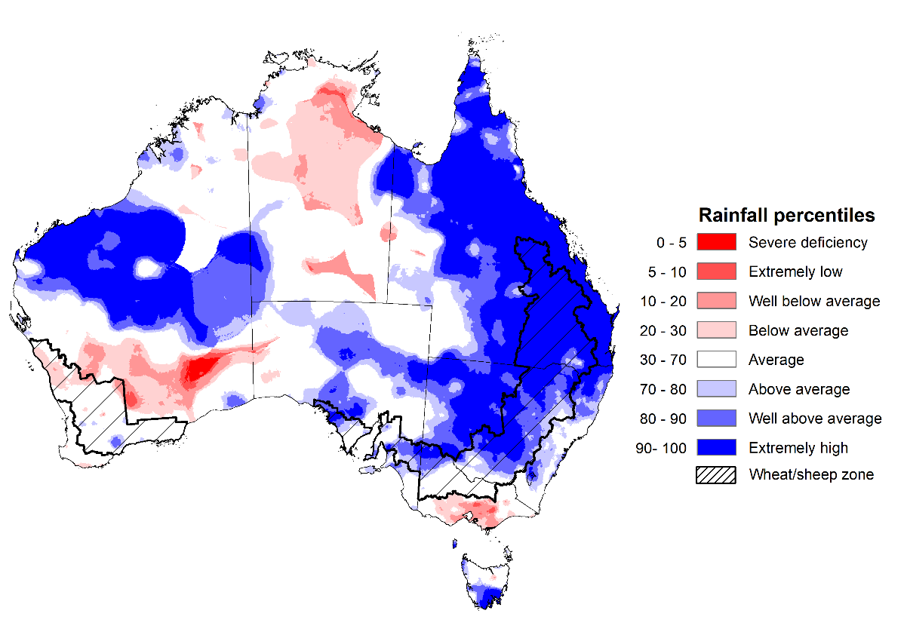
Note: Rainfall for May 2022 is compared with rainfall recorded for that period during the historical record (1900 to present). For further information, go to http://www.bom.gov.au/jsp/awap/
Source: Bureau of Meteorology

Seasonal rainfall
Autumn 2022 rainfall was 4% above average for Australia as a whole, but significant differences were observed between regions and months. The persistence of a La Niña event throughout autumn contributed to above average rainfall for parts of eastern Australia, with New South Wales recording its 7th wettest autumn on record. However, high pressure systems and weaker than average westerly winds to the south led to below average rainfall for Tasmania and parts of southern Australia. Rainfall was above average throughout New South Wales, central and eastern Queensland, northern parts of Victoria and the north-west of Western Australia. Below average rainfall was recorded across the Northern Territory, as well as parts of northern Queensland, the north-east of Western Australia and western Tasmania.
The season began with above average rainfall in March, resulting in significant flooding in coastal areas of New South Wales and south-east Queensland. The wet conditions interrupted harvesting of early sown crops in northern New South Wales and southern Queensland but boosted soil moisture levels for long-lived summer crops as they progressed through critical yield formation stages of development. Above average rainfall continued across parts of eastern Australia throughout April and May, restricting field access in northern New South Wales and southern Queensland. Cropping regions of Western Australia also received above average rainfall throughout March and April, prompting a large winter plant. For cropping regions across eastern Australia, the above average rainfall through autumn has provided good soil moisture levels heading into the winter cropping season.
Above average rainfall throughout autumn has resulted in above average dryland cotton yields across major growing regions. However, excess moisture has lowered irrigated yields, especially in southern Queensland, as well as contributing to potential quality downgrades. Central Queensland received below-average to average rainfall through March and April, contributing to below average yields for sorghum.

Rainfall percentiles for autumn 2022 (1 March 2021 to 31 May 2022)
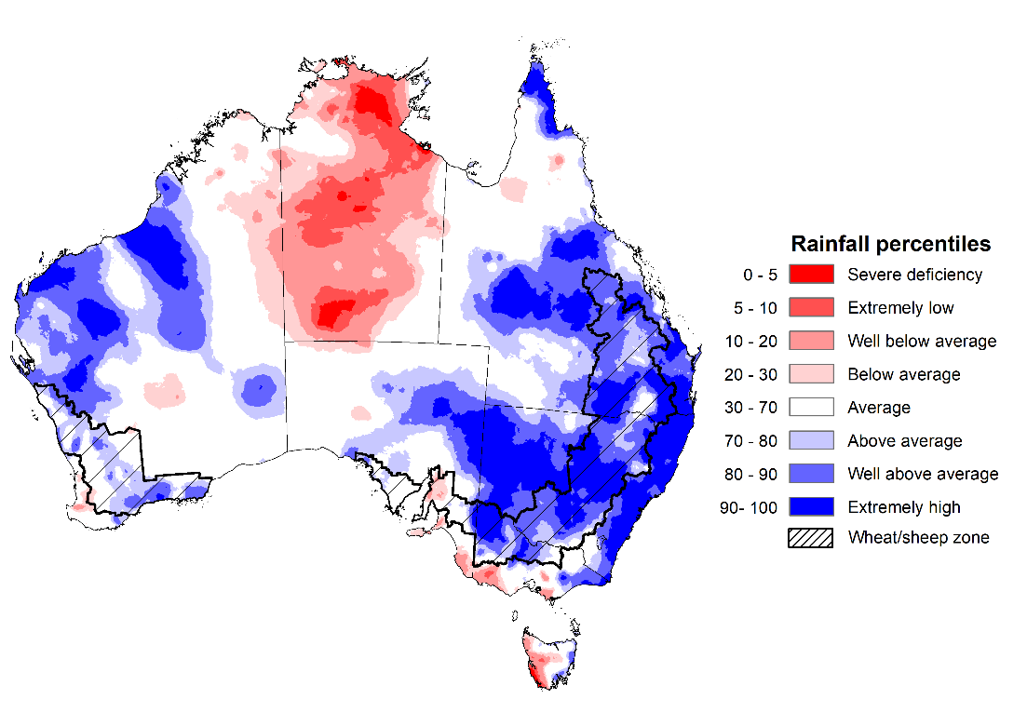
Note: Rainfall for March 2022 to May 2022 is compared with rainfall recorded for that period during the historical record (1900 to present). For further information, go to http://www.bom.gov.au/jsp/awap/
Source: Bureau of Meteorology

Monthly soil moisture
Upper layer soil moisture in May 2022 was average for this time of year across parts of southern New South Wales, western Queensland, northern and southern area of Western Australia and northern Tasmania, as well as most of Victoria, South Australia and the Northern Territory. Modelled upper layer soil moisture was extremely low for parts of southern Victoria, the south of Western Australia and northern parts of the Northern Territory due to below average rainfall in these areas in recent months. Extremely high soil moisture was evident across most of New South Wales and Queensland, northern parts of South Australia, central parts of Western Australia and southern Tasmania, reflecting the heavy rainfall in May.
At this time of year, upper layer soil moisture is important for winter crops across Australian growing regions since plant germination and establishment utilise this moisture. It is also an important indicator of the ability to access paddocks to undertake harvest and planting activities.
Upper layer soil moisture was well above average to extremely high for this time of year across cropping regions in New South Wales and Queensland. It was average to above average in western Victoria and the east of South Australia. Upper layer soil moisture was below average to average for northern cropping regions in the Western Australian Wheat Belt. The well above average to extremely high upper layer soil moisture is preventing field access across much of New South Wales and Queensland, which will delay the harvest of summer crops and sowing of winter crops in the short term. For crops sown before the onset of heavy rainfall in May, the soil moisture conditions across eastern states will provide an ideal start to the winter cropping season.

Modelled upper layer soil moisture for May 2022

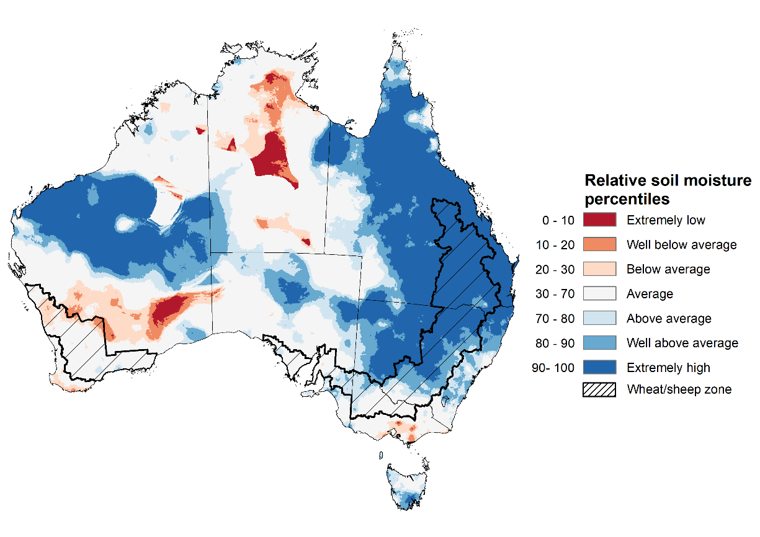

Note: This map shows the levels of modelled upper layer soil moisture (0 to 10 centimetres) during May 2022. This map shows how modelled soil conditions during May 2022 compare with February conditions modelled over the reference period (1911 to 2016). Dark blue areas on the maps were much wetter in May 2022 than during the reference period. The bulk of plant roots occur in the top 20 centimetres of the soil profile. Soil moisture in the upper layer of the soil profile is therefore useful indicator of the availability of water, particularly for germinating seed.
Source: Bureau of Meteorology (Australian Water Resources Assessment Landscape model)

Lower layer soil moisture for February 2022 was well above average to extremely high for this time of year across parts of north-western, south-central and eastern Australia. Lower layer soil moisture was well below average to below average across parts of southern Victoria, southern and northern parts of Western Australia, as well as much of the Northern Territory.
In cropping regions, lower layer soil moisture was well above average to extremely high for parts of northern and central New South Wales, Queensland, eastern and western parts of South Australia, as well as isolated parts in the south of Western Australia. High levels of lower layer soil moisture will continue to support above average pasture growth rates for this time of year across New South Wales and Queensland.
Modelled lower layer soil moisture for May 2022
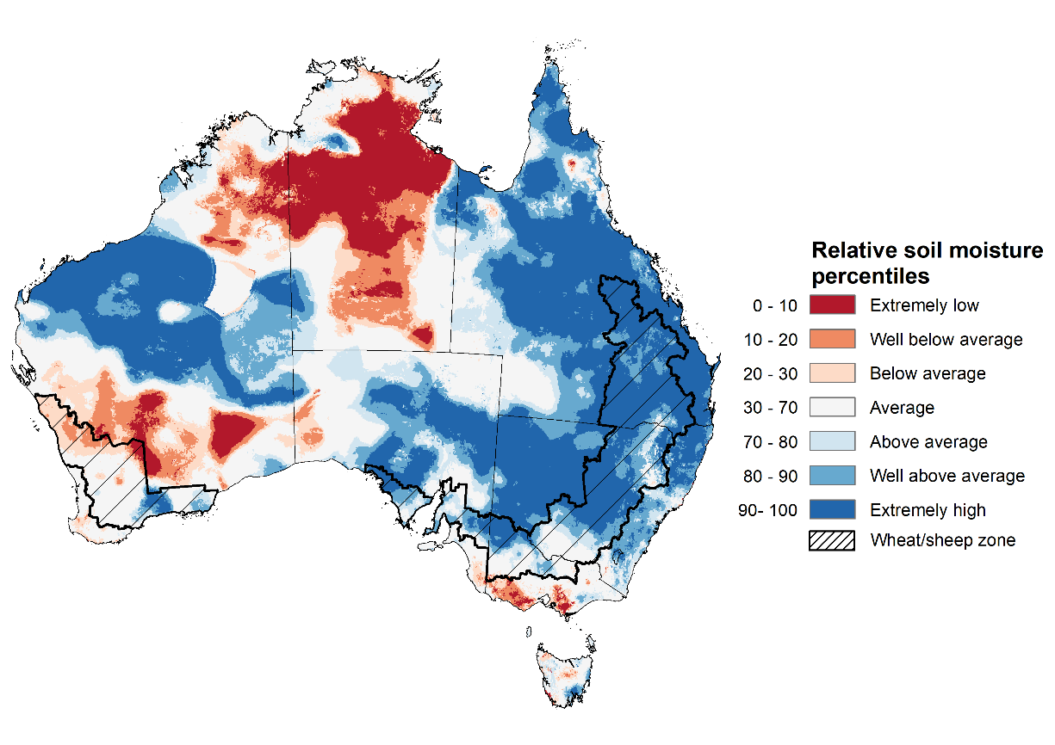
Note: This map shows the levels of modelled lower layer soil moisture (10 to 100 centimetres) during May 2022. This map shows how modelled soil conditions during May 2022 compare with February conditions modelled over the reference period (1911 to 2016). Dark blue areas on the maps were much wetter in May 2022 than during the reference period. The dark red areas were much drier than during the reference period. The bulk of plant roots occur in the top 20 centimetres of the soil profile. The lower layer soil moisture is a larger, deeper store that is slower to respond to rainfall and tends to reflect accumulated rainfall events over longer time periods.
Source: Bureau of Meteorology (Australian Water Resources Assessment Landscape model)

Pasture growth
Pasture growth during the March to May period affects the availability of fodder to support livestock production across northern Australia as it enters a seasonally low growth period. Across southern Australia, autumn pasture growth influences the standing biomass available to support livestock production over winter and the reliance on hay and grain during this period.
For the 3 months to May 2022, above average rainfall totals and mild temperatures resulted in above average to extremely high pasture production for this time of year across most grazing regions in central and western New South Wales, southern and central Queensland, western and northern Victoria, parts of eastern and south-western South Australia, and the west and north of Western Australia. Extremely low to below average pasture growth rates were recorded across parts of southern Western Australia, the south-east of Victoria and South Australia, northern Queensland and the Northern Territory consistent with below average rainfall. In contrast, below average pasture growth rates across parts of eastern New South Wales and south-eastern Queensland are likely the result of below average temperatures and waterlogged soils.
Above average to extremely high pasture production across much of New South Wales, Victoria, southern Queensland, South Australia, the west and north of Western Australia will likely enable farmers to continue to rebuild stock numbers and provide opportunities to build standing dry matter availability. Below average temperatures and waterlogged soils across eastern New South Wales and south-eastern Queensland may have restricted autumn pasture growth. However, it comes after extremely high pasture growth during spring and early summer that supplied average to above average pasture availability and ample opportunities to conserve excess fodder.

Relative pasture growth for 3-months ending May 2022 (1 March to 31 May 2022)
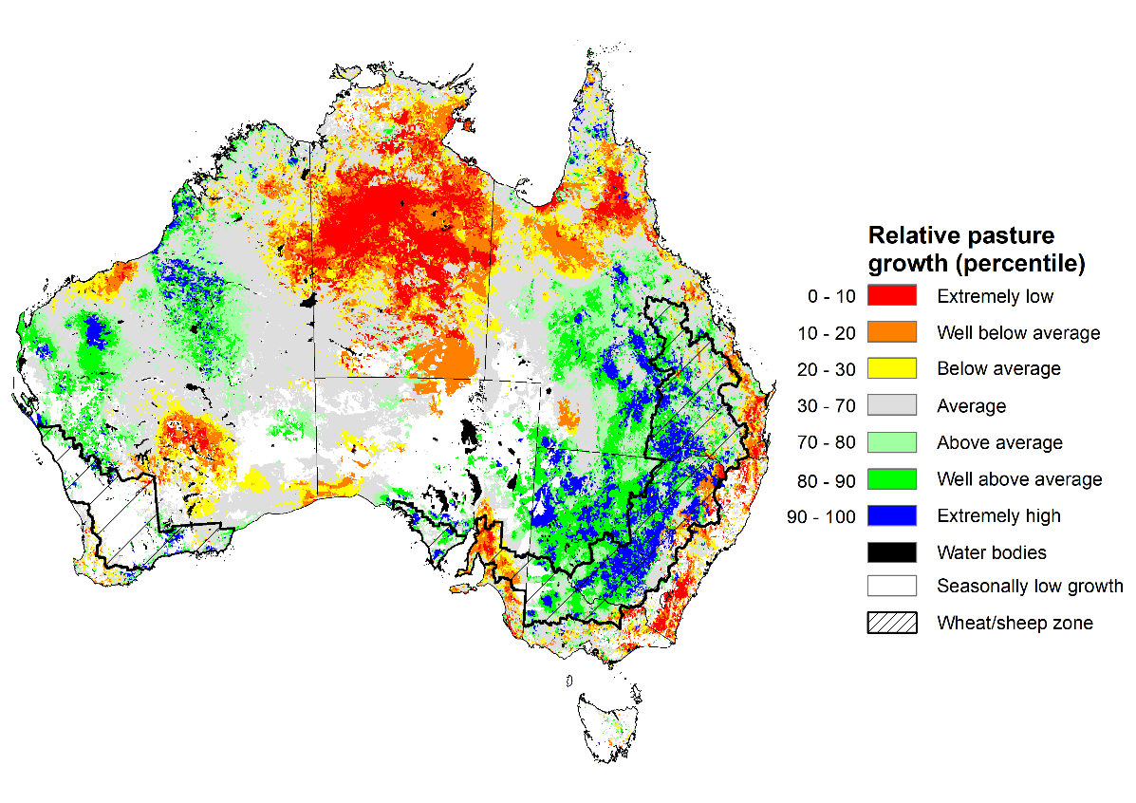
Notes: AussieGRASS pasture growth estimates are relative to the long-term record and shown in percentiles. Percentiles rank data on a scale of zero to 100. This analysis ranks pasture growth for the selected period against average pasture growth for the long-term record (1957 to 2016). Pasture growth is modelled at 5km2 grid cells.
Source: Queensland Department of Science, Information Technology and Innovation

Rainfall forecast for the next eight days
Over the 8-days to 9 June 2022, low-pressure troughs in the north-west and east of Australia, along with cold fronts in the south-east, are forecast to bring light to moderate rainfall. Meanwhile, high pressure systems are expected to bring mostly dry conditions to remaining parts of the country.
Rainfall totals of between 10 and 25 millimetres are forecast for north-eastern and south-eastern New South Wales, south-eastern and far northern Queensland, southern and north-eastern Victoria, the south-east of South Australia, the north-west of Western Australia, western parts of the Northern Territory, as well as most of Tasmania. Rainfall in excess of 25 millimetres is expected in alpine areas of New South Wales and Victoria, the north-west of Western Australia and western Tasmania.
In Australian cropping regions, rainfall totals of between 10 and 25 millimetres are expected across south-eastern and north-eastern New South Wales, southern Queensland and Victoria, as well as central parts of South Australia. Little to no rainfall is forecast for all remaining cropping regions during the next 8-days.
The forecast rainfall for northern New South Wales and southern Queensland will further delay access to fields, as well as the harvesting of summer crops and planting of winter crops. The rainfall also increases the risk of quality downgrades for unharvested, mature summer crops. Above average soil moisture levels across cropping regions of south-eastern Australia will support the development of winter crops, despite the lack of forecast rainfall. However, the forecast dry conditions in Western Australia follows a week without rainfall and soil moisture levels are beginning to drop to below average for this time of year. Further rainfall will be required over the coming weeks to support continued crop development. Rainfall forecast for parts of South Australia will consolidate falls received in the previous week, supporting the germination and establishment of dry sown winter crops.

Total forecast rainfall (mm) for the period 2 June to 9 June 2022
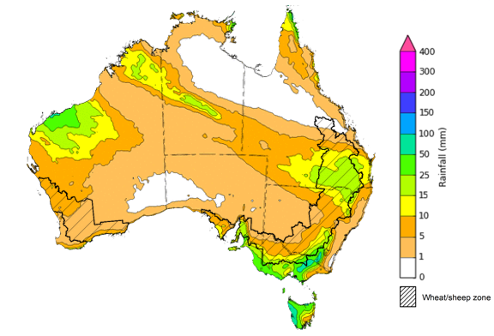
©Commonwealth of Australia 2022, Australian Bureau of Meteorology Issued: 1/6/2022

Water
Note: This rainfall forecast is produced from computer models. As the model outputs are not altered by weather forecasters, it is important to check local forecasts and warnings issued by the Bureau of Meteorology.

Water markets – current week
Water storage in the Murray–Darling Basin (MDB) increased by 18 gigalitres (GL) between 25 May 2022 and 1 June 2022. The current volume of water held in storage is 21,390 GL, which represents 85 of total capacity. This is 44% or 6,506 GL more than at the same time last year.

Water storages in the Murray-Darling Basin, 2013–2022
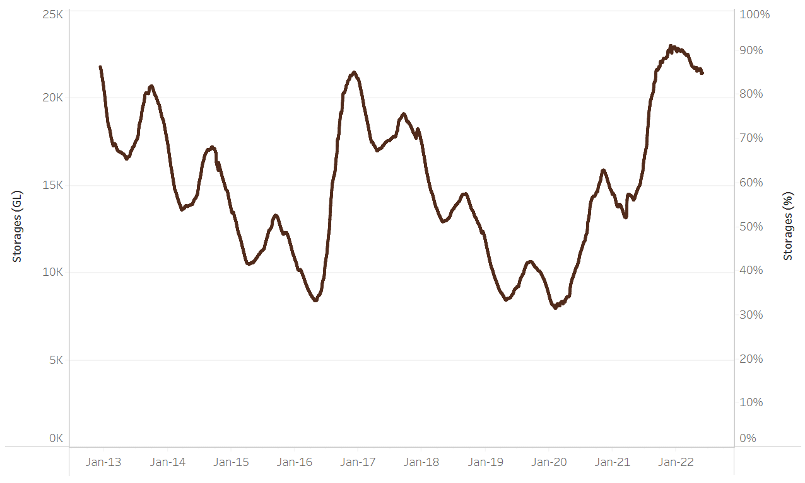
Allocation prices in the Victorian Murray below the Barmah Choke decreased from $27 per ML on 21 May 2022 to $18 per ML on 27 May 2022. Prices are lower in the Murrumbidgee and regions above the Barmah choke due to the binding of the Murrumbidgee export limit and Barmah choke trade constraint.
Water storage data is sourced from the Bureau of Meteorology.

Region | $/ML
NSW Murray Above | 4
NSW Murrumbidgee | 16
VIC Goulburn-Broken | 23
VIC Murray Below | 18

Surface water trade activity, Southern Murray–Darling Basin

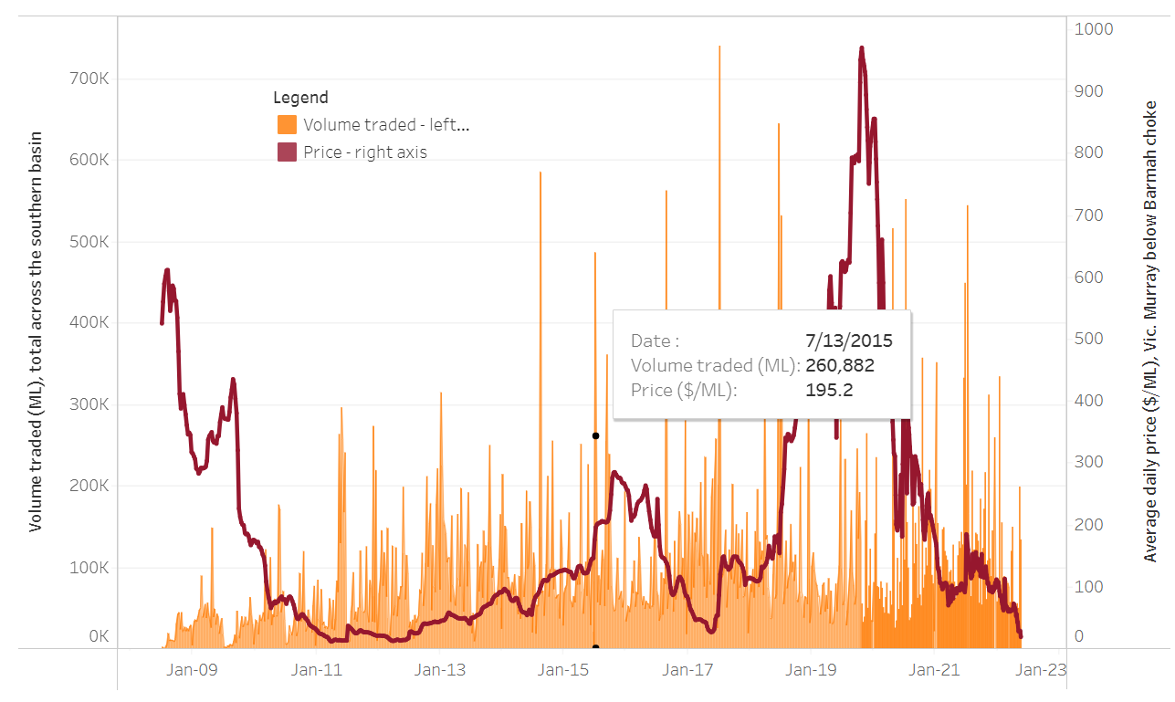
To access the full, interactive, weekly water dashboard, which contains the latest and historical water storage, water market and water allocation information, please visit http://www.agriculture.gov.au/abares/products/weekly_update/weekly-update-020622
The trades shown reflect estimated market activity and do not encompass all register trades. The price is shown for the VIC Murray below the Barmah choke. Historical prices (before 1 July 2019) are ABARES estimates after removing outliers from BOM water register data. Prices after 1 July 2019 and prior to the 30 October 2019 reflect recorded transaction prices as sourced from Ruralco. Prices after the 30 October 2019 are sourced from Waterflow. Data for volume traded is sourced from the BOM water register. Data shown is current at 2 June 2022.

Commodities

Indicator | Week ended | Unit | Latest price | Previous week | Weekly change | Price 12 months ago | Annual change
Selected world indicator prices
AUD/USD Exchange rate | 01-Jun | A$/US$ | 0.71 | 0.70 | 1% | 0.77 | -8%
Wheat – US no. 2 hard red winter wheat, fob Gulf | 01-Jun | US$/t | 523 | 534 | -2% | 292 | 79%
Corn – US no. 2 yellow corn, fob Gulf | 01-Jun | US$/t | 342 | 347 | -1% | 299 | 14%
Canola – Rapeseed, Canada, fob Vancouver | 01-Jun | US$/t | 969 | 960 | 1% | 725 | 34%
Cotton – Cotlook 'A' Index | 01-Jun | USc/lb | 161 | 161 | 0% | 93 | 72%
Sugar – Intercontinental Exchange, nearby futures, no.11 contract | 01-Jun | USc/lb | 19.8 | 19.9 | -1% | 18 | 12%
Wool – Eastern Market Indicator | 25-May | Ac/kg clean | 1,420 | 1,420 | 0% | 1,291 | 10%
Wool – Western Market Indicator | 06-Apr | Ac/kg clean | 1,417 | 1,421 | 0% | 1,222 | 16%
Selected Australian grain export prices
Milling Wheat – APW, Port Adelaide, SA | 01-Jun | A$/t | 615 | 619 | -1% | 375 | 64%
Feed Wheat – ASW, Port Adelaide, SA | 01-Jun | A$/t | 580 | 584 | -1% | 371 | 56%
Feed Barley – Port Adelaide, SA | 01-Jun | A$/t | 546 | 552 | -1% | 323 | 69%
Canola – Kwinana, WA | 01-Jun | A$/t | 1,281 | 1,295 | -1% | 776 | 65%
Grain Sorghum – Brisbane, QLD | 01-Jun | A$/t | 458 | 460 | 0% | 375 | 22%
Selected domestic livestock indicator prices
Beef – Eastern Young Cattle Indicator | 01-Jun | Ac/kg cwt | 1,105 | 1,112 | -1% | 892 | 24%
Mutton – Mutton indicator (18–24 kg fat score 2–3), Vic | 25-May | Ac/kg cwt | 673 | 617 | 9% | 665 | 1%
Lamb – Eastern States Trade Lamb Indicator | 01-Jun | Ac/kg cwt | 800 | 792 | 1% | 814 | -2%
Pig – Eastern Seaboard (60.1–75 kg), average of buyers & sellers | 30-Mar | Ac/kg cwt | 368 | 357 | 3% | 347 | 6%
Goats – Eastern States (12.1–16 kg) | 12-Jan | Ac/kg cwt | 879 | 879 | 0% | 818 | 8%
Live cattle – Light steers ex Darwin to Indonesia | 25-May | Ac/kg lwt | 480 | 480 | 0% | 320 | 50%
Live sheep – Live wethers (Muchea WA saleyard) to Middle East | 20-Apr | $/head | 113 | 113 | 0% | 122 | -7%

Indicator | Week ended | Unit | Latest price | Previous week | Weekly change | Price 12 months ago | Annual change
Global Dairy Trade (GDT) weighted average prices ª
Dairy – Whole milk powder | 18-May | US$/t | 3,934 | 3,916 | 0% | 2,820 | 40%
Dairy – Skim milk powder | 18-May | US$/t | 4,116 | 4,130 | 0% | 2,514 | 64%
Dairy – Cheddar cheese | 18-May | US$/t | 5,635 | 5,652 | 0% | 4,395 | 28%
Dairy – Anhydrous milk fat | 18-May | US$/t | 6,043 | 6,008 | 1% | 4,345 | 39%
a Global Dairy Trade prices are updated twice monthly on the first and third Tuesday of each month.

Selected world indicator prices
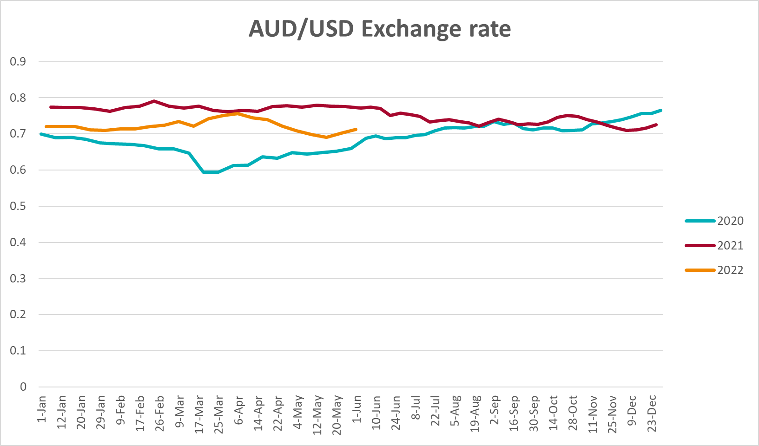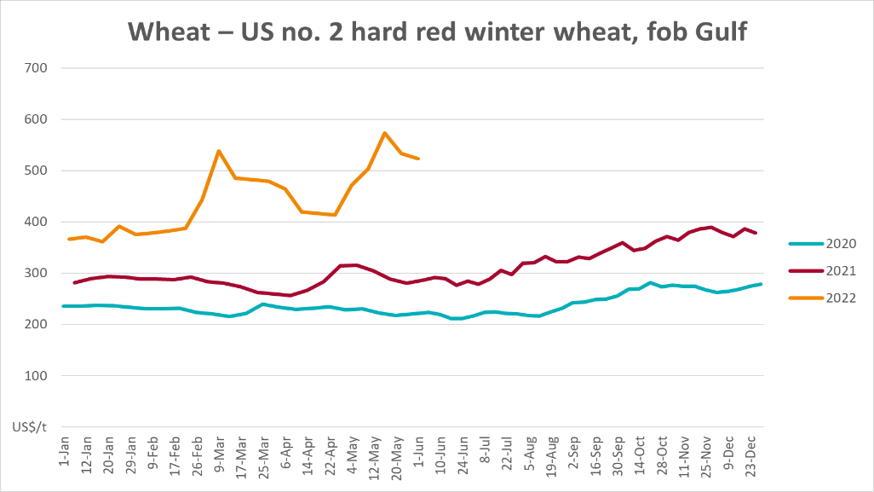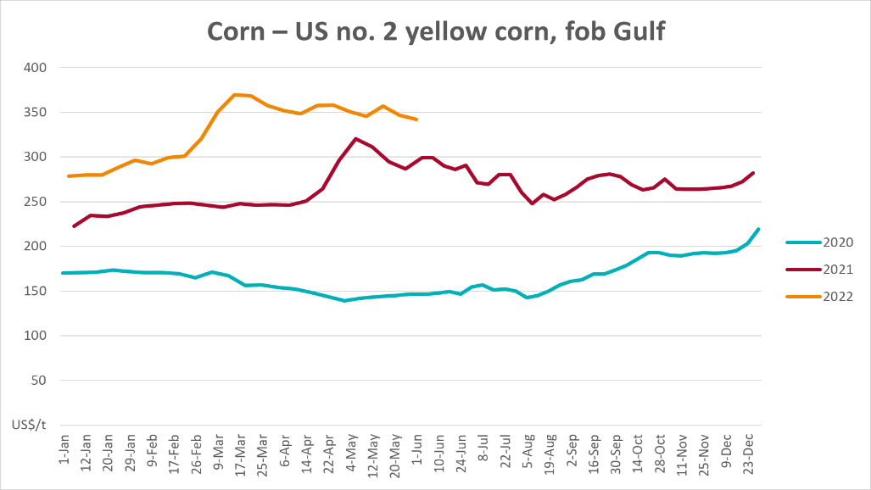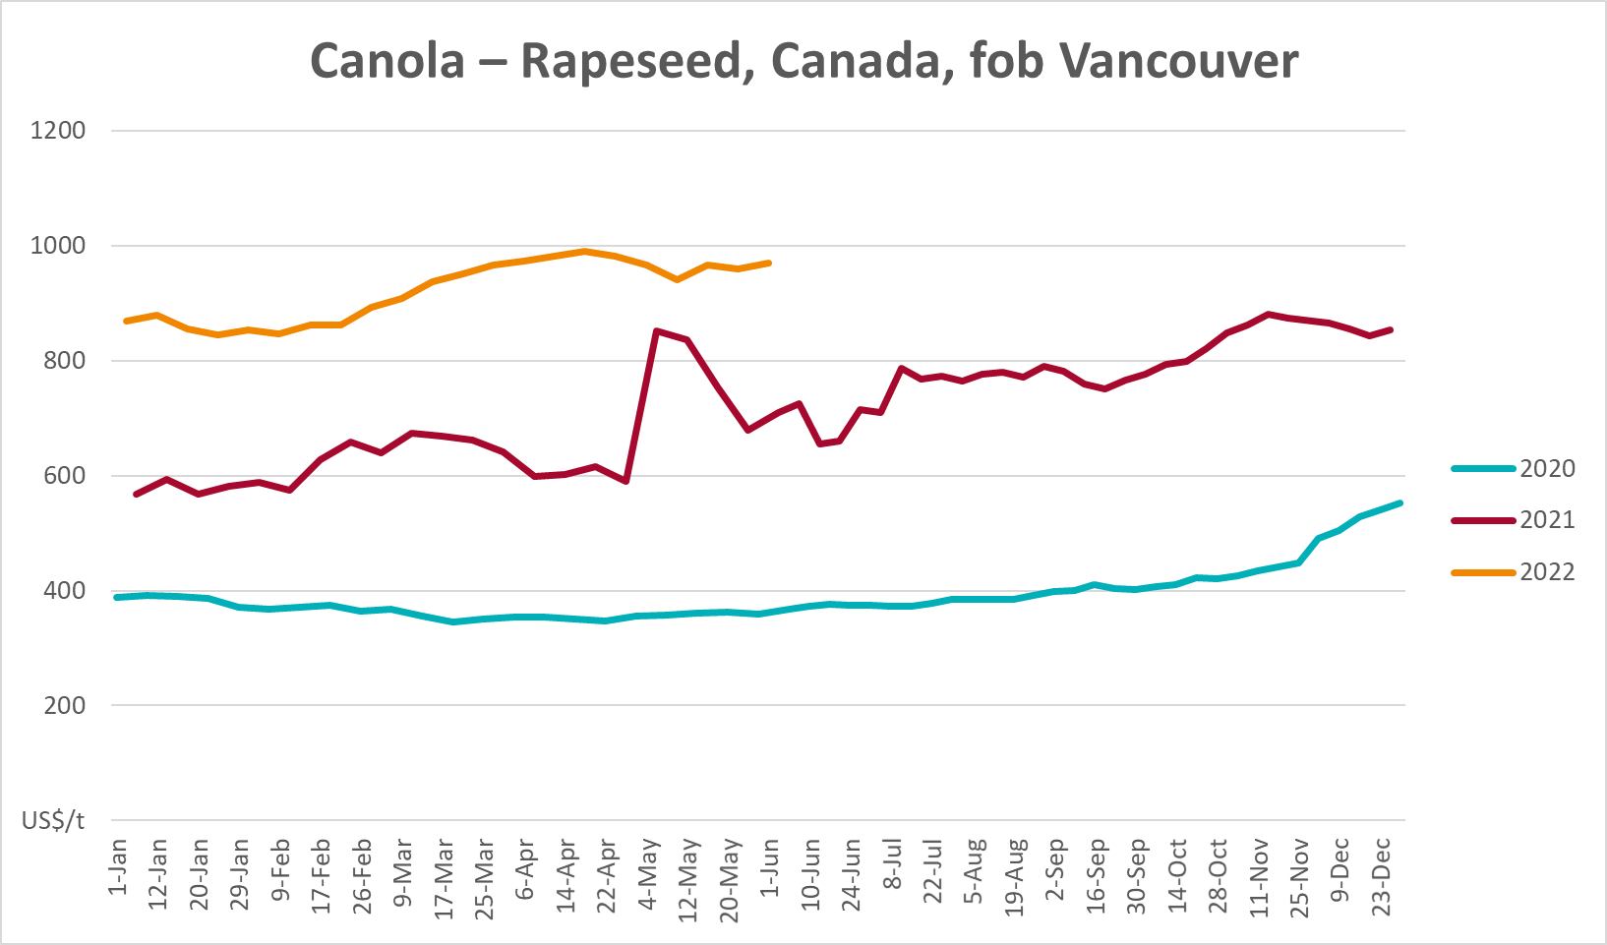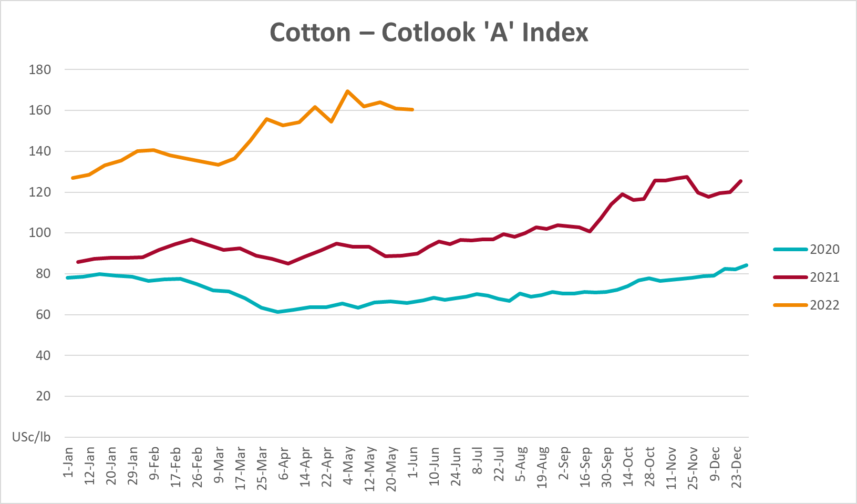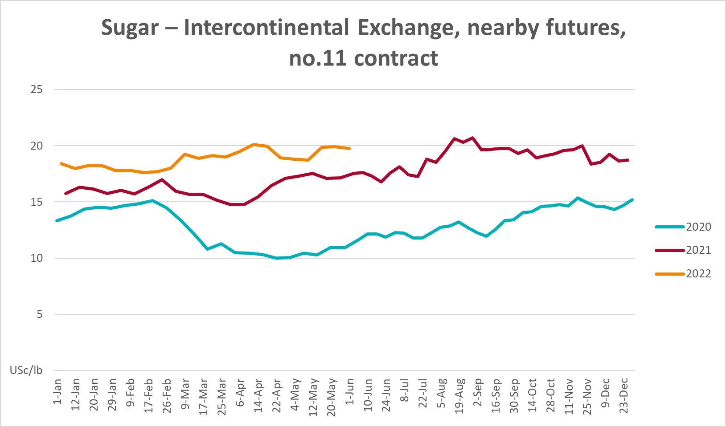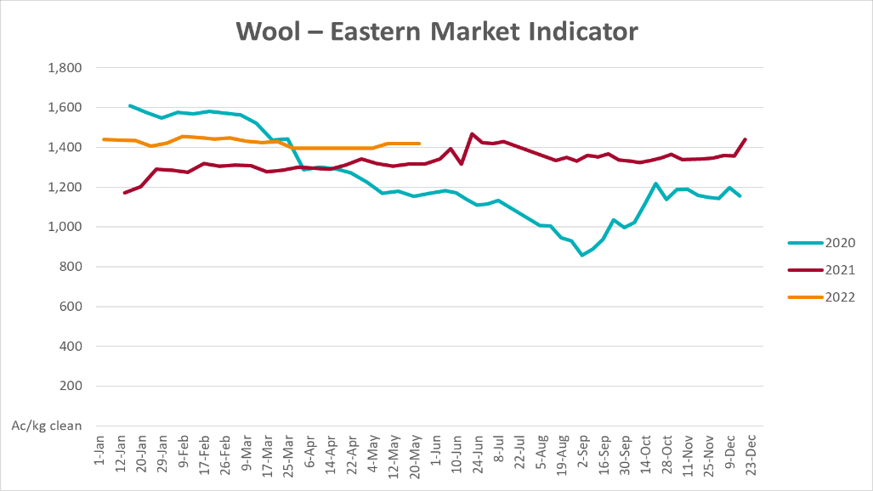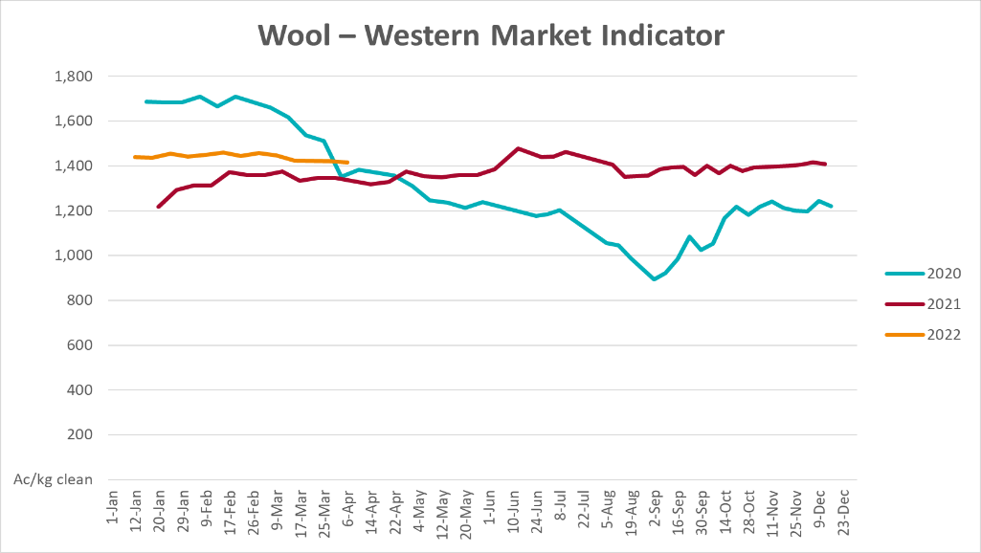

Selected domestic crop indicator prices
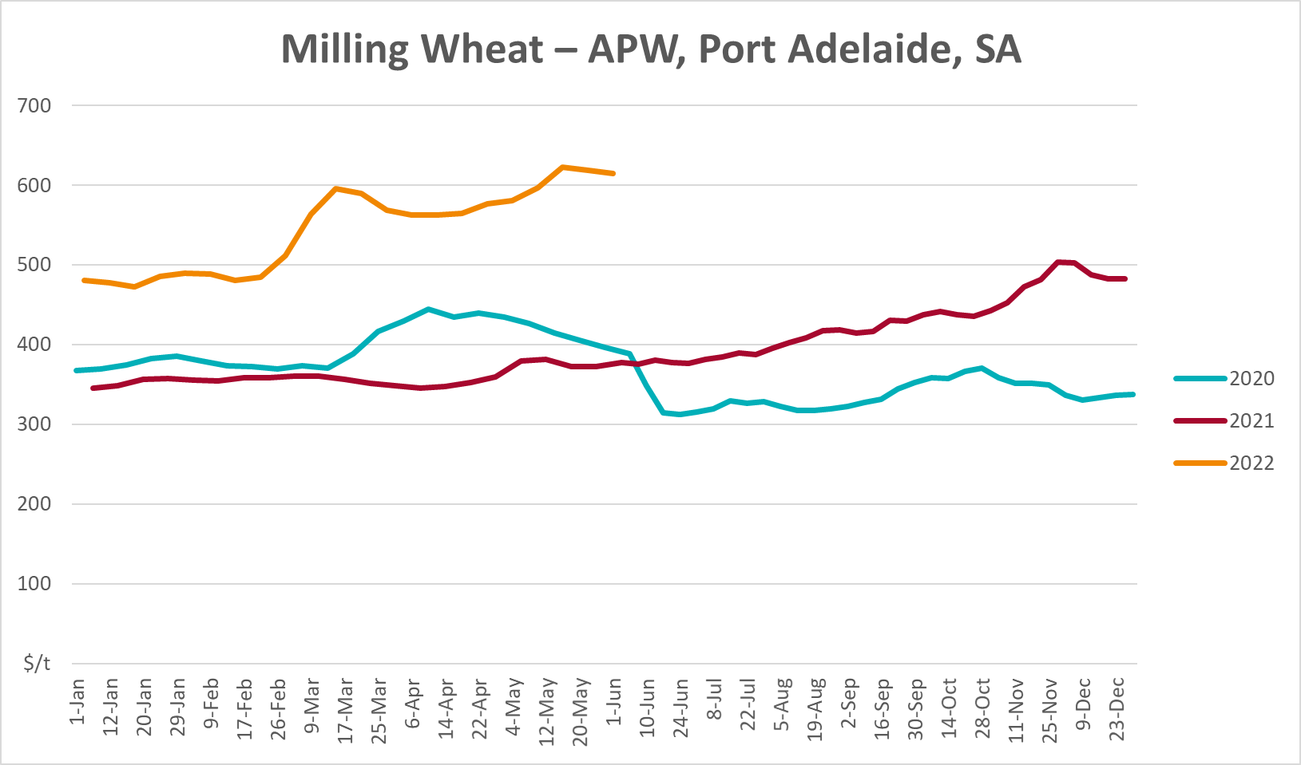
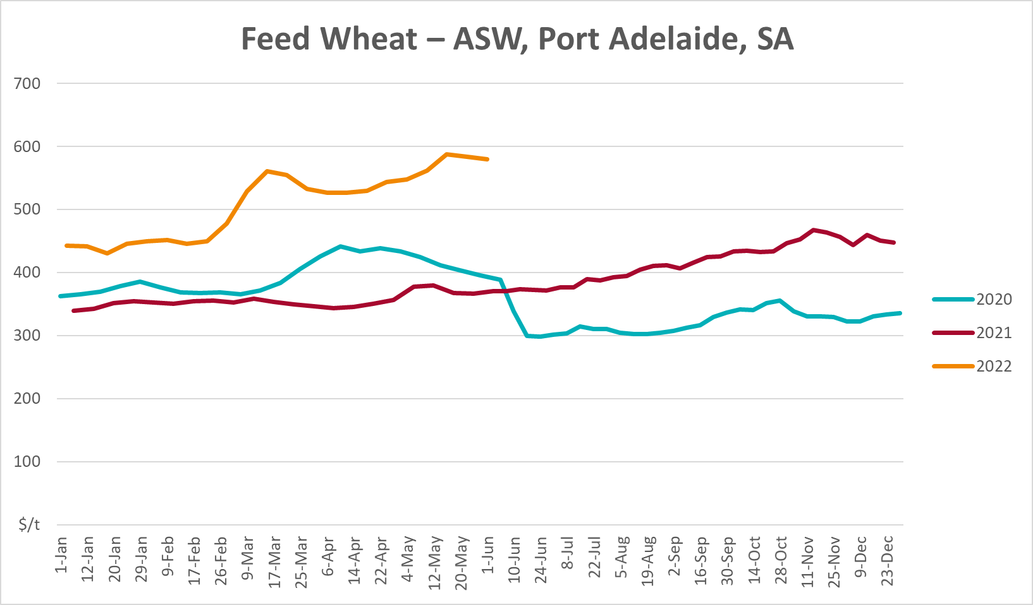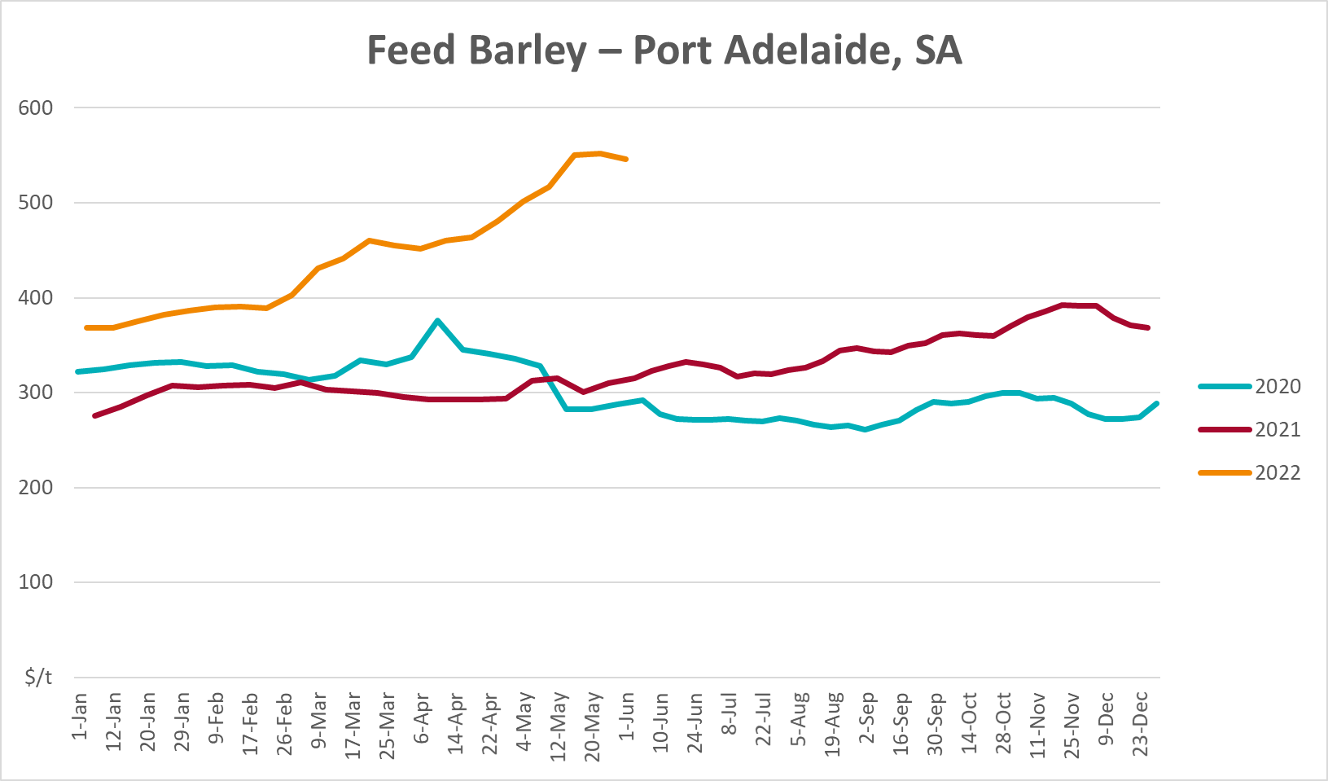
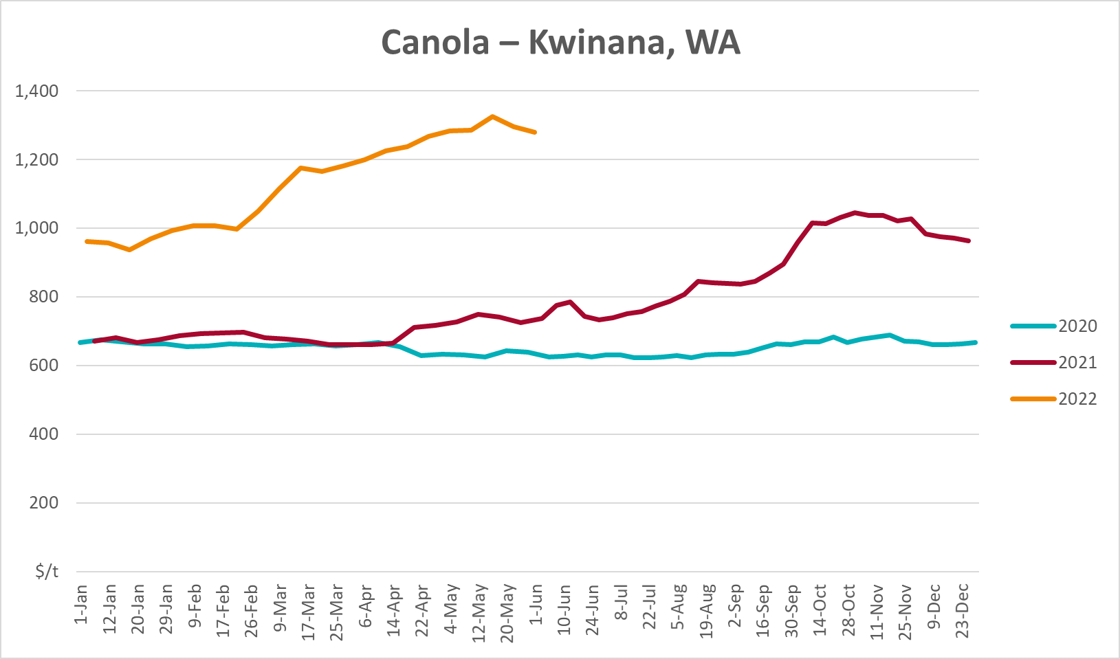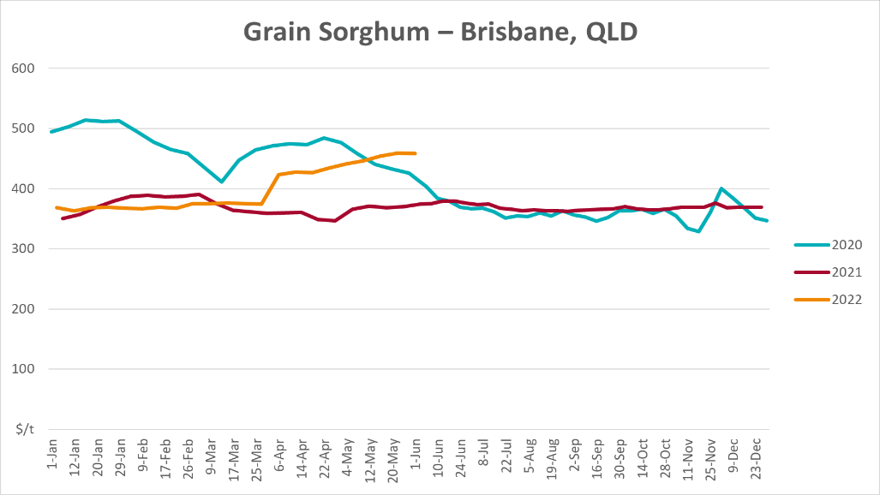

Selected domestic livestock indicator prices
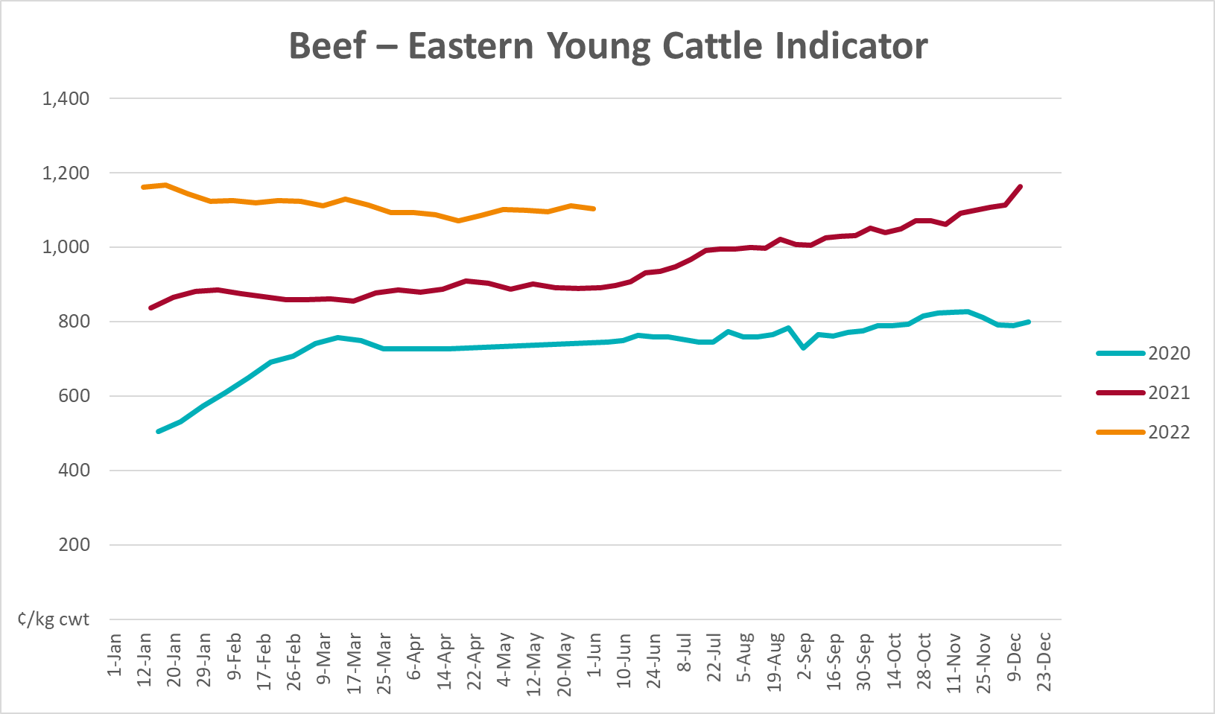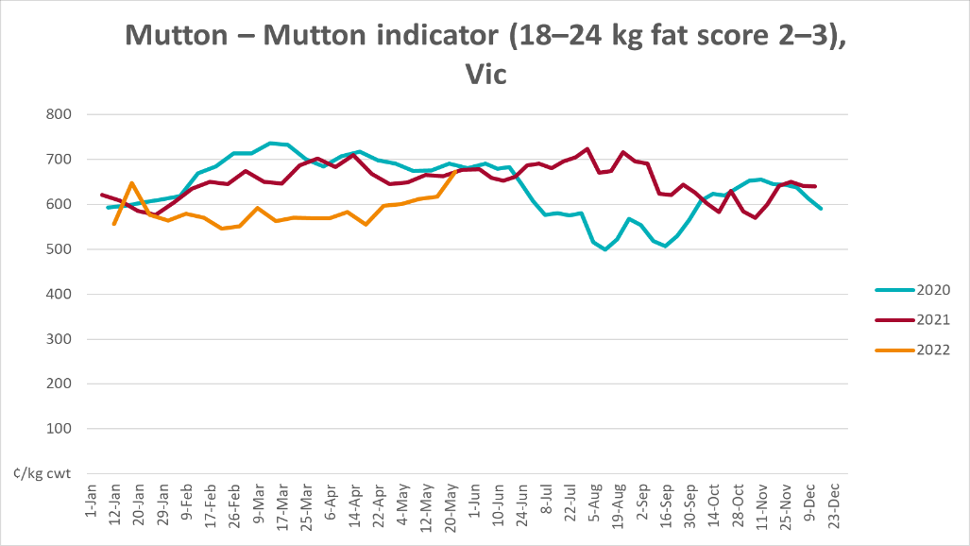
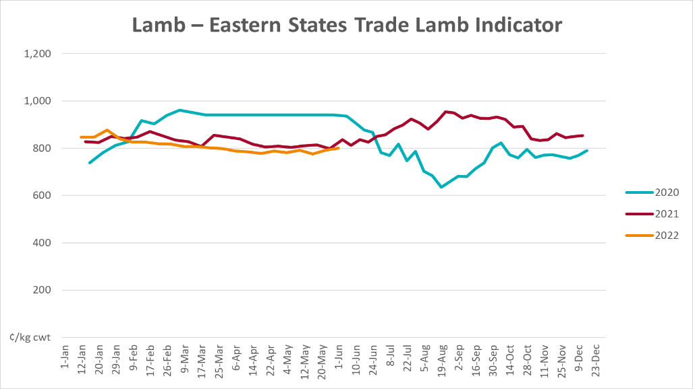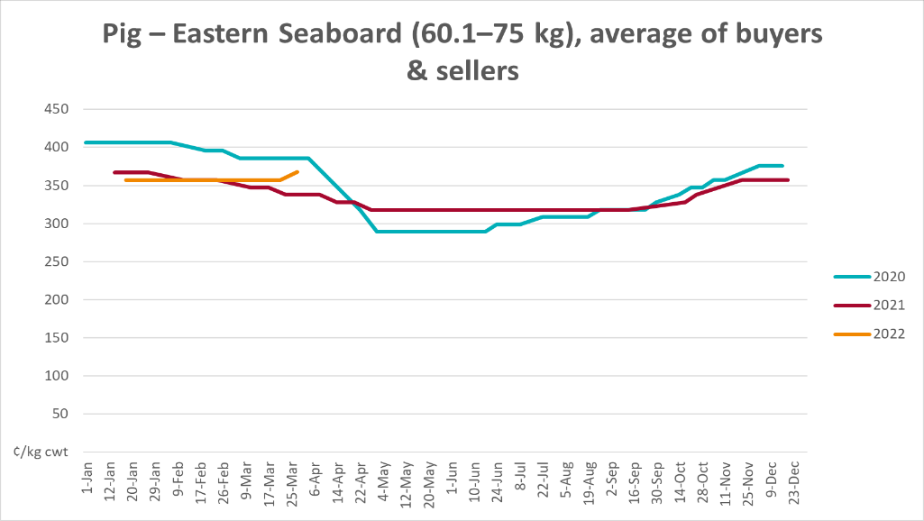
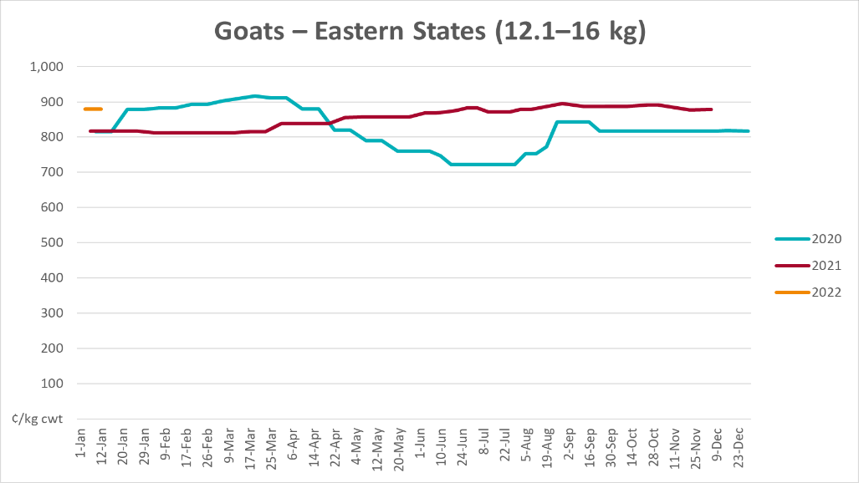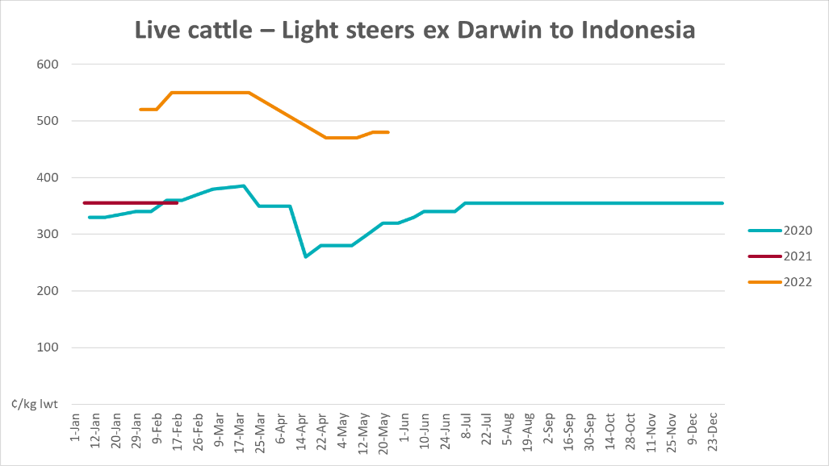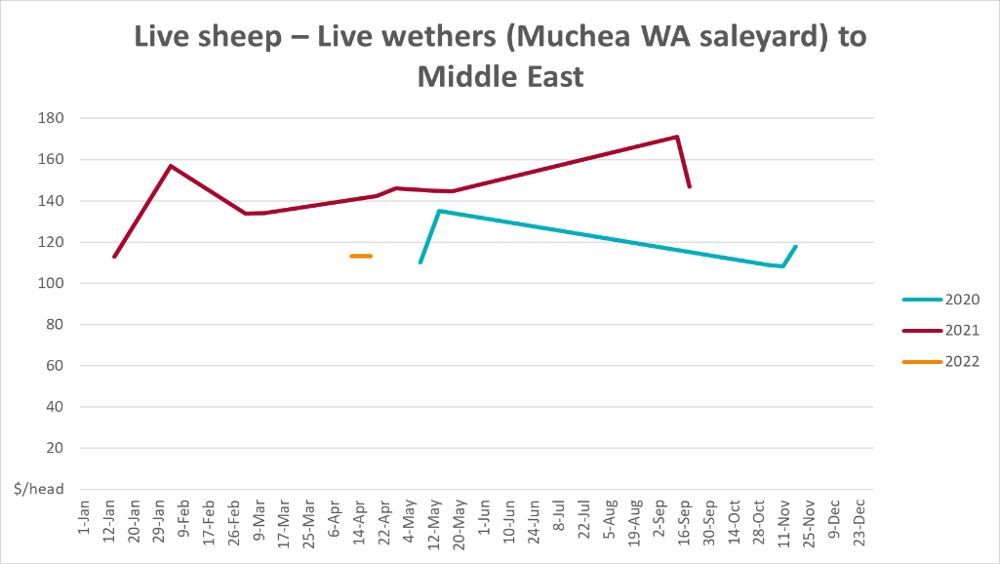

Global Dairy Trade (GDT) weighted average prices
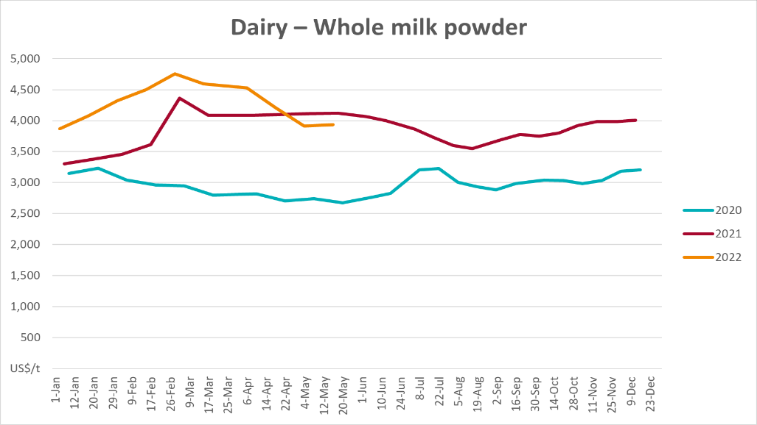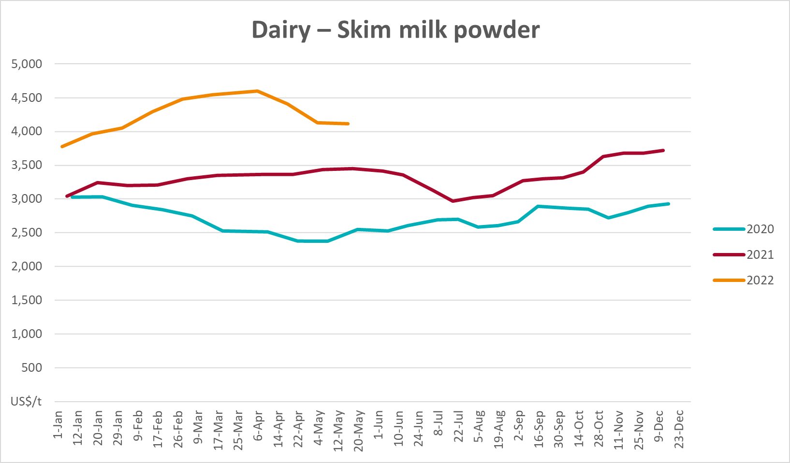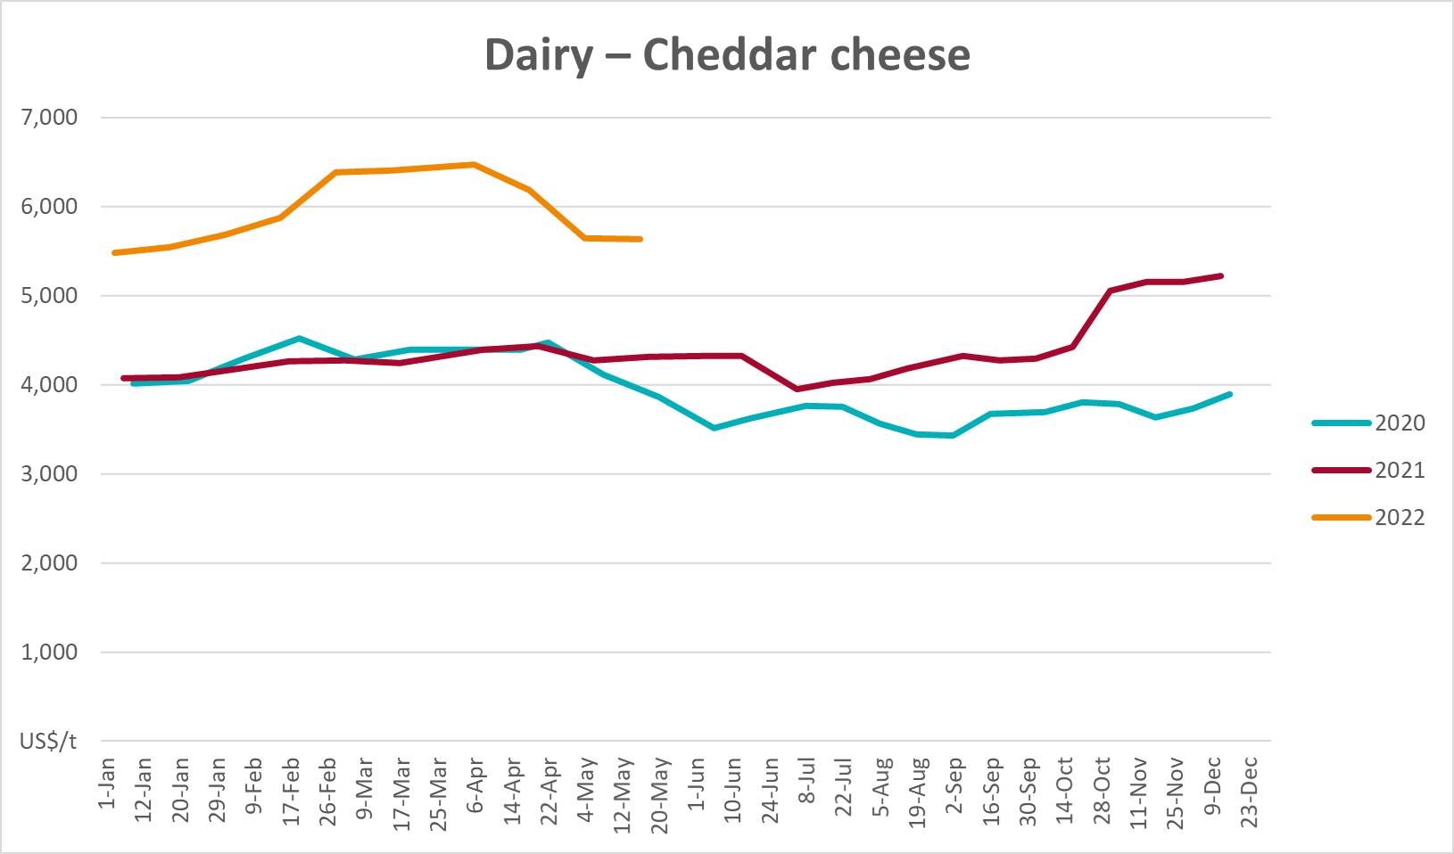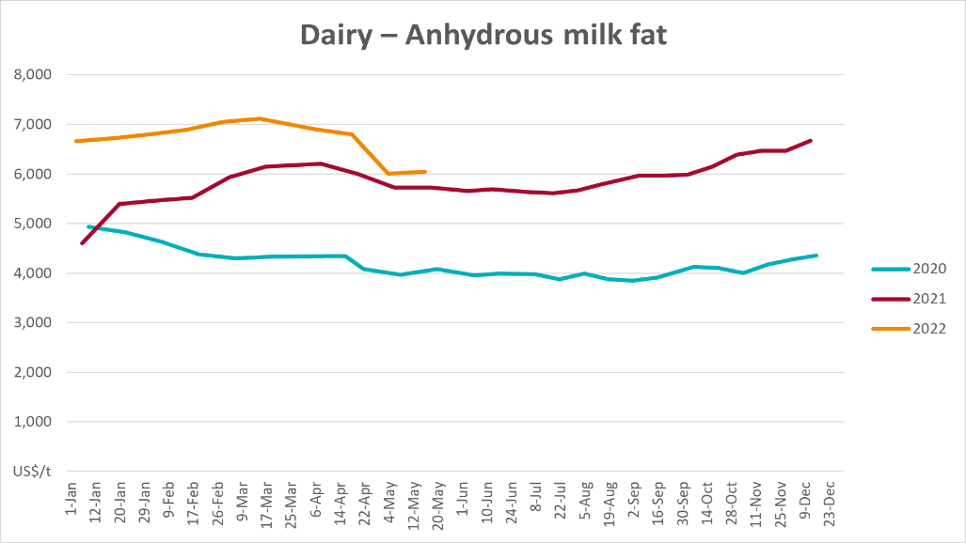

Selected fruit and vegetable prices
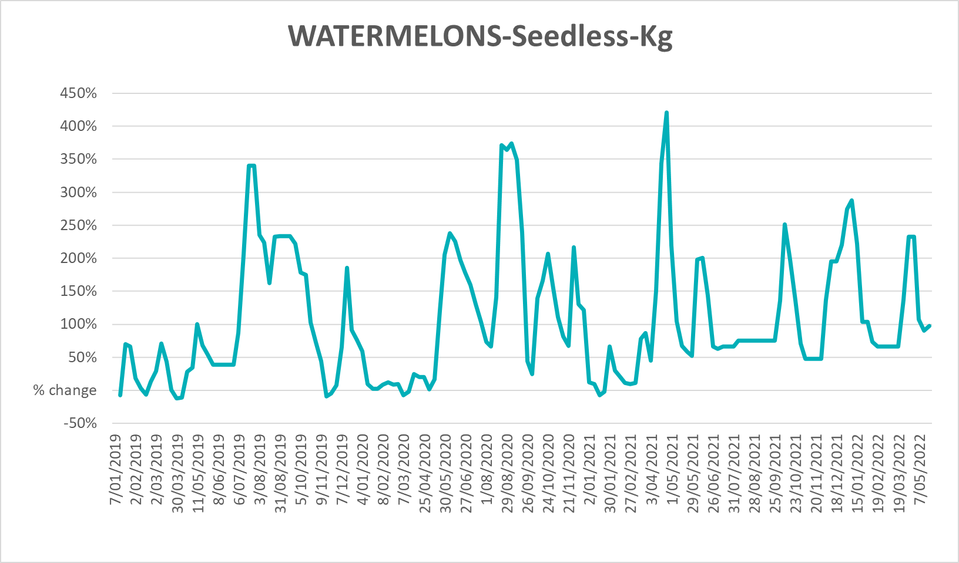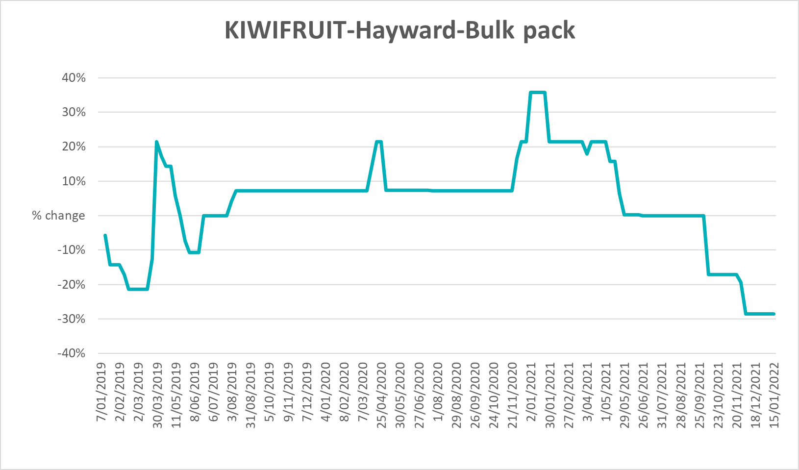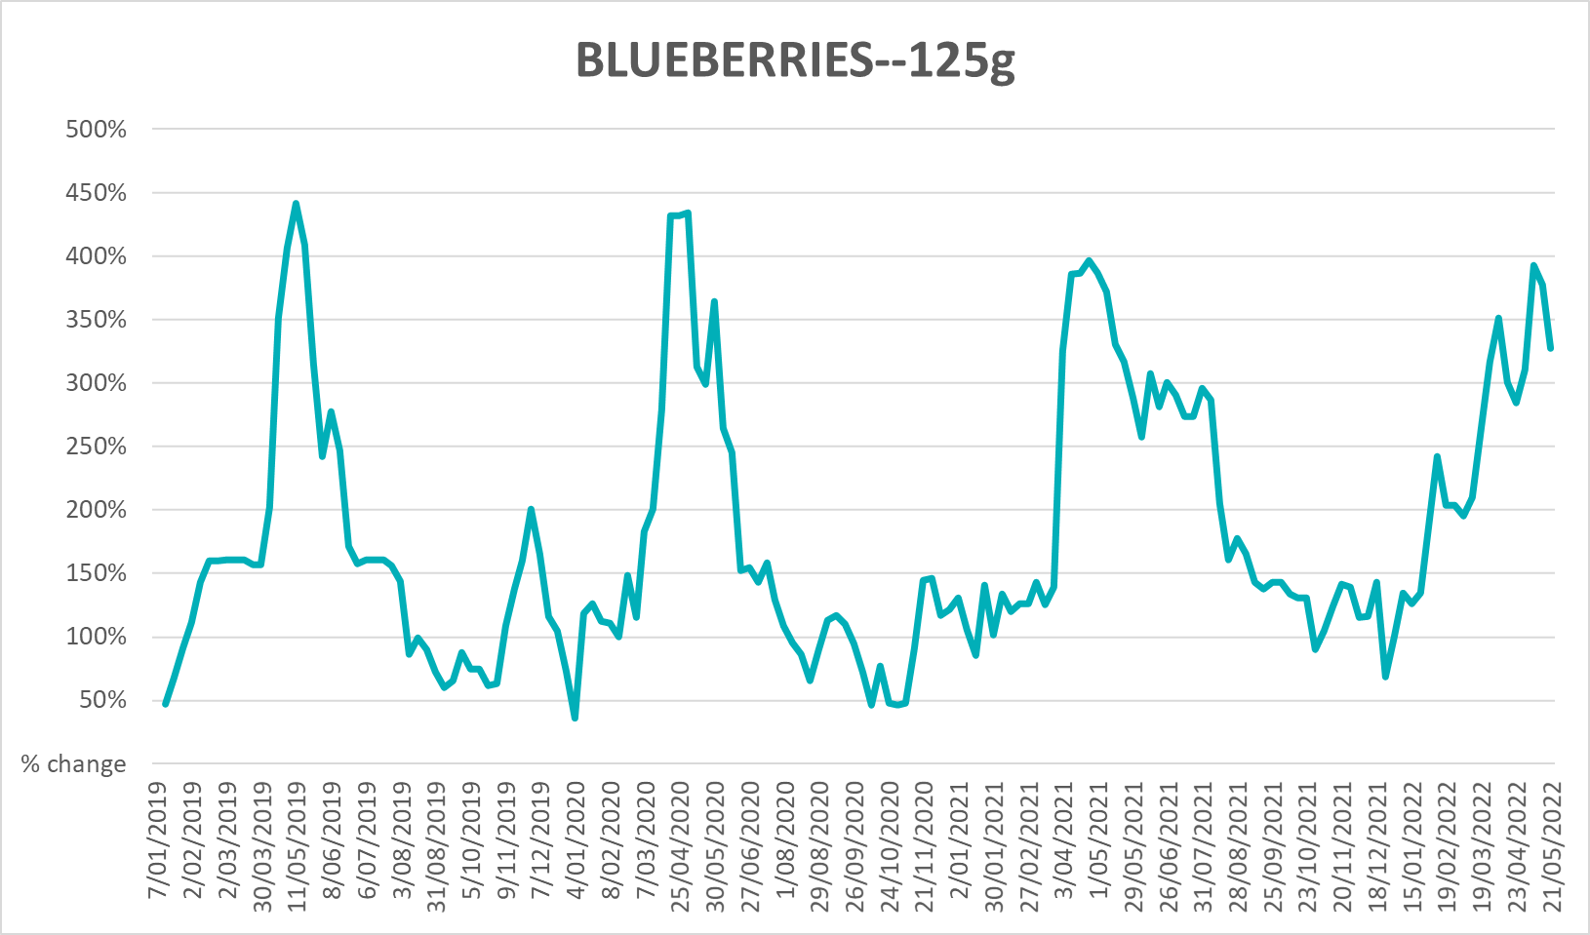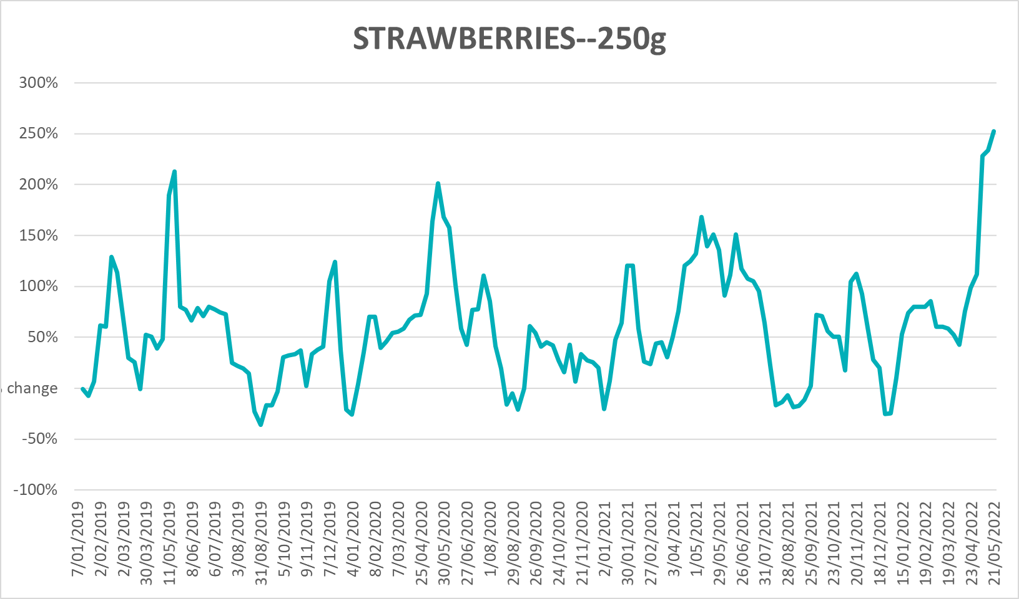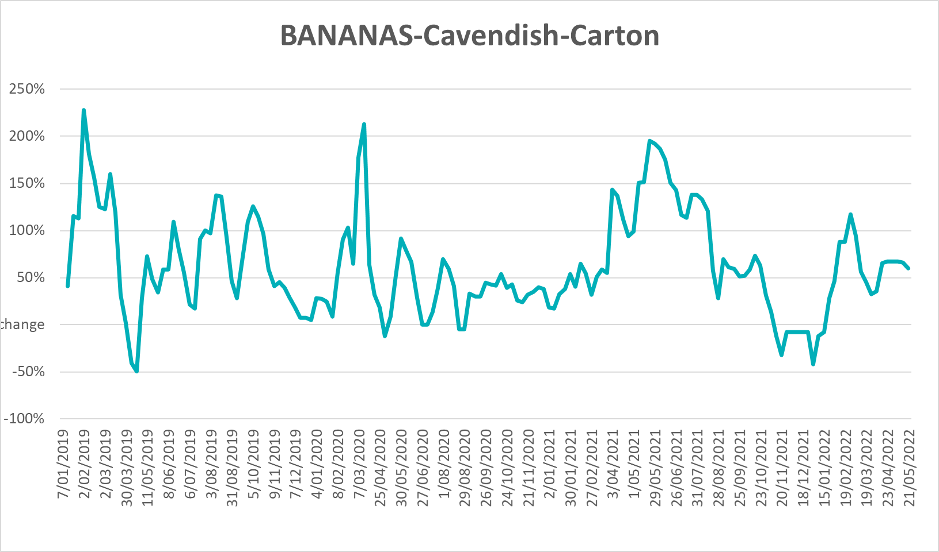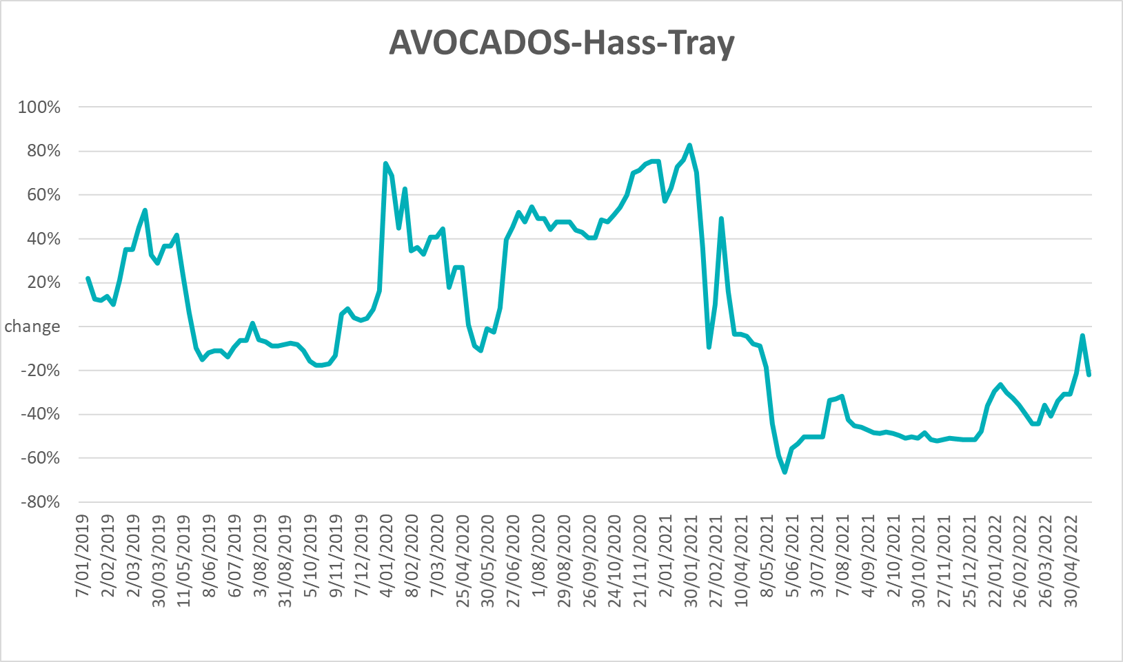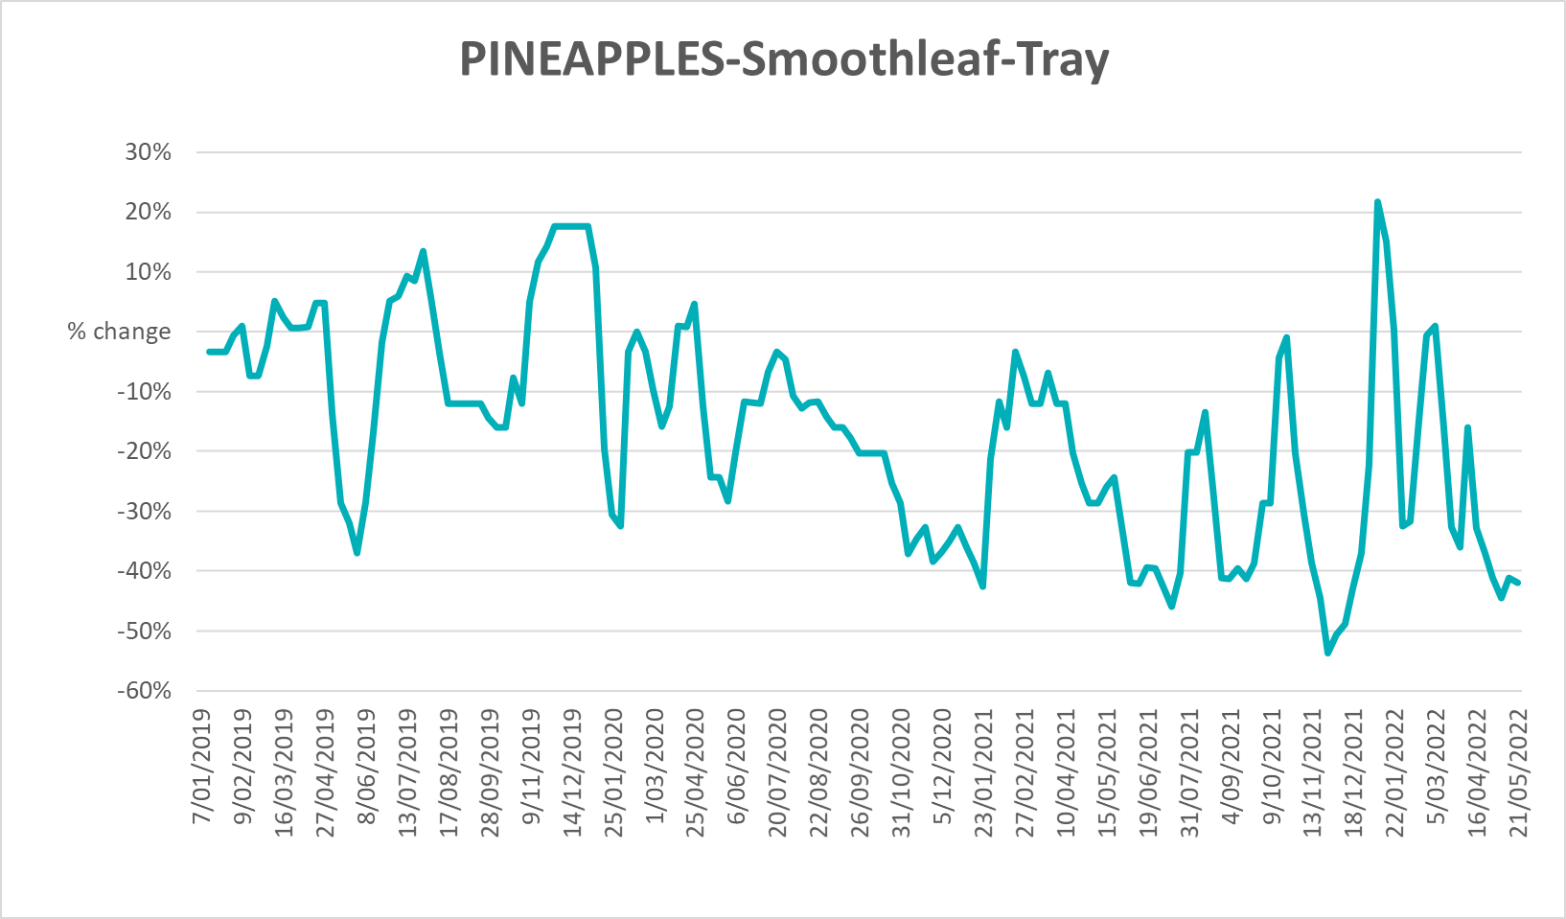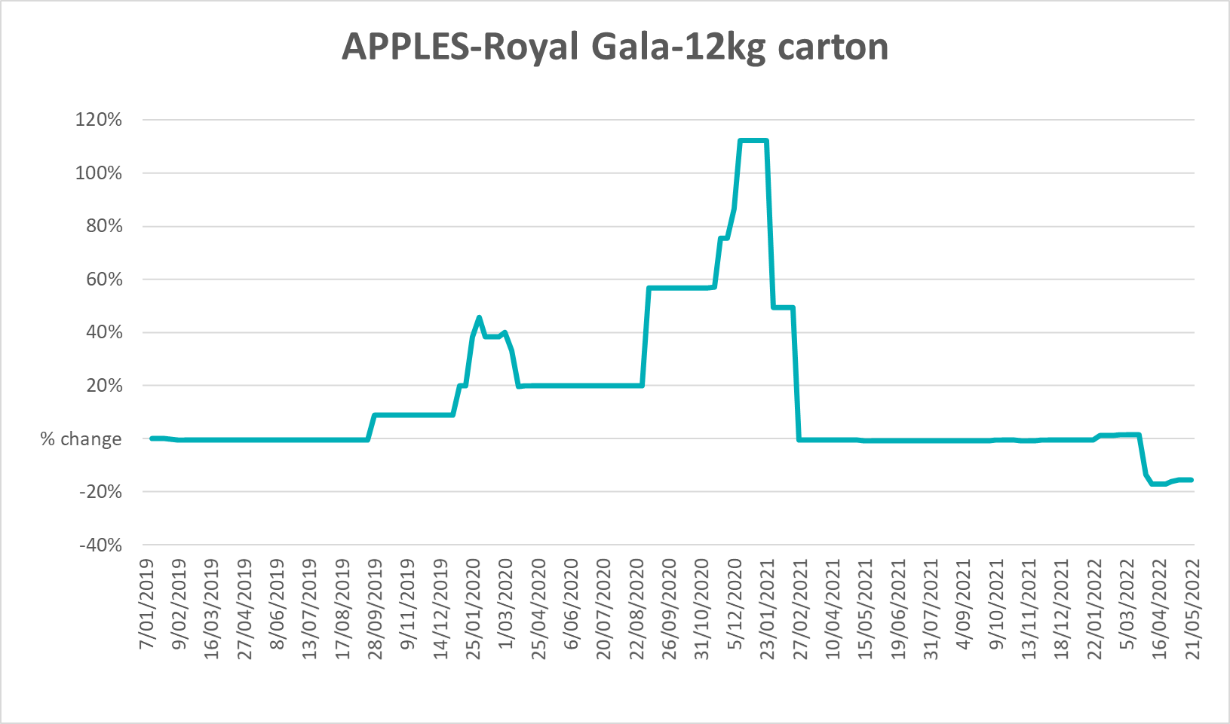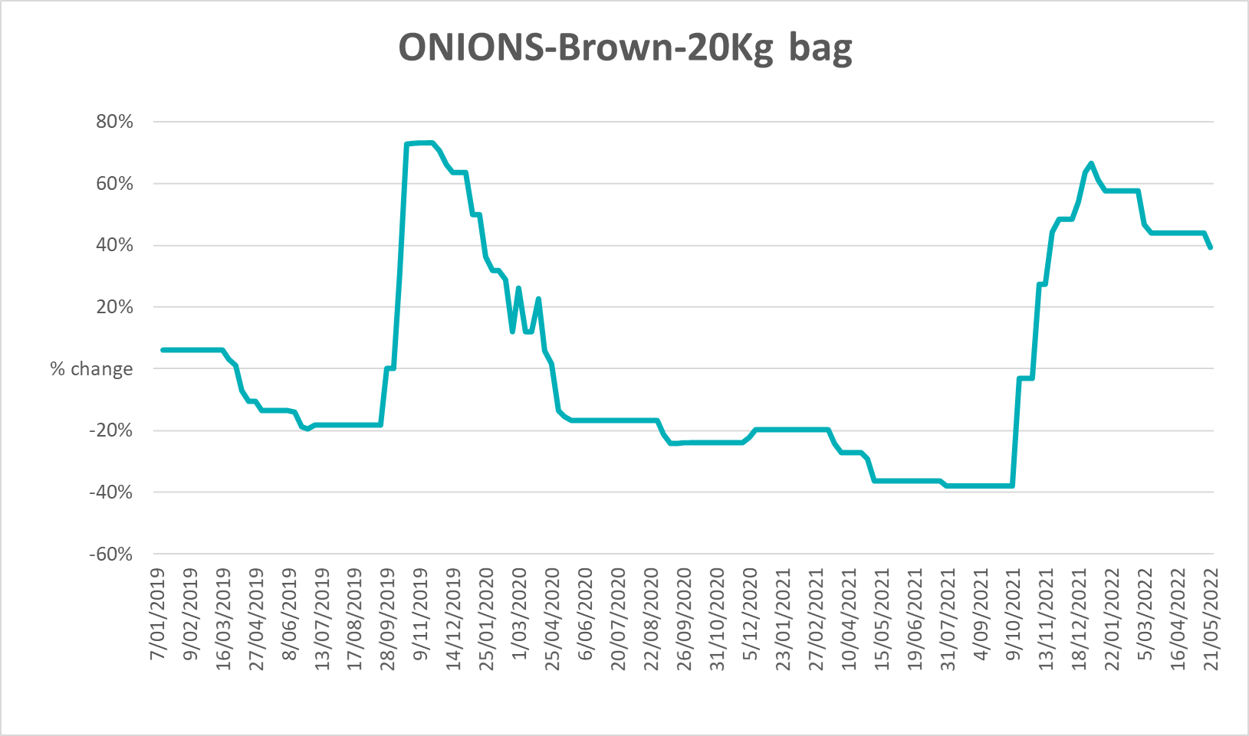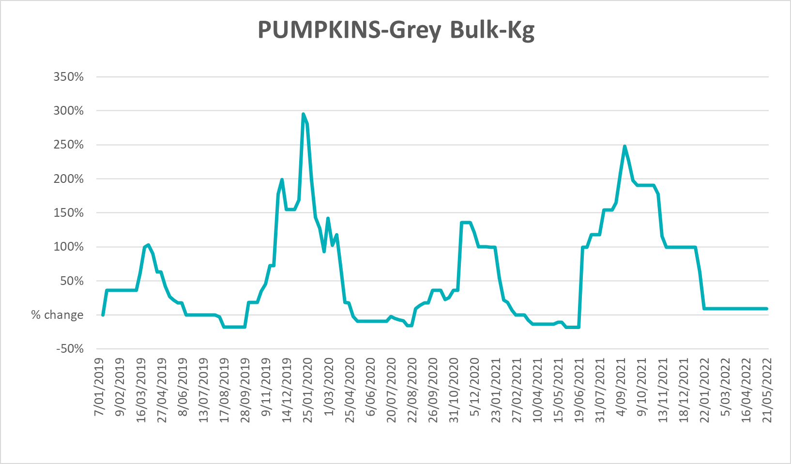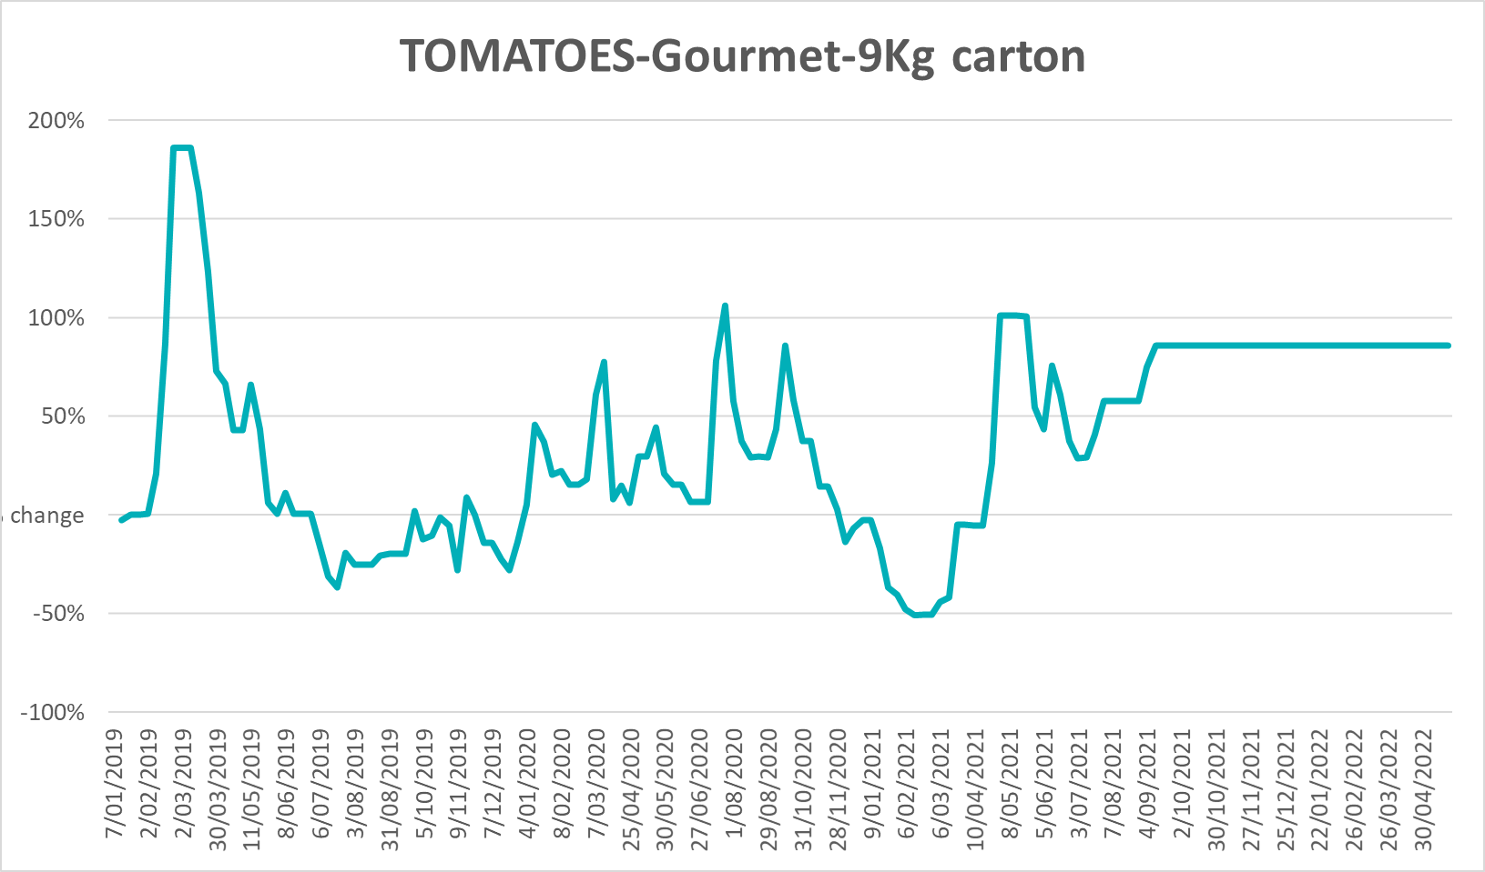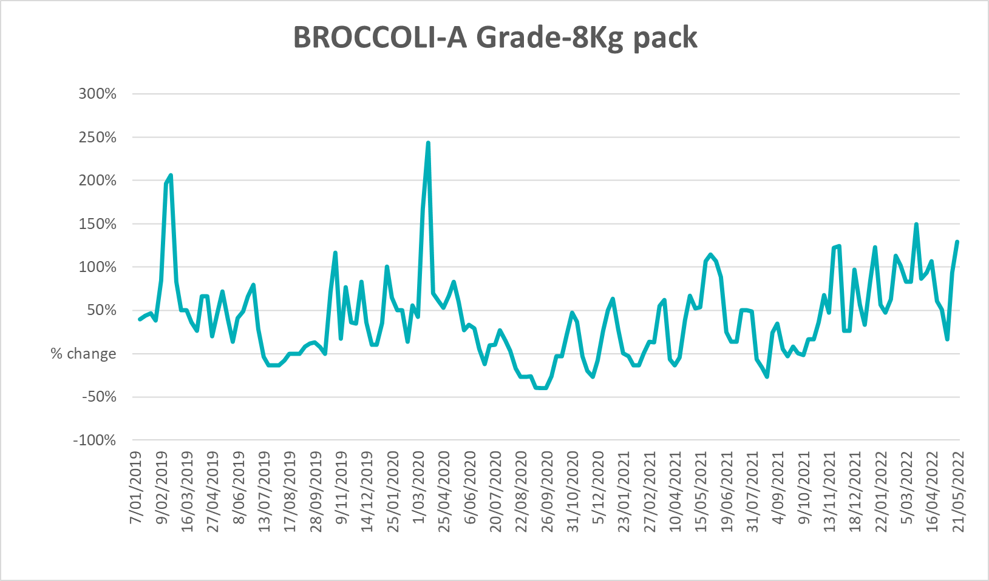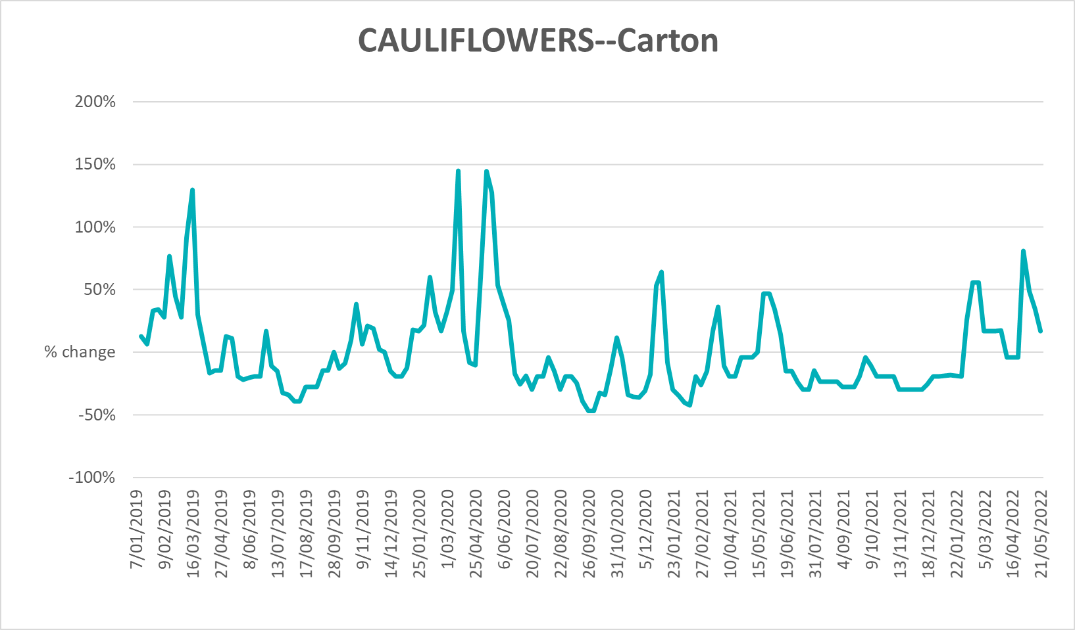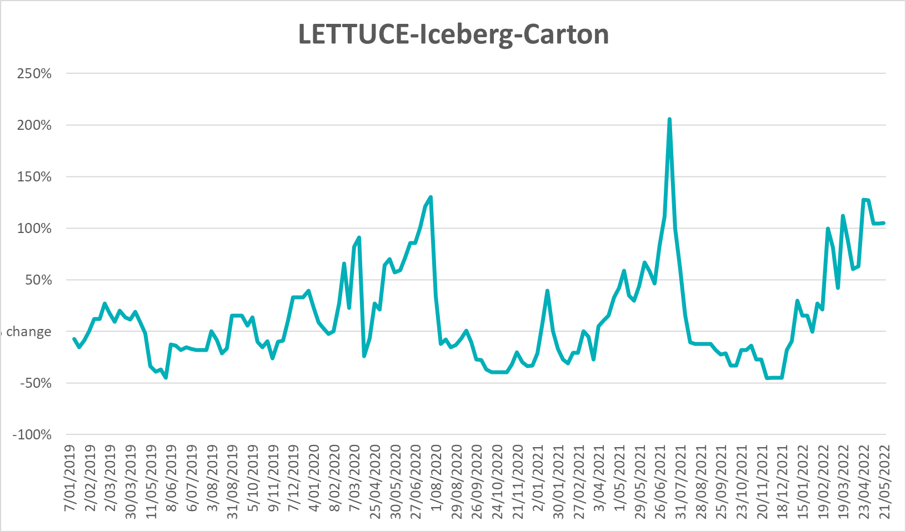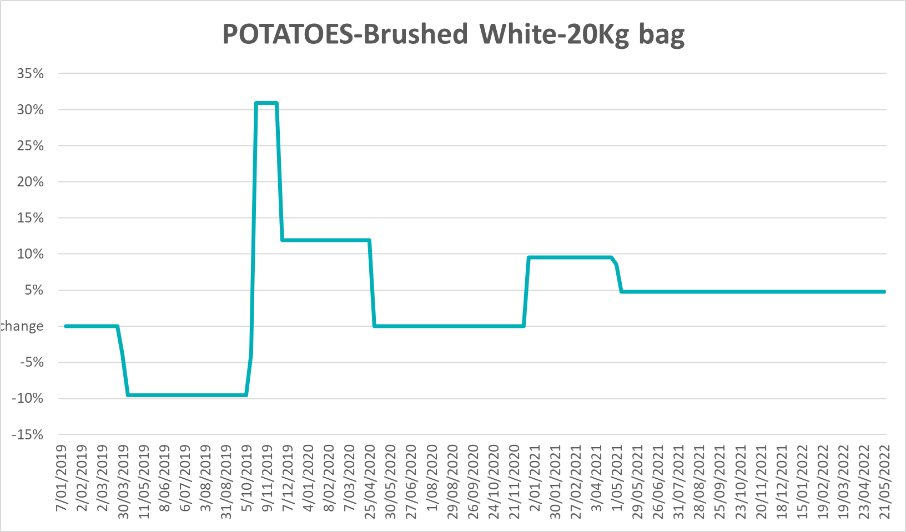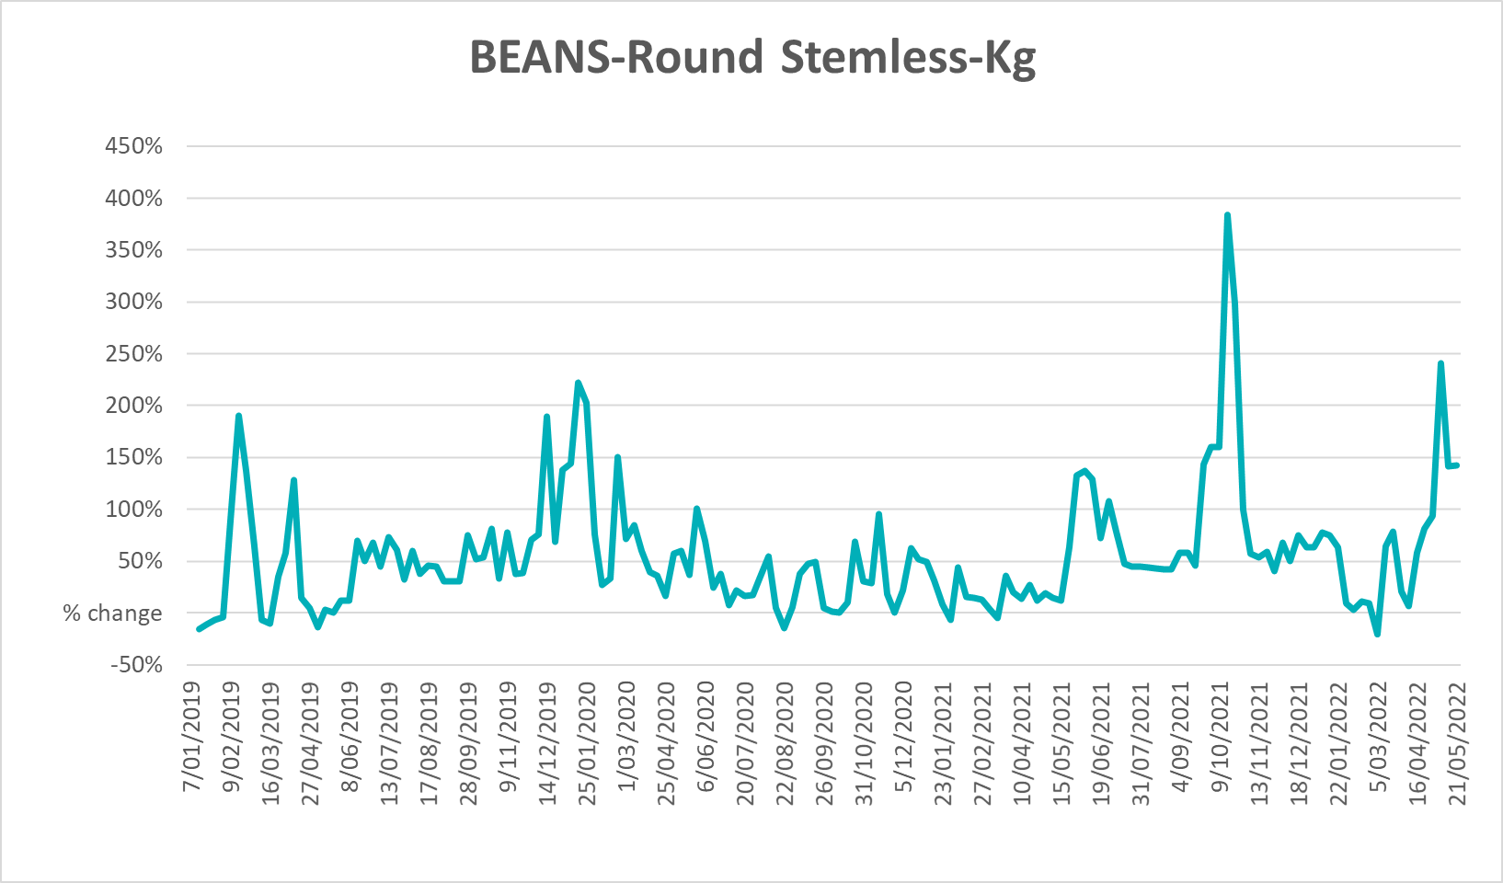

Selected domestic fodder indicator prices
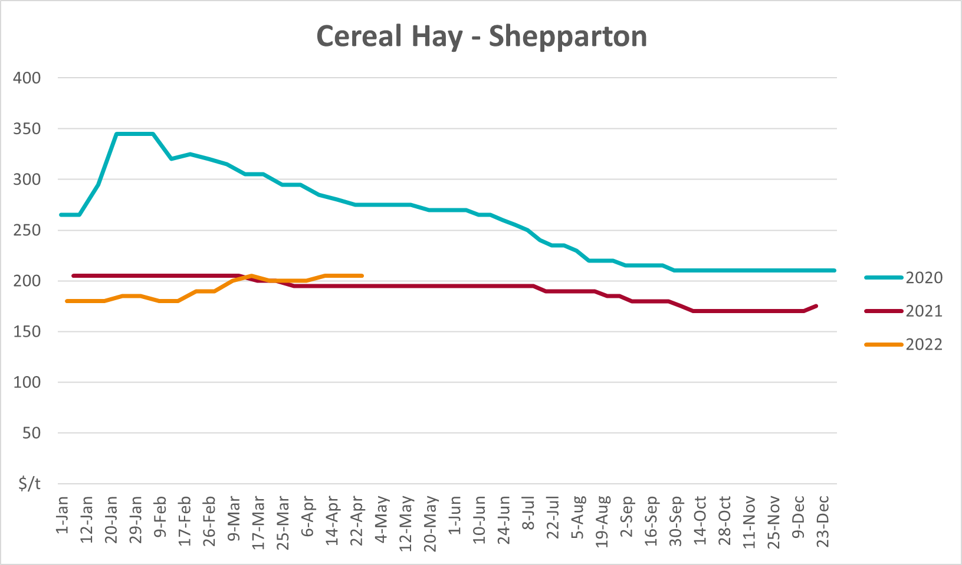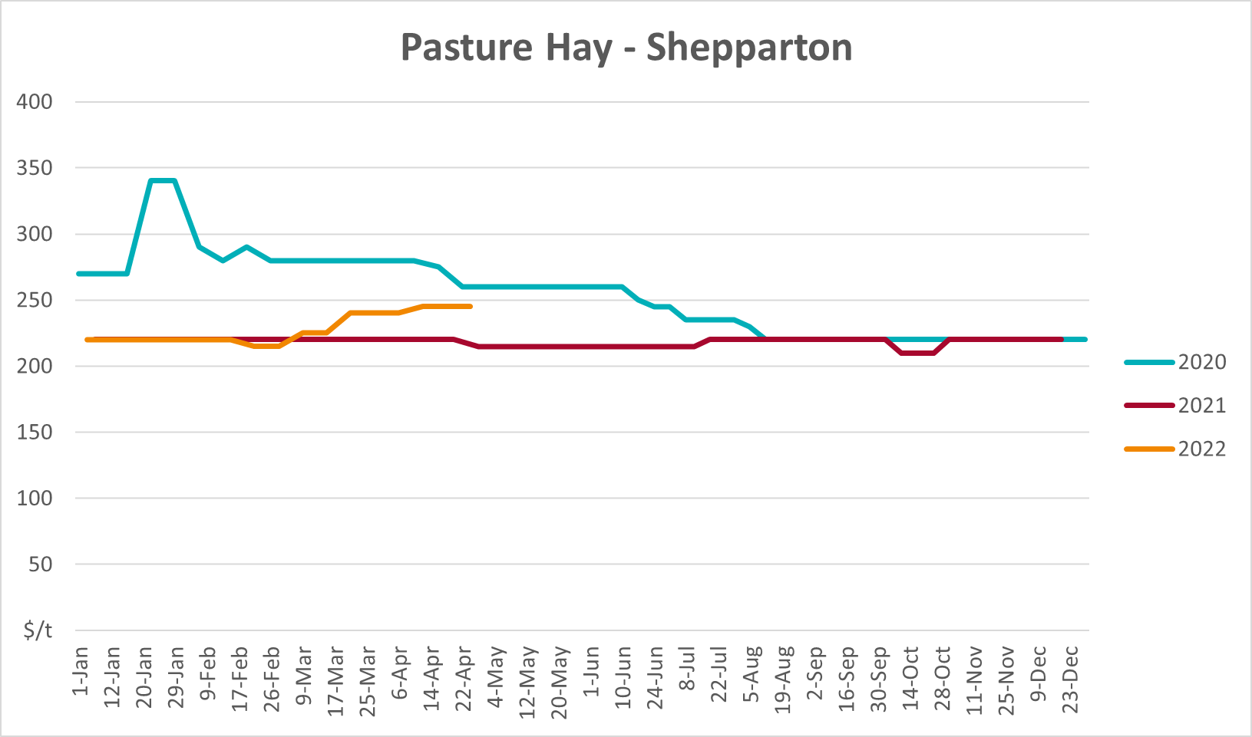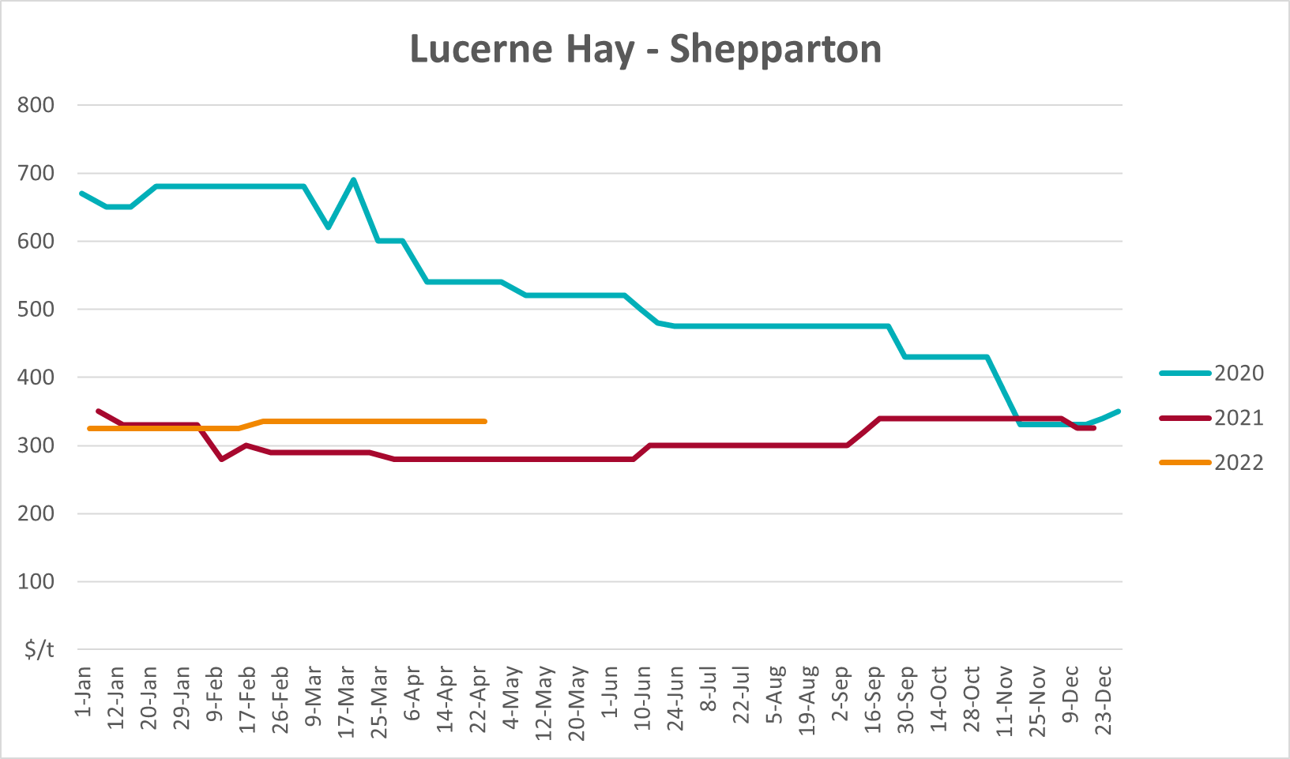

Data attribution

Climate
Bureau of Meteorology
- Weekly rainfall totals: www.bom.gov.au/climate/maps/rainfall/
- Monthly and last 3-month rainfall percentiles: www.bom.gov.au/water/landscape/
- Temperature anomalies: www.bom.gov.au/jsp/awap/temp/index.jsp
- Rainfall forecast: www.bom.gov.au/jsp/watl/rainfall/pme.jsp
- Seasonal outlook: www.bom.gov.au/climate/outlooks/#/overview/summary/
- Climate drivers: http://www.bom.gov.au/climate/enso/
- Soil moisture: www.bom.gov.au/water/landscape/
Other
- Pasture growth: www.longpaddock.qld.gov.au/aussiegrass/
- 3-month global outlooks: Environment and Climate Change Canada, NOAA Climate Prediction Center, EUROBRISA CPTEC/INPE, European Centre for Medium-Range Weather Forecasts, Hydrometcenter of Russia, National Climate Center Climate System Diagnosis and Prediction Room (NCC), International Research Institute for Climate and Society
- Global production: https://ipad.fas.usda.gov/ogamaps/cropmapsandcalendars.aspx
- Autumn break: Pook et al., 2009, https://rmets-onlinelibrary-wiley-com.virtual.anu.edu.au/doi/epdf/10.1002/joc.1833

Water
Prices
- Waterflow: https://www.waterflow.io/
- Ruralco: https://www.ruralcowater.com.au/
Bureau of Meteorology:
- Allocation trade: http://www.bom.gov.au/water/dashboards/#/water-markets/mdb/at
- Storage volumes: http://www.bom.gov.au/water/dashboards/#/water-storages/summary/drainage
Trade constraints:
- Water NSW: https://www.waternsw.com.au/customer-service/ordering-trading-and-pricing/trading/murrumbidgee
- Victorian Water Register: https://www.waterregister.vic.gov.au/TradingRules2019/

Commodities
Fruit and vegetables
- Datafresh: www.freshstate.com.au
Pigs
- Australian Pork Limited: www.australianpork.com.au
Dairy
- Global Dairy Trade: www.globaldairytrade.info/en/product-results/
World wheat, canola
- International Grains Council
World coarse grains
- United States Department of Agriculture
World cotton
- Cotlook: www.cotlook.com/
World sugar
- New York Stock Exchange - Intercontinental Exchange
Wool
- Australian Wool Exchange: www.awex.com.au/
Domestic wheat, barley, sorghum, canola and fodder
- Jumbuk Consulting Pty Ltd: http://www.jumbukag.com.au/
Cattle, beef, mutton, lamb, goat and live export
- Meat and Livestock Australia: www.mla.com.au/Prices-and-market
© Commonwealth of Australia 2022

Ownership of intellectual property rights
Unless otherwise noted, copyright (and any other intellectual property rights, if any) in this publication is owned by the Commonwealth of Australia (referred to as the Commonwealth).

Creative Commons licence
All material in this publication is licensed under a Creative Commons Attribution 4.0 International Licence except content supplied by third parties, logos and the Commonwealth Coat of Arms.
Inquiries about the licence and any use of this document should be emailed to copyright@awe.gov.au.


Cataloguing data
This publication (and any material sourced from it) should be attributed as:
ABARES 2021, Weekly Australian Climate, Water and Agricultural Update, Australian Bureau of Agricultural and Resource Economics and Sciences, Canberra, 2 June 2022. CC BY 4.0 DOI: https://doi.org/10.25814/5f3e04e7d2503
ISSN 2652-7561
This publication is available at https://www.awe.gov.au/abares/products/weekly_update
Department of Agriculture, Water and the Environment
GPO Box 858 Canberra ACT 2601
Telephone 1800 900 090
Web awe.gov.au/abares

Disclaimer
The Australian Government acting through the Department of Agriculture, Water and the Environment, represented by the Australian Bureau of Agricultural and Resource Economics and Sciences, has exercised due care and skill in preparing and compiling the information and data in this publication. Notwithstanding, the Department of Agriculture, Water and the Environment, ABARES, its employees and advisers disclaim all liability, including liability for negligence and for any loss, damage, injury, expense or cost incurred by any person as a result of accessing, using or relying on any of the information or data in this publication to the maximum extent permitted by law.

Statement of Professional Independence
The views and analysis presented in ABARES publications, including this one, reflect ABARES professionally independent findings, based on scientific and economic concepts, principles, information and data. These views, analysis and findings may not reflect or be consistent with the views or positions of the Australian Government, or of organisations or groups who have commissioned ABARES reports or analysis. More information on professional independence is provided on the ABARES website.

Acknowledgements
This report was prepared by Matthew Miller and Cameron Van-Lane.

