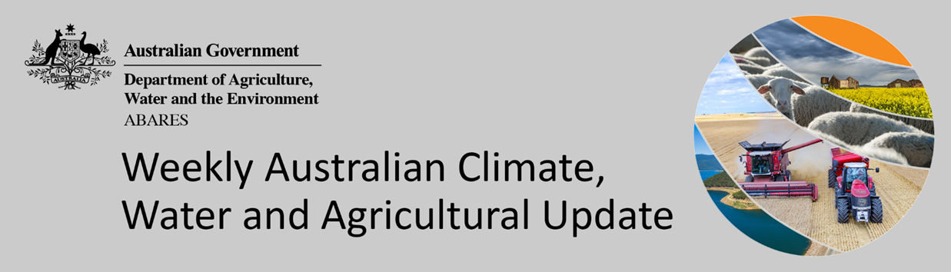
No. 16/2022

28 April 2022

Summary of key issues
- For the week ending 27 April 2022, low-pressure troughs across eastern and south-central Australia resulted in moderate to heavy rainfall. A cold front brought isolated rainfall to parts of south-western Australia, while high-pressure systems provided clear, dry conditions for remaining parts of the country (see Section 1.1).
- Planting of winter crops is well underway in most cropping regions across the country. Canola and long-season legumes have been the priority to-date, with planting of winter cereals to increase over the coming weeks. Moderate rainfall in Central Queensland over the past week has likely delayed the harvesting of cotton and planting of winter crops. Meanwhile, the dry conditions across southern Queensland and much of New South Wales would have allowed harvesting of summer crops and planting of winter crops to continue.
- The 2021–22 La Niña event continues to weaken, with oceanic indicators mostly at neutral levels. However, atmospheric indicators remain above La Niña thresholds, meaning La Niña's influence continues. Even as the event weakens, it is expected to continue influencing climate patterns in Australia over the coming months (see Section 1.2).
- The outlook for May 2022 indicates that there is a 75% chance of rainfall totals between 10 and 50 millimetres across eastern New South Wales, parts of eastern Queensland, Victoria, southern South Australia, the far-southwest of Western Australia and Tasmania. Rainfall totals in excess of 100 millimetres are expected in parts of northern Queensland and western Tasmania (see Section 1.3).
- There is a high—75%—chance that forecast rainfall totals for May to July 2022 in northern cropping regions will be sufficient to support the germination and establishment of winter crops. In remaining cropping regions, the expectation of close to average rainfall over the next three months is likely to provide an ideal start to the winter cropping season, particularly in areas with average or better soil moisture levels for this time of year.
- Over the 8-days to 5 May 2022, low-pressure troughs are expected to bring rainfall to south-eastern Australia, with a cold front bringing further rainfall to the far south-east (see Section 1.4).
- The dry conditions expected across Queensland cropping regions will allow the harvesting of cotton and sorghum to continue, as well as the planting of winter crops. However, for New South Wales and Victoria, this rainfall is likely to restrict field access, delaying harvesting and planting activity.
- Water storage in the Murray–Darling Basin (MDB) decreased by 134 gigalitres (GL) between 20 April 2022 and 27 April 2022. The current volume of water held in storage is 21,341GL, which represents 85 per cent of total capacity. This is 50% or 7,139 GL more than at the same time last year.
- Allocation prices in the Victorian Murray below the Barmah Choke decreased from $72 per ML on 14 April 2022 to $65 per ML on 21 April 2022. Prices are lower in the Goulburn-Broken, Murrumbidgee and regions above the Barmah choke due to the binding of the Goulburn intervalley trade limit, Murrumbidgee export limit and Barmah choke trade constraint.

Climate

Rainfall this week
For the week ending 27 April 2022, low-pressure troughs across eastern and south-central Australia resulted in moderate to heavy rainfall. A cold front brought isolated rainfall to parts of south-western Australia, while high-pressure systems provided clear, dry conditions for remaining parts of the country.
Rainfall totals of between 10 and 100 millimetres were recorded across central, western and north-eastern parts of New South Wales, much of Queensland, central and eastern South Australia, scattered areas of south-western Western Australia, the east of the Northern Territory and south-western Tasmania. Rainfall totals in excess of 100 millimetres were recorded across parts of central and northern Queensland. Remaining parts of Australia received little to no rainfall.
In cropping regions, rainfall totals of between 10 and 50 millimetres were recorded across central New South Wales, northern Queensland, the west of South Australia and isolated parts of Western Australia. Rainfall in excess of 50 millimetres was recorded in cropping regions in northern Queensland. Little to no rainfall was recorded across cropping regions in remaining parts of New South Wales, Queensland, Victoria, South Australia and Western Australia.
Planting of winter crops is well underway in most cropping regions across the country. Canola and long-season legumes have been the priority to-date, with planting of winter cereals to increase over the coming weeks. Moderate rainfall in Central Queensland over the past week has likely delayed the harvesting of cotton and planting of winter crops. Meanwhile, the dry conditions across southern Queensland and much of New South Wales would have allowed harvesting of summer crops and planting of winter crops to continue. In much of Victoria, South Australia and Western Australia, soil moisture conditions are favouring a good start to the season. However, the east of South Australia is yet to receive significant rainfall to start the winter cropping season.

Rainfall for the week ending 27 April 2022

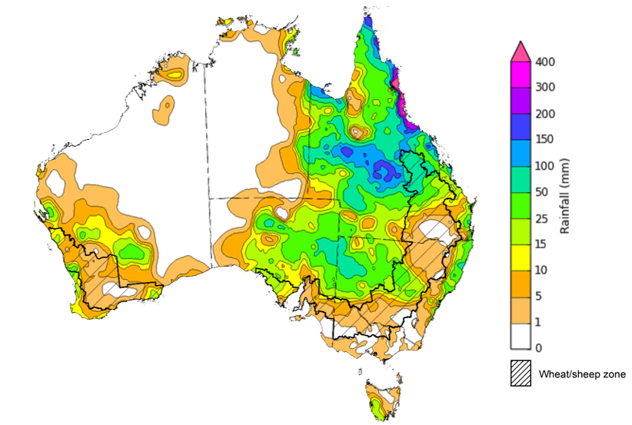
©Commonwealth of Australia 2022, Australian Bureau of Meteorology Issued: 27/4/2022
Note: The rainfall analyses and associated maps utilise data contained in the Bureau of Meteorology climate database, the Australian Data Archive for Meteorology (ADAM). The analyses are initially produced automatically from real-time data with limited quality control. They are intended to provide a general overview of rainfall across Australia as quickly as possible after the observations are received. For further information go to http://www.bom.gov.au/climate/rainfall/

Climate Drivers
Throughout late autumn and early winter, the climate drivers with the largest potential impact on Australia’s climate patterns are the El Niño–Southern Oscillation (ENSO) and the Southern Annular Mode (SAM). These climate drivers are likely to influence pasture growth across southern Australia and planting opportunities for winter crops.
The 2021–22 La Niña event continues to weaken, with oceanic indicators mostly at neutral levels. However, atmospheric indicators remain above La Niña thresholds, meaning La Niña's influence continues. La Niña events are typically associated with above average rainfall across large parts of eastern Australia during autumn, as well as the increased likelihood of tropical cyclones within the Australian region. Even as the event weakens, it is expected to continue influencing climate patterns in Australia over the coming months.
The SAM index is currently neutral but is expected to briefly dip to negative levels with neutral to positive levels thereafter for the coming two to three weeks. During autumn SAM typically has a weaker influence on Australian rainfall.
Below average sea surface temperature (SST) anomalies have persisted and weakened slightly along the equator in the central and eastern Pacific Ocean. Meanwhile, warm SST anomalies throughout the Maritime Continent have weakened slightly. Warm sub-surface water temperature anomalies have strengthened slightly in the eastern Pacific Ocean, foreshadowing the breakdown of the current La Niña event.

Difference from average sea surface temperature observations 18 to 24 April 2022
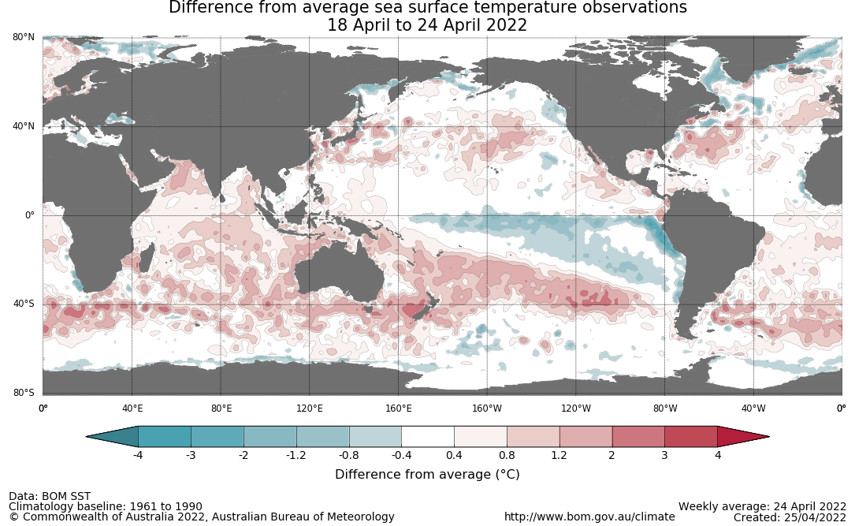

International climate model outlooks for the NINO 3.4 region in May 2022
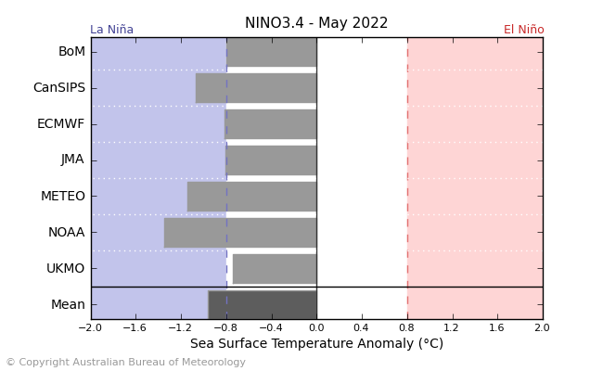
©Commonwealth of Australia 2022, Australian Bureau of Meteorology Issued: 11/4/2022
Most climate models surveyed by the Bureau of Meteorology expect the La Niña event to continue into May, with three of the seven models expecting it to remain active in June 2022. ENSO events are most active throughout spring and summer, then decay and return to neutral conditions in autumn. For the period ending 27 April 2022, the 30-day SOI was +18.8 and the 90-day SOI was +14.3, both well above the La Niña threshold of +7. Trade winds were stronger than average in the western Pacific but have returned to average strength in the eastern Pacific, and cloudiness near the Date Line remains below average. These indications are consistent with the ongoing La Niña event.

30-day Southern Oscillation Index (SOI) values ending 27 April 2022
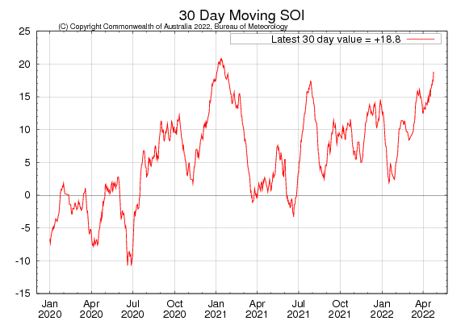

National Climate Outlook
These climate outlooks are generated by ACCESS–S (Australian Community Climate Earth-System Simulator–Seasonal). ACCESS–S is the Bureau of Meteorology's dynamical (physics-based) weather and climate model used for monthly, seasonal and longer-lead climate outlooks.
For further information, go to http://www.bom.gov.au/climate/ahead/about/
The Bureau of Meteorology’s latest rainfall outlook indicated wetter than average conditions are expected across the majority of Australia during May. The ACCESS-S climate model suggests there is close to a 60% chance of exceeding median for most of Australia, while the south-west and far south-east of Australia have roughly equal chances of being above or below median.
The outlook for May 2022 indicates that there is a 75% chance of rainfall totals between 10 and 50 millimetres across eastern New South Wales, scattered areas of Queensland, Victoria, southern South Australia, the far-southwest of Western Australia and Tasmania. Rainfall totals in excess of 100 millimetres are expected in parts of northern Queensland and western Tasmania.
Across cropping regions there is a 75% chance of rainfall totals of between 10 and 25 millimetres across most of New South Wales, southern Queensland, Victoria, South Australia and Western Australia. There is a 75% chance of rainfall less than 10 millimetres for most northern Queensland cropping regions. Given that many winter cropping regions have received sufficient rainfall to classify a consolidated autumn break, these forecast rainfall totals are expected to deliver sufficient additional soil moisture to provide a favourable start to the winter season. Meanwhile, lower rainfall totals during May, compared to March and April, across Queensland and northern New South Wales will allow timely field access for the planting of winter crops and harvesting activity for summer planted crops.
Rainfall totals that have a 75% chance of occurring May 2022
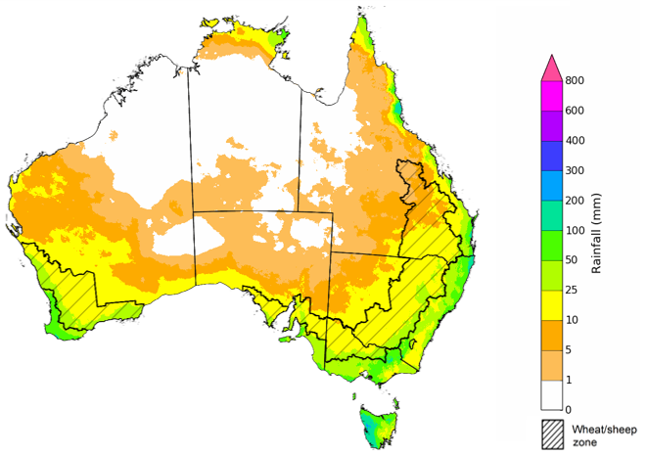
©Commonwealth of Australia 2022, Australian Bureau of Meteorology Issued: 21/4/2022

The rainfall outlook for May to July 2022 suggests there is a greater than 65% chance of exceeding median rainfall across most of New South Wales, Queensland, South Australia, northern Victoria and Western Australia and the Northern Territory. Between May to July 2022, below average rainfall is expected for parts of south-west Western Australia and isolated parts of western Tasmania. For remaining regions of Australia, there is roughly an equal chance of above and below median rainfall (Bureau of Meteorology ‘National Climate Outlook’, 21 April 2022).
Bureau of Meteorology rainfall outlooks for May to July have greater than 55% past accuracy across most of Australia. Outlook accuracy is greater than 65% across large areas of western and eastern Australia.
Chance of exceeding the median rainfall May to July 2022
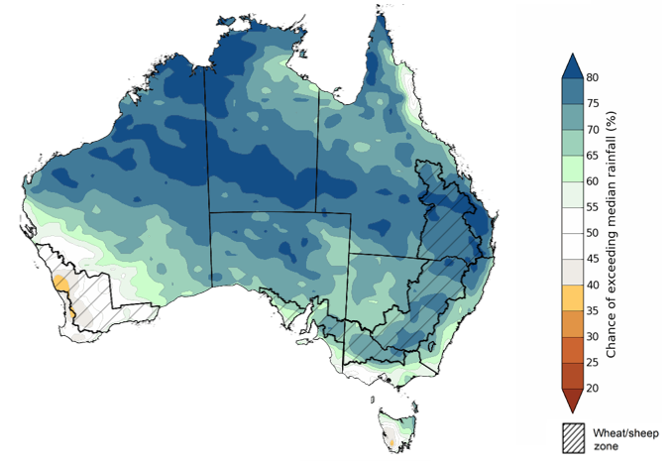
©Commonwealth of Australia 2022, Australian Bureau of Meteorology Issued: 21/4/2022

The outlook for May to July 2022 suggests there is a 75% chance of rainfall totals between 50 and 200 millimetres across much of New South Wales, south-eastern Queensland, Victoria, southern parts of South Australia, the south-west of Western Australia and Tasmania. Rainfall totals in excess of 200 millimetres are forecast for alpine regions of New South Wales and Victoria, the far south-west of Western Australia and western Tasmania.
Across cropping regions, there is a 75% chance of receiving between 50 and 100 millimetres across south-western New South Wales, much of Queensland, northern Victoria, eastern South Australia and eastern Western Australia. Totals of between 100 and 200 millimetres are expected across much of New South Wales, parts of southern Queensland, southern Victoria, central and western South Australia and western and southern Western Australia.
Root zone soil moisture levels are average to above average across much of the Wheat/sheep zone but below average to average across parts of South Australia and Victoria. There is a high—75%—chance that forecast rainfall totals in northern cropping regions will be sufficient to support the germination and establishment of winter crops. In remaining cropping regions, the expectation of close to average rainfall over the next three months is likely to provide an ideal start to the winter cropping season, particularly in areas with average or better soil moisture levels for this time of year.
Rainfall totals that have a 75% chance of occurring May to July 2022
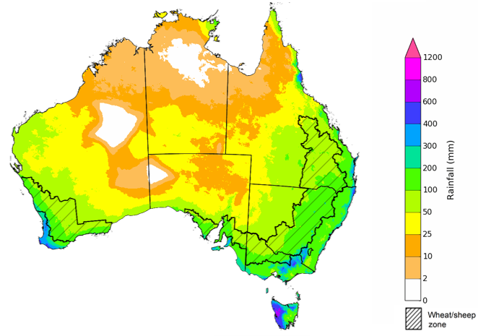
©Commonwealth of Australia 2022, Australian Bureau of Meteorology Issued: 21/4/2022

The temperature outlook for May to July 2022 indicates that maximum temperatures across most of Australia are likely to be close to the 1990-2012 average (- 1°C to 1°C), with slightly higher than average temperatures across the tropical north. Minimum temperatures are expected to be slightly above average for much of the northern two thirds of Australia, and close to average for the rest of Australia (Bureau of Meteorology ‘National Climate Outlook’, 21 April 2022).
Predicted maximum temperature anomaly for May to July 2022

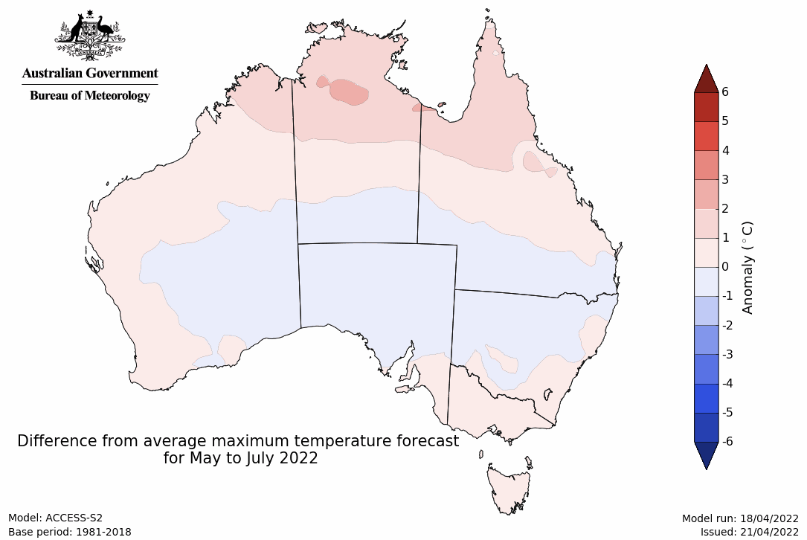
Predicted minimum temperature anomaly for May to July 2022
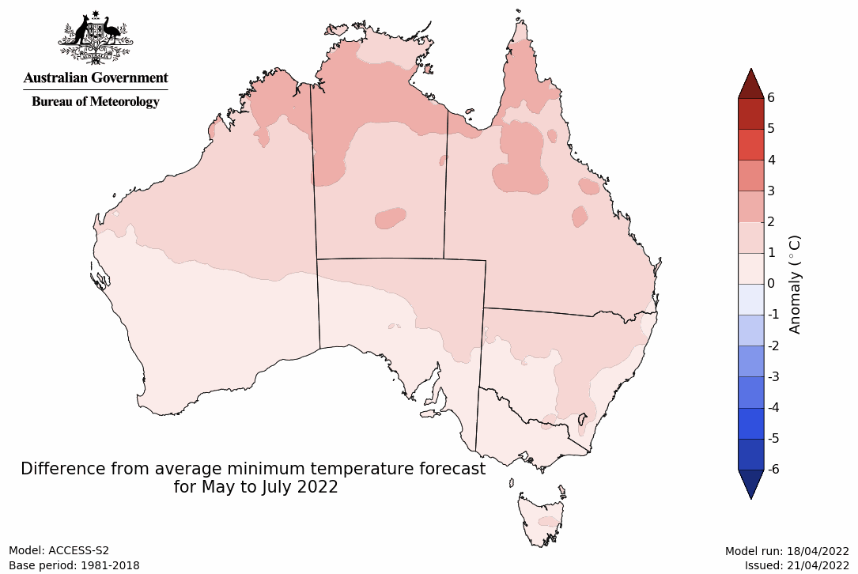

Rainfall forecast for the next eight days
Over the 8-days to 5 May 2022, low-pressure troughs are expected to bring rainfall to south-eastern Australia, with a cold front bringing further rainfall to the far south-east. In remaining parts of the country, high-pressure systems will bring mostly dry conditions.
Rainfall totals of between 10 and 50 millimetres are forecast for much of eastern New South Wales, parts of southern Queensland and the south-east of South Australia, as well as Victoria and Tasmania. Rainfall in excess of 50 millimetres is expected for central New South Wales, as well as western and northern parts of Tasmania.
In Australian cropping regions, rainfall totals of between 10 and 50 millimetres are expected across New South Wales and Victoria, and isolated areas of southern Queensland and the east of South Australia. Rainfall in excess of 50 millimetres is expected in cropping regions of central New South Wales. Little to no rainfall is forecast for all remaining cropping regions during the next 8-days.
The dry conditions expected across Queensland cropping regions will allow the harvesting of cotton and sorghum to continue, as well as the planting of winter crops. However, for most of New South Wales and Victoria, moderate rainfall is likely to restrict field access, delaying harvesting and planting activity. In South Australia and Western Australia, planting activity is expected to increase over the coming week, with relatively dry conditions. Many growers will be eager to complete planting programs as soon as possible given the expectation for a wetter than average winter. The east of South Australia is still yet to receive an autumn break, but growers are likely to dry-sow winter crops given the favourable 3-month rainfall outlook.

Total forecast rainfall (mm) for the period 28 April to 5 May 2022
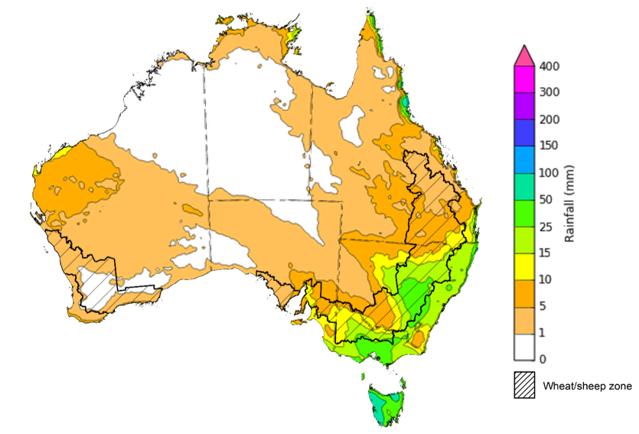

©Commonwealth of Australia 2022, Australian Bureau of Meteorology Issued: 28/04/2022

Water
Note: This rainfall forecast is produced from computer models. As the model outputs are not altered by weather forecasters, it is important to check local forecasts and warnings issued by the Bureau of Meteorology.

Water markets – current week
Water storage in the Murray–Darling Basin (MDB) decreased by 134 gigalitres (GL) between 20 April 2022 and 27 April 2022. The current volume of water held in storage is 21,341GL, which represents 85 per cent of total capacity. This is 50% or 7,139 GL more than at the same time last year.

Water storages in the Murray-Darling Basin, 2013–2022
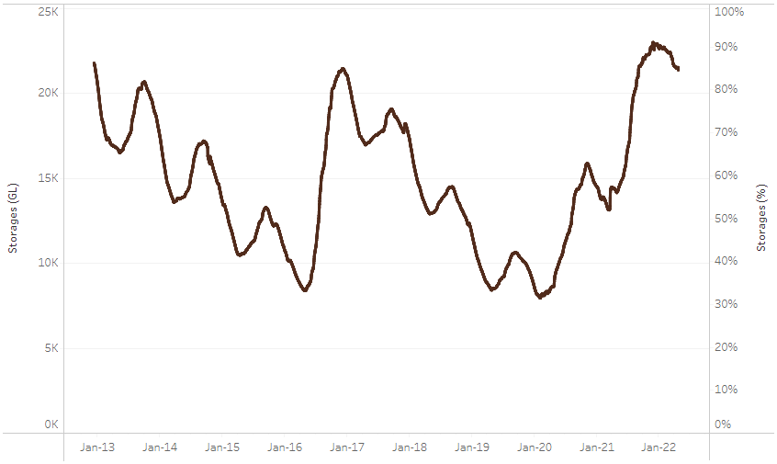
Allocation prices in the Victorian Murray below the Barmah Choke decreased from $72 per ML on 14 April 2022 to $65 per ML on 21 April 2022. Prices are lower in the Goulburn-Broken, Murrumbidgee and regions above the Barmah choke due to the binding of the Goulburn intervalley trade limit, Murrumbidgee export limit and Barmah choke trade constraint.
Water storage data is sourced from the Bureau of Meteorology.
Region | $/ML
NSW Murray Above | 7
NSW Murrumbidgee | 7
VIC Goulburn-Broken | 34
VIC Murray Below | 65

Surface water trade activity, Southern Murray–Darling Basin

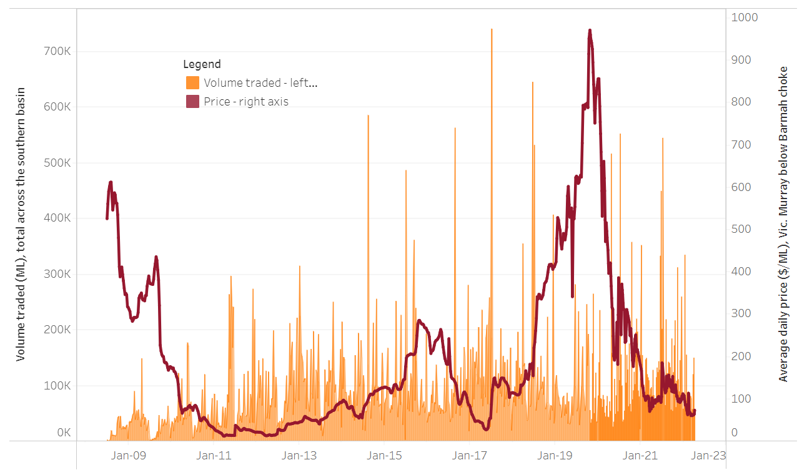
To access the full, interactive, weekly water dashboard, which contains the latest and historical water storage, water market and water allocation information, please visit http://www.agriculture.gov.au/abares/products/weekly_update/weekly-update-280422
The trades shown reflect estimated market activity and do not encompass all register trades. The price is shown for the VIC Murray below the Barmah choke. Historical prices (before 1 July 2019) are ABARES estimates after removing outliers from BOM water register data. Prices after 1 July 2019 and prior to the 30 October 2019 reflect recorded transaction prices as sourced from Ruralco. Prices after the 30 October 2019 are sourced from Waterflow. Data for volume traded is sourced from the BOM water register. Data shown is current at 28 April 2022.

Commodities

Indicator | Week ended | Unit | Latest price | Previous week | Weekly change | Price 12 months ago | Annual change
Selected world indicator prices
AUD/USD Exchange rate | 27-Apr | A$/US$ | 0.72 | 0.74 | -2% | 0.77 | -7%
Wheat – US no. 2 hard red winter wheat, fob Gulf | 27-Apr | US$/t | 413 | 417 | -1% | 315 | 31%
Corn – US no. 2 yellow corn, fob Gulf | 27-Apr | US$/t | 358 | 358 | 0% | 320 | 12%
Canola – Rapeseed, Canada, fob Vancouver | 27-Apr | US$/t | 982 | 990 | -1% | 852 | 15%
Cotton – Cotlook 'A' Index | 27-Apr | USc/lb | 155 | 162 | -4% | 93 | 66%
Sugar – Intercontinental Exchange, nearby futures, no.11 contract | 27-Apr | USc/lb | 18.9 | 19.9 | -5% | 17 | 10%
Wool – Eastern Market Indicator | 27-Apr | Ac/kg clean | 1,395 | 1,395 | 0% | 1,309 | 7%
Wool – Western Market Indicator | 06-Apr | Ac/kg clean | 1,417 | 1,421 | 0% | 1,222 | 16%
Selected Australian grain export prices
Milling Wheat – APW, Port Adelaide, SA | 27-Apr | A$/t | 540 | 528 | 2% | 379 | 42%
Feed Wheat – ASW, Port Adelaide, SA | 27-Apr | A$/t | 692 | 697 | -1% | 378 | 83%
Feed Barley – Port Adelaide, SA | 27-Apr | A$/t | 481 | 463 | 4% | 313 | 54%
Canola – Kwinana, WA | 27-Apr | A$/t | 1,268 | 1,238 | 2% | 727 | 74%
Grain Sorghum – Brisbane, QLD | 27-Apr | A$/t | 434 | 426 | 2% | 366 | 19%
Selected domestic livestock indicator prices
Beef – Eastern Young Cattle Indicator | 20-Apr | Ac/kg cwt | 1,072 | 1,088 | -1% | 880 | 22%
Mutton – Mutton indicator (18–24 kg fat score 2–3), Vic | 27-Apr | Ac/kg cwt | 597 | 555 | 8% | 710 | -16%
Lamb – Eastern States Trade Lamb Indicator | 27-Apr | Ac/kg cwt | 802 | 779 | 3% | 818 | -2%
Pig – Eastern Seaboard (60.1–75 kg), average of buyers & sellers | 30-Mar | Ac/kg cwt | 368 | 357 | 3% | 347 | 6%
Goats – Eastern States (12.1–16 kg) | 05-Jan | Ac/kg cwt | 879 | 879 | 0% | 818 | 8%
Live cattle – Light steers ex Darwin to Indonesia | 23-Mar | Ac/kg lwt | 550 | 550 | 0% | 260 | 112%
Live sheep – Live wethers (Muchea WA saleyard) to Middle East | 22-Sep-21 | $/head | 147 | 171 | -14% | 126 | 17%

Indicator | Week ended | Unit | Latest price | Previous week | Weekly change | Price 12 months ago | Annual change
Global Dairy Trade (GDT) weighted average prices ª
Dairy – Whole milk powder | 20-Apr | US$/t | 4,207 | 4,532 | -7% | 2,952 | 43%
Dairy – Skim milk powder | 20-Apr | US$/t | 4,408 | 4,599 | -4% | 2,747 | 60%
Dairy – Cheddar cheese | 20-Apr | US$/t | 6,185 | 6,472 | -4% | 4,398 | 41%
Dairy – Anhydrous milk fat | 20-Apr | US$/t | 6,802 | 6,908 | -2% | 4,331 | 57%
a Global Dairy Trade prices are updated twice monthly on the first and third Tuesday of each month.

Selected world indicator prices
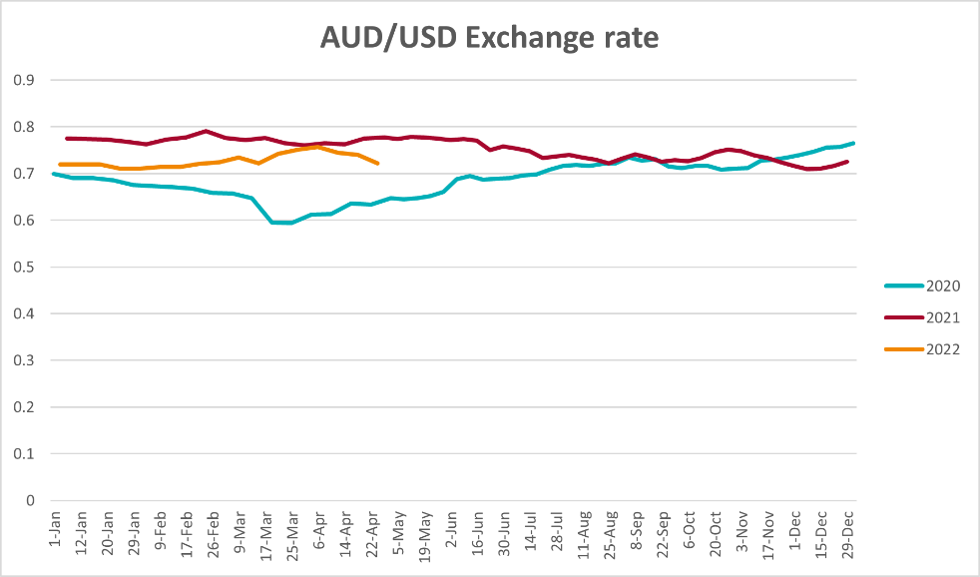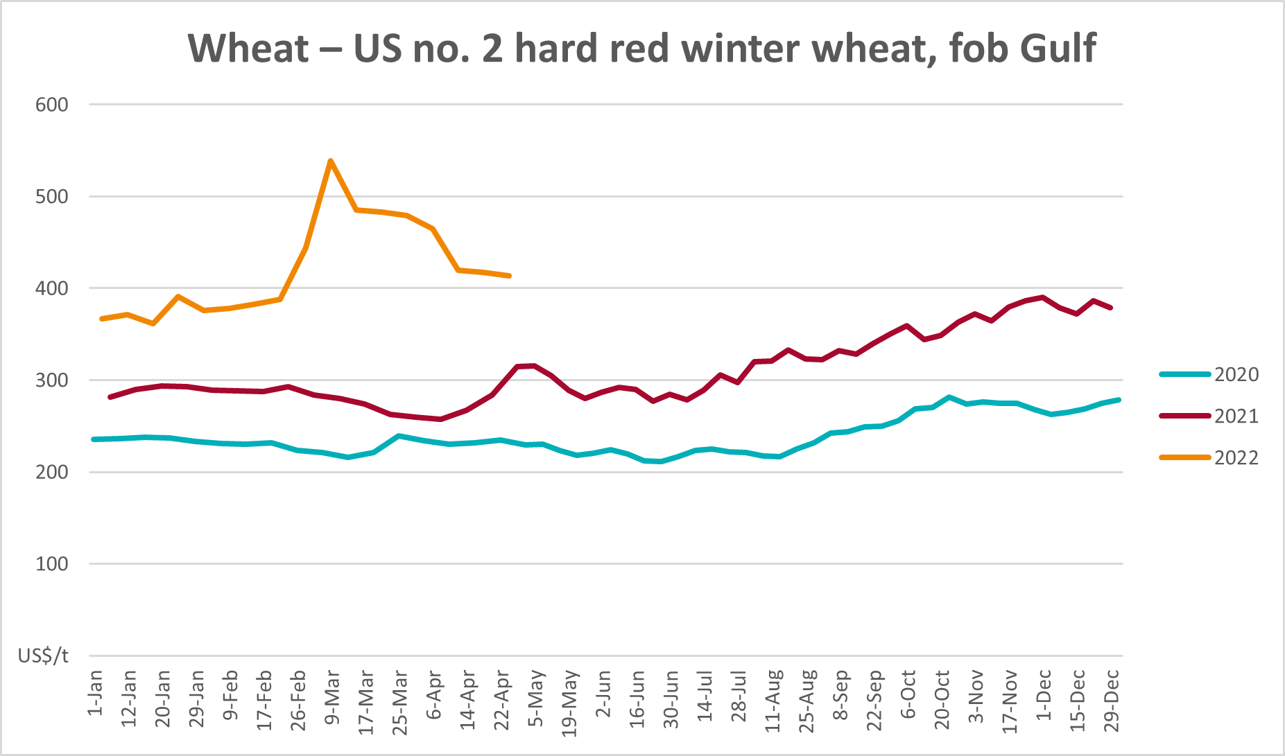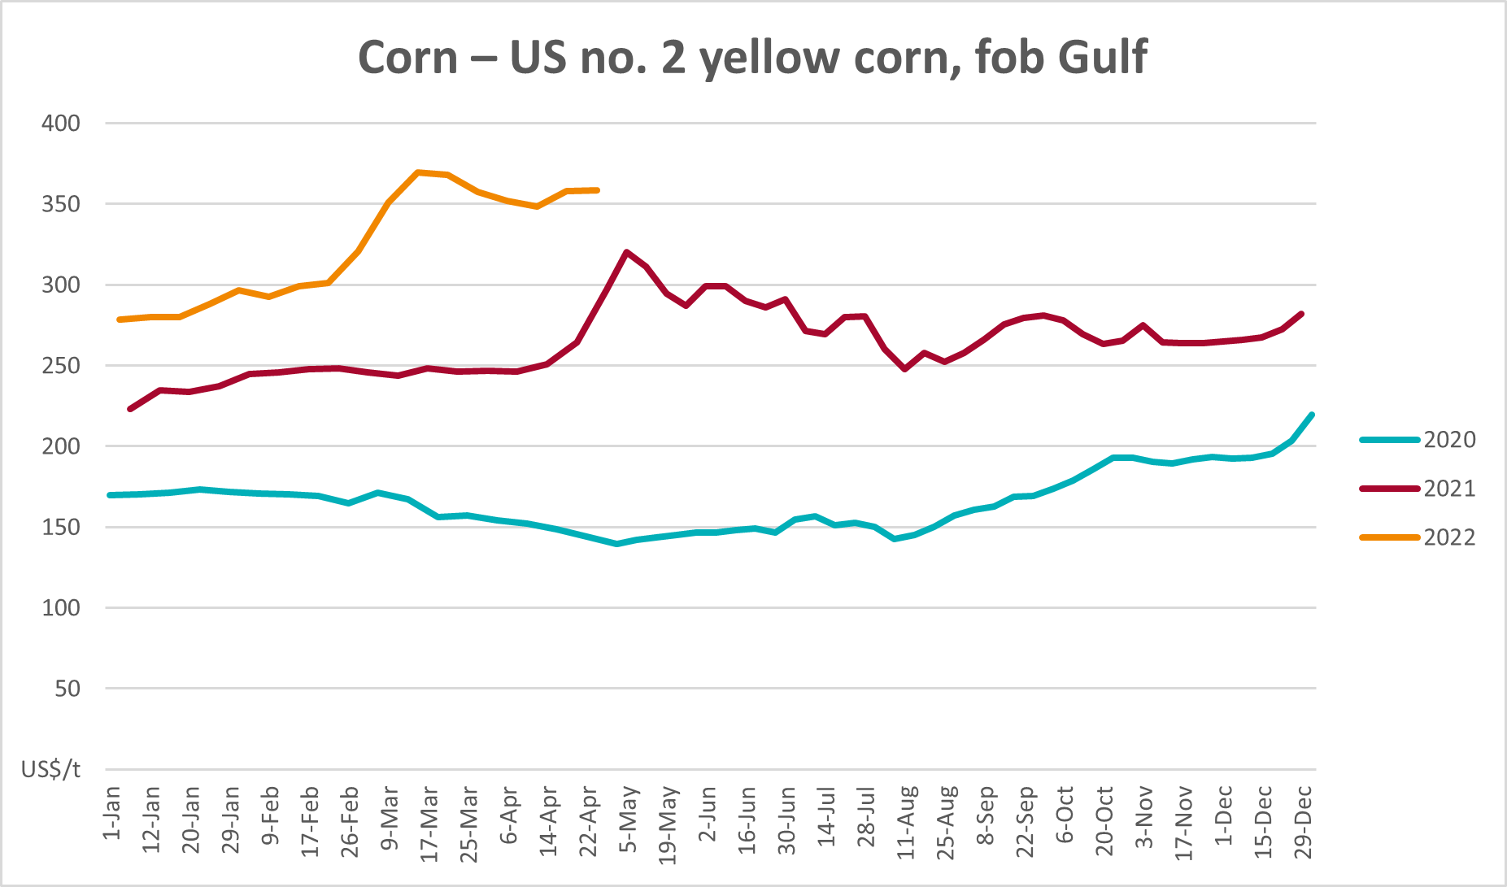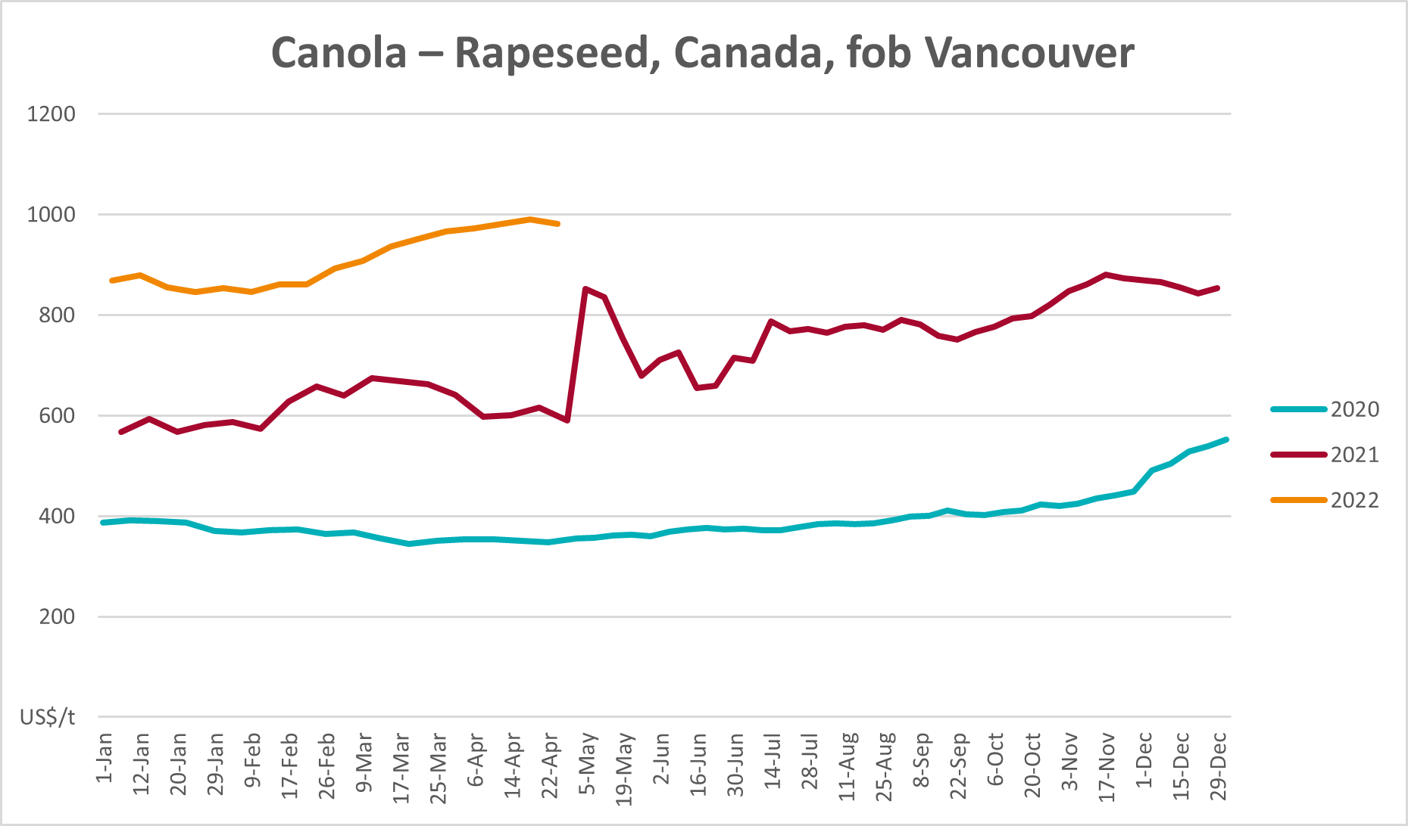
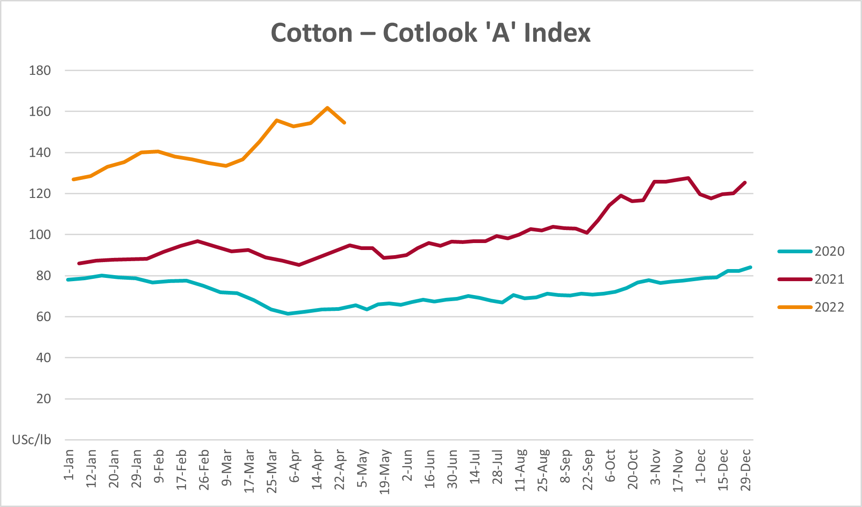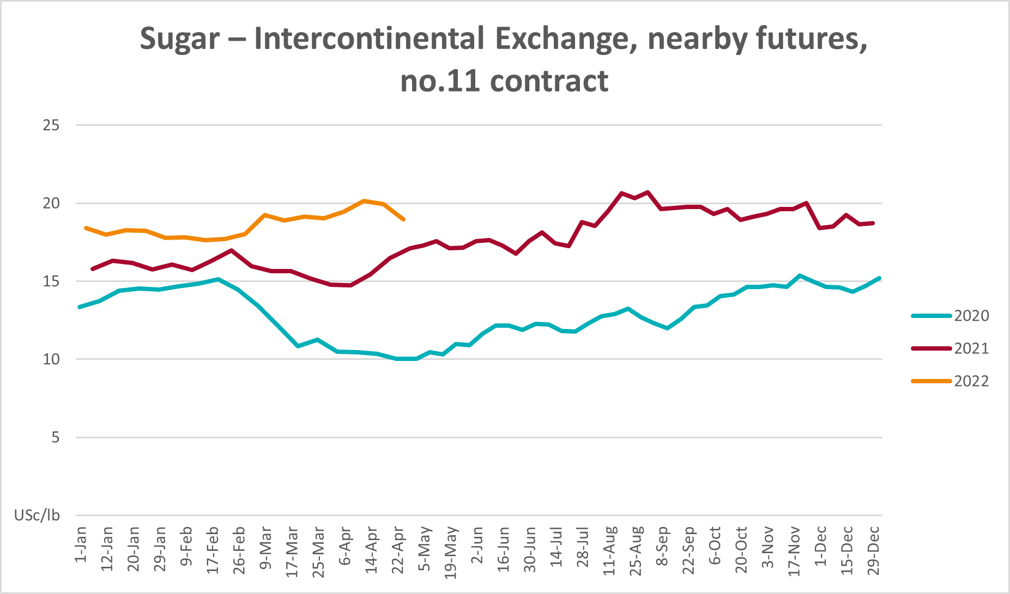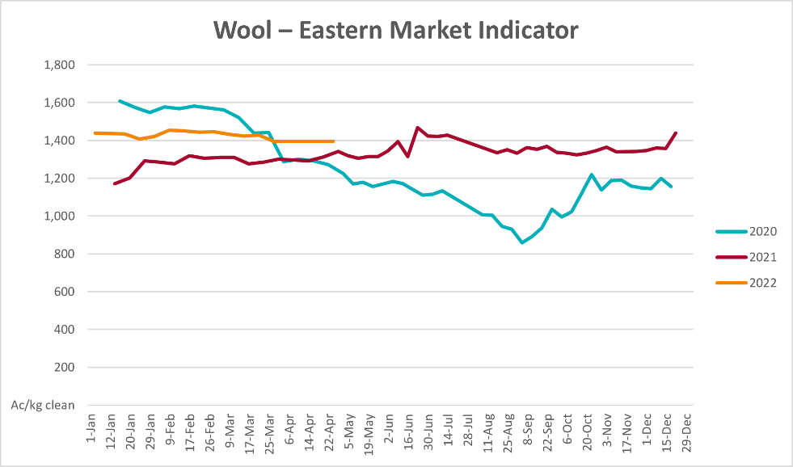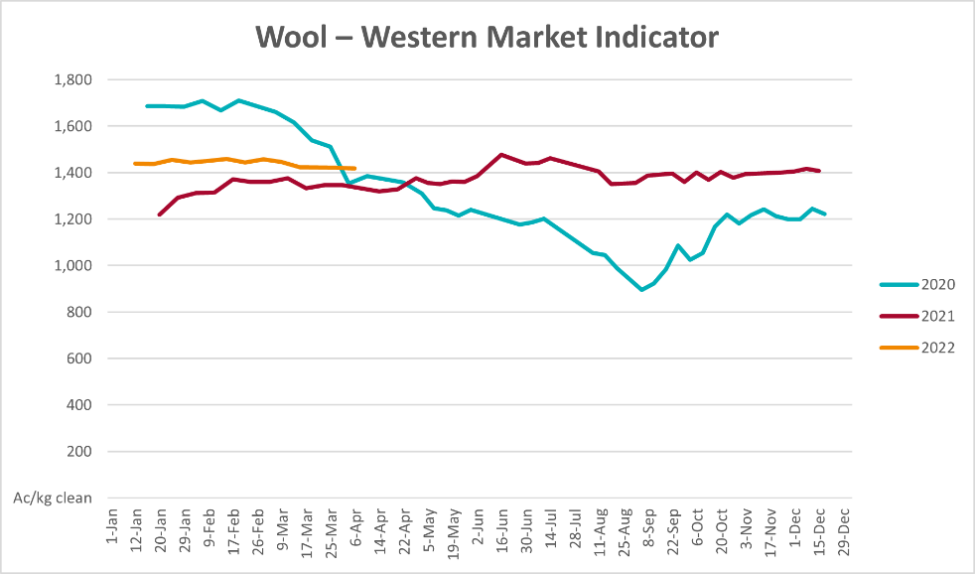

Selected domestic crop indicator prices
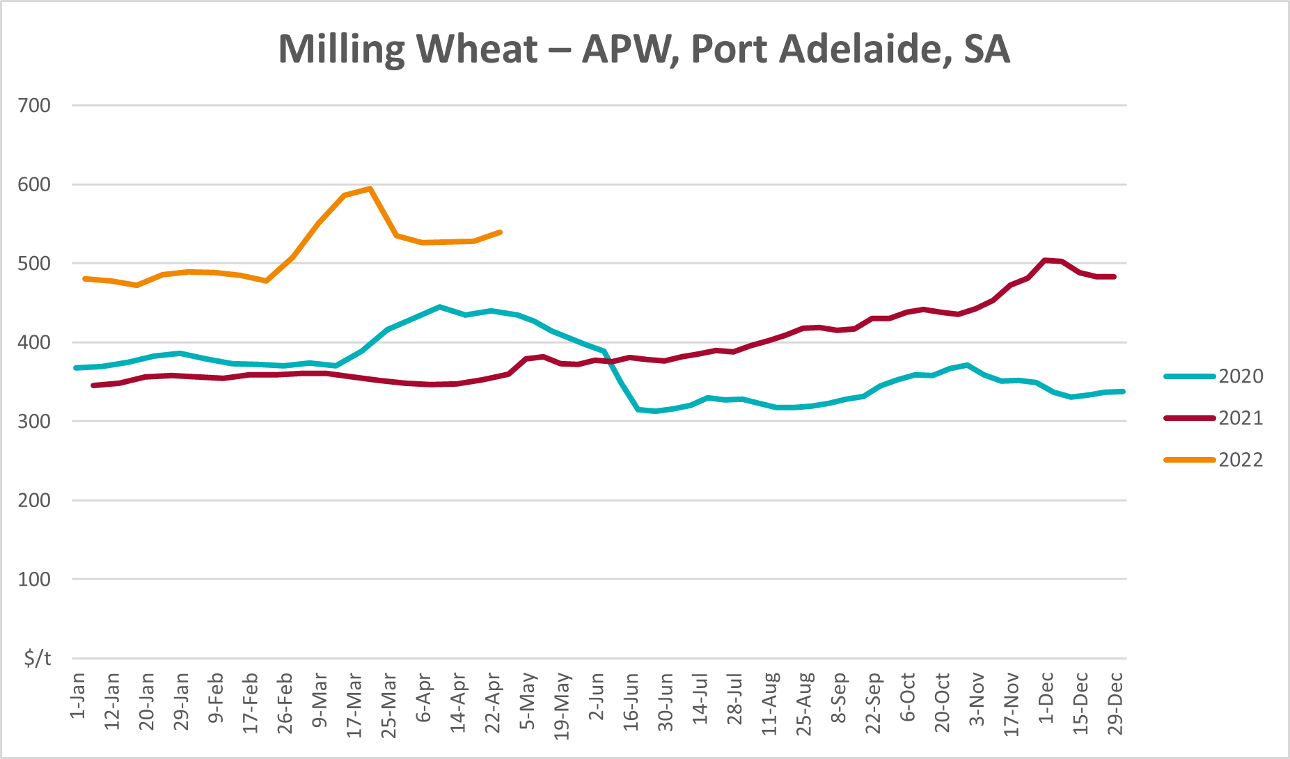
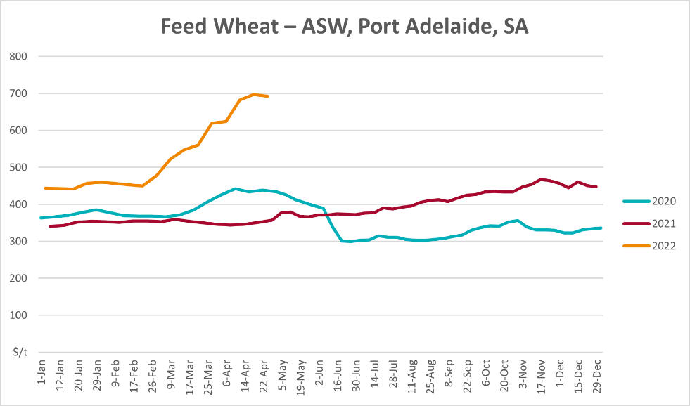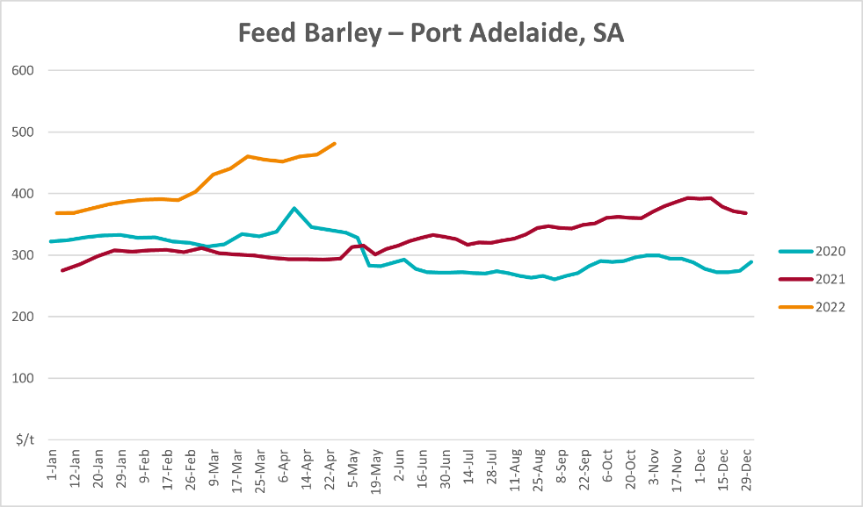
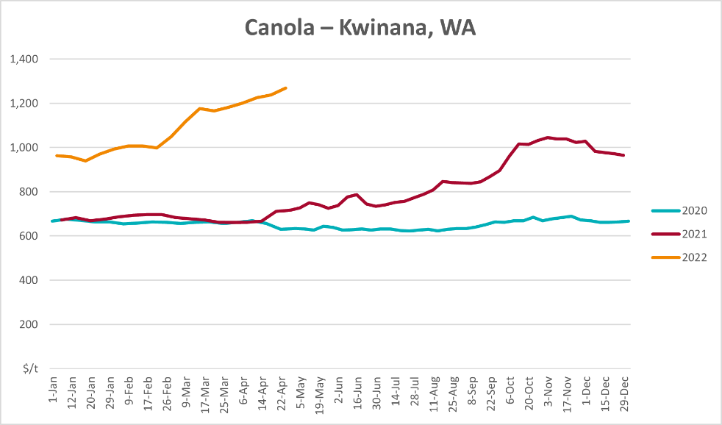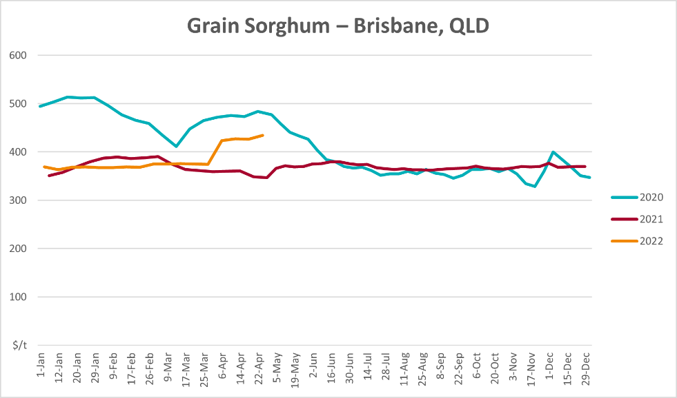

Selected domestic livestock indicator prices
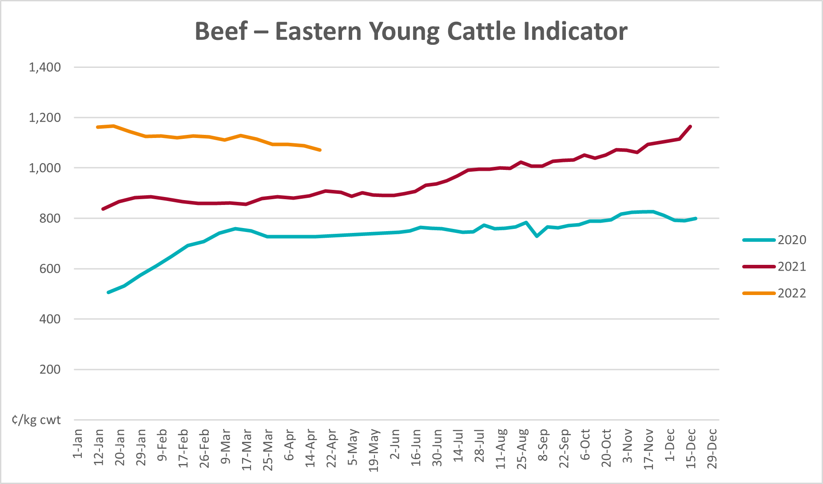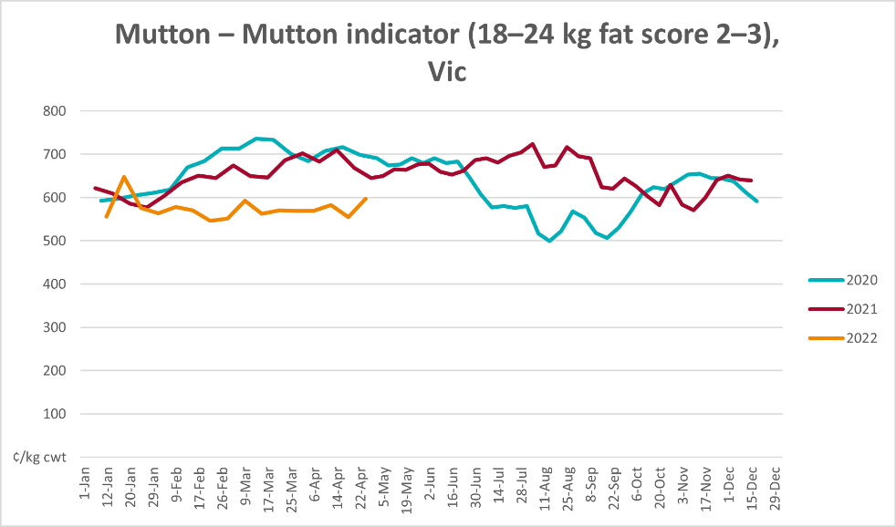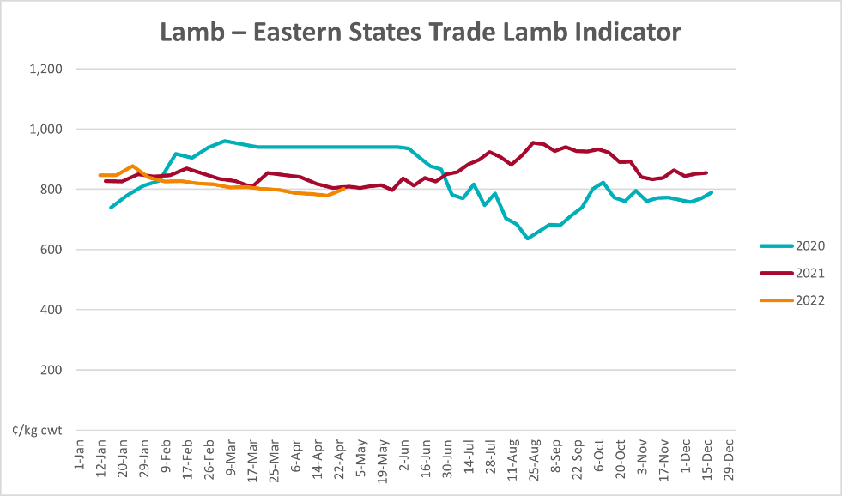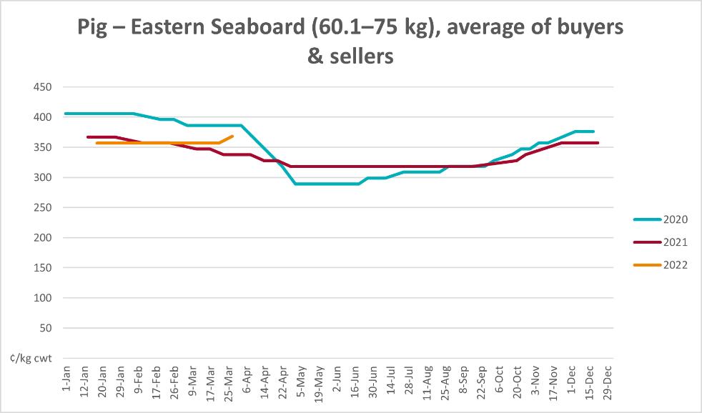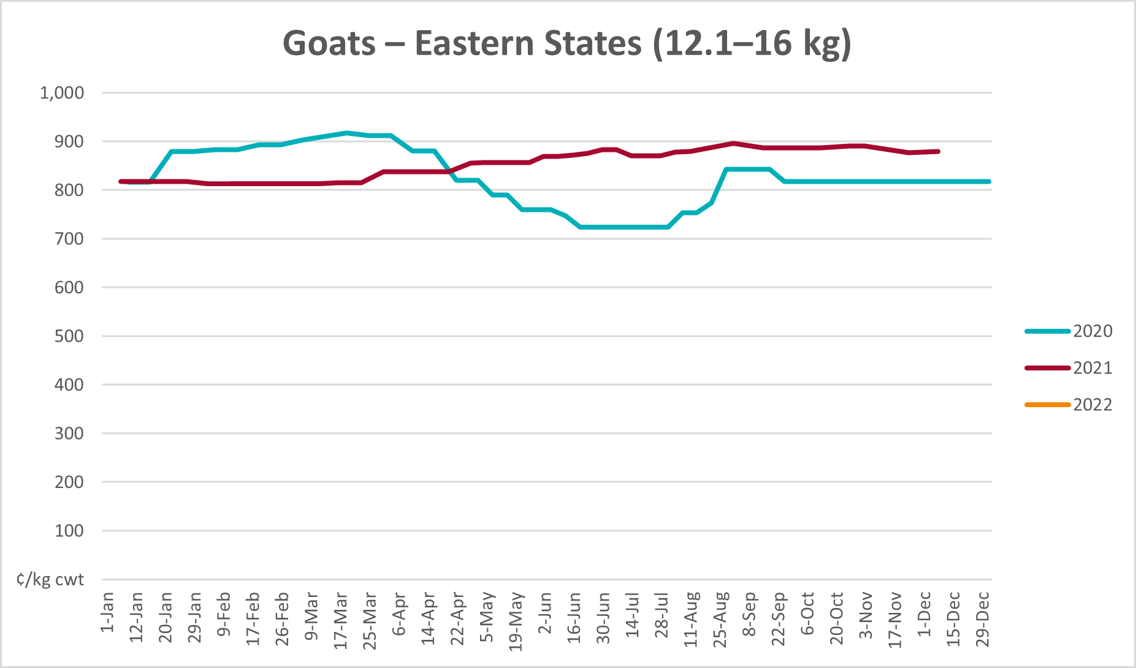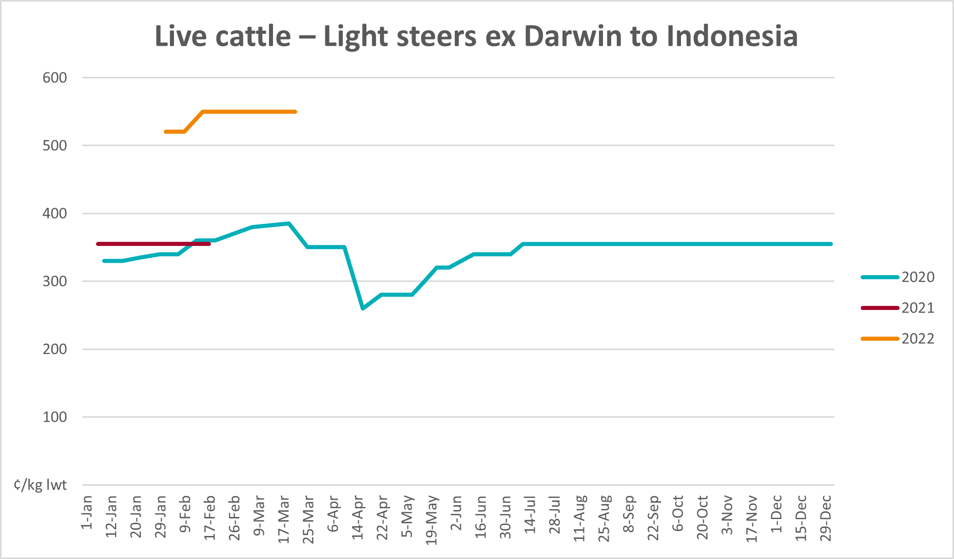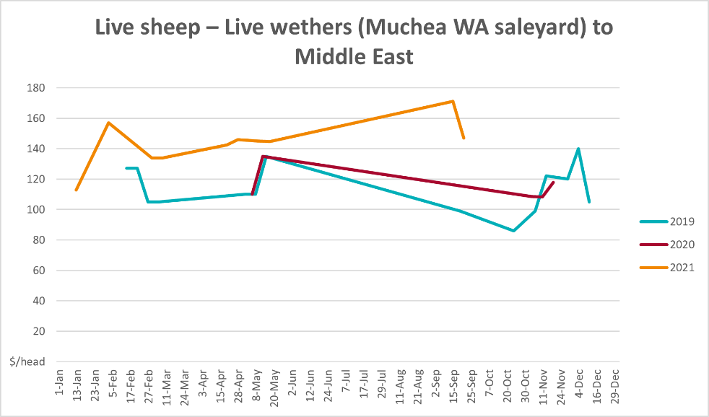

Global Dairy Trade (GDT) weighted average prices
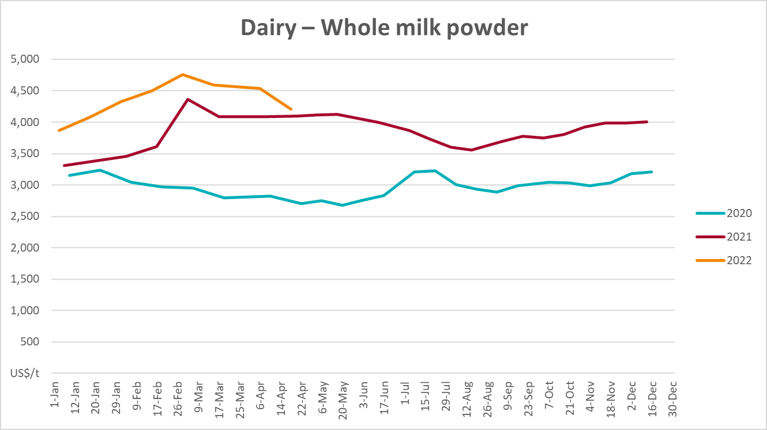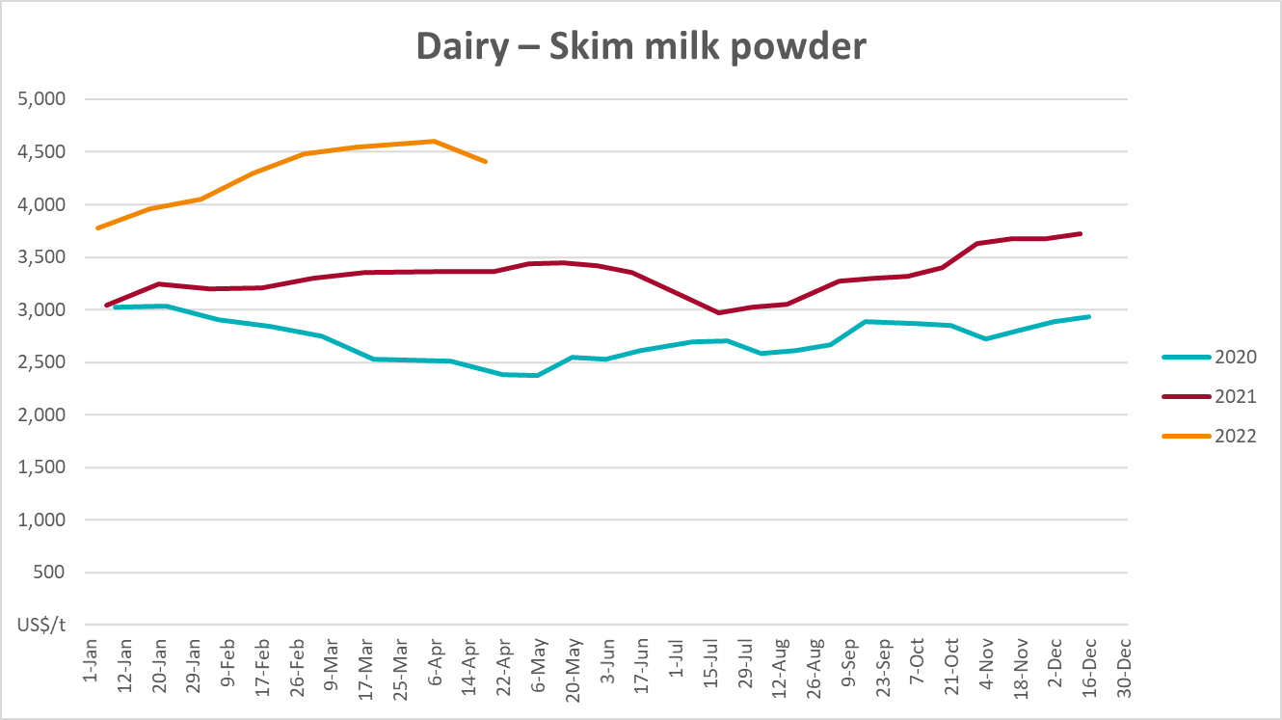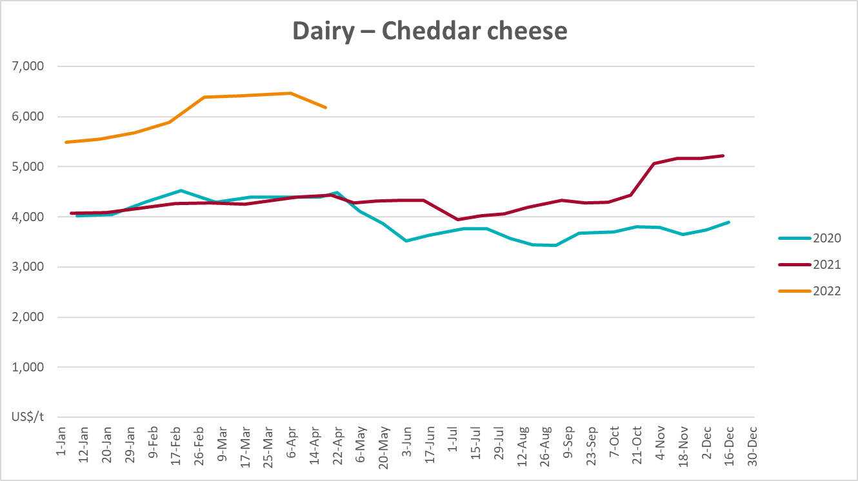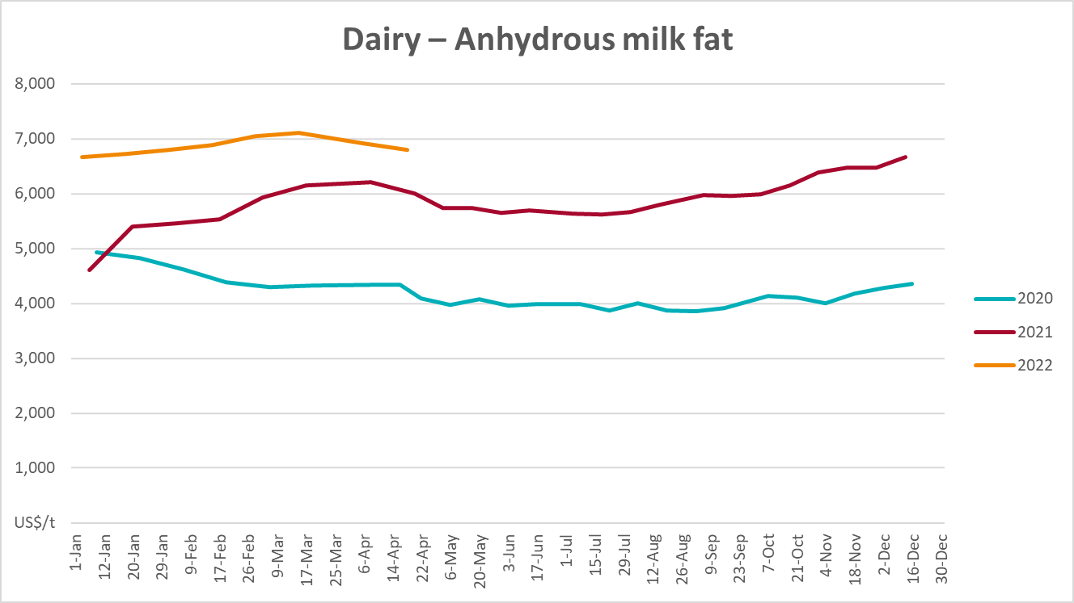

Selected fruit and vegetable prices
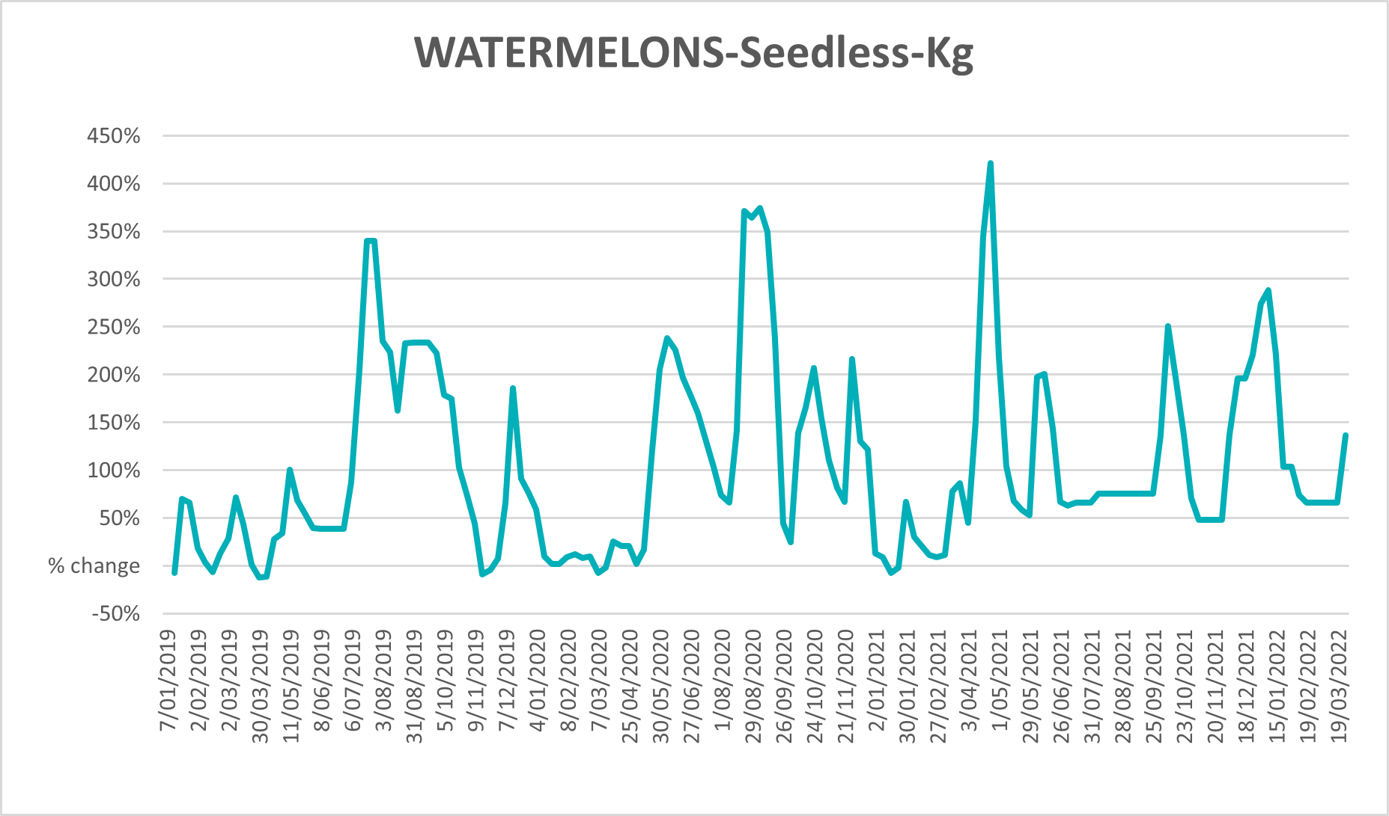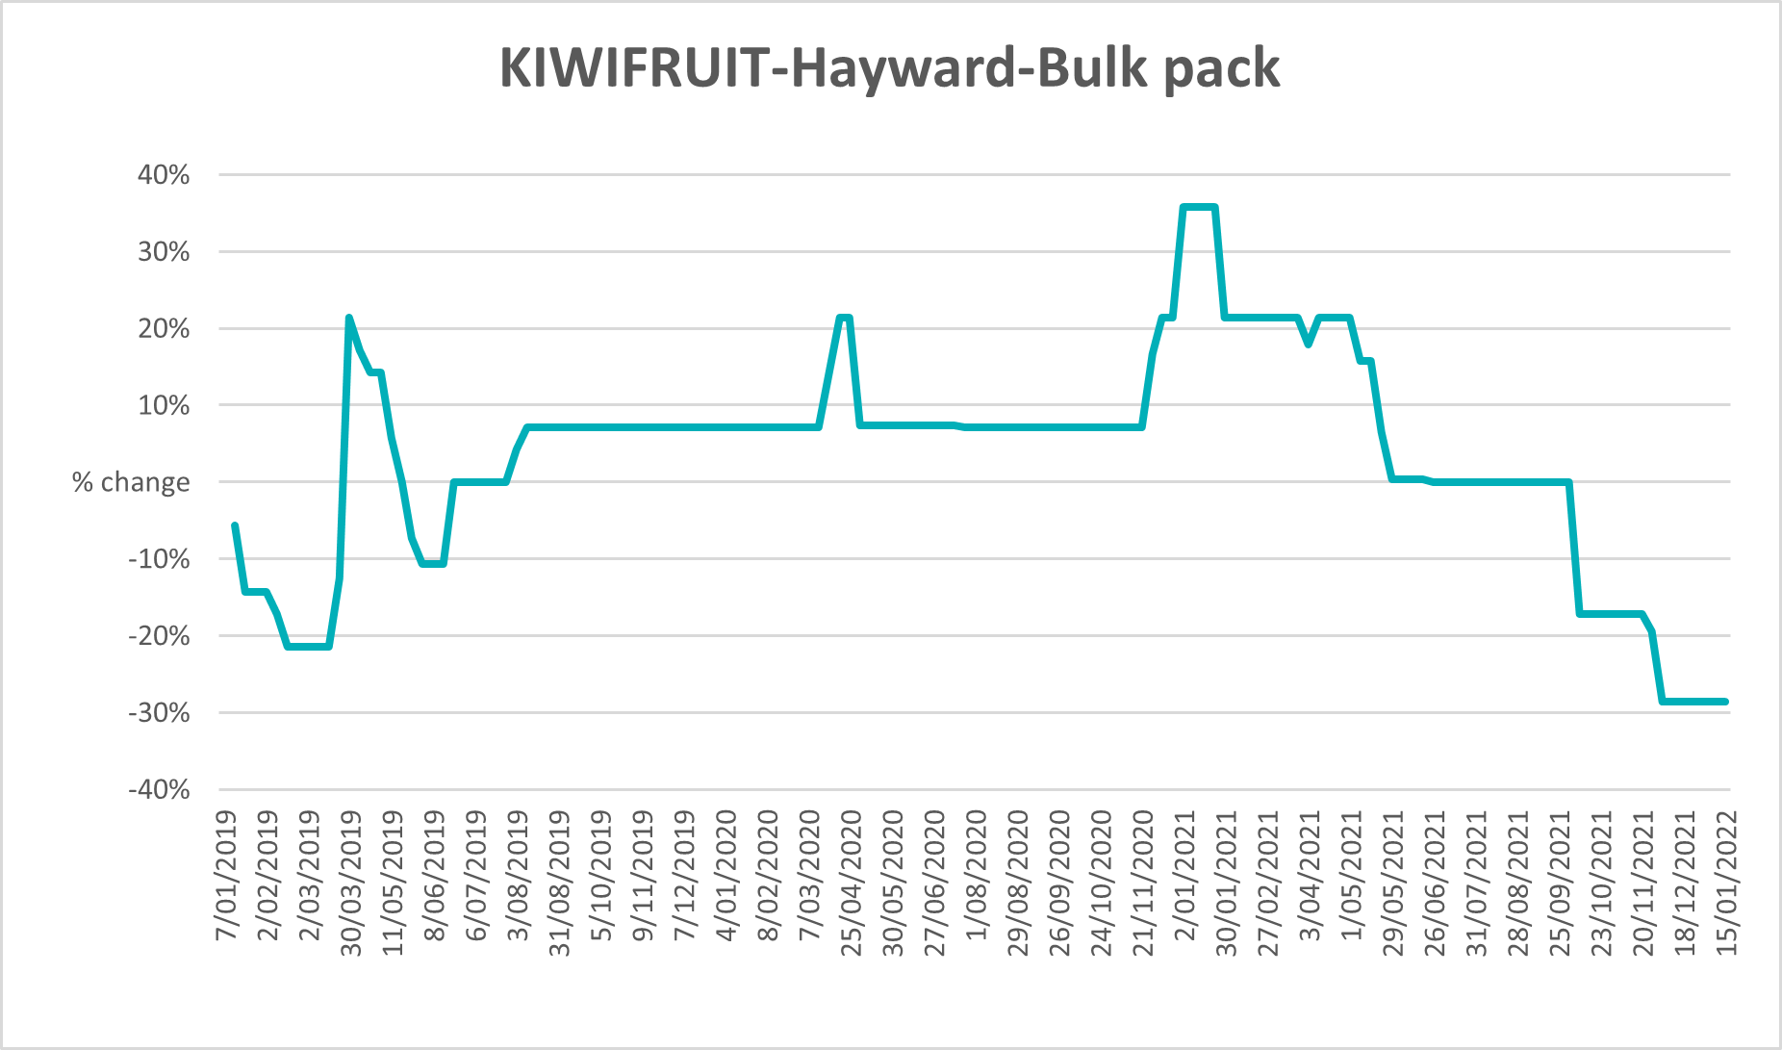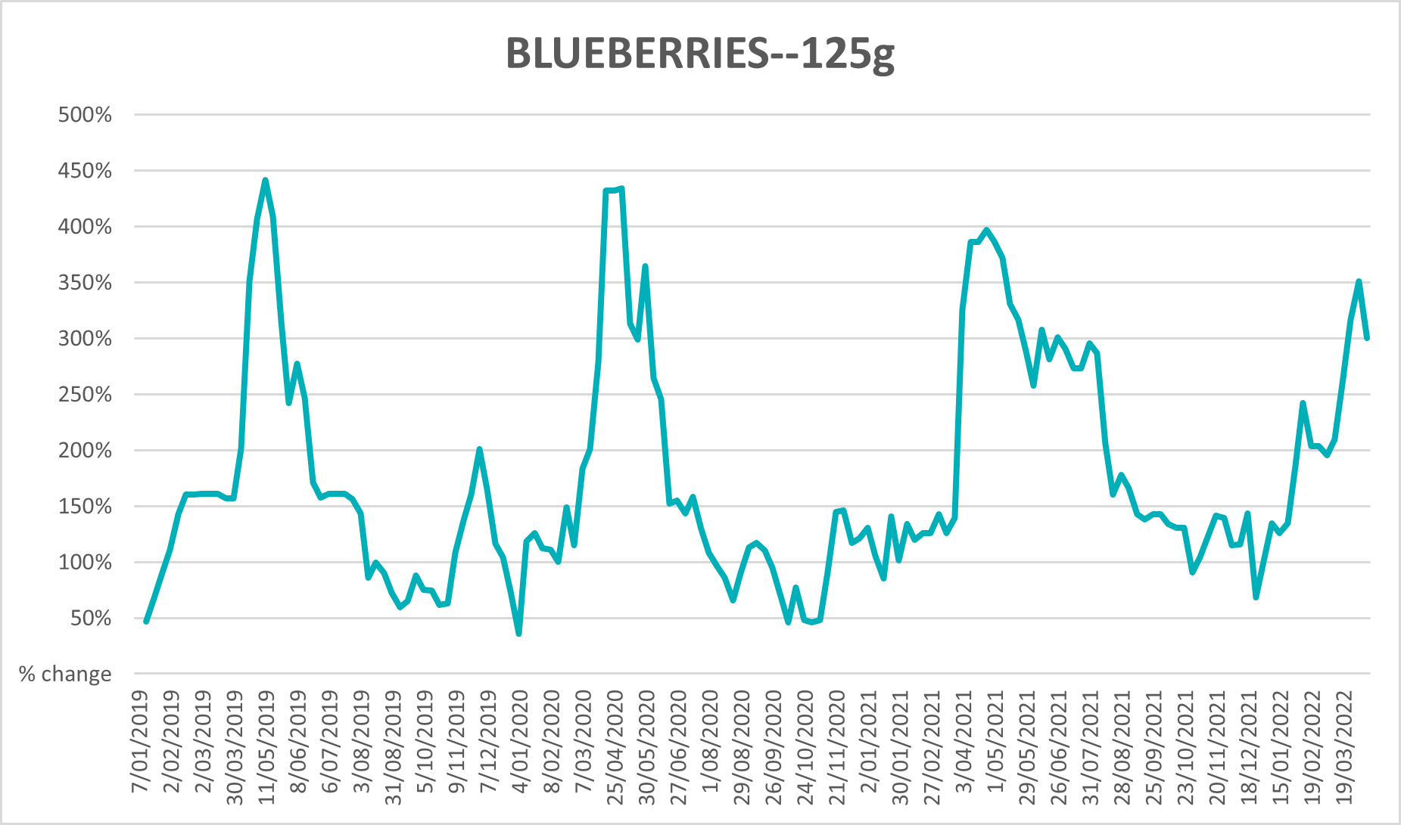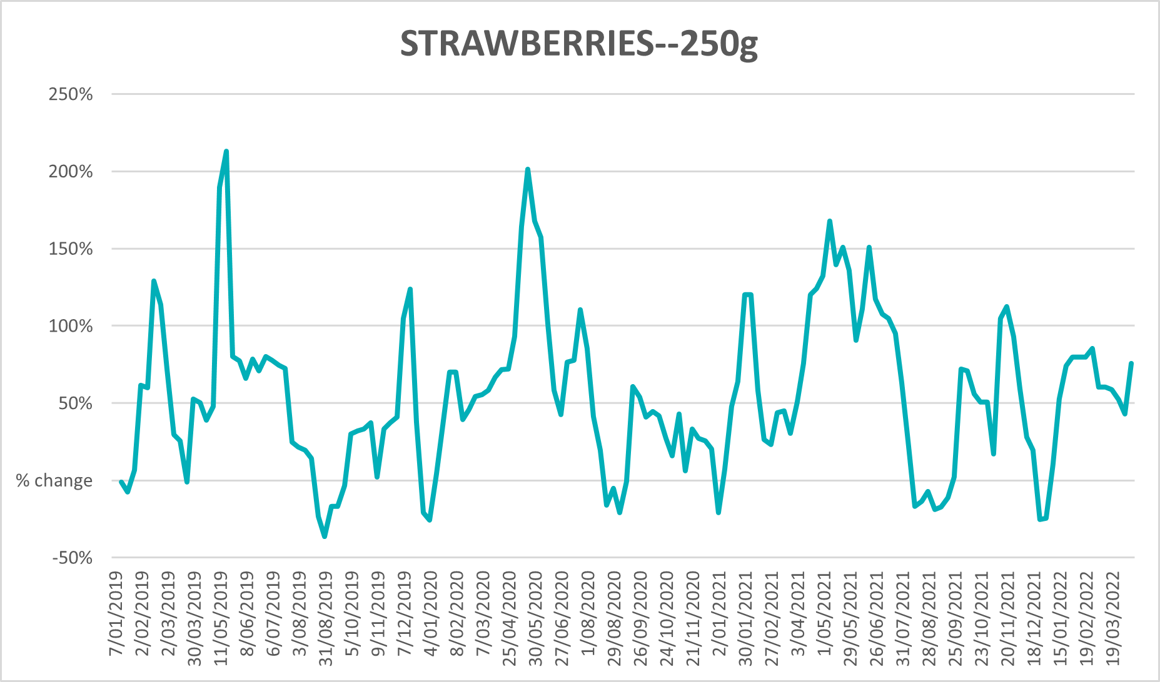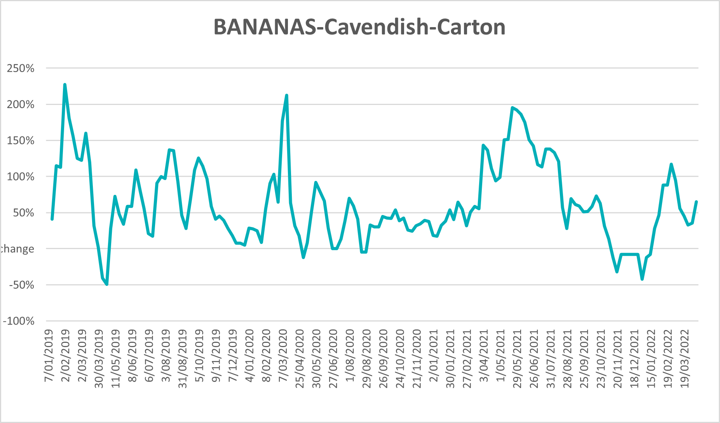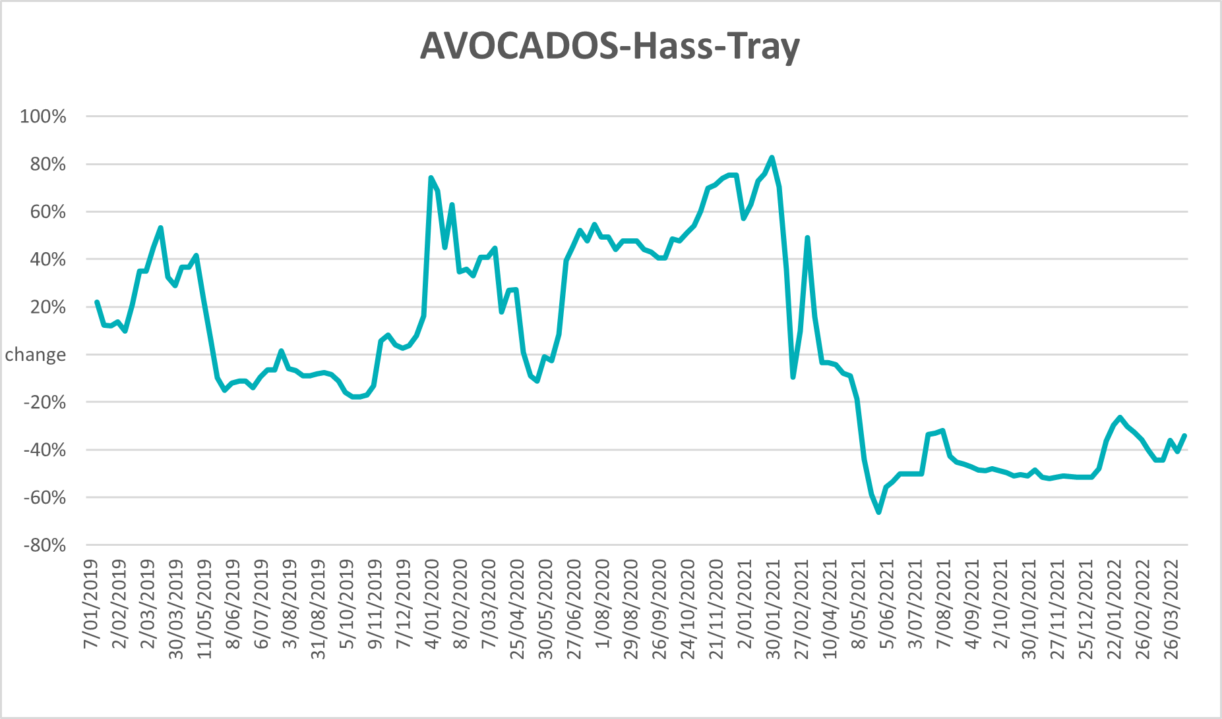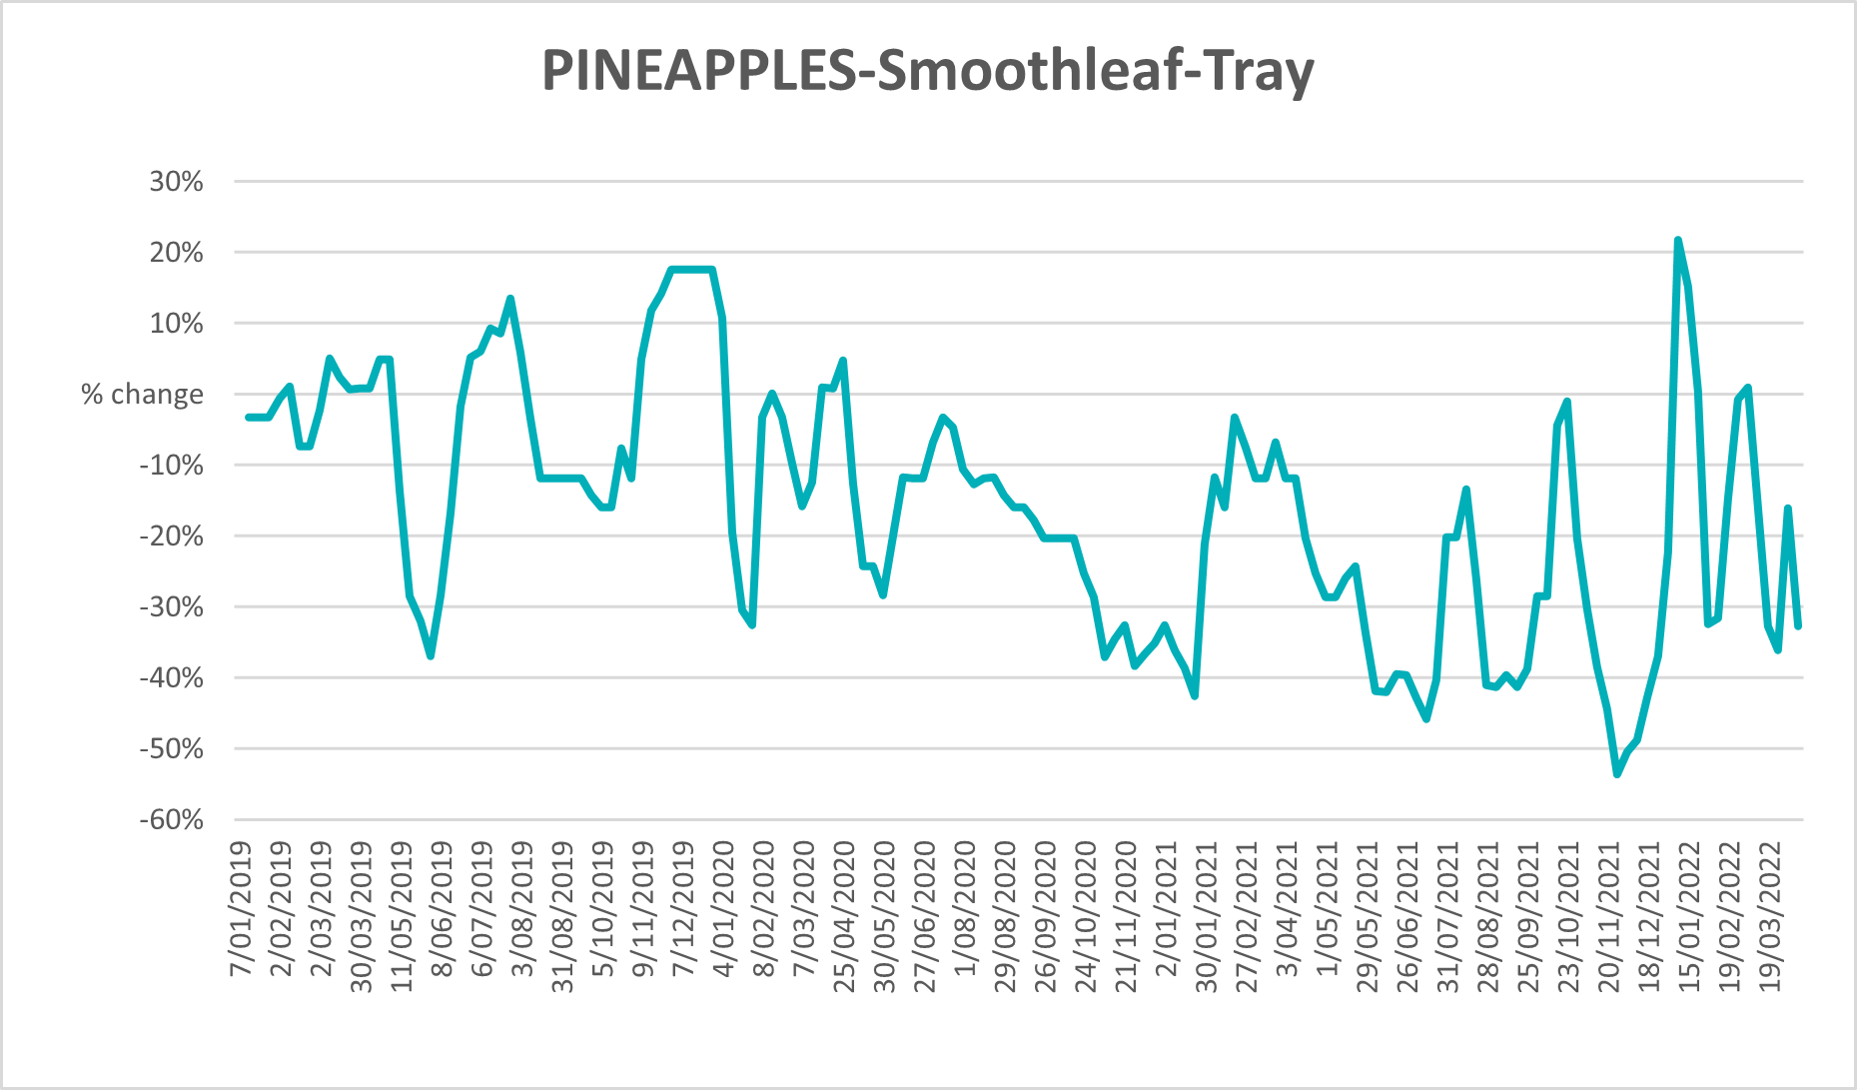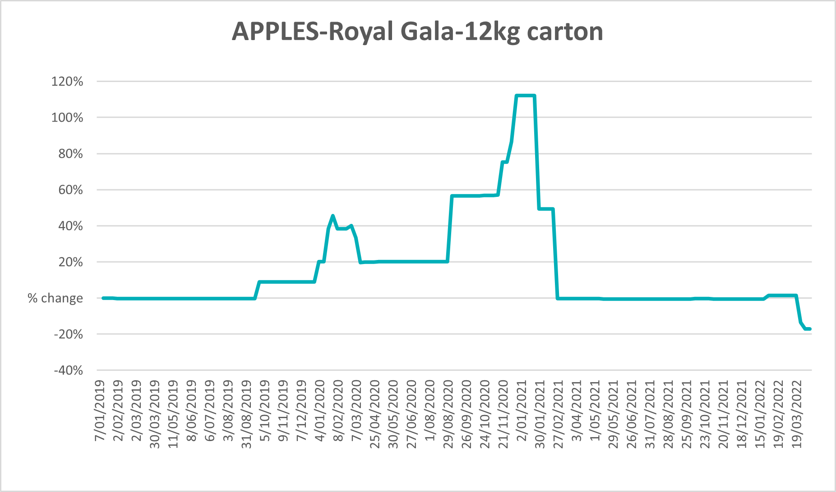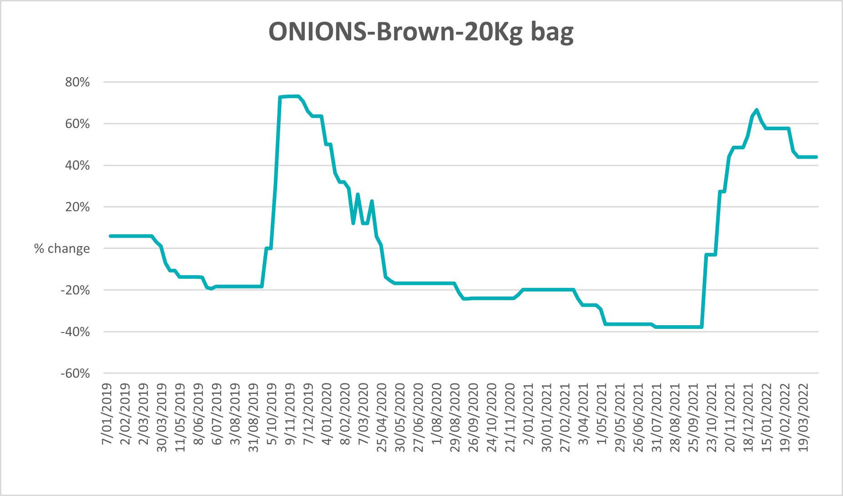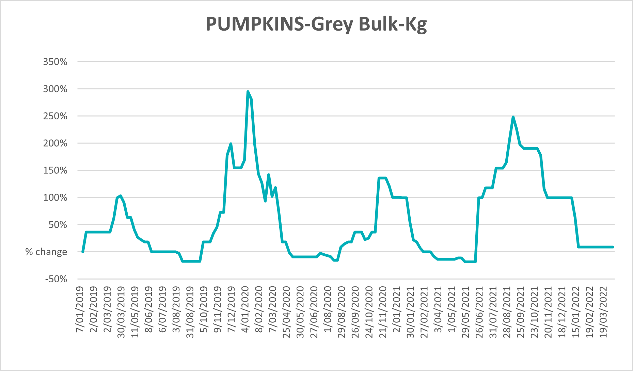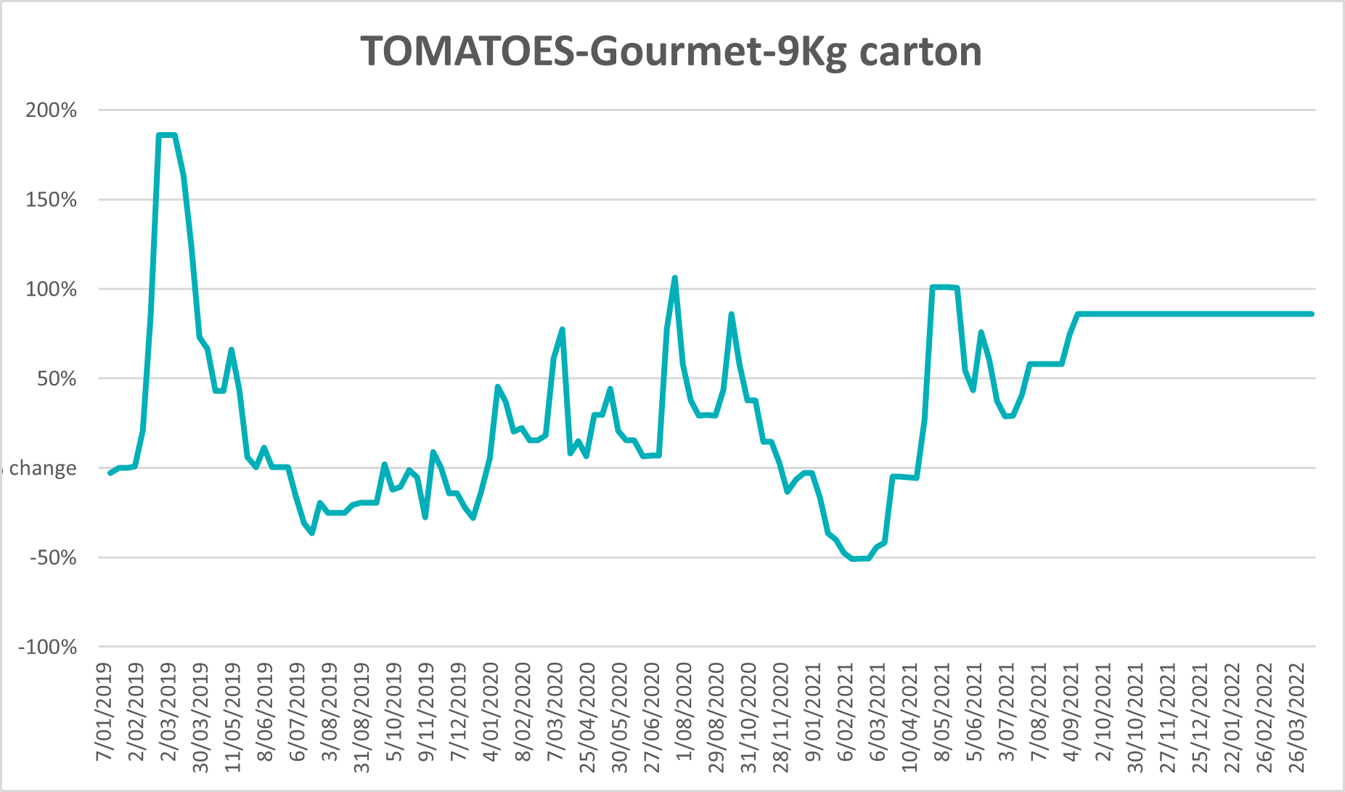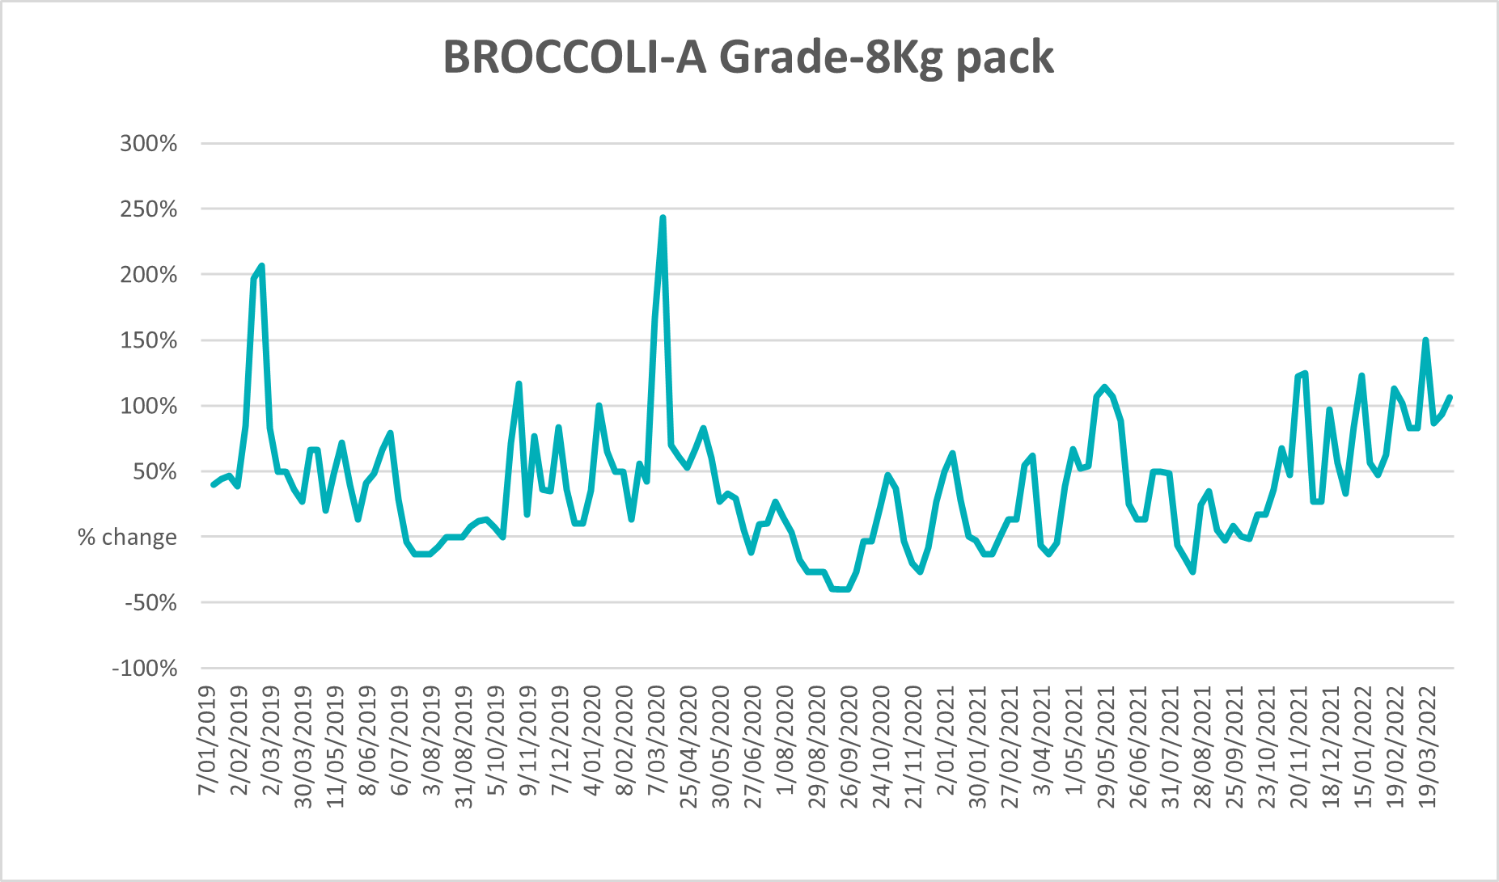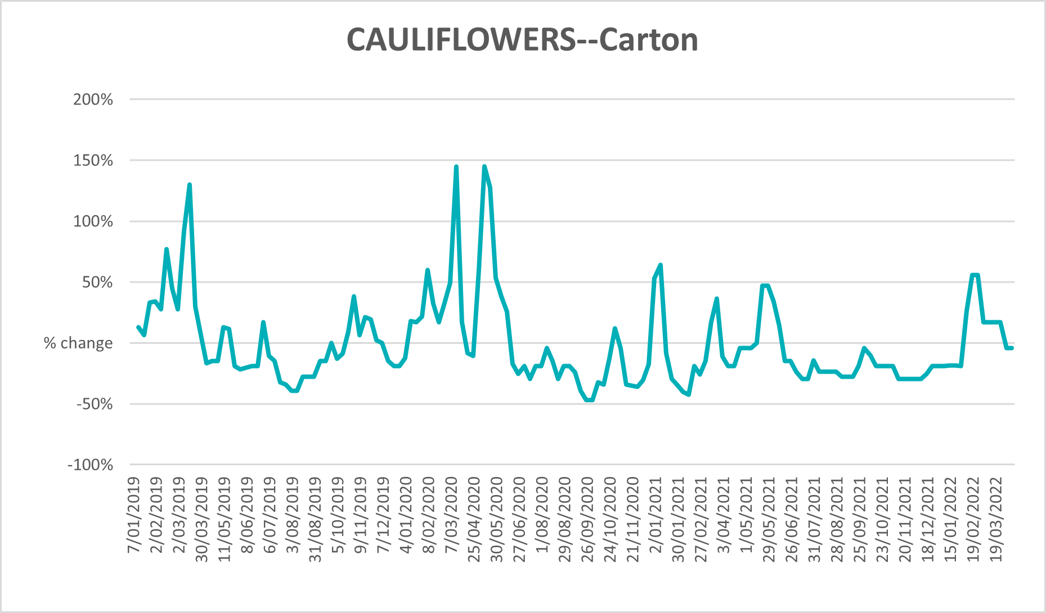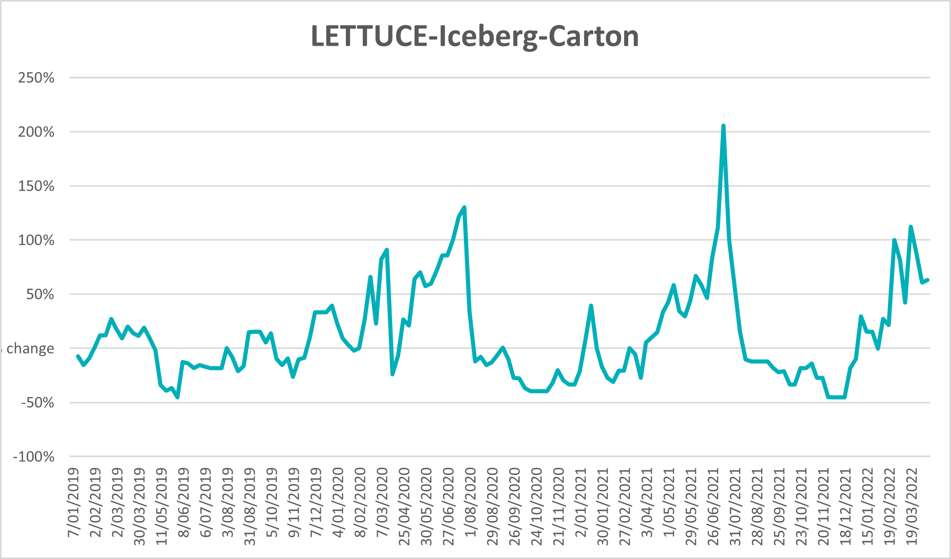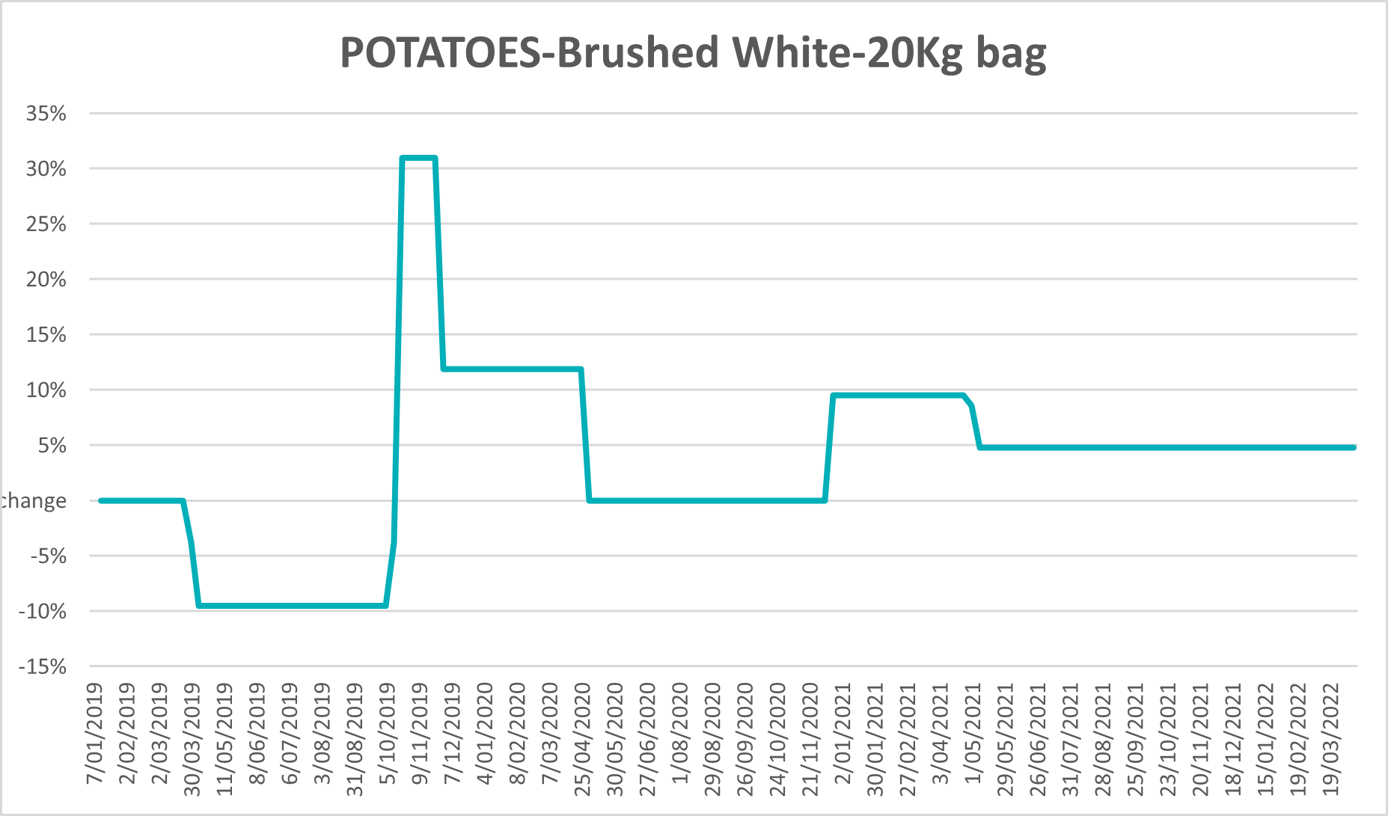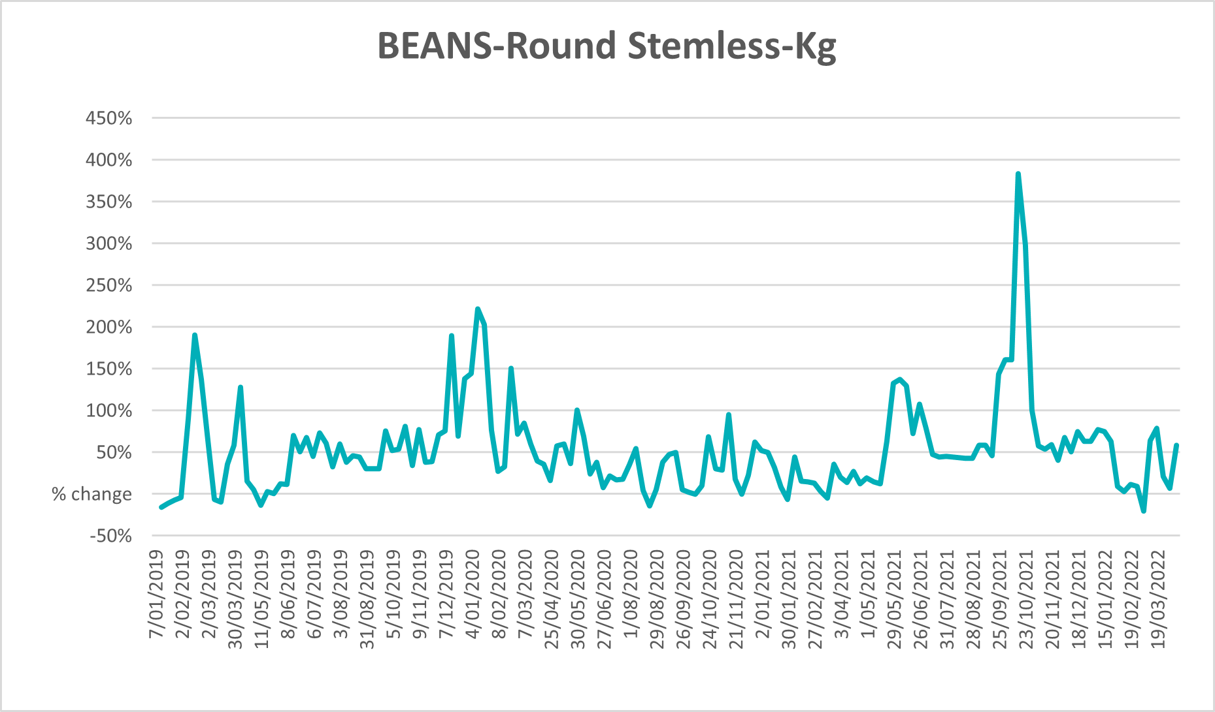

Selected domestic fodder indicator prices
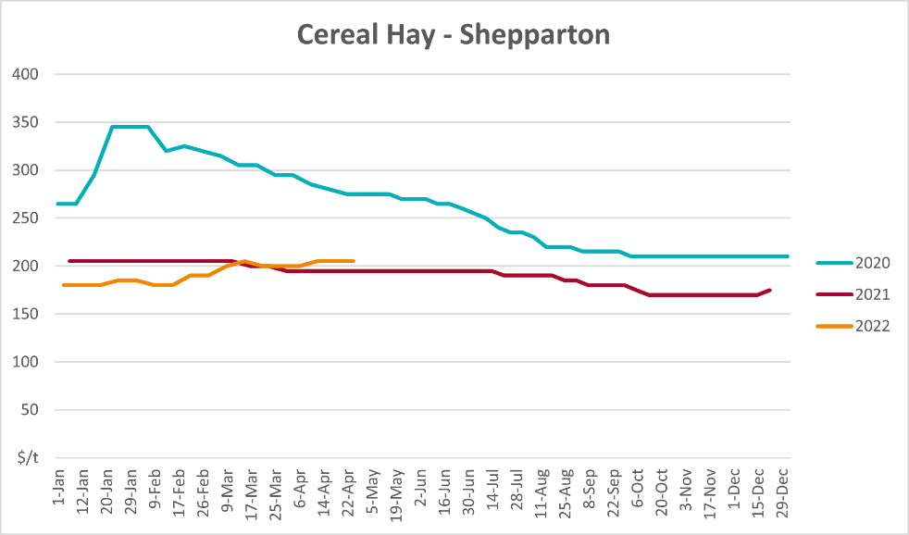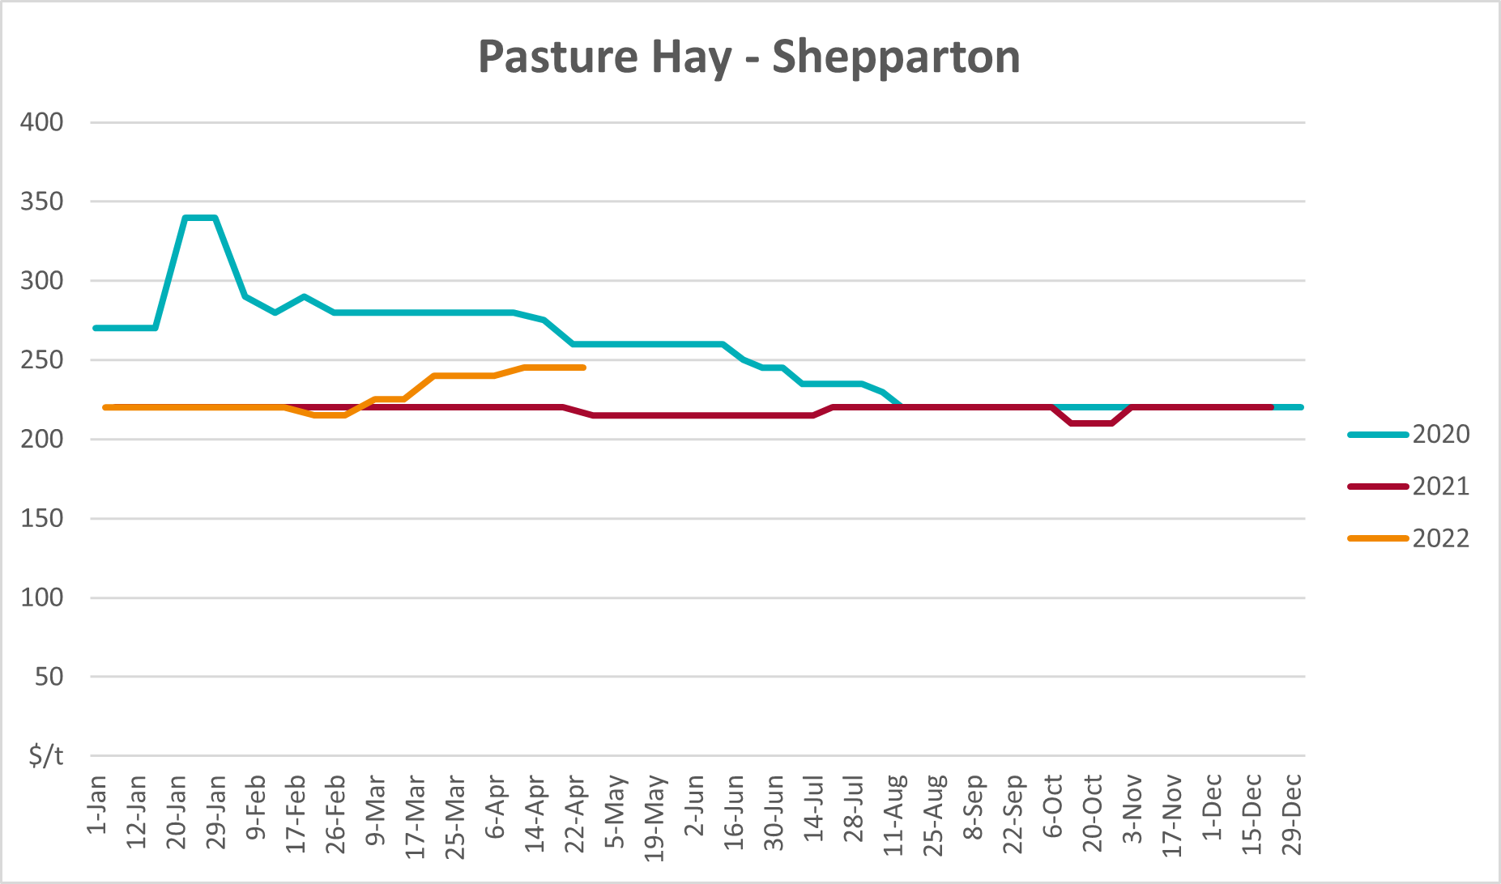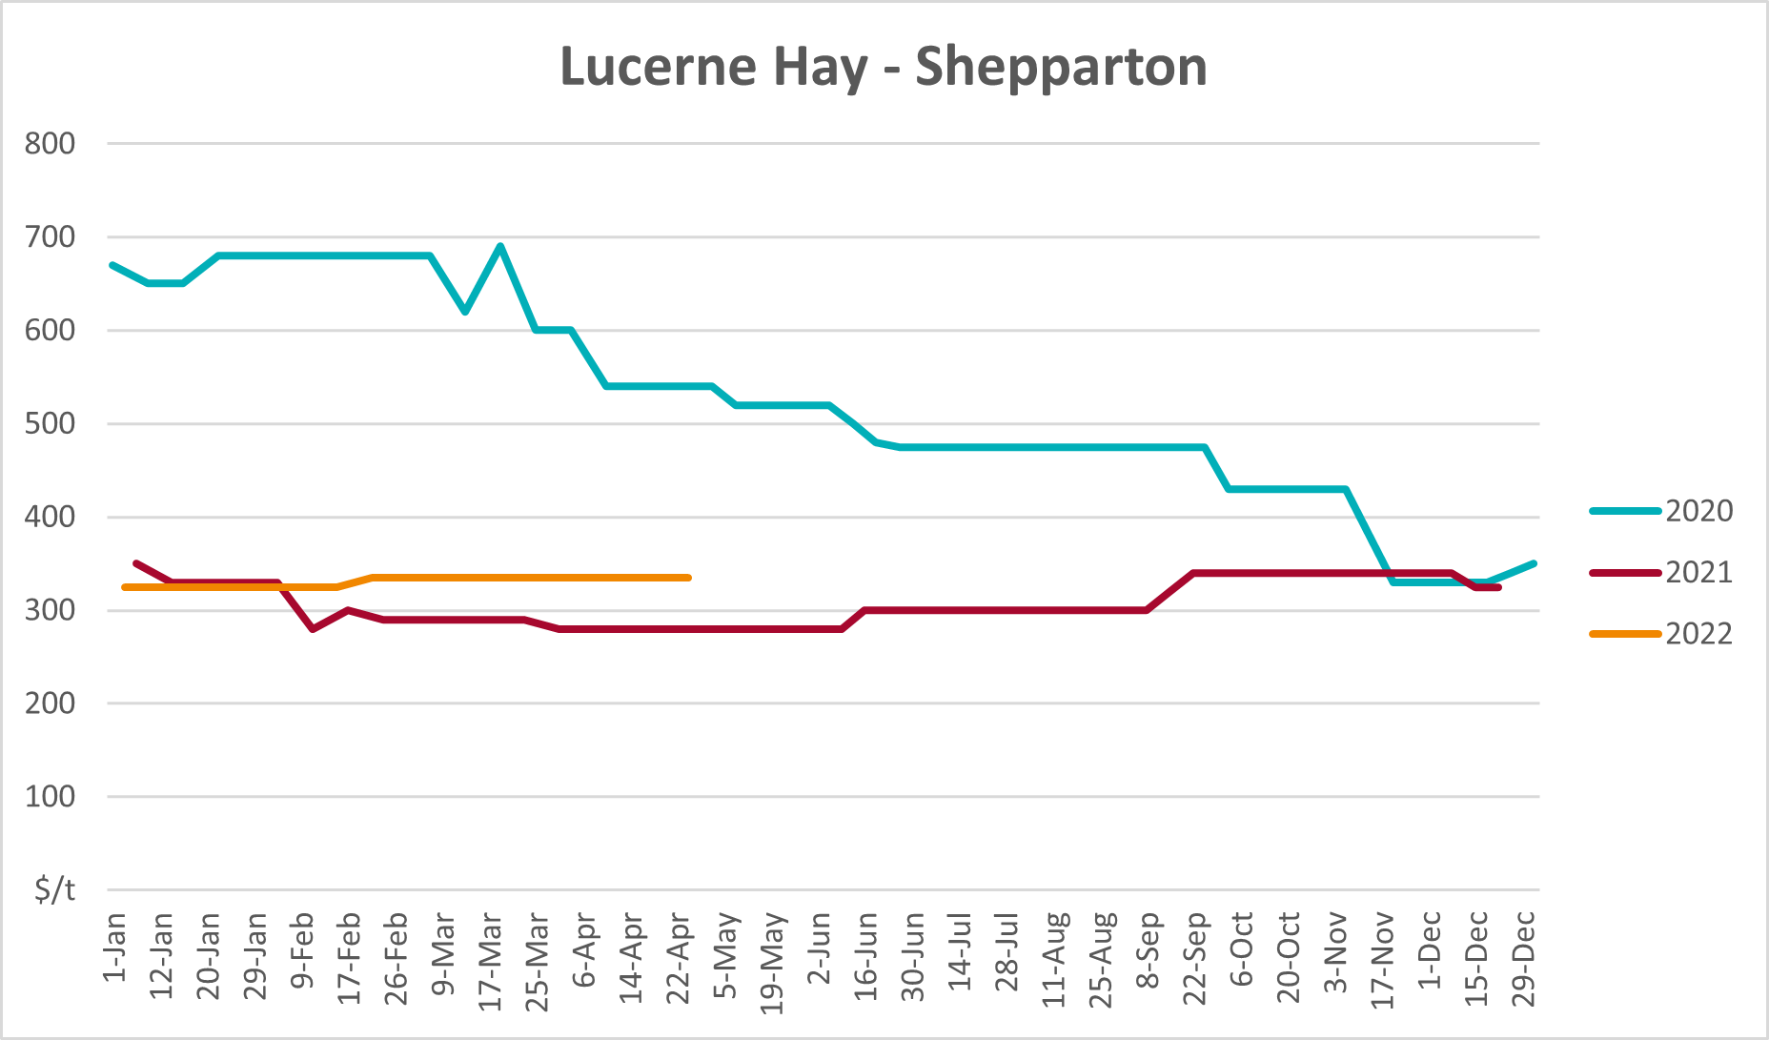

Data attribution

Climate
Bureau of Meteorology
- Weekly rainfall totals: www.bom.gov.au/climate/maps/rainfall/
- Monthly and last 3-month rainfall percentiles: www.bom.gov.au/water/landscape/
- Temperature anomalies: www.bom.gov.au/jsp/awap/temp/index.jsp
- Rainfall forecast: www.bom.gov.au/jsp/watl/rainfall/pme.jsp
- Seasonal outlook: www.bom.gov.au/climate/outlooks/#/overview/summary/
- Climate drivers: http://www.bom.gov.au/climate/enso/
- Soil moisture: www.bom.gov.au/water/landscape/
Other
- Pasture growth: www.longpaddock.qld.gov.au/aussiegrass/
- 3-month global outlooks: Environment and Climate Change Canada, NOAA Climate Prediction Center, EUROBRISA CPTEC/INPE, European Centre for Medium-Range Weather Forecasts, Hydrometcenter of Russia, National Climate Center Climate System Diagnosis and Prediction Room (NCC), International Research Institute for Climate and Society
- Global production: https://ipad.fas.usda.gov/ogamaps/cropmapsandcalendars.aspx
- Autumn break: Pook et al., 2009, https://rmets-onlinelibrary-wiley-com.virtual.anu.edu.au/doi/epdf/10.1002/joc.1833

Water
Prices
- Waterflow: https://www.waterflow.io/
- Ruralco: https://www.ruralcowater.com.au/
Bureau of Meteorology:
- Allocation trade: http://www.bom.gov.au/water/dashboards/#/water-markets/mdb/at
- Storage volumes: http://www.bom.gov.au/water/dashboards/#/water-storages/summary/drainage
Trade constraints:
- Water NSW: https://www.waternsw.com.au/customer-service/ordering-trading-and-pricing/trading/murrumbidgee
- Victorian Water Register: https://www.waterregister.vic.gov.au/TradingRules2019/

Commodities
Fruit and vegetables
- Datafresh: www.freshstate.com.au
Pigs
- Australian Pork Limited: www.australianpork.com.au
Dairy
- Global Dairy Trade: www.globaldairytrade.info/en/product-results/
World wheat, canola
- International Grains Council
World coarse grains
- United States Department of Agriculture
World cotton
- Cotlook: www.cotlook.com/
World sugar
- New York Stock Exchange - Intercontinental Exchange
Wool
- Australian Wool Exchange: www.awex.com.au/
Domestic wheat, barley, sorghum, canola and fodder
- Jumbuk Consulting Pty Ltd: http://www.jumbukag.com.au/
Cattle, beef, mutton, lamb, goat and live export
- Meat and Livestock Australia: www.mla.com.au/Prices-and-market
© Commonwealth of Australia 2022

Ownership of intellectual property rights
Unless otherwise noted, copyright (and any other intellectual property rights, if any) in this publication is owned by the Commonwealth of Australia (referred to as the Commonwealth).

Creative Commons licence
All material in this publication is licensed under a Creative Commons Attribution 4.0 International Licence except content supplied by third parties, logos and the Commonwealth Coat of Arms.
Inquiries about the licence and any use of this document should be emailed to copyright@awe.gov.au.


Cataloguing data
This publication (and any material sourced from it) should be attributed as:
ABARES 2021, Weekly Australian Climate, Water and Agricultural Update, Australian Bureau of Agricultural and Resource Economics and Sciences, Canberra, 28 April 2022. CC BY 4.0 DOI: https://doi.org/10.25814/5f3e04e7d2503
ISSN 2652-7561
This publication is available at https://www.awe.gov.au/abares/products/weekly_update
Department of Agriculture, Water and the Environment
GPO Box 858 Canberra ACT 2601
Telephone 1800 900 090
Web awe.gov.au/abares

Disclaimer
The Australian Government acting through the Department of Agriculture, Water and the Environment, represented by the Australian Bureau of Agricultural and Resource Economics and Sciences, has exercised due care and skill in preparing and compiling the information and data in this publication. Notwithstanding, the Department of Agriculture, Water and the Environment, ABARES, its employees and advisers disclaim all liability, including liability for negligence and for any loss, damage, injury, expense or cost incurred by any person as a result of accessing, using or relying on any of the information or data in this publication to the maximum extent permitted by law.

Statement of Professional Independence
The views and analysis presented in ABARES publications, including this one, reflect ABARES professionally independent findings, based on scientific and economic concepts, principles, information and data. These views, analysis and findings may not reflect or be consistent with the views or positions of the Australian Government, or of organisations or groups who have commissioned ABARES reports or analysis. More information on professional independence is provided on the ABARES website.

Acknowledgements
This report was prepared by Matthew Miller and Cameron Van-Lane.

