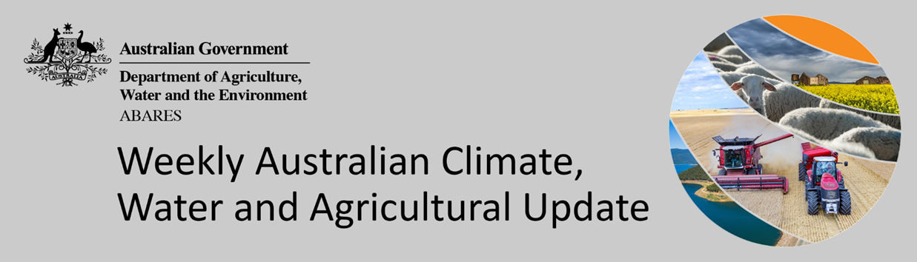
No. 13/2022

7 April 2022

Summary of key issues
- For the week ending 6 March 2022, low-pressure troughs across northern, eastern and western Australia resulted in moderate rainfall in the east, west and parts of the far north. High-pressure systems in the south resulted in clear, dry conditions for large areas of central and southern Australia (see Section 1.1).
- Rainfall in parts of northern New South Wales and southern Queensland will have exacerbated wet conditions, further delaying field access and increasing the chance of quality downgrades. The wet conditions in recent weeks mean that some early sown summer crops are still awaiting harvest. Cotton harvesting is underway in northern cropping regions of Queensland, but the wet conditions are expected to delay the start in southern Queensland and New South Wales. Across Australian cropping regions, preparation for winter sowing is underway where field access allows.
- Rainfall during March 2022 was 27% below average for Australia as a whole. Rainfall was severely deficient to below average in central and western Queensland, parts of south-central South Australia, most of the Northern Territory and western Tasmania. However, above average to extremely high rainfall was recorded across eastern and southern New South Wales, the far south-east of Queensland, western parts of Western Australia, including the Kimberley, and across large parts of Victoria, and north-eastern Tasmania (see Section 1.2).
- For the 3 months to March 2022, above average rainfall totals and mild summer temperatures resulted in average to well above average pasture production for this time of year across most grazing regions in New South Wales, Queensland, western and northern Victoria, northern South Australia, northern Western Australia, and the south of the Northern Territory. Extremely low to below average pasture growth rates were recorded across southern Western Australia, south-eastern Victoria, parts of central and northern Queensland and the north of the Northern Territory (see Section 1.4).
- Over the 8-days to 14 April 2022, troughs and low-pressure systems drawing down moisture laden air are expected to bring rainfall to much of south-eastern Australia, with cold fronts expected to bring rainfall to parts of western and southern Australia. Meanwhile, high pressure systems are expected to bring mostly dry conditions to central Australia (see Section 1.5).
- Water storage in the Murray–Darling Basin (MDB) decreased by 96 gigalitres (GL) between 30 March 2022 and 7 April 2022. The current volume of water held in storage is 21,567GL, which represents 85 per cent of total capacity. This is 49% or 7,124 GL more than at the same time last year.
- Allocation prices in the Victorian Murray below the Barmah Choke increased from $60 per ML on 30 March 2022 to $70 per ML on 6 April 2022. Prices are lower in the Goulburn-Broken, Murrumbidgee and regions above the Barmah choke due to the binding of the Goulburn intervalley trade limit, Murrumbidgee export limit and Barmah choke trade constraint.

Climate

Rainfall this week
For the week ending 6 March 2022, low-pressure troughs across northern, eastern and western Australia resulted in moderate rainfall in the east, west and parts of the far north. High-pressure systems in the south resulted in clear, dry conditions for large areas of central and southern Australia.
Rainfall totals of between 10 and 50 millimetres were recorded across parts of eastern and north-eastern parts of New South Wales, south-eastern, central and far northern Queensland, eastern Victoria, western and southern parts of Western Australia, as well as northern parts of the Northern Territory and parts of Tasmania. Rainfall totals in excess of 50 millimetres were recorded across coastal areas of New South Wales, south-east and northern Queensland, far-eastern Victoria and the west of Western Australia. Remaining parts of Australia received little to no rainfall.
In cropping regions, rainfall totals of between 10 and 50 millimetres were recorded across isolated areas of northern New South Wales, southern and western Queensland and most of Western Australia. Rainfall in excess of 100 millimetres was recorded in isolated parts of cropping regions in south-eastern Queensland. Little to no rainfall was recorded across cropping regions in remaining parts of New South Wales and Queensland, as well as Victoria and South Australia.
Rainfall in parts of northern New South Wales and southern Queensland will have exacerbated wet conditions, further delaying field access and increasing the chance of quality downgrades. The wet conditions in recent weeks mean that some early sown summer crops are still awaiting harvest. Cotton harvesting is underway in northern cropping regions of Queensland, but the wet conditions are expected to delay the start in southern Queensland and New South Wales. Across Australian cropping regions, preparation for winter sowing is underway where field access allows. Growers in central and southern New South Wales are reported to have dry sown winter crops ahead of an expected autumn break over the next 8 days.

Rainfall for the week ending 7 April 2022

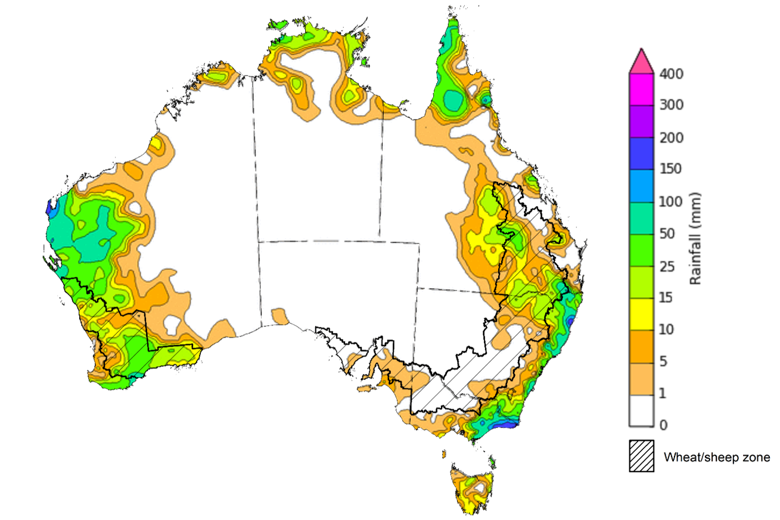
©Commonwealth of Australia 2022, Australian Bureau of Meteorology Issued: 30/3/2022
Note: The rainfall analyses and associated maps utilise data contained in the Bureau of Meteorology climate database, the Australian Data Archive for Meteorology (ADAM). The analyses are initially produced automatically from real-time data with limited quality control. They are intended to provide a general overview of rainfall across Australia as quickly as possible after the observations are received. For further information go to http://www.bom.gov.au/climate/rainfall/

Monthly rainfall
Rainfall during March 2022 was 27% below average for Australia as a whole. Rainfall was severely deficient to below average in central and western Queensland, parts of south-central South Australia, most of the Northern Territory and western Tasmania. However, above average to extremely high rainfall was recorded across eastern and southern New South Wales, the far south-east of Queensland, western parts of Western Australia, including the Kimberley, and across large parts of Victoria, and north-eastern Tasmania.
The main climate influences for March were a La Niña event in the Pacific, a positive South Annular Mode resulting in persistent high-pressure systems over the Great Australian Bight, and above average sea surface temperatures to the north-west and south-east of Australia. East Coast Lows brought extremely high rainfall totals across the east coast in the early and latter parts of March.
March rainfall was average to above average across cropping regions of New South Wales, Victoria and Western Australia, as well as most of Queensland, with below average falls recorded in cropping regions of Central Queensland and parts of South Australia.
The extremely high rainfall across eastern New South Wales and south-eastern Queensland resulted in localised flooding as well as crop losses. Moreover, the wet weather has further delayed the harvesting of mature summer crops. Across southern and western cropping regions, the wet weather has topped up soil moisture levels as winter sowing activity gets underway in some regions.

Rainfall percentiles for March 2022

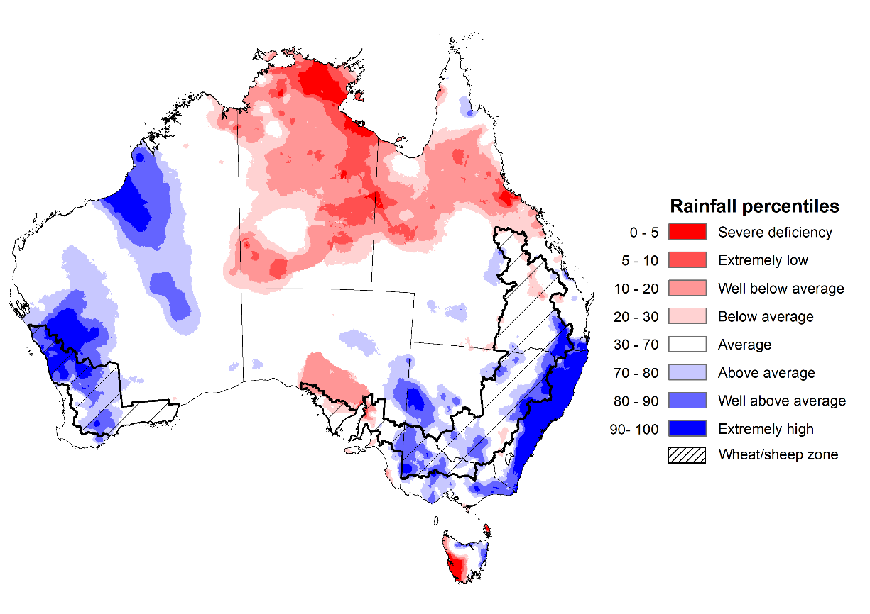
Note: Rainfall for March 2022 is compared with rainfall recorded for that period during the historical record (1900 to present). For further information, go to http://www.bom.gov.au/jsp/awap/
Source: Bureau of Meteorology

Monthly soil moisture
Upper layer soil moisture in March 2022 was extremely low for this time of year across much of northern Queensland, isolated parts of South Australia and Western Australia, as well as large parts of the Northern Territory and western Tasmania due to below average rainfall in these areas during March. Extremely high upper layer soil moisture was evident across large areas of New South Wales, south-east Queensland, Victoria, the east of South Australia, as well as the west and central areas of Western Australia reflecting heavy rainfall events towards the beginning of March. Modelled upper layer soil moisture was generally average across the remainder of the country.
At this time of year, upper layer soil moisture is important for the establishment and vegetative growth of late planted summer crops in the Central Queensland growing region and for pasture growth across northern Australia. It is also important indicator of the ability to access paddocks to undertake harvest and planting activities for long season winter crops.
Upper layer soil moisture was average to above average for this time of year across most cropping regions in New South Wales, Victoria and Western Australia, as well as southern Queensland. Upper layer soil moisture was below average to average for isolated parts of the northern Queensland growing region. Extremely high to above average upper layer soil moisture was evident across much of north-eastern New South Wales and west Victorian cropping regions. Extremely high upper layer soil moisture would have prevented field access for growers across much of New South Wales and south-east Queensland. The below average to average upper layer soil moisture in parts of northern Queensland may have negatively impacted late sown summer crops, but likely allowed field access for cotton harvesting to commence and field preparation for winter sowing.

Modelled upper layer soil moisture for March 2022

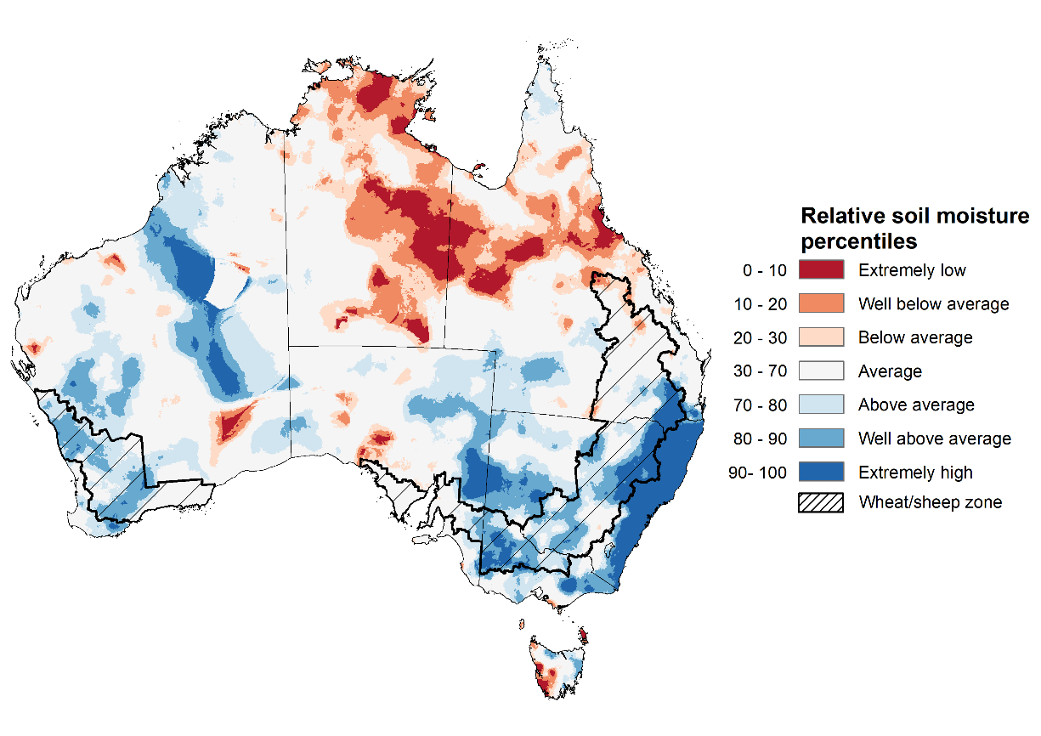

Note: This map shows the levels of modelled upper layer soil moisture (0 to 10 centimetres) during March 2022. This map shows how modelled soil conditions during March 2022 compare with January conditions modelled over the reference period (1911 to 2016). Dark blue areas on the maps were much wetter in March 2022 than during the reference period. The bulk of plant roots occur in the top 20 centimetres of the soil profile. Soil moisture in the upper layer of the soil profile is therefore useful indicator of the availability of water, particularly for germinating seed.
Source: Bureau of Meteorology (Australian Water Resources Assessment Landscape model)

Lower layer soil moisture for March 2022 was well above average to extremely high for this time of year across parts of south-eastern, south-central and north-western Australia. Lower layer soil moisture was well below average to below average across the much of central and northern Queensland, isolated parts of Western Australia, the north of the Northern Territory and western Tasmania.
In cropping regions, lower layer soil moisture was well above average to extremely high for parts of eastern New South Wales, south-east Queensland, Western Victoria as well as parts of the Eyre Peninsula in South Australia. Lower layer soil moisture was extremely low to below average for central and northern Queensland and eastern parts of Western Australian cropping regions. The below average lower layer soil moisture may reduce yield potentials for late sown summer crops in Central Queensland as their root systems extend into lower soil layers. Similarly, pasture growth in northern parts of Queensland and the Northern Territory has likely struggled due to the lack of lower layer moisture.
Modelled lower layer soil moisture for March 2022
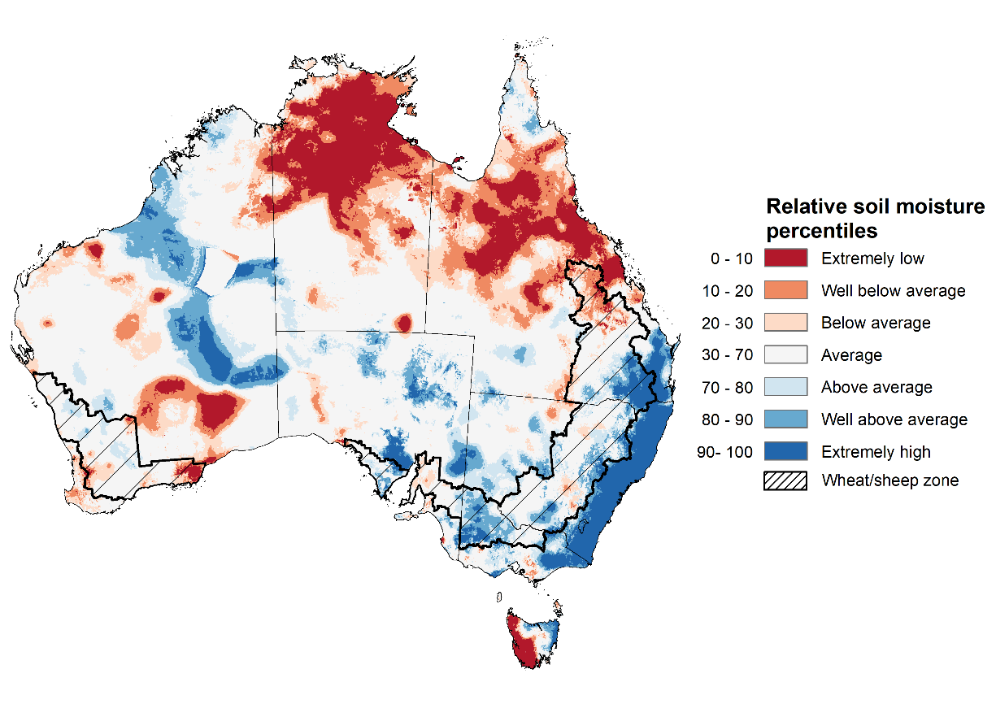
Note: This map shows the levels of modelled lower layer soil moisture (10 to 100 centimetres) during March 2022. This map shows how modelled soil conditions during March 2022 compare with March conditions modelled over the reference period (1911 to 2016). Dark blue areas on the maps were much wetter in March 2022 than during the reference period. The dark red areas were much drier than during the reference period. The bulk of plant roots occur in the top 20 centimetres of the soil profile. The lower layer soil moisture is a larger, deeper store that is slower to respond to rainfall and tends to reflect accumulated rainfall events over longer time periods.
Source: Bureau of Meteorology (Australian Water Resources Assessment Landscape model)

Pasture growth
January to March is the peak pasture growth period across much of northern Australia which typically provides the bulk of feed to maintain production through the low pasture growth months of the northern dry season. Across southern Australia, January to March pasture growth is typically low reflecting lower rainfall totals, high temperatures and high evapotranspiration rates at this time of year. Pasture availability during this period influences the growth and branding and marking rates of lambs and calves, livestock turnoff and the production of meat, milk, and wool.
For the 3 months to March 2022, above average rainfall totals and mild summer temperatures resulted in average to well above average pasture production for this time of year across most grazing regions in New South Wales, Queensland, western and northern Victoria, northern South Australia, northern Western Australia, and the south of the Northern Territory. Extremely low to below average pasture growth rates were recorded across southern Western Australia, south-eastern Victoria, parts of central and northern Queensland and the north of the Northern Territory consistent with above average temperatures and/or below average rainfall. In contrast, below average pasture growth rates across parts of eastern New South Wales and south-eastern Queensland are likely the result of below average temperatures and waterlogged soils.
Average to extremely high pasture production across much of New South Wales, southern Queensland, South Australia, northern Western Australia and the south of the Northern Territory will likely enable farmers to continue to rebuild stock numbers and provide opportunities to build standing dry matter availability. Below average temperatures and waterlogged soils across of eastern New South Wales and south-eastern Queensland may have restricted summer pasture growth, however, it comes after extremely high pasture growth during winter and spring that supplied average to above average pasture availability and ample opportunities to conserve excess fodder.

Relative pasture growth for 3-months ending March 2022 (1 January to 31 March 2022)
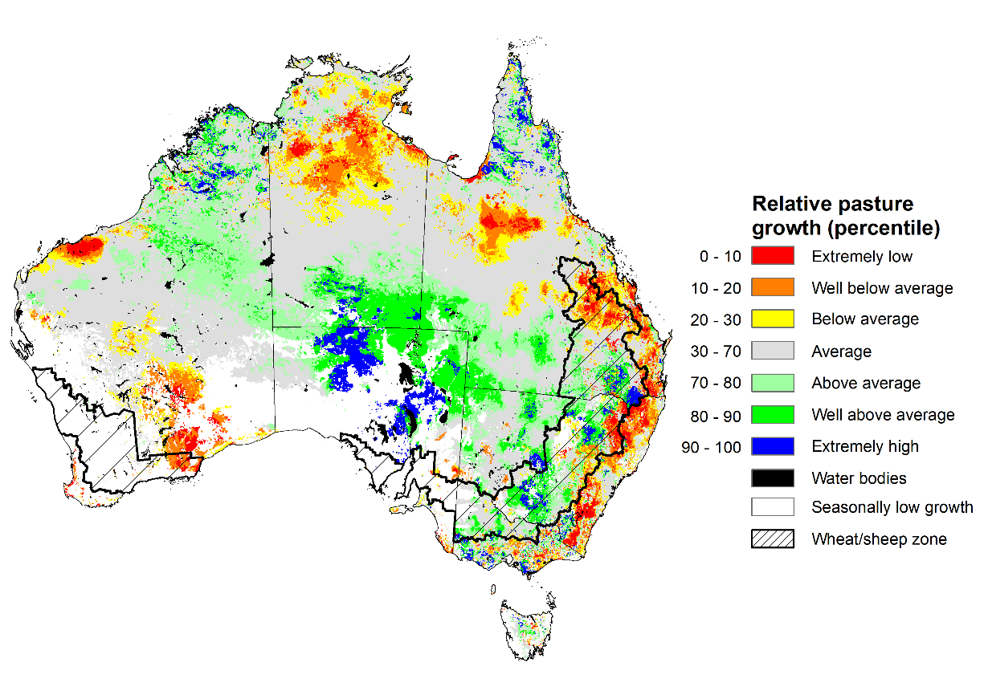
Notes: AussieGRASS pasture growth estimates are relative to the long-term record and shown in percentiles. Percentiles rank data on a scale of zero to 100. This analysis ranks pasture growth for the selected period against average pasture growth for the long-term record (1957 to 2016). Pasture growth is modelled at 5km2 grid cells.
Source: Queensland Department of Science, Information Technology and Innovation

Rainfall forecast for the next eight days
Over the 8-days to 14 April 2022, troughs and low-pressure systems drawing down moisture laden air are expected to bring rainfall to much of south-eastern Australia, with cold fronts expected to bring rainfall to parts of western and southern Australia. Meanwhile, high pressure systems are expected to bring mostly dry conditions to central Australia.
Rainfall totals of between 10 and 100 millimetres are forecast for eastern and central New South Wales and Victoria, as well as parts of south-central and eastern Queensland, southern parts of Western Australia, the far north of the Northern Territory and much of Tasmania. Rainfall in excess of 100 millimetres is expected for south-eastern New South Wales.
In Australian cropping regions, rainfall totals of between 10 and 100 millimetres are expected across much of New South Wales, with totals of between 10 and 50 millimetres expected in southern and eastern Victoria, past of south-western Queensland, as well as southern Western Australia. Little to no rainfall is forecast for all remaining cropping regions during the next 8-days.
The dry conditions across most cropping regions in Queensland will be a welcome break from heavy rainfalls in the past month. Soil moisture levels are well above average for parts of southern Queensland and much of northern New South Wales, delaying the harvesting of summer crops and planting of long season winter crops. The forecast dry conditions across most Queensland cropping regions will allow soil profiles to drain and mature crops to dry out. There are reports of yield losses for early sown sorghum crops due to grain shattering, as well as a high risk of production losses and ginning delays for cotton crops in southern Queensland and northern New South Wales due to recent rainfall. If realised, the rainfall across central and southern New South Wales would constitute an ideal autumn break, with planting of winter crops likely to get underway in the coming weeks, and plentiful plant available water to support germination and establishment.

Total forecast rainfall (mm) for the period 7 March to14 April 2022
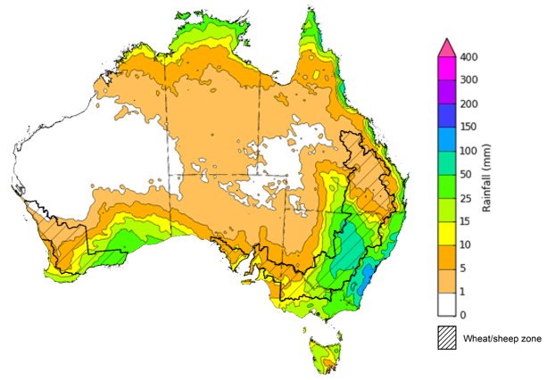
©Commonwealth of Australia 2022, Australian Bureau of Meteorology Issued: 07/04/2022
Note: This rainfall forecast is produced from computer models. As the model outputs are not altered by weather forecasters, it is important to check local forecasts and warnings issued by the Bureau of Meteorology.

Water

Water markets – current week
Water storage in the Murray–Darling Basin (MDB) decreased by 96 gigalitres (GL) between 30 March 2022 and 7 April 2022. The current volume of water held in storage is 21,567GL, which represents 85 per cent of total capacity. This is 49% or 7,124 GL more than at the same time last year.

Water storages in the Murray-Darling Basin, 2013–2022
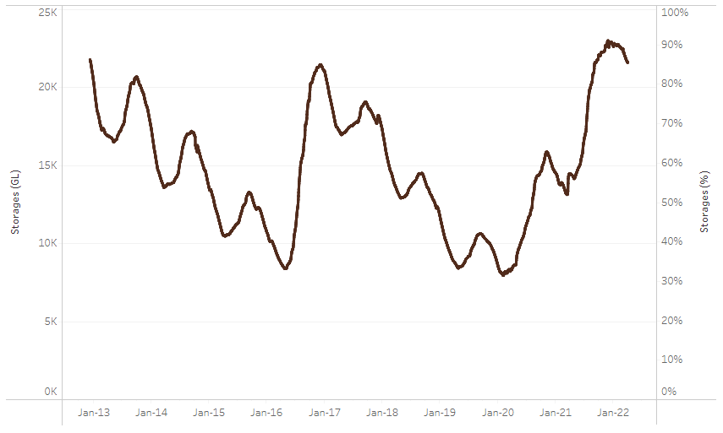
Allocation prices in the Victorian Murray below the Barmah Choke increased from $60 per ML on 30 March 2022 to $70 per ML on 6 April 2022. Prices are lower in the Goulburn-Broken, Murrumbidgee and regions above the Barmah choke due to the binding of the Goulburn intervalley trade limit, Murrumbidgee export limit and Barmah choke trade constraint.
Water storage data is sourced from the Bureau of Meteorology.

Region | $/ML
NSW Murray Above | 18
NSW Murrumbidgee | 10
VIC Goulburn-Broken | 40
VIC Murray Below | 70

Surface water trade activity, Southern Murray–Darling Basin

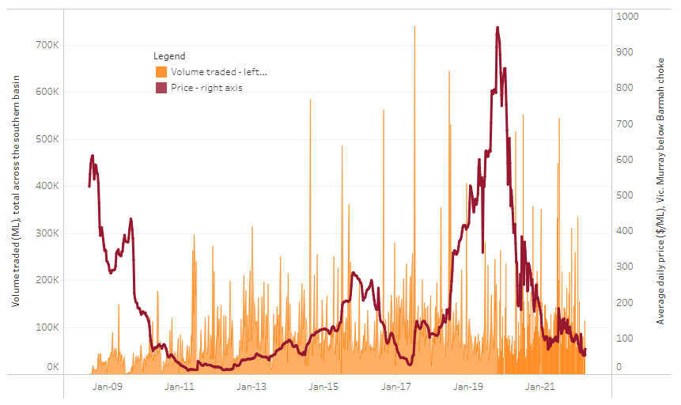
To access the full, interactive, weekly water dashboard, which contains the latest and historical water storage, water market and water allocation information, please visit http://www.agriculture.gov.au/abares/products/weekly_update/weekly-update-070422
The trades shown reflect estimated market activity and do not encompass all register trades. The price is shown for the VIC Murray below the Barmah choke. Historical prices (before 1 July 2019) are ABARES estimates after removing outliers from BOM water register data. Prices after 1 July 2019 and prior to the 30 October 2019 reflect recorded transaction prices as sourced from Ruralco. Prices after the 30 October 2019 are sourced from Waterflow. Data for volume traded is sourced from the BOM water register. Data shown is current at 31 March 2022.

Commodities

Indicator | Week ended | Unit | Latest price | Previous week | Weekly change | Price 12 months ago | Annual change
Selected world indicator prices
AUD/USD Exchange rate | 06-Apr | A$/US$ | 0.76 | 0.75 | 1% | 0.76 | -1%
Wheat – US no. 2 hard red winter wheat, fob Gulf | 06-Apr | US$/t | 465 | 479 | -3% | 267 | 74%
Corn – US no. 2 yellow corn, fob Gulf | 06-Apr | US$/t | 352 | 358 | -2% | 251 | 40%
Canola – Rapeseed, Canada, fob Vancouver | 06-Apr | US$/t | 972 | 966 | 1% | 601 | 62%
Cotton – Cotlook 'A' Index | 06-Apr | USc/lb | 153 | 156 | -2% | 88 | 73%
Sugar – Intercontinental Exchange, nearby futures, no.11 contract | 06-Apr | USc/lb | 19.5 | 19.0 | 2% | 15 | 26%
Wool – Eastern Market Indicator | 06-Apr | Ac/kg clean | 1,395 | 1,395 | 0% | 1,318 | 6%
Wool – Western Market Indicator | 02-Feb | Ac/kg clean | 1,443 | 1,455 | -1% | 1,024 | 41%
Selected Australian grain export prices
Milling Wheat – APW, Port Adelaide, SA | 06-Apr | A$/t | 526 | 535 | -2% | 347 | 52%
Feed Wheat – ASW, Port Adelaide, SA | 06-Apr | A$/t | 624 | 620 | 1% | 345 | 81%
Feed Barley – Port Adelaide, SA | 06-Apr | A$/t | 452 | 455 | -1% | 293 | 54%
Canola – Kwinana, WA | 06-Apr | A$/t | 1,200 | 1,181 | 2% | 666 | 80%
Grain Sorghum – Brisbane, QLD | 06-Apr | A$/t | 423 | 375 | 13% | 361 | 17%
Selected domestic livestock indicator prices
Beef – Eastern Young Cattle Indicator | 06-Apr | Ac/kg cwt | 1,094 | 1,093 | 0% | 879 | 24%
Mutton – Mutton indicator (18–24 kg fat score 2–3), Vic | 06-Apr | Ac/kg cwt | 570 | 569 | 0% | 687 | -17%
Lamb – Eastern States Trade Lamb Indicator | 06-Apr | Ac/kg cwt | 788 | 799 | -1% | 808 | -3%
Pig – Eastern Seaboard (60.1–75 kg), average of buyers & sellers | 23-Mar | Ac/kg cwt | 357 | 357 | 0% | 347 | 3%
Goats – Eastern States (12.1–16 kg) | 05-Jan | Ac/kg cwt | 879 | 879 | 0% | 818 | 8%
Live cattle – Light steers ex Darwin to Indonesia | 30-Mar | Ac/kg lwt | 550 | 550 | 0% | 280 | 96%
Live sheep – Live wethers (Muchea WA saleyard) to Middle East | 22-Sep | $/head | 147 | 171 | -14% | 126 | 17%

Indicator | Week ended | Unit | Latest price | Previous week | Weekly change | Price 12 months ago | Annual change
Global Dairy Trade (GDT) weighted average prices ª
Dairy – Whole milk powder | 06-Apr | US$/t | 4,532 | 4,596 | -1% | 2,966 | 53%
Dairy – Skim milk powder | 06-Apr | US$/t | 4,599 | 4,545 | 1% | 2,840 | 62%
Dairy – Cheddar cheese | 06-Apr | US$/t | 6,472 | 6,412 | 1% | 4,285 | 51%
Dairy – Anhydrous milk fat | 06-Apr | US$/t | 6,908 | 7,111 | -3% | 4,302 | 61%
a Global Dairy Trade prices are updated twice monthly on the first and third Tuesday of each month.

Selected world indicator prices
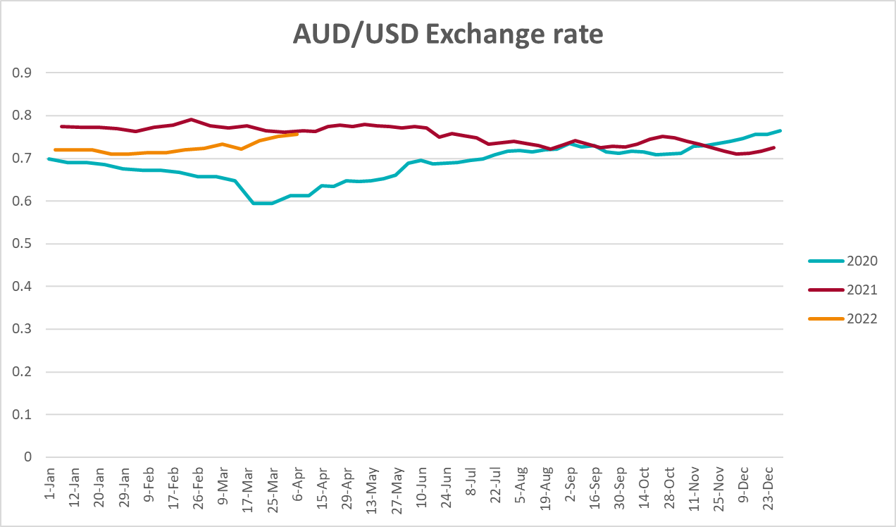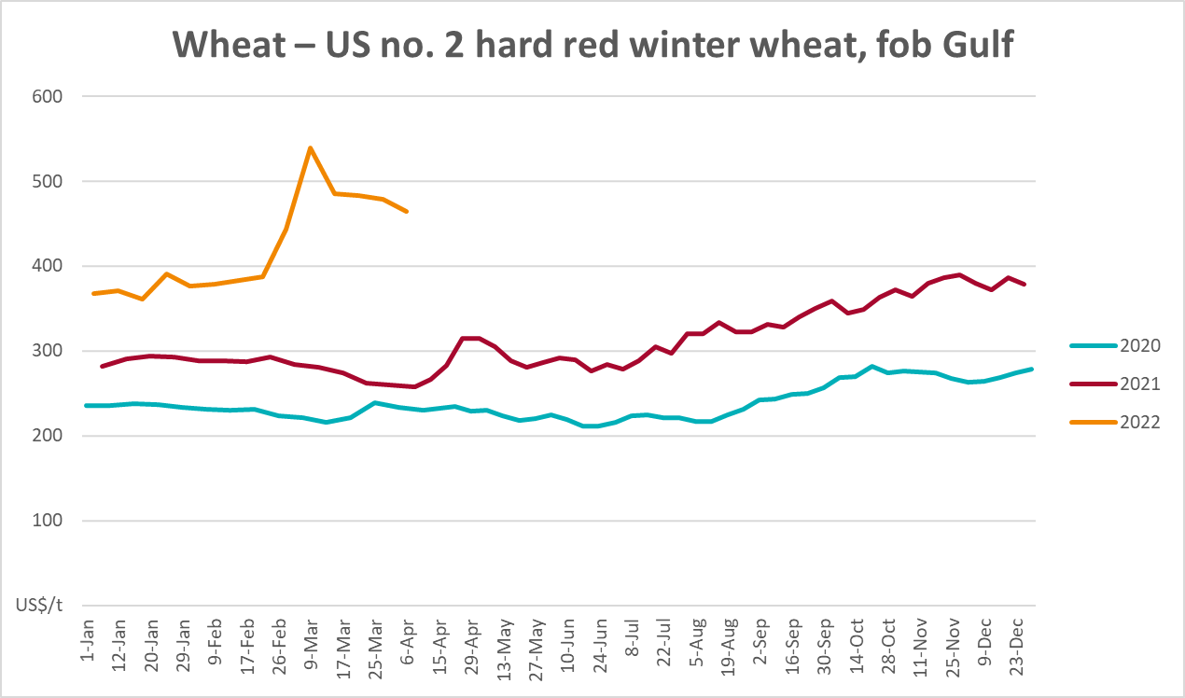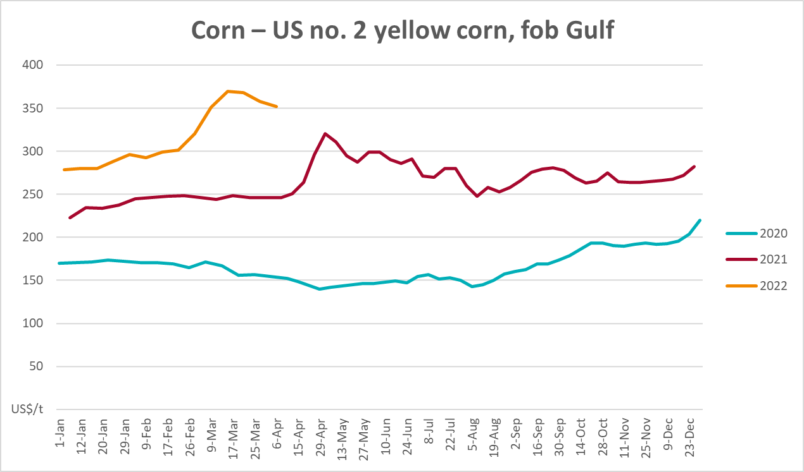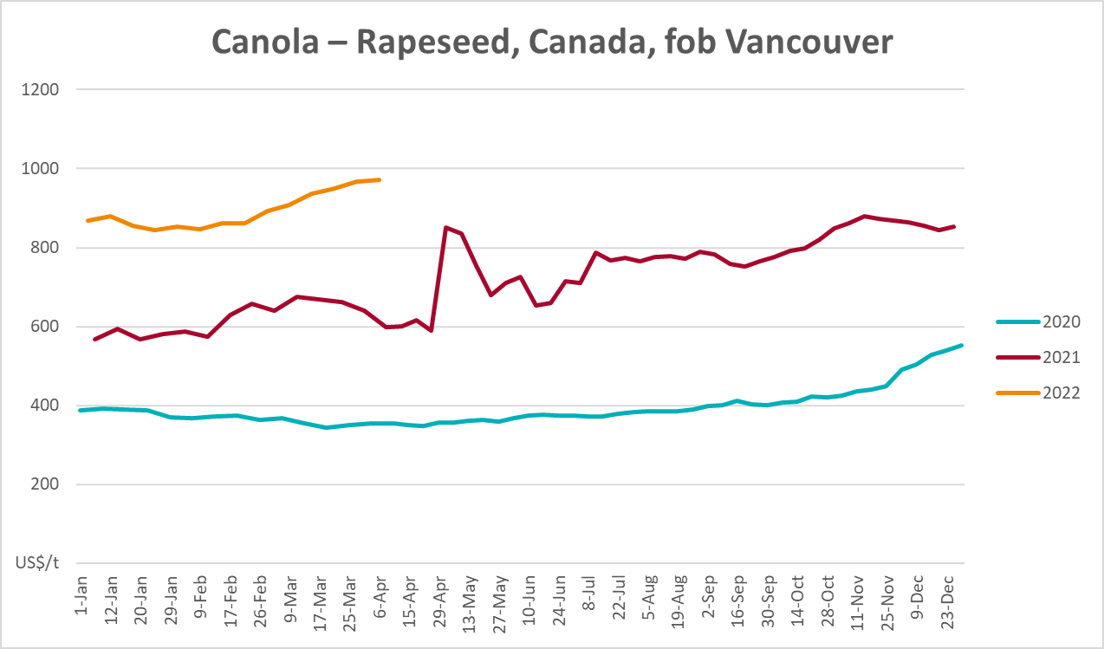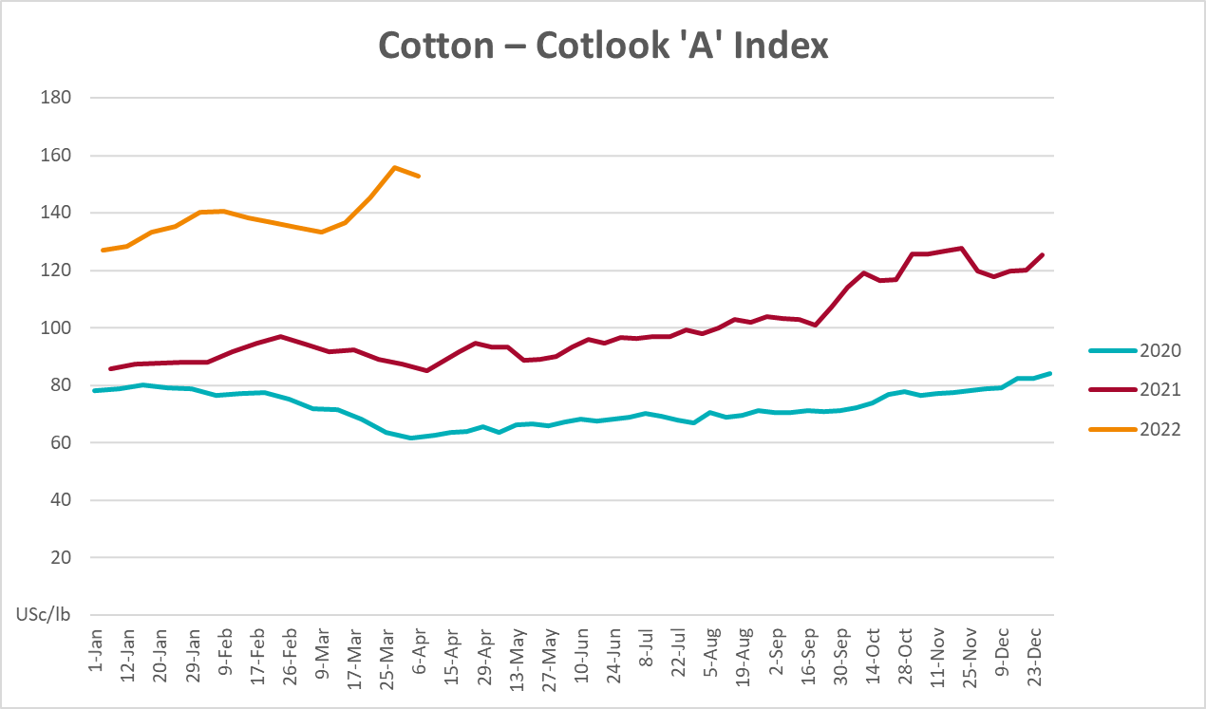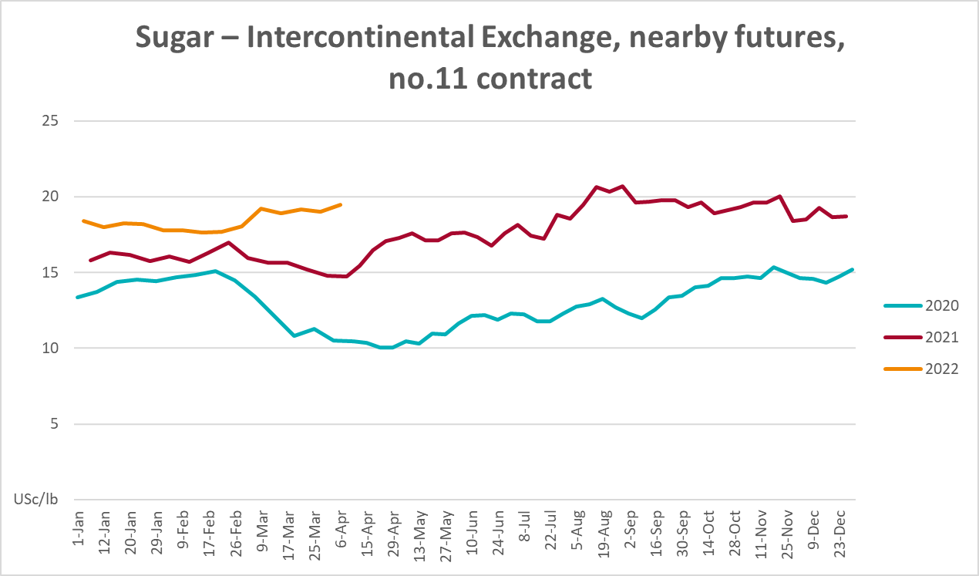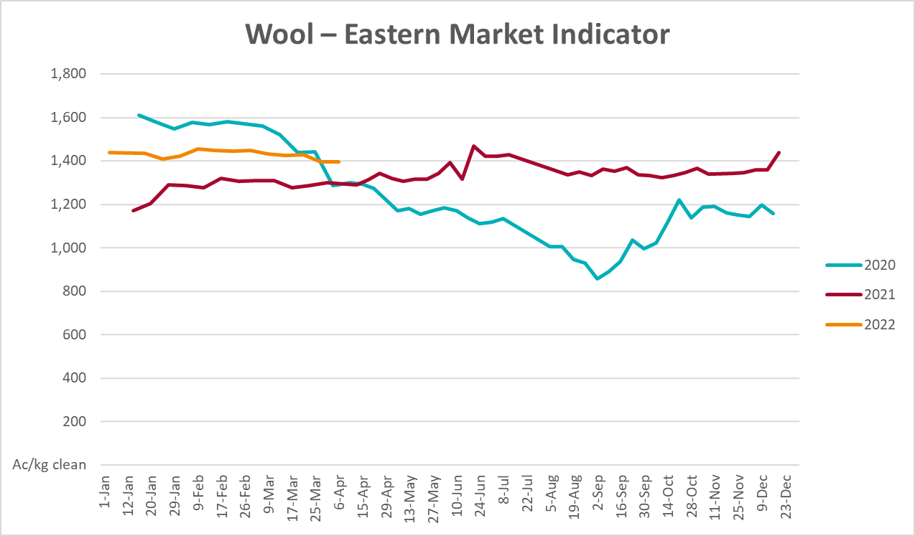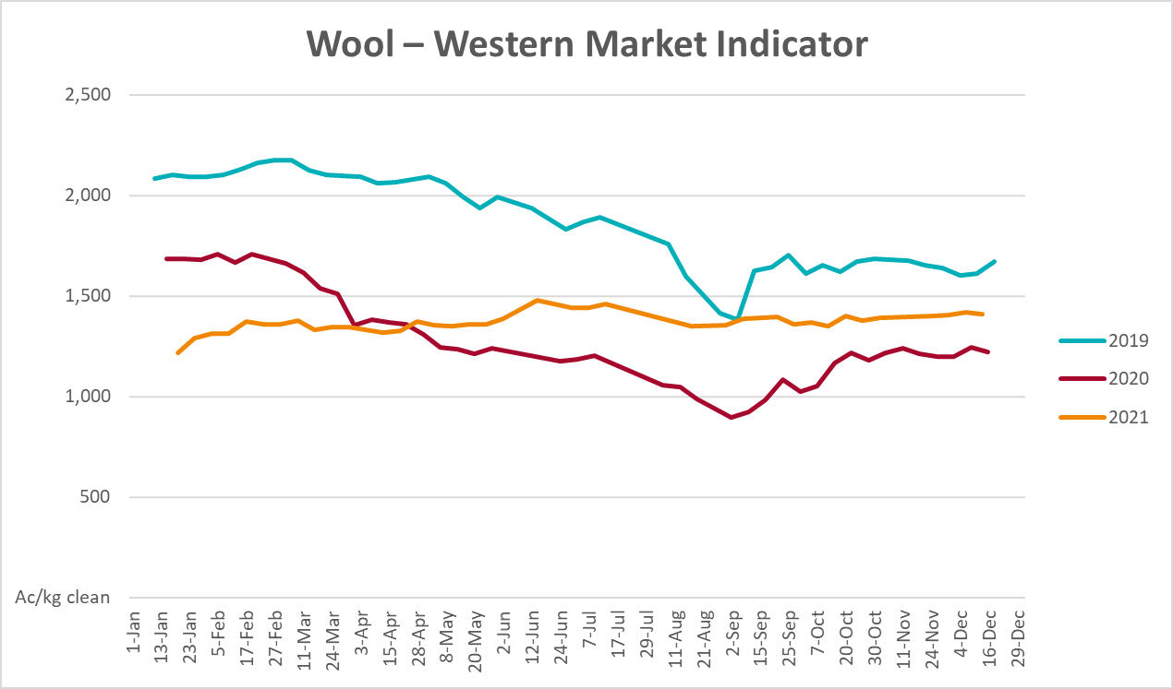

Selected domestic crop indicator prices
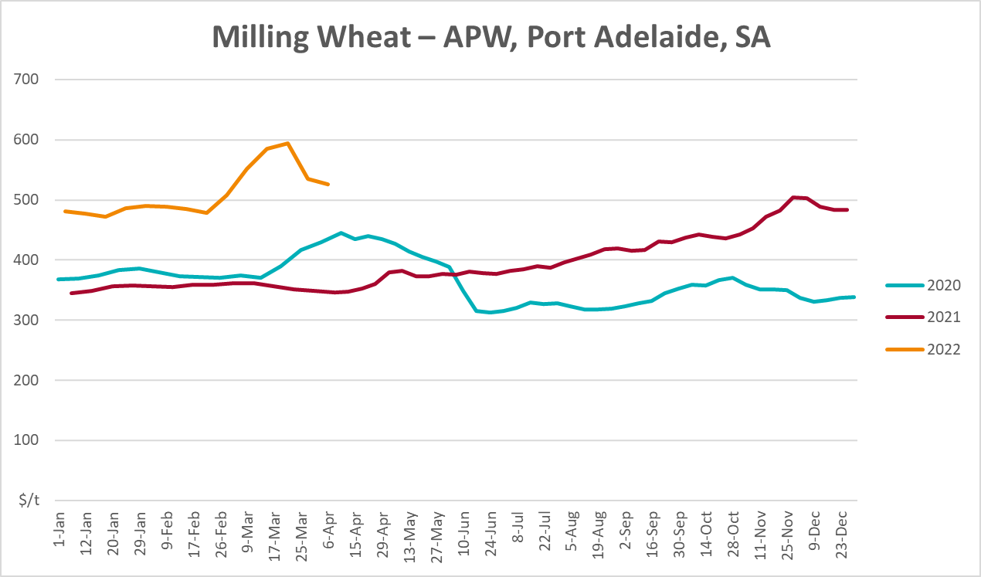
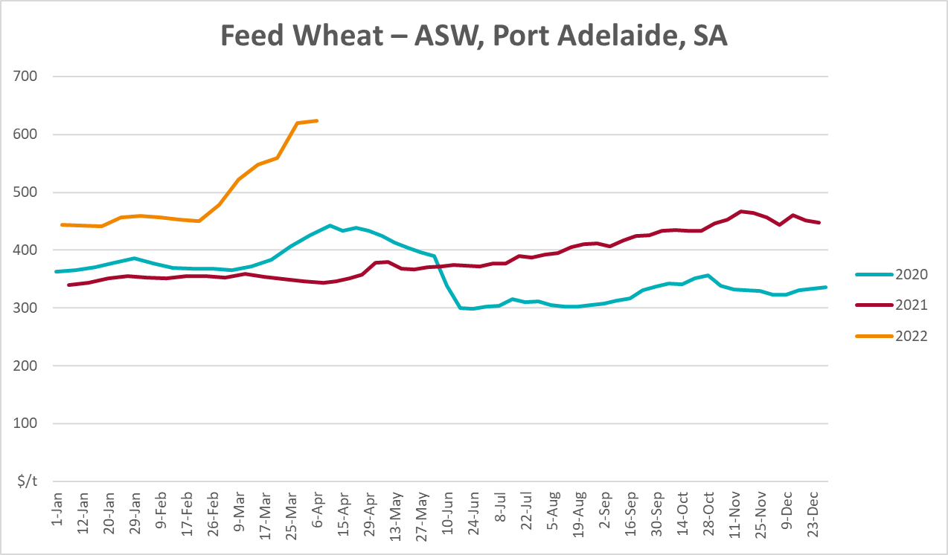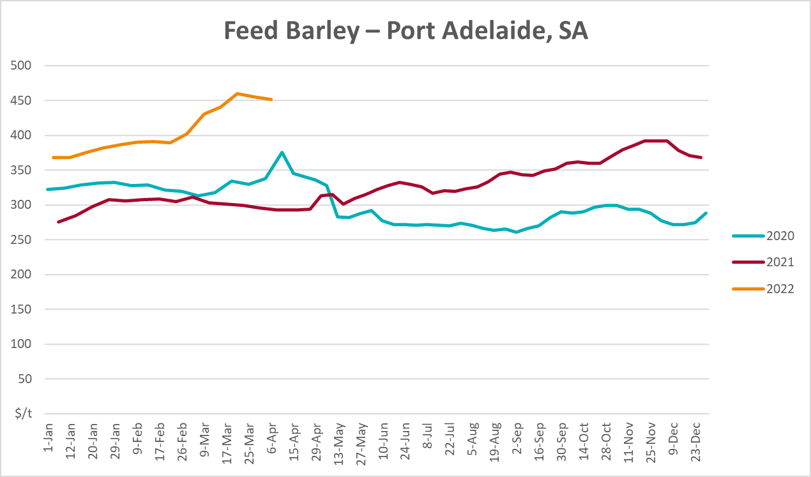
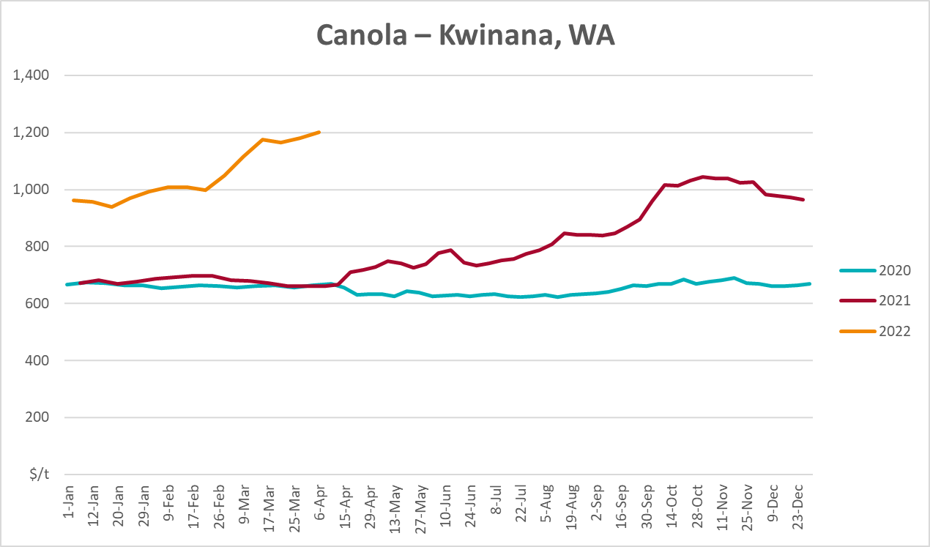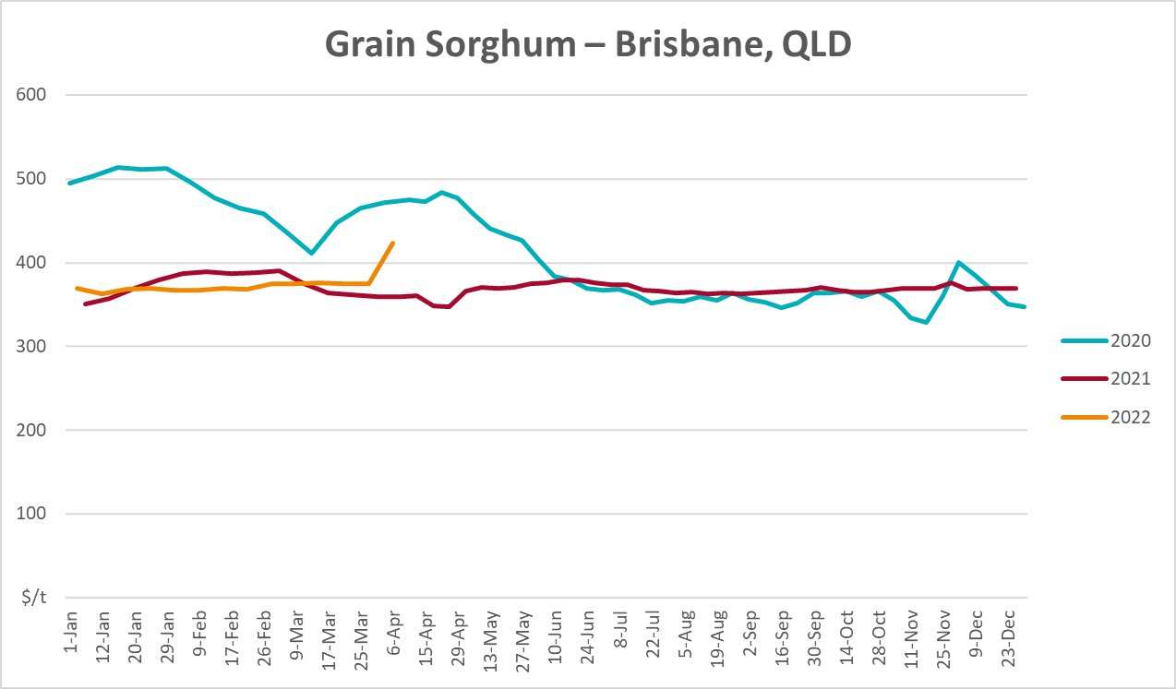

Selected domestic livestock indicator prices
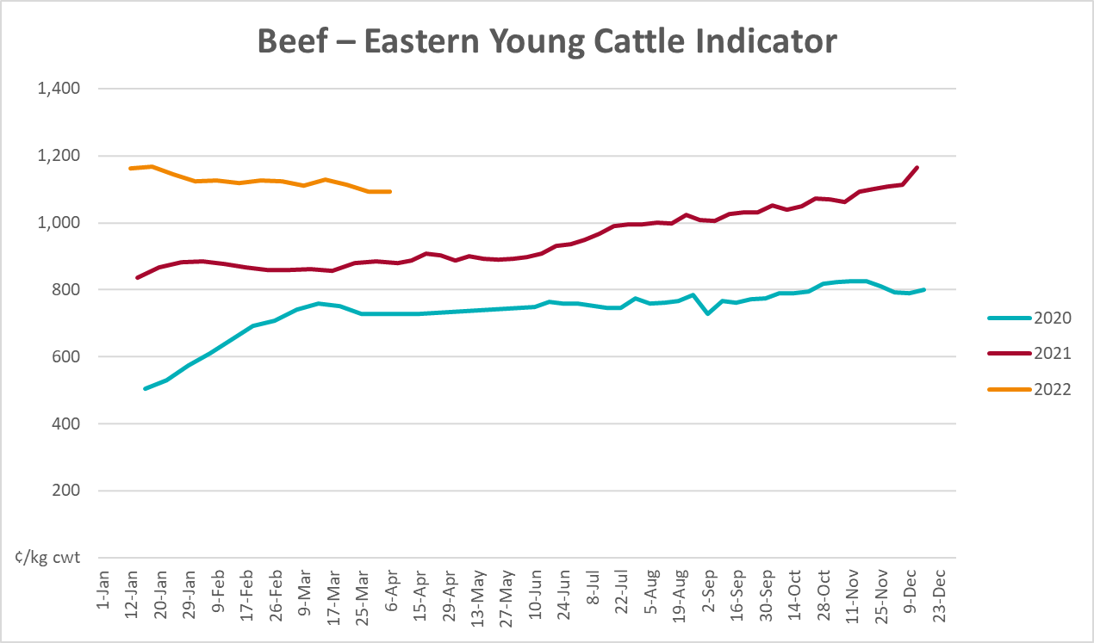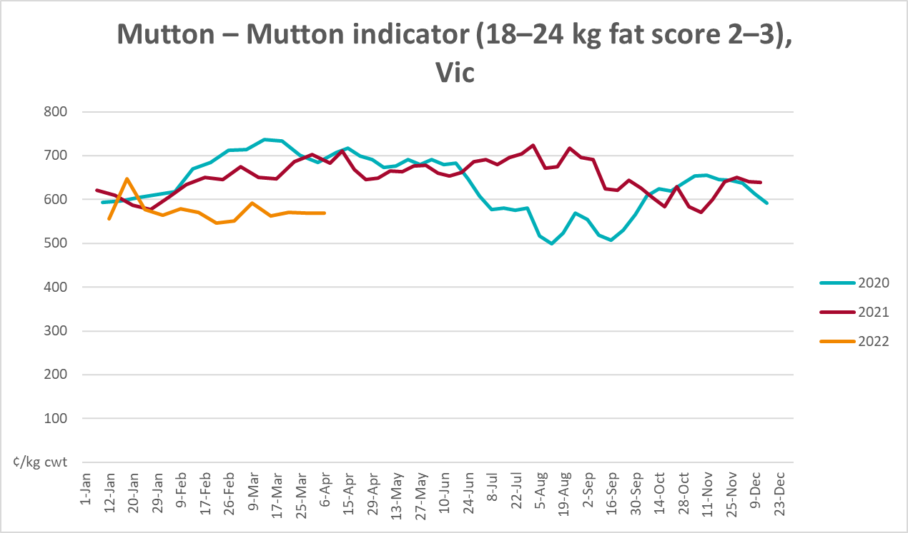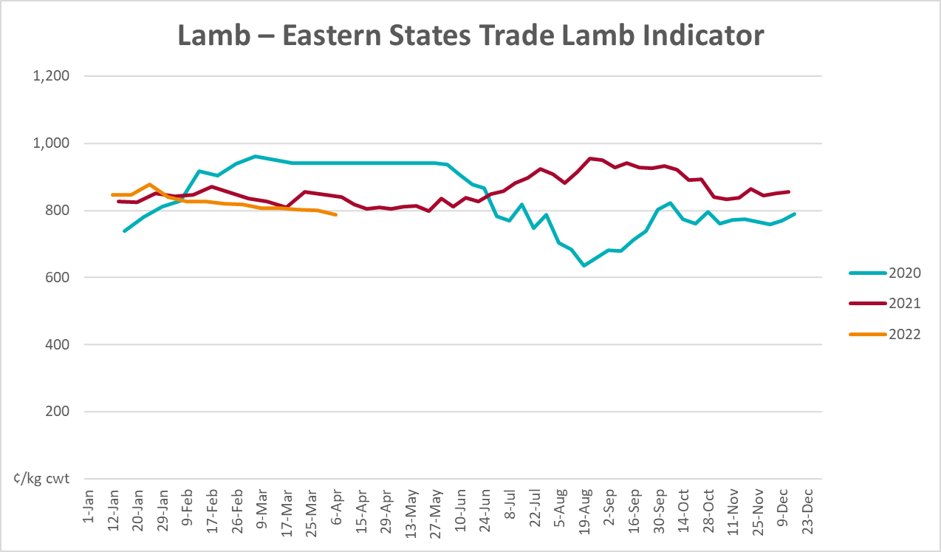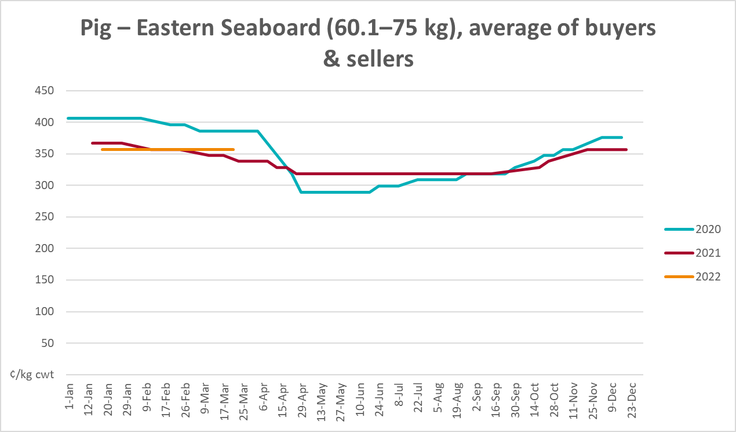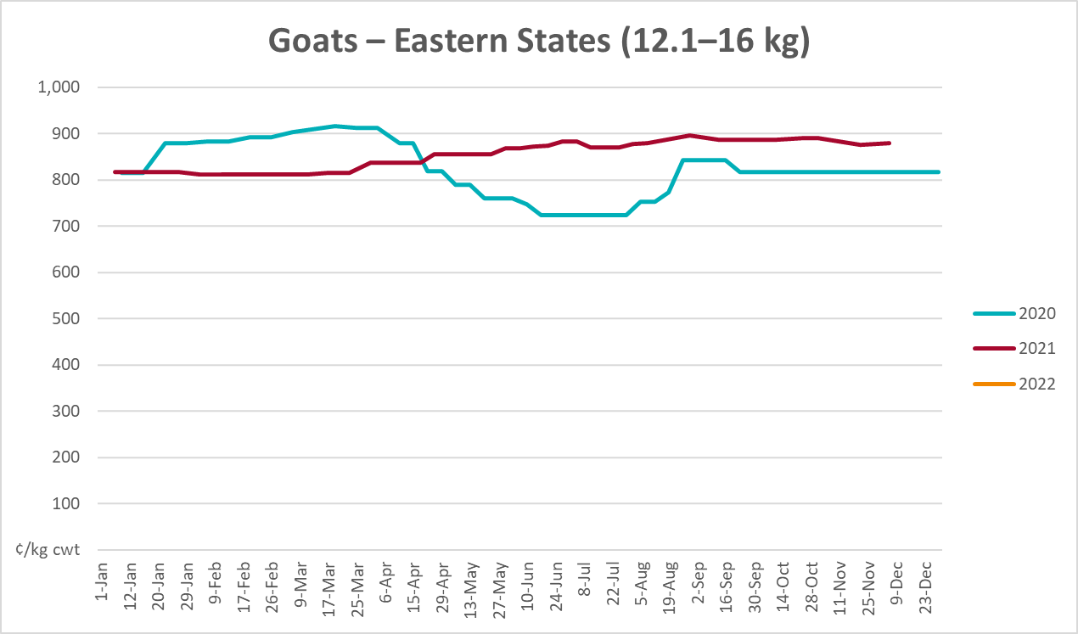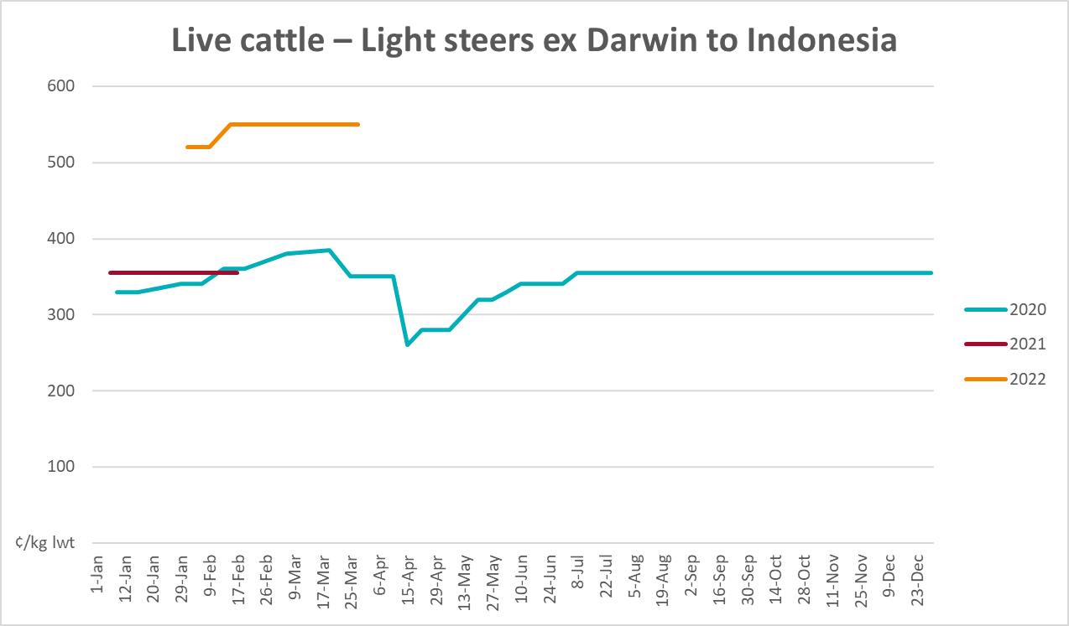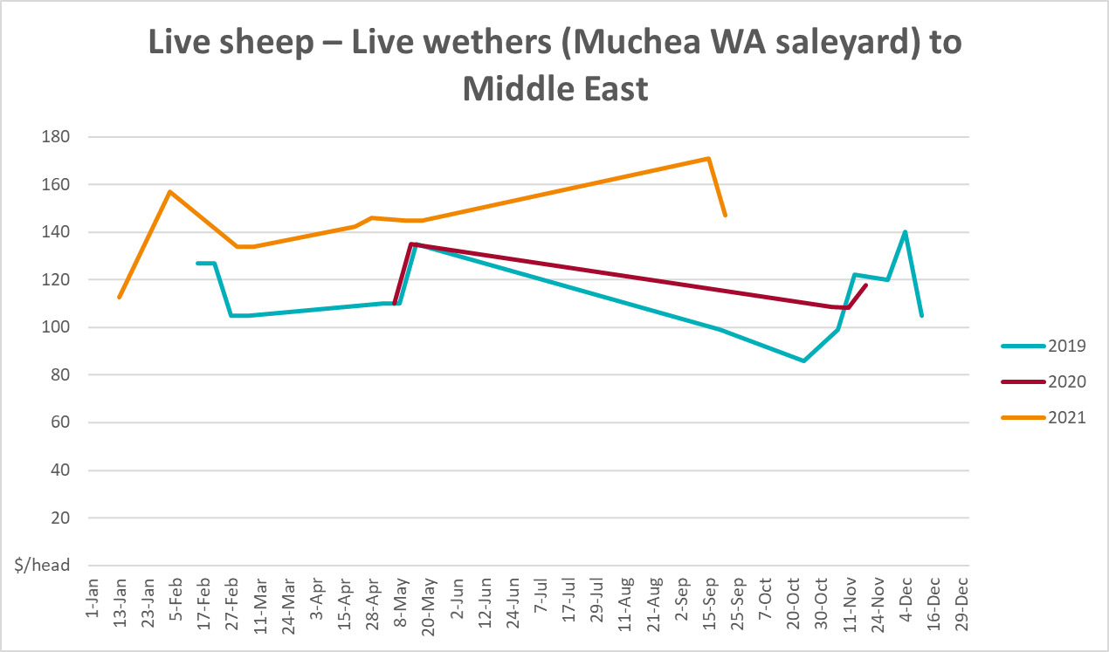

Global Dairy Trade (GDT) weighted average prices
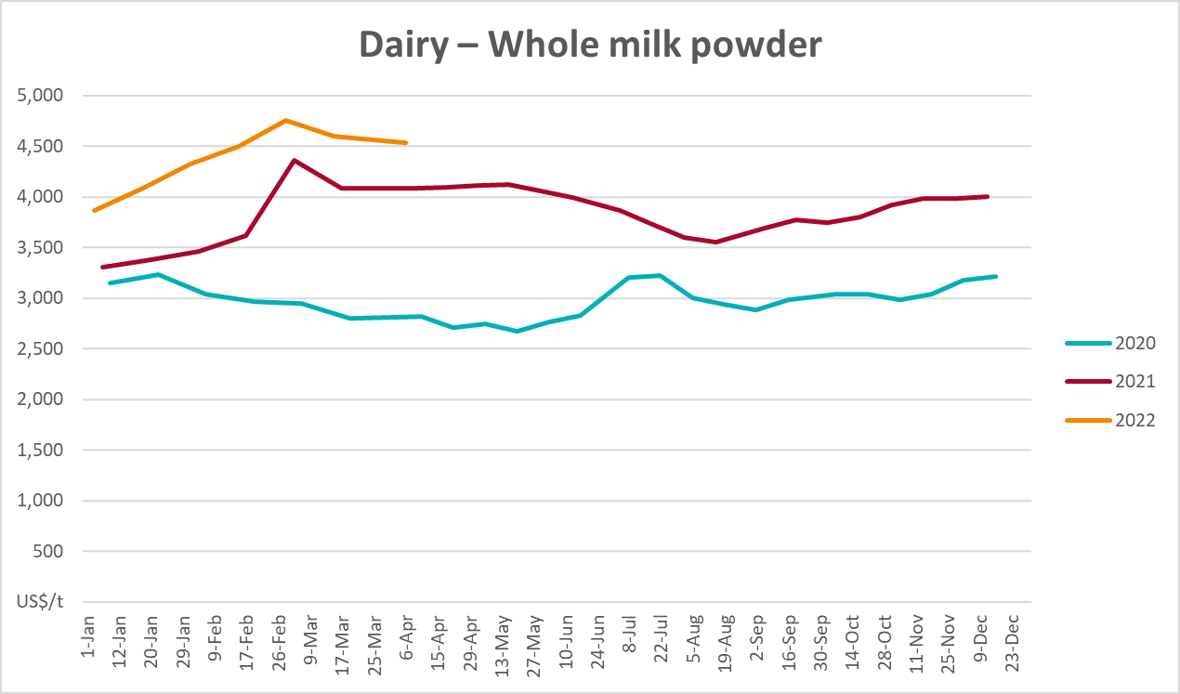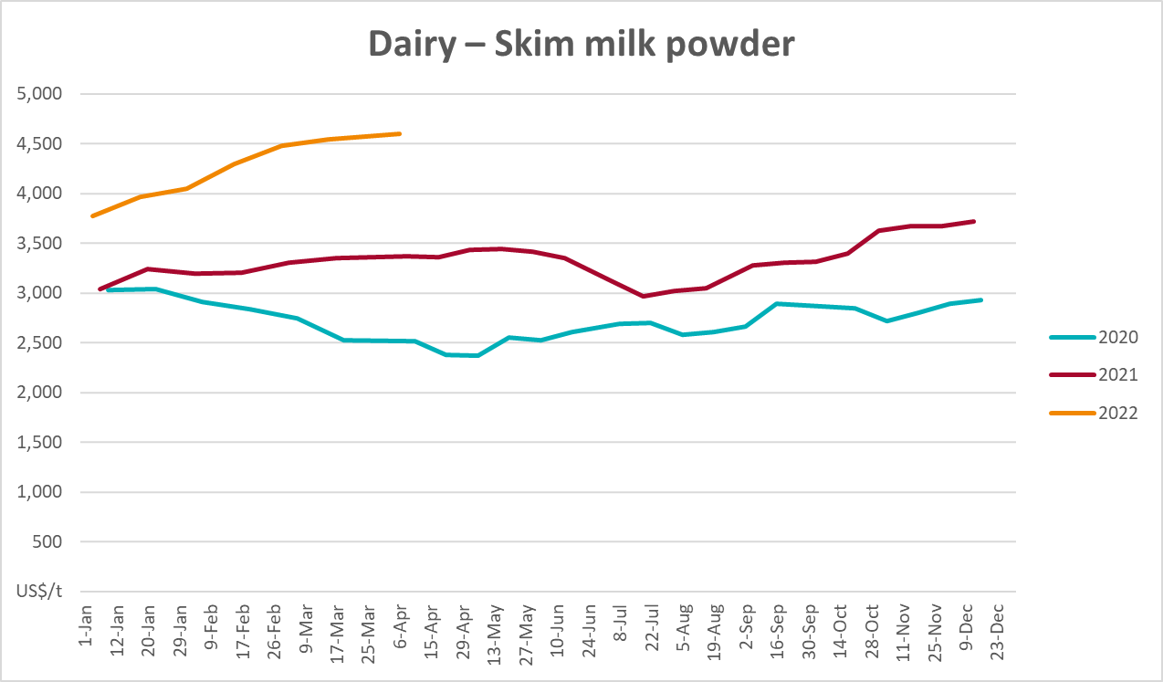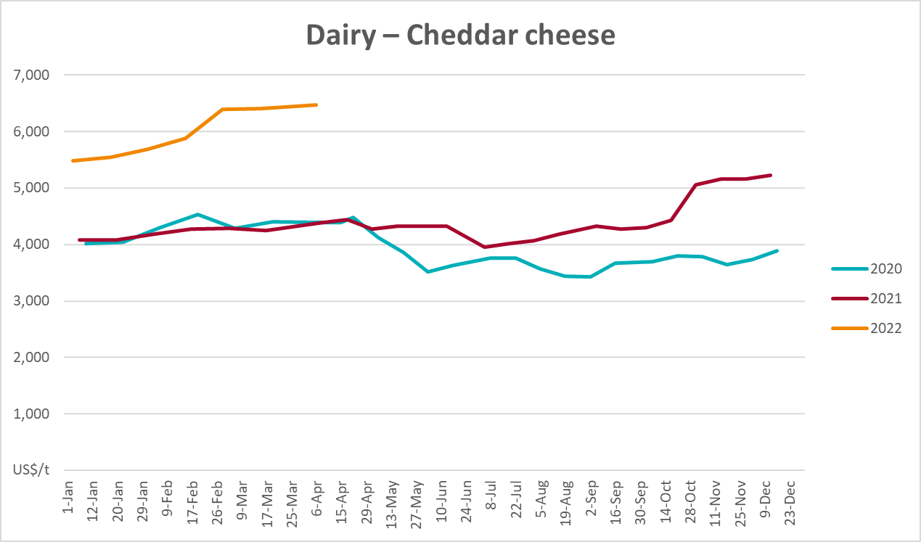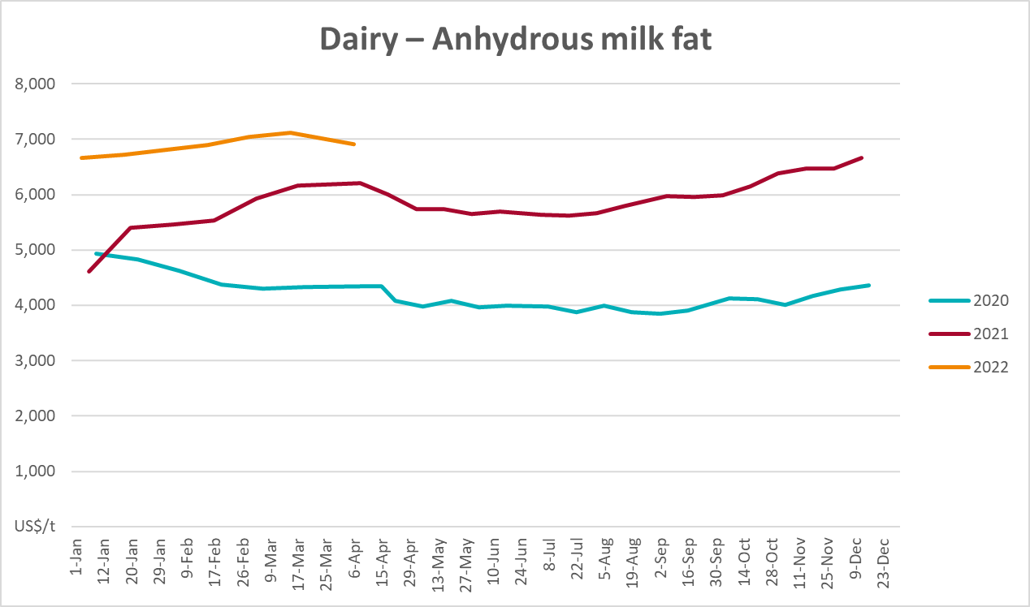

Selected fruit and vegetable prices
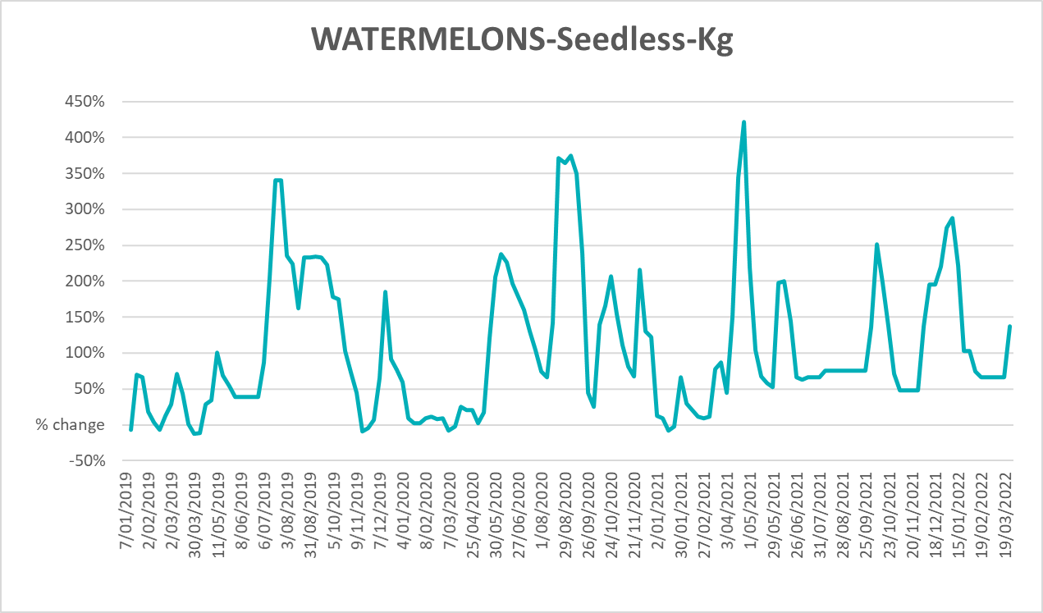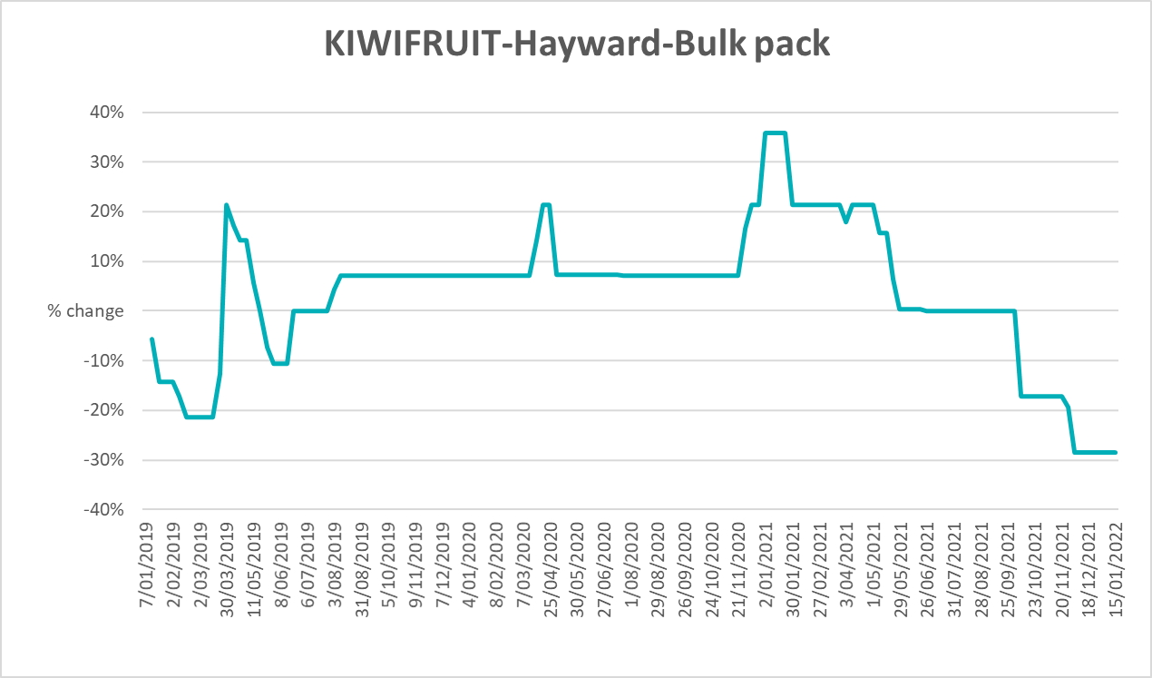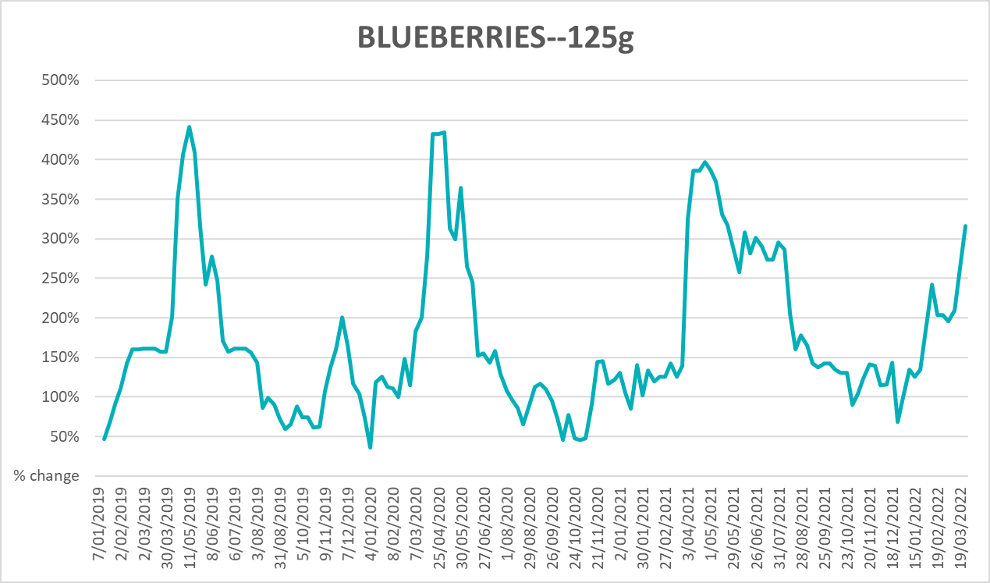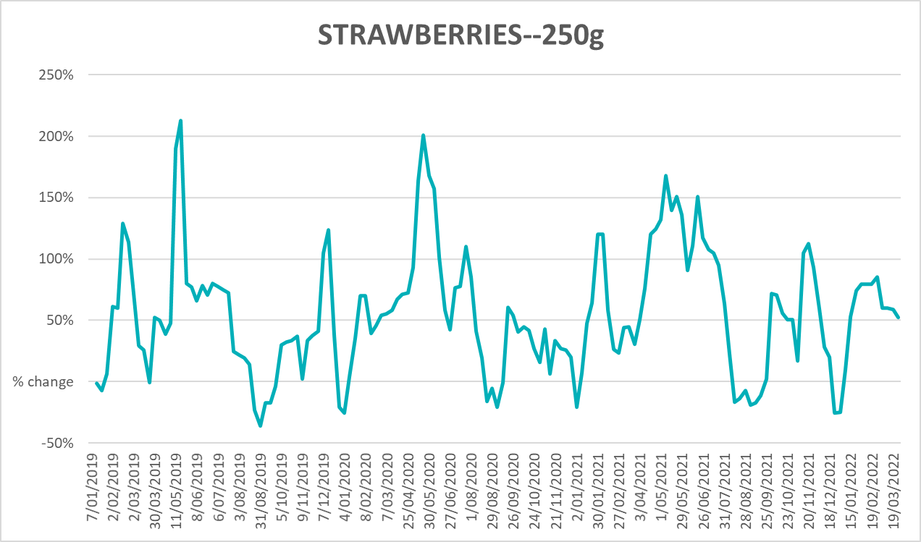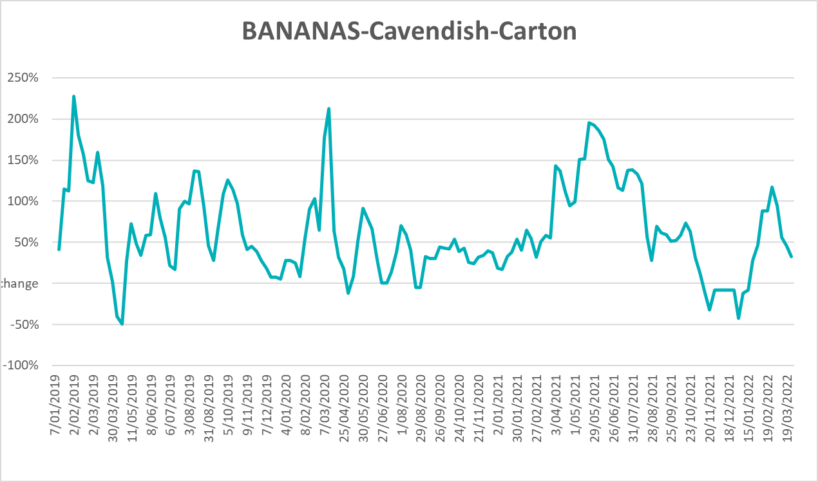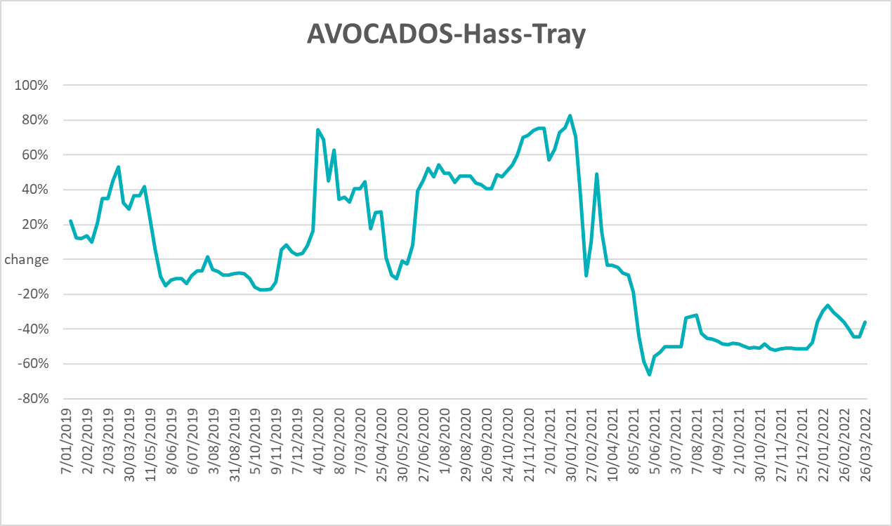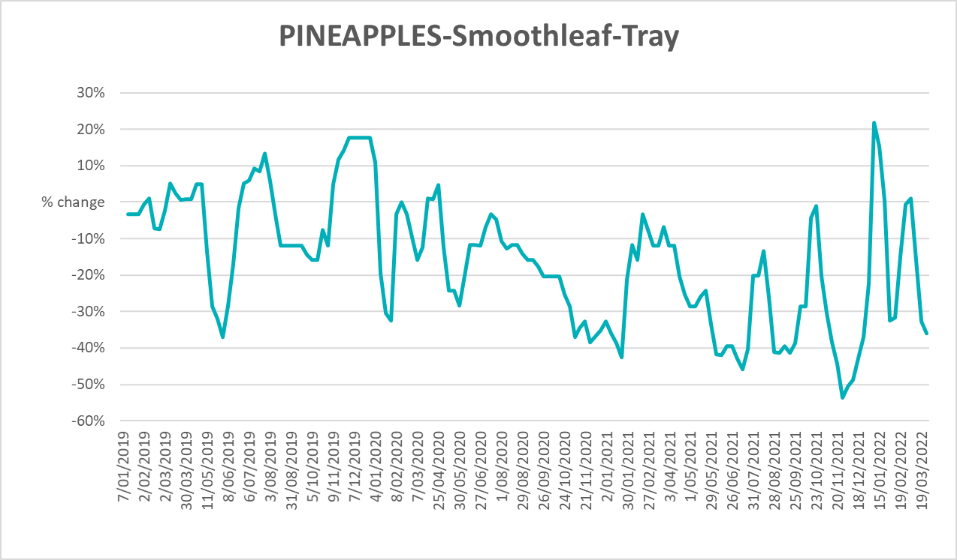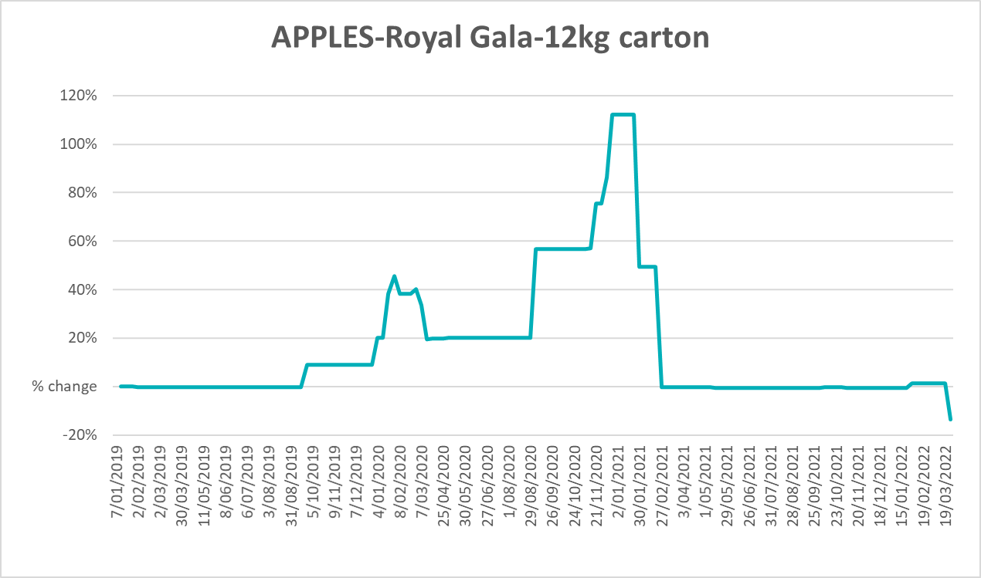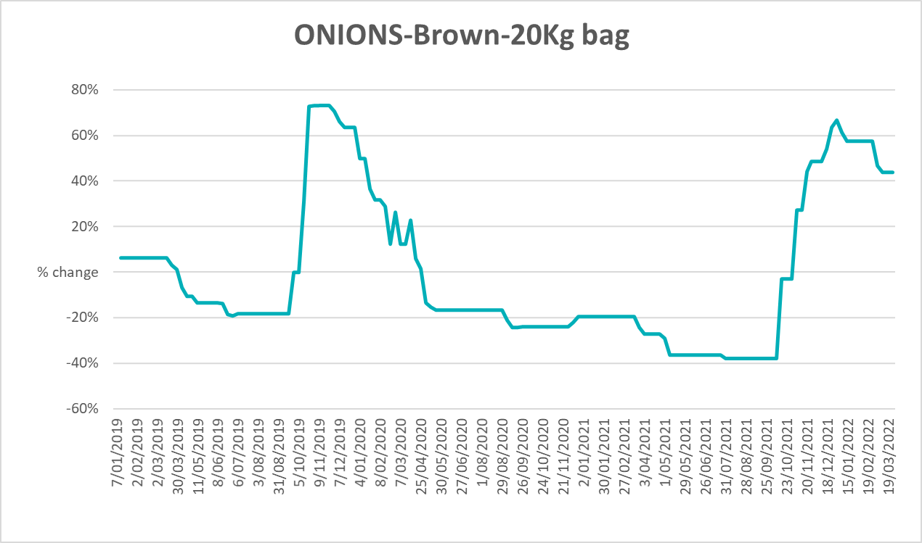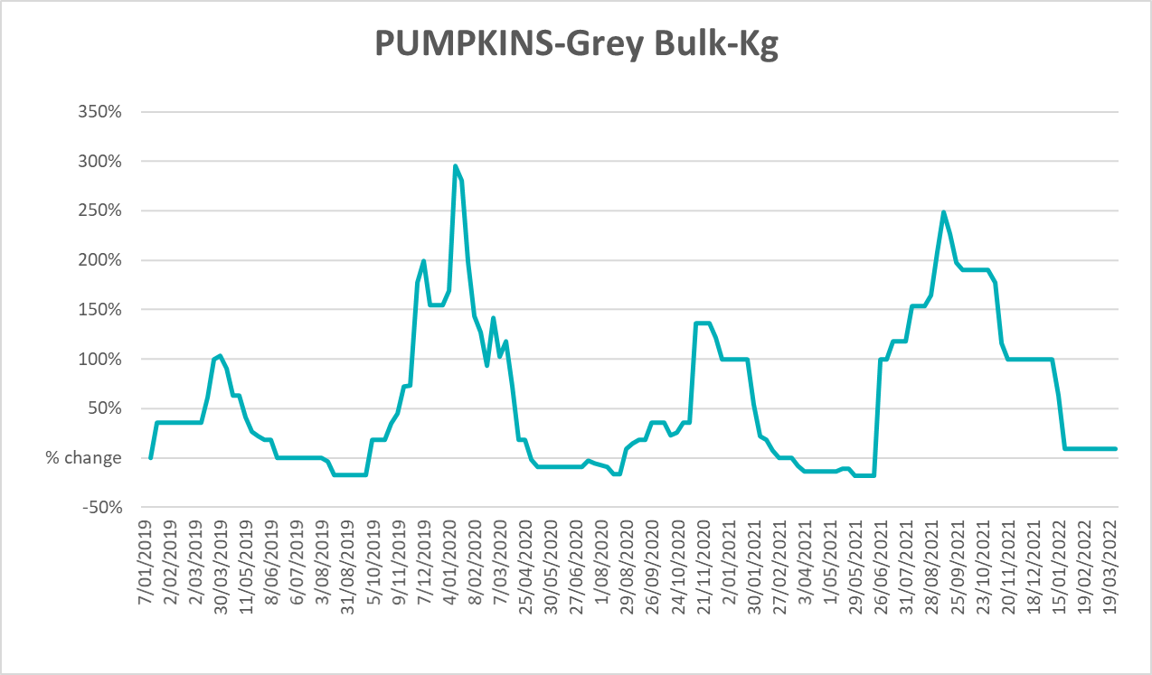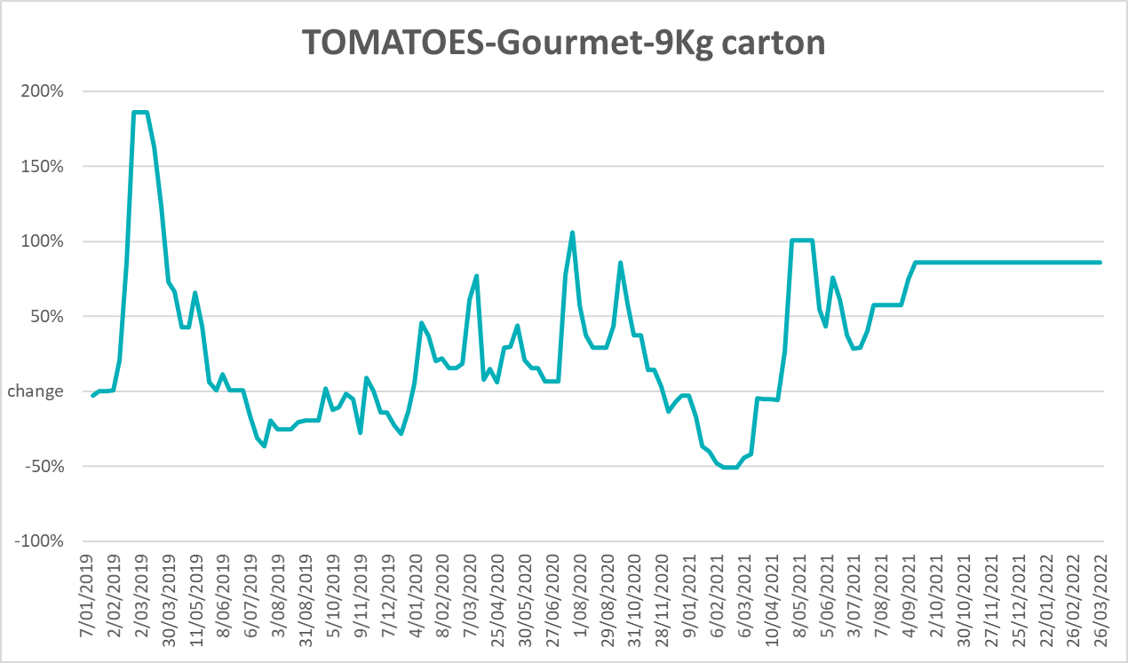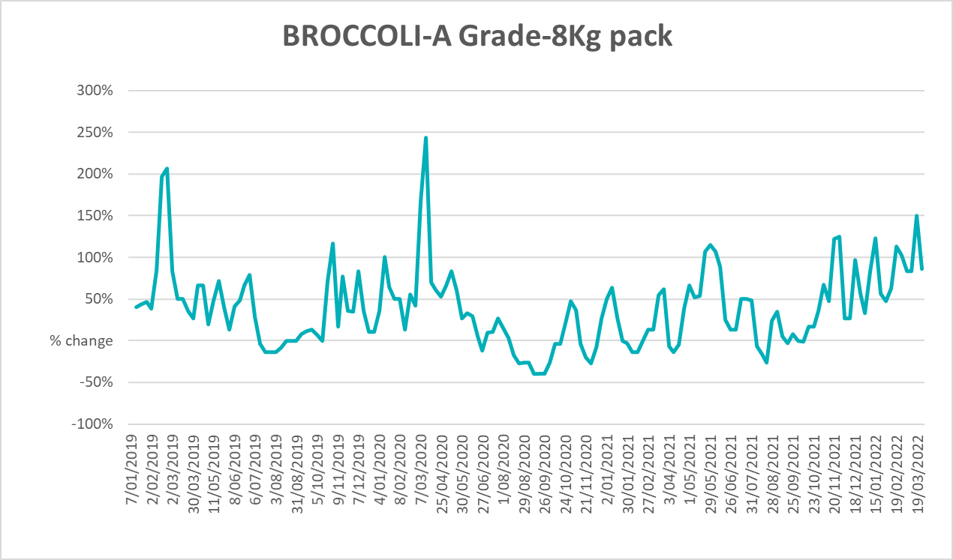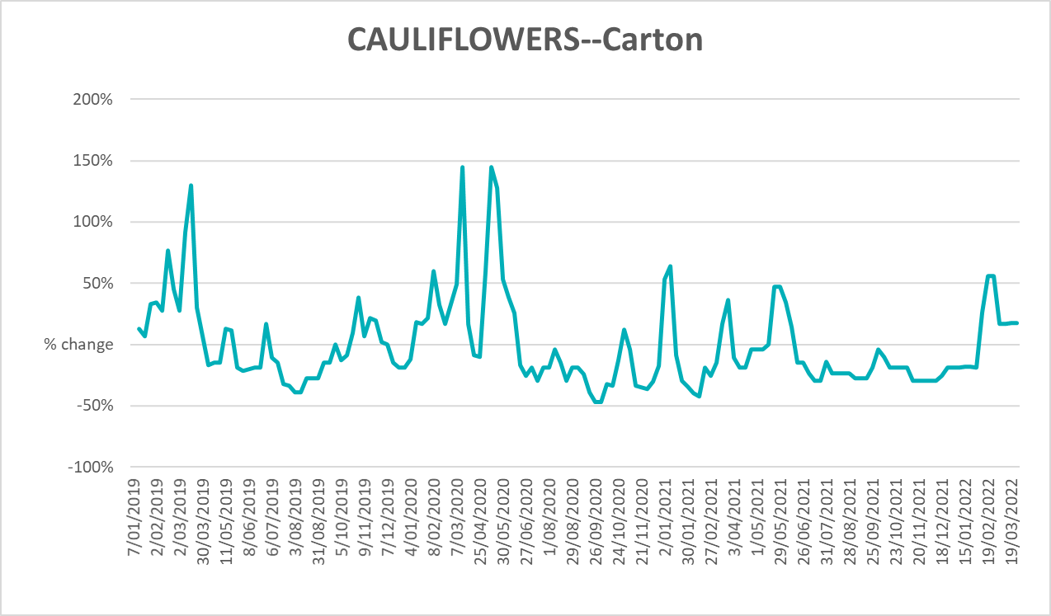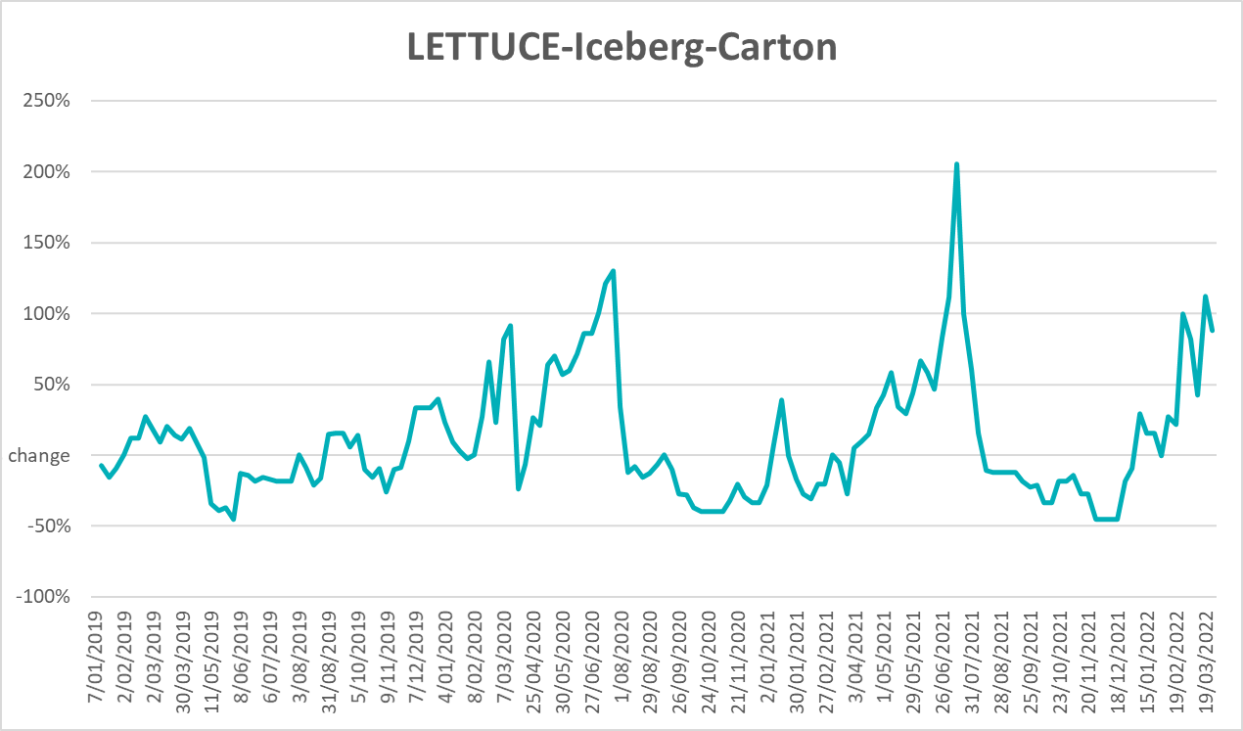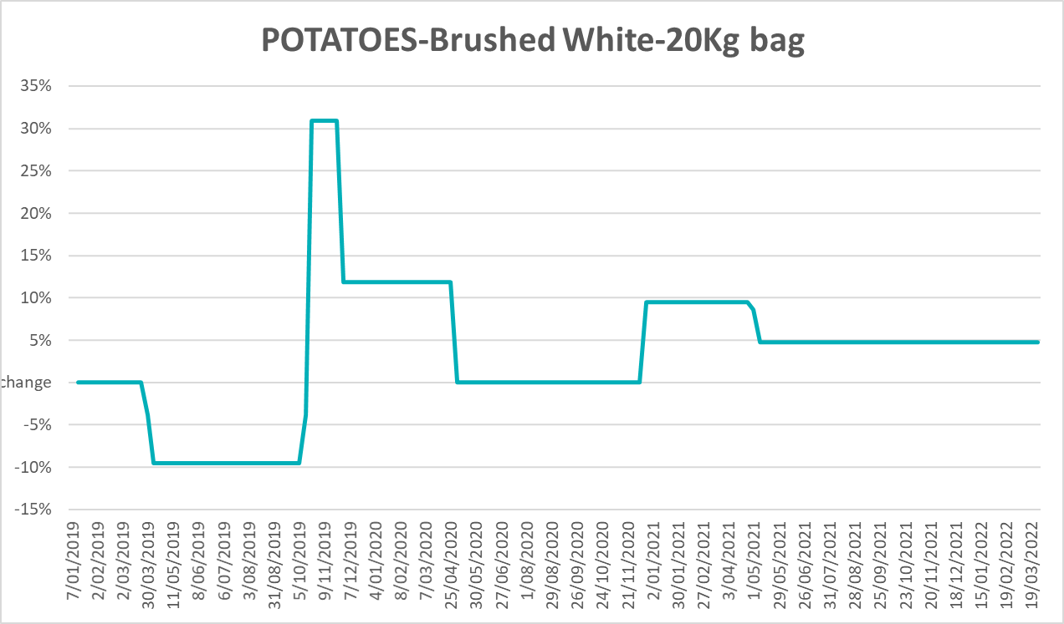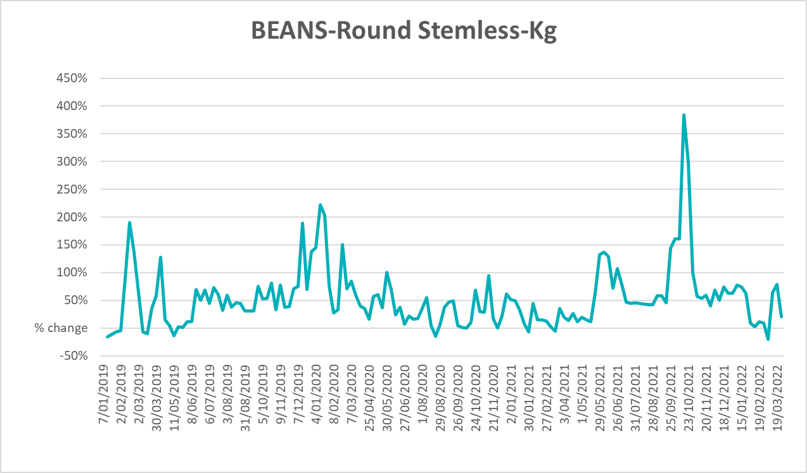

Selected domestic fodder indicator prices
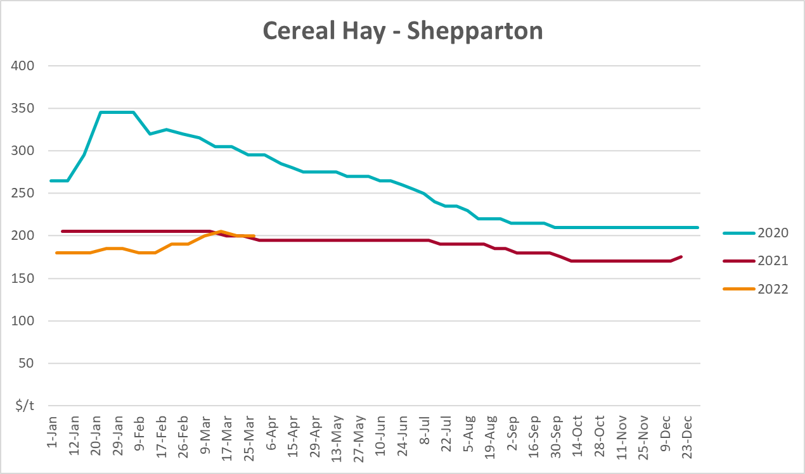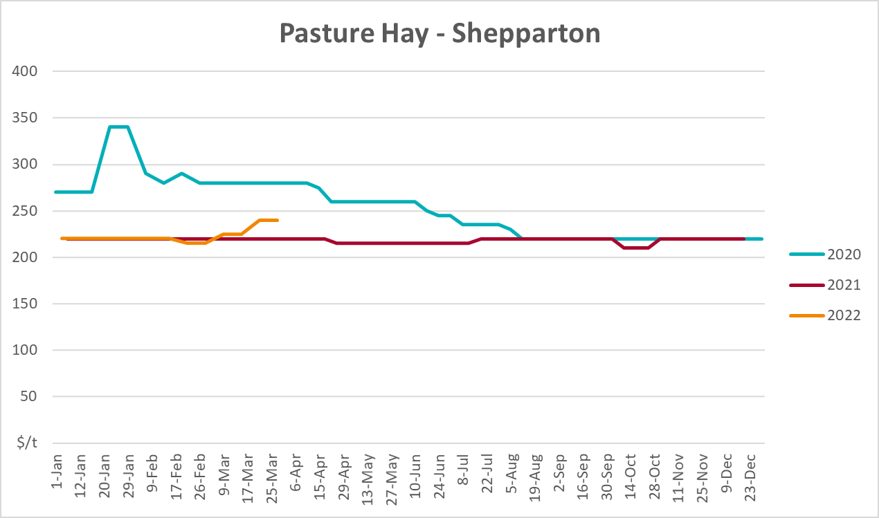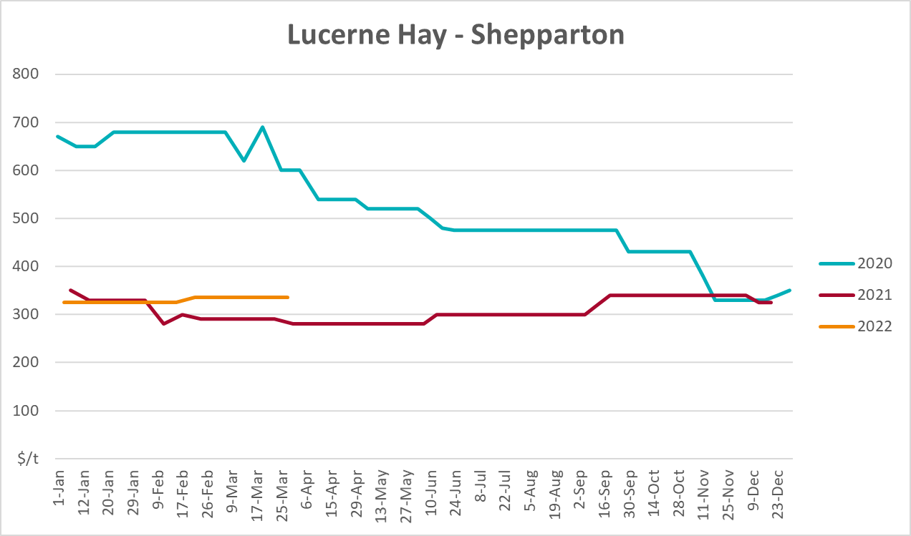

Data attribution

Climate
Bureau of Meteorology
- Weekly rainfall totals: www.bom.gov.au/climate/maps/rainfall/
- Monthly and last 3-month rainfall percentiles: www.bom.gov.au/water/landscape/
- Temperature anomalies: www.bom.gov.au/jsp/awap/temp/index.jsp
- Rainfall forecast: www.bom.gov.au/jsp/watl/rainfall/pme.jsp
- Seasonal outlook: www.bom.gov.au/climate/outlooks/#/overview/summary/
- Climate drivers: http://www.bom.gov.au/climate/enso/
- Soil moisture: www.bom.gov.au/water/landscape/
Other
- Pasture growth: www.longpaddock.qld.gov.au/aussiegrass/
- 3-month global outlooks: Environment and Climate Change Canada, NOAA Climate Prediction Center, EUROBRISA CPTEC/INPE, European Centre for Medium-Range Weather Forecasts, Hydrometcenter of Russia, National Climate Center Climate System Diagnosis and Prediction Room (NCC), International Research Institute for Climate and Society
- Global production: https://ipad.fas.usda.gov/ogamaps/cropmapsandcalendars.aspx
- Autumn break: Pook et al., 2009, https://rmets-onlinelibrary-wiley-com.virtual.anu.edu.au/doi/epdf/10.1002/joc.1833

Water
Prices
- Waterflow: https://www.waterflow.io/
- Ruralco: https://www.ruralcowater.com.au/
Bureau of Meteorology:
- Allocation trade: http://www.bom.gov.au/water/dashboards/#/water-markets/mdb/at
- Storage volumes: http://www.bom.gov.au/water/dashboards/#/water-storages/summary/drainage
Trade constraints:
- Water NSW: https://www.waternsw.com.au/customer-service/ordering-trading-and-pricing/trading/murrumbidgee
- Victorian Water Register: https://www.waterregister.vic.gov.au/TradingRules2019/

Commodities
Fruit and vegetables
- Datafresh: www.freshstate.com.au
Pigs
- Australian Pork Limited: www.australianpork.com.au
Dairy
- Global Dairy Trade: www.globaldairytrade.info/en/product-results/
World wheat, canola
- International Grains Council
World coarse grains
- United States Department of Agriculture
World cotton
- Cotlook: www.cotlook.com/
World sugar
- New York Stock Exchange - Intercontinental Exchange
Wool
- Australian Wool Exchange: www.awex.com.au/
Domestic wheat, barley, sorghum, canola and fodder
- Jumbuk Consulting Pty Ltd: http://www.jumbukag.com.au/
Cattle, beef, mutton, lamb, goat and live export
- Meat and Livestock Australia: www.mla.com.au/Prices-and-market
© Commonwealth of Australia 2022

Ownership of intellectual property rights
Unless otherwise noted, copyright (and any other intellectual property rights, if any) in this publication is owned by the Commonwealth of Australia (referred to as the Commonwealth).

Creative Commons licence
All material in this publication is licensed under a Creative Commons Attribution 4.0 International Licence except content supplied by third parties, logos and the Commonwealth Coat of Arms.
Inquiries about the licence and any use of this document should be emailed to copyright@awe.gov.au.


Cataloguing data
This publication (and any material sourced from it) should be attributed as:
ABARES 2021, Weekly Australian Climate, Water and Agricultural Update, Australian Bureau of Agricultural and Resource Economics and Sciences, Canberra, 7 April 2022. CC BY 4.0 DOI: https://doi.org/10.25814/5f3e04e7d2503
ISSN 2652-7561
This publication is available at https://www.awe.gov.au/abares/products/weekly_update
Department of Agriculture, Water and the Environment
GPO Box 858 Canberra ACT 2601
Telephone 1800 900 090
Web awe.gov.au/abares

Disclaimer
The Australian Government acting through the Department of Agriculture, Water and the Environment, represented by the Australian Bureau of Agricultural and Resource Economics and Sciences, has exercised due care and skill in preparing and compiling the information and data in this publication. Notwithstanding, the Department of Agriculture, Water and the Environment, ABARES, its employees and advisers disclaim all liability, including liability for negligence and for any loss, damage, injury, expense or cost incurred by any person as a result of accessing, using or relying on any of the information or data in this publication to the maximum extent permitted by law.

Statement of Professional Independence
The views and analysis presented in ABARES publications, including this one, reflect ABARES professionally independent findings, based on scientific and economic concepts, principles, information and data. These views, analysis and findings may not reflect or be consistent with the views or positions of the Australian Government, or of organisations or groups who have commissioned ABARES reports or analysis. More information on professional independence is provided on the ABARES website.

Acknowledgements
This report was prepared by Matthew Miller and Cameron Van-Lane.

