

Edition No. 2023/1

# March 2023

The Three Biosecurity Chiefs’ offices have settled into the new ‘Agriculture House’ building in Canberra and continue strengthening our biosecurity systems through our work in Australia, with the Pacific and near neighbours as well as internationally. Dr Robyn Cleland retired in December and we recently appointed our new Australian Chief Environmental Biosecurity Officer, Dr Bertie Hennecke. The Environmental Biosecurity office is now within the same division as the Chief Plant Protection Office to enhance closer collaboration. The Chief Veterinary office has also recently expanded with a focus on international collaboration and representation. Finally, this edition of the Three Chiefs has undergone a refresh and we now offer an online version available via subscription on the department website – please follow the details at the end of the newsletter to subscribe as soon as possible to continue receiving Three Chiefs news.

**Australian Chief Veterinary Officer (**[**ACVO**](http://www.agriculture.gov.au/animal/health/acvo)**)**

**Global leaders meet on Antimicrobial Resistance in Barbados**

The Australian Chief Veterinary Officer, Dr Mark Schipp is an external adviser to the Global Leaders Group on Antimicrobial Resistance. The group seeks to bring political attention to the issue of Antimicrobial Resistance (AMR) and recently held their first face to face meeting in Barbados. Global responses to the COVID pandemic have informed the need for integrated prevention, preparedness and response to AMR which is often called the ‘silent pandemic’. The group has successfully elevated the political profile of AMR through having the issue addressed at G7, G20 and the United Nations General Assembly. However key constraints remain – new antimicrobials are not being developed, and ongoing funding for a range of AMR activities including integrated surveillance is not assured.

The Global Leaders Group meeting was opened by the four Director Generals of the United Nations’ Food and Agriculture Organisation (FAO) the World Health Organisation (WHO), the United Nations Environment Program (UNEP) and the World Organisation for Animal Health (WOAH). The UNEP launched their report ‘Bracing for Superbugs: Strengthening environmental action in the One Health response to antimicrobial resistance’ into AMR in the environment.

We anticipate that the UN General Assembly next year will include a major political statement on AMR which will seek to position AMR as a global challenge affecting everyone, similar to climate change. There will be significant challenges ahead, particularly for animal health with shifting expectations for appropriate use of antimicrobials in livestock and companion animals.

Photo 1. Dr Schipp at the Global Leader’s Group on AMR meeting in Barbados. Credit: GLG-AMR.

**Regional cooperation on Transboundary Animal Diseases**

**Achievements**

**ACVO**

* Met with Mary van Andel, Chief Veterinary Officer of New Zealand.
* Attended the WOAH Council meeting.
* Expanded and integrated new staff into OCVO and the Northern Australia office.
* Participated in an Animal Health Committee Working group on engagement of private vets in emergency disease response.
* Met with a high-level delegation from Papua New Guinea, including Minister for Agriculture.

**ACPPO**

* Helped to finalise draft IPPC Communications Strategy 2023-2030 as part of the Commission on Phytosanitary Measures Focus Group on Communications.
* Presented at the Plant Health Quads meetings in New Zealand.
* Hosted UK Chief Plant Health Officer Dr Nicola Spence and Sam Bishop, Deputy Director for plant and bee health at the Department for Environment, Food and Rural Affairs.

**ACEBO**

**•** Attended the launch of EcoCommons platform including an address as the policy decision-making champion.

• Chaired the tenth meeting of the Environmental Biosecurity Advisory Group.

• Retirement of Dr Robyn Cleland in December 2022 and appointment of Dr Bertie Hennecke as the new ACEBO in February 2023.

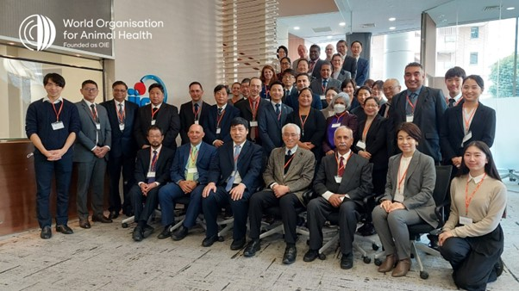The Chief Veterinary Office participated in the 12th Regional Steering Committee Meeting of the Global Framework for the Progressive Control of Transboundary Animal Diseases in Tokyo from 7-8 February. This is a coordinating mechanism and joint initiative of the WOAH and the FAO. A key focus of the meeting was progressing an Asia and Pacific Regional Strategy (2023-2027) for the control of priority animal diseases which include Foot-and-Mouth disease, Avian Influenza and African Swine Fever amongst others. The meeting saw agreement on the inclusion of Lumpy Skin Disease onto the list of priority diseases for the region, which will result in greater regional coordination and effort in addressing the control and spread of this significant disease of cattle which has moved closer to Australia’s borders.

Photo 2.The Global Framework for the Progressive Control of Transboundary Animal Diseases (meeting participants in Tokyo. Credit: WOAH.

**Global treaty on pandemic prevention, preparedness & response**

The Office of the Chief Veterinary Officer (OCVO) is contributing to Australia’s negotiating position on the development of a global treaty on pandemic prevention, preparedness and response. OCVO is advocating strongly to include One Health as a foundational and guiding principle of the treaty, with a particular focus on ensuring it adequately recognises the drivers of pandemic emergence and contains meaningful provisions to prevent future pandemics.

Current pandemic management strategies focus on responding to diseases after their emergence. Australia is keen to see this new instrument be used to better position member states to implement upstream measures that reduce the emergence of new pathogens with pandemic potential. OCVO is also advocating for explicit reference to the Quadripartite’s leadership and governance role in pandemic prevention, preparedness and response. This includes a provision to specifically include the World Organisation for Animal Health (WOAH) in the governance and implementation of the instrument.

Negotiations on the zero draft of the pandemic treaty progressed at the Intergovernmental Negotiating Body meeting in Geneva from 27 February to 3 March. A final draft of the instrument will be provided to the World Health Assembly in May 2024.

**Australia’s Focal Points to the WOAH**

A World Organisation for Animal Health Delegate can nominate individuals as National Focal Points to help improve communication between national veterinary services and the WOAH. At present, Australia has eight National Focal Point positions providing considerable expertise and networks in the following fields: -disease notification, veterinary products, communication, veterinary laboratories, aquatic animals, food safety, animal welfare, and wildlife.

Australia’s Focal Points engage frequently with WOAH, contributing to regional animal health activities. For example, in February Dr Samantha Ellis (representing the Focal Point for Veterinary Products) attended the WOAH Asia Pacific Animal Antimicrobial Use Global Database workshop in Bangkok. Dr Ellis received training and shared her experiences in antimicrobial usage data collection and visualisation. Wildlife Health Australia’s Dr Tiggy Grillo attended and presented at the training workshop for Wildlife Focal Points in the Asia Pacific Region, held in Bangkok in February. The workshop provided knowledge on reporting procedures, and the surveillance systems and capabilities needed to manage wildlife diseases.

Photo 3. WHA’s Dr Tiggy Grillo and delegates in Bangkok. Credit: Tiggy Grillo/WHA.

**Pacific Engagement Program for Animal Health**

The Chief Veterinary Office’s Pacific Engagement Program for Animal Health has been preparing for Pacific Week of Agriculture being held in Fiji from 6 to 10 March 2023. The team has collaborated closely with the department’s Trade, Market Access and International Division, the Pacific Community (SPC), and the FAO Subregional Office for the Pacific Islands. The team has supported coordination of an International Women’s Day breakfast, and a One Health side-event hosted by SPC.

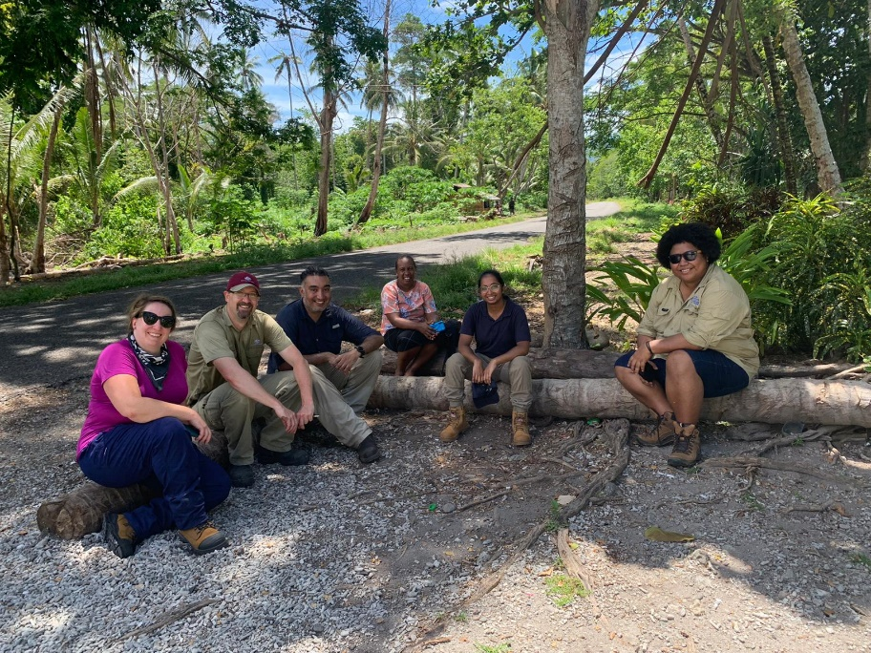The Pacific Week of Agriculture will also be an opportunity for SPC to progress the Pacific Animal Health and Production Capacity Development Plan 2022-2025, which will be presented for consideration by the Pacific Heads of Agriculture and Forestry Services and the Ministers of Agriculture and Forestry Services. This plan outlines the animal health, production and biosecurity priorities for the Pacific region, and was developed in collaboration with our office, SPC, the New Zealand Ministry of Primary Industries (MPI) and other stakeholders.

Our team has also been working closely with NZ MPI’s Pacific Foot and Mouth Disease Preparedness team and the Animal Health and Biosecurity Pacific Partnership team. A focus of collaboration is providing assistance to the Solomon Islands Ministry of Agriculture and Livestock (MAL) in the lead up to November’s 2023 Pacific Games, including supporting Dr Nigel Gillan, a NSW district vet who is undertaking a 6-month placement with MAL via DFAT’s Australian Volunteers Program.

Photo 4. OCVO collaboration with SPC in the Solomon Islands. Credit: DAFF

**Timor-Leste and Papua New Guinea capacity building**

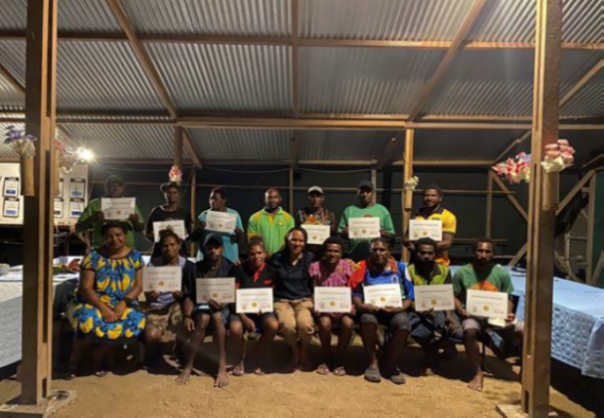The Chief Veterinary Office has been working with the Biosecurity Training Centre at Charles Sturt University (CSU) to design a pilot capacity building program for Timor-Leste’s quarantine services. An in-country assessment of biosecurity needs in Timor-Leste occurred in January. A train-the-trainer program is being developed tailored to Timor-Leste’s needs to commence at CSU in April, followed by a mentored training session in Timor-Leste to enable the trained officers to share their new skills.

Photo 5. Biosecurity capacity building in PNG. Credit: E. Kagena.

In Papua New Guinea (PNG), department veterinarians are working with their PNG colleagues to implement a passive animal health surveillance network, and training was recently provided for 20 village rangers in PNG’s Western Province. The rangers are now providing monthly reports on animal health and animal populations using PNG’s newly developed National Animal Health Information System. This provides early warning for changes in animal health and risk factors for emerging animal disease in a region traditionally difficult for PNG’s animal health officers to access.

**Australian Chief Plant Protection Officer (**[**ACPPO**](http://agriculture.gov.au/plant/health/acppo)**)**

**UK plant health chief tours Australia**

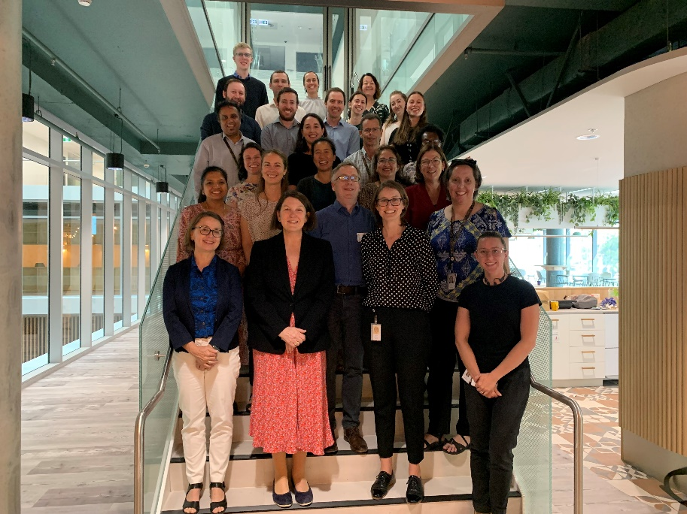Delegates from the United Kingdom Department for Environment, Food and Rural Affairs recently visited our department’s facilities as part of a week-long tour hosted by Dr Gabrielle Vivian-Smith’s office. Dr Nicola Spence**,** Chief Plant Health Officer and Deputy Director for plant and bee health, and her colleague Sam Bishop**,** Head of International plant health policy and risk co-ordination, took part in a “biosecurity system snapshot” in Melbourne, Canberra, and Sydney.

The tour began at the Melbourne gateway facility, where the delegates met detector dogs and saw how mail items are inspected. They continued to the Mickleham Plant Entry Quarantine facility to tour glasshouses and plant laboratories. At La Trobe University, they visited Agribio to discuss new diagnostic techniques and biological control with researchers.

Photo 6. UK Delegation after morning tea with DAFF staff at Agriculture House. Source: J. Richards

The following day Professor Tim Entwisle, outgoing Director of the Royal Victorian Botanic Gardens, described the ongoing biosecurity work at the gardens and their planning for climate change. Professor David Cantrell, Chief Botanist at the gardens and Director of the National Herbarium of Victoria showed the delegation around the herbarium, providing insight on significant specimens to Australia and the UK. On the delegation’s final Melbourne stop at the department’s new regional office at Moonee Ponds, staff explained Australia’s biosecurity continuum, from onshore surveillance and border interceptions, through to identification and treatment.

The tour continued in Canberra with visits to Plant Health Australia, the National Arboretum and the Australian Centre for International Agricultural Research. The delegates also stopped by ‘Agriculture House’ for a morning tea hosted by the ACPPO office and key staff. On the final leg of the trip, they visited the Royal Botanic Gardens Sydney to meet with Brett Summerell, Director of Science, Education and Conservation; Mila Bristow, General Manager of Trade and Biosecurity Research and Development at Hort Innovation; and Jo Luck, Program Director of the Plant Biosecurity Research Initiative.

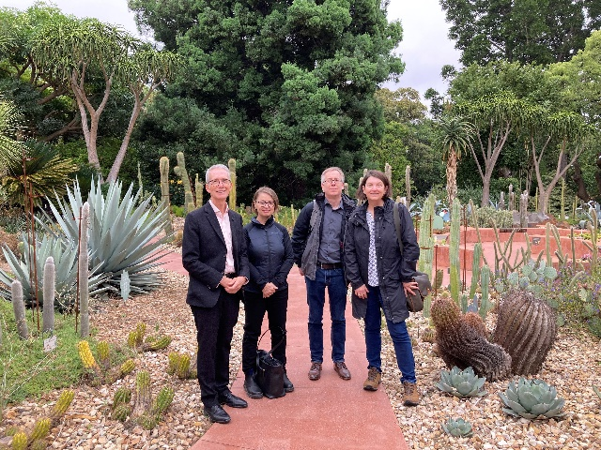At the end of the tour, the guests expressed their appreciation and reflected that they’d seen many common priorities between our two countries and opportunities to work together.

Photo 8. From left: Tim Entwisle, Gabrielle Vivian-Smith, Sam Bishop, Nicola Spence CBE). Credit: K Beattie

Photo 7. From left: Sam Bishop, Nicola Spence CBE, Operations Manager of International Mail Stephen Sirgiovanni, Gabrielle Vivian-Smith. Credit: K Beattie

**Record participation for sake of Safe Aid**

The International Plant Protection Convention (IPPC) community with the Commission on Phytosanitary Measures (CPM) acknowledged the importance of understanding and better managing the phytosanitary risks associated with the movement of aid in its sixteenth session (CPM-16, 2022). In this meeting, they agreed to establish a CPM Focus Group on the Safe Provision of Food and other Humanitarian Aid. Since this time, the group has worked to address its Terms of Reference virtually.

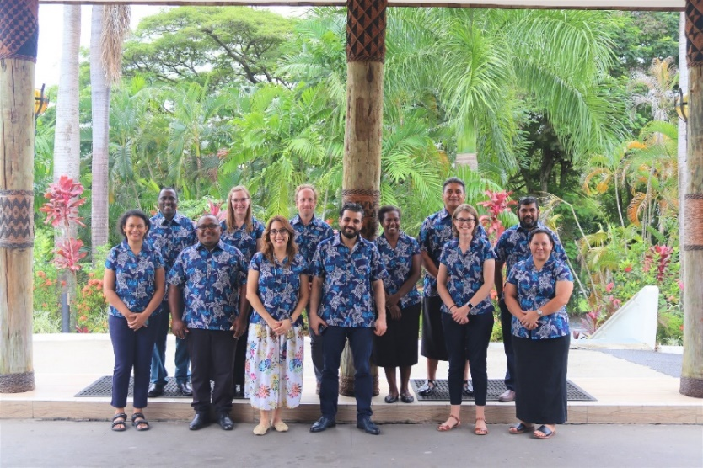In February 2023 the group met in person in Nadi Fiji. The location of the meeting was important as the South West Pacific has championed this topic and issue on the international stage, given the heightened risk the region faces to natural disasters. Australia provided funding for the meeting and the IPPC Secretariat provided travel assistance and continued to support the Focus Group, recording the meeting and assisting the Chair. The Pacific Plant Protection Organization (PPPO) and Biosecurity Authority of Fiji were co-hosts. Notably, this Focus Group also has the most representation from the South West Pacific region ever seen (six of the eleven members). This is an encouraging development and a demonstration of the importance of the topic and the desire of the region to participate in international policy development.

Photo 9. In Pacific style, a bula short was chosen by the Focus Group. Credit: S. Peterson

The Focus Group considered several papers submitted to support deliberations as it worked to understand the aid supply chain and the pathways that it incorporates. It also worked to articulate this system and address concerns that raised by members of the IPPC community about the proposal for a standard to support address of this issue.

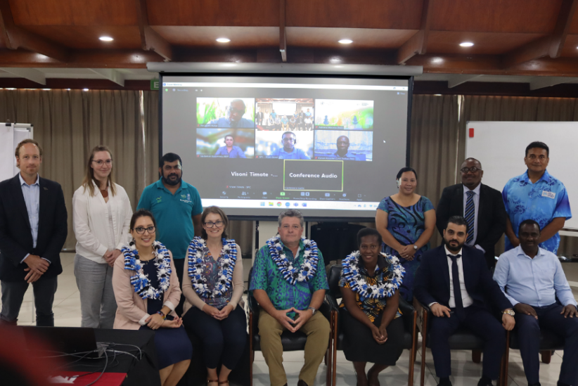During the meeting, the first of a suite of earthquakes also hit Türkiye and Syria and since, cyclones Gabrielle and Judy have impacted New Zealand, Vanuatu and other nations in our region, demonstrating the pertinence of these discussions and this work.

The next steps for the Focus Group involve developing a proposal paper to the IPPCs Strategic Planning Group for presentation in October this year, prior to a final proposal on a way forward to address this critical food security issue at CPM 18 in 2024.

Photo 10. Focus Group members and online attendees at the commencement of the meeting. Credit: S. Peterson.

The Focus Group’s reports can be found at:

<https://www.ippc.int/en/core-activities/governance/cpm/cpm-focus-group-reports/cpm-focus-group-on-safe-provision-of-food-and-other-humanitarian-aid/>

**Meet the Australian Plague Locust Commission**

From an inconspicuous looking building in the heart of Canberra’s industrial area Fyshwick, the Australian Plague Locust Commission (APLC)* monitors an area covering approximately 25% of the Australian mainland. With support of radar, light traps, out-posted field surveillance officers and reports from State counterparts, the public and landholders, the APLC monitors for and manages locust outbreaks posing credible, significant cross-border impacts.

While team members carry out many completely different activities, the work of each individual supports that of the others. The result is a finely tuned, well-organised program of work. This is critical, given locust numbers can build up very rapidly if conditions are favourable. Bands on the ground reach densities of over 4000 per square metre and adults can migrate up to 1000 Kms in one day.

Walk into the APLC on any given day, and you will see the following people hard at work.

* The Forecasting & Information Officer analyses the data collected from surveillance activities to determine likely developments, relevant risk levels and publish the monthly locust bulletin.
* The Quantitative Ecologist is working on a modern online dashboard that uses ecological, meteorological, vegetation and surveillance data to develop predictive models. The dashboard is under development and once it is live, stakeholders will be able to access the model and predict the likelihood of locust outbreaks near them up to 1 months in advance.
* The Director of Operations coordinates all field operations, including surveillance & monitoring and control programs.
* The Application Officer is researching new and emerging pesticides, evaluating their potential in both lab and field to determine which are most effective and under what conditions.
* 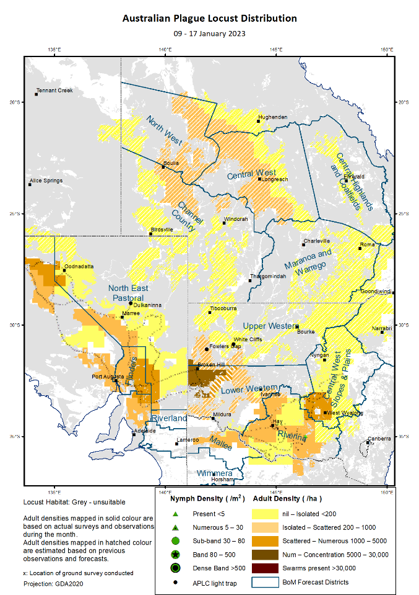Our Environmental Officer conducts research to identify sensitivities and determine what impact APLC locust management activities may have on the ecology of non-target species or the mammals, birds and reptiles that feed on locusts. Read an example at <https://www.publish.csiro.au/zo/pdf/ZO22006>

Control programs are only initiated if agriculture is at significant risk across more than one member state. They meet specific infestation criteria and require landholder consent and safe environmental and climatic conditions for spraying to occur. The APLC aims to use the minimum amount of insecticide and avoid sensitive areas when aerial spraying. ABARES determined that the control program carried out by the APLC in 2010-11 had a very strong benefit cost ratio of 50.7:1.

For more go to: <https://www.agriculture.gov.au/biosecurity-trade/pests-diseases-weeds/locusts/role/publications/abares-study11/benefit-cost-analysis-of-locust-control-operations-for-2010-11>   
Read the monthly bulletin:

<https://www.agriculture.gov.au/biosecurity-trade/pests-diseases-weeds/locusts/bulletins>

Photo 11. The APLC produce a detailed forecast of locust activity across member states in their monthly locust bulletin.

*\*The APLC is a joint venture between the commonwealth, NSW, Victoria, Queensland and South Australia.*

**Australian Chief Environmental Biosecurity Officer (**[**ACEBO**](https://www.agriculture.gov.au/biosecurity/environmental/cebo)**)**

**Introducing Dr Bertie Hennecke**

You will have noticed a change in faces in the masthead portrait of this edition of the Three Chiefs Newsletter. Dr Bertie Hennecke was recently announced as the new Australian Chief Environmental Biosecurity Officer (ACEBO). Prior to his appointment as the ACEBO, Dr Hennecke held senior leadership roles in the Australian Bureau of Agricultural and Resource Economics and Sciences (ABARES) and in several of the department’s plant biosecurity areas leading and implementing plant health policies.

Photo 12. Dr Bernie Hennecke is the new Australian Chief Environmental Biosecurity Officer. Credit: DAFF

Dr Hennecke joined the department in 2010 and has a background in natural resource management, invasive species, and agricultural sciences with nearly 30 years of experience in the public service and academia in Australia. He holds a PhD in Botany and a Master of International Agriculture.

“My passion throughout my career has focussed on invasive species and their management and I am excited to take on this leadership role within the department. Environmental biosecurity is complex and involves a broad range of stakeholders. I will be working to strengthen engagement and collaboration amongst communities, environmental groups, researchers and governments to build Australia’s capacity to manage environmental biosecurity risks.”

* Dr Hennecke takes on the role following the retirement of Dr Robyn Cleland in December 2022. Dr Cleland worked closely with environmental, community and state and territory stakeholders to highlight and progress a range of environmental biosecurity initiatives and was an active member of the Environment and Invasives Committee. Achievements under Dr Cleland’s tenure included:
* securing $20 million commitment for 30 on-ground pest and weed control projects that leveraged an additional $45 million of cash and in-kind support, by state and territory governments
* progressing the implementation of the National Environment and Community Biosecurity Research, Development and Extension Strategy 2021-2026 (<https://www.agriculture.gov.au/biosecurity-trade/policy/partnerships/nbc/research-development-extension-strategy>)
* commissioning a range of work to build environmental biosecurity capability, including the 2022-2032 National Roadmap for Wildlife Health Research, Development and Extension and the development of the National Established Weeds Priority Framework to guide future collaborative management of weeds in Australia
* working with the Threatened Species Commissioner to include environmental biosecurity considerations as part of the development of the Threatened Species Action Plan 2022-2032.

We wish Dr Cleland well in her retirement.

**Update: ABARES pest animal and weed survey series**

Every three years, the Australian Bureau of Agricultural and Resource Economics and Sciences conducts the pest animal and weed management survey.

The 2022 survey (and the previous surveys conducted in 2016 and 2019) sought information from agricultural land managers about the types of impacts caused by pest animals and weeds, the cost of management, and the types and effectiveness of management control actions. In addition, the survey seeks views on preferred sources of information on pest and weed management and participation in local support networks.

Photo 13. Percentage of respondents in each Natural Resource Management region reporting wild dogs as a major problem on their properties (2019). Credit: DAFF

The 2022 survey attracted 5,200 respondents and will provide data and information to assist the department and other stakeholders to further understand pest and weed impacts and inform future priorities to support land managers nationally. Survey results will be published later in 2023.

Previous surveys have highlighted a number of findings, including:

**Upcoming Events**

**20 March:** World Frog Day

**23 March:** Environmental biosecurity webinar

**30 March:** Seedy sales webinar– the costly risks of buying seeds and plants online.

**27-31 March:** Commission for Phytosanitary Measures

**3 April:** World Aquatic Animal Day

**3–5 April:** FAO Subregional Office for the Pacific Islands Regional ASF and FMD Simulation Exercise

**3–5 April:** WOAH Global Conference on Emergency Management, Paris

**5 April:** National Biosecurity Forum

**6–7 April:** WOAH Council, Paris

**17 April:** International Bat Appreciation Day

**25–27 April:** Animal Health Quads Alliance annual meeting, USA

**26–29 April:** 38th World Veterinary Association Congress, Taiwan

**29 April:** World Veterinary Day

**27 April:** APPCO webinar: “Taxonomy and systematics for the basis of our biosecurity”

**9-11 May:** Annual Diagnostics and Surveillance Workshop 2023

**11 May:** Environmental biosecurity webinar

**12 May:** International Day of Plant Health

**18 May:** ACPPO World Bee Day webinar: “Lessons from the Varroa response in New Zealand”

**20 May:** World Bee Day

**22–25 May:** 90th WOAH General Session, Paris

**Contact us**

**ACPPO:**

[**acppo@agriculture.gov.au**](mailto:acppo@agriculture.gov.au)

**ACVO:**

[**ocvo@agriculture.gov.au**](mailto:ocvo@agriculture.gov.au)

**ACEBO:**

[**acebo@agriculture.gov.au**](mailto:acebo@agriculture.gov.au)

* Twenty per cent of agricultural land managers reported that they were experiencing or had experienced a considerable feral animal problem on their property. Feral animals have contributed to crop damage, decreases in livestock production and damage to infrastructure, while freshwater pests impacted water sources.
* Twenty five percent of land managers reported major weed problems on their properties in the 2016 survey, but this dropped to 12 per cent in the 2019 survey. Similarly, reports of weed impacts on agricultural properties were down in 2019 across all impact types, likely due to reduced overall vegetation growth (including weeds) from severe, prolonged drought conditions across much of the country in 2019.
* In 2019, 74 per cent of land managers indicated they were actively managing a pest animal on their property in the last 12 months, down slightly from 76 per cent in 2016. In both surveys, the most important action that land managers thought could improve pest animal and weed management was having new or improved control methods or tools. This included biological control tools if they become available in the future.

Photo 14. Reports of weed impacts on agricultural properties were down in 2019 across all impact types. Paterson's curse, pictured, is just one example. Credit: Nyree Stenekes.

Previous survey results are available at <https://www.agriculture.gov.au/abares/research-topics/social-sciences/pest-animals-weed-management-survey>

**The National Carp Control Program**

Carp are one of the country’s most devastating pests and dominate the Murray Darling Basin, making up to 80 to 90 per cent of fish biomass. Carp impact freshwater ecosystems across Australia, with significant negative effects on water quality, the amenity value of our freshwater environments and biodiversity.

The Australian Government committed $15.2 million to investigate the feasibility of using the Cyprinid herpesvirus 3 (the carp virus) as a potential biocontrol agent for carp as part of a long-term biological control program. As part of this funding, the Fisheries Research and Development Corporation (FRDC) undertook a collaborative research program to assess the use of the carp virus. In late 2022, the FDRC completed the National Carp Control Plan (NCCP), the culmination of six years’ work involving eleven national and international research institutions and over 40 research scientists. The NCCP represents the largest body of research ever undertaken to evaluate the possible use of a biological control agent for an aquatic pest.

Photo 15. Carp Swarm. Credit: Matt Barwick

The research program underpinning the NCCP made several key contributions to increase our knowledge of the virus. For example, it demonstrated that the virus will not affect humans or other mammals and increased our understanding of the susceptibility of non-target native fish. It also confirmed the importance of direct transmission of the virus between carp and delivered tools to improve knowledge in the area of genetic resistance. The NCCP outlined uncertainties regarding the release of the virus and provided recommendations for further work, including an evidence base to help decision makers determine next steps.

The NCCP is only the first step of several important stages needed to adequately consider the release of the carp virus. The department is facilitating the process to enable all Australian governments to formally consider the NCCP and the next steps in the program. In deciding to proceed further with the program, all governments will need to be satisfied that the virus is safe; that it will be effective in significantly reducing carp populations for the medium- to long term; and that virus release will be cost-effective.

Any potential release of the virus is expected to take several years, and will not occur without further research, implementation planning, regulatory approvals, agreement from all relevant jurisdictions, and extensive stakeholder consultation.

For more information of the NCCP and next steps visit:

<http://www.agriculture.gov.au/pests-diseases-weeds/pest-animals-and-weeds/national-carp-control-plan> and the FRDC’s website frdc.com.au/knowledge-hub/national-carp-control-plan.

**Pest Profile: Didymo (*Didymosphenia geminate*)**

Didymo (*Didymosphenia geminate*) also known as rock snot, is a highly invasive exotic freshwater algae, that can have a significant environmental impact. It can spread quickly, forming massive blooms in waterways or lake edges. Once established, didymo blooms can adversely affect water quality, aquatic invertebrates and fish stocks and are a hazard for commercial industry, agricultural irrigations and recreational activities.

Figure 16. Didymo covered rock. Credit: Biosecurity New Zealand

While not present in Australia, it has invaded rivers and lakes in Europe, Asia, North America and New Zealand. Didymo is made up of cells that cannot be seen with the naked eye until a large colony is formed. Due to its highly invasive nature, it is listed on the National Priority List of Exotic Environmental Pests, Weeds and Diseases (EEPL).

It takes only one didymo cell in a single drop of water for the algae to spread. Didymo infects freshwater pathways via human movement and use of contaminated aquatic and fishing equipment. Preventing further spread relies on freshwater users cleaning aquatic equipment.

Eradication of didymo from infected waterways is likely to be extremely difficult and may not be possible. The department is working to prevent the introduction of didymo to Australia. Special care is required when bringing equipment into Australia that has been used in fresh water overseas. If you bring any items into Australia that have been exposed to overseas freshwater rivers, lakes and streams, ensure they are thoroughly cleaned and dry, and free of reservoirs of water. Any potentially contaminated fishing or recreational equipment will be confiscated by the department and treated at the traveller's expense. For advice on fishing equipment requirements visit [agriculture.gov.au/didymo](https://www.agriculture.gov.au/biosecurity-trade/travelling/to-australia/advice-to-travellers#fishing-and-water-sports-risk-of-didymo).

**The Three Chiefs are making changes to how they send their newsletter.**

**To make sure you don’t miss an issue, go to https://subscribe.agriculture.gov.au/subscribe**

**and tick the Three Chiefs Newsletter box on the signup page!**