National Red Imported Fire Ant Eradication Program Strategic Review August 2021

Report for the Steering Committee
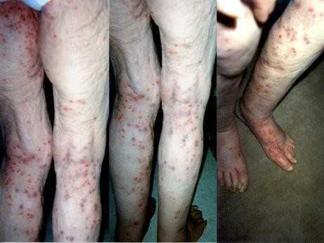
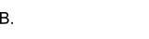
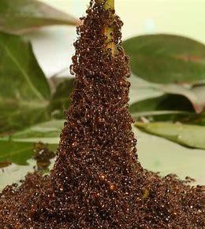
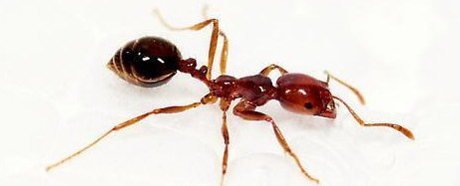
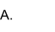


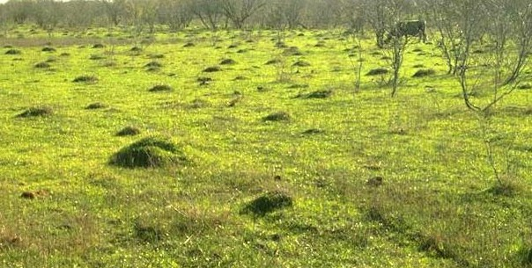
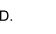
by Helen Scott-Orr, Monica Gruber and Will Zacharin (the Review Panel)

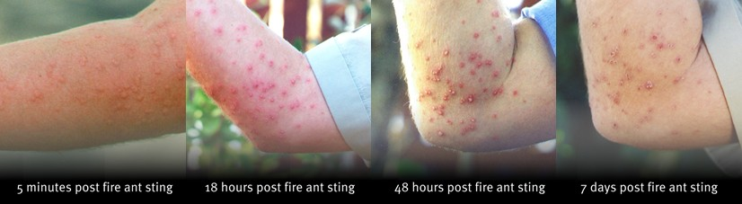


- Red imported fire ant worker (© Mario David Bazan, Creative Commons License) https://creativecommons.org/licenses/by-nd-nc/1.0/legalcode
- Woman, 87, Dies After 1,625 Ant Bites. Los Angeles Times. May 26 2000. https://www.latimes.com/archives/la-xpm-2000-may-26-mn-34259-story.html
- Red imported fire ants forming a tower - this is also how they form rafts to travel down rivers to new locations (©Candler Hobbs, George W. Woodruff School of Mechanical Engineering, Georgia Tech)
- Red imported fire ant mounds in paddock (©2021 Timothy C. Lockley)
- Progression of fire ant stings over time (© The State of Queensland 2021)

Disclaimer
This report has been prepared for the Steering Committee of the National Red Imported Fire Ant Eradication Program as contracted between the Queensland Department of Agriculture and Fisheries and individual members of the Review Panel.
The assessments, findings and recommendations presented have been formed from Program documentation, discussion with senior Program staff, structured surveys of Program staff and stakeholders as well as published information. These are sources we believe to be reliable and accurate at the time of writing. However, the authors accept no responsibility for any error of fact or opinion which may have informed the report. The panel does not accept liability for any loss or damage including without limitation, compensatory, direct, indirect or consequential damages and claims of third parties that may be caused directly or indirectly through use of, reliance upon, or interpretation of, the contents of this report.
The report is advisory. All recommendations are based on the analysis undertaken under the auspices of the Terms of Reference and may need to be further assessed for their wider impacts prior to implementation.

Acknowledgements
The authors acknowledge the assistance provided by Dr Wendy Craik, Chair, and all members of the Steering Committee for the National Red Imported Fire Ant Eradication Program. We are grateful to all Program staff who discussed the many issues surrounding the Program. In particular, we acknowledge the critical assistance provided by Dr Andrew Turley, who facilitated much of the ‘heavy-lifting’ of data gathering. We also appreciate the participation of staff and stakeholders in the anonymous surveys and phone or
face-to-face interviews.
All images in the report were supplied by the Program, except A. and C. on the front cover.

Disclosures
Dr Monica Gruber is a member of the independent Science Advisory Group (SAG) to the NRIFAEP Steering Committee. The SAG is not part of the Program and provides advice to the Steering Committee on issues the Science Group of the Program provides to it for comment. She has also co-written a report and journal article with Program staff, on topics not related to the Program.

Table of Contents

Summary 6
List of review recommendations 12
Report 16
1. Red Imported Fire Ants (RIFA) - a ‘super pest’ species 16
2. RIFA in Australia 20
3. Containing RIFA in South-East Queensland (SEQ) 21
3.1 RIFA eradication program evolution 21
3.2 The Ten-Year National RIFA Eradication Plan (‘the Ten-Year Plan’) 22
3.3 The National RIFA Eradication Program (the Program, or NRIFAEP) implementation 23
4. Progress against Ten-Year Plan objectives 26
4.1 Eradication of RIFA from the known infested area in SEQ 26
4.1.1 Broadscale treatment and clearance from Areas 1 and 2 26
4.1.1.1 Treatment gaps 27
4.1.1.2 Efficacy and safety of treatment products used against RIFA 29
4.1.1.3 Surveillance 30
4.1.1.4 Assessing risk of remnant RIFA populations in eradication Areas 31
4.1.2 Suppression in Areas 3 and 4 - the Residual Area 32
4.1.3 Polygyne colony eradication 33
4.2 Preventing RIFA spread to non-infested areas 35
4.2.1 Breakout detections and enlargement of the known infested area 35
4.2.2 Preventing further natural spread and establishment 37
4.2.3 Preventing further human-assisted spread and establishment 38
4.2.3.1 RIFA Biosecurity Zones 38
4.2.3.2 Controls for high-risk RIFA carriers 38
4.2.3.3 Monitoring of compliance with biosecurity obligations 39
4.3 Proving freedom from RIFA in SEQ 41
4.3.1 Odour detection dogs 41
4.3.2 Program visual on-ground surveillance 41
4.3.3 Public reports 42
4.3.4 Remote sensing surveillance (RSS) 42
4.4 Preventing new invasive ant incursions Australia-wide 43
5. RIFA eradication or management options 46
5.1 The challenge of ant eradication 46
5.2 Can eradication be achieved under the Ten-Year Plan? 47
5.3 Future options 47
5.3.1 Option A “Fire-ant free Olympics” - Contain, Suppress, Eradicate by 2032 49
5.2.2 Option B. Contain and suppress 58
5.2.3 Option C. Winding down, transition to state-by-state management 61
6. Moving to a shared responsibility for RIFA management in SEQ 64
6.1 Program governance 64
6.1.1 Current governance arrangements 64
6.1.2 Stronger national strategic oversight 65
6.1.3 Queensland Government accountability and whole-of-government approach 66
6.2 Public engagement and participation in RIFA eradication in all affected areas 69
6.2.1 Public communication about RIFA risks and management 69
6.2.2 QDAF and other government department RIFA communications 70
6.3 Broadscale containment and eradication treatment and surveillance 71
6.3.1 Wider containment treatment of boundary areas 71
6.3.2 Continued broadscale treatment of agricultural land 71
6.3.3 Rapid response to RIFA outbreaks within and outside of boundary areas 72
6.3.4 Strengthening polygyne colony eradication 72
6.3.5 Scaling up surveillance (remote sensing and ground validation) 73
6.4 Management of RIFA by Biosecurity Zones 74
6.4.1 Extend RIFA Biosecurity Zones 74
6.4.2 Strengthen RIFA carrier movement risk mitigation measures 76
6.4.3 Enforcing RIFA suppression and management on high risk land types 77
6.4.4 Devolving industry QA compliance services from the Program to Queensland agencies 78
6.5 More effective RIFA suppression and management in all Residual areas 79
6.5.1 Council and key stakeholder engagement 79
6.5.2 Mobilising council-led RIFA suppression programs 80
6.5.3 Mobilising other State and Commonwealth government agencies 81
6.6 Develop and implement innovations to improve RIFA eradication effectiveness 83
6.6.1 Integrating and improving information and reporting systems 83
6.6.2 Science and R&D into improved treatment and surveillance 86
7. Risks and Constraints 88
7.1 Transition from current to future strategy 88
7.2 Timely new Program and budget approval 89
7.3 Management of Queensland government changing role 89
7.4 Scaling-up of treatment and surveillance activities 89
7.5 Program staff management 90
7.6 Business Services and Logistics 91
8. Conclusion 92
Annexes 94
Annex 1: List of abbreviations 94
Annex 2: Review Process and Panel 95
Purpose 95
Scope 95
Out of scope 95
Potential risks 95
Review methodology 95
Review Panel 96

Summary
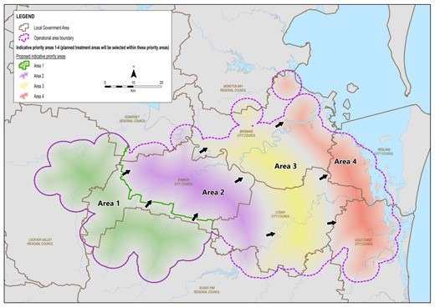
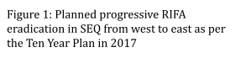
Red Imported Fire Ants (RIFA) are rightly considered a super-pest globally, causing high long-term public health, agricultural, economic and environmental costs in countries they invade. In Australia, an incursion in south-east Queensland (SEQ), probably present since 1992 but found in 2001, has been under attempted eradication ever since. Efforts up to 2017, with government funding of $367 million, confined RIFA to a small part of SEQ, although the infested area has widened somewhat since.
In 2017, a further cost-shared Ten-Year Plan was approved by all Australian governments, with
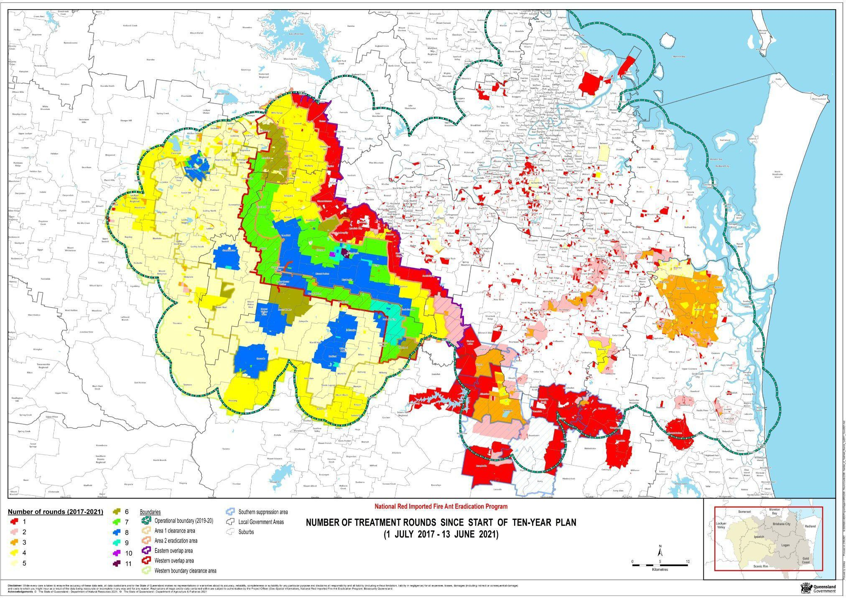
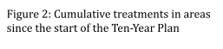
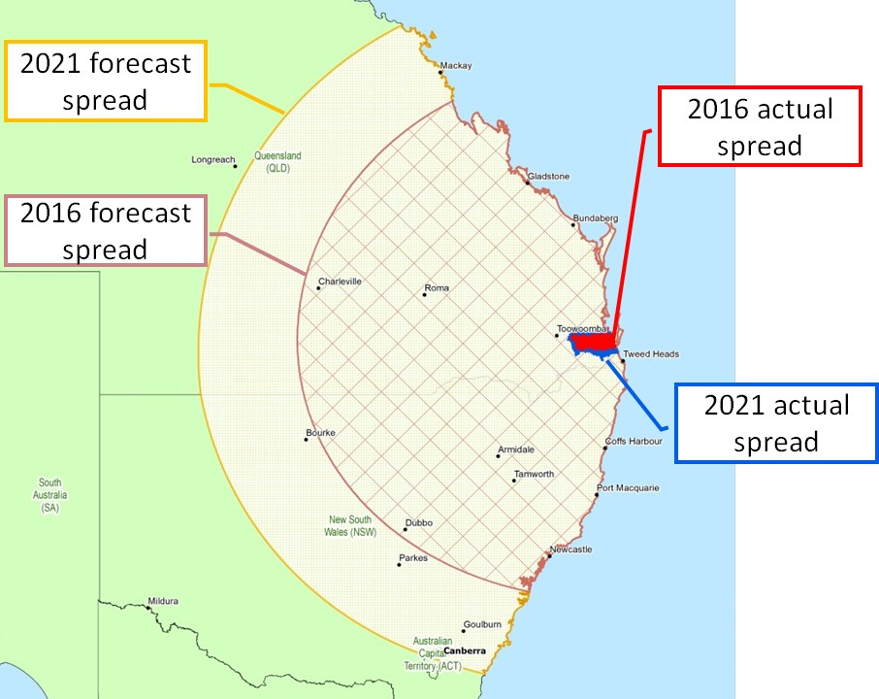
$411.4 million for the Queensland Government to host and deliver an expanded National Red Imported Fire Ant Eradication Program (NRIFAEP) from F/Y 2018 to 2027 under the direction of a national steering committee (Fig. 1). It aimed to eradicate RIFA from SEQ and Australia; and thus avert, by 2030, predicted annual impact and control costs of $2 billion, and up to 140,000 medical consultations and 3,000 anaphylactic reactions each year due to RIFA stings.
NRIFAEP is the largest ant eradication ever attempted globally. Delays in planning, gaining funding approval and scaling up operations, meant that broadscale control efforts only began in earnest in 2018, three years after the estimated extent of the ants had been mapped in 2015. By then, RIFA were already beyond the planned and budgeted treatment boundary, which surrounded 480,000 Ha in 2017. Although the national Program has to date contained RIFA within SEQ, largely by repeated rounds of aerial broadscale treatment (Fig. 2), it has not stopped the ants slowly spreading out and expanding the control area to 750,000 Ha in 2021.
RIFA are now only 23 km north of the NSW (and the Tweed Shire Council) border, 10 km closer than in 2017. The Program’s efforts have kept RIFA’s spread rate in SEQ to about 5 km per year (compared to at least 48 km per year in the USA
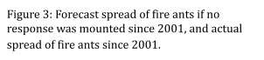

and 80 km per year in China), and have greatly reduced RIFA densities within the eradication areas, thus limiting local impacts and potential for spread from those areas (Fig. 3). However, further years of broadscale treatment and surveillance across and beyond the enlarged western and southern zone will be needed before proof of freedom activities could start.
The Ten-Year Plan’s agriculturally-focussed strategy of emphasising containment to protect the rest of the country, starting eradication in the west of the infested area, and progressively moving eastwards, left a large residual area around Brisbane to be dealt with in later years. Here, as since 2001, people were asked to report any suspect RIFA, but await Program staff to identify the ants and then treat the individual nests. While this was done for public safety reasons and to
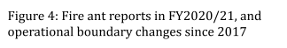
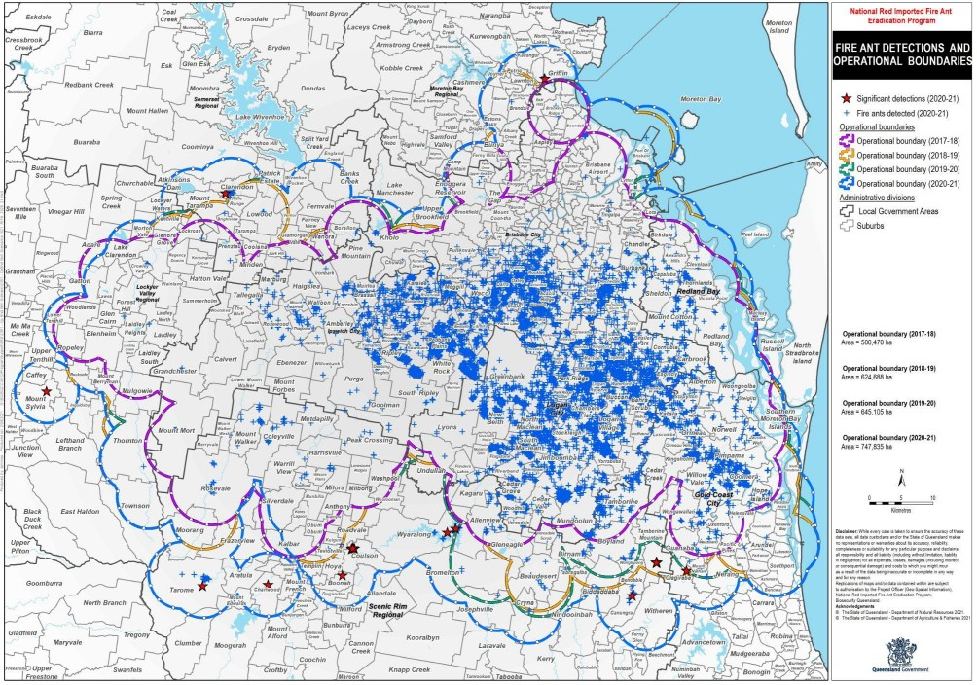
track infestations, lack of urban
area-wide management has allowed RIFA build-up to accelerate in the greater Brisbane area. Public reports have doubled in the past two years up to 7,000 in the first half of 2021(Fig. 4), which likely reflects increasing RIFA impacts and risks - especially to children, the elderly, outdoor workers and pets - of severe stings, allergies and anaphylaxis; but also of RIFA spread more widely in SEQ and beyond.
The past 20 years of investment in RIFA eradication and control has created a national asset in the NRIFAEP. Program
staff, now some of the best experts in the world at tackling this pest, have defined safe, effective and efficient RIFA treatment and detection regimes for many situations. They are continually gaining further insights into the context of eradicating RIFA in Australia, including scientific, operational, community, industry and political issues, and changes needed for successful eradication. They also provide critical support for managing other exotic ant incursions around Australia. Without these learnings and the successful suppression of RIFA across areas of the operational zone, the pest would have spread much faster, with public health and agricultural problems emerging by now in SEQ and in other jurisdictions. RIFA is still confined to approximately 12% of SEQ and only about 0.4% of Queensland.
This review, four years into the Ten-Year Plan, finds that, although the current program is significantly slowing spread of RIFA in and out of SEQ, it will not be able to eradicate or contain RIFA within the scope and budget of the Ten-Year Plan. With a fixed budget, and delayed implementation allowing RIFA spread beyond what the Plan had been based on, the Steering Committee and NRIFAEP management have been continually forced to make budget-driven decisions, which have prioritised efficiency over effectiveness. In the longer term, eradication may eventually be feasible, but will only be achieved with major changes in program scope, strategy, budget and governance, as well as new technologies.

In view of the outcomes of the Program to date and the current risks of spread, a major change of plan will be needed for any possibility of long term eradication and even for continued mitigation of a build-up of infestation with consequent serious problems. The gains made to date must be preserved if possible, while a new strategy is put in place.

Future options
The review has proposed three potentially feasible options for the future of RIFA management in Australia. Other options that the Panel considered, but rejected as unfeasible include continuing with the Program in some form under the current budget (which will achieve little) or conducting a single, short-term eradication effort across the entire infested area (which would be logistically impossible).

Option A. ‘A Fire-Ant Free Olympics’ - Contain, Suppress, Eradicate by 2032
If national eradication of RIFA is to be achieved, then the three pillars of Contain, Suppress and Eradicate across and beyond the whole operational zone need to be pursued. This will have budget implications for the national Program and also for Queensland state and local governments (Table 1). However, due to the large geographic area of infestation in both rural and urban environments, the Program cannot and should not achieve the three pillars by undertaking all operations alone, and broadscale operations on rural land will not be sufficient to contain, let alone eradicate RIFA.
To prevent RIFA spreading beyond SEQ, building up more around Brisbane, and eventually becoming entrenched throughout Australia, a larger, more comprehensive and inevitably more expensive program will be needed, with three key elements:
- stronger containment by strategic broadscale treatment and surveillance outside the known infested area, widening the RIFA Biosecurity Zone considerably, and stronger preventive measures for RIFA movement in carrier risk materials,
- more aggressive suppression by regular area-wide treatment programs especially in the current Residual Area, involving councils, communities and all land managers in implementing coordinated effective and efficient RIFA suppressive or preventive programs tailored for different groups on
RIFA-preferred land, while continuing broadscale or targeted treatment programs in agricultural areas, and
- eventual eradication, with progressive shrinkage of the operational zone once effective surveillance has demonstrated area freedom, and a long period (probably after 2032) of maintaining preventive and suppressive measures while complete freedom is proven.

Option B. Contain and Suppress
This option would involve the same containment operations as Option A, but with reduced broadscale suppressive or eradication treatment within the Operational Zone. There would be difficult choices to be made between containment and suppression.
Reduction of budget aimed at achieving eradication in certain areas would risk undermining the gains already made. Reduction of budget for comprehensive containment treatment would risk permitting some natural spread as has been happening since 2017. There would be little prospect of eventually shrinking the Zone and an increased level of risk of breakout and RIFA spread.

An urgent pivot to greater self-management within the former eradication areas would be needed, with commensurate reduction in eradication treatments. Goals, objectives and annual budgets would need urgent revision. Greater risk communication and preparedness would be needed, inside and outside SEQ and in other jurisdictions.

Option C. Winding down, transition to state by state management
If a national cost-shared program is wound down, the spread of RIFA in Australia is likely to mirror that in the USA. Even if the Queensland Government continued alone with major elements of the proposed suppression program, without external budget, accelerating spread of RIFA would be inevitable over a wider and wider area.
Without effective containment, RIFA could spread naturally around 48km per year in Australia¹ - in the first year spreading imperceptibly north to the Sunshine Coast, south into northern NSW and west to the Darling Downs past Toowoomba and into Warwick, QLD. Noticeable or severe impacts would likely build up within 5-10 years of RIFA arrival in new areas. Interstate movement controls on RIFA carriers from an increasing part of Queensland would become ineffective over time. Further RIFA build-up in SEQ would increase risks of it hitchhiking far and wide on cars, caravans and other vehicles.
Other areas of Queensland and other states and territories, especially northern NSW at first, would have to prepare their communities and industries for RIFA incursion and establishment. Strong community and industry engagement, both in and beyond Queensland, would be needed to prepare them for ongoing self-management.
Nevertheless, some land, especially along the coast, would become increasingly inhospitable for people, pets, livestock and crops.
The national capacity that has been built up to combat RIFA would dissipate over time and painful lessons would have to be re-learnt in the future.
Inevitable future costs of major public health impacts and billions worth of damage per year to Australian agriculture and the wider economy would need serious consideration.

¹ based on US experience: Hung, A. C. F., & Vinson, S. B. (1978). Factors affecting the distribution of fire ants in Texas (Myrmicinae: Formicidae). The Southwestern Naturalist, 23, 205– 213.

Table 1. Summary of RIFA response options and forecast costs of each option. These figures should be viewed as estimates rather than minimum or maximum.

$200M- $300M $100M-$250M Elimination of RIFA from SEQ by
Outcome
Queensland Gov.
and other agents annual costs
NRIFAEP
annual costs
$150M-$350M+ Containment of RIFA to SEQ
$150M-$250M

Option A Option B
Option C
2032

- Estimated impacts
up to $2B

Uncontrolled spread of RIFA nationwide

Recommended changes to achieve RIFA containment and eradication
The Panel recommends Option A, as the benefits of RIFA eradication outweigh the ongoing, perpetual costs of the ant’s impacts and management under Options B and C. Successful eradication under Option A should be possible because: 1) the budget is based on Program experience, and focuses on quality rather than cost-cutting to meet a constrained budget; 2) treatment will focus on the edges of the infestation to limit spread; 3) strengthened prevention of human-assisted movement is a major component;
4) suppression across the whole infested area, which is essential, is included.
Political will, combined with a stronger coalition for action and governance changes, are needed to pivot the program to a multifaceted approach making RIFA control truly a shared responsibility. An integrated community- and industry-centric management program is required across all councils in SEQ, to suppress and eventually eradicate RIFA from urban land. The Queensland government will have to step up as a major partner to the revised NRIFAEP.
There is an urgent need for aggressive area-wide suppression of RIFA in built-up areas by cooperative council / community / industry programs, integrated across the landscape.
Road verges, parks, gardens and school grounds must be treated at the same time as residential blocks, suburb by suburb, on a regular and coordinated basis.
A successful local government pilot project in 2020-21 showed that, by supplying councils with the right scientific advice, access to baits, and technical support, scaling up a suppression program across SEQ is achievable and should be started immediately, to maintain momentum.
New pest quality assurance requirements to treat RIFA, supported by compliance agreements under the Biosecurity Act (Qld) 2014, are needed for industries, businesses and government land managers to reduce increasing risks of human- assisted movement. Ongoing preventive ‘fire ant free’ QA programs are needed for high risk land such as waste depots and building development sites; for high risk RIFA carrier materials, such as nursery plants, turf and hay; and for sensitive sites such as childcare, school, hospital and

aged care facilities. Similar preventive programs are needed on Defence land, on State rail and roadsides, on airports and other open land.
These programs must be strengthened with coordination, technical and logistic support, and above all, stronger communication and engagement by the Program and other government agencies. Over time they must become embedded into routine operations of the land or enterprise managers, with effectiveness and compliance checks where indicated. Some preventive programs need to be applied beyond the operational boundary and indeed interstate, to support long-term RIFA containment. Only in this way can we achieve a fire-ant free Olympics in 2032.
Major increasing risks that will have to be managed in future are the:
- vastly increasing pace and area of land development in SEQ, which creates immensely favourable RIFA habitat and greatly increases risks of
human-assisted RIFA movement
- increasing frequency of extreme weather events such as severe storms, winds, floods and fires, which favour natural spread of the ants further into new habitats and make timely treatment and longer term surveillance much more difficult
- effort required to maintain community, industry and political support for a complex long-term program in SEQ, which has about 3.8 million people and many diverse industries
- need to supplement an agriculturally focussed national RIFA containment and eradication program, with a Queensland state and local whole-of-government approach, to implement an inclusive urban and peri-urban program aimed at protecting public health, infrastructure and our relaxed way of life, and
- difficulty of raising and maintaining national awareness of RIFA as a very serious pest, due in part to the Program’s success in slowing its spread and reducing its impact.
The loss of momentum between 2015 and 2018 set the Program back some years, so it is imperative that there are no further delays in the national program, as it pivots to a multifaceted program by mobilising the SEQ community. Without a concerted effort to effectively communicate and raise the risks of RIFA spread in SEQ with stakeholders, develop new and keep current expertise employed in the Program, and rapidly deploy the extra resources required, it is unlikely that further RIFA spread can be prevented. Raising national investment now in this eradication program should be seen as an opportunity cost.
If RIFA moves out of SEQ, the Review Panel considers, based on overseas experience, that any hope of eradication will be lost forever, and ongoing costs for all Australian jurisdictions and for rural and urban industries and communities will be far higher than the current or proposed program.

List of review recommendations
Number Recommendation
1 The Steering Committee progress consideration of strengthened national governance arrangements with the cost-sharing partners, including:
- expanding the expertise of the Steering Committee either by a larger membership or a subcommittee of Queensland Government representatives, and
- strengthening the independence of the Steering Committee by providing a small part of the Commonwealth contribution directly through DAWE to fund the Steering Committee’s Independent Chair and two project officers.
2
The Queensland Government form a RIFA Interdepartmental
Committee to coordinate intrastate management of RIFA in partnership with the National Program and to report regularly to the Steering Committee on its performance against agreed milestones.
3 Other jurisdictions, especially NSW, develop a whole-of-government approach to RIFA similar to Queensland, including broadscale communications, local government engagement, RIFA high-risk carrier movement control compliance, and RIFA incursion preparedness.
4
The Program be responsible for implementing the national communications
strategy approved by the Steering Committee, and for producing national advisory material to improve community awareness of RIFA risks and encourage passive surveillance and preventive behaviour - particularly for urban and peri-urban areas across SEQ and northern NSW - with state contacts and local arrangements for reporting and managing RIFA inserted as required.
5 The Queensland Government strongly support RIFA risk communication and engagement by the Program, with specific messages from the Program customised for different sectors through QDAF and other government agencies on a whole-of-government basis, emphasising the potential seriousness of RIFA across all sectors and how to recognise, report and manage them in different situations.
6
For Option A or B, the Program conduct ongoing suppressive treatment at
least 10 km outside and 2 km inside the revised operational boundary for some years to prevent further creeping RIFA spread.

7 For Option A, the Program continue broadscale treatment across all agricultural parts of the Operational Zone, with on-ground follow-up as needed to address any gaps.
8
The Program review and strengthen its guidelines for surveillance and
treatment around newly-found infestations to maximise the likelihood of eradicating them in one season.
9 A more aggressive polygyne eradication program be implemented throughout the Operational Zone, with best practice intensive treatment and follow-up surveillance for all known polygyne sites.
10
Laboratory resources be urgently refocussed to prioritise polygyne
detection and reduce the backlog of samples, with research into more rapid genetic tests for polygynes and for tracing.
11 The national Program be resourced to purchase sufficient RSS units and develop in-house analytic capacity in time to cover the areas designated for 2022 and later years’ surveillance seasons.
12
The Program make available its Guidelines and SOPs for ground surveillance
in different settings and for follow-up reporting and other action, to other jurisdictions, industry groups and the public, for their own QA and RIFA detection and reporting programs
13 Biosecurity Queensland implement a wider RIFA Biosecurity Zone in SEQ, at least south to the NSW border and west to the Great Dividing Range, and urgently scale up communications, engagement and compliance activities throughout the expanded zone.
14
States / Territories work through Plant Health Committee to harmonise
their interstate movement controls on RIFA carrier materials as the Queensland RIFA biosecurity zones and RIFA carrier movement requirements are reviewed, and implement suitable compliance checks at destination of high risk carriers such as nursery materials.
15 The Queensland and NSW governments implement coordinated RIFA communications, surveillance and movement compliance programs in LGAs bordering the expanded RIFA Biosecurity Zone.
16
The Program work with key industries and the government agencies that
regulate them to strengthen and expand existing controls preventing human-assisted movement of RIFA carrier materials out of and within the Biosecurity Zone.

17 The Program work with land developer and waste facility peak organisations and the Government agencies that regulate them to define appropriate routine RIFA suppressive programs that must be implemented throughout and beyond the Biosecurity Zone.
18
The Program embark on an industry-by-industry engagement program to
develop and embed appropriate RIFA carrier risk mitigation and suppressive treatment processes into QA programs, moving over time to more industry self-regulation, with relevant State or Local Government agencies as the compliance auditors of last resort.
19 Queensland state government agencies work with the Program to develop and implement a framework for councils and communities to manage RIFA in their areas, assisted by State and National bodies, as well as responding to reports of suspect RIFA and linking to national Program reporting systems.
20
The Program work with councils to develop and extend area-wide RIFA
suppression and eradication programs as soon as possible, starting in suburbs with significant RIFA infestations and moving to all LGAs with any land in or adjacent to the extended Biosecurity Zone.
21 Responsibility for responsive visits after reports of RIFA nests be devolved from the Program to local governments, with training of Council staff and linkages to the national recording system provided by the Program.
22
All Queensland Government agencies work with the Program to develop and
implement RIFA-suppressive programs on land for which they are responsible.
23 The Program work through QDAF and DAWE with Defence and port-of-entry operators to develop RIFA-suppressive programs for
Commonwealth land that Defence and airport and port operators will implement and report on to the Program.
24
The Program regularly review and improve its IT systems to optimise:
- performance, integration, data searchability, cost and adaptability
- ability to interface with other systems and apps used by the public and councils,
- more effective and timely reporting to support decision making by all parties, and
- efficiency in streamlining information capture to support reporting, analysis and operational management work at the local, state and national levels.

25 The Steering Committee explore development of a broader collaborative strategic research program for RIFA and other tramp ants, looking at longer-term applications of new ‘blue-sky’ technologies to the challenges of their eradication and surveillance.
26
Staff funded by the national Program be exempt from the Queensland Public
Sector FTE cap.
27 QDAF review its processes for approving Program expenditure and major contract procurement, with greater delegations for operational expenditure and procurement being given to the Program General Manager and more flexible oversight to assist program effectiveness.

Report

Red Imported Fire Ants (RIFA) - a ‘super pest’ species
Red imported fire ants (Solenopsis invicta Buren) are listed among the world’s worst invasive pests², causing high long-term public health, socio-economic and environmental damage, and extinctions of species³. Native to South America, they were accidentally introduced in the 1930s to the southern United States⁴, and the Caribbean region, and more recently to China, Japan, Taiwan and South Korea⁵. The USA has been battling RIFA since the 1940s and gave up on eradication in 1978. RIFA are now distributed over much of 11 states in south-eastern USA, with human-assisted spread to California and New Mexico, and impact costs estimated at US$7 billion/year. The presence of RIFA in the USA and close trading partners in Asia (China, Japan, Taiwan and South Korea) poses an ongoing major risk for Australian biosecurity.
When in high densities and abundance, RIFA have major impacts on all areas of human interest, including public health, recreation and tourism, agriculture, infrastructure and biodiversity.
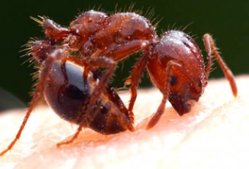
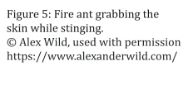
Public health impacts of RIFA are severe when they become established. The ants will swarm to aggressively attack if their nests are disturbed, and when foraging for food. The ants grip the skin tightly with their jaws and inject venom repeatedly with their stingers (Fig. 5), causing multiple painful stings that can provoke allergic reactions, anaphylaxis and sometimes death in susceptible people. A wide range of animals - pets, livestock and native animals - can also be stung, particularly around eyes and nostrils, and sometimes blinded or overcome and killed by the ants. RIFA may nest in walls of homes or other buildings and search for food, swarming to attack people or pets inside.⁶
Estimates of people in infested areas that are stung each year range from 30-89%. More than 1% of people stung are hypersensitive and may seek medical attention.The population of Australia as of December 2020 was 25.7 million. If RIFA infested the whole of Australia, at a conservative estimate of 30%, 8.3 million people would be stung and

² Lowe S et al. 2004. 100 of the world's worst invasive alien species : a selection from the Global Invasive Species Database. IUCN, Gland, Switzerland
³ Gruber MAM et al. 2021. A global review of socio-economic and environmental impacts of ants reveals new insights for risk assessment. Ecological Applications in revision
⁴ 128 million hectares in nine south-eastern states in the USA (Alabama, Arkansas, Florida, Georgia, Louisiana, Mississippi, North Carolina, South Carolina and Texas), with limited infestations in Arizona, Oklahoma, Tennessee, New Mexico and California: https://www.cabi.org/isc/datasheet/50569
⁵ Wylie R et al. 2020. Invader at the gate: The status of red imported fire ant in Australia and Asia. Ecological Research, 35: 6– 16. https://doi.org/10.1111/1440-1703.12076
⁶ Kemp SF, deShazo RD, Moffitt JE, Williams DF, Buhner WA 2nd. Expanding habitat of the imported fire ant (Solenopsis invicta): a public health concern. J Allergy Clin Immunol. 2000 Apr;105(4):683-91. doi: 10.1067/mai.2000.105707. PMID: 10756216.

83,100 would require medical attention for stings each year. The total cost of medical attention for 9.4 million Australian households due to stings could be $178m.⁷
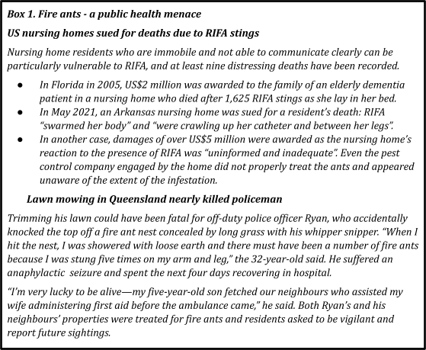

If RIFA were allowed to spread unchecked in Australia, annual impacts could amount to nearly $2 billion and apart from the health costs could include⁸:
- Cattle industry: RIFA stings to an animal’s eyes and nostrils can cause blindness, swelling and suffocation. Multiple stings can occasionally result in death, particularly of newborn animals. Cattle may become malnourished when the ant invades their food and water. RIFA in Texas have reduced cattle industry gross margins by about 10%. Cattle herd size in Australia is currently around 28 million and total losses to the industry from RIFA could total more than $300M.
- Wheat: The annual value of the wheat crop in Australia is about $2 billion. It has been estimated that the treatment, expenditure and the residual losses in revenue expected from RIFA could reduce gross margins by around 10% or $200M.
- Other crops: RIFA is known to impact more than 50 commercial food crops grown in Australia through loss of crop yield, plant mortality, damage to equipment, increased labour costs and market access, with a cost of $130M.

⁷ Wylie FR and Janssen-Ma, S. 2017. Red Imported Fire Ant in Australia: What if we lose the war?. Ecological Management and Restoration, 18: 32-44. https://doi.org/10.1111/emr.12238
⁸ Wylie FR and Janssen-Ma, S. 2017. Red Imported Fire Ant in Australia: What if we lose the war?. Ecological Management and Restoration, 18: 32-44. https://doi.org/10.1111/emr.12238

- Schools: Students are most likely to encounter RIFA in playgrounds or sports fields, but ants can also enter classrooms. As well as danger of stings and possible life-threatening reactions, ants can damage school electrical equipment and other infrastructure. Most costs are associated with treatment of grounds and fields. With 10,584 schools in Australia in 2019, the annual cost could exceed $150M.
- Telecommunications and electrical supply and equipment: RIFA has an affinity to electrical utilities, shorting out switching mechanisms and causing corrosion to housing of transformers and other equipment⁹. Road and airport runway lights can also be affected. Costs to the electrical and telecommunication companies in Australia could amount to $508M.
- Golf: RIFA has had a substantial economic impact on golf courses in the USA for treatment, repair, replacement and medical costs, including replacement of costly automated irrigation systems. Estimated costs in Australia could reach $22M.
- Tourism: This is an important sector of the Australian economy with international and domestic tourism in 2018/19 contributing $122 billion. 9.3 million tourists visited Australia in 2019. In the US, 3 out of 10 tourists in RIFA-infested areas were estimated to avoid outdoor activities because of the ants - often called
‘barbecue-stoppers’ - at a cost of $49/affected tourist/year¹⁰. Beaches are important drivers of tourism in Australia, and RIFA can establish nests along foreshores and sandy dunes and forage into the intertidal zone. Impacts in places like the Gold and Sunshine Coasts are likely to be severe. Around 13.5m people visit these areas each year and, on US figures, approximately four million could be affected with foregone opportunity costs of more than $200M.
RIFA’s ecology makes them uniquely difficult to suppress or eradicate. The ants reproduce prodigiously. A single queen in one nest can produce thousands of ants within six months of establishment (and millions over her lifetime). They have two genetically determined ‘social forms’: monogyne (single queen) colonies or polygyne (multi-queen) colonies. A nest will not survive without its queen(s). Monogyne queens can fly up 5 km or even further when wind-assisted to create a new nest; polygyne queens seldom fly, but their colonies can extend by ‘budding’ (or walking) by up to 30 metres per year, resulting in much higher densities and greater impacts. Another means of natural spread is ‘rafting’, whereby, during flooding events the flooded colony forms ‘rafts’ of individuals that can persist for weeks while floating down rivers¹¹.
Treatment of land for RIFA is largely by insect growth regulator (IGR) or toxicants mixed with corn grit and soybean oil to make an attractive ant bait. Both types of bait are virtually non-toxic to humans and other mammals. The IGR bait has very low toxicity to mammals but will interrupt the RIFA reproductive cycle. The toxicant baits contain the same chemical as that used in pet flea collars. They will kill the foraging worker ants which feed the queen and thus lead to colony death. Used alone or in combination with

⁹ Kemp SF, et al. 2000. Expanding habitat of the imported fire ant (Solenopsis invicta) : A public health concern. Journal of Allergy and Clinical Immunology 104,5: 683-691, DOI: https://doi.org/10.1067/mai.2000.105707
¹⁰ Lard, C.F., et al. 1999. The Economic Impact of the Red Imported Fire Ant on the Homescape, Landscape and the Urbanscape of Selected Metroplexes of Texas: A Part of the Texas Fire Ant Initiative 1997–1999. Economic Research Report # 99-08. Department of Agricultural Economics, Texas A&M University, College Station, TX. DOI: https://doi.org/10.22004/ag.econ.23994
¹¹ Morrill WL. 1974. Dispersal of red imported fire ants by water. Florida Entomologist 57: 39-42.

toxicants, if regularly spread in an area over a suitable time period, IGR treatments lead to local eradication of the ants.
Untreated, monogyne nests may reach densities of up to 500 mounds/Ha, while polygyne colonies may have densities of up to 5,000 mounds/Ha in SEQ,¹² as well as having larger individual nests with many more ants, and consequently being much more difficult to eradicate.
Both forms, especially polygynes, are easily spread over long distances by human-assisted movement of infested carrier materials, such as soil, hay, mulch, turf and nursery plants. In the USA, annual RIFA spread has averaged 48 km and is as high as 80 km in China.
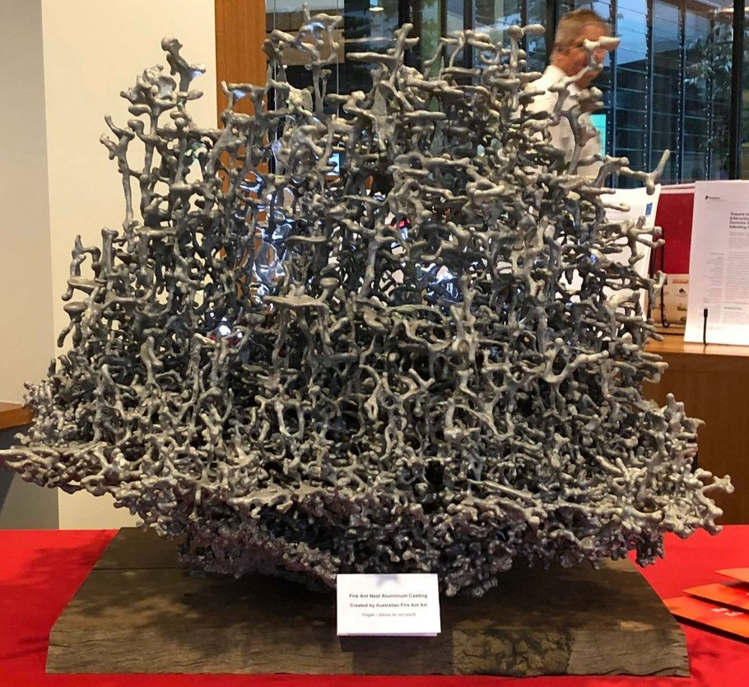
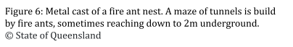
RIFA do not normally establish nests in forested or bush habitat, but may nest along fire trails or in any forest clearings. However, high density polygyne colonies may sometimes spread into what would be regarded as unsuitable habitat.
The ants prefer disturbed, open sites, such as new developments, waste management depots, ploughed land, gardens and parks, road, railway and river verges, and sandy shorelines, but will nest even through small cracks in concrete, and sometimes in house walls, or undermining roads and footpaths. They are attracted to electrical wires and may nest in outdoor
electric utility boxes, causing major outages, or in airport runway lights. Nests may be up to 2 metres deep and wide (Fig. 6), with burrows for worker ants to forage for food extending underground for up to 20 metres from each nest. In cooler months, RIFA build their nests up into mounds out of the ground, causing problems in backyard lawns, sportsfields, golf courses and farms.

¹² McNaught M et al. 2014. Effect of Broadcast Baiting on Abundance Patterns of Red Imported Fire Ants (Hymenoptera: Formicidae) and Key Local Ant Genera at Long-Term Monitoring Sites in Brisbane, Australia. Journal of Economic Entomology, 107(4):1307-1315

RIFA in Australia
RIFA was found in 2001 in south-east Queensland (SEQ) covering an area of between 28-71,000 Ha and may have been present since about 1992. A spirited attempt to eradicate this infestation knocked it down to such a low level by 2003 that success was
prematurely anticipated and Program funds were severely cut. Unfortunately, this led to a rebound of ant infestation a few years later and necessitated further increasingly expensive attempts to contain and eradicate the ants over an ever- widening area.
Between 2001 and 2017, the Australian and state and territory governments collectively spent $366.9 million trying to eradicate RIFA and managed to contain the pest within a small part of SEQ. These control efforts are estimated to have prevented RIFA spreading by 2016 to 69 million Ha of QLD and NSW and infesting an arc of country from near Mackay, Charleville, Bourke and Parkes down to Sydney. By 2021, left untreated, RIFA would likely have reached Canberra and have spread to most capital cities in Australia by long distance movement in carrier materials. Based on US experience, control activities could have cost upwards of $1 billion per year by 2021.
Around Brisbane, from 2002 to 2010, 61 per cent (1,749 sites) of known RIFA activity was in areas with significant soil disturbance in the preceding one to three years. This was mostly due to residential and industrial development¹³. The large amount of suburban development in SEQ poses a significant risk of movement of RIFA.
All of Australia (except possibly high country in Tasmania and the Snowy Mountains) provides suitable habitat for RIFA. Climate change is likely to increase risks of RIFA spread, into previously forested bushfire-affected land and by increased spread with flooding events. More severe weather events will also interfere with control efforts.
It is hard to estimate how long it would take before severe impacts of RIFA would be entrenched in Australia without eradication efforts. Based on overseas and local experience, significant impacts on communities and agriculture will occur between 5-10 years after entry into an area. On a 70 hectare rural property at Purga, SEQ, Program surveillance in 2005 found no RIFA but in 2010 there were an estimated 32,000 mounds, predominantly polygyne. The extent and timing of RIFA impacts across Australia will thus depend on whether it can be contained and /or eradicated, and how much natural spread and human assisted movement can be prevented.
In December 2016, an Independent Review by Magee et al.¹⁴ reported that, if established, RIFA would ‘surpass the combined effects of many pests we currently regard as Australia’s worst invasive animals (rabbits, cane toads, foxes, camels, wild dogs and feral cats)—which cost Australia $964 million each year in 2015 values’. As well, current US rates of RIFA-based medical consultations suggest that by 2030 there could be up to 140,000 consultations and 3,000 anaphylactic reactions each year due to RIFA stings. In July 2017, Australia’s agriculture ministers committed a further $411.4 million over 10 years to RIFA eradication.

¹³ Wylie FR and Janssen-May S. 2017. Red Imported Fire Ant in Australia: What if we lose the war?. Ecological Management and Restoration, 18: 32-44. https://doi.org/10.1111/emr.12238
¹⁴ Magee, Oi, Parkes, Adamson, Hyne, Langford, Holtkamp and Lawson. 2016. Independent Review of the National Red Imported Fire Ant Eradication Program

Containing RIFA in South-East Queensland (SEQ)

RIFA eradication program evolution
In 2010, a Scientific Review by Roush et al.¹⁵ had found that the RIFA restricted area had increased to 93,000 Ha and that surveillance and treatment methods at the time were inadequate to eradicate the RIFA Brisbane infestation. It recommended a focus on containment for 18-24 months until research could demonstrate success of remote sensing surveillance, improved efficacy of pesticide treatments and a further cost-benefit analysis, before a further review at that time.
As a result, a RIFA Eradication Program Response plan for 2013-2018 was developed and implemented from July 2012 with a cost-shared budget of $18-19 million per year, aiming to delimit, contain and recommence eradication of RIFA in SEQ.
The development of novel remote sensing surveillance (RSS) technology was key to delimitation of the SEQ RIFA infestation. However, the single RSS unit, originally obtained from the US Department of Defence, reached ‘end-of-life’ and was decommissioned after June 2015. A modelling team from Monash University ¹⁶ estimated a 99.9% probability that RIFA were contained “within the operational boundary corresponding with the area that had remote sensing completed”. At this time the operational zone area was estimated at 341,052 Ha.
The Monash model accounted for up to two years delay in re-deploying RSS, substituting surveillance with prolonged baiting of large areas. But, failure to invest in RSS R&D during the next two years, while securing funding for the TenYear Plan, led ultimately to a five-year delay (2016 - 2021) in RSS being used operationally. Surveillance between 2016 and 2020 was unfortunately confined to laborious and expensive ground-based inspection by teams of people or by sniffer dogs, as well as passive surveillance by investigating reports from the public..
Based on the 2015 RSS delimitation, the modelling, and other analysis, the 2016 Magee Independent Review concluded that “there was a small window of opportunity left” and recommended that eradication should still proceed. It calculated a benefit-cost ratio of 25:1 but that the then-current budget of $19 million per year was insufficient to achieve eradication. This led to the development of a new Ten-Year Eradication Plan and national funding agreement.
From July 2015 - July 2017 the Program continued with the stated aim of eradication, but without significant budget increase or change from previous activities. It focused on targeted treatment of planned areas, on-going ground surveillance, and movement controls on RIFA carriers to minimise human-assisted RIFA spread. In retrospect, this level of activity was insufficient to contain and suppress RIFA pending later eradication attempts.

¹⁵ Roush, Vander Meer, Davis, Bailey, Barry and Kompas. 2010. Scientific Review of the National Red Imported Fire Ant Eradication Program (NRIFAEP)
¹⁶ Spring and Croft. 2016. Simulation Modelling of Fire ant Eradication

With a (subsequently) estimated rate of spread of 4.8 km per year, ants were likely to be 10 km outside the previously delimited boundary by the time the Program restarted, and in fact, two detections 10-11km beyond the nearest previously known nests were found by limited ground surveillance (about 200 Ha at 17 sentinel sites) in winter 2017.

The Ten-Year National RIFA Eradication Plan (‘the Ten-Year Plan’)
A cost-shared Ten-Year Plan was negotiated between the Commonwealth and all State/Territory Governments for the Queensland Government to coordinate an expanded national response to eradicate RIFA, to run from 2017-18 to 2026-27.
The Ten-Year Plan aimed to eradicate RIFA from Australia with four objectives:
- eradicate RIFA from the known SEQ infested area and keep it free
- prevent RIFA spread to non-infested areas
- prove freedom from RIFA infestation in the SEQ area
- help prevent establishment of new incursions of invasive ants Australia-wide. Its strategy involved:
- progressive eradication by targeted treatment and clearance by surveillance and mop-up treatments in broad areas from west to east (Fig. 7)
  - starting with eradication by treatment and then clearance in the westernmost part of the overall zone (Area 1)
  - moving to eradication treatment in the adjacent more easterly part (Area 2), and
  - suppression, eventually moving to eradication, in indicative Areas 3 (Ipswich and Brisbane City) and 4 (Logan, Redlands and Gold Coast Cities) which formed a Residual Area to the east.
- community and industry education and some regulation to encourage reporting of infestations in eastern residual more urban areas, supported by responsive treatments, until eradication was undertaken in the later years of the Plan
- containment of RIFA within the 2015 delimited zone by biosecurity controls on RIFA carrier materials being moved out of different infested zones and interstate, and
- eventual proof of freedom surveillance area by area, following the Ten-Year Plan, with criteria to be developed during the program.

The National RIFA Eradication Program (the Program, or NRIFAEP) implementation
The Ten-Year Plan was broad and conceptual and needed fleshing out to become the Program. Implementation was budget-driven from the start, in many cases leading to efficiency being prioritised over effectiveness.
In late July 2017, the national Agriculture Ministers’ Forum (AGMIN) approved funding of
$411.4 million over 10 years, cost-shared between jurisdictions (Table 2), to be paid at
$41.14 M per year to QDAF to implement the Program.
A National Steering Committee for the Program was set up, with an Independent Chair and members from the Commonwealth and most States and Territories, to report through the Commonwealth Agriculture Minister to AGMIN on budget and progress oversight.

Table 2: Proportion of NRIFAEP funds contributed by jurisdictions

Jurisdiction | Total AUD | Percentage
Commonwealth | 212,542,198 | 51.7%
New South Wales | 61,370,000 | 14.9%
Victoria | 47,880,000 | 11.6%
Queensland | 43,231,082 | 10.5%
Western Australia | 23,422,150 | 5.7%
South Australia | 15,303,038 | 3.7%
Australian Capital Territory | 3,002,00 | 0.7%
Tasmania | 2,465,489 | 0.5%
Northern Territory | 2,210,439 | 0.5%
10 Year Plan | 411,426,396 | 100%

At the start of the Program the operational zone comprised an area of 500,470 Ha. This was significantly larger than the area delimited in 2015, on which the operational budget of $411 m over 10 years had been developed. Only once funding was signed off could major staff recruitment and procurement of facilities and material begin. Program staff numbers doubled between August 2017 and June 2018, new headquarters, depots and science labs were leased or built and outfitted, major procurement contracts established, and regulatory approval gained for helicopter treatment flights.
An Addendum to the Ten-Year Plan in October 2019 formalised changes to the original plan made in 2018-19, including moving from targeted to broadscale treatment in eradication areas, and a Western Boundary enlargement, almost doubling the initial eradication Area 1. $34 million was brought forward from future years to cover this extra treatment, with no change in the Ten-Year budget, to (hopefully) be recouped by future efficiencies in technology or staff.
In 2019, the Steering Committee commissioned B. Wonder to conduct a comprehensive ’Efficiency and Effectiveness review’ of the Program¹⁷. Wonder found that the Plan was already one year behind the original schedule, due to the expanding operational zone to the west from the original delimitation in 2015 (500,470 Ha) to 2019 (645,105 Ha) and other key constraints. These included the fixed annual budgets set out in the Ten-Year Plan, remote sensing surveillance unavailability, impediments to treatment of certain land, suboptimal community communication and engagement, poor industry compliance and challenges scaling up operations across a widening area. He noted that KPIs developed to track achievement of Ten-Year Plan objectives often did not define the

¹⁷ Wonder, B. 2019. Efficiency and Effectiveness Review of the National Red Imported Fire Ant Eradication Program.

targets, but rather just the measure, often focusing on outputs rather than outcomes. This led to implementation conflicts, such as focusing on the number of treatments in eradication areas, rather than the quality of these treatments. Wonder found it was too early to say whether or not eradication could be achieved and made 37 recommendations, most of which were subsequently implemented.
This led to development of a Three-Year Eradication Strategy (2020-23) to support the Ten-Year Plan, through changing the program focus to improve operations by:
- Broad-scale mobilisation of the community to look for, report and control RIFA infestations
- Enhancements in containment controls, surveillance and treatment activities to prevent the spread of RIFA
- Increased investment in innovative eradication treatments and surveillance methods to drive down the cost of these activities
- Optimising models for clearing areas and demonstrating proof of freedom, and
- Adopting more agile, efficient and effective business processes.
The Three-year Strategy was a watershed moment for the Program. In its first year, operations were improved to engage and mobilise the community by conducting a pilot self-management project through a number of Councils, which once bedded down and effectively structured could be rolled out across the affected Council areas to assist in suppression activities across all Areas (1, 2, 3 and 4), but particularly the inner-city Councils of Brisbane, Redlands and Gold Coast. The Strategy acknowledged that the Program could not undertake all the necessary actions to achieve eradication and that a stronger public/private partnership is required.
The current Independent Review of the Program was called following the National Steering Committee’s decision to activate a risk management trigger in the Ten-Year Plan, namely “any event or circumstance that means the objectives and eradication targets of the 10-year plan are unlikely to be achieved within the agreed time frame or budget”. The immediate trigger was the detection in late 2020-21 of multiple infestations outside the Operational Boundary.

Progress against Ten-Year Plan objectives

Eradication of RIFA from the known infested area in SEQ

Broadscale treatment and clearance from Areas 1 and 2
The first RIFA eradication area of 84,025 Ha (Area 1) was drawn up on the west of the Operational Zone with its boundary extending only 2km beyond all known RIFA infestations. The targeted treatment of known infestations envisaged in the Ten-Year Plan was changed to broadscale treatment, increasing area treatment costs, but improving treatment effectiveness.
Limited ground surveillance in early 2018 found seven infestations beyond the operational boundary. This triggered the addition of a 5km Western Boundary (WB) strip of 77,658 Ha to Area 1, almost doubling the planned eradication treatment area from June 2018 - July 2020.
Area 1 was the first priority for eradication at the start of the Ten-Year Plan. The recommended RIFA eradication protocol was six broadscale IGR treatments at six to fourteen week intervals, typically over 2 years, as operationally, six treatments are difficult to achieve in one year. In Area 1/WB in each of the first two years of the Program, only one to four treatments were applied in most parts due to many operational constraints (e.g. weather, terrain, helicopter availability), with some small areas missing out completely (‘gaps’) due to issues like organic farms, free-range poultry, etc.
This meant that additional treatments were needed in Area 1/WB in later years, limiting resources and delaying progress to move eastwards into Area 2. The Program adaptively managed its work plans to treat infestations based on risk and budget, targeting high-density infestations, waste facilities, and high-risk areas identified by ground surveillance, and applied lessons learned in previous years to improve operational efficiencies. However, gaps in areas treated remained in each round, compromising the minimal clearance treatment outlined in the Plan and overall area eradication prospects.
Between July 2017 and June 2021, most of Area 1/WB received four to five broadscale treatments, with some ‘hotspots’ receiving six to eight, while between July 2019 and June 2021 most of Area 2 received between four and eight (Fig. 8). A further long band of land comprising the ‘Eastern Overlap’ and ‘Southern Suppression’ Areas received one to two treatments.
The ‘hotspots’ with eight treatment rounds were areas where risk-based ground surveillance had detected RIFA after previous years’ programmed eradication treatment rounds. Nearly all were within 2 km of areas with gaps in treatment in earlier years.

Treatment gaps
Gaps still occurred in each treatment round in 2020-2021and accounted for between 2 and 5% of the treatment area (Table 3) ¹⁸. Unless addressed, they threaten the
west-to-east progressive clearance and shrinkage of the eradication area and would necessitate ongoing eradication or containment treatments across the whole area.
Patchy treatment of these areas increases the risk of ants remaining in eradication areas. and, although challenging, the Program is actively addressing the underlying causes of these situations by:
        - seeking changes to APVMA permits, particularly for cropping issues
        - enforcement with police escorts when access is unreasonably refused
        - customising ground-based treatment and assigning additional resources toward resolving gaps
        - closer monitoring of environmental conditions to optimise treatment times
Area 2 was defined in 2020 (a year later than envisaged in the Ten-Year Plan) and a more coherent program of four eradication treatments per year was implemented. Buffer areas on either side of Area 2, known as the Western and Eastern Overlap Areas, were also given one to two treatments, to mitigate the risk of reinfestation into

¹⁸ Systematic recording of gaps were not kept prior to 2020-2021.

Table 3: Treatment gaps in 2020-21 and reasons for gaps.
Treatment
gap category
Cause of treatment gap
Total Gaps
in Area 1/WB (Ha)¹⁹
Total Gaps
in Area 2 (Ha)²⁰

Not visited | Rain/low temperatures prevents  effective treatment as planned and/or insufficient staff to complete within time available | 111 | 2195
Refusal / safety / access issues | Landholders refuse treatment. Safety issues such as dogs, locked gates, extremely long grass or tenants threatening staff with violence prevent treatment, or sites partially completed. | 340 | 883
Poultry | Poultry must be separated from RIFA baits as per APVMA permit. Some  free-range chickens weren’t penned in time for planned treatment, and/or treatment may not be comprehensive. | 21 | 88
Cropping | Unable to treat certain crops under APVMA permit. | 971 | 451
Horses and livestock | Aerial treatment can spook horses and livestock - causing them to injure themselves. Some landholders refuse all or partial treatment. | 60 | 97
Unsuitable habitat | Land that was unpassable - ie flooded, road parcels etc. | 326 | 922
Other | Sliver left from incomplete aerial treatment, sites reserved for science experiments, gaps left from ground treatment before (rather than after) aerial treatment | 140 | 553
Total |  | 1969 | 5190
% of total planned area 4.5% 2.8%

¹⁹ Gaps in Area 1/WB reported are for FY20/21 only.
²⁰ Gaps in Area 2 reported are for FY20/21 only.

Area 1 from Area 2 in the east and from the Residual Area (Areas 3 and 4) in the east. About 97% of the total Area 2 was treated in each round of treatment, although surveillance data were not available to assess the success of this treatment at the time of writing,
The Program implemented a number of operational efficiencies to reduce the risks caused by suboptimal treatment that occurred during Area 1 eradication. To increase the speed of eradication, the Program trialled the addition of toxicant baits to the IGR regime for aerial and ground broadscale treatments, and increased frequency to four rounds of treatment in the first year of eradication for Area 2 (2020-21).

Efficacy and safety of treatment products used against RIFA
Program eradication and clearance treatment involves aerial or on-ground distribution of granular baits containing insect growth regulator (IGR), which interfere with RIFA reproduction but are of no risk to people, pets or livestock, and pose relatively low environmental risk. The IGR approach has been used to eradicate RIFA many times.
However, IGRs break down and are ineffective after 24 hours, are slow acting and require multiple treatments, with a best-practice guideline of six repeated treatments at six to fourteen week intervals to ensure eradication.
To increase the speed of eradication, in 2020-21 the Program trialled more fast-acting toxicant products (Table 4). Monitoring will continue to determine their success. There is no evidence that the treatment products pose any risk to human or mammalian health when used in accordance with APVMA conditions. Some of the toxicants have potential non-target effects on aquatic wildlife, but these risks are managed through APVMA conditions for their application near water.
Table 4: Treatment products used by the Program.

Product Name
Active
Ingredient
Use by Program
Supplier

Distance Plus IGR Pyriproxyfen Broadscale
treatment
Broadscale
Sumitomo

Engage P IGR S-Methoprene
treatment in sensitive areas
Sumitomo

Termidor Fipronil DNI and toxicant trials
BASF

Advion Indoxacarb Toxicant trials DuPont Syngenta

Amdro toxicant Hydramethylnon Toxicant trials BASF
Synergy Pro IGR
and toxicant
Pyriproxyfen &
Hydramethylnon
Toxicant trials
Sumitomo

Going forward, area-wide RIFA-suppression should involve a three-round treatment program, with an IGR applied in spring, either an IGR or a toxicant applied in summer

and another IGR applied in autumn. The Program considers that two years of this regime could achieve eradication provided that an entire area is treated. However, based on the Program’s experience to date, the larger the area, the more potential for some areas with RIFA nests to be missed, so extra years of treatment are likely to be required.

Surveillance
While previous containment and treatment activities continued in 2016 and 2017, ground surveillance at scale only restarted in May 2018. A new contract for RSS research and development was not signed until June 2018, with a new prototype ‘RSS 2.0’ unit being trialed in winter 2019, ‘trained’ in 2020 and becoming fully operational for use at scale in winter 2021.
Sentinel sites were located outside the Operational Area and used for early warning detection of RIFA through on-ground surveys (Fig. 9). According to the Plan a detection at a sentinel site or other detection of significance required the extension of the Operational Boundary by 5 km and the addition of sentinel more sites.
In winter 2017, only 17 sentinel sites were surveyed and, despite this limited surveillance, two detections 10-11km beyond the nearest known RIFA were found. The number of sentinel sites was increased after the Efficiency and Effectiveness Report (Wonder 2019). However, sentinel sites are not consistently applied across the Program and are allocated depending on the resources available to survey them.
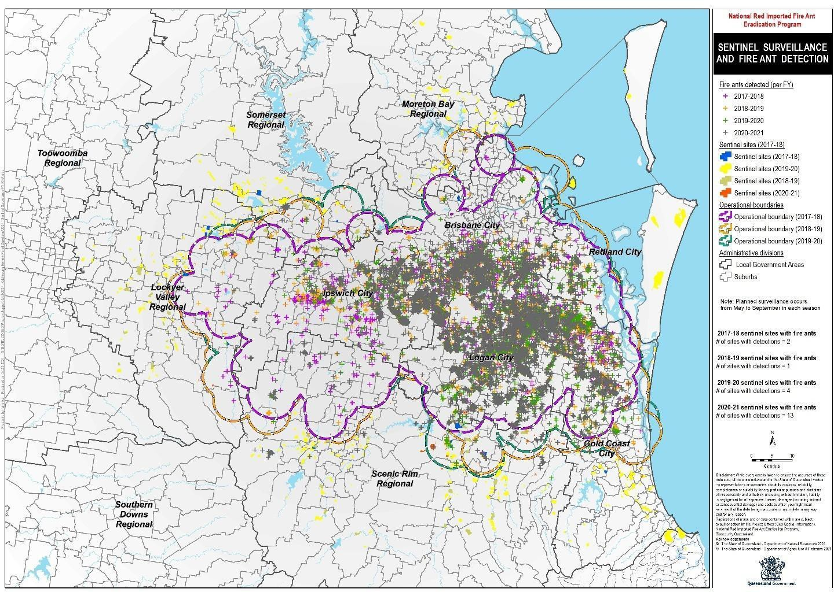

Previously sentinel sites were located outside Area 1 and the Western Boundary to the west. The Program did not have sufficient resources to implement sentinel sites around

the entire perimeter of the infestation in 2021-22 but was using RSS over the Western Boundary instead.

Assessing risk of remnant RIFA populations in eradication Areas
The Program developed a process to assess the risk of RIFA remaining in gaps via a ‘risk heat map’ that highlights sub-optimally treated areas for targeted surveillance and further treatment (Fig. 10).
The risk heat map was used to select priority sites for surveillance as it was not feasible to survey the entire eradication area without RSS. This map (Fig. 10) shows the selected priority sites (1=highest priority; 13=low priority), surveillance locations and RIFA detections since 1 March 2020. Surveillance is also undertaken in non-priority sites to ground-truth the model used to create the heat map. If the heat map is accurate, surveillance at these sites should be free of detections.
Using this approach, surveillance in March - June 2021 found significant numbers of residual ants within Area 1 that meant the area would require some additional broadscale treatment.
Hence, while the scope of activities envisaged in the Ten-Year Plan for these areas has been broadly delivered, progress with eradication in Areas 1 and 2 has been insufficient to allow shrinkage of these areas towards the east.
A further comprehensive treatment program would be needed in Areas 1 and 2, due to the number of nests detected after broadscale eradication treatment rounds. Further extension eastwards, while highly desirable, would involve substantial budgetary reallocation or supplementation. Risk-based eradication treatment programs would need to be continued in Areas 1 and 2 to maintain the gains already made and further broadscale treatments and reduction of any gaps be implemented progressively eastwards to advance towards eradication in these areas.
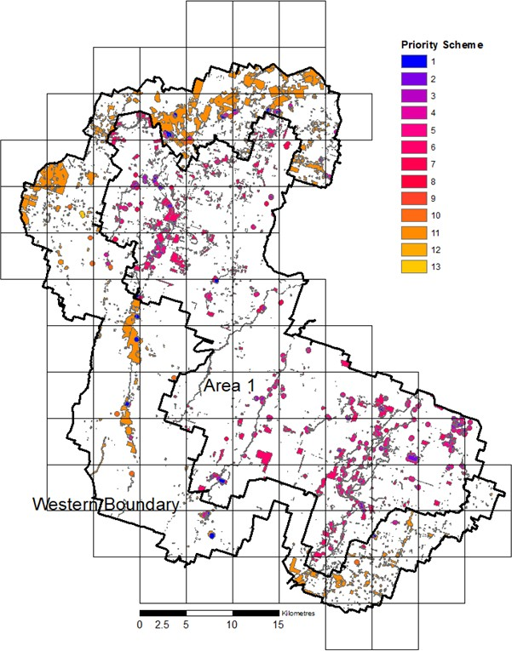

As has repeatedly been noted in reviews, the success of RSS remains critical to the success over the Program, even more so now that the infestation is very diffuse over a large area and anything other than broad-scale surveillance is not going to effectively detect ants to the level required for eradication, or even containment.
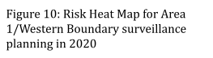

Importantly, assessment of progress would need a larger deployment of remote sensing surveillance,
with on-ground verification and response to any residual infestations, for several years,

before confidence in area clearance would allow any eastwards shrinkage of the eradication area.

Suppression in Areas 3 and 4 - the Residual Area
Areas 3 and 4 were indicated only vaguely in the Ten-Year Plan, forming a Residual Area where any area-wide management was deferred. These Areas include greater Brisbane and the growing areas of Ipswich, Moreton Bay, Logan, Redland, Gold Coast and the Scenic Rim, with a high proportion of residential, industrial and business properties, and much peri-urban development.
Suppression treatment involved broadscale IGR deployment at fewer repetitions than eradication treatment and was intended in the Ten-Year Plan to prevent spread and the risk of reinfestation of Areas under clearance, and adjacent to eradication areas. Single suppression treatments are not considered to be sufficient for containment but are intended to decrease the likelihood of spread and reinfestation, with budget constraints a main factor preventing more treatment rounds in these areas.
From 2019-2021,the Program undertook at least one round of broadscale suppressive treatment per year in the western and southern parts of the Residual Area, based on risks of spread of infestation further west into the eradication area or beyond the operational zone to the south. Only 10% of land in the Residual Are is suitable for broadscale treatment and surveillance. However, for adequate containment of RIFA within the operational zone, at least two further rounds of broadscale treatment per year would be required in these suppression areas.
Within the urban and peri-urban parts of the Residual Area, a responsive program has been the main activity. Since RIFA were found in Queensland in 2001, people have been urged to report any RIFA they suspect to the Program, but not to treat nests themselves (due to risk of stings and ineffective treatment). Program staff make site visits to all reported infestations, sample the ants, and treat all nests found. Previously treatment was always by direct nest injection (DNI) of dilute fipronil that required a skilled applicator, but now is often by a fast-acting toxicant bait (Advion) applied from a hand-held shaker.
While this change has markedly improved the response time, from over 40 days in 2018-19 to less than 10 days in 2020, it is still a highly inefficient and ineffective use of
Program resources, having no impact on overall prevalence of RIFA in an area. Treatment of adjacent properties and land is not systematically implemented, due to resource constraints and the original Plan that focused on Areas 1 and 2 as priorities for eradication and deferred area-wide management in Areas 3 and 4.
This responsive program has been under increasing challenge and is not holding the line. Despite no increase in broad community awareness messaging from the Program, the number of reported infestations has doubled in the last two years, with over 7,000 reports from January to June 2021 alone. This shows an accelerating build-up of RIFA infestations in the Residual Area (Fig. 11, Table 5), causing increased community concern and greater risks, especially to children, pets and all outdoor workers, of severe stings, allergies and anaphylaxis.

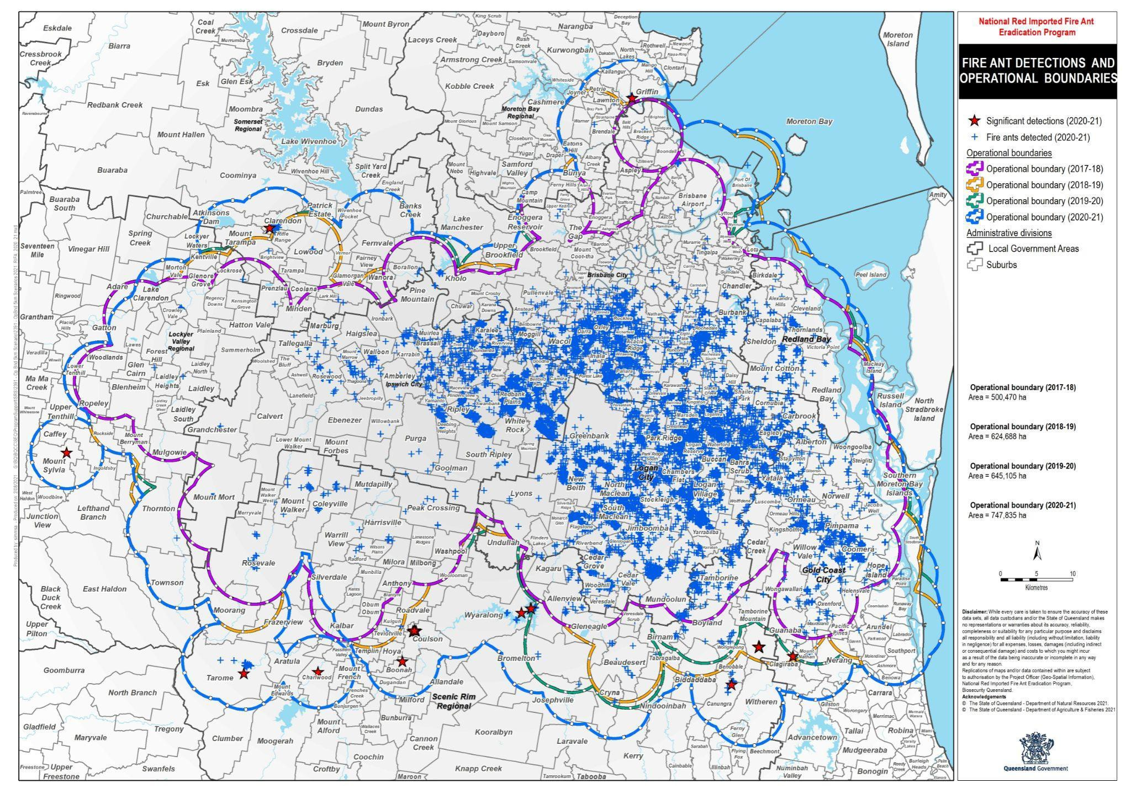

The build-up of infestations in the Residual Area poses serious risks of spread back to Areas 2 and 1 and also beyond the northern and southern Area boundaries, which abut on corridors leading towards the Sunshine Coast, and the Gold Coast and NSW border. This could occur by natural spread at the edges of the Area, by transport in high risk RIFA carrier materials such as soil, mulch, nursery plants etc., or just by small nests of RIFA forming in caked mud on the underside of cars, trucks and caravans, which are driven out of the Area. Clearly a change in strategy is urgently needed to suppress RIFA more effectively in the Residual Area and prevent unwitting human-assisted movement, through a massive increase in community engagement and implementation of council, community and industry-based suppressive and preventive management programs.

Polygyne colony eradication
When the Program detects a new nest, samples of ants are genetically tested to determine the social form. While the treatment is the same, polygyne nests are accorded a higher priority for treatment due to their higher density and higher risk, and they require more treatments to eradicate.
Polygyne detections have occurred in the centre of the Operational Area. Their distribution appears to be shrinking slightly, no detections of significance have been polygyne, and the number of samples that are genetically confirmed as polygyne each year is generally stable, which suggests they are being effectively contained within Areas 2 and 3 but not eradicated (Fig. 12).

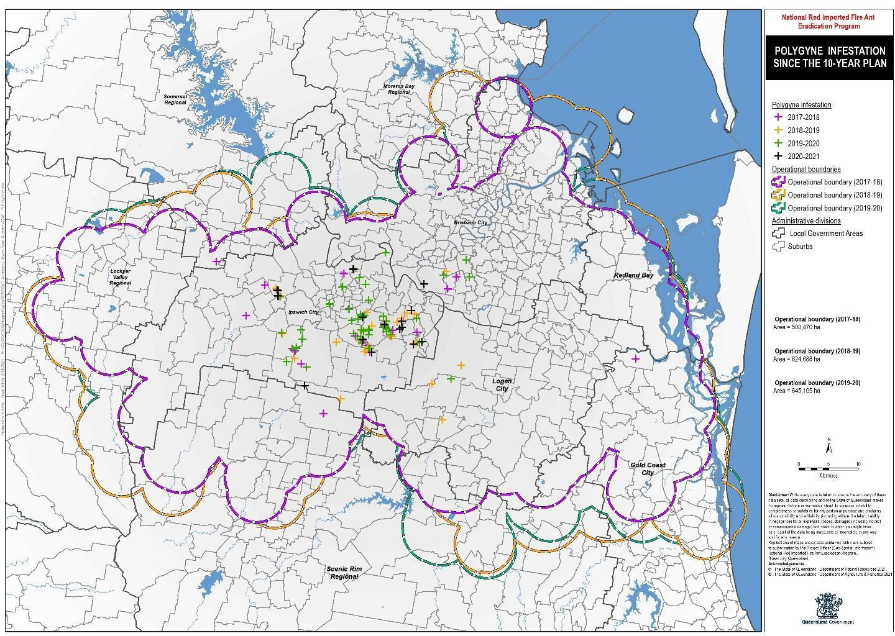

The more RIFA nests per hectare, the greater their impacts across all sectors - agricultural, public health, recreation or infrastructure. The Program’s Science group records polygyne nest densities in experimental sites used for treatment effectiveness trials. Between 2001 and 2006 typical polygyne
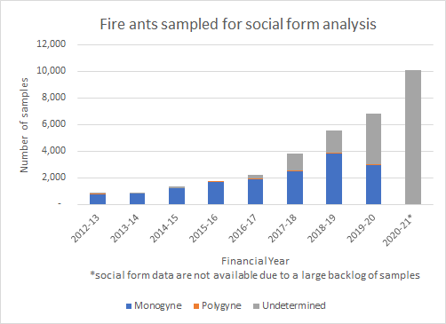
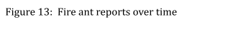
densities in SEQ ranged from 44-5,059 mounds per Ha, while in 2020-21, polygyne densities at experimental sites ranged from 35 to 454 nests. The Program is succeeding in reducing the densities, and so the potential impacts of RIFA in SEQ. Its operational research has identified promising new treatment regimes so that complete eradication of polygynes should be possible with best practice intensive treatment and follow-up surveillance for all known polygyne sites.
There is now a huge backlog of ant samples for laboratory genetic analysis (Fig. 13; grey shading). This delays identification of polygyne

colonies and tracing the origin of significant detections and increases risks of spread and needs attention to overcome. There could well be other undetected polygyne colonies in the large laboratory sample backlog.
Table 5: RIFA site reports by Program Area and calendar year. Green - broadscale (>1,300 contiguous hectares; up to 165,000 ha) treatment by year

Outside or
Year Western Area Area Residual very near Total Boundary 1 2 Areas Operational
Boundary
2015 | 8 | 92 | 102 | 2,418 | 10 | 2,630
2016 | 2 | 145 | 104 | 2,383 | 2 | 2,636
2017 | 13 | 176 | 133 | 3,519 | 21 | 3,862
2018 | 43 | 80 | 311 5,838 16 6,288
2019 | 35 | 33 | 125 | 6,797 | 14 | 7,004
2020 | 13 | 47 | 178 | 9,674 47 9,959
2021 Q1&2 | 6 | 20 | 17 | 7,029 | 23 | 7,095

Table 5 clearly shows both the accelerating build-up of RIFA in the largely unmanaged Residual Area and the diminution in RIFA detected in eradication areas a year after rounds of broadscale treatment are applied. It illustrates the possibility but also the challenge of achieving effective suppression which will lead to eventual eradication over the whole infested area.

Preventing RIFA spread to non-infested areas

Breakout detections and enlargement of the known infested area
From 2017, a risk-based, budget-driven ‘cost-optimised surveillance’ approach was applied in small sections of Areas 1 and 2, as well as at sentinel sites outside the operational boundary and surrounding significant detections, with no broadscale surveillance due to lack of RSS.
Despite this very limited structured surveillance, some RIFA infestations were found each year, most by public reports, beyond the then Operational Boundary. The Program prioritised these infestations for immediate intensive treatment, applied ground surveillance well beyond them to find any further infestations, and then extended the Operational Boundary by five km from the outermost detection for the following year’s eradication efforts. Any budget required for these unplanned emergency responses was taken from other planned work inside the Operational Area.
Most of these breakout detections (Table 6) were within five km of the Boundary, and all were monogyne, suggesting natural spread by flight of queens, while two (Witherin and Tarome) had evidence of having been moved in hay. The Mount Nathan detection in
2020-2021 was in the same location as the 2019-20 detection, indicating probable failure of the previous year’s attempt at local eradication.

Table 6: Significant detections of RIFA outside the Operational Boundary

Financial Number of General locations Year detections
2017-18 | 9 | Western Boundary
2018-19 | 8 | North: Brendale, Brisbane Airport, Fernvale.  South: Bromelton, Boyland, Helensvale (2), Southport
2019-20 | 5 | North: Mount Tarampa.  South: Gleneagle, Tamborine Mountain, Witheren, Mount Nathan
2020-21 | 11 | North: Griffin, Clarendon.  West: Mount Sylvia.  South: Tarome, Charlwood, Boonah, Wyalong, Coulson, Tamborine Mountain, Canungra, Mount Nathan

By the end of the first year of operations, the Operational Area had grown by 25%, due to a 5km wide Western Boundary (WB) to the west of Area 1. It continued to grow each year as rings were extended around new infestations (Table 7, Fig. 11).
Table 7: Changes in Operational Area (Ha) since the start of the Ten-Year Plan

Eradication Areas Residual Change Fin. Western Area 1 Area 2 Areas Total since Year Boundary (Suppressive / Operational previous
Responsive Area (Ha) year
Treatment)
2017-18 | - | 83,964 |  | N/A | 416,506 |  | 500,470
2018-19 | 77,658 | 87,518 |  | N/A | 459,512 |  | 624,688 | +24.82%
2019-20 | 77,658 | 87,518 |  | N/A | 479,929 |  | 645,105 | +3.27%
2020-21 77,658 |  |  | 87,518 | 46,461 |  | 536,198 | 747,835 | +15.92%
Cumulative change |  |  | +49.43%

The Operational Area has grown by 49% sincethe start of the Ten-Year Plan. This is far less than would have occurred in the absence of the Program - the Operational Area still only covers 12% of SEQ and 0.4% of Queensland (Fig. 14).
Overall, the rate of spread of RIFA in SEQ is currently estimated at 4.9 km per year (with a range of between 0 and 11.9 km varying across the infestation. This compares favourably with spread in the USA (48 km per year) and China (80 km per year). The rates of spread observed suggests that the Program is containing the infestation to some extent.
However, short distance natural spread leading to repeated detections outside the boundary, as seen to date, will likely result in longer distance movements of the ants unless wider containment treatments and surveillance are applied.

Preventing further natural spread and establishment
In 2020-21, breakout detections or those within two km inside the Operational Boundary were given three rounds of treatment out to two km, while other infestations further inside the Boundary were treated to 500 m as per protocols. Queens can fly up to five km from the parent nest (and rarely 10-15 km²¹ with wind assistance) although most (99%) fly no more than two km and 90% fly less than 500m. The two km buffer was acknowledged as a (budget-driven) compromise by the Program and that there was a risk that ants would be beyond this limit. It is clear that more vigorous treatment outside the boundary and surveillance well beyond will be required to protect key risk areas.
The Tarome infestations, seven km from the south-western operational boundary, are only about ten km from farming land up across the Great Dividing Range Escarpment on the upper reaches of Dalrymple Creek, a tributary of the Condamine that flows into the Murray-Darling River system. As RIFA can ‘raft’ down rivers for several weeks after inundation, flooding from an infested area carries a high risk of downstream spread.
Other breakout infestations are close to bushfire-disturbed areas of Lamington National

²¹ Markin et al. 1971. Nuptial flight and flight ranges of the imported fire ant, Solenopsis saevissima richteri (Hymenoptera: Formicidae). Journal of the Georgia Entomological Society, 6: 145-156.

Park and new suburban developments to the north and south. The southernmost infestations are only 23 km north of the NSW border, 10 km closer than in 2017.

Preventing further human-assisted spread and establishment
One of the major risks for the eradication program has been human assisted spread. People can unwittingly move RIFA long distances by moving a wide range of materials and machinery that may be infested with RIFA. The global spread of RIFA has been driven by their human-assisted movement as ‘hitchhiker pests’ - the relocation of only a single mated queen and a few workers in a small clump of mud, soil, or a bale of hay, is all that is needed to start a new infestation. Within SEQ, one of the fastest-growing regions of Australia, uncontrolled spread of RIFA in the Residual area is dramatically increasing the likelihood of human-assisted movements of RIFA within and outside this area.
The Ten-Year Plan recognised that RIFA containment would not be achieved without applying regulated arrangements to reduce the risk of RIFA translocation. Prevention of RIFA transport in carrier materials within and from SEQ is managed by a mixture of community and industry engagement and education, and regulatory controls supported by compliance activities. Both intrastate and interstate regulations may prohibit all movements of certain materials out of prescribed areas,, or allow such movements only subject to conformance with industry and community guidelines, industry accreditation schemes and compliance agreements.
The Biosecurity Act (Qld) 2014 prescribes a General Biosecurity Obligation (GBO) for anyone in Queensland to report any suspected RIFA. Individuals and organisations whose activities involve the movement or storage of materials that may carry RIFA must take all reasonable steps to ensure they do not spread RIFA. Inspectors who find non-compliance in relation to a direction or movement control under the Biosecurity Act may issue an Advisory Notice (to correct the illegal action), a Biosecurity Order (to take certain action), or a Penalty Infringement Notice (fine).

RIFA Biosecurity Zones
A Biosecurity Regulation 2016 prescribed RIFA Biosecurity Zones in SEQ with an outer boundary to contain RIFA within the Operational Zone, and an inner boundary between the Residual Area and Areas 1 and 2 to prevent reinfestation of areas where eradication treatments were being undertaken. It mandated procedures to follow when moving or storing a high-risk material. Specific provisions were not provided for all situations and there was flexibility to find better ways of managing risks. Since then, there have been three enlargements of the overall Zone, by 411,823 Ha in June 2018, 646,670 Ha in May 2020 and 703,504 Ha July 2021 (Fig. 15). Of note, Biosecurity Zones did not change between 2016 and 2020, despite the Operational Boundary increasing and RIFA spread beyond the Biosecurity Zone (Figure 7, Fig. 15).

Controls for high-risk RIFA carriers
The scientific evidence on RIFA establishment shows that effective mechanical, chemical and heat treatments, fit-for-purpose and industry-specific, can reduce or prevent human assisted movement of RIFA with high-risk products, such as soils; potted plants; turf; hay; organic mulch, composts and animal manure; and gravels, sand and non-soil aggregates.

Prescribed measures aim to disrupt and kill (mechanically or chemically) any RIFA nests in the products; and to prevent new RIFA queens flying in to establish nests in any of these products while they are stored, by appropriate shielding with impermeable ground covers, bale or bag covers, and covers such as shadecloth in nurseries.
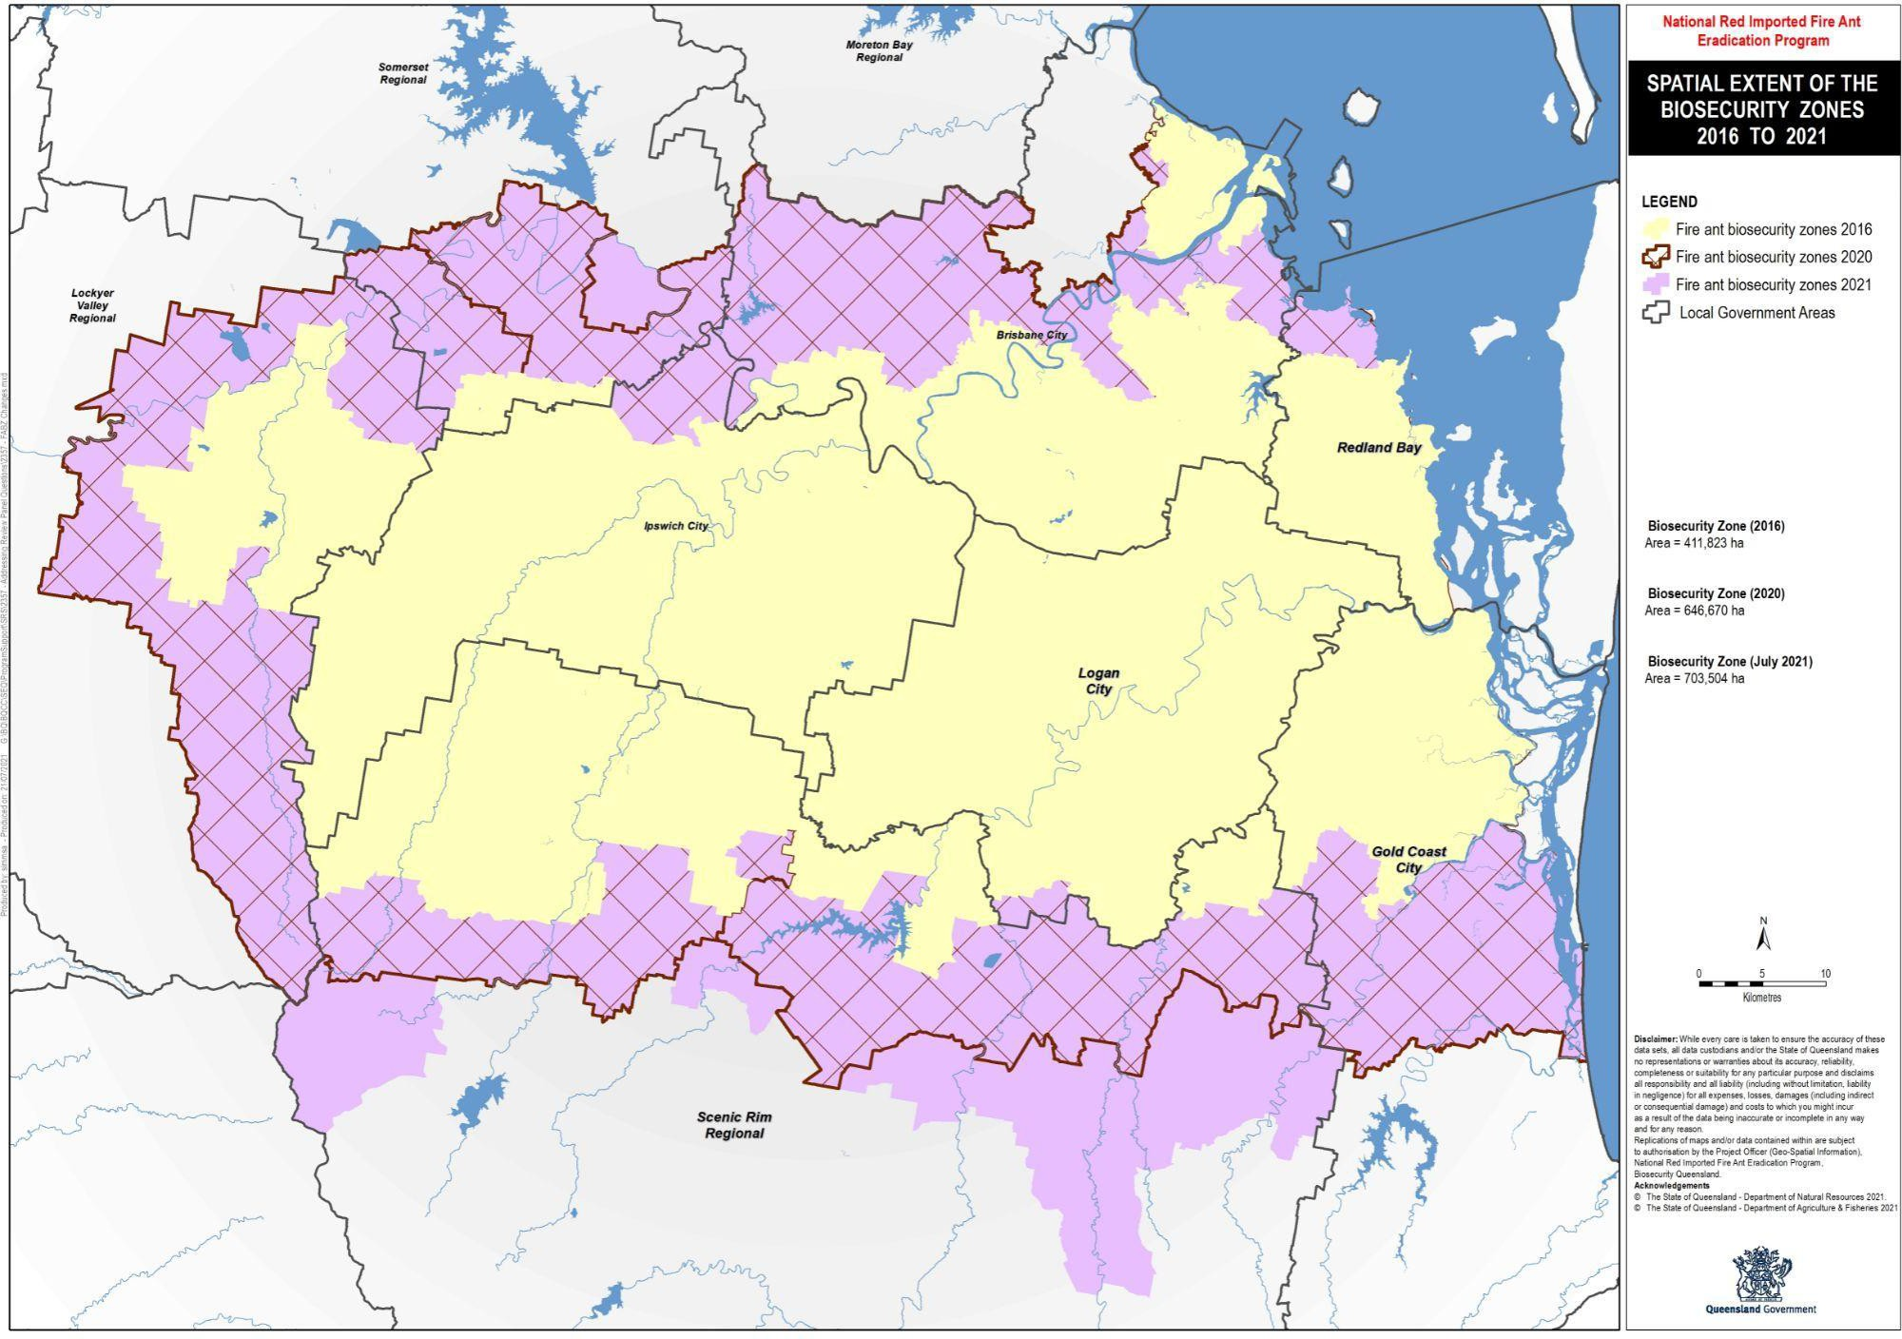
Potted plants and hay need particular attention because of the risks of long-distance transport out of the Biosecurity Zone and the difficulty of maintaining hay free from RIFA without chemical treatment (due to livestock feed requirements).
In 2017-18 the Program developed industry-by-industry science-based guidelines for the movement of high-risk RIFA carriers to control the spread of the ant by various industries. The Steering Committee had these guidelines reviewed by CSIRO in 2020. The review found that most of the Program’s guidelines were based on sound science; noted that the highest risk was likely from hay movements; and suggested areas where controls on carriers could be strengthened and avenues for future research.

Monitoring of compliance with biosecurity obligations
Over the first four years of the Program, the risk of human assisted movement through movement of high-risk carriers has been addressed at some level across a wide range of industry groups, but the rate of non-compliance in some industries is still of concern and could spread ants back into eradication Areas 1 and 2 and outside the current Biosecurity Zones, unless improved management arrangements are developed and implemented.

The Program has a staff of 14 Compliance Officers who conduct targeted announced and unannounced audits of groups of enterprises managing high risk RIFA carrier materials to ensure that prescribed controls are being applied. Overall non-compliance rates were between 5% and 17% from the start of the Ten-Year Plan (Table 8). This encompassed movements within the two Biosecurity Zones and movements from the overall zones to other parts of Queensland. There was no indication of whether different types of
non-compliance posed more or less serious risks of allowing RIFA carriage when the materials were moved.
Table 8: Number of compliance checks and % non-compliance.

Year Compliance Non-compliant %
checks Non-compliance
2017-18 | 534 | 54 | 5%
2018-19 | 912 | 82 | 9%
2019-20 | 619 | 56 | 9%
2020-21 Q1&2 | 251 | 42 | 17%

However, there were very different non-compliance rates among the industries checked. Program reports between 2018-19 and 2020-21 show that non-compliance rates in the nursery sector ranged from 34 to 46%, hay producers from 27 to 41%, turf farms from 16 to 19% and landscaping suppliers 28%, for different reasons. For example, in the first half of 2020-21 (Table 9), earthmoving and poultry farming were found to be 100% compliant. While the Program considered this reflected good awareness and practice among poultry farmers, the positive result for earthmoving was tempered by the difficulty in obtaining records of past movements and some earthmovers claiming they did not move soil from their working area. The Program is tailoring its approach to identifying risk pathways for this industry. The poor result for nurseries was often due to lack of awareness. Non-compliance in high-risk hay activities was considered by the Program to be unacceptably high, with the key to improving compliance levels continued engagement and communication.
Table 9: Compliance checks by industry for the first 2 quarters of 2020-21.

2020-21 by industry Number of Not %
checks compliant
Poultry | 13 | 0 | 0%
Landscape suppliers | 26 | 1 | 4%
Waste management | 12 | 2 | 17%
Nurseries | 50 | 22 | 44%
Earthmoving | 100 | 0 | 0%
Hay | 34 | 14 | 41%
Turf farms | 16 | 3 | 19%
Overall | 251 | 42 | 17%

Independent of the Program, Interstate Plant Quarantine (IPQ) areas for RIFA regulate the interstate movement of some RIFA carrying materials. IPQ areas for RIFA do not align

with the Queensland Biosecurity Zones. Each state or territory has their own entry requirements, although recently, NSW and Victoria aligned their movement controls with those set by the Program.

Proving freedom from RIFA in SEQ
The Ten-Year Plan stated that proof of freedom in SEQ would be declared some time after 2027, when no RIFA were detected in an Area for two years. The 2020-23 strategy outlined a more defined approach; that freedom from RIFA would be demonstrated using a probability model, based on the total clearance area effectively searched for RIFA, and the outcome (presence or absence of ants) of these searches. This model is still in development.
The Program has not yet reached the stage where area-wide proof-of-freedom is indicated. However, careful development and deployment of surveillance and reporting methods must be continued. Four surveillance methods are used by the Program to detect and delimit new infested areas and monitor success of eradication treatments.

Odour detection dogs
Trained sniffer dogs are by far the most sensitive surveillance method, more than 95% accurate and able to detect small nests and individual ants. However, dogs can only be used for short periods effectively over small areas for surveillance at key areas such as ports of entry, industrial or urban settings where nests may be cryptic (e.g, under concrete), proof of local eradication (e.g. of polygyne colonies), or delimitation of new outbreaks.
Their use becomes critical in situations where high surveillance sensitivity is needed, such as when deciding to apply or stop treatment of an area for polygyne eradication, or of key properties such as childcare or aged care centres.
The Wonder Review recommended 22 dogs be employed by the Program. The Program currently has six dogs, and does not consider increasing the number of dogs to be a feasible solution to large scale detectability of RIFA. However, an increase could be appropriate when there is sufficient confidence in robust treatment programs to institute proof of local freedom from RIFA in specific situations.

Program visual on-ground surveillance
Teams of people walk across an area systematically looking for RIFA nests. Visual surveys are considered by the Program to be 80% accurate, i.e. they find about 80% of nests in the area surveyed. However they typically fail to detect small or newly-founded nests, which may only be found by dogs.
Program staff may flag nests for direct nest injection (DNI) treatment, and / or sprinkle IGR or toxicant baits, and collect samples of ants for laboratory genetic analysis to determine if the colonies are monogyne or polygyne and to trace their likely origin. They also record their field findings into iPads using the FORAGE program. Because of the high labour cost, ground surveillance is only used across relatively small areas, based on risk mapping.

Public reports
Public reports of suspect RIFA or their nests constitute passive surveillance, with effectiveness depending on whether people recognise the ants or nests; realise that they are a problem; know who to report them to; and do so in a timely manner. As with ground surveillance, only nests that are several months old are likely to be big enough to be detected. Reports are entered by the Program into its CASES program.

Remote sensing surveillance (RSS)
RSS is the only method suitable for large scale surveillance of open ground and is far cheaper than ground surveillance. It enables the broadscale detection of RIFA nests (usually at least one year old) in cooler months in SEQ (May to September), as this is when the ants build their nests up into mounds. In cooler climates, RSS may be able to be used effectively over a longer season.
The Ten-Year Plan relied heavily on RSS to detect RIFA, with the Magee Review (2016) noting that without it eradication would not be achieved during the foreseen period. However, delays in funding approval affected its development and implementation. After the decommissioning of the RSS unit used in 2015, further RSS research and development work was put on hold pending future funding. RSS research and development contracts were only signed in June 2018, area-wide field testing only occurred from June 2019, and operational implementation in winter 2021.
In winter 2020 the new generation of RSS was extensively trialed in parallel with ground inspections and ‘trained’ so that its algorithms could detect RIFA nests accurately in more and more diverse land use situations. RSS found around 50% of nests in a search area, including 17 clusters of nests which covered 96 ha, and included detections not made by ground surveys. Its accuracy is expected to increase as more ground-truthing results are entered, further training the algorithms. While 50% may seem low, RSS is the only way to monitor large geographic areas. If, for example, RSS is deployed at 50% sensitivity over an entire 2500-Ha clearance zone compared to just 250 Ha of risk-based ground surveillance (with an 80% sensitivity) in the same zone, the the overall probability of finding RIFA nests within the zone will be 50% when using RSS, and only 8% when using ground surveillance. Moreover, annual fly-overs of large areas with RSS which repeatedly return negative findings will give higher confidence of area-wide absence of RIFA.
The Program estimates that over a potential operational area of 1 million Ha - extending up to 20 km beyond the current Operational Boundary - 40% is suitable for RSS use (Fig. 16). Unsuitable areas, shown in red, include residential areas and largely forested areas.
In 2021 the revamped RSS was used for broadscale surveillance in Area 1 and Western Boundary, to assess the effectiveness of previous eradication treatments. RSS use was to be maximised in the remaining cool season through to October 2021. However, RSS capacity in 2021 was limited to only one unit mounted on one helicopter, as opposed to two units assumed in modelling. Although RSS began in mid June, no results were available by late August when this report was completed.

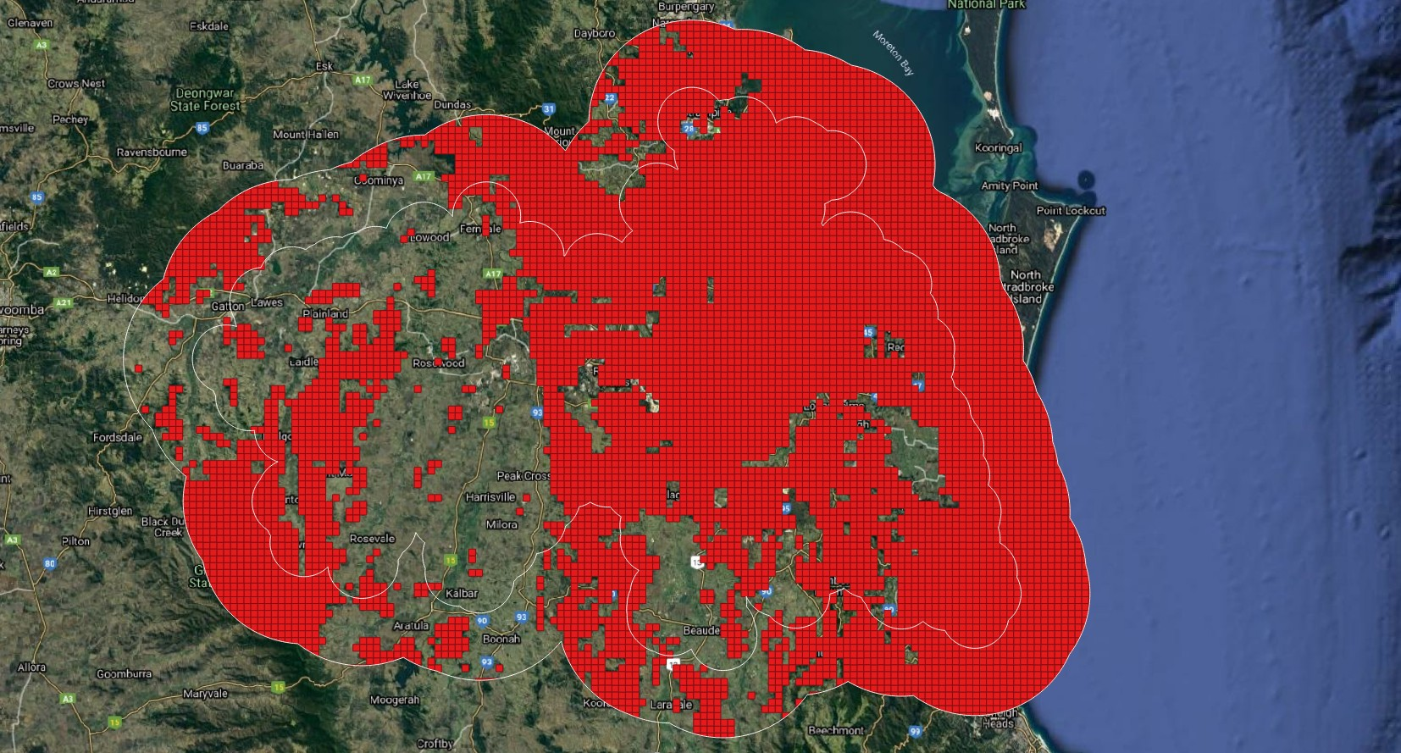
The lack of RSS until 2021 prevented detailed evaluation of its optimal use in long term repeated area-wide surveillance. The effectiveness of RSS is now more critical than ever to the Program’s success.

Preventing new invasive ant incursions Australia-wide
There were eight RIFA incursions or border breaches through ports or airports around Australia from 2001 to 2018 (Table 10). All were successfully eradicated, taking from 3-11 years to achieve proof of freedom, including one at the Port of Brisbane covering
over 8,300 Ha when discovered - the largest successful ant eradication globally to date. A further incursion in 2019 at Fremantle Port was still under eradication in 2021.
RIFA and other invasive ants have also been intercepted, mainly in various sea cargoes, at the border or in post-border biosecurity control, in all mainland capital cities. Between 2012 and 2017, Australian Government biosecurity officers intercepted exotic invasive ants on 309 occasions, from over 50 countries, through six major pathways, the largest being the sea container pathway. This shows the need for continued vigilance at all first ports of entry to prevent new incursions.
Apart from RIFA, many other exotic invasive ant species threaten Australia. Six have national priority for management, with eradication programs underway:
- Yellow crazy ant - Wet Tropics World Heritage Area since 2014; Townsville since 2017
- African big-headed ant - Lord Howe Island
- Argentine ant - Norfolk Island
- Electric ant - Queensland since 2006
- Tropical fire ant - Ashmore Reef, Tiwi Islands
- Browsing ant - WA and NT since 2013.
Program staff have had direct involvement with all the RIFA and other exotic ant incursions since 2001 and contributed to their successful eradications or containment. Considering the difficulty of eradicating or even containing ants, this repeated success

has been remarkable. This specialised scientific response capability is a national asset that will doubtless be needed to combat future ant incursions.

Table 10: Emergency responses to exotic invasive ants, 2001 to 2020²²
Start date Location
Pest
Detection type
Emergency response
outcome
2001 South-east Queensland RIFA Incursion Response phase
2001 Port of Brisbane RIFA Incursion Eradicated 2012

2001 Cairns Yellow crazy ant
Incursion Transition to management

2004 Port of Brisbane RIFA Border breach Eradicated 2004
2006 Cairns Electric ant Incursion Response phase
2006 Yarwun, QLD RIFA Incursion Eradicated 2010
2006 Melbourne RIFA Interception Eradicated 2006
2007 Darwin RIFA Interception Eradicated 2007
2009 Lytton, QLD RIFA Border breach Eradicated 2009
2009 Port of Brisbane RIFA Interception Eradicated 2009
2009 South Australia RIFA Interception Eradicated 2009
2013 Yarwun, QLD RIFA Incursion Eradicated 2017
2011 Roma, QLD RIFA Border breach Eradicated 2011
2011 Western Australia RIFA Interception Eradicated 2011
2014 Port of Brisbane RIFA Interception Eradicated 2014
2014 Port Botany, NSW RIFA Incursion Eradicated 2017
2015 Melbourne RIFA Interception Eradicated 2015
2015 Darwin Port Browsing ant Incursion Response phase
2016 Brisbane Airport RIFA Incursion Eradicated 2018
2018
Lismore, NSW
Yellow crazy
ant
Incursion
Response phase
2019 Fremantle Port, WA RIFA Incursion Response phase
2021 Port of Brisbane RIFA Incursion Response phase

²² Table updated from that published in: “Pest and disease interceptions and incursions in Australia Inspector-General of Biosecurity” REVIEW REPORT NO. 2018–19/05:
https://www.igb.gov.au/sites/default/files/documents/qid52820_igb_interceptions_and_incursions_report_-_final_1.pdf

RIFA eradication or management options

The challenge of ant eradication
Eradication requires complete removal of the population of the target species over a defined area. No individuals of that population can remain. Only 50% of ant eradications are successful²³. Key determinants for successful ant eradication include:
Technical
- Delimitation of the area of infestation with certainty, so that no unexpected infestations are found outside the treatment area;
- Containment of the population within the eradication area. Thorough surveillance, compliance with movement controls, preventing reinfestation, and understanding and forestalling the potential for natural spread of the ant, are all essential.
- Effective and reliable treatment methods. All eradication methods for ants require repeat applications. Treatment effectiveness relies on appropriate products, applied in the correct way at the correct time. External factors that can affect treatment effectiveness include unexpected weather events such as rain washing away the product, heat diminishing its effectiveness, refusal of treatment by property owners, consumption of the product by non-target animals. The wider the treatment area, the more chance that some colonies may survive, and the longer that area-wide treatment programs will be needed to achieve eradication. Suppression and containment of ants to numbers below which they can cause impacts or spread easily also need repeated, on-going applications of treatment product, but often not so regularly.
- Detectability of the last remaining ants. It is very hard to find the last remaining ants across a wide area and be certain that some residual nests have not survived. Once a timeframe for eradication treatment has passed, a ‘clearance’ period of monitoring is required. As a minimum, this clearance period begins when no ants are detected in an area after treatment, and continues for at least two years. Several seemingly successful eradications have found ants after a two year period, and needed further treatment and on-going monitoring. If there is potential for
re-infestation from outside the treatment area, this risk is further increased. Hence a longer period of surveillance is needed, particularly over a large area.
Socio-economic
- Cost-Benefit. The predicted impacts (social, economic and environmental) of establishment of the ant species must outweigh the cost of eradication.
- Commitment to apply the resources required (people, funding) for a long period until eradication is achieved. Because of unforeseen events affecting treatment effectiveness, uncertainty regarding detectability and risk of infestation, and incomplete compliance with movement controls, an adaptive management approach to ant eradication is essential, together with continuing stakeholder support, including awareness of the risks of discontinuing eradication efforts.

²³ Hoffmann BD. et al. 2016. Improving invasive ant eradication as a conservation tool: a review. Biological Conservation 198, 37–49.

Can eradication be achieved under the Ten-Year Plan?
The Review Panel was asked to evaluate the Program’s effectiveness in relation to the objectives of the Ten-Year Plan and the feasibility and likely achievability of the current strategy achieving these objectives, in particular the eradication of RIFA. It was also asked to suggest options moving forward in three areas:
- provide advice on any modifications to the Program that would facilitate achievement of eradication and estimate indicative costs of such a modified Program
- assess biological and technical feasibility of eradication
- consider alternative options to eradication and a brief assessment of likely outcomes of these options.
This review, four years into the Ten-Year Plan, finds that, although the current program is significantly slowing spread of RIFA in and out of SEQ, it will not be able to eradicate or contain RIFA within the scope and budget of the Ten-Year plan.
With a fixed budget, and delayed implementation allowing RIFA spread beyond what the Plan had been based on, the Steering Committee and Program management have been continually forced to make budget-driven decisions, which have prioritised efficiency over effectiveness.
In its first four years of operation, the Program has spent $202 million of the $411 million agreed for the Ten-Year Plan and needs a further $67 million ($33M committed and $34M extra requested) for 2021-22, leaving $142 million to last until 2027-28. It is clear that attempts to contain and suppress RIFA within the current budget will not achieve eradication, and will not prevent wider RIFA spread or increasing social, economic and environmental costs, though they will probably slow this down.
Based on previous successes, the containment of polygyne infestations and the elimination of RIFA from significant portions of SEQ, it is still considered biologically feasible to eradicate the ants. However, due to the scale of the infestation at this point, and outstanding uncertainty regarding the effectiveness and strategic use of RSS in routine operations, the technical feasibility of eradication is unclear at this time.
In view of Program outcomes to date and current risks of spread, a major change of strategy is needed for any possibility of long term eradication and even for continued mitigation of a build-up of infestation with consequent serious problems. Gains made to date must be preserved if possible, while a new strategy is put in place. In the longer term, eradication may eventually be feasible, but only with major changes in program scope, strategy, budget and governance, and possibly with new technologies.

Future options
Whatever strategy is put in place at the national level to mitigate RIFA risks to agriculture and the wider national economy, a fundamental change of approach will be needed. Far more involvement of Queensland state and local government agencies will be needed to deal with the build-up of RIFA in SEQ, which otherwise will cause steadily increasing public health, infrastructure, recreational and tourism impacts.

Increasingly dense RIFA invasions of urban areas need a much stronger suppression and management effort, which cannot be undertaken by the National Program alone. From initial management through Australia’s agricultural biosecurity system, a wider approach to RIFA will be needed, to mobilise urban communities and address emerging problems of public health, urban infrastructure damage and social amenity. If long term eradication or containment remains the objective, stronger urban suppression will be needed while still trying to contain and eliminate the pest from rural land, where it will otherwise cause major economic losses. The Program’s technical expertise should support a more holistic whole-of-government approach that could if needed be scaled nationally.
A transition of responsibility from the Program to all landowners and land managers, to contain, suppress and hopefully eventually eradicate RIFA in all environments, is a fundamental change in the 20-year eradication program, but an operational necessity.
In urban areas, community-and-industry centric management in partnership with councils and responsible government agencies is essential to deal effectively with all RIFA-susceptible land and tens of thousands of individual property owners. Suppression and eradication will be far more efficient and effective if all landowners, including councils, State and Commonwealth governments, businesses and property owners have to treat their land as a legal requirement. Technical and operational support and training could be provided by the Program.
The Review Panel explores three options for the future, with modifications to current Program governance, focus, revised budgeting and cost-sharing arrangements, and greatly enhanced risk communication needed irrespective of option. Likewise, recommendations below of how various underpinning processes have been operating, and how they may be improved, will be pertinent irrespective of which option is chosen, but have largely been framed around supporting Option A.
For the current agricultural cost-sharing partners to have confidence to invest in a far more expensive national Program aiming either to eradicate (Option A) or contain (Option B) RIFA from rural Australia, the Queensland government will have to commit to and invest in an enhanced whole-of-government approach through all relevant agencies; and work with local governments and industries to develop and implement complementary RIFA-suppressive programs. Even if the national Program is wound down (Option C), Queensland will need these RIFA-suppressive programs if it wants to avoid severe future RIFA impacts.
If eradication or even full containment of RIFA remains a long term goal, a new partnership and definition of roles will be needed between the National Program and the Queensland Government, with the Program responsible for broadscale eradication and containment operations while Queensland state and local government agencies take a much greater role in overseeing and implementing suppression and management of RIFA by industry and the community. Urban and peri-urban RIFA control costs will need to be built into council rate bases, and government and industry ongoing budgets.
Option A is the Panel’s preferred approach and is explored in more detail in Chapter 6.

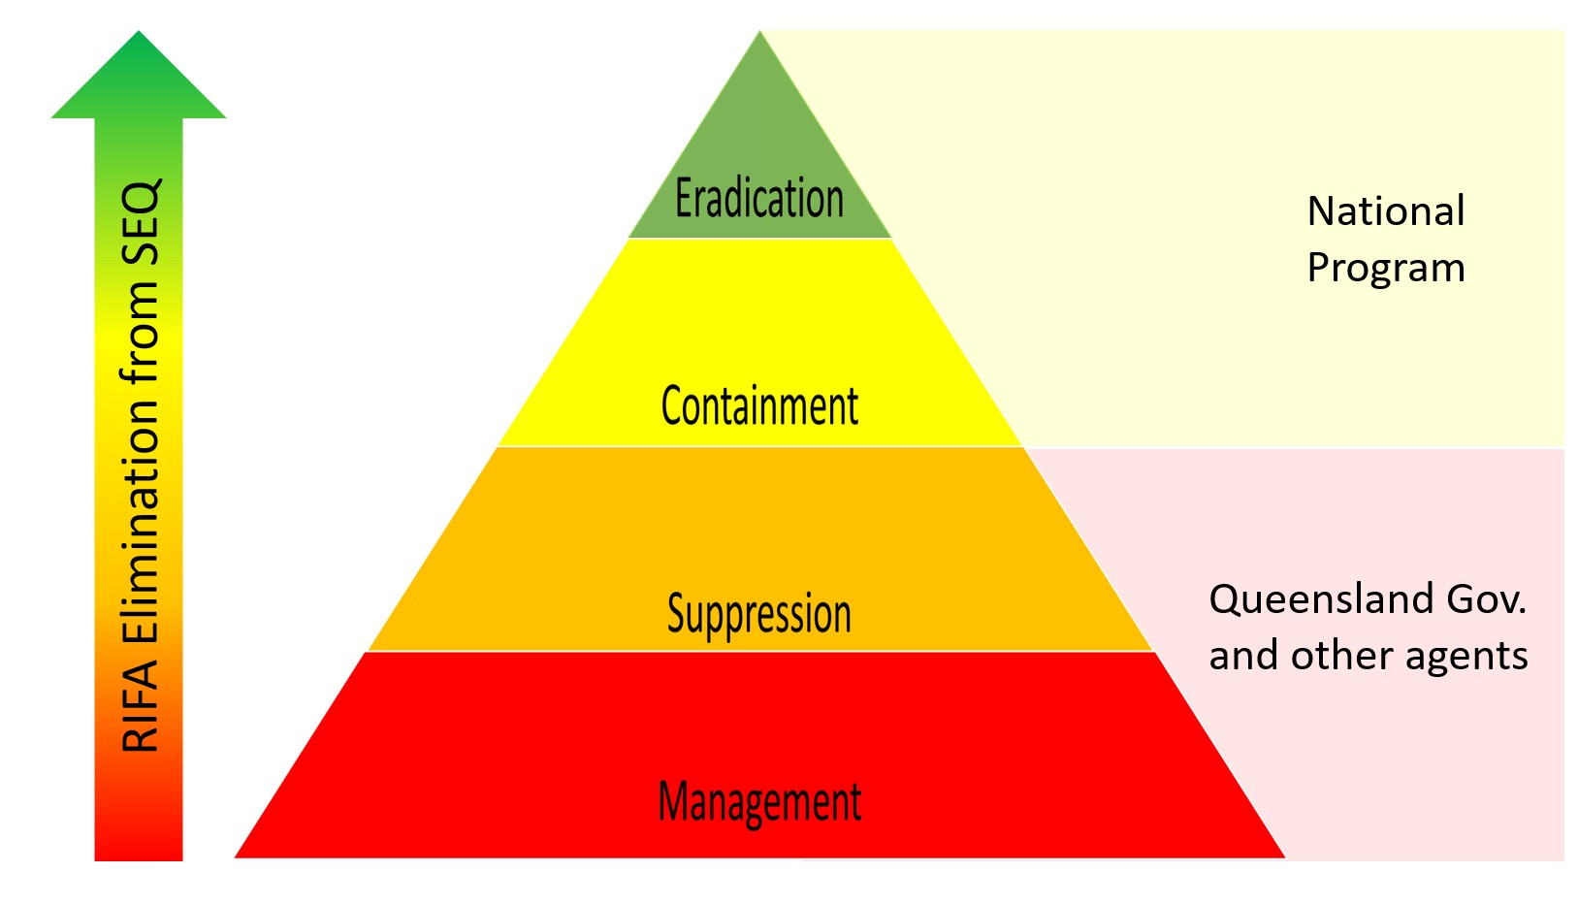
Option A “Fire-ant free Olympics” - Contain, Suppress, Eradicate by 2032
To prevent RIFA spreading beyond SEQ, building up more around Brisbane, and eventually becoming entrenched throughout Australia, a larger, more comprehensive and inevitably much more expensive program will be needed, with three key elements:
- stronger containment by strategic broadscale treatment and surveillance outside the known infested area, widening the biosecurity zone considerably, and stronger preventive measures for RIFA movement in carrier risk materials
- more aggressive suppression by regular area-wide treatment programs especially in the current Residual Area, involving councils, communities and all land managers in implementing coordinated effective and efficient RIFA suppressive or preventive programs tailored for different groups on RIFA-preferred land; while continuing broadscale and targeted treatment and surveillance in agricultural areas, and
- eventual eradication, with progressive shrinkage of the operational zone once effective surveillance has demonstrated partial area freedom, (possibly from 2027) and a long period (probably after 2032) of maintaining preventive and suppressive measures while eradication is proven.

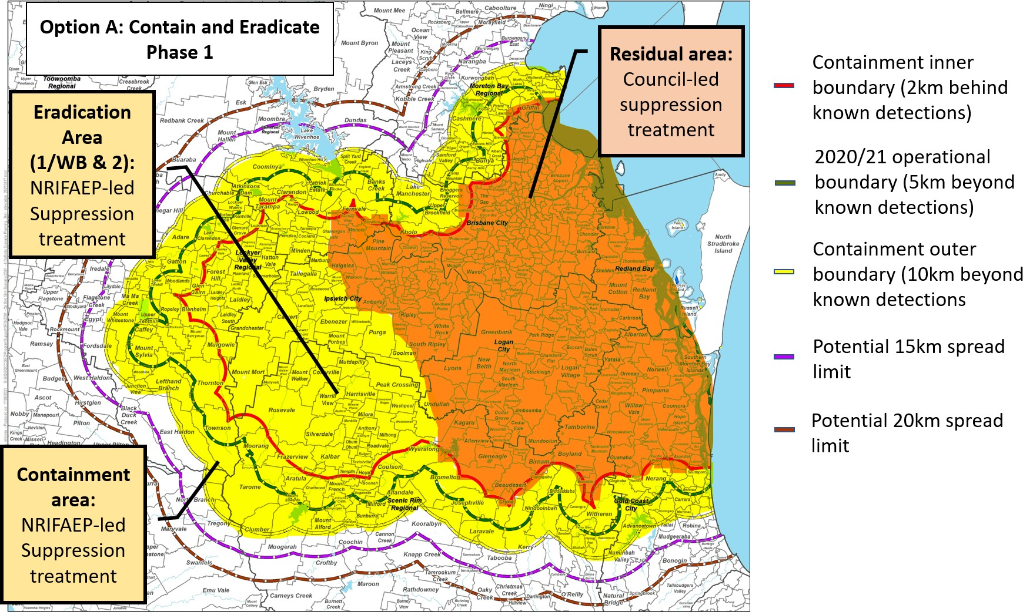

Key activities to implement this option, while consolidating gains made and not losing momentum, would be to obtain national approval for a revised plan and budget, and adjust the current operational plan to move to the new program as fast as possible.

Foster public engagement and participation in RIFA eradication in all affected areas by:
  - significantly strengthening public communication about increasing RIFA risks and how to manage them - particularly throughout the suppression area in the interests of public safety - and around / outside the Operational Boundary, to improve community awareness and encourage passive surveillance,
  - mobilising QDAF and other government departments to provide technical input to national messaging and promote key messages to their own stakeholders about RIFA risk management (e.g., Agriculture about RIFA risk carrier materials and field management, Health about treatment of stings, Education to schools, Transport and Planning for infrastructure), and
  - implementing new approaches to accelerate council and key stakeholder engagement in developing and undertaking area-wide and enterprise-specific RIFA suppression programs, especially in urban areas.

Contain spread of RIFA by:
  - broadscale treatment of boundary areas by applying three rounds of suppressive treatment (IGR or in combination with Toxicant baits) annually in a ring at least 10 km outside and 2 km inside all known RIFA detections (Containment Area; 334,000ha), identifying potential gaps and issues before treatment and engaging landowners as necessary,
  - addressing treatment gaps with specific policies and treatment regimes implemented for specific land uses (e.g. organic, free-range poultry, etc.),
  - scaling-up surveillance (remote sensing and ground validation) over the same area or beyond in key breakout risk areas (up to 250,000ha),
  - rapidly responding to RIFA outbreaks within and outside of boundary areas, mounting coordinated eradication efforts to clear newly or re-infested areas and prevent long-term establishment,
  - extending biosecurity zones to restrict the movement of RIFA-carrying materials across most or all of SEQ, and
  - strengthening RIFA-movement risk mitigation measures for high-risk carriers(e.g., hay, turf, nursery plants, soil, mulch etc), and enhancing capacity for compliance checking of these movements.

Continue suppression / eradication in existing Eradication (agricultural) areas by:
  - broadscale treatment across all suitable agricultural land (189,000ha) - three treatment rounds per year, progressively moving to targeted post-surveillance treatment, subject to surveillance results over several years,
  - addressing treatment gaps with specific policies and treatment regimes implemented for specific land uses (e.g. organic, free-range poultry, etc.),
  - continued targeted treatment whenever ants are found,
  - continued polygyne colony eradication wherever found, and
  - scaling-up surveillance (remote sensing and ground validation) in all open areas (up to 150,000ha)

More effective RIFA suppression and management in all Residual areas by:
  - widening local government engagement with greater outreach and definition of roles for councils neighbouring the Biosecurity Zone (possibly to northern NSW)
  - mobilising local government led suppression programs to work closely with local communities and other land owners / managers to suppress and manage RIFA infestations across all lands within their LGA
  - enforcing RIFA suppression and management on high risk land types - e.g. new building development sites, waste management facilities - with owners / businesses being made responsible for control / prevention of RIFA, following a quality management approach backed up by clear program guidelines, and regulation by appropriate government agencies, and
  - mobilising other State and Commonwealth governments agencies to proactively suppress and manage RIFA on land they control - like major rail / road corridors, Defence land, airports and ports.

Develop and implement innovations to improve RIFA eradication effectiveness by:
  - integrating and improving systems to efficiently manage and evaluate RIFA suppression and eradication, and to facilitate the transition of suppression to multiple agencies
  - continuing R&D into improved treatment and surveillance methodologies to improve ease of detecting and eradicating RIFA.

Option A would be deployed over two phases, with a progressive transition of responsibility over time from the NRIFAEP to other agencies (Fig. 19 and 20).
Phase 1, from 2022 to 2028, would focus national Program efforts on containing RIFA effectively from spreading outside the known infested area; eradication of RIFA from rural regions west and south of Brisbane overlapping 2017-21 Eradication areas; while the Queensland government progressively took responsibility for implementing, and reporting back to the Program on, effective RIFA suppression programs in the Residual areas by other agents - state, local and Commonwealth government agencies, and land managers, industries and communities.
By 2025, these suppression programs would be embedded with other agents, with the Program monitoring their implementation and effectiveness. The Program would continue up to 2028 with rural containment and eradication treatment and surveillance to guarantee that treatment could be stopped in these areas without danger of resurgent infestations.
The success of the Program moving forward will be reliant on many factors not within its control, such as the commitment and compliance of other agents. Key indicators should be developed by the Steering Committee, to identify the conditions (both internal and external to the Program) affecting the success of eradication efforts. These should be regularly reviewed to ensure early warning of any issues affecting successful outcomes.
Phase 2, from 2028 to 2032, would involve the national Program in proof of freedom surveillance over the previous containment and eradication areas, with a progressive shrinkage of the area requiring any continued treatment. The Program would monitor the effectiveness of urban and peri-urban RIFA suppression and help introduce any innovations in treatment and surveillance that could allow eventual proof of freedom in these areas. The capacity for emergency response to any new incursions or outbreaks nationally would be maintained.

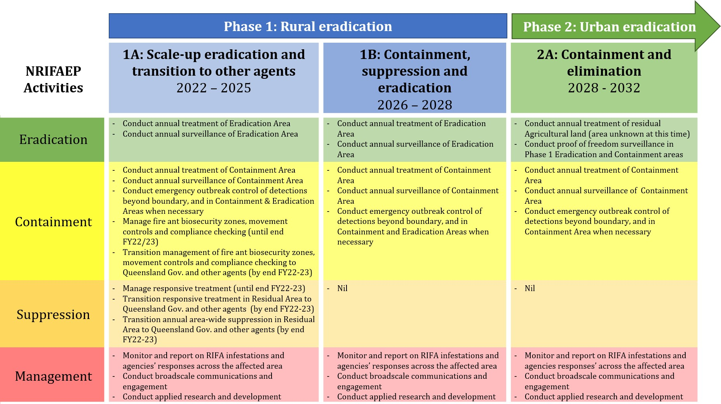

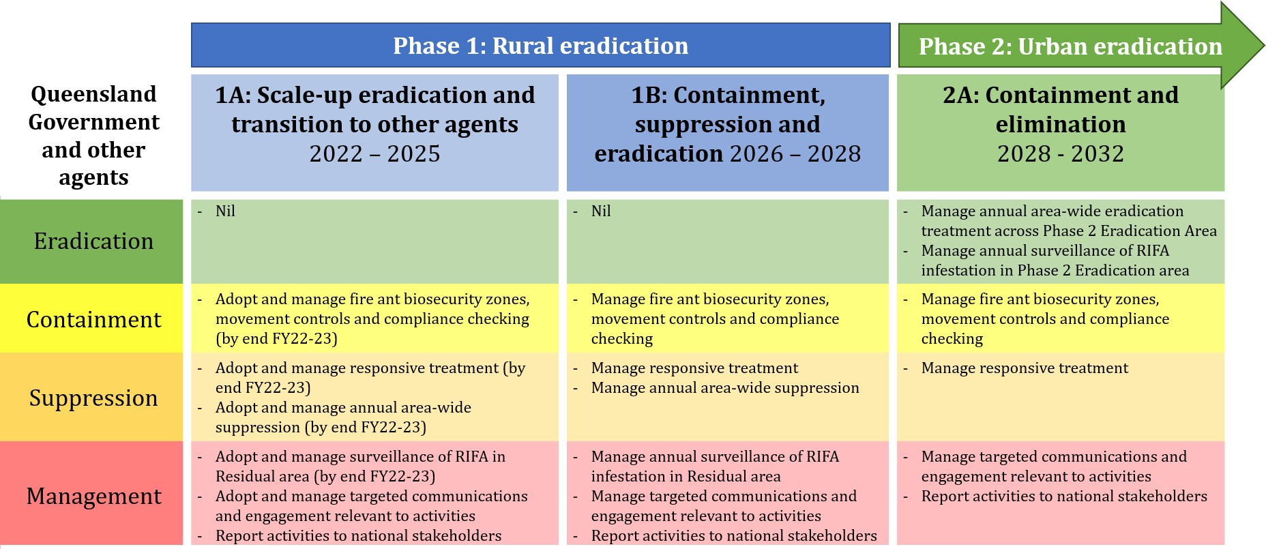

This option is estimated to cost NRIFAEP $200 - $300M per annum - funded by
cost-sharing partners - to implement over the next 5 years (Table 11). Key assumptions underpinning cost estimates are shown in Box 2.

Table 11: Annual-costing forecast for NRIFAEP-led operations as part of Option A, Phase 1, 2022 - 2028
NRIFAEP Unit | Activity | Lower estimate | Upper Estimate | Key assumptions
Operations | Treatment | $113,406,662 | $167,245,363 | 1:9 ground to aerial, 3
 |  |  |  | treatments per annum
 | Surveillance | $25,000,000 | $50,000,000 | RSS is a viable method
 | Outbreak control | $4,165,350 | $8,330,700 | 4 outbreaks per annum
 | Compliance | $5,670,333 | $8,362,268 | Led by NRIFAEP²⁴

Logistics | Business | $15,876,933 | $23,414,351 | No significant governance
 | Services²⁵ |  |  | changes that improve
 |  |  |  | efficiency
Planning | Policy | $3,402,200 | $5,017,361 | Policy team heavily involved in
 |  |  |  | transition to councils and
 |  |  |  | industry sectors
 | Science | $3,402,200 | $8,362,268 | Reduced genetics load
 | ICT | $5,670,333 | $10,034,722 | Scaling systems with Councils
Communications | Communications & Engagement | $15,876,933 | $23,414,351 | Broadscale campaigns are led by NRIFAEP

Administration | Directorate²⁶ | $3,402,200 $5,017,361 | Steering Committee & executive management etc expanded to improve governance and KPI reporting
Option A TOTAL | $191,707,794 $300,868,044

An additional estimated $100-$200M will be required to be spent by other government agencies, councils, industry, and the general public to conduct effective suppression in urban and peri-urban areas. The cost of bait alone for effective suppression (3 treatments) will be $45 - $90M per annum - depending on the products selected.
However, many of the proposed functions could be performed by existing staff, allowing cost-efficiencies compared to managing all functions through the national Program.

²⁴ Compliance costs for the program may come down to zero if this can be fully delegated to other government functions/agencies or industry programs
²⁵ Business services includes facilities, finance, procurement, HR
²⁶ Directorate includes funding for governance bodies, executive management and regular audits expenses

Table 12: Annual-costing forecast for all operations as part of Option A, Phase 1, 2022 - 2027
Agency Costing forecast Funding source
NRIFAEP $200M - $300M States, Territories & Commonwealth

Queensland Gov. and other $100M - $250M agents
Self funded (high proportion of internalised costs)

The first phase of Option A might take five years to show evidence of progressive eradication of RIFA from these areas, however indicators of success should be apparent sooner. If this is achieved, a second phase of work should be considered to move towards ultimate elimination of RIFA from SEQ. This could involve NRIFAEP continuing to provide containment and surveillance services over a shrunken area , and conducting eradication in any remaining agricultural land, with overall technical coordination. However, suppression for eradication in urban areas would be led by the state and local governments.

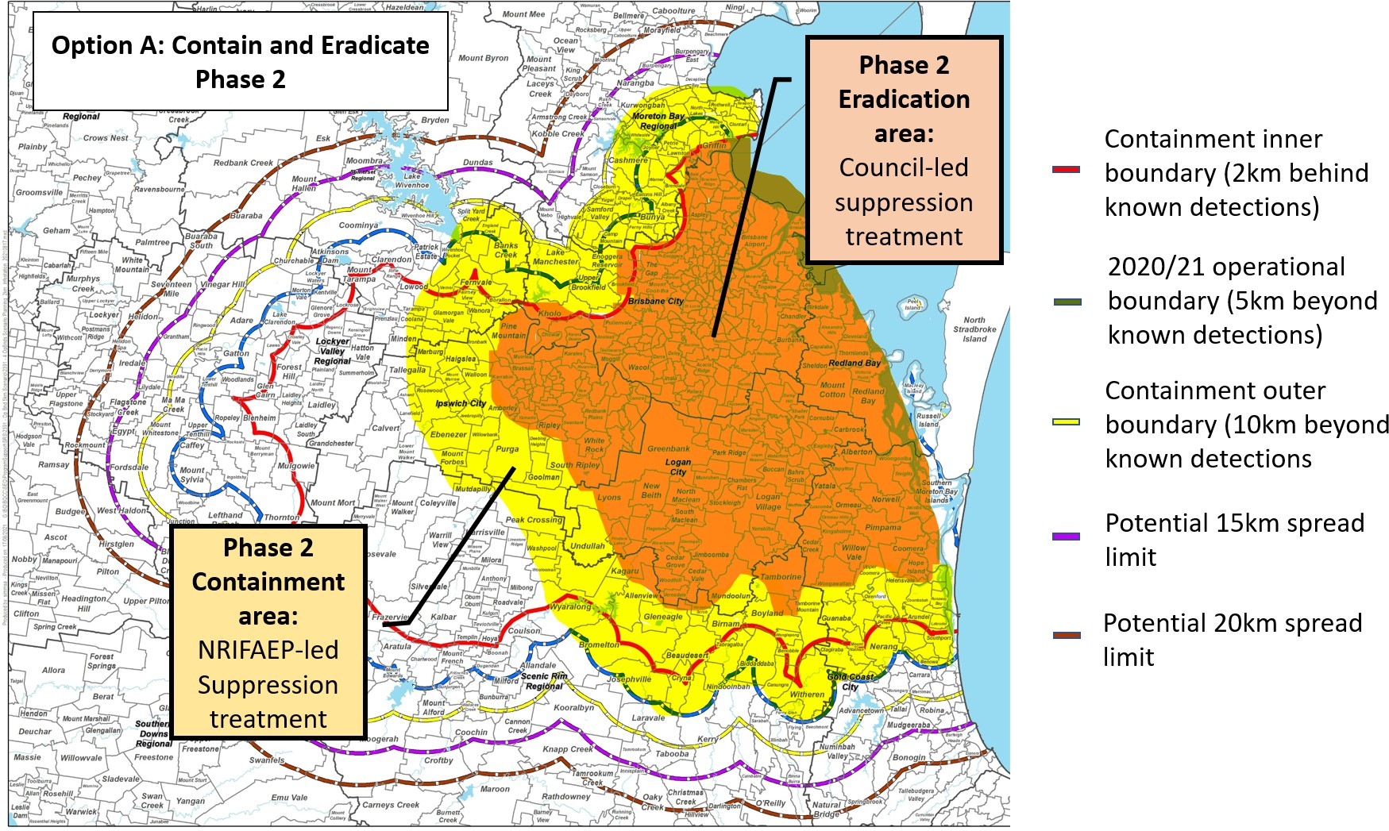

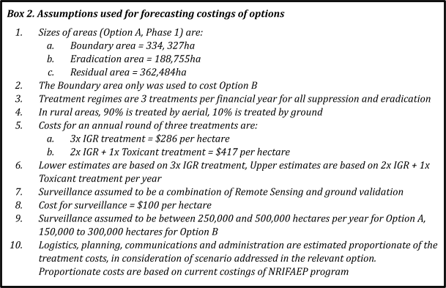

Option B. Contain and suppress
This option would involve the same containment operations as Option A, but with reduced broadscale suppressive or eradication treatment within the Operational Zone. There would be difficult choices to be made between containment and suppression.
Reduction of budget aimed at achieving eradication in certain areas would risk undermining the gains already made. Reduction of budget for comprehensive containment treatment would risk permitting some natural spread as has been happening since 2017. There would be little prospect of eventually shrinking the Zone and an increased level of risk of breakout and RIFA spread.
An urgent pivot to greater self-management within the former eradication areas would be needed, with a commensurate reduction in eradication treatments. Goals, objectives and annual budgets would have to be urgently revised. Greater risk communication and preparedness would need to be actioned, inside and outside SEQ and in other jurisdictions.

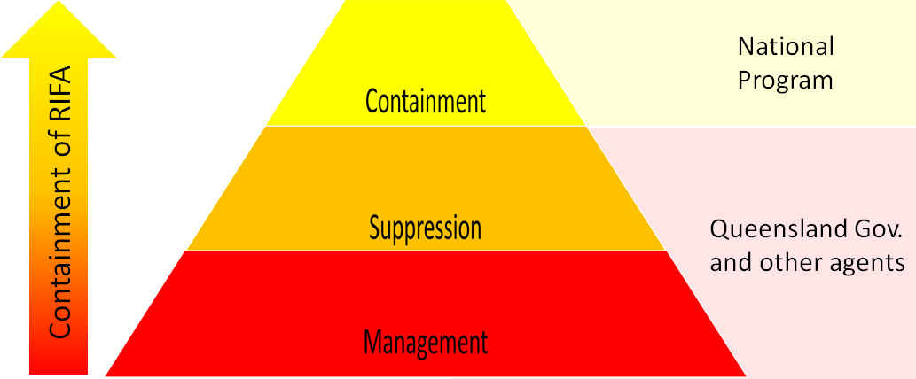
Key activities to implement this option - additional support for transitioning existing Eradication areas (Area 1/WB and 2) to council-led suppression and management, while the Program’s operational plan would focus only on containment (Fig. 23).

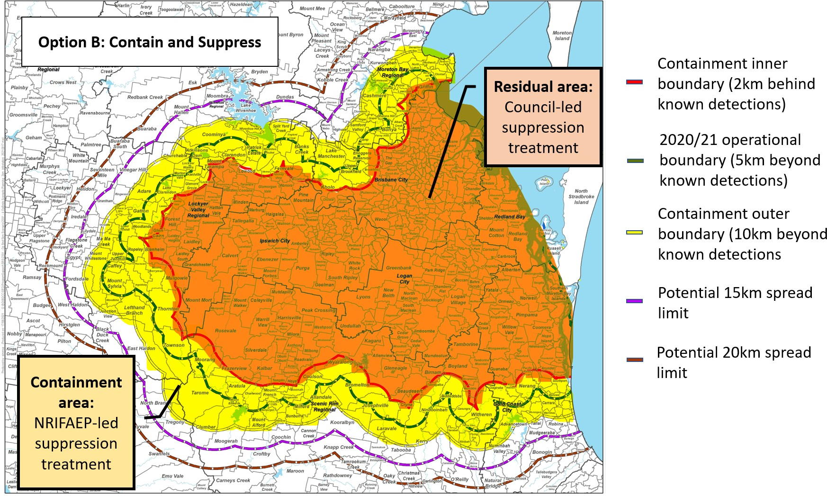

Foster public engagement and participation in RIFA eradication in all affected areas (as per Option A):
      - significantly strengthening public communication about increasing RIFA risks
      - mobilise QDAF and other government departments to provide technical input to national messaging
      - implementing new approaches to accelerate council and key stakeholder engagement

Contain spread of RIFA (as per Option A) by:
      - broadscale treatment of boundary areas
      - addressing treatment gaps
      - scaling-up surveillance
      - rapidly responding to RIFA outbreaks
      - extending biosecurity zones
      - strengthening RIFA-movement risk mitigation measures

More effective RIFA suppression and management in Residual areas (as per Option A) by:
      - widening local government engagement
      - mobilising local government led suppression programs
      - mobilising other State and Commonwealth governments agencies
      - enforcing RIFA suppression and management on high risk land types

Fostering and implementing innovations to improve RIFA eradication effectiveness (as per Option A) by:
      - integrating and improving systems
      - continuing R&D into improved treatment and surveillance

This option is forecast to cost NRIFAEP $160 - $250M+ per annum - funded by
cost-sharing partners - to implement a robust RIFA containment program every year in perpetuity. Containment funding below this level would likely result in the slow ‘controlled’ spread of RIFA, as with current NRIFAEP treatment and surveillance activities. If strong suppression within the containment boundary were not also applied effectively by Queensland state and local governments and other agents, RIFA would build up and risks of transport outside the Biosecurity Zone would increase over time.

Table 13: Annual cost forecast for NRIFAEP-led operations as part of Option B, 2022 and beyond
Unit | Activity | Lower estimate | Upper Estimate | Assumptions
Operations | Treatment | $99,894,872 | $147,589,597 | 1:9 ground to aerial, 3 treatments
 |  |  |  | per annum
 | Surveillance | $15,000,000 | $30,000,000 | RSS is a viable method
 | Outbreak Control | $4,165,350 | $8,330,700 | 2-4 outbreaks per annum
 | Compliance | $4,994,744 | $8,855,376 | Led by NRIFAEP

Logistics Business services²⁷
$13,985,282 $20,662,544 No major governance changes

Planning
Policy
$3,496,321
Science
ICT
$1,997,897
$1,997,897
$5,903,584 Policy team heavily involved in
transition to councils and industry sectors
$4,427,688 No population genetic testing
$4,427,688 Investment to integrate systems with Councils

Communications Communications
& Engagement
$13,985,282 $17,710,752 Led by NRIFAEP

Administration Directorate²⁸
Option B Total
$2,996,846 $4,427,688 No major Governance changes
$158,349,141 $244,004,916

²⁷ Business services includes facilities, finance, procurement, HR
²⁸ Directorate includes funding for governance bodies, executive management and regular audits expenses

It is estimated that an additional $150-$250M will be required to be spent by councils, industry, the general public and other government agencies annually to conduct effective suppression in non-eradication areas. The cost of bait alone for effective suppression (3 treatments) will be between $70 - $130M per annum - depending on the product selected.

Table 14: Annual-costing forecast for all operations as part of Option B
Agency Costing forecast Funding source
NRIFAEP $150 - 250M States, Territories & Commonwealth

Queensland Gov. and other $150 - 350M+ agents
Self funded (high proportion of internalised costs)

Option C. Winding down, transition to state-by-state management
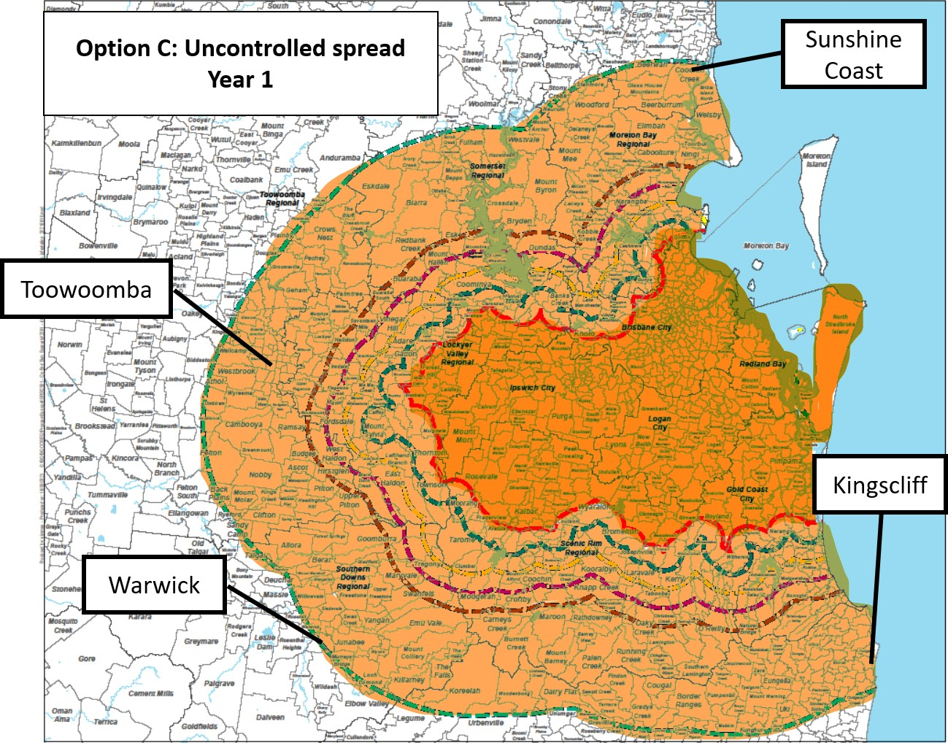
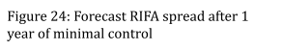
If a national cost-shared program is wound down, the spread of RIFA in Australia is likely to mirror that in the USA. Even if the Queensland Government continued alone with major elements of the proposed suppression program, without external budget, accelerating spread of RIFA would be inevitable over a wider and wider area.
Without effective containment, RIFA would likely spread up to 48km per year in Australia - in the first year spreading imperceptibly north to the
Sunshine Coast, south into northern NSW and west to the Darling Downs past
Toowoomba and into Warwick (Fig. 24). Noticeable or severe impacts would likely build up within 5-10 years of their arrival in a new area. Interstate movement controls on RIFA carriers from an increasing part of Queensland would likely become ineffective over time. Further build-up of RIFA in SEQ would increase risks of RIFA hitchhiking far and wide on cars, caravans and other vehicles (Fig. 25).
Other areas of Queensland and other states and territories, especially northern NSW at first, would have to prepare their communities and industries for incursions. This would need a strong process of community and industry engagement, both in and beyond Queensland, to prepare them for ongoing self-management.

The national capacity that has been built up to combat RIFA would dissipate over time and painful lessons would have to be re-learnt in the future.
The inevitable future costs of major public health impacts and billions worth of damage per annum to the Australian economy would likely be realised. Whether these costs are acceptable needs to be seriously considered if choosing this option.
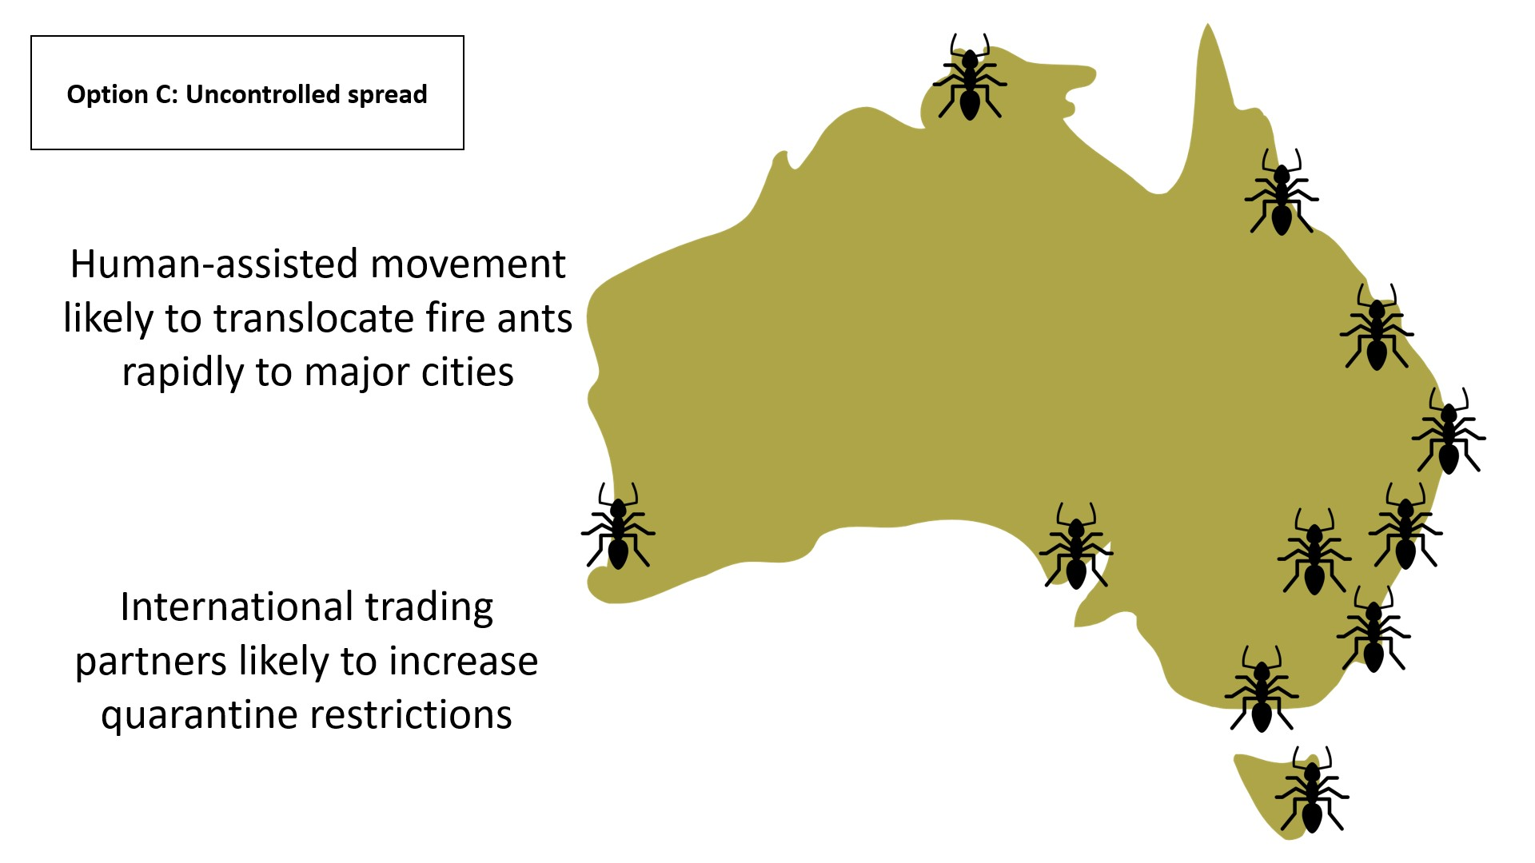
Without effective controls on human-assisted movement of RIFA, it is also highly likely that RIFA will move to major cities in just a few years, although they would only be detected after 5 - 10 years - when they start having major impacts on infested land and stinging people - and by then eradication would not be possible, even though Australia would have derived many years of benefit from having slowed their spread.
It is also possible that international trading partners, particularly those such as the EU and the UK, where RIFA is absent, might place increased restrictions on a wide range of goods being exported from Australia.
A transition period would be needed to effectively transfer responsibility for RIFA abatement and management to local governments. It would be important for the Program to be funded to transfer as much practical expertise as possible in RIFA management to council and other government staff, and to communities and industry, through ‘train the trainer’ programs and national resources on the web. Furthermore, it would be equally important to conduct a broadscale communications campaign to alert the community to the threat of RIFA, and empower them to control them on their own properties.

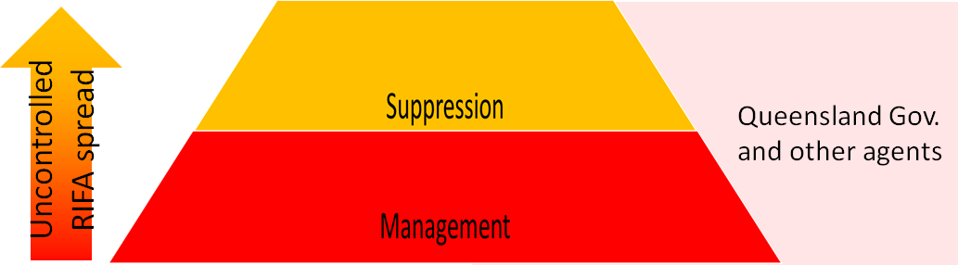

Key activities to implement Option C - Uncontrolled spread:
Foster public engagement and participation in RIFA eradication in all affected areas (as per Option A) by:
- significantly strengthening public communication about increasing RIFA risks and how to manage them
- mobilise QDAF and other government departments to provide technical input to national and statewide messaging about RIFA risk management, and
- implementing new approaches to accelerate council and key stakeholder engagement in area-wide and enterprise-specific RIFA suppression.

More effective RIFA suppression and management (as per Option A) by:
- widening local government engagement in SEQ and beyond
- mobilising local government-led RIFA suppression programs
- mobilising other State and Commonwealth governments agencies to suppress and manage RIFA on land they control
- enforcing RIFA suppression and management on high risk land types.

Moving to a shared responsibility for RIFA management in SEQ

Program governance

Current governance arrangements
The NRIFAEP is run by QDAF on behalf of all cost-sharing partner governments of the Commonwealth, States and Territories. All its staff are QDAF employees or contractors employed under Queensland Public Service policies. Large and important contracts for the National Program, including that of the Chair of the Steering Committee, must be approved by the QDAF DG.
The NRIFAEP Steering Committee has an independent Chair, a Secretary and Chief Finance Officer who are QDAF employees, and a senior representative of each
cost-sharing jurisdiction, except the ACT and SA. It meets at least quarterly and reviews program reports to assess and approve future plans, within the approved overall Ten-Year Plan. All Steering Committee members have other ‘day jobs’ with only one Executive Assistant located with the Program in Brisbane fully dedicated to their support.
Its Risk Management Sub-Committee (RMSC) has an external Chair, as well as five members and the Secretary of the Steering Committee. This Sub-Committee has maintained a comprehensive register of key Program risks, although many identified high risk issues have been beyond control of the Program, being hard-baked into the Ten-Year Plan and its budget. Because of this, some risk treatments have remained unactioned on the register, with no progress on untreated high priority risks.
Its Scientific Advisory Group (SAG) has an external Chair and consists mainly of voluntary external experts together with the Program’s Science Leader and Science Manager and the Steering Committee Secretary. The SAG meets six-monthly and reviews plans and information presented by the Program Science Group, highlighting potential improvements and opportunities.
The Program General Manager reports both directly to the independent Chair of the Steering Committee, which oversees the whole Ten-Year Plan implementation, and to the QDAF DG through the Deputy Director General of Biosecurity Queensland, for compliance with Departmental and Queensland Government policies.
Through QDAF, the Program provides services at three levels:
National
- Accountability through the Steering Committee to the cost-sharing partners for achieving approved objectives within budget
- Assistance with emergency responses to ant incursions outside SEQ
- Guidelines for cooperative government monitoring and preventive actions around ports, airports, military land, etc. around the country, and
- Operational research and development (R&D).

Queensland
- Delivering eradication and suppression by treatment and surveillance
- Containment by industry regulation to prevent RIFA carriage, and
- Community engagement; and responsive services in SEQ.
Local
- Engaging with councils and communities to trial self-management.
Complete reliance on QDAF and Queensland Public Service processes for the great majority of Program activities and services places some constraints and leads to some inefficiencies. These could be rectified by restructuring to strengthen national governance; more delegations for efficient and effective Program operation at state level; and state, local government, community and industry implementation of agreed policies. Governance, oversight and risk management of the Program would be strengthened by diversifying accountability at the appropriate scale.

Stronger national strategic oversight
Regardless of the option chosen, given the large investment by cost-sharing partners and the complexity of balancing a national program - with elements of emergency response and long-term management not only in Queensland but around the country, and with Queensland government priorities - it would be desirable to strengthen and support Steering Committee independence, national strategic oversight capacity, risk and issues management, and accountability.
The current Steering Committee was established when this national eradication campaign was only seen as an agricultural biosecurity agency responsibility. However, as RIFA management will impact all sectors of the SEQ community, it could be useful to supplement the Steering Committee with some additional expertise-based members, with experience in fields such as epidemiology, public health, and local government.
Alternatively, this expertise might be provided through a subcommittee of Queensland Government representatives with appropriate skills and experience.
The Steering Committee’s independence and strategic oversight would be improved by DAWE using a small part of its National Program contribution to fund the Steering Committee Chair and a small staff - perhaps two Project Officers - carrying out strategic roles, including oversight of:
- national technical strategy development, modelling and cost-benefit analysis
- strategy implementation with more objective and effective streamlined reporting and analysis of performance by the Program and external agents), and
- high-level communications and appropriate messaging.
Key accountabilities for Program delivery under the new Plan and funding arrangements need to be formalised. Without agreed measurable KPIs for the Program, it is difficult to monitor progress and improve accountability, which can lead to program drift and blame shifting. Clear reporting lines for delivery and accountability must be incorporated into

the respective KPIs to give funders and partners improved confidence that the largest pest eradication program in Australia’s history is being effectively delivered.
The Project Officers would work with the Steering Committee, its subcommittees and the Program General Manager to set more meaningful and measurable Program key performance indicators (KPIs) and identify Critical Success Factors (CSFs) to ensure operations and reporting are focused on addressing these indicators and key risks are addressed. Examples of deliverables over the next year might include:
- KPI - the number of councils in SEQ that have begun developing / developed a suppression program within their LGA
- KPI - the number of key risk sectors (e.g. waste disposal sites) for which industry quality assurance protocols and programs have been developed.
- CSF - amendment of regulations to strengthen the restrictions on human assisted movement of high-risk materials.
A presence in DAWE could be implemented fairly quickly to provide this strategic support, while consideration is given to a more permanent body, especially if Option A is agreed to by the cost-sharing partners. RIFA is unfortunately not likely to be the last serious new invasive pest that requires a major response. One model is a small agency like the Australian Plague Locust Commission. Alternatively, there could be merit in setting up a body called Invasives Management Australia, run as a company limited by guarantee, like Animal Health Australia and Plant Health Australia, with members would be the Commonwealth, State and Territory Governments, to provide strategic management of and preparedness not only for RIFA but for other invasive pest species that do not fit easily into an animal or plant health framework. This would take longer to set up but might be particularly useful if Option A or B were selected.

The Steering Committee progress consideration of strengthened national governance arrangements with the cost-sharing partners, including:
- expanding the expertise of the Steering Committee either by a larger membership or a subcommittee of Queensland Government representatives, and
- strengthening the independence of the Steering Committee by providing a small part of the Commonwealth contribution directly through DAWE to fund the Steering Committee’s Independent Chair and two project officers.
Recommendation 1

Queensland Government accountability and whole-of-government approach
Under the National RIFA cost-sharing agreement, the Queensland government through QDAF is currently responsible for supporting the Program to carry out

both national and state-level functions to meet target outcomes agreed with the Steering Committee.
Under Option A or B, accountability for delivery of containment and rural eradication will be with the National Eradication Program, while a diverse range of Queensland Government state and local government agencies will become responsible for implementing or oversighting area-wide RIFA suppression in urban and peri-urban areas under their control. The State Government will be responsible for RIFA treatment of other public lands and infrastructure, ensuring compliance with Biosecurity Zone requirements, and public health initiatives, while the Commonwealth Government must manage RIFA on Defence and other Commonwealth lands and assets, and at all ports of entry (Fig. 19 and Fig. 20).
Under Option C, the Queensland Government and general public would be left with full responsibility for RIFA management in SEQ, apart from local Commonwealth lands responsibilities..
Options A or B require a very high investment by the National Program cost-sharing partners, who will need confidence that Queensland is carrying out its complementary roles to the Program in RIFA management and that progress is being achieved.
A very substantial political and financial commitment will also be required by Queensland to mobilise the SEQ population, councils and all industries and agencies managing or disturbing land, to suppress and contain RIFA effectively. Many issues will need addressing, including stakeholder funding and partnership arrangements, targeted public education and awareness programs for different sectors, addressing policy constraints, strengthening movement controls of high-risk materials, treating public land and infrastructure, reducing potential public health impacts, and removing red tape that hinders best practice operations.
National Program operations within QDAF should be given greater recognition and support. The Program must carry out its national responsibilities as agreed by the Steering Committee, as well as an emerging role of working with other parts of QDAF, other state and local government bodies and industry.
Apart from delivering major broadscale treatment and surveillance activities, the Program should deliver national and operational communications and media, including developing a web-based store of Best-Practice communications, SOPs etc to reduce duplication at state and local levels.
Other parts of QDAF should participate or take responsibility as relevant in
- rural community and industry engagement using Program messaging,
- training programs for other government, council and industry staff in RIFA control operations including QA, and
- management of Biosecurity Zones, movement controls on RIFA high-risk carrier materials, and oversight of compliance with agricultural industry RIFA-preventive self-treatment QA programs.

Other Queensland Government agencies - It would be appropriate for the Queensland Government to form a RIFA Inter-departmental Committee (IDC), to articulate roles and responsibilities for a whole-of-Queensland government approach to RIFA management, with representatives suggested initially from Premiers, Agriculture, Health, Local Government, Public Works, Education and Environment agencies. The IDC would oversight engagement and cooperative RIFA management program development and delivery, particularly with councils but also with other state and Commonwealth government departments. This IDC should report regularly to the Steering Committee on Queensland’s performance against agreed milestones and on progress with the assumption of responsibility for key operations from the National Program.

The Queensland Government form a RIFA Interdepartmental Committee to coordinate intrastate management of RIFA in partnership with the National Program and to report regularly to the Steering Committee on its performance against agreed milestones.
Recommendation 2

Other jurisdictions, especially NSW, should consider developing a similar whole-of-government approach, including communications and training as above
with local government engagement using Program-prepared material. They should work with the National Program to customise approaches and materials developed in Queensland to anticipate and hopefully prevent emerging RIFA challenges. They should also harmonise regulations on RIFA carrier interstate movements, inform relevant industries of these requirements, monitor and improve preparedness planning for RIFA incursions. This should be prioritised in NSW because of the proximity of RIFA to its border with Queensland.

Other jurisdictions, especially NSW, develop a whole-of-government approach to RIFA similar to Queensland, including broadscale communications, local government engagement, RIFA high-risk carrier movement control compliance, and RIFA incursion preparedness.
Recommendation 3

Public engagement and participation in RIFA eradication in all affected areas

Public communication about RIFA risks and management
The Ten-Year Plan communications strategy aimed to
- promote community cooperation with Program eradication activities
- encourage the public to check their properties for RIFA and report suspected sightings, and
- help prevent human-assisted spread by advising the public of their obligations to manage risks of moving RIFA in carrier materials.
From 2017 - 2019, the Program conducted targeted area-wide communications and community engagement to support its eradication efforts across Areas 1 and 2, with very limited effort in the Residual Area. Activities included general RIFA training sessions, a school engagement program and attendance at community events, but no broadscale communications campaigns or systematic public surveys.
Community surveys in 2021 showed that the public are still largely unaware of the serious threats that RIFA pose. Despite high awareness of RIFA presence in SEQ, few people knew what a RIFA looks like, and even less knew what a RIFA nest looks like. Crucially, only half of residents surveyed were fully aware that RIFA stings could kill them and their pets, or how RIFA impact different agricultural and other industries.
Low awareness of RIFA threats to public health is of particular concern given the dramatic increase in RIFA reports by the public in the greater Brisbane area in recent years - a 450% increase since 2017. This likely reflects the increasing impacts that RIFA are having in these communities. Without increased public awareness of RIFA threats and how to manage them, morbidity and mortality from RIFA stings will increase in SEQ. Low public awareness also results in poor detection and reporting rates of RIFA, allowing them to spread unchecked. Even with the offer of free treatment and increasing RIFA incidence, it is estimated by scientific analysis that less than 5% of RIFA nests are ever reported to the Program.
In 2020, the Steering Committee endorsed a broader communications campaign by the Program, with materials emphasising RIFA risks and providing practical public information on how to identify, report and treat RIFA. This messaging was watered down during the rather cumbersome multi-stage government communications approval process. All communications from the Program require approval by the QDAF communications team and, additionally, all advertising requires Queensland Government Advertising and Communication Committee (GACC) approval to “ensure campaigns align to, and support, the government’s key priorities”. Clearly the GACC was still mainly focussing on broadscale agricultural treatment rather than urban RIFA control. There may also have been concerns about scaring the public on the dangers of RIFA; and the potential for awareness of RIFA infestations to impact land values, industry and tourism.
In the interests of public safety, a strong broad-scale communications campaign is urgently needed, particularly throughout urban and peri-urban areas, right across SEQ and into northern NSW. This should raise awareness of RIFA risks - especially to public

health and amenity - and how to manage them. It will be important for the GACC to support this, as there is a duty of care to warn the public about increasing risks.
The national Program needs to produce nationally suitable communications materials that can be customised for each jurisdiction. Clear common messages are needed about RIFA biology, risks and best-practice management in both urban and rural settings, with state-specific messages about how to report and any local operational activities.

The Program be responsible for implementing the national communications strategy approved by the Steering Committee, and for producing national advisory material to improve community awareness of RIFA risks and encourage passive surveillance and preventive behaviour - particularly for urban and peri-urban areas across SEQ and northern NSW - with state contacts and local arrangements for reporting and managing RIFA inserted as required.
Recommendation 4

QDAF and other government department RIFA communications
QDAF and other government departments need to provide technical input to national messaging and promote key messages to their own stakeholders about RIFA risk management (e.g., Agriculture about RIFA risk carrier materials and management of RIFA treatment programs over crops and livestock, Health about treatment of stings, Local Government to councils, Transport and Planning for infrastructure).
Effective communication of RIFA threats is needed more broadly to mobilise more widespread action against RIFA. The Queensland government needs to create an enabling environment for communities, industries and other government agencies to adopt effective RIFA management practices. The campaign needs to build awareness, consensus and responsibility for people treating RIFA on their own properties. Information on baiting and professional advice are all essential parts of this engagement strategy. This strategy should be developed by experienced social science advertising specialists and then supported by the central government communications approach.
Furthermore, key messages need to be built into education curricula at all levels - primary and high school and TAFE - and tailored for different communities, especially outdoor workers (e.g. gardeners, electricians, farmers etc.) who may be at greater risk.
The Queensland RIFA IDC should work with the Program to prepare appropriate RIFA public health and other risk mitigation, communication and treatment strategies for their sectors. Once prepared for Queensland, they could be promoted nationally and customised for other States and Territories as needed.

The Queensland Government strongly support RIFA risk communication and engagement by the Program, with specific messages from the Program customised for different sectors through QDAF and other government agencies on a
whole-of-government basis, emphasising the potential seriousness of RIFA across all sectors and how to recognise, report and manage them in different situations.
Recommendation 5

Broadscale containment and eradication treatment and surveillance
If containment of RIFA to its current area and / or eradication continue to be national goals, the Program must implement strengthened broadscale containment and eradication treatment and surveillance regimes as outlined in Options A and B.
Based on evidence to date, a program applying three rounds annually of suppressive treatment (IGR alone or in combination with toxicant baits) should achieve effective RIFA suppression and eventual eradication provided the treatment is truly area-wide, without gaps.

Wider containment treatment of boundary areas
A program of ongoing suppressive treatment at least 10 km outside and 2 km inside the revised operational boundary should be applied for some years to prevent further creeping spread.
This should initially be applied in a ring at least 10 km outside and 2 km inside all known RIFA detections (Containment Area; 334,000ha), identifying potential gaps and issues before treatment and engaging landowners as necessary.
For Option A or B, the Program conduct ongoing suppressive treatment at least 10 km outside and 2 km inside the revised operational boundary for some years to prevent further creeping spread.
Recommendation 6

Continued broadscale treatment of agricultural land
Broadscale treatment across all suitable agricultural land inside the Operational Zone (189,000ha), addressing treatment gaps with specific policies and treatment regimes implemented for specific land uses (e.g. organic, free-range poultry, etc.), will be needed for several years, until surveillance results indicate that routine treatments can be replaced by progressively moving to targeted post-surveillance treatment whenever ants are found.

For Option A, the Program continue broadscale treatment across all agricultural parts of the Operational Zone, with on-ground follow-up as needed to address any gaps.
Recommendation 7

    - Rapid response to RIFA outbreaks within and outside of boundary areas Mounting coordinated eradication efforts to clear newly-found infested areas, whether inside or outside the Operational Area, will be critical to prevent failures of area-wide eradication and long-term RIFA (re-)establishment.

The Program review and strengthen its guidelines for surveillance and treatment around newly-found infestations to maximise the likelihood of eradicating them in one season.
Recommendation 8

Strengthening polygyne colony eradication
The Program is succeeding in reducing the densities, and therefore potential impacts of RIFA in SEQ. Polygygne colonies pose the greatest risk of multiplying to high densities but have been effectively suppressed to date, although not eliminated. Operational research has identified promising new treatment regimes so that complete eradication of polygynes should be possible with best practice intensive treatment and follow-up surveillance for all known polygyne sites.

A more aggressive polygyne eradication program be implemented throughout the Operational Zone, with best practice intensive treatment and follow-up surveillance for all known polygyne sites.
Recommendation 9

Given the importance of quickly identifying polygyne colonies, laboratory resources should be urgently refocused to prioritise polygyne detection over other genetic testing and reduce the backlog of samples. Research should be undertaken into more rapid genetic tests for polygynes.
To date the Program has only established a direct genetic link to human-assisted movement (HAM) twice. In the most recent case, RIFA were found in the suburb of Witheren, outside the southern Operational boundary. The owner of the destination site was stung when unloading bales of mulch he had purchased from a property in Norwell. Genetic results established that the parent (source) nest was located on the Norwell property. The hay farmer was found to be incorrectly storing the product and was fined

under S71 of the Biosecurity Act 2014. It is very rare that a case is this clear cut. While the genetic testing confirmed the empirical tracing result, presumably the purchase history of the hay and follow-up inspection of the source would have been sufficient evidence to issue the fine.
In many cases human-assisted movement is simple to infer. For example, the Bromelton dump has RIFA whose genetic diversity suggests they are from all over the biosecurity zone. However, waste dumps are already identified as high risk sites because they receive risk material from all over the Residual Area.
Population genetic analysis shows that established genetic families of RIFA are mixing more frequently within the operational area. More detailed genetic analysis of all ant isolates is of long term interest but not likely to impact on short-term management of the SEQ infestation. This should be a separate research project, with possibly a sampling framework applied to look at trends on an area basis, rather than trying to investigate every detection. The work will become more important in situations of low RIFA density, including future new incursions or detections during proof of freedom investigations.

Laboratory resources be urgently refocussed to prioritise polygyne detection and reduce the backlog of samples, with research into more rapid genetic tests for polygynes and for tracing.
Recommendation 10

Scaling up surveillance (remote sensing and ground validation)
Broadscale surveillance around the boundary treatment area as well as inside eradication areas will be critical to assessing whether or not the containment treatment strategy is proving effective. Additional RSS units will be needed to find RIFA nests in unwooded rural and peri-urban environments, where large open areas cannot be
cost-effectively covered by foot. Subject to validation of 2021 remote sensing surveillance results and satisfactory efficiency of detection (e.g. 50% or greater), the Program should be resourced to progressively expand RSS capacity to cover the areas designated for 2022 and later years’ surveillance:-
- for Option A, all suitable land around the Operational Boundary or beyond in key breakout risk areas and within the Operational Zone in the eradication area
- for Option B, a lesser area inside the Operational Zone but still around the Operational Boundary as for Option A
- for Option C, maintain some level of capacity until national decisions are made on its usefulness.
Operationally, to maintain momentum, the Program should work out when extra RSS capacity will be required and therefore when approval to purchase sufficient RSS units will be needed. It should bring RSS analytic capacity in-house and resource suitable and sufficient staff to expedite recovery of RSS results for verification by ground crews.

The national Program be resourced to purchase sufficient RSS units and develop in-house analytic capacity in time to cover the areas designated for 2022 and later years’ surveillance seasons.
Recommendation 11

Further operational research into RSS RIFA detection effectiveness over different land use types, and its use mounted in planes for wider reach, is highly desirable and is likely to yield future effectiveness and efficiency gains. This depends partly on rigorous ground truthing of RSS aerial results. The Program has developed and implemented SOPs for safe and effective ground surveillance that should be shared widely.

The Program make available its Guidelines and SOPs for ground surveillance in different settings and for follow-up reporting and other action, to other jurisdictions, industry groups and the public, for their own QA and RIFA detection and reporting programs.
Recommendation 12

Management of RIFA by Biosecurity Zones

Extend RIFA Biosecurity Zones
Incremental widening of the Biosecurity Zones at the end of a season after RIFA nests have been found beyond the Zone Boundary does not provide sufficient assurance that high risk RIFA carrier materials located outside the boundary might not already be infested. Further natural spread may have already occurred. People operating outside the Zone may be unaware of preventive actions to apply before moving some RIFA high-risk carriers, such as hay, nursery plants or turf.

For the protection of the rest of Queensland and Australia, Biosecurity Queensland should implement a wider outer RIFA Biosecurity Zone, at least south to the NSW border and west to the Great Dividing Range, and possibly covering all LGAs with any land within 10 km of the Operational Zone, to account for current or future undetected spread of RIFA. This should occur as soon as possible and be urgently accompanied by scaled-up communications, engagement and compliance activities throughout the expanded zone.

Biosecurity Queensland implement a wider RIFA Biosecurity Zone in SEQ, at least south to the NSW border and west to the Great Dividing Range, and urgently scale up communications, engagement and compliance activities throughout the expanded zone.
Recommendation 13

Any enlargement of the Queensland RIFA Biosecurity Zone should be reflected in changed interstate movement controls for RIFA high-risk carrier materials, with other jurisdictions harmonising their requirements, and publicising and ensuring compliance with new measures.

States / Territories work through Plant Health Committee to harmonise their interstate movement controls on RIFA carrier materials as the Queensland RIFA biosecurity zones and RIFA carrier movement requirements are reviewed, and implement suitable compliance checks at destination of high risk carriers such as nursery materials.
Recommendation 14

LGAs around the expanded Queensland Biosecurity Zone are at particular risk of RIFA incursions either by natural spread or by human-assisted movements on carrier materials or vehicles. This could involve, in Queensland, the Moreton Bay, Somerset, Lockyer Valley, Toowoomba and Southern Downs Councils, while in NSW it would involve the Tweed Shire Council and possibly the Kyogle Shire Council.
It would be prudent for the Queensland and NSW governments to work with these councils to implement coordinated RIFA communications and surveillance programs in these LGAs, also involving suitable compliance checks for RIFA carrier movement controls.

The Queensland and NSW governments implement coordinated RIFA communications, surveillance and movement compliance programs in LGAs bordering the expanded RIFA Biosecurity Zone.
Recommendation 15

Strengthen RIFA carrier movement risk mitigation measures
Strengthen RIFA-movement risk mitigation measures for high-risk carriers (e.g., hay, turf, nursery plants, soil, mulch etc), and enhance capacity for compliance checking of these measures.
Prevention of RIFA transport out of the Biosecurity Zone in carrier materials is being managed by a mixture of community and industry engagement and education, and regulatory controls supported by compliance activities. Industry-by-industry
science-based controls are being defined and enforced but it is logistically and financially impossible for this to be managed solely by the national Program.
It is clear from Program audits, non-compliance reports and the CSIRO Review of RIFA Scientific Principles and Controls that the management of high-risk materials to prevent human-assisted movement needs to improve. A modified approach is required to improve industry understanding of the risks associated with movement of high-risk materials and how to effectively address these risks. The current approach does not provide sufficient incentives/disincentives to comply. There is also some ambiguity between the Act,
Regulations and recommended requirements for industries to effectively treat their
high-risk materials. It is understandable that lower cost options have been recommended in some sectors, but where these options are shown to be ineffective, improved protocols are required. Strengthening and expansion of existing RIFA controls, communications and compliance activities are required immediately.
For example, chemical treatments e.g. incorporating a very low concentration of bifenthrin in potting mix, will provide more reliable protection of potted plants from RIFA than covered storage. This could be mandated, particularly if pots are to be moved outside the Biosecurity Zone.
Soil and hay present the highest risk, with known transfers of RIFA occurring. There should be no movement of these products outside the Biosecurity Zone, as the efficacy of any treatment, whether mechanical or chemical, is insufficient to reduce the risk of ant transfers.
Organic mulch and compost can be effectively treated using mechanical, chemical or heat treatment, but there is an urgent need for audit and evaluation of these approaches, particularly if the movement is outside the Biosecurity Zone.
Industry-led suppression may involve regular area-wide treatment using baits, preventive measures to protect materials against infestation, and targeted treatment of any RIFA nests detected. These programs should be developed in collaboration between the Program, relevant industries, and the government agencies which regulate them, and integrated into existing quality-assured control programs when possible. Once these industry-based programs are developed and well-understood by industry operators, compliance must be strengthened and customised for each industry.

The Program work with key industries and the government agencies that regulate them to strengthen and expand existing controls preventing human-assisted movement of RIFA carrier materials out of and within the Biosecurity Zone.
Recommendation 16

Enforcing RIFA suppression and management on high risk land types
Apart from existing movement controls, the only practical way to effectively mitigate the risk of RIFA establishment in some high-risk carriers or on high-risk land classes (like building development sites and waste depots), is to implement long-term RIFA suppression programs on risky land. Programs for regular preventive bait application for RIFA suppression in potentially infested land (as defined by appropriate biosecurity zoning and enterprise class) need to be developed and implemented. Enforcing RIFA suppression and management on high risk land types Ie. new building development sites, waste management facilities - with owners / businesses being made responsible for control / prevention of RIFA - can only occur following a quality management approach backed up by clear program guidelines, and appropriate government regulation.
Land developments - Developers of land for building houses and infrastructure need strengthened plans for RIFA management of their high-risk sites This should become a legal condition in all development approvals within the Biosecurity Zone. Regular surveillance of land development sites could be included in building planning approvals and audited by authorised inspectors, with suitable fines applying if RIFA is not controlled and suppressed on-site.
Waste management facilities - As approved destinations for movements of RIFA-carrier materials, waste management, landfill and recycling depots pose a particularly high risk of being a source of RIFA spread. RIFA found at waste dumps have shown to be highly genetically diverse, which is evidence of multiple instances of human-assisted movement to this site. Routine suppression of RIFA is the only effective risk mitigation for these sites. Waste dumps are extremely high risk and should be subject to ongoing suppressive prophylactic treatment regimes by their operators.

The Program work with land developer and waste facility peak organisations and the Government agencies that regulate them to define appropriate routine RIFA suppressive programs that must be implemented throughout and beyond the Biosecurity Zone.
Recommendation 17

Devolving industry QA compliance services from the Program to Queensland agencies
For agricultural industries managing RIFA risk carrier materials, such as hay and nursery plants, it would be appropriate for the Program to work with industry peak organisations and QDAF to integrate best-practice RIFA controls on agricultural risk carrier materials into existing or new industry QA programs (e.g. BioSecure HACCP for the nursery industry). Oversight of this should be integrated with other plant biosecurity programs, with compliance managed by Biosecurity Queensland rather than the Program.
The Biosecurity Act (Qld) 2014 has the required arrangements to facilitate improved industry compliance. Section 393 allows for compliance agreements and Section 435 for approved accreditation schemes. This approach should be taken in future with all industry sectors, as the continuation of an expensive compliance regime that is ambiguous, resource intensive and difficult to audit is not warranted. Once compliance agreements and accreditation schemes are developed for sectors, it will be up to each business to operate within these arrangements. Non-compliance detected through industry funded audits, may result in a range of sanctions, from fines through to loss of accreditation.These arrangements would resemble current industry accreditation schemes and compliance agreements across industry sectors already operating in Australia, which have demonstrated their effectiveness (e.g., fruit fly control, food safety audits, plant health arrangements, transport haulage services).
Once the compliance agreements and/or accreditation schemes are implemented, compliance services should no longer be provided by the Program. For agriculture-related industries, the services should be provided by the compliance
resources already employed in QDAF, while for the industry accreditation schemes, audit services are funded by individual businesses on a cost recovery basis. Local Governments employ their own compliance staff and may need to increase these services to support RIFA control activities in their area. Any prosecution warranted would be provided by the Queensland Department of Justice, like any other prosecution and not be a Program cost.

The Program embark on an industry-by-industry engagement program to develop and embed appropriate RIFA carrier risk mitigation and suppressive treatment processes into QA programs, moving over time to more industry self-regulation, with relevant State or Local Government agencies as the compliance auditors of last resort.
Recommendation 18

More effective RIFA suppression and management in all Residual areas

Council and key stakeholder engagement
A move is needed to much greater involvement of local councils and communities in coordinated area-wide treatment and surveillance, to rapidly damp down the level of infestation in urban and peri-urban areas. Annual coordinated treatment efforts will be needed for some years, with self-treatment and council coordinated eradication teams. This is critical to ensure that reinfestation does not continue, or is substantially dampened, from the unmanaged nests in these wide Council areas.
Prophylactic treatment of Council roadside land, parks, reserves and coastal dunes will greatly assist in suppressing the potential for new infestations. Without area-wide management, suburb by suburb, users of public land, including Council grounds staff, will become increasingly at risk of RIFA stings and their sequelae, and requests for responsive treatment will continue to increase.
Councils would become key ‘responsibility’ partners in coordinating local area-wide treatment rounds, facilitating self-management by residential and other land owners, and distributing bait and bait shakers, as well as collecting and monitoring reports of infestations. Council would be required to treat their own land, as would State and Commonwealth-owned agencies. Contracts with pest controllers could also support residential treatment activity and responsive activity.
It may also be appropriate for the Program to develop contracts with councils for staff to carry out ground-based RIFA surveillance in parts of the operational zone. This would allow for synergies with councils’ other insect control and land management activities. This might include facilitating Program funding or training of dedicated field staff (RIFA rangers) employed by councils to carry out local RIFA treatment, surveillance and biosecurity regulatory duties under state and Program guideline
Extensive engagement and communication will be needed at all levels while redefining public, council and industry roles and responsibilities and how far the national Program or Queensland government should support them. Supporting community reporting of infestations and provision of effective self-treatment baits and regimes will be critical, as will ongoing monitoring of compliance with required land treatment schedules and appropriate regulatory sanctions where needed.
Section 50 of the Biosecurity Act (Qld) 2014 allows for the Minister for Agriculture to enter into a compliance agreement with local government. Section 53 stipulates that a local government must have a Biosecurity Plan for invasive biosecurity matter for its local government area, so there are no legal impediments to local governments being responsible for RIFA management and control within their jurisdictions.
The terms of such a compliance agreement are open to the Minister, so specific responsibilities, funding and technical support are all areas that can be explored in developing these compliance agreements. The mechanisms and funding to facilitate this transfer of responsibility are yet to be worked through and require urgent discussion.

Queensland state government agencies work with the Program to develop and implement a framework for councils and communities to manage RIFA in their areas, assisted by State and National bodies, as well as responding to reports of suspect RIFA and linking to national Program reporting systems.
Recommendation 19

Mobilising council-led RIFA suppression programs
While the Ten-Year Plan included provision for treatment of RIFA infestations by landowners and licensed pest controllers, this only became a focus of the Program recently. It followed the Three-Year Strategy’s significant Mobilisation component to increase the participation of stakeholders in the Program’s treatment activities.
The Program observed varying levels of support, commitment and capacity to commit to self-management among the local councils impacted by RIFA, due to their different structures, resources and budgets. All councils have taken part in RIFA training run by the Program, and four have been asked to treat their land as part of pilot projects. Two (Logan and Gold Coast City Councils) have done so, while Scenic Rims Regional Council said it did not have enough personnel, and Brisbane City Council indicated that their budget would not cover the cost of self-management. The Local Government Association of Queensland recently discussed council self-management of RIFA and was supportive.
This trial should be followed up as soon as practicable in 2021-22 with the Brisbane City Council and/or other Councils e.g. (Logan, Ipswich, Gold Coast, Scenic Rim) to commence an area-wide suppression and eradication program in a number of suburbs, which have significant RIFA infestations. This project would test the strategy and refine the systems for rollout in all Council areas within the Operational Boundary. An allocation in the 2021-22 budget will be needed to support the extension of the self-management project.

The Program work with councils to develop and extend area-wide RIFA suppression and eradication programs as soon as possible, starting in suburbs with significant RIFA infestations and moving to all LGAs with any land in or adjacent to the extended Biosecurity Zone.
Recommendation 20

Responsive treatment of RIFA nests should also be devolved from the Program as soon as possible. This would obviate the need for national Program staff to be diverted from strategic eradication activities to responsive visits which have no impact on area-wide control of RIFA. This transfer of responsibility needs to be managed in a coordinated way, so that the public knows where to report and how to treat suspect nests, and trained staff

or licensed pest controllers are available to respond promptly, deliver the correct treatment, submit ant samples for analysis if needed, and report on their findings.
Best practice community reporting of multiple issues and subsequent council support is already being practised by city councils across Australia via apps such as Snap, Send, Solve (https://www.snapsendsolve.com/). A module should be developed for RIFA reporting, with links to both Council and Program IT systems to improve local feedback and state- and national-level reporting.

Responsibility for responsive visits after reports of RIFA nests be devolved from the Program to local governments, with training of Council staff and linkages to the national recording system provided by the Program.
Recommendation 21

Mobilising other State and Commonwealth government agencies
Other Queensland and Commonwealth government agencies need to proactively suppress and manage RIFA on land they control. Major rail and road corridors, Defence land, airports and ports are all at high risk of RIFA establishment. This could pose risks of continued RIFA spread but also of damage to specific infrastructure. Regular suppressive programs should be implemented on all such land types, with oversight and reporting back to the Program by the responsible Government agency.

Rail line verges contain bare soil that is highly attractive to RIFA. If left unchecked, infestations could occur and eventually spread along these lines even if RIFA were being suppressed nearby. The proposed route for the national Inland Rail line goes through the current Residual Area. Untreated, such lines could allow RIFA movements out of SEQ. Regular three-monthly spraying of rail verges inside the Biosecurity Zone with IGR could be simply managed from a rail service carriage and should become part of the ongoing operations of Queensland Rail. Major road verges likewise should be regularly sprayed by the responsible government agency or private operator.

Preventive and suppressive land treatment regimes should be developed and applied regularly in childcare, school, hospital, aged care and similar facility grounds in SEQ. QA frameworks and reporting could be applied as part of integrated council-led programs.

All Queensland Government agencies work with the Program to develop and implement RIFA-suppressive programs on land for which they are responsible.
Recommendation 22

Defence land is of particular concern. There are two major parcels of Defence land in the current Residual Area - the Greenbank Military Reserve and the RAAF Base Amberley.
The Greenbank reserve in particular is surrounded by a highly RIFA-infested area (Fig. 9 and Fig. 11), and also is very close to polygyne infestations that have persisted year after year (Fig. 12). It could well act as a reservoir for reinfestation if it were not included in any nearby suppressive program. Likewise the Amberley airbase provides ideal RIFA habitat.

Apart from being a risk to nearby areas, RIFA buildup at either of these bases could cause WHS problems for service personnel operating there and could damage infrastructure such as airport runway lights or electrical service boxes and other sensitive equipment.

An ongoing RIFA-suppressive program should be implemented at all Defence land inside the RIFA Biosecurity Zone. Specialised advice or access for the Program may be needed to assess the polygyne risks and advise appropriate treatment and local surveillance programs that Defence can implement. RAAF Base Amberley has helicopters that could presumably be used for broadscale bait application over both Amberly and Greenbank if there are military concerns about a civilian operator carrying out these operations.

The Commonwealth Department of Defence (Defence) has a Biosecurity MoU with the Department of Agriculture, Water and the Environment (DAWE) to manage military biosecurity risks effectively (Box 3). Airports and ports, as key ports of entry, also have robust Commonwealth biosecurity arrangements in place. Nevertheless, these arrangements mainly focus on the threat of newly arriving pests and diseases, as opposed to establishment of pests that may reinvade such land. Operators at these sites within and near the Biosecurity Zone should be required to implement suitable RIFA suppressive programs and report performance and outcomes to the state and national programs.

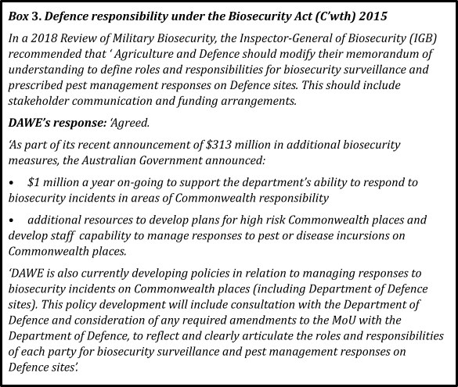

The Program work through QDAF and DAWE with Defence and port-of-entry operators to develop RIFA-suppressive programs for Commonwealth land that Defence and airport and port operators will implement and report on to the Program.
Recommendation 23

Develop and implement innovations to improve RIFA eradication effectiveness

Integrating and improving information and reporting systems
Integrating and improving information and reporting systems to efficiently manage and evaluate RIFA suppression and eradication, and to facilitate their transition to multiple agencies

Effective systems to record data are necessary to plan, track progress and identify issues. The Program uses a range of information systems to record and represent data, plan

work and report on effort. IT services are developed and managed through the Queensland Government’s inter-departmental Information and Technology Partner (ITP) and are governed by the QDAF ICTC along with all other departmental IT projects.
Since 2017, three key systems have been progressively developed and integrated, with a major push for improvement since 2020. The primary systems are:
- CASES, the Program’s customer relationship management system for public-facing activities, such as reports to the Program’s call centre of suspect RIFA nests or stings; requests for or complaints about responsive treatment; and reports from pest management technicians about RIFA treatments they have delivered. CASES has been built onto an original Microsoft software package, with a complex original design that is costly and difficult to update.
- FAMS (Fire ant management system) which records, stores and provides access to program data about where, when and how RIFA treatment and surveillance have been performed by Program staff. and
- FORAGE, a real-time mobile application operating from January 2021 that allows information to be directly entered into FAMS by field teams, greatly increasing data capture efficiency and timely monitoring of field surveillance and treatment. Additional enhancements could further improve the program’s in-field efficiency.
Mapping RIFA detections, treatment and surveillance - Data from FAMS, FORAGE and CASES is geolocated and mapped by Program staff using the ARCGIS software. Data are not easily transferred to the mapping software, needing time- and resource-consuming extra manual processing, and delaying critical provision of up-to-date maps for operational monitoring, planning and KPI reporting.
Complaints management is currently managed in both FAMS and CASES, which have limited integration, depending on if the complaint comes via the call centre (CASES) or directly to a field staff member (FORAGE/FAMS). This has led to community complaints being mis-managed at times.
Operational planning has been significantly improved by the FORAGE field app. Before 2020, all dispatching of work was entirely paper based, with packages of maps and forms produced for each field team’s daily work. FORAGE deployment eliminated most of this manual handling, improving data quality and speed of access (now almost real-time), and reducing planning staff needed. Further centralisation of daily work plans and dispatch (previously managed by each field depot) will improve field efficiency and accountability.
Efficiency gains from FORAGE allow Program management to better monitor the quality and quantity of key performance issues such as treatment area coverage (identifying the scale and importance of gaps in treatment), field staff work rates, or correct application of updated treatments and surveillance. However, the systems in place have not scaled effectively as the Program grows, with ongoing issues of poor field data entry. Digitisation of business processes should help resolve these issues and ensure that effective quality management plans and updated SOPs are developed and applied.

Reporting is an onerous overhead on the Program’s resources. Various information systems with often rudimentary reporting functions record and represent data, plan

work, and report on effort. Information outputs for reporting should be automated where possible to improve efficiency and provide improved, more timely summary data for Program management, Steering Committee and QDAF progress reports.

The 2020-23 strategy outlined a swathe of reports the Program is required to produce. A recent Program audit identified 34 different reports, covering a range of timeframes from weekly to annually, that typically require approval from the General Manager or Steering Committee. Reporting suffers from replication such as different reporting and approvals of essentially the same information to QDAF and the SC and their two separate Risk Committees. Partly due to workload and lack of automation, reports are not timely - a monthly report takes a month to complete, prior to approval.

Development of agreed KPIs, suitable for both QDAF and the Steering Committee to assess progress and performance, would allow reduction of the large volume of reports generated by the program. Automated reporting can distill output reports down to outcome summaries, which focus on the key issues and free up time by Program managers for planning and operations, instead of report writing.
FAMS and CASES are older systems with limited integration. They were not structured to accommodate agile changes in operations, with fixed reports needing IT input if a change in field or a new report is required. IT support is not always rapid enough to keep pace with innovations that could further improve the Program’s efficiency in field surveillance and treatment.
The Program has reported challenges in interfacing their systems and searching and integrating data. These will only increase as the pace of innovations and improvements accelerates and further initiatives such as remote sensing surveillance and outsourced implementation of area-wide RIFA management and compliance programs are widened to councils, government agencies, and industry.
A systems architecture review in 2021-22 will assess whether existing systems are fit for purpose and recommend changes to optimise their performance, integration, data searchability, cost and future adaptability. Epidemiological input should be included in this review to ensure that data capture supports clear reporting at all levels, both for technical and operational performance monitoring, and ease of use. The review should build on successful development of current IT systems, to enable further extension and networking with councils and /or the Steering Committee as appropriate

The Program regularly review and improve its IT systems to optimise:
- performance, integration, data searchability, cost and adaptability
- ability to interface with other systems and apps used by the public and councils,
- more effective and timely reporting to support decision making by all parties.
- efficiency in streamlining information capture to support reporting, analysis and operational management work at the local, state and national levels.
Recommendation 24

Science and R&D into improved treatment and surveillance
Research and development are critical to improve detection and eradication of RIFA. The national Program relies heavily on scientific and technical research, advice and expertise provided by its Science Group and external Australian and international research partners. The Science Group provides operational and strategic advice across the breadth of the Program and is critical to the success of eradication in SEQ, and managing incursions of tramp ants nationwide. It focuses mainly on shorter-term operational needs to speed up eradication and improve surveillance, and designs and carries out much field research on how different treatment and surveillance regimes are working or could be improved.

The Steering Committee’s Science Advisory Group primarily reacts to the needs of the Program’s Science Group for timely advice on both tactical operational research questions as well as more strategic advice on new technologies.

Notably absent from the SAG are contributions from experts in countries where RIFA have more recently established (e.g. China, Taiwan and Japan). It could be useful for SAG membership to be opened to members from these countries, and others who are actively involved in RIFA research, and to focus on operational questions, including modelling of RIFA or large-scale ant eradications, as well as operational advice to the Program out-of- session as needed. The emphasis on the Program ‘reporting’ to the SAG should be reduced, to lessen the overall reporting burden of the Science Team.

The Program’s 2020-23 Strategy included investigating the potential viability of new treatments for RIFA eradication that might target different RIFA biological vulnerabilities. These new technologies need R&D in partnership with research organisations (industry, academic and government), then operational deployment some time in the future. They will not be operational by 2023, but should be part of a long-term strategy. The first part of the strategy is to develop the relationships. Potential solutions (e.g. viral or other biological controls, environmental DNA (eDNA) surveillance, RNAi and CRISPR ) are not straightforward or quick to discover, let alone implement, with many false starts and dead ends. Given the highly technical and diverse nature of the solutions suggested, the Program should partner with agencies and institutions that have demonstrated the

operational effectiveness of these and other technologies in other biological systems, particularly social insect specialists.

This longer-term R&D strategy might be better delivered by an external R&D program, driven by Program needs; working closely with the Program’s Science Group to provide a mix of best-practice advice and solutions using tools that do not require major capital investment to develop and can be operationalised relatively quickly, and innovative new technologies. The R&D Program would focus particularly on strategic ‘blue sky’ research that requires greater effort and new regulatory approvals (and is more uncertain) prior to being field-ready (e.g. viral or other biological controls, environmental DNA (eDNA) surveillance, RNAi and CRISPR gene silencing and editing, and novel toxicant treatment). Linking with the Centre for Invasive Species Solutions (CISS) should be explored.

The Steering Committee explore development of a broader collaborative strategic research program for RIFA and other tramp ants, looking at longer-term applications of new ‘blue-sky’ technologies to the challenges of their eradication and surveillance.
Recommendation 25

Risks and Constraints
South-east Queensland is a dynamic growth area of Australia, whose population has increased in the last ten years by about 1 million to its current 3.8 million people. The RIFA- infested area currently occupies approximately 12% of SEQ (and only 0.4% of Queensland) and is slowly expanding, despite a large and costly program to contain and eradicate it. The Program has reduced community and industry damage greatly, but must be sustained and expanded, if we wish to hold the line against RIFA.
Major continuing risks that appear to have increased since the Ten-Year Plan’s start, and will have to be managed in future are:-
- the vastly increasing pace and area of land development in SEQ, which creates habitat that is immensely favourable for RIFA and greatly increases risks of human-assisted movement of the ants,
- the increasing frequency of extreme weather events such as severe storms, winds, floods and fires, which favour natural spread of the ants further into new habitats and make timely treatment and longer term surveillance much more difficult,
- the effort required to maintain community, industry and political engagement and support for a complex long-term program in SEQ, an area with about 3.8 million people and many diverse industries, and
- the difficulty of raising and maintaining national understanding of RIFA as a very serious pest, due in part to the Program’s success in slowing its spread and reducing its impact.

Transition from current to future strategy
Implementation of Option A or Option B will require a relatively seamless transition to expanded Program containment and eradication efforts while negotiating and implementing new institutional relationships for RIFA suppression with Queensland state and local governments.
The full transition to a shared responsibility for RIFA management from the Queensland Government to new institutional arrangements may take up to 15 months, due to employment and contract arrangements. However, it is of strategic importance that there is no hiatus in Program delivery, as occurred between 2015 and 2017. This would just exacerbate the spread of RIFA, increase future costs, and diminish success prospects.
There is a necessary sense of urgency required in extending the current Program based on eradication from west to east and eradication of identified significant detections outside the operational boundary. Aerial prophylactic baiting outside of the operational boundary must be programmed to ensure RIFA does not continue to expand its infestation in SEQ. The southern significant detections are of great concern, as this area is close to the northern reaches of the Murray Darling Basin and the NSW border.
Scaling up pilot self-management programs in partnership with Councils is of equal priority. Baiting on an area-wide basis needs to be coordinated by Councils, or residents will be reinfested from their neighbours or public land and just waste time and money. Sourcing bait and bait shakers for all residents within the Brisbane, Redlands and Gold

Coast Council areas is urgent. The Program has established contracts for bait and bait shaker supply, so as long as the budget is made available and procurement constraints are avoided, obtaining these resources should not be difficult. The treatments are not noxious to people or mammalian pets, so there are few concerns about household use.
The model going forward needs to recognise that all three facets of the program are important: Contain, Suppress and Eradicate. All three must be worked on to achieve the goal of eradication and stop the spread of RIFA.

Timely new Program and budget approval
Assuming this year’s request by the Steering Committee of a $34M advance is approved and provided well before Christmas, there will be a need to also get AGMIN support for proposed Option A and associated forward budget as quickly as possible. This will be critical for the new Program’s success.
Due to the complexity of multiple jurisdictions’ budget processes, requiring separate cabinet approvals and then joint agreement, the Steering Committee might explore the possibility of bringing forward further Ten-year Plan plan funds for a blitz of area-wide treatment across the whole containment and operational zone in 2022-23. The earlier in 2022 this could be implemented, the greater the long term prospects for maintaining Program momentum.
As the budget quantum is very large compared to other biosecurity program budgets and past NRIFAEP budgets, there may be a strong tendency to try for a compromise budget that will not be able to achieve the goals of containment and/or eventual eradication, just as happened with the framing of the Ten-Year Plan budget.

Management of Queensland government changing role
Provided there is political will from Queensland to play a long term partnership role with other governments to complement a costs-shared national Program, it should be relatively simple to use QDAF’s emergency operations arrangements and facilities to marshal Queensland state and local government and other peak industry bodies to plan and implement specified activities, defining and refining roles of Program and other agencies as soon as possible.

Scaling-up of treatment and surveillance activities
The increasing size of the infestation increases the risk of spread and reinfestation. The incursions of RIFA elsewhere in Queensland and Australia were far smaller when detected than the current SEQ infestation under eradication.
Over such a large area, scaling-up operations to coordinate and complete suitable eradication activities (including 100% treatment, 100% surveillance over multiple years, community and industry engagement, etc.) is challenging, especially under the financial and logistical constraints that the Program faces.

Broadscale treatment and surveillance operations are, however, already being implemented at scale by the Program, making their expansion relatively simple provided budget, staff hire and procurement can be arranged in a timely manner.
The Program’s ability in the past to manage major changes in scope and emergency responses to new findings was severely constrained by fixed budgets and sometimes by dual reporting and approval processes. Given the unpredictability of RIFA spread and the lack of additional funding to address detections outside of the original Ten-Year Plan, the Program repeatedly faced immense challenges in effectively forecasting and planning operations. The sheer scale of the work being conducted created large overheads which often had not been systematically accounted for in strategic planning.
Further compounding these issues were problems with internal integration of knowledge and processes that led to operational issues, such as gaps in treatment, that were not identified, escalated and resolved fast enough to prevent major operational challenges.
The adoption of agile planning processes and weekly progress review meetings have improved this situation since 2019, but internal structural change may be needed to further improve this situation.

Program staff management
Program staff are either permanent or temporary QDAF employees, or contract staff employed by a range of companies that provide general employment or specialised services. Bulk labour hire contracts are large and tend to be implemented by financial or calendar year, rather than by projected work demands. Their application depends on certainty of budget for the following year, which can be delayed.
The Program is subject to QDAF’s Public Sector FTE cap, which skews it towards using more contract staff, even though this is less efficient than employing temporary public servants, due to their high turnover, lower motivation, and higher unit costs due to higher induction and training requirements. This greatly reduces Program flexibility to increase or decrease human resources and get the right skills mix as needed.
Since the Queensland Government is only contributing 10.5% of national cost-shared Program funds, this is completely anomalous. The Program should be able to recruit and allocate staff to implement nationally agreed strategies, respond to emergencies, and service its operational needs within approved budgets, irrespective of the QDAF FTE cap.
However, the Queensland Public Service Act 2008 and subsequent directives provide for temporary staff to become permanent if employed for more than one year. There is concern that, if Program funding were diminished or not continued, QDAF would have to find alternative employment for Program staff and would exceed its budget. Negotiations with unions may be needed to create an exemption to this provision as well.
The Program should apply for an exemption to the FTE cap as soon as possible, and if achieved, move relatively skilled jobs (e.g. team leaders and above) in house where appropriate, to reduce turnover and retain expertise. It would also be appropriate to reduce use of relatively unskilled contractors for field operations wherever possible, and train up council staff to carry out some base field duties like ground surveillance.

Staff funded by the national Program be exempt from the Queensland Public Sector FTE cap.
Recommendation 26

Business Services and Logistics
Business services and logistics are critical activities underpinning successful large-scale Program operation. While largely effective, a number of issues need addressing. In particular, processes for approving and managing major contracts are cumbersome. Due to seasonal work requirements, timely resolution of contracts is essential, but delegations are held at very senior levels, with long delays frustrating operational efficiency.
Two major contracts for the program - aerial services and bait supply - are provided on a sole supplier basis, which runs the risk of the Program being subject to non-competitive rates. The supply of bulk baits (IGR and toxicant) is a constraint, as both are manufactured in the USA, with significant supply chain intervals. The large margins between wholesale and retail bait costs increase the desirability of centralised purchase and supply. It will be far more cost-effective to make baits available in sufficient quantities to support any area-wide strategy no matter if applied by Program, Councils, industry, govts, pest controllers or homeowners.
Major procurement contracts for supply of contract field and office staff, helicopters for broadscale treatment, remote sensing surveillance and different RIFA baits all require QDAF DG approval, with lengthy internal double-checking that often adds little value, creating additional bureaucratic delays and real impacts on Program operations, and making it hard for the Program’s procurement team to focus on strategic needs.
Delegations should be lowered to the Program General Manager, whose financial limit should be substantially raised. External QDAF financial accountability and probity processes should be reviewed and, where possible, streamlined with the Program to ensure that they do not impede major planned operations.

QDAF review its processes for approving Program expenditure and major contract procurement, with greater delegations for operational expenditure and procurement being given to the Program General Manager and more flexible oversight to assist program effectiveness.
Recommendation 27

Conclusion
Before the Ten-Year Plan even began, RIFA eradication from SEQ was compromised. The inadequacy of funding and subsequent loss of momentum in implementing previous review recommendations between 2015 and 2018 set RIFA eradication back some years. With a fixed budget and RIFA spread beyond what the Ten-Year Plan had been based on, the Steering Committee and NRIFAEP management have been continually forced to make budget-driven decisions that prioritised efficiency over effectiveness.
This review, four years into the Ten-Year Plan, finds that, although the current program is significantly slowing RIFA spread in and out of SEQ, it will not be able to eradicate or contain RIFA within the Plan’s scope and budget. However, eradicating RIFA from SEQ may still be feasible if major changes are implemented at national, state and local levels.
The SEQ RIFA infestation represents the largest eradication ever attempted globally, and restricting RIFA to SEQ to date is a major achievement. Without a national response to RIFA since 2001, it is estimated that RIFA would now infest approximately 100 million hectares in an arc of country from north of Mackay, west to Longreach and south to Canberra. Efforts by NRIFAEP since 2001 have restricted RIFA to 750,000 hectares of SEQ, greatly reduced their densities, prevented their long term establishment in any other state, and avoided the billions of dollars of public health, infrastructure, agricultural, environmental and social amenity impacts that the nation would have otherwise incurred. These major achievements have delivered significant social, environmental and economic benefits to Queensland and the nation as whole.
The past 20 years of investment in RIFA eradication and control has also created a national asset in the NRIFAEP staff, who are collectively global experts on RIFA eradication. The Program has developed a highly competent workforce who fully understand the context of eradicating RIFA in SEQ, and who also provide critical support for managing other invasive ant incursions around Australia. Their abilities and collective knowledge should be acknowledged and fostered for future invasives control programs.
However, it is no longer feasible for NRIFAEP to be the sole agency responsible for the control and eradication of RIFA. If national eradication of RIFA is to be continued, then the three pillars of Contain, Suppress and Eradicate across and beyond the whole operational zone need to be pursued. Due to the large and diverse geographic area of infestation in both rural and urban environments, the Program cannot and should not attempt to achieve the three pillars by undertaking all operations alone. It is critical that communities, industry and governments at all levels mobilise to address RIFA as the major national threat that it is.
Should RIFA containment or eradication be pursued, a new partnership and definition of roles will be needed between the national Program and the Queensland Government.
Rural and agricultural RIFA control will be the most challenging and expensive for landholders. Agricultural departments can play in protecting these communities and the nation's agriculture. However, broadscale operations on rural land will not be sufficient to contain, let alone eradicate, RIFA, and increased commitment from the Queensland government to take a whole-of-government approach and to effectively suppress RIFA in urban environments will be required.

Irrespective of the response option chosen, urban areas affected by RIFA need a much stronger suppression and management effort, in the interests of public health and amenity as well as economics. This should be led by local agencies. RIFA suppression and management will be far more efficient and effective if all landowners, including local councils, State and Commonwealth governments, businesses and property owners understand why they must treat their land for RIFA and are legally required to do so.
However, this will have financial and political implications that will need to be managed by Queensland state and local governments, and their affected communities.
There is an urgent need for aggressive area-wide suppression of RIFA in built-up areas by cooperative council / community / industry programs, integrated across the landscape.
Road verges, parks and school grounds must be treated at the same time as residential blocks, suburb by suburb, on a regular basis. Ongoing preventive ‘fire ant-free’ QA programs are also needed for high risk land such as waste depots and building development sites; for high risk RIFA carrier materials, such as nursery plants, turf and hay; and for sites such as childcare, school, hospital and aged care facilities. These programs must be developed or strengthened with coordination, technical and logistic support, and above all, stronger communication and engagement by the Program and other government agencies. Over time they must become embedded into routine operations of the land or enterprise managers, with effectiveness and compliance checks where indicated. Some preventive programs need to be applied beyond the operational boundary and indeed interstate to support long-term RIFA containment. Only in this way can Australia achieve a fire-ant free Olympics in 2032.
The majority of Australia is still free of RIFA due to the nation’s biosecurity efforts to detect and respond to RIFA incursions, but risks of establishment within and beyond south-east Queensland are increasing. RIFA populations in some urban areas are at the highest level they have been since 2001, and detections of RIFA are occurring more frequently outside the Operational Boundary. The loss of momentum before the Ten-Year Plan set RIFA eradication back some years, so it is imperative that there are no further delays in funding current RIFA control programs. Without sufficient funding and a concerted effort to effectively address the risks of RIFA in SEQ with stakeholders, it is unlikely that further RIFA spread can be prevented. Raising the national investment now for on-going funding of RIFA containment and eradication should be seen as an opportunity cost, and should be seriously considered. Eradication is still a long-term possibility, but if RIFA moves out of SEQ, then any hope of eradication will be lost forever and ongoing costs for all Australian jurisdictions will be far higher than the current control program.

Annexes

Annex 1: List of abbreviations
AGMIN – Agriculture Ministers’ Forum
AGSOC – Agriculture Senior Officials Committee ATV – All-Terrain Vehicle
BIP – Biosecurity Instrument Permit BQ – Biosecurity Queensland
CaSES – Client and Stakeholder Engagement Solution CISS – Centre for Invasive Species Solutions
CRISPR – Clustered Regularly Interspaced Short Palindromic Repeats CRM – Customer Relationship Management
DG - Director General
DNI – Direct Nest Injection eDNA – environmental DNA EU - European Union
FAMS – Fire Ant Management System FTE – Full-Time Equivalents
GBO – General Biosecurity Obligation GM – General Manager
HR – Human Relations
IGR – Insect growth regulator IT – Information technology
ICT – Information and communications technology IDC – Inter-departmental committee
KPI – Key Performance Indicator
NBC – National Biosecurity Committee
NRIFAEP – National Red Imported Fire Ant Eradication Program POC – Proof of Concept
QA – Quality Assurance
QDAF – Queensland Department of Agriculture and Fisheries R&D – Research and Development
RIFA – Red Imported Fire Ant RNA-i – RNA interference
RMSC – Risk Management Sub-Committee RSS – Remote Sensing Surveillance
SAG – Scientific Advisory Group SEQ – South East Queensland
SOA – Standard Operating Arrangement SOP – Standard Operating Procedures UK - United Kingdom
USA - United States of America WB – Western Boundary
WH&S – Workplace Health and Safety

Annex 2: Review Process and Panel

Purpose
The purpose of this review was to examine:
- Program effectiveness in relation to the objectives of the Ten-Year Plan
- the feasibility and likely achievability of the current strategy achieving these objectives, in particular the eradication of fire ants
- alternative strategies for achieving the strategic objectives, in particular the eradication of fire ants

Scope
This review covered activities conducted by the NRIFAEP to execute the Ten-Year Plan. This included:
- reviewing the efficiency and effectiveness of the current Program approaches, assessing the conditions under which successful achievement of the Program’s objectives would be feasible.
- providing advice on any modifications to the Program that would facilitate achievement of eradication and estimating indicative costs of such a modified Program
- assessing biological and technical feasibility of eradication
- considering alternative options to eradication and a brief assessment of likely outcomes of these options
- liaising with analysts undertaking cost benefit analyses of Program options as required.

Out of scope
This review did not examine in detail NRIFAEP activities before the last major review (Magee, 2016)

Potential risks
Potential risks considered as part of this review included:
- potential impacts of fire ants on Australia’s health, social amenity, economies and environment.
- effectiveness of NRIFAEP activities
- adequacy of funding to execute strategy
- adequacy of governance structures for delivery of agreed strategy

Review methodology
In undertaking the Strategic Review of the Program, the Panel considered all matters that they believed to be relevant, including:

- previous reviews and audits of the Program, including the Independent Review in 2016–17, procurement and governance audits in 2018-19, and Mr Wonder’s 2019 review
- Program Ten-Year Plan, Addendum and annual work plans, and quarterly and annual reports since 1 July 2017, particularly since 2019
- NRIFAEP Steering Committee minutes and reports particularly since 2019
- Scientific Advisory and Risk Management sub-committee minutes and summaries
- planned actions, including observation of current operations in and off the field
- surveys of and meetings with Program staff and key stakeholders
- relevant scientific literature, reports and departmental policies and procedures
- current and proposed technologies and methods and their effectiveness and efficacy in delivering Program outcomes, and
- response of NRIFAEP Steering Committee members to their draft report.

Review Panel
Dr Helen Scott-Orr AM PSM FAICD BVSc(Hons) DipBact(Lond) MANCVS(Epidem), who chaired the Review Panel, was formerly Australian Inspector-General of Biosecurity (2016-19), and Executive Director Research, Advisory and Education (1998-2009), NSW Chief Veterinary Officer(1989-1997) and Assistant/Director Brucellosis and Tuberculosis Eradication (1980-86) with NSW Agriculture/Primary Industry. She also led veterinary capacity-building projects in Indonesia on zoonotic disease control - rabies, anthrax, brucellosis and leptospirosis - and served on boards of Animal Health Australia and the Cooperative Research Centres for Invasive Animals, Weeds, Beef, Sheep, Cotton and Rice.
Dr Monica Gruber PhD BSc(Hons) GCertLaw co-founded and leads the Pacific Biosecurity program at Victoria University of Wellington. She has researched the ecology of invasive social insects in the Pacific, New Zealand and Australia since 2008, studying their impacts and novel genomic and viral control methods. Monica has led yellow crazy ant control work in Tokelau and Kiribati. Together with the Pacific Community (SPC), Pacific Biosecurity leads the Pacific Regional Environment Programme’s Protect our Islands program (SPREP PRISMSS POI). One of the goals of Pacific Biosecurity is to prevent RIFA spreading to Pacific Island Countries and Territories.
Mr Will Zacharin BSc (Hons), MSc, Grad Dip Bus Mangt, GAICD currently works as a private consultant specialising in fisheries and biosecurity. He spent 20 years as a Senior Executive with the Department of Primary Industries and Regions South Australia, with his last 9 years as the Executive Director, Biosecurity SA (2010-19), responsible for animal and plant pest and disease management. During this period, he was the South Australian Government representative on the National Biosecurity Committee. Will was also involved in fisheries science and management throughout his public service career and was Executive Director, Fisheries for 10 years. In 2019, he was appointed a member of the Department of Agriculture, Water and the Environment’s Scientific Advisory Group.

