
No. 23/2023 15 June 2023

Summary of key issues
- For the week ending 14 June 2023, an intense low, cold front and a trough generated rainfall of between 10 and 50 millimetres across much of New South Wales, and parts of southern Queensland, southern South Australia and far southwest Western Australia. Rainfall up to 200 millimetres were recorded across in Victoria and Tasmania.
- Across cropping regions, rainfall totals of between 10 and 50 millimetres was recorded across much of New South Wales, and parts of southern South Australia and eastern Western Australia. Rainfalls of between 15 and 100 millimetres were recorded across Victoria. Little to no rainfall was recorded elsewhere. Most growers across eastern Australia are likely to have completed their winter planting programs and these falls would have provided a useful boost to soil moisture levels and will support the establishment and development of crops. In Western Australia the mainly dry conditions will have allowed for field access for the finalisation of planting programs in the south and for nitrogen and herbicide application following widespread rainfall early June (see Section 1.1).
- Above average rainfall globally during May is likely to result in improved wheat production potential in the United States, isolated parts of central and western Canada, western Kazakhstan, north-western India, western, central and eastern China and isolated parts of the southern and eastern Russian Federation. Below average rainfall and above average temperatures in recent months have also negatively affected corn and soybean production across parts of Argentina. Global production conditions have improved compared to those used to formulate ABARES forecasts of global grain supplies and world prices in its June 2023 edition of the Agricultural Commodities Report. As a result, global grain and oilseed production is currently expected to be higher than that published in early June (see Section 1.2).
- Over the 8-days to 22 June 2023, fronts and troughs crossing southern Australia are expected to bring cold and showery conditions to southern South Australia, much of Victoria, southern New South Wales and Tasmania. Cool onshore winds should bring showers to the southern Western Australian coast. A high-pressure system will keep the remainder of the country dry (see Section 1.3).
- Across cropping regions, rainfall totals of between 10 and 25 millimetres are expected across much of Victoria and South Australia. Lighter falls of between 1 and 10 millimetres are expected across Western Australia, New South Wales and southern Queensland. Little to no rainfall is expected across remaining cropping regions. This rainfall should be sufficient to allow for the germination and establishment of dry sown crops, and benefit soil moisture levels and the growth of earlier sown crops (see Section 1.3).
- Water storage levels in the Murray-Darling Basin (MDB) increased between 8 June 2023 and 15 June 2023 by 237 gigalitres (GL). Current volume of water held in storage is 20 563 GL. This is 1 percent or 182 GL more than at the same time last year.
- Allocation prices in the Victorian Murray below the Barmah Choke decreased from $13 on 8 June 2023 to $11 on 15 June 2023. Prices are lower in the Murrumbidgee due to the binding of the Murrumbidgee export limit.

Climate

Rainfall this week
For the week ending 14 June 2023, an intense low, cold front and a trough generated rainfall of between 10 and 50 millimetres across much of New South Wales, and parts of southern Queensland, southern South Australia and far southwest Western Australia. Rainfall of up to 200 millimetres were recorded across in Victoria and Tasmania. A high-pressure system kept the remainder of the country dry.
In cropping regions, rainfall totals of between 10 and 50 millimetres was recorded across much of New South Wales, and parts of southern South Australia and eastern Western Australia. Falls of between 15 and 100 millimetres were recorded across Victoria. Little to no rainfall was recorded across remaining cropping regions. Most growers across eastern Australia are likely to have completed their winter planting programs and these falls would have provided a useful boost to soil moisture levels and will support the establishment and development of crops. In Western Australia the mainly dry conditions will have allowed for field access for the finalisation of planting programs in the south and for nitrogen and herbicide application following widespread rainfall last week.

Rainfall for the week ending 14 June 2023
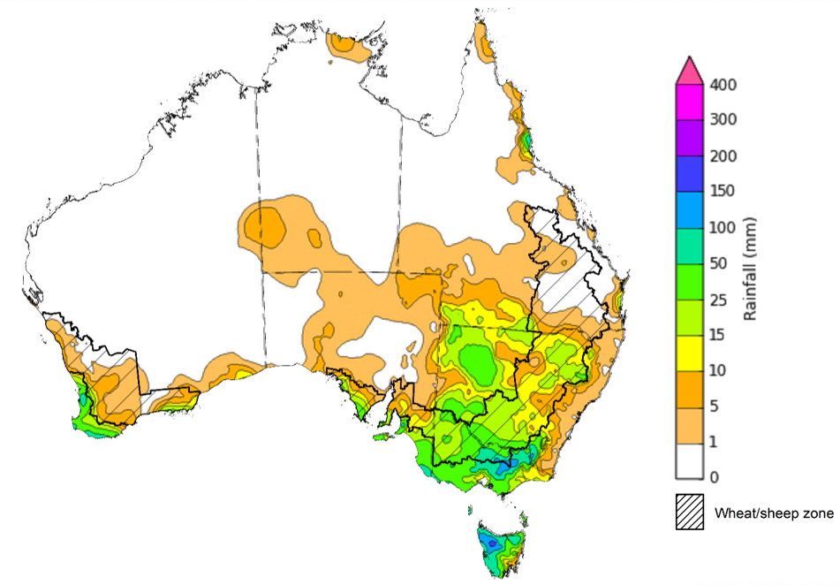
©Commonwealth of Australia 2023, Australian Bureau of Meteorology Issued: 14/06/2023
Note: The rainfall analyses and associated maps utilise data contained in the Bureau of Meteorology climate database, the Australian Data Archive for Meteorology (ADAM). The analyses are initially produced automatically from real-time data with limited quality control. They are intended to provide a general overview of rainfall across Australia as quickly as possible after the observations are received. For further information go to http://www.bom.gov.au/climate/rainfall/

Global production conditions and climate outlook
Crop production is affected by long-term trends in average rainfall and temperature, interannual climate variability, shocks during specific growth stages, and extreme weather events. Some crops are more tolerant than others to certain types of stresses, and at each growth stage, different types of stresses affect each crop species in different ways.
The precipitation anomalies and outlooks presented here give an indication of the current and future state of production conditions for the major grain and oilseed producing countries which are responsible for over 80% of global production. This is an important input to assessing the global grain supply outlook.

May precipitation percentiles and current production conditions
As of the end of May 2023, rainfall was mixed for the world’s major grain-producing and oilseed-producing regions.
In the northern hemisphere, precipitation was below average in north-eastern United States, scattered areas in the west, central and much of eastern Canada, much of Europe and central Russian Federation, northern and southern Kazakhstan, southern China and across Thailand and Cambodia. Precipitation was above average for central United States, isolated part of central and western Canada, western Kazakhstan, north-western India, western, central and eastern China and isolated parts of the southern and eastern Russian Federation. Precipitation was close to average across the remainder of the major grain-producing and oilseed-producing regions in the northern hemisphere.
In the southern hemisphere, May precipitation was below average across southern Brazil and Argentina and much of western and eastern Australia. Precipitation was above average for a localised area of eastern Brazil and Argentina. Precipitation was close to average across the remainder of major grain-producing and oilseed-producing regions in the southern hemisphere.

Global precipitation percentiles, May 2023
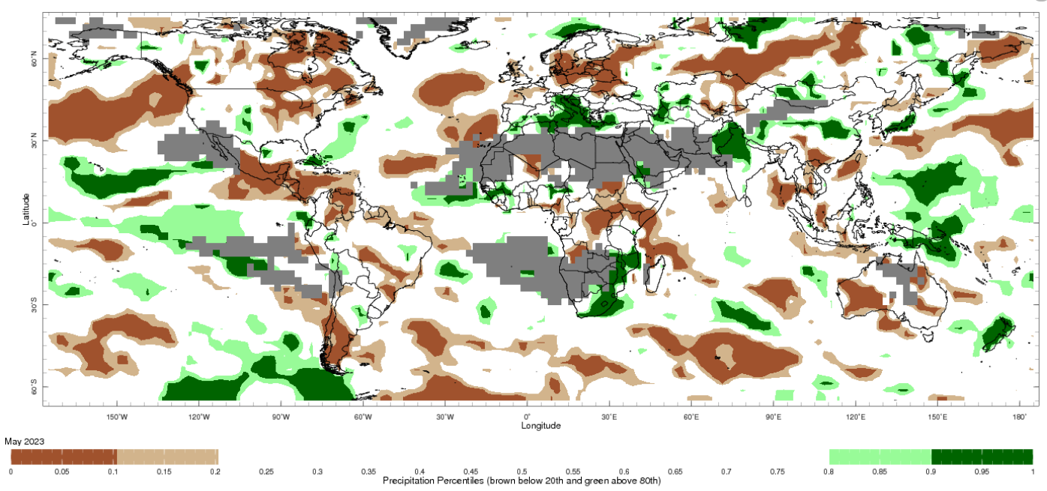
Note: The world precipitation percentiles indicate a ranking of precipitation for May, with the driest (0th percentile) being 0 on the scale and the wettest (100th percentile) being 1 on the scale. Percentiles are based on precipitation estimates from the NOAA Climate Prediction Center's Climate Anomaly Monitoring System Outgoing Precipitation Index dataset. Precipitation estimates for May 2023 are compared with rainfall recorded for that period during the 1981 to 2010 base period.
Source: International Research Institute for Climate and Society
As of 28 May 2023, global production was generally favourable for maize and rice, while mixed for wheat and soybeans.
In the northern hemisphere production conditions for wheat have been favourable to exceptional except for in Spain, central and southern Great Plains of the United States due to prolonged drought and in the Ukraine due to the ongoing conflict. In the southern hemisphere, winter wheat sowing was carried out under mixed conditions in Australia and favourable conditions in Brazil.
For corn, production conditions are generally favourable except for Argentina where harvest is continuing with significantly reduced yields for both early- and late-planted crops. The summer planted crops in Brazil is in the reproductive stage under favourable conditions. In the northern hemisphere, sowing is beginning in Canada, well underway in Russian Federation and East Asia, and wrapping up in the US and EU under generally favourable conditions albeit dry conditions in Spain and Portugal and away from war zones in Ukraine. Conditions are favourable for spring-planted crops and sowing of summer crops in China.
For rice, early planted rice is in the reproductive stage in China and harvesting of Rabi crop and wet-season rice is wrapping up in India and Indonesia, respectively, under favourable conditions. Sowing is wrapping up in the US under favourable conditions.
For soybeans, production conditions are favourable in the US, Canada, China and Ukraine. In Argentina, harvesting is continuing for both early- and late planted crops with reduced yields across all regions. With an expected shift from La Nina to El Nino conditions in 2023–24, a return to more favourable growing conditions globally is likely to see global soybean production rebound to new record levels, mainly due to increased expected production across South America and the US.
Crop conditions, AMIS countries, 28 May 2023
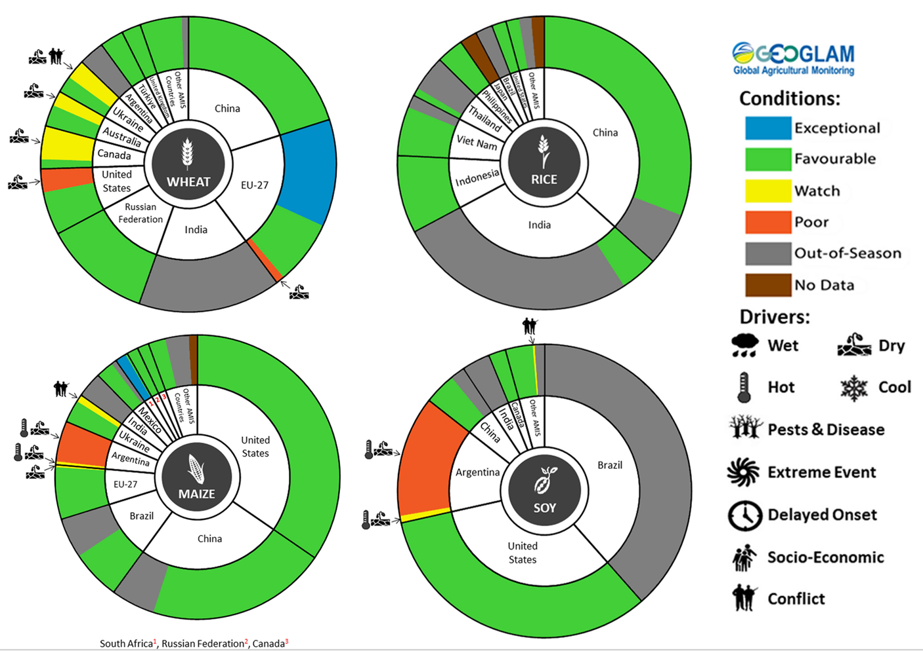
AMIS Agricultural Market Information System.
Source: AMIS

The global climate outlook for July 2023 to September 2023 indicates that variable rainfall conditions are expected for the world's major grain-producing and oilseed-producing regions. Outlooks and potential production impacts for the major grain and oilseed producing countries are presented in the table.
Rainfall outlook and potential impact on the future state of production conditions between July 2023 to September 2023
Region | July - September rainfall outlook | Potential impact on production
Argentina | Below average-to-average rainfall is expected across northern Argentina while above average rainfall is expected in southern Argentina between July and September 2023. | Below average rainfall across northern Argentina is likely to adversely affect the establishment and growth of wheat. Dry conditions in September could adversely affect wheat yields and delay planting of corn and cotton.
Black Sea Region | Average rainfall is likely in Ukraine, Kazakhstan and Russian Federation. | Average rainfall across much of The Russian Federation, Ukraine and Kazakhstan will support yield potential for spring wheat, corn, cotton and sunflower during flowering and grain filling in July and August 2023.
Brazil | Average to above average rainfall is more likely across southern Brazil and well below average rainfall is more likely across central and northern Brazil between July and September 2023. | Below average rainfall in July 2023 across central Brazil may adversely affect the establishment and growth of wheat. Dry conditions in August to September could adversely affect wheat yields and delay the planting of corn and soybean in northern and central areas.
Canada | Average rainfall is more likely for much of Canada, especially across major production regions between July and September 2023. | Average rainfall is likely to positively impact yields for spring wheat and canola during critical stages of flowering and filling in July and August. Likewise, average rainfall conditions will support the development and growth of corn, soybeans and sunflower.
China | Average to above average rainfall is more likely across China between July and September 2023. | Average to above average rainfall across China is likely to positively impact cotton, spring wheat, sunflower and rice yields. Above average rainfall across north-eastern China is likely to support the yield potential for corn, sorghum and soybean between July and September 2023.
Europe | Average to above average rainfall is more likely for Europe between July and September 2023. | Above average rainfall across Europe may boost the yield potential of corn, soybean, sorghum and sunflower seeds during flowering and grain development.
South Asia (India) | Average to above average rainfall is more likely across India between July and September 2023. | Average to above average rainfall across much of India is likely to benefit the yield potential of non-irrigated rice, corn, millet and sorghum from July 2023.
Southeast Asia (SEA) | Above average rainfall is more likely for Southeast Asian countries except for in Malaysia where below average rainfall is more likely between July and September 2023. | Average or better rainfall across most of Southeast Asia is likely to benefit corn and rice potential yields. Below average rainfall across Malaysia may adversely impact rice and corn production.
The United States of America | Above average rainfall is likely for much of the southern-east US and below average rainfall is more likely for southern-west growing regions between July and September 2023. | Average or better rainfall across the southern-east US is likely to support the yield potential of cotton, corn, groundnuts and soybeans during the flowering and grain development in July and August. Below average rainfall in southern-west US is likely to adversely impact canola, cotton, sorghum and spring wheat yields in affected regions.

Rainfall forecast for the next eight days
Over the 8-days to 22 June 2023, fronts and troughs crossing southern Australia are expected to bring cold, windy and showery conditions to southern South Australia, much of Victoria, parts of southern New South Wales and Tasmania. Cool onshore winds should bring showers to the southern Western Australian coast. A high-pressure system will keep the remainder of the country dry.
Across cropping regions, rainfall totals of between 10 and 25 millimetres are expected across much of Victoria and South Australia. Lighter falls of between 1 and 10 millimetres are expected across Western Australia, New South Wales and southern Queensland. Little to no rainfall is expected across remaining cropping regions. This rainfall should be sufficient to allow for the germination and establishment of dry sown crops, and benefit soil moisture levels and the growth of earlier sown crops.

Total forecast rainfall for the period 15 June 2023 to 22 June 2023
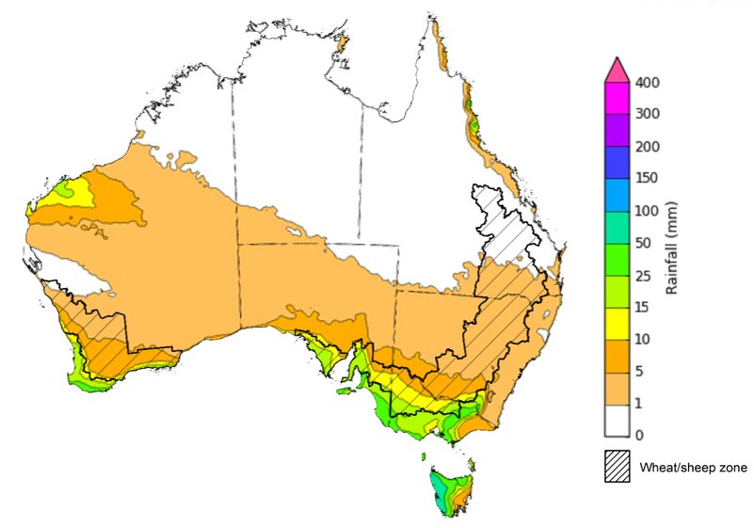

©Commonwealth of Australia 2023, Australian Bureau of Meteorology Issued 15/06/2023
Note: This rainfall forecast is produced from computer models. As the model outputs are not altered by weather forecasters, it is important to check local forecasts and warnings issued by the Bureau of Meteorology.

Water

Water markets – current week
Water storage levels in the Murray-Darling Basin (MDB) increased between 8 June 2023 and 15 June 2023 by 237 gigalitres (GL). Current volume of water held in storage is 20 563 GL. This is 1 percent or 182 GL more than at the same time last year.

Water storages in the Murray-Darling Basin, 2013–2023
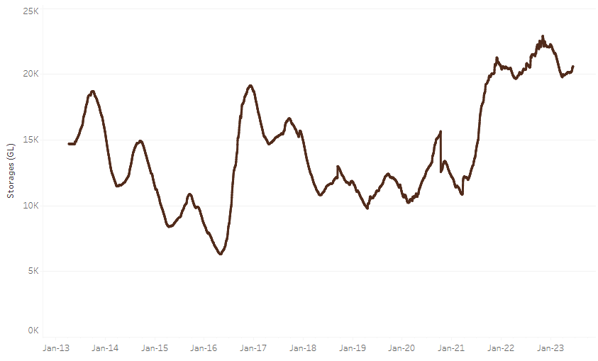
Allocation prices in the Victorian Murray below the Barmah Choke decreased from $13 on 8 June 2023 to $11 on 15 June 2023. Prices are lower in the Murrumbidgee due to the binding of the Murrumbidgee export limit.
Water storage data is sourced from the Bureau of Meteorology.

Region | $/ML
NSW Murray Above | 5
NSW Murrumbidgee | 3
VIC Goulburn-Broken | 10
VIC Murray Below | 11

Surface water trade activity, Southern Murray–Darling Basin
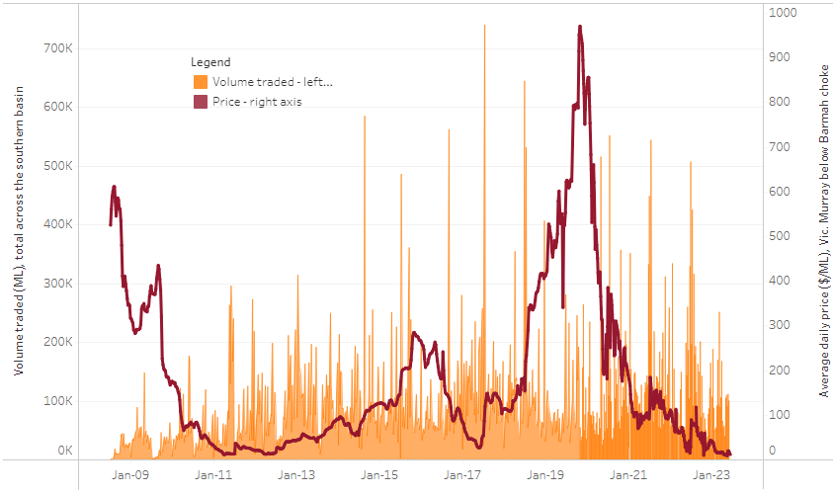
The trades shown reflect estimated market activity and do not encompass all register trades. The price is shown for the VIC Murray below the Barmah choke. Historical prices (before 1 July 2019) are ABARES estimates after removing outliers from BOM water register data. Prices after 1 July 2019 and prior to the 30 October 2019 reflect recorded transaction prices as sourced from Ruralco. Prices after the 30 October 2019 are sourced from Waterflow. Data for volume traded is sourced from the BOM water register. Only the price data shown is current on 15 June 2023.

To access the full, interactive, weekly water dashboard, which contains the latest and historical water storage, water market and water allocation information, please visit https://www.agriculture.gov.au/abares/products/weekly_update/weeakly-update-15623

Commodities
Indicator | Week ended | Unit | Latest Price | Previous Week | Weekly change | Price 12 months ago | Annual change
Selected world indicator prices
AUD/USD Exchange rate | 14-Jun | A$/US$ | 0.68 | 0.66 | 2% | 0.69 | -2%
Wheat – US no. 2 hard red winter wheat, fob Gulf | 14-Jun | US$/t | 337 | 354 | -5% | 441 | -24%
Corn – US no. 2 yellow corn, fob Gulf | 14-Jun | US$/t | 270 | 269 | 0% | 336 | -20%
Canola – Rapeseed, Canada, fob Vancouver | 14-Jun | US$/t | 570 | 547 | 4% | 799 | -29%
Cotton – Cotlook 'A' Index | 14-Jun | USc/lb | 93 | 96 | -2% | 155 | -40%
Sugar – Intercontinental Exchange, nearby futures, no.11 contract | 14-Jun | USc/lb | 25.0 | 24.2 | 3% | 19 | 35%
Wool – Eastern Market Indicator | 31-May | Ac/kg clean | 1,208 | 1,209 | 0% | 1,377 | -12%
Wool – Western Market Indicator | 24-May | Ac/kg clean | 1,366 | 1,337 | 2% | 1,457 | -6%
Selected Australian grain export prices
Milling Wheat – APW, Port Adelaide, SA | 14-Jun | A$/t | 431 | 446 | -3% | 628 | -31%
Feed Wheat – ASW, Port Adelaide, SA | 14-Jun | A$/t | 401 | 416 | -4% | 593 | -32%
Feed Barley – Port Adelaide, SA | 14-Jun | A$/t | 346 | 353 | -2% | 557 | -38%
Canola – Kwinana, WA | 14-Jun | A$/t | 810 | 810 | 0% | 1,210 | -33%
Grain Sorghum – Brisbane, QLD | 14-Jun | A$/t | 484 | 476 | 2% | 473 | 2%
Selected domestic livestock indicator prices
Beef – Eastern Young Cattle Indicator | 14-Jun | Ac/kg cwt | 556 | 574 | -3% | 1,121 | -50%
Mutton – Mutton indicator (18–24 kg fat score 2–3), Vic | 14-Jun | Ac/kg cwt | 348 | 363 | -4% | 631 | -45%
Lamb – Eastern States Trade Lamb Indicator | 14-Jun | Ac/kg cwt | 607 | 564 | 8% | 805 | -25%
Pig – Eastern Seaboard (60.1–75 kg), average of buyers & sellers | 31-May | Ac/kg cwt | 357 | 357 | 0% | 368 | -3%
Goats – Eastern States (12.1–16 kg) | 07-Jun | Ac/kg cwt | 324 | 330 | -2% | 838 | -61%
Live cattle – Light steers ex Darwin to Indonesia | 17-Aug | Ac/kg lwt | 420 | 480 | -13% | 320 | 31%
Live sheep – Live wethers (Muchea WA saleyard) to Middle East | 14-Sep | $/head | 93 | 113 | -18% | 114 | -18%
Global Dairy Trade (GDT) weighted average prices ª
Dairy – Whole milk powder | 07-Jun | US$/t | 3,173 | 3,244 | -2% | 4,123 | -23%
Dairy – Skim milk powder | 07-Jun | US$/t | 2,755 | 2,766 | 0% | 3,447 | -20%
Dairy – Cheddar cheese | 07-Jun | US$/t | 4,668 | 4,407 | 6% | 4,321 | 8%
Dairy – Anhydrous milk fat | 07-Jun | US$/t | 4,728 | 4,600 | 3% | 5,730 | -17%
a Global Dairy Trade prices are updated twice monthly on the first and third Tuesday of each month.

Selected world indicator prices
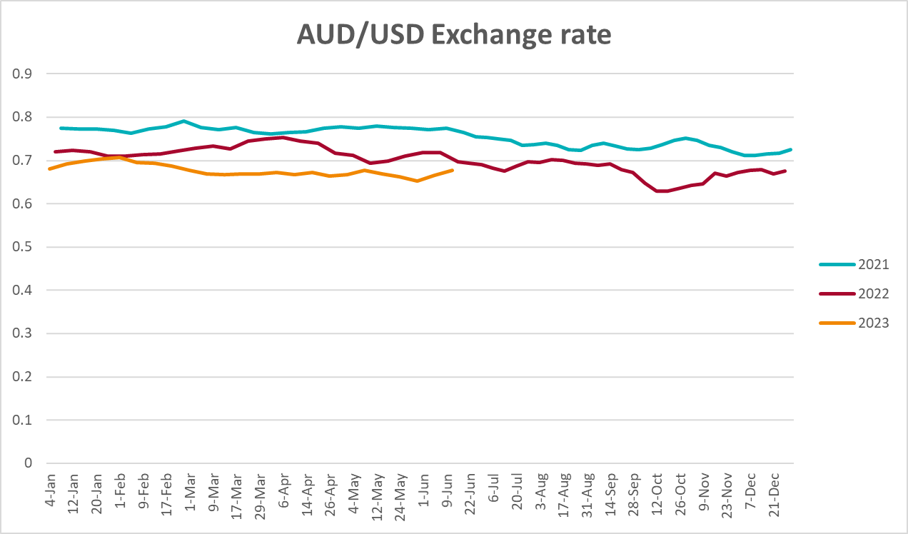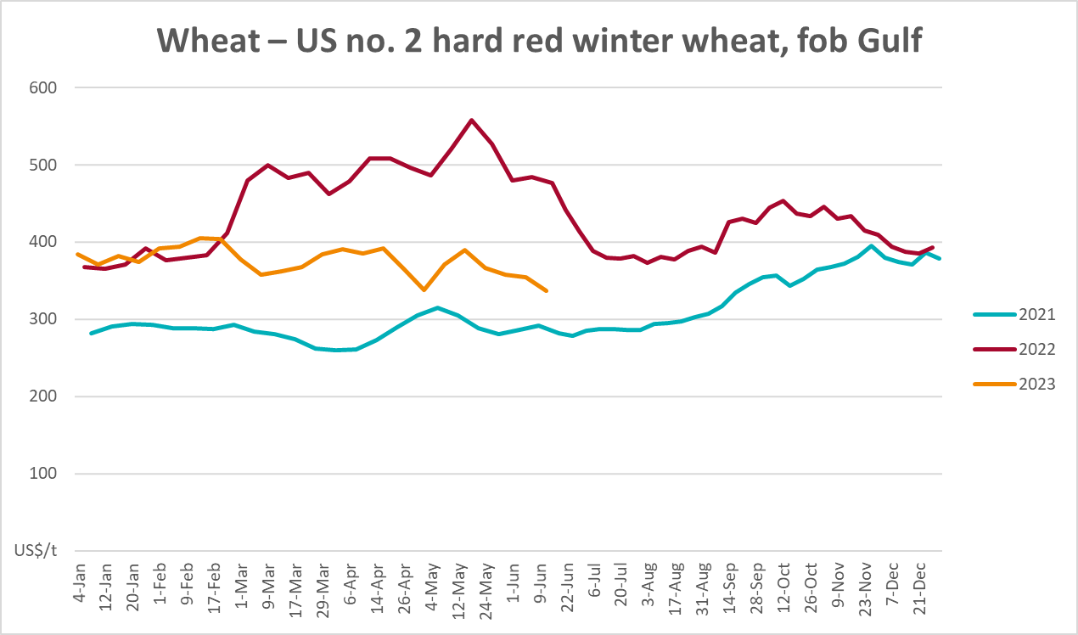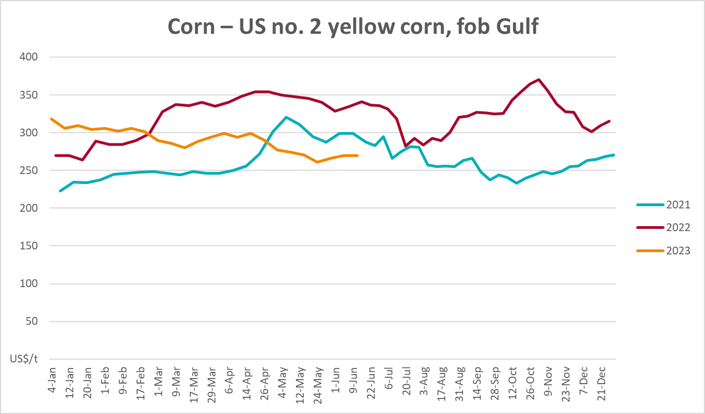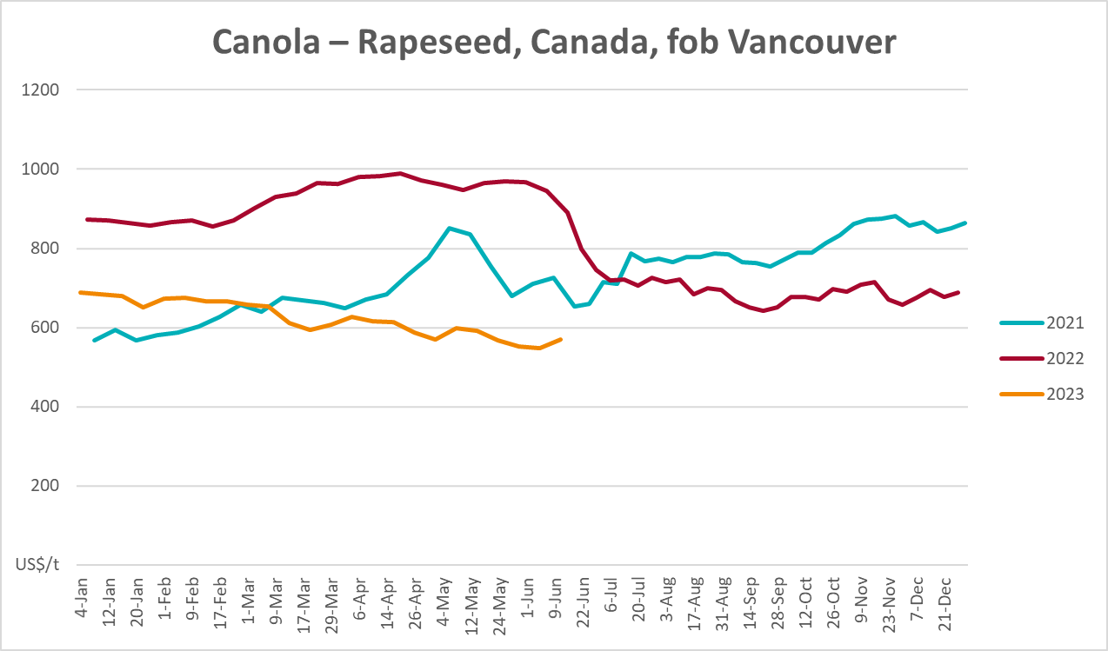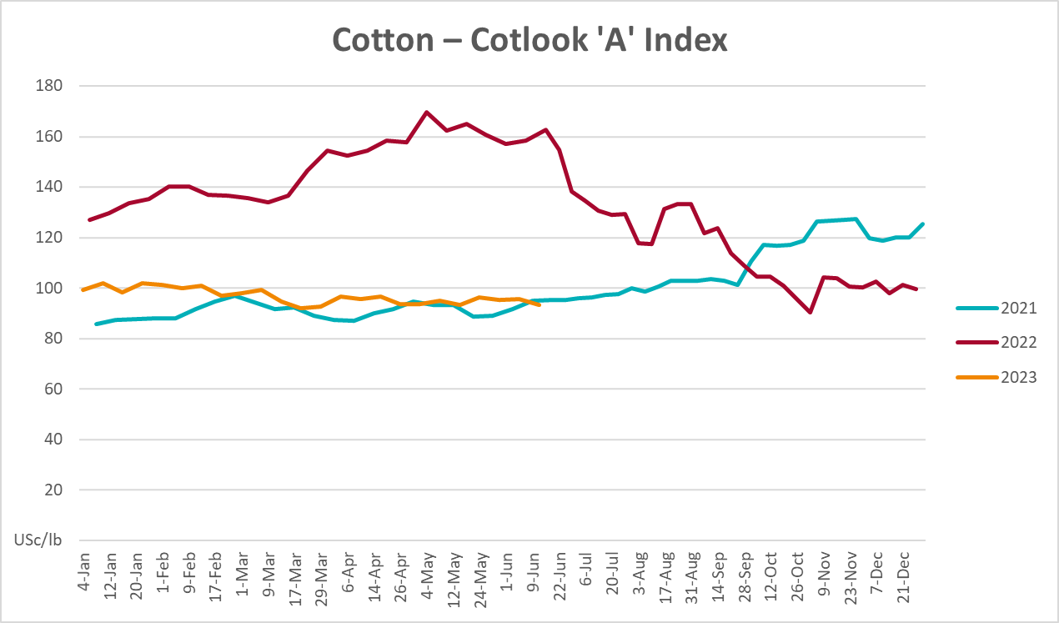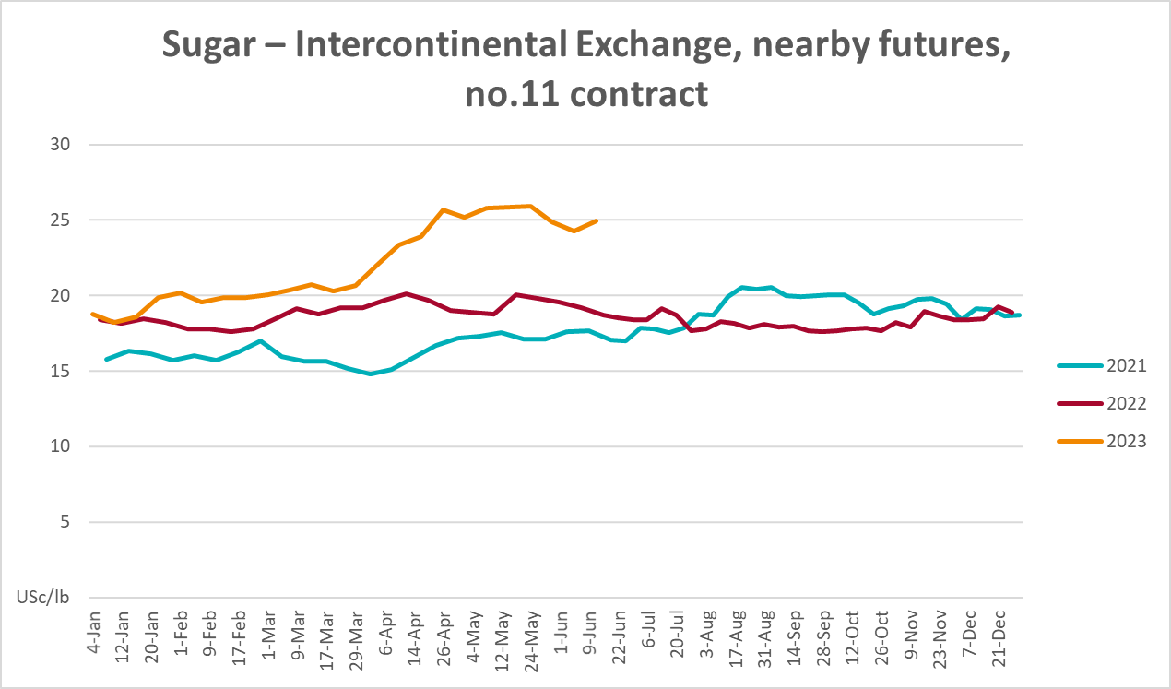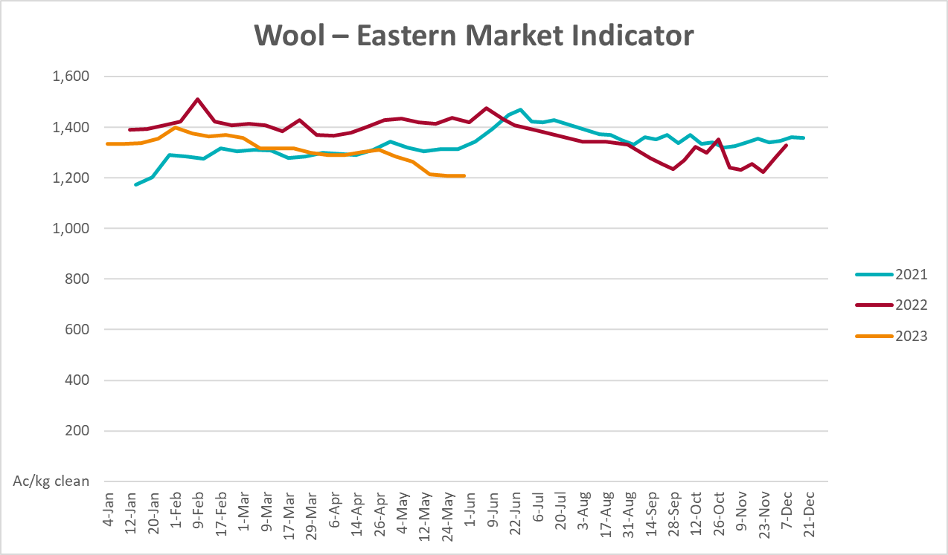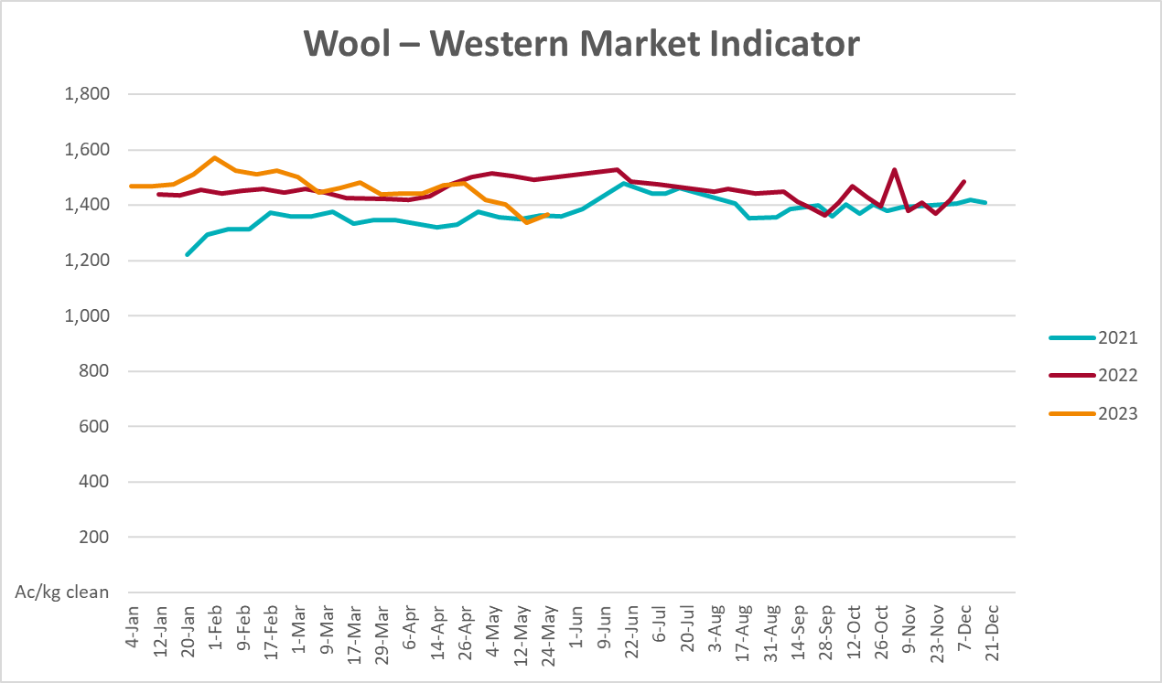

Selected domestic crop indicator prices
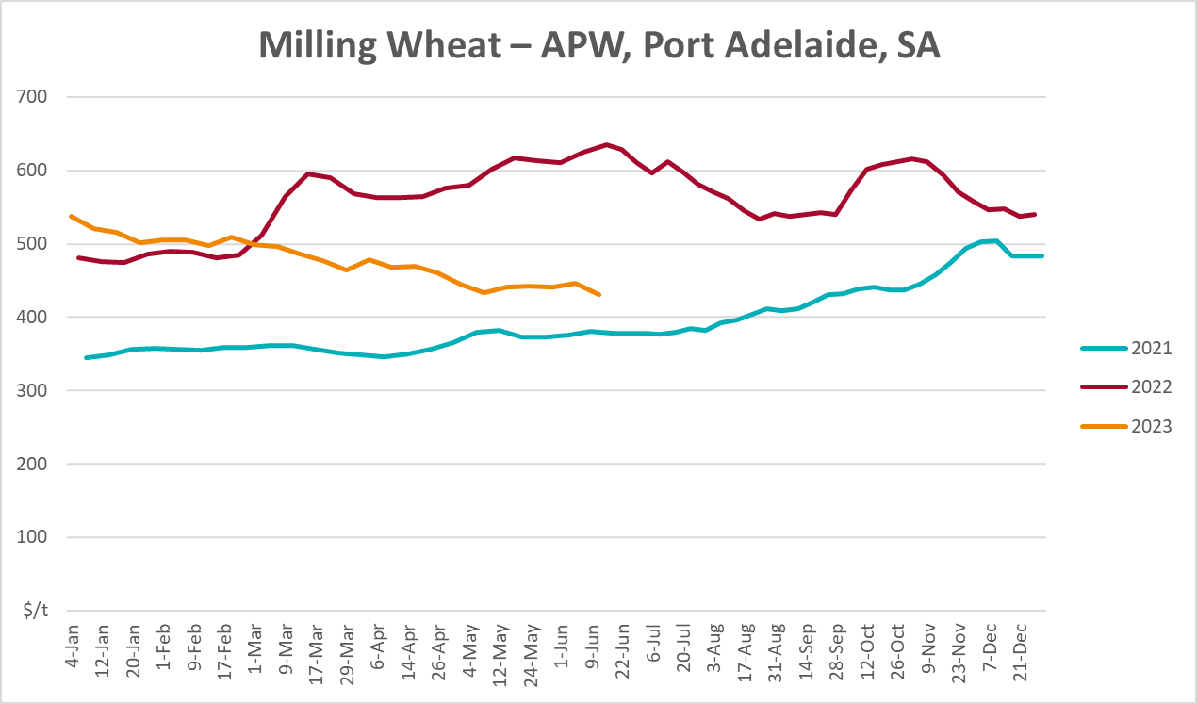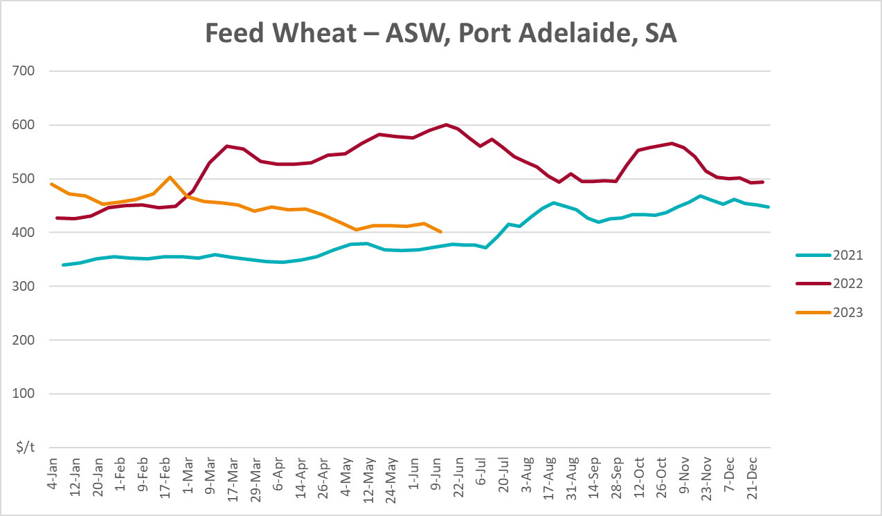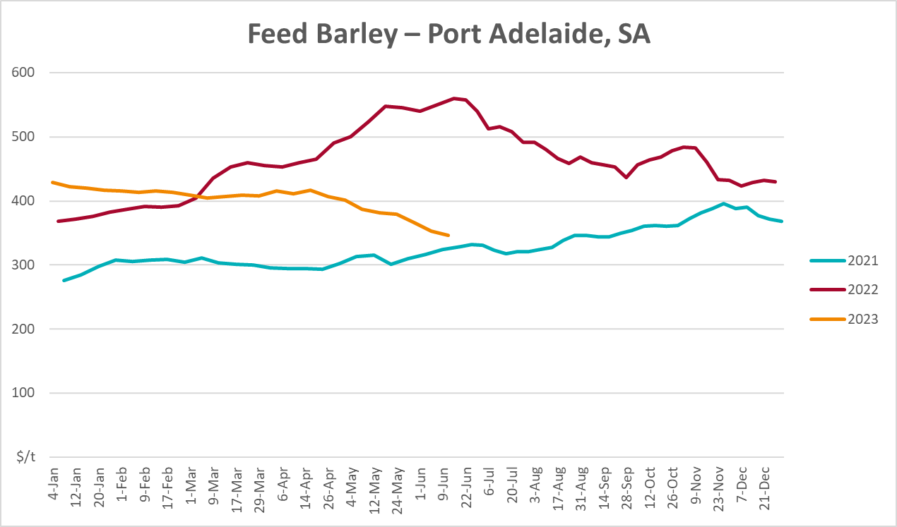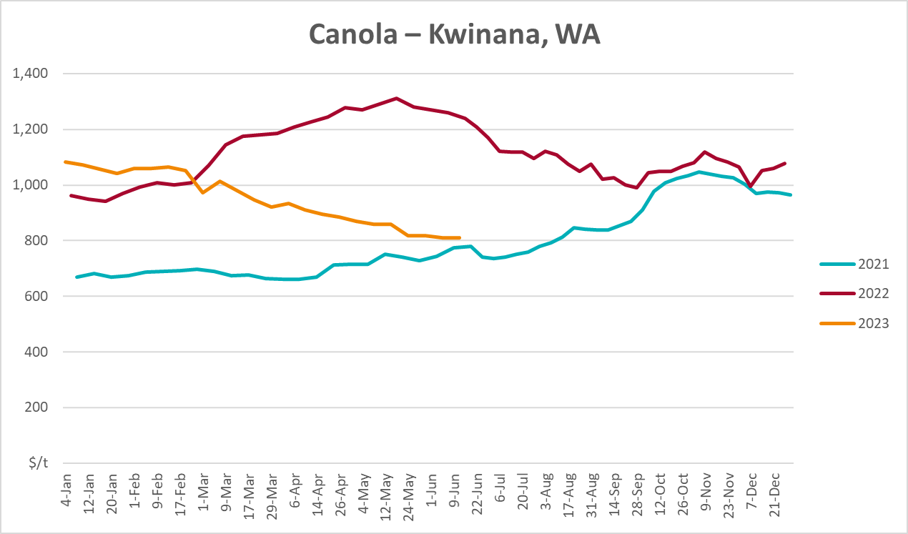
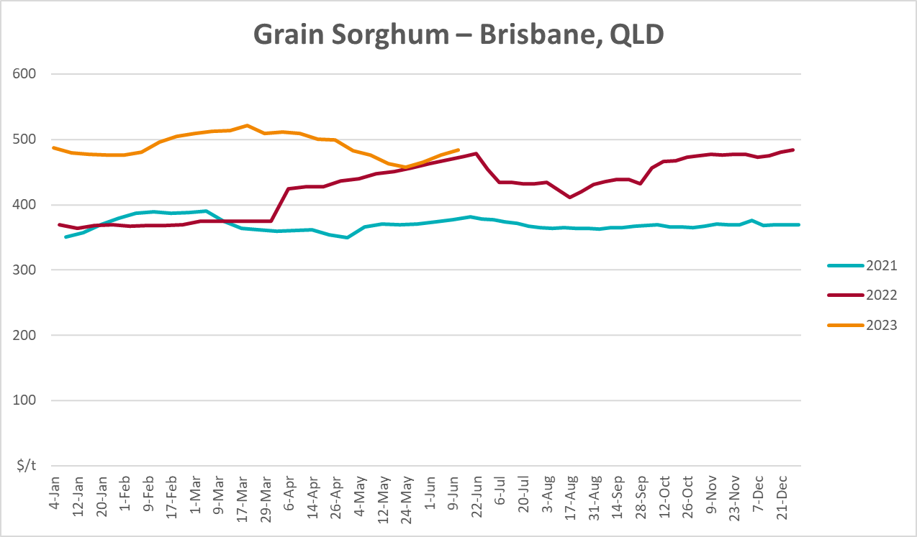

Selected domestic livestock indicator prices
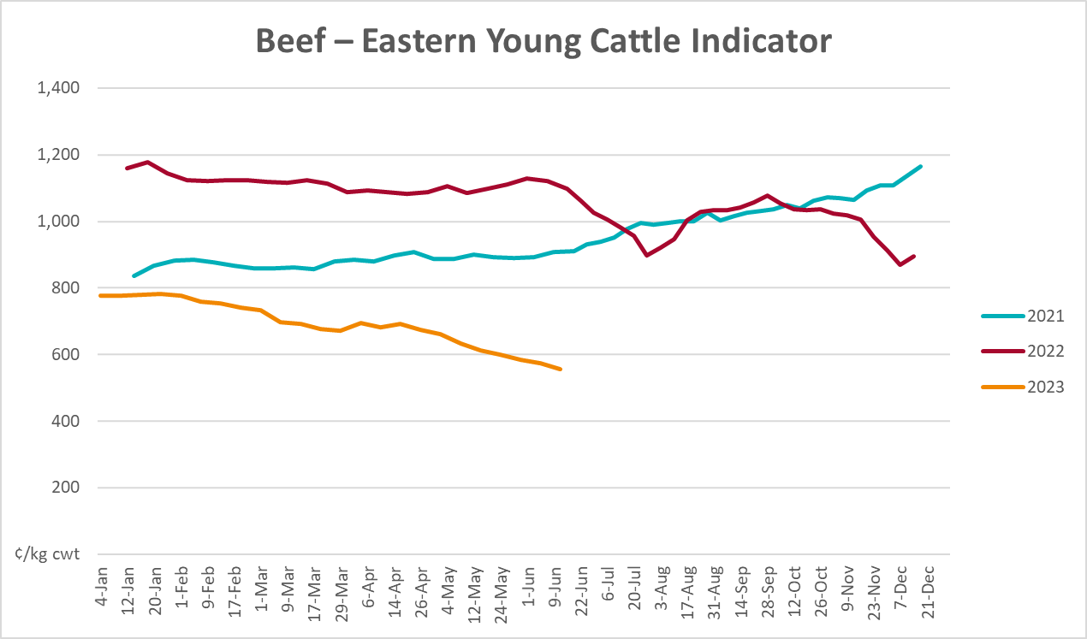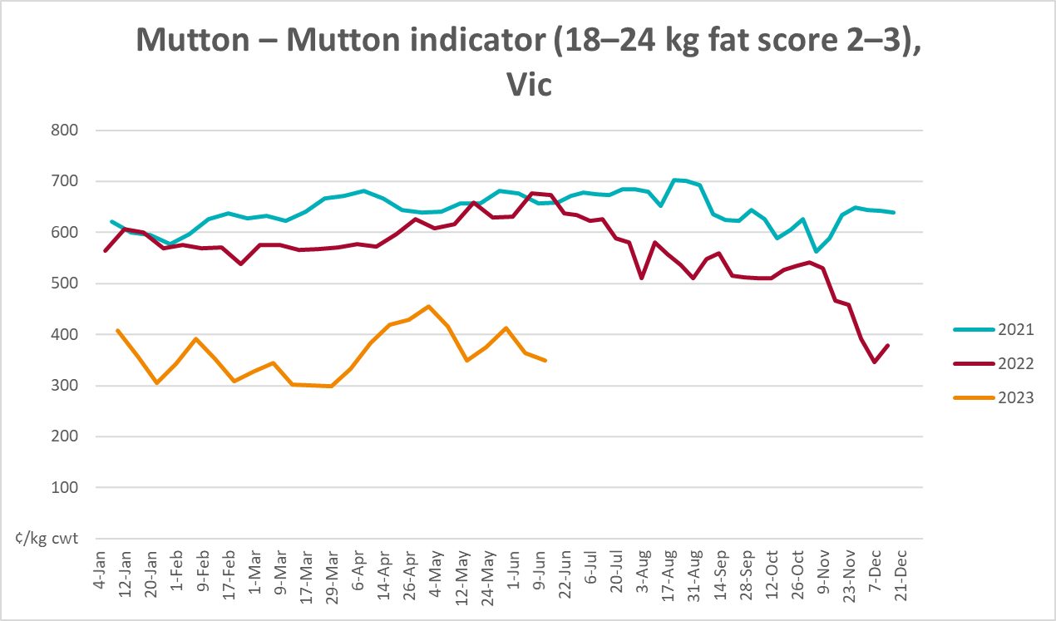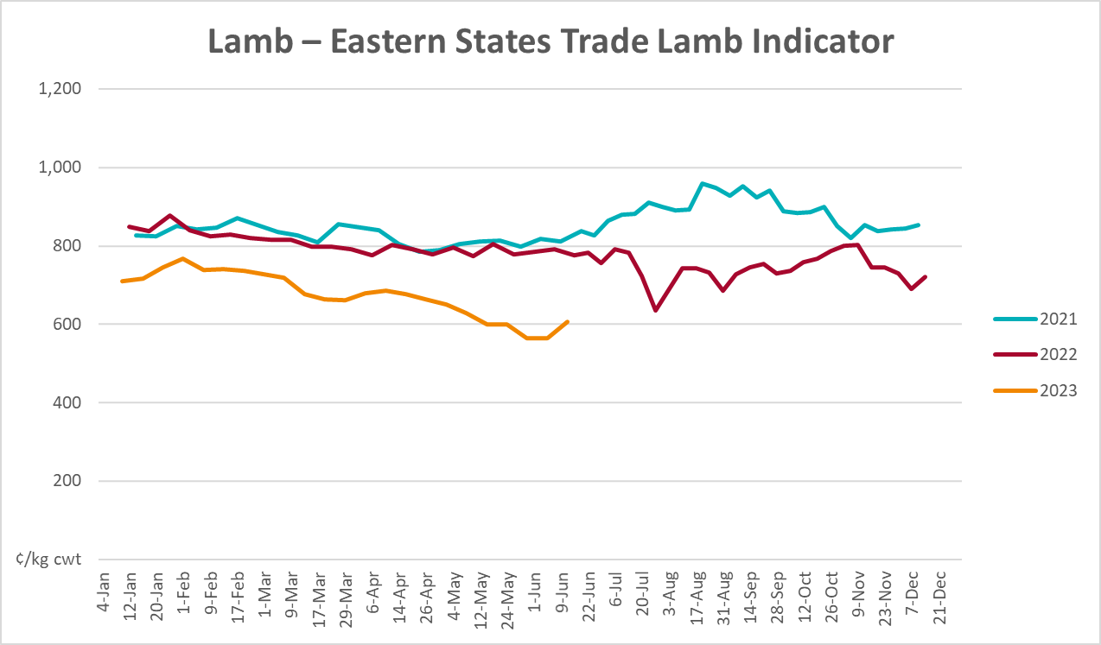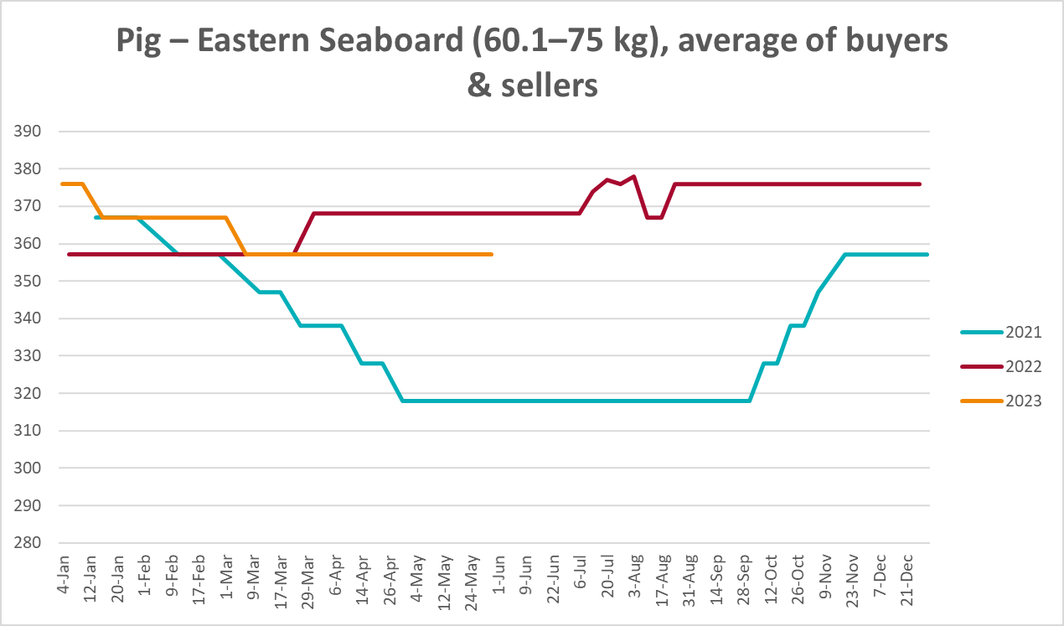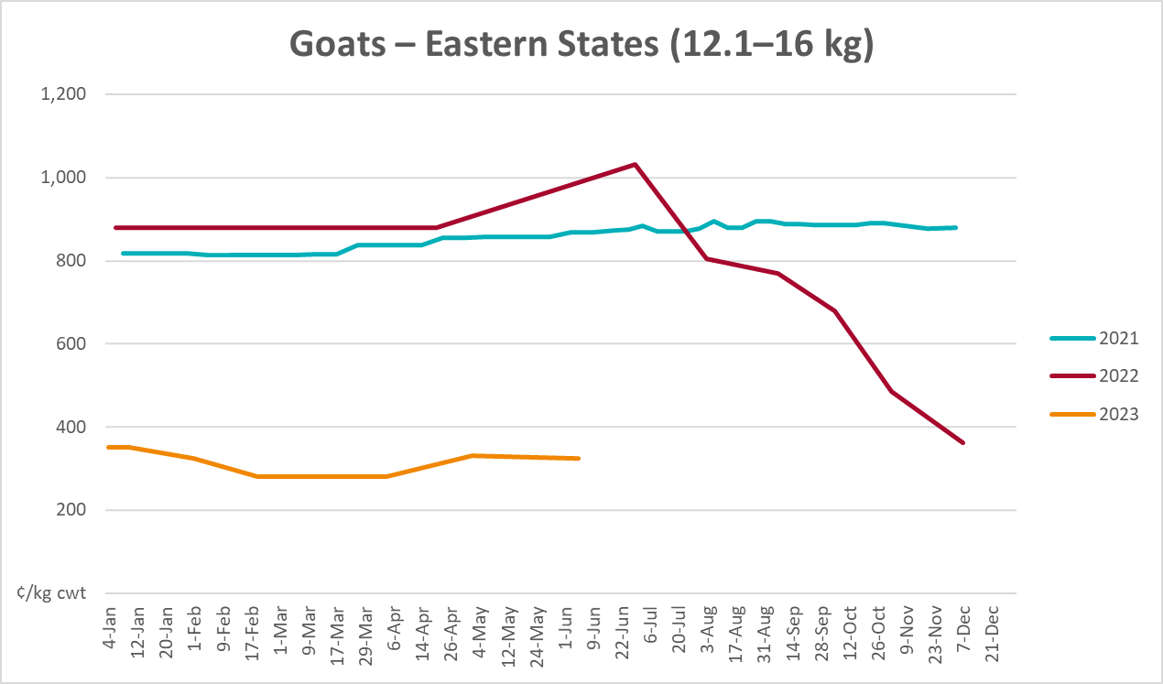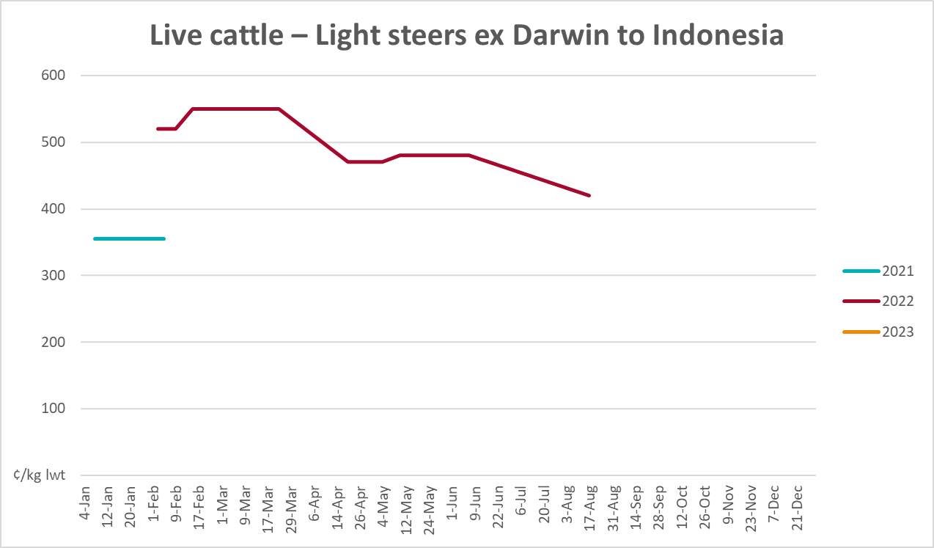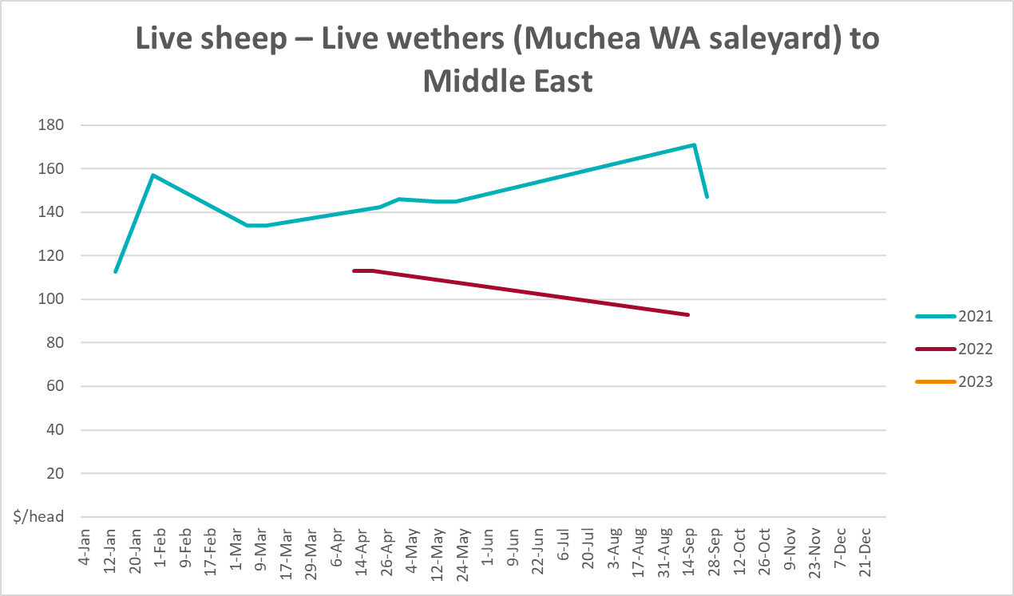

Global Dairy Trade (GDT) weighted average prices
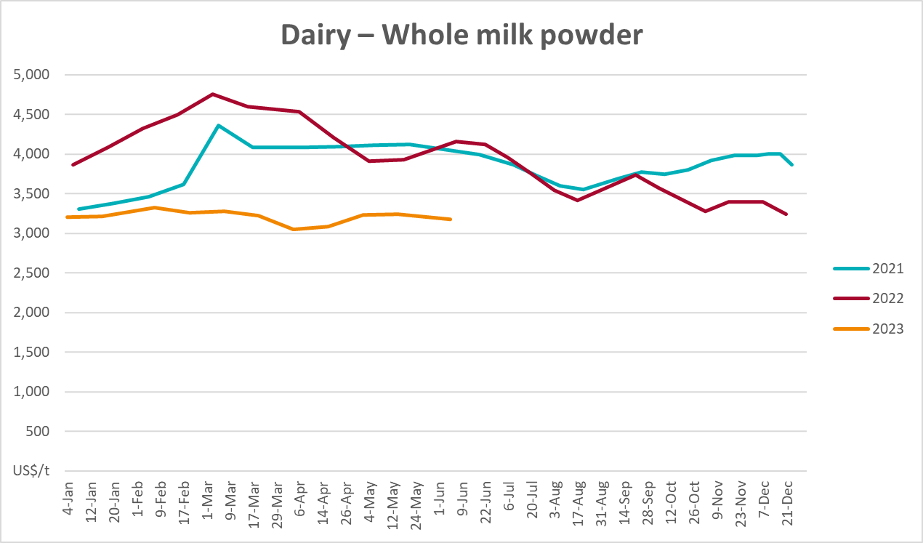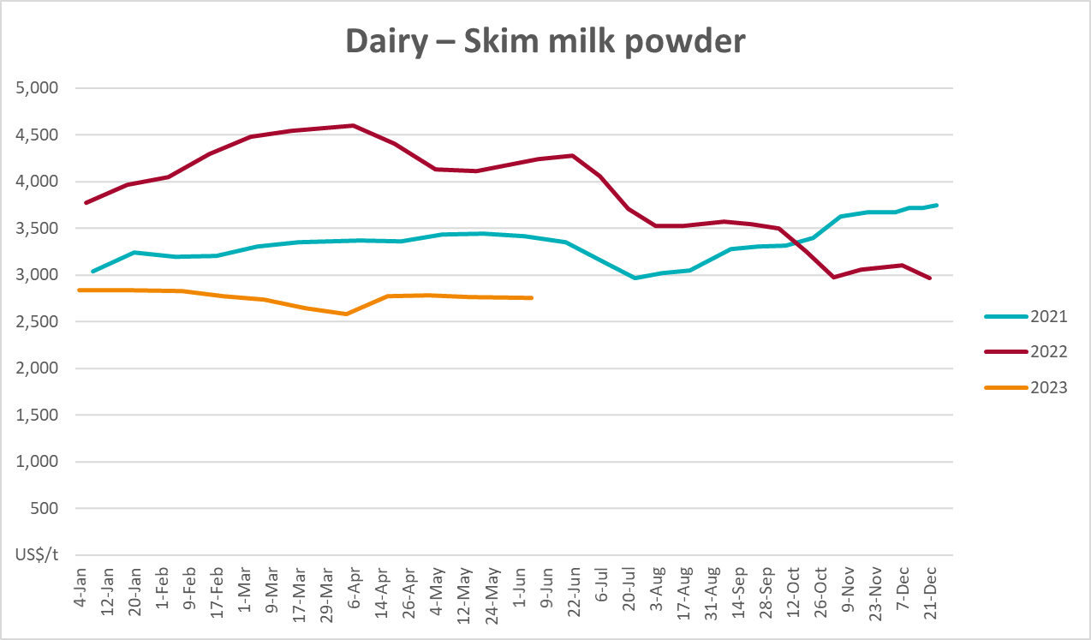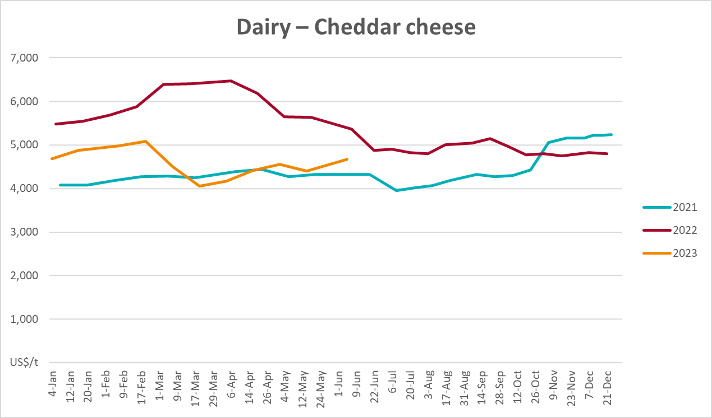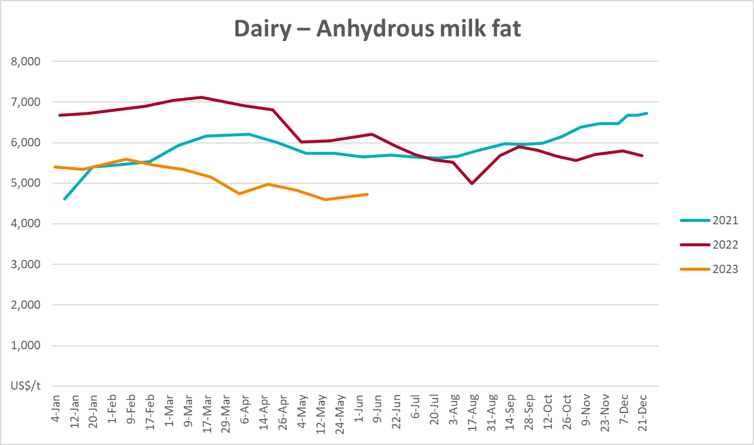

Selected fruit and vegetable prices
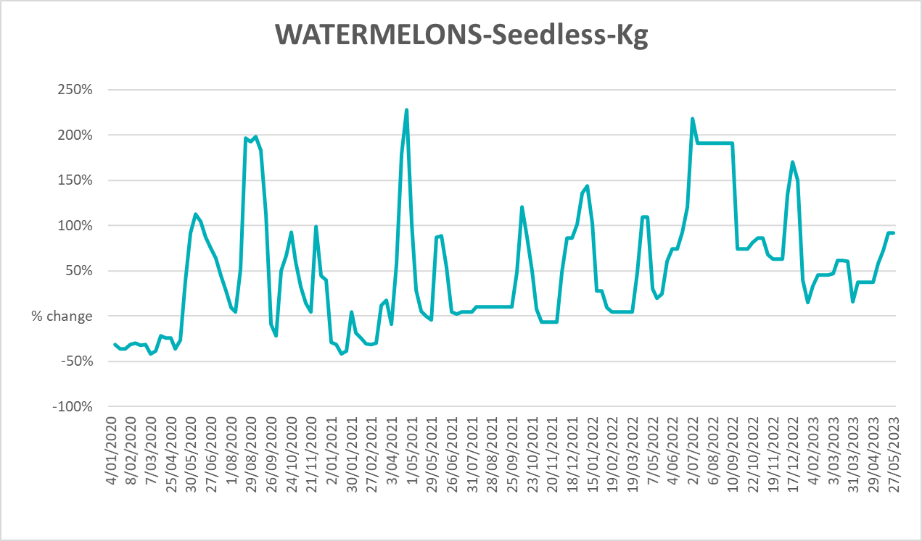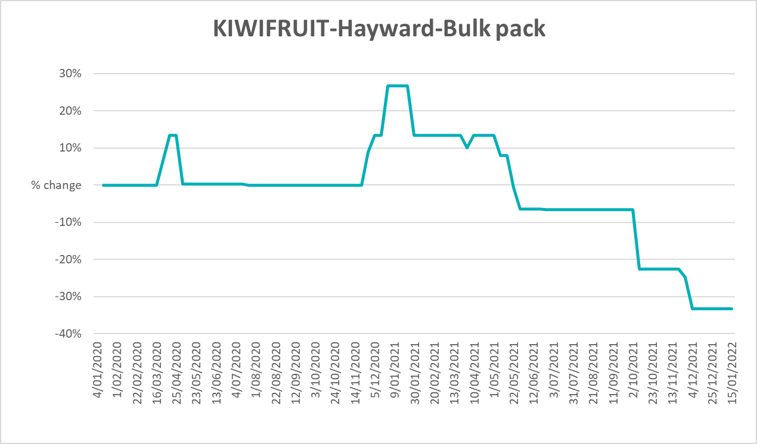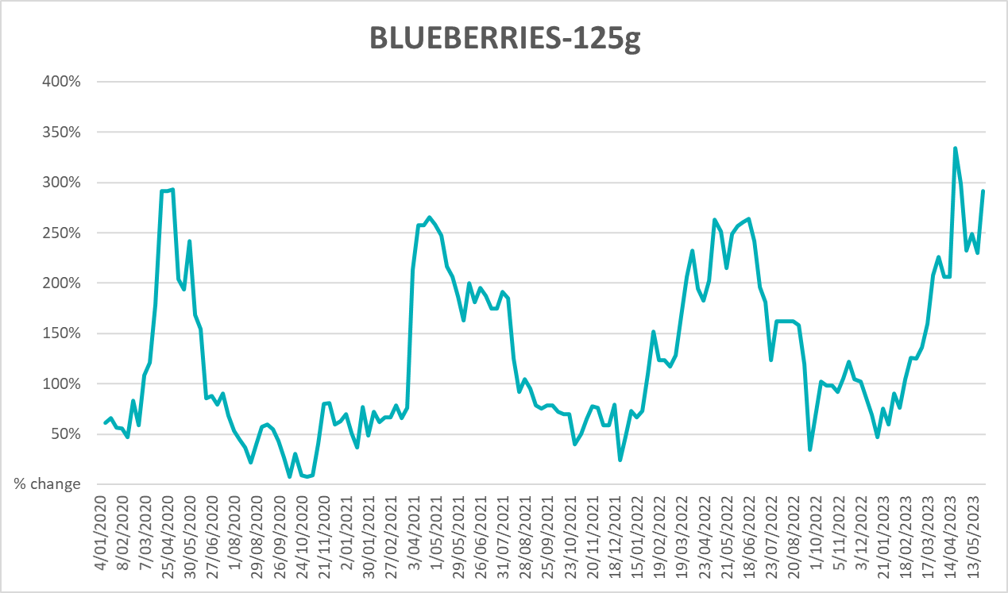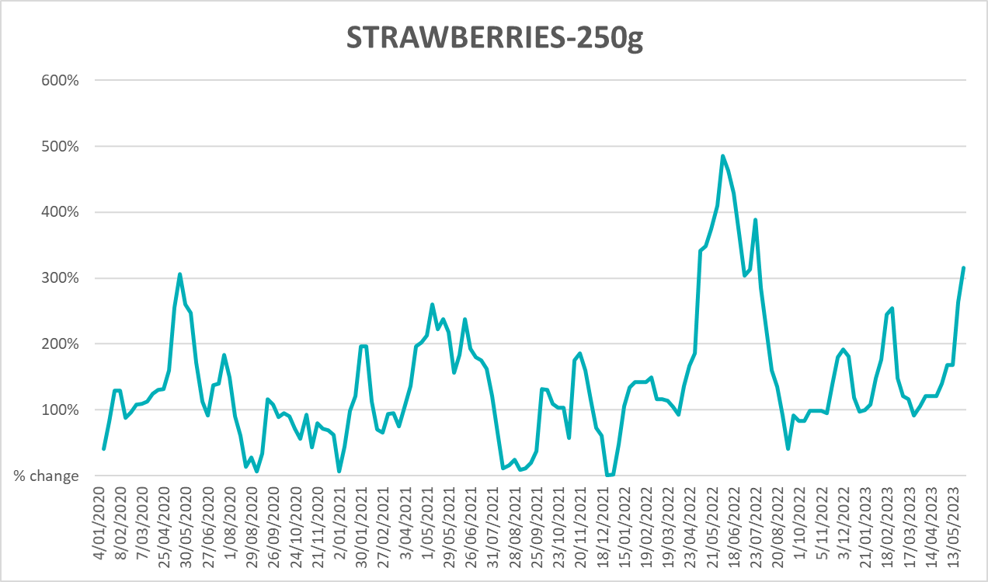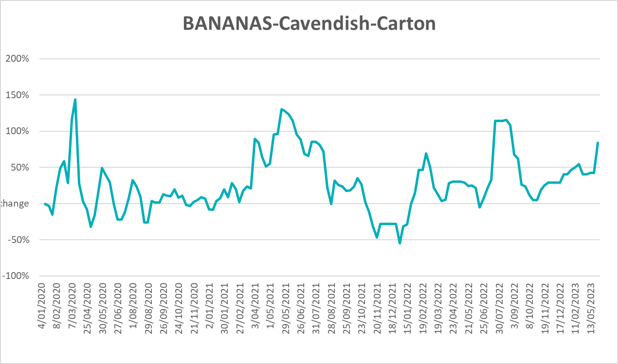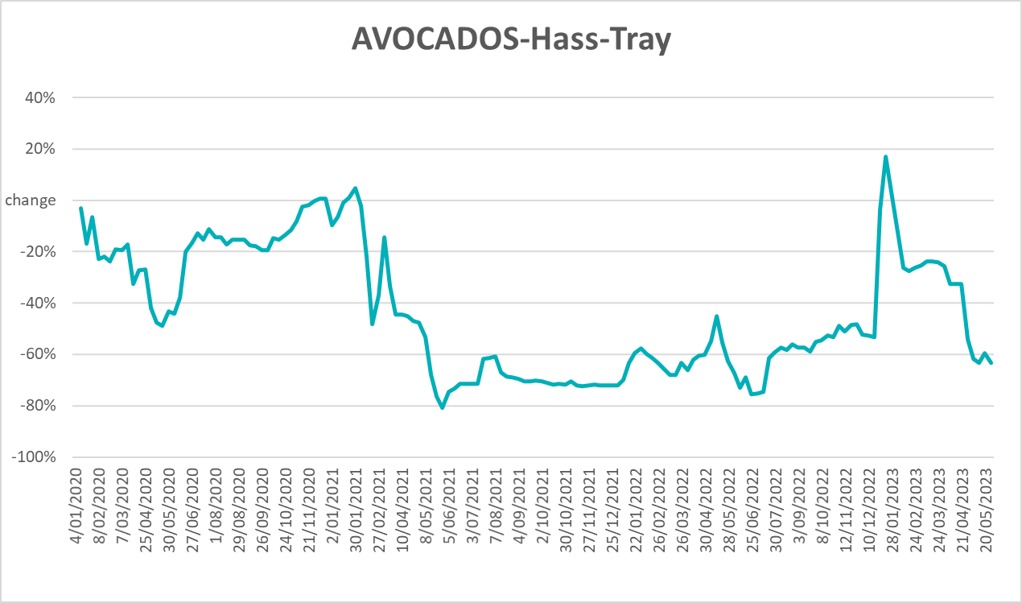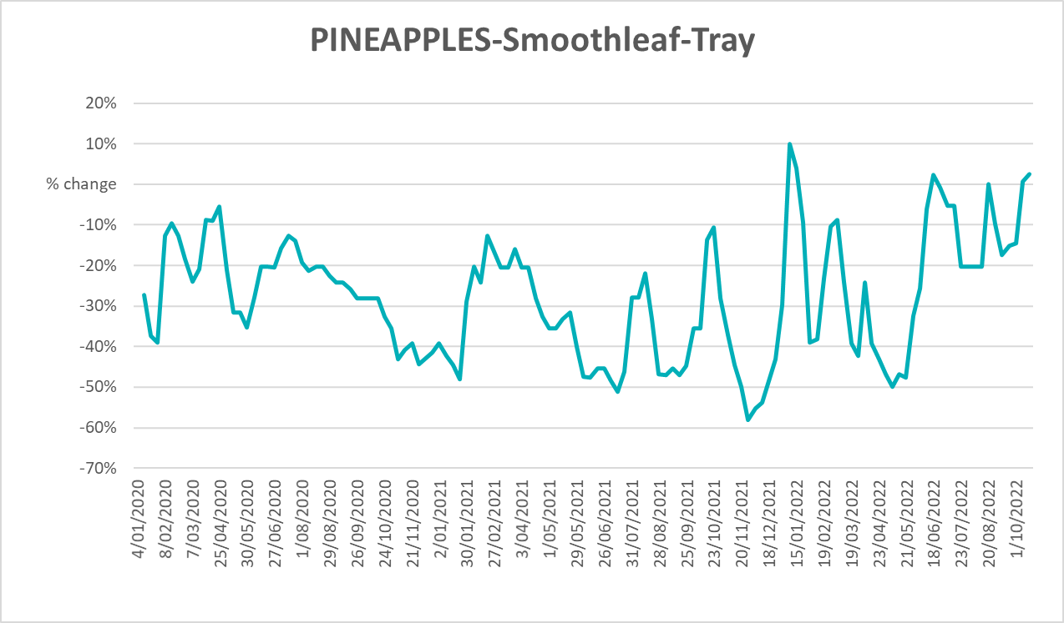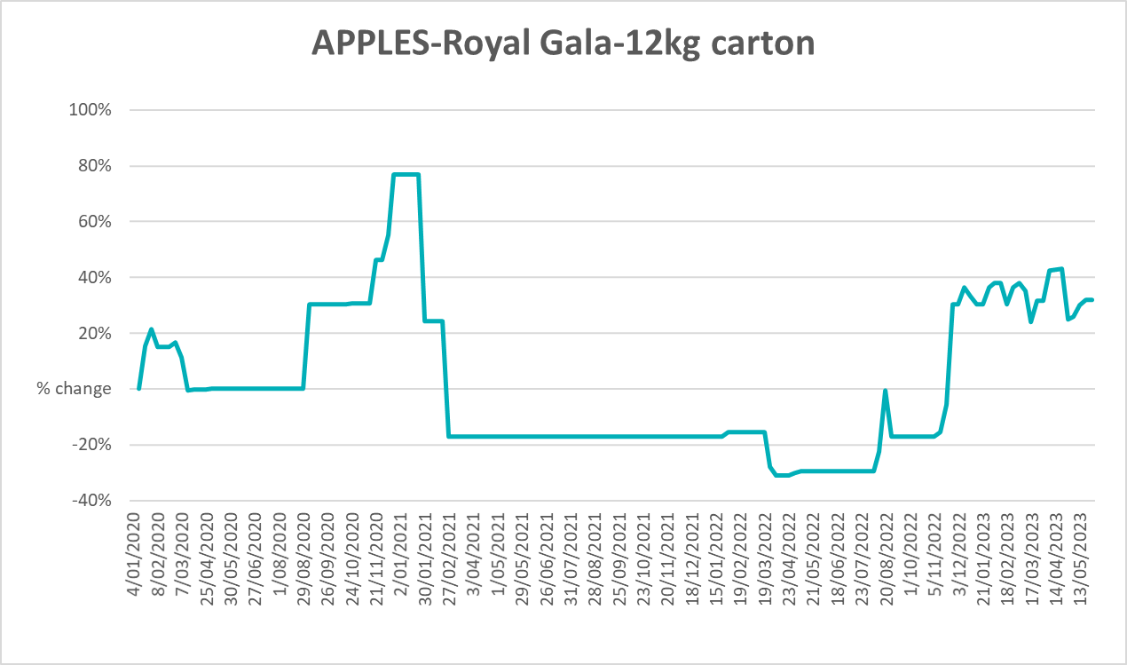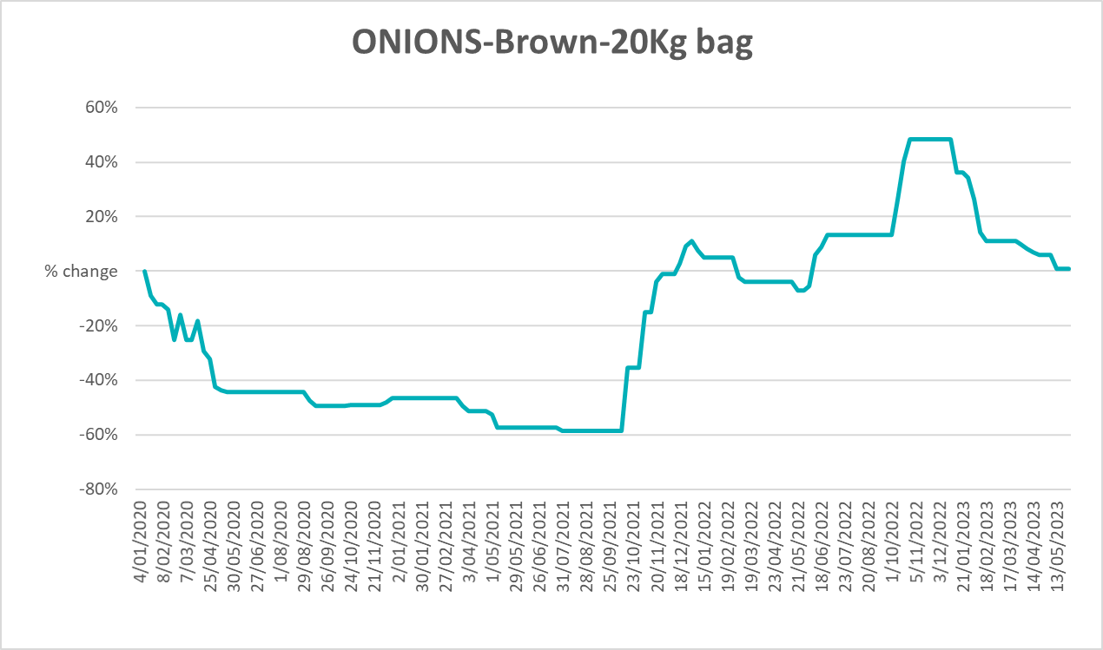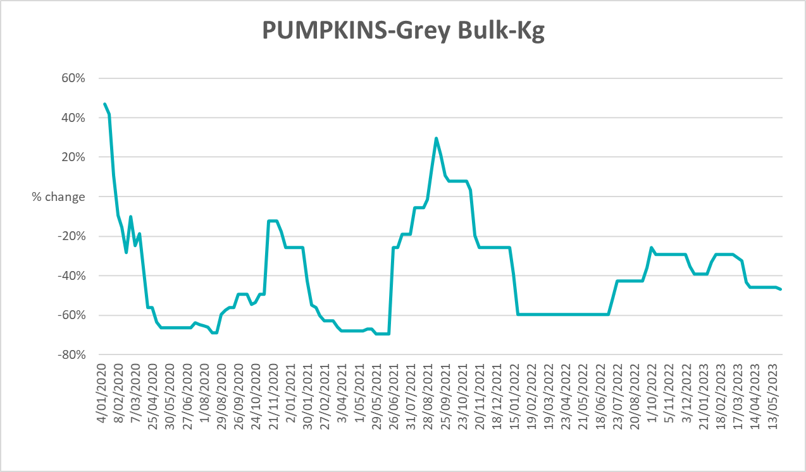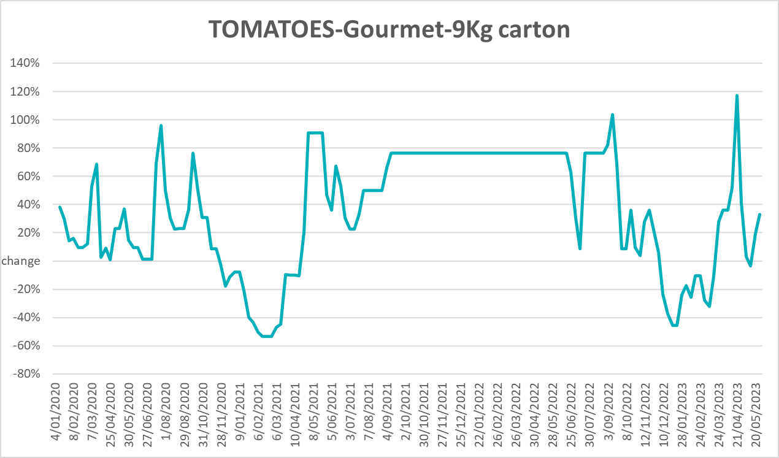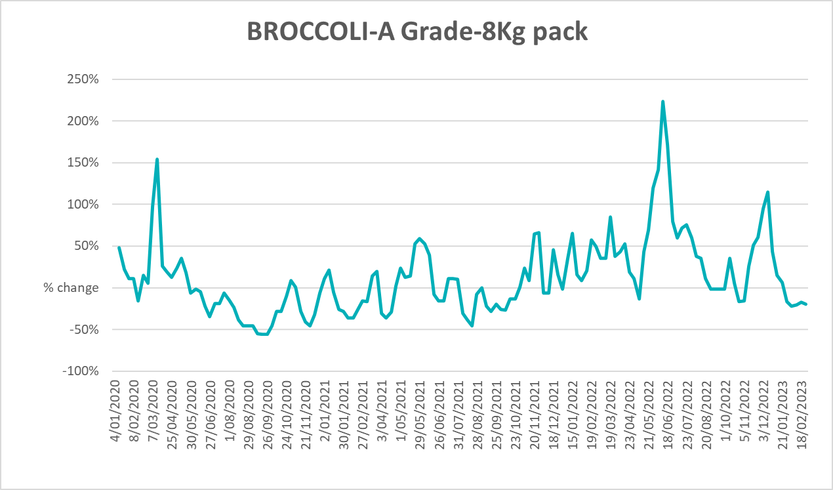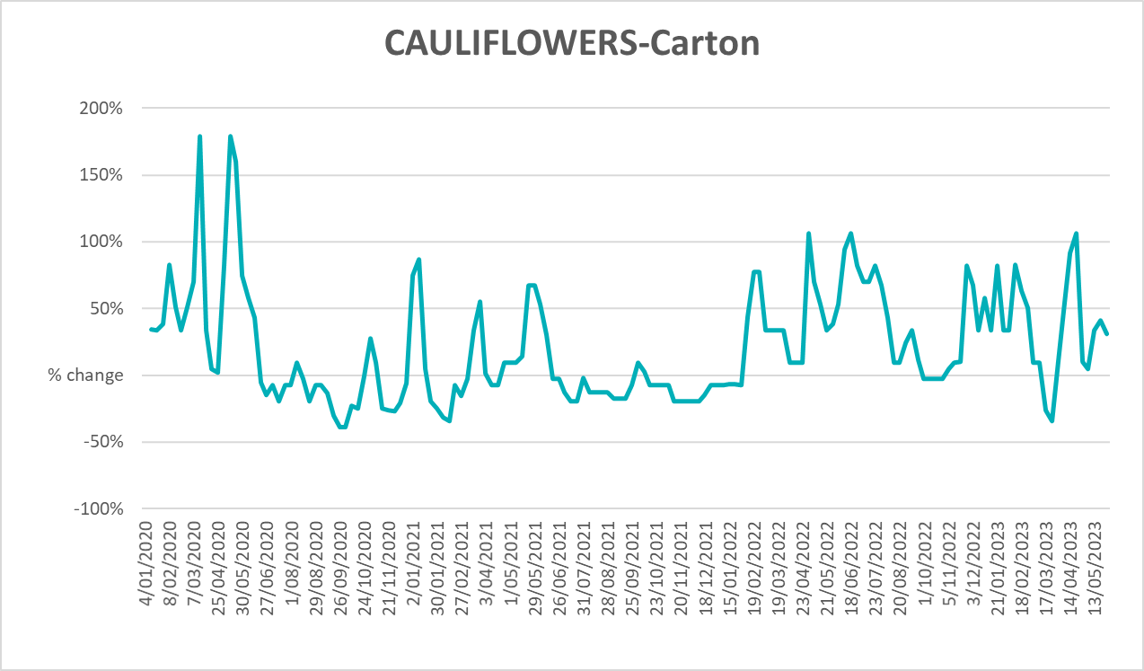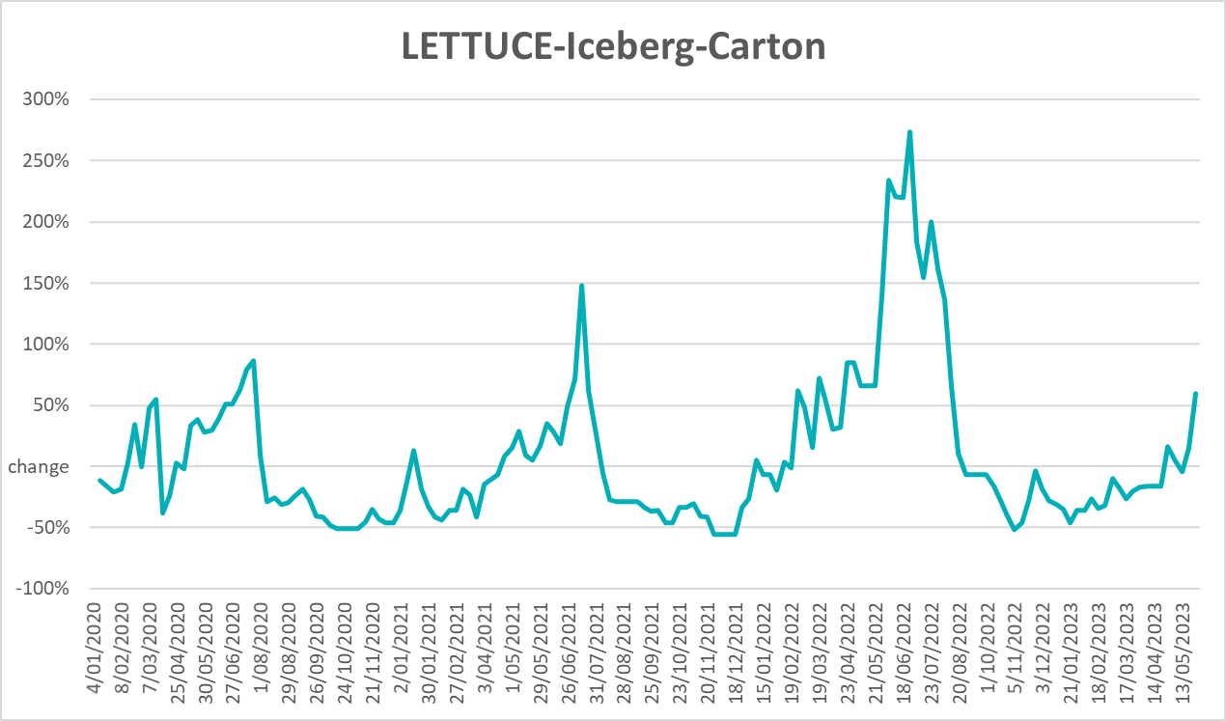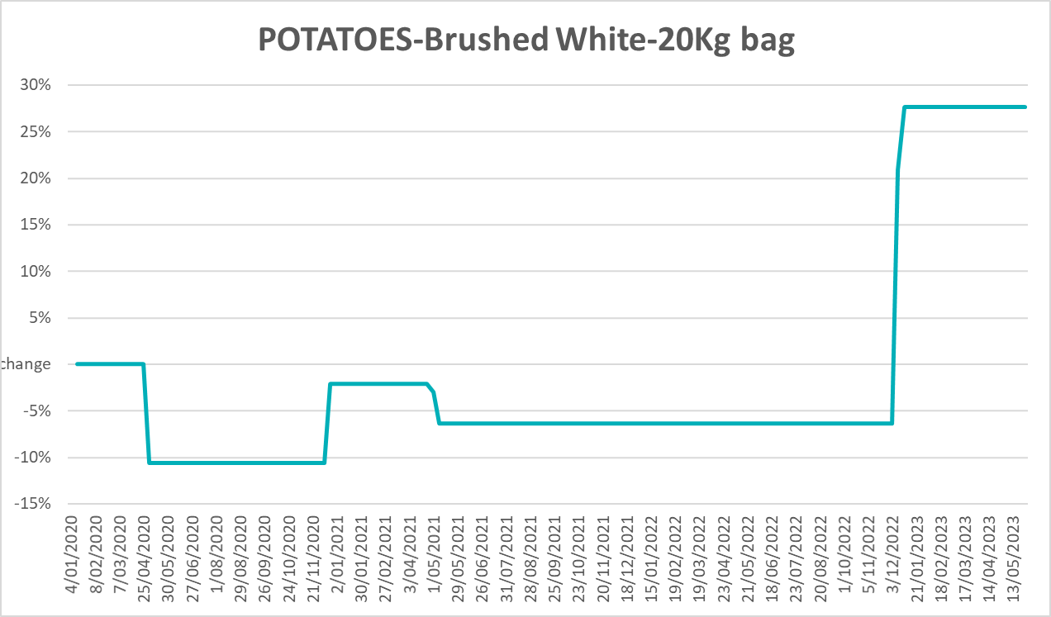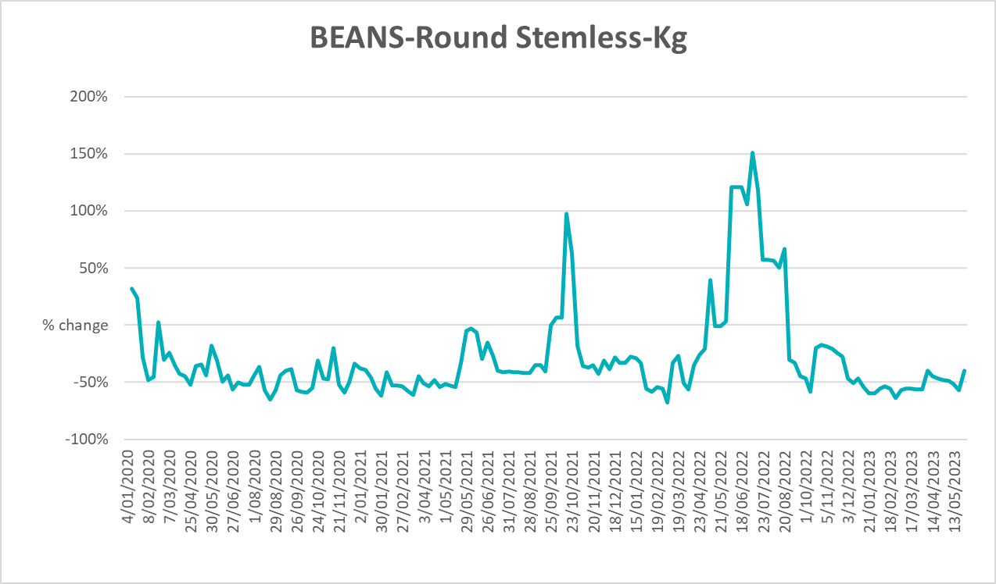

3.6 Selected domestic fodder indicator prices
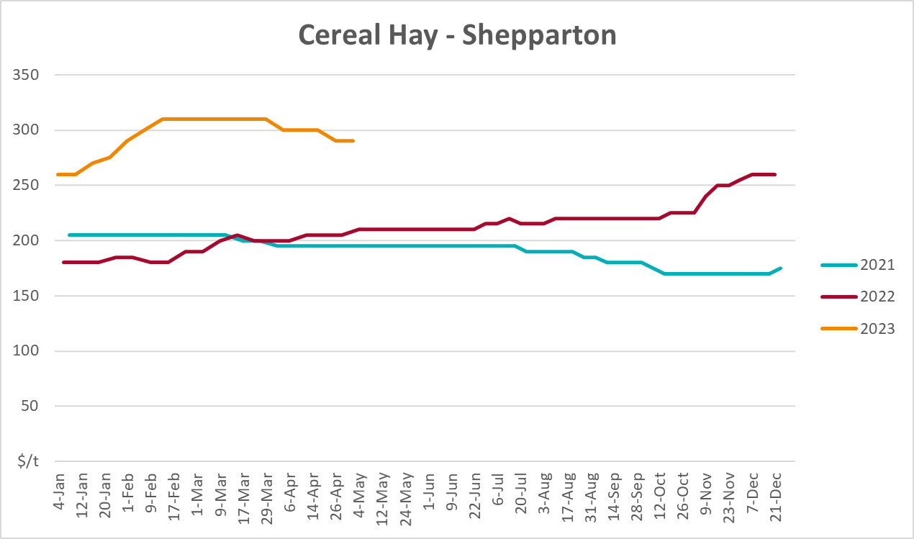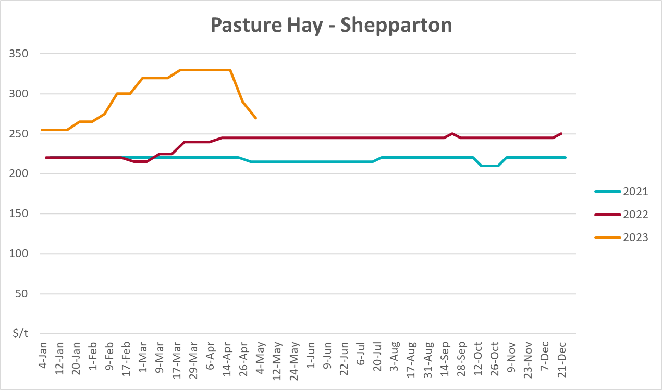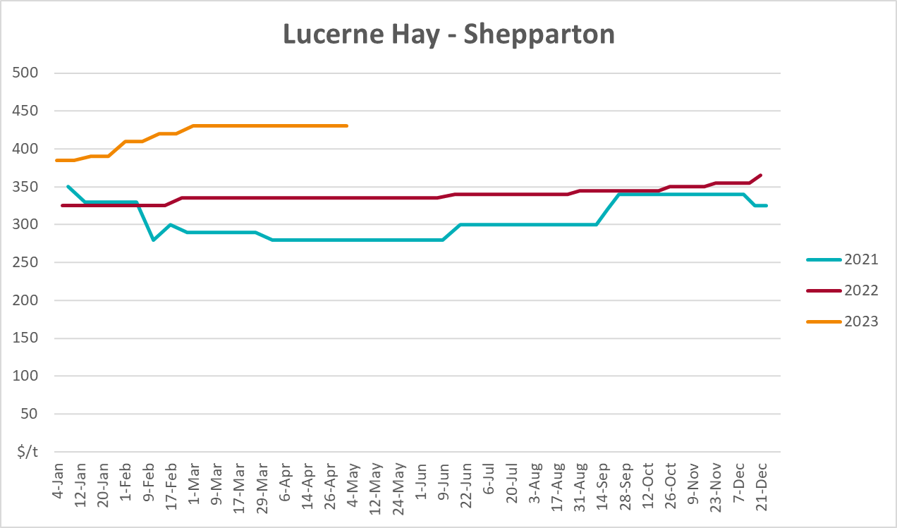

4. Data attribution

Climate
Bureau of Meteorology
- Weekly rainfall totals: www.bom.gov.au/climate/maps/rainfall/
- Monthly and last 3-month rainfall percentiles: www.bom.gov.au/water/landscape/
- Temperature anomalies: www.bom.gov.au/jsp/awap/temp/index.jsp
- Rainfall forecast: www.bom.gov.au/jsp/watl/rainfall/pme.jsp
- Seasonal outlook: www.bom.gov.au/climate/outlooks/#/overview/summary/
- Climate drivers: http://www.bom.gov.au/climate/enso/
- Soil moisture: www.bom.gov.au/water/landscape/
Other
- Pasture growth: www.longpaddock.qld.gov.au/aussiegrass/
- 3-month global outlooks: Environment and Climate Change Canada, NOAA Climate Prediction Center, EUROBRISA CPTEC/INPE, European Centre for Medium-Range Weather Forecasts, Hydrometcenter of Russia, National Climate Center Climate System Diagnosis and Prediction Room (NCC), International Research Institute for Climate and Society
- Global production: https://ipad.fas.usda.gov/ogamaps/cropmapsandcalendars.aspx
- Autumn break: Pook et al., 2009, https://rmets-onlinelibrary-wiley-com.virtual.anu.edu.au/doi/epdf/10.1002/joc.1833

Water
Prices
- Waterflow: https://www.waterflow.io/
- Ruralco: https://www.ruralcowater.com.au/
Bureau of Meteorology:
- Allocation trade: http://www.bom.gov.au/water/dashboards/#/water-markets/mdb/at
- Storage volumes: http://www.bom.gov.au/water/dashboards/#/water-storages/summary/drainage
Trade constraints:
- Water NSW: https://www.waternsw.com.au/customer-service/ordering-trading-and-pricing/trading/murrumbidgee
- Victorian Water Register: https://www.waterregister.vic.gov.au/TradingRules2019/

Commodities
Fruit and vegetables
- Datafresh: www.freshstate.com.au
Pigs
- Australian Pork Limited: www.australianpork.com.au
Dairy
- Global Dairy Trade: www.globaldairytrade.info/en/product-results/
World wheat, canola
- International Grains Council
World coarse grains
- United States Department of Agriculture
World cotton
- Cotlook: www.cotlook.com/
World sugar
- New York Stock Exchange - Intercontinental Exchange
Wool
- Australian Wool Exchange: www.awex.com.au/
Domestic wheat, barley, sorghum, canola and fodder
- Jumbuk Consulting Pty Ltd: http://www.jumbukag.com.au/
Cattle, beef, mutton, lamb, goat and live export
- Meat and Livestock Australia: www.mla.com.au/Prices-and-market
© Commonwealth of Australia 2023

Ownership of intellectual property rights
Unless otherwise noted, copyright (and any other intellectual property rights, if any) in this publication is owned by the Commonwealth of Australia (referred to as the Commonwealth).

Creative Commons licence
All material in this publication is licensed under a Creative Commons Attribution 4.0 International Licence except content supplied by third parties, logos and the Commonwealth Coat of Arms.
Inquiries about the licence and any use of this document should be emailed to copyright@awe.gov.au.


Cataloguing data
This publication (and any material sourced from it) should be attributed as:
ABARES 2023, Weekly Australian Climate, Water and Agricultural Update, Australian Bureau of Agricultural and Resource Economics and Sciences, Canberra, 15 June 2023. CC BY 4.0 DOI: https://doi.org/10.25814/5f3e04e7d2503
ISSN 2652-7561
This publication is available at https://www.agriculture.gov.au/abares/products/weekly_update
Department of Agriculture, Fisheries and Forestry
GPO Box 858 Canberra ACT 2601
Telephone 1800 900 090
Web agriculture.gov.au/abares

Disclaimer
The Australian Government acting through the Department of Agriculture, Fisheries and Forestry, represented by the Australian Bureau of Agricultural and Resource Economics and Sciences, has exercised due care and skill in preparing and compiling the information and data in this publication. Notwithstanding, the Department of Agriculture, Fisheries and Forestry, ABARES, its employees and advisers disclaim all liability, including liability for negligence and for any loss, damage, injury, expense or cost incurred by any person as a result of accessing, using or relying on any of the information or data in this publication to the maximum extent permitted by law.

Statement of Professional Independence
The views and analysis presented in ABARES publications, including this one, reflect ABARES professionally independent findings, based on scientific and economic concepts, principles, information and data. These views, analysis and findings may not reflect or be consistent with the views or positions of the Australian Government, or of organisations or groups who have commissioned ABARES reports or analysis. More information on professional independence is provided on the ABARES website.

Acknowledgements
This report was prepared by Kavina Dayal and Matthew Miller.

