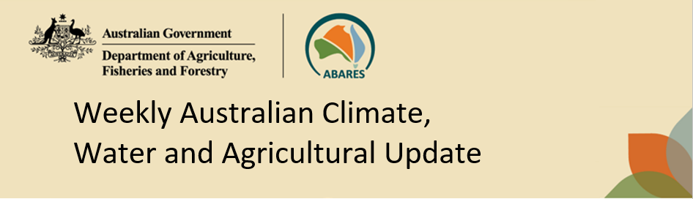
No. 22/2023 8 June 2023

Summary of key issues
- For the week ending 7 June 2023, a low-pressure trough and a series of cold fronts brought rainfall up to 100 millimetres to areas of western New South Wales, central and western Victoria, eastern South Australia, south-western Western Australia, northern and western Tasmania, parts of southern Northern Territory and scattered areas along eastern coast. High-pressure systems kept the remainder of the country dry.
- Across cropping regions, up to 25 millimetres rainfall was recorded in southern New South Wales, Victoria and eastern South Australia and up to 100 millimetres in Western Australia cropping regions. This rainfall will have brought some very welcome relief from dry conditions that were seen during May and should be sufficient to allow for the germination and establishment of dry sown crops. Little to no rainfall was recorded elsewhere (see Section 1.1).
- The Bureau of Meteorology’s ENSO outlook has shifted to El Niño ALERT, indicating that there is a 70% chance of an El Niño developing in 2023. Sea-surface temperatures in the Pacific and some atmospheric indicators have reached the El Niño thresholds. There is also a strong possibility of positive IOD event developing in June. A positive IOD can suppress winter and spring rainfall over much of Australia, potentially exacerbating the drying effect of El Niño (see Section 1.3).
- During July there is a 75% chance of rainfall totals to be below 10 millimetres in Queensland and northern New South Wales, but up to 50 millimetres in Western Australia and up to 25 millimetres in the remaining cropping regions. During July to September 2023, rainfall between 50 and 100 millimetres is expected across New South Wales, Victoria, South Australia, southeast Queensland, and up to 200 millimetres in Western Australia. In areas with low soil moisture these probable low forecast rainfall totals are unlikely to be sufficient to sustain average levels of crop production (see Section 1.4).
- Over the 8-days to 15 June 2023, an intense low, cold fronts and trough will generate showers up to 100 millimetres over parts of southern and central New South Wales, Victoria, far southwest Western Australia, parts of southern South Australia, and across Tasmania. A high-pressure system will keep the remainder of the country dry (see Section 1.5).
- Across cropping regions, rainfall totals of between 10 and 50 millimetres are expected across central and southern New South Wales, southern Victoria and parts of central and western South Australia. This rainfall should be sufficient to allow for the germination and establishment of dry sown crops, and benefit soil moisture levels and the growth of earlier sown crops (see Section 1.5).
- Water storage levels in the Murray-Darling Basin (MDB) increased between 1 June 2023 and 8 June 2023 by 89 gigalitres (GL). Current volume of water held in storage is 20 240 GL. This is 0.2 percent or 42 GL more than at the same time last year.
- Allocation prices in the Victorian Murray below the Barmah Choke decreased from $19 on 1 June 2023 to $13 on 8 June 2023.

Climate

Rainfall this week
For the week ending 7 June 2023, a low-pressure trough and a series of cold fronts brought rainfall up to 100 millimetres over western New South Wales, central and western Victoria, eastern South Australia, south-western Western Australia, northern and western Tasmania, parts of southern Northern Territory and scattered areas along eastern coast. High-pressure systems kept the remainder of the country dry.
Across cropping regions, rainfall totals up to 25 millimetres was recorded in southern New South Wales, across Victoria and eastern South Australia. Rainfall totals up to 100 millimetres were recorded in Western Australia cropping regions. Little to no rainfall was recorded in northern New South Wales, Queensland and western South Australia. This rainfall will have brought some very welcome relief from dry conditions that were seen during May. These falls should be sufficient to allow for the germination and establishment of dry sown crops.

Rainfall for the week ending 7 June 2023
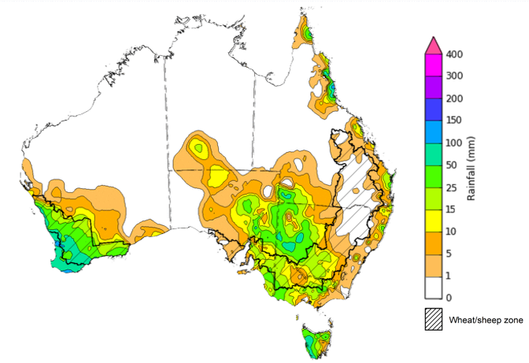
©Commonwealth of Australia 2023, Australian Bureau of Meteorology Issued: 7/06/2023
Note: The rainfall analyses and associated maps utilise data contained in the Bureau of Meteorology climate database, the Australian Data Archive for Meteorology (ADAM). The analyses are initially produced automatically from real-time data with limited quality control. They are intended to provide a general overview of rainfall across Australia as quickly as possible after the observations are received. For further information go to http://www.bom.gov.au/climate/rainfall/

Pasture Growth
Pasture growth during the March to May period affects the availability of fodder to support livestock production across northern Australia as it enters a seasonally low growth period. Across southern Australia, autumn pasture growth influences the standing biomass available to support livestock production over winter and the reliance on hay and grain during this period.
For the 3 months to May 2023, variable rainfall resulted in mixed pasture growth for this time of year across Australia. Pasture growth was average to extremely high across much of southern New South Wales, northern and eastern Victoria, southern and western Queensland, central Western Australia, central and southern Northern Territory and isolated parts of South Australia. Average to extremely high pasture production across grazing regions will likely enable farmers to continue to maintain current stock numbers and provide opportunities to build standing dry matter availability.
In contrast, extremely low to below average pasture growth rates were recorded across parts of southern and northern Western Australia, southern Victoria, large areas of northern and eastern New South Wales, parts of southern and northern Queensland, and the north of the Northern Territory, consistent with above average temperatures and/or below average rainfall. Across northern Australia, below average pasture growth over the past 3 months will likely result in graziers not being able to maintain current stocking rate leading to increased turnoff. Across southern Australia, graziers will be more reliant on the supplementary feed to maintain current stocking rate and production.

Relative pasture growth for 3-months ending May 2023 (1 March 2023 to 31 May 2023)
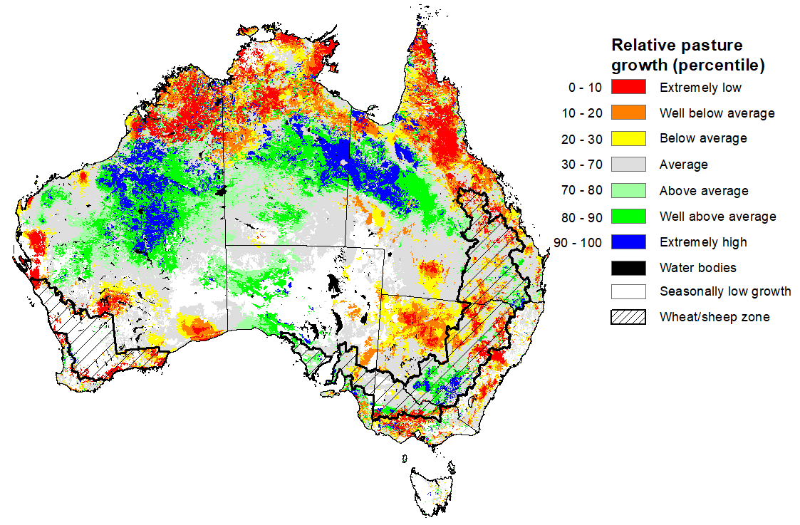
Notes: AussieGRASS pasture growth estimates are relative to the long-term record and shown in percentiles. Percentiles rank data on a scale of zero to 100. This analysis ranks pasture growth for the selected period against average pasture growth for the long-term record (1957 to 2016). Pasture growth is modelled at 5km2 grid cells.
Source: Queensland Department of Science, Information Technology, and Innovation

Climate Drivers
The climate drivers with the largest potential impact on Australia’s climate patterns are the El Niño–Southern Oscillation (ENSO), Madden-Julian Oscillation (MJO), Indian Ocean Dipole (IOD) and Southern Annular Mode (SAM). These climate drivers are likely to influence harvest progress of later planted summer crops in northern growing regions, pasture growth across both northern and southern Australia, and planting opportunities and the establishment and growth for winter crops.
The Madden–Julian Oscillation (MJO) pulse is currently over the Western Pacific and is forecast to become indiscernible in the coming days. At this time of the year MJO has little influence on northern Australia rainfall.
The Bureau of Meteorology’s ENSO outlook has shifted to El Niño ALERT, indicating that there is a 70% chance of an El Niño developing in 2023. Oceanic indicators are measured in terms of the sea surface temperature (SST) anomalies, which have warmed to El Niño thresholds. For the week ending 4 June, the SST were warmer than average over the eastern equatorial Pacific Ocean, with anomalies over 4°C in the far east. Compared to two weeks ago, the warm anomalies have remained similar in strength but extended spatially reaching further westwards. All models surveyed by the Bureau of Meteorology indicate the likelihood of further warming and the warm SSTs will remain above El Niño thresholds at least into the southern hemisphere spring.
Atmospheric indicators are measured in terms of the surface air pressure difference between Tahiti and Darwin, called Southern Oscillation Index (SOI), the direction and strength of the trade winds and cloudiness at the date line. Some atmospheric indicators such as the SOI have shifted towards El Niño thresholds. For the period ending 4 June 2023, the 30-day SOI was -20.5, the 60-day SOI was -10.6, and the 90-day SOI was -7.1. The gradual decrease in both the 30-day and 90-day SOI have entered the El-Niño threshold. However, winds, clouds and broadscale pressure patterns indicate that the ocean and atmosphere are yet to reinforce each other, as occurs during El Niño events.

Difference from average sea surface temperature observations 29 May to 4 June 2023
INCLUDEPICTURE "http://www.bom.gov.au/climate/enso/wrap-up/archive/20230606.ssta_global_weekly.png" \* MERGEFORMATINET INCLUDEPICTURE "http://www.bom.gov.au/climate/enso/wrap-up/archive/20230606.ssta_global_weekly.png" \* MERGEFORMATINET INCLUDEPICTURE "http://www.bom.gov.au/climate/enso/wrap-up/archive/20230606.ssta_global_weekly.png" \* MERGEFORMATINET INCLUDEPICTURE "http://www.bom.gov.au/climate/enso/wrap-up/archive/20230606.ssta_global_weekly.png" \* MERGEFORMATINET INCLUDEPICTURE "http://www.bom.gov.au/climate/enso/wrap-up/archive/20230606.ssta_global_weekly.png" \* MERGEFORMATINET INCLUDEPICTURE "http://www.bom.gov.au/climate/enso/wrap-up/archive/20230606.ssta_global_weekly.png" \* MERGEFORMATINET INCLUDEPICTURE "http://www.bom.gov.au/climate/enso/wrap-up/archive/20230606.ssta_global_weekly.png" \* MERGEFORMATINET INCLUDEPICTURE "http://www.bom.gov.au/climate/enso/wrap-up/archive/20230606.ssta_global_weekly.png" \* MERGEFORMATINET INCLUDEPICTURE "http://www.bom.gov.au/climate/enso/wrap-up/archive/20230606.ssta_global_weekly.png" \* MERGEFORMATINET 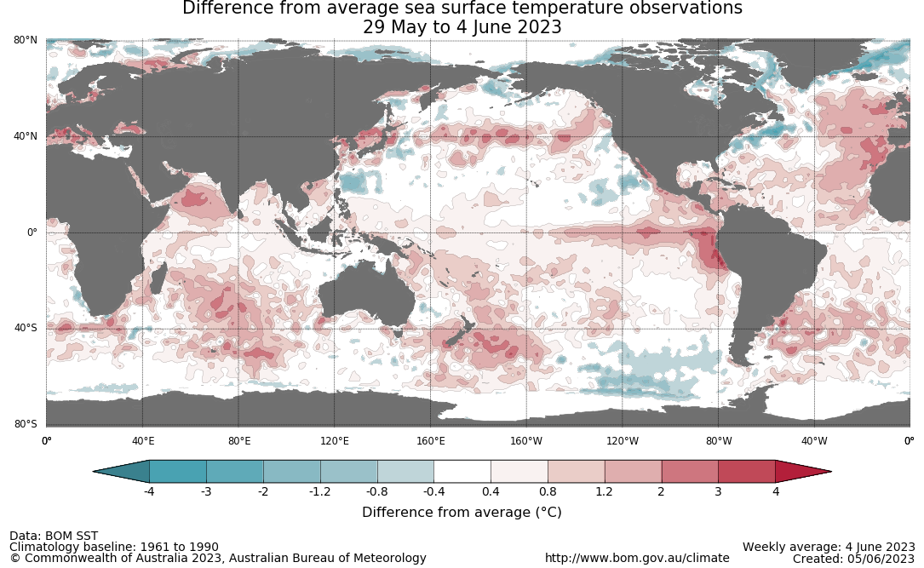

30-day Southern Oscillation Index (SOI) values ending 4 June 2023
INCLUDEPICTURE "http://www.bom.gov.au/clim_data/IDCKGSM000/soi30.png?1686093716" \* MERGEFORMATINET INCLUDEPICTURE "http://www.bom.gov.au/clim_data/IDCKGSM000/soi30.png?1686093716" \* MERGEFORMATINET INCLUDEPICTURE "http://www.bom.gov.au/clim_data/IDCKGSM000/soi30.png?1686093716" \* MERGEFORMATINET INCLUDEPICTURE "http://www.bom.gov.au/clim_data/IDCKGSM000/soi30.png?1686093716" \* MERGEFORMATINET INCLUDEPICTURE "http://www.bom.gov.au/clim_data/IDCKGSM000/soi30.png?1686093716" \* MERGEFORMATINET INCLUDEPICTURE "http://www.bom.gov.au/clim_data/IDCKGSM000/soi30.png?1686093716" \* MERGEFORMATINET INCLUDEPICTURE "http://www.bom.gov.au/clim_data/IDCKGSM000/soi30.png?1686093716" \* MERGEFORMATINET INCLUDEPICTURE "http://www.bom.gov.au/clim_data/IDCKGSM000/soi30.png?1686093716" \* MERGEFORMATINET INCLUDEPICTURE "http://www.bom.gov.au/clim_data/IDCKGSM000/soi30.png?1686093716" \* MERGEFORMATINET 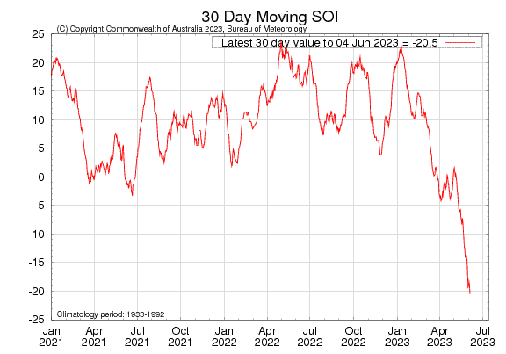

All but one international climate model surveyed by the Australian Bureau of Meteorology suggest sea-surface temperatures in the tropical Pacific will exceed El Niño thresholds in June.

International climate model outlooks for the ENSO in NINO 3.4 region
INCLUDEPICTURE "http://www.bom.gov.au/climate/model-summary/archive/20230606.nino_summary_2.png" \* MERGEFORMATINET INCLUDEPICTURE "http://www.bom.gov.au/climate/model-summary/archive/20230606.nino_summary_2.png" \* MERGEFORMATINET INCLUDEPICTURE "http://www.bom.gov.au/climate/model-summary/archive/20230606.nino_summary_2.png" \* MERGEFORMATINET INCLUDEPICTURE "http://www.bom.gov.au/climate/model-summary/archive/20230606.nino_summary_2.png" \* MERGEFORMATINET INCLUDEPICTURE "http://www.bom.gov.au/climate/model-summary/archive/20230606.nino_summary_2.png" \* MERGEFORMATINET INCLUDEPICTURE "http://www.bom.gov.au/climate/model-summary/archive/20230606.nino_summary_2.png" \* MERGEFORMATINET INCLUDEPICTURE "http://www.bom.gov.au/climate/model-summary/archive/20230606.nino_summary_2.png" \* MERGEFORMATINET INCLUDEPICTURE "http://www.bom.gov.au/climate/model-summary/archive/20230606.nino_summary_2.png" \* MERGEFORMATINET INCLUDEPICTURE "http://www.bom.gov.au/climate/model-summary/archive/20230606.nino_summary_2.png" \* MERGEFORMATINET 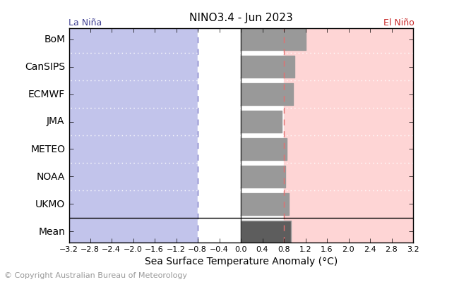
©Commonwealth of Australia 2023, Australian Bureau of Meteorology Issued: 6/6/2023

The Indian Ocean Dipole (IOD) is currently neutral with index value of +0.32°C. All international climate models surveyed by the Bureau of Meteorology suggest a positive IOD event thresholds maybe reached this winter. A positive IOD can supress winter and spring rainfall over much of central and south-eastern Australia, potentially exacerbating the drying effect of El Niño.

International climate model outlook for the Indian Ocean Dipole
INCLUDEPICTURE "http://www.bom.gov.au/climate/model-summary/archive/20230606.iod_summary_2.png" \* MERGEFORMATINET INCLUDEPICTURE "http://www.bom.gov.au/climate/model-summary/archive/20230606.iod_summary_2.png" \* MERGEFORMATINET INCLUDEPICTURE "http://www.bom.gov.au/climate/model-summary/archive/20230606.iod_summary_2.png" \* MERGEFORMATINET INCLUDEPICTURE "http://www.bom.gov.au/climate/model-summary/archive/20230606.iod_summary_2.png" \* MERGEFORMATINET INCLUDEPICTURE "http://www.bom.gov.au/climate/model-summary/archive/20230606.iod_summary_2.png" \* MERGEFORMATINET INCLUDEPICTURE "http://www.bom.gov.au/climate/model-summary/archive/20230606.iod_summary_2.png" \* MERGEFORMATINET INCLUDEPICTURE "http://www.bom.gov.au/climate/model-summary/archive/20230606.iod_summary_2.png" \* MERGEFORMATINET INCLUDEPICTURE "http://www.bom.gov.au/climate/model-summary/archive/20230606.iod_summary_2.png" \* MERGEFORMATINET INCLUDEPICTURE "http://www.bom.gov.au/climate/model-summary/archive/20230606.iod_summary_2.png" \* MERGEFORMATINET 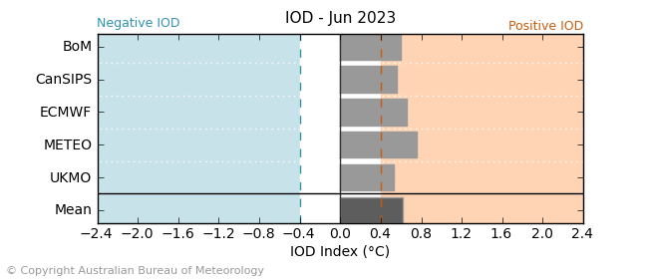
©Commonwealth of Australia 2023, Australian Bureau of Meteorology Issued: 6/6/2023

The Southern Annular Mode (SAM) index is currently neutral and is forecast to reach positive SAM thresholds in the coming days. During winter, a positive SAM often has a drying influence for parts of south-west and south-east Australia.

Southern Annular Mode (SAM) daily index
INCLUDEPICTURE "http://www.bom.gov.au/clim_data/IDCK000080/sam_index.daily.20230604.png?1686093681166" \* MERGEFORMATINET INCLUDEPICTURE "http://www.bom.gov.au/clim_data/IDCK000080/sam_index.daily.20230604.png?1686093681166" \* MERGEFORMATINET INCLUDEPICTURE "http://www.bom.gov.au/clim_data/IDCK000080/sam_index.daily.20230604.png?1686093681166" \* MERGEFORMATINET INCLUDEPICTURE "http://www.bom.gov.au/clim_data/IDCK000080/sam_index.daily.20230604.png?1686093681166" \* MERGEFORMATINET INCLUDEPICTURE "http://www.bom.gov.au/clim_data/IDCK000080/sam_index.daily.20230604.png?1686093681166" \* MERGEFORMATINET INCLUDEPICTURE "http://www.bom.gov.au/clim_data/IDCK000080/sam_index.daily.20230604.png?1686093681166" \* MERGEFORMATINET INCLUDEPICTURE "http://www.bom.gov.au/clim_data/IDCK000080/sam_index.daily.20230604.png?1686093681166" \* MERGEFORMATINET INCLUDEPICTURE "http://www.bom.gov.au/clim_data/IDCK000080/sam_index.daily.20230604.png?1686093681166" \* MERGEFORMATINET INCLUDEPICTURE "http://www.bom.gov.au/clim_data/IDCK000080/sam_index.daily.20230604.png?1686093681166" \* MERGEFORMATINET 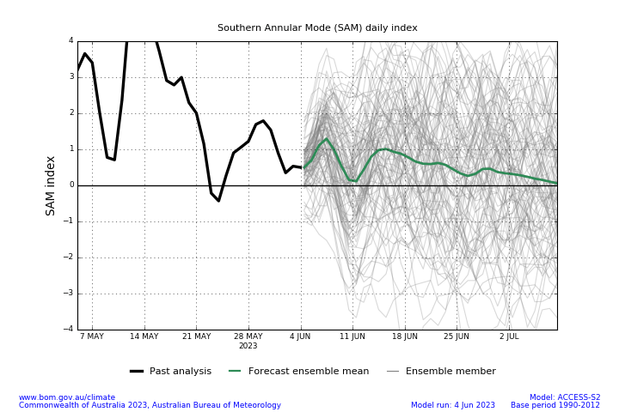

National Climate Outlook
These climate outlooks are generated by ACCESS–S (Australian Community Climate Earth-System Simulator–Seasonal). ACCESS–S is the Bureau of Meteorology's dynamic (physics-based) weather and climate model used for monthly, seasonal, and longer-lead climate outlooks. For further information, go to http://www.bom.gov.au/climate/ahead/about/.
The Bureau of Meteorology’s latest rainfall outlook for July 2023 indicates drier than average conditions are expected across much of Australia.
The ACCESS-S climate model suggests that there is a 75% chance of rainfall totals between 10 and 50 millimetres across eastern New South Wales, scattered areas of coastal Queensland, Victoria, southern South Australia, much of Tasmania, and the southwest of Western Australia. Rainfall totals in excess of 100 millimetres are expected across western Tasmania and far southwest Western Australia.
Across cropping regions, there is a 75% chance of rainfall totals of between 10 and 25 millimetres across southern New South Wales and much of Victoria, and between 25 and 50 millimetres in South Australia and Western Australia. July rainfall totals are expected to be below 10 millimetres in the remaining cropping regions. Given the very dry conditions during May and the start of June, these probable low one-month rainfall totals are unlikely to be sufficient to sustain average levels of crop production, particularly in northern New South Wales and northern Queensland growing regions.
Rainfall totals that have a 75% chance of occurring in July 2023
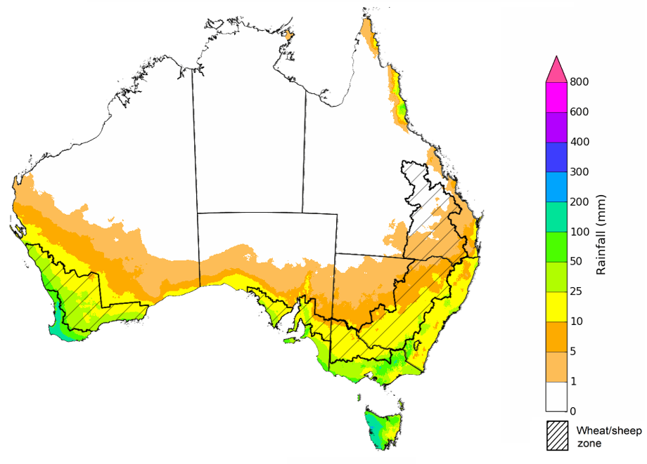
©Commonwealth of Australia 2023, Australian Bureau of Meteorology Issued: 8/06/2023

The rainfall outlook for July to September 2023 suggests that below median rainfall is likely to very likely (60% to greater than 80% chance) for much of Australia. However, there is close to equal chances of above or below median rainfall for parts of Western Australia, tropical Queensland and coastal New South Wales, as well as in the southern Tasmania.
Bureau of Meteorology rainfall outlooks for July to September have greater than 55% past accuracy across most of Australia. Outlook accuracy is greater than 65% across large areas of eastern Australia. However, there is low past accuracy for scattered areas of central and southwestern Australia.
Chance of exceeding the median rainfall July to September 2023
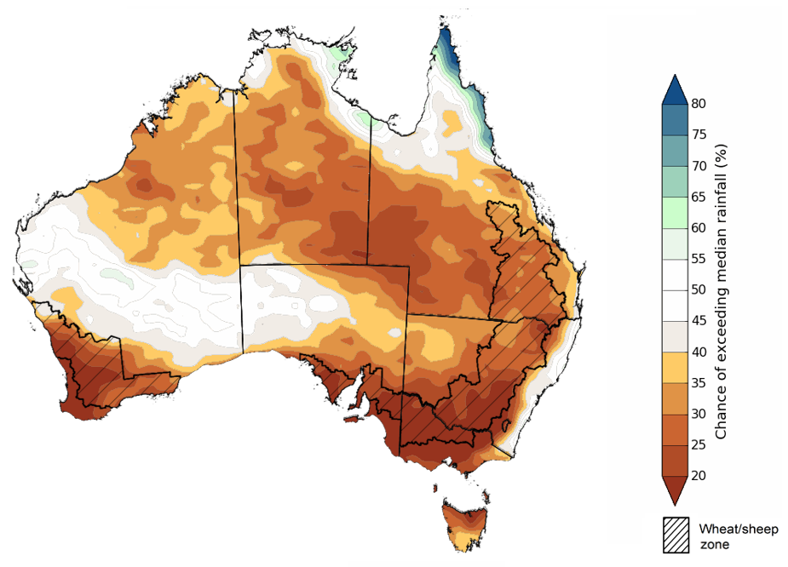
©Commonwealth of Australia 2023, Australian Bureau of Meteorology Issued: 8/06/2023

The outlook for July to September 2023 suggests there is a 75% chance of rainfall totals between 25 and 200 millimetres across central and eastern New South Wales, parts of south-eastern and coastal Queensland, southern parts of South Australia and Western Australia, and much of Victoria and Tasmania. Rainfall totals in excess of 200 millimetres are forecast for alpine regions of Victoria and New South Wales, part of coastal northeast Queensland, far southwest of Western Australia and western Tasmania.
In the cropping regions, there is a 75% chance of receiving between 25 and 100 millimetres New South Wales, Victoria, South Australia, south-eastern Queensland, and Western Australia between July and September 2023. In those areas that have benefited from soaking rainfall during early June, these falls are likely to be sufficient to support close to average plant growth. However, in areas with low soil moisture these probable low three-month rainfall totals are unlikely to be sufficient to sustain average levels of crop production.
Rainfall totals that have a 75% chance of occurring July to September 2023 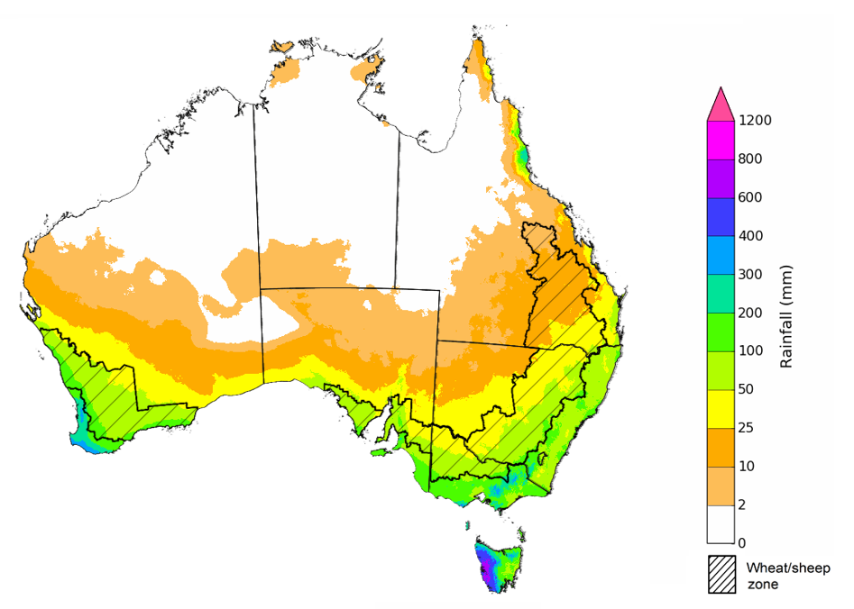
©Commonwealth of Australia 2023, Australian Bureau of Meteorology Issued: 8/06/2023

The temperature outlook for July to September 2023 indicates that maximum temperatures across the northern Australia, coastal east and Tasmania are likely to be close to the 1990-2012 average (-1°C to +1°C) while warmer (above +1°C) across much of southern and central Australia. The daytime temperatures in parts of Western Australia are likely to be even warmer (above +2°C). The minimum temperatures across most of Australia are expected to be close to the 1990-2012 average (-1°C to +1°C). The night-time temperatures in western parts of Western Australia are likely to be warmer that average (above +1°C).
Predicted maximum temperature anomaly for July to September 2023
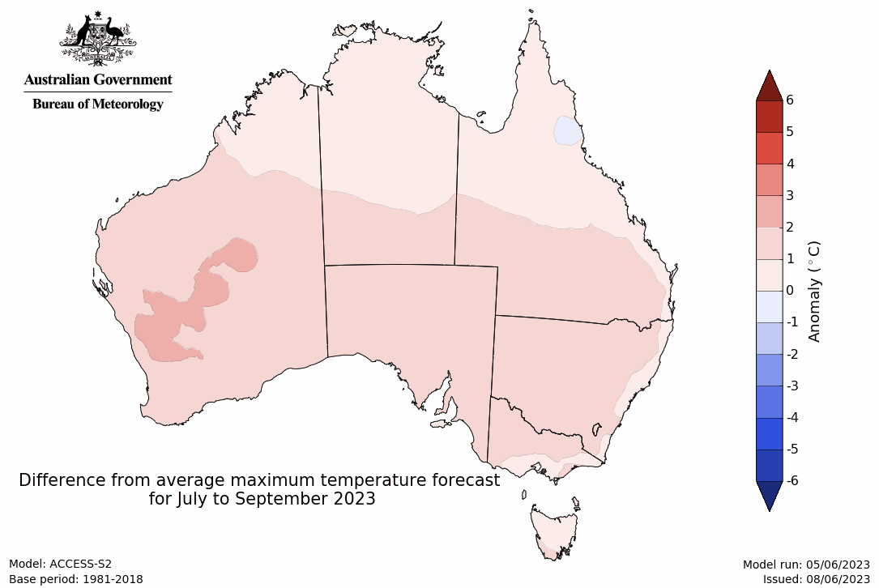
Predicted minimum temperature anomaly for July to September 2023

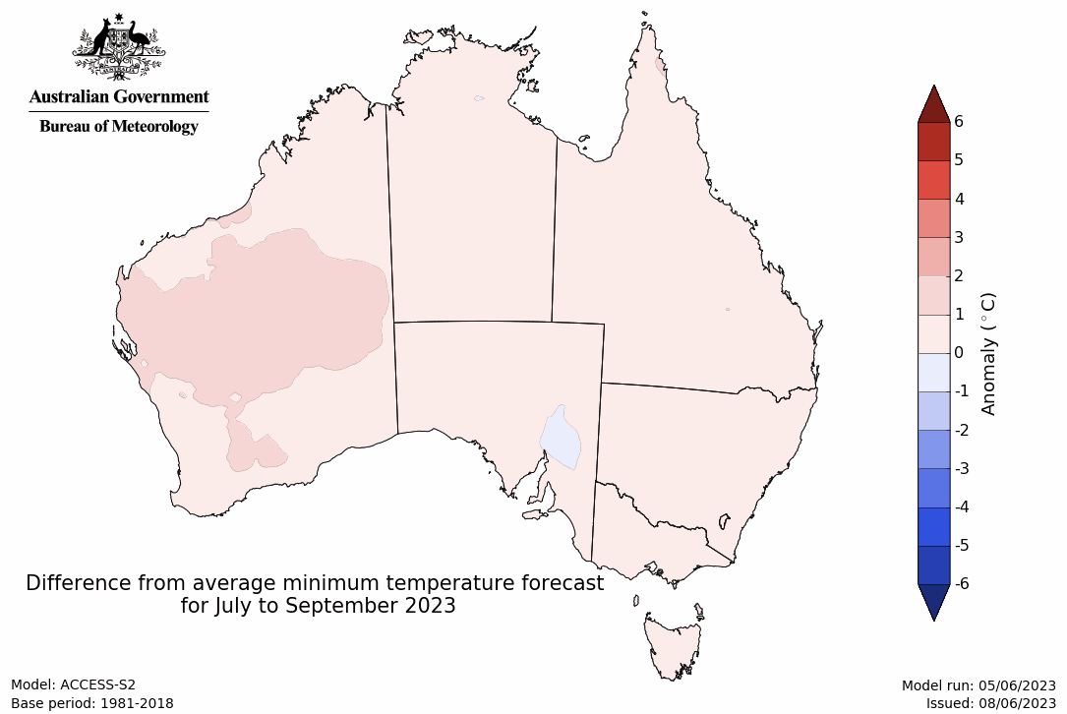

Rainfall forecast for the next eight days
Over the 8-days to 15 June 2023, an intense low, cold fronts and trough will generate showers up to 100 millimetres over parts of southern and central New South Wales, Victoria, far southwest Western Australia, parts of southern South Australia, and across Tasmania. A high-pressure system will keep the remainder of the country dry.
Rainfall totals of between 10 and 50 millimetres are expected across central and southern New South Wales, southern Victoria and parts of central and western South Australia. Little to no rainfall is expected across remaining cropping regions. This rainfall should be sufficient to allow for the germination and establishment of dry sown crops, and benefit soil moisture levels and the growth of earlier sown crops.

Total forecast rainfall for the period 8 June 2023 to 15 June 2023
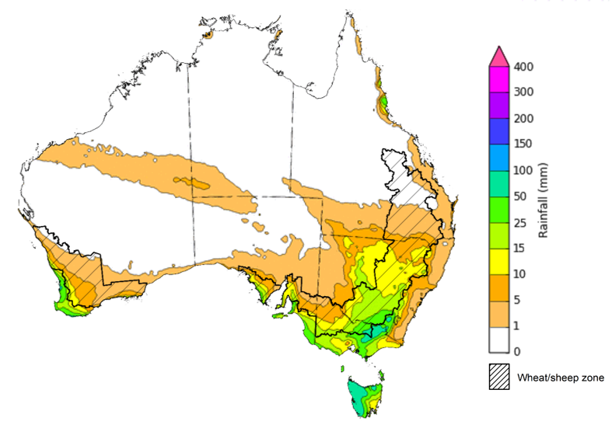

©Commonwealth of Australia 2023, Australian Bureau of Meteorology Issued 08/06/2023
Note: This rainfall forecast is produced from computer models. As the model outputs are not altered by weather forecasters, it is important to check local forecasts and warnings issued by the Bureau of Meteorology.

Water

Water markets – current week
Water storage levels in the Murray-Darling Basin (MDB) increased between 1 June 2023 and 8 June 2023 by 89 gigalitres (GL). Current volume of water held in storage is 20 240 GL. This is 0.2 percent or 42 GL more than at the same time last year.

Water storages in the Murray-Darling Basin, 2013–2023
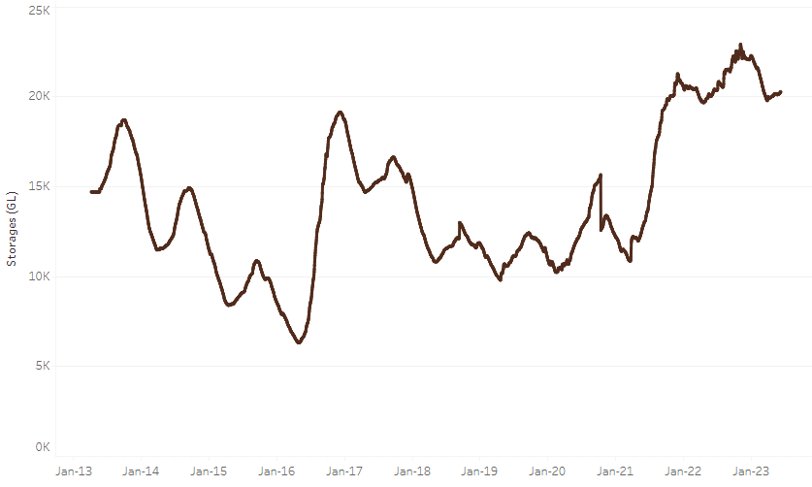
Allocation prices in the Victorian Murray below the Barmah Choke decreased from $19 on 1 June 2023 to $13 on 8 June 2023.
Water storage data is sourced from the Bureau of Meteorology.

Region | $/ML
NSW Murray Above | 6
NSW Murrumbidgee | 3
VIC Goulburn-Broken | 15
VIC Murray Below | 13

Surface water trade activity, Southern Murray–Darling Basin
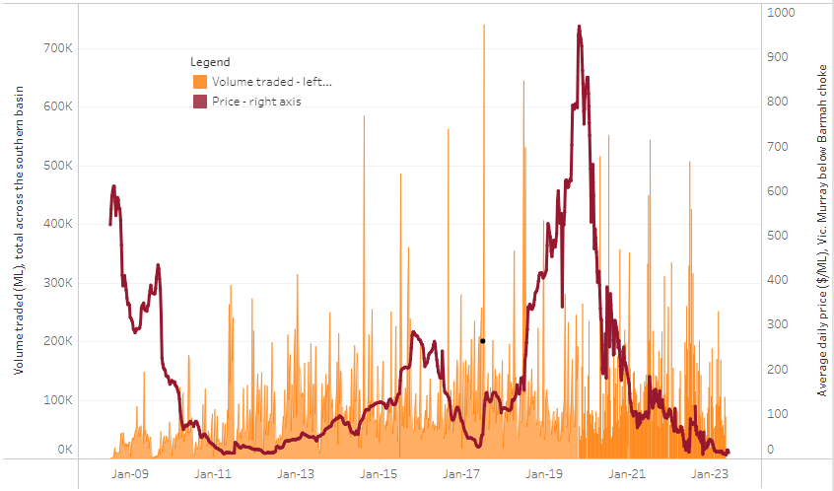
The trades shown reflect estimated market activity and do not encompass all register trades. The price is shown for the VIC Murray below the Barmah choke. Historical prices (before 1 July 2019) are ABARES estimates after removing outliers from BOM water register data. Prices after 1 July 2019 and prior to the 30 October 2019 reflect recorded transaction prices as sourced from Ruralco. Prices after the 30 October 2019 are sourced from Waterflow. Data for volume traded is sourced from the BOM water register. Only the price data shown is current on 8 June 2023.

To access the full, interactive, weekly water dashboard, which contains the latest and historical water storage, water market and water allocation information, please visit https://www.agriculture.gov.au/abares/products/weekly_update/weeakly-update-8623

Commodities
Indicator | Week ended | Unit | Latest Price | Previous Week | Weekly change | Price 12 months ago | Annual change
Selected world indicator prices
AUD/USD Exchange rate | 07-Jun | A$/US$ | 0.66 | 0.65 | 2% | 0.70 | -5%
Wheat – US no. 2 hard red winter wheat, fob Gulf | 07-Jun | US$/t | 354 | 357 | -1% | 477 | -26%
Corn – US no. 2 yellow corn, fob Gulf | 07-Jun | US$/t | 269 | 266 | 1% | 341 | -21%
Canola – Rapeseed, Canada, fob Vancouver | 07-Jun | US$/t | 547 | 552 | -1% | 891 | -39%
Cotton – Cotlook 'A' Index | 07-Jun | USc/lb | 96 | 95 | 0% | 163 | -41%
Sugar – Intercontinental Exchange, nearby futures, no.11 contract | 07-Jun | USc/lb | 24.2 | 24.9 | -3% | 19 | 29%
Wool – Eastern Market Indicator | 31-May | Ac/kg clean | 1,208 | 1,209 | 0% | 1,377 | -12%
Wool – Western Market Indicator | 24-May | Ac/kg clean | 1,366 | 1,337 | 2% | 1,457 | -6%
Selected Australian grain export prices
Milling Wheat – APW, Port Adelaide, SA | 07-Jun | A$/t | 446 | 441 | 1% | 635 | -30%
Feed Wheat – ASW, Port Adelaide, SA | 07-Jun | A$/t | 416 | 411 | 1% | 600 | -31%
Feed Barley – Port Adelaide, SA | 07-Jun | A$/t | 353 | 366 | -4% | 559 | -37%
Canola – Kwinana, WA | 07-Jun | A$/t | 810 | 819 | -1% | 1,240 | -35%
Grain Sorghum – Brisbane, QLD | 07-Jun | A$/t | 476 | 465 | 2% | 468 | 2%
Selected domestic livestock indicator prices
Beef – Eastern Young Cattle Indicator | 07-Jun | Ac/kg cwt | 574 | 583 | -2% | 1,128 | -49%
Mutton – Mutton indicator (18–24 kg fat score 2–3), Vic | 07-Jun | Ac/kg cwt | 363 | 412 | -12% | 629 | -42%
Lamb – Eastern States Trade Lamb Indicator | 07-Jun | Ac/kg cwt | 564 | 565 | 0% | 774 | -27%
Pig – Eastern Seaboard (60.1–75 kg), average of buyers & sellers | 24-May | Ac/kg cwt | 357 | 357 | 0% | 368 | -3%
Goats – Eastern States (12.1–16 kg) | 07-Jun | Ac/kg cwt | 324 | 330 | -2% | 838 | -61%
Live cattle – Light steers ex Darwin to Indonesia | 17-Aug | Ac/kg lwt | 420 | 480 | -13% | 320 | 31%
Live sheep – Live wethers (Muchea WA saleyard) to Middle East | 14-Sep | $/head | 93 | 113 | -18% | 114 | -18%
Global Dairy Trade (GDT) weighted average prices ª
Dairy – Whole milk powder | 07-Jun | US$/t | 3,173 | 3,244 | -2% | 4,123 | -23%
Dairy – Skim milk powder | 07-Jun | US$/t | 2,755 | 2,766 | 0% | 3,447 | -20%
Dairy – Cheddar cheese | 07-Jun | US$/t | 4,668 | 4,407 | 6% | 4,321 | 8%
Dairy – Anhydrous milk fat | 07-Jun | US$/t | 4,728 | 4,600 | 3% | 5,730 | -17%
a Global Dairy Trade prices are updated twice monthly on the first and third Tuesday of each month.

Selected world indicator prices
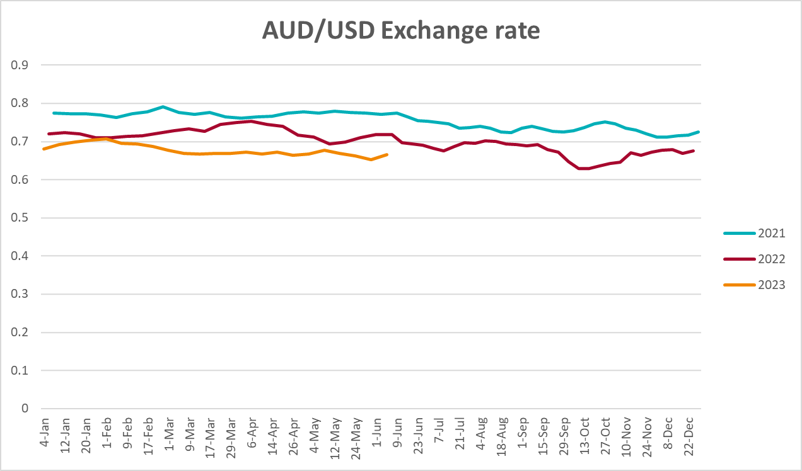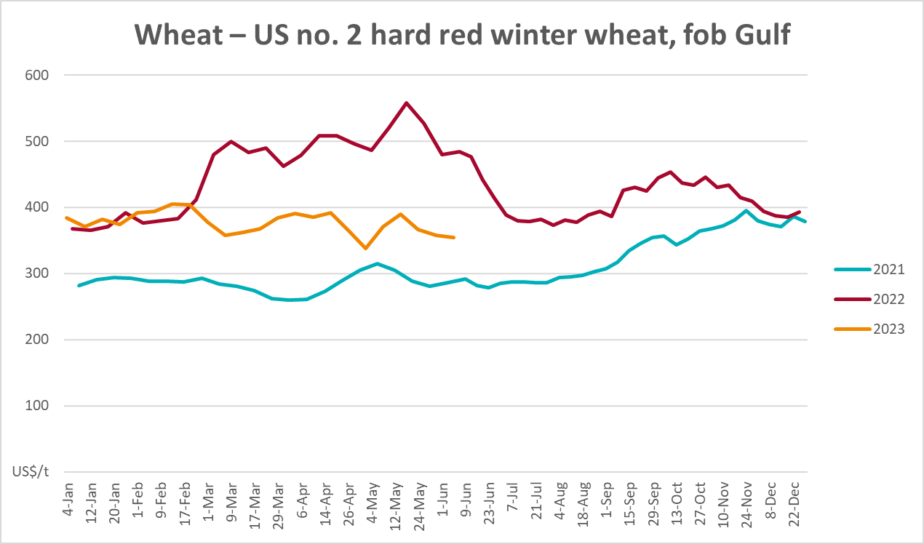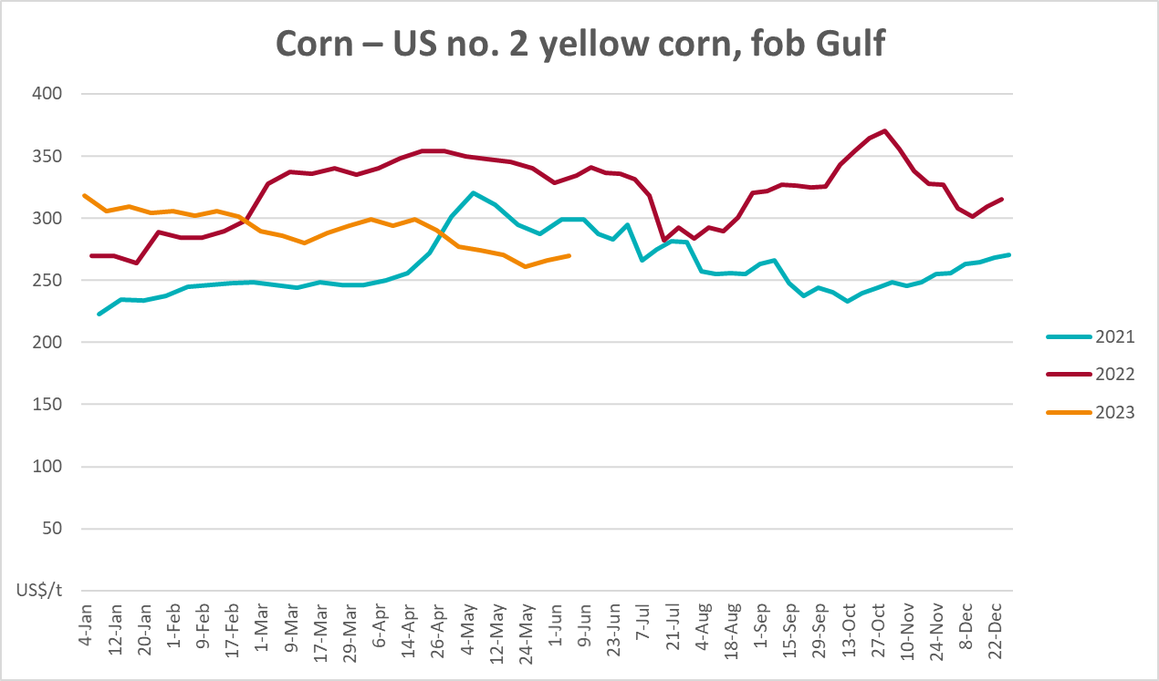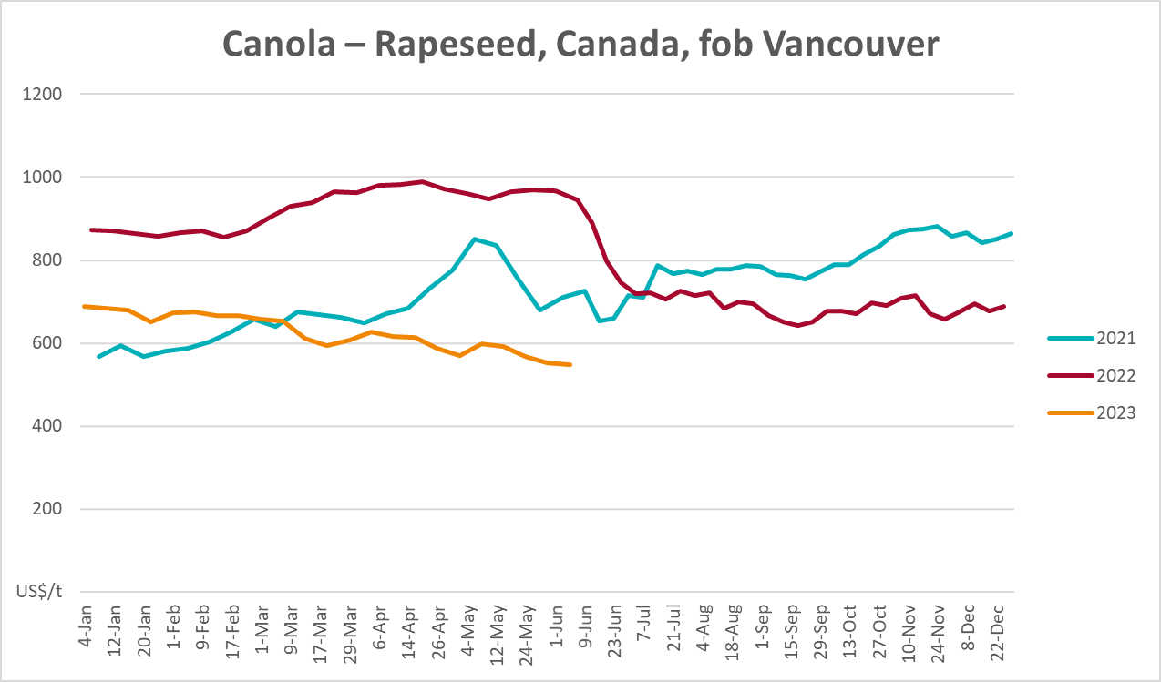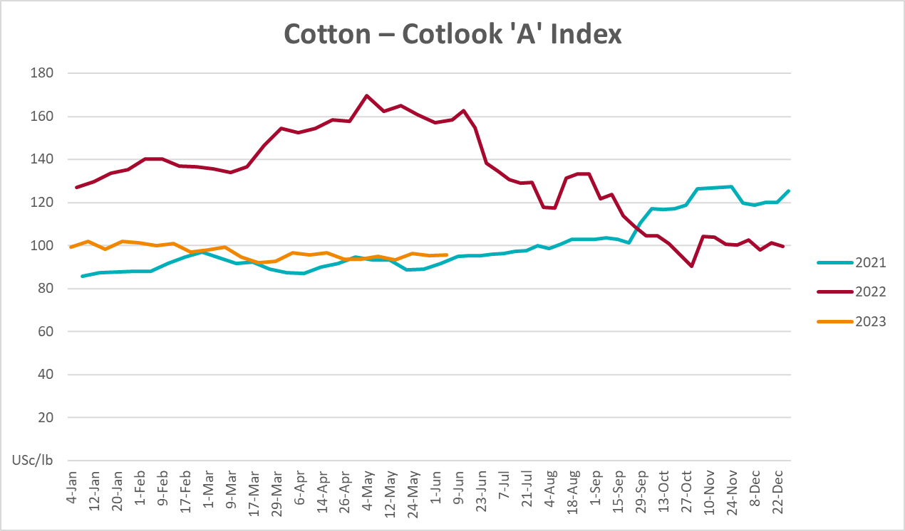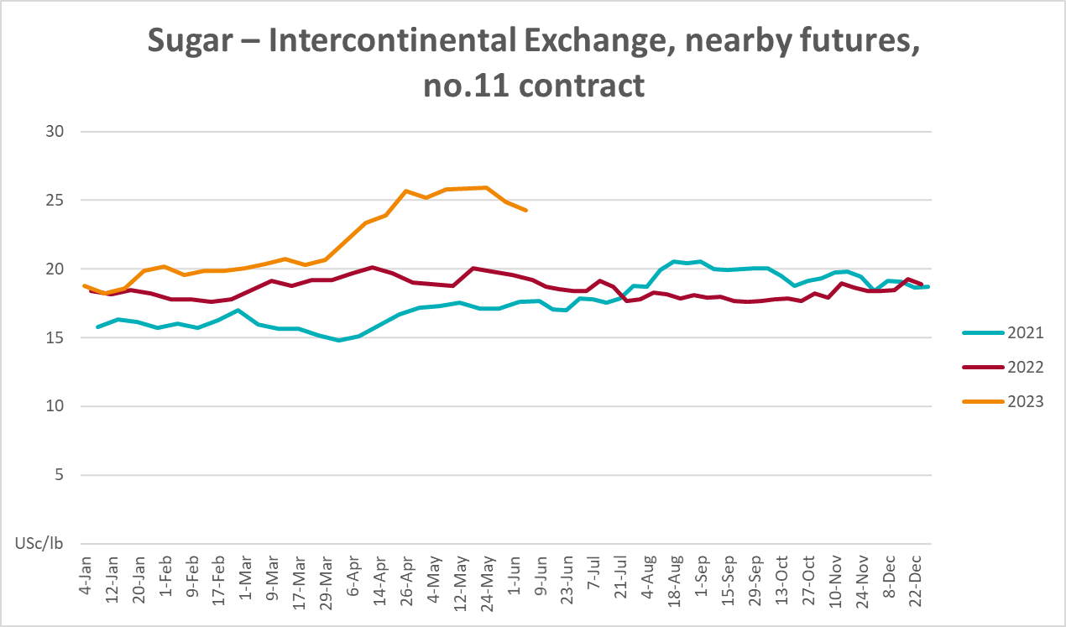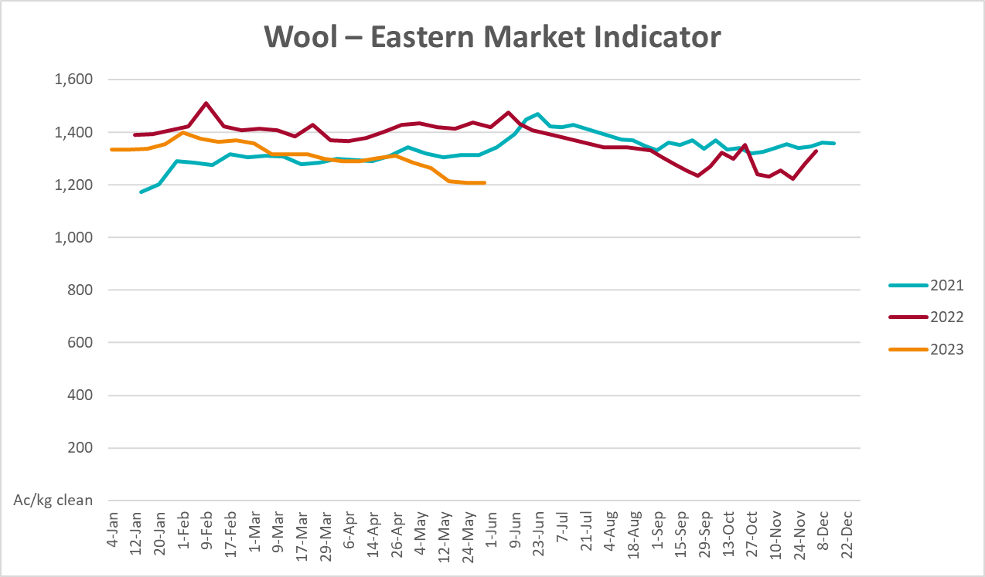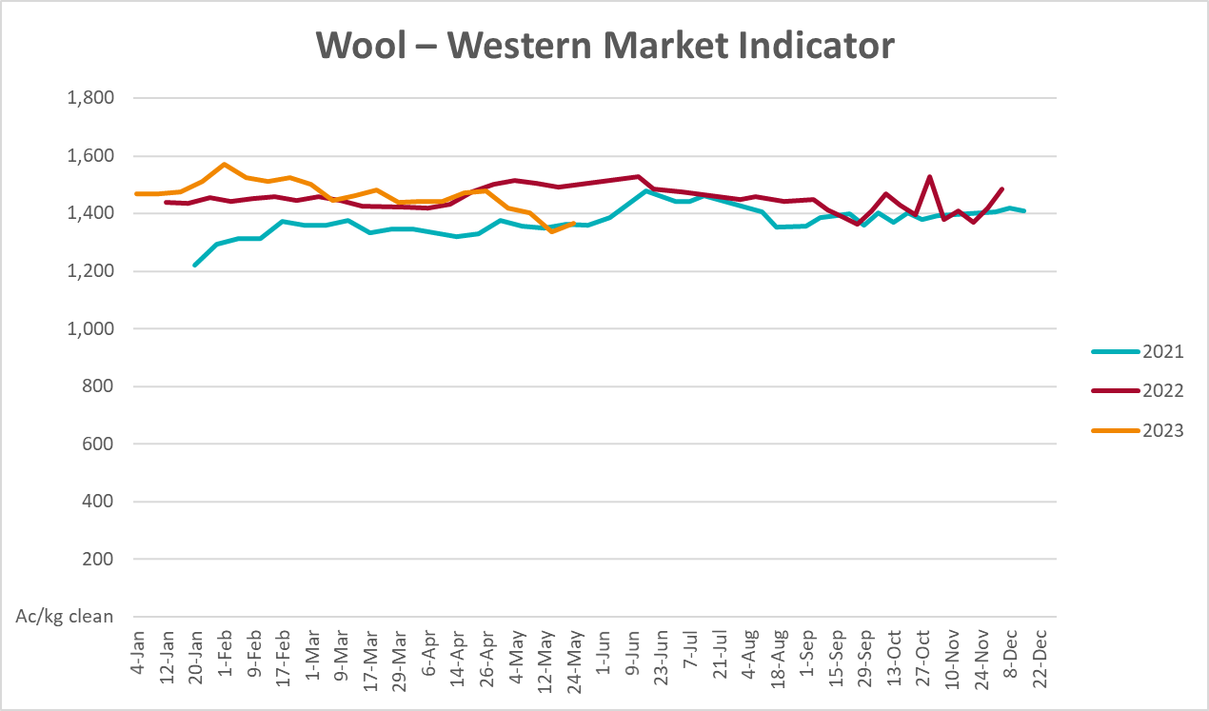

Selected domestic crop indicator prices
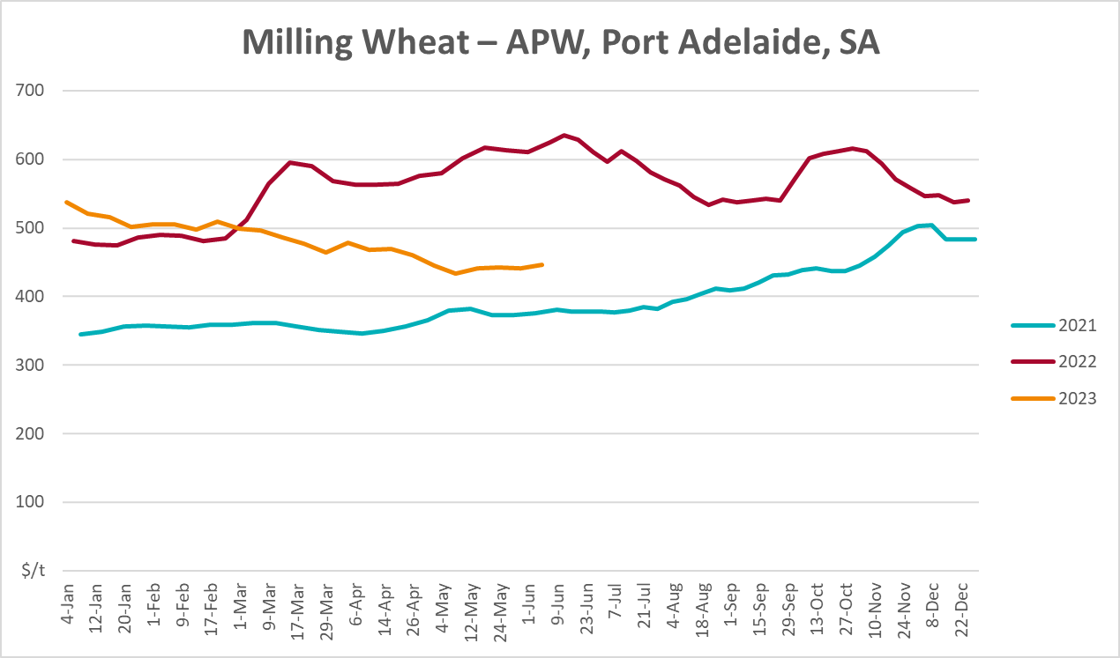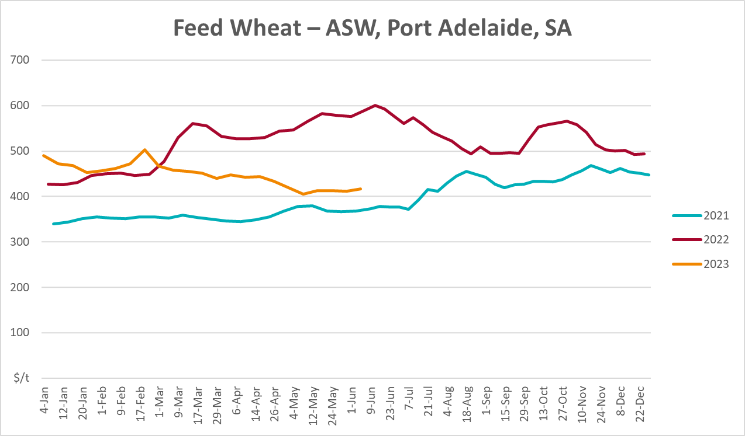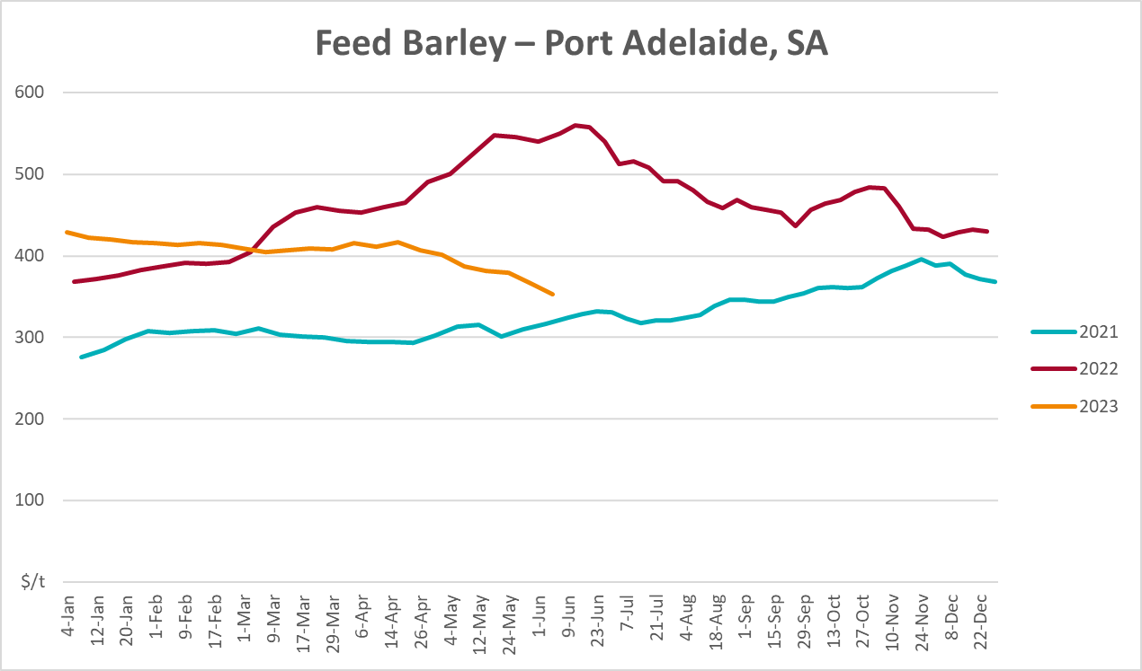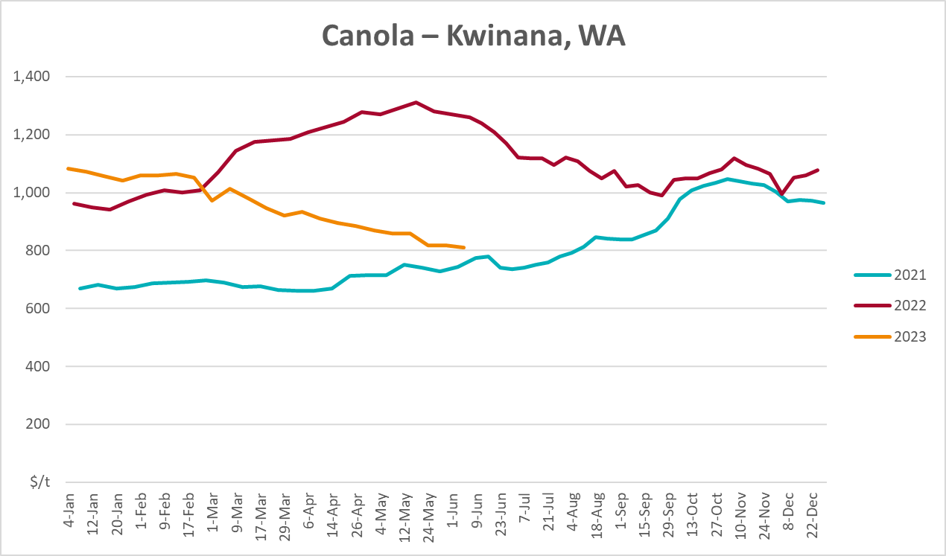
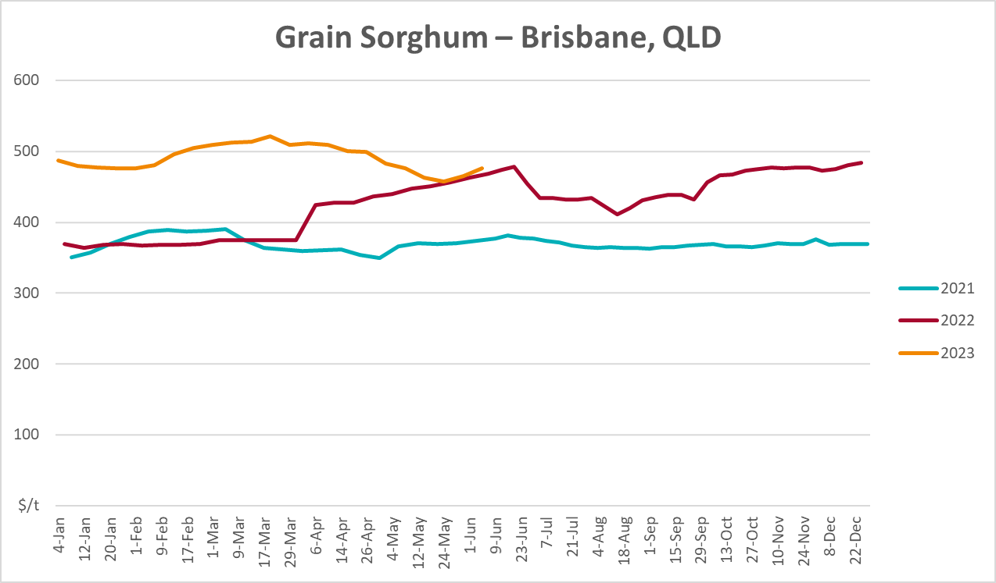

Selected domestic livestock indicator prices
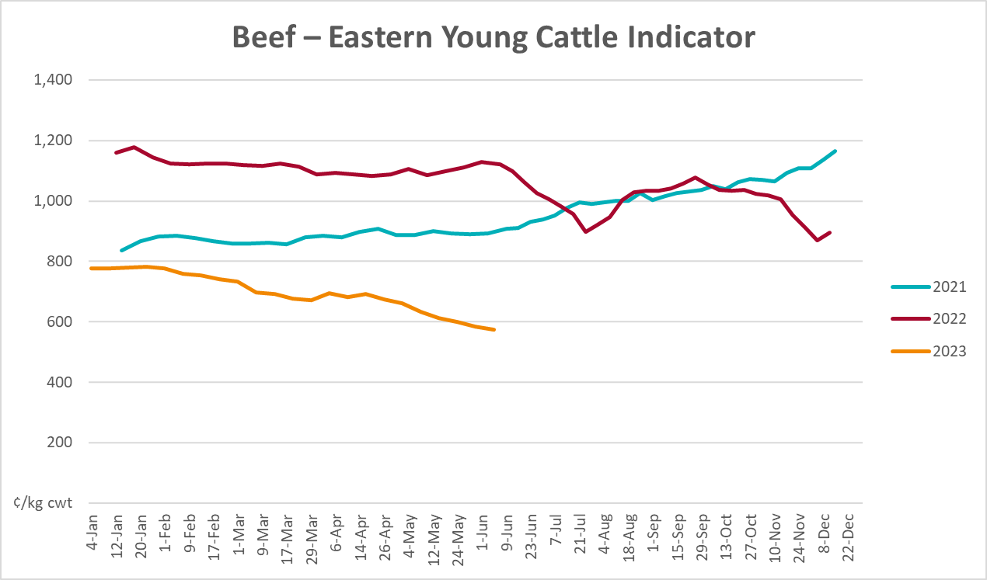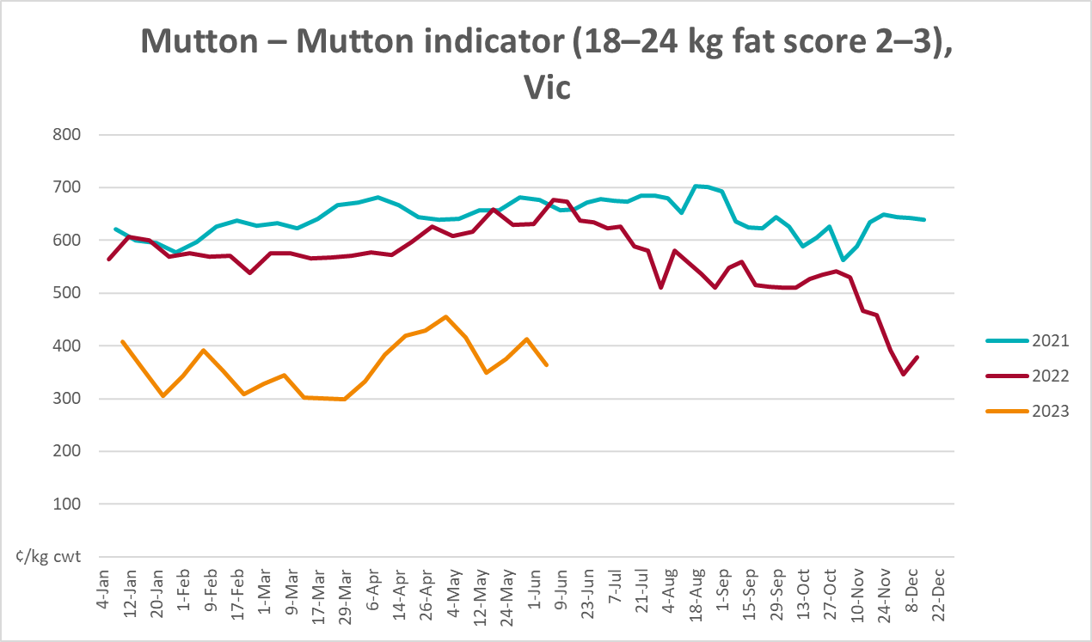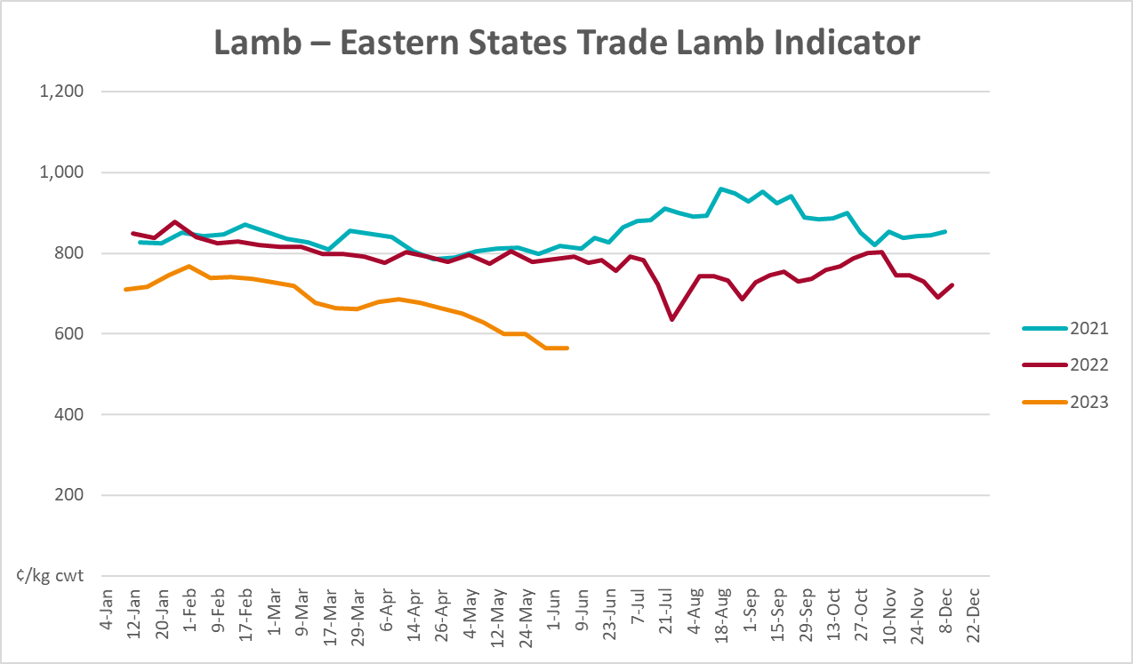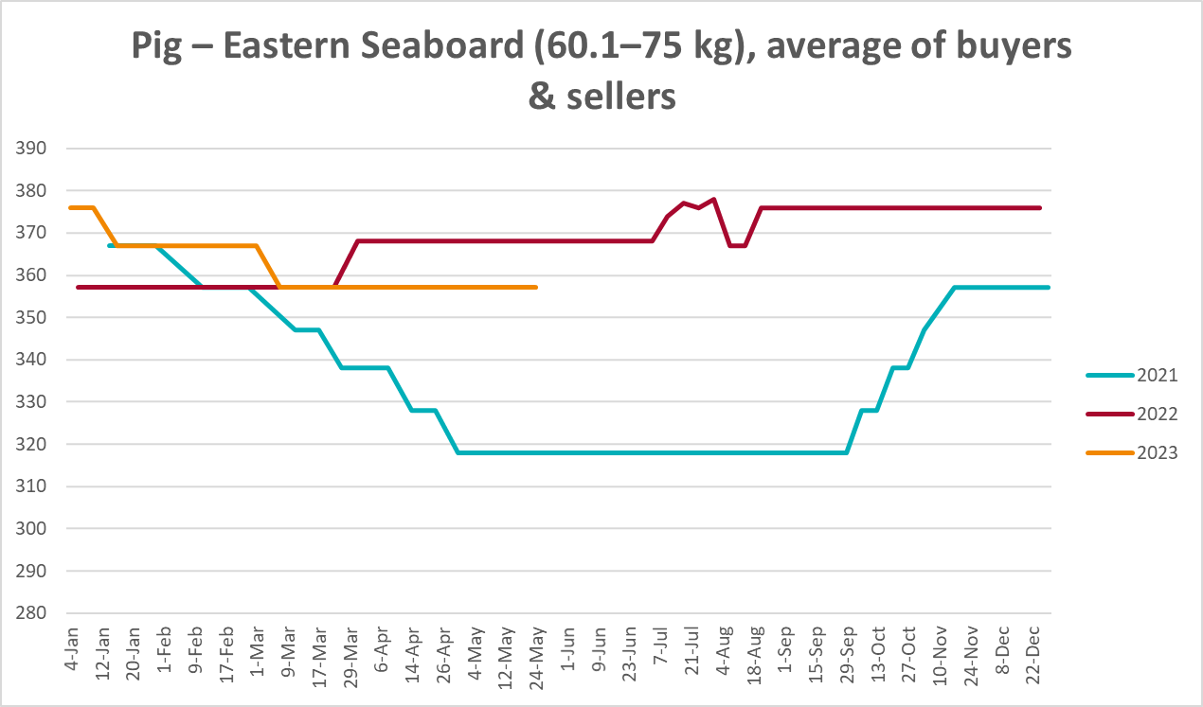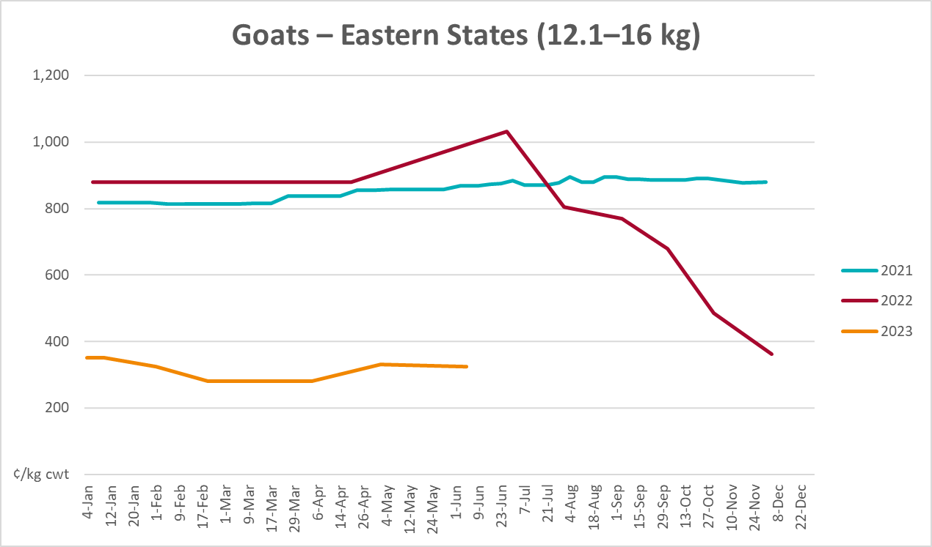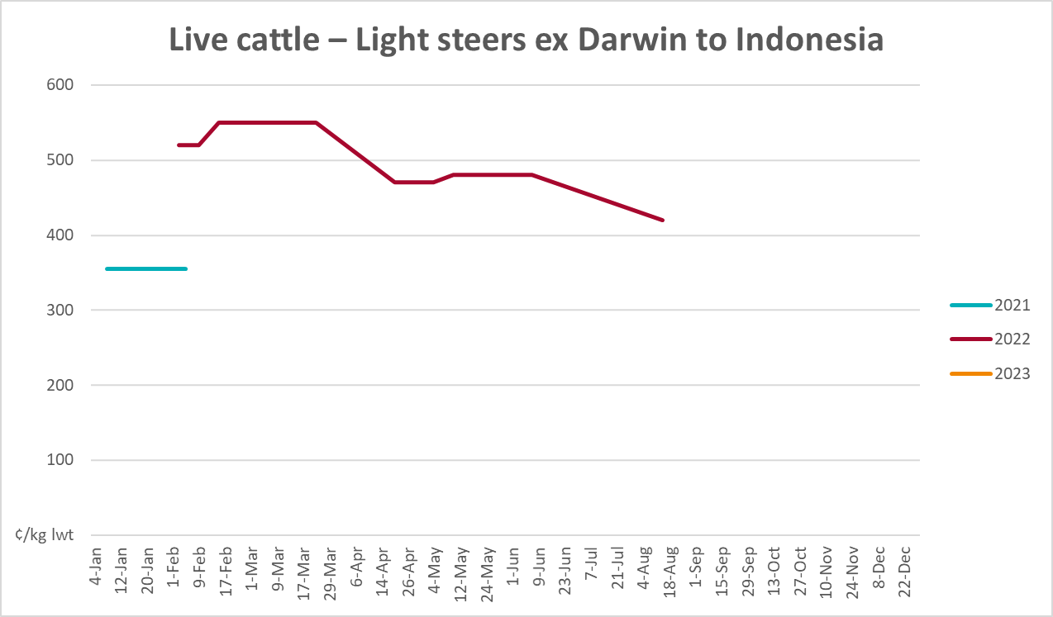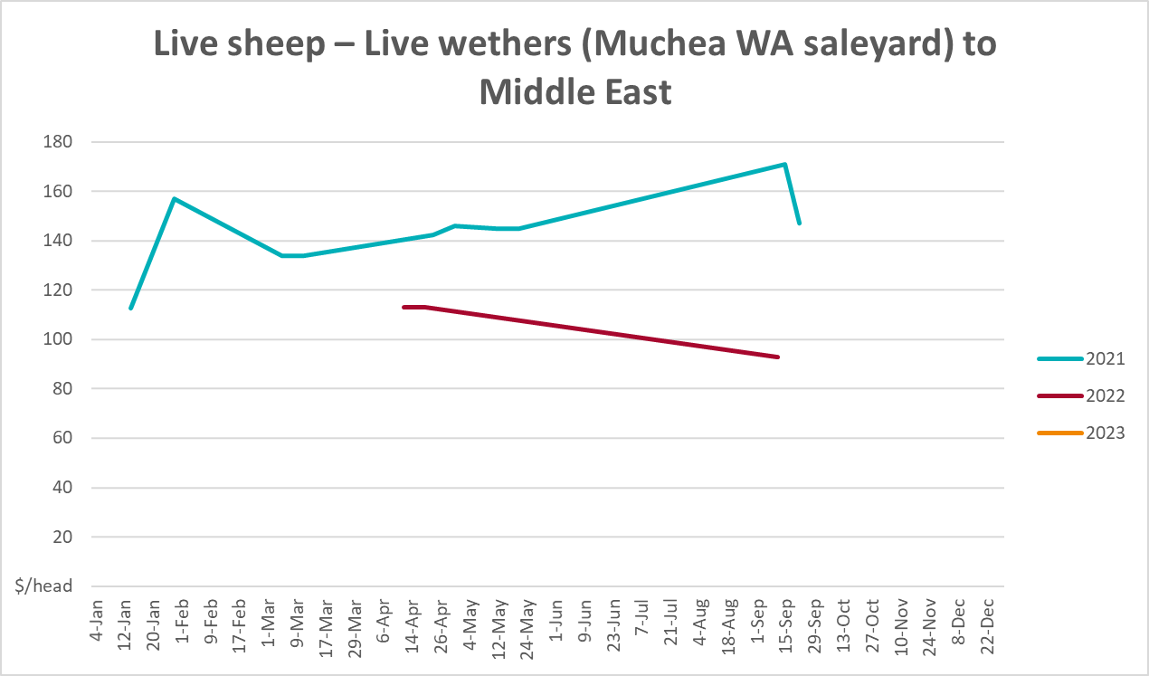

Global Dairy Trade (GDT) weighted average prices
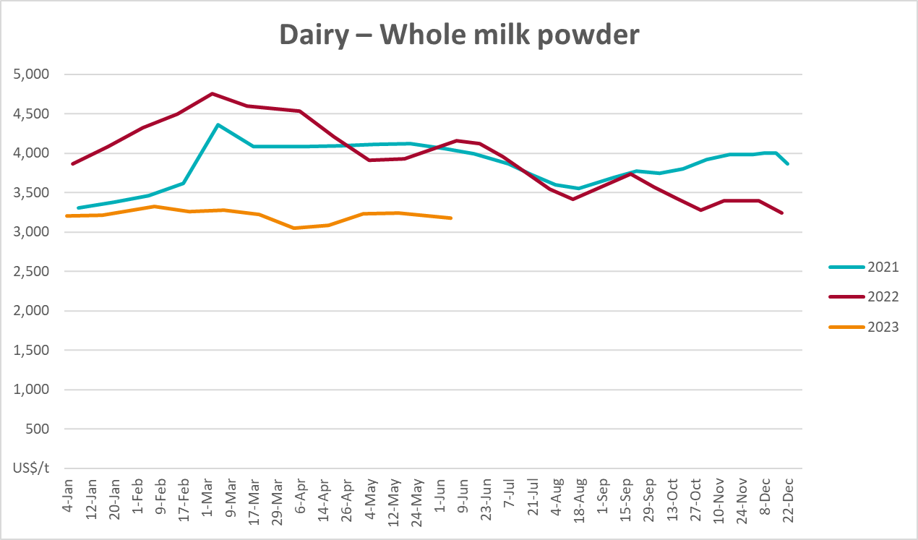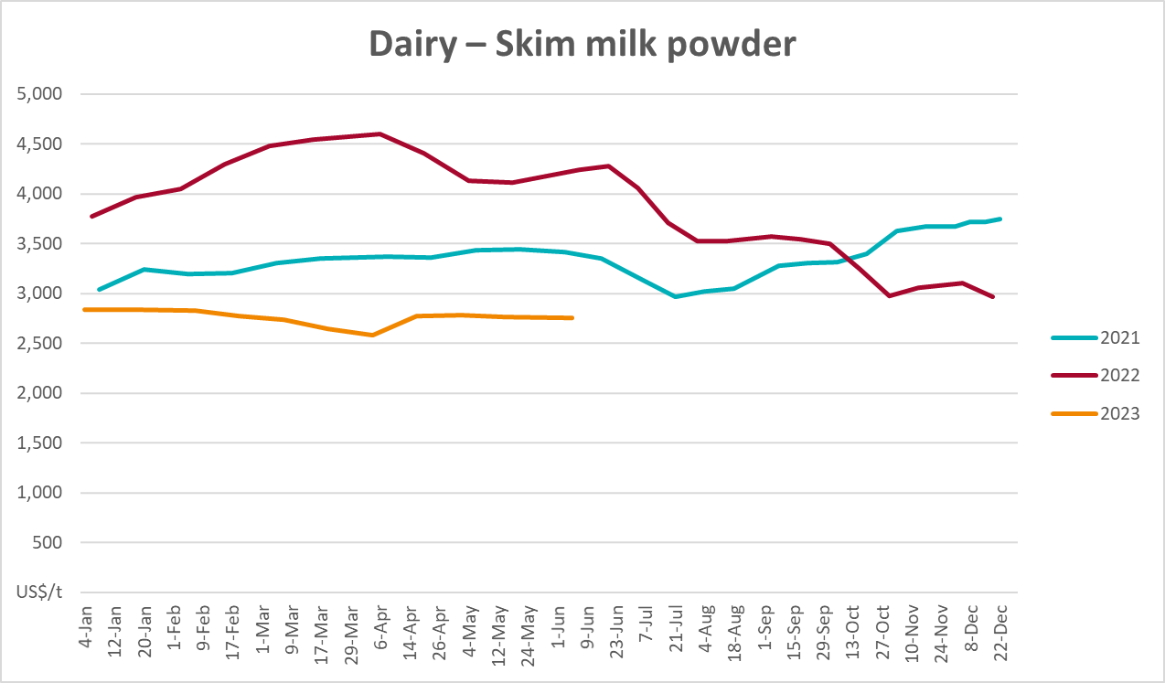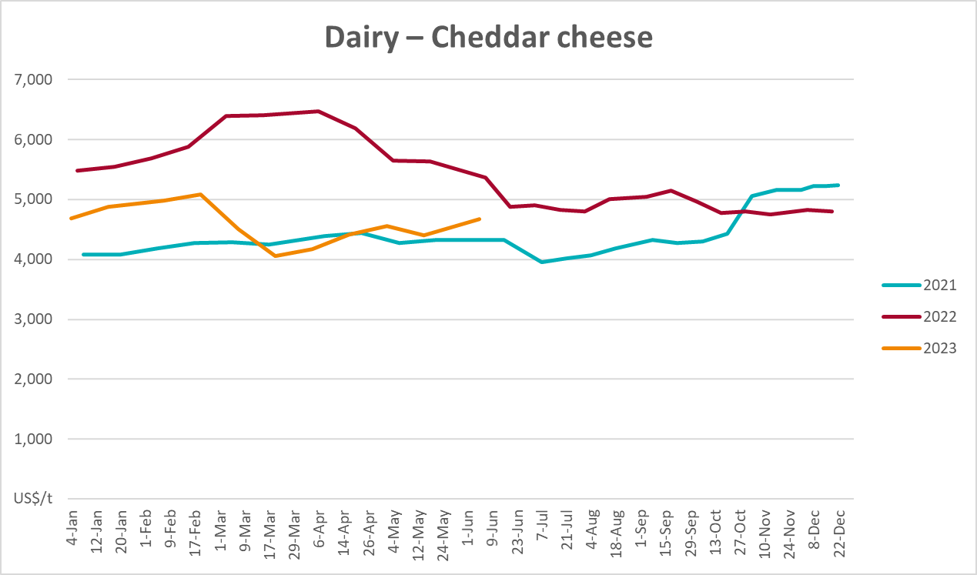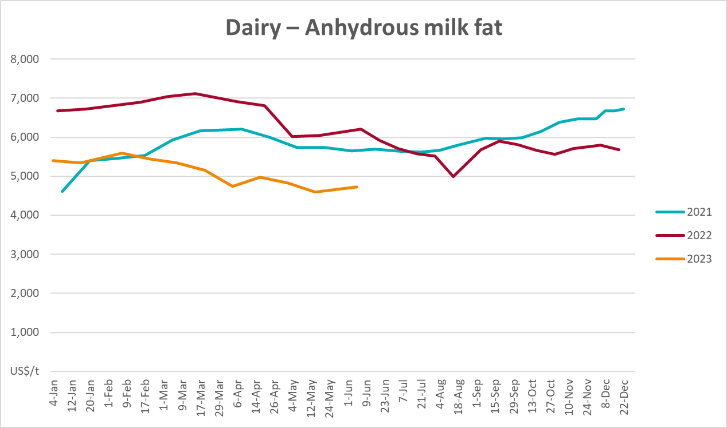

Selected fruit and vegetable prices
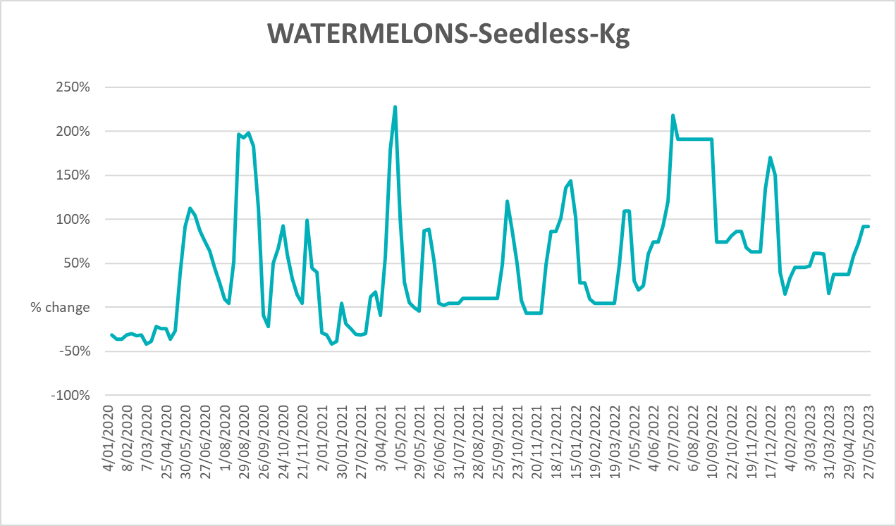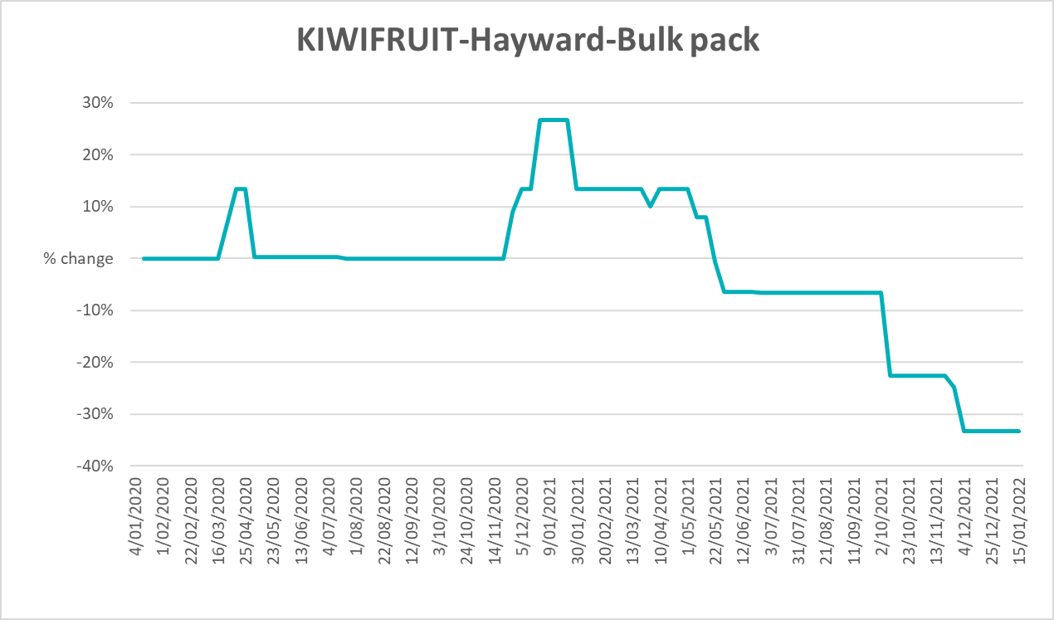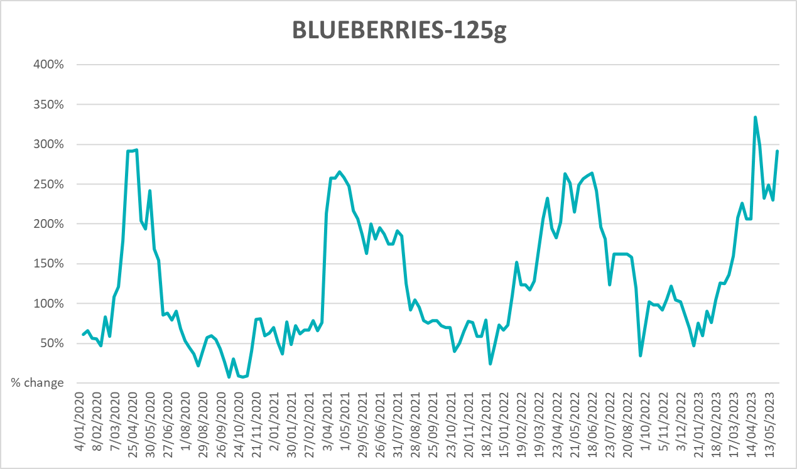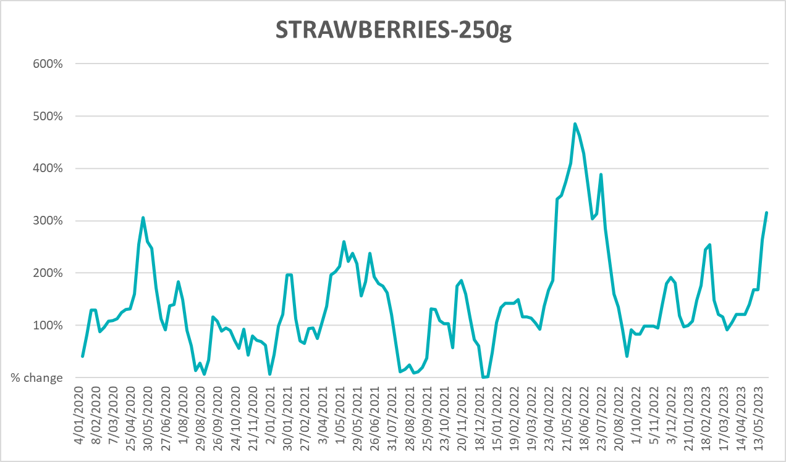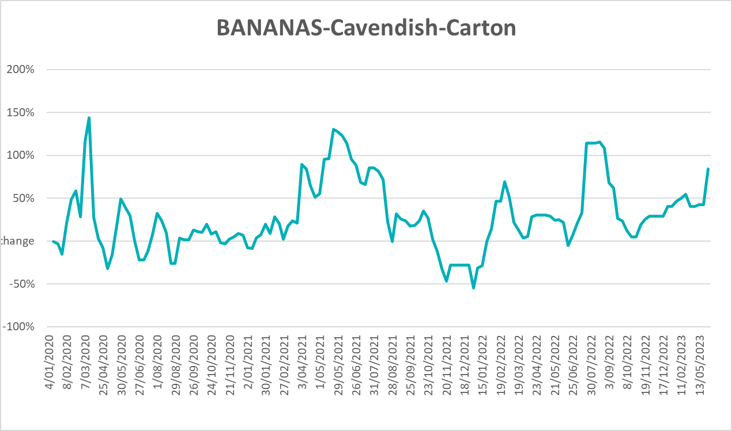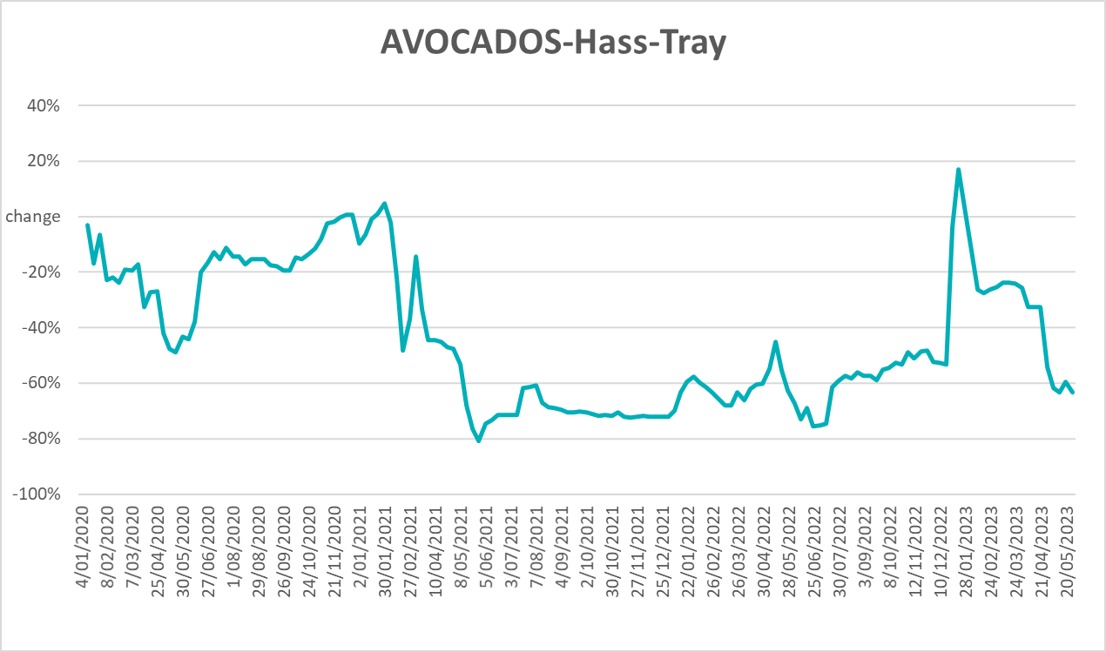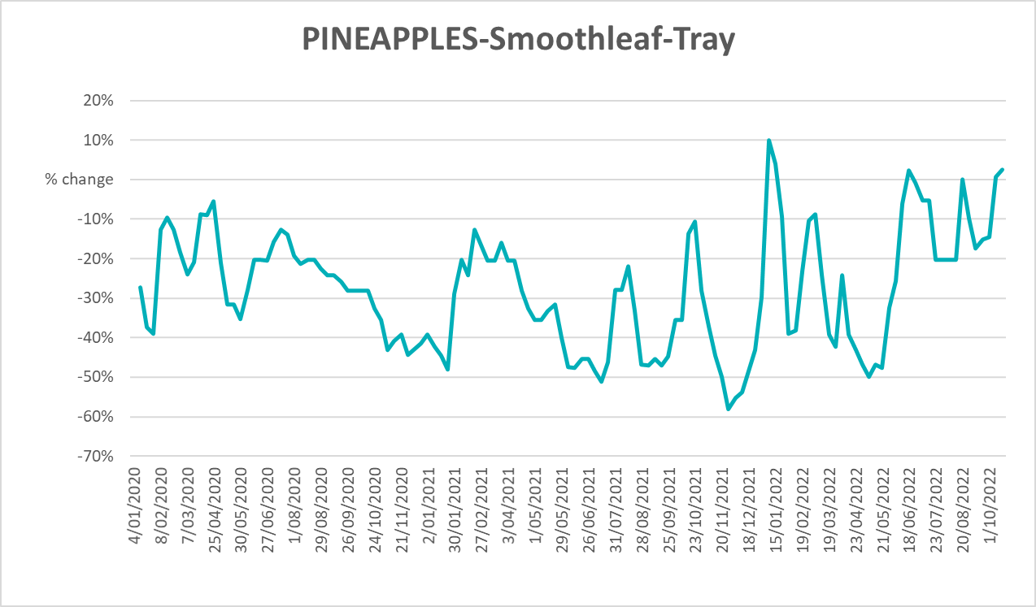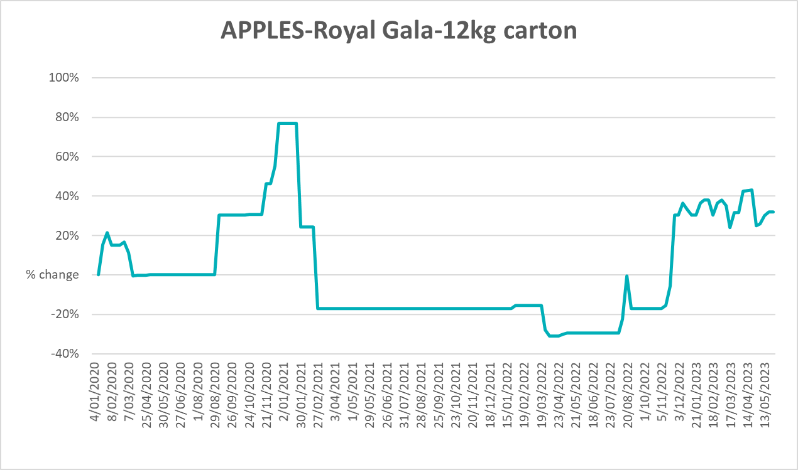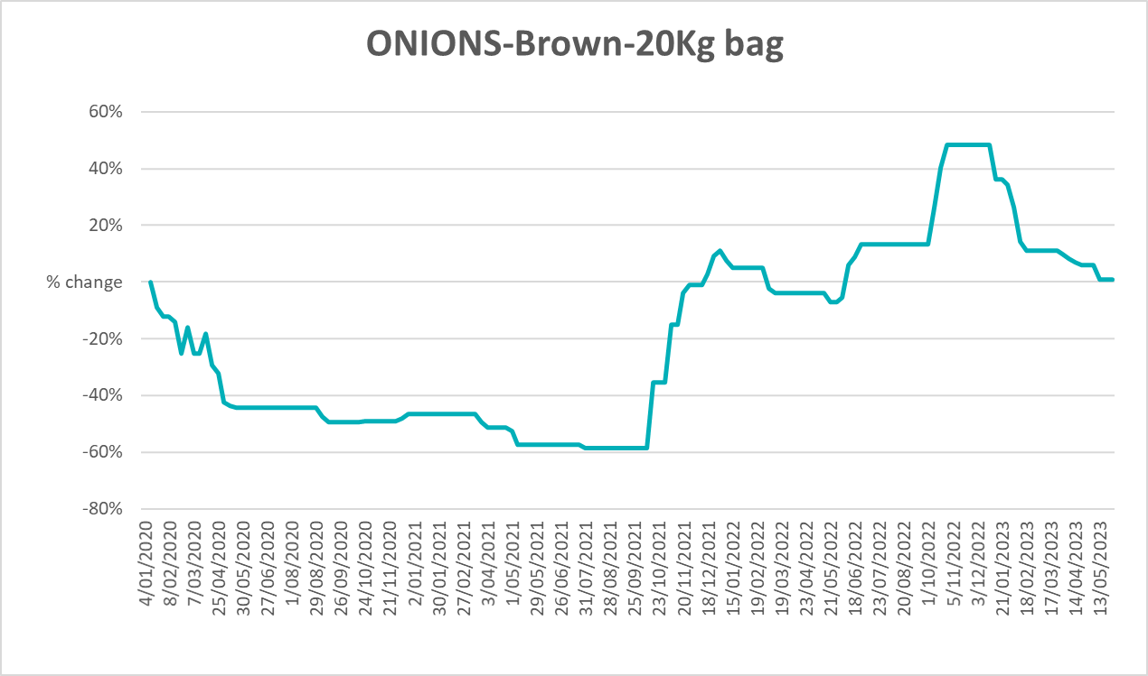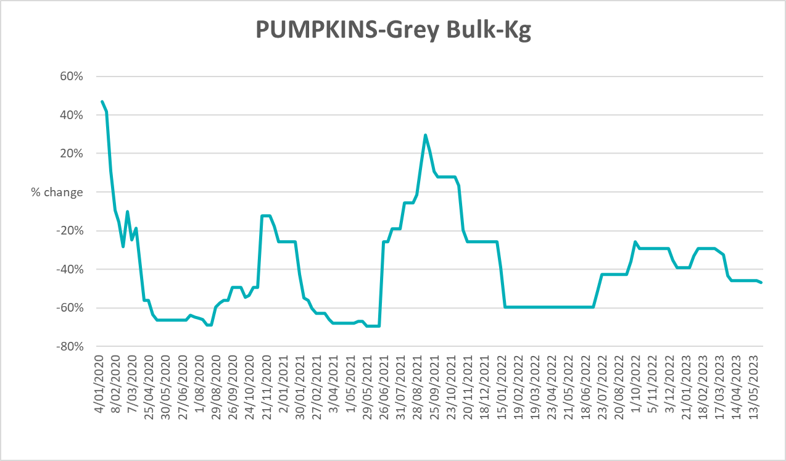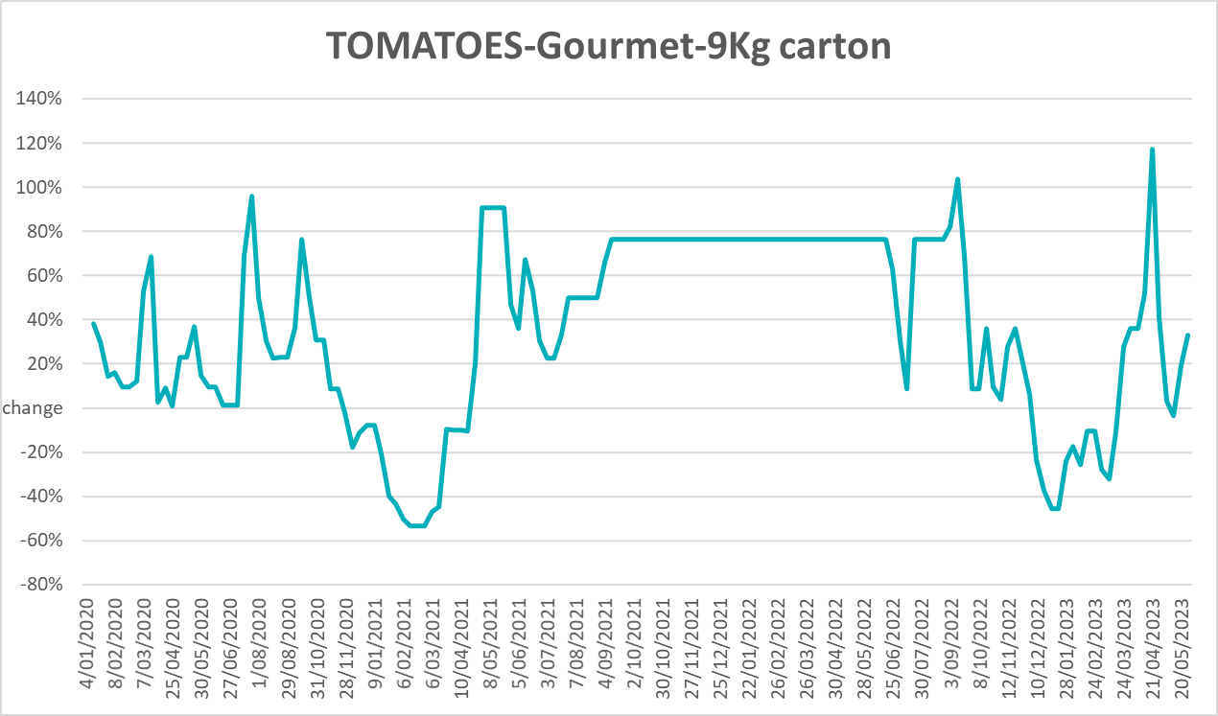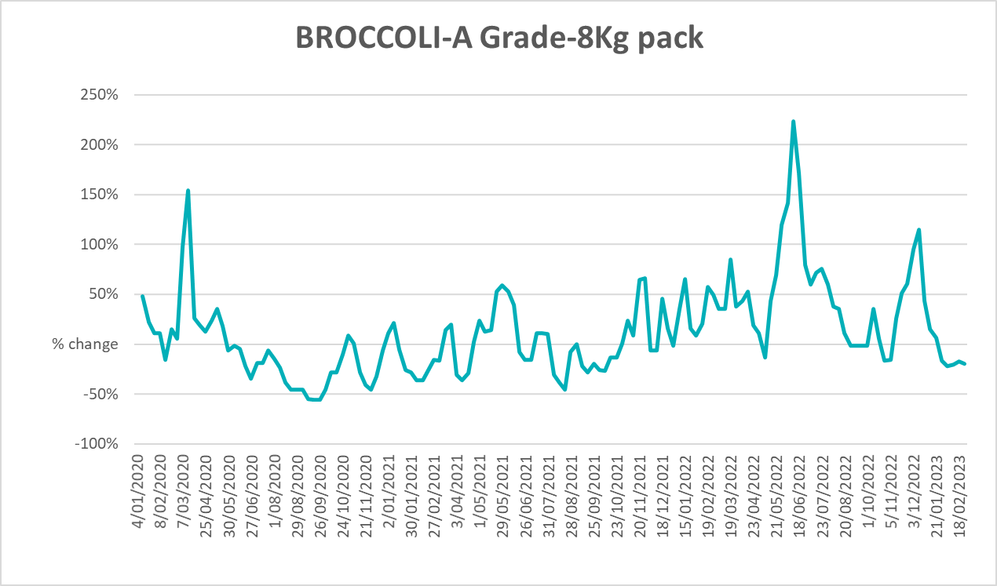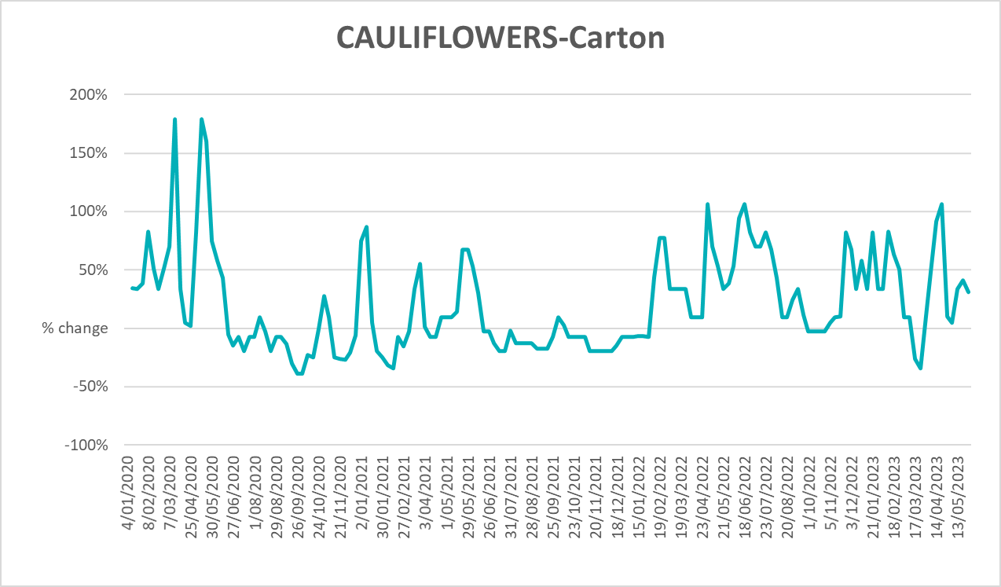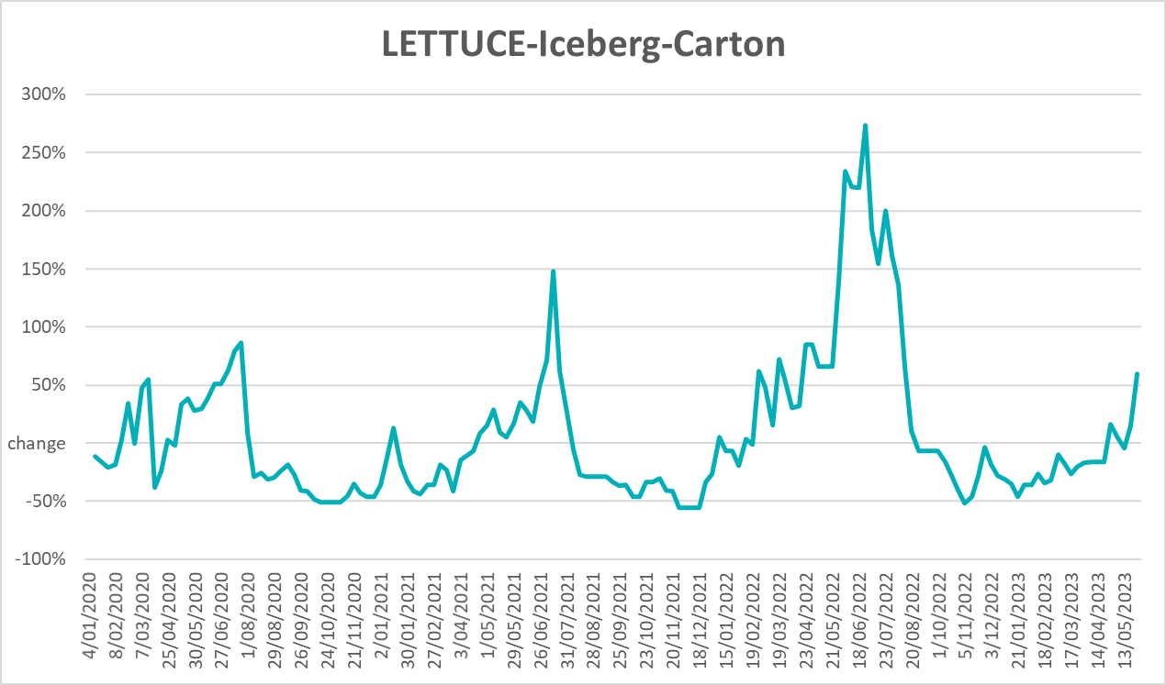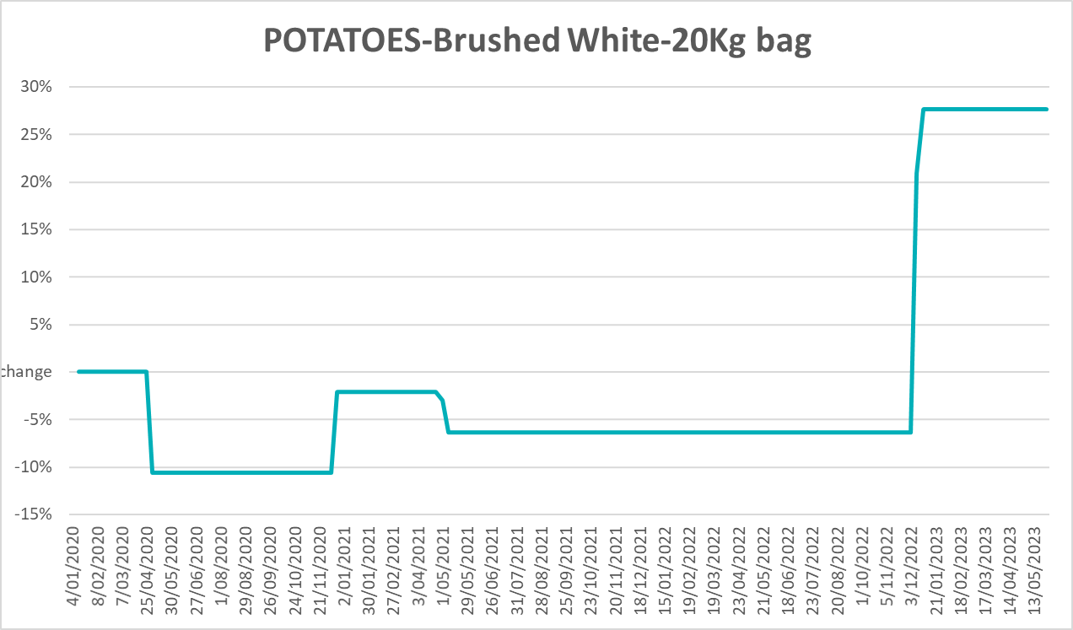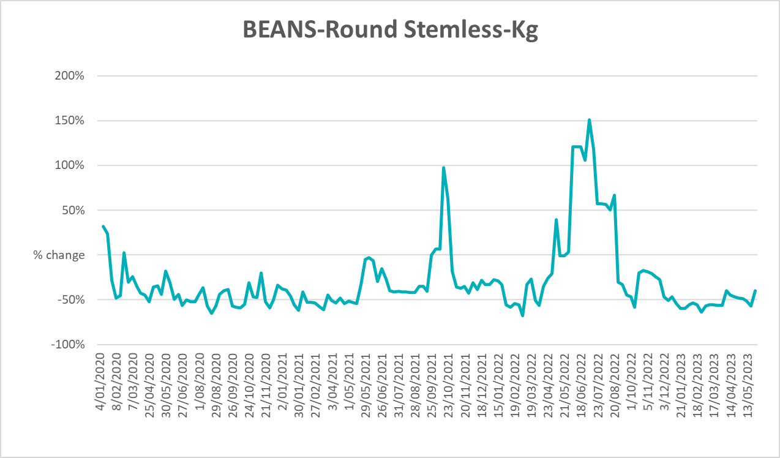

3.6 Selected domestic fodder indicator prices
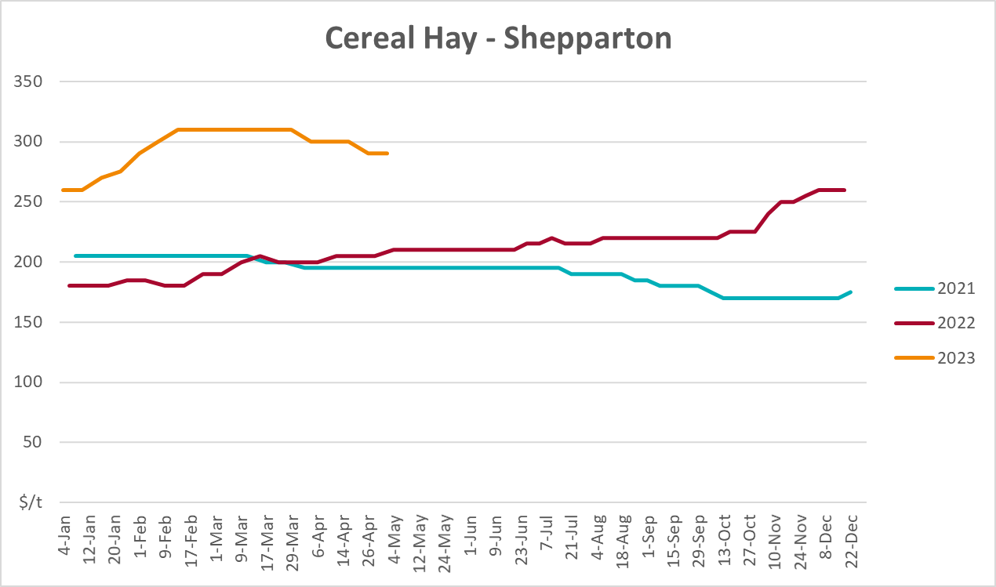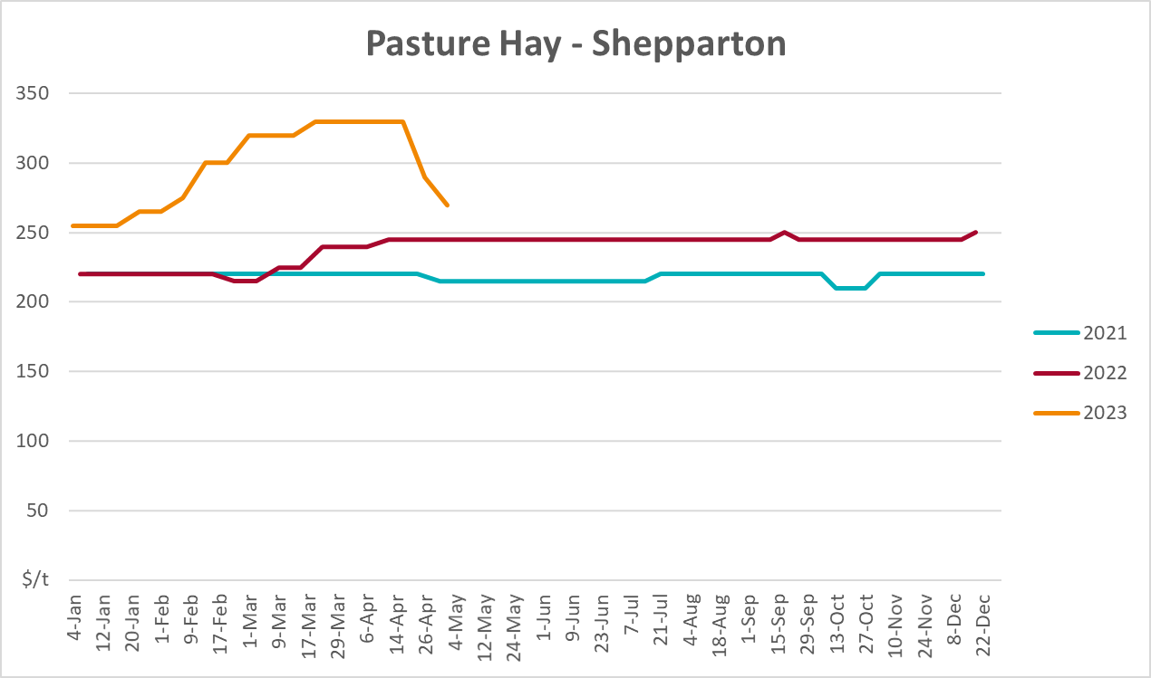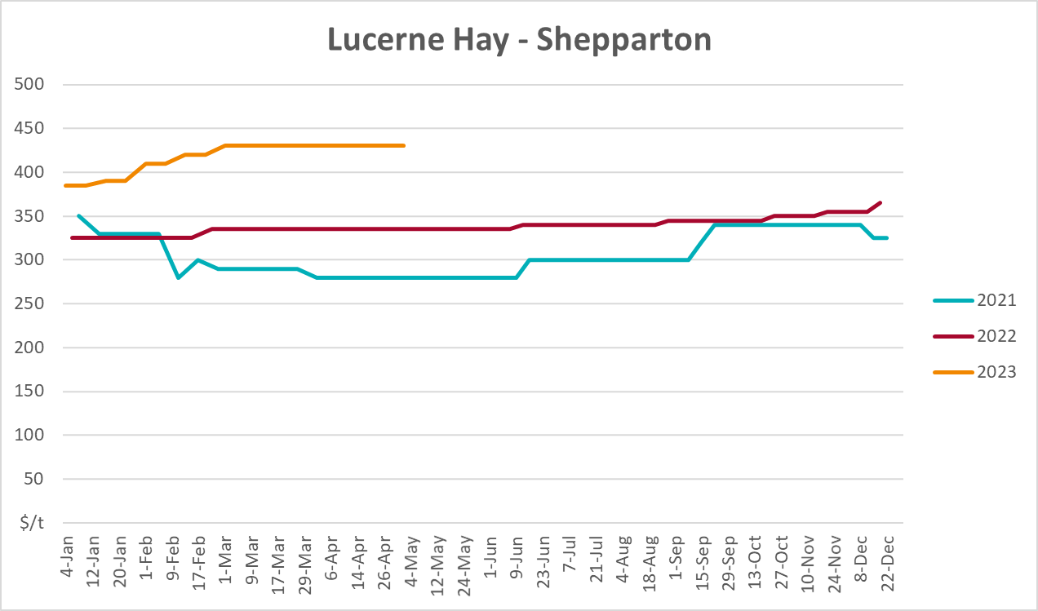

4. Data attribution

Climate
Bureau of Meteorology
- Weekly rainfall totals: www.bom.gov.au/climate/maps/rainfall/
- Monthly and last 3-month rainfall percentiles: www.bom.gov.au/water/landscape/
- Temperature anomalies: www.bom.gov.au/jsp/awap/temp/index.jsp
- Rainfall forecast: www.bom.gov.au/jsp/watl/rainfall/pme.jsp
- Seasonal outlook: www.bom.gov.au/climate/outlooks/#/overview/summary/
- Climate drivers: http://www.bom.gov.au/climate/enso/
- Soil moisture: www.bom.gov.au/water/landscape/
Other
- Pasture growth: www.longpaddock.qld.gov.au/aussiegrass/
- 3-month global outlooks: Environment and Climate Change Canada, NOAA Climate Prediction Center, EUROBRISA CPTEC/INPE, European Centre for Medium-Range Weather Forecasts, Hydrometcenter of Russia, National Climate Center Climate System Diagnosis and Prediction Room (NCC), International Research Institute for Climate and Society
- Global production: https://ipad.fas.usda.gov/ogamaps/cropmapsandcalendars.aspx
- Autumn break: Pook et al., 2009, https://rmets-onlinelibrary-wiley-com.virtual.anu.edu.au/doi/epdf/10.1002/joc.1833

Water
Prices
- Waterflow: https://www.waterflow.io/
- Ruralco: https://www.ruralcowater.com.au/
Bureau of Meteorology:
- Allocation trade: http://www.bom.gov.au/water/dashboards/#/water-markets/mdb/at
- Storage volumes: http://www.bom.gov.au/water/dashboards/#/water-storages/summary/drainage
Trade constraints:
- Water NSW: https://www.waternsw.com.au/customer-service/ordering-trading-and-pricing/trading/murrumbidgee
- Victorian Water Register: https://www.waterregister.vic.gov.au/TradingRules2019/

Commodities
Fruit and vegetables
- Datafresh: www.freshstate.com.au
Pigs
- Australian Pork Limited: www.australianpork.com.au
Dairy
- Global Dairy Trade: www.globaldairytrade.info/en/product-results/
World wheat, canola
- International Grains Council
World coarse grains
- United States Department of Agriculture
World cotton
- Cotlook: www.cotlook.com/
World sugar
- New York Stock Exchange - Intercontinental Exchange
Wool
- Australian Wool Exchange: www.awex.com.au/
Domestic wheat, barley, sorghum, canola and fodder
- Jumbuk Consulting Pty Ltd: http://www.jumbukag.com.au/
Cattle, beef, mutton, lamb, goat and live export
- Meat and Livestock Australia: www.mla.com.au/Prices-and-market
© Commonwealth of Australia 2023

Ownership of intellectual property rights
Unless otherwise noted, copyright (and any other intellectual property rights, if any) in this publication is owned by the Commonwealth of Australia (referred to as the Commonwealth).

Creative Commons licence
All material in this publication is licensed under a Creative Commons Attribution 4.0 International Licence except content supplied by third parties, logos and the Commonwealth Coat of Arms.
Inquiries about the licence and any use of this document should be emailed to copyright@awe.gov.au.
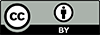

Cataloguing data
This publication (and any material sourced from it) should be attributed as:
ABARES 2023, Weekly Australian Climate, Water and Agricultural Update, Australian Bureau of Agricultural and Resource Economics and Sciences, Canberra, 8 June 2023. CC BY 4.0 DOI: https://doi.org/10.25814/5f3e04e7d2503
ISSN 2652-7561
This publication is available at https://www.agriculture.gov.au/abares/products/weekly_update
Department of Agriculture, Fisheries and Forestry
GPO Box 858 Canberra ACT 2601
Telephone 1800 900 090
Web agriculture.gov.au/abares

Disclaimer
The Australian Government acting through the Department of Agriculture, Fisheries and Forestry, represented by the Australian Bureau of Agricultural and Resource Economics and Sciences, has exercised due care and skill in preparing and compiling the information and data in this publication. Notwithstanding, the Department of Agriculture, Fisheries and Forestry, ABARES, its employees and advisers disclaim all liability, including liability for negligence and for any loss, damage, injury, expense or cost incurred by any person as a result of accessing, using or relying on any of the information or data in this publication to the maximum extent permitted by law.

Statement of Professional Independence
The views and analysis presented in ABARES publications, including this one, reflect ABARES professionally independent findings, based on scientific and economic concepts, principles, information and data. These views, analysis and findings may not reflect or be consistent with the views or positions of the Australian Government, or of organisations or groups who have commissioned ABARES reports or analysis. More information on professional independence is provided on the ABARES website.

Acknowledgements
This report was prepared by Kavina Dayal and Matthew Miller.

