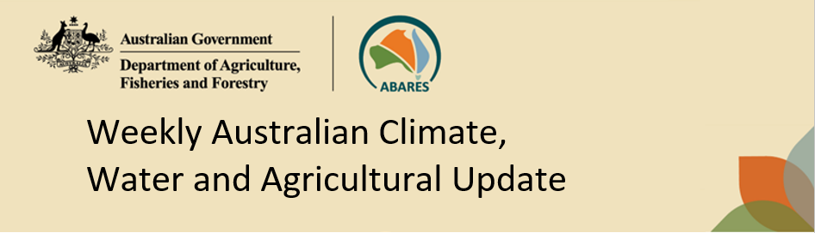
No. 16/2023 27 April 2023

Summary of key issues
- For the week ending 26 April 2023, high pressure systems brought little to no rainfall to much of Australia. Meanwhile, a low-pressure trough across northern Queensland combined with south-easterly airflow resulted in heavy falls in parts of the North Tropical Coast and Gulf Country. Onshore airflow brought locally heavy showers to coastal parts of northern New South Wales and northern Queensland coasts. A cold front resulted in heavy rainfall across southern parts of Western Australia.
- In cropping regions, rainfall total of up to 25 millimetres was recorded across south-eastern Western Australia. Little to no rainfall was recorded across the remaining cropping regions. Harvesting of summer crops would have continued with the clear, dry conditions (see Section 1.1).
- The El Niño–Southern Oscillation is in its neutral phase. The El Niño WATCH issued by the Bureau of Meteorology continues. The Indian Ocean Dipole (IOD) is currently neutral. A positive IOD event may develop in the coming months. A positive IOD can suppress winter and spring rainfall over much of Australia, potentially exacerbating the drying effect of El Niño, should it occur (see Section 1.2).
- The outlook for May 2023 indicates drier than average conditions are expected across much of Australia. Given that many winter cropping regions have received enough rainfall to classify as an early autumn break, these forecast rainfall totals are likely to be sufficient to provide a favourable start to the winter season (see Section 1.3).
- The outlook for May to July 2023 suggests there is a 75% chance of rainfall totals over 25 millimetres across central and eastern New South Wales, the southeast and northeast of Queensland, southern parts of South Australia and Western Australia, and across Victoria and Tasmania. Across most winter cropping regions there is a 75% chance of receiving between 25 and 100 millimetres, except for central and northern Queensland where rainfall totals are expected to be below 25 millimetres (see Section 1.3).
- Over the 8-days to 4 May 2023, troughs and a front are expected to trigger showers over southern parts of Western Australia and South Australia. A front and a low will generate showers and storms over Victoria, New South Wales, Tasmania and southern Queensland. Onshore, moist winds will trigger showers over southeast Queensland and northeast New South Wales. The high-pressure systems will keep the interior clear and dry (see Section 1.4).
- Across Australian cropping regions, rainfall totals of up to 50 millimetres are expected for central and northern New South Wales and up to 25 millimetres in southern Victoria and South Australia. Little to no rainfall is expected for the remaining cropping regions (see Section 1.4).
- Water storage levels in the Murray-Darling Basin (MDB) decreased between 20 April 2023 and 27 April 2023 by 353 gigalitres (GL). Current volume of water held in storage is 19 603 GL. This is 1 percent or 224 GL more than at the same time last year.
- Allocation prices in the Victorian Murray below the Barmah Choke decreased from $11 on 20 April 2023 to $10 on 27 April 2023. Prices are lower in the Murrumbidgee and regions above the Barmah choke due to the binding of the Murrumbidgee export limit.

Climate

Rainfall this week
For the week ending 26 April 2023, high pressure systems brought little to no rainfall to much of Australia. Meanwhile, a low-pressure trough across northern Queensland combined with south-easterly airflow resulted in heavy falls in parts of the North Tropical Coast and Gulf Country. Onshore airflow brought locally heavy showers to coastal parts of northern New South Wales and northern Queensland coasts. A cold front resulted in heavy rainfall across southern parts of Western Australia.
In cropping regions, rainfall total of up to 25 millimetres was recorded across south-eastern Western Australia. Little to no rainfall was recorded across the remaining cropping regions. Harvesting of summer crops would have continued with the clear, dry conditions over the past week.

Rainfall for the week ending 26 April 2023
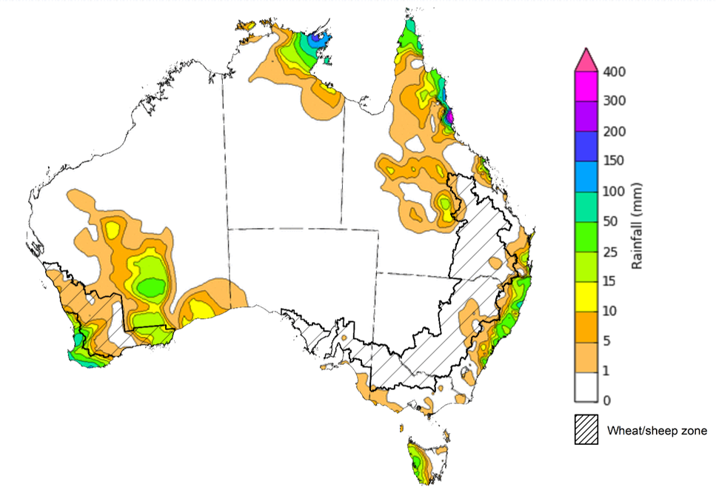
©Commonwealth of Australia 2023, Australian Bureau of Meteorology Issued: 26/04/2023
Note: The rainfall analyses and associated maps utilise data contained in the Bureau of Meteorology climate database, the Australian Data Archive for Meteorology (ADAM). The analyses are initially produced automatically from real-time data with limited quality control. They are intended to provide a general overview of rainfall across Australia as quickly as possible after the observations are received. For further information go to http://www.bom.gov.au/climate/rainfall/

Climate Drivers
The climate drivers with the largest potential impact on Australia’s climate patterns are the El Niño–Southern Oscillation (ENSO), Madden-Julian Oscillation (MJO), Indian Ocean Dipole (IOD) and Southern Annular Mode (SAM). These climate drivers are likely to influence the growth and development of later planted summer crops in northern growing regions, pasture growth across both northern and southern Australia and planting opportunities for winter crops.
The ENSO is in its neutral phase. For the week ending April 23, the oceanic indicator measured in terms of the sea surface temperature (SST) were warmer than average over the eastern equatorial Pacific. The warm SST anomalies have increased in strength and spatial extent in the far east compared to two weeks ago. For the period ending 24 April 2023, the 30-day Southern Oscillation Index (SOI), i.e., the atmospheric indicator, was -3.6 and the 90-day SOI was +3.6, both have continued to decrease over the past fortnight where the 30-day SOI continues to be negative.

Difference from average sea surface temperature observations 17 to 23 April 2023
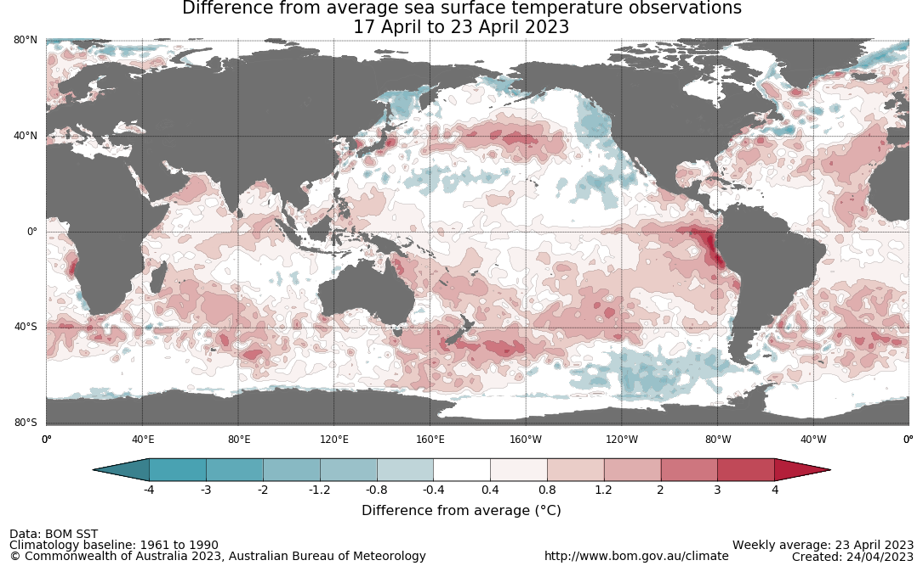

30-day Southern Oscillation Index (SOI) values ending 24 April 2023
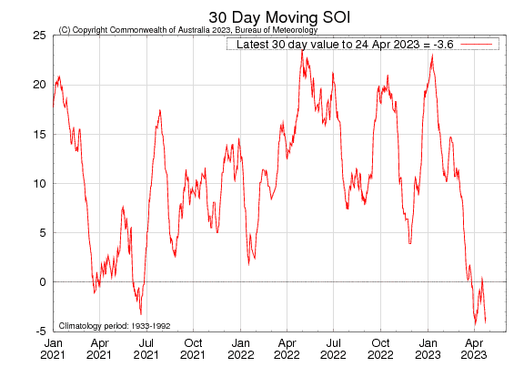

The El Niño WATCH issued by the Bureau of Meteorology continues. This indicates that there is around a 50% chance that an El Niño may develop later in 2023. El Niño WATCH is not a guarantee that El Niño will occur, but it is an indication that some of the typical precursors are currently observed. All but one international climate model surveyed by the Australian Bureau of Meteorology suggest sea-surface temperatures in the tropical Pacific will remain neutral through the southern hemisphere autumn, with one model exceeding El Niño thresholds in May. From June, all but one of the models indicate El Niño threshold will be met or exceeded, with the remaining model surpassing El Niño threshold in July.

International climate model outlooks for the ENSO in NINO 3.4 region
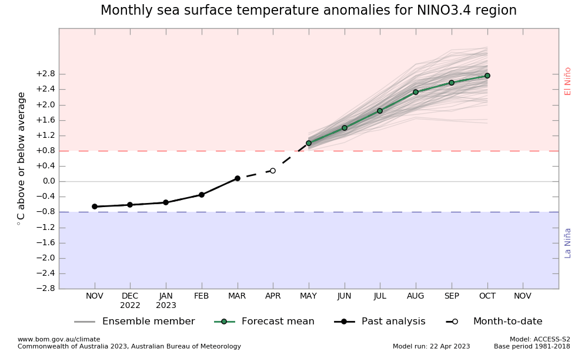
©Commonwealth of Australia 2023, Australian Bureau of Meteorology Issued: 11/4/2023

The Indian Ocean Dipole (IOD) is currently neutral. A negative phase typically sees above average winter-spring rainfall in Australia, while a positive phase brings drier than average seasons. The majority of international climate models surveyed by the Bureau of Meteorology suggest a positive IOD event may develop in the coming months. A positive IOD can supress winter and spring rainfall over much of Australia, potentially exacerbating the drying effect of El Niño, should it occur.
While models’ predictions are tipping towards an El Niño developing in mid-to-late 2023 and a positive IOD may emerge during late autumn or winter, the ENSO and IOD forecasts made at this time of the year have very low accuracy when forecasting through the autumn and therefore ENSO and IOD outlooks that extend past autumn should be viewed with caution.

International climate model outlook for the Indian Ocean Dipole
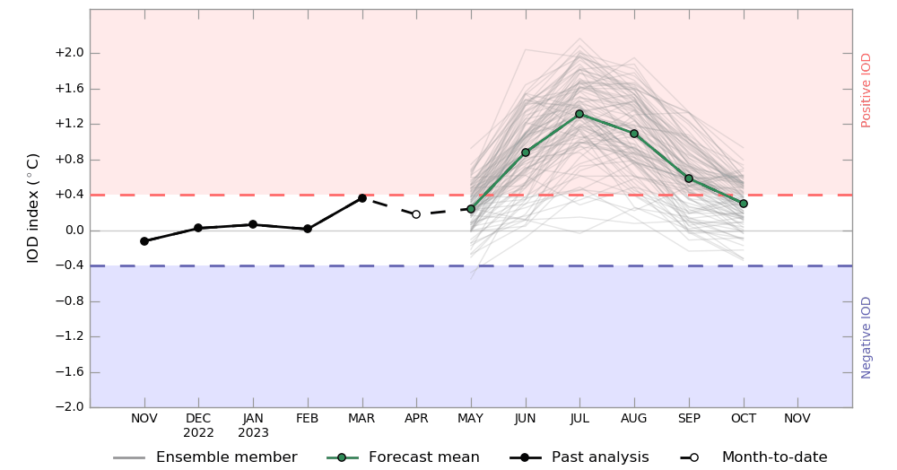
©Commonwealth of Australia 2023, Australian Bureau of Meteorology Issued: 11/4/2023

The Madden–Julian Oscillation (MJO) pulse is expected to weaken in the coming days before possibly strengthening over the Maritime Continent in early May. This may result in rainfall over northern Australia. By May, the MJO has little to no influence on rainfall patterns, resulting in an end to the northern Australia wet season.

Madden–Julian Oscillation (MJO) daily index
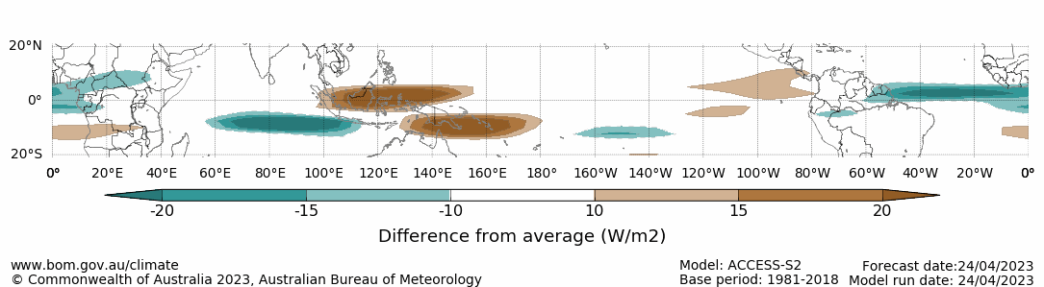
Note: This map displays the forecast outgoing longwave radiation (OLR) difference from expected cloudiness to identify convective rain clouds and the position of the Madden–Julian Oscillation (MJO). The blue shading indicates higher than normal, active or enhanced tropical weather and the brown shading indicates lower than normal clouds or suppressed conditions.

National Climate Outlook
These climate outlooks are generated by ACCESS–S (Australian Community Climate Earth-System Simulator–Seasonal). ACCESS–S is the Bureau of Meteorology's dynamic (physics-based) weather and climate model used for monthly, seasonal, and longer-lead climate outlooks. For further information, go to http://www.bom.gov.au/climate/ahead/about/.
The Bureau of Meteorology’s latest rainfall outlook for May 2023 indicates drier than average conditions are expected across much of Australia.
The ACCESS-S climate model suggests that there is a 75% chance of rainfall totals between 10 and 50 millimetres across eastern New South Wales, scattered areas of coastal Queensland, much of Victoria, southern South Australia, Tasmania and the southwest of Western Australia. Rainfall totals in excess of 100 millimetres are expected in parts of northeast Queensland and western Tasmania.
Across cropping regions there is a 75% chance of rainfall totals of between 10 and 25 millimetres across the far southeast of New South Wales, southern Victoria, central and western South Australia and much of Western Australia. There is a 75% chance of rainfall less than 10 millimetres for Queensland, much of New South Wales, northern Victoria, and eastern South Australia and parts of eastern Western Australia. Given that many winter cropping regions have received enough rainfall to classify as an early autumn break, these forecast rainfall totals are likely to be sufficient to provide a favourable start to the winter season. Meanwhile, lower rainfall totals during May will allow timely field access for the planting of winter crops and harvesting activity for late planted summer crops across Queensland and northern New South Wales.
Rainfall totals that have a 75% chance of occurring in May 2023
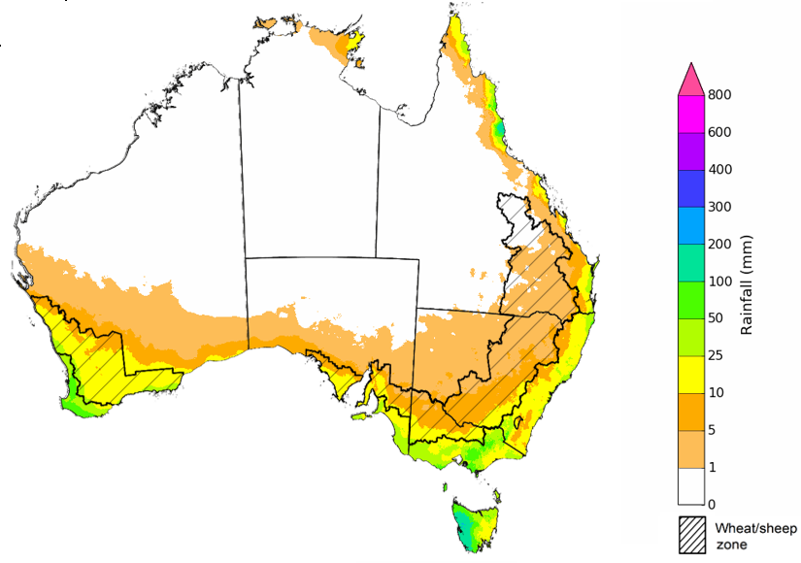

©Commonwealth of Australia 2023, Australian Bureau of Meteorology Issued:27/04/2023

The rainfall outlook for May to July 2023 suggests that below median rainfall is likely to very likely (60% to greater than 80% chance) for most of Australia. However, there is close to equal chances of above or below median rainfall for parts of tropical northern Queensland and south-eastern Victoria, western part of Western Australia, as well as in the southern Tasmania.
Bureau of Meteorology rainfall outlooks for May to July have greater than 55% past accuracy across most of Australia. Outlook accuracy is greater than 65% across large areas of western and eastern Australia. However, there is low past accuracy for scattered areas of northern Australia.
Chance of exceeding the median rainfall May to July 2023
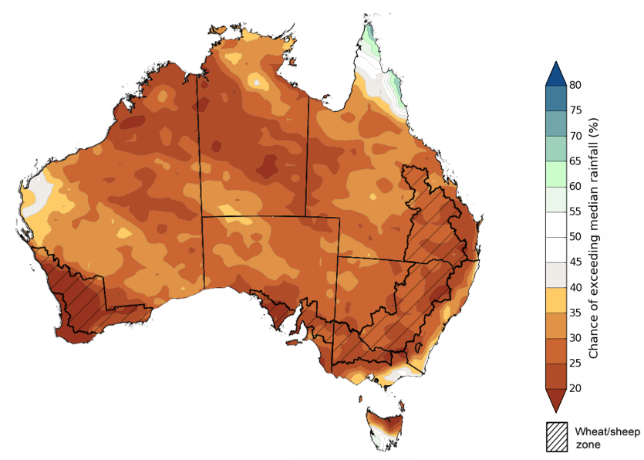
©Commonwealth of Australia 2023, Australian Bureau of Meteorology Issued: 27/04/2023

The outlook for May to July 2023 suggests there is a 75% chance of rainfall totals between 25 and 200 millimetres across central and eastern New South Wales, the southeast and northeast of Queensland, southern parts of South Australia and Western Australia, Victoria and Tasmania. Rainfall totals in excess of 200 millimetres are forecast for alpine regions of Victoria, part of northeast Queensland, far southwest of Western Australia and western Tasmania.
Across most winter cropping regions there is a 75% chance of receiving between 25 and 100 millimetres, except for central and northern Queensland where rainfall totals are expected to be below 25 millimetres.
Root zone soil moisture levels are average to above average across much of the Wheat/sheep zone but below average across south-western Queensland and parts of north-western New South Wales. A lack of rainfall during summer and declining soil moisture levels led to reductions in yield potentials for later sown summer crops across northern cropping regions. In remaining cropping regions, given the current average to above average levels of root zone soil moisture levels the expectation of below average rainfall over the next three months is still likely to provide a good start to the winter cropping season.
Rainfall totals that have a 75% chance of occurring May to July 2023
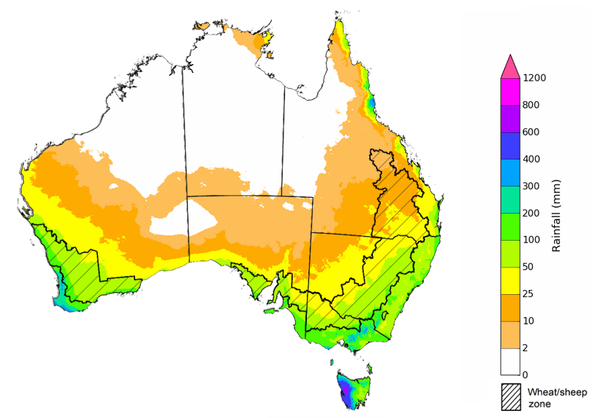
©Commonwealth of Australia 2023, Australian Bureau of Meteorology Issued: 27/04/2023
The temperature outlook for May to July 2023 indicates that maximum temperatures across most of Australia are likely to be close to the 1990-2012 average (-1°C to +1°C) while slightly warmer (up to +2°C) across much of Western Australia and in parts of South Australia, southern Queensland and northern New South Wales. The minimum temperatures across most of Australia are expected to be close to the 1990-2012 average (-1°C to +1°C).
Predicted maximum temperature anomaly for May to July 2023
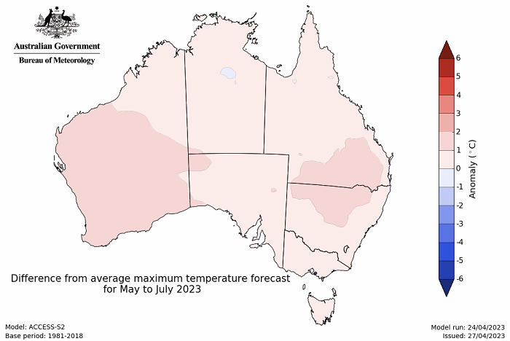
Predicted minimum temperature anomaly for May to July 2023
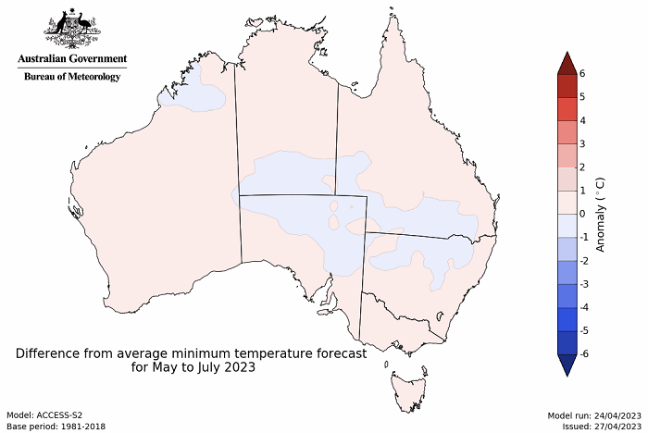

Rainfall forecast for the next eight days
Over the 8-days to 4 May 2023, troughs and a front are expected to trigger showers over southern parts of Western Australia and South Australia. A front and a low will generate showers and storms over Victoria, New South Wales, Tasmania and southern Queensland. Onshore, moist winds will trigger showers over southeast Queensland and northeast New South Wales. The high-pressure systems will keep the interior clear and dry.
Across Australian cropping regions, rainfall totals of up to 50 millimetres are expected for central and northern New South Wales and up to 25 millimetres in southern Victoria and South Australia. Little to no rainfall is expected for the remaining cropping regions in the next eight days. For those areas of the Australian wheatbelt where rainfall is forecast over the coming 8-days it is likely to build soil moisture levels in the led up to the winter cropping season and also benefit pasture growth rates and availability.

Total forecast rainfall for the period 27 April to 4 May 2023
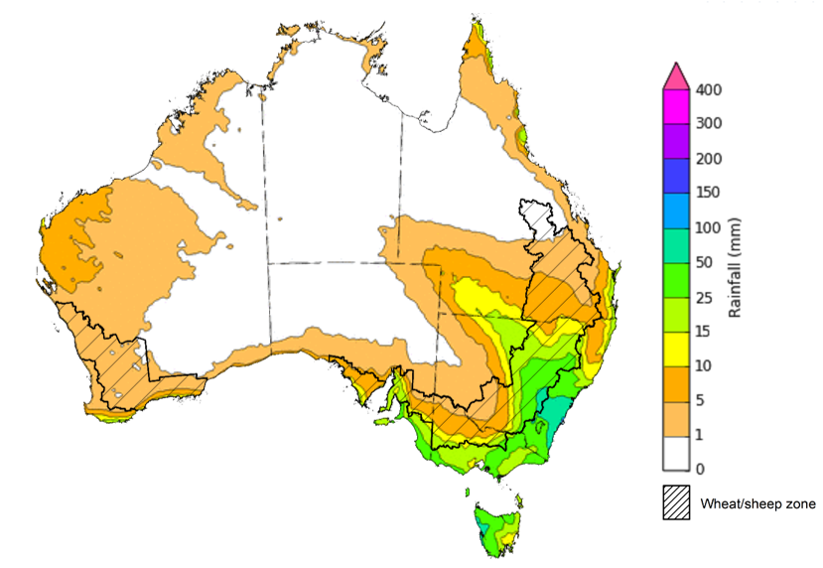

©Commonwealth of Australia 2023, Australian Bureau of Meteorology Issued 27/04/2023
Note: This rainfall forecast is produced from computer models. As the model outputs are not altered by weather forecasters, it is important to check local forecasts and warnings issued by the Bureau of Meteorology.

Water

Water markets – current week
Water storage levels in the Murray-Darling Basin (MDB) decreased between 20 April 2023 and 27 April 2023 by 353 gigalitres (GL). Current volume of water held in storage is 19 603 GL. This is 1 percent or 224 GL more than at the same time last year.

Water storages in the Murray-Darling Basin, 2013–2023
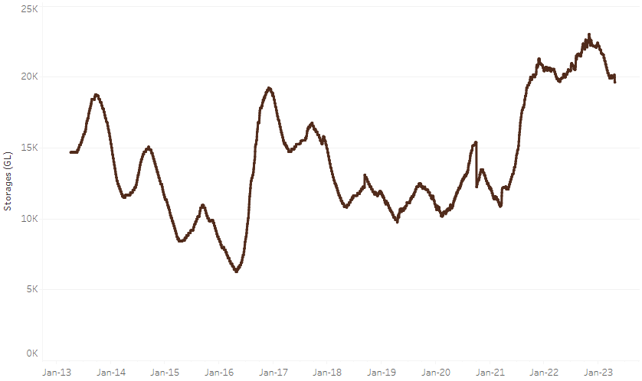
Allocation prices in the Victorian Murray below the Barmah Choke decreased from $11 on 20 April 2023 to $10 on 27 April 2023. Prices are lower in the Murrumbidgee and regions above the Barmah choke due to the binding of the Murrumbidgee export limit.
Water storage data is sourced from the Bureau of Meteorology.

Region | $/ML
NSW Murray Above | 12
NSW Murrumbidgee | 5
VIC Goulburn-Broken | 11
VIC Murray Below | 10

Surface water trade activity, Southern Murray–Darling Basin
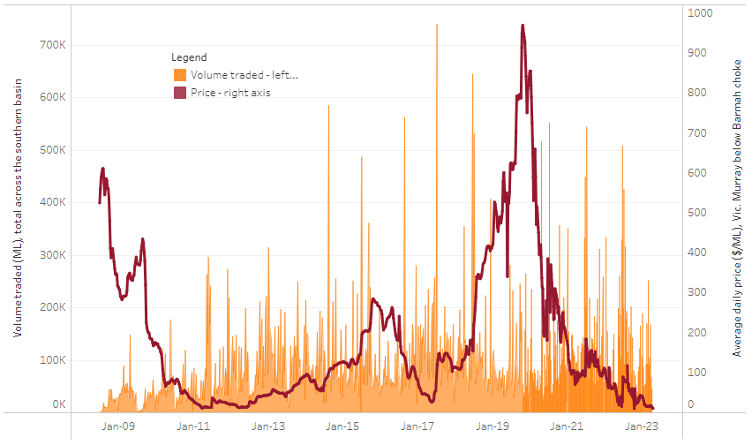
The trades shown reflect estimated market activity and do not encompass all register trades. The price is shown for the VIC Murray below the Barmah choke. Historical prices (before 1 July 2019) are ABARES estimates after removing outliers from BOM water register data. Prices after 1 July 2019 and prior to the 30 October 2019 reflect recorded transaction prices as sourced from Ruralco. Prices after the 30 October 2019 are sourced from Waterflow. Data for volume traded is sourced from the BOM water register. Only the price data shown is current on 13 April 2023.

To access the full, interactive, weekly water dashboard, which contains the latest and historical water storage, water market and water allocation information, please visit https://www.agriculture.gov.au/abares/products/weekly_update/weeakly-update-27423

Commodities
Indicator | Week ended | Unit | Latest Price | Previous Week | Weekly change | Price 12 months ago | Annual change
Selected world indicator prices
AUD/USD Exchange rate | 26-Apr | A$/US$ | 0.66 | 0.67 | -1% | 0.71 | -7%
Wheat – US no. 2 hard red winter wheat, fob Gulf | 26-Apr | US$/t | 366 | 392 | -7% | 486 | -25%
Corn – US no. 2 yellow corn, fob Gulf | 26-Apr | US$/t | 290 | 299 | -3% | 350 | -17%
Canola – Rapeseed, Canada, fob Vancouver | 26-Apr | US$/t | 587 | 613 | -4% | 961 | -39%
Cotton – Cotlook 'A' Index | 26-Apr | USc/lb | 94 | 97 | -3% | 170 | -45%
Sugar – Intercontinental Exchange, nearby futures, no.11 contract | 26-Apr | USc/lb | 25.6 | 23.9 | 7% | 19 | 36%
Wool – Eastern Market Indicator | 12-Apr | Ac/kg clean | 1,289 | 1,289 | 0% | 1,407 | -8%
Wool – Western Market Indicator | 12-Apr | Ac/kg clean | 1,442 | 1,442 | 0% | 1,436 | 0%
Selected Australian grain export prices
Milling Wheat – APW, Port Adelaide, SA | 26-Apr | A$/t | 460 | 469 | -2% | 580 | -21%
Feed Wheat – ASW, Port Adelaide, SA | 26-Apr | A$/t | 434 | 443 | -2% | 547 | -21%
Feed Barley – Port Adelaide, SA | 26-Apr | A$/t | 406 | 416 | -2% | 500 | -19%
Canola – Kwinana, WA | 26-Apr | A$/t | 886 | 895 | -1% | 1,269 | -30%
Grain Sorghum – Brisbane, QLD | 26-Apr | A$/t | 500 | 501 | 0% | 437 | 14%
Selected domestic livestock indicator prices
Beef – Eastern Young Cattle Indicator | 26-Apr | Ac/kg cwt | 673 | 691 | -3% | 1,082 | -38%
Mutton – Mutton indicator (18–24 kg fat score 2–3), Vic | 26-Apr | Ac/kg cwt | 429 | 420 | 2% | 572 | -25%
Lamb – Eastern States Trade Lamb Indicator | 26-Apr | Ac/kg cwt | 664 | 676 | -2% | 791 | -16%
Pig – Eastern Seaboard (60.1–75 kg), average of buyers & sellers | 05-Apr | Ac/kg cwt | 357 | 357 | 0% | 357 | 0%
Goats – Eastern States (12.1–16 kg) | 05-Apr | Ac/kg cwt | 280 | 280 | 0% | 815 | -66%
Live cattle – Light steers ex Darwin to Indonesia | 17-Aug | Ac/kg lwt | 420 | 480 | -13% | 320 | 31%
Live sheep – Live wethers (Muchea WA saleyard) to Middle East | 14-Sep | $/head | 93 | 113 | -18% | 114 | -18%
Global Dairy Trade (GDT) weighted average prices ª
Dairy – Whole milk powder | 19-Apr | US$/t | 3,089 | 3,053 | 1% | 4,085 | -24%
Dairy – Skim milk powder | 19-Apr | US$/t | 2,776 | 2,579 | 8% | 3,367 | -18%
Dairy – Cheddar cheese | 19-Apr | US$/t | 4,411 | 4,167 | 6% | 4,393 | 0%
Dairy – Anhydrous milk fat | 19-Apr | US$/t | 4,981 | 4,736 | 5% | 6,209 | -20%
a Global Dairy Trade prices are updated twice monthly on the first and third Tuesday of each month.

Selected world indicator prices
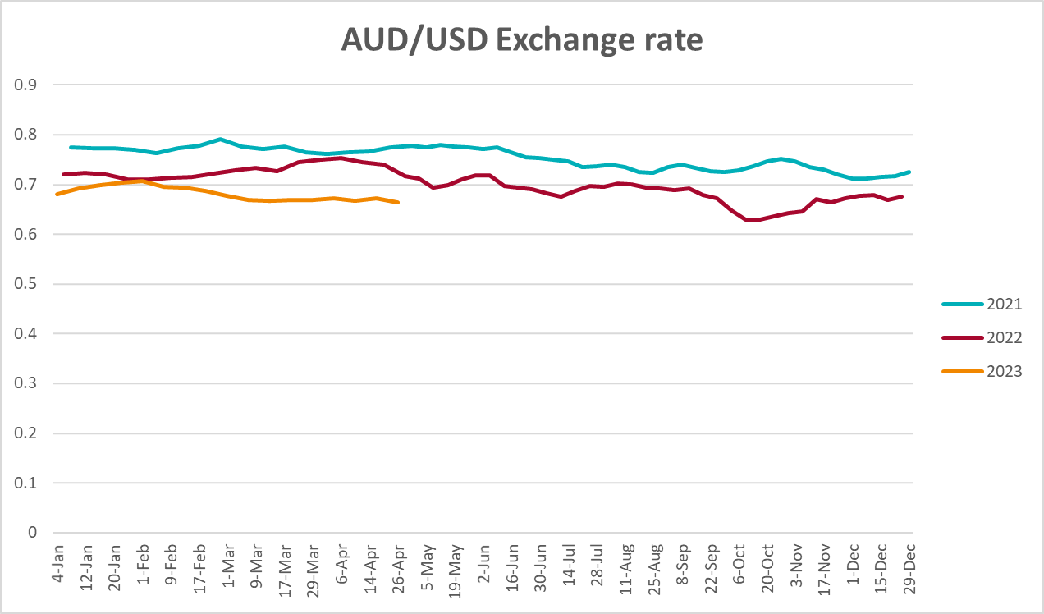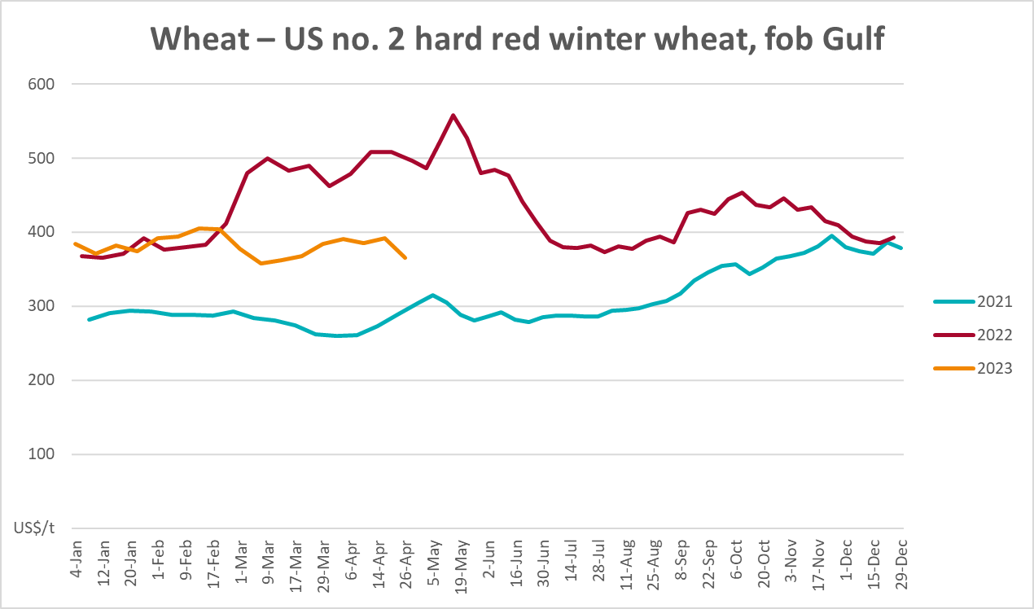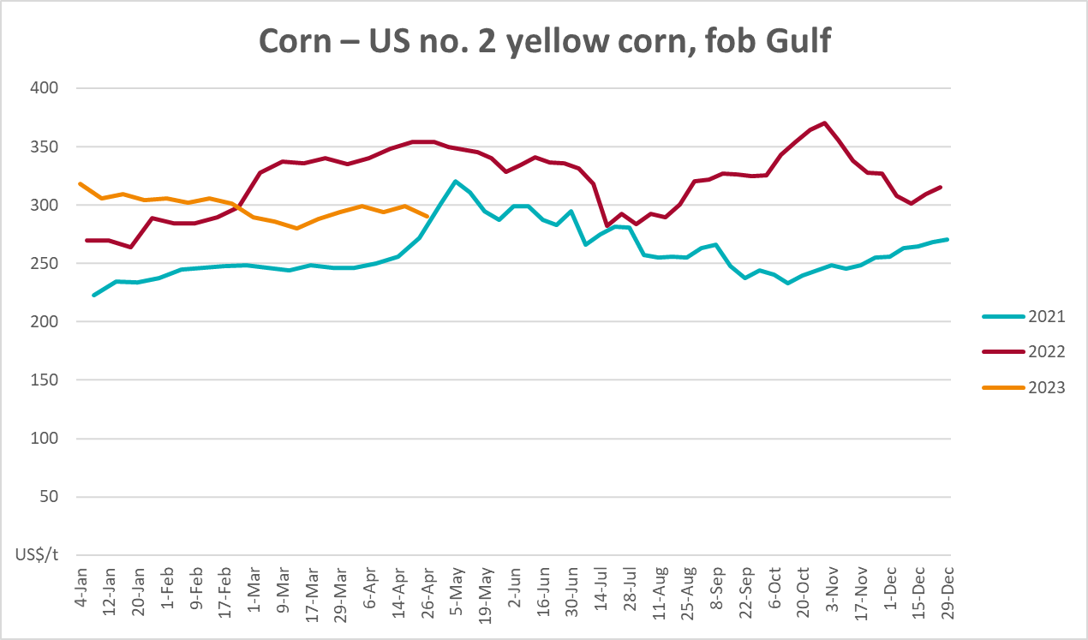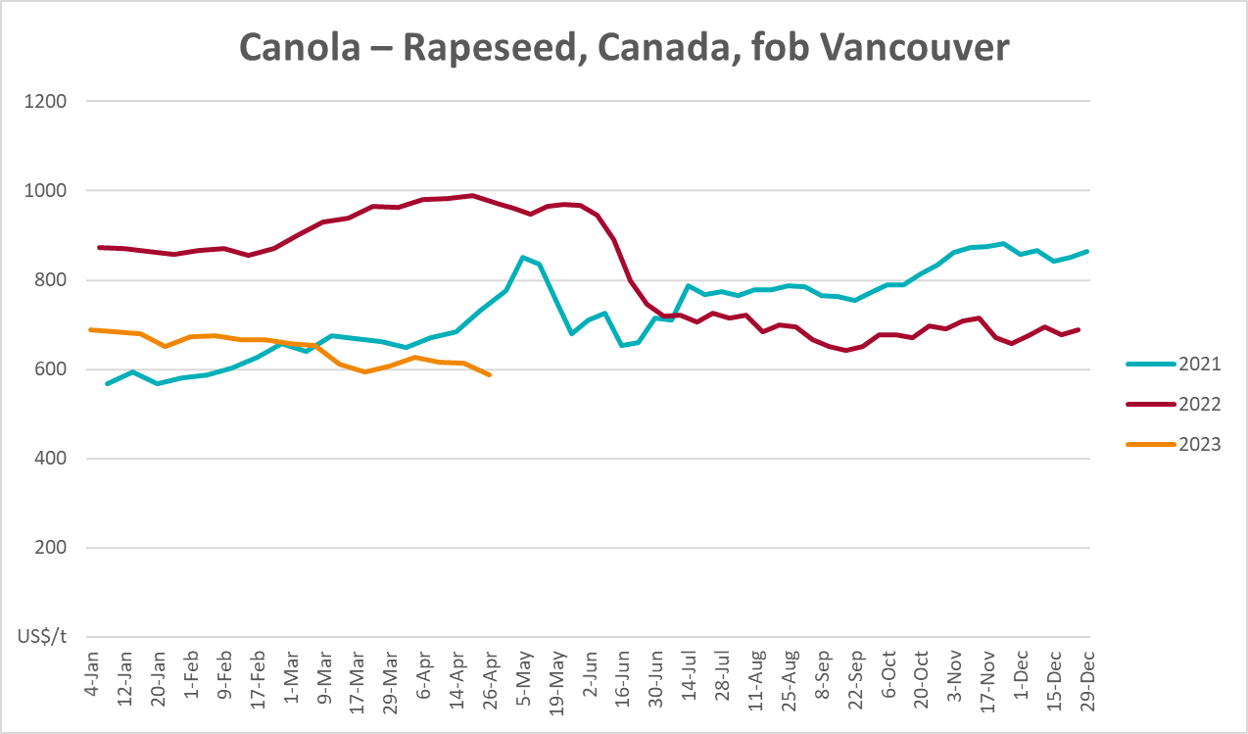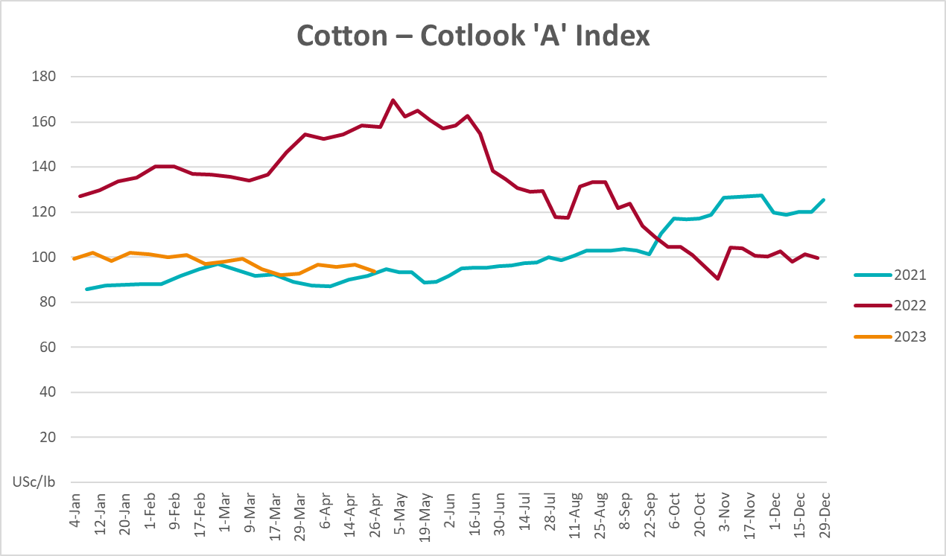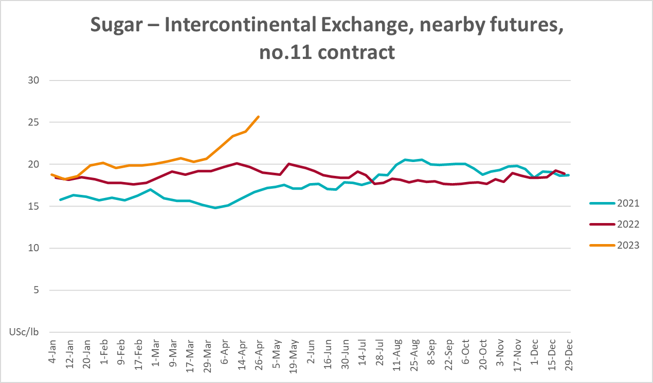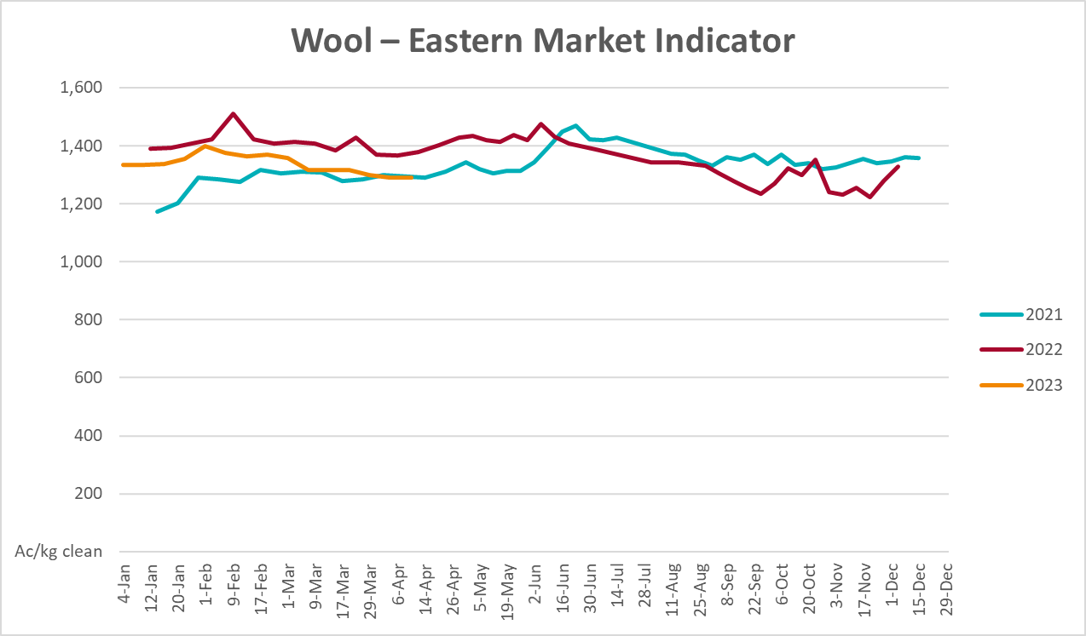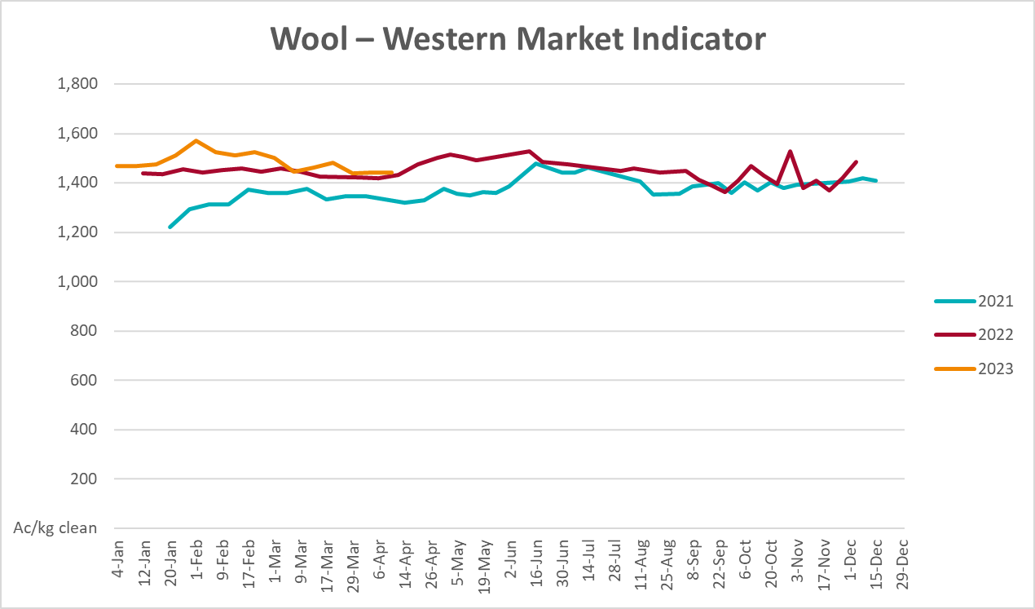

Selected domestic crop indicator prices
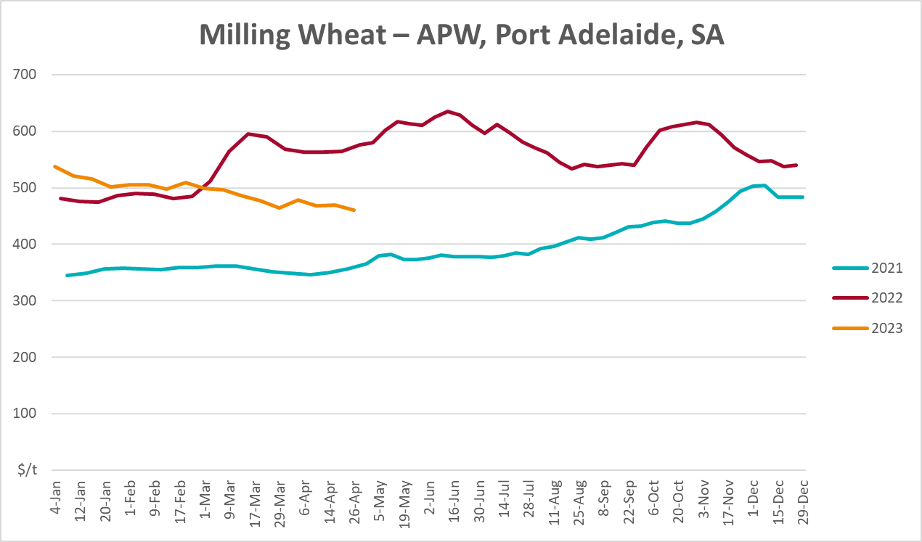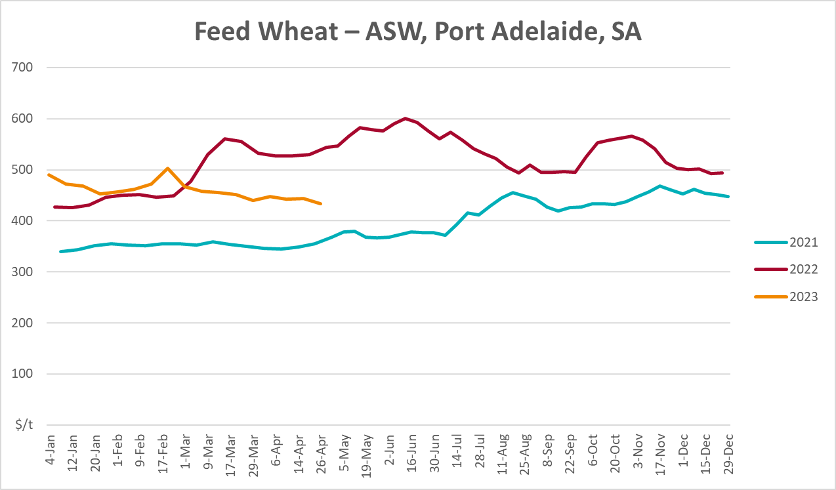
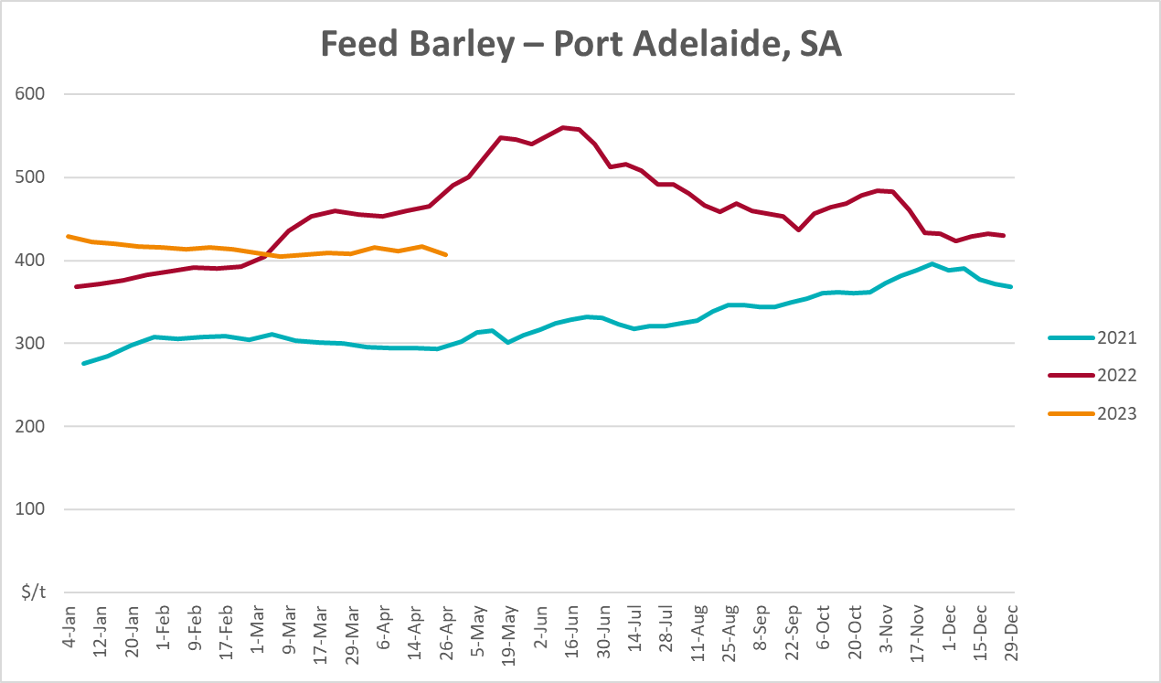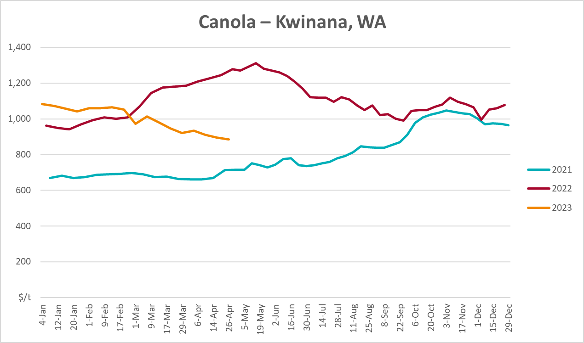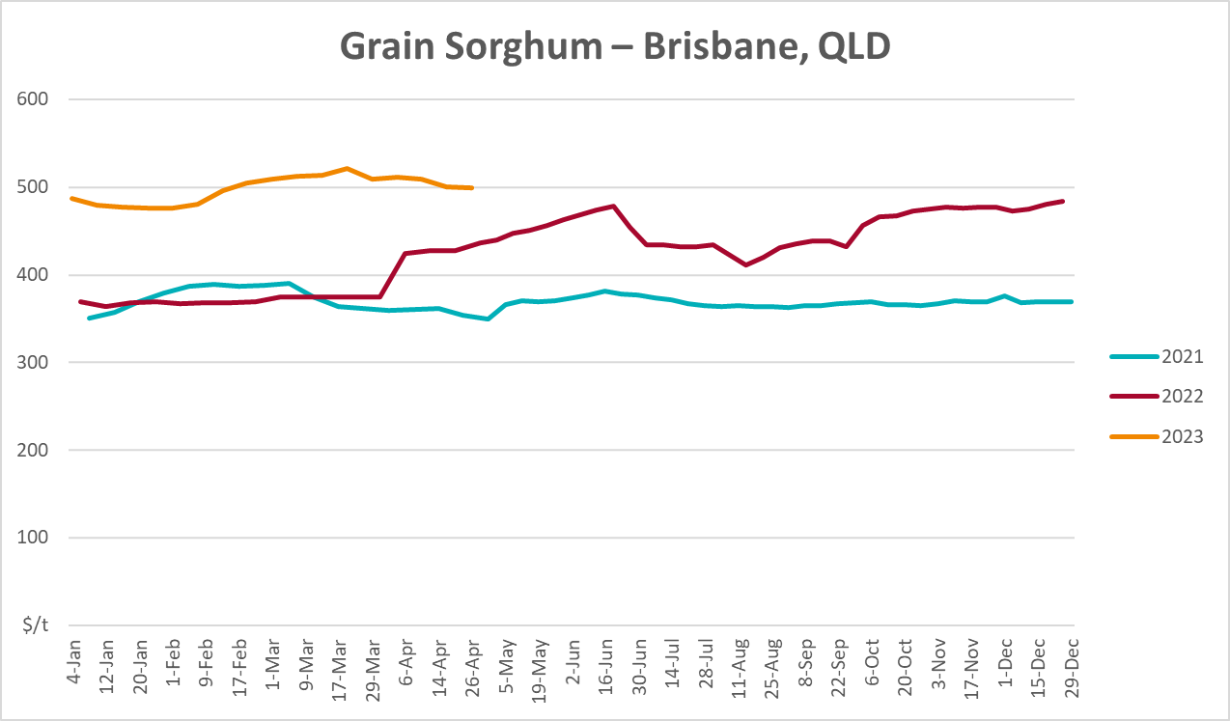

Selected domestic livestock indicator prices
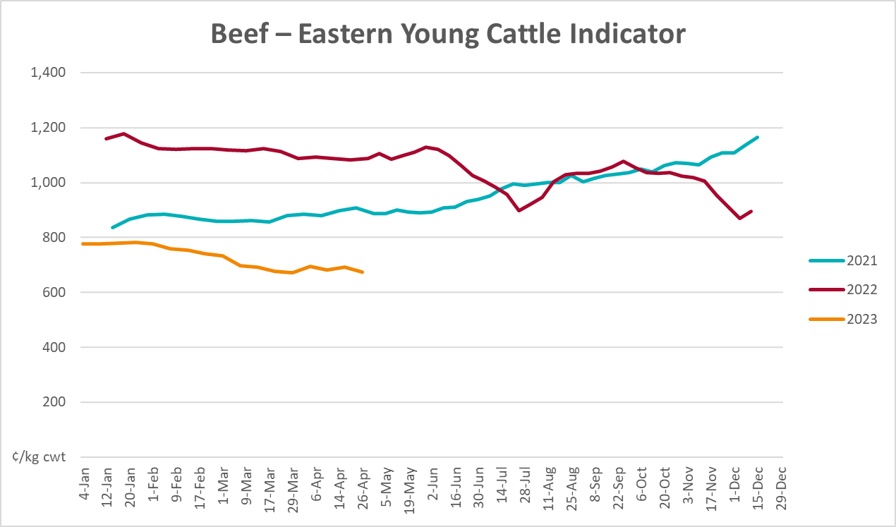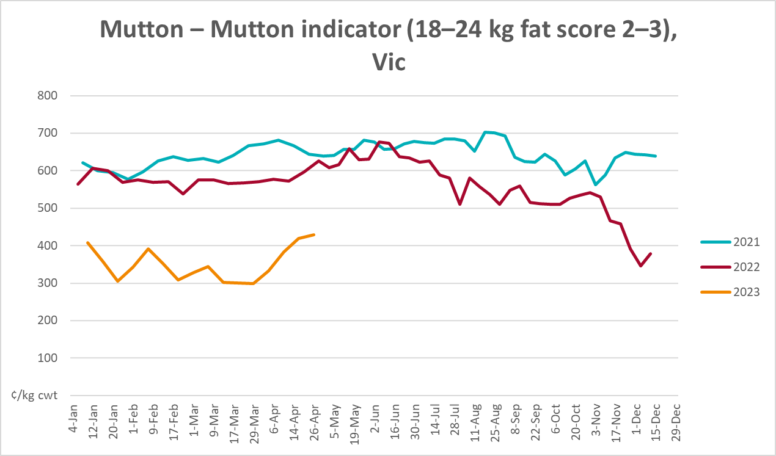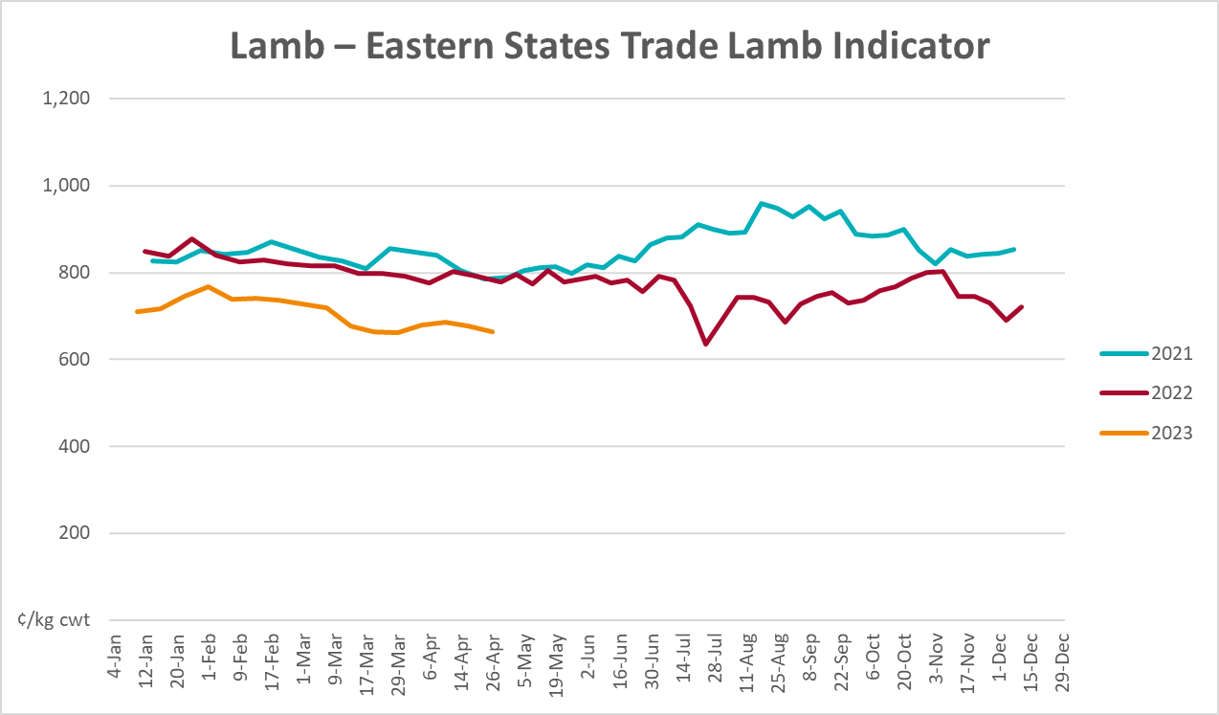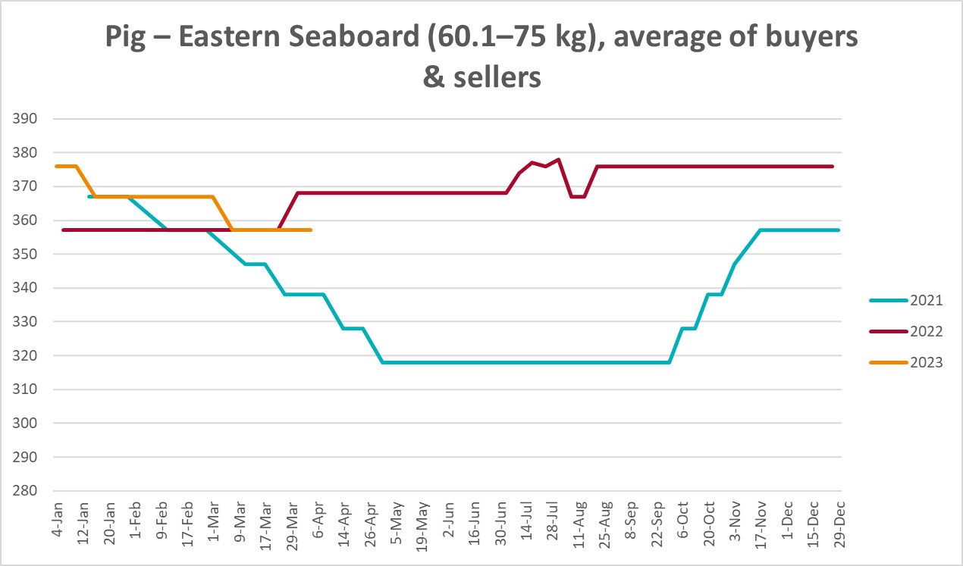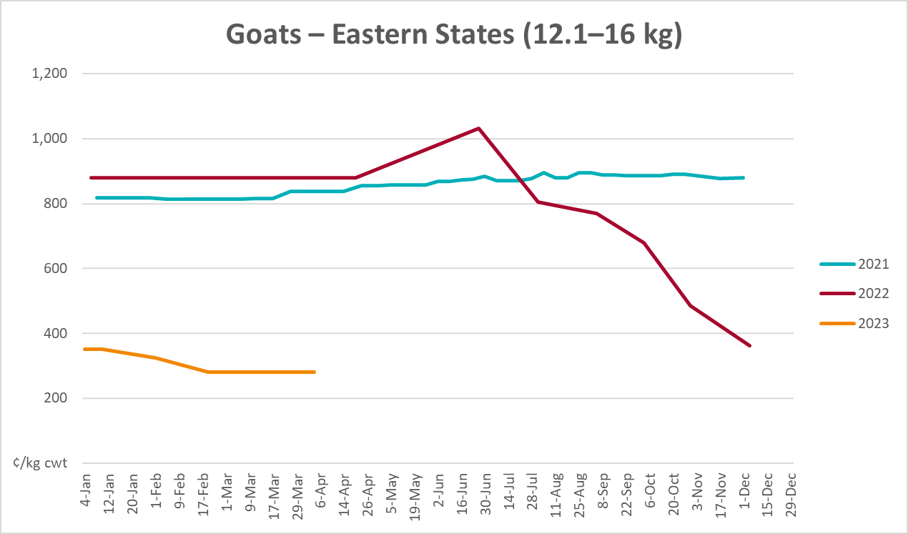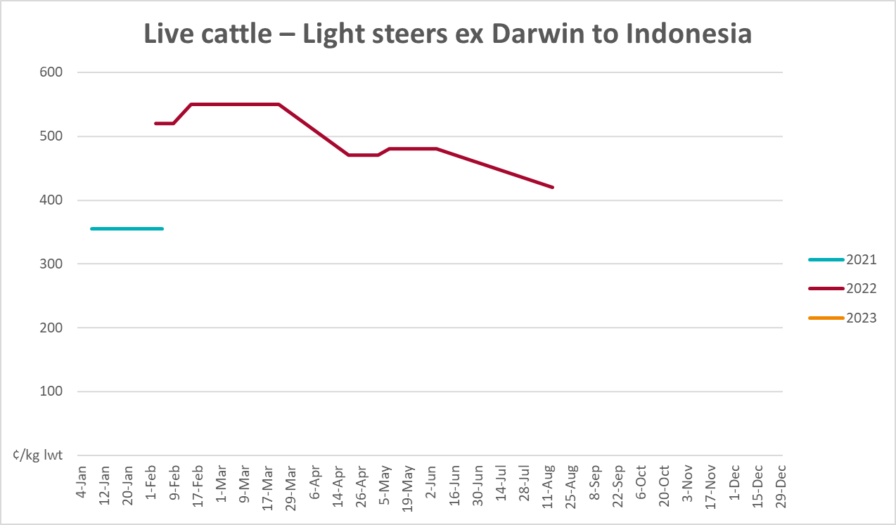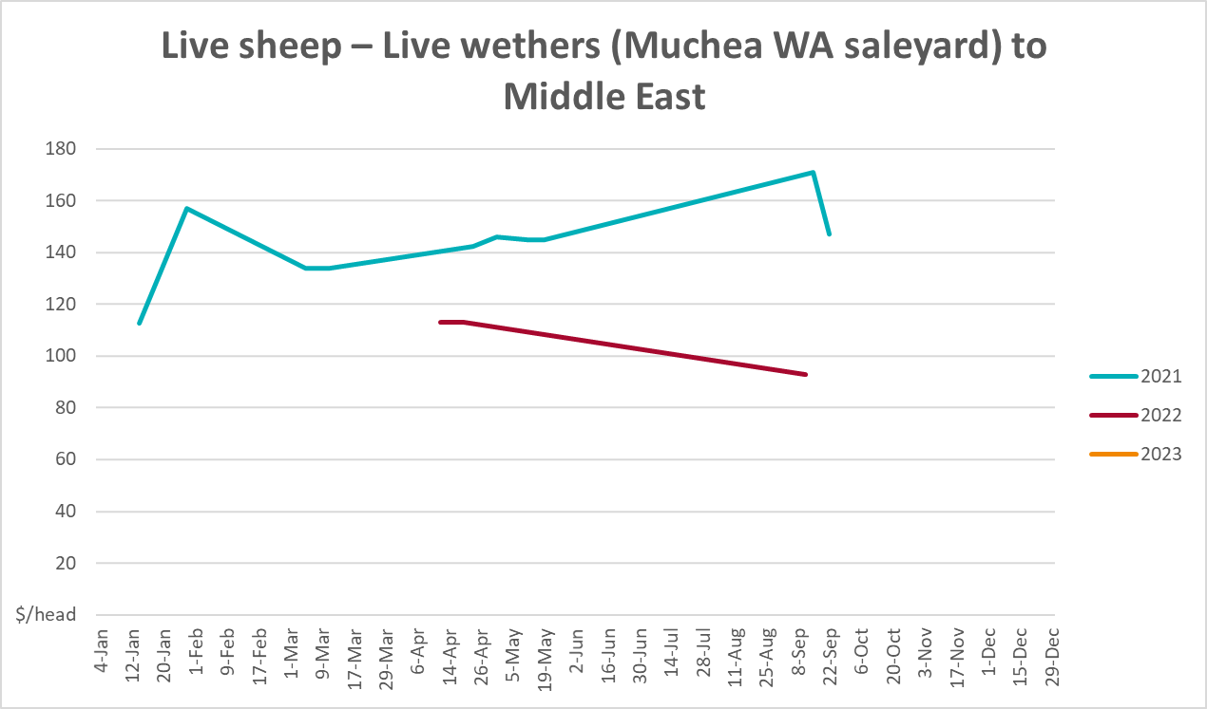

Global Dairy Trade (GDT) weighted average prices
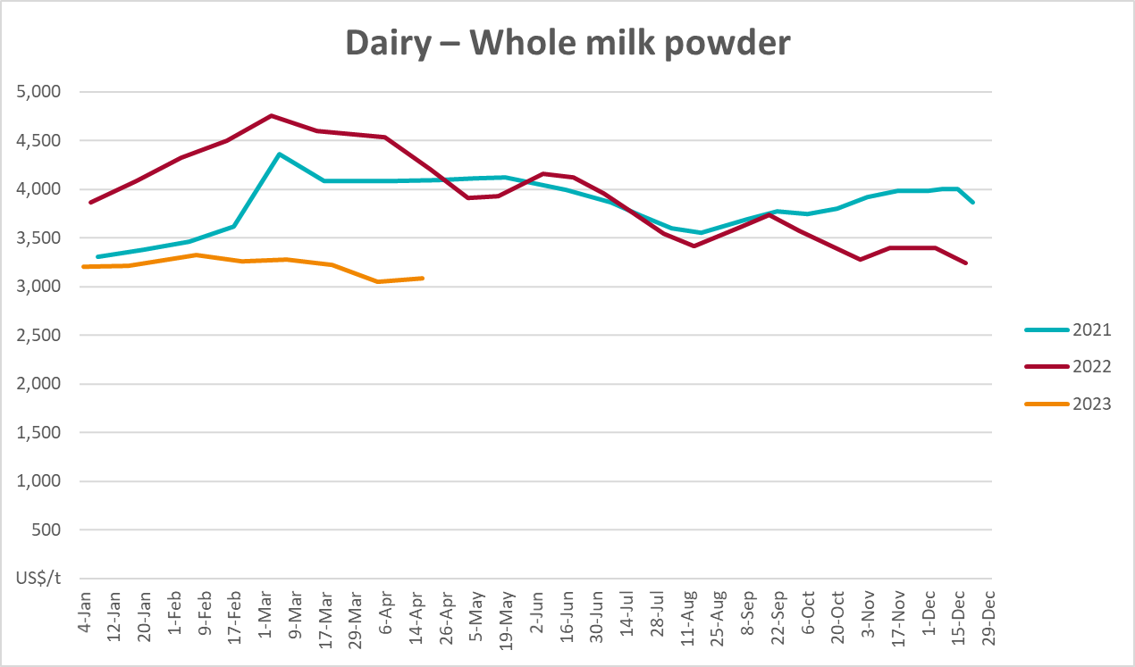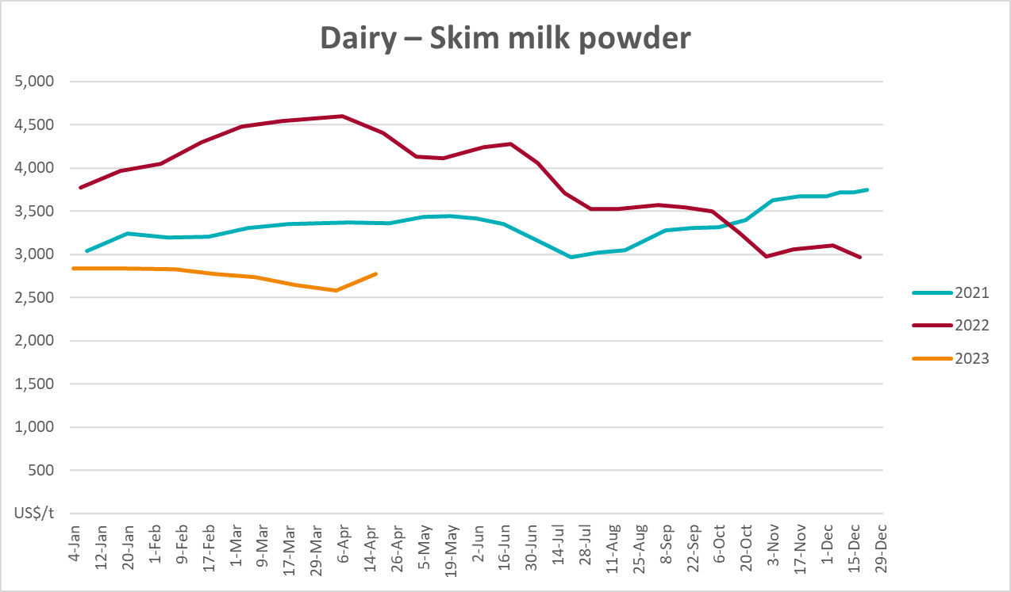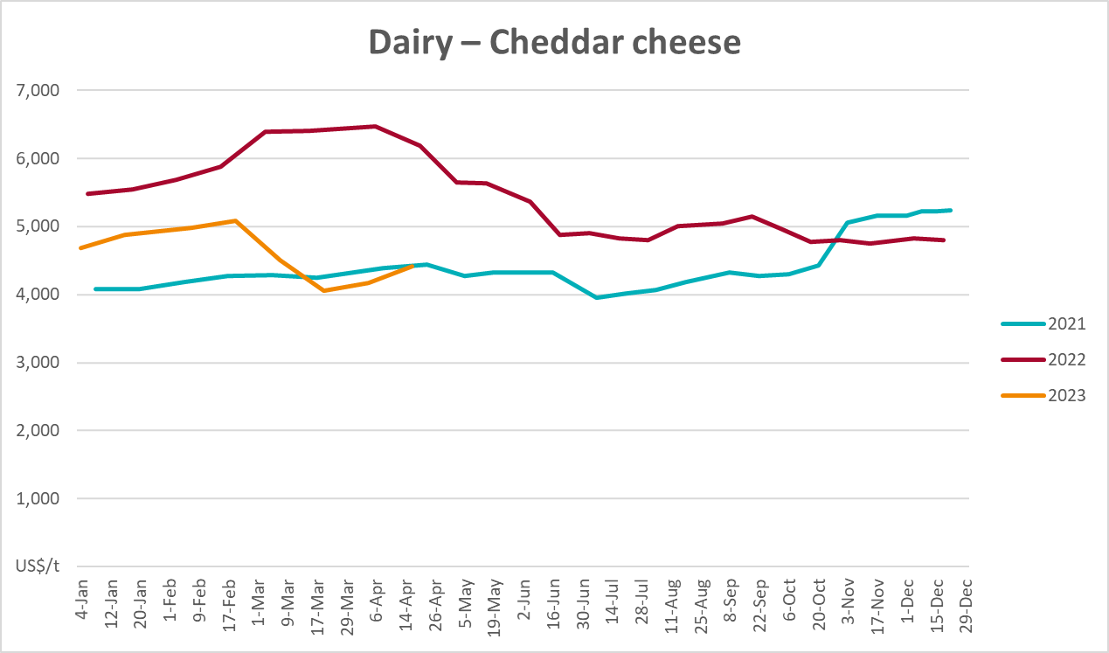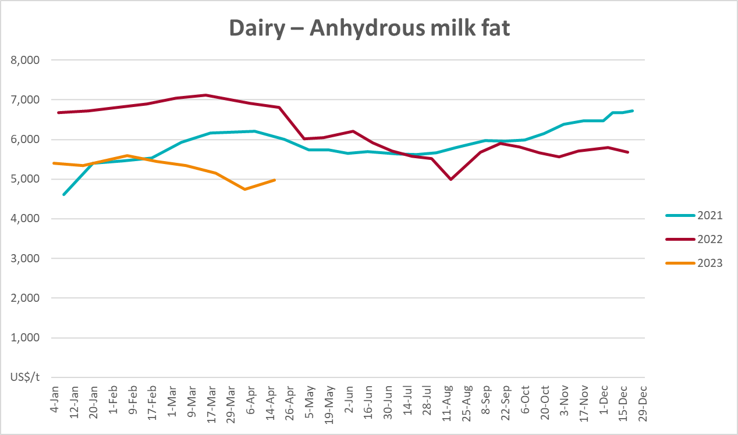

Selected fruit and vegetable prices
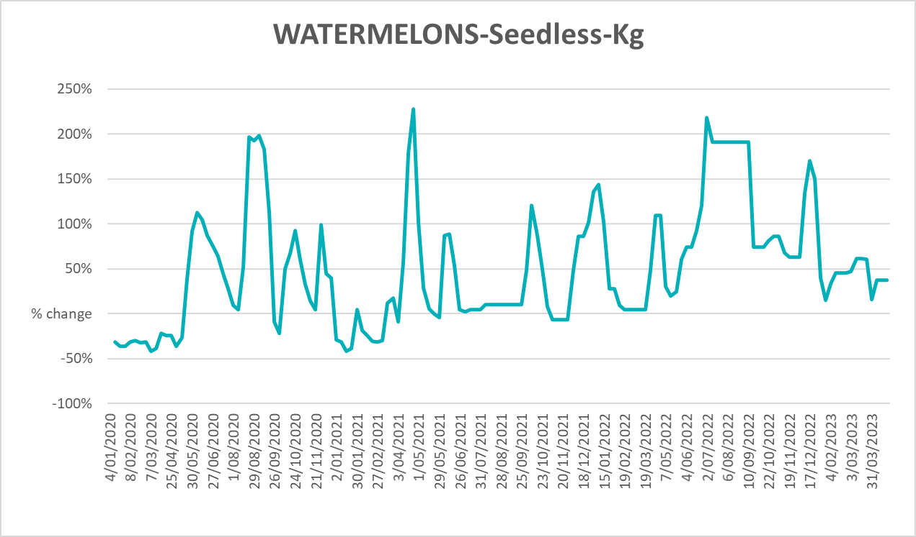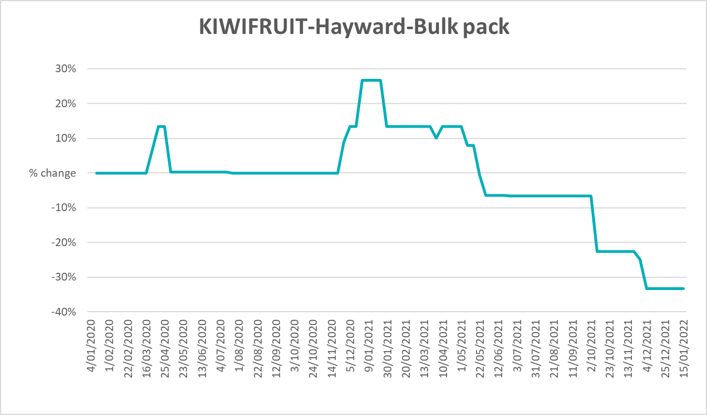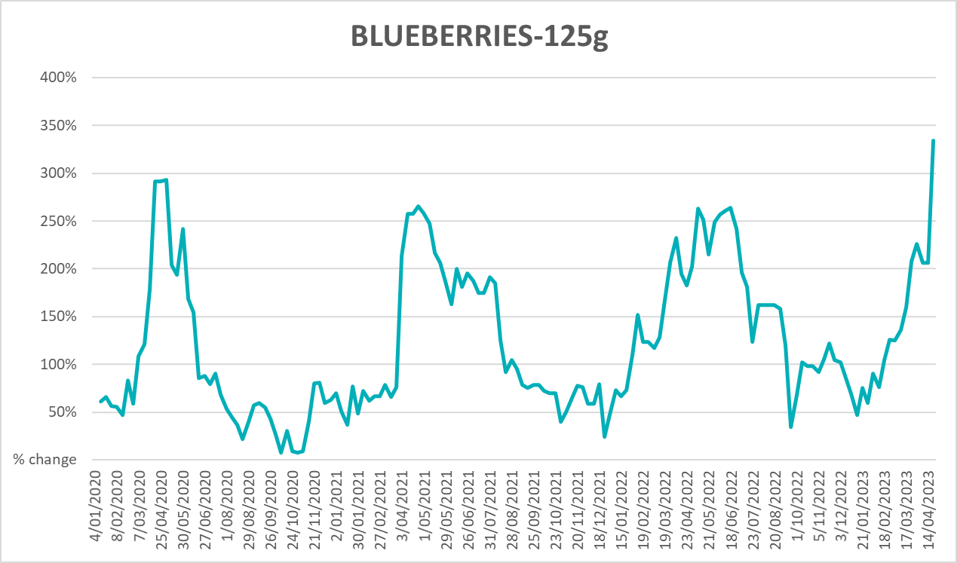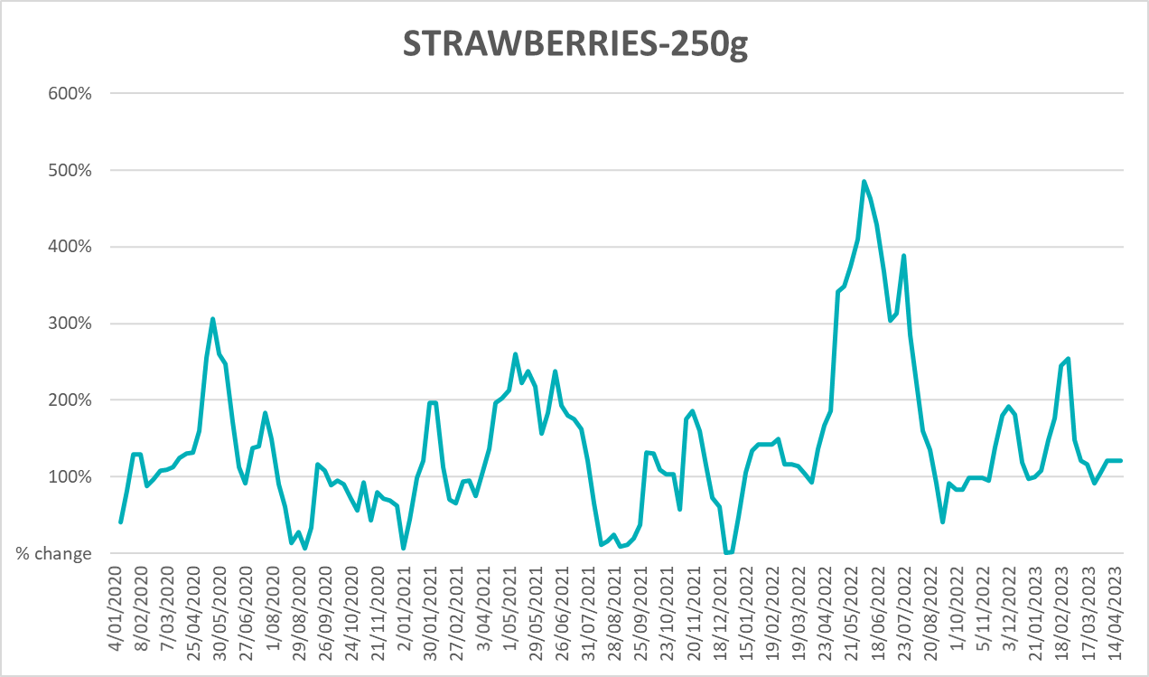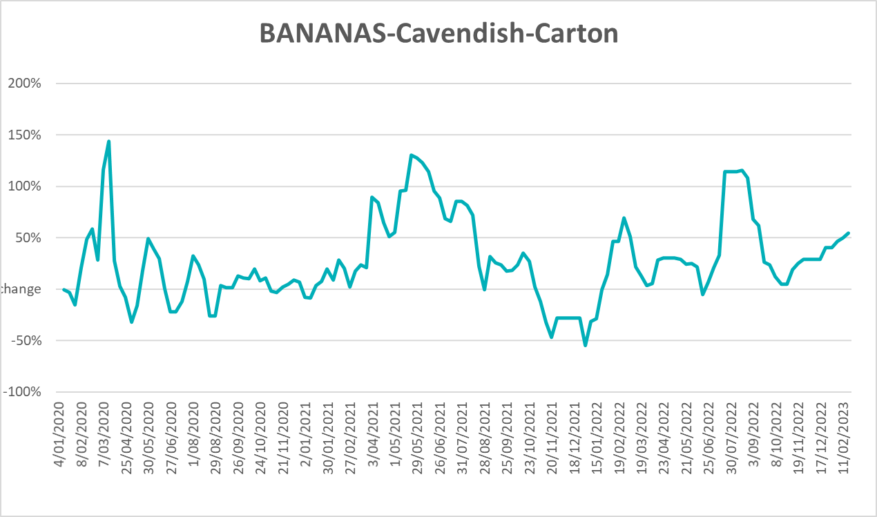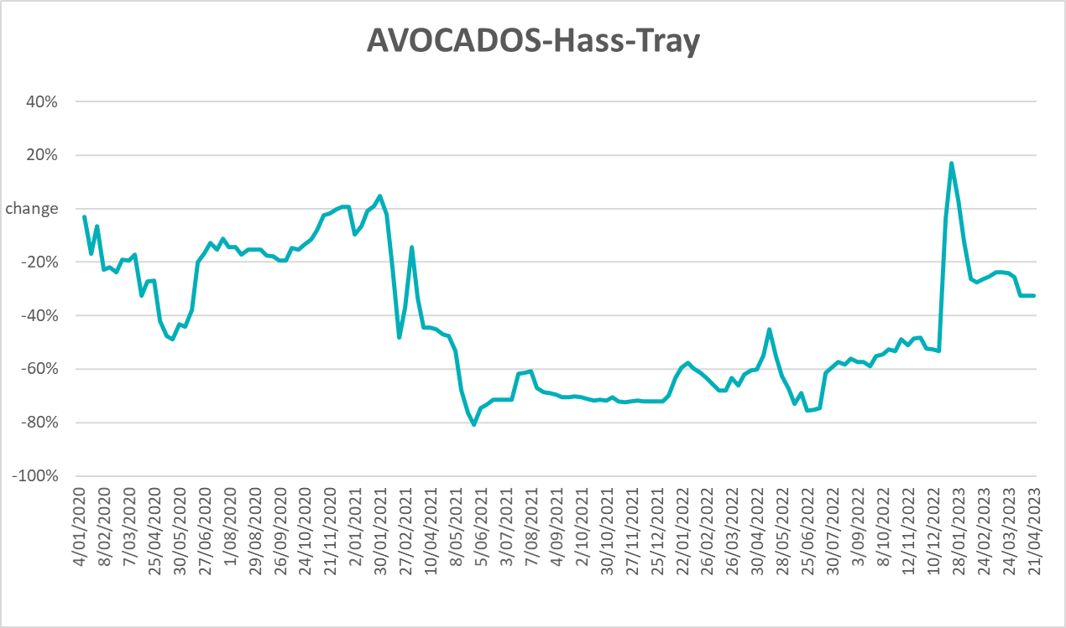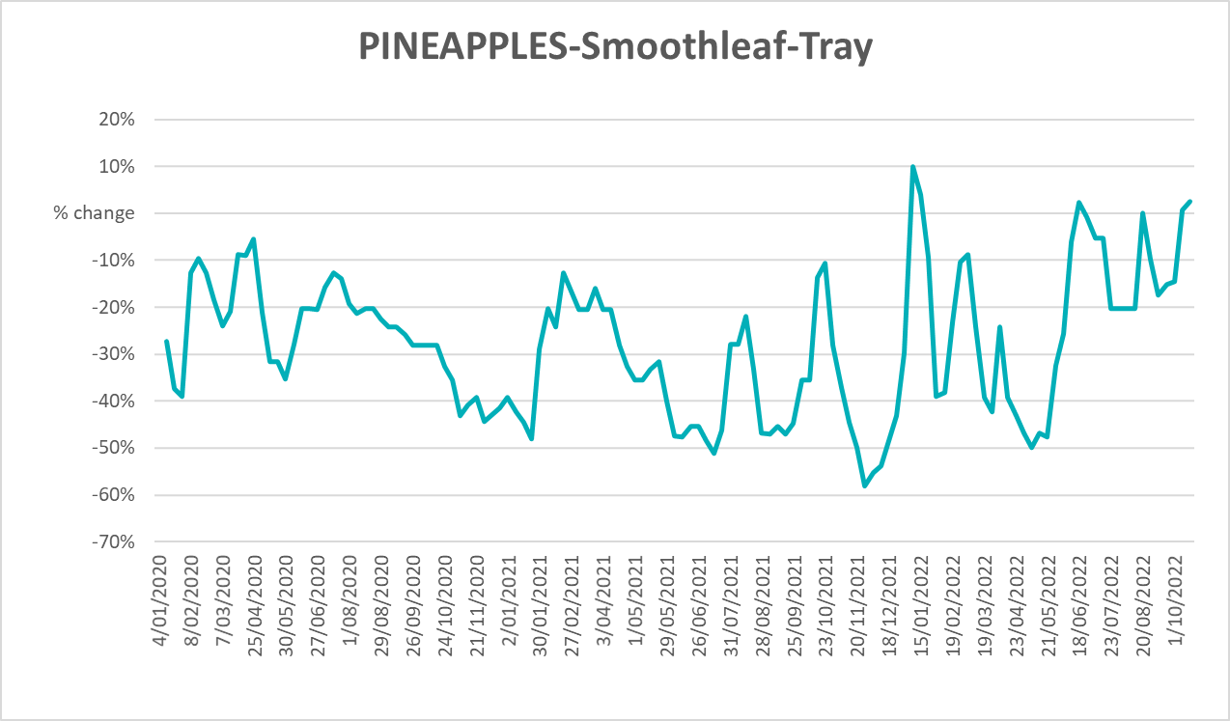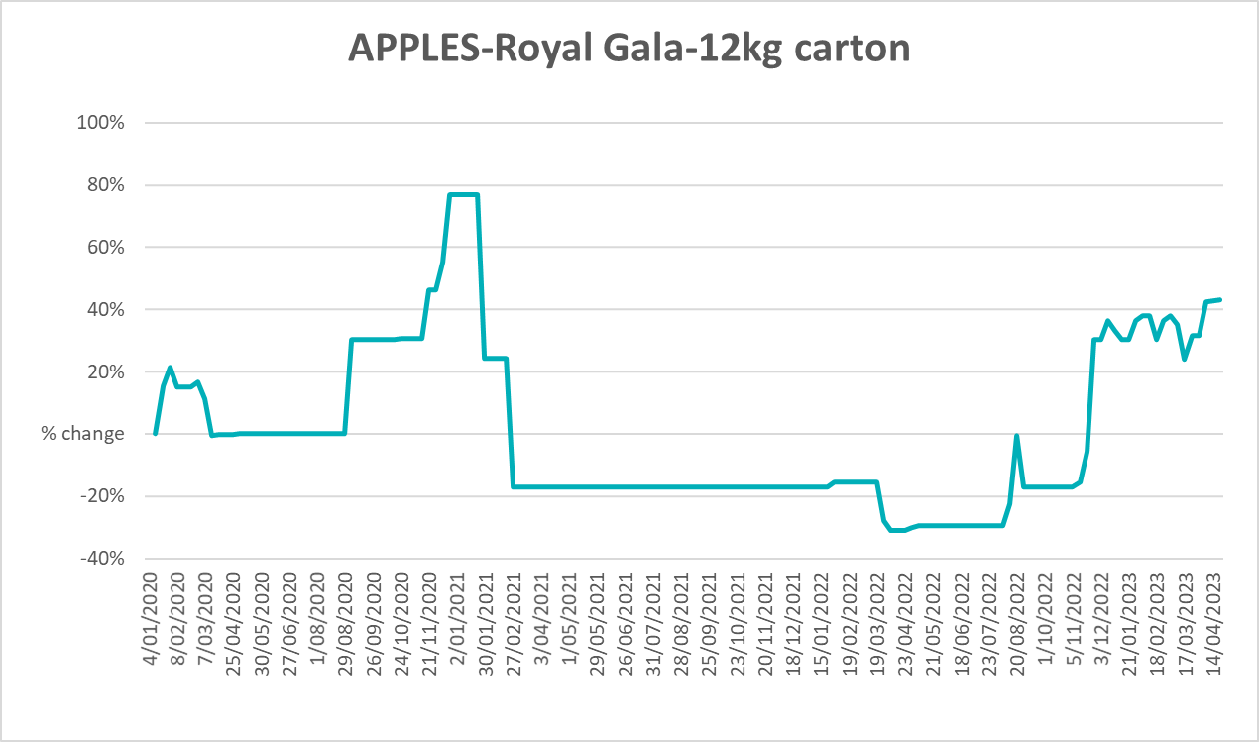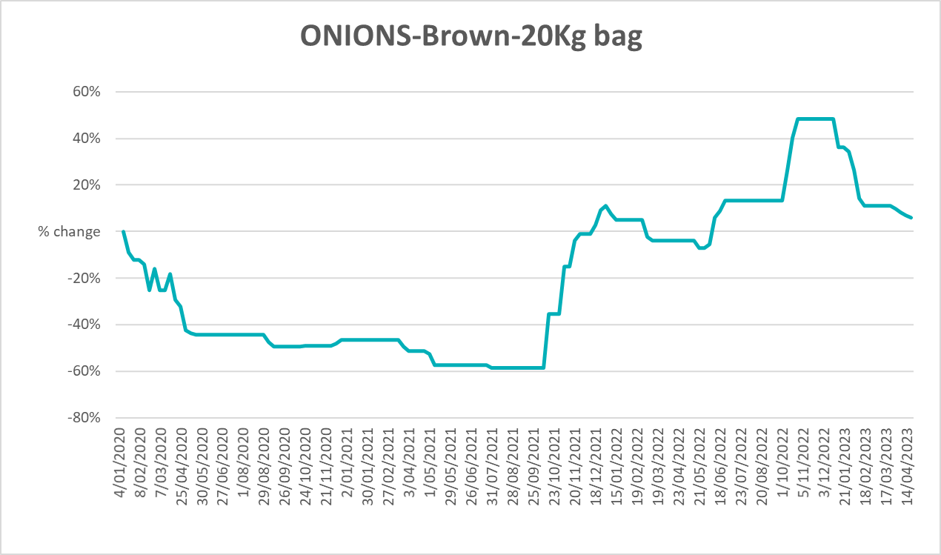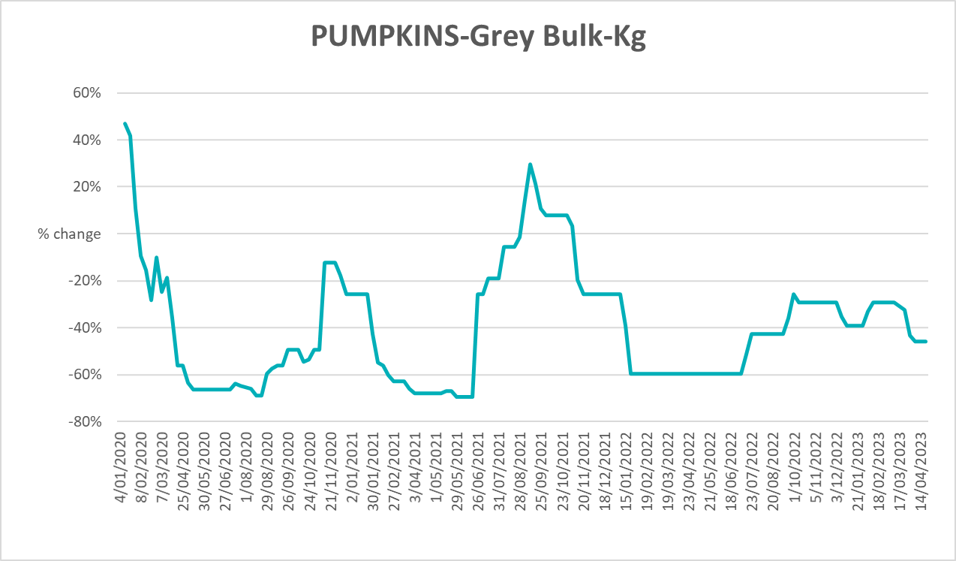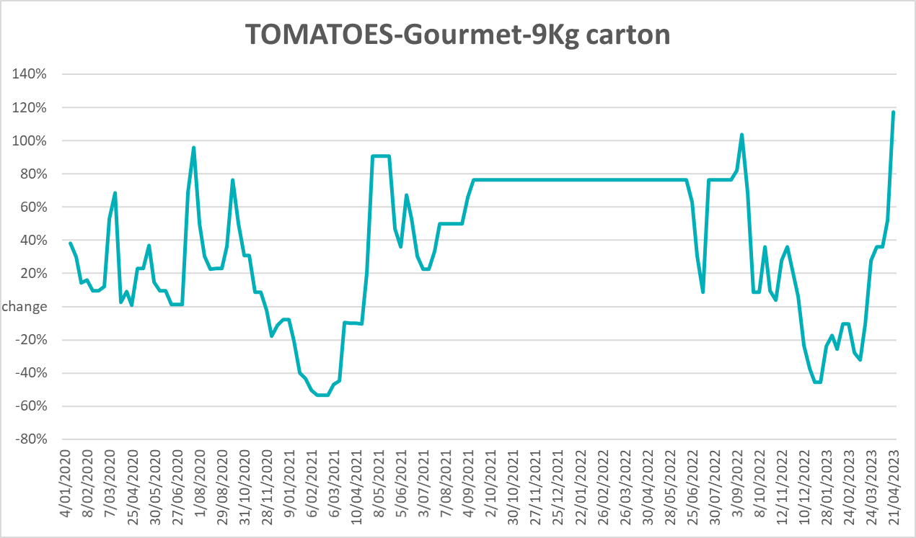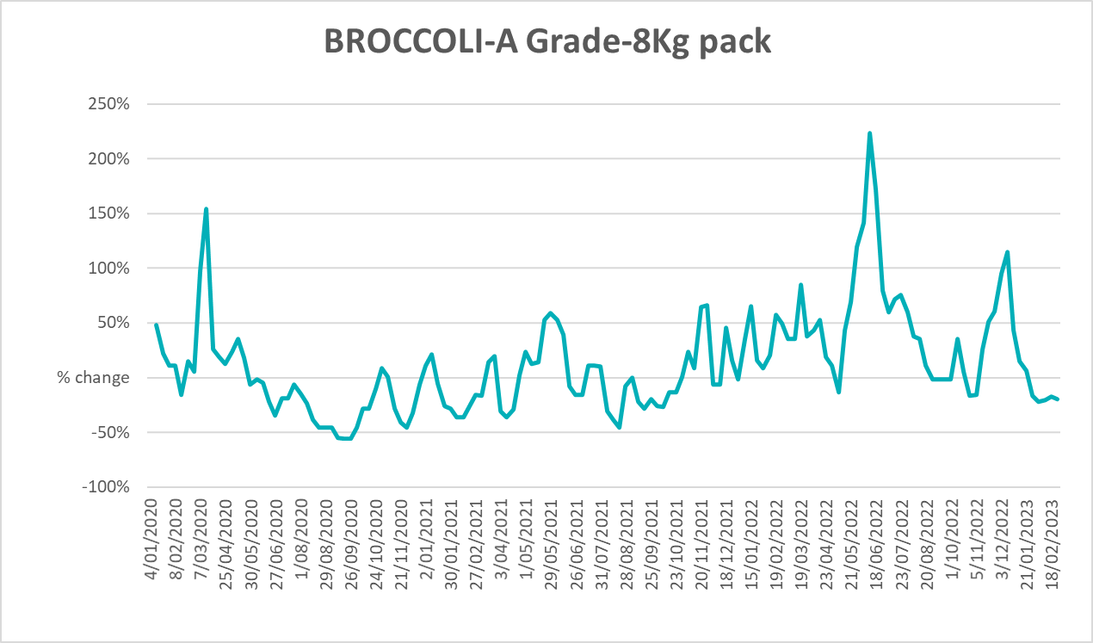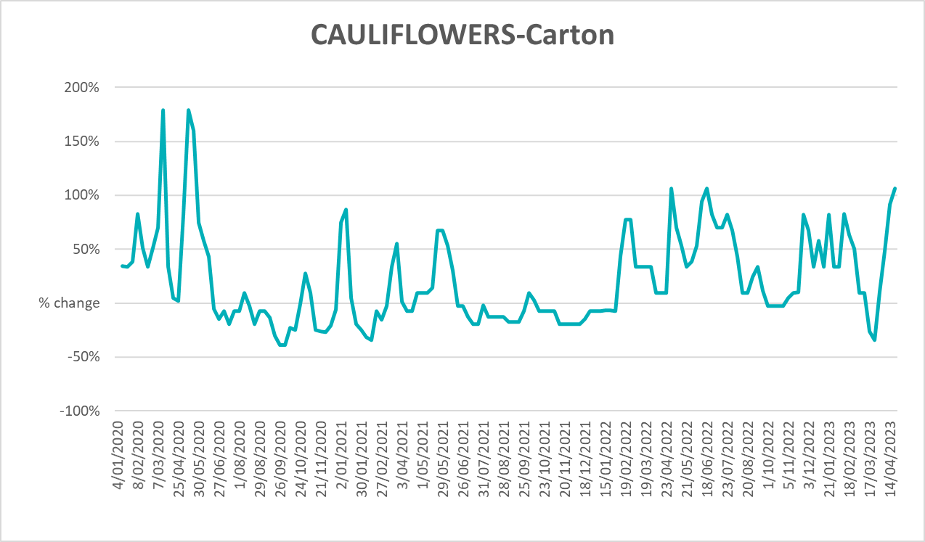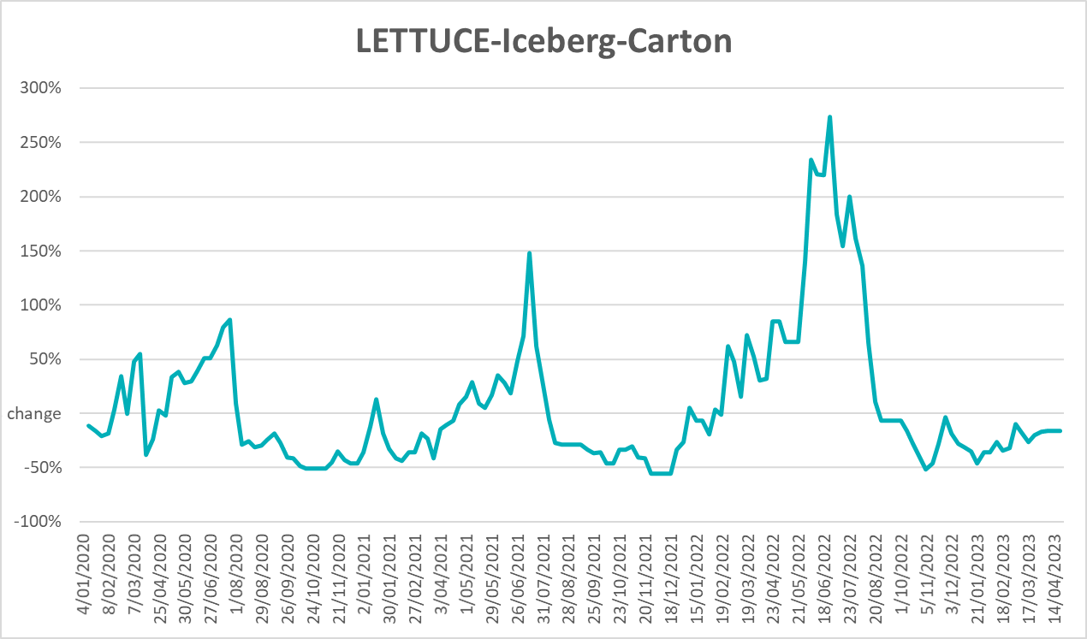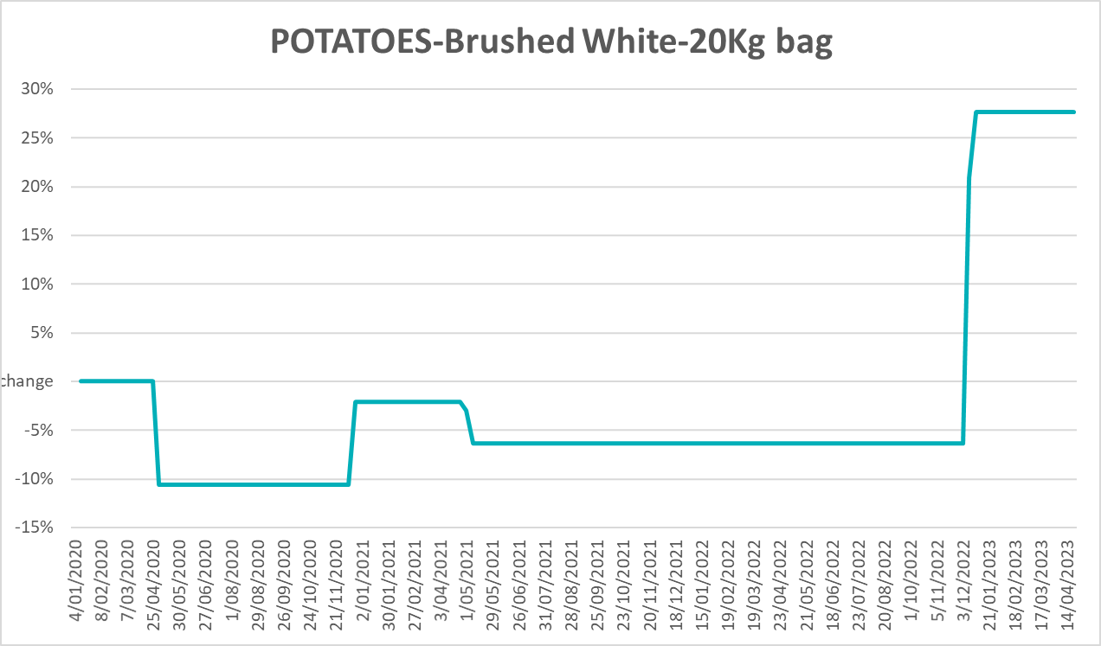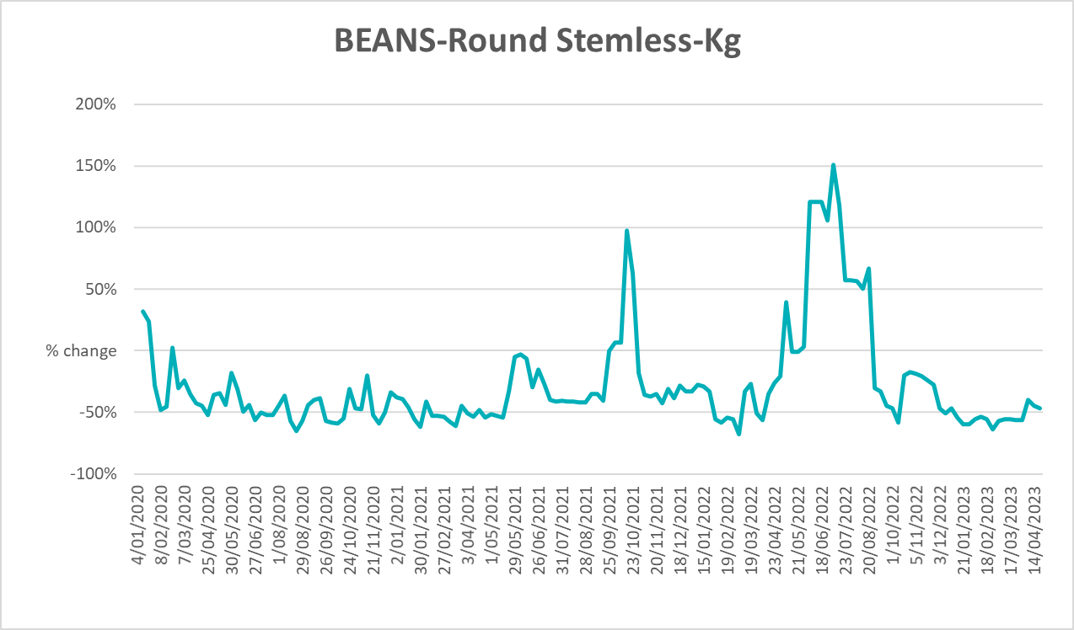

3.6 Selected domestic fodder indicator prices
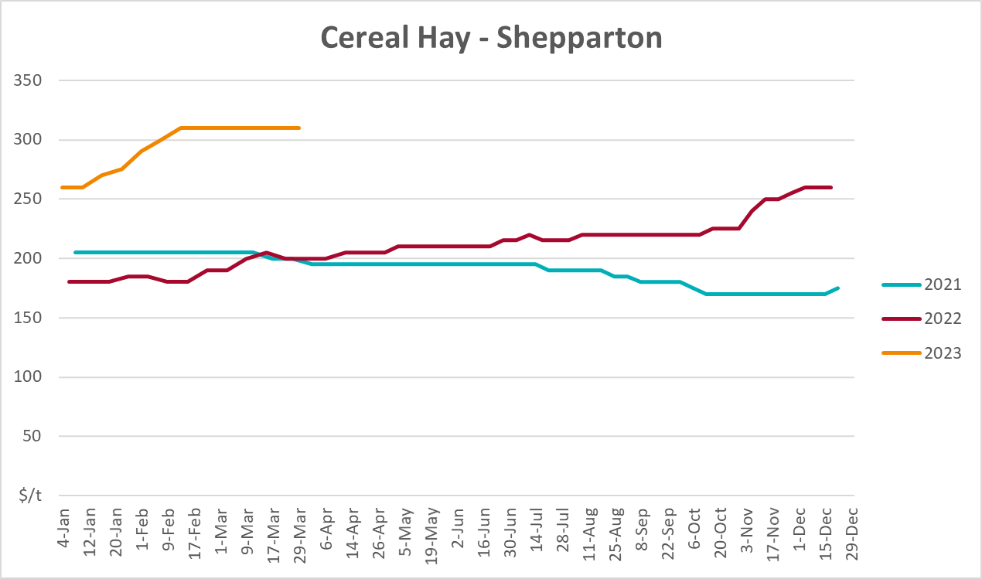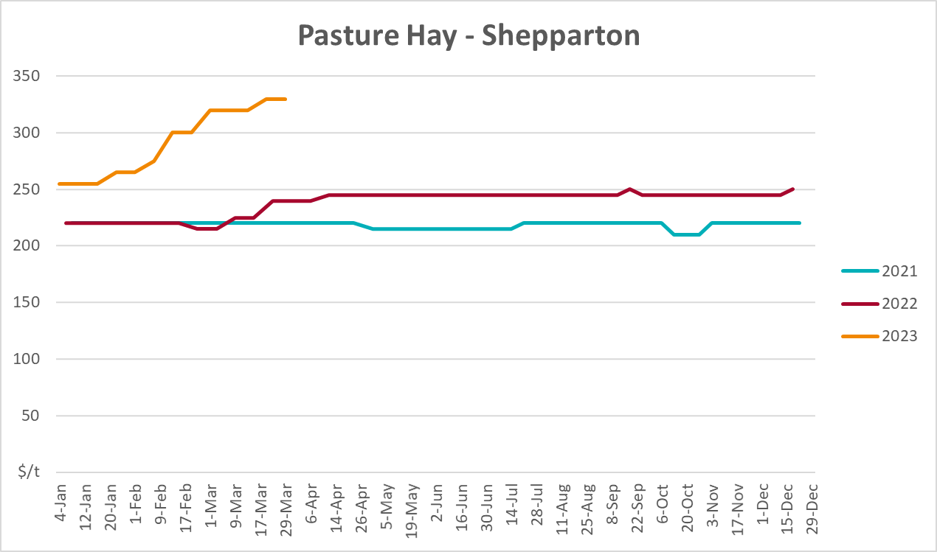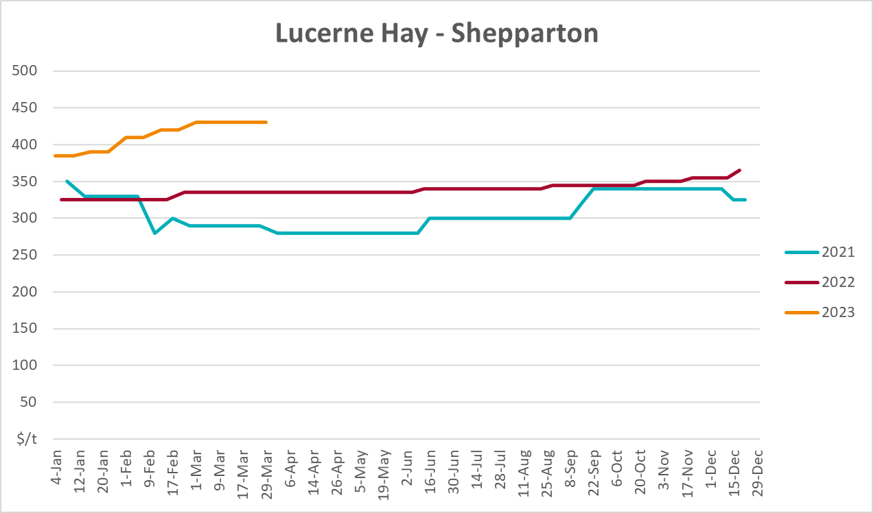

4. Data attribution

Climate
Bureau of Meteorology
- Weekly rainfall totals: www.bom.gov.au/climate/maps/rainfall/
- Monthly and last 3-month rainfall percentiles: www.bom.gov.au/water/landscape/
- Temperature anomalies: www.bom.gov.au/jsp/awap/temp/index.jsp
- Rainfall forecast: www.bom.gov.au/jsp/watl/rainfall/pme.jsp
- Seasonal outlook: www.bom.gov.au/climate/outlooks/#/overview/summary/
- Climate drivers: http://www.bom.gov.au/climate/enso/
- Soil moisture: www.bom.gov.au/water/landscape/
Other
- Pasture growth: www.longpaddock.qld.gov.au/aussiegrass/
- 3-month global outlooks: Environment and Climate Change Canada, NOAA Climate Prediction Center, EUROBRISA CPTEC/INPE, European Centre for Medium-Range Weather Forecasts, Hydrometcenter of Russia, National Climate Center Climate System Diagnosis and Prediction Room (NCC), International Research Institute for Climate and Society
- Global production: https://ipad.fas.usda.gov/ogamaps/cropmapsandcalendars.aspx
- Autumn break: Pook et al., 2009, https://rmets-onlinelibrary-wiley-com.virtual.anu.edu.au/doi/epdf/10.1002/joc.1833

Water
Prices
- Waterflow: https://www.waterflow.io/
- Ruralco: https://www.ruralcowater.com.au/
Bureau of Meteorology:
- Allocation trade: http://www.bom.gov.au/water/dashboards/#/water-markets/mdb/at
- Storage volumes: http://www.bom.gov.au/water/dashboards/#/water-storages/summary/drainage
Trade constraints:
- Water NSW: https://www.waternsw.com.au/customer-service/ordering-trading-and-pricing/trading/murrumbidgee
- Victorian Water Register: https://www.waterregister.vic.gov.au/TradingRules2019/

Commodities
Fruit and vegetables
- Datafresh: www.freshstate.com.au
Pigs
- Australian Pork Limited: www.australianpork.com.au
Dairy
- Global Dairy Trade: www.globaldairytrade.info/en/product-results/
World wheat, canola
- International Grains Council
World coarse grains
- United States Department of Agriculture
World cotton
- Cotlook: www.cotlook.com/
World sugar
- New York Stock Exchange - Intercontinental Exchange
Wool
- Australian Wool Exchange: www.awex.com.au/
Domestic wheat, barley, sorghum, canola and fodder
- Jumbuk Consulting Pty Ltd: http://www.jumbukag.com.au/
Cattle, beef, mutton, lamb, goat and live export
- Meat and Livestock Australia: www.mla.com.au/Prices-and-market
© Commonwealth of Australia 2023

Ownership of intellectual property rights
Unless otherwise noted, copyright (and any other intellectual property rights, if any) in this publication is owned by the Commonwealth of Australia (referred to as the Commonwealth).

Creative Commons licence
All material in this publication is licensed under a Creative Commons Attribution 4.0 International Licence except content supplied by third parties, logos and the Commonwealth Coat of Arms.
Inquiries about the licence and any use of this document should be emailed to copyright@awe.gov.au.


Cataloguing data
This publication (and any material sourced from it) should be attributed as:
ABARES 2023, Weekly Australian Climate, Water and Agricultural Update, Australian Bureau of Agricultural and Resource Economics and Sciences, Canberra, 27 April 2023. CC BY 4.0 DOI: https://doi.org/10.25814/5f3e04e7d2503
ISSN 2652-7561
This publication is available at https://www.agriculture.gov.au/abares/products/weekly_update
Department of Agriculture, Fisheries and Forestry
GPO Box 858 Canberra ACT 2601
Telephone 1800 900 090
Web agriculture.gov.au/abares

Disclaimer
The Australian Government acting through the Department of Agriculture, Fisheries and Forestry, represented by the Australian Bureau of Agricultural and Resource Economics and Sciences, has exercised due care and skill in preparing and compiling the information and data in this publication. Notwithstanding, the Department of Agriculture, Fisheries and Forestry, ABARES, its employees and advisers disclaim all liability, including liability for negligence and for any loss, damage, injury, expense or cost incurred by any person as a result of accessing, using or relying on any of the information or data in this publication to the maximum extent permitted by law.

Statement of Professional Independence
The views and analysis presented in ABARES publications, including this one, reflect ABARES professionally independent findings, based on scientific and economic concepts, principles, information and data. These views, analysis and findings may not reflect or be consistent with the views or positions of the Australian Government, or of organisations or groups who have commissioned ABARES reports or analysis. More information on professional independence is provided on the ABARES website.

Acknowledgements
This report was prepared by Kavina Dayal and Matthew Miller.

