What’s New, What’s Different: Quick Reference Guide

PEMS Release – 27 June 2024
Following the outage on Thursday 27 June 2024 the Plant Export Management System (PEMS) will be updated with the following changes:
PEMS Updates
Update | Changes
Improved cyber security is being added to PEMS. From 28 June 2024, you will no longer be able to attach outdated MS Word document formats, emails or rich text items into PEMS.  These file types are:  ___.doc  __.msg  __.rft  Emails or rich file text documents can be converted to PDF prior to uploading (see instructions below). | If an attempt is made to upload these file types, the error message below will appear.  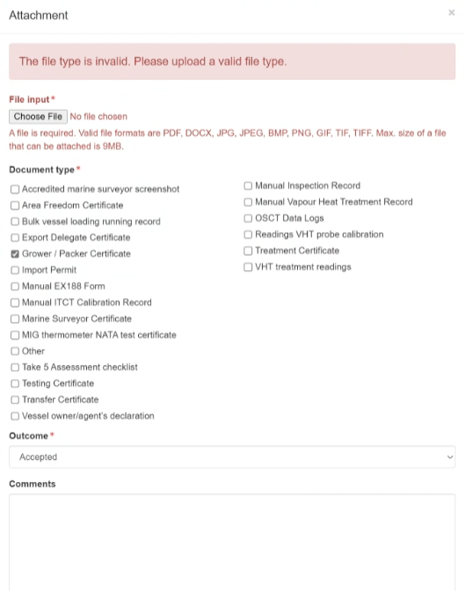
To convert your emails (__.msg file type) to PDF:
- In Outlook (or your email application), find your email in the mailbox and highlight it.
- Select ‘File’ from the top menu bar.

- Select ‘Print’ from the options to the left.
- Click on the Printer drop down and select ‘Microsoft Print to PDF’.
- Click on ‘Print’.
- The system will open your File Explorer for you to select where you want to save your PDF email.
- Save it to your computer and upload it from the saved location as a PDF.
To convert an __.rft document to PDF:
- Open the document you want to convert.
- Open the system’s print dialog box.
Follow on from the step selecting ‘Print’, as done in the example above.

Update | Changes
From 28 June 2024, the Assessment Services – Exports (ASE) staff will be able to see the RFP version section for both Grain and Horticulture Request for Permits (RFPs).  The RFP version section appears at the bottom of the form.  Click on the ‘View Amendments’ button to see what has changed from V1 to V2 and V2 to V3 and the like.  The user responsible for refreshing the RFP will also be displayed. | 