USER GUIDE

NEXDOC
How to view a Member Token in the NEXDOC portal

__________________________________________________________________________________
In this document
This document contains the following topics.
Purpose of this document 2
How to view a Member Token in the NEXDOC portal 2
Contact the NEXDOC help desk 5

Purpose of this document
The purpose of this document is to provide guidance on how to view your Member Token in the NEXDOC portal.
Note: You must register via the online service portal before you can use the NEXDOC portal. Please refer to Create and Manage your account user guide for instructions on how to complete this registration.
Note: If you have registered for a client group administrator, you are able to:
- View your Member token.
- Add/ remove people from your Member Token group.

How to view a Member Token in the NEXDOC portal
Step 1  Log in to the Online services portal | 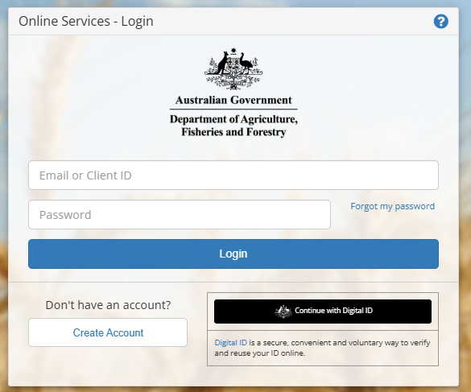
Step 2  Select Go to NEXDOC Homepage | 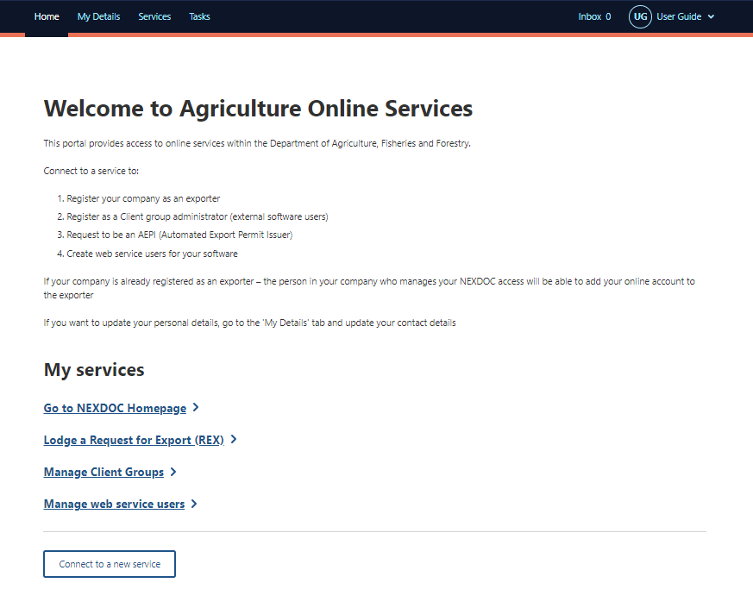
Step 3  Select the Account tab | 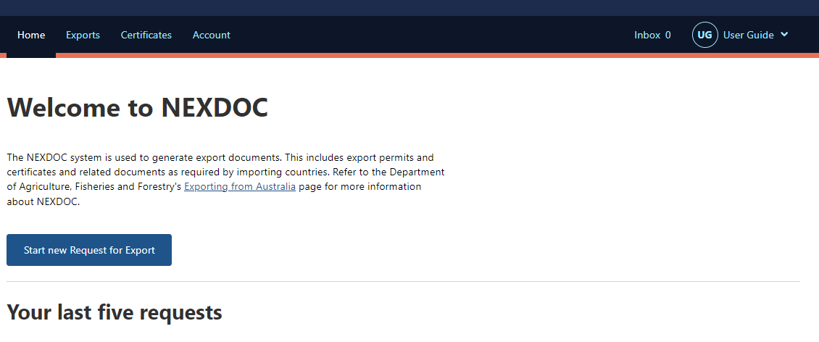
Step 4  Select the NEXDOC services | 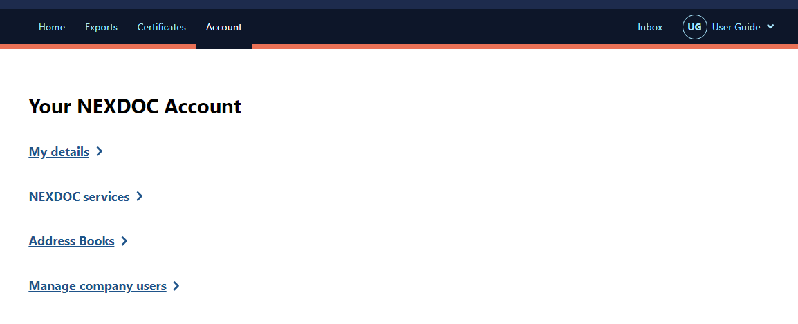
Step 5  Select the Client Groups tab | 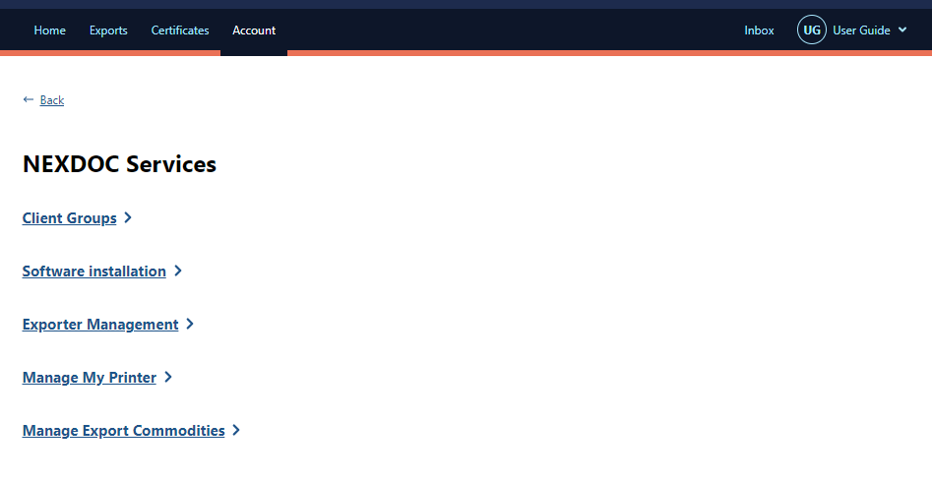
Step 6  Select Change under the heading Manage members. | 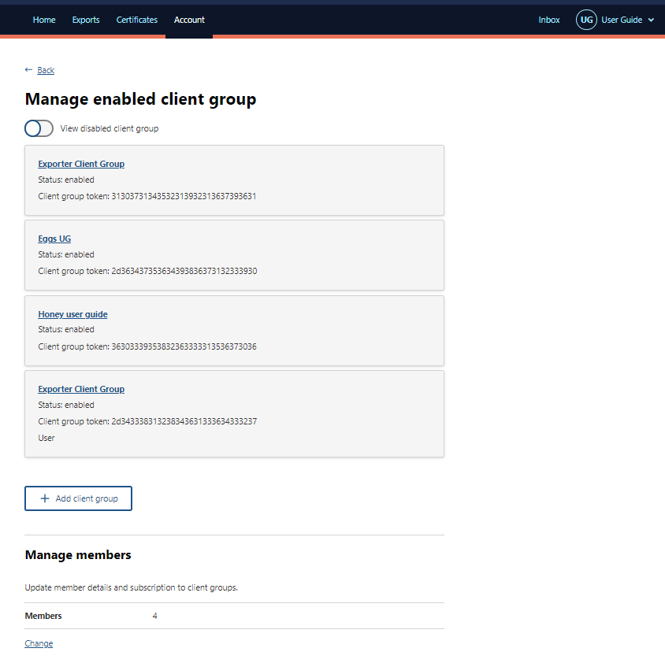
Step 7  Select Edit on the line of the member details you wish to view. | 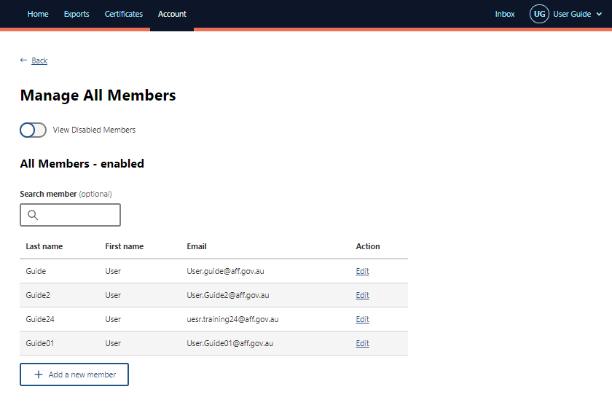
Step 8  The Member Token will display under their name. | 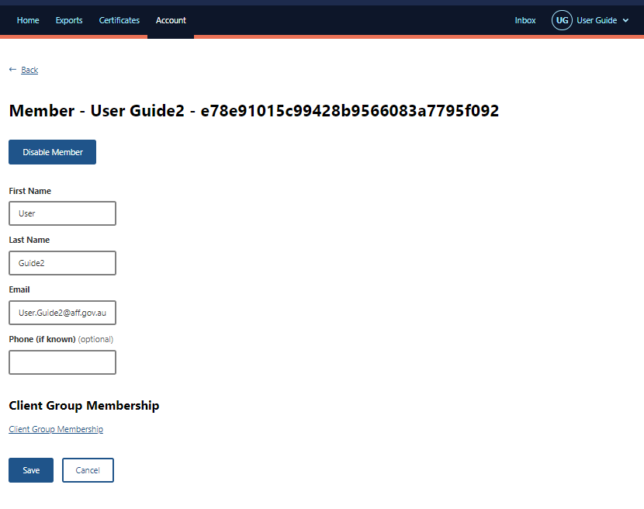
Step 9
Select Back to return to the Manage all Members screen.

Contact the NEXDOC help desk
For more information or assistance, please contact NEXDOC@aff.gov.au

