USER GUIDE

NEXDOC:
How to add a new commodity to my existing profile

__________________________________________________________________________________
In this document
This document contains the following topics.
Purpose of this document 2
How to add a new commodity to my existing exporter profile. 2
How to request My print for a commodity. 5
Contact the NEXDOC help desk. 7

Purpose of this document
Exporters using the NEXDOC Portal can now add Alternate Trading names to their exporter account. This document will give you a step-by-step guide to adding an Alternate Trading name in the NEXDOC Portal.

How to add a new commodity to my existing exporter profile.
As more commodities are onboarded onto NEXDOC you can add a commodity onto your existing exporter profile.
NEXDOC Portal Homepage
Step 1  Log in to NEXDOC. | 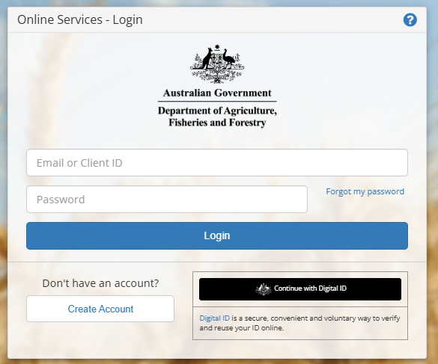
Step 2  Select Go to NEXDOC Homepage. | 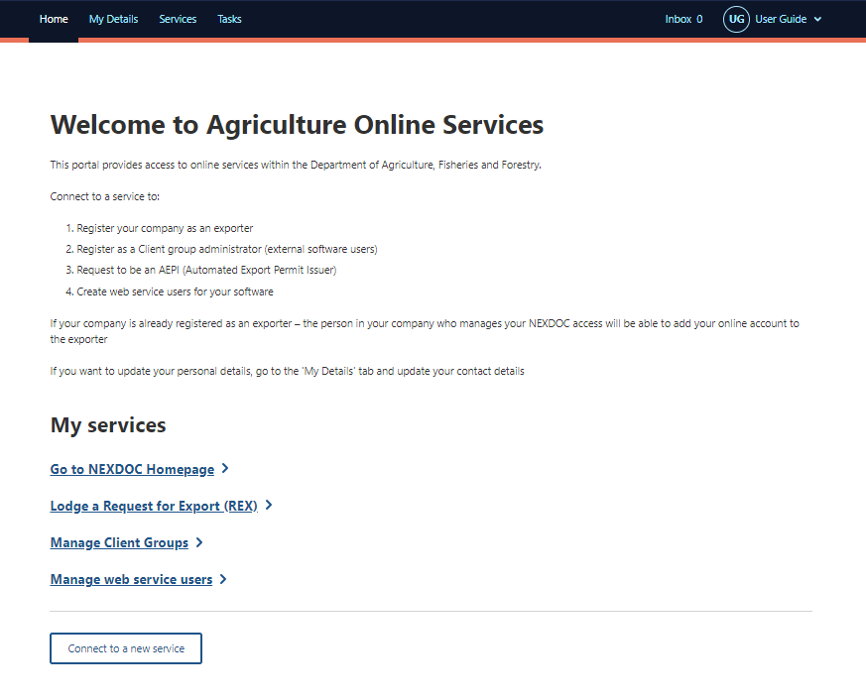
Step 3  Select Account tab. | 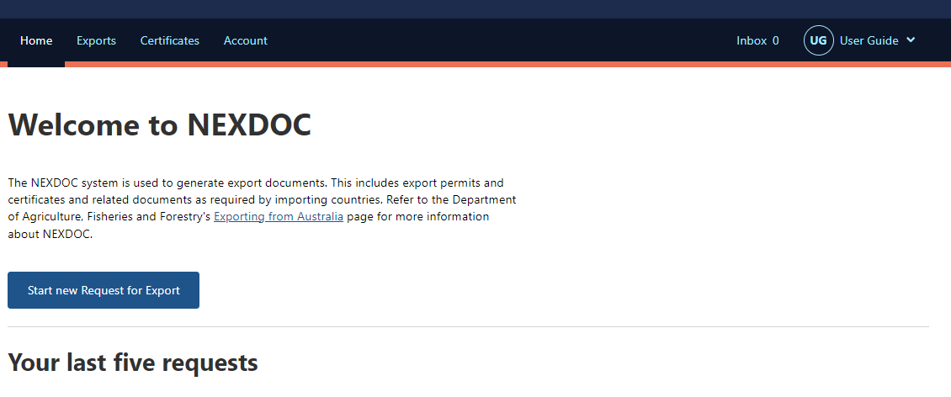
Step 4  Select NEXDOC services. | 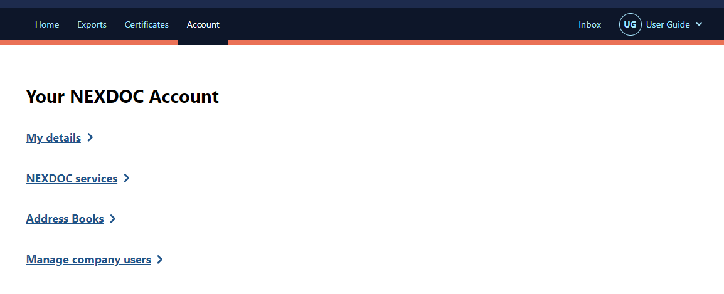
Step 5  Select Manage Export Commodities. | 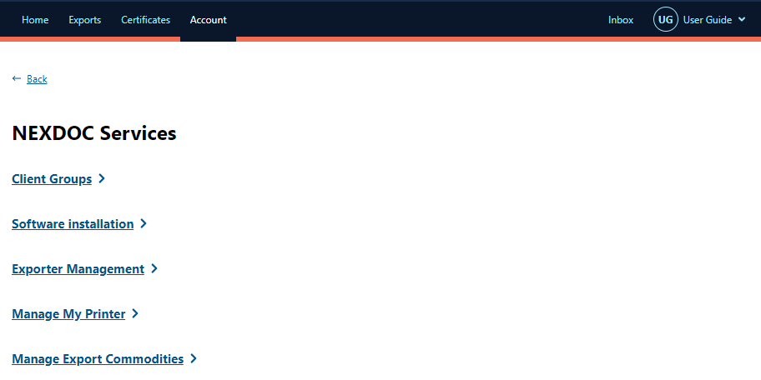
Step 6  Select the commodity you would like to export and select Save. | 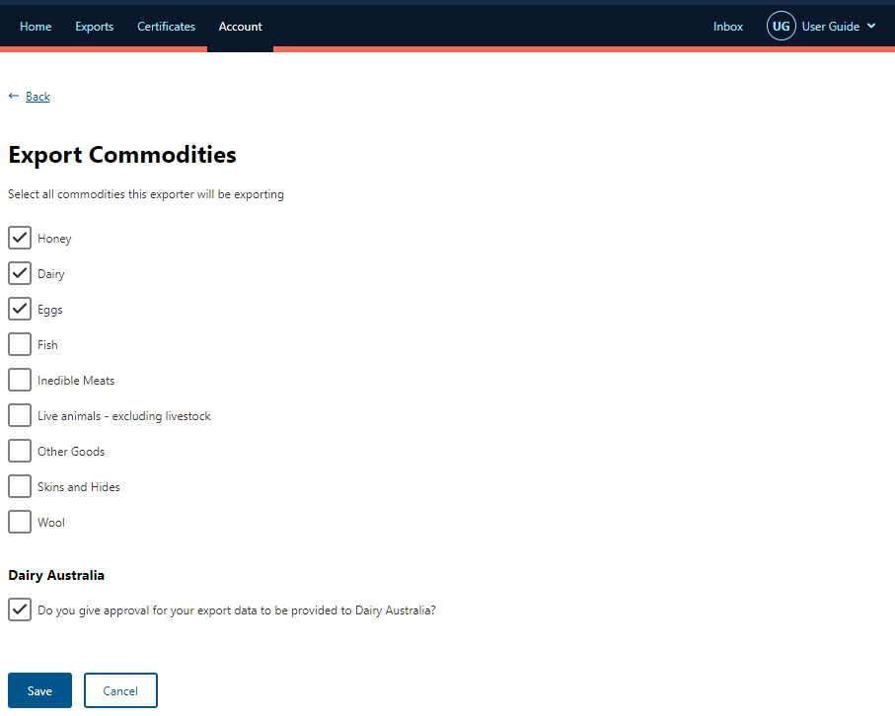
Step 7  You will receive a notification your request has been submitted to the department. | 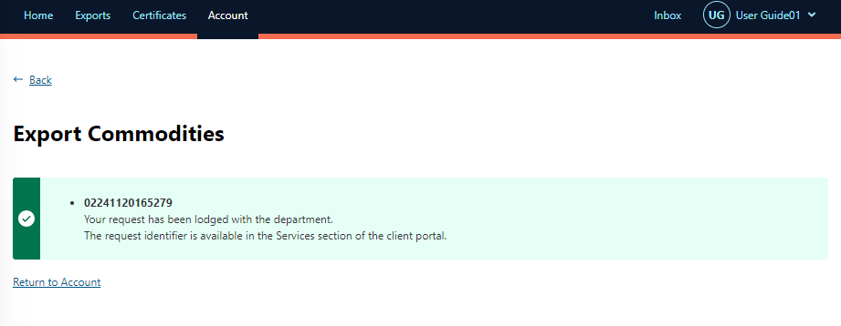
Step 8  You will receive a notification advising you application has been approved. | 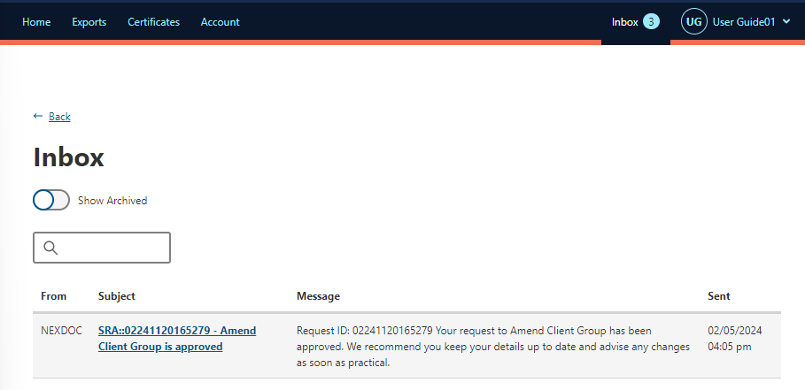

Once the department has approved your commodity request you will need to request My print.

How to request My print for a commodity.
Step 1
Select Account.

Step 2
Select NEXDOC services.
Step 3
Select Manage My Printer.
Step 4  Select the commodity you would like to allow My Printer permissions. | 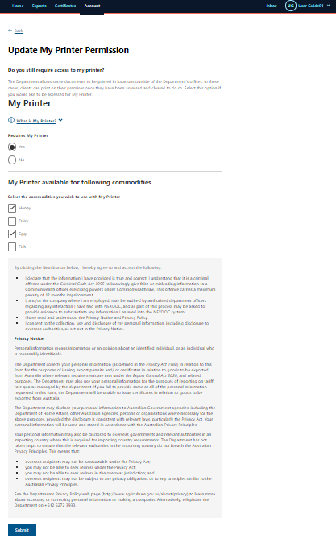
Step 5  Select Submit | 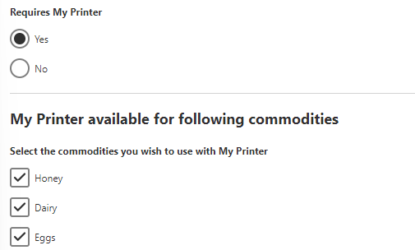  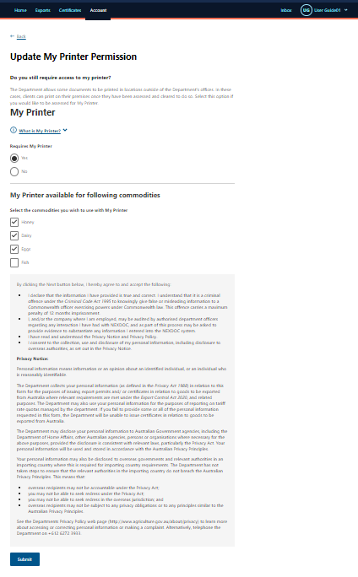
Step 6  A notification will appear confirming the action. | 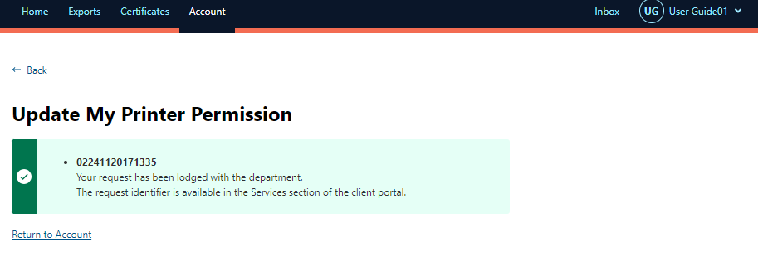

Contact the NEXDOC help desk.
For more information or assistance, please contact NEXDOC@aff.gov.au

