## GENERAL SITUATION in March and OUTLOOK to May 2024

### Australian Plague Locust *Chortoicetes terminifera*

Locust populations likely increased moderately to low-medium levels across inland eastern Australia with some localised high-densities during February. Limited surveys conducted in the first half of February identified some low-density adults with occasional nymphs detected in parts of Queensland and New South Wales (NSW). However, locust activities of egg-laying, hatching, and banding were reported latterly from several parts of NSW. The light trap at Nooyeah Downs (Queensland) captured locust activities in early February with more than 40 locusts caught in a single night. Light traps at White Cliffs and Fowlers Gap (NSW) captured similar numbers of locust in mid- and late-February respectively, but the one at Dulkaninna (South Australia) did not catch any locusts during February. There were frequent nocturnal flights detected by the University of New South Wales (UNSW) insect monitoring radar in Hay, NSW, during February. Most short-range migrations occurred in the vicinity of low-pressure troughs, but a couple of long-distance movements were under the influence of pre-front troughs. These reflect the existence of localised locust populations and the evidence of aggregations, redistributions, and migrations.

Rainfall totals in February were 50-100 mm over much of north-eastern part, while nil or below 10 mm across the south-western part of inland eastern Australia. February rainfall reflected above average to very much above average levels over the arid interior and below average to very much below average levels in the south-western part. February mean temperatures were above averages to very much above averages over much of the inland with parts more than 2 degrees higher, attributed to hotter daytime temperatures in the southern part but warmer night temperatures in the northern part. The mild El Niño persisted and continued to decay. Under the influence of a weakening El Niño event, a dry March is likely but average rainfall is expected for April and May over inland eastern Australia with continuous warmer temperatures.

The outlook for autumn is for overall low-medium level populations across inland eastern Australia, with localised high-density populations under favourable habitat conditions. By migration and aggregation, locust egg-laying activities may continue to appear in favourable habitats and some eggs may enter diapause phase from now onwards. Locust bands may develop in some parts of Queensland and NSW and late hatchings are possible under warm autumn temperatures. Under suitable weather systems, locust migration and aggregation may result into some swarms. However, it is unlikely that any significant bands will develop, nor any large-scale swarms are likely to form during autumn.

There is a low likelihood of widespread infestations developing during autumn.

**09 March 2024**

### Spur-throated Locust *Austracris guttulosa*

The overall population likely increased moderately from low-medium to medium levels. Limited surveys in the first half of February identified frequent Isolated–Scattered density adults in central Queensland with persistent Present-Numerous density nymphs detected. This reflects seasonal breeding has been successfully undergoing in the subtropical Queensland. APLC light traps at Fowlers Gap (NSW), White Cliffs (NSW), Nooyeah Downs (Qld), or Dulkaninna (SA) did not capture any locust during February. Habitats would have remained in good condition after February rain, and breeding is likely to continue.

A moderate population increase is expected with more localised high densities of nymphs developing during autumn.

There is a low-moderate risk of a widespread infestation developing in Queensland during autumn.

### Migratory Locust *Locusta migratoria*

The overall population likely remained at very low levels. No locusts were detected in areas surveyed in February. The usual occurrence area of southeastern Queensland had variable rainfalls from 10 to 80 mm at very much below average to average levels, but breeding was likely to continue under favourable habitat conditions.

Limited sporadic breeding is unlikely to produce any high-density populations from previously very low background population levels.

There is a very low risk of a widespread infestation developing during autumn.

**It is important that any locust activity be reported as soon as possible to your local biosecurity authority or to the Australian Plague Locust Commission. A toll-free call to the APLC hotline can be made on 1800 635 962. An answering machine is attached to this phone for after-hours calls. Reports can also be emailed to APLC via** [**aplc@agriculture.gov.au**](mailto:aplc@agriculture.gov.au) **or made through the website at** [**https://www.agriculture.gov.au/pests-diseases-weeds/locusts/landholders/reporting_locusts**](https://www.agriculture.gov.au/pests-diseases-weeds/locusts/landholders/reporting_locusts)**.**

### Locust distribution map—*Chortoicetes terminifera*

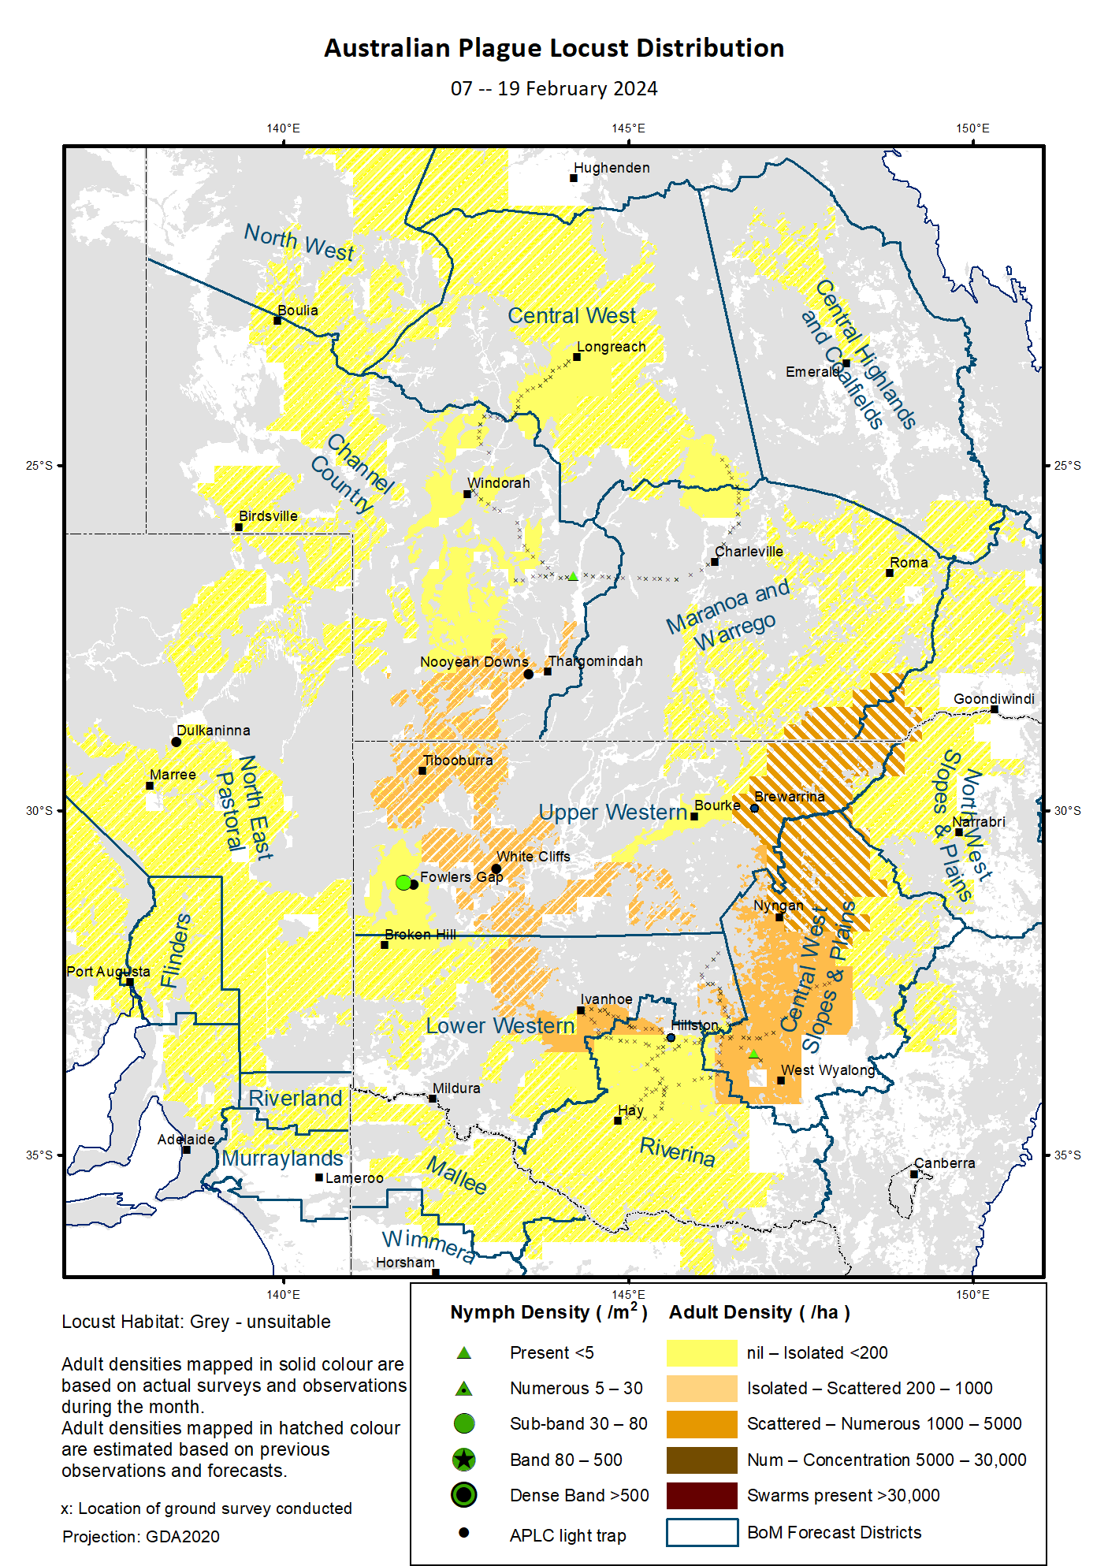

# Australian Plague Locust (*Chortoicetes terminifera*)

## SITUATION in March and OUTLOOK to May 2024

#### NEW SOUTH WALES

##### NORTH WEST SLOPES & PLAINS

###### Northwest Local Land Services

Locusts and conditions

* No surveys were conducted in this district in February.
* No locust reports were received from this district in February.
* This district received 20–80 mm of rainfall in February, generally at below average to average levels.

Forecast

* Limited breeding likely underwent but unlikely to result into any large high-density populations from previously very low background levels.
* There is a very low probability of any significant migrations during autumn.
* The general population density is expected to remain at low levels with possible localised medium density populations during autumn.

Risks

* There is a very low risk of a regional infestation developing during autumn.

##### CENTRAL WEST SLOPES & PLAINS

###### Central West Local Land Services

Locusts and conditions

* Surveys in the southern part of this district identified Isolated-Scattered density adults with occasional nymphs detected in early February.
* Several locust reports of adult fledging and egg-laying were received and assessed by LLS staff from Nyngan area in late February.
* This district received 20–100 mm of rainfall in February, ranging from average to very much above average levels.

Forecast

* Breeding is likely to continue, and nymphs of autumn generation are likely to hatch from early March.
* There is a probability of migration/dispersal events occurring during autumn.
* The general population density is expected to remain at low-medium levels with possible localised high density populations during autumn.

Risks

* There is a low-moderate risk of regional infestations developing during autumn.

##### RIVERINA

###### Riverina, Murray Local Land Services

Locusts and conditions

* Surveys in the northern part of this district identified Isolated-density adults without any nymphs detected in early February.
* No reports of locust activity were received from this district in February.
* The UNSW insect monitoring radar in Hay detected frequent nocturnal migrations of locust-shaped insects during February. Most locust migrations were over short ranges in westward directions under the influence of low-pressure troughs. Several nights of long-distance migrations were mainly under the influence of pre-front troughs in southward directions, such as the nights of 13, 22 and 28 February. This reflects some local populations and their migration/redistributions.
* This district received 5–25 mm of rainfall in February, ranging from below average to average levels.

Forecast

* Breeding is likely to continue under favourable habitats with possible localised medium-density populations to appear, but large bands are less likely to develop during autumn.
* There is a low-moderate probability of migration/dispersal events during autumn. Small swarms may be formed from population redistribution and aggregation.
* The population level is likely to remain low for the autumn.

Risks

* There is a low risk of regional infestation developing during autumn.

##### UPPER and LOWER WESTERN

###### Western Local Land Services

Locusts and conditions

* Limited surveys conducted in the Ivanhoe area identified Scattered-density adults with no nymphs detected in early February.
* A report of locust egg-laying activity was received from the Lightning Ridge-Collarenebri area on 05 February. Several reports of locust banding and swarming were received from the Tibooburra, Fowlers Gap, and Cobar areas in mid-February.
* The light trap at White Cliffs captured 45 locusts on the night of 11 February and 1–5 locusts in other nights during 8 and 13 February. A second wave of capture was recorded on two consecutive nights of 17-19 February for 9 and one locust respectively. The light trap at Fowlers Gap captured 15, 5, and 3 locusts on three consecutive nights of 25-28 February.
* February rainfall totals varied from almost nil in the southwest to nearly 100 mm over the Tibooburra-Cobar belt, ranging from below average to above average levels.

Forecast

* Breeding is likely to continue under favourable habitat conditions, and results into some localised bands in the Upper Western district.
* There is a moderate probability of migration/dispersal events during autumn.
* The overall population is likely to remain at low-medium levels and large-scale bands and warms are unlikely to develop during autumn.

Risks

* There is a low-moderate risk of regional infestations developing during autumn.

**All locust activity should be reported to your** [**Local Land Services**](https://www.lls.nsw.gov.au/) **(1300 795 299) or the** [**Department of Primary Industries**](https://www.dpi.nsw.gov.au/climate-and-emergencies/locusts)**. A toll-free call to the APLC hotline can be made on 1800 635 962. An answering machine is attached to this phone for after-hours calls. Reports can also be emailed to APLC via** [**aplc@agriculture.gov.au**](mailto:aplc@agriculture.gov.au) **or sent through the web page at** [**https://www.agriculture.gov.au/pests-diseases-weeds/locusts/landholders/reporting_locusts**](https://www.agriculture.gov.au/pests-diseases-weeds/locusts/landholders/reporting_locusts)**.**

#### QUEENSLAND

##### CENTRAL HIGHLANDS AND COALFIELDS

###### Isaac and Central Highlands Regional Councils; Banana Shire

Locusts and conditions

* No surveys were conducted in this district in February.
* No reports of locust activity were received from this district in February.
* This district received 20–170 mm of rainfall in February, generally at average levels over much of this district.

Forecast

* Localised breeding is likely to continue under favourable habitat conditions, but any resulting population is likely to remain at low levels.
* There is a very low probability of any significant migration events during autumn.
* The overall population is likely to remain at low level.

Risks

* There is a very low risk of a regional infestation developing during autumn.

##### DARLING DOWNS AND GRANITE BELT

###### Western Downs and Goondiwindi Regional Councils

Locusts and conditions

* No surveys were conducted in this district in February.
* No locust reports were received from this district in February.
* This district received 10–80 mm of rainfall in February, varying from very much below average to average levels.

Forecast

* Breeding is likely to continue under favourable habitats, and any resulting population is likely at low-medium level.
* There is a low probability of any significant migration events during autumn.
* The overall population is likely to remain at low level.

Risks

* There is a low risk of a regional infestation developing during autumn.

##### CENTRAL WEST

###### Barcaldine, Longreach, and Blackall-Tambo Regional Council; Flinders and Winton Shires

Locusts and conditions

* Limited surveys conducted in this district identified Isolated-density adults only in mid-February.
* No locust reports were received from this district in February.
* This district received 40–200 mm of rainfall in February, ranging from average to above average levels.

Forecast

* Breeding is likely to continue under favourable habitats, but any resulting population is likely at low-medium level.
* There is a low probability of any significant migration events but some short-distance redistributions possible during autumn.
* Locust populations are likely to remain at low levels with possible localised higher numbers.

Risks

* There is a low risk of a regional infestation developing during autumn.

##### MARANOA AND WARREGO

###### Maranoa Regional Council; Murweh, Paroo, and Balonne Shires

Locusts and conditions

* Limited surveys conducted in the north-western part of this district identified some Isolated-density adults only in mid-February.
* No locust reports were received from this district in February.
* This district received 15–100 mm of rainfall in February, at average levels over much of this district.

Forecast

* Breeding is likely to continue and result into some localised high-density populations.
* There is a low probability of any significant migration events but some short-distance redistributions and migrations possible during autumn.
* Populations are likely to remain at low-medium levels with some localised higher densities possible.

Risks

* There is a low risk of a regional infestation developing during autumn.

##### NORTH WEST

###### Mt Isa, Cloncurry, McKinlay, Boulia, and Winton Shires

Locusts and conditions

* No surveys were conducted in this district in February.
* No locust reports were received from this district in February.
* This district received 40–300 mm of rainfall in February, ranging from average to very much above average levels.

Forecast

* Sporadic breeding is possible under favourable habitats, but any resulting locust population is likely at low levels.
* There is a very low probability of any significant migration events during autumn.

Risks

* There is a low risk of a regional infestation developing during autumn.

##### CHANNEL COUNTRY

###### Boulia, Diamantina, Barcoo, Quilpie, and Bulloo Shires

Locusts and conditions

* Limited surveys conducted in the north-eastern part of this district identified frequent Isolated-density adults with occasional nymphs detected in February.
* The light trap at Nooyeah Downs, Thargomindah, captured 41 locusts on the night of 04 February after high-capture records in late January. A few locusts were captured on other nights in early February as well, reflecting some local populations and short-distance aggregations/redistributions.
* No locust reports were received from this district in February.
* This district received 40–100 mm of rainfall in February, generally at above average to very much above average levels over much of this district.

Forecast

* Breeding is likely to continue under favourable habitat conditions and may result into some localised high-density populations.
* There is a probability of migration/redistribution events during autumn.
* Populations are likely to remain at low-medium levels with possible localised higher numbers.

Risks

* There is a low-moderate risk of a regional infestation developing during autumn.

**All locust activity should be reported the** [**Biosecurity Queensland (Department of Agriculture and Fisheries)**](https://www.daf.qld.gov.au/business-priorities/biosecurity) **via the** [**Customer Service Centre**](https://www.daf.qld.gov.au/contact/customer-service-centre) **on 13 25 23. A toll-free call to the APLC hotline can be made on 1800 635 962. An answering machine is attached to this phone for after-hours calls. Reports can also be emailed to APLC via** [**aplc@agriculture.gov.au**](mailto:aplc@agriculture.gov.au) **or sent through the website at** [**https://www.agriculture.gov.au/pests-diseases-weeds/locusts/landholders/reporting_locusts**](https://www.agriculture.gov.au/pests-diseases-weeds/locusts/landholders/reporting_locusts)**.**

#### SOUTH AUSTRALIA

##### NORTH EAST PASTORAL and FLINDERS

Locusts and conditions

* No surveys were conducted in these two districts in February.
* No locust reports were received from these two districts in February.
* The light-trap at Dulkaninna did not capture any locusts in February.
* These two districts received nil in the south-western part to over 100 mm of rainfall in the Innamincka area in February, ranging from very much below average to very much above average levels.

Forecast

* Sporadic breeding is possible under favourable habitats, but any resulting population is likely to remain at low levels.
* There is a probability of migration/dispersal events under favourable weather systems during autumn.

Risks

* There is a low risk of a regional infestation developing during autumn.

##### RIVERLAND and MURRAYLANDS

Locusts and conditions

* No surveys were conducted in the two districts in February.
* No locust reports were received from these two districts in February.
* These two districts received less than 5 mm of rainfall in February, generally at very much below average to below average levels.

Forecast

* Limited sporadic breeding is possible, but any resulting population is likely to remain at low levels.
* There is a low probability of any significant migration/dispersal events during autumn.

Risks

* There is a very low risk of a regional infestation developing during autumn.

**Locust activity should be reported to** [**Biosecurity SA (Primary Industries and Regions South Australia)**](https://www.pir.sa.gov.au/biosecurity) **via the Plant Health Hotline on 1300 666 010.** **A toll-free call to the APLC hotline can be made on 1800 635 962. An answering machine is attached to this phone for after-hours calls. Reports can also be emailed to APLC via** [**aplc@agriculture.gov.au**](mailto:aplc@agriculture.gov.au) **or sent through the website at** [**https://www.agriculture.gov.au/pests-diseases-weeds/locusts/landholders/reporting_locusts**](https://www.agriculture.gov.au/pests-diseases-weeds/locusts/landholders/reporting_locusts)**.**

#### VICTORIA

##### MALLEE

**Mildura and Swan Hill Rural Cities; Yarriambiack and Buloke Shires**

Locusts and conditions

* No surveys were conducted in this district in February.
* No reports were received from this district in February.
* This district received less than 10 mm of rainfall in February, ranging from very much below average to below average levels over much of this district.

Forecast

* Sporadic breeding is possible under favourable habitat conditions, but any resulting population is likely to remain at low levels.
* There is a probability of migration events under favourable weather systems during autumn.

Risks

* There is a low risk of a regional infestation developing during autumn.

##### WIMMERA

**Hindmarsh and West Wimmera Shires**

Locusts and conditions

* No surveys were conducted in this district in February.
* No locust reports were received from this district in February.
* This district received almost nil rainfall in February, at very much below average levels.

Forecast

* Limited sporadic breeding is likely under favourable habitats, but any resulting population is likely to remain at low levels.
* There is a low probability of any significant migration events during autumn.

Risks

* There is a very low risk of a regional infestation developing during autumn.

**Locust activity should be reported to the** [**Agriculture Victoria**](https://agriculture.vic.gov.au/)[**Customer Contact Centre**](https://agriculture.vic.gov.au/about/contact-us) **on 136 186. Alternatively, you can make a report via the online form at**[**https://forms.bio.vic.gov.au/2020**](https://forms.bio.vic.gov.au/2020)**. Please include photos where possible. A toll-free call to the APLC hotline can be made on 1800 635 962. An answering machine is attached to this phone for after-hours calls. Reports can be emailed to APLC via** [**aplc@agriculture.gov.au**](mailto:aplc@agriculture.gov.au) **or sent through the website at** [**https://www.agriculture.gov.au/pests-diseases-weeds/locusts/landholders/reporting_locusts**](https://www.agriculture.gov.au/pests-diseases-weeds/locusts/landholders/reporting_locusts).

# Glossary of locust terms and density categories used in the Locust Bulletin

**Locust biology and behaviour**

|  |  |
| --- | --- |
| **Term** | **Definition** |
| adult | A fully developed, mature locust capable of breeding and migrating |
| band | Dense congregation of nymphs, usually marching together |
| diapause | Period of dormancy induced in anticipation of unfavourable environmental conditions |
| egg bed | An area of soil containing many egg pods (hundreds per square metre) |
| fledge | Final nymphal moult to a soft-bodied adult (fledgling) incapable of long-distance flight |
| hatch | A young nymph (hatchling) newly emerged from an egg |
| instar | Discrete stages of nymphal development each separated by a moult |
| laying | Female locusts depositing clutches of 20–60 eggs into the ground in froth-lined egg pods |
| nymph | An immature locust. Often referred to as the hopper stage |
| swarm | Dense congregation of adults, milling at the same spot or flying closely together |

###### Locust density categories

Where higher densities occur, a large proportion of the regional population is concentrated in very small areas with lower densities elsewhere, so the higher densities cannot be extrapolated over the area of an entire region. A range of density classes is usually found within a surveyed region.

|  |  |  |
| --- | --- | --- |
| **Nymph Densities** | **Number per m2** |  |
| Present | 1 – 5 |  |
| Numerous | 6 – 30 |  |
| Sub-band | 31 – 80 |  |
| Band | 81 – 500 |  |
| Dense Band | >500 |  |
|  |  |  |
| **Adult Densities** | **Number per m2** | **Number per 250 m2** |
| Isolated | – 0.02 | 1 5 |
| Scattered | 0.024 – 0.1 | 6 – 25 |
| Numerous | 0.104 – 0.5 | 26 – 125 |
| Concentration | 0.504 – 3 | 126 – 750 |
| Low Density Swarm | 4 – 10 | 751 – 2,500 |
| Medium Density Swarm | 11 – 50 | 2,501 – 12,500 |
| High Density Swarm | >50 | >12,500 |
|  |  |  |
| **General density classes** | **Nymph densities** | **Adult densities** |
| very low, occasional | Nil – Present | Nil – Isolated |
| low | Present – Numerous | Isolated – Scattered |
| medium | Numerous – Sub-band | Scattered – Numerous |
| high | Bands | Concentration – Swarms |

###### Reporting locust infestations

It is important that all locust activity is reported as soon as possible to your nearest state agriculture agency office or to the Australian Plague Locust Commission.

|  |  |
| --- | --- |
| **State** | **Authority for reporting locusts** |
| New South Wales | Local Land Services (LLS) or Department of Primary Industries |
| Queensland | Biosecurity Queensland, Department of Agriculture and Fisheries |
| South Australia | Biosecurity SA, Department of Primary Industries & Regions |
| Victoria | Biosecurity and Agriculture Services, Department of Energy, Environment and Climate Action |

Reports to the **Australian Plague Locust Commission** can be made by:

Free call (Canberra): 1800 635 962 (24 hours)

Fax (Canberra): (02) 6272 5074

Email: [aplc@agriculture.gov.au](mailto:aplc@agriculture.gov.au)

Website: <https://www.agriculture.gov.au/pests-diseases-weeds/locusts/landholders/reporting_locusts>