## GENERAL SITUATION in Autumn and OUTLOOK to Spring 2024

### Australian Plague Locust *Chortoicetes terminifera*

Locust populations increased moderately across inland eastern Australia in autumn, with bands and swarms developing in the Lightning Ridge-Narrabri-Walgett and Nyngan areas of New South Wales, and swarms appearing in the Innamincka and surrounding areas of South Australia during March.

Surveys conducted in March identified frequent sub-bands and bands of nymphs in the Lightning Ridge and Nyngan areas, with low-medium densities of nymphs in the surrounding areas. Several swarms of adults were identified in the Walgett-Narrabri and Nyngan-Cobar areas later in March. Occasional nymphs and consistent low-medium densities of adults were present in other surveyed areas in the northern part of inland NSW. Some low-density nymphs and consistent low-medium density adults were identified in central Queensland, while only low-density adults were detected in central parts of SA. April surveys identified high-density adults persistent in the Nyngan area with occasional nymphs detected. However, only low-density adults remained in the Lightning Ridge-Walgett areas, while medium densities of adults appeared in the Bourke, Broken Hill and Tibooburra areas. Helicopter surveys conducted during 11-13 April identified occasional fifth instar nymphs and over 27 thousand hectares of medium-high density young adults, with swarms mainly in the Innamincka-Moomba-Tirrawarra areas of SA and some in the adjacent Durham Downs-Noccundra areas of Queensland. April surveys identified low-density adults in northwest inland Queensland with occasional nymphs detected. By early May low-medium densities of adults were still present in the Innamincka and surrounding areas, while low-density adults were identified in the Channel Country. No surveys were conducted in Victoria during autumn.

Light traps and other means detected increased locust activities during autumn. The light trap at White Cliffs (NSW) recorded strong locust activity in early March, and another two periods in middle and end of March respectively. The light trap at Fowlers Gap (NSW) recorded locust activities in early and middle March, and again in early and middle April. The light trap at Dulkaninna (SA) was not in operation during March, but more than a thousand locusts were reported attracted by veranda lights on the night of 31 March. The light trap resumed operation from mid-April with the only record of 7 locusts caught on the night of 30 April. The light trap at Nooyeah Downs (Queensland) recorded frequent low levels of locust activities during autumn with the last capture of 15 locusts on the night of 30 May. There were frequent nocturnal flights of locust-shaped insects detected by the University of New South Wales insect monitoring radar in Hay, NSW, during the first half of March. However, these detected migrants were more likely grasshoppers which were at high levels in this region. A dozen reports of sudden locust appearance were received from the Innamincka-Durham Downs-Noccundra areas during the end of March and early April. These reflect either local aggregations or short-distance redistributions of locusts facilitated by disturbed weather during autumn with a general trend of westward shift in inland eastern Australia. NSW Local Land Services received and assessed more than 50 reports of locust banding, swarming and egg laying, most of which were from the Nyngan area with a few from the surrounding areas during autumn.

Autumn rainfall ranged from average to very much above average levels over much of inland eastern Australia with heavy rainfall in March and May respectively. March heavy rains fell in central Queensland, Channel Country and parts of central NSW while the Walgett-Narrabri areas received less than 25 mm in total. April heavy rains fell in central and southeast Queensland and the southeastern part of inland NSW with almost nil in the arid/semi-arid interior. May heavy rains were mostly over the inland NSW where several parts received over 100 mm of rainfall. Most locust habitats remained in good conditions during autumn.

Autumn was generally warmer (up to two degrees) than average over much of inland eastern Australia, ranging from average to very much above average levels. March mean temperatures were 1-4 degrees above averages, but April was cooler with mean temperatures below averages (as low as 2 degrees down), while May mean temperatures were 1-2 degrees higher above averages in the north but below the averages in the south.

The mild El Niño ended in April and the El Niño–Southern Oscillation returned to neutral, but a La Niña watch was issued in mid-May by the Bureau of Meteorology, indicating possible La Niña formation late in 2024. Above average rainfall is likely for June to August over the arid/semi-arid interior of eastern Australia with continuous above average temperatures. The arid interior would remain in favourable conditions for locust breeding during the winter.

The outlook for spring is for overall low-medium level populations across inland eastern Australia, with localised high-density populations developing from overwintering eggs in the Central West of NSW and North East of SA. For late egg-laying in autumn and a warmer winter forecast, part of these eggs may develop slowly during the winter while others enter diapause (see hatching forecast below). Localised bands may develop from early September onwards in Central West of NSW, but could be from early August onwards in the North East of SA and Channel Country of Queensland.

There is a moderate-high probability of some significant localised populations developing from late winter onwards in several areas.

There is a high likelihood of regional infestations developing in spring.

**24 June 2024**

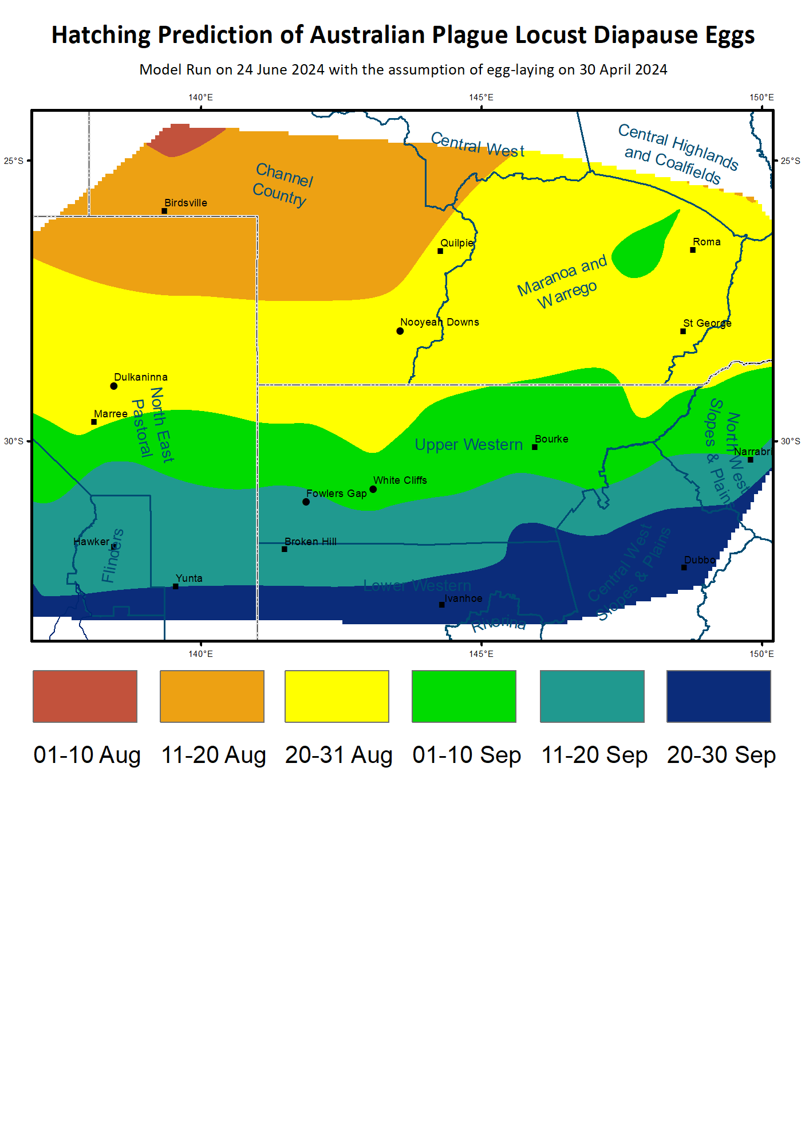

### Locust distribution map—*Chortoicetes terminifera*

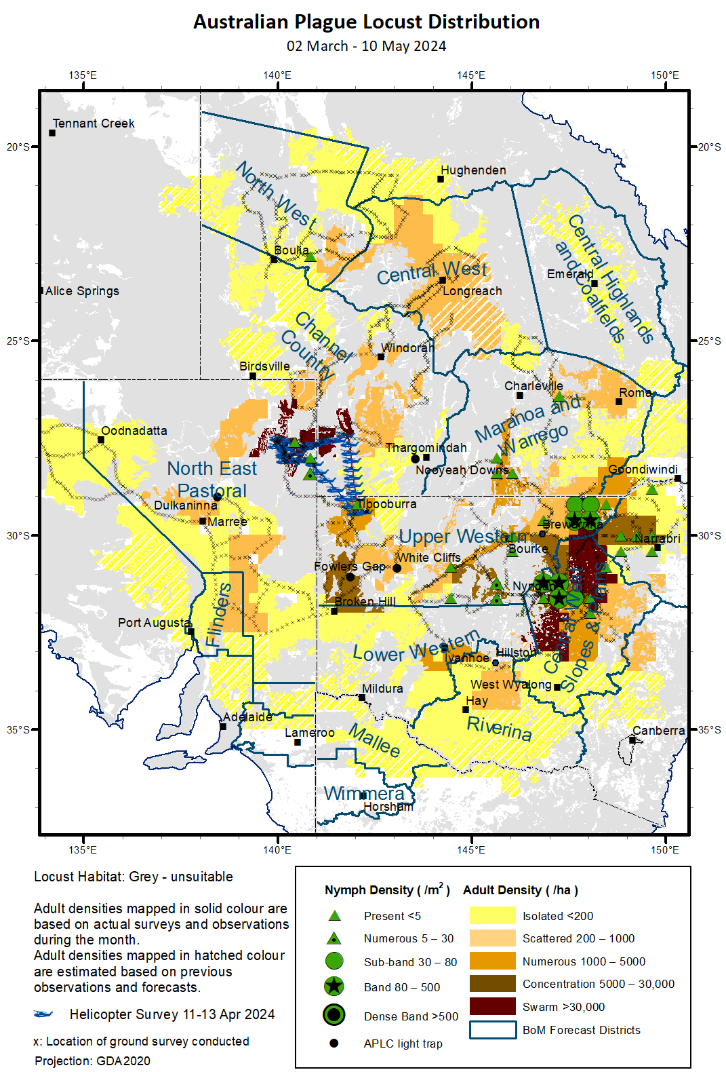

### Spur-throated Locust *Austracris guttulosa*

The overall population increased moderately from low-medium to medium levels. Surveys conducted in March identified consistent Isolated–Concentration density adults in central Queensland and northeastern parts of inland NSW with frequent Present to Numerous and occasional Sub-band density nymphs of mid to late instar detected. Only low-density adults were identified in northwest NSW and northeast SA. April surveys identified consistent Scattered-Concentration densities of adults in the North West of Queensland with frequent late instars of nymphs detected, and Isolated-Scattered density adults in other surveyed areas of northern part of inland NSW and northeast SA and the adjacent Channel Country of Queensland. Surveys conducted in early May identified frequent Isolated-Numerous density adults with occasional nymphs detected in southwest Qld and northeast SA. APLC light traps at Fowlers Gap (NSW), White Cliffs (NSW), Nooyeah Downs (Qld), and Dulkaninna (SA) started to capture some locusts from early March. This reflects a successful seasonal breeding undergone in eastern Australia.

A moderate population increase is expected with some swarms likely to form during winter.

There is a moderate-high risk of some regional infestations developing in Queensland and possibly in northeast inland NSW during winter.

### Migratory Locust *Locusta migratoria*

The overall population has likely increased moderately during the season but would be at low levels from very low background populations. Some nymphs and adults were identified in the Central West of NSW in March. The usual occurrence area of southeastern Queensland and northeastern NSW have been in favourable habitat conditions with successful breeding likely.

There is a low probability of any high-density populations developing from previously very low background levels.

There is a very low risk of a widespread infestation developing during spring.

**It is important that any locust activity be reported as soon as possible to your local biosecurity authority or to the Australian Plague Locust Commission. A toll-free call to the APLC hotline can be made on 1800 635 962. An answering machine is attached to this phone for after-hours calls. Reports can also be emailed to APLC via** [**aplc@agriculture.gov.au**](mailto:aplc@agriculture.gov.au) **or made through the website at** [**https://www.agriculture.gov.au/pests-diseases-weeds/locusts/landholders/reporting_locusts**](https://www.agriculture.gov.au/pests-diseases-weeds/locusts/landholders/reporting_locusts)**.**

# Australian Plague Locust (*Chortoicetes terminifera*)

## SITUATION in Autumn and OUTLOOK to Spring 2024

#### NEW SOUTH WALES

##### NORTH WEST SLOPES & PLAINS

###### Northwest Local Land Services

Locusts and conditions

* Surveys conducted in late March identified consistent adults of Scattered to Low-Density-Swarm between Walgett and Narrabri with occasional nymphs of late instars detected.
* Several reports of locust banding were received from this district in early March.
* The western part of this district (Walgett-Narrabri) received 10–25 mm of rainfall in March while the eastern part received slightly more, at below average to average levels. April rainfall totals ranged from 40 to 160 mm, at above average to very much above average levels. May rainfall totals ranged from 15 to 75 mm, ranging from average to above average level. Locust habitats had generally been in good conditions.

Forecast

* Breeding is likely to occur in favourable habitats, but unlikely to result into any large high-density spring populations when these nymphs hatch from overwintering diapause eggs from late August onwards.
* There is a low probability of any significant migration events during spring.
* The general population density is expected to be at low-medium levels with some localised high-density populations in spring.

Risks

* There is a low-moderate risk of a regional infestation developing during spring.

##### CENTRAL WEST SLOPES & PLAINS

###### Central West Local Land Services

Locusts and conditions

* Surveys conducted in March identified Isolated to Low-Density-Swarm adults with higher numbers in the south of Walgett. March surveys also identified several Sub-Band and Band density nymphs in the Nyngan area.
* April surveys identified Numerous to Low-Density-Swarm adults persistent in the Nyngan and surrounding areas with occasional nymphs detected. Isolated-Scattered densities of adults were identified in other parts of this district.
* Over twenty locust reports of nymphal banding were received and assessed by LLS staff from the Nyngan area in March with more reports of adult swarming in April.
* This district received 20–60 mm of rainfall with heavy rainfall in the Nyngan area in March, generally at average level with the Nyngan area at above average level. April rainfall ranged from 25 to 200 mm over much of this district, at above average level. May rainfall totals ranged from 25 to 100 mm, ranging from average to very much above average level. Habitats had remained in good conditions for locust breeding.

Forecast

* Breeding is likely to occur under favourable habitats, and some localised high-density nymphs likely to hatch from early September onwards from diapause eggs laid later than usual in autumn.
* There was low-moderate probability of migration events during spring.
* The general population density is expected to be at medium levels with localised high-density populations in spring.

Risks

* There is a moderate risk of regional infestations developing during spring.

##### RIVERINA

###### Riverina, Murray Local Land Services

Locusts and conditions

* No surveys were conducted in this district in March, and limited surveys conducted in mid-April in the northern part of this district only identified occasional Isolated or Scattered-density adults.
* No reports of locust activity were received from this district in autumn.
* The UNSW insect monitoring radar in Hay detected frequent nocturnal migrations of locust-shaped insects during the first half of March. These migrants were likely dominated by grasshoppers which were at high levels in this region. This reflects general westward redistributions facilitated by low-pressure troughs.
* This district received 5–25 mm of rainfall in March, ranging from below average to average levels. April rainfall totals ranged from 20 to 60 mm, at average to very much above average level. May rainfall ranged from 25 to 125 mm, ranging from very much below average to very much above average level. Locust habitats were generally in poor conditions in early autumn but had improved later.

Forecast

* Sporadic breeding was possible, but any large bands are unlikely to develop in spring.
* There is a low-moderate probability of migration events during spring.
* The population level is likely to remain low in spring.

Risks

* There is a low risk of regional infestation developing during spring.

##### UPPER and LOWER WESTERN

###### Western Local Land Services

Locusts and conditions

* Surveys conducted in Upper Western district in early March identified several Sub-Band and Band densities of nymphs in the Lightning Ridge area. March surveys also identified Present to Numerous densities of nymphs in the eastern part and widespread Isolated to Scattered densities with occasional Numerous-density adults detected in the Lightning Ridge, Bourke, Cobar, and Broken Hill areas.
* April surveys identified consistent Isolated to Numerous-density adults in the Cobar-Bourke-Wilcannia-Ivanhoe areas without any nymphs detected. The Broken-Hill area had some Concentration-density adults detected, and Scattered to Low-Numerous densities of adults were present in the Tibooburra area with occasional nymphs.
* Surveys conducted in early May in the Broken Hill-Tibooburra areas identified Isolated to Low-Numerous density adults without any nymphs detected.
* Several reports of locust banding were received from the Lightning Ridge area in early March, and locust swarms moving through the Bourke area in mid-April.
* The light trap at White Cliffs captured 360 and 340 locusts on two consecutive nights of 6 and 7 March with a few captures immediately before and after, 15 and 20 locusts on 13 and 16 March respectively, and 2 and 61 locusts on last two nights of 30 and 31 March. The light trap at Fowlers Gap captured 3 locusts on the night of 4 March, 20 locusts on 7 March, and 30, 50 and 10 locusts on three consecutive nights of 10-12 March. The light trap at Fowlers Gap also recorded two periods of locust activities in April on three consecutive nights of 6-8 April with captures of 80, 200 and 50 locusts, and on two consecutive nights of 14 and 15 April with 7 and 15 locusts captured. These captures reflect either local aggregations under the influence of disturbed weathers or short-distance migrations facilitated by low-pressure troughs with a general trend of westward movements.
* March rainfall totals varied from a few millimetres in much of Lower Western District to 25-60 mm over the eastern part of Upper Western district, ranging from below average to above average levels. April rainfall totals were less than 25 mm over much of these two districts, generally at below average to average levels. May rainfall totals ranged from 10 mm in the western part to 50-100 mm in the eastern part of these two districts, ranging from average to very much above average level. Most locust habitats were in average conditions in March and April.

Forecast

* Breeding is likely to occur under favourable habitat conditions, and late egg-laying of overwintering eggs could have occurred in early May after widespread rainfall and result into some localised bands in the Upper Western district from late August onwards.
* There is a low-moderate probability of any significant migration events during spring.
* The overall population is likely to be at low-medium levels, however some localised bands could develop in spring.

Risks

* There is a low-moderate risk of regional infestations developing during spring.

**All locust activity should be reported to your** [**Local Land Services**](https://www.lls.nsw.gov.au/) **(1300 795 299) or the** [**Department of Primary Industries**](https://www.dpi.nsw.gov.au/climate-and-emergencies/locusts)**. A toll-free call to the APLC hotline can be made on 1800 635 962. An answering machine is attached to this phone for after-hours calls. Reports can also be emailed to APLC via** [**aplc@agriculture.gov.au**](mailto:aplc@agriculture.gov.au) **or sent through the web page at** [**https://www.agriculture.gov.au/pests-diseases-weeds/locusts/landholders/reporting_locusts**](https://www.agriculture.gov.au/pests-diseases-weeds/locusts/landholders/reporting_locusts)**.**

#### QUEENSLAND

##### CENTRAL HIGHLANDS AND COALFIELDS

###### Isaac and Central Highlands Regional Councils; Banana Shire

Locusts and conditions

* No surveys were conducted in this district in autumn.
* No reports of locust activity were received from this district in autumn.
* This district received from nearly nil in the centre to 50-100 mm of rainfall in both northern and southern parts in March, ranging from very much below average to above average level. April rainfall totals were 5-25 mm over much of this district, at below average to average levels. May rainfall totals were below 5 mm over much of this district, at very much below average and below average levels. Much of locust habitats was unfavourable for locust breeding.

Forecast

* Sporadic breeding is possible under favourable habitat conditions, but any resulting population is likely to remain at low levels.
* There was a very low probability of any significant migration events during spring.
* The overall population is likely to remain at low levels in spring.

Risks

* There is a very low risk of a regional infestation developing during spring.

##### DARLING DOWNS AND GRANITE BELT

###### Western Downs and Goondiwindi Regional Councils

Locusts and conditions

* No surveys were conducted in this district in autumn.
* No locust reports were received from this district in autumn.
* This district received 25–125 mm of rainfall in March, at average and above average levels. April rainfall totals ranged from 50 to 150 mm, at above average to very much above average levels. May rainfall totals were 5-25 mm over much of this district, at below average and average levels. Habitats were in favourable conditions for locust breeding.

Forecast

* Breeding is possible, but any resulting population is likely at low to medium levels from previously low background.
* There is a low probability of any significant migration events during spring.
* The overall population is likely to remain at low levels.

Risks

* There is a low risk of a regional infestation developing during spring.

##### CENTRAL WEST

###### Barcaldine, Longreach, and Blackall-Tambo Regional Council; Flinders and Winton Shires

Locusts and conditions

* Limited surveys conducted in March identified Isolated to Scattered-density adults without any nymphs detected in the central part of this district, occasional Isolated-density adults detected in the northwestern part in April, and Isolated to Scattered-density adults detected in the central part in May.
* No locust reports were received from this district in autumn.
* This district received 30–120 mm of rainfall in March, at average and above average levels. April rainfall totals ranged from nearly nil in the northern part to over 100 mm in the southern part, ranging from below average to above average level. May rainfall totals were less than 5 mm over much of this district, at very much below average and below average levels. Habitat conditions had become unfavourable for locust breeding.

Forecast

* Limited breeding is likely under favourable habitats, but any resulting population is likely to remain at low levels.
* There is a low probability of any significant migration events during spring.
* The overall locust population is likely to remain at low levels with possible localised higher numbers.

Risks

* There is a low risk of a regional infestation developing during spring.

##### MARANOA AND WARREGO

###### Maranoa Regional Council; Murweh, Paroo, and Balonne Shires

Locusts and conditions

* Surveys conducted in March identified consistent Isolated-Scattered densities of adults with frequent Present-density nymphs detected in the southern part, and occasional Isolated to Low-Numerous densities of adults and Present-density nymphs were present in other parts of this district. By early May, there were still some Isolated-density adults present.
* No locust reports were received from this district in autumn.
* This district received 25–130 mm of rainfall in March, at average to very much above average levels. April rainfall totals from nearly nil in the southwest to over 120 mm in the northeast, ranging from average to very much above average level. May rainfall totals were 10-25 mm over much of this district, at average level. Habitat conditions had generally remained favourable for locust breeding.

Forecast

* Breeding is likely to occur under favourable habitats and result in some localised low to medium densities.
* There is a low probability of any significant migration events during spring.
* The overall population is likely to remain at low-medium levels with localised higher densities possible.

Risks

* There is a low-moderate risk of a regional infestation developing during spring.

##### NORTH WEST

###### Mt Isa, Cloncurry, McKinlay, Boulia, and Winton Shires

Locusts and conditions

* No surveys were conducted in this district in March. April surveys identified frequent Isolated to Scattered-density adults with occasional nymphs detected.
* No locust reports were received from this district in autumn.
* This district received 30–200 mm of rainfall in March, ranging from average to very much above average levels. April rainfall totals were below 10 mm over much of this district, at average to above average levels. May rainfall totals were below 10 mm again over much of this district, at below average to average levels. Habitat conditions had become unfavourable for locust breeding.

Forecast

* Sporadic breeding is possible under favourable habitats, but any resulting locust population is likely to remain at low levels.
* There is a very low probability of any significant migration events during spring.
* The overall population is likely to remain at low levels.

Risks

* There is a low risk of a regional infestation developing during spring.

##### CHANNEL COUNTRY

###### Boulia, Diamantina, Barcoo, Quilpie, and Bulloo Shires

Locusts and conditions

* No surveys were conducted in this district in March. Helicopter surveys conducted during 12 and 13 April identified Numerous to Low-Density-Swarm adults in the Durham Downs-Noccundra-Orientos areas. May surveys identified frequent Isolated to Scattered-density adults with occasional Low-Numerous density adults present.
* The light trap at Nooyeah Downs, Thargomindah, recorded two periods of locust activities in early and late March respectively, and frequent captures of several locusts until early May. The last capture of 15 locusts were on the night of 30 May. This reflects some local populations and short-distance aggregations/redistributions facilitated by disturbed weather.
* Several locust reports of adult appearance were received from the Durham Downs and Noccundra areas in the end of March and early April.
* This district received 20–90 mm of rainfall in March, generally at average levels over much of this district. April rainfall totals were below 10 mm over much of this district, at below average to average levels. May rainfall totals ranged from 10-25 mm in the northern part and 25-60 mm in the southern part of this district, at above average to very much above average level. Some habitats had remained in good conditions for locust breeding.

Forecast

* Breeding is likely to occur under favourable habitat conditions and may result in some localised high-density populations.
* There is a low probability of any significant migration events during spring.
* Populations are likely to remain at low-medium levels with localised higher numbers likely.

Risks

* There is a moderate risk of a regional infestation developing during spring.

**All locust activity should be reported the** [**Biosecurity Queensland (Department of Agriculture and Fisheries)**](https://www.daf.qld.gov.au/business-priorities/biosecurity) **via the** [**Customer Service Centre**](https://www.daf.qld.gov.au/contact/customer-service-centre) **on 13 25 23. A toll-free call to the APLC hotline can be made on 1800 635 962. An answering machine is attached to this phone for after-hours calls. Reports can also be emailed to APLC via** [**aplc@agriculture.gov.au**](mailto:aplc@agriculture.gov.au) **or sent through the website at** [**https://www.agriculture.gov.au/pests-diseases-weeds/locusts/landholders/reporting_locusts**](https://www.agriculture.gov.au/pests-diseases-weeds/locusts/landholders/reporting_locusts)**.**

#### SOUTH AUSTRALIA

##### NORTH EAST PASTORAL and FLINDERS

Locusts and conditions

* Surveys conducted in late March identified Isolated-Scattered adults in the Flinders district, and the southwestern part of North East district. Helicopter surveys conducted during 12 and 13 April identified more than 20 thousand hectares of adults at Concentration to High-Density-Swarm in the Innamincka-Moomba-Tirrawarra areas with occasional nymphs detected. By early May, Scattered to Numerous densities of adults were still present in this region with occasional Low-Density-Swarm detected.
* The light trap at Dulkaninna (SA) was not in operation during March, but more than a thousand locusts were reported attracted by veranda lights on the night of 31 March. The light trap resumed operation from mid-April with the only record of 7 locusts caught on the night of 30 April.
* Several locust reports of sudden adult appearance were received from the Innamincka-Moomba areas from the end of March to early April.
* These two districts received 5-60 mm of rainfall in March, generally at above average levels over much of these two districts with parts at very much above average levels in the northeastern part. April rainfall totals were below 10 mm over much of these two districts, generally at below average level. May rainfall totals were nil to 35 mm (at average level) over these two districts with the northeastern part, where high-density locusts were identified previously, received 25-35 mm of rainfall (above average to very much above average level). Habitats where large autumn populations identified had remained generally in favourable conditions for locust breeding.

Forecast

* Successful breeding is possible under favourable habitats, resulting localised high-density populations from late winter onwards.
* There is a low probability of any significant migration events during spring.
* The overall locust population is likely to be at medium level in these two districts with possible bands and swarms developing in the North East district.

Risks

* There is a moderate-high risk of a regional infestation developing during late winter and early spring.

##### RIVERLAND and MURRAYLANDS

Locusts and conditions

* No surveys were conducted in the two districts in autumn.
* No locust reports were received from these two districts in autumn.
* These two districts received less than 10 mm of rainfall in March, at very much below average to average levels. April rainfall totals were below 5 mm over much of these two districts, at very much below average to below average level. May rainfall totals were 5-10 mm, again at very much below average to below average level. Habitat conditions had remained unfavourable for locust breeding.

Forecast

* Limited sporadic breeding is possible, but any resulting population is likely to remain at low levels.
* There is a low probability of any significant migration/dispersal events during spring.

Risks

* There is a very low risk of a regional infestation developing during spring.

**Locust activity should be reported to** [**Biosecurity SA (Primary Industries and Regions South Australia)**](https://www.pir.sa.gov.au/biosecurity) **via the Plant Health Hotline on 1300 666 010.** **A toll-free call to the APLC hotline can be made on 1800 635 962. An answering machine is attached to this phone for after-hours calls. Reports can also be emailed to APLC via** [**aplc@agriculture.gov.au**](mailto:aplc@agriculture.gov.au) **or sent through the website at** [**https://www.agriculture.gov.au/pests-diseases-weeds/locusts/landholders/reporting_locusts**](https://www.agriculture.gov.au/pests-diseases-weeds/locusts/landholders/reporting_locusts)**.**

#### VICTORIA

##### MALLEE

**Mildura and Swan Hill Rural Cities; Yarriambiack and Buloke Shires**

Locusts and conditions

* No surveys were conducted in this district in autumn.
* No reports were received from this district in autumn.
* This district received less than 10 mm of rainfall in March, ranging from very much below average to average levels. April rainfall totals ranged from 5 to 25 mm, but generally at average level. May rainfall totals were 5-25 mm over much of this district, at very much below average to below average level. Habitats had generally remained in unfavourable conditions for locust breeding.

Forecast

* Sporadic breeding is possible under favourable habitat conditions, but any resulting population is likely to remain at low levels.
* There is a very low probability of any significant migration events during spring.

Risks

* There is a low risk of a regional infestation developing during spring.

##### WIMMERA

**Hindmarsh and West Wimmera Shires**

Locusts and conditions

* No surveys were conducted in this district in autumn.
* No locust reports were received from this district in autumn.
* This district received less than 10 mm of rainfall in March, ranging from lowest on record to average levels. April rainfall ranged from 10 to 40 mm, at below average to average level. May rainfall totals were 10-25 mm over much of this district, at very much below average to below average level. Habitats had generally remained unfavourable for locust breeding.

Forecast

* Limited sporadic breeding is likely under favourable habitats, but any resulting population is likely to remain at low levels.
* There is a very low probability of any significant migration events during spring.

Risks

* There is a very low risk of a regional infestation developing during spring.

**Locust activity should be reported to the** [**Agriculture Victoria**](https://agriculture.vic.gov.au/)[**Customer Contact Centre**](https://agriculture.vic.gov.au/about/contact-us) **on 136 186. Alternatively, you can make a report via the online form at**[**https://forms.bio.vic.gov.au/2020**](https://forms.bio.vic.gov.au/2020)**. Please include photos where possible. A toll-free call to the APLC hotline can be made on 1800 635 962. An answering machine is attached to this phone for after-hours calls. Reports can be emailed to APLC via** [**aplc@agriculture.gov.au**](mailto:aplc@agriculture.gov.au) **or sent through the website at** [**https://www.agriculture.gov.au/pests-diseases-weeds/locusts/landholders/reporting_locusts**](https://www.agriculture.gov.au/pests-diseases-weeds/locusts/landholders/reporting_locusts).

# Glossary of locust terms and density categories used in the Locust Bulletin

**Locust biology and behaviour**

|  |  |
| --- | --- |
| **Term** | **Definition** |
| adult | A fully developed, mature locust capable of breeding and migrating |
| band | Dense congregation of nymphs, usually marching together |
| diapause | Period of dormancy induced in anticipation of unfavourable environmental conditions |
| egg bed | An area of soil containing many egg pods (hundreds per square metre) |
| fledge | Final nymphal moult to a soft-bodied adult (fledgling) incapable of long-distance flight |
| hatch | A young nymph (hatchling) newly emerged from an egg |
| instar | Discrete stages of nymphal development each separated by a moult |
| laying | Female locusts depositing clutches of 20–60 eggs into the ground in froth-lined egg pods |
| nymph | An immature locust. Often referred to as the hopper stage |
| swarm | Dense congregation of adults, milling at the same spot or flying closely together |

###### Locust density categories

Where higher densities occur, a large proportion of the regional population is concentrated in very small areas with lower densities elsewhere, so the higher densities cannot be extrapolated over the area of an entire region. A range of density classes is usually found within a surveyed region.

|  |  |  |
| --- | --- | --- |
| **Nymph Densities** | **Number per m2** |  |
| Present | 1 – 5 |  |
| Numerous | 6 – 30 |  |
| Sub-band | 31 – 80 |  |
| Band | 81 – 500 |  |
| Dense Band | >500 |  |
|  |  |  |
| **Adult Densities** | **Number per m2** | **Number per 250 m2** |
| Isolated | – 0.02 | 1 5 |
| Scattered | 0.024 – 0.1 | 6 – 25 |
| Numerous | 0.104 – 0.5 | 26 – 125 |
| Concentration | 0.504 – 3 | 126 – 750 |
| Low Density Swarm | 4 – 10 | 751 – 2,500 |
| Medium Density Swarm | 11 – 50 | 2,501 – 12,500 |
| High Density Swarm | >50 | >12,500 |
|  |  |  |
| **General density classes** | **Nymph densities** | **Adult densities** |
| very low, occasional | Nil – Present | Nil – Isolated |
| low | Present – Numerous | Isolated – Scattered |
| medium | Numerous – Sub-band | Scattered – Numerous |
| high | Bands | Concentration – Swarms |

###### Reporting locust infestations

It is important that all locust activity is reported as soon as possible to your nearest state agriculture agency office or to the Australian Plague Locust Commission.

|  |  |
| --- | --- |
| **State** | **Authority for reporting locusts** |
| New South Wales | Local Land Services (LLS) or Department of Primary Industries |
| Queensland | Biosecurity Queensland, Department of Agriculture and Fisheries |
| South Australia | Biosecurity SA, Department of Primary Industries & Regions |
| Victoria | Biosecurity and Agriculture Services, Department of Energy, Environment and Climate Action |

Reports to the **Australian Plague Locust Commission** can be made by:

Free call (Canberra): 1800 635 962 (24 hours)

Fax (Canberra): (02) 6272 5074

Email: [aplc@agriculture.gov.au](mailto:aplc@agriculture.gov.au)

Website: <https://www.agriculture.gov.au/pests-diseases-weeds/locusts/landholders/reporting_locusts>