## GENERAL SITUATION in January and OUTLOOK to April 2024

### Australian Plague Locust *Chortoicetes terminifera*

Locust populations were most likely at low levels across inland eastern Australia with possible localised medium-density populations. Limited surveys conducted in January identified some low-density adults with occasional medium-density adults detected in New South Wales. Occasional nymphs were also detected by January survey. The light trap at Nooyeah Downs (Queensland) captured a few adults in mid-January, and so did both light traps at White Cliffs and Fowlers Gap (NSW). The light trap at Dulkaninna (South Australia) did not capture any locust during January, while much higher captures were recorded at the end of January on the light trap at Nooyeah Downs. There were some nocturnal flights detected by the UNSW insect monitoring radar in Hay, NSW, during January. These reflect the existence of localised locust populations and the evidence of short-distance aggregations, redistributions, or migrations. There were no reports of locust activities received from the public in January, but some adult activities like egg-laying from the Lightning Ridge-Collarenebri areas in early February.

Rainfall totals in January varied from 15-50 mm over the arid interior to 50-100 mm across much of inland eastern Australia with parts of over 200 mm rainfall. January rainfall reflected generally above average to very much above average levels with some parts at average levels. January mean temperatures were above averages with the interior centre at more than 4 degrees higher, ranging from above average to very much above average levels over inland eastern Australia. The mild El Niño event seemed to have peaked and likely continues to decay into April. Apart from warmer temperatures, rainfall has not been significantly influenced by this El Niño event over inland eastern Australia. Warm temperatures and below average rainfall are most likely for February, but average rainfall with warmer temperatures is expected for autumn 2024.

The outlook for February to April is for overall low-level populations across inland eastern Australia, with low-moderate population increases to produce some localised medium-density populations under favourable habitat conditions. Summer generation adults are likely to continue emerging, and autumn nymphs could appear from late February onwards. However, it is unlikely that any significant bands will develop during late summer and autumn from currently low background population levels, nor any large-scale swarms are likely to form if no significant migration events occur.

There is a very low likelihood of widespread infestations developing during late summer and autumn.

**07 February 2024**

### Spur-throated Locust *Austracris guttulosa*

The overall population was likely at low-medium levels. Limited surveys in January identified frequent Isolated–Scattered-density adults in southern Queensland and the adjacent area of New South Wales. Some Numerous-density second instar nymphs were detected in the Hebel area by mid-January survey. This reflects seasonal breeding has been successfully undergoing since November 2023. The light trap at Fowlers Gap (NSW) caught a few locusts in mid-January, but not by other light traps at White Cliffs (NSW), Nooyeah Downs (Qld), or Dulkaninna (SA). Habitats would have remained in good condition after January rain, and breeding is likely to continue as a result of favourable habitat conditions.

A moderate population increase is expected with more localised high densities of nymphs hatching during late summer and early autumn.

There is a low-moderate risk of a widespread infestation developing during late summer and autumn.

### Migratory Locust *Locusta migratoria*

The overall population was likely to have remained at very low levels. No locusts were detected in areas surveyed in January. The usual occurrence area of southeastern Queensland had good rainfalls in January again, and breeding was likely to continue in these areas.

Sporadic localised breeding is possible under favourable habitat conditions produced from good January rains. However, high-density infestations are unlikely to result from previously very low background population levels.

There is a very low risk of a widespread infestation developing during late summer and autumn.

**It is important that any locust activity be reported as soon as possible to your local biosecurity authority or to the Australian Plague Locust Commission. A toll-free call to the APLC hotline can be made on 1800 635 962. An answering machine is attached to this phone for after-hours calls. Reports can also be emailed to APLC via** [**aplc@agriculture.gov.au**](mailto:aplc@agriculture.gov.au) **or made through the website at** [**https://www.agriculture.gov.au/pests-diseases-weeds/locusts/landholders/reporting_locusts**](https://www.agriculture.gov.au/pests-diseases-weeds/locusts/landholders/reporting_locusts)**.**

### Locust distribution map—*Chortoicetes terminifera*

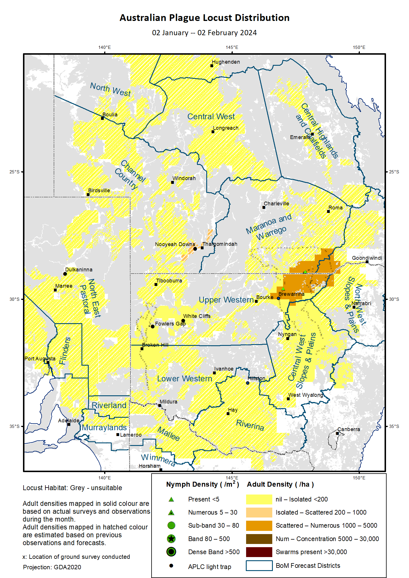

# Australian Plague Locust (*Chortoicetes terminifera*)

## SITUATION in January and OUTLOOK to March 2024

#### NEW SOUTH WALES

##### NORTH WEST SLOPES & PLAINS

###### Northwest Local Land Services

Locusts and conditions

* No surveys were conducted in this district in January.
* No locust reports were received from this district in January.
* This district received 30–120 mm of rainfall in January, generally at average to above average levels.

Forecast

* Limited breeding was likely to continue but unlikely to result into large high-density populations from previously very low background levels.
* There is a very low probability of any significant migrations during late summer and autumn.
* The general population density is expected to remain at low levels with possible localised medium density populations during late summer and autumn.

Risks

* There is a very low risk of a regional infestation developing during late summer and autumn.

##### CENTRAL WEST SLOPES & PLAINS

###### Central West Local Land Services

Locusts and conditions

* Surveys in the northern part of this district identified Isolated-density adults with no nymphs detected in early January.
* No locust reports were received from this district in January.
* This district received 40–120 mm of rainfall in January, ranging from average to very much above average levels.

Forecast

* Limited breeding is likely to continue but unlikely to be widespread or result into high numbers.
* There is a very low probability of any significant migrations during late summer and autumn.
* The general population density is expected to remain at low levels with possible localised medium density populations during late summer and autumn.

Risks

* There is a very low risk of regional infestations developing during late summer and autumn.

##### RIVERINA

###### Riverina, Murray Local Land Services

Locusts and conditions

* No surveys were conducted in this district in January.
* No reports of locust activity were received from this district in January.
* The UNSW insect monitoring radar in Hay detected migrations of locust-shaped insects on nights of 1, 11-13, 20, and 23-24 January, mainly in east-west directions covering possible 200 km ranges. Some short-distance flights at less intensity were also detected in north-south directions in early January. This reflects some local populations and short-distance migration/redistributions.
* This district received 40-110 mm of rainfall in January, ranging from above average to very much above average levels.

Forecast

* Breeding is likely to continue under favourable habitats with possible localised medium-density populations to appear, but bands or swarms are unlikely to develop during late summer and autumn.
* There is a low-moderate probability of migration/dispersal events during late summer and autumn.
* The population level is likely to remain low for the late summer and autumn.

Risks

* There is a low risk of regional infestation developing during late summer and autumn.

##### UPPER and LOWER WESTERN

###### Western Local Land Services

Locusts and conditions

* Limited surveys conducted in the Coonbah-Broken Hill-Packsaddle areas identified Isolated-density adults, and in the Brewarrina-Goodooga-Mungindi-Walgett areas detected occasional Isolated and Low-Numerous-density adults and nymphs.
* No reports of locust activity were received from the public in these two districts in January, but locusts were observed under streetlights of Broken Hill in the early evening of 10 January by APLC staff. Egg-laying activities were reported from the Lightning Ridge-Collarenebri areas on 5 February.
* The light trap at White Cliffs captured 4 and 3 locusts on nights of 9 and 10 January respectively, and the one at Fowlers Gap captured 4, 7, and 2 locusts on three consecutive nights of 15-17 January.
* January rainfall totals varied from 15 mm over the northwestern corner to 150 mm in the eastern part, ranging from average to very much above average levels.

Forecast

* Sporadic breeding is likely to continue under favourable habitat conditions, and any resulting population is likely to remain at low-medium level.
* There is a low-moderate probability of migration/dispersal events during late summer and autumn.
* The overall population is likely to remain at low levels and large-scale bands and warms are unlikely to develop during late summer and autumn.

Risks

* There is a low risk of regional infestations developing during late summer and autumn.

**All locust activity should be reported to your** [**Local Land Services**](https://www.lls.nsw.gov.au/) **(1300 795 299) or the** [**Department of Primary Industries**](https://www.dpi.nsw.gov.au/climate-and-emergencies/locusts)**. A toll-free call to the APLC hotline can be made on 1800 635 962. An answering machine is attached to this phone for after-hours calls. Reports can also be emailed to APLC via** [**aplc@agriculture.gov.au**](mailto:aplc@agriculture.gov.au) **or sent through the web page at** [**https://www.agriculture.gov.au/pests-diseases-weeds/locusts/landholders/reporting_locusts**](https://www.agriculture.gov.au/pests-diseases-weeds/locusts/landholders/reporting_locusts)**.**

#### QUEENSLAND

##### CENTRAL HIGHLANDS AND COALFIELDS

###### Isaac and Central Highlands Regional Councils; Banana Shire

Locusts and conditions

* No surveys were conducted in this district in January.
* No reports of locust activity were received from this district in January.
* This district received 50-200 mm of rainfall in January, generally at average levels with parts of above average and very much above average levels.

Forecast

* Localised breeding is likely to continue under favourable habitat conditions, but any resulting population is likely to remain at low levels.
* There is a very low probability of any significant migration events during late summer and autumn.
* The overall population is likely to remain at low level.

Risks

* There is a very low risk of a regional infestation developing during late summer and autumn.

##### DARLING DOWNS AND GRANITE BELT

###### Western Downs and Goondiwindi Regional Councils

Locusts and conditions

* Limited surveys in the south-western corner of this district but did not identify any locust in early January.
* No locust reports were received from this district in January.
* This district received 90-200 mm of rainfall in January, generally at above average to very much above average levels.

Forecast

* Breeding is likely to continue under favourable habitats, and any resulting population is likely at low-medium level.
* There is a very low probability of any significant migration events during late summer and autumn.
* The overall population is likely to remain at low level.

Risks

* There is a very low risk of a regional infestation developing during late summer and autumn.

##### CENTRAL WEST

###### Barcaldine, Longreach, and Blackall-Tambo Regional Council; Flinders and Winton Shires

Locusts and conditions

* No surveys were conducted in this district in January.
* No locust reports were received from this district in January.
* This district received 35–150 mm of rainfall in January, ranging from below average to above average levels.

Forecast

* Sporadic breeding is likely to continue under favourable habitats, but any resulting population is likely at low-medium level.
* There is a low probability of any significant migration events but some short-distance redistributions possible during late summer and autumn.
* Locust populations are likely to remain at low levels with possible localised higher numbers.

Risks

* There is a low risk of a regional infestation developing during late summer and autumn.

##### MARANOA AND WARREGO

###### Maranoa Regional Council; Murweh, Paroo, and Balonne Shires

Locusts and conditions

* Limited surveys were conducted in the south-eastern part of this district in January. Occasional Isolated and Low-Numerous-density adults were identified with some nymphs detected as well.
* No locust reports were received from this district in January, but some adult activities were reported in early February, reflecting some local populations.
* This district received 60 mm to over 160 mm of rainfall in January, ranging above average to very much above levels with some small parts at average levels.

Forecast

* Sporadic breeding is likely to continue resulting some localised populations.
* There is a low probability of any significant migration events but some short-distance redistributions possible during late summer and autumn.
* Populations are likely to remain at low levels with some higher densities possible.

Risks

* There is a low risk of a regional infestation developing during late summer and autumn.

##### NORTH WEST

###### Mt Isa, Cloncurry, McKinlay, Boulia, and Winton Shires

Locusts and conditions

* No surveys were conducted in this district in January.
* No locust reports were received from this district in January.
* This district received 60-350 mm of rainfall in January, ranging from above average to very much average levels.

Forecast

* Sporadic breeding is possible under suitable habitats, but any resulting locust population is likely at low levels.
* There is a very low probability of any significant migration events during late summer and autumn.

Risks

* There is a low risk of a regional infestation developing during late summer and autumn.

##### CHANNEL COUNTRY

###### Boulia, Diamantina, Barcoo, Quilpie, and Bulloo Shires

Locusts and conditions

* No surveys were conducted in this district in January.
* The light trap at Nooyeah Downs, Thargomindah, captured 3 locusts on the night of 13 January, and 12 and 94 locusts on nights of 30 and 31 January respectively, reflecting some local populations and short-distance aggregations/redistributions.
* No locust reports were received from this district in January.
* This district received 20-100 mm of rainfall in January, generally at average levels.

Forecast

* Sporadic breeding is possible along drainages and under favourable habitats, but less likely to develop bands or swarms.
* There is a low probability of any significant migration/redistribution events but some migrations/redistributions possible during late summer and autumn.
* Populations are likely to remain at low levels with possible localised higher numbers.

Risks

* There is a low risk of a regional infestation developing during late summer and autumn.

**All locust activity should be reported the** [**Biosecurity Queensland (Department of Agriculture and Fisheries)**](https://www.daf.qld.gov.au/business-priorities/biosecurity) **via the** [**Customer Service Centre**](https://www.daf.qld.gov.au/contact/customer-service-centre) **on 13 25 23. A toll-free call to the APLC hotline can be made on 1800 635 962. An answering machine is attached to this phone for after-hours calls. Reports can also be emailed to APLC via** [**aplc@agriculture.gov.au**](mailto:aplc@agriculture.gov.au) **or sent through the website at** [**https://www.agriculture.gov.au/pests-diseases-weeds/locusts/landholders/reporting_locusts**](https://www.agriculture.gov.au/pests-diseases-weeds/locusts/landholders/reporting_locusts)**.**

#### SOUTH AUSTRALIA

##### NORTH EAST PASTORAL and FLINDERS

Locusts and conditions

* No surveys were conducted in these two districts in January.
* No locust reports were received from these two districts in January.
* The light-trap at Dulkaninna did not capture any locusts in January.
* These two districts received 15-80 mm of rainfall in January. Much of these two districts ranged at above average to very much above average levels with parts at average levels.

Forecast

* Sporadic breeding is possible under favourable habitats, but any resulting population is likely to remain at low levels.
* There is a low probability of any significant migration/dispersal events but some migrations and redistributions possible during late summer and autumn.

Risks

* There is a low risk of a regional infestation developing during late summer and autumn.

##### RIVERLAND and MURRAYLANDS

Locusts and conditions

* No surveys were conducted in the two districts in January.
* No locust reports were received from these two districts in January.
* These two districts received 14–50 mm of rainfall in January, generally at above average to very much above average levels.

Forecast

* Limited sporadic breeding is possible, but any resulting population is likely to remain at low levels.
* There is a very low probability of any significant migration/dispersal events during late summer and autumn.

Risks

* There is a very low risk of a regional infestation developing during late summer and autumn.

**Locust activity should be reported to** [**Biosecurity SA (Primary Industries and Regions South Australia)**](https://www.pir.sa.gov.au/biosecurity) **via the Plant Health Hotline on 1300 666 010.** **A toll-free call to the APLC hotline can be made on 1800 635 962. An answering machine is attached to this phone for after-hours calls. Reports can also be emailed to APLC via** [**aplc@agriculture.gov.au**](mailto:aplc@agriculture.gov.au) **or sent through the website at** [**https://www.agriculture.gov.au/pests-diseases-weeds/locusts/landholders/reporting_locusts**](https://www.agriculture.gov.au/pests-diseases-weeds/locusts/landholders/reporting_locusts)**.**

#### VICTORIA

##### MALLEE

**Mildura and Swan Hill Rural Cities; Yarriambiack and Buloke Shires**

Locusts and conditions

* No surveys were conducted in this district in January.
* No reports were received from this district in January.
* This district received 35–100 mm of rainfall in January, generally at very much above average levels with a northern part at above average levels.

Forecast

* Localised breeding is possible under favourable habitats, but any resulting population is likely to remain at low levels.
* There is a low probability of any significant migration events but some migrations or redistributions possible during late summer and autumn.

Risks

* There is a low risk of a regional infestation developing during late summer and autumn.

##### WIMMERA

**Hindmarsh and West Wimmera Shires**

Locusts and conditions

* No surveys were conducted in this district in January.
* No locust reports were received from this district in January.
* This district received 35–85 mm of rainfall in January, ranging from above average to very much above average levels.

Forecast

* Limited sporadic breeding is likely to continue under favourable habitats, but any resulting population is likely to remain at low levels.
* There is a low probability of any significant migration events but some migrations or redistributions possible during late summer and autumn.

Risks

* There is a very low risk of a regional infestation developing during late summer and autumn.

**Locust activity should be reported to the** [**Agriculture Victoria**](https://agriculture.vic.gov.au/)[**Customer Contact Centre**](https://agriculture.vic.gov.au/about/contact-us) **on 136 186. Alternatively, you can make a report via the online form at**[**https://forms.bio.vic.gov.au/2020**](https://forms.bio.vic.gov.au/2020)**. Please include photos where possible. A toll-free call to the APLC hotline can be made on 1800 635 962. An answering machine is attached to this phone for after-hours calls. Reports can be emailed to APLC via** [**aplc@agriculture.gov.au**](mailto:aplc@agriculture.gov.au) **or sent through the website at** [**https://www.agriculture.gov.au/pests-diseases-weeds/locusts/landholders/reporting_locusts**](https://www.agriculture.gov.au/pests-diseases-weeds/locusts/landholders/reporting_locusts).

# Glossary of locust terms and density categories used in the Locust Bulletin

**Locust biology and behaviour**

|  |  |
| --- | --- |
| **Term** | **Definition** |
| adult | A fully developed, mature locust capable of breeding and migrating |
| band | Dense congregation of nymphs, usually marching together |
| diapause | Period of dormancy induced in anticipation of unfavourable environmental conditions |
| egg bed | An area of soil containing many egg pods (hundreds per square metre) |
| fledge | Final nymphal moult to a soft-bodied adult (fledgling) incapable of long-distance flight |
| hatch | A young nymph (hatchling) newly emerged from an egg |
| instar | Discrete stages of nymphal development each separated by a moult |
| laying | Female locusts depositing clutches of 20–60 eggs into the ground in froth-lined egg pods |
| nymph | An immature locust. Often referred to as the hopper stage |
| swarm | Dense congregation of adults, milling at the same spot or flying closely together |

###### Locust density categories

Where higher densities occur, a large proportion of the regional population is concentrated in very small areas with lower densities elsewhere, so the higher densities cannot be extrapolated over the area of an entire region. A range of density classes is usually found within a surveyed region.

|  |  |  |
| --- | --- | --- |
| **Nymph Densities** | **Number per m2** |  |
| Present | 1 – 5 |  |
| Numerous | 6 – 30 |  |
| Sub-band | 31 – 80 |  |
| Band | 81 – 500 |  |
| Dense Band | >500 |  |
|  |  |  |
| **Adult Densities** | **Number per m2** | **Number per 250 m2** |
| Isolated | – 0.02 | 1 5 |
| Scattered | 0.024 – 0.1 | 6 – 25 |
| Numerous | 0.104 – 0.5 | 26 – 125 |
| Concentration | 0.504 – 3 | 126 – 750 |
| Low Density Swarm | 4 – 10 | 751 – 2,500 |
| Medium Density Swarm | 11 – 50 | 2,501 – 12,500 |
| High Density Swarm | >50 | >12,500 |
|  |  |  |
| **General density classes** | **Nymph densities** | **Adult densities** |
| very low, occasional | Nil – Present | Nil – Isolated |
| low | Present – Numerous | Isolated – Scattered |
| medium | Numerous – Sub-band | Scattered – Numerous |
| high | Bands | Concentration – Swarms |

###### Reporting locust infestations

It is important that all locust activity is reported as soon as possible to your nearest state agriculture agency office or to the Australian Plague Locust Commission.

|  |  |
| --- | --- |
| **State** | **Authority for reporting locusts** |
| New South Wales | Local Land Services (LLS) or Department of Primary Industries |
| Queensland | Biosecurity Queensland, Department of Agriculture and Fisheries |
| South Australia | Biosecurity SA, Department of Primary Industries & Regions |
| Victoria | Biosecurity and Agriculture Services, Department of Energy, Environment and Climate Action |

Reports to the **Australian Plague Locust Commission** can be made by:

Free call (Canberra): 1800 635 962 (24 hours)

Fax (Canberra): (02) 6272 5074

Email: [aplc@agriculture.gov.au](mailto:aplc@agriculture.gov.au)

Website: <https://www.agriculture.gov.au/pests-diseases-weeds/locusts/landholders/reporting_locusts>