## GENERAL SITUATION in March and OUTLOOK to Spring 2023

### Australian Plague Locust *Chortoicetes terminifera*

The locust population decreased to low levels across inland eastern Australia except for some localised higher numbers of adults in the south-eastern parts. Surveys in March identified consistent Isolated-density adults in the Maranoa and Warrego district of Queensland, some Isolated-density adults with occasional Scattered-density adults in the Flinders and North East Pastoral districts of South Australia, and consistent Isolated-density adults with some Scattered-density adults in New South Wales with the exception of the Riverina district where adults were frequently detected at Scattered-density level and some at Numerous – Medium-density Swarm levels. No nymphs were identified by survey. No surveys were conducted in March in much of western Queensland due to persistent widespread flooding and adverse weather. The light traps at Dulkaninna (SA) and White Cliffs (NSW) did not capture any locusts during March but the one at Fowlers Gap (NSW) caught several locusts on the nights of 22 and 23 March, respectively. The Insect Monitoring Radar in Hay (NSW) detected several nights of short-range migrations in early March, indicating the presence of localised high-density populations. Several reports of locust/grasshopper activity were also received from the Riverina district.

March rainfall totals were less than 10 mm over the arid/semi-arid interior areas, but more than 50 mm of rainfall was received in south-eastern and north-eastern parts of inland eastern Australia. Rainfall levels were below average across much of the arid/semi-arid interior with small parts at very much below average level, but at above average to very much above average levels in the border areas of inland eastern Australia. March temperatures were above average to very much above average levels (1 – 4 °C) over the arid interior, but below average (< -2 °C) over the northern portion. The La Niña event ended after three consecutive years, with early signs that an El Niño pattern is likely to form later this year. Thus, below average rainfall is likely over much of the arid/semi-arid interior with an above average amount in the north-eastern portion of the inland, and average temperatures are expected for April. Below average rainfall and cooler temperatures are expected for May to July.

The outlook for the remainder of autumn is for a further population decrease to low background levels, with possible localised higher-density populations developing under favourable habitat conditions in inland Queensland. The adults of the autumn generation in the southern portion of inland eastern Australia will continue to lay overwintering eggs, either entering diapause directly or slowly continuing development during winter. There is only a low probability of any significant population increase in the short term, or of a high-density of nymphs in spring in the southern inland portion.

There is a low likelihood of any significant migration events, but short-distance nocturnal migration and daytime dispersal are both possible under any warm conditions and may result in localised high densities.

There is a low likelihood of region-wide infestations developing between now and spring.

**12 April 2023**

### Spur-throated Locust *Austracris guttulosa*

The overall population was at low to medium levels. Surveys in March identified widespread Isolated – Scattered-density adults in the southern portion of inland eastern Australia with occasional Numerous-density adults in Queensland. No nymphs were detected. Western Queensland was not surveyed due to access constraints. Light traps at Dulkaninna (SA), White Cliffs (NSW) and Fowlers Gaps (NSW) did not capture any locusts in March.

There is a low risk of a widespread infestation. Though, some localised medium – high-density infestations are possible after congregation in Queensland during the remainder of autumn.

### Migratory Locust *Locusta migratoria*

The overall population was likely to remain at low levels. No locusts were detected in areas surveyed in March in the southern portion of inland eastern Australia.

Localised breeding should continue under favourable habitat conditions. However, high-density infestations are unlikely to result from the current low background population level.

There is a low risk of a widespread infestation developing during the remainder of autumn or spring.

**It is important that any locust activity be reported as soon as possible to your local biosecurity authority or to the Australian Plague Locust Commission. A toll-free call to the APLC hotline can be made on 1800 635 962. An answering machine is attached to this phone for after-hours calls. Reports can also be emailed to APLC via** [**aplc@agriculture.gov.au**](mailto:aplc@agriculture.gov.au) **or made through the website at** [**https://www.agriculture.gov.au/pests-diseases-weeds/locusts/landholders/reporting_locusts**](https://www.agriculture.gov.au/pests-diseases-weeds/locusts/landholders/reporting_locusts)**.**

### Locust distribution map—*Chortoicetes terminifera*

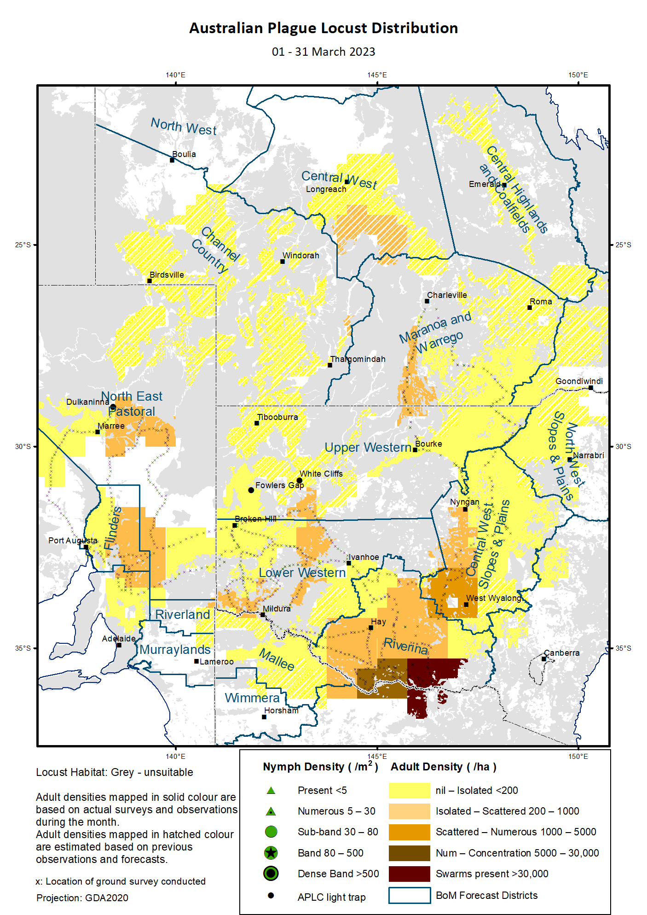

# Australian Plague Locust (*Chortoicetes terminifera*)

## SITUATION in March and OUTLOOK to Spring 2023

#### NEW SOUTH WALES

##### NORTH WEST SLOPES & PLAINS

###### Northwest Local Land Services

Locusts and conditions

* No surveys were conducted in March in this district.
* No locust reports were received from this district in March.
* This district received 15 – 200 mm of rainfall in March, ranging from average to highest on record levels.

Forecast

* Any eggs laid in autumn will be in either slow development or diapause. Nymphs will not hatch from diapause eggs until late August.
* There is a low probability of any significant migration during the remainder of autumn.
* The general population density is expected to remain at low levels between now and spring.

Risks

* There is a low risk of a widespread regional infestation developing between now and spring.

##### CENTRAL WEST SLOPES & PLAINS

###### Central West Local Land Services

Locusts and conditions

* Surveys in March identified consistent Isolated-density adults with occasional Scattered-density adults in this district. No nymphs were detected.
* No locust reports were received from this district in March.
* This district received almost nil to over 100 mm of rainfall in March, ranging from very much below average to very much above average levels.

Forecast

* Any eggs laid in autumn will be in either slow development or diapause. Nymphs will not hatch from diapause eggs until September.
* There is a low probability of any significant migration during the remainder of autumn.
* The general population density is expected to remain at low levels between now and spring.

Risks

* There is a low risk of widespread regional infestations developing between now and spring.

##### RIVERINA

###### Riverina, Murray Local Land Services

Locusts and conditions

* Surveys in March identified consistent Isolated – Scattered-density and some occasional Numerous-density – Medium-Density Swarm adults in this district. No nymphs were detected.
* Several reports of locust activity were received from the Deniliquin-Jerilderie-Corowa areas.
* The UNSW insect monitoring radar in Hay detected several nights of short-distance migration events in early March. These migrations varied in direction, reflecting some redistribution of localised populations facilitated by disturbed weather conditions.
* This district received 15 – 130 mm of rainfall with less than 25 mm of rainfall over much of the district in March, at average to very much above average levels.

Forecast

* Any eggs laid in autumn will be in either slow development or diapause. Nymphs will not hatch from diapause eggs until September.
* There is a low probability of migration/dispersal events during the remainder of autumn.
* The population level is likely to be low for the remainder of autumn or spring with possible localised higher densities.

Risks

* There is a low-moderate risk of some localised infestation developing between now and spring.

##### UPPER and LOWER WESTERN

###### Western Local Land Services

Locusts and conditions

* Surveys in March identified consistent Isolated-density and occasional Scattered-density adults in the Upper and Lower Western districts. No nymphs were detected.
* No reports of locust activity were received from these two districts in March.
* The light trap at White Cliffs did not capture any locusts in March, but the one at Fowlers Gap caught several locusts on the nights of 22 and 23 March, respectively, reflecting low background population levels and very low nocturnal movements around these areas.
* These two districts received less than 25 mm of rainfall in March, ranging from very much below average level to average levels across thee two districts.

Forecast

* Some nymphs may hatch from successful localised breeding in suitable habitats, but a large proportion of the eggs laid in autumn will undertake slow development or dormancy/diapause. Nymphs will not hatch from diapause eggs until mid-August in the Upper Western district and early September in the Lower Western district.
* Localised high density adults may form under hot weather conditions after redistribution by nocturnal migration and day-time dispersal from adjacent areas or within these two districts.
* There is a low-moderate probability of migration/dispersal events during the remainder of autumn.
* The population is likely to remain at low levels for the remainder of autumn and spring.

Risks

* There is a low risk of regional infestations developing during the remainder of autumn, but widespread high-density infestation is unlikely for spring.

**All locust activity should be reported to your** [**Local Land Services**](https://www.lls.nsw.gov.au/) **(1300 795 299) or the** [**Department of Primary Industries**](https://www.dpi.nsw.gov.au/climate-and-emergencies/locusts)**. A toll-free call to the APLC hotline can be made on 1800 635 962. An answering machine is attached to this phone for after-hours calls. Reports can also be emailed to APLC via** [**aplc@agriculture.gov.au**](mailto:aplc@agriculture.gov.au) **or sent through the web page at** [**https://www.agriculture.gov.au/pests-diseases-weeds/locusts/landholders/reporting_locusts**](https://www.agriculture.gov.au/pests-diseases-weeds/locusts/landholders/reporting_locusts)**.**

#### QUEENSLAND

##### CENTRAL HIGHLANDS AND COALFIELDS

###### Isaac and Central Highlands Regional Councils; Banana Shire

Locusts and conditions

* No surveys were conducted in March in this district.
* No reports of locust activity were received from this district in March.
* This district received 40 – 100 mm of rainfall, at generally average to above average levels.

Forecast

* Localised breeding is possible, but any resulting population is likely to remain at low levels.
* There is a low probability of any significant migration events during the remainder of autumn.

Risks

* There is a low risk of a widespread infestation developing between now and spring.

##### DARLING DOWNS AND GRANITE BELT

###### Western Downs and Goondiwindi Regional Councils

Locusts and conditions

* No surveys were conducted in March in this district.
* No locust reports were received from this district in March.
* This district received 30 – 170 mm of rainfall in March, at generally average to very much above average levels.

Forecast

* Some sporadic breeding is possible, but nymphs will not hatch from diapause eggs laid in autumn until August and only a low-density population is expected.
* There is a low probability of any significant migration events during the remainder of autumn.

Risks

* There is a low risk of a widespread infestation developing between now and spring.

##### CENTRAL WEST

###### Barcaldine, Longreach, and Blackall-Tambo Regional Council; Flinders and Winton Shires

Locusts and conditions

* No surveys were conducted in March in this district.
* No locust reports were received from this district in March.
* This district received 40 – 170 mm of rainfall for March, at generally average to above average levels.

Forecast

* Some sporadic breeding is possible, but the population is likely to remain at low levels.
* There is a low probability of any significant migration events during the remainder of autumn.

Risks

* There is a low risk of a widespread infestation between now and spring.

##### MARANOA AND WARREGO

###### Maranoa Regional Council; Murweh, Paroo, and Balonne Shires

Locusts and conditions

* Surveys in March identified consistent Isolated-density adults (but no nymphs) in this district.
* No locust reports were received from this district in March.
* March rainfall for the district varied from 4 – 100 mm of rainfall increasing in the direction of southwest to northeast, ranging from below average to above average levels.

Forecast

* Sporadic breeding may result in some localised low density population.
* There is a low probability of any significant migration events during the remainder of autumn.

Risks

* There is a low risk of a widespread infestation developing between now and spring.

##### NORTH WEST

###### Mt Isa, Cloncurry, McKinlay, Boulia, and Winton Shires

Locusts and conditions

* No surveys were conducted in March in this district.
* No locust reports were received from this district in March.
* This district received ~50 – 430 mm of rainfall in March, at generally above average to very much above average levels.

Forecast

* Sporadic breeding may result in some localised low-density populations in suitable habitats.
* There is a low probability of migration/redistribution events activity during the remainder of autumn.

Risks

* There is a low risk of a widespread infestation developing between now and spring.

##### CHANNEL COUNTRY

###### Boulia, Diamantina, Barcoo, Quilpie, and Bulloo Shires

Locusts and conditions

* No surveys were conducted in March in this district.
* No locust reports were received from this district in March.
* March rainfall totals were less than 25 mm over much of the district, at generally below average to average levels.

Forecast

* Locust numbers are likely to remain at low levels with the possibility of some sporadic breeding.
* There is a low-moderate probability of some emigration to adjacent districts during the remainder of autumn.

Risks

* There is a low risk of a widespread infestation developing between now and spring.

**All locust activity should be reported the** [**Biosecurity Queensland (Department of Agriculture and Fisheries)**](https://www.daf.qld.gov.au/business-priorities/biosecurity) **via the** [**Customer Service Centre**](https://www.daf.qld.gov.au/contact/customer-service-centre) **on 13 25 23. A toll-free call to the APLC hotline can be made on 1800 635 962. An answering machine is attached to this phone for after-hours calls. Reports can also be emailed to APLC via** [**aplc@agriculture.gov.au**](mailto:aplc@agriculture.gov.au) **or sent through the website at** [**https://www.agriculture.gov.au/pests-diseases-weeds/locusts/landholders/reporting_locusts**](https://www.agriculture.gov.au/pests-diseases-weeds/locusts/landholders/reporting_locusts)**.**

#### SOUTH AUSTRALIA

##### NORTH EAST PASTORAL and FLINDERS

Locusts and conditions

* Surveys in March identified Isolated – Scattered-density adults in these districts. No nymphs were detected.
* A report of locust banding on the Borefield Road was received on 20 March but was not subsequently verified by survey.
* The light-trap at Dulkaninna did not capture any locusts in March.
* March rainfall was less than 10 mm across these two districts with <5 mm of rainfall over much of areas, at generally below average to average levels.

Forecast

* Locust numbers are likely to remain low, even with successful localised breeding under favourable habitat conditions and redistribution by nocturnal migration and day-time dispersal from adjacent districts.
* Some high-density adults may form under warm weather conditions.
* Some eggs laid in autumn may enter diapause and nymphs will not hatch until September.
* There is a low-moderate probability of migration/dispersal events within these districts and adjacent areas during the remainder of autumn.

Risks

* There is a low risk of a regional infestation developing between now and spring.

##### RIVERLAND and MURRAYLANDS

Locusts and conditions

* No surveys were conducted in March in the two districts.
* No locust reports were received from these two districts in March.
* March rainfall ranged from 7 – 20 mm, at generally average levels.

Forecast

* The locust population is likely to remain at a low level.
* There is a low-moderate probability of some migration/dispersal events during the remainder of autumn.
* Eggs laid in autumn may continue slow development or enter diapause and nymphs will not hatch until September.

Risks

* There is a low risk of a widespread infestation developing between now and spring.

**Locust activity should be reported to** [**Biosecurity SA (Primary Industries and Regions South Australia)**](https://www.pir.sa.gov.au/biosecurity) **via the Plant Health Hotline on 1300 666 010.** **A toll-free call to the APLC hotline can be made on 1800 635 962. An answering machine is attached to this phone for after-hours calls. Reports can also be emailed to APLC via** [**aplc@agriculture.gov.au**](mailto:aplc@agriculture.gov.au) **or sent through the website at** [**https://www.agriculture.gov.au/pests-diseases-weeds/locusts/landholders/reporting_locusts**](https://www.agriculture.gov.au/pests-diseases-weeds/locusts/landholders/reporting_locusts)**.**

#### VICTORIA

##### MALLEE

**Mildura and Swan Hill Rural Cities; Yarriambiack and Buloke Shires**

Locusts and conditions

* No surveys were conducted in March in this district.
* No reports were received from this district in March.
* March rainfall ranged from 6 – 25 mm in this district, at generally average levels.

Forecast

* Locust numbers are likely to remain at low levels even following any successful immigration from adjacent districts.
* There is a low-moderate probability of immigration events during the remainder of autumn from adjacent districts.
* Eggs laid in autumn may continue slow development or enter diapause and nymphs will not hatch until September.

Risks

* There is a low-moderate risk of a regional infestation developing between now and spring.

##### WIMMERA

**Hindmarsh and West Wimmera Shires**

Locusts and conditions

* No surveys were conducted in March in this district.
* No locust reports were received from this district in March.
* March rainfall ranged from 15 – 25 mm in this district, at generally average levels.

Forecast

* Locust numbers are likely to remain at low levels even following any immigration from adjacent districts.
* There is a low-moderate probability of immigration events during the remainder of autumn.
* Eggs laid in autumn may continue slow development or enter diapause and nymphs will not hatch until September.

Risks

* There is a low risk of a widespread infestation developing between now and spring.

**Locust activity should be reported to the** [**Agriculture Victoria**](https://agriculture.vic.gov.au/)[**Customer Contact Centre**](https://agriculture.vic.gov.au/about/contact-us) **on 136 186. Alternatively, you can make a report via the online form at**[**https://forms.bio.vic.gov.au/2020**](https://forms.bio.vic.gov.au/2020)**. Please include photos where possible. A toll-free call to the APLC hotline can be made on 1800 635 962. An answering machine is attached to this phone for after-hours calls. Reports can be emailed to APLC via** [**aplc@agriculture.gov.au**](mailto:aplc@agriculture.gov.au) **or sent through the website at** [**https://www.agriculture.gov.au/pests-diseases-weeds/locusts/landholders/reporting_locusts**](https://www.agriculture.gov.au/pests-diseases-weeds/locusts/landholders/reporting_locusts).

# Glossary of locust terms and density categories used in the Locust Bulletin

**Locust biology and behaviour**

|  |  |
| --- | --- |
| **Term** | **Definition** |
| adult | A fully developed, mature locust capable of breeding and migrating |
| band | Dense congregation of nymphs, usually marching together |
| diapause | Period of dormancy induced in anticipation of unfavourable environmental conditions |
| egg bed | An area of soil containing many egg pods (hundreds per square metre) |
| fledge | Final nymphal moult to a soft-bodied adult (fledgling) incapable of long-distance flight |
| hatch | A young nymph (hatchling) newly emerged from an egg |
| instar | Discrete stages of nymphal development each separated by a moult |
| laying | Female locusts depositing clutches of 20 – 60 eggs into the ground in froth-lined egg pods |
| nymph | An immature locust. Often referred to as the hopper stage |
| swarm | Dense congregation of adults, milling at the same spot or flying closely together |

###### Locust density categories

Where higher densities occur, a large proportion of the regional population is concentrated in very small areas with lower densities elsewhere, so the higher densities cannot be extrapolated over the area of an entire region. A range of density classes is usually found within a surveyed region.

|  |  |  |
| --- | --- | --- |
| **Nymph Densities** | **Number per m2** |  |
| Present | 1 – 5 |  |
| Numerous | 6 – 30 |  |
| Sub-band | 31 – 80 |  |
| Band | 81 – 500 |  |
| Dense Band | >500 |  |
|  |  |  |
| **Adult Densities** | **Number per m2** | **Number per 250 m2** |
| Isolated | – 0.02 | 1 5 |
| Scattered | 0.024 – 0.1 | 6 – 25 |
| Numerous | 0.104 – 0.5 | 26 – 125 |
| Concentration | 0.504 – 3 | 126 – 750 |
| Low Density Swarm | 4 – 10 | 751 – 2,500 |
| Medium Density Swarm | 11 – 50 | 2,501 – 12,500 |
| High Density Swarm | >50 | >12,500 |
|  |  |  |
| **General density classes** | **Nymph densities** | **Adult densities** |
| very low, occasional | Nil – Present | Nil – Isolated |
| low | Present – Numerous | Isolated – Scattered |
| medium | Numerous – Sub-band | Scattered – Numerous |
| high | Bands | Concentration – Swarms |

###### Reporting locust infestations

It is important that all locust activity is reported as soon as possible to your nearest state agriculture agency office or to the Australian Plague Locust Commission.

|  |  |
| --- | --- |
| **State** | **Authority for reporting locusts** |
| New South Wales | Local Land Services (LLS) or Department of Primary Industries |
| Queensland | Biosecurity Queensland, Department of Agriculture and Fisheries |
| South Australia | Biosecurity SA, Department of Primary Industries & Regions |
| Victoria | Biosecurity and Agriculture Services, Department of Energy, Environment and Climate Action |

Reports to the **Australian Plague Locust Commission** can be made by:

Free call (Canberra): 1800 635 962 (24 hours)

Fax (Canberra): (02) 6272 5074

Email: [aplc@agriculture.gov.au](mailto:aplc@agriculture.gov.au)

Website: <https://www.agriculture.gov.au/pests-diseases-weeds/locusts/landholders/reporting_locusts>