Appendix 1:
The following table provides instructions on how to find your ‘incomplete’ courses in Learnhub.
Step | Action | Graphic
1. | Log into your Learnhub account at https://learnhub.gov.au/ | 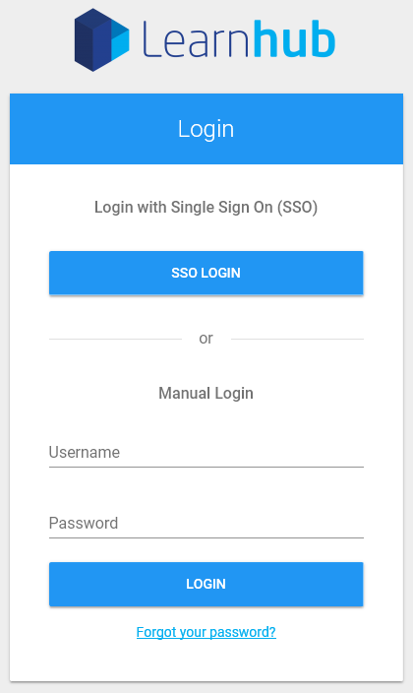
2. | From the ‘Training History’ tab, select ‘My Enrolments’. | 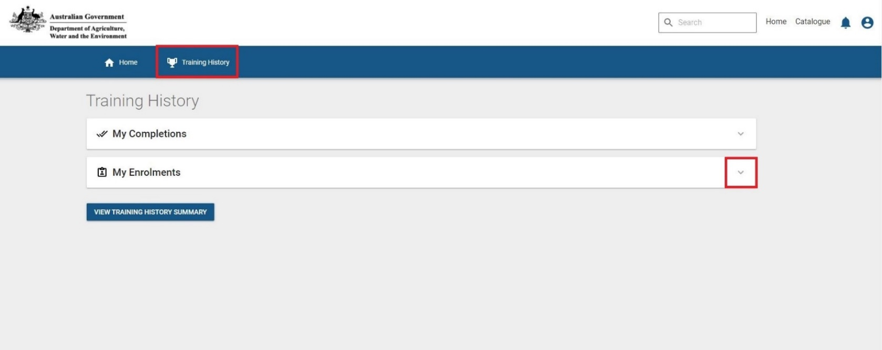
3. | Click on the name of the program you are enrolled in.  Note: If you are enrolled in more than one program, you will need to complete this step for each program. | 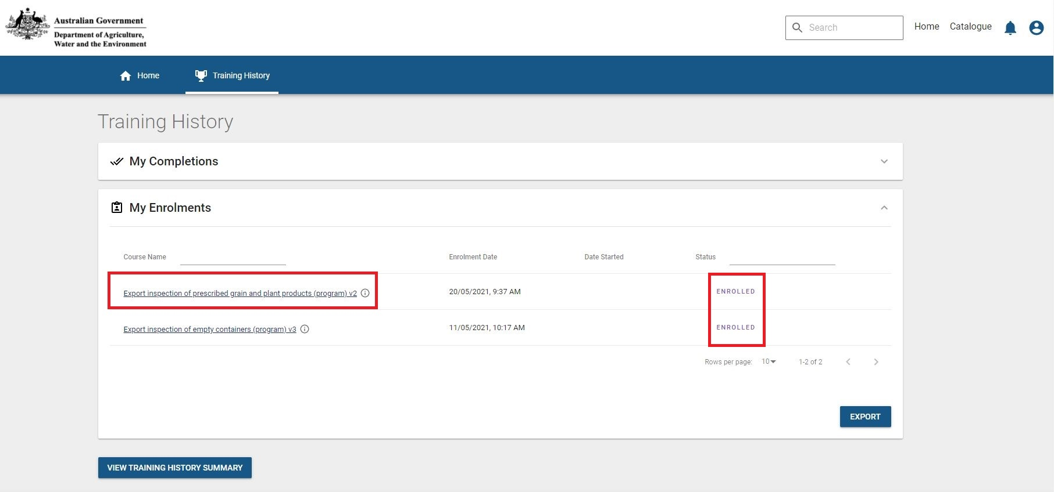
4. | - A list of courses will appear with a status of ‘complete’ or ‘incomplete’.  - Click on and complete the courses that are marked ‘incomplete’. | 