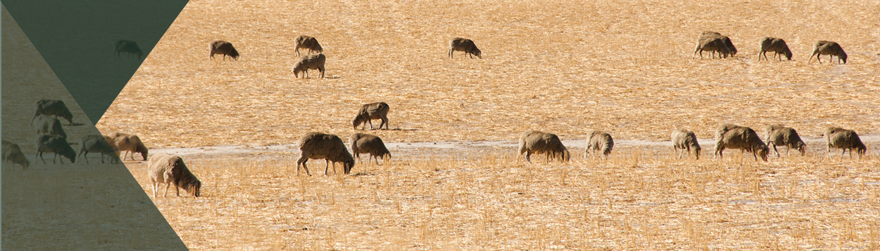

**Implementation of the   
Live Sheep Export Phase Out**

**$5.6 million**

The Australian Government is committed to delivering its election commitment to phase out live sheep exports by sea.

A four-person panel is undertaking an independent assessment and broad-ranging consultation process, to inform implementation of the government’s election commitment to phase out live sheep exports by sea.

The consultation process will inform the development of a report that will make recommendations to the government about how and when to phase out live sheep exports by sea. The report will consider the views and interests of domestic and international stakeholders, ways to support the industry’s transition away from live sheep exports, and further opportunities to protect and grow the sheep meat industry in the future.

**What’s in this year’s Budget**

The government has established an independent panel to assess how and when to phase out live sheep exports from Australia by sea**.** The funding in the Budget will support the work of the independent panel and the department in ensuring the effective delivery of the government’s election commitment to phase out live sheep exports by sea.

**Implementation of the Live Sheep Export Phase Out**

**The government is committing $5.6 million over 2 years to this initiative.**

Why this is important

The government is committed to implementing its election commitment to phase out live sheep exports by sea in a considered and orderly way. The government recognises the strong industry and community interest in the implementation of this election commitment and understands it will impact farmers, exporters and other supply chain participants. An open and transparent consultation process is necessary to ensure all views are considered across the spectrum of interests, including the agricultural industry and animal welfare.

An independent assessment will ensure analysis is high-quality and considers economic, trade and diplomatic impacts, and that the report and subsequent implementation plan is appropriately considered and informed.

A four-person independent panel provides specific government, regulatory, industry, regional and animal welfare experience to this work.

To allow sufficient time for the panel to undertake its assessment and the consultation process, the reporting date will be 30 September 2023. This will allow the panel to complete its work and deliver a high-quality report to the government.

How much this will cost

|  |  |  |  |  |  |
| --- | --- | --- | --- | --- | --- |
|  | **2022-23 $m** | **2023-24 $m** | **2024-25 $m** | **2025-26 $m** | **TOTAL $m** |
| **Phase Out of Live Sheep Exports by Sea – Independent Panel** |  |  |  |  |  |
| Phase Out of Live Sheep Exports by Sea – Independent Panel | 2.195 | 3.411 | - | - | 5.606 |
| **Subtotal** | **2.195** | **3.411** | **-** | **-** | **5.606** |

More information

For more information on the implementation of the Live Sheep Export Phase Out visit [agriculture.gov.au](http://www.agriculture.gov.au)

For more information about the 2023–24 Budget visit [budget.gov.au](http://www.budget.gov.au)