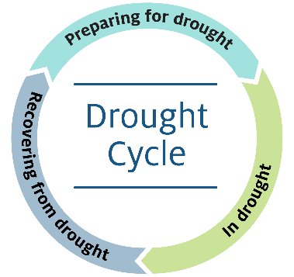January 2025

***Living with drought***

**Australian Government support**

Drought is a case of when, not if.

Planning for drought can help you prepare and grow your farm business when conditions are good and manage the impacts as it dries. See what resources and support are available in your region through your state, territory or local government.

Visit drought.gov.au for information on Australian Government programs that can help.

**Help to prepare and grow**

You don’t have to be in hardship to be eligible.

**Farm Business Resilience Program**

Access subsidised training and coaching to help you achieve your farm business goals.

**My Climate View**

Explore climate information for your location and commodity, wherever you are across Australia.

**Farm Management Deposit Scheme**

Set aside income in good years that you can draw on when you need it.

**Tax deductions**

Access accelerated depreciation for fencing, dams, pumps, silos, bins, landcare operations and carbon sink forests.

**Income tax averaging**

Even out your income and tax payable over a maximum of 5 years.

**Concessional loans**

Apply for a low-cost Regional Investment Corporation loan if you’re an eligible farm business in financial need.

**Help in hard times**

**Farm Household Allowance**

Check if you’re eligible for up to 4 years of support. Call the Farmer Assistance Hotline on 132 316.

**Rural Financial Counselling Service**

Access free, confidential and independent financial counselling if you’re an eligible primary producer or small business experiencing, or at risk of, financial hardship. Call 1300 771 741.

**Concessional loans**

Apply for a low-cost Regional Investment Corporation loan if you’re an eligible farmer or farm-related small business in financial need.

**Tax support**

Check if you can get more time to lodge and pay tax.

Access other concessions, such as spreading or deferring profits from the forced disposal or death of livestock.

**Social support and wellbeing**

Call Lifeline on 13 11 14 or find other social support.

**Who else can help and how**

Do you want to know more about:

• diversifying your production

• managing price and input risks

• farm exit and succession plans

• structuring your business in a tax effective way

• accessing rebates and concessions

• expanding your off-farm income

• maintaining soil moisture and ground cover

• new farm practices and technologies

• other financial, social and personal support?

There is no one “right way” of getting ready for drought but there are people and organisations you can talk to confidentially about your options. They include farm industry groups, banks, financial planners and accountants, lawyers, agronomists, community groups and charities.

**QR code linking to www.drought.gov.auFor more information**

Visit drought.gov.au

**Acknowledgement of Country**

We acknowledge the Traditional Custodians of Australia and their continuing connection to land and sea, waters, environment and community. We pay our respects to the Traditional Custodians of the lands we live and work on, their culture, and their Elders past and present.

© Commonwealth of Australia 2025

Unless otherwise noted, copyright (and any other intellectual property rights) in this publication is owned by the Commonwealth of Australia (referred to as the Commonwealth). All material in this publication is licensed under a [Creative Commons Attribution 4.0 International Licence](https://creativecommons.org/licenses/by/4.0/legalcode) except content supplied by third parties, logos and the Commonwealth Coat of Arms.

The Australian Government acting through the Department of Agriculture, Fisheries and Forestry has exercised due care and skill in preparing and compiling the information and data in this publication. Notwithstanding, the Department of Agriculture, Fisheries and Forestry, its employees and advisers disclaim all liability, including liability for negligence and for any loss, damage, injury, expense or cost incurred by any person as a result of accessing, using or relying on any of the information or data in this publication to the maximum extent permitted by law.