DAFF Maritime Waste Recycling Pilot Cleaning and Segregation Guide

|  |  |  |  |  |
| --- | --- | --- | --- | --- |
| **Waste that CAN be recycled in Australia**   |  |  | | --- | --- | | **Cleaned and segregated** | | | * **Aluminium cans** * **Plastic beverage containers and cups** * **Paper and cardboard** | * **Glass** * **Hard plastic containers** * **Tin and kitchen metal cans/containers** | |
| Picture shows items which can be recycled in Australian ports which are aluminium cans, glass drink bottles, non-beverage glass bottles and jars, tin and steel cans, plastic drink bottles and cups, non-beverage plastic tubs, bottles and jars, paper and magazines, and clean cardboard boxes. A green tick appears in the centre to indicate that these items are recyclable. |

|  |  |  |
| --- | --- | --- |
|  |  |  |

|  |
| --- |
| **Waste that CANNOT be recycled in Australia** |
|  |

**HOW TO SORT RECYCLABLES**

**Sort recyclables according to category. The categories are:**

* **Aluminium drink cans**
* **Steel or tin cans**
* **Paper and magazines**
* **Cardboard (excluding egg, fruit, vegetable, seafood and meat boxes)**
* **Plastic drink bottles and cups**
* **Glass drink bottles**
* **Non-beverage glass jars and bottles**
* **Plastic tubs and jars and non-beverage bottles**

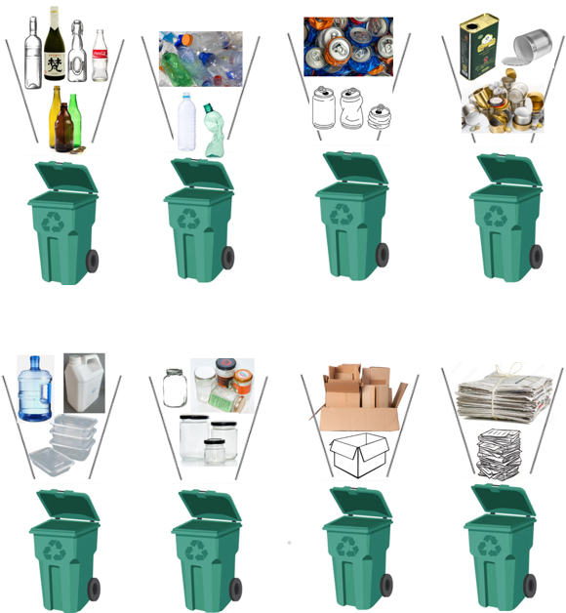

**HOW TO STORE RECYCLABLES**

|  |  |  |
| --- | --- | --- |
| A green tick mark on a black background  Description automatically generatedA group of seven recycling bins with labels for different categories of recycable materials; including Glass bottles, Plastic Bottles, Paper, tin cans. A green tick is imposed over the image of the bins to indicate that segregated bins are an acceptable method to sort and store recyclables. **Bins** | A green tick mark on a black background  Description automatically generatedA picture of two Bulk Bags which are labelled with the category of recyclable they contain. The bulk bags contain Glass. The Bulk Bags are placed on ISPM 15 pallets.  A green tick is imposed over the image of the bulk bags and ISPM 15 pallets to indicate that these are an acceptable method to sort and store recyclables. **Bulk Bags** | A green tick mark on a black background  Description automatically generatedPicture of a bulk box which is an oversize cardboard box. The bulk box is labelled with the category of recyclable that it contains, which are crushed aluminium cans.  A green tick is imposed over the image of the bulk box to indicate that these are an acceptable method to sort and store recyclables.**Bulk box** |

* **Store each category of recyclable separately**
* **Store in stored bins, bulk bags, bulk box or on ISPM 15 palettes.**
* **Label each bin, bulk bag, bulk box or pallet**
* **Keep recyclables separated from other types of waste.**

**HOW TO PRESENT RECYCABLES FOR INSPECTION**

|  |  |
| --- | --- |
| * **Present each category of recyclable in it’s own bin, bulk bag or pallet.** * **Clearly label the recyclables according to category.** * **Recyclables must be packaged to allow visual inspection in bulk bags, bins or on ISPM 15 or plastic pallets.** * **Recyclables must be clearly labelled by the crew** | A blue plastic pallet. |

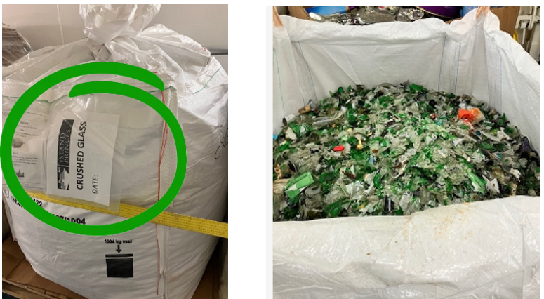

|  |  |  |
| --- | --- | --- |
| **Recyclables presented in soft plastic bags (**e.g. garbage bags or grocery bags) **are not permitted.  A pile of soft plastic bags which are full of rubbish and recyclable materials. A red cross is imposed on the image to indicate that materials bagged in soft plastic bags cannot be recycled.**  **Recyclables Contaminated with soft plastic bags such as,** garbage bags and grocery bags**, must be managed as biosecurity waste and all recyclables within that bin become in-eligible for recycling.**  **WHAT HAPPENS AFTER ONBOARD INSPECTION?**  The vessel is required to provide their own method of labelling to clearly identify which recyclables were released from biosecurity control following on-board inspection.  Recyclables which have been released from biosecurity control may be discharged.  Recyclables which have NOT been released from biosecurity control following inspection must be managed as biosecurity waste through an Approved Arrangement. | A yellow sign with black text  Description automatically generatedPlease note that materials that are not included in the DAFF Maritime Waste Recycling Pilot may be discharge by completing an ABF Form 44 *Request to remove goods (other than cargo) from ship,* or disposed of as biosecurity waste via an Approved Arrangements provider. These materials may be subject to additional biosecurity import conditions as per DAFF [BICON](https://www.agriculture.gov.au/biosecurity-trade/import/online-services/bicon) in accordance with the *Biosecurity Act 2015.*  Items cannot be recycled when they previously contained dairy or egg ingredients, such as bulk mayonnaise or bulk cream cheese etc.  A red x on a black background  Description automatically generatedA HDPE plastic bucket labelled as containing whole egg mayonnaise with pictures of eggs and a jug of milk. A red cross overlays the bucket. | |
| A plain white HPDE plastic bucket with a hole or puncture in it to prevent reuse. A green tick is next to the hole in the bucket.   | | | **4. Recyclables must be sorted according to category.**  **5. Recyclables presented within soft plastic bags (e.g. garbage bags or grocery bags) are not permitted.**  **6. Items which previously contained dairy, egg, honey, whole fruit, whole vegetables and/or meat and meat products (including seafood) are not permitted for recycling.**  **7. Recyclable items mixed with materials that previously held dairy, honey or whole fruit, whole vegetables or meat (e.g. meat boxes etc.) must be managed as biosecurity waste through an Approved Arrangement.**  **8. Recyclables must be clearly identified and segregated from other types of waste including biosecurity waste.**  **9. Recyclables must be clearly labelled with contents before inspection.**  **10.Following onboard inspection additional labels must be applied by the crew to clearly identify which recyclables have passed inspection and are therefore permitted to be discharged. The vessel must provide their own labelling and records.** | |
| Recyclable materials, including HPDE plastics, that previously contained **non-dairy,** **non-egg** foods and beverages or non-food items (e.g. cleaning chemicals) **may** be recycled.  **They should be crushed or punctured to prevent reuse in Australia and ensure they are recycled once discharged from the vessel.**  Recyclable materials that previously contained **dairy** or **egg** products **cannot** be recycled.  These materials cannot be discharged from the vessel unless they are managed as biosecurity waste through an Approved Arrangement. They cannot be reused or repurposed in Australia and should be crushed or punctured to prevent this.  **KEY TALKING POINTS FOR DISCUSSION WITH CREW**   1. **Recyclables must be washed clean; this includes removing food residue and fruit garnishes (e.g. lemon wedges) from beverage bottles.** 2. **Mixed recyclable materials** **are not allowed while on-board.** 3. **Recyclables must be stored in bins, bulk bags or bulk boxes or on ISPM15 pallets or plastic pallets.** | | |

**Example of waste for recycling label (99.1 mm x 139 mm)**

Labels are used to clearly identify waste released for recycling by biosecurity officers.

Labels used must clearly identify waste for recycling on at least 2 visible sides.

Labels should use the recycling symbol with the number of each pallet and total number of pallets released for recycling.

Label to be affixed to each bin, bulk bag, box or pallet approved during Biosecurity Officer inspection for recycling**.** Number each with total e.g. 1 of 5, 2 of 5, 3 of 5 etc.

Not to be affixed to any waste directed for biosecurity disposal.

