USER GUIDE

NEXDOC:
Lodge a Request for Export (REX) for Dairy

__________________________________________________________________________________
In this document
This document contains the following topics.
Purpose of this document 2
Start a new Request for Export (REX) 2
REX Section 1: Country details 3
REX Section 2: Product Details 4
REX Section 3: Exporter Details 12
REX Section 4: Consignee Details 13
REX Section 5: Transport Details 14
REX Section 6: Authorisation 17
REX Section 7: Endorsements 18
REX Section 8: Single Electronic Window (SEW) 19
REX Section 9: Additional Details 21
REX Section 10: Attachments 23
REX Section 11: Submit 24
Contact the NEXDOC Help Desk. 26

Purpose of this document
The below information will guide you through lodging a Request for Export (REX) for dairy.
Lodge your REX using the Next Export Documentation (NEXDOC) system.
The department will then:
- assess whether you have met all export requirements.
- issue an export certificate, if approved.

Start a new Request for Export (REX)
Step 1  Log in to the Online Services Portal. | 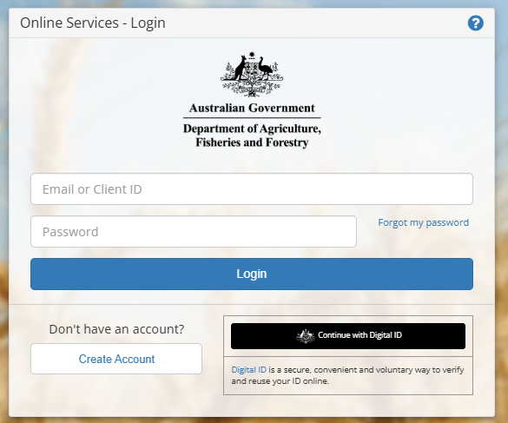
Step 2  Select Lodge a Request for Export. | 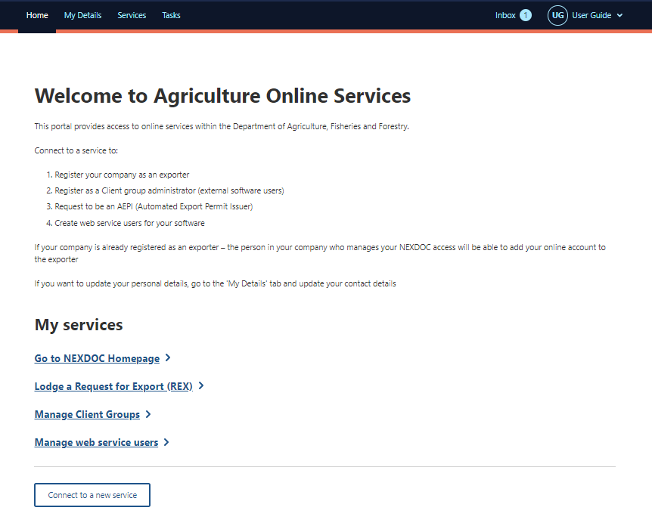
Step 3  Select the Commodity type of your export drop down menu. You will need to select Dairy for a dairy REX.  Questions may appear after you have selected the dairy commodity.  - Are you using a Quota for this request?  - Do these products contain any imported dairy ingredients?  If these questions apply, please select the tick box next to the relevant question and fill in any additional information requested.  Then select Start. | 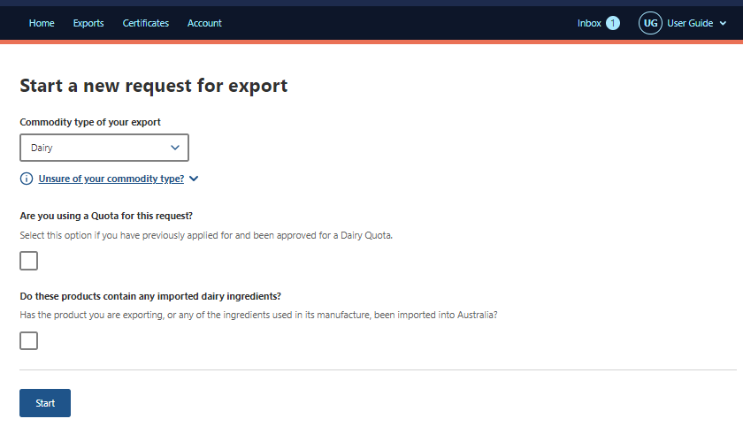

REX Section 1: Country details
Step 1  Type the Country you wish to export to drop down menu.  Select Next. | 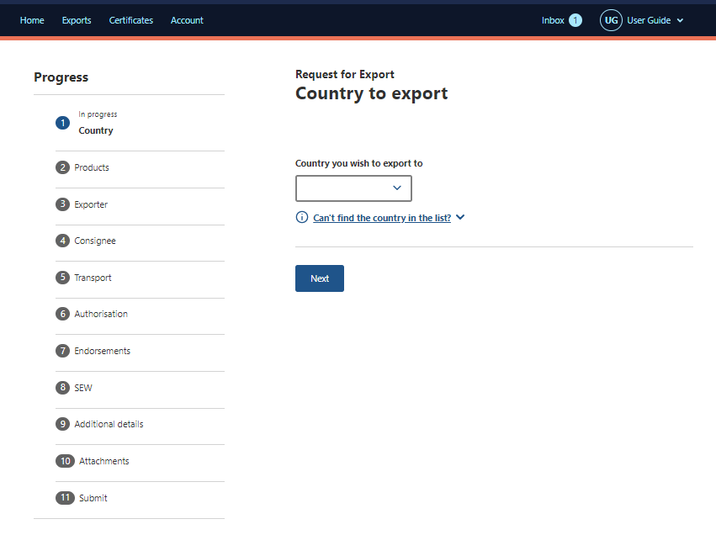

REX Section 2: Product Details
Step 1  Select the + Add a product to export button. | 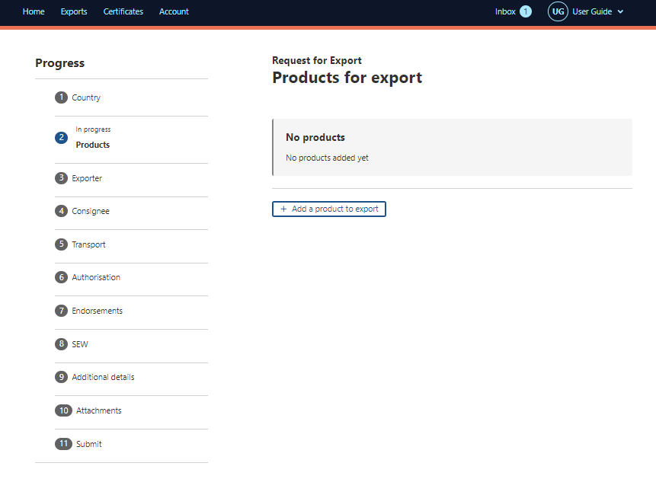
Step 2  Select Product you wish to export drop down menu. | 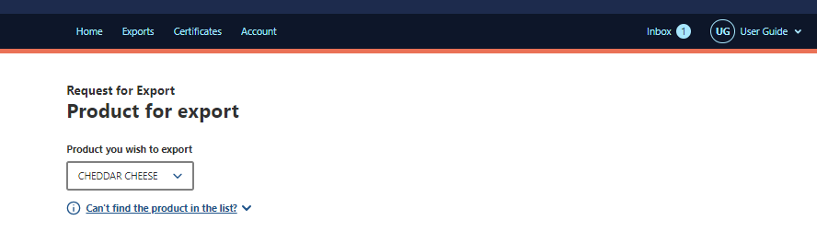
Step 3  Complete relevant fields within Add details for the product. | 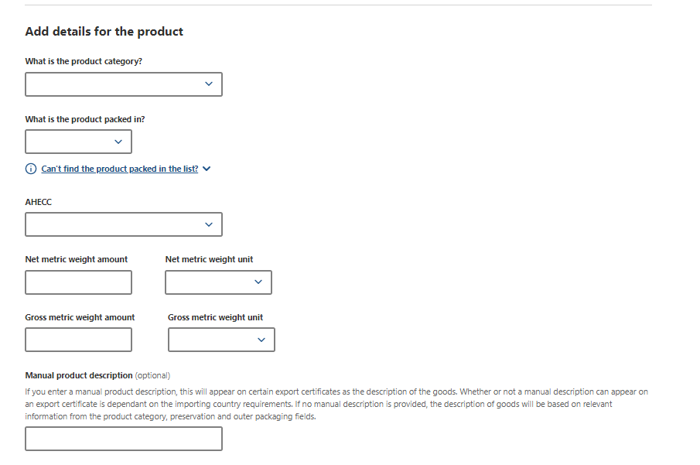
Step 4  Select relevant fields within Outer packaging. | 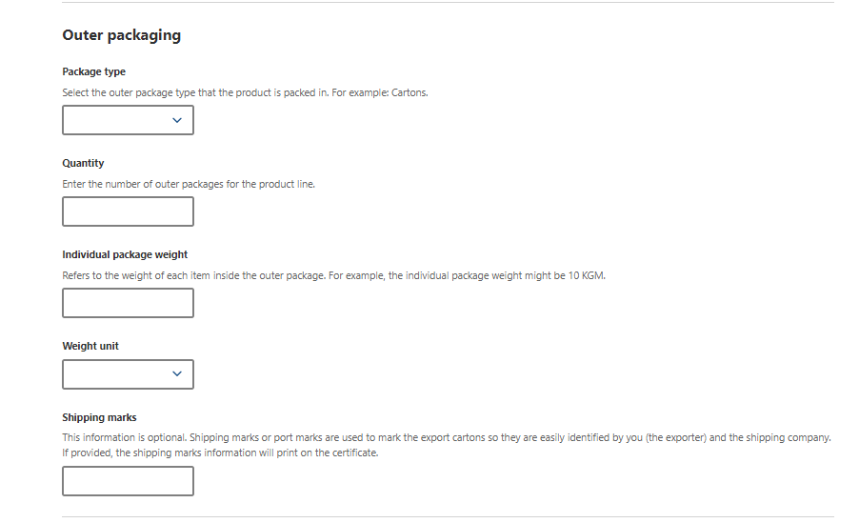
To add additional information about your product:
Step 5  Select Additional packaging tab. | 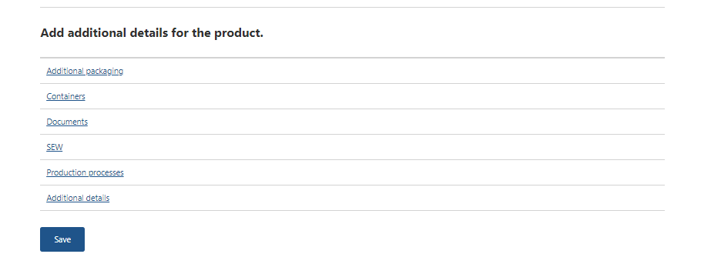
Step 6  Complete relevant fields within Packaging for the product.  Select Save. | 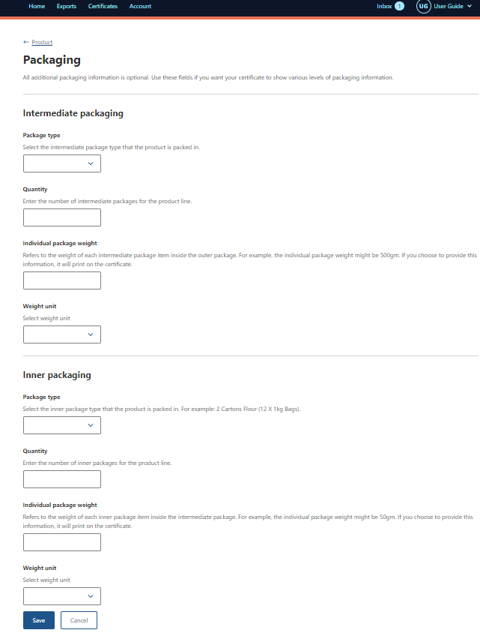
Step 7
Select Containers tab.

Step 8  Select the tick box for Air or Sea freight.  Select + Add container. | 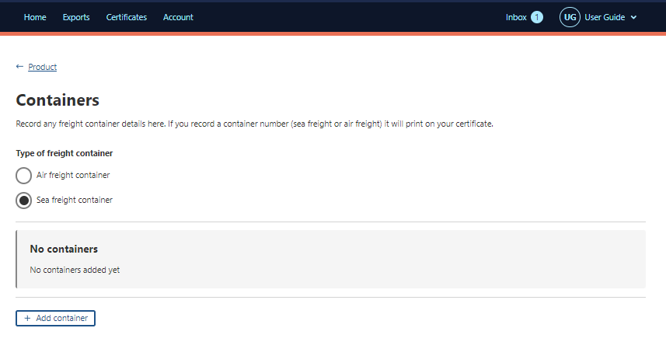
Step 9  Type the Air or Sea freight container number.  Select Add. | 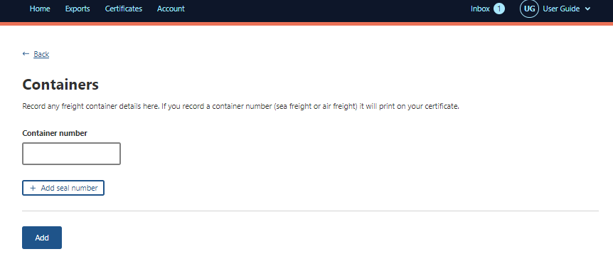
Step 10  If Air Freight  Provide the Container number for the Air Freight container.  If seal numbers are available, select Add seal number and provide the Start seal number and End seal number.  Select Add.  Note: Optional fields. | 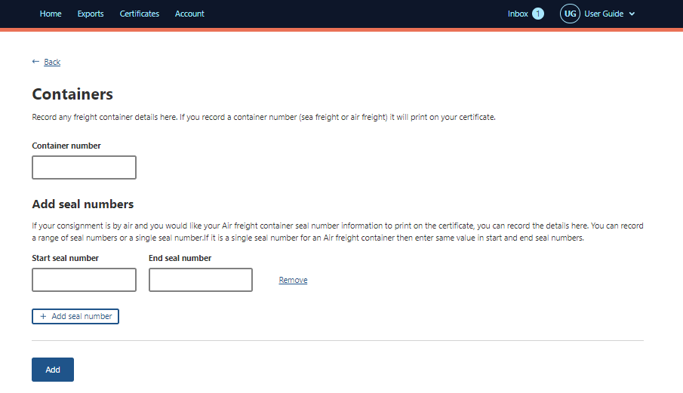
Step 11
Select Documents tab.

Step 12  Select + Add document | 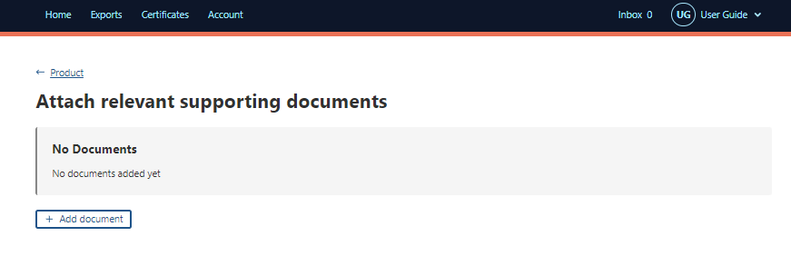
Step 13  Type in the type of documentation in the Description field.  Drag and drop the file.  Select Add. | 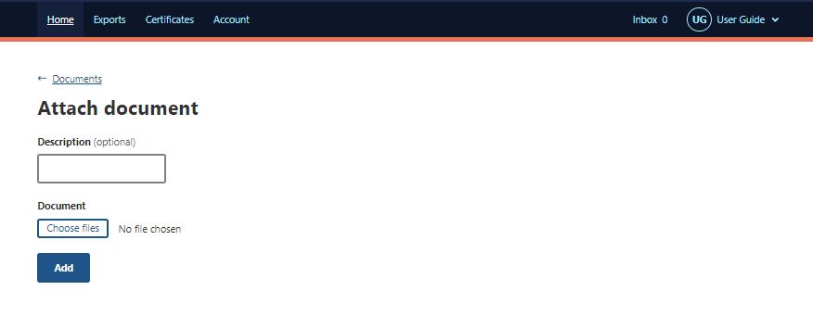
Step 14

Select SEW tab.
Step 15  SEW information is optional.  This information becomes mandatory if you are using the Single Electronic Window (SEW) connection to obtain an Export Declaration Number (EDN) via NEXDOC.  Complete relevant fields within SEW information for the product.  Select Save to return to the product page. | 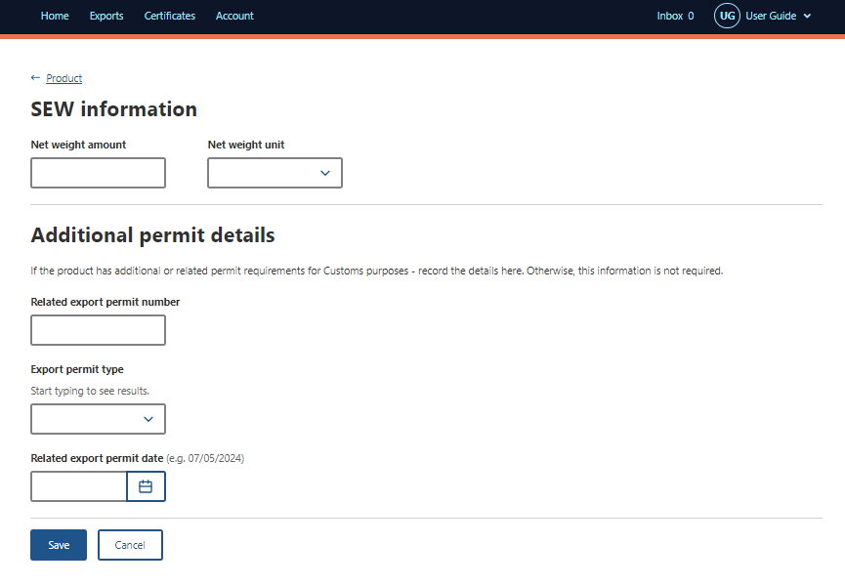
Step 16  Select Production Processes tab | 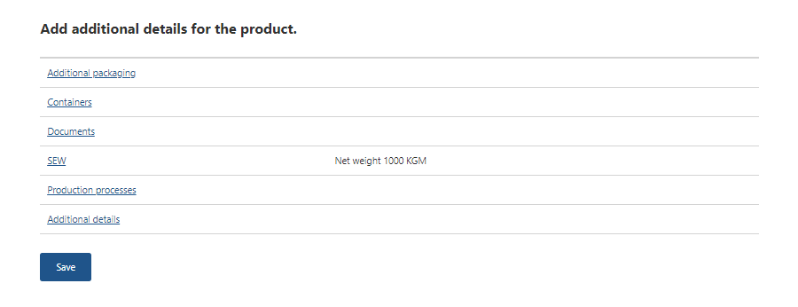
Step 17  Select Add Production process | 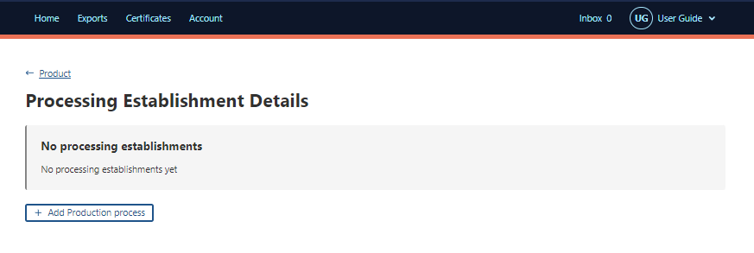
Step 18  Complete the relevant fields.  Select Add | 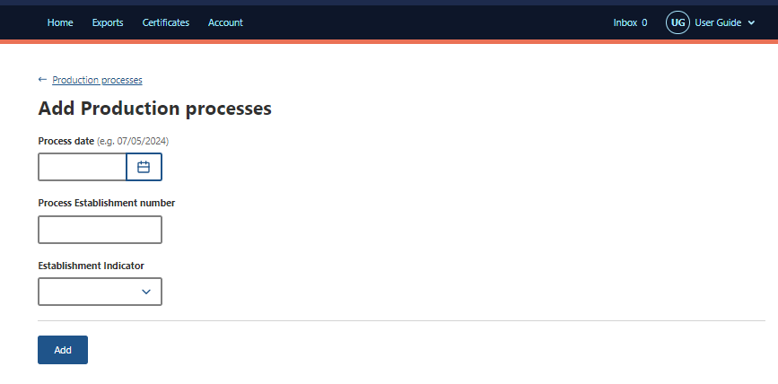
Step 19  Select Product to go back to the product screen | 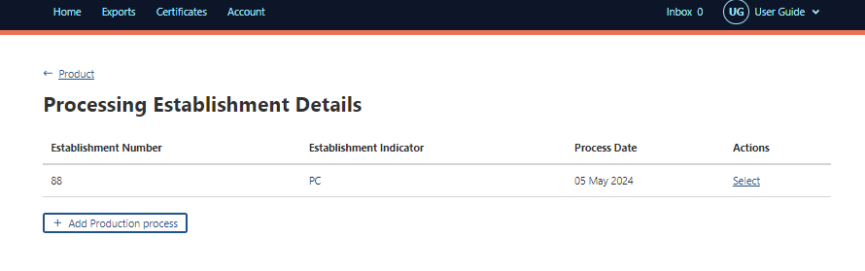
Step 20  Select the Additional Details tab. | 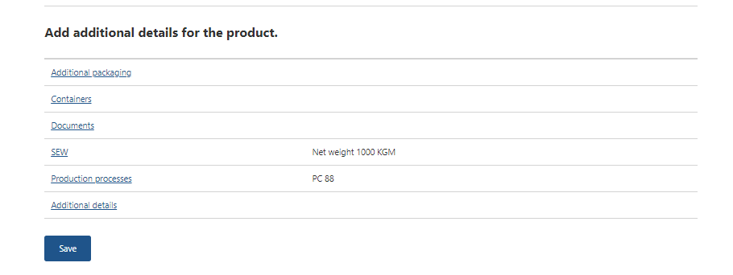
Step 21  Complete the relevant fields.  Select Save. | 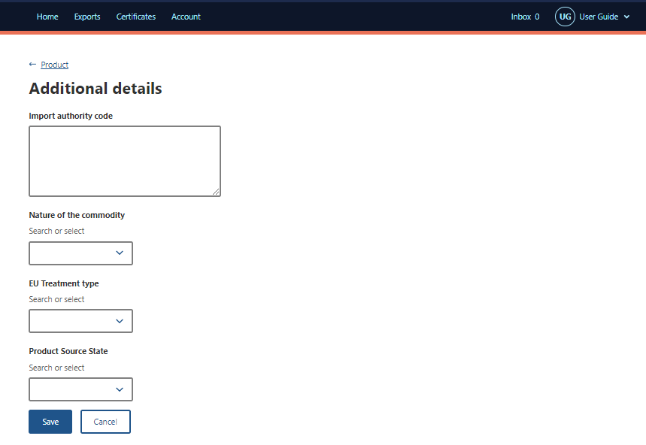
Step 22  Select the Save button on the Product for export tab. | 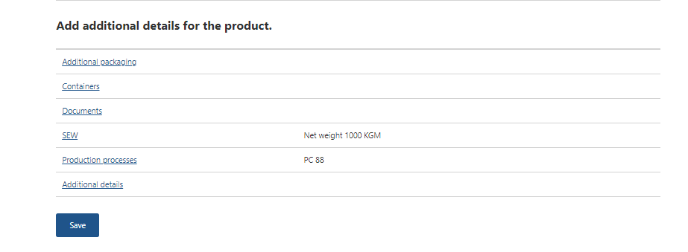
Step 23  Your REX application has been saved and assigned a REX number.  If desired, you may add additional product lines by selecting Add a product to export or Copy a product line.  This is an optional feature. | 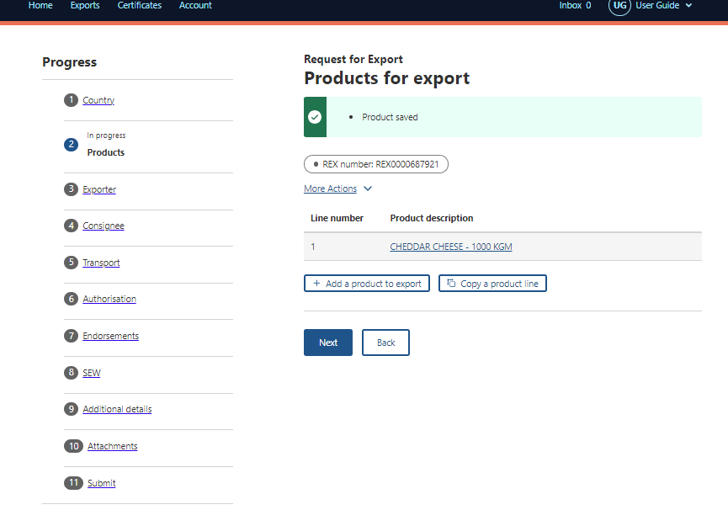
Step 24
Once all necessary products are added to the REX, select Next.

REX Section 3: Exporter Details
Step 1  Exporter details are prepopulated from your exporter registration for NEXDOC.  If you need to update these details, select Edit exporter details.  If you wish to use your other exporter details for the consignment, please select Request new exporter.  Provide your Exporter Reference.  This is a mandatory field.  Select Save and next. | 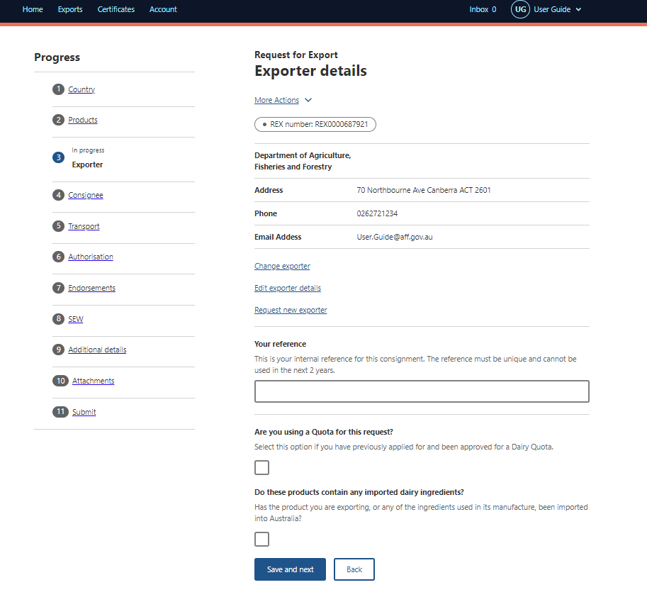

REX Section 4: Consignee Details
Step 1  Provide the consignee Name. This is a mandatory field.  Provide the consignee Phone number, if known. This is an optional field.  Provide the consignee Address. This is a mandatory field. | 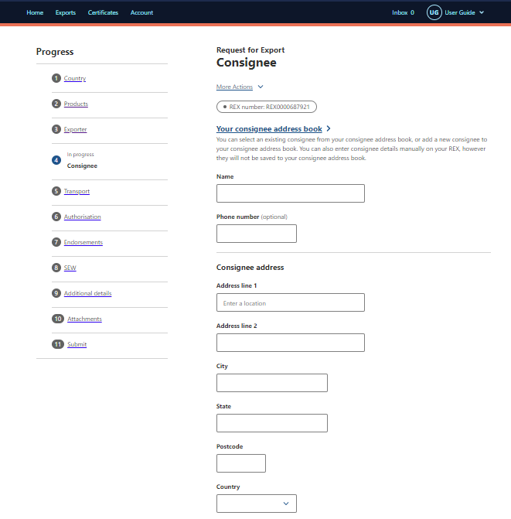  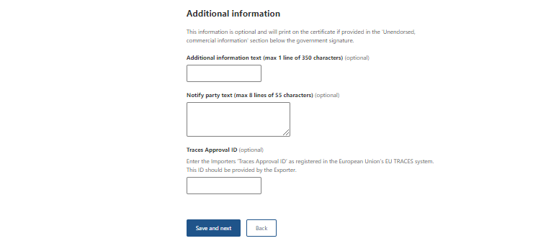
Step 2
Provide the Consignee’s TRACES Approval ID. The consignee is issued this number by the European Union and should provide it to you. It will be validated in the EU TRACES NT system. This is a mandatory field.

Select Save and next.

The Consignee’s TRACES Approval ID must be recorded in NEXDOC prior to lodging your REX, as well as in each REX application. Contact the NEXDOC Help Desk to request your Consignee TRACES Approval ID to be added to the system.

REX Section 5: Transport Details
Step 1  Enter the Departure Date. The date must be in the future and is a mandatory field.  Select the Load Port from the drop-down menu. This is a mandatory field.  Select the Discharge Port from the drop-down menu. This is an optional field.  Select the Border Inspection Port from the drop-down menu. This is a mandatory field and must be an EU port.  Provide the Destination City. This is a mandatory field.  Transit Countries is an optional field. | 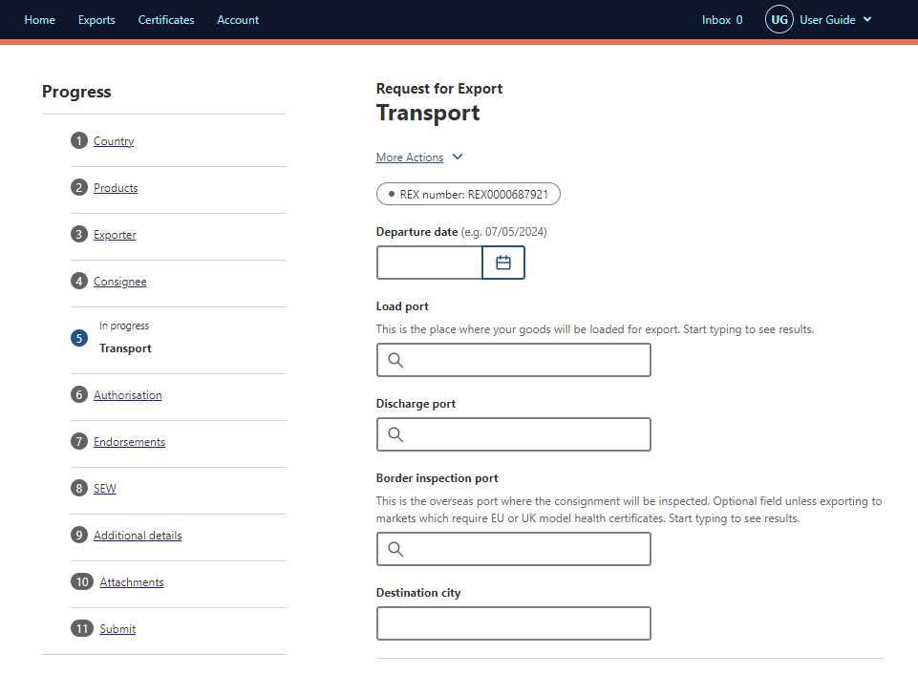
Step 2  Enter the Place of Destination details.  Provide the Approval Number for the Place of Destination.  The EU issues this number to the establishment of destination.  It will be validated in the EU TRACES NT system. This is a mandatory field.  Provide the Destination Business Name.  This should reflect the business name per the EU TRACES NT records.  This is a mandatory field.  Enter the Place of Destination Address.  This is a mandatory field. | 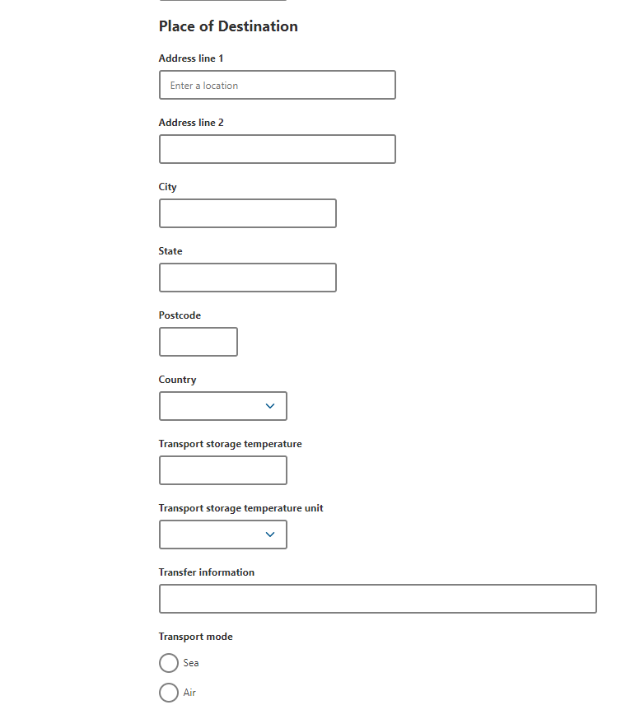
Step 3
Type Transport storage Temperature, Transport storage Temperature unit and Transfer Information.

Step 4  Select the Transport Mode. It is mandatory to select either Sea, Air or Mail. | 
Step 5  If you select Sea, you must provide the Vessel Name and Voyage Number. These are mandatory fields. | 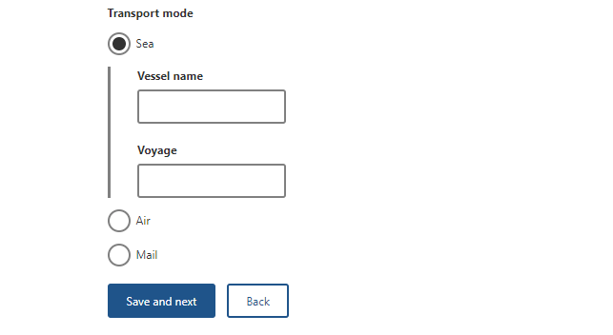
Step 6  If you select Air, you must provide the Flight Number. This is a mandatory field. | 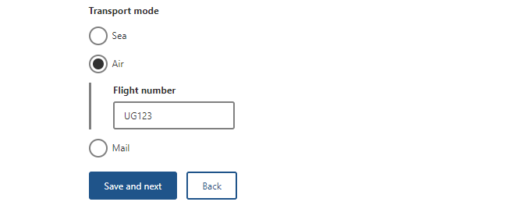
Step 7  Select Mail if this is the transport mode.  Select Save and next. | 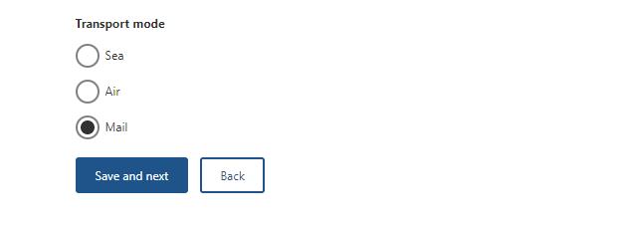

REX Section 6: Authorisation
Step 1  Type the Authorising Establishment Number.  If you have AEPI permission, you will have the ability to select if you would like to authorise this REX for export?  If you select Yes, the below fields will display. You must insert an Authorisation Date for the REX to be authorised.  This date must be before or equal to today’s date. If you do not wish to authorise the REX yet, leave it blank. You can amend your REX and input the Authorisation Date after submitting.  If you select No, the department will review your REX for authorisation.  Select Save and next. | 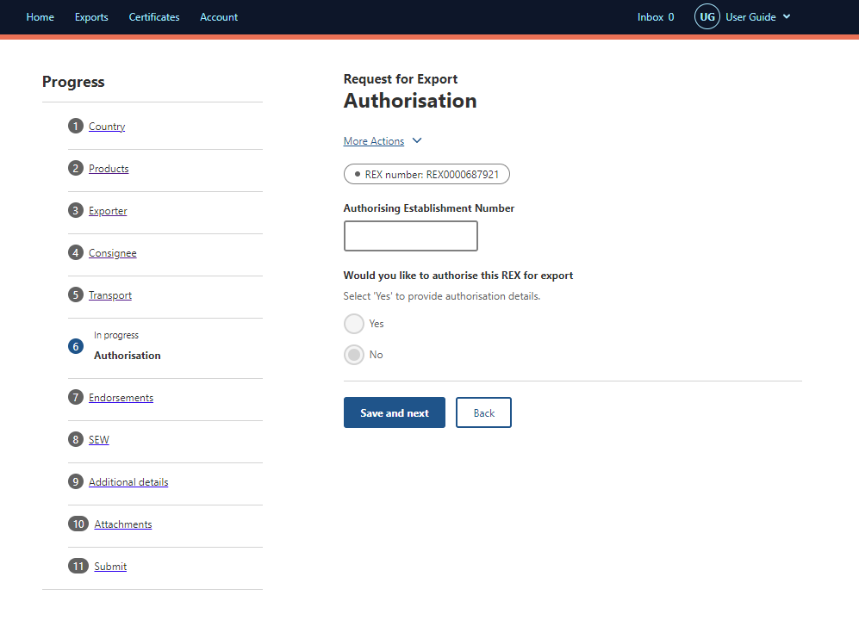  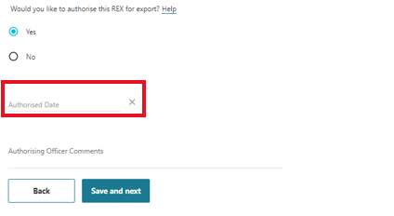

REX Section 7: Endorsements

Step 1  The system will automatically allocate you the default certificate template and endorsement if applicable.  If you would like to change the template or endorsement select the Select button.  Use the drop-down menu to choose the appropriate Certificate Template and or Endorsement.  Select Next. | 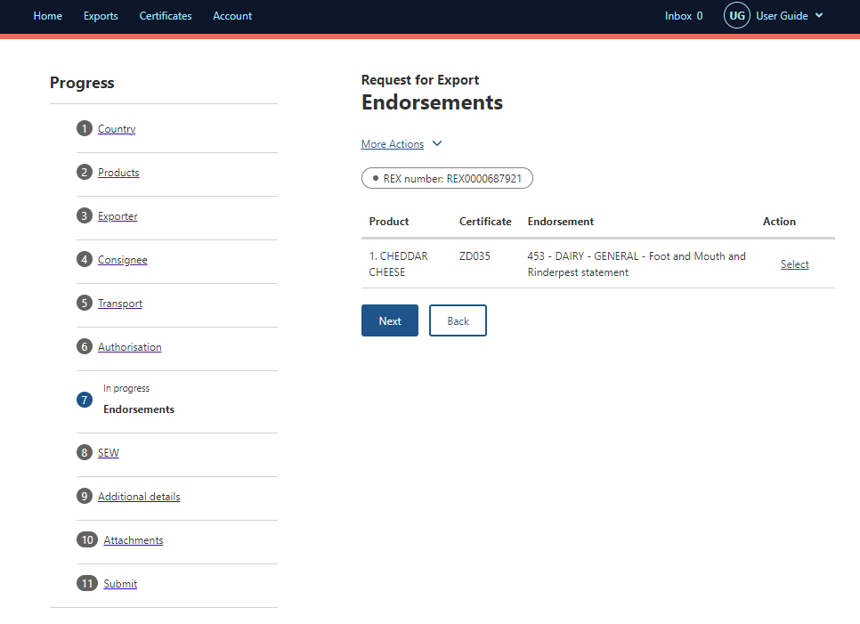
Step 2  Update fields as required using the drop down options.  Select Save. | 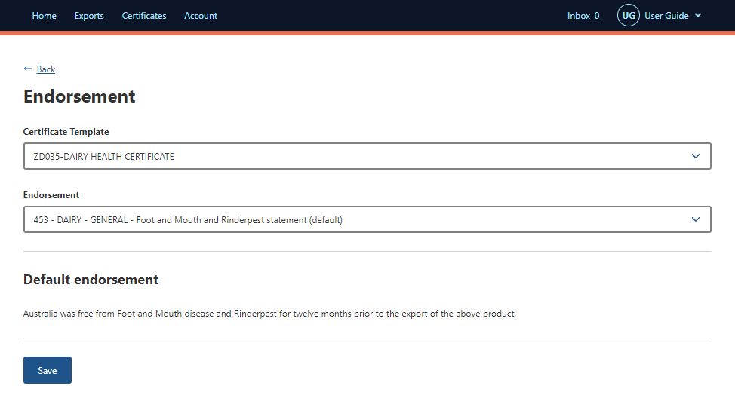
Step 3  Then Endorsement has been saved.  Select Next. | 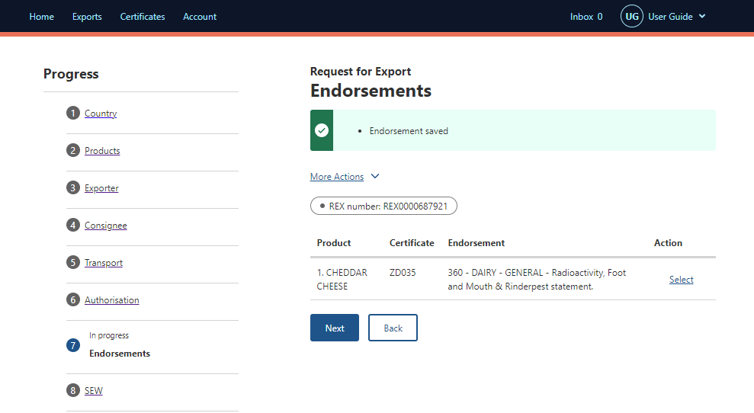

REX Section 8: Single Electronic Window (SEW)
Step 1  If you are not using Single Electronic Window (SEW), deselect the box next to Would you like to use SEW integration (ICS)?  Select Save and next.  Move to Rex Section 9: Additional details.  If you are using SEW you will need to complete the details on this screen.  Continue to step 2. | 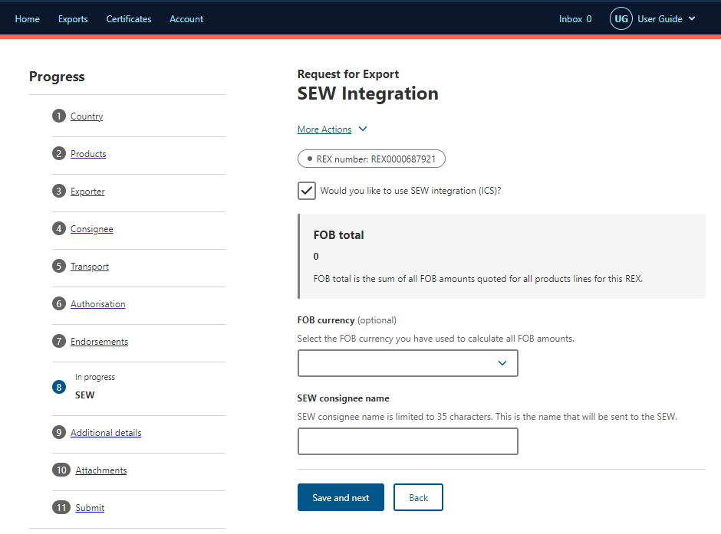
Step 2
If you are using SEW, you will need to complete the details on this screen.

Tick the box next to Would you like to use SEW integration (ICS)?

Complete the FOB currency and SEW consignee name.

Select Save and Next.

Note:
You must have requested access to SEW in your exporter registration for this to be available. Alternatively, you can update your account and request this permission.

If you wish to use the SEW connection, you must have provided the relevant details in each of your product lines.

These are optional fields.

REX Section 9: Additional Details
Step 1  Select your Certificate Print Indicator  You must select Automatic or Hold.  This selection is mandatory.  Please view the NEXDOC Printing FAQ on the NEXDOC Help Page for further information regarding these options. | 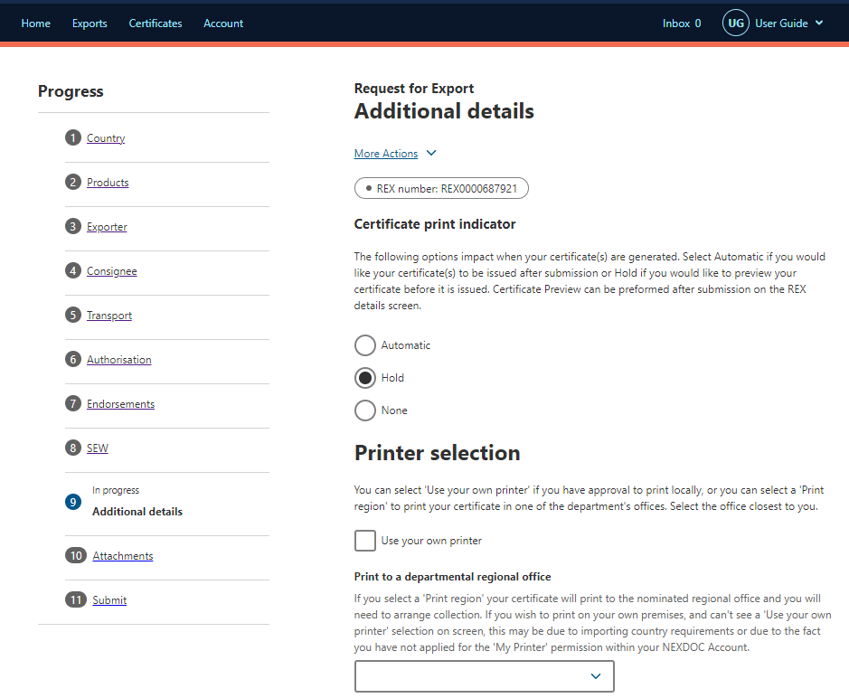
Step 2
Selecting the Use your own printer tick box will allow you to print your eCert extract remotely rather than needing to collect it from a regional department office.
If you do not have this option on screen, please request this permission via your registered NEXDOC exporter account.
Step 3
If you do not wish to print remotely, you must select an available regional office from the Print region to print your extract.
You will need to contact the department’s Assessment Services (Exports) team to make arrangements to collect your eCert extract.
Step 4  Should you wish to save your import permit number and import permit date within your REX, select Add import permit.  This is an optional feature. | 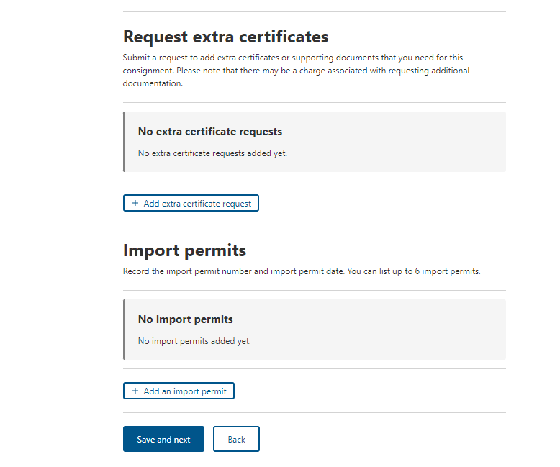
Step 5  Provide your Import permit number and Import permit date.  These are optional fields.  If provided, the import permit date must be in the past.  Select Save. | 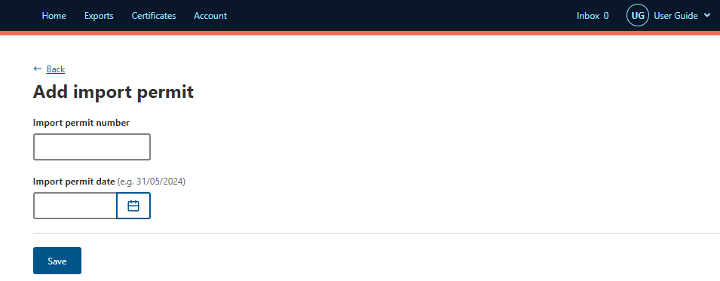
Step 6  Your import permit has saved, and you will return to the Additional details page.  Select Save and next. | 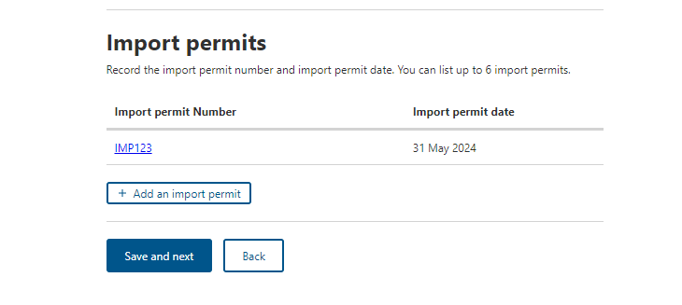

REX Section 10: Attachments
Step 1  Each REX is assessed against importing country requirements. You must provide all relevant documentation to support your request for certification. This may include, but is not limited to, an import permit and manufacturers declarations.  Please liaise with your importer and check MICOR for specific details.  If required, select Add attachment. | 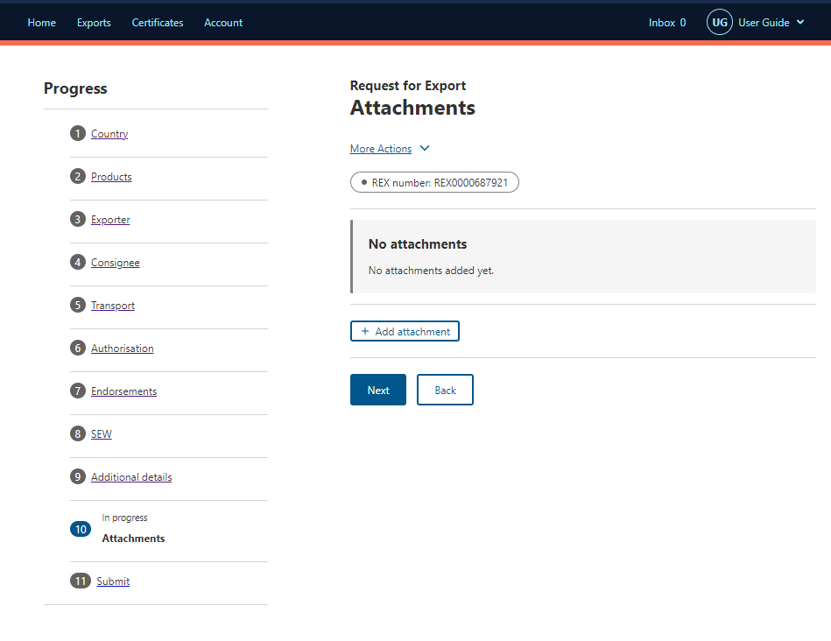
Step 2  Select the drop-down menu and indicate the Document type.  This is a mandatory field if you are attaching a document.  Provide a Comment in relation to your attachment, if applicable.  This is an optional field.  Select Choose files in the Document field to attach.  Select Save. | 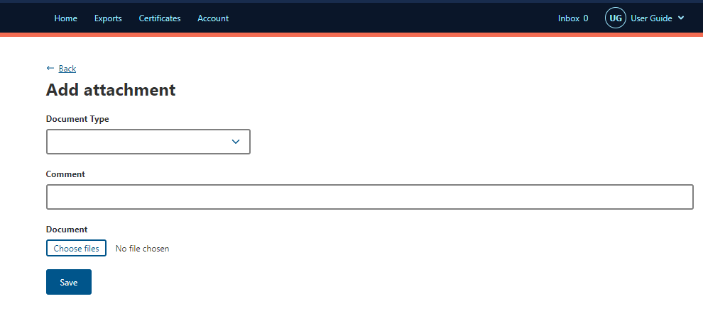
Step 3  Attach all necessary documentation to support your application. A departmental officer will review these documents when assessing your REX.  Select Next. | 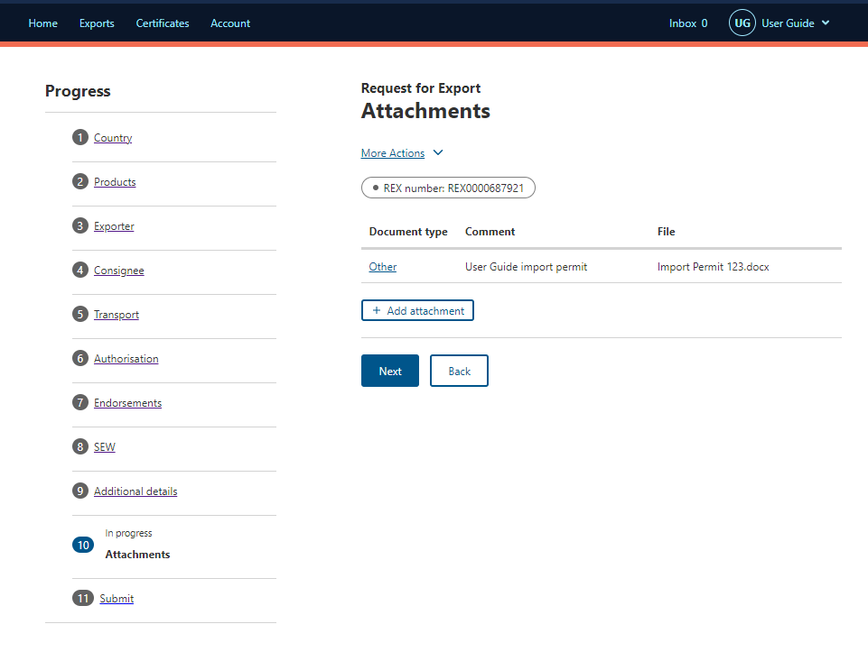

REX Section 11: Submit
Step 1  The Declaration will display. Please read this carefully.  If you wish to proceed with your lodgement, select I agree. | 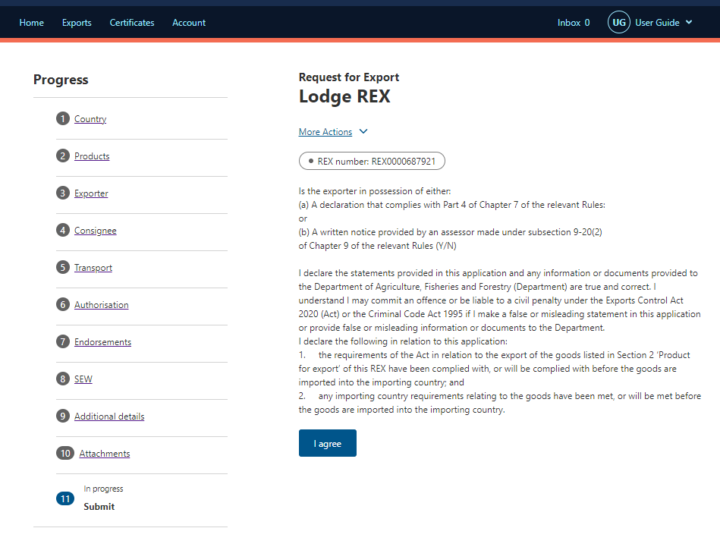
 | 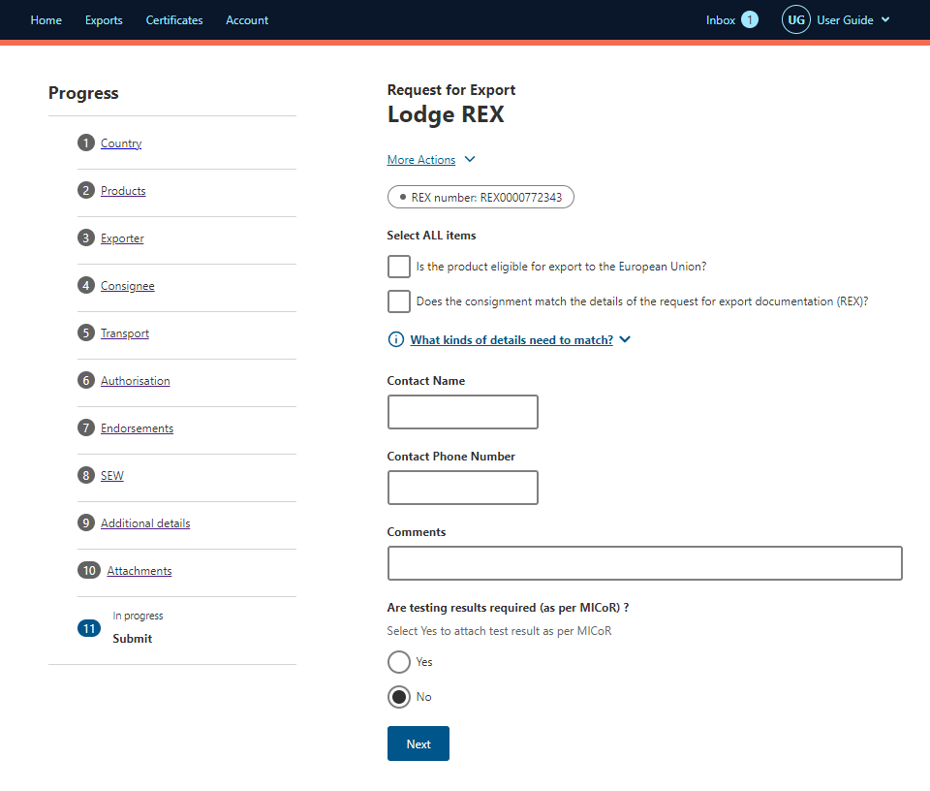
Step 2  The destination country and products will display. If there are no changes required, select Lodge REX. | 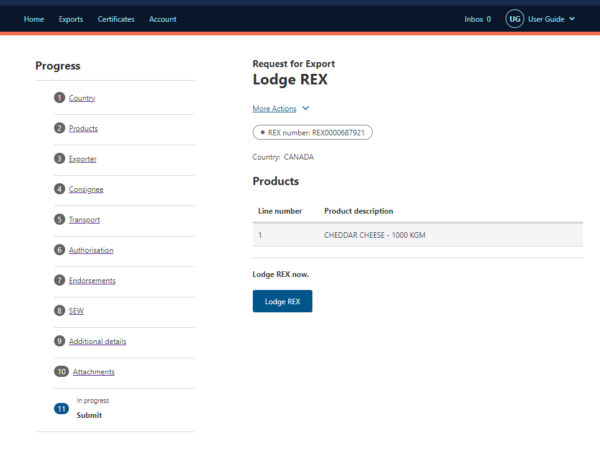
Step 3  A confirmation message will appear, alongside the Service ID associated with your application. Your REX is now awaiting assessment from a departmental officer. | 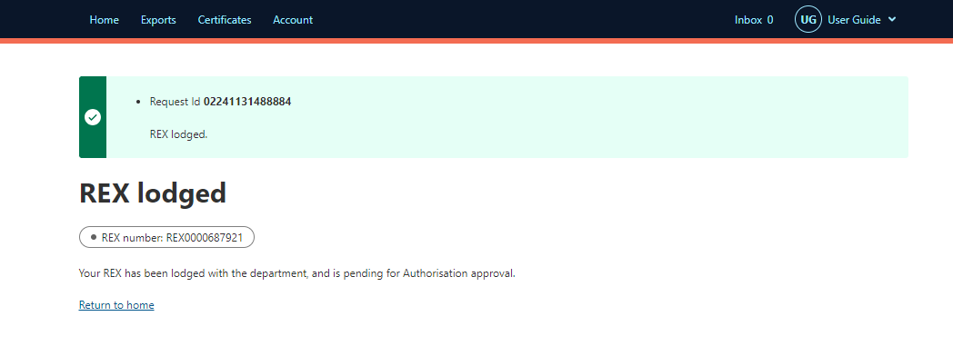

Contact the NEXDOC Help Desk.
For more information or assistance, please contact NEXDOC@aff.gov.au

