Publication details

**Title:**

**Catchment Scale Land Use of Australia – Commodities – Update December 2023**

**Alternative Title:**

CLUM_Commodities_2023

**Date published:**

2024-02-26

**Date prepared:**

2023-12-07

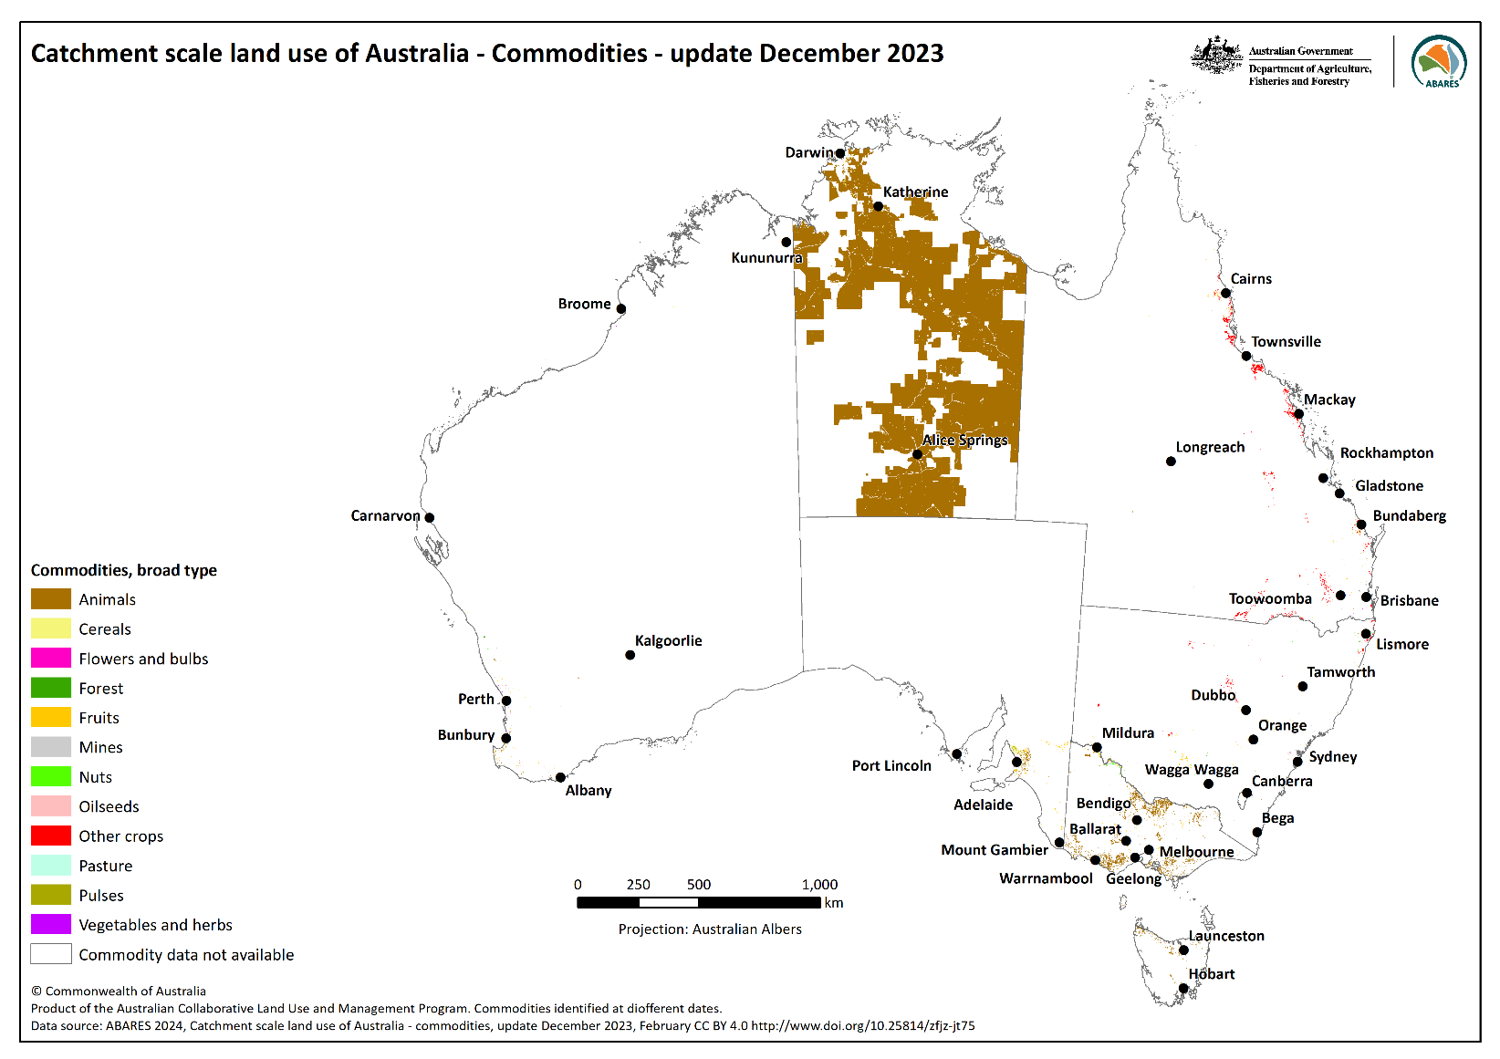**Preview:**

**Abstract:**

The *Catchment Scale Land Use of Australia – Commodities – Update December 2023* dataset shows the location and extent of select commodities, where mapped. This dataset replaces the Catchment Scale Land Use of Australia – Commodities – Update December 2020. This dataset is the fourth national compilation of catchment scale commodity data for Australia (CLUMC), current as at December 2023. It has been compiled from vector land use datasets collected as part of state and territory mapping programs and other authoritative sources through the Australian Collaborative Land Use and Management Program (ACLUMP). The commodities data complements the Catchment Scale Land Use of Australia – Update December 2023 dataset (ABARES 2024).

This dataset comprises more than 176 thousand features representing 185, predominantly agricultural, commodities over 63 million hectares.

**What’s new?**

The following areas have updated mapping since the December 2020 version: Northern Territory (2022), Tasmania (2021); New South Wales (2017 v1.5); Queensland Great Barrier Reef Natural Resource Management (NRM) regions (2021). Data from the Australian Tree Crop and Queensland Soybean Crops maps (downloaded 30 November 2023) were also included.

Users should update any references or links to previous CLUMC datasets in their databases.

Descriptive information

**Authors:**

Australian Bureau of Agricultural and Resource Economics and Sciences (ABARES)

**Acknowledgements:**

This dataset was produced by Australian Bureau of Agricultural and Resource Economics and Sciences (ABARES) within the Australian Government Department of Agriculture, Fisheries and Forestry as part of the Australian Collaborative Land Use and Management Program (ACLUMP).

ACLUMP, of which ABARES is a partner, is a consortium of Australian Government, and state and territory government partners that promotes the development of nationally consistent land use, land cover and land management practice information for Australia. This consortium of Australian and state and territory government partners is critical to providing nationally consistent land use mapping at both catchment and national scale, underpinned by common technical standards including an agreed national land use classification. ACLUMP provides a national land use data directory and the maintenance of land use datasets on Australian and state government data repositories. More information on ACLUMP is available at <https://www.agriculture.gov.au/abares/aclump>.

Datasets were provided by: New South Wales Department of Climate Change, Energy, the Environment and Water; the Northern Territory Department of Environment, Parks and Water Security; the Queensland Department of Environment, Science and Innovation; the South Australian Department of Environment and Water; the Department of Natural Resources and Environment Tasmania; the Victorian Department of Energy, Environment and Climate Action; the Department of Primary Industries and Regional Development, Western Australia and the Applied Agricultural Remote Sensing Centre, University of New England.

Constraints

**Disclaimer**

The Australian Government acting through the Department of Agriculture, Fisheries and Forestry, represented by the Australian Bureau of Agricultural and Resource Economics and Sciences, has exercised due care and skill in preparing and compiling the information and data in this publication. Notwithstanding, the Department of Agriculture, Fisheries and Forestry, ABARES, its employees and advisers disclaim all liability, including liability for negligence and for any loss, damage, injury, expense or cost incurred by any person as a result of accessing, using or relying on any of the information or data in this publication to the maximum extent permitted by law.

**Acknowledgement of Country**

We acknowledge the Traditional Custodians of Australia and their continuing connection to land and sea, waters, environment and community. We pay our respects to the Traditional Custodians of the lands we live and work on, their culture, and their Elders past and present.

**Constraints on using the material:**

Copyright

**Other constraints:**

Licence type: Copyright  
(c) Commonwealth of Australia 2024  
All material in this publication is licensed under a [Creative Commons Attribution 4.0 International Licence](https://creativecommons.org/licenses/by/4.0/), save for content supplied by third parties, logos and the Commonwealth Coat of Arms.



**Citation:**

This publication (and any material sourced from it) should be attributed as:

ABARES 2024, [Catchment Scale Land Use of Australia – Commodities – Update December 2023](https://doi.org/10.25814/jhjb-c072), Australian Bureau of Agricultural and Resource Economics and Sciences, Canberra, February CC BY 4.0. DOI: [10.25814/zfjz-jt75](http://www.doi.org/10.25814/zfjz-jt75)

Additional information about this material

**Purpose for which the material was obtained:**

This dataset provides commodity level mapping information for Australia’s regions, where available, as at December 2023. The data vary in the source year that the commodity was captured (1967 to 2023) and the date the land use mapping was published or downloaded (2014 to 2023).

**How to use this data:**

Use this data to:

* Provide more detailed commodity information to supplement the Catchment Scale Land Use of Australia – Update December 2023.

Do not use this data to:

* Derive national statistics. The Land use of Australia data series, ABARES commodity reports and ABS agricultural census could be used for this purpose.
* Calculate commodity change.

It is not possible to calculate change statistics between annual CLUM commodity national compilations as; commodity collection is incomplete; not all regions are updated each year; land use mapping methodologies, precision, accuracy and source data (in particular satellite imagery) have improved over the years; and the land use classification has changed over time.

Not all commodities are captured consistently across Australia. Attribution depends on whether the land use mapper was able to capture the commodity accurately. Commodities which are captured consistently include avocados, bananas, citrus, cotton, dairy cattle, grapes, macadamias, mangoes, olives, pigs, poultry (primarily chicken), rice, sandalwood, sugar cane and truffles.

**Progress status of this material:**

Completed

**Maintenance and Update Frequency:**

As needed

**KEYWORD(S)**

**ANZLIC Search Words:**

AGRICULTURE  
AGRICULTURE Crops

AGRICULTURE Horticulture

AGRICULTURE Irrigation

AGRICULTURE Livestock

FORESTS

FORESTS Agroforestry

FORESTS Natural

FORESTS Plantation

LAND

LAND Topography

LAND Use  
VEGETATION

**General Keywords:**

Australian Collaborative Land Use and Management Program (ACLUMP)

Land use

Mapping

**TOPICS**

**ABARES Topic categories:**

Agriculture  
Land Use  
Environment and Natural Resource Management  
Models, Risk, Spatial Data and Datasets

**ISO topic categories:**

Farming  
Environment  
Biota

**SPATIAL EXTENT(S)**

**Description of spatial extent:**

Australian Land

**Spatial bounding box included in:**

North: -11.18 degrees; South: -43.37 degrees; East: 153.599 degrees; West: 113.66 degrees.

**Spatial area included in:**

Australian Mainland. Australia excluding external territories.

**Projection:**

EPSG:4283

**Coordinate reference details: Well-Known Text:**

PROJCS["GDA94 / Geographic",

GEOGCS["GDA94",

DATUM["D_GDA_1994",

SPHEROID["GRS_1980",6378137,298.257222101]],

PRIMEM["Greenwich",0],

UNIT["Degree",0.017453292519943295]],

PROJECTION["GCS_GDA_1994"]

**DATA PACKAGE CONTENTS**

**Table 1: Description of CLUMC data package**

|  |  |
| --- | --- |
| File name | File description |
| CLUM_Commodities_2023.zip | CLUMC vector dataset of commodities as at December 2023. ESRI shapefile and supporting files package (including layer files for visualising data), coordinate system GDA94 / Geographic. |
| CLUMC_ DescriptiveMetadata_December2023.pdf | This document, which describes the GIS data, supporting files and GIS dataset attributes published in this data package. |
| CLUMC_map_December2023_broadtype.png | Map showing the CLUMC dataset, based on broad commodity types. Map produced in landscape format suitable for printing at A4 size. |
| CLUMC_map_December2023_sourceyear.png | Map showing the currency of the CLUMC dataset. Map produced in landscape format suitable for printing at A4 size. |

**DATA DICTIONARY**

**Table 2: Attributes of the CLUMC vector dataset (CLUM_Commodities_2023.shp)**

| Field name | Field description | Code values |
| --- | --- | --- |
| FID | Internal feature number that uniquely identifies each polygon | Integer numeric value |
| Shape | Internal feature geometry (“polygon”) | Geometry |
| Commod_dsc | Commodity description as a string  Examples: “bananas”, “chickens”, “bauxite” | Text, width 50 |
| Broad_type | Broad classification of commodities as a string – Animals, Cereals, Flowers and bulbs, Forest, Fruits, Mines, Nuts, Oilseeds, Other crops, Pasture, Pulses, Vegetables and herbs. | Text, width 50 |
| Source_yr | Year the spatial feature was captured. Can differ to date field. | Short integer. Range 1967 to 2023 |
| State | State abbreviation as a string | Text, width 5 |
| Area_ha | Area of polygon in hectares | Double numeric value |
| LU_CODEV8N | Australian Land Use and Management (ALUM) Classification v8 code as a three-digit integer, as mapped. First digit is primary code, second digit is secondary code, and third digit is tertiary code.  Examples:  341 (3 ‘Production from dryland agriculture and plantations’, 3.4 ‘Perennial horticulture’, 3.4.1 ‘Tree fruits’)  523 (5 ‘Intensive uses’, 5.2 ‘Intensive animal production’, 5.2.3 ‘Poultry farms’)  581 (5 ‘Intensive uses’, 5.8 ‘Mining’, 5.8.1 ‘Mines’)  LU_CODEV8N is equivalent to VALUE in CLUM raster dataset. | Integer numeric value Range: 117 to 663 |
| Tertiary | ALUM tertiary code and description as a string, as mapped.  Examples: 1.1.1 Strict nature reserves 6.6.3 Estuary/coastal waters – intensive use  Tertiary is equivalent to TERTV8 in CLUM raster dataset. | Text, width 50 |
| Date | The year the source data was published or downloaded. | Integer numeric value Range: 2014 to 2023 |

**Table 3: List of commodities in the CLUMC dataset (CLUM_Commodities_2023.shp)**

|  |  |
| --- | --- |
| Broad commodity type | Commodities mapped, where available |
| Animals | abalone, algae, alpacas, bees, camels, cattle, cattle dairy, cattle meat, cattle stud, chickens, chickens eggs, chickens meat, crocodiles, crustaceans, deer, ducks, emus, finfish, geese, goats, goats dairy, horses, molluscs, ostriches, pigs, poultry, sheep, sheep dairy, sheep meat, sheep stud, sheep wool, spirulina, turkeys |
| Cereals | barley, maize, oats, rice**\***, rye cereal, sorghum, triticale, wheat |
| Flowers and bulbs | cycads, flowers and bulbs, flowers and foliage, lavender, orchids, palms, roses, tulips, turf**\*a** |
| Forest | blue gum, christmas trees, eucalyptus oil, lemon myrtle, oil mallee, sandalwood, tea tree |
| Fruits | apples, apricots, avocados, babacos, bananas, bilimbi, blackberries, blueberries, caimito, carambolas, cherries, citrus**\***, curcuma, custard apples, dates, dragon fruit, durian, figs, grapefruit, grapes**\***, grapes dried, grapes table, grapes wine, guavas, jackfruit, jujube, kiwifruit, lemons, limes, longans, lychees, mandarins, mangoes, melons, moringa, mulberries, nashi pears, nectarines, olives**\***, oranges, passionfruit, paw paws, peaches, pears, persimmons, pineapples, plumcots, plums, pluots, pomegranate, quinces, rambutans, raspberries, sapodilla, strawberries, tamarillo, watermelons. |
| Mines | bauxite, tungsten |
| Nuts | almonds, chestnuts, hazelnuts, macadamias, pecans, pistachios, walnuts, water chestnuts |
| Oilseeds | canola, chia, jojoba, oil palms, safflower |
| Other crops | alkaloid poppies, azuki bean, cocoa, coffee, cotton**\***, hops, pyrethrum, sugar cane**\***, tea |
| Pasture | legumes, lucerne |
| Pulses | chickpeas, field beans, field peas, lentils, lupins, soybeans, vetches |
| Vegetables  [Vegetables and herbs] | artichokes, asparagus, beans, bitter melons, broccoli, cabbages, capsicums, carrots, cauliflowers, chicory, chillies, chinese cabbages, cucumbers, cucurbits, eggplants, garlic, herbs, leeks, lemongrass, lettuces, mushrooms, okra, onions, parsnips, peas, potatoes, pumpkins, rhubarb, spring onions, swedes, sweet corn, sweet potatoes, tomatoes, truffles, vegetable seeds, vegetables, vegetables and herbs, zucchini |

**\*** Also tertiary class in Catchment scale land use of Australia – update December 2023.

**a** Turf is included under ‘Flowers and bulbs’ as it is the only commodity under commodity type ‘Horticulture’ in ALUMv8 Table 2.

**RESPONSIBILITY FOR THIS MATERIAL**

**Custodian**

Department of Agriculture, Fisheries and Forestry:

Australian Bureau of Agricultural and Resource Economics and Sciences  
Data Manager  
GPO Box 858 CANBERRA ACT 2601 AUSTRALIA  
Telephone 1800 900 090

Email [info.ABARES@aff.gov.au](mailto:info.ABARES@aff.gov.au)

Web [agriculture.gov.au/abares](https://www.agriculture.gov.au/abares)

**PROCESS USED TO GENERATE THIS MATERIAL**

**Lineage Statement**

# Lineage: ABARES has produced this vector dataset from vector catchment scale land use data provided by state and territory agencies, and others, as follows: Catchment Scale Land Use Mapping for the Australian Capital Territory 2012; 2017 NSW Land Use v1.5; Land Use Mapping Project of the Northern Territory, 2016 – 2022 (LUMP); Land use mapping - 1999 to Current – Queensland (June 2019); Land use mapping - 2021 - Great Barrier Reef NRM regions; [South Australia] Land Use (ACLUMP) 2017; Tasmanian Land Use 2021; Victorian Land Use Information System [VLUIS] 2016-17; Catchment Scale Land Use Mapping for Western Australia 2018; Australian Tree Crops, Australian Protected Cropping Structures and Queensland Soybean Crops maps (as at 30 November 2023; Applied Agricultural Remote Sensing Centre (AARSC), University of New England).

# Links to land use mapping datasets and metadata are available at the ACLUMP data download page at [agriculture.gov.au/abares/aclump/land-use/data-download](https://www.agriculture.gov.au/abares/aclump/land-use/data-download)

Commodities are assigned to the Australian Land Use and Management (ALUM) Classification version 8 (ABARES 2016) classes based on; perceived intervention to the landscape, growing conditions and management, the intended use of the commodity, consistency with national and international reporting frameworks and standards, such as National Plantation Inventory, industry guidelines, Australian Bureau of Statistics, harmonised trade codes and ABARES commodity reports, where possible.

Commodities data were produced as part of catchment scale land use mapping and primarily uses fine-scale satellite data and information collected in the field using agreed methods (ABARES 2011, 2015). Field validation was critical for mapping commodities. It is important to note that the location of a commodity may change each year or season, depending on factors such as climate, markets, or farming systems.

Jurisdictions captured commodity data (where possible) for those areas most recently mapped in the Catchment scale land use of Australia – Update December 2023 (ABARES 2024) with a focus on horticultural and intensive animal industries. Other commodities which are tertiary classes of the ALUM classification (such as sugar cane, cotton, rice, olives and grapes) have been mapped by jurisdictions for some time and are included in this dataset.

Agricultural commodity level mapping is available for all the Northern Territory, and is likely to be complete for the following commodities nationally (taking into consideration the source year and date of mapping):

* Crops: rice, cotton, sugar cane
* Fruits: avocados, bananas, citrus, grapes, mangoes, olives
* Nuts: macadamias
* Vegetables (and herbs): truffles
* Livestock: dairy cattle, pigs, poultry, horse studs.

Commodity information is selected from an agreed list of commodity names developed by ACLUMP partners (see Table 2 in ABARES (2016)). A commodity may be applied to one or many land use codes. For example, the commodity ‘wheat’ is applied to class 3.3.1 Cropping or 4.4.1 Irrigated cropping, while ‘cattle’ may be applied to any land use where cattle are observed including 2.1.0 Grazing native vegetation, 3.2.0 Grazing modified pastures, 4.2.0 Grazing irrigated modified pastures, 5.2.2 Feedlots etc.

Commodities data were extracted using the ALUM tertiary code or the commodity description where appropriate. The state, source year and date (year) of publishing were added to the attribute table and the area of the polygon calculated in hectares. The source year indicates the date of field mapping or most recent validation. Finally, the commodities were joined to a lookup table to include a broad classification of commodities by type.

The commodity description is intended to add information to the catchment scale land use map which is not otherwise recorded in the ALUM Classification. Where there are several suitable commodity descriptions mappers are encouraged to record the most detailed description. For example, when cattle breeds are known to be for milk production, mappers would apply the commodity description ‘cattle dairy’ rather than just ‘cattle’.

**Positional Accuracy:**The scale of the source data varies from 1:5,000 to 1:250,000. See individual land use mapping dataset metadata for specific measures of accuracy.

**Attribute Accuracy:**The methods for mapping and classifying commodities adhere to the standards outlined in ‘The Australian Land Use and Management Classification Version 8’ (ABARES 2016). Datasets mapped to version 7 of the ALUM Classification were converted to version 8 using a look-up table based on Appendix 1 in ABARES (2016).

**Logical Consistency:**All input polygon datasets were checked for topological consistency.

**Completeness:**Complete for all relevant data provided.

References

ABARES 2011, [Guidelines for land use mapping in Australia: principles, procedures and definitions](https://daff.ent.sirsidynix.net.au/client/en_AU/search/asset/1031500/0), A technical handbook supporting the Australian Collaborative Land Use and Management Program, 4th edition, Australian Bureau of Agricultural and Resource Economics and Sciences, Canberra.

ABARES 2015, [Addendum to the Guidelines for land use mapping in Australia: principles, procedures and definitions, 4th edition](https://daff.ent.sirsidynix.net.au/client/en_AU/search/asset/1031480/0), Australian Bureau of Agricultural and Resource Economics and Sciences, Canberra.

ABARES 2016, [The Australian Land Use and Management Classification Version 8](https://daff.ent.sirsidynix.net.au/client/en_AU/search/asset/1027181/0), Australian Bureau of Agricultural and Resource Economics and Sciences, Canberra.

ABARES 2024, [Catchment Scale Land Use of Australia – Update December 2023](https://doi.org/10.25814/aqjw-rq15), Australian Bureau of Agricultural and Resource Economics and Sciences, Canberra, CC BY 4.0, DOI: [10.25814/2w2p-ph98](http://www.doi.org/10.25814/2w2p-ph98)