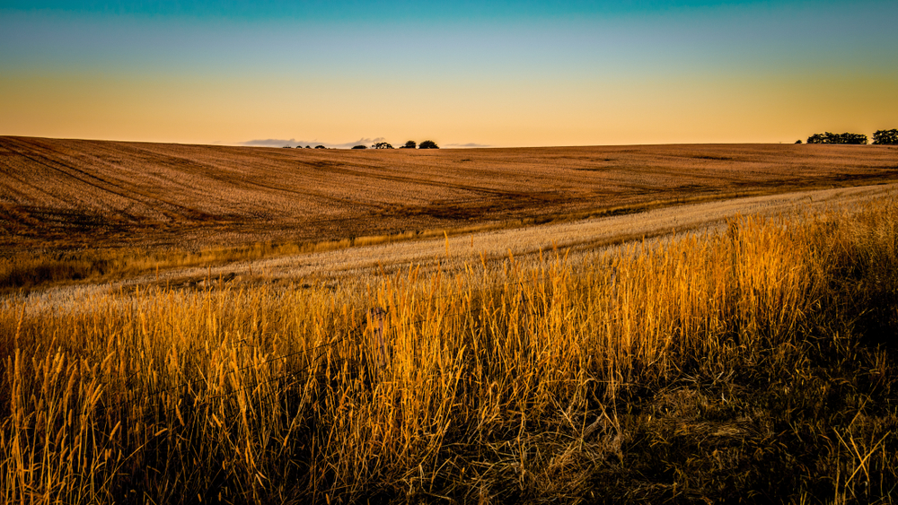

Future Drought Fund on the front foot

$561.3 million

The Australian Government will spend more than $500 million over the next 8 years to ensure rural and regional communities have what they need to plan for future drought.

The Australian Government is committed to implementing policies and programs that support the agriculture, fisheries and forestry sector adapt to the impact of climate change including drought, to ensure they can continue to prosper and grow into the future.

**What’s in this year’s Budget**

**The Australian Government is supporting our farmers to be drought ready by investing in well-planned and funded initiatives that help them to become more resilient to the shocks of climate change, through the Future Drought Fund (FDF).**

**Australia’s farming communities are facing the reality of more frequent and severe droughts with significant economic, social and environmental impacts.**

**Helping regional and rural communities prepare for drought** **is a key focus of the Australian Government.**

**Building on the success of the FDF, the Australian Government is providing $519.1 million over 8 years to continue funding, extend and refine existing programs, and develop new initiatives. A further $42.2 million over 4 years is committed to ensuring the effective management of the FDF. Which represents a total investment of $561.3 million.**

**The measures also respond to the 2023 Productivity Commission recommendations and the national consultations on the FDF held late last year.**

**Since it began 4 years ago, the FDF has helped farmers across the country to plan, manage diversification and set goals to adapt to a changing climate. It has also helped regional communities to manage drought and other climate risks, and provided leadership training and mentoring to individuals within those communities.**

There is a lot of good work underway driving change on the ground. This funding will further improve the operation of the FDF and build on its momentum to deliver even greater impact for our farming communities.

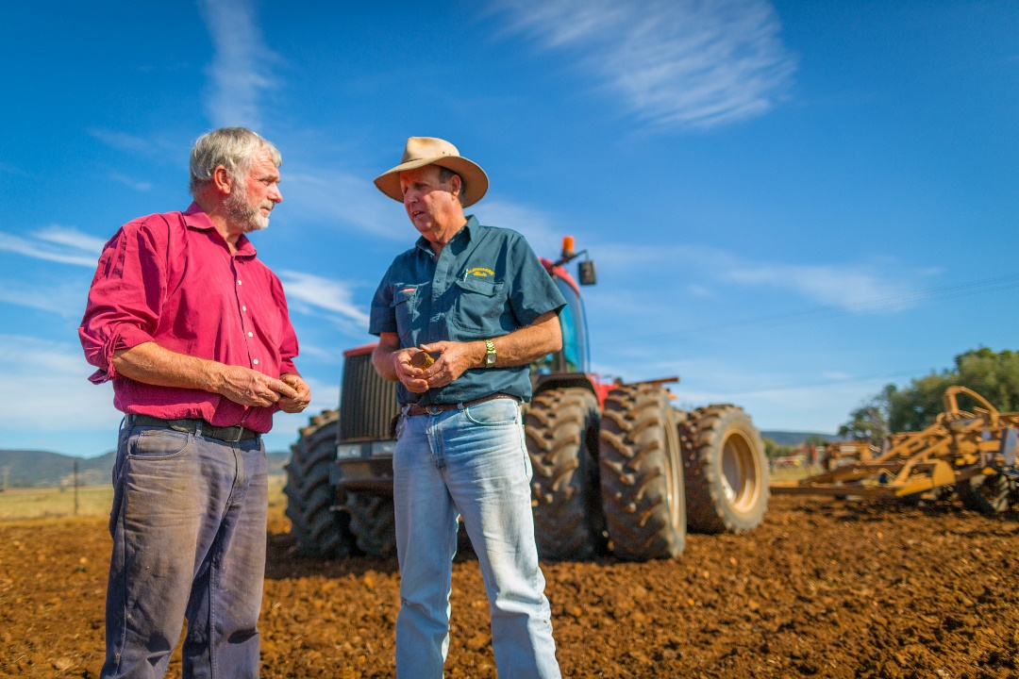

**Delivering the next phase of the Future Drought Fund**

* **The $519.1 million commitment** will **continue to** support farmers and their communities with the necessary skills, tools and networks to plan for and manage during times of drought by supporting locally-led action through collaborative projects and building on projects and networks that are already driving change. This includes funding for 5 key areas:

**Partnering for Local Solutions**

* $235 million over 8 years from 2024-25 to work with regions and communities to help them manage their own drought and climate risks, through collaborative and locally led action.
* A short-term extension of funding for the continuation of the Drought Resilience Adoption and Innovation Hubs as recommended by the 2023 Productivity Commission Inquiry Report, while the Hubs are reviewed. The 8 central hubs and more than 40 regional nodes are designed to empower regional stakeholders address the challenges of drought and climate variability with specific local solutions.
* Delivery of the revised FDF Communities program, which supports projects that strengthen community leaders, networks and organisations to build social resilience to drought and other climate impacts, and contribute to the mental wellbeing of farmers and communities including First Nations communities.
* Delivery of the next phase of the Regional Drought Resilience Planning Program to support locally-tailored actions to help regions prepare for and manage drought and other issues which may include climate change and natural hazards.

**Building Knowledge, Skills and Capability**

* $137.4 million over 5 years from 2024–25 to support farmers and regional communities to make informed decisions and better manage drought and climate risks.
* The Farm Business Resilience program will be continued, which has already enabled thousands of farmers to participate in business planning, coaching and financial literacy training. The program will also support the continuation of drought resilience scholarships through Nuffield Australia.
* Farmers, farm advisors and regional communities will continue to have accessible and useful climate information through the government’s My Climate View platform – a free online decision-support tool.
* Scaling Success Program – previously funded FDF programs that demonstrated successful drought or climate resilience outcomes will be eligible for further funding to allow scaling-up work.

**Innovating for Transformation**

* $120.3 million over 6 years from 2024-25 to trial innovative solutions with the potential to build the agriculture sector, landscapes and communities’ long-term resilience to drought and climate risks, through transformational change.
* Funding will continue and expand the FDF Long Term Trials Program, a revised FDF Resilient Landscapes Program, and will implement a new FDF Innovation Challenges Pilot.

**First Nations Initiatives**

* $15 million over 4 years from 2024–25 to work with First Nations peoples and communities to support connection to country through management of drought and climate risks.
* A pilot program to facilitate place-based, First Nations-led activities and dedicated funding to support activities that seek to improve opportunities for Indigenous participation in FDF drought and climate resilience activities.
* Additional departmental funding will establish a First Nations Advisory Group to provide advice to the government on issues relating to drought and climate resilience.

**Measuring Progress and Knowledge Sharing**

* $11.4 million over 4 years for monitoring, evaluation and learning activities to determine how, and to what extent, funding is contributing to the FDF’s priorities of increasing social, economic and environmental resilience to drought and climate change, and to share knowledge generated by FDF programs about how to address drought and climate risks.
* Responding to a PC recommendation, this measure will drive uptake of FDF programs and enable continuous improvement in program design and delivery.

Why this is important

Climate change is driving an increase in the frequency and severity of climatic events, including drought.

Building drought resilience supports farmers and communities to reorganise, adapt, and potentially transform in response to climate impacts now and into the future. Building drought resilience supports our agriculture sector and landscapes to become more sustainable and thrive.

The work of the FDF is so important, as it supports proactive efforts to prepare, adapt and manage through future droughts – a major impact of the changing climate.

In delivering a more impactful suite of programs with enhanced alignment, integration of activities and longer-term funding we will see greater impact and more enduring outcomes, greater place-based collaboration with stakeholders, including First Nations people, tailored activities which focus on local needs, greater knowledge sharing, improved monitoring, evaluation and learning and ultimately greater drought and climate resilience.

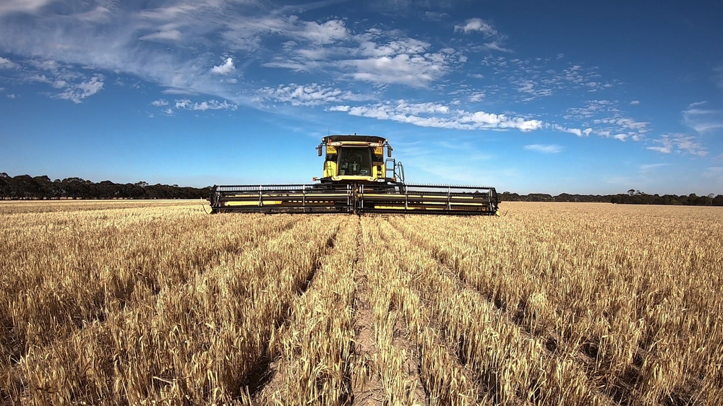

How much this will cost

|  |  |  |  |  |  |  |  |  |  |
| --- | --- | --- | --- | --- | --- | --- | --- | --- | --- |
|  | **2024-25 $m** | **2025-26 $m** | **2026-27 $m** | **2027-28 $m** | **2028-29 $m** | **2029-30 $m** | **2030-31 $m** | **2031-32 $m** | **TOTAL $m** |
| **Future Drought Fund** |  |  |  |  |  |  |  |  |  |
| Partnering for Local Solutions | 27.000 | 38.375 | 48.188 | 45.438 | 31.000 | 15.000 | 15.000 | 15.000 | 235.001 |
| Partnering for First Nations Initiatives | 1.500 | 3.000 | 5.500 | 5.000 | - | - | - | - | 15.000 |
| Building Knowledge, Skills and Capability | 3.000 | 34.800 | 39.800 | 39.800 | 20.000 | - | - | - | 137.400 |
| Innovating for Transformation | 20.315 | 25.000 | 25.000 | 20.000 | 15.000 | 15.000 | - | - | 120.315 |
| Measuring Progress and Knowledge Sharing | 1.099 | 3.923 | 2.689 | 3.689 | - | - | - | - | 11.400 |
| Sub total | 52.914 | 105.098 | 121.177 | 113.927 | 66.000 | 30.000 | 15.000 | 15.000 | 519.116 |
| Effective management of the program | 11.117 | 10.662 | 9.347 | 11.099 | - | - | - | - | 42.225 |
| **Total package** | 64.031 | 115.760 | 130.524 | 125.026 | 66.000 | 30.000 | 15.000 | 15.000 | **561.341** |

More information

For more information about the Future Drought Fund visit [agriculture.gov.au/agriculture-land/farm-food-drought/drought/future-drought-fund](https://www.agriculture.gov.au/agriculture-land/farm-food-drought/drought/future-drought-fund)

For more information about the 2024–25 Budget visit [budget.gov.au](https://deptagriculture-my.sharepoint.com/personal/georgia_carroll_aff_gov_au/Documents/Documents/Ag/Misc%20Projects/budget.gov.au)