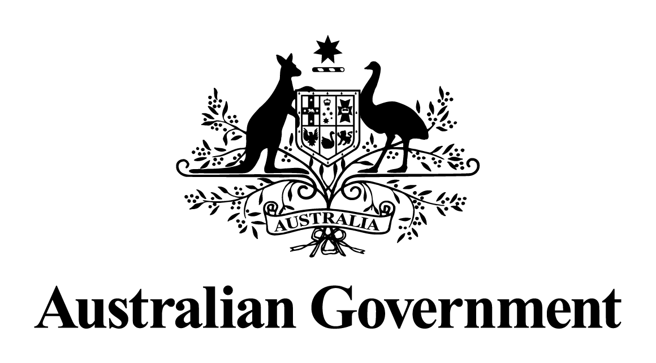

Australian Government response to the   
House of Representatives Standing Committee on Agriculture advisory report:

Inquiry into the Export Control Amendment (Ending Live Sheep Exports by Sea) Bill 2024

November 2024

**Introduction**

The Australian Government thanks the House of Representative Standing Committee on Agriculture for its inquiry into the *Export Control Amendment (Ending Live Sheep Exports by Sea) Bill 2024* and for its advisory report.

The *Export Control Amendment (Ending Live Sheep Exports by Sea) Act 2024* received Royal Assent on 9 July 2024. The Act commenced on 10 July 2024 (the day after Royal Assent) and prohibits the export of live sheep from Australia by sea from 1 May 2028.

The legislation gives effect to a commitment made by the Australian Government to the Australian people at the last two elections to phase out live sheep exports by sea. Phasing out this trade marks a considerable step forward for sheep welfare, reflecting our nation's values of compassion and ethical treatment of animals.

The legislation implements government decisions based on advice and recommendations received on 25 October 2023 from an independent panel. The advice of the panel is underpinned by extensive consultation and consideration of over 800 written submissions and 3,300 survey responses, a wide range of existing data and specifically commissioned analysis.

The panel made 28 recommendations, including that the end of live sheep exports by sea from Australia should occur at the beginning of the Northern Hemisphere Summer Prohibition in 2028 and that it should be legislated during this term of the Australian Parliament (47th Parliament).

Under the terms of the legislation, the live sheep exports by sea trade continues until 1 May 2028 without caps or quotas. This provides a stable framework for all participants in the supply chain to operate with certainty and allows them to make decisions on when and how they will transition away from the trade with reference to their own individual circumstances.

The Australian Government has committed $139.7 million over 5 years from 2024-25 for the phase out of live sheep exports by sea. This package includes assistance for producers and the supply-chain, including $97.3 million to assist businesses to plan and implement transition actions and $27 million to enhance demand within Australia and internationally for sheep products and to diversify the trade of Australian agri-food products to the Middle East and North Africa region.

This transition assistance is to ensure those affected by the phase out can be well-positioned, resilient and ready when the trade ends. The legislation contains spending powers to enable this funding to be delivered.

**Response**

|  |
| --- |
| **Recommendation 1**  The Committee recommends that the bill be passed. |

**Supported**

The legislation has been passed. The bill passed in the House of Representatives on 26 June 2024, the Senate on 1 July 2024 and came into effect on 10 July 2024 (the day after receiving Royal Assent).

|  |
| --- |
| **Recommendation 2**  The Committee recommends that the Australian Government considers making additional funding available to support the transition, potentially through the 2026 stocktake of industry progress. |

**Supported**

The Government announced a $107 million transition assistance package as part of the 2024-25 Budget. On 15 October 2024, the Minister for Agriculture, Fisheries and Forestry, the Hon Julie Collins MP, announced an additional $32.7 million bringing the total transition assistance package to $139.7 million.

The Australian Government is committed to assisting sheep producers, supply chain participants and connected communities through the transition period to ensure those affected by the phase out of live sheep exports by sea as a market avenue can be well-positioned, resilient and ready when the trade ends.

|  |
| --- |
| **Recommendation 3**  The Committee recommends that the Australian Government continues to seek opportunities to work with the Western Australian Government to refine and implement the transition support package. |

**Supported**

The Australian Government recognises the importance of local knowledge, expertise and connections when delivering support to individuals, businesses and communities in regional areas.

On 15 October 2024, the Government announced the Australian Government will work with the Western Australian Government to deliver programs to assist sheep producers and other supply chain participants in Western Australia to transition away from live sheep exports by sea.