# Phase out of live sheep exports by sea

Background information and analysis

Australian Bureau of Agricultural and Resource Economics and Sciences

March 2023

© Commonwealth of Australia 2024

**Ownership of intellectual property rights**

Unless otherwise noted, copyright (and any other intellectual property rights) in this publication is owned by the Commonwealth of Australia (referred to as the Commonwealth).

**Creative Commons licence**

All material in this publication is licensed under a [Creative Commons Attribution 4.0 International Licence](https://creativecommons.org/licenses/by/4.0/legalcode) except content supplied by third parties, logos and the Commonwealth Coat of Arms.



**Cataloguing data**

This publication (and any material sourced from it) should be attributed as: ABARES 2024, *Phase out of live sheep exports by sea: background information and analysis*, internal report to the Independent Panel for the Phase Out of Live Sheep Exports by Sea, Department of Agriculture, Fisheries and Forestry, Canberra, February. CC BY 4.0.

This publication is available at [agriculture.gov.au/live-sheep-phase-out](http://agriculture.gov.au/live-sheep-phase-out).

Department of Agriculture, Fisheries and Forestry

GPO Box 858 Canberra ACT 2601

Telephone 1800 900 090

Web [agriculture.gov.au](https://www.agriculture.gov.au/)

**Disclaimer**

The Australian Government acting through the Department of Agriculture, Fisheries and Forestry has exercised due care and skill in preparing and compiling the information and data in this publication. Notwithstanding, the Department of Agriculture, Fisheries and Forestry, its employees and advisers disclaim all liability, including liability for negligence and for any loss, damage, injury, expense or cost incurred by any person as a result of accessing, using or relying on any of the information or data in this publication to the maximum extent permitted by law.

**Acknowledgement of Country**

We acknowledge the Traditional Custodians of Australia and their continuing connection to land and sea, waters, environment and community. We pay our respects to the Traditional Custodians of the lands we live and work on, their culture, and their Elders past and present.

Contents

Introduction 1

Global market for live sheep 2

Australian exports 2

Characteristics of Western Australian sheep farms 5

Specialist sheep farms 5

Domestic market impacts of restricting live exports 8

Saleyards 8

Processing 9

Global market impacts of restricting live exports 11

Impacts on sheep farms 13

Scenario assumptions 13

Estimated impacts 14

Longer-term impacts 14

Impacts on the supply chain 16

Transport 16

Shearers 16

Registered premises 16

Stock feed manufacturers 17

Exporters and ship owners 17

Impact on research and development corporations (RDCs) 18

References 19

**Tables**

Table 1 Annual characteristics of Western Australian sheep farms, 3-year ave. to 2021–22 5

**Figures**

Figure 1 Annual live sheep exports from Western Australia and rest of Australia 2

Figure 2 Annual Western Australian sheep meat, wool, and crop production 4

Figure 3 Average annual farm receipts, Western Australian farms with 100 sheep 7

Figure 4 Trade Lamb Indicator, July 2015 to March 2023 9

Figure 5 Average September and October price difference between trade lamb prices in the eastern states and Western Australia, 2015 to 2022 9

Figure 6 Australian sheep meat exports, top 4 destinations 11

Figure 7 Australian export unit values of sheep meat 12

Figure 8 Average annual farm cash income, Western Australian farms 15

Figure 9 Meat & Livestock Australia (MLA) revenue summary, 2021–22 18

## Introduction

The Australian Government has outlined its policy of phasing out live sheep exports. In response, the Department of Agriculture, Fisheries and Forestry has re-examined previous analysis of the impacts of a phase out of live sheep exports. ABARES has previously investigated the economics of the live sheep trade in detail (Nelson et al. 2021), providing assessments of the market impacts and industry adjustments to restricting sheep exports to the Middle East. The analysis is still broadly applicable but has been updated to reflect market conditions as at March 2023.

In December 2018, the Australian Live Exporters’ Council (ALEC) announced an intention to observe, from 1 June 2019, a 3-month moratorium on live sheep shipments to the Middle East during the Northern Hemisphere summer. In April 2019, the Government introduced a Northern Hemisphere Summer Prohibition on the export of live sheep to the Middle East, by any vessel leaving an Australian port between 1 June 2019 and 31 August 2019. This provided a legislative basis to the voluntary moratorium already announced by the industry. In 2020 the ban was amended. Live sheep exports are now banned between 1 June and 14 September and additional conditions apply on voyages departing between 1 May and 31 October depending on export destination. The prohibition is set to continue in 2023 and 2024 as the phase out will not take place during the current term of the Australian Parliament.

Live sheep exports are a part of the strategies that Australian farmers – almost exclusively now located in Western Australia – use to generate income and to manage risk. Live exports provide flexibility to Western Australian sheep farms with an additional market to prime lambs in terms of livestock age, quality, and timing of delivery. A farmer can set out at the beginning of the season to produce prime lambs but sell these sheep for live export at reasonable prices if the growing season proves unfavourable. In addition, having diversified enterprises can provide agronomic benefits, such as having sheep graze stubble to make better use of resources. However, the volume of Australian live sheep exports has declined significantly over the last 2 decades and most West Australian sheep farms now rely on a wide variety of enterprises for farm income, including cropping, wool and selling lambs for slaughter domestically.

## Global market for live sheep

In 2021, the global live sheep export sector was worth $USD 1.1 billion (UN 2023). The top live sheep exporting countries were Romania, Spain and Jordan and the top importers were Middle Eastern countries including Saudi Arabia, Jordan, and Kuwait. Australia’s share of the international live sheep trade has steadily fallen in the last few years from around 12.4% of international trade in 2017 to 6.5% in 2021, as Middle Eastern countries have increasingly looked to source live sheep at a lower cost from European countries such as Romania.

### Australian exports

In 2021–22, Australia exported around 489,000 live sheep (valued at $85.2 million) which represented 1% of the total value of Australia’s sheep meat and wool exports, and around 0.1% of the total value of Australia’s agricultural exports. The 3 largest export destinations were Kuwait, the United Arab Emirates, and Israel. The value and volume of the live sheep trade declined by around 8% and 19% respectively in 2021–22. In Western Australia, the number of live sheep exports declined by 17% to around 487,000 head in 2021–22, with Western Australia accounting for 99.6% of Australia’s live sheep exports (Figure 1). Western Australia’s now exclusive contribution to live sheep exports is due to the state’s proximity to Middle Eastern markets, resulting in lower transport costs.

Figure 1 Annual live sheep exports from Western Australia and rest of Australia

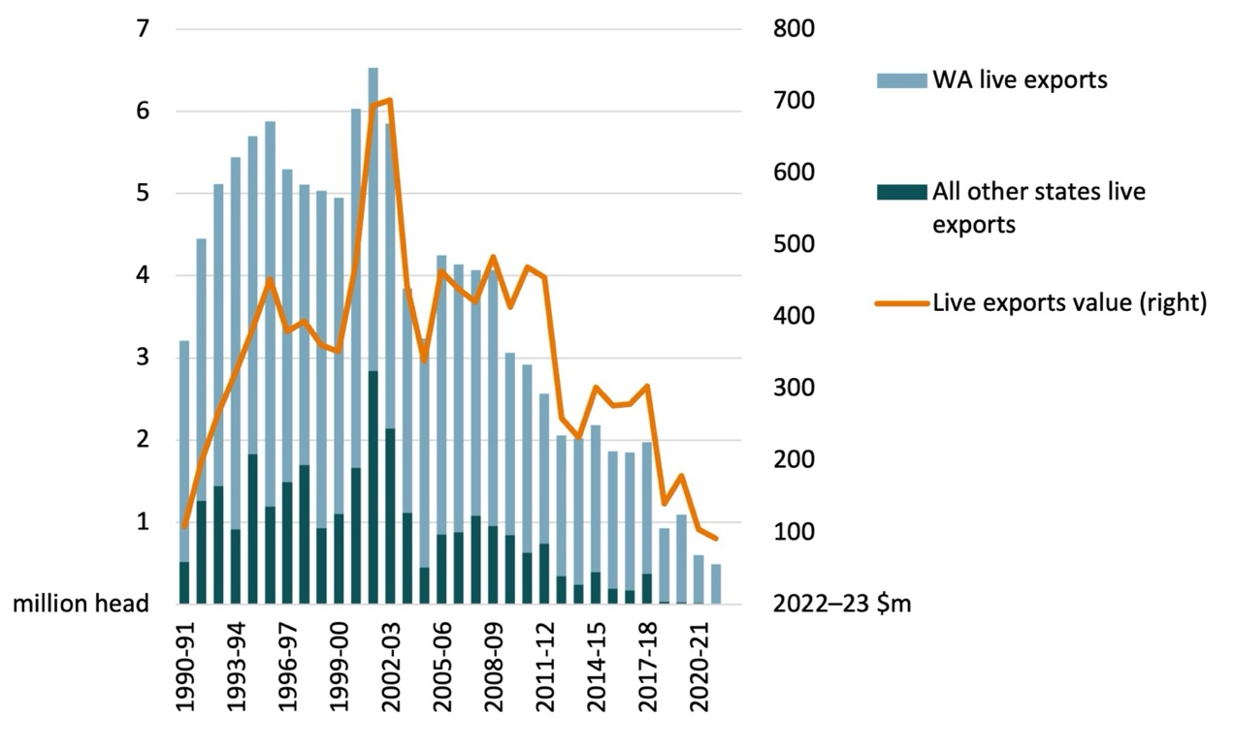

Sources: ABARES; ABS

Australian live sheep exports have declined significantly over the last 2 decades. This has been driven in large part by the substantial increase in the cost of sourcing live sheep from Australia. Record high saleyard prices and increased transportation costs have driven the decline in demand for Australian live sheep in key markets. The EU is now the world’s largest exporter of live sheep, with the majority originating in Romania. The EU exported $USD 406 million worth of live sheep in 2021, over 90% of which were sent to the Middle East. By comparison, Australia exported $USD 72 million worth of live sheep in 2021.

In Australia, the decline in live sheep exports coincided with a period of increased profitability of cropping production. Western Australian live sheep exports peaked at around 4.4 million head in 2000–01 and declined to 0.5 million head in 2021–22. Over this period, many producers within the wheatbelt switched to focus their enterprises more on cropping. Winter crop production in Western Australia increased from 8.7 thousand kilotonnes in 2000–01 to 23.4 thousand kilotonnes in 2021–22 (Figure 2). The shift to cropping reflects greater profitability of growing crops relative to sheep in Western Australia, due both to productivity improvements reducing the cost of production and high grain and oilseed prices relative to sheep meat and wool. In contrast, total wool produced has declined significantly since 2000–01 and total sheep meat produced in Western Australia was 90,000 tonnes in 2021–22, a decrease on the 102,000 tonnes produced in 2000–01.

Figure 2 Annual Western Australian sheep meat, wool, and crop production

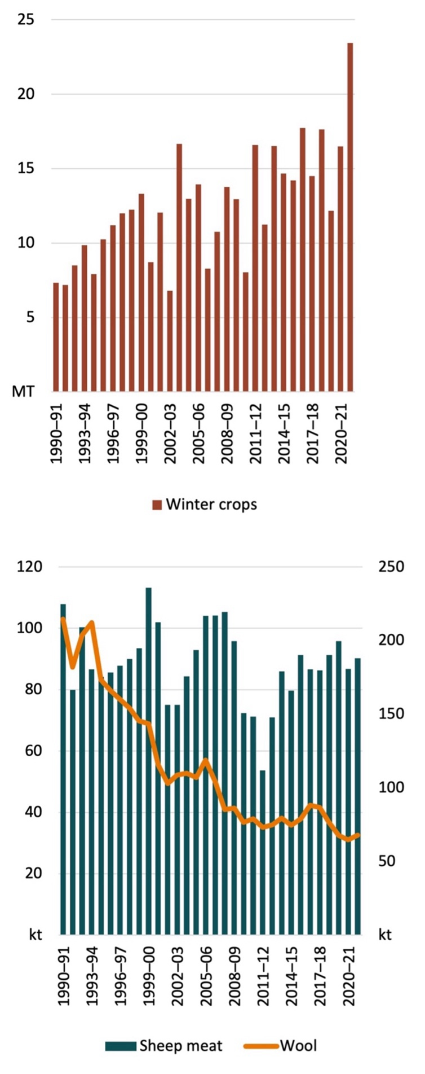

Sources: ABARES; ABS

## Characteristics of Western Australian sheep farms

Australian Bureau of Statistics published data for 2021–22 indicates that there was a total of 8,233 commercial scale (value of agricultural operations greater than $40,000 per year) agricultural businesses in Western Australia (ABS 2023). Of these businesses, around 4,281 had a sheep flock and ABARES estimates that around 4,000 had a flock of at least 100. ABARES farm survey data shows that of the 4,000 commercial scale farm businesses in Western Australia with at least 100 sheep, around 2,200 of these were specialist sheep farms with at least 50% of farm receipts derived from sheep meat and wool (ABARES 2023). The other 1,800 farms with at least 100 sheep were non-specialist sheep farms, primarily deriving their income from cropping (Table 1).

Sheep destined for live export in Western Australia are mostly sold directly to buyers working for export companies, but sheep sold through saleyards can also be exported live. Farmers selling sheep via saleyards may not know whether they end up on other farms, are exported live or are processed locally. Based on ABS live export statistics and farm survey data, ABARES estimates that on average over the 3 years to 2021–22, 34% of adult sheep sold by Western Australian farms ended up being live exported.

### Specialist sheep farms

Specialist sheep farms in Western Australia are reliant on a mix of enterprises for farm income, including selling adult sheep for live export. Adult sheep receipts accounted for 17% of total revenue on specialist sheep farms in Western Australia on average over the 3 years to 2021–22. This compares to 27% for lamb receipts, 30% for wool, 19% for crops, 3% for beef cattle and 4% for other revenue sources. Around 70% of specialist sheep farms in Western Australia are located in the central and southern wheat belt, 16% in the south-west coastal region and 14% in the north and east wheat belt.

Specialist sheep farms are smaller on average compared to non-specialist sheep farms, measured by total capital value and farm receipts. In addition, specialist sheep farms generated a lower average annual rate of return (1.3%) compared to non-specialists (3.7%) over the 3 years to 2021–22. Due to smaller farm size and weaker financial performance on average, specialist sheep farms are likely to find transitioning into other farming enterprises more difficult than non-specialists, with a lack of scale and financial reserves.

Table 1 Annual characteristics of Western Australian sheep farms, 3-year ave. to 2021–22

| Estimate | Unit | Specialist sheep farms | Non-specialists | All farms with 100 sheep |
| --- | --- | --- | --- | --- |
| Population of farm businesses | no. | 2,200 | 1,800 | 4,000 |
| Farm capital value | Average $ per farm | 6,268,000 | 14,306,000 | 9,793,000 |
| **Farm livestock** | – | – | – | – |
| Lambs sold | Average no. per farm | 1,010 | 1,090 | 1,040 |
| Adult sheep sold | Average no. per farm | 590 | 460 | 530 |
| Sheep shorn | Average no. per farm | 4,080 | 3,770 | 3,950 |
| Lambs on hand at 30 June | Average no. per farm | 970 | 1,170 | 1,060 |
| Rams on hand at 30 June | Average no. per farm | 60 | 50 | 50 |
| Wethers on hand at 30 June | Average no. per farm | 250 | 160 | 210 |
| Ewes on hand at 30 June | Average no. per farm | 2,000 | 1,840 | 1,930 |
| Total sheep flock at 30 June | Aggregate no. | 7,216,000 | 5,474,000 | 12,675,000 |
| **Farm receipts** | – | – | – | – |
| Lamb receipts | Average $ per farm | 149,000 | 178,000 | 162,000 |
| Adult sheep meat receipts | Average $ per farm | 93,000 | 78,000 | 87,000 |
| Wool receipts | Average $ per farm | 164,000 | 139,000 | 153,000 |
| Beef cattle receipts | Average $ per farm | 14,000 | 33,000 | 22,000 |
| Crop receipts | Average $ per farm | 107,000 | 1,659,000 | 788,000 |
| Other farm receipts | Average $ per farm | 22,000 | 101,000 | 57,000 |
| Total farm receipts | Average $ per farm | 549,000 | 2,188,000 | 1,269,000 |
| **Total cash costs** | Average $ per farm | 365,000 | 1,577,000 | 899,000 |
| Farm cash income (net) | Average $ per farm | 184,000 | 611,000 | 370,000 |
| Proportion of farms with negative income | % of population | 10 | 13 | 12 |
| **Rate of return to all capital** | Average % per farm | 1.3 | 3.7 | 2.9 |

Notes: Sheep specialist farms include farms with >50% of total revenue from sheep meat and wool. Other cash costs include costs more related to cropping production and fixed costs. All financial data inflated to 2022–23 dollars.

Source: ABARES Australian Agricultural and Grazing Industries Survey

Over the last 20 years, adult sheep meat receipts have averaged around 7% of total revenue on farms with at least 100 sheep in Western Australia (Figure 3). The majority of revenue over the period is dominated by cropping and to a lesser extent wool. Average adult sheep meat receipts per farm have stayed relatively stable since 2001–02 but cropping receipts have fluctuated in line with changes in seasonal conditions.

Figure 3 Average annual farm receipts, Western Australian farms with 100 sheep

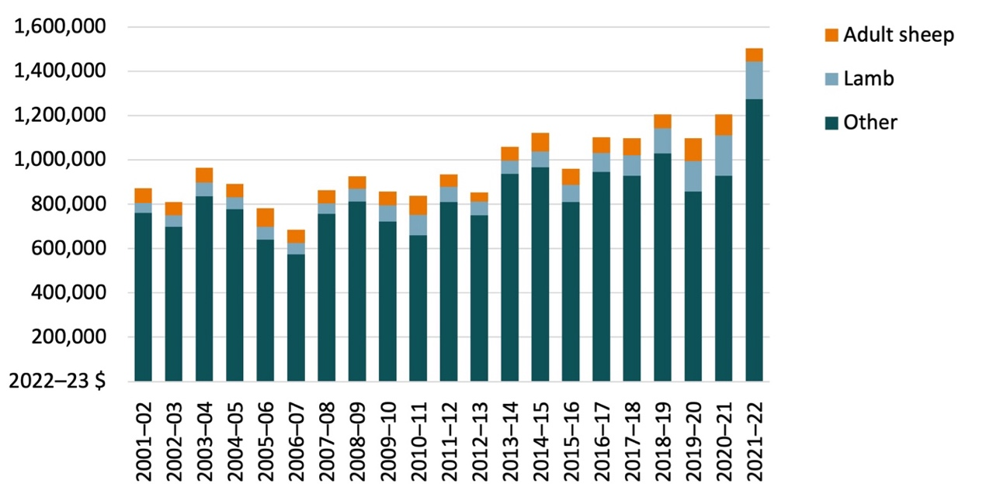

Note: Values shown are the average per farm. All financial data inflated to 2022–23 dollars.

Source: ABARES Australian Agricultural and Grazing Industries Survey

## Domestic market impacts of restricting live exports

The phase out of live sheep exports will likely have a small impact on the Western Australian lamb and sheep market in the short term, and an even smaller impact on the global market due to Australia’s small share of live exports. In the short term, Western Australian sheep meat saleyard prices would likely decrease, and domestic sheep meat production would likely increase.

### Saleyards

Late winter and early spring (September and October) are when lamb and sheep saleyards are at their busiest in Australia. Before the Northern Hemisphere Summer Prohibition, over the 4 years to 2019 Western Australian trade lamb prices averaged 8% lower than in the eastern states in September and October (Figure 4). This reflects lower demand for sheep from re-stockers and from processors due to Western Australia’s relative isolation. Since the Northern Hemisphere Summer Prohibition on live exports, Western Australian trade lamb prices have averaged 14% lower than in the eastern states – a decline of 6 percentage points from the earlier period (Figure 5). This reflects a greater number of sheep in Western Australia being sold via saleyards instead of being sold direct to buyers to service the live export market.

According to ABS labour force survey data, the number of people employed in meat and meat product manufacturing in spring in Western Australia has increased, on average, since the Northern Hemisphere Summer Prohibition has been in effect. This indicates that during periods when the live export of sheep is prohibited, Western Australian farmers direct more sheep towards domestic slaughter which increases the demand for workers by the meat processing industry.

Short-term falls in saleyard prices in Western Australia have been limited in the past by the option of paying to transport sheep to saleyards in the eastern states. The average cost of transporting sheep to the eastern states for processing was around $30 per head in 2020 (McCutcheon 2020), which is around 24% of the average pre-restriction (2017–18) saleyard price of trade lambs. In 2022 the saleyard price in Western Australian was 32% lower than in the eastern market. This is higher than estimated 24% limit due to higher freight, fuel, and labour costs in 2022 meaning the option of transporting sheep to the eastern market was more expensive. Saleyard prices have been lower than they would have been without disruptions to live exports, but strong global demand for sheep meat has provided some support to saleyard prices.

Figure 4 Trade Lamb Indicator, July 2015 to March 2023

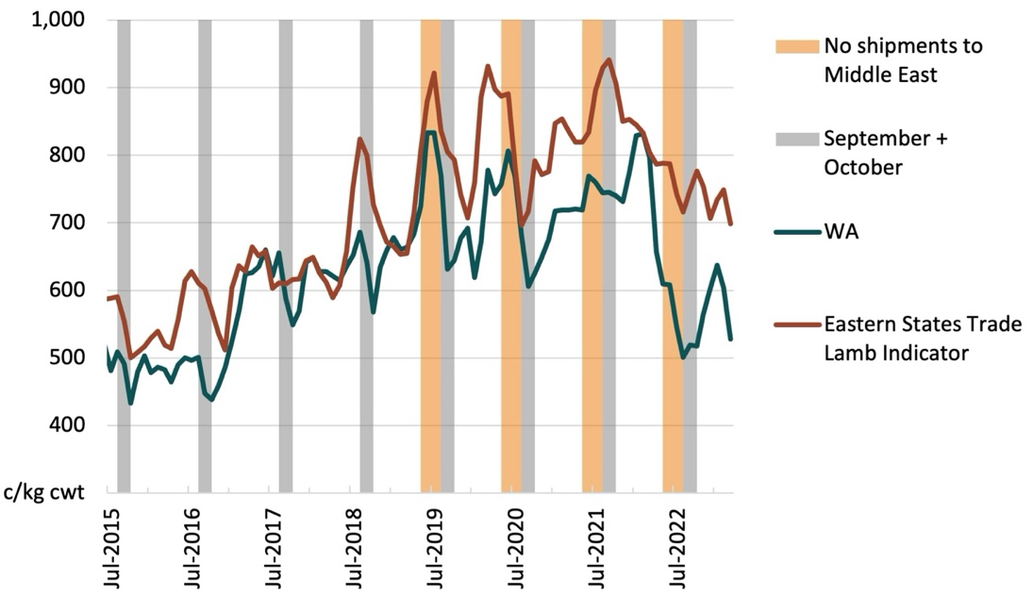

Note: The periods of no shipments to the Middle East represent 1 June to 31 August.

Sources: ABARES; MLA

Figure 5 Average September and October price difference between trade lamb prices in the eastern states and Western Australia, 2015 to 2022

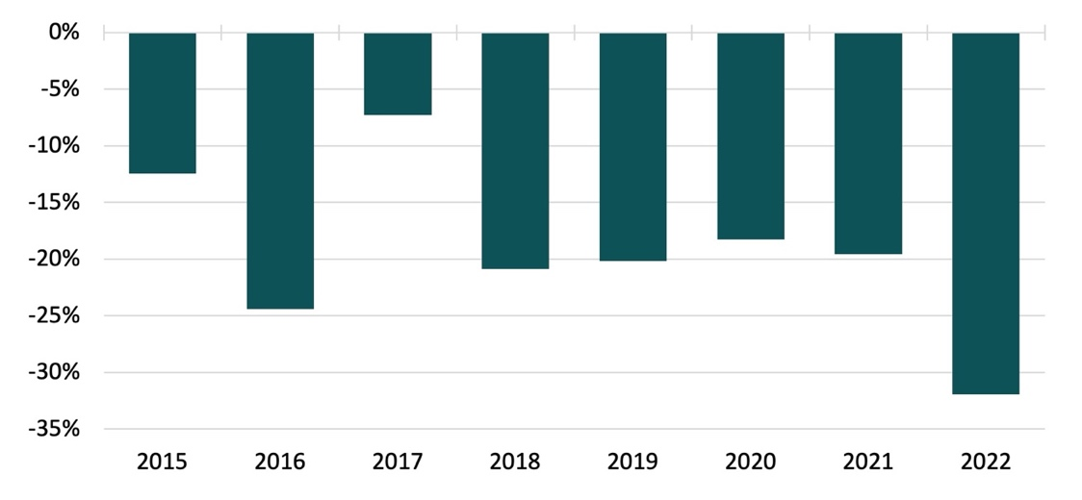

Sources: ABARES; MLA

### Processing

The diversion of sheep from live exports to domestic processing caused by the phase out of live sheep exports is likely to lower saleyard prices in Western Australia during the period that meat processors are recommissioning processing capacity. Meat-processing capacity in Western Australia is underutilised as a result of long-term declines in flock numbers and sheep slaughter. A shift to focus more on crop production reduced Western Australia’s sheep numbers from around 38.4 million in 1989–90 to just under 14 million from 2010–11 onwards. This reduction in sheep numbers occurred before restrictions were placed on live sheep exports. Annual slaughter fell by 22%, from an average of 4.6 million head per year between 2000 and 2009 to 3.6 million head per year between 2010 and 2018. The reduction in Western Australia’s sheep flock means that saleyards and meat-processing facilities are operating below their past capacity.

Domestic processors would likely have a strong financial incentive to increase slaughter in response to a phase out of live exports. This is because saleyard prices for sheep for slaughter in Western Australia are likely to fall to a greater extent than world sheep meat prices in the short term. However, the cost of recommissioning previously used processing capacity is likely to increase processing costs. Capacity is likely to be sufficient to facilitate the roughly 500,000 sheep currently sold for live export, but investment will likely be required to recommission facilities that have fallen into disuse. These additional costs are likely to include recruiting and training new staff, leasing temporary equipment and refrigeration, and refurbishing buildings and machinery. If the phase out is communicated well in advance, then processing costs can be better managed. In addition, investment to recommission underutilised capacity would need to be considered in the context of future profitability, given the long-term trend of declining sheep meat production in Australia.

## Global market impacts of restricting live exports

Irrespective of a live sheep export ban, global prices for sheep meat are expected to fall over the medium-term mainly due to increased supply of Australian sheep meat. Australian supply is increasing due to higher turn-off rates with the expectation and onset of drier seasonal conditions following several years of flock rebuilding.

The increased supply will be partially offset by income growth, urbanisation in developing countries, and changing consumers preferences towards a higher protein diet increasing demand for sheep meat products. Consumers in emerging markets with increased spending capacity are shifting towards a high-protein diet and high-quality meats. Demand for sheep meat in China is expected to increase in 2023 due to the ending of COVID-19 lockdowns imposed throughout the last 3 years. However, consumers in Middle Eastern nations are expected to continue a long trend of substituting away from lamb towards other types of meat.

Australia’s top sheep meat export markets are China, the United States, the Middle East, and Malaysia (Figure 6). China is Australia’s largest mutton export market, and the United States is Australia’s largest lamb export market. In recent years there have been increases in export volumes to Papua New Guinea, the Republic of Korea and Malaysia.

Figure 6 Australian sheep meat exports, top 4 destinations

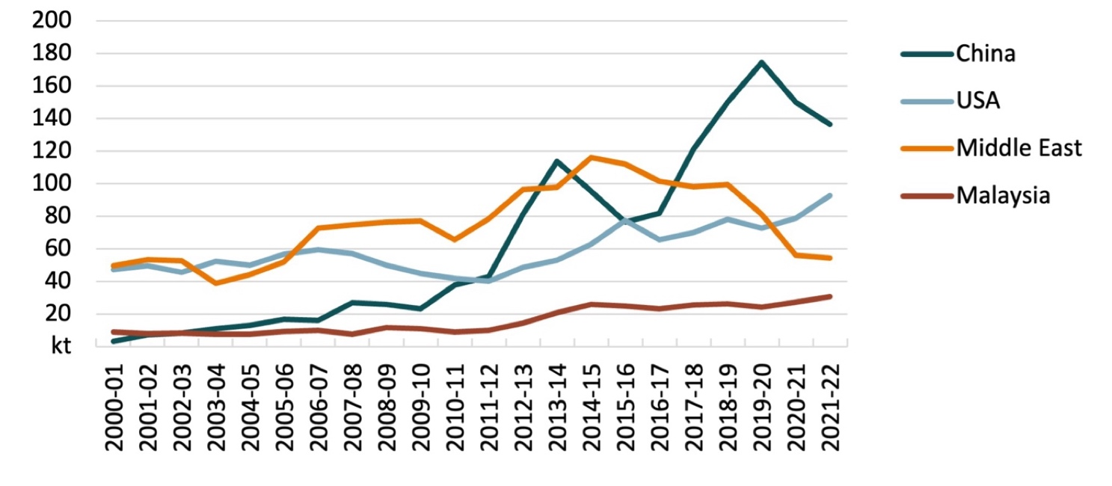

Source: ABS

Australia is the largest sheep meat exporter in the world with New Zealand the second largest. The New Zealand Ministry for Primary Industries is forecasting sheep meat export volumes to continue a downward trend from 295,000 tonnes in 2023 to 280,000 tonnes in 2026, which will help to support global sheep meat prices. This is due to subdued production from a declining sheep flock, decreasing lambing rates and a reduction in breeding ewes.

While Australian sheep meat export unit values have risen in recent years (Figure 7), the higher supply in 2023–24 is likely to more than offset expected increases in global demand for Australian sheep meat. This will lower the export price and moderate the increase in sheet meat export value for 2023–24. The value of sheep meat exports from 2024–25 to 2027–28 is expected to rise due to an increased consumer base and income growth in existing key, and emerging, markets.

Figure 7 Australian export unit values of sheep meat

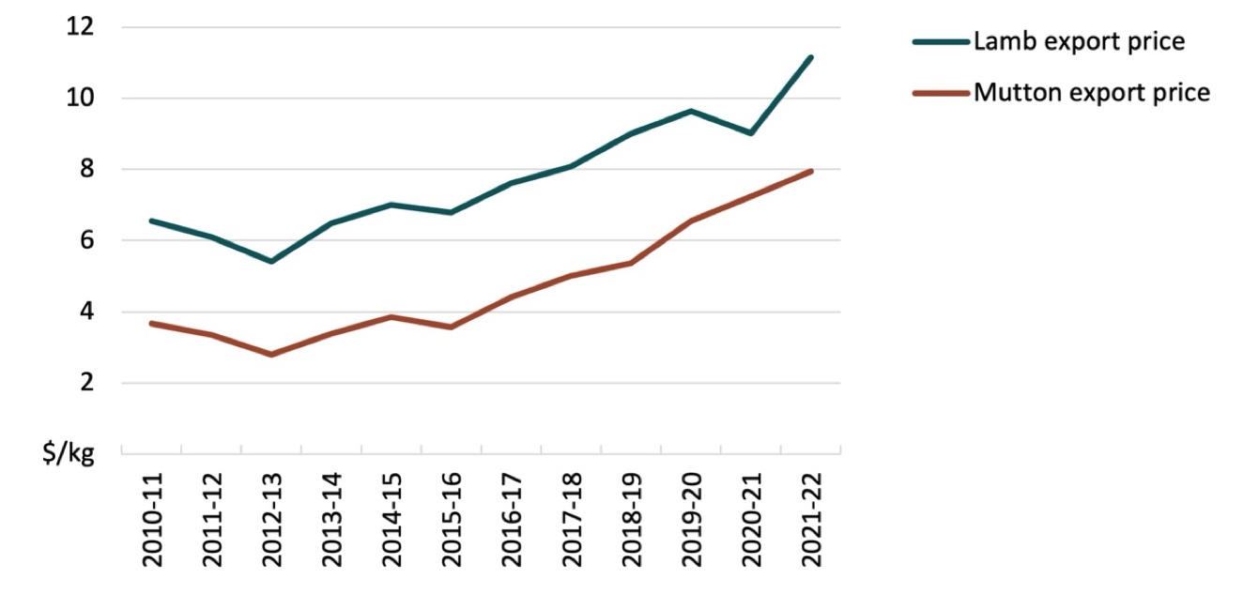

Source: ABS

A phase out of live sheep exports would mean global prices for sheep meat are likely to fall very slightly in the short term, all else equal, as meat supply increases from Australia. Australia’s sheep meat prices are largely set in world markets, where Australia and New Zealand each contributed just over one-third of world exports in the 5 years to 2016 (prior to disruptions to the live sheep trade). Australia’s large share of the world sheep meat trade means that world prices could fall if Australia’s sheep meat exports increased significantly. However, the potential increase in supply is small compared to the volume of world trade. If all the sheep exported live in 2021–22 were slaughtered in Australia and exported as meat, the world supply of sheep as meat would increase by around 1%.

World sheep meat prices are unlikely to fall as much as this small increase in supply. Consumption of sheep meat in importing nations is likely to be higher than it would otherwise be, due to the slight fall in price.

## Impacts on sheep farms

Western Australian sheep farmers will be negatively impacted by the phase out of live sheep exports. However, most businesses generate revenue from a diverse mix of sources including cropping, wool, and lamb production, with adult sheep meat receipts only account for a small percentage of income on average. Across the farm distribution in Western Australia, those businesses that rely on sheep meat receipts for the majority of income will be most heavily affected. Nevertheless, any phase out of live exports should be communicated well in advance to ensure farmers have the opportunity to transition away from live exports as efficiently as possible.

If the live export trade was phased out, farmers producing sheep for live export will likely switch to alternative marketing strategies. Farmers would likely adjust farm production to finish more prime lambs for local slaughter, harvest more wool and sell more sheep for local processing as mutton. Most sheep farms in Western Australia already produce lambs. However, supplementary feeding is often required to bring lambs up to market specifications. These additional feed costs could contribute to lamb production becoming less profitable for some producers than if they still had the option to live export, leading them to concentrate on other activities such as cropping where possible.

### Scenario assumptions

ABARES farm survey data from 2019–20 to 2021–22 was used to create an illustrative scenario based on a set of assumptions relative to the base case. This is not an assessment of the potential impacts of the live sheep ban at a future point in time. The illustrative scenario was used to model the pathway of impact on farm incomes of switching from live exports to increased lamb production if the trade in live exports was phased out. Most sheep redirected from live export will be finished to prime lamb standard for domestic processing, as lambs tend to attract higher prices than mutton. If lambs are finished on farm to a higher standard for domestic processing, they are likely to be sent to slaughter sometime in spring after the period they are normally sold for live export.

In our illustrative scenario, it is assumed that restrictions on live exports were foreshadowed well before the growing season, and therefore farmers can divert one-quarter of the sheep intended for live export that year to lamb production. Lamb prices per head are assumed to be 2.5% lower than the base case. Sheep that can’t be diverted to lamb production in the first year – the other three-quarters – are diverted to domestic processing as mutton, with adult sheep prices per head assumed to be 10% lower. In the second year, it is assumed that farmers can divert one-half of the sheep intended for live export that year to lamb production and markets adjust somewhat so that lamb prices now don’t change, with adult sheep prices 5% lower. In addition, it is assumed that there are greater costs associated with transitioning to expanded lamb production. Total cash costs are assumed to increase by 1% in the first year and by 0.5% in year 2. All other receipts and costs associated with the production and sale of crops and other livestock were held constant.

Under this scenario, farm survey data can be used to estimate the impact on farm incomes of the change in lambs sold relative to adult sheep sold, as well as prices received. Receipts and costs for an average farm were adjusted relative to a base period (Table 1), which reflect average operating conditions for the 3 years to 2021–22 – the period when the Northern Hemisphere Summer Prohibition was introduced. The change in farm cash income (total cash receipts minus total cash costs) was estimated for the first and second year relative to the base period. An estimate of the aggregate cost of the scenario was obtained by multiplying the average change in income by the population of farms in Western Australia with more than 100 sheep.

### Estimated impacts

Redirecting sheep from live exports to domestic processing is estimated to reduce farm incomes in the short term as the processing sector adjusts and prices fall relative to the base case. Average farm cash incomes for the 4,000 farms in Western Australia with more than 100 sheep are projected to fall by 5.7% in the first year following complete restriction on live sheep exports and 2.2% in the second year. Across the farm distribution, the percentage of farms generating negative income also increases. In aggregate, a complete restriction is estimated to translate to a reduction in farm cash income of $84 million in the first year and $33 million in the second year. As a comparison, the total value – Free on Board (FOB) – of Australia’s live sheep exports averaged $125 million per year over the same base period (2019–20 to 2021–22).

### Longer-term impacts

Over the long term, some specialist sheep-farms in Western Australia will have the flexibility to shift into greater cropping activity due to being located in the wheat belt region. However, more frequent droughts in future may limit the extent to which farmers on more marginal land can transition towards cropping. Switching to wool production over the long-term is also a likely option for some specialist sheep farms impacted by restrictions on live exports, although this might be impacted by the availability of shearers in Western Australia. Many specialist sheep farms are likely to lack the scale and cash reserves (Table 1) to diversify profitably into other enterprises such as cropping or wool, therefore there is likely to be some industry consolidation. In addition, removing the option to farmers of being able to live export adult sheep will amplify the risks associated with a short lamb growing season in Western Australia and may reduce risk resilience for some farms over the long term.

The overall financial impact of a phase out of live sheep exports on non-specialist sheep farms will be limited on average, despite non-specialists accounting for 43% of the total sheep flock in Western Australia (Table 1). This is because over the 3 years to 2021–22, non-specialist sheep farms derived 76% of their revenue per farm from cropping and only 4% from adult sheep meat receipts on average. Non-specialist sheep farms are primarily large farm businesses with substantial capital values and high farm incomes (Figure 8).

Figure 8 Average annual farm cash income, Western Australian farms

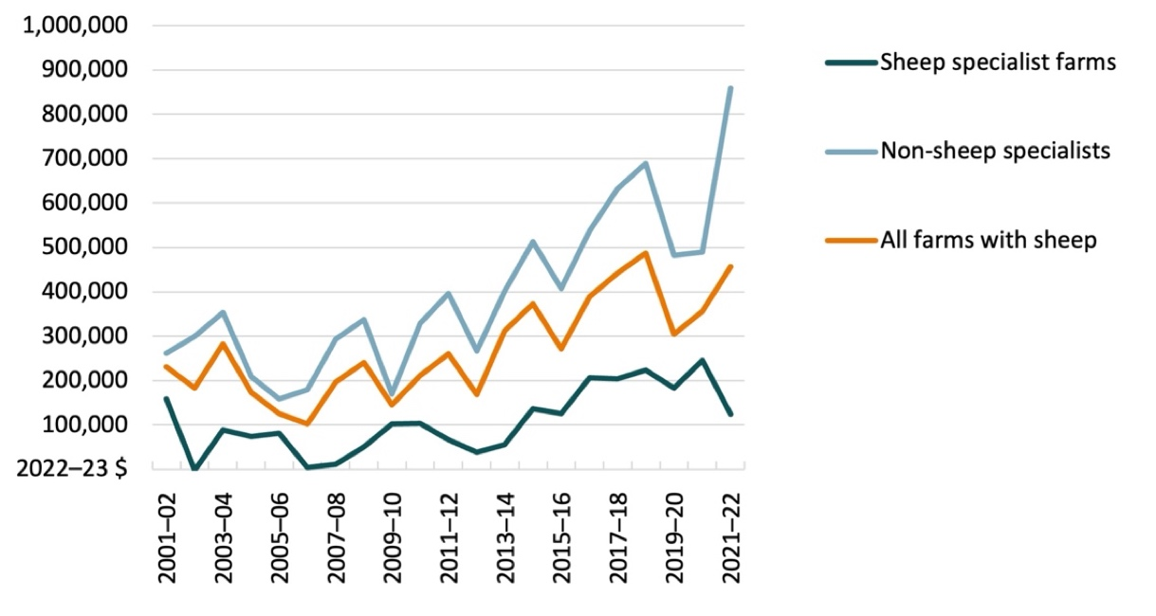

Note: Values shown are the average per farm. Farm cash income is calculated as total cash receipts minus total cash costs. Sheep specialist farms include farms with >50% of total revenue from sheep meat and wool.

Source: ABARES Australian Agricultural and Grazing Industries Survey

## Impacts on the supply chain

The potential effects of the phase out of live sheep exports on other areas of the supply chain was detailed in the Department of Agriculture, Water and the Environment’s (2020) regulatory impact statement on ‘Live sheep exports to, or through, the Middle East–Northern Hemisphere summer’. The information in that report was constructed through industry consultation and feedback.

### Transport

The Australian Livestock and Rural Transporter’s Association is a federation of 6 state associations, representing around 850 transport businesses. It includes owner–drivers, small fleet operators and large fleet operators. The number of transport businesses heavily reliant on live sheep exports is only a small proportion of the total number of these businesses. However, in their submission to the discussion paper, the Australian Livestock Export Corporation Ltd (LiveCorp) advised that some livestock transporters are specialised with purpose-built sheep trailers.

Industry groups state that the road transport operators mentioned in the previous paragraph are highly dependent on the live export trade in Western Australia, averaging 25–50% of business revenue. According to LiveCorp, on average, the sale of sheep from farm to the live export trade requires 3.5 movements. In comparison, sheep sold to a WA abattoir would be moved just 1.5 times.

### Shearers

Shearing is a specialist skill and shearing is normally conducted on a seasonal basis. Shearing services form part of the live export supply chain, with the requirement under the Australian Standards for the Export of Livestock (ASEL) 2011 (version 2.3, S1.19) that sheep for live export must have wool not more than 25mm in length. This means that sheep for live export may need to be shorn out of the normal annual cycle to meet this requirement. Discussion with industry indicates that shearing for the live export trade can fill a gap in the work calendar for shearing services providers. A prohibition may distort the distribution of their workload, resulting in an imbalance between strenuous work periods and no work.

### Registered premises

Registered premises are used for assembling and preparing livestock prior to export by sea. Sheep are currently held for a minimum of 5 days in a registered premises for Northern Hemisphere summer voyages, where they undergo inspection for health and welfare and other preparations prior to export.

In 2020 there were 12 registered premises in Australia approved to hold sheep prior to export. The vast majority of sheep destined for live export to the Middle East will be prepared at 3 of these premises, with all 3 located in Western Australia.

A registered premises may have indoor housing in elevated sheds or outdoor housing in paddocks, or a combination of both. Approved holding capacities for premises varies seasonally. The largest premises has a winter holding capacity of 140,000 sheep and a summer holding capacity of 84,000 sheep. If not used for live exports, these facilities could potentially be used as sheep feedlots to finish animals for domestic slaughter.

### Stock feed manufacturers

In 2020, there were 6 feed mills supplying feed to the live export sheep trade, 3 in Western Australia, 2 in South Australia and 1 in Victoria. The proportion of product sold to domestic markets versus live exports varies from business to business, with some manufacturers focusing their business on supplying live exports. In discussion with industry, it is estimated that for these 6 feed mills, between 50% and 90% of production is for the live sheep export trade, producing fodder specifically for consumption at registered premises and during voyages. However, if live sheep are phased out then the likely fall in demand for fodder from these mills would be moderated by an increase in demand for fodder for domestic lamb and sheep meat production.

### Exporters and ship owners

In 2020 there were 33 exporters licensed to export sheep by sea. The majority of sheep exports are undertaken by 15 companies with 2 exporters accounting for over 80% of the trade by volume.

Sixteen different specialised vessels carried live sheep to the Middle East from 2015 to 2019. Three vessels accounted for almost 75% of live sheep exports from 2015 to 2018. These 3 vessels currently servicing the Middle East market from Australia are either owned by exporters or by shipping companies closely associated with exporters.

## Impact on research and development corporations (RDCs)

LiveCorp is the industry body that provides services to licenced exporters of Australian cattle, sheep, and goats. It is funded through statutory levies which are invested in research, development, and extension (RD&E) and marketing services (promotion of animal welfare standards and preference for Australian livestock). In 2021–22, the statutory levies on live sheep exports accounted for 11% –approximately $300,000 – of LiveCorp’s levy income (LiveCorp 2022). The phase out of live sheep exports will reduce LiveCorp’s levy income; however, it will also reduce the number of industries for which LiveCorp needs to fund RD&E projects. As a result, LiveCorp’s RD&E projects in other live export industries – such as cattle – are unlikely to be affected by the phase out of live sheep exports.

Meat and Livestock Australia (MLA) is the RDC for the livestock industry. MLA is primarily funded by transaction levies paid on livestock sales by producers and are used to support marketing, research, and development activities as well as government matched funding. MLA received a $1.1 million contribution from LiveCorp in 2021–22 which represented 0.4% of MLA’s total annual revenue ($288.2 million) (MLA 2022). Assuming that LiveCorp’s contribution to MLA decreases by the same proportion as its loss of revenue from the phase out of live sheep exports, MLA would expect to lose around $121,000 or 0.04% of their total annual revenue. The remainder of MLA’s funding mostly comes from domestic livestock sale levies, processor contributions, government contributions and the MLA Donor Company (Figure 9). It is expected that these income sources would be mostly unaffected by the phase out of live sheep exports. It is likely that MLA’s ability to invest in marketing as well as research and development activities in Australia will be unaffected by phase out of live sheep exports.

Figure 9 Meat & Livestock Australia (MLA) revenue summary, 2021–22

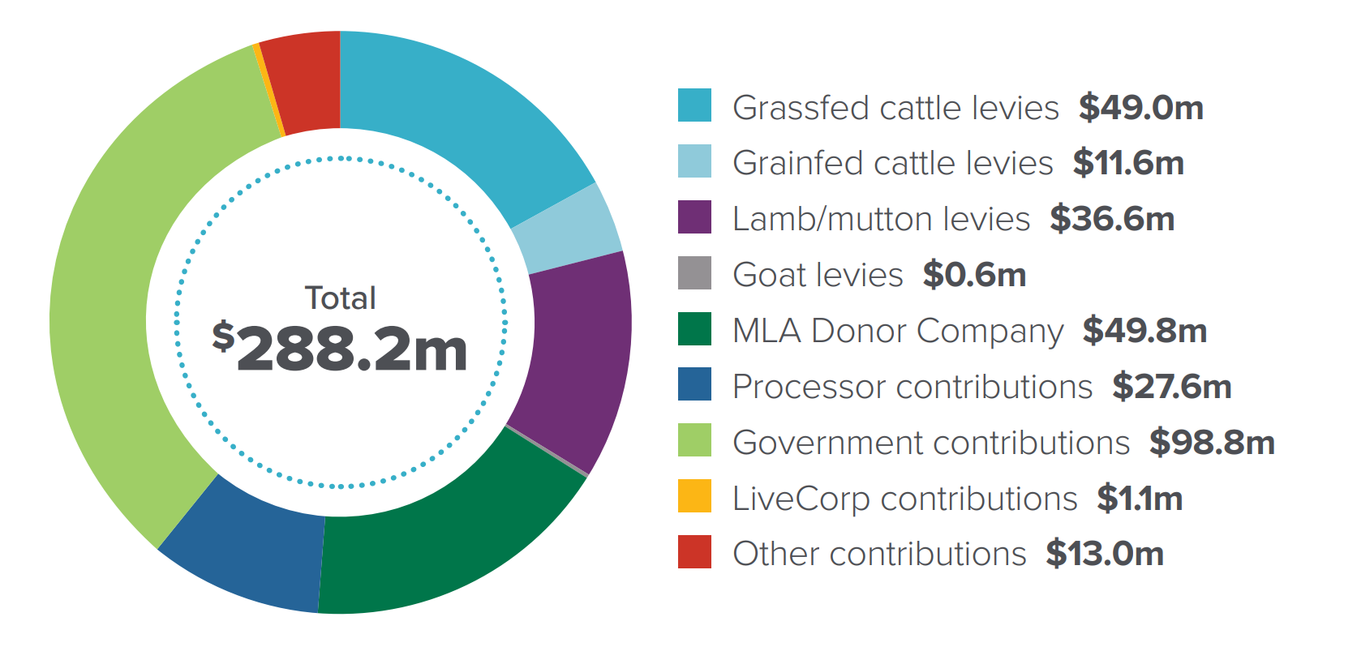

Source: MLA Annual Report 2021–22

## References

ABS 2023, [Agricultural Commodities, Australia](https://www.abs.gov.au/statistics/industry/agriculture/agricultural-commodities-australia/2019-20), cat. no. 7121.0, Australian Bureau of Statistics, Canberra.

Department of Agriculture, Water and the Environment 2020, [Live sheep exports to or through the Middle East–Northern Hemisphere summer: regulation impact statement](https://oia.pmc.gov.au/published-impact-analyses-and-reports/live-sheep-exports-or-through-middle-east-northern-0), Department of Agriculture, Water and the Environment, Canberra, March.

LiveCorp 2022, [2021–22 Annual Report](https://livecorp.com.au/article/2irWvEVpR3XeeBTcDe3cnb), Australian Livestock Export Corporation Ltd (LiveCorp).

McCutcheon, J 2020, [Western NSW farmers buying Western Australia sheep to rebuild flocks](https://www.abc.net.au/news/2020-05-20/nsw-farmers-restock-buying-wa-sheep/12262140), Australian Broadcasting Corporation, accessed March 2023.

MLA 2022, [Annual Report 2021–22](https://www.mla.com.au/about-mla/how-we-are-governed/Planning-reporting/annual-reporting/), Meat & Livestock Australia.

Nelson, R, Mornement, C, Bruce, M, Weragoda, A, Litchfield, F & Collins, P 2021, [The economic impacts of regulating live sheep exports](https://daff.ent.sirsidynix.net.au/client/en_AU/ABARES/search/detailnonmodal/ent:$002f$002fSD_ASSET$002f0$002fSD_ASSET:1031441/one), ABARES research report 21.01, Canberra, February.

UN 2023, [UN Comtrade Database](https://comtradeplus.un.org/TradeFlow?Frequency=A&Flows=X&CommodityCodes=TOTAL&Partners=0&Reporters=all&period=2022&AggregateBy=none&BreakdownMode=plus), United Nations, New York, accessed March 2023.