# Responding to regional transitions

Australian live sheep export transition

Regional Australia Institute

August 2023

ABOUT THE REGIONAL AUSTRALIA INSTITUTE

The RAI is Australia’s only independent think-tank dedicated to research and activation to inform regional policy and investment.

Established in 2011, for more than a decade the Institute has been researching topics relevant to the prosperity and success of regional Australia including migration and population; regional employment; jobs and skills; population; housing and health.

The RAI exists so that decision-makers at all levels of government, industry and community have the information they need to ensure the best outcomes for regional Australia.

**Our purpose is to empower regions to thrive.**

CONTACTS AND FURTHER INFORMATION

P. 02 6260 3733

E. [info@regionalaustralia.org.au](mailto:info@regionalaustralia.org.au)

Further information can be found at [www.regionalaustralia.org.au](http://www.regionalaustralia.org.au)

Contents

Executive summary vi

Introduction vi

Three dynamic regional economies vii

Transition considerations ix

1 Regional analysis 1

About the data 1

Population 2

Agricultural workers are in demand 5

Employment patterns are regional 7

Housing supply is tight 10

2 Western Australian regional priorities 13

Impact of the phase out in the Mid West–Gascoyne, Wheatbelt and Great Southern 14

Economic development opportunities in the Mid West–Gascoyne, Wheatbelt, and Great Southern 15

3 Communities in transition 18

Insights from previous research 18

International examples 18

Australian examples of communities in transition 22

4 Transition plan considerations 26

Place-based development and smart specialisation 27

5 Potential phase out pathways 30

Regional intelligence delivery models 30

Mobilising mental health services 31

Investment in enabling infrastructure 31

Housing availability for workers 32

Coordination group and investment fund to increase meat processing capacity 32

Financial support for impacted businesses 33

Reinforcing market development 34

Workforce attraction for industry to respond 34

Governance of pathways 35

6 Conclusion 39

7 References 41

**Tables**

Table 1 Comparative advantage industry opportunities – RDA regions vi

Table 2 Population and working-age population change – RDA regions viii

Table 3 LGAs with population growth in Great Southern, Mid West–Gascoyne, and Wheatbelt, 2018 to 2022 3

Table 4 LGAs with population decline in Great Southern, Mid West–Gascoyne, and Wheatbelt, 2018 to 2022 3

Table 5 Working-age population, 2017 to 2021 4

Table 6 LGAs with working-age population decline in Great Southern, Mid West–Gascoyne, and Wheatbelt, 2017 to 2021 5

Table 7 LGAs with highest employment proportion in Agriculture, Forestry, and Fishing industry, 2021 8

Table 8 LGAs with lowest employment proportion in Agriculture, Forestry, and Fishing industry, 2021 8

Table 9 Priority regional development issues in the Mid West–Gascoyne, Wheatbelt and Great Southern 13

Table 10 Top 3 industry sectors by output in 2022 14

Table 11 Comparative advantage industry opportunities 16

Table 12 Unemployment rate, looking for full-time and part-time work, 2011 to 2021 34

Table 13 Governance and funding levels for transition pathways 36

**Figures**

Figure 1 Components of population change, 2021 to 2022 3

Figure 2 Working-age population, 2017 to 2021 4

Figure 3 Monthly internet job vacancies in South West WA and Goldfields and Southern WA (IVI regions), 2019 to 2023 6

Figure 4 Monthly internet job vacancies for sheep industry in South West WA, 2019 to 2023 6

Figure 5 Monthly internet job vacancies for sheep industry in Goldfields and Southern WA, 2019 to 2023 7

Figure 6 Employment by industry in Outback North and South (SA4 region), 2019 to 2023 8

Figure 7 Employment by industry in Wheat Belt (SA4 region), 2019 to 2023 9

Figure 8 Employment by sheep farming occupation in Great Southern, Mid West–Gascoyne, and Wheatbelt, 2016 and 2021 9

Figure 9 Sales volumes in selected LGAs, 2019 to 2023 10

Figure 10 Median asking rents in selected LGAs, 2019 to 2023 11

Figure 11 Volume of rental listings in selected LGAs, 2019 to 2023 11

Figure 12 Rental vacancy rates in selected LGAs, 2019 to 2023 12

Figure 13 Satisficing model 26

## Executive summary

### Introduction

The Australian Government has committed to phasing out live sheep export by sea from Australia (the Phase Out). To support preparations for the Phase Out, the Minister for Agriculture, Fisheries and Forestry, Senator the Hon. Murray Watt has appointed a panel to consult with stakeholders and provide advice on the Phase Out timing, implementation mechanisms, and potential ways to support the transition (the Transition Plan).

The decision to phase out live sheep export by sea is a policy change that is expected to cause a structural adjustment for individuals, businesses, communities, and regional economies in Western Australian (WA). As such, there is a need to understand the opportunities and vulnerabilities associated with this kind of regional transition in WA.

As part of its work, the Department of Agriculture, Fisheries and Forestry (DAFF) engaged the Regional Australia Institute (RAI) to undertake 3 areas of research in relation to the Mid West–Gascoyne, Wheatbelt and Great Southern Regional Development Australia (RDA) regions in Western Australia and this transition. This study does not include a formal social-economic impact assessment. Similar to the terms of reference of the Ministerially appointed Panel, this study will also not make formal comment on the merits or otherwise of the Government’s policy. It intends to capture impact and transition considerations at a high level, in a region-specific context.

To support the transition to better align with the distinct needs and strengths of the affected regions, this report draws on:

1. a literature review of best practice in regional transitions
2. regional analysis of population, employment, and housing data
3. a review of the regional priorities and opportunities.

The report describes the regional economic context of the transition, the economic activities that underpin the regional economy, and the population, regional employment and housing context in each of these regions. It is important to note that the Phase Out will directly affect businesses and communities outside of these regions with broadacre farming, meat processing, supply chain, logistics and support industries extending into the South-West, Peel, Goldfields–Esperance, and Perth metropolitan regions.

The short timeframe for this study required a prioritised stakeholder engagement methodology. Consultation and investigation have been limited to the following organisations and their strategic documents:

* Mid-West Development Commission (MWDC)
* RDA Mid West–Gascoyne
* Wheatbelt Development Commission (WDC)
* RDA Wheatbelt
* Great Southern Development Commission (GSDC)
* RDA Great Southern
* Department of Primary Industries and Regional Development (DPIRD)
* The Panel appointed by the Minister for Agriculture, Fisheries and Forestry.

### Three dynamic regional economies

The Phase Out is landing in a dynamic regional economic context in the Great Southern, Wheatbelt and Mid West–Gascoyne regions. Analysis of demographic, employment and housing data largely indicates these regions are growing but at varying degrees and in different ways.

The 3 RDA regions have mature economies, characterised by export-focused primary producers responding to continued growth in the global demand for food. The Agriculture, Forestry and Fishing sector features in the top 3 industries by output for 2022 in all 3 regions, and there are significant opportunities for growth in this sector, including in:

* horticulture
* aquaculture
* intensive animal farming
* pastoral revitalisation
* premium end food and beverage
* downstream processing.

However, across all 3 regions there is also a range of other economic development opportunities and projects, outside of the agriculture industry that should be considered in the transition. The issues of housing, workforce and digital connectivity are universally present across all 3 RDA regions, and this transition cannot occur in isolation from them. Opportunity spaces in the region are summarised in Table 1.

Table 1 Comparative advantage industry opportunities – RDA regions

| Industry | Mid West Gascoyne | Wheatbelt | Great Southern |
| --- | --- | --- | --- |
| International and tertiary education | n/a | n/a | Great Southern Universities Centre  University of Western Australia Albany campus  Great Southern Marine Research Facility, which houses Marine Energy Research Australia |
| Manufacturing | n/a | n/a | Supporting mining developments; seafood processing and marine sector; agricultural equipment sector; and expanding food and beverage production |
| Mining | Diversity of extracted products  Capturing increased demand for local services | Exploration and development of green metals projects  Manufacturing, transport and logistic support businesses | n/a |
| Renewable and hydrogen energy / carbon farming and green energy | Proposed Mid-West Clean Hydrogen Hub at Oakajee Strategic Industrial Area  Proposed Project Haber urea manufacturing and Midwest Geothermal project by Strike Energy  Proposed Murchison Hydrogen Renewables project | Hydrogen and biofuel production  Proposed large scale wind and solar farms | n/a |
| SME sector | n/a | The region has almost 9.500 SMEs, more per capita than any other region in WA  Positioned to capitalise on opportunities associated with a pipeline of over $10 billion in private sector investment over the next 10 years | n/a |
| Space economy | Square kilometre array  Mingenew Space Precinct  Astronomy tourism | n/a | n/a |
| Tourism and lifestyle | n/a | n/a | Complementing premium food and beverage products, cultural assets, natural attractions, tourism events, and international trade missions  Capabilities in Aboriginal tourism, sports tourism and trails  Arts/heritage/cultural tourism, eco-tourism, and cruises |

**n/a** Not applicable.

While residential populations have grown in all 3 regions overall, population changes in the working-age population are disproportionate (see Table 2), and population growth is not evenly distributed. Increased demand for workers means any additional capacity in the workforce, particularly where people have transferable skills or occupations with low entry requirements, could be valuable. The Wheatbelt has seen a decline in working-age population, indicating a general decline in the proportion of the population in this region available for employment. At the same time and depending on the impacts of the Phase Out on the agricultural workforce, additional capacity created in the transition would likely be in the Wheatbelt SA4 region (encompassing the Wheatbelt and Great Southern RDA regions), where agriculture accounts for 17% of employment. This is in comparison to 4% in the Outback North and South region (which includes the Mid West–Gascoyne region).

Table 2 Population and working-age population change – RDA regions

| Population | Great Southern | Wheatbelt | Mid West–Gascoyne |
| --- | --- | --- | --- |
| Population (2018–2022) | +4.3% | +1.9% | +3.8% |
| Working-age population (2017–2021) | +2.2% | −2.0% | 0.8% |

Significant growth in job vacancies identified through the Internet Vacancy Index (IVI) in the South West WA (Great Southern) and Goldfields & Southern WA (Wheatbelt and parts of Mid West–Gascoyne) IVI regions indicates that any loss of, or a disproportionate level of working-age groups, would be putting pressure on businesses in these regions to operate, as vacancies are at near record highs.

The 3 regions are all experiencing housing shortages, as is common across much of regional Australia. A scarcity of housing in the purchase and rental markets is observable in the 8 Local Government Areas (LGAs) analysed in this report, particularly in larger centres such as Bunbury and Albany. These LGAs surround Western Australia’s abattoirs. Reduced housing availability has gone hand in hand with significant asking price increases. Access to housing will be one of the most significant barriers to attracting and retaining workers to these regions and may have an impact on industry diversification efforts.

### Transition considerations

Policy induced change in the live sheep export industry will have an impact on employees and business owners directly involved in live sheep export. This will involve farm business adaption to manage the extra flock, particularly wethers, increasing vulnerability to climatic events, eroding of wool and meat prices, and reducing business diversification (DAFF, 2023). The processing industry has indicated that a current lack of capacity could impact the processing of extra supply, potential limits include access to labour, employee accommodation and cold storage capacity at abattoirs and ports (DAFF, 2023).

International experiences in supporting transitions underscore the need to understand the relative importance of the live sheep export trade to regions as part of impact assessments. Live sheep are not a single enterprise system. The market is made up of large and small contributors with different levels of involvement; consequently, the relative impact on and the subsequent responses from each enterprise will vary. International and Australian experiences of exogenous transitions, in terms of new industries or changes within existing industries, highlight the importance of developing place-based approaches.

Place-based policies need to focus on the unique characteristics of the region and the overall impact policy changes will have on those areas. Evaluating the percentage of the workforce employed within the industry experiencing change, dependency of the community on that industry, and opportunities for new employment or retraining for the displaced workers are important elements of transition planning.

The Australian Government has a range of approaches to consider in supporting these regions through this transition. Overall, a review of regional priorities across the RDA regions has highlighted that:

* the support response needs to address the micro and macro impacts of the Phase Out to ensure a profitable sheep industry with integrated strong regional development outcomes
* there is a suite of mechanisms available to government to provide a multifaceted Transition Plan
* embedding on-ground industry and regional intelligence in the design and delivery of the Transition Plan to build upon existing efforts in economic diversification and value-add opportunities for growth and resilience.

International and Australian examples of transitions, while diverse, demonstrate the importance of interim programs to assist in the transition phase. Additionally, resilience in communities informs community responses to shocks, either economic, natural or policy induced. Resilience is impacted by several factors, such as social capital and local capitalism. As such, the use of place-based strategies and bottom-up approaches to navigate industry transitions can be important in leveraging existing assets (social, human, or natural capital), community leadership, and knowledge of community needs.

Key lessons for regional transitions therefore include:

* early notification, intervention and assistance to communities is vital – providing information and certainty is an important part of the preparation
* the resilience of communities will impact how transition is received. Resilience is made up of social capital, including bonding and bridging capital, human capital, and local capitalism (or economic diversification)
* identification of regional resources and strengths can assist in the creation of new opportunities and economic diversification, which can support the transition and reduce negative impacts on communities
* assistance with workforce transition and business adaption can ease the pressure of the transition
* engagement and collaboration with regional leaders and stakeholders can assist in the transition process and support community ownership of the transition
* policy action to support specific transition is important; however, it needs to take into consideration, and work in support of, the long-term view of development in the region
* regions already experiencing economic decline will need greater assistance in recovery, and place-based approaches will be key to this.

This report proposes **8 transition pathways** which can be summarised in relation to economic diversification more broadly and meat processing. Considering industry feedback through the lens of a ‘satisficing’ model suggests that while the transition has already begun in some areas, local strategies will be impacted by changes in local employment and farm profitability. The ‘satisficing’ model can assist in understanding the adaptations that need to take place in communities when exogenous shocks take place (Fuentes & Pipkin, 2022). This model looks at how far a shock will go to overwhelm the goals and available capability of a place, and the subsequent response needed.

Support for local economic diversification (for example, activities in Table 1) will be important. High level analysis suggests that a **regional intelligence delivery model** would support immediate local transition arising from the Phase Out, as part of wider regional economic diversification. Such a delivery model would advise on and require support for:

* mobilising mental health services
* investment in enabling infrastructure
* housing availability for workers.

At the same time, increased demand for domestic meat processing resulting from the Phase Out may overwhelm existing capacity. Specific responses to enable appropriate exploitation of alternative markets for sheep meat need consideration. There is a general sense among RDA and RDC stakeholders that the Phase Out presents opportunities to strengthen meat processing hubs in the region. The transition might consider the establishment of a **Coordination Group and Investment Fund** to advise on strategies for increasing meat processing capacity including, for example:

* financial support for impacted businesses
* reinforcing market development
* workforce attraction for industry to respond.

Previous research has highlighted that any one approach alone cannot adequately support a successful transition, and it will be important for the Australian Government to find the most appropriate mix. Governance of regional transitions rarely sits with one level of government and there will be important roles for each level of government in the implementation of the Transition Plan. The optimal path for the Australian Government would be one that aligns support with existing regional priorities to facilitate the transition. Importantly, the Australian Government will need to consider the enmeshed nature of the live sheep export in the broader wool, meat processing and broadacre value chains and the likely level of impact in WA regions.

## Regional analysis

### About the data

Multiple data sources were used for the regional analysis of 3 RDA regions: Mid West–Gascoyne Gascoyne, Wheatbelt, and Great Southern. The Estimated Regional Population (ERP) data from the Australian Bureau of Statistics (ABS) was used to analyse population and working-age population trends. The Internet Vacancy Index (IVI) from the Jobs and Skills Australia (JSA) was applied to track job vacancy trends. The ABS Labour Force (detailed) dataset was used to explore the employment by industry, and the Corelogic dataset served to understand housing trends. These collective metrics offer insights into the social-economic factors that could impact the outcome of the Transition Plan and contextualise potential impacts of the Phase Out. They underscore the intricate interplay between various elements, such as workforce mobilisation – a crucial factor in facilitating the transition process – and housing provision, an essential aspect in attracting and retaining workforce in growing industries.

From 2018 to 2022, all 3 RDA regions experienced population growth. In the Great Southern and Wheatbelt regions, net internal migration was the main driver of population growth during 2021–22, accounting for over half of the population increase in these areas. In comparison, natural increase played a pivotal role in the population growth of the Mid West–Gascoyne region, suggesting a younger population or higher birth rates.

However, this consistent growth in population is not necessarily flowing through to the working-age population, where these 3 RDA regions exhibited distinct trends. The Great Southern region consistently saw growth in its working-age population from 2017 to 2021, whereas the Wheatbelt region experienced a decline during the same period. In contrast to these 2 regions, the working-age population in the Mid West–Gascoyne region initially dropped from 2017 to 2019 but rebounded afterwards.

The Internet Vacancies Index (IVI) data was applied to decipher the trend of job vacancies over the last 5 years. The boundaries of IVI regions differ from those of the RDA regions. Our primary focus was on South West WA IVI region, which includes Great Southern, and Goldfields & Southern WA IVI region, which encompasses the Wheatbelt and parts of the Mid West–Gascoyne. Both IVI regions have shown an increasing trend in job vacancies. This indicates that additional capacity in the workforce, particularly where people have transferable skills or occupations have low entry requirements, could be absorbed.

The analysis of employment by industry was based on SA4 regions. The Wheat Belt SA4 region primarily consists of the Wheatbelt and Great Southern regions, while the Outback (North and South) SA4 region encompasses the Mid West–Gascoyne region. In the Wheat Belt (SA4), Agriculture, Forestry, and Fishing stood as the dominant employment industry, despite a decreasing trend. But in the Outback (North and South) (SA4), the Mining sector was the major contributor to employment. This indicates that agriculture related policy shocks may be more acutely felt in the Wheat Belt and Great Southern regions.

Finally, 8 LGAs surrounding Western Australia’s abattoirs were selected for analysing housing market trends. These LGAs, which include Albany, Bunbury, Esperance, Gingin, Katanning, Kojonup, and Narrogin, presented diverse patterns in both sales and rental markets. Largely, housing stock in both the purchase and rental markets has become scarcer since the COVID-19 pandemic, and more expensive. Access to these markets for people moving into these regions would be difficult.

### Population

Population settlement patterns across Australia have been driven by a range of factors including geography and history, industry and investment, and the provision of good and services and amenity. These factors have had widespread impacts on how Australia’s population has dispersed itself over the last century. Australia has developed strongly around the presence of natural resources and geography and historical settlement patterns from this have largely stayed in place. However, there has still been a significant decline in the number of inland settlements across Australia, particularly in agricultural areas. The 1950s saw the transition Australia’s population from the majority being regionally based, to metropolitan based. This has largely been driven by productivity and economies of scale gains associated with the predominant industries of these regional towns and gave rise to regional centres. The relationship between a regional town and its industry has remained – particularly when that industry has been mining. Australia’s population has also drifted towards the coast, an indication of urbanisation, industrial change (away from agriculture, to manufacturing, and then service economies), centralisation of services and development of lifestyle locations.

Western Australia’s population developed around Perth with clusters of towns around agricultural and gold regions. Population was initially driven by the discovery of gold, and the State’s population grew substantially during the 1890s to 1910s. The State’s natural resources have continued to drive its population growth, with mining supporting population growth. The mining industry has contributed to the development of towns, services and economies in regional WA. However, this same harsh natural environment has made it more difficult for mining towns to survive in the State than those in the eastern states. Changes in mining practices have enabled output to grow without related growth in local employment as Fly-In Fly-Out and Drive-In Drive-Out systems expanded. Both mining and agriculture have seen capital investment in machinery and automation, which continues to reduce the requirement for local-resident labour. Further, the centralisation of services is driving people in WA, and elsewhere, to seek out places with services and strong(er) liveability factors. These trends are seen in regional towns included in this study, with most of the inland towns showing slow growing, stable or slow declining populations, as these overarching macro factors influence population patterns (Bureau of Infrastructure, Transport and Regional Economics, 2014).

Population data across all 3 RDA regions indicates consistent but low growth from 2018 to 2022. Each region has hit population peak over the last 5 years, and this contrasts with other regional areas that saw a decline in population during the pandemic.

This growth was driven by 3 factors: natural increase, net internal migration, and net overseas migration. Analysis of population components show that in the Great Southern and Wheatbelt regions, population growth is being driven by people moving from other parts of Australia (net internal migration), followed by people moving from overseas (net overseas migration). However, in the Mid West–Gascoyne region more population growth has been driven by more births (natural increase) than by migration.

Figure 1 Components of population change, 2021 to 2022

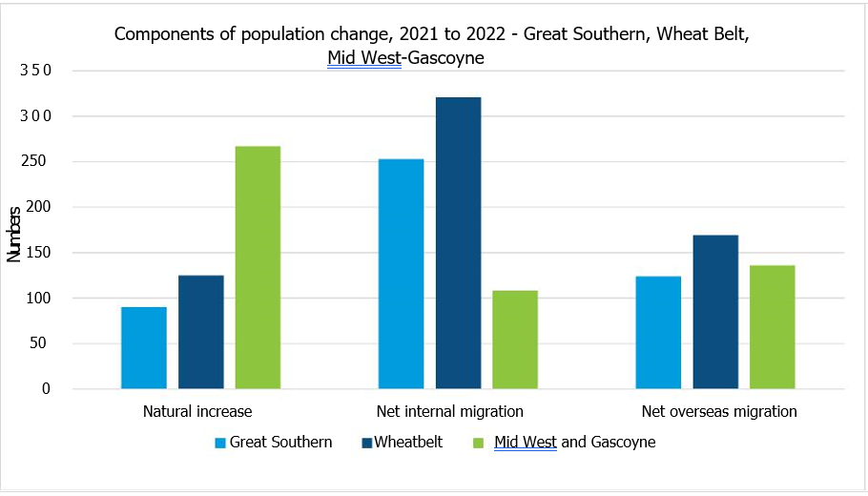

There was a significant variation in population change among different LGAs across the 3 RDA regions. During the period between 2018 and 2022, coastal or densely populated LGAs – including Denmark and Albany in Great Southern, Greater Geraldton in Mid West–Gascoyne, and Chittering in Wheatbelt – witnessed considerable population growth. Meanwhile, some inland and less populated areas like Cue in the Mid West–Gascoyne, as well as Wandering in Wheatbelt, also experienced notable growth rates. Although the actual growth numbers were small, these rate increases were significant due to the low population base in these regions. In contrast, inland LGAs saw the largest decline in population during the same period.

Table 3 LGAs with population growth in Great Southern, Mid West–Gascoyne, and Wheatbelt, 2018 to 2022

| RDA regions | LGA | Growth rate (%) | Population number change |
| --- | --- | --- | --- |
| Greater Southern | Denmark | 5.9 | 362 |
| Albany | 5.0 | 1,916 |
| Mid West–Gascoyne | Cue | 27.1 | 49 |
| Greater Geraldton | 3.7 | 1,484 |
| Wheatbelt | Wandering | 11.4 | 69 |
| Chittering | 10.3 | 589 |

Table 4 LGAs with population decline in Great Southern, Mid West–Gascoyne, and Wheatbelt, 2018 to 2022

| RDA regions | LGA | Growth rate (%) | Population number change |
| --- | --- | --- | --- |
| Greater Southern | Kent | 6.1 | −33 |
| Broomehill–Tambellup | 3.7 | −42 |
| Mid West–Gascoyne | Murchison | 22.9 | −32 |
| Upper Gascoyne | −20.1 | −47 |
| Wheatbelt | Westonia | −11.9 | −34 |
| Trayning | −9.5 | −32 |

#### Working-age population

The working-age population (15 to 64 years) across the 3 regions varies. Whilst the Wheatbelt RDA region had the largest working-age population in 2021, the Mid West–Gascoyne region has the largest population of working-age, at 63%. This indicates that the region has both the largest workforce to draw on, but at the same time needs to provide the largest number of jobs and training places to retain and use this capacity.

Figure 2 Working-age population, 2017 to 2021

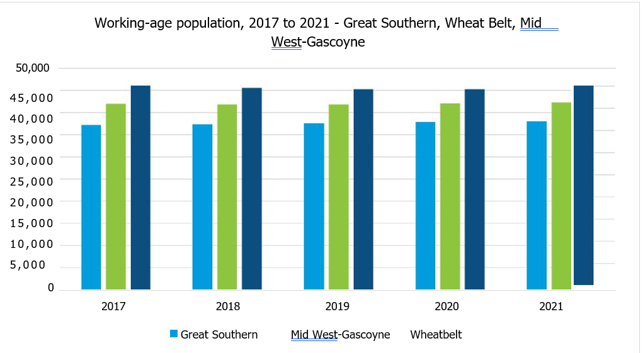

From 2017 to 2021, the Great Southern grew its working-age population by on average 0.5% per year, reaching a new record of 38,000 in 2021. In comparison, the Mid West–Gascoyne region only grew by an average of 0.2% and the Wheatbelt region declined on average by 0.5% per year.

Despite the overall growth of the working-age population, the picture varied widely across smaller LGAs within the 3 RDA regions. Similar to the total population change trends, larger areas such as Albany and the nearby LGA of Plantagenet, Greater Geraldton, and Chittering experienced the highest increases in the working-age population between 2017 and 2021. Some smaller LGAs also had significant growth rates, even if the absolute numbers were relatively modest. On the contrary, the working-age population was shrinking in inland LGAs during the same period. The declining working-age population in these areas may raise concerns about future workforce availability.

Table 5 Working-age population, 2017 to 2021

| RDA regions | LGA | Growth rate (%) | Population number change |
| --- | --- | --- | --- |
| Greater Southern | Albany | 3.4 | 774 |
| Plantagenet | 2.7 | 88 |
| Mid West–Gascoyne | Mount Magnet | 31.7 | 111 |
| Greater Geraldton | 1.4 | 357 |
| Wheatbelt | Wandering | 25.3 | 74 |
| Chittering | 6.6 | 243 |

Table 6 LGAs with working-age population decline in Great Southern, Mid West–Gascoyne, and Wheatbelt, 2017 to 2021

| RDA regions | LGA | Growth rate (%) | Population number change |
| --- | --- | --- | --- |
| Greater Southern | Kojonup | −3.7 | −42 |
| Gnowangerup | −5.0 | −41 |
| Mid West–Gascoyne | Murchison | −38.1 | −40 |
| Upper Gascoyne | −37.5 | −60 |
| Wheatbelt | Westonia | −41.4 | −84 |
| Corrigin | −18.0 | −122 |

### Agricultural workers are in demand

The number of internet job vacancies in the wider region of South West WA and Goldfields and Southern WA have rocketed in recent years. Nearly twice the number of employees are now needed across the 2 regions compared to the period prior to the COVID-19 pandemic. This is in line with broader trends across regional Australia, which are showing significant demand for workers. Analysis was also undertaken for 3 occupations related to sheep production: Farmers and Farm Managers, Skilled Animal and Horticultural workers, and Farm, Forestry and Garden Workers.

Both South West WA and Goldfields and Southern WA regions demonstrate a stronger preference for Farm, Forestry, and Garden Workers compared to the other 2 occupations. In these 2 IVI regions, the vacancy numbers for Farm, Forestry, and Garden Workers have been on the rise, averaging around 30 during the first half of 2023. Meanwhile, the monthly vacancy trends for the other 2 occupations have remained relatively stable at around 10.

Figure 3 Monthly internet job vacancies in South West WA and Goldfields and Southern WA (IVI regions), 2019 to 2023

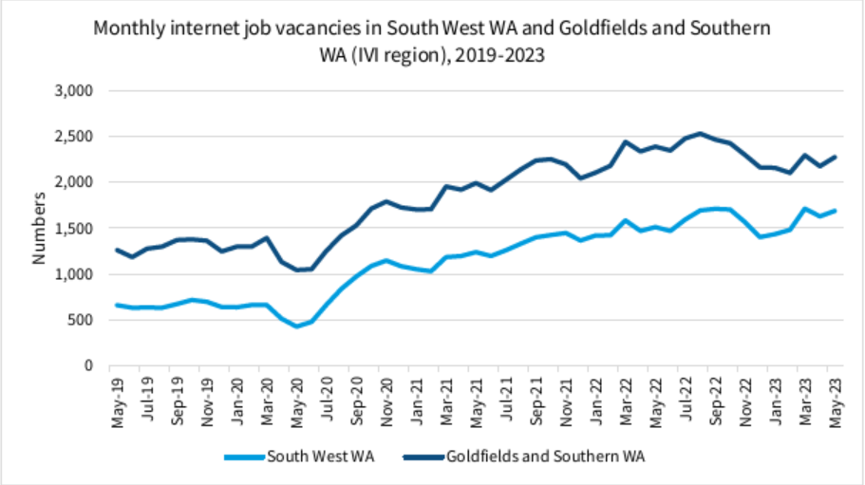

Figure 4 Monthly internet job vacancies for sheep industry in South West WA, 2019 to 2023

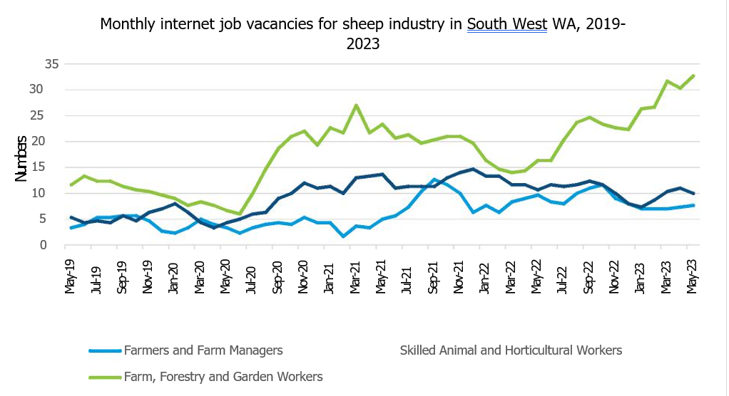

Figure 5 Monthly internet job vacancies for sheep industry in Goldfields and Southern WA, 2019 to 2023

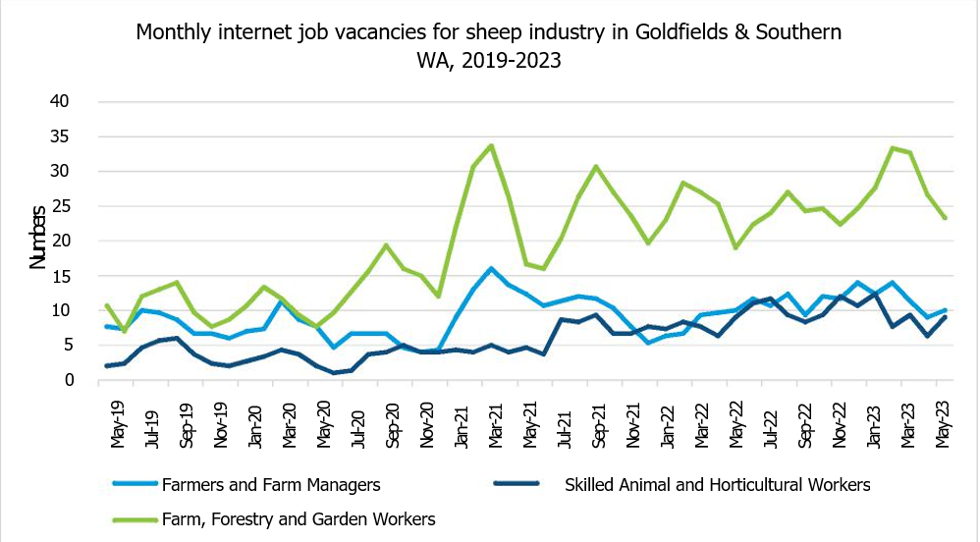

### Employment patterns are regional

As might be expected, the share of agricultural employment is highest in sparsely populated LGAs in SA4 regions across the Wheatbelt and Outback (North and South) regions.

In the Wheatbelt – the Agricultural, Forestry and Fishing industry is the largest and most dominant sector by employment. Employment in the industry in the Wheatbelt peaked at nearly 20,000 employees during 2020–21 but has since declined to 13,000 in 2022–23. Health Care and Social Assistance and Education and Training are the next largest employers in the region.

In comparison, in the Outback (North and South) region, the largest industry of employment is Mining, which has consistently employed 20,000 or more people over the last 5 years and saw a 3,000-employee boost in 2022–23. Public Administration and Safety has consistently been the second largest industry of employment, followed by Construction. In comparison, Agriculture, Forestry and Fisheries has remained between 3,000 and 5,000 people over this period.

According to Census 2021, sparsely populated LGAs across the 3 RDA regions such as Kent, Mingenew, and West Arthur stood out with the largest share of employment in the Agriculture, Forestry, and Fishing industry. This suggests that in these rural regions, agriculture remains a significant economic driver and a primary source of employment opportunities for local residents.

In contrast, densely populated LGAs such as Albany, Greater Geraldton, and Northam recorded the lowest employment shares in the agriculture sector. Despite having the high absolute numbers of employment, their proportions were much lower compared to the smaller, more rural LGAs. This situation may be influenced by a more diversified job market in these more populated areas.

Table 7 LGAs with highest employment proportion in Agriculture, Forestry, and Fishing industry, 2021

| RDA regions | LGA | Proportion (%) | Number |
| --- | --- | --- | --- |
| Greater Southern | Kent | 67.2 | 166 |
| Cranbrook | 56.1 | 286 |
| Mid West–Gascoyne | Mingenew | 50.8 | 94 |
| Murchison | 47.6 | 20 |
| Wheatbelt | West Arthur | 60.9 | 229 |
| Chittering | 56.7 | 89 |

Table 8 LGAs with lowest employment proportion in Agriculture, Forestry, and Fishing industry, 2021

| RDA regions | LGA | Proportion (%) | Number |
| --- | --- | --- | --- |
| Greater Southern | Albany | 7.0 | 1184 |
| Denmark | 9.7 | 243 |
| Mid West–Gascoyne | Exmouth | 2.7 | 43 |
| Greater Geraldton | 4.5 | 775 |
| Wheatbelt | Northam | 5.6 | 244 |
| Toodyay | 7.6 | 136 |

Figure 6 Employment by industry in Outback North and South (SA4 region), 2019 to 2023

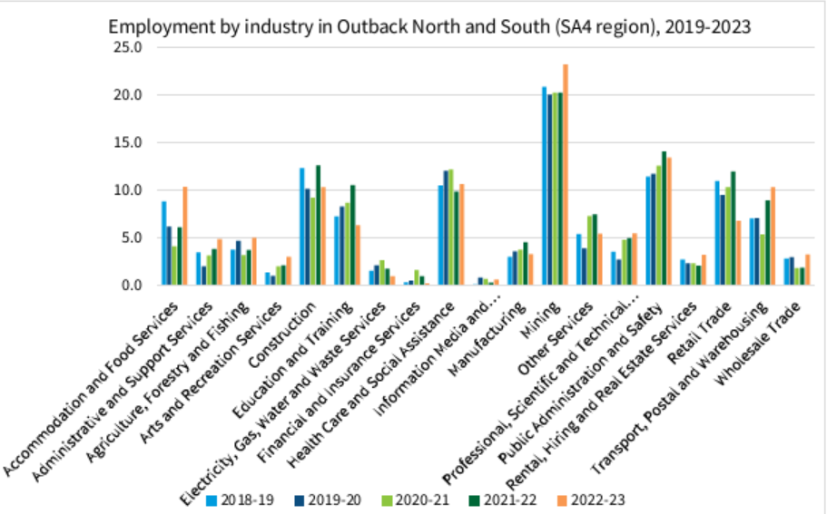

Figure 7 Employment by industry in Wheat Belt (SA4 region), 2019 to 2023

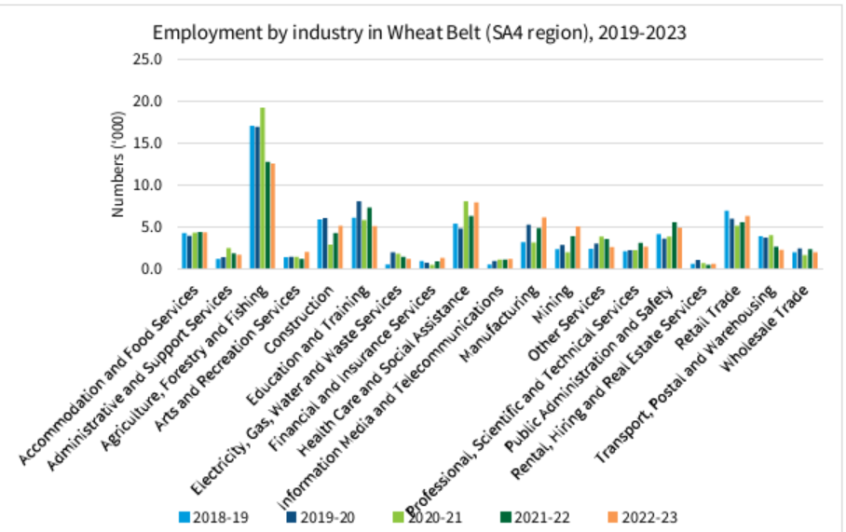

Analysis of sheep production-related occupations shows higher employment in Great Southern and Wheatbelt than in Mid West–Gascoyne. Employment for mixed crop and livestock producers was particularly high in Wheatbelt, with numbers reaching nearly 2,500 in both 2016 and 2021. Across these 3 RDA regions, there were no significant shifts in sheep farming-related employment patterns between 2016 and 2021.

Figure 8 Employment by sheep farming occupation in Great Southern, Mid West–Gascoyne, and Wheatbelt, 2016 and 2021

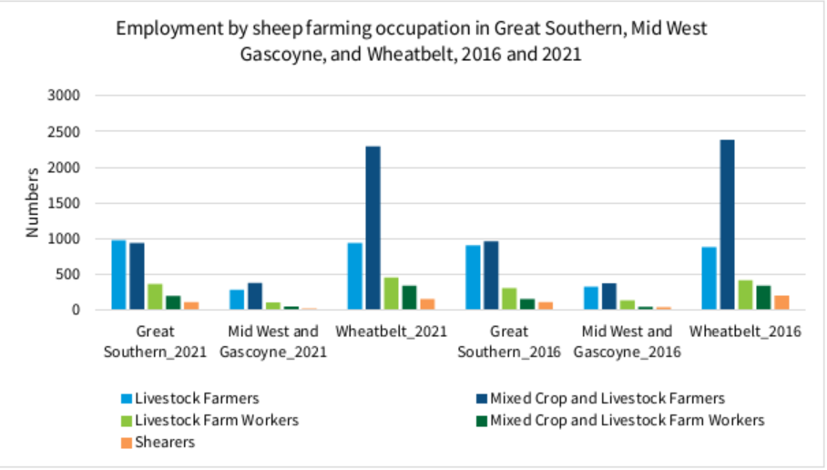

### Housing supply is tight

Housing data is provided and analysed by LGA. Eight LGAs were selected for their proximity to Western Australia’s abattoirs. Data for sales highlight significant growth in sales volumes in March 2020, alongside the beginning of the COVID-19 pandemic. Albany, Bunbury, and Gingin showed peaks in mid-2021 and later again in early 2022. Since mid-2022, however, these 3 LGAs have seen a decline in sales volumes, while other areas have shown stability and growth.

Figure 9 Sales volumes in selected LGAs, 2019 to 2023

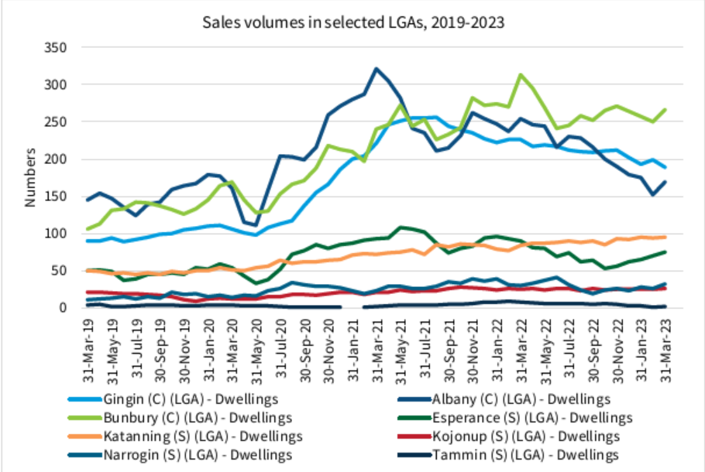

Whilst sales volumes have largely increased, rental listings have substantially contracted. In conjunction with the contraction in volume, median asking rents have also consistently increased. In particular, over the last 5 years, the volume of rental listings in Bunbury declined by 70%. Bunbury and Albany together have also witnessed the highest growth in median rental prices, with Bunbury experiencing a remarkable 56.7% increase in median asking rent over the past 5 years The smaller population shires have very low volumes of rental stock on market.

There has also been a consistent decline in the vacancy rate among the selected LGAs over the past 5 years, indicating a tightening of the rental market. This tightening of the rental market aligns with the national trend, particularly in larger regional areas such as Albany and Bunbury. Of the 7 LGAs, 5 have rental vacancy rates under 1.5%, meaning these are very hard markets for renters to find accommodation.

Figure 10 Median asking rents in selected LGAs, 2019 to 2023

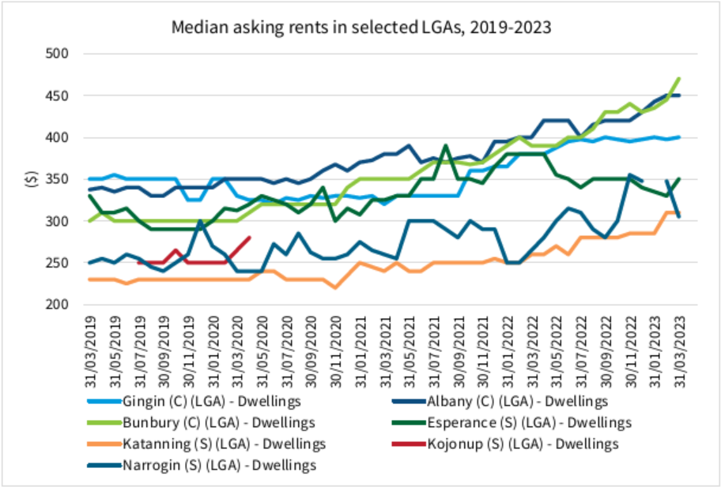

Figure 11 Volume of rental listings in selected LGAs, 2019 to 2023

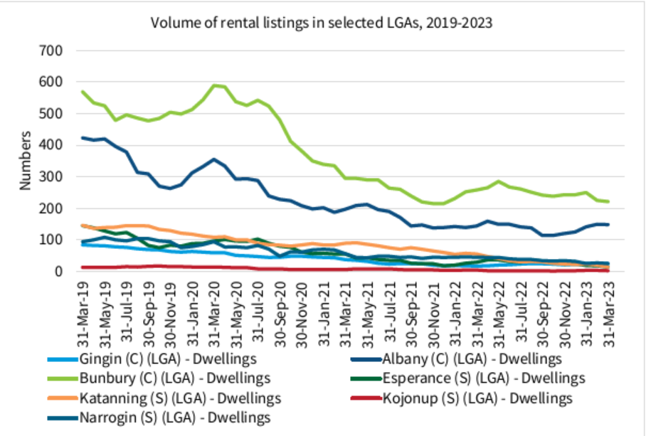

Figure 12 Rental vacancy rates in selected LGAs, 2019 to 2023

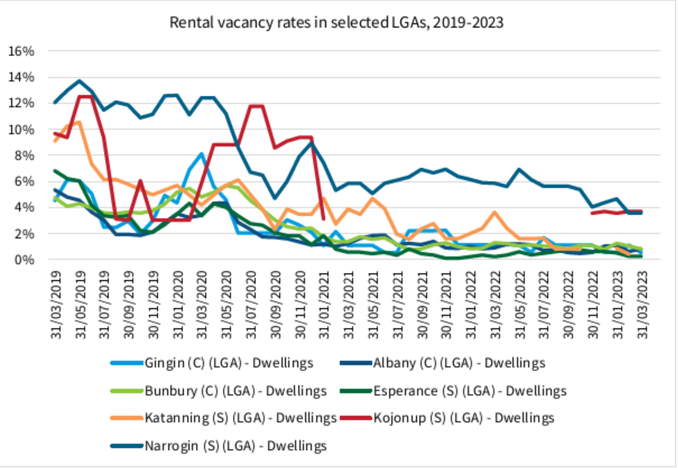

## Western Australian regional priorities

The State Government’s Regional Development Commissions (RDC) and the Australian Government’s Regional Development Australia (RDA) networks play a role in identifying enabling infrastructure and regional issues affecting economic and community development, growth, and resilience. The Phase Out will result in an economic shock given the role of agriculture; how the live sheep export market is used in WA farming enterprises; cross-sector interface with regional Small–Medium Enterprises (SME), and the economies of scale in the Mid West–Gascoyne Wheatbelt, Great Southern and WA regions beyond. The impact of the Phase Out will not occur in isolation to the broader challenges currently experienced in the Mid West–Gascoyne, Wheatbelt and Great Southern. These are summarised in Table 9.

Table 9 Priority regional development issues in the Mid West–Gascoyne, Wheatbelt and Great Southern

| Issue | Description |
| --- | --- |
| Housing | Lack of affordability and availability of housing (purchase and rent) |
| Need for greater variety of housing product to attract and cater for transient, contract and service workers typically employed in agriculture, tourism, construction, and mining sectors |
| Materials and workforce costs rising significantly in the construction sector |
| Projects suffering from cost escalations and delivery delays |
| Instances of market failure and negative equity due to high cost of land assembly and connection to services to be ‘development ready’ |
| Workforce | Lack of available and affordable housing (purchase and rent) |
| Lack of childcare resulting in underemployment |
| Reliance on international and backpacker workers in agriculture, processing, tourism, and hospitality sectors |
| Disconnect with training institutions |
| Digital and mobile connectivity | Unreliable or poor access to digital technology and mobile phone coverage in parts of the regions impacting business performance/development, liveability, and emergency services |
| Infrastructure not at capacity to support industry growth and adoption of ‘Industry 4.0’ technology **a** |
| Service gaps are often now in commercially marginal areas or areas of market failure for telecommunication companies and are not suited to current regional blackspot funding program criteria |

**a** Industry 4.0 describes the next phase in the digitisation of the manufacturing sector, driven by the rise of data and connectivity, analytics, human–machine interaction, and improvements in robotics.

It should be noted that the Mid West–Gascoyne, Wheatbelt and Great Southern have experienced recent global and regional-level shocks, which have exposed and heightened challenges already impacting regional development and liveability. These include:

* COVID-19 pandemic (2020–2022) – the associated border restrictions impacted access to skilled and unskilled workers usually sourced internationally and interstate in multiple sectors including agriculture, tourism, hospitality, construction, and health. The global trade disruptions resulted in project delays and cost escalations (workforce, materials, and equipment)
* Tropical Cyclone Seroja (2021) – caused extensive damage to public and private infrastructure in Kalbarri, Northampton, Chapman Valley, and surrounding farming regions in the Mid West–Gascoyne and upper Wheatbelt
* Wheatbelt Bushfires (2022) – impacted over 65,000 hectares of farmland, livestock and infrastructure across the Shires of Corrigin, Quairading, Bruce Rock, Cuballing, Narrogin and Wickepin.

Lessons can be learnt for the Transition Plan from the direct and indirect impact, and the community and government responses to these events. Acknowledging the financial and mental health challenges that individuals, families, businesses, and communities have already experienced in parts of these regions is vital and should be sensitively managed when considering impacts of the Phase Out decision.

### Impact of the phase out in the Mid West–Gascoyne, Wheatbelt and Great Southern

The 3 study regions have mature economies characterised by export-focused primary producers responding to continued growth in the global demand for food. The Agriculture, Forestry and Fishing sector features in the top 3 industries by output for 2022 in all 3 regions (Table 10).

Table 10 Top 3 industry sectors by output in 2022

| Region | Sectors | % of total economy |
| --- | --- | --- |
| Mid West–Gascoyne | Mining | 49 |
| Construction | 8 |
| Agriculture, Forestry and Fishing | 6 |
| Wheatbelt | Agriculture, Forestry and Fishing | 25 |
| Mining | 25 |
| Construction | 7 |
| Great Southern | Agriculture, Forestry and Fishing | 19 |
| Manufacturing | 14 |
| Construction | 13 |

More specifically, Sheep, Grains, Beef and Dairy Cattle contributed 20% ($3.1 billion) of total regional output for the Wheatbelt; 15% ($1.5 billion) for the Great Southern; and 4% ($0.7 billion) for the Mid West (Australian Bureau of Statistics, 2022a, 2023).

For the Wheatbelt and Great Southern regions, the agriculture sector is also the largest employer, making up 29% and 16% of the total regional workforce respectively (Australian Bureau of Statistics, 2022b). This differs in the Mid West–Gascoyne where mining and construction had larger employing roles than agriculture in 2022. The stability and maturity of the agriculture sector in these regional economies is evident in the historical data, whereas the mining and construction sectors tend to be subject to boom–bust cycles.

Livestock production (predominately sheep meat and wool) plays an important role in mixed-farming enterprises in the Mid West–Gascoyne, Wheatbelt and Great Southern. The live export market often underpins the specific characteristics of WA’s production systems. It provides a viable market option for wool and semi-finished livestock, and a viable market option for the shorter pasture seasons in the Mid West–Gascoyne, Wheatbelt and Great Southern. The scale and reliance of the live export market varies across individual farming enterprises. It also varies year-on-year as an important risk-management strategy and dry season response to seasonal conditions.

In the Mid West–Gascoyne, Wheatbelt and Great Southern, stakeholders expect the Phase Out to impact:

* livestock prices
* flock levels in the wool and crossbreed industries
* ability to maximise sustainability and overall value of farming enterprises (loss of income stream)
* dry season contingency response and pasture load management
* viability of SMEs and workforce numbers directly and indirectly servicing the live export market and the impacted livestock class (e.g., shearers, feedlots, saleyards, vets, transport, logistics etc.)
* industry confidence stability, community resilience, and individual mental health
* demand on existing meat processing facilities which currently face workforce shortages; floorspace constraints; cold storage limitations; and required infrastructure upgrades to meet regulations
* Southern WA cattle live export market which relies on multi-species to achieve economies of scale
* investment trajectory in emerging industries relying on the stability of the foundational economy
* international trade relations with market partners.

This is not intended to be an exhaustive impact list and is high level only.

### Economic development opportunities in the Mid West–Gascoyne, Wheatbelt, and Great Southern

Economic growth strategies identified by the RDC and RDA networks in the Mid West–Gascoyne, Wheatbelt and Great Southern focus on promoting diversification and value-adding opportunities within agriculture and encouraging investment in other comparative advantage industries. These strategies aim to achieve long-term economic growth and build regional resilience to economic shocks.

Opportunities for growth and investment within the primary industries sector in the 3 regions include horticulture, aquaculture (Great Southern and Mid West–Gascoyne), intensive animal farming, pastoral revitalisation (Mid West–Gascoyne), premium-end food and beverage, and downstream processing. This capitalises on WA’s established systems of food quality, biosecurity, and animal welfare regulation that is providing producers access to an extensive range of international markets.

Alongside agriculture, Table 11 summarises other industry opportunities and several project examples in the Mid West–Gascoyne, Wheatbelt and Great Southern. Mining operations have been expanding over the past 2 decades in these regions. Many of the other industries, however, are emerging in scale and projects can be subject to long lead times and significant private investment yet to be confirmed.

Table 11 Comparative advantage industry opportunities

| Industry | Mid West Gascoyne | Wheatbelt | Great Southern |
| --- | --- | --- | --- |
| International and tertiary education | n/a | n/a | Great Southern Universities Centre **a**  University of Western Australia Albany campus  Great Southern Marine Research Facility, which houses Marine Energy Research Australia |
| Manufacturing | n/a | n/a | Supporting mining developments; seafood processing and marine sector; agricultural equipment sector; and expanding food and beverage production |
| Mining | Diversity of extracted products  Capturing increased demand for local services | Exploration and development of green metals projects  Manufacturing, transport and logistic support businesses | n/a |
| Renewable and hydrogen energy / carbon farming and green energy | Proposed Mid-West Clean Hydrogen Hub at Oakajee Strategic Industrial Area  Proposed Project Haber urea manufacturing and Midwest Geothermal project by Strike Energy  Proposed Murchison Hydrogen Renewables project | Hydrogen and biofuel production  Proposed large scale wind and solar farms | n/a |
| SME sector | n/a | The region has almost 9.500 SMEs, more per capita than any other region in WA  Positioned to capitalise on opportunities associated with a pipeline of over $10 billion in private sector investment over the next 10 years | n/a |
| Space economy | Square kilometre array  Mingenew Space Precinct  Astronomy tourism | n/a | n/a |
| Tourism and lifestyle | n/a | n/a | Complementing premium food and beverage products, cultural assets, natural attractions, tourism events, and international trade missions  Capabilities in Aboriginal tourism, sports tourism and trails  Arts/heritage/cultural tourism, eco-tourism, and cruises |

**a** This is funded by the Australian Government’s Regional University Centre Program and opened in 2021. RDA Wheatbelt was successful in securing funding from this program in 2022 and is establishing the Lumen Wheatbelt Regional University Centre.

## Communities in transition

### Insights from previous research

Research shows that international responses to policy changes vary between industry and government. Many studies note the importance of interim programs to assist in the transition phase, such as the welfare-to-work program. The level of change and adaptation required for community transitions is reflective of the relative importance of the industry. In cases where major employers leave a small community, the shift into other industries is important in terms of maintaining population and employment opportunities. In examples like the United Kingdom (UK) coal mine closures, old mining towns experienced high out migration of youth alongside high hidden unemployment, through early retirement and disability claims. Notably in the UK examples, replacement jobs were frequently lower paid than the mining jobs, possibly reflective of the lower risk in the replacement industries compared to mining where higher incomes are paid for higher risk jobs.

Early interventions in the preparation for transition are important in building resilience in communities facing industry transition. The UK case of coal mines closing is a good example of this, where much support for the transition came, in some instances, a decade after the mines began to close. The slower interventions saw a decrease in regional productivity and an increase in out migration, particularly of younger people. While other cases, such as the Midwestern communities in the United States of America (USA), the building of social capital and local capital saw better responses to policy changes and natural disasters, as the community was in an improved position to respond to the loss of major employers.

Other case studies highlighted that building social capital and a diversified local economy were important foundations as they helped the community to be in an improved position to respond to the loss of major industries. A collaborative approach, with horizontal and vertical integration between local, state, and federal government, community leaders and industry, brings in new knowledge to communities whilst also listening to community needs and wants.

Often within communities there is an understanding of a need for change when there are exogenous policy shocks, but ideas on how to implement the process of change may or may not exist, depending on community capabilities. Bringing in external opportunities, in consultation with communities, can utilise the extensive knowledge gained through academic and industry research, whilst also stimulating entrepreneurship and other forms of engagement within the community in the process of change. By empowering communities to engage with the process of change there can be feelings of support and engagement in their own development rather than ‘things being done to them’. This will receive better outcomes for the broader community and more willing participation from change agents who can stimulate adaption on the ground.

### International examples

#### Canada

The coal ban in Ontario affected 4 power generating stations in Lambton, Naticoke, Thunder Bay, and Atikokan (Dampier, Shahi, Lemelin & Luckai, 2016). Of these regions, one was in a remote rural area, Atikokan. The 2 propositions for these power plants were to (1) close the power plant, or (2) replace coal with woody biomass in Atikokan, with the primary source coming from forests in Ontario. These forests were managed under the Crown Forest Sustainability Act. This decision was expected to have a direct and indirect economic impact on the broader community, including power plant jobs and jobs within the community from retail to community services. This transition to woody biomass as the sole power plant fuel was expected to increase household spending by 1.4%, while closing of the power plant reduced the overall household spending by 12.8%.

Similar evaluation conducted in the Alberta region, with the Cold Lakes First Nations (CLFN), found that the woody biomass was much harder to access and not competitive against the natural gas resources available in the region (Mansuy, Staley & Taheriazad, 2020). Whilst in the Atikokan example, the accessibility and supply were greater. The community located in Northern Alberta had a need to diversify their economy to bring stable incomes to the community and CLFN. The study demonstrated potential barriers in developing sustainable biomass supply chains for CLFN communities. However, the restoration of community-based management through CLFN community could improve sustainability.

The challenge facing the Atikokan economy was the significance of the powerplant in the local labour market and its resultant specialized workforce. Similar challenges in the Northern Alberta CLFN community existed, with the need to diversify the economy around the powerplant. In these instances, government and non-profit support are beneficial to help with the transition into a new industry. The new industries need to provide support for existing communities, which includes greater community engagement due to the industrial shift that is occurring. An evaluation of alternative industries looked at the income potential change because of the shift. This community engagement was effective in responding to exogenous shocks by building community resilience and other capitals to maintain the regional economy.

##### Lessons learnt for community transition

* Economic diversification is beneficial in transitions. Place-based planning involving a range of community stakeholders can assist in the diversification and transition to a new industry, reducing the negative impacts on the community.
* Identification of existing regional resources can assist in the creation of new opportunities for communities.
* Engagement with community leaders can assist in the process with perceptions of fairness, ownership, and community support. First Nations involvement can improve environmental and social sustainability in remote communities.

#### United States of America

Analysis of the transitions affecting regional communities in Midwestern US states done by Besser (2013) demonstrated the importance of social capital through links within and across diverse groups, for effective preparedness and community betterment. This information was collected from 1994 and 2004, looking at communities impacted by natural disasters, including hurricanes, tornados and floods, and economic shifts, including the loss of major employers. The impact of these changes on communities varied, based on the resilience of the community and their capacity to rebound after shocks. The longitudinal study demonstrated that the development of social capital and local capital improved the perceptions of quality of life. The social capital was believed to contribute to resilience through the contribution of businesses to community betterment.

The US farm labour market is tightening as the supply of Mexican farm workers decreases, which is the largest source of foreign-born farmworkers in the US (Boucher & Taylor, 2007). The driving forces for the labour tightening are changes within Mexico, including movement of Mexico to a service economy and increasing employment in the services industry, rising education levels of Mexican citizens and a decline in unauthorized immigration from Mexico to the US (Zanhniser, Taylor, Hertz & Charlton, 2018). The resulting impact of these changes has tightened the labour supply for US farms.

Policy changes can have broad impacts on regional and rural communities. Immigration policy in the US has had an impact on the employment of seasonal agricultural workers. A large portion of the seasonal workforce comes from migrants from rural Mexico, including illegal immigrants. However, in response to this, there was an increase in employment through the H-2A Temporary agricultural program, raising farm wages, further mechanisation and switching to less labour-intensive crops (Zanhniser, Taylor, Hertz & Charlton, 2018). The greater use of H-2A visas is expected to be effective in the short-term to address labour shortages but may not be viable in the long run (Charlton, Taylor, Vougioukas & Rutledge, 2019). While mechanisation appears more viable, it will have higher upfront costs for farms that can take longer to recuperate and the viability of these innovations need to be evaluated for smaller farms (Charlton, Taylor, Vougioukas & Rutledge, 2019). Responses to the shift in the agricultural workforce in the US demonstrate a need for further innovations in labour saving technology as workers become fewer and demanding higher wages and job security.

The education system in the US had grant support offered after policy changes were made to the welfare system. Wherein the Personal Responsibility and Work Opportunity Reconciliation Act of 1996 altered the way welfare was provided and moved towards a work-based system. To support this transition the welfare-to-work grant was provided to the US Department of Labor. This provided support for training in basic skills, structured job search, and training and education (Greenberg & Robins, 2010). In response to this policy change, community colleges began offering short-term courses (3–6 months long) to assist welfare recipients to return to employment. The response of community colleges was influenced by several internal factors, including:

* college leadership commitment to a comprehensive mission for the college
* the existence of programs and prior experiences servicing the disadvantaged
* faculty and staff attitudes towards non-degree programs
* ongoing relations and collaborations with local labour, businesses, industries, and social service agencies.

The outcomes of these programs were that participants improved their earning capacity, although often faced financial losses in the initial stages of the program engagement (Dyke, Heinrich, Mueser & Troske, 2006). The findings show that higher and more intensive training initially showed greater losses in the short-term, but greater income returns in the long run.

##### Lessons learnt for community transition

* Early intervention and assistance to communities in transition is vital in the early stages. This provides support and certainty to the affected community groups.
* The resilience of communities will impact how transition is received. Resilience is made up of social capital, including bonding and bridging capital, human capital, and local capitalism (or economic diversification).
* Policy and industry action is important to assist in exogenous shocks, such as loss of labour force, but needs to take a long-term view of development. Short-term adjustments may show losses whilst groups are building new skills.

#### United Kingdom

The UK coal mine closures from the 1980s through to the early 2000s saw a shift in many regional areas with varying levels of community transition and demonstrating long-term impacts. In cases where the community was well connected to other services, such as transportation through the road and rail network, there was a faster recovery and less disruption to the local employment market (Fieldhouse & Hollywood, 1999). However, in areas with less connectivity, such as regional Wales, where there is less access to the road network, the attraction of new industries was slower, and recovery was also slower (Beatty, Fothergill, & Gore, 2019). The provision of retraining services in regions was a step towards reducing the impact of mine closures, however, the groups that took this opportunity up were generally younger miners and those who were working underground (Murray, Baldwin, Ridgway, & Winder, 2005). Workers with other training, such as electricians and mechanics, saw fewer challenges in securing new employment or pursuing their own entrepreneurial activities.

Yorkshire saw a net increase in non-coal jobs of 55,000 from 1981 to 2004, after the coal mine closure in one of the largest coal mining regions in the UK (Fieldhouse & Hollywood, 1999). This was done with collaboration between industry and local government. Within the UK example communities with pre-existing socio-economic issues, such as Durham, did not have a quick recovery and in some cases are still experiencing socio-economic problems. Whilst those that were in better connected areas were able to attract new industries, such as a Nissan factory in the Northeast of England.

##### Lessons learnt for community transition

* Jobs can form the identity of a person and be an emotional trigger when these are being viewed as taken away, making the transition to new industries difficult, particularly if the previous industry is engrained in the workforce view of personal identity.
* Regions already experiencing economic decline will need greater assistance in recovery from the loss of a major industry. Place-based approaches will be key in the development of policies and programs that can assist communities.
* Active attraction of new industries by community stakeholders, such as chambers of commerce and local government, is beneficial in the process of economic diversification and securing alternative employment for the community.
* Engagement with stakeholders, such as trade unions, could have reduced the stress of industry shifts and having timely plans prepared for the transition could have reduced long-term negative impacts on communities.

### Australian examples of communities in transition

Jobs Queensland produced the *Supporting workforces during the industry transition: Key elements of success* report in 2018, which highlighted the key policy considerations for managing industry transitions and structural adjustment programs to best support affected workers. The report highlighted that whilst there is no one size-fits-all approach, the following 8 elements are important to tailored responses:

* Time – this speaks to the long-term impacts of industry transitions, the need to start working on responses early, and to give them enough time to work including in the period after the transition.
* Anticipatory planning – in line with the first element, this report highlighted that, largely, industry transitions can be anticipated, and as such initiatives can and should be implemented early to reduce negative impacts.
* Governance and information dissemination – those who are going to be impacted need to be identified and given ownership of the transition plan and the broader community must be kept informed.
* Focus on the affected region – the transition plan should be focused specifically on the region affected.
* Human capital – the transition for workers from one occupation and industry to another is significant and should be addressed through education and training initiatives.
* Economic diversification – regions should build on their existing capabilities and capacities to diversify their economies.
* Local coordination and case management – a local coordinator or administrator should be appointed to provide oversight and effective administration.
* Evaluation – an evaluation framework should be developed and implemented.

Changes to forestry policy in Western Australia during 1999 to 2004 resulted in social and economic impacts on the forestry industry. These impacts were recorded as both positive and negative by different business owners and managers at varying stages within the manufacturing and supply chain. Three types of social impact were seen: (1) uncertainty and predictability, (2) perceptions of injustice, and (3) financial stress and opportunities (Loxton, Schirmer & Kanowski, 2013a). This included impacts on a range of businesses within the forestry industry and employees within those businesses. For example, employees experienced uncertainty particularly in terms of job security, influenced by their level of knowledge and awareness of how the policy changes were impacting their employer. The research found that these were not mutually exclusive impacts, but could intensify each other, for example, those viewing the policy as unjust increased the negative impacts of financial stress due to that perception (Loxton, Schirmer & Kanowski, 2013b, p.59).

Perceptions of fairness and equity in the implementation process of the Regional Forest Agreements (RFAs) policy was varied across different groups. There was a general perception that the decision was already made before consultations, although some also felt the consultations did not fully take into consideration the feedback received from key stakeholders. This resulted in emotional responses to the policy and feelings of insecurity moving forward with the decisions.

Large scale responses for those within the forestry industry varied, but common responses included (Loxton, Schirmer & Kanowski, 2013b, p.60):

* exiting the public native forest timber industry, with or without assistance from the business and retiring or seeking new employment or business opportunities
* increasing investment in valued-adding or adjusting to new harvesting regulation
* participating in retraining, or seeking new employment within a forestry sector business, or applying for funds to assist in worker relocation.

The experience of the forestry industry highlighted the need for community consultation to bring the community to an understanding of why decisions were being made. Key elements of the perceptions of the policy were the level of community engagement and the view of the policy change by business owners and managers, with some stakeholders viewing it as a purely political decision. Some businesses saw opportunities to extend their business or adapt with new value-added services or products, while others felt levels of uncertainty about the future. The assistance made available to stakeholders was not always well understood, with evidence suggesting there was not always great awareness of the available supports, while others noted that the eligibility criteria for support could be restrictive (Loxton, Schirmer & Kanowski, 2013a).

The closure of the Ford, Holden, and Toyota (the Original Equipment Manufacturers or OEMs) manufacturing plants in 2016 and 2017 was a significant structural adjustment to the manufacturing sector, requiring coordinated response by governments, the OEMs, and the supply chain to manage the transition and support workers into other jobs. The transition saw supply chain companies adjust and diversify their operations, reducing the overall job loss, although there was downsizing attributed to the extensive lead times. While the OEMs retained some staff and transferred them into functions within the company, after 12 months of closure, 9% of OEM workers retired and 2% were studying. Longer lead times in closures allowed for workers to prepare to and focus on career planning and taking advantage of new job opportunities and allowed them time to psychologically adjust to the changes.

The successful skills transfer needs to consider evidence-based practices; some of these include:

* Training is one component of a package to reduce impacts of industry restructuring.
* Training is more likely to be effective when providers and support agencies have coordinated efforts and collaborative activities to assist displaced workers in career development and job searching.
* Employees from small-to-medium sized enterprises (SMEs) will often experience more challenges in access to training resources than those of larger companies.

To engage and increase awareness of available supports to OEM and supply chain workers during the closing of the Ford, Holden and Toyota manufacturing plants multiple communication channels were used. This included formal channels, such as newsletters, radio, online and face-to-face meetings, and informal channels including networks within the organisations such as union shop stewards and government service agencies engaging with staff. Engaging with workers and their families also assisted in the transition process and family decision-making. The family engagement was particularly helpful for families with English as a second language, where children were effective in reinforcing information to workers.

Considering a Means, Motive, Opportunity (MMO) framework, can be useful as an evaluation tool for how communities respond to adaption. In the case of exogenous policy shocks the motivation to change is extrinsic to the business and the individual, there may or may not be an intrinsic motivator to change. Due to the external nature of exogenous shocks, the need to change may be accepted by businesses and communities or could result in no adaptation and damage regional communities through job loss and population decline. Providing the opportunity for businesses to change can be important in feeding extrinsic motivation, but feelings of engagement in that process can help build intrinsic motivation to perpetuate the change.

In the case of banning live sheep exports, there needs to be additional support to provide means for change. There is likely to be excess meat or wool sheep, particularly wethers, that need to be processed, affecting the means to change. Support in this adaptation, with industry consultation as to what is needed, could potentially improve engagement with the process from a business perspective.

Regarding potential community changes, such as job losses from the banning of live sheep exports, those within the community will also need MMO to change. Part of this will come from the types of adaptation and transition undertaken as a business and government level, such as job fairs to promote existing vacancies and retraining opportunities.

Victoria has supported the creation of Regional Partnerships to build vertical links between local and central government to raise issues, identify priorities and ensure decision making is reflective of local concerns, while still leaving Cabinet with final decisions on funding. (Pearson & Houghton, 2018, p.8)

The Victorian example involved several stakeholders from government and a Cabinet committee, Regional Development Victoria network of staff with a strong understanding of local stakeholders and interests, and development of regional partnerships. These groups bring together the views of the broader community to create opportunities that understand the distinct attributes of regions and work with them in their own development, whilst Cabinet still has decision making power on funding. This case study demonstrates the value of collaborative regional development. Collaborative policy requires the capacity for success to lie in the team of multiple actors, a collaborative ‘brains trust’. This requires horizontal and vertical linkages within and beyond communities.

##### Lessons learnt for community transition

* Early notification and communication of industry changes allows time for employees and their families for financial and career planning. It also allows for psychological preparation. Government assistance in job searching and career planning was beneficial early in this process to ease the transition.
* Training is an important component to transition, but not the only consideration. It needs to be part of an overall transition plan that considers the needs and existing capabilities of the workforce and the potential for future employment in the region.
* Collaboration and communication between government and community when implementing policy changes can reduce ill-will between stakeholders. Providing support during the transition that is in line with what industry needs can only be achieved by this clear communication and collaboration.
* Assisting in business adaption during the transition and for a time after the transition can ease the pressure on SMEs. These businesses are typically harder to reach and more subject to economic and policy challenges.

## Transition plan considerations

Place-based strategies are important components of preparing for regional transitions, with engagement from the community. Community leadership that plays a central role in the industry transformation can help take advantage of existing assets, whether that is social, human, or natural capital. Using bottom-up approaches to transition can create a robust plan for community development, through things such as communication and understanding of protocols and procedures, improved awareness of community needs, access to broader range of financial and in-kind supports, and transfer skills and broaden access to human resources (Halseth & Ryser, 2015).

The exogenous policy shock created by the Phase Out is likely to have varying levels of impact on regional communities (Wilson, 2013). Resilience in communities is an important response to shocks, either economic, natural or policy induced (Flint & Lulloff, 2005). The system’s capacity to adapt to shocks is impacted by several factors relating to resilience, including social capital and local capitalism (Flint & Lulloff, 2005). Natural resource-based communities, such as those in agriculture and mining, are situated in a dynamic interface between social and environmental processes.

The ‘satisficing’ model can assist in understanding the adaptations that need to take place in communities when exogenous shocks take place (Fuentes & Pipkin, 2022). This model looks at the interrelationship between shocks, goals and slack, and the impact on decision makers. This model can be used to understand the level of adaptation that needs to take place within the community to adapt to transitions, whether this is new industries or changes within existing industries.

Figure 13 Satisficing model

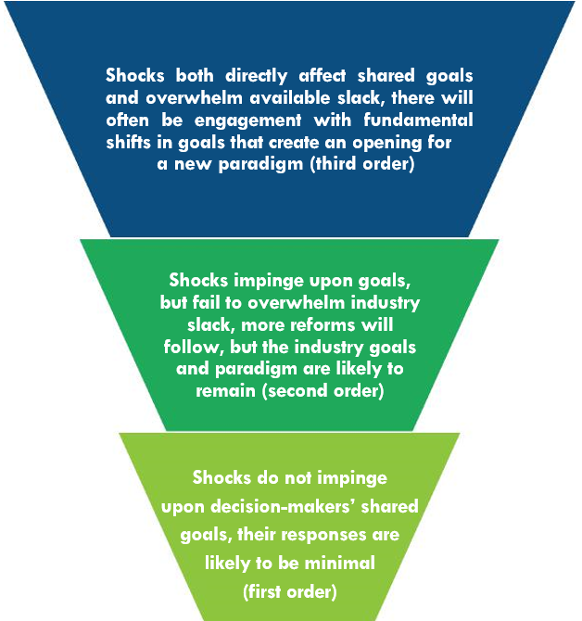

In the application of this model to live sheep exporting, the level of adaption needs to look at decisions made by businesses, including those on and off farm, and changes these can have on communities that operate within the supply chain.

This model was reflective in the types of changes that occurred internationally between countries during the 1973 oil price shocks (Fuentes & Pipkin, 2022). The different policy responses between countries drew attention to the satisficing model. For example, Mexico during this crisis did not instigate any major reforms to the petroleum industry, on the flip side, Brazil prompted a policy shift during this time to transform the petroleum and automotive industry.

In understanding the impact on regional communities, consideration of the relative importance of live sheep exports to the region will be important. This will include the supply chain challenges that live sheep export face. As live sheep are not a single enterprise system and the market is made up of large and small contributors, the relative impact on each enterprise will vary (Dalgleish, Agar & Herrmann, 2020).

The expected responses from sheep operations will vary depending on the level of involvement each has with live sheep export and the extent of their involvement in the industry. There are similar examples of barley exports to China being stopped due to anti-dumping tariffs. In this instance Australian barley growers experienced losses in export revenue and continued price drops due to limited market availability initially, however, sales to other countries soon replaced the loss of the Chinese market (Wickes, Adams & Brown, 2021). In addition to sales to alternative markets, many growers shifted their production to alternative crops, although the shift was to lower-value new markets creating a higher opportunity cost (Cao & Greenville, 2021). There is anecdotal evidence that some sheep operations are already shifting away from sheep and converting land to cropping or additional cattle (Dalgleish, Agar & Herrmann, 2020). This shift could be seen as a second or third order shift based on the impact of the trade restrictions to individual producers and how the shock impacts the company goals and industry slack.

### Place-based development and smart specialisation

The Productivity Commission investigated mechanisms for supporting transitioning regions in an Inquiry in 2017. The final report revealed in its findings and recommendations the benefit of place-based approaches to regional development. The Commission identified principles that should guide the application of specific adjustment assistance (Productivity Commission, 2017) when the policy and market adjustments are unanticipated and impose a clear and sizeable burden on a disadvantaged group. These adjustments should be moderated and not used as shield for regional communities from any possible adverse event or ongoing pressure, and the Commission highlighted that targeted and specialised approaches to regions are usually necessary. Certain regions will face continued declines in employment and economic activity that cannot be reversed, and appropriate decisions need to be made within those regions, including assistance with training, and relocating.

Place-based policies need to focus on the unique characteristics of the region and the overall impact policy changes will have on those areas. This will include evaluating the percentage of the workforce employed within the industry experiencing change, dependency of the community on that industry and opportunities for new employment or retraining for the displaced workers. Cross boundary approach to rural development, by utilising bottom-up community knowledge and top-down development knowledge in a collaborative approach led by the communities’ needs and wants, could be used as a method for rural development during an economic shift (Eversole, 2022). Utilising regional, state, and national policies to encourage innovation and growth can be achieved by interregional cooperation and across all levels of governance to work towards key priorities (European Commission, 2017). Smart specialisation is discussed further later in this section and is a framework that can be employed to maximise synergies of investment between the private and public sector, creating a pipeline of projects designed to match those key priorities (European Commission, 2017).

The RAI found in 2018 the value of collaboratively driven place-based development in meeting community needs (Pearson & Houghton, 2018). Common drivers for regional development; infrastructure, innovation, vision, collaboration, and capital, should be understood in identifying the desired outcomes from regional investment.

Success in regional development policy comes from understanding what the local impediments for growth are and tailoring an approach to address those impediments. Building community capabilities through 'enabling' support, such as by offering affordable credit in vulnerable communities can give rise to both financial and social inclusion (Wilson, 2012). Communities will often be familiar with their needs and opportunities that exist, and collaboration and communication with community stakeholders can help identify opportunities that exist that can be leveraged through government support (Eversole, 2022). For effective community collaboration 3 key principles have been identified (Pearson & Houghton, 2018, p.17):

1. Agree to outcomes.
2. Understand regional capabilities.
3. Address the ‘rules of engagement’.

Community capabilities can be expanded upon through diversification from other external actors (Neffke, Hartog, Boschma & Henning, 2018). Other exogenous sources can stimulate this change and bring in new actors and activating existing actors within regions (Trippl, Grillitsch & Isaksen, 2018). For this reason, exogenous sources of innovation and change can play important roles in regional development, whilst building regional capabilities through knowledge creation and skills training (Eversole, 2022; Trippl et al, 2018).

Engagement with regional communities in this process assists in identifying the regional capabilities, whilst making local leaders and community members feel part of the change can help establish ‘collective agency’ (Rainnie, Beer & Rafferty, 2018). Industry changes can be stressful due to the nature of the relationship between business, family, and community, and in particularly SMEs can feel this pressure and may find it more challenging to adapt. When local people are feeling engaged in their adaptation, rather than having ‘things done to them’, there is often better uptake and acceptance of new ideas (Eversole, 2022). Place-based leadership has been demonstrated through international transition packages as an essential element to success and building collective agency. Transition packages in Australia are often lacking measures of effectiveness, such as population retention and unemployment rate (Rainnie, Beer & Rafferty, 2018).

Like the findings by the Productivity Commission (2017), RAI work from Rainnie, Beer & Rafferty (2018) agreed that transfer of welfare is not the solution to long-term regional development. Instead, engaging in relocation opportunities for regions is often an effective strategy, such as supporting infrastructure projects to build on existing industries, or building new infrastructure to improve access and connectivity to regions.

An example of this is smart specialisation – a place-based approach to regional development. This process involves the identification of strategic areas of intervention based on the strengths and potential of the economy (European Commission, 2023).

Smart specialisation has 5 key principles that strategy should be designed around:

1. Smart specialisation is a place-based approach, building on the existing assets and resources specific to socio-economic challenges to identify unique opportunities for development and growth.
2. Making choices for investment from a limited number of well-identified priorities for knowledge-based investments and/or clusters.
3. Setting priorities should be an inclusive process of stakeholder involvement centred on ‘entrepreneurial discovery’.
4. Strategy should embrace a broad view of innovation, supporting technological, practice-based, and social innovations.
5. Implementation of a sound monitoring and evaluation system, and revision mechanism for updating strategic choices.

## Potential phase out pathways

Previous research and stakeholder feedback has highlighted:

* The support response needs to address the micro and macro impacts of the Phase Out to ensure a profitable sheep industry with integrated strong regional development outcomes.
* There is a suite of mechanisms available to government to provide a multifaceted Transition Plan.
* Embedding on-ground industry and regional intelligence in the design and delivery of the Transition Plan will build upon existing efforts in economic diversification and value-add opportunities for growth and resilience.

This section provides contextual considerations for potential Transition Plan approaches:

* Regional intelligence delivery models
* Mobilising mental health services
* Investment in enabling infrastructure
* Housing availability for workers
* Coordination group and investment fund to increase meat processing capacity
* Financial support for impacted businesses
* Reinforcing market development
* Workforce attraction for industry to respond.

### Regional intelligence delivery models

To ensure that the Transition Plan achieves fit-for-purpose and efficient outcomes to support those impacted by the Phase Out, the design and implementation stages need to involve on-ground industry and regional specialists.

The previous sections have gone some way to provide examples of agencies with industry and regional intelligence. Experiences can be drawn from cross-government responses to other transitioning economies and emergency events where delivery units were funded in-region, providing:

* regional knowledge and understanding
* established stakeholder networks
* project development, grant management, coordination, and governance capabilities
* direct avenues for community engagement and communication delivery
* liaison between community, business, and governments of all levels
* awareness of existing aligned activities and projects.

Recent examples include:

* Collie Delivery Unit focusing on transiting Collie’s economy from its dependence on coal (led by South-West Development Commission and Department of Premier and Cabinet) (Department of Premier and Cabinet WA, 2022)
* Tropical Cyclone Seroja State Recovery Coordination Group, led by the Department of Fire and Emergency Services (Emergency WA, n.d.)
* Flood Hubs in Derby and Fitzroy Crossing as part of the Kimberley Floods Recovery Package, led by the Department of Fire and Emergency Services (Emergency WA, n.d.)
* Wheatbelt Fires District Recovery Coordination Group (led by WDC and Department of Fire and Emergency Services).

The Transition Plan needs to be conscious of avoiding a ‘sugar hit’ of investment. Timing of program delivery and expenditure of funds needs to be driven by regional reality, not political pressure. Awareness of the timeframes associated with restructuring business and the broader industry on the micro level, and addressing the accompanying regional development issues (e.g., worker attraction and housing availability) on a macro level will take leadership, but will be critical for success.

### Mobilising mental health services

Mental health services in the Mid West–Gascoyne, Wheatbelt and Great Southern are delivered through WA Primary Health Alliance, Mental Health Commission, and WA Country Health Service (acute). Services are under resourced and require improved service delivery models that are more appropriate for these regional populations which are geographically dispersed.

That said, mental health services can be expanded and targeted in response to emergencies or other government priorities. State and District Recovery Coordination Groups were established after Tropical Cyclone Seroja and the Wheatbelt Bushfires as part of the Federal–State Disaster Recovery Funding Arrangements. As well as focusing on infrastructure and business impacts, these groups were tasked with ensuring targeted support was delivered in mental health support, community resilience, and future preparedness. Whilst acknowledging that the Phase Out is not an emergency incident, the Transition Plan can take lessons learnt from the cross-government, on-ground resourcing, and regional input model that has been recently mobilised in these regions.

### Investment in enabling infrastructure

There will be required improvements to digital and mobile connectivity; water and power solutions; and logistics networks in areas impacted by the Phase Out (particularly if meat processors are to expand). The Transition Plan can call upon established government programs in the areas of:

* mobile blackspot and regional connectivity
* Industry 4.0, advanced manufacturing, supply chain/cold chain, and innovation and automation
* carbon farming, net zero, drought resilience and water security. The MWDC, WDC, GSDC, and DPIRD are finalising Drought Vulnerability Assessments and Drought Resilience Plans funded through the Australian Government’s Future Drought Fund)
* energy efficiency and renewable energy. There are a growing number of renewable and non-renewable microgrid projects underway in the Mid West, Wheatbelt and Great Southern to address localised energy constraints. This is occurring on an industry scale and community scale.

Current programs often exclude projects, businesses, and not-for-profits in the Mid West–Gascoyne, Wheatbelt and Great Southern based on project size, co-contribution levels, and minimum annual turnover criteria. It is important to note that smaller scale projects can still achieve significant impacts. The criteria of these existing programs can be adapted to suit the scale of the communities and businesses impacted by the Phase Out.

Taking a regional level, rather than a project level, approach to the infrastructure solutions required for improvements in digital connectivity, innovation adoption, and water/energy/logistics systems could achieve positive regional development outcomes, minimise impacts of the Phase Out, and meet Australian Government policy objectives.

### Housing availability for workers

Attracting workers for new economic opportunities including meat processing requires available and affordable housing options (for purchase and rent). The Transition Plan cannot decouple these 2 issues without worsening the housing situation in areas impacted by the Phase Out.

The RDC and RDA networks in the Mid West–Gascoyne, Wheatbelt and Great Southern have been working with stakeholders to identify projects and infrastructure investments to contribute to normalising the housing market. It is anticipated that the Australian Government will receive funding applications for several key worker accommodation projects from these regions as part of the recently announced Growing Regions Program.

The Transition Plan should consider establishing a strong partnership with existing abattoirs and the RDC and RDA networks as part of a Housing Development Program. Such a program will ensure there is cross-government funding support in projects that contribute to addressing housing issues faced by the agriculture and processing industry and their communities.

There are examples of successful region-led, government supported responses to housing challenges, such as the ‘Lakes and 4WD Well Aged Housing Project’. This saw 45 independent living units constructed across 7 local governments in the Wheatbelt and Great Southern. It uniquely addressed the difficulty of achieving commercial development economies of scale by taking a regional approach instead of tackling the issue at a local-only level (e.g. cost efficiencies achieved by grouping procurement). This is critical in the Mid West–Gascoyne, Wheatbelt and Great Southern with a settlement structure vastly different to that of the eastern states.

### Coordination group and investment fund to increase meat processing capacity

The ability to process livestock in WA feedlots and abattoirs is critical to maintain, or even grow, stock numbers (particularly in wool class breeds) in the Mid West–Gascoyne, Wheatbelt and Great Southern regions. Establishing a Coordination Group to identify and provide funding support to address capacity constraints in existing sites could have the ability to direct efforts bespoke to each facility. DPIRD has established links in the industry and is a likely partner to host this function.

Examples of required support to increase meat processing capacity could include (not limited to):

* investment in equipment, infrastructure, and innovation
* support in meeting planning and environmental regulations
* assistance in attracting skilled and unskilled workforce
* investment in supply chain, logistics and ancillary businesses.

Expansion in the meat processing industry in these regions has the potential to have broader economic multipliers particularly associated with increased workforce and ancillary support operations. It is important to note, however, that this effort will intersect with broader regional development challenges already facing the Mid West–Gascoyne, Wheatbelt and Great Southern. This includes workforce attraction, housing availability, and improving enabling infrastructure. The Transition Plan should aim to meaningfully contribute to addressing these issues or, at the very least, prevent the Phase Out from exacerbating them.

### Financial support for impacted businesses

It is important to consider that livestock prices have already been impacted by the announcement and business decisions will be made well prior to the determined Phase Out date. A combination of government supported loans, subsidies, grant programs and/or compensation can generate industry-led responses to the Phase Out. The criteria need to be flexible given the vast difference in how reliant enterprises are of the live sheep market (e.g. ranging from 100% income dependent to a seasonal risk management response). The process also needs to be user-friendly to avoid low uptake and reporting burden.

Examples of required adjustments to on- and off-farm operations could include (not limited to):

* increase supplementary feed required to finish livestock to meet target specifications for processing
* equipment, infrastructure, and logistics to change livestock class
* equipment, infrastructure, and logistics to run older livestock
* training and reskilling to participate in a different industry function.

It has been reported that personal and business loans offered by financial institutions do not favour investment in these regions. This does not assist in addressing regional housing shortages or fostering private sector investment, start-up businesses, or adoption of innovation. Government supported loans, interest rate subsidies, and grants can contribute to supporting the Phase Out in this regional development context. These mechanisms would directly target the loss of income and/or costs associated with needing to modify farming enterprises and businesses currently supporting the live sheep export market.

Examples of Government supported loans, subsidies, grant programs, and compensation include:

* Collie Transition Package (including the Collie Futures Industry Development Fund and the Collie Futures Small Grants Program)
* Native Forestry Transition Plan (range of grants, funding programs, and compensation package)
* Kimberley Floods Recovery Package (range of grants and measures including business interest rate subsidies)
* COVID-19 Economic Response – SME Recovery Loan Scheme
* Northern Australia Development Program.

### Reinforcing market development

The sheep industry, including Meat and Livestock Australia (MLA), is already directing efforts to secure new markets and diversify product offerings to meet consumer demand in domestic and international markets. The Transition Plan can reinforce resources in market development activity for livestock classes impacted by the Phase Out (e.g. packaged mutton).

This needs to consider:

* managing international trade relations and flow-on affects for other Australian exports
* bridging the gap in the economies of scale for domestic and international freight
* encouraging consumer demand for diverse sheep meat products (e.g., marketing campaigns)
* ensuring investment in the market and production ends support each other in a systems approach
* protecting the integrity of Australia’s lamb market.

The importance of adjusting and securing markets to mitigate impacts of losing the live sheep export trade option cannot be overstated. It will play a major role in determining future livestock levels and productivity of WA’s sheep industry.

### Workforce attraction for industry to respond

Meat industry workers are in high demand and recruitment efforts nationally and locally have little success. The Mid West–Gascoyne, Wheatbelt and Great Southern regions have historically low unemployment rates (see Table 12).

Table 12 Unemployment rate, looking for full-time and part-time work, 2011 to 2021

| RDA region | 2021 (%) | 2016 (%) | 2011 (%) |
| --- | --- | --- | --- |
| Mid West–Gascoyne | 2.8 | 4.8 | 3.2 |
| Wheatbelt | 2.4 | 3.2 | 2.7 |
| Great Southern | 2.2 | 2.8 | 2.9 |

Growing the domestic workforce in the Mid West–Gascoyne, Wheatbelt and Great Southern will require targeted attraction and retention efforts, converting underemployed population segments, and generating a stronger connection with training institutions. Addressing childcare shortages is part of this systems approach. Sustainability of childcare services in parts of the Mid West, Wheatbelt and Great Southern has been challenging in a changing and complex environment. This includes lack of economies of scale; difficulty attracting childcare workers; lack of affordable housing for that workforce; changing visa conditions (e.g., increase of the Temporary Skilled Migration Income Threshold) for international workers; and increasing industry regulation. The unique governance model established under Regional Early Education and Development Inc. in the Wheatbelt is a regional-led response to these challenges.

The meat processing industry in the Mid West–Gascoyne, Wheatbelt and Great Southern regions relies on an international visa workforce, often through Meat Industry Labour Agreements. Additional unskilled workers have also been sourced through the Pacific Australia Labour Mobility Scheme.

Three Designated Area Migration Agreements (DAMA) are under investigation by RDA Mid West–Gascoyne, RDA Wheatbelt and RDA Great Southern. Meeting annual labour shortages with seasonal workers with Working Holiday Visas suffices only to partly meet unskilled positions on a short-term basis. A more important need exists to fill semi-skilled and skilled permanent positions with a longer-term focus on attracting workers and their families to these 3 regions.

The Transition Plan can incorporate dedicated, regional-level support from Department of Home Affairs. A holistic approach with potential to expedite processing will contribute to achieving workforce targets. There is a demonstrated track record of activating Department of Home Affairs resources (supported by Department of Foreign Affairs and Trade) to respond to specific industry and regional priorities such as flood and bushfire recovery, COVID-19 pandemic, DAMAs.

### Governance of pathways

Governance of regional transitions rarely sits with one level of government. Whilst the decision to phase out live sheep trade by boat is being made by the Federal Government, there are important roles for State and Local levels of governance to play in the preparation for and implementation of the Transition Plan.

The international and domestic examples of transitions highlight the differing roles of government. In Canada and the UK, local and regional governance levels supported place-based planning, industry engagement and new industry attraction activities. In the US, the Federal government was responsible for providing welfare to work funding for training and reskilling. In Australia, we have seen the Victorian Government develop regional partnerships model that provides local governments with the opportunity to raise regional issues with the Cabinet, which then has the funding decision-making power.

The Senate’s Select Committee into Jobs for the Future in Regional Areas identified the role of government in regional transitions, particularly in relation to energy transitions. The report highlighted important roles in market creation, particularly through policy and regulatory frameworks that enable planning and industry development. It focused strongly on the role of government procurement at all levels to support this and in creating market access opportunities.

From a Federal Government perspective, the report noted roles in capital investment, through functions such as the Modernisation Manufacturing Fund, and in creating support administrative infrastructure, specifically recommending (in the energy transition context):

... an independent regional transitions authority...established by federal government. Their role should be to fund and steer the creation of localised transition groups involving employers, local government, unions and communities.

In this model the role for the Federal Government is in secretariat support, funding provision and steering of local decision making (Commonwealth of Australia, 2019).

Importantly what has been highlighted is the need for regional led models, that preface regional knowledge but also have the opportunity to utilise the powers and funding of each level of government. These models should focus on fostering regional leadership and on coordination and collaboration among government agencies to reduce duplication of effort and ensure services are not operating in isolation (Productivity Commission, 2017). This acknowledges the overlapping nature of government actors in regional development, for example the Federally funded RDAs and the State funded RDCs in WA. The optimal path would be one which aligned Federal Government support with existing regional priorities to facilitate the transition.

The 8 transition pathways outlined in this section have highlighted examples for each pathway, with each involving different levels of Local, State and Federal action and decision-making. Different levels of government can act as sources of resources and funding, facilitators of networks, committees and groups, and direct service providers. Table 13 outlines the role for each level of government in these examples.

Table 13 Governance and funding levels for transition pathways

| Transition pathway | Transition examples | Governance and funding |
| --- | --- | --- |
| Regional intelligence delivery model | Collie Delivery Unit – South-West Development Commission and Department of Premier and Cabinet  Tropical Cyclone Seroja State Recovery Coordination Group – Department of Fire and Emergency Services  Flood Hubs in Derby and Fitzroy Crossing as part of the Kimberley Floods Recovery Package – Department of Fire and Emergency Services  Wheatbelt Fires District Recovery Coordination Group – WDC and Department of Fire and Emergency Services | Each of the examples of delivery models preface the need for regional level delivery and leadership, that guide investment and actions by broader levels of government. These examples are each led by State Government agencies and state funded RDCs, however a number of them are funded through joint arrangements between Federal and State Governments, such as the Disaster Recovery Funding Arrangements. |
| Mobilising mental health services | Mental Health Commission  WA Country Health Service  WA Primary Health Alliance | These mental health services are largely provided at the State level, but also provided through Federal organisations, such as the PHNs, providing opportunities for both levels of government to extend targeted support. |
| Investment in enabling infrastructure | Mobile blackspot and regional connectivity  Industry 4.0, advanced manufacturing, supply chain/cold chain, and innovation and automation  Carbon farming, net zero, drought resilience and water security  Energy efficiency and renewable energy | Investment in enabling infrastructure is being undertaken at the Federal level through programs such as Future Drought Fund and Modernisation Manufacturing Fund and the Mobile Black Spot Program, and at the State level through programs such as the Clean Energy Future Fund. This enabling infrastructure to support economic development and diversification, should be implemented in line with both Regional (RDA and RDC) and Local (Shire) economic priorities and planning. |
| Housing availability for workers | Regional First Home Buyer Guarantee  Growing Regions Program | Housing availability is an issue that needs to be addressed at all levels of government. In transition regions, RDAs and RDCs are seeking federal funding, via the Growing Regions Program, to support a range of housing and accommodation programs.  In addition, the Federal Government is supporting access via the Regional First Home Buyer guarantee (provided through the National Housing Finance and Investment Corporation). |
| Coordination Group and Investment Fund to increase meat processing capacity | Establishing a Coordination Group to identify and provide funding support to address capacity constraints in existing meat processing sites | Increasing industry capacity and generating new industry requires a coordinated effort. Increasing the capacity of the current meat processing sector to meet new market demand will require attention workforce attraction, housing, enabling infrastructure. Noting the cross regional nature of increasing capacity in this industry, State Government would be well placed to drive this pathway. However, the Federal Government has a role in international workforce development, via migration and funding for enabling infrastructure. |
| Financial support for impacted businesses | Collie Transition Package  Native Forestry Transition Plan  Kimberley Floods Recovery Package  COVID-19 Economic Response – SME Recovery Loan Scheme  Northern Australia Development Program | Financial support for impacted businesses is an option that has been exercised by both State and Federal Governments. This is often determined by the source of the exogenous shock or transition, for example, the Western Australian Government made the decision to end native forest harvesting and has invested $80 million in the Native Forest Transition Plan. There are also opportunities for partnership arrangements such as under the Disaster Funding Recovery Arrangements. |
| Reinforcing market development | Market development activity for livestock classes impacted by the Phase Out:   * market access and trade relations * domestic freight and other enabling infrastructure * encouraging consumer demand | The Federal Government largely has responsibility for trade and market access (for new via the Department of Agriculture, Fisheries and Forestry and the Department of Foreign Affairs and Trade. However, it is important this work happens in partnership with industry development activities at the regional and state levels (see increasing meat processing capacity and investment in enabling infrastructure). |
| Workforce attraction for industry to respond | Regional-level support from the Federal Government to effectively implement:   * Designated Area Migration Agreements (DAMA) * Pacific Australia Labour Mobility Scheme (PALM) * Meat Industry Labour Agreement (MILA) * Working Holiday Visa | Workforce attraction and retention is a complex issue, that includes factors such as development of the local learning systems, housing availability, and enabling migration programs.  There are a combination of migration programs and pathways that are implemented through Federal government agencies, operating at both the federal and regional level.  While the Federal Government has responsibility for migration programs (via the Department of Home Affairs and Department of Employment and Workplace Relations), local and regional organisations are leading the work on DAMAs. |

## Conclusion

The Australian Government’s commitment to phase out live sheep export by sea from Australia will act as an exogenous policy shock on individuals, communities, and businesses in the Western Australian regions of Mid West–Gascoyne, Wheatbelt and Great Southern.

There is an important chance for DAFF and the transition panel to understand the opportunities and vulnerabilities for these regions as they respond to this transition. Drawing on international and domestic literature, regional data, a review of regional priorities and opportunities, this report has endeavoured to capture the impact and transition considerations at a high level, in a region-specific context.

The Phase Out is landing in a dynamic regional context in the Great Southern, Wheatbelt and Mid West–Gascoyne regions. Analysis of population, employment and housing data largely indicates these regions are growing but at varying degrees and in different ways. The issues of housing, workforce and digital connectivity are universally present across all 3 RDA regions, and this transition cannot occur in isolation from them.

The 3 RDA regions have mature economies, characterised by export-focused primary producers responding to continued growth in the global demand for food. The Agriculture, Forestry and Fishing sector features in the top 3 industries by output for 2022 in all 3 regions, and there are significant opportunities for growth in this sector. However, across all 3 regions there is also a range of other economic development opportunities and projects, outside of the agriculture industry that should be considered in the transition.

Noting this, it will be important to understand the relative importance of the live sheep export trade to regions as part of impact assessments. Given that live sheep are not a single enterprise system, the market is made up of large and small contributors with different levels of involvement; consequently, the relative impact on and the subsequent responses from each enterprise and region will vary.

This emphasises the need for place-based approaches that focus on the unique characteristics, comparative advantages, and the broader policy contexts of each region. Place-based strategies and bottom-up approaches to navigate industry transitions support leveraging existing assets (social, human, or natural capital), community leadership, and knowledge of community needs.

This report has proposed 8 transition pathways for the Australian Government to consider in the development of the Transition Plan:

* Regional intelligence delivery model
* Mobilising mental health services
* Investment in enabling infrastructure
* Housing availability for workers
* Coordination Group and Investment Fund
* Financial support for impacted businesses
* Reinforcing market development
* Workforce attraction for industry to respond.

Overall, the review of regional priorities across the RDA regions has highlighted that support needs to address both micro and macro impacts, be multifaceted, and embed on-ground and regional intelligence in both design and delivery to build on existing opportunities for economic diversification. Importantly, preparation for the Phase Out provides the opportunity for the Australian Government to find the right combination of approaches to support sheep producers, the broader wool, meat processing and broadacre value chains, and regional communities effectively.

## References

ACIL Allen Consulting. (2017). [Ford Transition Program evaluation](https://docs.education.gov.au/system/%20files/doc/other/acil_allen_ftp_evaluation.pdf), report to Auto Skills Australia, viewed October 2017.

ACIL Allen. (2023, June). [Performance and value of the live sheep export trade](https://livecorp.com.au/report/5yfRJ1B0iLbR7WHi4y3QaU).

Aither. (2014). [Structural adjustment in regionalp Australia: learning from experience, improving future responses](https://aither.com.au/wp-content/uploads/2019/04/15-110-NRI-Structural-Adjustment_online.pdf), Rural Industries Research & Development Corporation, Canberra.

Australian Bureau of Statistics. (2022a). June 2022 Gross State Product, ABS. Accessed via REMPLAN.

Australian Bureau of Statistics. (2022b). 2021 Census Place of Work Employment (Scaled), ABS. Accessed via REMPLAN.

Australian Bureau of Statistics. (2023). 2020/2021 National Input Output, ABS. Accessed via REMPLAN.

Beatty, C., Fothergill, S., & Gore, A. (2019). The state of the coalfields 2019: economic and social conditions in the former coalfields of England, Scotland and Wales. Sheffield Hallam University.

Besser, T. L. (2013). Resilient small rural towns and community shocks. Journal of Rural and Community Development, 8(1).

Boucher, S. R., & Taylor, J. E. (2007). Policy shocks and the supply of Mexican labor to US farms. Choices, 22(1), 37–42.

Bureau of Infrastructure, Transport and Regional Economics (BITRE). (2014). The evolution of Australian towns, Report 136, Canberra ACT.

Callan, V & Bowman, K. (2015). [Industry restructuring and job loss: helping older workers get back into employment](https://www.ncver.edu.au/%20data/assets/file/0010/10090/industry-restructuring-and-job-loss-2839.pdf), NCVER, Adelaide.

Charlton, D., Taylor, J. E., Vougioukas, S., & Rutledge, Z. (2019). Can wages rise quickly enough to keep workers in the fields?. Choices, 34(2), 1–7.

Commonwealth of Australia (2019). Select committee into jobs for the future in regional areas , Canberra, ACT.

DAFF. (2023). [Update from the independent panel consulting on the phase out of live sheep exports by sea](https://www.agriculture.gov.au/about/news/update-from-independent-panel-consulting-phase-out-live-sheep-exports). Accessed 27 July.

Dalgleish, M., Agar, O., Herrmann, R. (2020). [Impacts of the live sheep export trade’s self-imposed moratorium and regulatory changes](https://livecorp.com.au/report/oLS7Gv9fkcu11703tJB5H).

Dampier, J. E., Shahi, C., Lemelin, R. H., & Luckai, N. (2016). Assessment of potential local and regional induced economic impact of an energy policy change in rural Northwestern Ontario. Energy, Sustainability and Society, 6, 1–11.

Department of Premier and Cabinet WA. (2022). [Collie Delivery Unit](https://www.wa.gov.au/organisation/department-of-the-premier-and-cabinet/collie-delivery-unit).

Dyke, A., Heinrich, C. J., Mueser, P. R., Troske, K. R., & Jeon, K. S. (2006). The effects of welfare-to-work program activities on labor market outcomes. Journal of Labor Economics, 24(3), 567¬607.

Emergency WA. (n.d.). [Who can I talk to?](https://dfes.wa.gov.au/emergencywa/recovery?tab=seroja#who-can-i-talk-to)

European Commission. (2017). [Strengthening Innovation in Europe’s regions: strategies for resilient, inclusive and sustainable growth](https://s3platform.jrc.ec.europa.eu/documents/portlet_file_entry/20125/com_2017_376%202_en.pdf/3e58fbca-d9f9-04ba-bf94-dd431ef27537). Retrieved on 7th July, 2023.

European Commission. (2023). What is smart specialisation? Accessed from: What is smart specialisation – smart specialisation platform (europa.eu).

Eversole. (2022). [Crossing boundaries in rural research](https://doi.org/10.1177/14407833211014257). Journal of Sociology, 58(2).

Fieldhouse, E., & Hollywood, E. (1999). Life after mining: hidden unemployment and changing patterns of economic activity amongst miners in England and Wales, 1981–1991. Work, employment and society, 13(3), 483–502.

Flint, C. G., & Luloff, A. E. (2005). Natural resource-based communities, risk, and disaster: an intersection of theories. Society and Natural Resources, 18(5), 399–412.

Frank Neffke, Matté Hartog, Ron Boschma & Martin Henning. (2018). Agents of structural change: the role of firms and entrepreneurs in regional diversification, Economic Geography, 94:1, 23–48, DOI: 10.1080/00130095.2017.1391691.

Fuentes, A., & Pipkin, S. (2022). Appetite for reform: when do exogenous shocks motivate industrial policy change?. The Journal of Development Studies, 58(6), 1081–1101.

Greenberg, D., & Robins, P. K. (2010). Have welfare-to-work programs improved over time in putting welfare recipients to work. Indus. & Lab. Rel. Rev., 64, 910.

Halseth, G., & Ryser, L. (2016). Rapid change in small towns: when social capital collides with political/bureaucratic inertia. Community Development, 47(1), 106–121. DOI: 10.1080/15575330.2015.1105271.

Jobs Queensland. (2018). [Supporting workforces during industry transitions: key elements for success](https://jobsqueensland.qld.gov.au/wp-content/uploads/2018/11/supporting-workforces-transition-report.pdf).

Loxton, Schirmer & Kanowski. (2013a). Social impacts of forest policy changes in Western Australia on members of the natural forest industry: implications for policy goals and decision-making processes.

Loxton, Schirmer & Kanowski. (2013b). Exploring the social dimensions and complexity of cumulative impacts: a case study of forest policy changes in Western Australia.

Mansuy, N., Staley, D., & Taheriazad, L. (2020). Woody biomass mobilization for bioenergy in a constrained landscape: a case study from Cold Lake First Nations in Alberta, Canada. Energies, 13(23), 6289.

Nous Group. (2013). [Lessons learnt from large firm closures – main report (volume 1)](https://nousgroup.com/wp-content/uploads/2022/01/Lessons-Learnt-From-Large-Firm-Closures-Vol-1.pdf), Department of Innovation, Industry, Science, Research and Tertiary Education, Canberra.

Pearson, L. and Houghton, K. (2018). The case for collaboration: what it is and how to do it well, Canberra, The Regional Australia Institute.

Productivity Commission. (2017). Transitioning regional economies, study report, Canberra.

Rainnie, A., Beer, A, and Rafferty, M. (2018). Effectiveness of place-based packages: preliminary framework report, Regional Australia Institute, Canberra.

Trippl, M., Grillitsch, M., & Isaksen, A. (2018). [Exogenous sources of regional industrial change: attraction and absorption of non-local knowledge for new path development](https://doi-org.ezproxy.csu.edu.au/10.1177/0309132517700982). Progress in Human Geography, 42(5), 687–705.

Wilson, T. A. (2012). [Supporting social enterprises to support vulnerable consumers: the example of community development finance institutions and financial exclusion](https://doi.org/10.1007/s10603-011-9182-5). Journal of Consumer Policy, 35.

Zahniser, S., Taylor, J. E., Hertz, T., & Charlton, D. (2018). Farm labor markets in the United States and Mexico pose challenges for US agriculture.