# Report to Office of the Threatened Species Commissioner: 3-year review of progress on priority bird and mammal species

H.M. Geyle, S.T. Garnett, S.M. Legge and J.C.Z. Woinarski

Threatened Species Recovery Hub, National Environmental Science Program

27 November 2019

Contents

Report to Office of the Threatened Species Commissioner: 3-year review of progress on priority bird and mammal species 0

Summary 2

Introduction 4

Methods 9

Expert elicitation 9

Significance of changes in trajectory 11

Cross-species trends 12

Threat assessment 12

Results 13

Population trajectories, and their changes for individual species 13

Cross-species trends 16

Threat assessment 16

Discussion and Conclusions 16

Management and research 18

Process-related issues 19

Recommendations for reporting at Year 5 of the Threatened Species Strategy, and beyond 20

Acknowledgements 21

References 22

Appendix A – detailed description of the scorecards 24

Appendix B – threat assessment methods and results 28

Methods 28

Results 30

Appendix C. Alternative mode of analysis 38

## Summary

This report describes the process for assessing population trajectories, and their actual or projected changes, for a set of threatened bird and mammal species recognised as priorities in the 2015 Australian *Threatened Species Strategy*, and the results of that assessment. The primary question addressed relates to a target specified in the strategy – that,

**by 2018 (i.e. after three years), the population trajectory of at least 50% of these 40 (subsequently 41) priority species had improved**.

The assessment is not straightforward as there is substantial variation among species in the extent and quality of available information on population size and its trends: some priority species are intensively monitored across their range, but monitoring is absent or inadequate for most.

We note that in many cases, population trajectories of these species have been substantially influenced by management actions undertaken by state agencies, non-government conservation organisations, Indigenous ranger groups and many others.

As context to this assessment, we compiled information on threats, management actions, population (and subpopulation) estimates, monitoring activities and results, and other relevant factors that may determine population trajectories, into individual species’ scorecards. This information was collated across all relevant documentation (Recovery Plans, Conservation Advices etc.) and with considerable input from individual researchers, state agencies, conservation NGOs, Indigenous groups and others. We also assessed the extent to which knowledge about threats and the management of them improved over the period 2015-18 (i.e., since the Strategy was implemented), on the assumption that such progress will underpin improved trajectories in population size of threatened species in the longer term.

We used structured expert elicitation (from a pool of 30 individual elicitors each with expertise in one or more priority species) to estimate, for every species, the population size in 2005 and 2015, and then under four different scenarios – no management, continuation of pre-2015 management, continuation of pre-2015 management with the additional support provided by the Australian Government in many cases as a consequence of the strategy (i.e. including management by any government agencies, non-government organisations and others), and best possible management (i.e. including additional management actions not yet implemented) – in 2018, 2025, 2035 and 2045. The number of elicitors per species ranged from 6 to 9. We derived and graphed population trajectories for relevant time periods from these assessments of population size combined across elicitors (and weighted by each elicitor’s confidence). We tested the degree of conformity amongst elicitors in their trajectory estimates, using Wilcoxon matched-pairs tests, to assess whether the estimated population trajectory for 2015-18 was better, worse or the same as that for 2005-15 (and, if different, whether that difference was statistically significant).

We present the results of elicitations on 40 (of 42) taxa because the Christmas Island Frigatebird was added to the original 20 priority birds, one bird species (the eastern bristlebird) was subdivided into two disjunct populations because they are managed separately (and are sometimes recognised as separate subspecies), and two species (Leadbeater’s Possum and Northern Hopping-mouse) were excluded from this reporting as they were (at December 2018) undergoing listing assessment by the Threatened Species Scientific Committee.

Across the complete set of all priority species, there was a trend for population trajectories to improve from 2005-15 to 2015-18, with this trend statistically significant (p<0.01). Thirty priority species (16 out of 22 birds and 14 out of 18 mammals) had trajectories that improved over the period 2015-18 relative to that in 2005-15, and 11 species had trajectories that worsened.

When examined at the individual species level, these trajectory changes were statistically significant for 15 out of 40 taxa (comprising six birds and nine mammals); in 14 cases (35%) the change was for improvement. Only one species had a deteriorating trajectory (the mainland population of the Eastern Bettong), with this anomalous result due to a slowing of population increase in the 2015-18 period relative to the 2005-15 period, during which it was first reintroduced to a mainland exclosure.

In some cases, the estimated change of trajectory was very minor (e.g., Mahogany Glider), and in other cases it was substantial (e.g. Norfolk Island Green Parrot). Of the 14 species that had significantly improved trajectories, four species (all birds) moved from a trajectory of decline in 2005-15 to a trajectory of increase in 2015-18 (i.e. they were recovering); six species (one bird and five mammals) were still declining, but at a slower rate; and four species (one bird and three mammals) were recovering at a greater rate.

**Whilst there is evidence that the Strategy has contributed to improvements across the set of priority species, the individual trajectories of only 35% of the priority species have significantly improved since 2015, and we conclude that the target given in the Threatened Species Strategy is not met.**

The population trajectories derived from the available evidence and elicitations show that for many species, decline to extinction within 3-4 decades is likely should current management cease. Even under current management, expected population trajectories indicate a high risk of extinction over this period for some species (e.g., Norfolk Island Boobook, Swift Parrot, Western Ringtail Possum).

The Threatened Species Strategy (and related Commonwealth government actions) has supported new research and management actions, or helped to consolidate or extend pre-existing or pre-planned actions undertaken by others, for most of the priority species.

## Introduction

The 2015 *Threatened Species Strategy* (Commonwealth of Australia 2015) represents a major new commitment by the Australian government to the conservation of Australia’s threatened species. One of its key components is a strategic focus on the management and recovery of a set of priority threatened bird, mammal and plant species (Table 1), many of which are at dire risk of extinction. The Strategy has explicit objectives, including a commitment to assess performance at Years 3 and 5, with the target that at least ten of these 20 priority bird species and at least ten of these 20 priority mammal species should demonstrate an improvement in population trajectory at Year 3 (i.e., 2018) and all of the priority bird and mammal species should do so by Year 5. Note that this target does not consider the *magnitude* of any improvement, nor whether a species’ trajectory is now increasing, but simply the direction of change in that trajectory.

This report, commissioned by the Office of the Threatened Species Commissioner (OTSC), provides the supporting material for the OTSC to report on those Year 3 targets for priority bird and mammal species. The bulk of our assessment comprises individual scorecards for every priority bird and mammal species, but this report provides a description of the methods and analysis, an explanation of the material included in the scorecards, and presents some overall findings.

Several priority species encompass two or more threatened subspecies. Collectively, this report therefore provides information for 45 taxa listed as threatened (ca. 10% of the 457 threatened Australian animals listed under the EPBC Act), comprising 21 birds[1] (16% of listed threatened bird taxa) and 24 mammals (22% of listed threatened mammal taxa).

The scorecards present a consistent framework that underpins the assessment of progress in terms of improving population trajectory, with some additional information reporting on progress in acquisition of relevant knowledge necessary to inform management, and on management effectiveness. The scorecards include contextual information about the species, including:

* the species’ conservation status, including in its range states and territories;
* information on size and trends of subpopulations;
* main threats;
* a record of recent management actions, as provided by different groups;
* a brief summary of the state-of-knowledge of key aspects of the species (e.g. the extent to which its responses to putative threats are known) and the extent to which this knowledge may have advanced;
* an indication of key management priorities that may inform future investment; and
* the results of expert elicitation to describe past, current and future population trajectories under a range of management scenarios.

A description of the scorecards, and a rationale for their framing components, is presented in Appendix A. The scorecards themselves are presented elsewhere.

All scorecards were populated iteratively, initially from information presented in Conservation Advices, Recovery Plans (where available) and comparable documentation, and then updated, consolidated and refined through the invaluable contributions of relevant conservation agencies and NGOs, and individual experts knowledgeable about the species. At least 166 individuals and 43 organisations contributed such information, with most scorecards informed by contributions from at least five experts or stakeholder organisations (see Acknowledgements for list of contributors). While diligent efforts were made to contact all experts, managers and data-holders knowledgeable about each species, we acknowledge that some sources of input may have inadvertently been missed.

The basis of the scorecards and the consultation process was developed jointly by the OTSC and the Threatened Species Recovery Hub of the National Environmental Science Program (NESP). The *Threatened Species Strategy* noted that ‘the NESP Threatened Species Recovery Hub will … support the delivery and measurement of the targets’ (p. 46). The Threatened Species Recovery Hub was represented by Professors Stephen Garnett, Sarah Legge and John Woinarski and Ms Hayley Geyle. Individuals on this team have previously compiled comprehensive assessments of the status of Australian birds (Garnett *et al.* 2011) and mammals (Woinarski *et al.* 2014), have primary research and management experience with many of the priority bird and mammal species, include a member of the Threatened Species Scientific Committee (Legge), and have extensive expertise with elicitation analyses (McBride et al. 2012, Geyle *et al.* 2018), and measurements of progress in conservation research and management (Garnett *et al.* 2018).

For many to most species, the assessment of population trajectory, and the extent and direction of its change, is challenging. Assessment of recovery due to contributions made as a result of the Strategy would be relatively straightforward if:

1. The population size or population trend of species was known or estimated with confidence based on robust evidence. However, this is not the case for most Australian threatened species (Garnett *et al.* 2011; Woinarski *et al.* 2014; Chapple *et al.* in press);
2. Species were regularly, comprehensively and robustly monitored, and the resulting monitoring data were routinely collated, integrated and analysed. However, there is limited monitoring of most threatened species in Australia, and no monitoring at all for many species (including some of the priority species); and most of the limited monitoring data are not routinely and regularly reported publicly (Garnett and Geyle 2018; Legge *et al.* 2018; Woinarski 2018);
3. Outcomes arising from management investment were routinely and appropriately measured (e.g., as a consequence of a pest-baiting program, the local population size of species *X* increased from *a* to *b*);
4. The responses of species to threat intensity and management inputs were well understood, such that even if outcomes were not measured, there would be reasonable grounds for predicting responses to any program that may ameliorate the impacts of a putative threat.

Given the generally limited primary information available on species’ population size and trends, inference on these parameters can be based indirectly from information (of varying quality) on threats and their relative impacts and extent, on the effectiveness of management directed towards ameliorating those threats and on the extent to which such management is implemented. For example, if a particular threat is considered primarily responsible for a species’ decline, then the effective management of that threat across the majority of a species’ range can be expected to lead to some improvement in population size or trajectory.

Trajectory assessments reported here are grounded on available information, but then quantified with a consistent expert elicitation process. This process follows a now well-established protocol (McBride *et al.* 2012), whereby a group of individuals use the same information set (in this case the final version of the scorecard, and, where relevant, supplemented by their own knowledge) to provide, individually and independently, their best estimate of population size of a species at time X, the upper and lower bounds of that estimate, and their confidence in the actual population size being within those bounds (see Methods section below for further details).

Species’ population trajectories have changed inconsistently over time, rendering it somewhat arbitrary to define a benchmark or baseline against which to measure trajectory change subsequent to (and at least partly due to) the 2015 *Threatened Species Strategy*. For example, over at least 180 years following European settlement, the population of the Golden Bandicoot *Isoodon auratus* declined continuously such that it disappeared from almost all of its formerly extensive near-continental range. However, this decline may have stabilised and there have been at least some local increases over the last 10-20 years as a consequence of translocations. To compare trajectories consistently across species, we set the period 2005-15 as the trend baseline. Elicitations were used to estimate species’ population size (the number of mature individuals) in 2005 and 2015 (i.e. at the commencement of the Strategy), and then to estimate post-2015 population size under four different management scenarios (i) no management; (ii) ‘business-as-usual’ management (i.e. continuation of pre-2015 management); (iii) as for (ii) but augmented by the additional contributions enacted through Commonwealth government support during 2015-18; and (iv) best-possible management, for 2018, 2025, 2035 and 2045. Hence, these estimates incorporate some assessment of the Strategy’s actual achieved impact (2015-18) as well as its expected impact into the future (2015-25, 2015-35, 2015-45). These timeframes are used on the basis that the status and population trajectory of many threatened species are deeply etched and it may be unrealistic to expect change in the complex threat environment of a species over the 3-year period of the Strategy to date. However, changes made in 2015-18 (such as the establishment of a predator-exclosure fence, a translocation, or habitat restoration) may have a beneficial legacy that is realised and amplified over time, and extending the forecast into the future recognises that the Strategy is seeking to make a long-lasting contribution to the recovery of Australia’s threatened species.

Note that although scenario (iv) was incorporated in the elicitation process, we do not explicitly document elicitation results relating to that scenario in this report. However, information underpinning that scenario was used to indicate additional management actions that could further improve the recovery of species.

The comparison made explicitly to evaluate performance against the targets in the *Threatened Species Strategy* is: has the estimated population trend for a species over the period 2015-18 (i.e. under management scenario 3) improved relative to the trend in the period 2005-15? Note that ‘improvement’ does not necessarily mean that the species is showing an overall population increase over the period 2015-18: for example, improvement could be that the species is still declining, but less steeply.

For every species, at least six experts contributed to the elicitation, with all elicitations conducted via email. To help provide consistency across species, a set of six experts provided elicitations for all 22 priority birds and a set of five experts provided elicitations for all 20 priority mammals (with five experts participating in all 42 elicitations). These were then supplemented by a variable number of experts familiar with individual species.

Given the generally limited amount of robust population data available for most species, in the elicitations, many experts placed considerable uncertainty around their estimates of population size historically (i.e. in 2005 and 2015), currently (in 2018) and projected in the future. Hence, there are broad confidence limits around population estimates. This uncertainty is manifest in the overlapping confidence bounds for different scenarios displayed in the elicitation results for many species.

The primary focus of this project and report is on assessment of the priority species’ population trajectories and the extent to which management may have contributed to an improvement in those trajectories relative to various counterfactual scenarios. However, effective management needs to be based on evidence, and the scorecards also report on the extent to which knowledge of the species, and of its threats and management capability, has improved, with this assessment following the approach documented by Garnett *et al.* (2018). Information on progress in knowledge and management effectiveness is also summarised in this report (see particularly Appendix B).

All assessments of trajectories and their changes relate to estimates of *total population size*. For a few species (such as Red-tailed Black-cockatoo) other important life history parameters are available (e.g. variation among years in reproductive success), but we did not focus on these other parameters because they were not available across the set of all priority mammal and bird species. Furthermore, there are marked differences among species in the extent to which population size may respond to management, and their timescale for such responses. Long-lived species with low reproductive outputs (such as Norfolk Island Boobook and Red-tailed Black-cockatoo) are unlikely to show marked change in population trajectories over a 3-year period, but such apparent stability may mask ongoing unfavourable demographic characteristics, such as very low breeding success.

Note also that population estimates and trajectories reported here are for the Australian range only for those few of the priority species that also occur beyond Australia (e.g. Southern Cassowary, Brush-tailed Rabbit-rat).

**Table 1**. List of the priority threatened birds and mammals. Note that this listing includes the Christmas Island Frigatebird, added as a priority species additional to the 20 priority birds initially considered under the *Threatened Species Strategy*; and that the northern and southern populations of the Eastern Bristlebird were considered separately in the analyses and elicitations. Results for Leadbeater’s Possum and Northern Hopping-mouse are not included in this report, as (at December 2018) they are currently under assessment for listing by the Threatened Species Scientific Committee.

| **Common name** | **Scientific name** | **EPBC Act conservation status** |
| --- | --- | --- |
| ***BIRDS*** |  |  |
| Alligator Rivers Yellow Chat | *Epthianura crocea tunneyi* | Endangered |
| Australasian Bittern | *Botaurus poiciloptilus* | Endangered |
| Christmas Island Frigatebird | *Fregata andrewsi* | Endangered |
| Eastern Bristlebird | *Dasyornis brachypterus* | Endangered |
| Eastern curlew (Far Eastern Curlew) | *Numenius madagascariensis* | Critically Endangered |
| Eastern Hooded Plover | *Thinornis rubricollis rubricollis* | Vulnerable |
| Golden-shouldered Parrot | *Psephotus chrysopterygius* | Endangered |
| Helmeted Honeyeater | *Lichenostomus melanops cassidix* | Critically Endangered |
| Mallee Emu-wren | *Stipiturus mallee* | Endangered |
| Malleefowl | *Leipoa ocellata* | Vulnerable |
| Night Parrot | *Pezoporus occidentalis* | Endangered |
| Norfolk Island Boobook | *Ninox novaeseelandiae undulata* | Endangered |
| Norfolk Island Green Parrot | *Cyanoramphus cookii* | Endangered |
| Orange-bellied Parrot | *Neophema chrysogaster* | Critically Endangered |
| Plains-wanderer | *Pedionomus torquatus* | Critically Endangered |
| Regent Honeyeater | *Anthochaera phrygia* | Critically Endangered |
| Red-tailed Black-cockatoo (south-eastern) | *Calyptorhynchus banksii graptogyne* | Endangered |
| Southern Cassowary | *Casuarius casuarius johnsonii* | Endangered |
| Swift Parrot | *Lathamus discolor* | Critically Endangered |
| Western Ground Parrot | *Pezoporus flaviventris* | Critically Endangered |
| White-throated Grasswren | *Amytornis woodwardi* | Vulnerable |
| ***MAMMALS*** |  |  |
| Bilby (Greater Bilby) | *Macrotis lagotis* | Vulnerable |
| Black-footed Rock-wallaby | *Petrogale lateralis* | Endangered (for *P. l. lateralis*), Vulnerable (for *P. l. hacketti*, *P. l.* MacDonnell Ranges race, *P. l.* West Kimberley race), not listed (*P. l. pearsoni*) |
| Brush-tailed Rabbit-rat | *Conilurus penicillatus* | Vulnerable |
| Central Rock-rat | *Zyzomys pedunculatus* | Critically Endangered |
| Christmas Island Flying-fox | *Pteropus natalis* | Critically Endangered |
| Chuditch (Western Quoll) | *Dasyurus geoffroii* | Vulnerable |
| Eastern Barred Bandicoot (mainland population) | *Perameles gunnii* | Endangered (for Victorian population); Vulnerable (for Tasmanian population |
| Eastern Bettong (Tasmanian bettong) (mainland population) | *Bettongia gaimardi* | Extinct (*B. g. gaimardi*); not listed (*B. g. cuniculus*) |
| Eastern Quoll | *Dasyurus viverrinus* | Endangered |
| Gilbert's Potoroo | *Potorous gilbertii* | Critically Endangered |
| Golden Bandicoot | *Isoodon auratus* | Vulnerable (*I. a. auratus*, *I. a. barrowensis*) |
| Kangaroo Island Dunnart | *Sminthopsis aitkeni* | Endangered |
| Leadbeater's Possum | *Gymnobelideus leadbeateri* | Critically Endangered |
| Mahogany Glider | *Petaurus gracilis* | Endangered |
| Mala | *Lagorchestes hirsutus* Central Australian subspecies | Endangered |
| Mountain Pygmy possum | *Burramys parvus* | Endangered |
| Northern Hopping-mouse | *Notomys aquilo* | Vulnerable |
| Numbat | *Myrmecobius fasciatus* | Endangered |
| Western Ringtail Possum | *Pseudocheirus occidentalis* | Critically Endangered |
| Woylie | *Bettongia penicillata ogilbyi* | Endangered |

## Methods

### Expert elicitation

We used four-step elicitation and the structured approach of the IDEA (investigate, discuss, estimate, aggregate) protocol (Hemming *et al.* 2017) to inform trends and expected response of priority threatened birds and mammals to four different management scenarios.

*Step 1: Investigate*

All individuals and organisations who contributed to the development of the scorecards were invited to participate in the expert elicitation. Experts were provided with a final draft scorecard containing detailed information on threats, management actions, population estimates (including historic rates of decline where available), monitoring activities and results. They were then asked a series of questions relating to the estimated population size (the number of mature individuals), first for 2005 and 2015 (i.e. a retrospective assessment of the *actual* population size in those years), then under three different management scenarios for 2018, 2025, 2035 and 2045. While the specific context of each management scenario differed among species, they all followed the same format. In total, a response was required for 18 questions, and experts were asked to provide (i) their lowest plausible estimate; (ii) their highest plausible estimate; (iii) their best estimate; and (iv) their confidence that the true value lies within the range of estimates given (between 50-100%) (round 1 estimates). Experts were asked to constrain their confidence between 50 and 100%, because an estimate < 50% implies that the expert is more confident that the true value lies *outside* of their bounds than within (which is generally not what they believe; Hemming *et al.* 2017). Questions were provided to experts in an Excel template via email, with instructions on how to complete the assessment. Experts were asked not to communicate with other participants about the elicitation prior to the discussion phase (step 3).

*Step 2: Discuss*

Experts were provided with feedback in relation to how their estimates conformed or otherwise with those of the rest of the participants. This information was provided in the form of graphs, summary tables and comments (see step 4 for details on aggregation). All names were removed for confidentiality purposes. With assistance of a facilitator, experts were encouraged to discuss the results via email, and were given the opportunity to determine whether they believed the outputs to be a reasonable representation of the truth, to offer additional information that might influence the results, and to cross-examine various sources of information. The purpose of this discussion was not to reach consensus, but to resolve any linguistic ambiguity, promote critical thinking, and to share evidence (Hemming *et al.* 2017). This is based on research that suggests that including a discussion stage as part of an elicitation exercise can generate improvements in response accuracy (McBride *et al.* 2012).

*Step 3: Estimate*

Participants were encouraged to revise their initial estimates (based on the group discussion) if they wished to do so (round 2 estimates).

*Step 4: Aggregate*

Once received, all data was cleaned, and clarification was sought where apparent mistakes were made (for example, where the lowest plausible estimate was higher than the best estimate).

Because the four-step approach requires experts to specify credible intervals and provide a level of confidence that the true value lies within these intervals, the lowest and highest plausible bounds were standardised to 80% (equations 1 and 2), so that the uncertainty of all experts across all questions was applied on a consistent scale.

LSI = *B* – *(( B* – *L ) x ( S / C ))* **(eq. 1)**

USI = B + (( U – B ) x ( S / C )) **(eq. 2)**

Where LSI = lower standardised interval, USI = upper standardised interval, B = best guess, L = lowest plausible estimate, U = highest plausible estimate, S = level of confidence to be standardised to, and C = level of confidence given by the participant. In cases where the adjusted estimates fall outside of reasonable bounds (e.g. where values <0) the data were truncated. We included a level of confidence for the credible intervals because Speirs-Bridge et al. (2010) found that overconfidence was reduced when experts were obliged to specify their own level of confidence.

Because we were interested in the direction of the trends, rather than absolute population numbers (and because there is much uncertainty regarding population size for many of the priority taxa) we converted the best guess estimates provided by each elicitor to a measure of relative percentage change, whereby the best guess estimates for 2005, 2018, 2025, 2035 and 2045 (for all three management scenarios) were standardised against the best guess estimate for 2015 (B15) (corresponding to the timing of implementation of the Threatened Species Strategy, hereby referred to as the *baseline* value), in which:

Sbest% = (B / B15)*100 **(eq. 3)**

Where Sbest% = the standardised best estimate (i.e. the relative percentage change, compared with the 2015 baseline). To convert the lowest and highest plausible estimates to a percentage, we calculated the difference between the best guess estimate for each year under each scenario (individually for each elicitor) and the lower standardised interval and upper standardised interval as:

Slower% = Sbest% – (( B – LSI ) / B) *100) **(eq. 4)**

Supper% = Sbest% + (( USI – B ) / B) *100) **(eq. 5)**

Where Slower% = standardised lowest bound (i.e. the relative percentage *decrease* compared with the best estimate) and Supper% = standardised highest bound (i.e. the relative percentage *increase* compared with the best estimate).

The standardised best estimates, standardised lowest bounds and standardised highest bounds for each elicitor were then averaged and plotted on a graph, with a dashed line to represent the 2015 estimate (standardised to 100). Values that fall above the dashed line thus represented a relative *increase* in population size (from the 2015 value), while values that fall below the dashed line represented a relative *decrease* in population size (see Figs 1 and 2).

An alternative presentation of the population estimate and hence trajectory, results is presented in Appendix C, in which raw population estimates (rather than relative estimates against a population standardized at 100 in 2015) are presented.

### Significance of changes in trajectory

To determine if there had been an improvement in trajectory (and the statistical significance of any such change) since implementation of the Threatened Species Strategy, we calculated, for each independent elicitor separately, their estimates of the annual rate of change from 2005 to 2015 (i.e. based on their estimates of population size in 2005 and 2015) and their estimates of the annual rate of change from 2015 to 2018 (i.e. based on their population estimates in 2015 and 2018). We then compared these two sets of trajectories across the set of elicitors using Wilcoxon matched-pairs tests, or (if too many tied observations prevented that test, the simpler sign test). An example of this working is presented in the following table.

|  |  |  |  |  |  |
| --- | --- | --- | --- | --- | --- |
| Elicitor | Population estimate 2005 | Population estimate 2015 | Population estimate 2018 | annual rate of change 2005-15 (relative to 2015 value) | annual rate of change 2015-18 |
| 1 | 30000 | 60000 | 71461 | 5.0 | 6.4 |
| 2 | 35000 | 60000 | 100000 | 4.2 | 22.2 |
| 3 | 40000 | 60000 | 100000 | 3.3 | 22.2 |
| 4 | 20000 | 60000 | 100000 | 6.7 | 22.2 |
| 5 | 15000 | 60000 | 60000 | 7.5 | 0 |
| 6 | 45000 | 65000 | 105000 | 3.1 | 20.5 |
| 7 | 15000 | 65000 | 100000 | 7.7 | 17.9 |

In this example, all elicitors reported population increases from 2005 to 2015, and six of the elicitors also reported population increases for the period 2015-18. For six of the seven elicitors the rate of annual increase was higher for the 2015-18 period than the 2005-15 period, and because of this relative extent of conformity this result was statistically significant (z=2.03, p=0.04).

Note that an alternative analytical approach is described in Appendix C.

### Cross-species trends

For every species, we calculated the average annual trajectory (across all elicitors) in the 2005-15 period and in the 2015-18 period. The detailed analysis described above explains the process for comparing these for individual species. We also compared the trajectories (averaged across all elicitors) across the entire set of all priority species, again using Wilcoxon matched-pairs test for the set of all priority bird species and for the set of all priority mammal species. This testing relates to the relative numbers of species that showed any increase (not necessarily individually statistically significant) relative to the number of species showing decrease in population trajectories from the period 2005-15 to 2015-18.

### Threat assessment

Progress in conservation can be measured in terms of population trajectories, but these are generally the consequential outcomes of management based on an understanding of the threats affecting the species and of the manner in which those threats can be controlled. So, in addition to reporting on population outcomes, the scorecards for each species also evaluated progress in understanding of individual threats and their management. We collated and analysed this information using the methods outlined in Appendix B and Garnett *et al.* (2018), and provide an overview of the results (Appendix B). The specific parameters (metrics) we evaluated were:

1. **Threat impact** whichis based on additive scores and defined thresholds relating to the timing, extent and severity of a given threat (IUCN, 2012). Threat impact reflects the total population decline over ten years or three generations (whichever is longer);
2. **Research need** and **research achievement** which are measures of the current level of knowledge on how to manage a given threat; and
3. **Management need** and **management achievement** which are measures of the extent to which the impact of a given threat has been alleviated.

## Results

### Population trajectories, and their changes for individual species

As evident in the collation of information in scorecards, and in the results of elicitations, there was marked variation among species in the extent and quality of information available on population size and trends. A few species (such as Helmeted Honeyeater and Orange-bellied Parrot) have very small populations that are intensively monitored, such that almost every individual is regularly counted. In contrast, for other species (such as Kangaroo Island Dunnart), there is still no reliable estimate of population size and no robust and regularly implemented monitoring program that can detect changes in that population size.

Estimation of population sizes at 2005, 2015 and 2018, and projected estimates at 2025, 2035 and 2045 are given for example species in Figure 1 (standardised to a 2015 population estimate set at 100). Raw population estimates (i.e. not standardised to the 2015 value) are given for all species in Appendix C. Examples indicated in Figure 1 are of species undergoing continuing declines, under all management scenarios with no significant benefit yet evident (at least in population trajectories) from management inputs (e.g. Eastern Curlew); species with an ongoing downward trajectory but indication that this slowed in 2015-18 relative to 2005-15 (Western Ringtail Possum); species showing significant recovery (i.e. from declining to increasing population trajectories) over the period 2015-18 relative to 2005-15 (Norfolk Island Green Parrot); species showing increasing trajectories under recent and ongoing management but likely to decline rapidly with any future withdrawal of management (e.g. Eastern Barred Bandicoot); species showing significant improvement in trajectory due to ongoing management supported further by Australian Government investment (Central Rock-rat); and species with relatively stable populations that may decline in the future if current management ceases (Southern Cassowary).

From these estimated population sizes, assessments of the population trajectories for 40 of the 42 priority species (i.e. excluding Leadbeater’s Possum and Northern Hopping-mouse) are given individually in the scorecards, and summarised in Table 2. When comparing trajectories between 2005-15 with 2015-18, the level of agreement among elicitors was statistically significant for 15 (out of 40) priority species (six (out of 22) birds and nine (out of 18) mammals), with 14 species demonstrating a statistically significant improvement in trajectory over the period 2015-18 relative to that in 2005-15, and only one demonstrating a significant deteriorating trajectory (the Eastern Bettong). In some cases with high elicitor agreement, the change of trajectory was relatively minor (e.g. Mahogany Glider trajectory improved by ca. 1% per year), and in other cases it was substantial (e.g. Norfolk Island Green Parrot improved by 107%). Of the 15 species with improved trajectories, four species (all birds) moved from a trajectory of decline in 2005-15 to a trajectory of increase in 2015-18 (i.e. they were recovering); six species (one bird and five mammals) were still declining, but at a slower rate; and four species (one bird and three mammals) were showing population increase at a greater rate in 2015-18 compared with 2005-15.

**Figure 1**. Examples of population trajectories derived from elicitations, illustrating variation among species in trajectories. Red line=no management, i.e. management scenario 1 (MS1); blue line=pre-existing management i.e. management scenario 2 (MS2); green line=pre-existing management augmented by additional support from the Australian government, i.e. management scenario 3 (MS3).

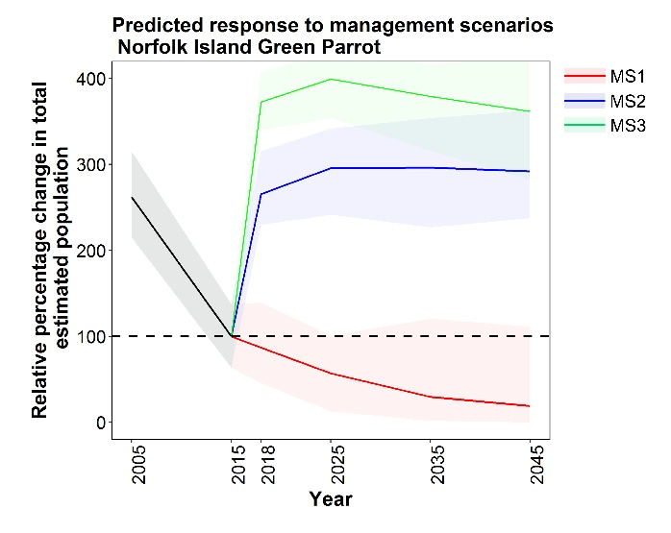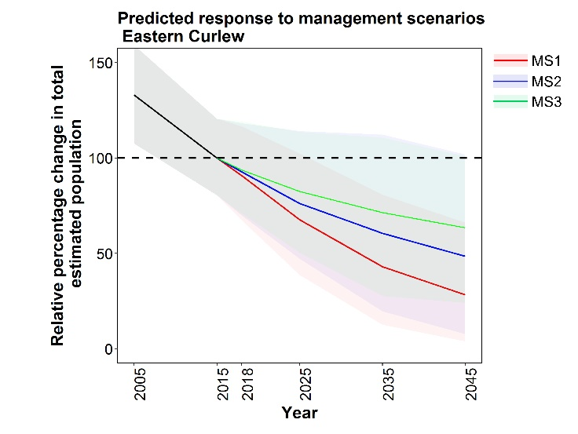

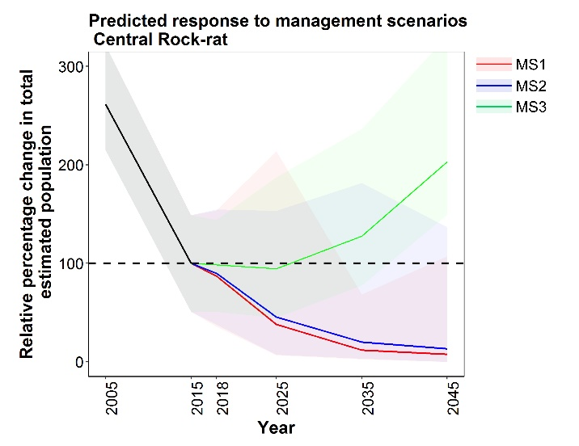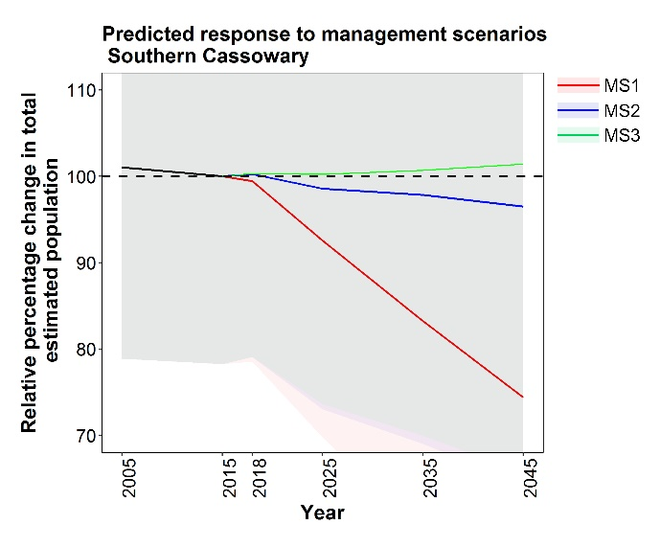

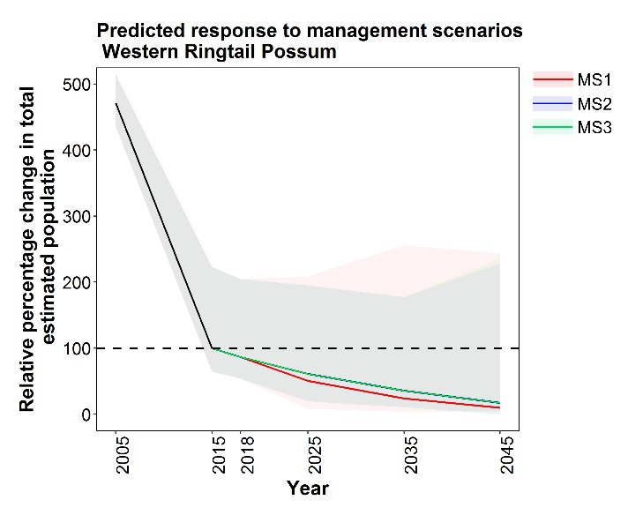

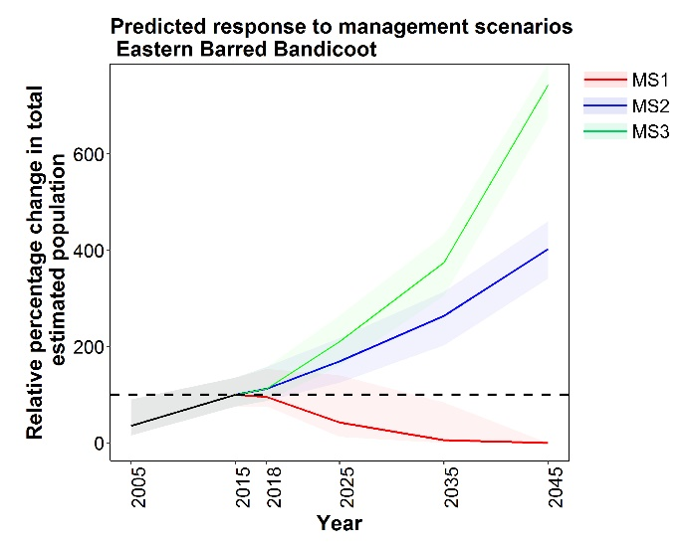

**Table 2**. Trajectories of species over the period 2005-15 compared with 2015-18. The trajectory for each period is the average across elicitors, expressed as an annual % change. Red font indicates a negative trajectory. The results of the Wilcoxon’s matched-pairs test (or Sign Test: ST) for the trajectory changes are summarised in columns 4 and 5: ns indicates the differences in trajectory are not significant. Values for Leadbeater’s Possum and Northern Hopping-mouse are not presented, because the conservation status of these species is under review. The direction of change in trajectories is summarised as improved or worsened for those species where agreement among elicitors was significant.

|  |  |  |  |  |  |
| --- | --- | --- | --- | --- | --- |
| Species | Annual % change in population trajectory | | Concordance among elicitors | | Trajectory in 2015-18 cf. 2005-15 |
| 2005-15 | 2015-18 | z-score | Probability |
| **Birds** | | | | | |
| Alligator Rivers Yellow Chat | -5.56 | -1.23 | 1.46 | 0.14 ns |  |
| Australasian Bittern | -0.30 | -2.42 | 1.69 | 0.09 ns |  |
| Christmas island Frigatebird | 0.08 | -0.12 | 0.50 (ST) | 0.62 ns |  |
| Eastern Bristlebird (northern) | -7.07 | 12.2 | 2.52 | **0.01** | **improved** |
| Eastern Bristlebird (southern) | 1.70 | 1.41 | 0.17 | 0.87 ns |  |
| Eastern Hooded Plover | -0.82 | -0.89 | 1.4 | 0.16 ns |  |
| Eastern Curlew | -3.30 | -2.11 | 1.48 | 0.14 ns |  |
| Golden-shouldered Parrot | -0.65 | -1.65 | 1.68 | 0.09 ns |  |
| Helmeted Honeyeater | 2.84 | 12.6 | 2.52 | **0.01** | **improved** |
| Mallee Emu-wren | -17.9 | 0.10 | 2.52 | **0.01** | **improved** |
| Malleefowl | -2.00 | -0.94 | 1.4 | 0.16 ns |  |
| Night Parrot | -0.56 | 0.04 | 1.48 | 0.14 ns |  |
| Norfolk Island Boobook | 0.14 | -0.48 | 1.07 | 0.29 ns |  |
| Norfolk Island Green Parrot | -16.2 | 90.8 | 2.37 | **0.02** | **improved** |
| Orange-bellied Parrot | -15.8 | -2.83 | 1.6 | 0.11 ns |  |
| Plains-wanderer | -0.45 | 0.37 | 0.67 | 0.50 ns |  |
| Red-tailed Black-cockatoo (SE) | -0.71 | -0.41 | 1.21 | 0.22 ns |  |
| Regent Honeyeater | -5.33 | -0.91 | 2.2 | **0.03** | **improved** |
| Southern Cassowary | -0.10 | 0.11 | 1.83 | 0.07 ns |  |
| Swift Parrot | -5.45 | -4.69 | 0.68 | 0.50 ns |  |
| Western Ground Parrot | -8.81 | -1.75 | 1.12 | 0.26 ns |  |
| White-throated Grass-wren | -4.82 | 2.37 | 2.03 | **0.04** | **improved** |
| **Mammals** | | | | | |
| Bilby | 0.93 | 0.21 | 1.15 | 0.25 ns |  |
| Black-footed Rock-wallaby | 0 | 0.12 | 0.4 | 0.69 ns |  |
| Brush-tailed Rabbit-rat | -5.97 | -1.78 | 1.96 | **<0.05** | **improved** |
| Central Rock-rat | -16.2 | -0.56 | 2.2 | **0.03** | **improved** |
| Christmas Island Flying-fox | -3.23 | 0 | 1.83 | 0.07 ns |  |
| Chuditch | 0.41 | -0.26 | 0.94 | 0.35 |  |
| Eastern Barred Bandicoot (mainland) | 6.46 | 4.10 | 1.01 | 0.31 ns |  |
| Eastern Bettong (mainland) | 10.0 | 1.31 | 2.2 | **0.03** | **worsened** |
| Eastern Quoll | -2.98 | 1.56 | 1.78 | 0.08 ns |  |
| Gilbert's Potoroo | 4.67 | 7.69 | 1.99 | **<0.05** | **improved** |
| Golden Bandicoot | 0.08 | 0.45 | 0.4 | 0.69 ns |  |
| Kangaroo Island Dunnart | -3.07 | -0.56 | 1.21 | 0.22 ns |  |
| Leadbeater's Possum |  |  |  |  |  |
| Mahogany Glider | -1.18 | -0.12 | 2.02 | **0.04** | **improved** |
| Mala | 3.2 | 6.92 | 2.1 | **0.04** | **improved** |
| Mountain Pygmy Possum | -0.62 | 0.98 | 1.15 | 0.25 ns |  |
| Northern Hopping-mouse |  |  |  |  |  |
| Numbat | 1.15 | 11.7 | 2.2 | **0.03** | **improved** |
| Western Ringtail Possum | -37.1 | -4.41 | 2.2 | **0.03** | **improved** |
| Woylie | 5.35 | 15.9 | 2.03 | **0.04** | **improved** |

The sole significant deterioration in trajectory among the priority species, for the Eastern Bettong, is something of an artefact. The 2005-15 period bracketed the re-introduction of the species to the mainland, in fenced exclosures, with rapid increase from this founder stock. The rate of increase slowed in 2015-18, as the reintroduced population stabilised to carrying capacity within the exclosures.

### Cross-species trends

The section above described results for individual species, focusing particularly on whether their trajectory for one period was or was not significantly different from that in another period. Table 2 also shows, for each species, whether the direction of the estimated trajectory (averaged across elicitors) is improving or worsening, even if that individual change is not significantly different. In most cases the direction of those trajectories is improving in 2015-18 relative to 2005-15. We tested whether there was a tendency for more improvements or deteriorations in trajectories, across the set of species. For birds, there was a highly significant tendency (z=2.91, p=0.004) across the set of all priority species for the trajectory in 2015-18 (mean annual *increase* across species of 4.5%) to be better than that in 2005-15 (mean annual *decline* across species of 4.1%). There was a similar significant (z=2.80, p=0.005) improvement across the set of mammal species, from an average (across species) population trajectory in 2005-15 of a 2.7% annual *decline* to an average annual *increase* of 2.0% in 2015-18. These results reflect both the major significant improvements in trajectories for some individual species, but also that the majority of species showed a tendency for improvement, even those whose trajectory changes were individually non-significant.

### Threat assessment

Summaries of the progress in understanding threats and their management is presented in Appendix B.

## Discussion and Conclusions

The main purpose of this analysis and report was to assess whether the population trajectories of at least 50% of the 41 priority species identified in the Threatened Species Strategy had improved. We carried out assessments for 40 taxa (including two populations of the Eastern Bristlebird, and excluding Leadbeater’s Possum and the Northern Hopping-mouse, from the starting set of 41 taxa).

**There is clear evidence of improved trajectories across the set of priority species. However, when viewed at the level of individual species, the trajectories have significantly improved for only 35% of priority species:**

Trajectories for the period 2015-18 were significantly improved relative to the trajectories during 2005-15 for 14 out of the 40 taxa (35%; six birds and eight mammals). For 25 taxa, there was less consistency amongst experts on their assessments for trajectory change, such that any change in trajectory did not reach statistical significance. Only one species – the mainland population of the Eastern Bettong - had a deteriorating trajectory, and this species represents a special case because the pre-2015 population increase occurred following the translocation of individuals into fenced areas. By 2015 this population had stabilised around a carrying capacity for their fenced areas, and further population increases were not expected.

**Thus, we conclude that the target of improved trajectories for at least 50% of priority species is not met, but that there is evidence that the Strategy has contributed to improvements across the set of priority species.**

Improvements to population trajectories were often a result of efforts by many stakeholders over many years. For some species, especially the more imperilled species, these efforts may need to be maintained for decades to reduce the risks of extinction appreciably. In addition, some species still face high risks of extinction with the current levels of management, even if that management is showing some signs of success. The elicitations showed that the trajectories of most species could be improved further if all potential management actions were undertaken; extinction can be more confidently avoided with more substantial and comprehensive management inputs.

**The Strategy commits to reporting on the outcomes of conservation management (i.e. population size and trajectories) rather than the more usual approach of reporting on management inputs (i.e. investment and management actions). This represents a substantial advance in the reporting paradigm, compared with many previous Commonwealth and other agency programs**. However, the assessment was challenging, mostly because of the limited primary evidence available on population size and trajectories for most species, forcing many of the evaluations to be based on inference or evidence held by diverse stakeholders that has not been presented in peer-reviewed publications. Assessments were particularly challenging for some threatened species occurring across large ranges; for which threats, management regimes and population trajectories varied markedly across this area; and with multiple stakeholders involved in management: examples included the Bilby and Black-footed Rock-wallaby.

Within the scorecards summarising information for individual species, the scope, rigour and detail of management inputs were variable, making this information difficult to summarise. It was also sometimes difficult to align those actions with priorities in recovery plans or analogous documents or with threats. Similarly, some stakeholders provided costs on management inputs, but not all, and without a framework for guiding the derivation of costs, this information could not be rigorously summarised.

### 

### Management and research

The collation of information as presented in the scorecards demonstrated a substantial management effort is being invested by many individuals and agencies for almost all of the priority threatened species, either specifically for these species or as part of more general conservation management programs. Management actions were diverse: they included captive breeding; translocations; establishment of predator exclosures; broad-scale baiting of pests; genetic rescue; fire management; weed management; regulation of timber harvesting, clearing and developments; habitat augmentation and restoration; and reservation of sites containing important populations. There was marked variation among species in the extent, intensity and effectiveness of management. For some species (especially the highly localised species with very few individuals, such as Helmeted Honeyeater, Orange-bellied Parrot, Central Rock-rat and Gilbert’s Potoroo), almost every individual was subject to (and benefited from) some form of intensive management. However, for other species (e.g. Northern Hopping-mouse, Brush-tailed Rabbit-rat), there was relatively little targeted management and it occurred in only part of the range or was likely to provide (limited) benefit to only a small proportion of the population.

Many of these management actions were based on evidence obtained as a result of targeted research (Appendix B). Such research included survey to delineate distribution, assess relative abundance or population size, identify habitat and management requirements, and help guide locations for management investment; monitoring; assessments of the extent and abundance of pest species and of their impacts; trialling of new management techniques; studies of life history (including breeding success and requirements); studies of diet, food and other resource availability and their responses to threats and management actions; assessments of genetic heterogeneity within and among populations; and studies of dispersal patterns. As with management, there was marked variation among species in the extent and effectiveness of this research effort. For some species (e.g., Helmeted Honeyeater), nearly every individual is marked and there has been an intensive research effort extending over many decades that has resulted in a comprehensive understanding of the ecology and management requirements of the species. However, for other species (e.g., Kangaroo Island Dunnart), many aspects of the species’ ecology are unknown, despite recent research effort, and hence it is difficult to evaluate the relative impacts of different putative threats and hence of management priorities.

As demonstrated in the scorecards, for most of the priority species the Threatened Species Strategy (and related Commonwealth government actions) has supported new research and management actions, or helped to consolidate or extend pre-existing or pre-planned actions undertaken by others. In some cases (e.g., Central Rock-rat), this support enabled significant research and management actions that were novel or would not have occurred otherwise.

### 

### Process-related issues

We recognise a range of other process-related issues constrained this assessment and that may need to be addressed more proactively in subsequent assessments, such as the Year 5 report:

1. Some stakeholders were concerned that the scorecards, and especially the management information presented in them, could be seen to constitute *de facto* recovery plans, and that this would represent an improper process. This was explicitly not the intent of these scorecards, which are without legislative basis. We included information on management priorities and inputs, because it was needed to help interpret and estimate population trajectories – the primary purpose of this exercise.
2. The time period for stakeholders to contribute information was limited, and some stakeholders, especially state agencies with responsibilities for many priority species, were unable to provide relevant information within that timeframe.
3. Although the process for building information held in the scorecards was explicitly iterative (designed to cumulatively build on information contributed by stakeholders), this was not effectively communicated or understood by all contributors, and consequently some stakeholders considered that early iterations of draft scorecards were incomplete or provided a suboptimal assessment of the relative magnitude of threats or of management priorities or implementation. Other stakeholders who received more than one iteration found this confusing, not understanding that the iterations were designed to collect different types of information.
4. Some stakeholders considered that the scorecards should have been developed, populated and managed primarily through existing Recovery Teams. However, development of scorecards for individual species through individual Recovery Teams would have come at the cost of reduced consistency among species (notably between those sets of species that had or didn’t have Recovery Teams). Furthermore, most individuals and agencies that were members of Recovery Teams were solicited for contributions anyway.

Responses to these process-related issues are considered in the Recommendations section below.

Note that notwithstanding these concerns, the prevailing attitude of stakeholders was highly constructive and informed, and a vast amount of relevant and often novel information was contributed in a timely manner by most researchers and managers.

## 

## Recommendations for reporting at Year 5 of the Threatened Species Strategy, and beyond

1. Monitoring. For many species, the assessment of trajectories and their changes was based on best possible inference rooted in knowledge of management effort and assessment of its effectiveness. More reliable and straightforward would be measurement of trajectories through data derived from direct monitoring programs, robustly designed and implemented across much of the species’ range; and, where multiple agencies or organisations conduct monitoring, coordinated across individual monitoring projects. Recommendation: *Establish appropriate monitoring programs (for species that currently do not have such programs); where required, enhance existing monitoring programs; where relevant, coordinate monitoring across different organisations and integrate data across individual monitoring projects; ensure monitoring data are readily and publicly available*.

2. Ongoing collation of management activities. Many individuals and organisations are contributing to the conservation management of threatened species. Where Recovery Teams exist for threatened species, these individual management efforts may be collated and coordinated, such that the outcomes from management protocols may be readily communicated among stakeholders, and gaps in priority management actions identified. However, there may be no comparable process for threatened species without Recovery Teams. Recommendation: *Where multiple stakeholders have some responsibilities for the conservation of priority threatened species, Recovery Teams (or similar coordinating mechanisms) should be established to help coordinate management and to more effectively document individual management actions.*

3. Assessment of species’ responses to management inputs. We collated much information reporting on management actions. However, for many of these management investments, there was little accompanying information on the direct or indirect consequences of the actions – most notably, the extent to which the target species exhibited an increase in population size in response to the action. Recommendation: *Wherever possible, managers should attempt to report on direct outcome measures (such as resultant increase in abundance or vital rates of the priority species, whether directly observed or inferred) arising from management investment. Where agencies support conservation projects, the project management system should ensure that outcomes of these projects are explicitly measured.*

4. Assessment of management activity. Information on management actions was collected from stakeholders without necessarily providing guidance on framing the type, scope, scale and impacts of that management in a consistent manner. The information could not, therefore, easily be synthesised or evaluated. A more standardised approach to collecting this information would also facilitate the mapping of implemented actions against either the priority recovery actions identified in recovery plans and analogous documents or against the main threats, in order to identify gaps for potential future investment*.* Recommendation: *Future reporting could consider approaches to filtering and systematically collating information on management actions by spatial coverage, effectiveness, and duration to gain a better understanding of the nature of gaps in management. This understanding could underpin more strategic and targeted investment, including from the Commonwealth.*

5. Process for compiling scorecards. Many of the concerns over the scorecard compilation process could be addressed by building in longer lead-up times before information is harvested, in which the process of compilation is outlined more clearly to stakeholders. Recommendation: *The scorecards should also be re-designed to avoid some duplication of information, to focus attention on the core issues, and to ensure that information is gathered as consistently and evenly as possible*.

## Acknowledgements

We thank the Threatened Species Commissioner, Sally Box, and her colleagues Kerry Cameron, Fiona Fraser and Jacqui Goonrey, for their indefatigable contribution to framing and progressing this project. We also thank our NESP TSR colleagues who have supported the delivery of this project, including Brendan Wintle, Martine Maron, David Lindenmayer, Christine Fenwick, and Roanne Ramsey. Many individuals, state agencies and non-government conservation organisations contributed invaluable information to help populate the species’ scorecards, often within very tight timeframes. We specifically acknowledge the ACT Government, the ACT Woodlands and Wetlands Trust, Jerry Alexander, Graeme Armstrong, the Arthur Rylah Institute, John Augusteyn, the Australian Wildlife Conservancy, David Bain, David Baker-Gabb, Michelle Ballestrin, Lisa Bamwell, Paul Barden, Fiona Bartlett, Will Batson, Kerrie Benison, Joe Benshemesh, Birdlife Australia, Lucas Bluff, Kev Bradley, Rob Brewster, Linda Broome, Allana Brown, Allan Burbidge, Tim Burnard, Bush Heritage Australia, Mark Carey, the Cassowary Recovery Team, the Central Land Council, Jessica Chapman, Alan Clarke, Rohan Clarke, Sarah Comer, Peter Copley, Andrew Crane, Ross Crates, Gabriel Crowley, the CSIRO, Meghan Cullen, Dambimangari Aboriginal Corporation, Dambimangari Rangers, Hugh Davies, the Department of Environment, Land, Water and Planning, Desert Support Services, Nick Dexter, Rebecca Diete, Jacqui Diggins, Michelle Drew, Guy Dutson, Martin Dziminski, the Eastern Barred Bandicoot Recovery Team, David Egan, Glenn Ehmke, Luke Einoder, Environs Kimberley, Bronwyn Fancourt, Ron Firth, Samantha Flakus, Stephen Florence, Tony Friend, Jody Gates, Luke Geelan, Lesley Gibson, the Golden-shouldered Parrot Recovery Team, Margarita Goumas, the Greater Bilby Recovery Team, Nigel Green, Heidi Groffen, Darren Grover, Cassie H, Merril Halley, Belinda Harding, Dan Harley, Jaime Heiniger, Robert Heinsohn, Stephen Henry, Matthew Herring, Jennifer Higbid, Richard Hill, Brydie Hill, Pat Hodgens, Rosie Hohnen, Mark Holdsworth, Gary Howling, Dean Ingwersen, Marc irvin, Micha Jackson, Stephen Jackson, David James, Melissa Jensen, John Kanowski, Rod Kavenagh, the Kiwirrkurra Indigenous Protected Area, Peter Kyne, Jim Lane, Peter Latch, Jenny Lau, Ivan Lawler, Robin Leppit, Nick Leeseberg, Amanda Lilleyman, David Lindenmayer, Malcolm Lindsay, Cheryl Lohr, Richard Loyn, Ben Lullfitz, Lindy Lumsden, Sylvana Maas, Nicholas Macgregor, Grainne Maquire, Paul Mahon, Adrian Manning, Dion Maple, Paul McDonald, Michael McGrath, Peter Menkhorst, Danae Moore, Adrian Moorrees, Keith Morris, Katherine Moseby, Feach Moyle, Mt Rothwell Biodiversity Centre, Amy Mulcahy, Mulligans Flat Woodland Sanctuary, Fiona Murdoch, Steve Murphy, Brett Murphy, Simon Nally, Georgina Neave, Jenny Nelson, Fransisca Noni, North Central Catchment Management Authority, Northern Territory Department of Environment and Natural Resources, New South Wales Office of Environment and Heritage, David O’Malley, the Olkola Aboriginal Corporation, Kim Onton, Katie Oxenham, Manda Page, Rachel Paltridge, David Parker, Parks Australia, Parks Victoria, Marissa Parrott, David Pearson, Marc Perri, Phillip Island Nature Parks, Planning and Sustainable Development Directorate, Rachel Pritchard, Queensland Department of Environment and Science, Bruce Quin, Ian Radford, John Read, Juanita Renwick, Rewilding Australia, Natasha Robinson, Kelly Roche, Karrie Rose, David Roshier, Samantha Ryan, Annette Rypalski, South Australia Department of Environment and Water, Debbie Saunders, the Save the Bilby Fund, Katherine Schneider, Colleen Sims, Anja Skoblin, James Smith, Mike Smith, Jennifer Smits, Rick Southgate, Darren Southwell, David Stewart, Zoe Stone, Deb Sullivan, the Taronga Conservation Society, Tasmanian Department of Primary Industries, Parks, Water and Environment, Terrain Natural Resource Management, Oliver Tester, Abby Thomas, Chris Todd, Katherine Tuft, Deon Ubter, Uunguu Rangers, Simon Verdon, Mark Virgo, Western Australia Department of Biodiversity, Conservation and Attractions, Simon Ward, James Watson, Alexander Watson, Adrian Wayne, Justin Welbergen, David Westcott, Mike Weston, Wheatbelt Natural Resource Management, Alicia Whittington, Kim Williams, Melinda Wilson, Belinda Wilson, Eric Woehler, the Woodlands and Wetlands Trust, the Wunambal Gaambera Aboriginal Corporation, WWF-Australia and Zoos Victoria.

We are also especially grateful to the experts who contributed elicitations, again often within tight timeframes: in addition to this report’s authors, these included Graeme Armstrong, Rob Brewster, Allan Burbidge, Andrew Burbidge, Rebecca Diete, Guy Dutson, Tony Friend, Luke Geelan, Pat Hodgens, Rosemary Hohnen, Mark Holdsworth, Micha Jackson, Peter Latch, Nick Leseberg, Amanda Lilleyman, Richard Loyn, Lindy Lumsden, Nick Macgregor, Peter Menkhorst, Keith Morris, Rachel Paltridge, David Roshier and Leigh-Ann Woolley. The information and expertise provided by all contributors helped make this assessment as contemporary, comprehensive and robust as possible.

## References

Chapple D, Mitchell N, Cox N, Bowles P, Tingley R, Macdonald S, Shea G, Keogh S, Woinarski J (in press) 'The Action Plan for Australian squamates.' (CSIRO Publishing: Melbourne)

Commonwealth of Australia (2015) 'Threatened species strategy.' Commonwealth of Australia, Canberra.

Garnett ST, Butchart SHM, Baker GB, Bayraktarov E, Buchanan K, Burbidge AA, Chauvenet ALM, Christidis L, Ehmke G, Grace M, Hoccom DG, Legge SM, Leiper I, Lindenmayer DB, Loyn RH, Maron M, McDonald P, Menkhorst P, Possingham HP, Radford J, Reside A, Watson DM, Watson JEM, Wintle B, Woinarski JCZ, Geyle HM (2018) Metrics of progress in the understanding and management of threats to Australian birds. *Conservation Biology*.

Garnett ST, Geyle HM (2018) The extent and adequacy of monitoring for Australian threatened bird species. In 'Monitoring threatened species and ecological communities'. (Eds S Legge, DB Lindenmayer, NM Robinson, BC Scheele, DM Southwell and BA Wintle) pp. 43-55. (CSIRO Publishing: Clayton)

Garnett ST, Szabo JK, Dutson G (2011) 'The action plan for Australian birds 2010.' (CSIRO Publishing: Collingwood)

Geyle HM, Woinarski JCZ, Baker GB, Dickman CR, Dutson G, Fisher DO, Ford H, Holdsworth M, Jones M, Kutt A, Legge S, Leiper I, Loyn R, Murphy BP, Menkhorst P, Reside A, Ritchie EG, Roberts FE, Tingley R, Garnett ST (2018) Quantifying extinction risk and forecasting the number of impending Australian bird and mammal extinctions. *Pacific Conservation Biology* **24**, 157-167.

Legge S, Scheele BC, Woinarski JCZ, Garnett ST, Keith DA, Lintermans M, Robinson NM, Lindenmayer DB (2018) Summary: monitoring extent and adequacy for threatened species. In 'Monitoring threatened species and ecological communities'. (Eds S Legge, DB Lindenmayer, NM Robinson, BC Scheele, DM Southwell and BA Wintle) pp. 127-133. (CSIRO Publishing: Clayton)

McBride MF, Garnett ST, Szabo JK, Burbidge AH, Butchart SHM, Christidis L, Dutson G, Ford HA, Loyn RH, Watson DM (2012) Structured elicitation of expert judgments for threatened species assessment: a case study on a continental scale using email. *Methods in Ecology and Evolution* **3**, 906-920.

Woinarski JCZ (2018) The extent and adequacy of monitoring for Australian threatened mammals. In 'Monitoring threatened species and ecological communities'. (Eds S Legge, DB Lindenmayer, NM Robinson, BC Scheele, DM Southwell and BA Wintle) pp. 21-41. (CSIRO Publishing: Clayton)

Woinarski JCZ, Burbidge AA, Harrison PL (2014) 'The Action Plan for Australian Mammals 2012.' (CSIRO Publishing: Melbourne)

## Appendix A – detailed description of the scorecards

The scorecards are broken down into a series of subsections – many are self-explanatory, but some require further information. Below we provide details on what is included in each subsection and where necessary, some additional background details about the information presented.

*Title*

The common and scientific name of the taxon.

*Key findings*

A summary of the species’ threats and management, and a brief conclusion on the extent of any trajectory change from the period 2005-15 to 2015-18.

*Priority future actions*

A very brief summary of near-term management needs.

*1. Conservation status and taxonomy*

This section lists the current conservation status (Commonwealth and, where applicable, global (under the IUCN) and state/territory), and includes a description on taxonomy. Here we describe whether taxonomy is or is not stable, and list subspecies (and where relevant their conservation status).

*2. Conservation history and prospects*

This section is a summary of the conservation history of a taxon, including historic declines, details of successful management actions, and a description of the likely future outlook.

*3. Past and current trends*

This section provides details about past trends (i.e. pre-2015) and current trends pertaining to the timing of the Threatened Species Strategy implementation (i.e. 2015), and its year three targets (i.e. 2018). The text in this section also provides information on current monitoring activity and data availability. The information on population trends is presented in two tables:

Table 1 summarises information on population size, Extent of Occurrence, Area of Occupancy and numbers of subpopulations and locations, as reported in published baselines, and as estimated in 2015 and in 2018 (for some taxa these dates have been modified slightly based on data availability). Where applicable, we include estimates for wild populations (including translocated populations), then we separate out the populations in exclosures and on islands, and captive populations, and report on the confidence for each parameter (see criteria below).

Table 2 summarises information on population trends over two time periods, 2005-15 and 2015-18. Where readily available and appropriate (i.e. for taxa in which the impact of threats varies geographically, or for which there are varying levels of management and recovery success among sub-populations) we have broken the trends down into sub-populations or locations. All trends have an associated level of confidence (see key below).

|  |  |
| --- | --- |
| **Confidence** | **Description** |
| High | Estimate or trend documented |
| Medium | Estimate or trend considered likely based on documentation |
| Low | Estimate or trend suspected but evidence indirect or equivocal |

|  |  |  |
| --- | --- | --- |
| Trend | | Criteria |
|  | Improving | Increase in population size or geographic distribution observed or inferred relevant to time period considered |
|  | Stable | Population size and geographic distribution stable relative to time period considered |
|  | Deteriorating | Decrease in population size or geographic distribution observed relevant to time period |
| **?** | Unknown | Insufficient information to ascertain trend relevant to time period |

*4. Key threats*

Here, we summarise (and in Table 3, tabulate) the processes most likely to threaten the taxon with extinction. We do not consider all possible threats, but rather focus on the threats that are likely to have the biggest impact on populations. Impact is determined using a modified version of the IUCN threat impact scoring system (greater detail provided under “expected response to management”).

*5. Past and current management*

In this section we list (and in Table 4 summarise) past and current *management* actions (i.e. not surveys, research or monitoring, or planned actions yet to be implemented), the location in which management is occurring, and the contributors and partners responsible for implementing management actions. Most of this material was provided by contributors.

*6. Actions undertaken or supported by the Australian Government resulting from inclusion in the Threatened Species Strategy*

This section details actions that have been implemented or supported by (through various grants and funding schemes) the Australian Government. Here we acknowledge only actions that are likely to have a direct impact on improving the status and trajectory of a given taxon (whether the result be an increase in population size, an increase in habitat extent or quality, or a decrease in the impact of threats, i.e. introduced predators), or that provide evidence necessary to implement, enhance or prioritise recovery actions.

*7. Measuring progress towards conservation*

This section (Table 5) summarises progress towards understanding how to manage threats (i.e. management understanding) and actions towards alleviating their impacts (i.e. management implementation). To assess our progress in management understanding and management implementation, we have used the framework developed by Garnett *et al.* (2018). This involves identifying the major threats facing a taxon and assessing their impact using the following three parameters:

1. Timing – continuing ongoing (currently affecting the taxon and likely to continue); near future (likely to affect the taxon within 10 years or three generations, includes former threat no longer causing impact but could readily recur); or distant future (likely to affect the taxon within 30 years, includes former threat no longer causing impact and unlikely to recur);
2. Extent – the percentage of the population directly affected by the threat, now, in the past or in the future.
3. Severity – the rate of decline caused as a result of the threat (within its extent) assuming no management.

Each threat is measured against a “progress framework” and allocated a score based on where it sits along the progress scale. See Appendix B for details on methodology.

*8. Expert elicitation for population trends*

In most cases, a taxon’s responses to newly established management actions are not likely to be evident after a short time period (i.e. within the three years since implementation of the TSS). We used four-step elicitation to estimate the *expected* future response to four alternative management scenarios:

* *Management scenario 1 –* assuming no conservation management undertaken since 2015 and no new actions implemented;
* *Management scenario 2 –* assuming a continuation of existing management without additional (new) support provided by the Australian Government;
* *Management scenario 3 –* assuming a continuation of existing conservation management, augmented by support mobilised by the Australian Government through the TSS; and
* *Management scenario 4 –* assuming all potential conservation interventions are pursued (i.e. best practise management).

In each scorecard, we have listed the main actions that have occurred under management scenarios 1 to 3, and identified potential management actions. Although included in the expert elicitation process, we do not include the results from elicitations relation to Management Scenario 4 in this report.

The data used to populate Figure 1 were derived from expert assessments of the estimated population size in 2005, 2015, and under each of the management scenarios 1-3 for 2018, 2025, 2035 and 2045.

Table 6 summarises the elicitation results for the period 2005-15 to 2015-18 (under Management Scenario 3), with a summary (Table 6) of the statistical significance (degree of concordance among elicitors) of any such change in trajectory.

This section also provides a brief description of those additional actions (i.e. beyond those currently implemented) that may further improve trajectories in the future.

*9. Immediate priorities for 2019*

Here we list the research and management priorities for the near future (in the lead up to year 5 of the targets under the TSS).

*10. Contributors*

We list those researchers and managers who provided input to the scorecards and elicitations.

*11. Legislative documents*

This section lists relevant legislative documents (e.g. Conservation Advices, Recovery Plans).

*12. References*

We provide a bibliography for information cited throughout the scorecard.

## Appendix B – threat assessment methods and results

### Methods

We used the approach developed by Garnett *et al.* (2018) to assess our progress in understanding and alleviating the impacts of the threats facing the priority birds and mammals. This approach has five components: (i) identifying the threats affecting each species; (ii) assessing the timing, scope and severity of those threats to identify which are having the greatest impact; (iii) assessing our level of understanding in how to manage each threat; (iv) assessing the effectiveness of our management attempts aimed at alleviating threat impacts; and (v) assembling the data into metrics of progress for individual species or threats. These metrics allow for ready comparison of large numbers of threatened species, and may be aggregated to understand trends in conservation success for an individual species through time or for threats across multiple species and locations.

*Identifying threats*

Key threats were derived from relevant policy documents (including Conservation Advices and Recovery Plans), relevant literature, Action Plans and IUCN listing advices, with some amendments made by contributing experts based on new information. We did not consider all plausible threats, but rather focused on the threats that were likely to have the biggest impact on populations. All threats were categorised using the IUCN Red List classification scheme (IUCN, 2012) down to the most specific level possible.

*Assessing the timing, scope and severity of threats* *(threat impact)*

Following IUCN 2012, we assessed the timing of each threat (i.e. ongoing, near future; may occur or return in the short-term, or distant future; may occur or return in the long-term); its extent or scope (i.e. the proportion of the total population affected); and its severity (i.e. the rate of population decline caused by the threat within its scope), with scoring validated by contributing experts. The timing, scope and severity was then converted to a weighted threat impact score, which reflected the total population decline over ten years or three generations (whichever is longer), likely to be caused by the threat (i.e. the product of the scope and severity) weighted by timing (IUCN 2012; see Garnett *et al.* 2018 for greater detail). Scores were then readily translated into categories of threat impact, where negligible impact refers to population declines of <2%, low impact refers to population declines of 2-10%, medium impact refers to population declines 11-50% and high impact refers to population declines >50%.

*Assessing progress in understanding (research need and achievement) and managing (management need and achievement) threats*

For each threat affecting each priority species, we assigned a category of progress for management understanding (which represents the current level of knowledge on how to manage the threat) and management implementation (which represents the extent to which each threat has been managed). We considered both research and management need as well as research and management achievement. For management understanding, there were seven mutually exclusive categories ranging from (i) no knowledge and no research (weighted against 1 for need and 0 for achievement) to (vii) research complete and being applied or ongoing research associated with adaptive management (weighted against 0 for need and 1 for achievement). For management implementation, there were another seven mutually exclusive categories ranging from (i) no management (weighted against 1 for need and 0 for achievement) to (vii) the threat no longer needs management (weighted against 0 for need and 1 for achievement; Table B1).

**Table B1**. Categories of progress for understanding threats and implementing management.

|  |  |  |
| --- | --- | --- |
| Category | Weighting | |
| Management understanding | Need | Achievement |
| i. No knowledge and no research | 1.00 | 0.00 |
| ii. Research being undertaken or completed but limited understanding on how to manage threat | 0.83 | 0.17 |
| iii. Research has provided strong direction on how to manage threat | 0.67 | 0.33 |
| iv. Solutions being trialled but work only initiated recently | 0.50 | 0.50 |
| v. Trial management under way but not yet clear evidence that it can deliver objectives | 0.33 | 0.67 |
| vi. Trial management is providing clear evidence that it can deliver objectives | 0.17 | 0.83 |
| vii. Research complete and being applied OR ongoing research associated with adaptive management of threat | 0.00 | 1.00 |
| Management implementation | Need | Achievement |
| i. No management | 1.00 | 0.00 |
| ii. Management limited to trials | 0.83 | 0.17 |
| iii. Work has been initiated to roll out solutions where threat applies across the taxon’s range | 0.67 | 0.33 |
| iv. Solutions have been adopted but too early to demonstrate success | 0.50 | 0.50 |
| v. Solutions are enabling achievement but only with continued conservation intervention | 0.33 | 0.67 |
| vi. Good evidence available that solutions are enabling achievement with little or no conservation intervention | 0.17 | 0.83 |
| vii. The threat no longer needs management | 0.00 | 1.00 |

*Assembling data into metrics of progress for individual species and threats*

For each threat facing each of the priority species, we calculated the research need and research achievement (i.e. our management understanding), and management need and management achievement (i.e. management implementation) as in Garnett *et al.* (2018). Each of the metric scores were weighted against threat impact, so that threats assessed as having a higher impact were afforded a greater weight, leading to greater scores for each of the need and achievement metrics. We took this approach because higher impact threats are likely to cause more devastating declines over time, and thus require more urgent attention. Conversely, it allows for greater recognition to be given when threats of higher impact are alleviated.

We also calculated the overall research and management needs and achievements for each species by summing the species-specific needs or achievements for a given threat, then dividing by the maximum possible score for each threat to provide a measure that could be compared between species. These scores also took into consideration the number of threats facing each species; for example, a species likely to be affected by 4 medium impact threats would have higher scores for all metrics compared with a species that is likely to be affected by 2 medium impact threats (assuming a similar level of management understanding and implementation).

All aggregated metric scores (i.e. for individual threats or species) were standardised to 100, and thus are relative to all other threats or species considered; e.g. a score of 100 for management achievement for a given threat does not necessarily mean that the threat no longer needs management (i.e. vii in Table B1), but rather suggests that, compared to all other threats considered, it is being managed the most effectively.

For further information on how the metrics are derived see Garnett *et al.* (2018).

### Results

*Priority birds*

Across all 21 priority birds, there were a total of 123 recognised or specified threats (covering 36 different categories, IUCN 2012), with an average of 5.6 threats per species. For 72% of the threats affecting the priority birds, research has provided or is providing at least strong direction on what needs to be done to manage them, although this means that there is little or no understanding on how to manage the remaining 28% (Fig. B1). About 80% of the threats have some management underway, but none are at the stage where solutions are being achieved without continued conservation intervention (Fig. B2). Overall, there has been greater progress in understanding and managing the threats facing the priority birds compared to the national average for all threatened Australian birds; Garnett et al. (2018) estimated that research was providing strong direction on how to manage only 52% of the threats, while only 43% of threats had some management underway.

There was a tight relationship between research need and management need, with eight species ranking in the top 10 for both metrics (Table B2). Likewise, there were eight species that ranked in the top 10 for both research achievement and management achievement. Research and management *need* was greatest for the northern population of Eastern Bristlebird and the Swift Parrot, while research and management *achievement* was greatest for the Helmeted Honeyeater (Table B2).

Invasive species (comprising feral cats, red foxes, introduced plants, birds and herbivores) comprised the major threat class, with the highest normalised scores for all metrics (Fig. B3). Natural system change (e.g. fire, water management), climate change, agriculture and other factors (e.g. lack of genetic variability) all had moderate normalised scores for all metrics. Within these broader categories, increases in fire frequency and/or intensity posed the greatest threat to the priority birds, affecting ~67% of all taxa considered, followed by an increase in the frequency or duration of drought (~43%), feral cat predation (~38%), and lack of genetic variability (~14%) (Table B3). There has been some success in managing fire regimes, with fire scoring highest for research and management achievement (relative to all other threats considered). There has also been some progress in managing cats (which ranked at number 3 for both research and management achievement). While our knowledge on how to manage cats is improving (through research aimed at improving the efficacy of feral cat control), cat management is currently generally effective only at localised scales. There was limited research or management achievement for drought or lack of genetic variability (Table B3).

*Priority mammals*

There were a total of 124 threats (covering 33 different categories, IUCN 2012) affecting the 20 priority mammals, with an average of 6.2 threats per species. Research is providing strong direction on how to manage 75% of these threats (Fig. B1), with some management underway for around 70% (Fig. B2). As with the birds, all of threats facing the mammals require continued conservation intervention.

There was much overlap of species with high research and management need scores, with nine of those ranking in the top 10 for research need also ranking in the top 10 for management need. Likewise, nine species ranked in the top 10 for both research achievement and management achievement (Table B4). The Mountain Pygmy-possum had the highest score for research and management *need*, followed closely by Leadbeater’s Possum, Northern Hopping-mouse and Western Ringtail Possum. Research and management *achievement* was greatest for the Eastern Barred Bandicoot, Eastern Bettong and Woylie (Table B4).

Invasive species (particularly feral cats, red foxes and European rabbits), comprised the major threat class, with the highest normalised scores for all metrics except for research need (Fig. B4). Natural system change (e.g. fire) had the highest normalised score for research need, and moderately high scores for all other metrics. Within these broader categories, feral cats posed the greatest risk to the priority mammals (with the highest score for threat impact and affecting all but one of the species considered), followed by increases in fire frequency and/or intensity (80%) and red foxes (65%) (Table B5). Research and management achievements were greatest for the threat posed by red foxes, followed by feral cats (comparative to all other threats), suggesting that there has been some, at least localised, success in alleviating the impacts of these threats. Climate change (particularly an increase in the frequency or length of drought) had moderate research and management need scores; while there has been some limited advancement in our understanding on how to manage these threats, no management has been successfully implemented (Table B5).

**Table B2**. The ^normalised scores for threat impact, research and management needs and achievements for the 21 priority birds listed in the Threatened Species Strategy. Grey shading refers to values ranking in the top 10 for each metric.

|  |  |  |  |  |  |  |  |  |  |
| --- | --- | --- | --- | --- | --- | --- | --- | --- | --- |
|  |  |  | **Need** | | |  | **Achievement** | | |
| **Species** | **Threat impact** |  | **Research** |  | **Management** |  | **Research** |  | **Management** |
| Alligator Rivers Yellow Chat | 67.9 |  | 70.9 |  | 54.5 |  | 45.2 |  | 57.4 |
| Australasian Bittern | 35.2 |  | 27.5 |  | 29.1 |  | 31.3 |  | 28.4 |
| Christmas Island Frigatebird | 14.8 |  | 23.9 |  | 18.7 |  | 2.7 |  | 1.78 |
| Eastern Bristlebird (northern) | 76.4 |  | 100.0 |  | 88.6 |  | 33.6 |  | 21.5 |
| Eastern Bristlebird (southern) | 54.9 |  | 22.6 |  | 37.4 |  | 65.9 |  | 56.9 |
| Eastern Hooded Plover | 44.4 |  | 31.2 |  | 39.6 |  | 42.4 |  | 31.2 |
| Far Eastern Curlew | 39.9 |  | 44.5 |  | 36.5 |  | 24.2 |  | 26.7 |
| Golden-shouldered Parrot | 48.2 |  | 51.0 |  | 38.3 |  | 31.4 |  | 41.2 |
| Helmeted Honeyeater | 100.0 |  | 64.9 |  | 70.5 |  | 100.0 |  | 100.0 |
| Mallee Emu-wren | 38.7 |  | 41.3 |  | 38.9 |  | 25.0 |  | 20.5 |
| Malleefowl | 75.7 |  | 48.7 |  | 67.5 |  | 76.1 |  | 53.5 |
| Night Parrot | 29.2 |  | 22.0 |  | 27.6 |  | 26.5 |  | 18.1 |
| Norfolk Island Boobook (Morepork) | 39.0 |  | 42.1 |  | 38.7 |  | 0.0 |  | 21.2 |
| Norfolk Island Green Parrot | 2.5 |  | 0.0 |  | 1.1 |  | 3.9 |  | 3.5 |
| Orange-bellied Parrot | 65.7 |  | 65.6 |  | 44.5 |  | 46.1 |  | 68.5 |
| Plains-wanderer | 66.4 |  | 37.5 |  | 58.3 |  | 71.1 |  | 48.2 |
| Red-tailed Black-Cockatoo (south-eastern) | 31.0 |  | 21.4 |  | 22.6 |  | 29.8 |  | 29.8 |
| Regent Honeyeater | 62.2 |  | 71.9 |  | 64.8 |  | 35.5 |  | 29.0 |
| Southern Cassowary | 10.4 |  | 12.6 |  | 10.6 |  | 5.39 |  | 5.2 |
| Swift Parrot | 82.8 |  | 96.8 |  | 100.0 |  | 46.2 |  | 16.9 |
| Western Ground Parrot | 74.4 |  | 60.0 |  | 49.0 |  | 64.5 |  | 79.8 |
| White-throated Grass-wren | 14.6 |  | 15.6 |  | 13.1 |  | 9.4 |  | 10.2 |

^Note that the results of this analysis are normalised so that the scores provided for each species are relative. For example, a score of 100 for research achievement does not mean that all of the threats facing the Helmeted Honeyeater are well understood, but that collectively we know more about the threats facing the Helmeted Honeyeater than any other species under consideration.

**Table B3**. The list of threats that ranked in the top 10 (grey shading) for threat impact, research or management needs or achievements (based on scores ^normalised to 100) for the 21 priority birds listed in the Threatened Species Strategy. The number of species affected by each threat is in parenthesis.

|  |  |  |  |  |  |  |  |  |  |
| --- | --- | --- | --- | --- | --- | --- | --- | --- | --- |
|  |  |  | **Need** | | |  | **Achievement** | | |
| **Threat type** | **Threat impact** |  | **Research** |  | **Management** |  | **Research** |  | **Management** |
| Housing and urban areas (4) | 21.7 |  | 20.1 |  | 24.8 |  | 21.2 |  | 17.1 |
| Habitat shifting and alteration (2) | 11.4 |  | 18.0 |  | 18.6 |  | 3.6 |  | 0.7 |
| Drought (9) | 67.7 |  | 100.0 |  | 98.8 |  | 28.2 |  | 21.3 |
| Lack of genetic variability (4) | 47.2 |  | 70.5 |  | 62.3 |  | 18.7 |  | 24.4 |
| Small population size (3) | 28.0 |  | 29.2 |  | 32.4 |  | 23.9 |  | 21.5 |
| Agro-industry farming (10) | 37.9 |  | 22.8 |  | 44.6 |  | 49.3 |  | 28.0 |
| Agro-industry grazing, ranching or farming (8) | 32.0 |  | 12.5 |  | 30.0 |  | 48.4 |  | 34.9 |
| Increase in fire frequency/intensity (14) | 100.0 |  | 89.9 |  | 100.0 |  | 100.0 |  | 100.0 |
| Suppression in fire frequency/intensity (3) | 22.9 |  | 24.9 |  | 22.2 |  | 18.5 |  | 23.9 |
| Feral cat (8) | 52.2 |  | 44.4 |  | 54.9 |  | 54.7 |  | 48.1 |
| Feral pig (3) | 17.1 |  | 16.8 |  | 15.4 |  | 15.7 |  | 19.7 |
| Introduced herbivores (2) | 21.5 |  | 11.1 |  | 21.25 |  | 29.8 |  | 21.9 |
| Red fox (7) | 45.6 |  | 16.6 |  | 37.6 |  | 70.2 |  | 57.5 |
| Native herbivores (3) | 22.4 |  | 12.5 |  | 22.7 |  | 30.1 |  | 21.9 |

^Note that the results of this analysis are normalised so that the scores provided for each threat are relative. For example, a score of 100 for management achievement does not mean that we are managing fire regimes effectively across the entire range of each of the priority birds, but that collectively, we are doing a better job at managing fire (with respect to reducing its impact on the priority birds) than the other threats considered.

**Table B4**. The ^normalised scores for threat impact, research and management needs and achievements for the 20 priority mammals listed in the Threatened Species Strategy. Grey shading refers to values ranking in the top 10 for each metric.

|  |  |  |  |  |  |  |  |  |  |
| --- | --- | --- | --- | --- | --- | --- | --- | --- | --- |
|  |  |  | **Need** | | |  | **Achievement** | | |
| **Species** | **Threat impact** |  | **Research** |  | **Management** |  | **Research** |  | **Management** |
| Bilby | 38.9 |  | 19.9 |  | 31.7 |  | 35.3 |  | 38.5 |
| Black-footed Rock-wallaby | 15.1 |  | 10.1 |  | 11.6 |  | 12.3 |  | 15.7 |
| Brush-tailed Rabbit-rat | 38.4 |  | 62.0 |  | 55.0 |  | 10.1 |  | 14.0 |
| Central Rock-rat | 47.7 |  | 34.9 |  | 68.6 |  | 37.1 |  | 17.1 |
| Christmas Island Flying-fox | 17.2 |  | 21.6 |  | 24.3 |  | 8.1 |  | 6.6 |
| Chuditch | 40.4 |  | 21.7 |  | 37.5 |  | 36.1 |  | 35.5 |
| Eastern Barred Bandicoot | 94.3 |  | 23.8 |  | 70.6 |  | 100.0 |  | 100.0 |
| Eastern Bettong | 95.9 |  | 40.7 |  | 78.6 |  | 92.07 |  | 94.9 |
| Eastern Quoll | 45.9 |  | 67.4 |  | 79.6 |  | 0.0 |  | 2.6 |
| Gilbert’s Potoroo | 37.9 |  | 27.9 |  | 35.8 |  | 29.5 |  | 32.6 |
| Golden Bandicoot | 5.8 |  | 7.3 |  | 5.4 |  | 2.7 |  | 5.1 |
| Kangaroo Island Dunnart | 18.3 |  | 18.3 |  | 12.0 |  | 11.4 |  | 21.2 |
| Leadbeater’s Possum | 87.0 |  | 97.3 |  | 99.8 |  | 48.1 |  | 57.1 |
| Mahogany Glider | 40.7 |  | 36.7 |  | 56.6 |  | 27.7 |  | 16.6 |
| Mala | 51.1 |  | 23.8 |  | 33.7 |  | 47.8 |  | 58.9 |
| Mountain Pygmy-possum | 100.0 |  | 100.0 |  | 100.0 |  | 62.3 |  | 80.5 |
| Northern Hopping-mouse | 46.5 |  | 79.4 |  | 82.2 |  | 9.7 |  | 1.0 |
| Numbat | 48.0 |  | 20.0 |  | 32.7 |  | 46.3 |  | 54.2 |
| Western Ringtail Possum | 68.3 |  | 75.3 |  | 87.4 |  | 38.4 |  | 35.5 |
| Woylie | 88.1 |  | 67.4 |  | 76.9 |  | 66.9 |  | 82.3 |

^Note that the results of this analysis are normalised so that the scores provided for each species are relative. For example, a score of 100 for research achievement does not mean that all of the threats facing the eastern barred bandicoot are well understood, but that collectively we know more about the threats facing the bandicoot than any other species under consideration.

**Table B5**. The list of threats ranking in the top 10 (grey shading) for threat impact, research or management needs or achievements (based on scores ^normalised to 100) for the 20 priority mammals listed in the Threatened Species Strategy. The number of species affected by each threat is in parenthesis.

|  |  |  |  |  |  |  |  |  |  |
| --- | --- | --- | --- | --- | --- | --- | --- | --- | --- |
|  |  |  | **Need** | | |  | **Achievement** | | |
| **Threat type** | **Threat impact** |  | **Research** |  | **Management** |  | **Research** |  | **Management** |
| Urban development (3) | 13.7 |  | 7.5 |  | 13.9 |  | 13.9 |  | 13.6 |
| Tourism, recreation (1) | 3.6 |  | 1.2 |  | 2.2 |  | 4.1 |  | 5.05 |
| Habitat shifting, alteration (1) | 4.5 |  | 9.0 |  | 8.5 |  | 0.0 |  | 0.0 |
| Increased drought frequency (6) | 28.1 |  | 37.6 |  | 53.1 |  | 13.0 |  | 0.0 |
| Temperature extremes (2) | 5.9 |  | 8.8 |  | 11.2 |  | 2.15 |  | 0.0 |
| Agro-industry farming (8) | 22.0 |  | 12.0 |  | 17.6 |  | 22.2 |  | 26.8 |
| Non-target poisoning (4) | 6.2 |  | 6.6 |  | 8.5 |  | 4.0 |  | 3.67 |
| Increase in fire frequency, intensity (16) | 76.0 |  | 100.0 |  | 93.5 |  | 36.3 |  | 56.3 |
| Suppression in fire frequency, intensity (1) | 7.5 |  | 10.0 |  | 11.7 |  | 3.4 |  | 2.6 |
| Loss of tree hollows (1) | 7.5 |  | 2.5 |  | 4.7 |  | 8.6 |  | 10.6 |
| Disease (4) | 7.9 |  | 13.3 |  | 12.2 |  | 3.89 |  | 0.0 |
| Feral cats (19) | 100.0 |  | 71.9 |  | 100.0 |  | 89.0 |  | 99.9 |
| Introduced herbivores (3) | 9.2 |  | 3.2 |  | 5.9 |  | 10.5 |  | 12.9 |
| European rabbits (5) | 4.9 |  | 1.0 |  | 3.1 |  | 6.1 |  | 6.9 |
| Red foxes (13) | 76.8 |  | 9.4 |  | 56.1 |  | 100.0 |  | 100.0 |
| Native herbivores (1) | 3.4 |  | 0.0 |  | 2.1 |  | 4.7 |  | 4.8 |

^Note that the results of this analysis are normalised so that the scores provided for each threat are relative. For example, a score of 100 for management achievement does not mean that red foxes are managed effectively across the entire range of each of the priority mammals, but that collectively, we are doing a better job at managing red foxes (with respect to reducing their impacts on the priority mammals) than the other threats considered.

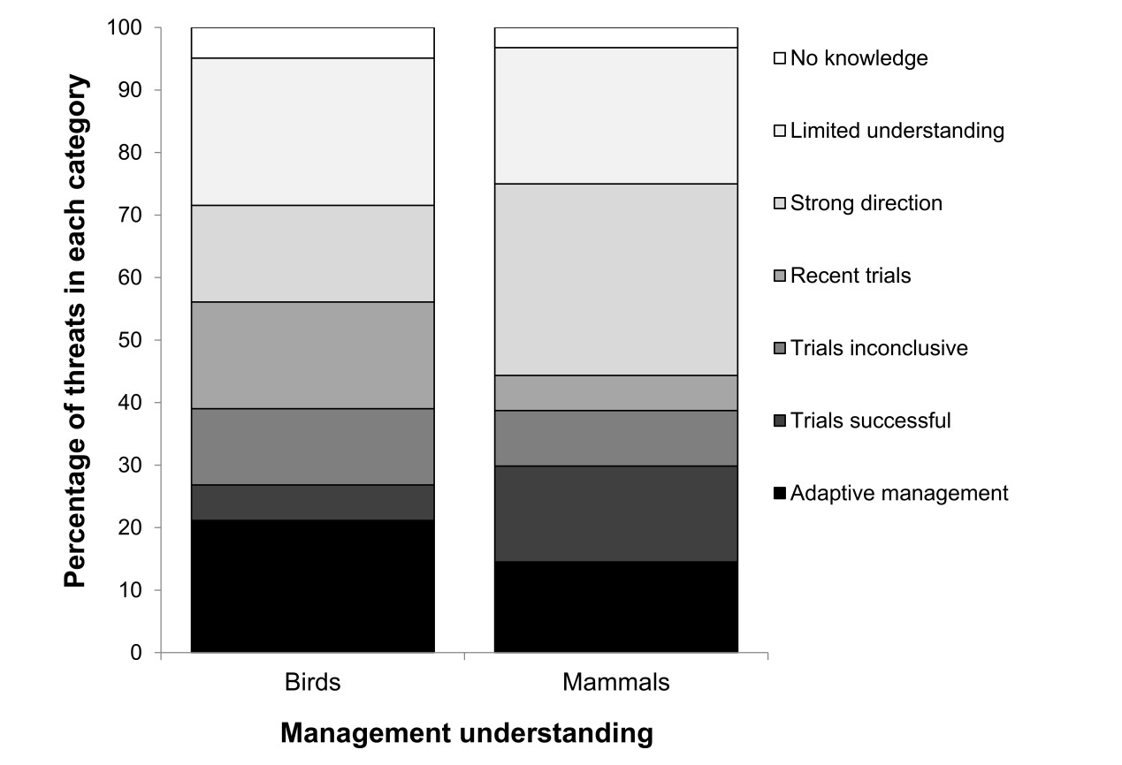

**Figure B1**. The level of progress in understanding threats to all 41 priority species listed in the Threatened Species Strategy.

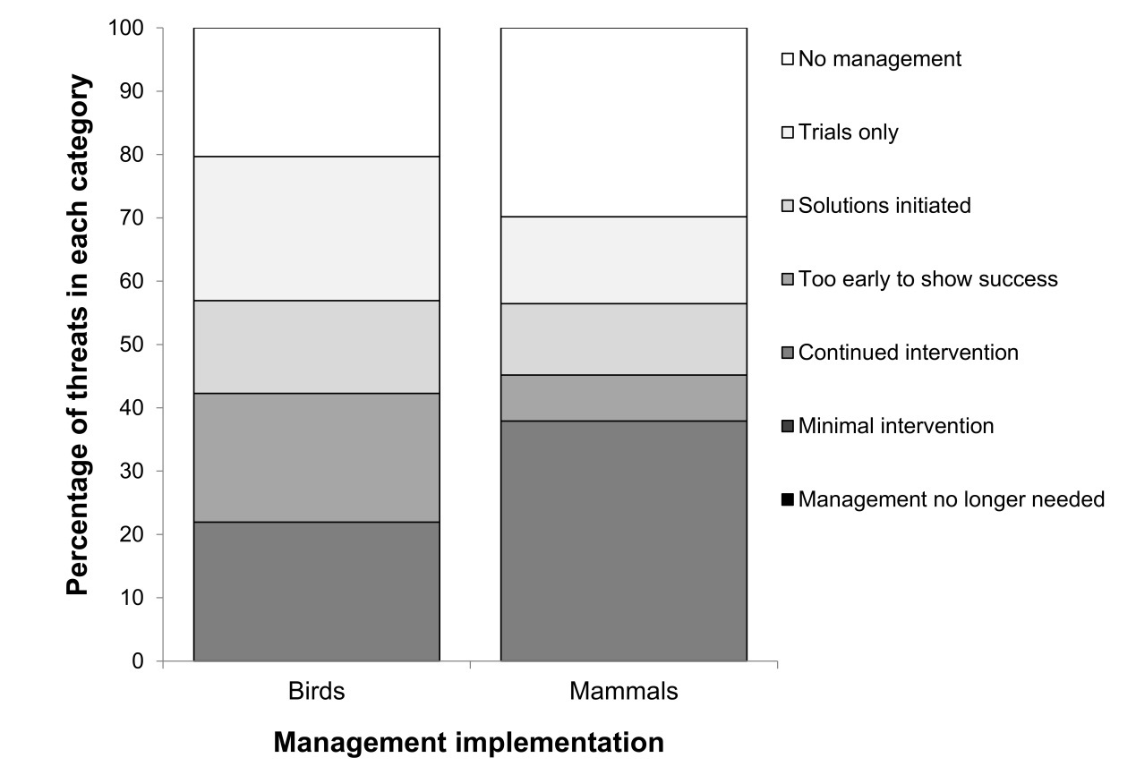

**Figure B2**. The level of progress in managing threats to all 41 priority species listed in the Threatened Species Strategy.

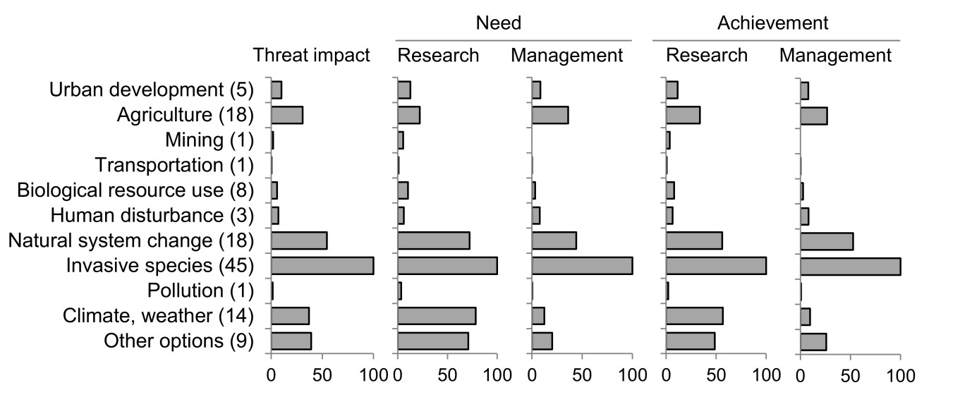

**Figure B3**. Normalised values for threat impact, research and management needs and achievements for the 12 major threat classes (IUCN, 2012) affecting the 21 priority birds listed in the Threatened Species Strategy. The figure in parenthesis refers to the total number of individual threats facing the priority birds within each category.

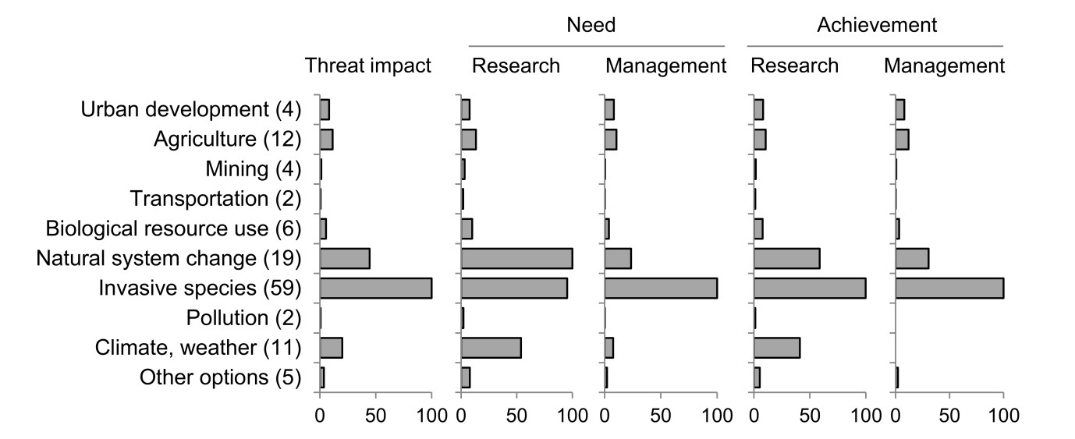

**Figure B4**. Normalised values for threat impact, research and management needs and achievements for the 12 major threat classes (IUCN, 2012) affecting the 20 priority mammals listed in the Threatened Species Strategy. The figure in parenthesis refers to the total number of individual threats facing the priority mammals within each category.

**References**

Garnett ST, Butchart SHM, Baker GB, Bayraktarov E, Buchanan K, Burbidge AA, Chauvenet ALM, Christidis L, Ehmke G, Grace M, Hoccom DG, Legge SM, Leiper I, Lindenmayer DB, Loyn RH, Maron M, McDonald P, Menkhorst P, Possingham HP, Radford J, Reside A, Watson DM, Watson JEM, Wintle B, Woinarski JCZ, Geyle HM (2018) Metrics of progress in the understanding and management of threats to Australian birds. *Conservation Biology*.

IUCN (International Union for Conservation of Nature) (2012). Threats classification scheme. Version 3.2. IUCN. Gland, Switzerland. Available from <http://www.iucnredlist.org/technical-documents/>classification-schemes/threats-classification-scheme (accessed April 2018).

## Appendix C. Alternative mode of analysis

The Threatened Species Strategy has explicit targets of improving the trajectory of populations of threatened species. There are several ways in which such trajectory changes can be assessed; the Year Five report for the Threatened Species Strategy will draw on the experience of preparing the current Year Three report to select the most useful approach for reporting trajectory change.

In the body of our report contributing to, and describing, the Year Three assessment, we focus assessment particularly on species’ population status in 2015 (the establishment of the Threatened Species Strategy) and on comparison of the population trajectory in the three-year period after this date and the ten-year period preceding this date. To focus particularly on this comparison pre- and post-2015, we calculated the 2005-15 population change as:

*A.* 100*[(population in 2015)-(population in 2005)]/[10*(population in 2015)]

and the 2015-18 trajectory as:

*B.* 100*[(population in 2018)-(population in 2015)]/[3*(population in 2015)].

We recognise that an analysis with a shifting baseline is also valid, such that in both cases, the earlier date is used as the denominator, such that the 2005-15 trajectory would be calculated as:

*C.* 100*[(population in 2015)-(population in 2005)]/[10*(population in 2005)]

with the 2015-18 trajectory calculated as for *B* above.

For example, if a species had a population size of 2 individuals in 2005, 12 individuals in 2015 and 15 individuals in 2018, the 2015-anchored calculation would conclude that the trajectory increased by 1000/120=8.3% per year over the 2005-15 period (i.e. formula *A* above), and 300/36=8.3% per year over the 2015-18 period (i.e. formula *B* above): i.e. the population growth (the mean number of individuals added per year) was constant. However, formula *C* would conclude that the average increase in the 2005-15 period was 1000/20=50% per year; a much higher *proportional* rate of increase than that for the 2015-18 period.

We present workings for a representative species, Malleefowl, in Table D1 below to illustrate these different analytical pathways.

**Table C1**. Population estimates given by eight elicitors for the Malleefowl in 2005, 2015 and 2018 (with the latter based on MS3, existing management augmented by support mobilised by the Australian Government); and analyses of changes in trend from 2005-15 to 2015-18.

|  |  |  |  |  |  |  |  |  |
| --- | --- | --- | --- | --- | --- | --- | --- | --- |
| Elicitor | Population estimate | | | Annualised trajectory | | | Change in trajectory 20015-18 relative to 2005-15 | |
| 2005 | 2015 | 2018 (under MS 3) | 2005-15, relative to 2005 benchmark  (i.e. formula C above) | 2005-15, relative to 2015 benchmark (i.e. formula A above) | 2015-18, relative to 2015 benchmark  (i.e. formula B above) | With 2005-15 trend based on 2005 benchmark | With 2005-15 trend based on 2015 benchmark |
| 1 | 24,168 | 19,827 | 18,661 | -1.80 | -2.19 | -1.96 | -0.16 | 0.23 |
| 2 | 28,000 | 20,000 | 19,300 | -2.86 | -4.00 | -1.17 | 1.69 | 2.83 |
| 3 | 24,000 | 20,000 | 18,600 | -1.67 | -2.00 | -2.33 | -0.66 | -0.33 |
| 4 | 23,000 | 19,000 | 19,000 | -1.74 | -2.11 | 0 | 1.74 | 2.11 |
| 5 | 24,300 | 19,800 | 18,700 | -1.85 | -2.27 | -1.85 | 0.002 | 0.42 |
| 6 | 23,375 | 18,700 | 18,700 | -2.00 | -2.50 | 0 | 2.00 | 2.50 |
| 7 | 19,800 | 18,800 | 18,700 | -0.51 | -0.53 | -0.18 | 0.33 | 0.35 |
| 8 | 19,800 | 19,000 | 19,000 | -0.40 | -0.42 | 0 | 0.40 | 0.42 |

In this example, most elicitors concluded that the annual rate of decline from 2015 to 2018 had reduced relative to 2005-15, with this direction largely consistent irrespective of whether the 2005 or 2015 baseline is used (i.e. the signs in the last two columns are generally positive). There are two exceptions: elicitor 3 considered the rate of decline was steeper in 2015-18 relative to 2005-15 (regardless of which baseline was used); and elicitor 1 indicated that the rate of decline was less steep in 2015-18 than in 2005-15 if the latter used 2015 as the baseline, but was more steep if the 2005-15 trajectory was measured from a 2005 baseline.

In this case, both approaches indicated no significant change in trajectory from 2005-15 to 2015-18. With the 2005-15 trend baselined at the 2005 value, the z-score from Wilcoxon matched-pairs testing was 1.40, which was not statistically significant (at p=0.16) – i.e., the trajectories could not be said to have changed from 2005-15 to 2015-18. With the 2005-15 trend baselined at 2015, the z-score was 1.54, again not statistically significant (p=0.12).

1. Note that we provide separate anlayses and elicitations for the northern and southern populations of the Eastern Bristlebird