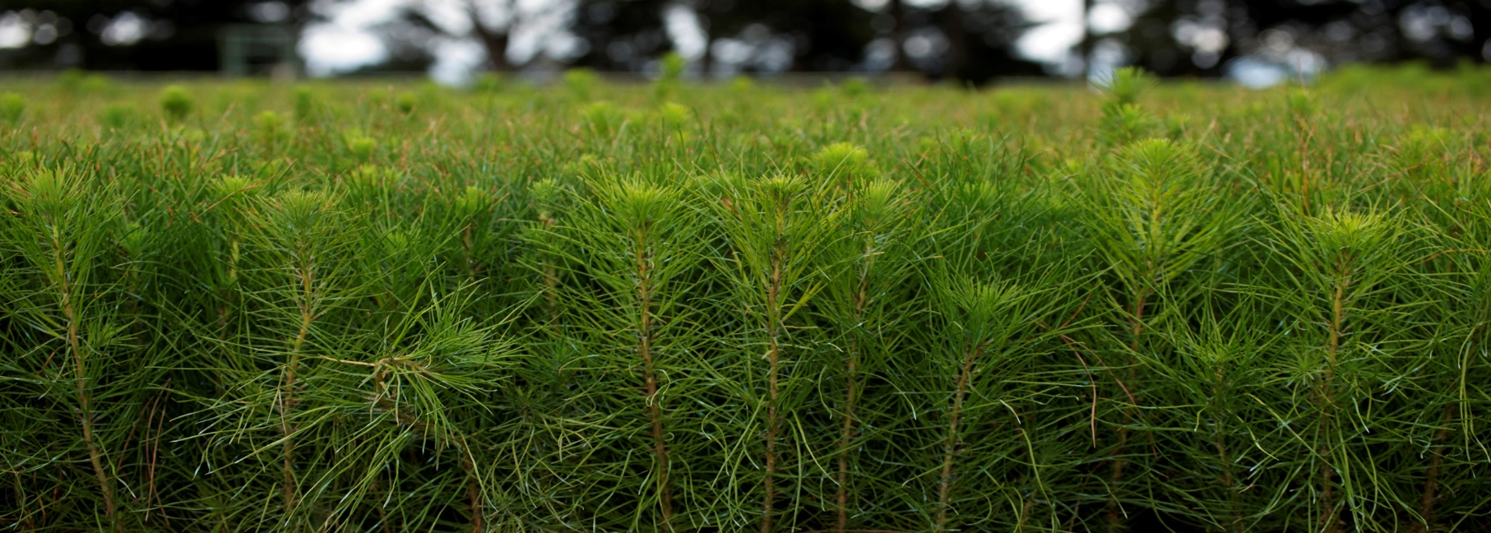

Strategy for strong forestry future

$3.4 million

The Australian Government continues to support the future of the Australian forestry industry, delivering on its commitment to invest more than $300.0 million in the sector.

What’s in this year’s Budget

**The Australian Government will direct $3.4 million to initiatives that will help Australia’s forestry industry to plan for the long term.**

**This funding ensures the government meets its commitments to:**

* Work with stakeholders to review the 1992 National Forest Policy Statement to ensure it meets contemporary objectives for our future wood and fibre needs.
* Support the Strategic Forest and Renewables Materials Partnership and develop a Timber Fibre Strategy, including conducting a roundtable with the forestry sector, industry bodies, states and territories.

Why this is important

Wood products provide important economy-wide, carbon, environmental and social benefits.

The government is taking action through this investment to help the industry plan for the long-term and strengthen its contribution to positive national economic and decarbonisation outcomes.

This funding is part of the government’s suite ofinitiatives supporting innovation and improved capacity and capability in the forestry sector including:

* $100.0 million to establish the Australia-wide National Institute for Forest Products Innovation (operating as Australian Forest and Wood Innovations)
* More than $100.0 million in grant funding through the Accelerate Adoption of Wood Processing Innovation program
* $73.76 million as part of the Support Plantation Establishment program
* $10.0 million through the Forestry Workforce Training Program

How much this will cost

|  |  |  |  |  |  |
| --- | --- | --- | --- | --- | --- |
|  | **2024–25 $m** | **2025–26 $m** | **2026–27 $m** | **2027–28 $m** | **TOTAL $m** |
| **Delivering the Australian Government’s Commitments on Forestry Strategy Development** |  |  |  |  |  |
| Forestry Strategy Development | 0.653 | 0.513 | 0.205 | 0.207 | 1.578 |
| State and Territory Forestry Strategy Funding | 1.160 | 0.624 | - | - | 1.784 |
| **Subtotal** | **1.813** | **1.137** | **0.205** | **0.207** | **3.362** |

More information

For more information about our forestry program visit [agriculture.gov.au](https://www.agriculture.gov.au/agriculture-land/forestry)

For more information about the 2024–25 Budget visit [budget.gov.au](https://budget.gov.au/)