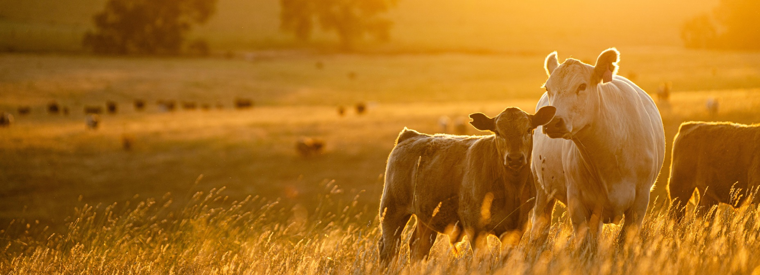**Budget 2024–25: Protecting and growing the future of Australian agriculture**

$789 million

Australian farmers are on the frontline of climate change.

It’s impacting their land, it’s impacting their produce and it’s impacting their bottom line.

The Australian Government is determined to stand with farmers and regional communities to reduce their emissions, while becoming more productive and profitable.

The Budget provides $789.0 million over 8 years to help farmers and producers adapt to the impacts of climate change, build their resilience and maintain Australia’s position as a trusted and reliable trading partner.

New investments in the Budget build on the government’s previous investments in Agriculture, Fisheries and Forestry, worth $3.1 billion over 6 years, which includes more than $1.8 billion of additional funding for biosecurity since May 2022.

Key measures in this Budget include:

* Committing a record $519.1 million to help regional and rural communities prepare for the next drought and manage climate risk through the Future Drought Fund.
* To ensure the agriculture and land sectors can meaningfully contribute to the whole-of-economy transition to net zero, the government is investing $63.8 million in the Agriculture and Land Sector Decarbonisation Plan to support initial emissions reduction efforts.
* Investing $107.0 million to help the Australian sheep industry transition away from live exports, realising the booming opportunities for Australian sheep meat and wool across the globe. This package includes:
  + $64.6 million to assist sheep producers and the supply chain, particularly in Western Australia, to capitalise on existing and emerging opportunities so that they are well positioned when the trade ends.
  + $27.0 million to enhance demand within Australia and internationally for sheep products to maintain and develop market opportunities.
  + $2.6 million to continue to improve sheep welfare standards so that they are practical and meet community expectations.
  + $1.7 million to appoint a Transition Advocate to facilitate two-way communication between industry and government, provide information to industry about the transition plan and support, and provide advice to government on how the transition is progressing.
  + $11.1 million for the implementation of the phase out, including a stocktake of transition progress in 2026–27 and to facilitate ongoing engagement with industry, communities, trading partners and other stakeholders.

Other Budget measures include:

* $13.9 million to ensure the government maintains its readiness for drought.
* $1.9 million for National Farm Safety Week, the continuation of the AgCAREERSTART program and a new skilled agricultural work liaison program.
* $1.5 million to improve arrangements and do consumer research to understand the extent of any consumer confusion caused by plant-based and alternative protein product labelling.
* $3.4 million to implement the government’s plan for forestry, A Future Grown in Australia: A Better Plan for Forestry and Forestry Products.
* $16.9 million for biosecurity services at the new Western Sydney Airport, which is in addition to the $102.0 million that was already provided last year in the Mid-Year Economic and Fiscal Outlook.
* $3.6 million for the Digital Trade Accelerator Program that will strengthen border protection and improve digital information sharing with business to increase productivity and reduce costs.
* $1.7 million to ensure the Australian Fisheries Management Authority can protect our northern waters from the growing threat of illegal fishing, which is a risk to our fishing industry, our biosecurity and our border security.

Why this is important

Australian farmers are among the best in the world at innovation and adaptation, and are constantly improving the way they manage drought and other environmental impacts. These efforts need to continue with effects of climate change increasingly felt by the agricultural sector and across regional Australia.

Protecting our $84.9 billion agriculture, $3.6 billion fisheries $2.3 billion forestry industries is critical to the economic success of the nation and growing our $68.0 billion agriculture export market remains paramount.

Building a strong workforce in the sector, that will be able to take advantage of productivity and technological advances which are essential to the ongoing efficient operation of agricultural businesses is vital, and will secure our access to safe, affordable and sustainable food.

The measures funded in this year’s Budget will ensure we have well-planned and funded policies and programs in place to support the agriculture, fisheries and forestry sector adapt to the impact of climate change, including drought and continue to maintain and grow their ongoing productivity.

More information

For more information visit [agriculture.gov.au](https://www.agriculture.gov.au/budget)

For more information about the 2024–25 Budget visit [budget.gov.au](https://budget.gov.au/)