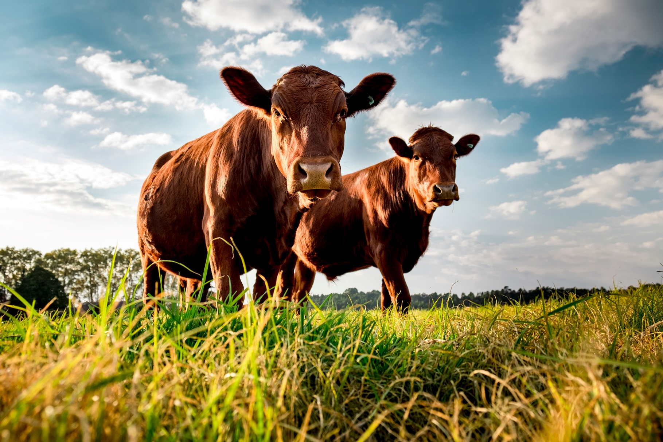



**Driving emissions reduction   
in the agriculture and land sectors**

$63.8 million

The Australian Government is committed to working in partnership with the agriculture and land sectors toward a low emissions future, while improving productivity and profitability. We will do this by investing in new programs built on the knowledge, innovation and ideas of Australian farmers and landholders, ensuring the agricultural industry remains sustainable and increasingly competitive in a net zero economy.

**What’s in this year’s Budget**

**The 2024-25 Budget includes $63.8 million over 10 years from 2024-25 (and $0.9 million per year ongoing) to assist the agriculture and land sectors to further contribute to the whole-of-economy transition to net zero** and make the most of existing and future opportunities. This investment will be jointly administered by the Department of Agriculture, Fisheries and Forestry (DAFF) and the Department of Climate Change, Energy, the Environment and Water (DCCEEW). The package is a direct response to key issues raised by stakeholders on the Agriculture and Land Sector Plan and will support the sector to reduce emissions by:

* **steering and driving fundamental research and innovation in the agriculture sector that will drive emissions reductions**
* accelerating on-ground action to reduce agriculture and land emissions through the upskilling of trusted advisors
* improving the estimation and reporting of agriculture and land sector emissions at both the national level and on-farm to underpin a climate-smart sector in a low-emissions future.

**Investments will also strengthen First Nations engagement and participation to enable to agriculture sector to draw benefits from traditional knowledge and support First Nations agriculture enterprise.**

**Partnering to drive innovation**

The Australian Government will fund $4.4 million over 10 years from 2024-25 for the Department of Agriculture, Fisheries and Forestry (DAFF) to become a formal partner to the Zero Net Emissions from Agriculture Cooperative Research Centre (ZNE Ag CRC) for the full lifespan of the CRC.

The ZNE Ag ACRC, to be established on 1 July 2024, will be a major vehicle for long-term research required to support emissions reduction from Australian agriculture.

Partnering with the ZNE Ag CRC will ensure the Australian Government is actively involved in this important initiative for a lower emissions future to drive positive outcomes for the sector.

Meaningful emissions reduction from agriculture depends strongly on innovation and research and development. Enhanced coordination and collaboration will increase the likelihood of achieving important R&D outcomes, and at a faster rate.

**Accelerating on-ground action**

The Australian Government is prioritising training, education and capacity building to accelerate on-ground action to reduce agriculture and land emissions. This funding will provide a significant boost to the national effort on outreach for on-ground action. We will do this by upskilling existing independent and trusted advisors to support farmers and land managers to integrate emissions reduction knowledge and practices into their core business.

**$30.8 million over 4 years will build on the existing Carbon Farming Outreach Program and will:**

* **provide additional train-the-trainer sessions to trusted advisors including within existing Commonwealth programs such as the Future Drought Fund**
* **establish a knowledge-bank to integrate the existing training with tailored resources for First Nations peoples and information on nature positive and climate-smart farms**
* **provide grants for Rural Research and Development Corporations (RDCs) to develop commodity-specific information for the ‘knowledge-bank’ and connect existing best practice to extension activities for faster adoption of lower emission solutions.**

**Improving Greenhouse Gas Accounting at national to farm levels**

As supply chains, international markets and the finance sector require increasing engagement from farmers and land managers to report on their emissions, access to enhanced measurement and reporting is essential and will unlock more abatement opportunities in the agriculture and land sector.

Empowering the agriculture and land sector with improved estimation and reporting mechanisms will drive action to reduce emissions, increase carbon sequestration and ensure abatement interventions contribute to Australia’s emissions reduction targets.

$28.7 million over 10 years (inclusive of 0.9 million ongoing from 2028–29) will improve greenhouse gas accounting in the agriculture and land sector at the national through to farm level. Funding will be used to:

* enhance the National Greenhouse Accounts methods and data collection processes
* develop, publish and maintain voluntary emissions estimation and reporting ‘standards’ for the agriculture, fisheries and forestry industries.

This measure seeks to leverage the significant investment industry and the private sector have already made in support of on-farm accounting.

Key stakeholders will be engaged in the implementation of these measures through the establishment of a technical advisory group and a reference group that will include representatives from industry, agtech providers, supply chain participants, the finance sector and First Nations Groups.

Why this is important

Australia has committed to reach net zero emissions by 2050. This target is ambitious and will require significant action across the economy. Agriculture will have an important role to play – as a sector with emissions, but also as a sector that manages large parts of Australia’s land. Meeting these commitments will help position Australia’s agriculture sector to take advantage of shifts in markets that are expected to flow from global transition toward lower emissions.

The agriculture sector continues to contribute essential knowledge and ideas to help identify current and future climate-smart opportunities. This investment represents a commitment from the Australian Government to work in partnership with the agriculture sector in charting its role in a net zero economy.

How much this will cost

|  |  |  |  |  |  |
| --- | --- | --- | --- | --- | --- |
|  | **2024–25 $m** | **2025–26 $m** | **2026­–27 $m** | **2027–28 $m** | **TOTAL $m** |
| **Agriculture and Land Sectors  – low emissions future** |  |  |  |  |  |
| Partnering to drive innovation 1 | 0.545 | 0.529 | 0.499 | 0.482 | 2.055 |
| Accelerating on-ground action | 10.911 | 11.014 | 4.408 | 4.460 | 30.793 |
| Improving GHG accounting at national  to farm levels2 | 6.950 | 6.221 | 5.712 | 4.234 | 23.118 |
| **Subtotal** | **18.406** | **17.764** | **10.619** | **9.176** | **55.966** |

$300,000 partnership payment per annum until 2033-34, supported by $1.4 million in departmental funding.

2 Includes $0.9 million ongoing from 2028 until 2037-38.

Total funding over a 10-year life span is $63.846 million. Numbers may not add up due to rounding.

More information

For more information about our Agriculture and Land package visit [agriculture.gov.au](https://www.agriculture.gov.au/agriculture-land/farm-food-drought/climatechange/ag-and-land-sectoral-plan).

For more information about the 2024–25 Budget visit [budget.gov.au](https://budget.gov.au/).