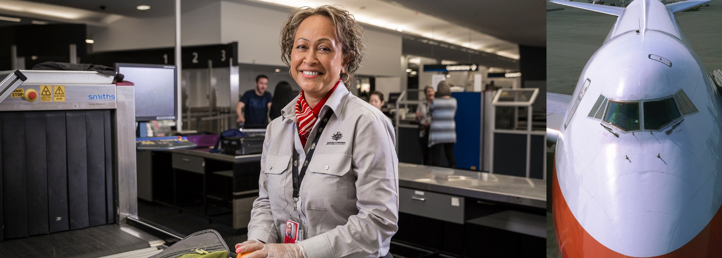



Boost to Biosecurity funding package for Western Sydney International Airport fit-out

$16.9 million

The Australian Government is committing $16.9 million over 4 years to further enhance and support our biosecurity screening measures at Western Sydney International Airport.

**This builds on the $102.7 million allocation for Western Sydney Airport that was announced in the 2023–24 Mid-Year Economic and Fiscal Outlook and 2023–24 Budget.**

**Protecting Australia from potentially devastating pest and disease outbreaks is paramount to a secure economy, export markets and production industries, which ABARES forecasts to be worth more than $90 billion in 2024**–**25.**

**The Australian Government’s biosecurity measures protect our production commodities:**

* $84.9 billion agriculture,
* $3.6 billion fisheries
* $2.3 billion forestry industries

**Approximately 70% of our agricultural, fisheries and forestry production are exported, ABARES estimates the value of these exports for 2024**–**25 to be $68.1 billion.**

**When opened, the new Western Sydney International Airport introduces another international traveller and trade access point requiring establishment costs to protect Australian agriculture industries from biosecurity threats.**

What’s in this year’s Budget

A strengthened biosecurity system secures better economic outcomes for producers and related industries and protects Australia’s environment, biodiversity and our people.

In 2023–24, 16.6 million international travellers entered Australia. The Australian Government is committing a further $16.9 million and $0.5 million ongoing from 2028–29 for the Western Sydney International Airport to provide contemporary technology and specialist equipment to support frontline biosecurity operations in dealing with constantly evolving global risks to Australia’s agriculture, environment and human health.

When it opens, Western Sydney International Airport will be one of Australia’s busiest airports. Continued investment for the Western Sydney International Airport ensures Border Agencies are equipped to manage security and biosecurity risks when the airport commences operations.

**Western Sydney International Airport Biosecurity Capability and Terminal Facilities**

**The Australian Government is supporting our frontline biosecurity capability with the facilities design and fit-out of specialist technology and equipment for** the passenger terminal and shared Commonwealth standalone facilities (Command Centre, canine and cargo examination facilities) at Western Sydney International (Nancy-Bird Walton) Airport (WSI)**.**

**The investment will enable the biosecurity officer workforce to screen and assess biosecurity risks associated with incoming passengers, crew, cargo and animals to protect Australia’s agriculture sector from pests and diseases.**

**Funding for Western Sydney International terminal facilities**

* Cross agency funding for supply and fit-out of the terminal and standalone facilities with ICT network and infrastructure;
* non-ICT specialist equipment, including (but not limited to) border processing equipment, such as x-ray screening technology mobile plant, vehicles and scientific laboratory equipment to undertake essential pest and disease diagnostics;
* supply and fit-out the Detector Dog facility with required equipment and specialist services for canine care (such as medication, veterinarian costs, food and living supplies); and
* extension of program management resourcing essential to delivering the design, fit-out, testing, commissioning and operationalisation of Border Agency systems and services necessary for day one international freight and passenger operations at WSI.

Why this is important

Continuing to invest in the biosecurity system demonstrates the importance the Australian agriculture sector plays for all Australians lives, from producers, employees and export markets and our environment and way of life. Investment in specialist technology and equipment underpins contemporary risk management to meet evolving global biosecurity threats to complement a leading aviation and economic Agribusiness precinct.

It provides essential capability to support offshore and on-arrival informed risk assessment and decision-making about security and biosecurity risks. This investment builds our future ability to meet growth in international travel and trade and securing Australia to enhance its global competitiveness, which eases pressure on Australian households through expanded and diverse market choice.

Border Agencies are using the design and construction phases to integrate systems and operating models, using shared building and operational facilities to realise economies of scale and optimising shared technology to deliver streamlined regulatory services.

How much this will cost

|  |  |  |  |  |  |
| --- | --- | --- | --- | --- | --- |
|  | **2024–25 $m** | **2025–26 $m** | **2026–27 $m** | **2027–28 $m** | **TOTAL $m** |
| Western Sydney International Airport Biosecurity Capability and Terminal Facilities | 5.464 | 5.555 | 4.668 | 1.252 | 16.939 |

* and $0.5 million ongoing from 2028–29.

More information

For more information about our Biosecurity efforts visit [agriculture.gov.au](https://www.agriculture.gov.au/biosecurity-trade)

For more information about the 2024–25 Budget visit [budget.gov.au](https://budget.gov.au/)