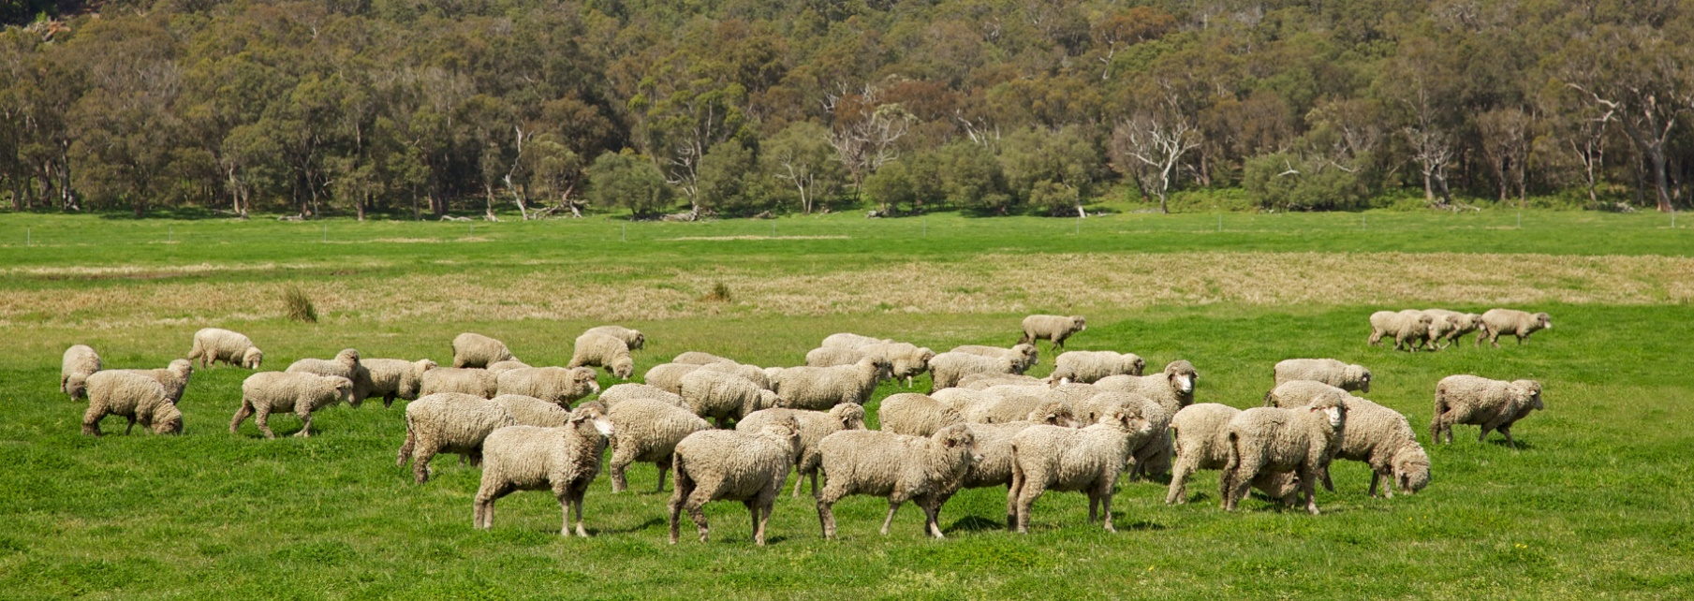**Phase Out of Live Sheep Exports by Sea – transition support**

**$107 million**

The Australian Government is delivering on its election commitment to phase out live sheep exports by sea from Australia.

Live sheep exports by sea will end on 1 May 2028. Legislation will be introduced in this term of government to enact the end date.

**What’s in this year’s Budget**

The 2024-25 Budget includes $107.0 million over 5 years from 2024-25 for transition support for the phase out of live sheep exports by sea.

* $64.6 million to assist sheep producers and the supply chain, particularly in Western Australia, to capitalise on existing and emerging opportunities so that they are well positioned when the trade ends. Funding will assist businesses to plan and implement transition actions and to expand domestic sheep processing capacity. It will also support community wellbeing activities and rural financial counsellors.
* $27.0 million to enhance demand within Australia and internationally for sheep products to maintain and develop market opportunities. With a range of delivery partners, including Austrade, this will fund activities such as market analyses, consumer studies, product promotions and building business relationships. Agricultural counsellors and Austrade will also work to support diverse trade to and relationships in the Middle East and North Africa region.
* $2.6 million to continue to improve sheep welfare standards so that they are practical and meet community expectations and for Australia to enhance its engagement in the World Organisation for Animal Health.
* $1.7 million to appoint a Transition Advocate to facilitate two-way communication between industry and government, provide information to industry about the transition plan and support, and provide advice to government on how the transition is progressing.
* $11.1 million for the implementation of the phase out, including a stocktake of transition progress in 2026-27 and to facilitate ongoing engagement with industry, communities, trading partners and other stakeholders.

**Why this is important**

The transition support provides individuals, communities and businesses with the opportunity to be resilient, well positioned and ready when the trade ends in 2028.

The funding provides for a range of complementary actions for sheep producers and the supply chain, market development, improving sheep welfare and for the implementation of the phase out and stakeholder engagement.

The independent panel recommended early action by government to support the transition away from export of live sheep by sea. The impact of the phase out can be moderated through decisions taken by the supply chain from now. Early action is encouraged with these commitments.

How much this will cost

|  |  |  |  |  |  |  |
| --- | --- | --- | --- | --- | --- | --- |
|  | **2024-25 $m** | **2025-26 $m** | **2026-27 $m** | **2027-28 $m** | **2028-29 $m** | **TOTAL $m** |
| **Phase out of live sheep exports by sea - transition support(a)** |  |  |  |  |  |  | |
| Phase out of live sheep exports by sea - transition support | 23.657 | 32.067 | 27.689 | 22.026 | 1.543 | 106.983 | |
| **Subtotal** | **23.657** | **32.067** | **27.689** | **22.026** | **1.543** | **106.983** | |

1. The lead entity for this measure is the Department of Agriculture, Fisheries and Forestry with some program delivery being undertaken by other Commonwealth agencies. This measure builds on the 2023–24 Budget measure titled Phase Out of Live Sheep Exports by Sea – independent panel.

More information

For more information visit [agriculture.gov.au/live-sheep-phase-out](https://www.agriculture.gov.au/live-sheep-phase-out)

For more information about the 2024–25 Budget visit [budget.gov.au](https://budget.gov.au/)