Attachment 1
Registration information for China International Trade Single Window System
The Single Window is owned and administered by the General Administration of Customs of the People’s Republic of China (GACC) and the department does not have oversight of the information submitted.
The department has developed registration information that are general in nature and should not be taken as definitive or exhaustive. The instructions are current to the version of the Single Window System available as at 26 November 2021 and may be subject to change.
The China International Trade Single Window system can be accessed through the following link: www.singlewindow.cn
Registration is based on the physical location of the facility. Each location needs to be registered separately. Brand owners using contract manufacturers should not register but ensure each contract manufacturer completes the self-register process. Contract manufacturers only need to self-register once. Freight forwarders providing transitory storage services do not need to apply.
The Single Window is in Chinese only.
STEP 1
This link will take you to the landing page below. As you can see, the information on this page will be in Chinese language. The department suggests navigating to Step 2 without using automatic translation functions as this may affect the formatting of the webpage.
By clicking on the ORANGE tab at the top right-hand corner of the screen (circled) which will take you to the ‘new single window portal’.
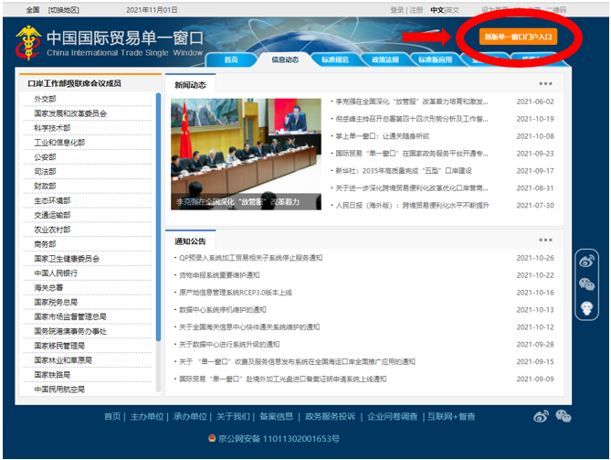

STEP 2
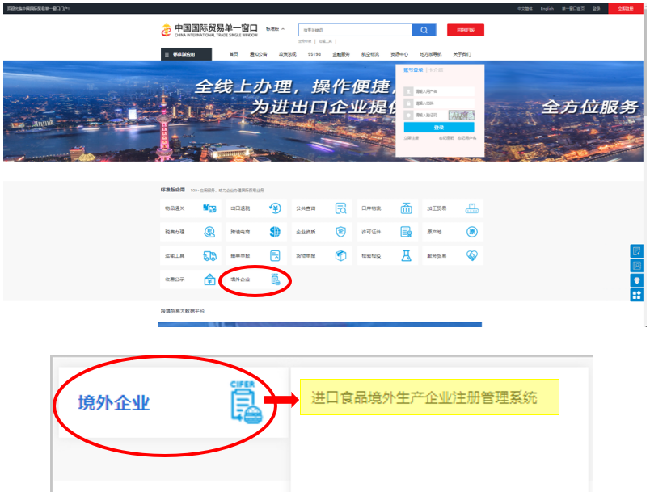
You will now be directed to the webpage below. Hover your mouse over the tab with the word ‘CIFER’, clipboard and hamburger icon (circled below). This translates to ‘Overseas business’ or ‘Foreign enterprise’. This will open a second box with a link, which translates to the ‘registration management system for overseas production enterprises of imported food’ (yellow highlight). Click on this link (yellow highlight) to progress to Step 3.

STEP 3

You will now see the following webpage below.

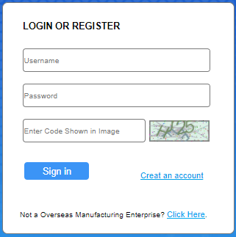
If you have already created an account with the China International Trade Single Window System, enter your username and password in the fields below and progress to Step 4.

If you have not created an account with the China International Trade Single Window System, click on the ‘create an account’ link (circled).
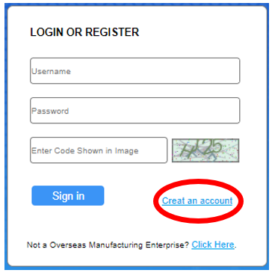

You will then be directed to the following webpage form where you will need to fill out the applicable details. Note that only the fields marked with a red Asterix/star are mandatory.
Usernames are required to be between 6-18 characters. A mixture of letters and numbers can be used.
Passwords need to be 8-16 characters with at least one upper and lower case letter, a number and a symbol.
Note:
- The country abbreviation for Australia is AUS.
- The form will have a field which requests the ‘Approval NO’, which the department understands is where you should enter your registration number approved by the competent authority in the country in which you are located or your GACC number. Refer to MAA2021-46 (Dairy), MAA2021-26 (Seafood), MAA2021-20 (NPG) further guidance on registration numbers.
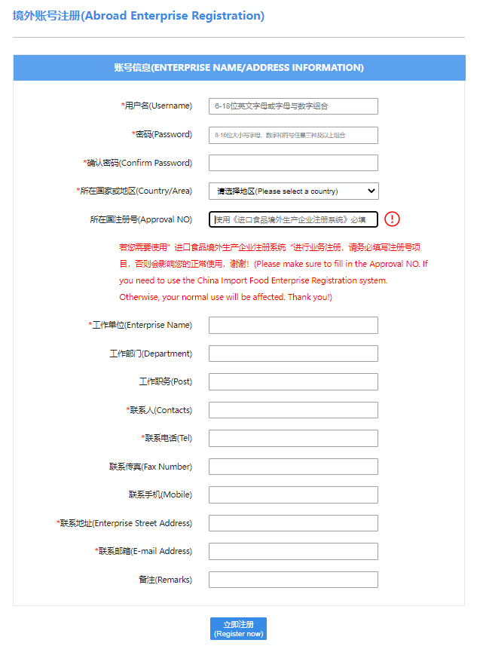

STEP 4
You should now see the following webpage. The information on the webpage will be in Chinese language, however depending on the web browser you are using, you may have the option of an English translation. Note that automatic translations may not be an accurate representation of the information.
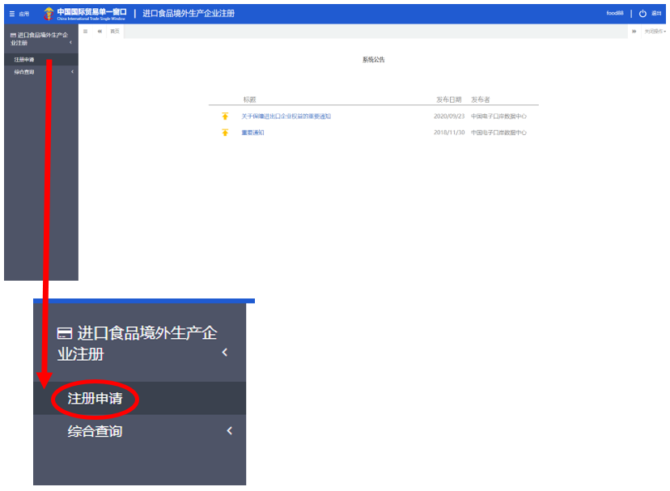
On the left-hand side of the screen, click the grey tab circled in red below. This translates to ‘registration application’.

STEP 5
The following webpage will appear, which shows a comprehensive list of food product categories. Note that the commodities listed are divided into two categories;
- Foods which require recommendation by the competent authority of the located country/region for registration with GACC (that is meat, dairy, seafood and Article 7 foods) *Note: GACC is developing new applications for these food groups, please refer to Section 4 of MAA2021-46 (Dairy), MAA2021-26 (Seafood), MAA2021-20 (NPG).
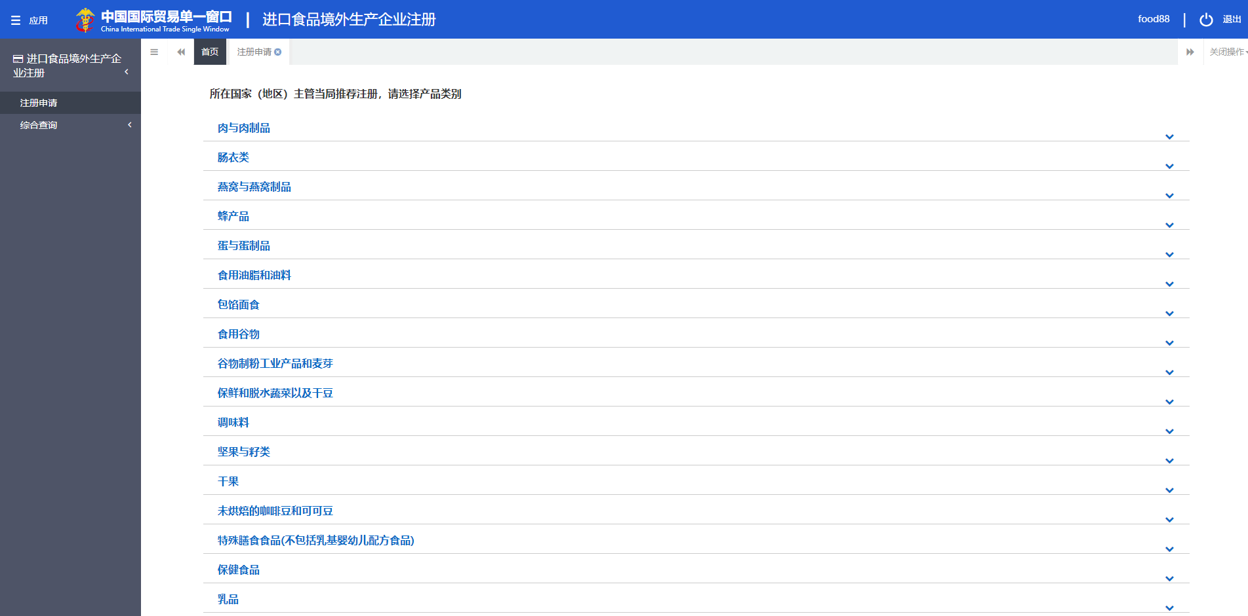
- Foods which require self-registration with GACC (Article 9 foods)

Select the appropriate food category that you wish to register for your food processing or storage facility. An example has been provided below which translates to ‘candy, chocolate (including chocolate, cocoa butter chocolate and its products).
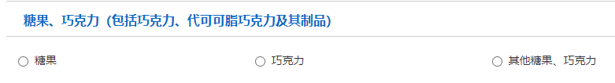

STEP 6
An application form will then open for you to fill out the appropriate details. An example of this form is provided below. Note it may be difficult to amend your application once submitted. For further information please refer to MAA2021-46 (Dairy), MAA2021-26 (Seafood), MAA2021-20 (NPG).
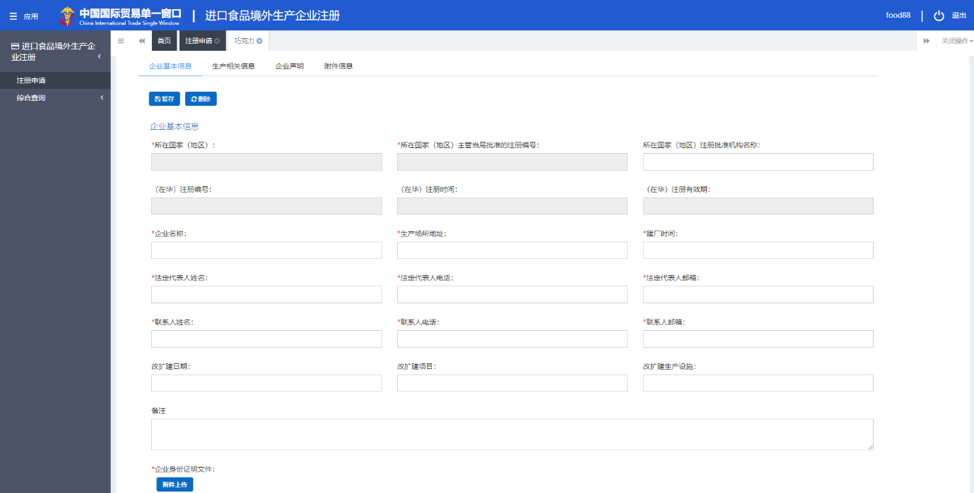
As the self-registration process with GACC is a commercial activity, the department encourages food storage and processing facilities to seek advice from their importer or agent in China should they require further information.

Article 7 foods include casings, bee products, eggs and egg products, edible fats and oils, stuffed wheaten food, edible grains, milled grain products and malt, fresh-kept/ preserved and dehydrated vegetables and dry beans, condiments and seasonings, nuts and seeds, dry fruits, unroasted coffee and cocoa beans, food for special dietary uses, health/ functional foods.
Article 9 foods include all food categories that are not meat, dairy or seafood and are not an Article 7 food.

