**ADDENDUM to the 2015 State Party Report on the state of conservation of the Great Barrier Reef World Heritage Area (Australia), 6 March 2015**

This Addendum reports on significant recent policy changes that have occurred since Australia submitted its State Party Report on the Great Barrier Reef on 29 January 2015. It also provides further clarification on issues raised by the UNESCO World Heritage Centre and IUCN during Australia’s ongoing discussions on the state of conservation of the Great Barrier Reef.

As this Addendum supplements information already provided in the State Party Report, Australia is pleased to authorise the upload of this additional information and the accompanying letter from the Australian Minister for the Environment, the Hon Greg Hunt MP, to the World Heritage Centre’s state of conservation website.

This Addendum should be read in conjunction with the State Party Report and the Reef 2050 Long-Term Sustainability Plan.

Finalisation of the Reef 2050 Long-Term Sustainability Plan was delayed due to a state election in Queensland in late January 2015. A new Queensland Government was confirmed in mid-February 2015 and the Reef 2050 Plan has since been finalised to reflect the policies of the new Queensland Government. These policies are also outlined in this Addendum.

**Addressing climate change**(to be read in conjunction with Chapter 3.1 of the State Party Report)

In addition to the climate change mitigation measures the Australian Government is undertaking as indicated on page 24 of the State Party Report, the new Queensland Government will contribute to carbon emission reduction efforts by enhancing practical regulatory controls on the clearing of remnant and high value regrowth vegetation and boosting support for the take-up of renewable energy technology.

The Queensland Government is also developing a partnership-driven adaptation strategy to reduce risks to the State’s economy, environment, infrastructure and communities from current and future climate impacts. This strategy will incorporate measures which contribute to the resilience of the Great Barrier Reef. Queensland coastal planning laws will be modernised to take into account the projected effects of climate change and ensure uptake in State, regional and local planning and development decisions.

Correction: The National Environmental Science Programme is a long term commitment to environment and climate research with funding of $142.5 million over six years from 2015. On page 25 of the State Party Report this funding was inadvertently referred to as annual funding of $142.5 million over six years.

**Managing land-based run-off**(to be read in conjunction with Chapter 3.2 of the State Party Report)

In addition to its $35 million a year investment in improving water quality, the new Queensland Government has committed an additional $100 million over five years towards water quality initiatives, scientific research and helping business transition to better environmental practices in the primary production and fishing industries. This further investment will focus on reducing nutrient and sediment loads to minimise the effect of land‑based run-off in Reef catchments, helping to build the Reef’s resilience to climate change.

The new Queensland Government has also announced ambitious additional water quality measures to supplement the 2013 Reef Water Quality Protection Plan (Reef Plan) targets. By 2025, in key Reef catchments such as the Wet Tropics and the Burdekin, these new targets include:

* Up to an 80 per cent reduction in nitrogen run-off, and
* Up to a 50 per cent reduction in total suspended sediment run-off.

As a priority, the Queensland Government will seek the advice of a high-level taskforce to advise on the best possible approach to achieve the 2025 targets for pollution run-off into the Great Barrier Reef. The taskforce will be required to report within a year of commencement on the effectiveness and cost of robust regulations, a market based trading mechanism or a combination thereof.

In addition, the new Queensland Government will introduce riverine protection permits to guard against excessive clearing of riparian vegetation and, until advice is received from the high-level taskforce, will require farmers in relevant catchments to operate under Environmental Risk Management Plans unless they have been accredited to best management practice standards.

**Coastal land-use change: improved assessment and planning**(to be read in conjunction with Chapter 3.3 in the State Party Report)

In addition to the coastal land-use measures indicated on page 27 of the State Party Report, Queensland will strengthen its laws to ensure that development on the Queensland coast does not disadvantage the Great Barrier Reef. Specifically, Queensland will:

* strengthen vegetation management laws to protect remnant and high value regrowth native vegetation (including in riparian zones)
* strengthen coastal planning laws based on the best available science, making allowance for expected sea level rise, protecting ecologically important areas such as wetlands and prohibiting development in high-hazard greenfield areas, and
* ensure ecologically sustainable regulation of water extraction in catchments leading to the Great Barrier Reef.

**Limiting impacts of ports and dredging**(to be read in conjunction with Chapter 3.4 of the State Party Report)

The State Party Report stated on page 5 that a permanent ban would be placed on the disposal of capital dredge material in the Great Barrier Reef Marine Park from major capital dredging projects. This ban will now apply to the disposal of material from all capital dredging projects. Similarly, on page 29 the State Party Report indicated the Australian Government will use its regulatory powers to permanently ban the disposal of capital dredge material in the Great Barrier Reef Marine Park from any future major port development. This ban will now apply to all disposal of capital dredge material in the Great Barrier Reef Marine Park.

In addition, the new Queensland Government will, through current and new legislation:

* Protect greenfield areas by restricting new port development in and adjoining the Great Barrier Reef World Heritage Area to within current port limits. These port limits are long-established and fixed in regulations under the *Transport Infrastructure Act 1994* (Qld).
* Restrict capital dredging for the development of new or expansion of existing port facilities to within the regulated port limits of Gladstone, Hay Point/Mackay, Abbot Point and Townsville.
* Ensure that any new development inside these port limits is also consistent with the Great Barrier Reef Marine Park Act, the Queensland Marine Parks Act, their regulations and zoning plans.
* Prohibit the sea-based disposal of material into the Great Barrier Reef World Heritage Area generated by port related capital dredging.
* Require master plans at the major ports of Gladstone, Hay Point/Mackay, Abbot Point and Townsville which optimise infrastructure and address operational, economic, environmental and social relationships as well as supply chains and surrounding land uses.
* Support on-land disposal or land reclamation for dredge material at Abbot Point.
* The Queensland Government will require all proponents of new dredging works to demonstrate their project is commercially viable.
* Not support transhipping operations that adversely affect the Great Barrier Reef Marine Park.
* Establish a maintenance dredging framework which identifies future dredging requirements, ascertains appropriate environmental windows to avoid coral spawning and protect seagrass, and examines opportunities for beneficial reuse of dredge material or on land disposal where it is environmentally safe to do so.
* Further protect the Fitzroy Delta, including North Curtis Island and Keppel Bay, which are clearly outside the Gladstone Port Area, through extension and strengthened conservation zoning in the Great Barrier Reef Coast Marine Park, extension of the existing Fish Habitat area, establishment of a new net free zone under fisheries legislation, and additional protections in associated inter-tidal and terrestrial areas.
* Mandate the beneficial re-use of port related capital dredge spoil, such as land reclamation in port development areas, or disposal on land where it is environmentally safe to do so.

For clarity, **Annex A** to this Addendum contains four maps showing where port development may occur subject to the Great Barrier Reef Marine Park Act, the Queensland Marine Parks Act, their regulations and zoning plans. The maps will also be made available at http://www.environment.gov.au/marine/gbr

The Overview of Australia’s progress against the 2011-2014 World Heritage Committee decisions and 2012 Mission recommendations (Appendix 2 of the State Party Report) has been updated to reflect these changes and is **Annex B** to this Addendum.

The Chronology of key management responses to emerging issues from the 1970s to the present that appears at Appendix 3 of the State Party Report has been updated to reflect the policy and legislative amendments referred to above. The revised table is **Annex C** to this Addendum.

The status of capital dredging projects adjacent to the Great Barrier Reef coast at Appendix 5 of the State Party Report (page 60) has been updated to reflect these changes. The revised table is provided in Appendix F of the Reef 2050 Long-Term Sustainability Plan.

**Ensuring direct use is sustainable**(to be read in conjunction with Chapter 3.5 of the State Party Report)

Australia will build on its already very strong management of shipping and fishing in the Great Barrier Reef to further reduce the potential impact of direct-use activities. Australia is also considering the development of a new classification for bulk vessels travelling through the World Heritage Area.

Since the State Party Report was delivered, the new Queensland Government has announced it will not support trans-shipping projects that adversely affect the Great Barrier Reef Marine Park.

Three new net-free fishing zones will be established and a fisheries allocation policy will be adopted in Queensland that maximises the value of a sustainable commercial catch.

Correction: page 30 of the State Party Report incorrectly listed the size of the four largest ports in the Reef region as Gladstone (20 berths); Townsville (10 berths); Hay Point (6 berths); and Abbot Point (2 berths).Gladstone has 18 berths and Townsville has 9 berths. This further emphasises that these ports are very small compared to the megaports of China, Singapore, Europe and the United States, which have 75 to 250 shipping berths.

**Implementation and investment**(to be read in conjunction with Chapter 3.6 of the State Party Report)

The new Queensland Government has announced it will invest an additional $100 million over five years towards improving water quality, expanding scientific research, and securing better agricultural and grazing practices and more sustainable fisheries. This funding is in addition to Queensland’s existing $35 million per year investment, and will focus on reducing nutrient and sediment loads to minimise the effect of land-based run-off in Reef catchments to build the Reef’s resilience.

The finalised Reef 2050 Long-Term Sustainability Plan includes details of the significant investment at all levels of government to support the resilience of the Reef, the principles which will guide investment decisions and an outline of how the investment framework will support implementation of the Plan.

The Reef 2050 Long-Term Sustainability Plan will be made a schedule to the *Great Barrier Reef Intergovernmental Agreement 2009*. This will provide a strong governance framework for Australian and Queensland Governmentactions to protect the Reef.

**Strengthened legislation and governance**(to be read in conjunction with Chapter 3.7 of the State Party Report)

A new National Dugong and Turtle Protection Plan is being implemented to better protect dugong and turtle populations off Far North Queensland and the Torres Strait from the threats of poaching, illegal hunting and marine debris.

Since the submission of the State Party Report, agreement has been reached in the Australian Parliament to increase the maximum criminal and civil financial penalties for taking or injuring turtles and dugong in Commonwealth marine areas and the Great Barrier Reef Marine Park.

**Conclusion**

Australia attaches the utmost importance to meeting its obligations to maintain the Outstanding Universal Value of the Reef.

Australia regards the Reef as an important natural icon. Management of the Great Barrier Reef has been a priority for four decades. Severe weather events and cumulative impacts have taken a toll on the Reef’s health over recent years, and Australia acknowledges that it will take time to turn around the overall outlook for the Reef and to improve its resilience and capacity to recover. The State Party Report, this Addendum, and critically, the Reef 2050 Long-Term Sustainability Plan provide strong evidence that Australia has made unprecedented progress, including a comprehensive response to all the recommendations of the World Heritage Committee and those of the 2012 UNESCO World Heritage Centre/IUCN reactive monitoring mission.

With strong action being taken to address the threats to the Reef across all levels of government, Australia considers that the property retains its Outstanding Universal Value and will continue to do so for future generations.

The property does not warrant ‘in danger’ listing.

**ATTACHMENTS**

**ANNEX A** – Maps: Port Areas and Marine Park Zones

**ANNEX B** – Updated Appendix 2 to the 2015 State Party Report: Overview of Australia’s progress against the 2011-2014 World Heritage Committee decisions and 2012 Mission recommendations

**ANNEX C** – Updated Appendix 3 to the 2015 State Party Report: Chronology of key management responses to emerging issues, 1970s to present

**ANNEX A:** **Maps – Port Areas and Marine Park Zones**

Map 1: Port of Gladstone Area

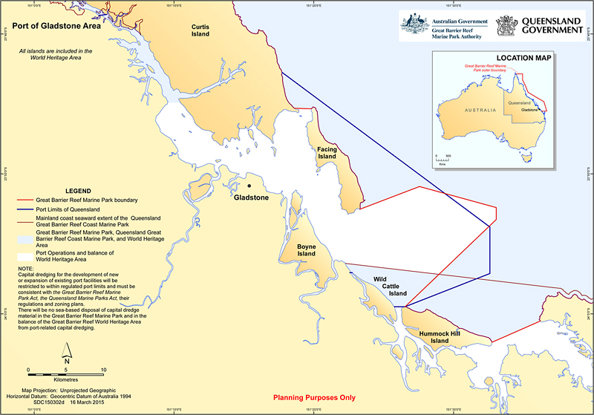

Map 2: Port of Hay Point Area

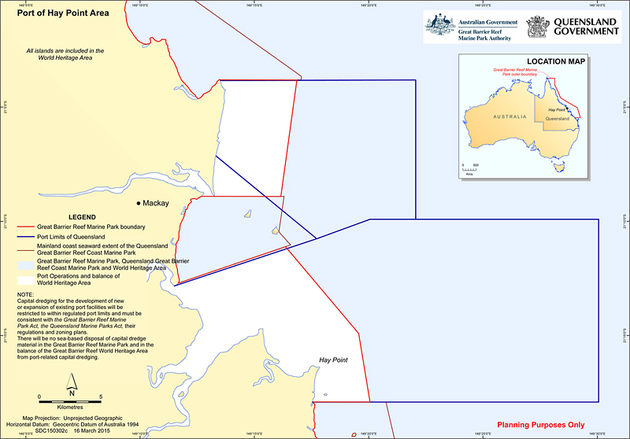

Map 3: Port of Abbot Point Area

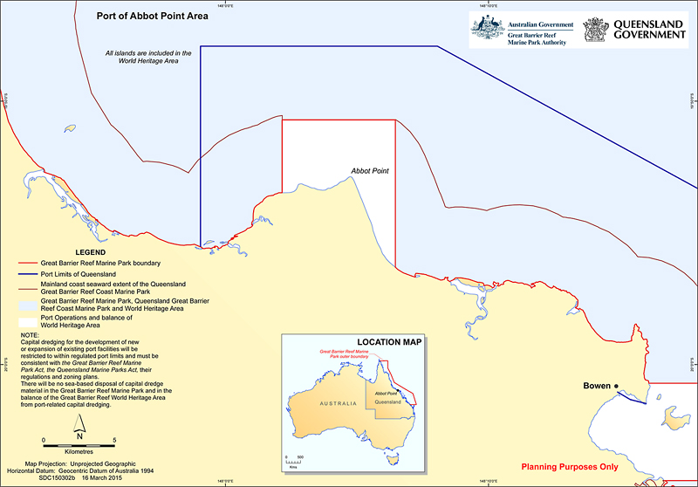

Map 4: Port of Townsville Area

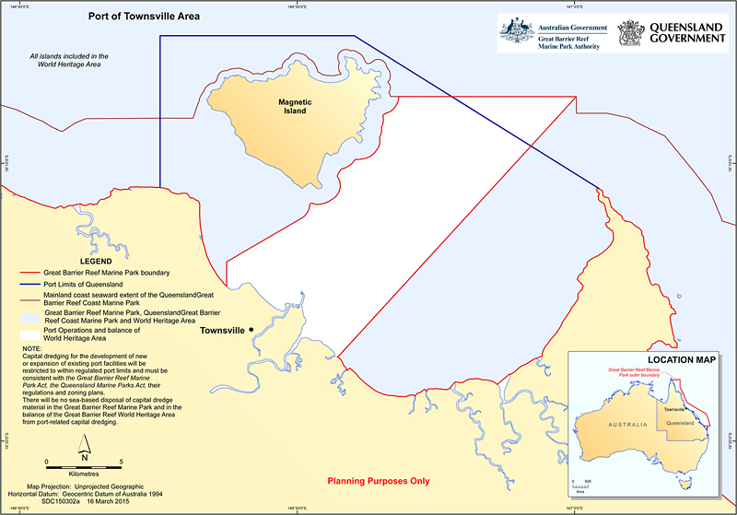

# aNNEX B: Appendix 2 from 2015 STate Party Report on the Great barrier reef, updated on 6 March 2015

# Overview of Australia’s progress against the 2011–2014 World Heritage Committee decisions and 2012 Mission recommendations

| **Subject (synthesis of World Heritage Committee decisions and Mission recommendations)** | **Status** | **Summary of Australia’s progress** | **2014 38 COM 7B.63 para #** | **2013 37 COM 7B.10 para #** | **2012 36 COM 7B.8 para #** | **Mission recommendation #** | **2011 35 COM 7B.10 para #** |
| --- | --- | --- | --- | --- | --- | --- | --- |
| **1. MAINTAINING AND ENHANCING OUTSTANDING UNIVERSAL VALUE** | | | | | | | |
| **1.1 Ensure all components of the Outstanding Universal Value of the Great Barrier Reef World Heritage Area (GBRWHA) are clearly defined and form a central element within the protection and management system** | **In place** | • In 2014 the **EPBC Act Referral Guidelines for the Outstanding Universal Value of the Great Barrier Reef World Heritage Area** were finalised. The guidelines are based on the Statement of Outstanding Universal Value of the GBRWHA approved by the World Heritage Committee in 2012. <http://www.environment.gov.au/resource/epbc-act-referral-guidelines-outstanding-universal-value-great-barrier-reef-world-heritage>.  • In the Strategic Environmental Assessment the Queensland Government and GBRMPA committed to explicit consideration of Outstanding Universal Value in decision-making and planning.  • The **Reef 2050 Long-Term Sustainability Plan** and the **North-East Shipping Management Plan** explicitly consider the Outstanding Universal Value and integrity of the GBRWHA. |  |  | **7** | **9** |  |
| **1.2 No development to impact individually or cumulatively on the Outstanding Universal Value of the property** | **In place** | • The ***Environment Protection and Biodiversity Conservation Act 1999*** ensures that the protection of the values of World Heritage properties is achieved in environmental assessment decisions. Developments with an unacceptable impact on the Reef are not approved.  • The *Great Barrier Reef Marine Park Act 1975* requires consideration of the potential impact of proposed activities on the heritage values of the Marine Park.  • The Strategic Environmental Assessment includes commitments to prepare Cumulative Impact Assessment Guidelines and a Net Benefit Policy to guide decision-making. <http://www.environment.gov.au/environment-assessments>. | **7 & 8a** | **6a** | **5 & 6** | **2, 7, 8 & 13** |  |
| **1.3 Ensure legislation remains strong and adequate to maintain and enhance Outstanding Universal Value** | **In place** | Australia has a comprehensive legislative regime in place, including the following:  • Development proposals considered under national and state laws are assessed with enhanced consideration and understanding of the Outstanding Universal Value of the GBRWHA, utilising the **EPBC Act Referral Guidelines for the Outstanding Universal Value of the Great Barrier Reef World Heritage Area**.  • Australia will deliver a **single streamlined process for environmental assessments and approvals** that maintains existing high environmental standards including explicit consideration of the Outstanding Universal Value and integrity of the property when development proposals are being considered.  • The Queensland Government has amended legislation to reflect this commitment, allowing for the judicial review of approval decisions in relation to matters of national environmental significance, and to provide the power to put conditions in place to protect matters of national environmental significance, including World Heritage properties. The Queensland Government has amended the *Environmental Protection Act 1994* to formally recognise the GBRWHA with maximum penalties for wilful environmental harm raised to over $710 000 for individuals and $3.56 million for corporations plus costs of restoration. Gaol terms have also increased from two to five years.  • The Australian Government will use its regulatory powers to permanently ban the disposal of capital dredge material in the Great Barrier Reef Marine Park.  • The new Queensland Government will, through current and new legislation:  Protect greenfield areas by restricting new port development in and adjoining the Great Barrier Reef World Heritage Area to within current port limits. These port limits are long-established and fixed in regulations under the Transport Infrastructure Act 1994 (Qld).  Restrict capital dredging for the development of new or expansion of existing port facilities to within the regulated port limits of Gladstone, Hay Point/Mackay, Abbot Point and Townsville.  Ensure that any new development inside these port limits is also consistent with the Great Barrier Reef Marine Park Act, the Queensland Marine Parks Act, their regulations and zoning plans.  Prohibit the sea-based disposal of material into the Great Barrier Reef World Heritage Area generated by port related capital dredging. |  | **6c** |  | **9** |  |
| **2. IMPROVED ASSESSMENT AND PLANNING** | | | | | | | |
| **2.1 Strategic environmental assessment and Reef 2050 Long-Term Sustainability Plan—**to be completed against defined criteria for success, fully address direct, indirect and cumulative impacts and lead to concrete measures for conservation of Outstanding Universal Value | **Complete** | • Australia has completed a **strategic environmental assessment** of the Reef, which was the largest and most comprehensive analysis ever undertaken in Australia. The Queensland Government and GBRMPA have committed to a raft of improvements to their management frameworks as a result. These form the foundation for the Reef 2050 Long-Term Sustainability Plan. <http://www.environment.gov.au/protection/assessments/strategic/great-barrier-reef>. | **3 & 7** | **3** | **6 & 8** | **5, 8, 10 & 11** | **3** |
| **3. RIGOROUS MANAGEMENT OF PORTS AND SHIPPING** | | | | | | | |
| **3.1 Integrated approach to planning, regulation and management of ports and shipping activity** | **In place** | • The Australian Government will use its regulatory powers to permanently ban the disposal of capital dredge material in the Great Barrier Reef Marine Park.  • The **North-East Shipping Management Plan**, which establishes further protections, was released by the Australian Maritime Safety Authority (AMSA) in October 2014. <http://www.amsa.gov.au/forms-and-publications/Publications/AMSA439.pdf>.  • Through the Queensland Ports Strategy, released in June 2014, the Queensland Government has committed to introduce comprehensive legislation covering the planning, regulation and management of ports, with a prohibition on significant port development outside existing long-established port areas. <http://www.dsdip.qld.gov.au/queensland-ports-strategy/infrastructure-and-planning/infrastructure-planning-and-reform/queensland-ports-strategy.html>.  • Require master plans at the major ports of Gladstone, Hay Point/Mackay, Abbot Point and Townsville which optimise infrastructure and address operational, economic, environmental and social relationships as well as supply chains and surrounding land uses.  • The new Queensland Government has announced it will not support trans-shipping projects that adversely affect the Great Barrier Reef Marine Park. |  | **4** |  | **3 & 13** |  |
| **3.2 Manage development in Gladstone Harbour and on Curtis Island** | **Significant progress** | • The **Independent Review of the Port of Gladstone** was completed and reports released in two stages (July and November 2013). <http://www.environment.gov.au/gladstonereview> and [www.healthyharbour.org.au](http://www.healthyharbour.org.au).  • A further review of the bund wall at Gladstone was released in May 2014. [http://www.environment.gov.au/marine/gbr/gladstone-bund-wall-review](http://www.environment.gov.au/topics/marine/gbr/gladstone-bund-wall-review).  • Improving port operation and managing concerns identified by the Independent Review of the Port of Gladstone are supporting the work of the new **Gladstone Healthy Harbour Partnership** and other efforts to protect the GBRWHA. <http://www.rc.ghhp.org.au>. |  | **4** | **9** | **3** | **2** |
| **3.3 No port development outside existing and long-established port areas** | **Significant progress** | • The Queensland Government will protect greenfield areas by restricting new port development in and adjoining the Great Barrier Reef World Heritage Area to within current port limits. These port limits are long-established and fixed in regulations under the *Transport Infrastructure Act 1994 (Qld)*. | **5 & 8a** | **4 & 6b** | **5** | **2, 3 & 4** |  |
| **3.4 Port plans to exclude development in areas within port limits that are zoned as being ‘of conservation significance’** | **Significant progress** | • Any new development inside the port limits of Gladstone, Hay Point/Mackay, Abbot Point and Townsville must also be consistent with the Great Barrier Reef Marine Park Act 1975, the Queensland Marine Parks Act, their regulations and zoning plans.  • An action of the Reef 2050 Long-Term Sustainability Plan is to adopt the best practice principles identified in the Gladstone Independent Review Reports and integrate them into port planning and development. | **8b** |  |  |  |  |
| **4. WATER QUALITY IMPROVEMENTS—ENHANCED MONITORING, REPORTING AND ACTION** | | | | | | | |
| **4.1 Improve Reef water quality** | **In place** | • Thelatest **Report Card (2012–13)** shows the quality of water from broadscale land use entering the Reef is improving. This is the result of an investment by the Australian and Queensland governments of more than $375 million over five years, complemented by substantial real and in-kind investment by industry. Water quality will continue to be a focus for the new $40 million Reef Trust. <http://www.reefplan.qld.gov.au/measuring-success/report-cards.aspx>.  • The **Reef Water Quality Protection Plan 2013** (Reef Plan) was endorsed and released by the Australian and Queensland governments, guided by a revised Scientific Consensus Statement, and is backed by substantial investment. | **4** | **5** | **3** | **1** |  |
| **5. STRENGTHENED GOVERNANCE AND RESOURCING** | | | | | | | |
| **5.1 Independent review of the overall institutional and management arrangements for the GBRWHA** | **In place** | • The **Independent Review of the Institutional and Legal Mechanisms that provide Coordinated Planning, Protection and Management of the Great Barrier Reef World Heritage Area** was completed in September 2014. <http://www.environment.gov.au/marine/gbr/publications/independent-review>. | **6** |  |  | **11** |  |
| **5.2 Overall protection and management of the property, including ensuring adequate resources** | **Significant progress** | • Ongoing significant investment is being made in the management and understanding of the Reef, projected to be more than $2 billion over the next decade.  • Strong protection and management are already in place and will continue to be improved via the Reef 2050 Long-Term Sustainability Plan.  • The new **Reef Trust** has been established with an initial contribution of $40 million.  • The Reef 2050 Long-Term Sustainability Plan includes measures to support the resilience of the Reef. Over $200 million is being spent by the Australian and Queensland governments in 2014–2015 on reef protection and management.  • The Queensland Government has completed implementation of a $9 million buyback of commercial net fishing authorities and is undertaking a comprehensive review of fisheries management.  • The Queensland Government has committed an additional $100 million over five years towards water quality initiatives, scientific research and helping business transition to better environmental practices in the primary production and fishing industries. | **3 & 4** | **7** | **8** | **1 & 12** |  |
| **5.3 Full implementation of Committee requests and Mission recommendations** | **Complete** | • Australia is fully implementing the World Heritage Committee decisions and Mission recommendations and is taking action to maintain the Outstanding Universal Value and integrity of the GBRWHA.  • A strong foundation of existing protection and management of the property remains firmly in place and continues to be built upon.  • Australia’s 2012, 2013 and 2014 **State Party Reports** demonstrate significant progress on Reef protection and implementation of Committee requests and Mission recommendations. <http://www.environment.gov.au/world-heritage/gbr>. | **9 & 10** | **6 & 8** | **4 & 10** | **2, 6, 9 & 15** |  |
| **6. ADDRESSING CLIMATE CHANGE** | | | | | | | |
| **6.1 Address climate change and other forms of environmental degradation** | **In place** | • In 2011 the World Heritage Committee welcomed Australia’s commitment to improve the property’s resilience and its ability to adapt to **climate change** and other forms of environmental degradation following extreme weather events.  • Climate change is a global problem, and global action is required. The Australian Government is playing its part internationally by working constructively towards a new global climate change agreement that involves all countries and by pledging $200 million to the Green Climate Fund.  • Domestically Australia is meeting its 2020 emissions reduction targets and will mitigate climate change through the new $2.55 billion Emissions Reduction Fund, which was passed by the Australian Parliament in November 2014.  • The new Queensland Government will contribute to carbon emissions reduction efforts by enhancing practical regulatory controls on the clearing of remnant and high value regrowth vegetation and boosting support for the take-up of renewable energy technology. |  |  |  |  | **6** |
| **7. REGULAR REPORTING** | | | | | | | |
| **7.1 World Heritage Centre / IUCN Reactive Monitoring Mission** | **Complete** | • The Australian Government invited a joint World Heritage Centre / IUCN Reactive Monitoring Mission to the property in March 2012. <http://www.whc.unesco.org/download.cfm?id_document=117104>. |  |  |  |  | **5** |
| **7.2 Inform Committee of developments that may affect Outstanding Universal Value** | **In place** | • Since November 2011 Australia has provided **regular quarterly reports** to the World Heritage Centre on proposed developments being assessed for any potential impact on World Heritage properties and the outcomes of each assessment. [http://www.environment.gov.au/heritage/about-australias-heritage/world-heritage/notification-development-proposals](http://www.environment.gov.au/topics/heritage/about-australias-heritage/world-heritage/notification-development-proposals). |  |  |  | **15** | **4** |
| **7.3 Share best practices and success stories with other World Heritage sites facing similar management challenges** | **In place** | • Australia is pleased to share its experience and success stories through international symposiums and workshops.  • Australia hosted the 2014 IUCN World Parks Congress in Sydney, which included field trips to the Reef.  • Australia (through GBRMPA) co-hosted the International Coral Reef Initiative for 2012–14, in partnership with the Government of Belize.  • Australia’s investment in the Coral Triangle Initiative seeks to foster sustainable economic opportunities for people in the region and to share Australia’s expertise in the conservation and wise management of natural resources including marine parks.  • Research and reports developed as part of the strategic environmental assessment are available on websites so they can be accessed by other World Heritage management authorities. <http://www.environment.gov.au/marine/gbr/publications>. |  |  |  | **14** |  |
| **7.4 Include in future Outlook Reports a specific assessment of the condition, trends, threats and prospects for the Outstanding Universal Value of the GBRWHA** | **In place** | • The Great Barrier Reef Marine Park Regulations were amended in 2013 to require Outlook Reports to include **assessments of the current state, influencing factors, resilience, risks, and long-term outlook** of the Region’s heritage values. These assessments were included in the 2014 Outlook Report, released on 12 August 2014. <http://www.gbrmpa.gov.au/managing-the-reef/great-barrier-reef-outlook-report>. |  |  | **7** | **6** |  |
| **7.5 Submit State Party reports, *Great Barrier Reef Outlook Report 2014* and other reports** | **Complete** | • The 2015 **State Party Report and Addendum** and the **Reef 2050 Long-Term Sustainability Plan** demonstrate clear progress on reef protection, assessment, planning and investment including responses to all of the World Heritage Committee’s requests since 2011. <http://www.environment.gov.au/world-heritage/gbr>.  • The *Great Barrier Reef Outlook Report 2014* was provided to the World Heritage Centre in September 2014. | **9 & 10** | **8** | **10 &11** | **6 &15** | **7** |

# ANNEX C: APPENDIX 3 FROM 2015 STATE PARTY REPORT, UPDATED ON 6 MARCH 2015

**Chronology of key management responses to emerging issues, 1970s to present**

Over the past 40 years, management arrangements have been continually adapted, building on the improvements of previous years. The focus of management action across the decades has shifted as the highest risks have changed.

|  |  |  |  |  |  |
| --- | --- | --- | --- | --- | --- |
| 1970s | 1980s | 1990s | | 2000s | Present |
| Key outcomes | | | | | |
| * Great Barrier Reef Marine Park established and protected by law * Ban on mining * Australian and Queensland Government overarching arrangements for management established | * Listed as W**orld Heritage Area** * New **spatial planning** to address tourism growth * Increased integration of **science** to underpin management decisions * Comprehensive **management framework** established | * Continuous improvement in **commercial fisheries** (introducing bycatch reduction devices) * Partnership between the Great Barrier Reef Marine Park Authority and the **tourism** industry commences * Plans of management address rapid growth in tourism * Ban on mining extended to entire Great Barrier Reef Region | | * Improved management practices to reduce pollutant loads in **land-based run-off** from agriculture, point sources, including sewage treatment upgrades * Improvements in catchment run-off and cumulative impacts of **coastal development** on ecosystem function * Focus on **climate change** and linkages between terrestrial and marine systems * **Revised** **zoning** arrangements implemented | * Comprehensive **strategic environmental assessment** * Action to limit port development and prohibit the sea-based disposal of material in the Great Barrier Reef World Heritage Area generated by port related capital dredging |
| Legislative and policy actions | | | | | |
| * *Great Barrier Reef Marine Park Act 1975* (Cth) * Great Barrier Reef Marine Park Authority established * Intergovernmental Agreement — Emerald Agreement | * Inscribed on World Heritage List * *Environment Protection (Sea Dumping) Act 1981(*Cth) * Marine Park sections proclaimed and zoning plans developed * Joint field management arrangements with Queensland Government established * Joint permit arrangements between Great Barrier Reef Marine Park Authority and Queensland Government * Research and monitoring programs initiated | | * *Nature Conservation Act 1992* (Qld) * *Environment Protection and Biodiversity Conservation Act 1999 (*Cth) * 25-Year Strategic Plan * Plans of management for Cairns Area and Whitsundays (Cth) * Declaration of Particularly Sensitive Sea Area for shipping * Compulsory pilotage * Dugong Protection Areas * Environmental management charge * Cooperative Research Centre | * Consolidated Great Barrier Reef Marine Park Zoning Plan 2003 (Cth) * *Marine Parks Act 2004* (Qld) * Great Barrier Reef Coast Zoning Plan 2004 (Qld) * Reef Vessel Tracking System (2004) * Plans of management for Hinchinbrook and Shoalwater Bay (Cth) * Reef Water Quality Protection Plan * Aquaculture Regulations (Cth) * Traditional Use of Marine Resources Agreements and sea country partnerships * Best practices and stewardship * Reef Guardian program * Great Barrier Reef Climate Change Vulnerability Assessment and Action Plan * Outlook Report 2009 * Great Barrier Reef Intergovernmental Agreement 2009 * Research partnerships | * Comprehensive strategic environmental assessment for the Great Barrier Reef World Heritage Area and adjacent coastal zone * Climate Change Adaptation Strategy 2012 - 2017 * Informing the outlook for Great Barrier Reef coastal ecosystems * Biodiversity Conservation Strategy and vulnerability assessments * Water quality improvement plans * Outlook Report 2014 * Responding to the 2011–2014 recommendations of the World Heritage Committee * Reef Trust * North-East Shipping Management Plan 2014 * *Environmental Protection Act 1994* (Qld) and *State Development and Public Works Organisation Act 1971* (Qld) amended to meet *Environment Protection and Biodiversity Conservation Act 1999* standards * Reef 2050 Long-Term Sustainability Plan |