Criterion 5 Maintenance of forest contribution to global carbon cycles
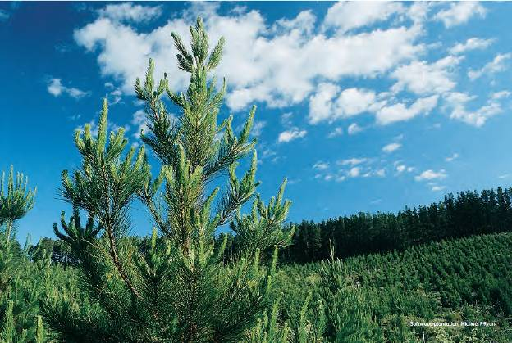
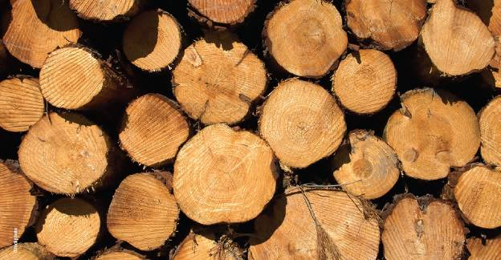
Harvested plantation pine logs.
Internationally, concern about the effects on climate of increased atmospheric concentrations of greenhouse gases, such as carbon dioxide (CO₂), has focused attention on the global carbon cycle and human-induced changes to it. Forests are an important component of the global carbon cycle because of the large amounts of carbon stored in forests, the sequestration of carbon in growing forests, the storage of carbon in wood and wood products in service and (at the end of service life) in landfill, and potentially the reduction in emissions when wood is used instead of fossil fuels or more energy-intensive structural materials.
Sustainable management of forests includes maintenance of forest carbon stocks. This criterion, which comprises only one indicator, reports on and quantifies the effects of natural disturbance, forest management and forest land-use change on carbon dynamics.
Forests absorb CO₂ from the atmosphere during photosynthesis, and release it by respiration and the decay or burning of plant material. Early forest growth stages remove net amounts of CO₂ from the atmosphere as the forests grow and store carbon in their biomass. In mature and older forests, however, the net absorption from the atmosphere is usually low, with absorption due to growth balanced by emissions due to death and decay. At the landscape level, the amount of carbon stored in forests changes over time because of:
- the natural developmental or successional dynamics of the forest
- natural disturbances such as wildfire (bushfire), dieback and storms
- variation in climatic factors such as temperature and rainfall
- human activities such as wood harvesting, or clearing for agriculture, urban expansion or other land uses
- increases in forest area due to reforestation of cleared areas, or establishment of commercial plantations and environmental plantings.
Once wood has left the forest, its role in the carbon cycle is determined by factors such as:
- energy used and emissions produced during wood processing and transport
- change in the stocks of wood and wood products in service and in landfill
- reductions in greenhouse gas emissions due to the use of wood for energy generation instead of fossil fuels, and the use of wood for structural purposes in place of other, more energy-intensive structural materials.
For emissions reporting, the forest sector is defined as all living forests (native and plantation) and all wood products. The role of forests and forest management in the carbon cycle is determined by their net effect across the landscape and the economy over a relatively long time, rather than by short-term local changes at individual forest sites. National forest carbon dynamics thus need to be considered over long time frames (more than a decade) to properly assess the contribution of Australia's forests and forest management to the global carbon cycle.

Key findings
Key findings are a condensed version of the Key points presented at the start of the indicator in this criterion.
- A total stock of 13,067 million tonnes of carbon was held in Australia's forests and harvested wood products at the end of 2010. Almost all this carbon (12,841 million tonnes; 98%) was stored in living forest.
- Carbon stocks in Australia's forests declined by approximately 91 million tonnes of carbon in the period 2001-05, then increased by 10 million tonnes of carbon in the period 2006—10. These changes were driven by the net effects of natural disturbances such as wildfire, regrowth following wildfire, and the clearing and conversion of forest land to other land uses, mainly agriculture.
- A total of 103 million tonnes of carbon was held in wood and wood products in service in 2010, which is an increase of 7 million tonnes from 2005, and an increase of 14 million tonnes from 2000. The 123 million tonnes of carbon stored in wood and wood products in landfill in 2010 was 6 million tonnes more than in 2005, and 13 million tonnes more than in 2000.
- Harvested logs contain sequestered carbon. On average, one cubic metre of plantation softwood logs contains sequestered carbon equivalent to 787 kilograms of CO₂, while on average one cubic metre of native forest hardwood logs contains sequestered carbon equivalent to 982 kg of CO₂. The total amount of greenhouse gases emitted by forestry operations to produce a given volume of logs is, on average, equivalent to 3.2% (for softwoods) and 7.3% (for hardwoods) of the amount of CO₂ sequestered in that volume of logs.
- Increasing the use of wood products in place of greenhouse gas—intensive construction materials could increase the greenhouse gas mitigation benefits of forest management.
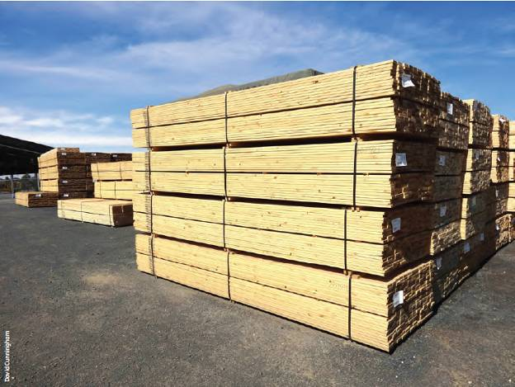
Sawn plantation softwood timber.

Indicator 5.1a Contribution of forest ecosystems and forest industries to the global greenhouse gas balance
Rationale
This indicator assesses the contribution of Australian forests to the global carbon cycle.
Forest management can have a significant positive or negative impact on the global carbon cycle.

Key points
- The effects of natural disturbance, management and land-use change on carbon sequestration by forests, forest carbon stocks and carbon in wood products are quantified and reported in this indicator. The forest area for which carbon stocks are reported (106 million hectares) is the forest area held in the National Greenhouse Gas Inventory and used for Australia's National Greenhouse Accounts.
- A total stock of approximately 13,067 million tonnes of carbon (Mt C) was held in Australia's forests, plus harvested and discarded wood products, at the end of 2010. Almost all this carbon (12,841 Mt C; 98%) is stored in forests; 103 Mt C (0.8%) is stored in wood and wood products in service, and 123 Mt C (0.9%) is stored in wood and wood products in landfill. Of the carbon stored in forests, 16% is stored in production forests and 1.3% in plantations.
- Carbon stocks in Australia's forests declined by approximately 91 Mt C in the period 2001-05. This change was driven by natural disturbances such as wildfire (especially in 2003), and clearing and conversion of forest land to other land uses, mainly agriculture. Over the period 2006—10, forest carbon stocks recovered by 10 Mt C, mainly due to regrowth following wildfires, and less forest being affected by clearing and wildfire. Between 2001 and 2010, therefore, the stock of carbon in Australia's forests decreased by an estimated 81 Mt C (0.6%). Timeframes of more than one decade are needed to determine long-term trends in carbon stocks in forests.
- In the period 2001—10, transfers of carbon from forests to harvested wood products were approximately 103 Mt C; carbon stocks in the pool of wood and wood products in service increased by 14 Mt C (net); and carbon stocks in the pool of wood and wood products in landfill increased by 13 Mt C (net).
- The average plantation softwood log contains sequestered carbon equivalent to 787 kilograms of CO₂-equivalents per cubic metre (kg CO₂-e/m³), while the average native forest hardwood log contains sequestered carbon equivalent to 982 kg CO₂-e/m³. Total greenhouse gas emissions from forestry operations for production of these average logs represent 3.2% of the CO₂ sequestered in the softwood log and 7.3% of the CO₂ sequestered in the hardwood log.
- Increasing the use of wood products in place of greenhouse gas—intensive construction materials could increase the greenhouse gas mitigation benefits of forest management.
International concern about the effects on climate of increased atmospheric concentrations of greenhouse gases, such as carbon dioxide (CO₂), has focused attention on the global carbon cycle. Forests are an important component of the global carbon cycle, and maintenance of forest carbon stocks is a key indicator of sustainable forest management. This indicator quantifies and reports on the greenhouse gas balance of Australia's forests, and how this is affected by both natural disturbances and the stewardship and use of Australia's forested lands. The indicator also considers how the forest sector contributes to the global carbon cycle through storage of carbon in wood and wood products in service and, at the end of service life, in landfill.
Forests absorb CO₂ from the atmosphere during photosynthesis and store carbon in biomass, litter and soil organic matter. A significant amount of carbon is stored in wood (Figure 5.1). Carbon is released from forests by respiration, and by the decay and combustion of plant material. The rate of storage of carbon in woody tissue is highest in early-age to mid-age growth phases of trees (regenerating and regrowth forests). In mature and older forests, net exchange of carbon with the atmosphere is usually low—slower growth is balanced by death and decay. Nitrous oxide (N₂O) may be emitted from forest ecosystems as a byproduct of nitrification and denitrification processes, as well as the burning of organic matter. Other gases released during biomass burning include methane (CH₄), carbon monoxide (CO), other oxides of nitrogen (NO_{x}), and non-methane volatile organic compounds (NMVOC).
The amount of carbon stored in Australian forested landscapes can change over time because of:
- the natural developmental or successional dynamics of forests
- natural disturbances such as wildfire (bushfire), dieback and storms
- variation in climatic factors such as temperature and rainfall
- human activities such as wood harvesting, or clearing for agriculture, urban expansion or other land uses
- increases in forest area due to reforestation, or establishment of commercial plantations and environmental plantings.
The role of forests in the carbon cycle is best interpreted at a macro scale—that is, the atmosphere is influenced by the net effect of forest biology and forest management across landscapes, the nation and the economy, rather than local changes at individual forest sites.
Activities such as site preparation and planting, fertiliser application, spraying for pests and weeds, pruning and thinning, and preparation for harvesting influence the uptake and release of greenhouse gases by production plantation forests.
Figure 5.1: Cross-section of stem of radiata pine (Pinus radiata)
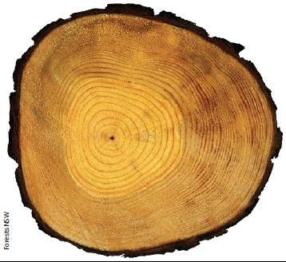
Note: Annual growth is marked by the rings. During photosynthesis and active growth, carbon dioxide (CO₂) captured from the atmosphere is combined with water taken up from the soil to produce wood and return oxygen to the atmosphere; about 1 tonne of CO₂ is captured to produce 1 cubic metre of wood containing 0.27 tonnes of carbon.
Once wood has left the forest, its role in the carbon cycle is determined by factors such as:
- energy used and emissions produced during wood processing and transport
- change in the stocks of wood and wood products in service and in landfill
- reductions in greenhouse gas emissions from fossil fuels due to the use of wood for energy generation instead of fossil fuels, and the use of wood for structural purposes in place of more energy-intensive structural materials.
Australia's National Greenhouse Accounts during the SOFR reporting period were published annually by the then Australian Government Department of Climate Change and Energy Efficiency, DCCEE. These accounts are derived from Australia's National Greenhouse Gas Inventory, and are prepared according to the rules specified under the United Nations Framework Convention on Climate Change and the Kyoto Protocol. National inventories report anthropogenic emissions by sources, and removals by sinks, of greenhouse gases not controlled by the Montreal Protocol.
Figure 5.2: Biomass density of Australia’s forests, 2010
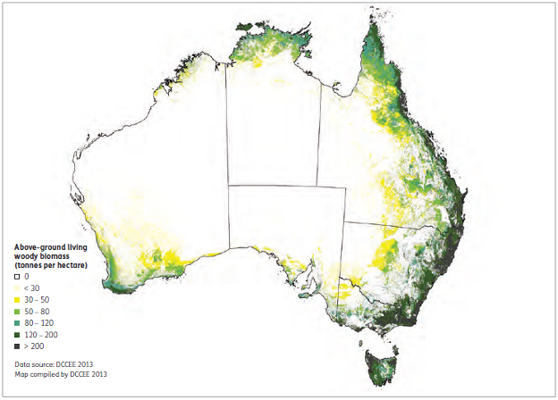
Notes:
Forest extent (106.4 million hectares) as determined for Australia's National Greenhouse Gas Inventory for greenhouse gas accounting as at the end of 2010 differs from that used elsewhere in this report because of methodological and measurement reasons: see Indicator 1.1a.
Forests with higher carbon densities are found in the wetter areas of the south-west, south-east and east of Australia; the northern and inland forests have lower carbon densities.
In Australia, the National Greenhouse Gas Inventory (DCCEE 2012b) has been developed to provide emissions estimates from the entire economy, including Australia's extensive land sector. The land sector includes approximately 106 million hectares of forests, as assessed by DCCEE as at the end of2010 (Figure 5.2), and contributes about 7% of total human-induced greenhouse gas emissions to the annual national inventory, primarily through activities such as land clearing. The analyses of carbon stocks presented in this indicator result from the application of Australia's national inventory system to the quantification of carbon stocks in the forest area of Australia assessed for the purpose of the National Greenhouse Accounts.
DCCEE has monitored forest cover using national coverages of Landsat satellite data (using the Landsat MSS, TM, and ETM+ products) over 20 time periods from 1972 to (most recently) 2011, including annually from 2004. This imagery is assembled as maps, and used to detect fine-scale changes in forest cover at a resolution of 25 metres by 25 metres. The changes are analysed to identify whether they are due to human activity (e.g. wood harvesting, forest clearing, plantation establishment) or natural events (e.g. dieback, wildfire).
Changes in the carbon stock in Australia's forests are estimated using modelling methodologies consistent with international requirements (Penman et al. 2003). Changes in carbon stock in production forests are estimated using the Full Carbon Accounting Model (FullCAM), an ecosystem model that uses a mass-balance approach to carbon cycling for each of the following carbon pools:
- biomass
- above-ground biomass (stem or bole, branches, bark, leaves)
- below-ground biomass (roots)
- dead organic matter
- dead wood
- litter
- soil organic matter.
CO₂ emissions related to harvested wood products (HWPs) are reported in the land use, land-use change and forestry (LULUCF) component of Australia's National Greenhouse Gas Inventory. Emissions over time depend on the service life of wood-based products. Emissions from disposal of HWPs are reported in the waste sector if HWPs are transferred to landfill, or the energy sector if HWPs are combusted for electricity generation.
Box 5.1: The Carbon Farming Initiative
The Carbon Farming Initiative (CFI) is a voluntary offsets scheme that allows farmers and land managers to create carbon credits either by reducing greenhouse gas emissions or by storing carbon in vegetation or soils.
CFI methodologies set out the rules and instructions for undertaking projects, estimating abatement, and reporting to the Clean Energy Regulator. Each CFI project must use an approved CFI methodology to ensure that abatement is measurable and verifiable.
Sequestration projects remove CO₂ from the atmosphere by sequestering carbon in plants as they grow and as they increase soil organic matter. Projects that avoid losses of vegetation or soil organic matter are also sequestration projects. Examples are reforestation, revegetation, restoring rangelands, increasing soil carbon, and protecting native forests or vegetation at imminent risk of clearing.
In addition to boosting farmers' and landholders' incomes through the sale of carbon credits, the CFI provides other benefits. For example, the environmental plantings methodology could be used by landholders who want to establish plantings to provide shelter for stock, minimise erosion, reduce salinity, improve water quality or provide habitat for wildlife.
Carbon stored in vegetation and soils can be released to the atmosphere, reversing the environmental benefit of the sequestration project. For this reason, all sequestration projects are subject to permanence obligations. The CFI permanence rules recognise the realities of Australia's natural environment and climatic conditions. Owners of environmental planting projects will not be penalised for losing carbon because of bushfire, drought, pests or disease. In most cases, vegetation and other carbon stores will recover naturally after these events; if not, landowners must take reasonable action to re-establish carbon stores.
The permanence rules allow landholders to cancel their projects and remove carbon stores at any time by handing back the credits that were issued for the project. Credits could be purchased at the prevailing market price or transferred from another project.
Participants can use the CFI Reforestation Modelling Tool to calculate carbon stocks. They may also use the CFI Mapping Tool to monitor and report on geospatial information in line with the spatial mapping guidelines. These tools are free and, together with the mapping guidelines and additional information about the CFI, are available at www.climatechange.gov.au/cfi.

Carbon stock account for Australia's forests, 2001—10

Causes of carbon stock changes in forest systems
Major events causing reductions in national forest carbon stocks that are monitored and estimated include natural disturbance events, such as bushfires; wood harvest from production forests; and forest clearing for agriculture, urban or industrial development.
Major increases in carbon pools occur in forests regrowing from past disturbance events such as fire or wood harvesting, and also following planting events, afforestation and reforestation. Regrowth may take 100 years for the trees to approach maturity (see Indicator 1.1b).
This assessment also includes changes in carbon stocks as a result of temporary or intermittent changes in forest cover, gains and losses of leaf area in areas that remain forest, and natural growth or woody thickening.

Carbon stock changes, 2001—05 and 2006—10
The stock of carbon in Australia's forests in 2010 is estimated to be 12,841 million tonnes of carbon (Mt C) (Table 5.1). The stock of carbon in forests decreased by 81 Mt C (0.6%) between 2001 and 2010. While these figures are indicative, timeframes longer than one decade are needed to properly assess trends in carbon stocks in Australia's forests.
The key feature of carbon stock changes in the decade 2001—10 is the shift from a net loss of carbon in the period 2001—05 (91 Mt C) to a net gain in the period 2006—10 (10 Mt C). A key driver of the carbon stock decline in the period 2001—05 was wildfire. During this period, the 'millennium drought' had taken hold and, with fuel loads that had built up over decades and the hot dry conditions caused by the drought, wildfire (especially in 2003—see Figure 5.3) caused a high loss of carbon (93 Mt C) from Australia's forests. Another driver of carbon stock decline in this period was reclassification to 'non-forest' of land that lost its forest cover through clearing; this accounted for a loss of 97 Mt C in the forest carbon accounts (Table 5.1).
Table 5.1: Carbon accounts for Australia's forests, 2001-10
Parameter | 2001-05 - Carbon stock (million tonnes) | 2006-10 - Carbon stock (million tonnes) | 2001-10 - Carbon stock (million tonnes)
Initial stock | 12,922 | 12,831 | 12,922
Gains in stock ª
Parameter | 2001-05 - Carbon stock (million tonnes) | 2006-10 - Carbon stock (million tonnes) | 2001-10 - Carbon stock (million tonnes)
Growth in stock - Native forests | 175 | 182 | 357
Growth in stock - Plantations | 27 | 32 | 59
Growth in stock - Total | 202 | 214 | 416
Reclassification to forest ^{b} - Native forests ^{c} | — | — | —
Reclassification to forest ^{b} - Plantations | 8 | 5 | 12
Reclassification to forest ^{b} - Total | 8 | 5 | 12
Total gains in stock | 209 | 219 | 428
Losses from stock
Parameter | 2001-05 - Carbon stock (million tonnes) | 2006-10 - Carbon stock (million tonnes) | 2001-10 - Carbon stock (million tonnes)
Transfer to product pools ^{d} - Native forests | 35 | 31 | 66
Transfer to product pools ^{d} - Plantations | 18 | 19 | 37
Transfer to product pools ^{d} - Total | 53 | 50 | 103
Managed losses ^{e} - Native forests | 58 | 32 | 90
Managed losses ^{e} - Plantations^{f} | — | — | —
Managed losses ^{e} - Total | 58 | 32 | 90
Major disturbances ^{g} - Native forests | 93 | 55 | 148
Major disturbances ^{g} - Plantations | 0 | 0 | 0
Major disturbances ^{g} - Total | 93 | 55 | 148
Reclassification to non-forest ^{h} - Native forests | 97 | 72 | 169
Reclassification to non-forest ^{h} - Plantations^{i} | — | — | —
Reclassification to non-forest ^{h} - Total | 97 | 72 | 169
Total losses in stock | 300 | 209 | 509
Final stock | 12,831 | 12,841 | 12,841
Net change | -91 | 10 | -81
Net change from reclassification of land to and from forest and transfers to products ^{j} | -142 | -117 | -259
Net exchange with atmosphere ^{k} | 51 | 127 | 178
- = not reported
ª Carbon stock change due to tree growth, plus increases in the debris and soil pools, minus losses due to decay of forest debris and loss of soil carbon.
^{b} Gain by the forest sector of carbon in debris and soil associated with transfer of land into the sector.
^{c} Not reported: current land classifications are being evaluated to determine how to characterise reclassifications to native forest.
^{d} Transfers to wood and wood products in service.
^{e} Emissions from prescribed burns, post-harvest burns, and burning as part of forest clearing.
^{f} Not separately reported: carbon stock changes due to managed losses in plantations are currently aggregated with net carbon stock gain data.
^{g} Emissions from major bushfires or potentially other disturbances.
^{h} Loss from the forest sector of carbon in debris and soil associated with transfer out of the sector of cleared forest land or land where forest cover has been lost through dieback or degradation.
^{i} Conversion of plantations to non-forest land use is not reported here.
^{j} Sum of reclassification to forest, transfer to product pools and reclassification to non-forest.
^{k} Sum of growth in stock, managed losses and major disturbances.
Note: Figures may not tally due to rounding.
Source: Australian Government Department of Climate Change and Energy Efficiency.
Over the period 2006—10, the recovery of forest carbon stocks was driven by less reclassification of forest land to non-forest land, by smaller wildfire losses, and by growth in stock associated with regeneration and recovery of forests following wildfires in the period 2001—05.

Carbon stock gains—growth in stock
Over the period 2001—10, gross increases in carbon stocks in Australia's forests (due to tree growth and increases in the debris and soil pools, minus losses due to decay of forest debris and loss of soil carbon) were estimated to be 416 Mt C (Table 5.1). These gross increases do not include losses to the atmosphere (e.g. fire), transfers out of forest land (e.g. to harvested products), or land reclassification (e.g. to agriculture), which are presented separately.
The majority of the gross carbon stock gains (357 Mt C—88%) occurred in Australia's native forests (Table 5.1). Gains in both plantations and native forests were slightly higher in 2006—10 than in 2001—05 (Table 5.1). Drivers for the increase in native forest carbon stock included forests regenerating or regrowing after fire early in the decade, and drivers for the increase in plantation carbon stock included the early growth of young plantations following the peak planting period between 2000 and 2005 (Gavran and Parsons 2011).

Carbon stock gains—reclassification to forest
The reclassification of land from grassland to forest appears as a gain in stock in the carbon accounts (Table 5.1); however, it does not represent a gain in carbon from the atmosphere. This item represents carbon stocks on the land transferred into the forest land base—that is, when a plantation is established on ex-agricultural land or when native forests regenerate naturally on non-forest land, all of the carbon in soil and debris on that land at the time of reclassification is transferred into the forest carbon accounts.

Carbon stock losses—transfer to product pools
Over the period 2001—10, an estimated 103 Mt C was transferred to the product pool. This transfer occurred at a relatively stable rate between 2001—05 and 2006—10 (Table 5.1). However, between these periods, there was a slight increase (from 34% to 38%) in the proportion of carbon transferred to the product pool that originated from plantations (Table 5.1).
In the period 2001—10, an estimated 50 Mt of firewood was burnt for heating (DCCEE 2012b), equivalent to the consumption of about 25 Mt of carbon.

Carbon stock losses—managed losses
Managed losses are losses of carbon directly from forests to the atmosphere that are associated with the management of forests—for example, prescribed burning of forest fuels or post-harvest burning of harvest debris (losses due to decay of slash following harvesting are incorporated in net growth in stock)—and losses associated with burning of forest debris followed land clearing. In the period 2001—10, managed losses were estimated to be 90 Mt C, with 58 Mt C in 2001—05 and 32 Mt C in 2006—10.
Post-harvest burning as part of native forest harvesting operations and for fire suppression was estimated to cause the loss of approximately 15 Mt C in 2001—05 and 16 Mt C in 2006—10. However, the largest source of carbon stock loss in the 'managed losses' category was clearing of forests in preparation for land-use change to agriculture or other development. As part of this process, forest debris is generally burnt, resulting in a direct loss of greenhouse gases to the atmosphere that is not balanced by subsequent forest regrowth.
No emissions from this source were recorded for plantation forests as part of this analysis. The carbon stock changes associated with post-harvest burning in plantations are included in the modelling of carbon stocks in these forests, and embedded in the data on overall carbon stock gain.
Figure 5.3: Area of forest burnt by wildfire, 2001-10
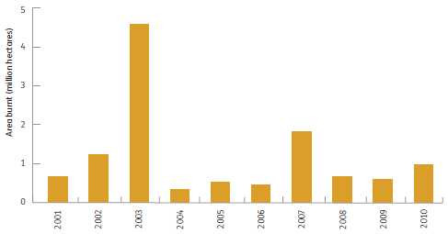
Note: Fire activity only in forests in southern Australia, as considered by DCCEE. Indicator 3.1b reports on fires across all of Australia's forests.
Source: DCCEE (2012b), states and territories.

Carbon stock losses—major disturbances
Losses of carbon stocks attributed to wildfire were 93 Mt C in 2001-05, and declined by 40% to 55 Mt C in 2006-10. The higher losses of carbon attributed to wildfire in 2003 (Figure 5.3) were a key contributor to the net loss of carbon from Australia's native forests recorded for the period 2001—05. The lower carbon losses from Australia's native forests in 2006—2010, and the carbon stock increase resulting from forest regeneration and regrowth after fires in 2001—05, were key drivers of a net increase in carbon stocks in Australia's native forests in 2006—10.
Relative to the carbon stock losses attributed to wildfire in native forests, the loss of carbon stocks attributed to wildfire in plantations is minor (0.01% and 0.03% of total losses in 2001—05 and 2006—10, respectively). The low losses from this source are due to the small area of plantations relative to native forest, and may also indicate that it is easier for management to limit losses from wildfire in plantations.

Carbon stock losses—reclassification to non-forest land
Reclassification of 'forest land' to 'non-forest land' occurs after forest cover is lost in preparation for agriculture, urban development or mining. It involves the transfer of carbon in soils and residual debris from the forest accounts into the accounts associated with the new land use, and does not represent a loss of carbon to the atmosphere. It does not include the temporary losses of carbon in forests that are managed on a harvesting and regrowth cycle, or in forests that degrade and regenerate in response to physiological drivers of growth.
Over the period 2001—10, reclassification of 'forest land' to 'non-forest' land resulted in a reported decrease of carbon stocks in forest lands of approximately 169 Mt C (Table 5.1). The decline in human-induced forest clearing in 2006—10 (see Figure 5.4) was one of the main reasons that Australia's forest changed from a net source to a net sink of carbon between 2001—05 and 2006—10 (Table 5.1).

Net exchange with atmosphere and net effect of transfers and reclassification
The net change in Australia's forest carbon stocks was a loss of 91 Mt C in 2001—05, and a gain of 10 Mt C in 2006—10 (Table 5.1). This net change can be separated into the net transfers in and out of the forest (e.g. through harvesting operations for wood products) and the net exchange with the atmosphere (e.g. through tree growth and fire) (Table 5.1).
In the decade to 2010, there was a decrease in losses associated with carbon stock transfers from the forest sector due to transfer of carbon to the product pool and reclassification of land, from 142 Mt C in 2001—05 to 117 Mt C in 2006—11. One of the key causes of this reduced loss was a decline in losses from reclassification of land to non-forest associated with land-use change (see Figure 5.4).
Over the same period, net exchange with the atmosphere increased from a gain in forest carbon stock of 51 Mt C during 2001—05 to a gain in forest carbon stock of 127 Mt C during 2006—10 (Table 5.1). This was primarily due to a reduction in carbon stock losses associated with fire and an increase in gains associated with regeneration and recovery of forests from fire during 2006—10.
Table 5.2: Carbon stored in forest lands and harvested wood products
Forests
Carbon pool | 2000 - Carbon (million tonnes) | 2005 - Carbon (million tonnes) | 2010 - Carbon (million tonnes)
Production native forests ª | 2,051 | 2,051 | 2,057
Non-production native forests ^{b} | 10,734 | 10,626 | 10,613
Plantations ª | 137 | 153 | 171
Total | 12,922 | 12,831 | 12,841
Harvested wood products
Carbon pool | 2000 - Carbon (million tonnes) | 2005 - Carbon (million tonnes) | 2010 - Carbon (million tonnes)
Wood and wood products in service | 89 | 96 | 103
Wood and wood products in landfill | 110 | 117 | 123
Total | 199 | 213 | 226
Total forests and harvested wood products | 13,121 | 13,044 | 13,067
ª Modelling with FullCAM is used for carbon stocks in 'Production native forests' and 'Plantations'. Carbon losses and gains associated with wildfire and subsequent regrowth in all forests are also included in the 'Production native forests' data.
^{b} Carbon stocks in the 'Non-production native forests' category are derived from separate assumptions and modelling, not using FullCAM.
Source: Department of Climate Change and Energy Efficiency.

Carbon in forests
At the end of 2010, forests stored approximately 12,841 Mt C (Tables 5.1 and 5.2). This carbon is stored in living biomass (above ground and below ground), debris and soil. The majority of the carbon in forests (10,613 Mt C—83%) was held in the category 'Non-production native forests', which includes all protected forest areas plus areas of extensive inland woodland forests. The remaining carbon was held in production native forests (16%) and plantations (1.3%). Figure 5.2 shows the distribution of above-ground living woody biomass in Australia's forest.
In summary, a loss of 91 Mt in carbon stocks occurred in 2001—05, followed by a small gain of 10 Mt C in 2006—10 (Tables 5.1 and 5.2). These changes were the result of the combined effects of wildfire and land clearing.

Production native forests—harvesting
The gross production area of multiple-use public forest is estimated to be 9.6 million hectares (see Indicators 1.1 a, 1.1c and 2.1a). An additional 0.39 million hectares of private native forest is categorised as managed for timber production.
Harvesting from production native forests declined from 10.8 million cubic metres of roundwood per year in 2000—01 to 6.5 million cubic metres in 2010—11 (see Indicator 2.1c), with a sharp decline in 2009—10. Over the period 2001—10, approximately 86 million cubic metres of roundwood was removed from native forests, which equates to the transfer of approximately 42 Mt C from forest land to the harvested wood products pool. Carbon losses from decay of harvested wood products, including losses associated with processing, are accounted for within the harvested wood product pool.
After taking into account harvesting losses, decay of slash and other material, and transfers to wood products, the carbon stored in production native forests has remained relatively constant over the decade to 2010 (Table 5.2). In 2010, the amount of carbon stored in production native forests was approximately 12 times the amount stored in plantations (Table 5.2).

Plantations
Carbon stored in Australia's plantation forests increased from 137 Mt C in 2001 to 171 Mt C in 2010 (Table 5.2). This increase in carbon stock was caused by the continued expansion of Australia's plantation estate, as well as the continued growth of plantations established since 1990 (Gavran and Parsons 2011); the carbon stock in older plantations, established before 1990, declined by 5 Mt C in the period 2001—10 as the net result of harvesting and growth.

Natural disturbances
The effects of natural disturbances on the carbon stocks of Australia's forests are included in the carbon stock accounts under the classification of major disturbance losses (Table 5.1).
Wildfires occur every year in Australia's forests (see Indicator 3.1b). The fire regime in forests varies with climatic zone, soil type and vegetation type. In particular, climatic variability contributes large year-to-year variations in the extent of fires across southern Australia (Figure 5.3).
Natural events such as wildfires have significant impacts on Australia's forests, and losses of carbon stocks from forest lands can be very high in years in which substantial wildfires occur. In the period 2001—10, wildfires burnt a total of approximately 12 million hectares, and resulted in the direct loss of 148 Mt C from forest stocks (Table 5.1). The largest area was burnt in 2003 (Figure 5.3)—this was approximately three times the area burnt in 2007, the year of the next largest area burnt. The large area burnt in 2003 caused high losses of carbon stocks from forest lands in the period 2001—05 (Table 5.1).
Losses of carbon caused by fire are determined by the size of the areas burnt and the amount of biomass burnt per unit area. The rates of recovery of forest carbon stocks after fire (a component of 'Growth in stock' in Table 5.1) vary with climate, ecosystem type, previous fire history and site conditions. Many Australian tree species are fire tolerant; fire of moderate intensity often primarily burns fine debris and leaves, without killing trees, so recovery can be quite rapid. When a large forest landscape is in steady state over time, the amount of carbon lost as a result of fire is balanced over time and space by that reabsorbed by plant growth.

Forest clearing
Forest clearing is associated with the conversion of forested land to agricultural, urban or other land uses. Root material can be extracted ('tree-pulling') to allow subsequent cultivation for pasture and cropping; limited use of tree poisons, with subsequent decay of standing biomass and roots, also occurs in some agricultural areas. When forest land is reclassified as non-forest land, the carbon stock remaining after harvesting is transferred to the carbon stock of the non-forest land. Conversion of forests to non-forest land uses was one of the largest causes of greenhouse gas emissions and carbon loss from the forest sector in the periods 2001—05 and 2006—10 (Table 5.1).
Historically, economic considerations are an important driver of land clearing for farmers and other land managers. When the prices of agricultural products have been high (reflected in farmers' terms of trade), landowners have had a stronger incentive to clear land and expand production (Figure 5.4). Typically, an increase (or decrease) in farmers' terms of trade has been followed by an increase (or decrease) in forest clearing about one year later (DCCEE 2012b).
In recent decades, state governments have passed legislation to restrict land clearing. The Queensland Government substantially restricted clearing from 2007 onwards and reinforced the restrictions in 2009. This policy change is reflected in the sharp drop in national land clearing figures since 2007 (Figure 5.4). Other recent reductions in rates of land clearing, deriving from legislation rather than economic conditions, were not accompanied by significant changes in farmers' terms of trade (Figure 5.4). Both regulatory constraints and farmers' terms of trade can therefore be useful indicators of land clearing.
Figure 5.4: Time series of land clearing in Australia from 1973, and farmers' terms-of-trade index
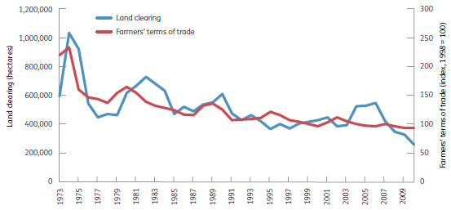
Note: Land clearing data include first-time clearing and reclearing, and are from the National Greenhouse Gas Inventory datasets used for Australia's greenhouse accounts.
Source: DCCEE (2012b).

Forest soil carbon
Based on estimates derived from the National Greenhouse Gas Inventory (DCCEE 2012b), approximately 3,600 Mt C was stored in the soils of Australia's forests in 2010. This equates to approximately 30% of total forest carbon stocks (see Table 5.1). This value is likely to be an underestimate because soil carbon data are currently unavailable for large areas of forest land, and because measurements and calculations are only made to 0.3 metres in depth.
High uncertainty exists in the calculation of the flow of carbon into and out of forest soils. The high spatial and temporal variability of soil carbon stocks and fluxes makes sampling and measurement of soil carbon stocks and change impractical over large land areas, and overall understanding of the dynamics of soil carbon in Australian forests is low, especially in native forests.
Both the rate of input of carbon to the soil carbon pool and the rate of output from the soil carbon pool are affected by management events, particularly forest clearing and soil cultivation, intensive harvesting and wildfire (Page et al. 2011). Changes in total soil carbon stocks in response to management depend on initial soil carbon levels and past management practices. For example, soil carbon stocks generally decline under pine plantations established on land that had previously carried pastures, associated with a large loss of nitrogen from the soil and soil acidification, but do not decline on land that was formerly under broadleaved forests (Paul et al. 2002).
In most Australian forests, the above-ground carbon pools (trees and debris) are likely to be most vulnerable to rapid loss through management events or natural disturbances. The temporal pattern of change in soil carbon stocks is generally much slower than rates of change in above-ground carbon pools (Page et al. 2011), and the mass ratio of above-ground to below-ground carbon can vary markedly across the landscape.

Carbon stored in wood products in service and landfill
Harvesting of forest lands for wood products results in the loss of forest carbon stocks to the atmosphere during and after the harvesting event, and a transfer of some carbon to the wood products pool. The lifecycle of wood products varies from very short term (e.g. some paper) to very long term (e.g. structural timber), although some types of paper products can be relatively stable in landfill.
In total, a stock of approximately 13,067 Mt C was held in Australia's forests and in wood products at the end of 2010 (Table 5.2). Of this, only 1.7% is stored in harvested wood products in service and in landfill. However, the carbon stocks of harvested wood and wood products in service and in landfill increased progressively over the decade to 2010 (Table 5.2). This trend reduced the net loss of 81 Mt C in forests alone over the period 2001—10 (from 12,922 Mt C to 12,841 Mt C), to a net loss of 54 Mt C in forest plus wood and wood products over this period (from 13,121 Mt C to 13,067 Mt C) (Table 5.2).
Carbon stock changes of harvested wood products are quantified using a model-based method, which employs decay rates for each wood product category (DCCEE 2012b). There is still considerable uncertainty in the rates of turnover of some pools, especially for wood and paper going into landfill, so modelled estimates of change are approximate. A national database of domestic wood production, including import and export quantities, has been maintained in Australia since the 1930s (most recently reported in ABARES 2012g). This consistent and detailed collection of time-series data has been useful for development of a national wood products model. The model links intake of raw materials, through various processing options, to outputs of products and by-products, including to export, recycling, entry to and decomposition in landfill, use for bioenergy, and loss to atmosphere. For a detailed description of the harvest wood products model, see DCCEE (2012b, Appendix 7.I).
Figure 5.5: Carbon in paper consumed, recycled and disposed to landfill, Australia, 1940-2010
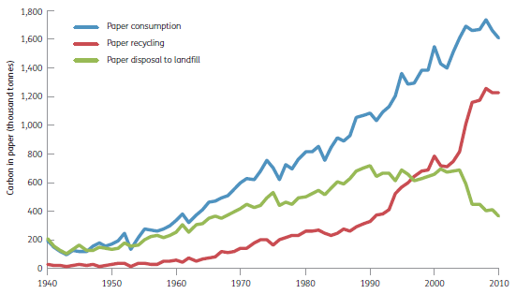
Note: Consumption is calculated as production plus imports minus exports.
Source: DCCEE (2012b).
Both paper and wood in landfill decay relatively slowly. In Australia, 23% of the carbon in wood transferred to a well-managed landfill was estimated to decay over a span of some decades, with the remainder present for longer periods (Ximenes et al. 2012b). Consequently, with the current quantities of wood being disposed of to landfill, the total stock of carbon stored in landfills will continue to increase.

Trends in waste paper generation and disposal
Over relatively short periods, the amount of paper waste generated for disposal will be consistent with the amount of paper consumed, given the short service life of this product. Overall, annual paper consumption rose from 190 thousand tonnes of carbon (kt C) in 1940 to 1,612 kt C in 2010 (Figure 5.5), reflecting both increasing population and increasing per capita consumption (from an estimated annual 26 kg C per person in the 1940s, to 72 kg C per person in 2010). The amount of waste paper transferred to landfill is estimated to have increased from 204 kt C in 1940 to a maximum of 719 kt in 1990, declining to 367 kt C by 2010 as a result of a shift from disposal in landfill to recycling since the late 1980s (Figure 5.5). The amount of waste paper recycled increased from 30% in 1990 to 75% in 2010; a sharp jump was recorded in 2006. Commensurately, the proportion of paper disposed of to landfill declined in the same period (Figure 5.5). The increase in the proportion of product recycled partly reflects the effectiveness of a number of state government waste management initiatives.

Trends in wood products in service, for disposal and in landfill
On average, carbon accumulated in harvested wood products (HWPs) in service by 1.6% per year over the period from 2001 to 2010 (Table 5.3). The bulk of this was stored in stable products such as timber used for construction. In 2010, 103 Mt C was stored in HWPs in service (Table 5.3).
The amount of wastes generated with disposal of HWPs to landfill depends on how much of the wastes are diverted to other disposal paths or uses, including combustion for energy, use to produce other products (e.g. paper), or disposal to aerobic treatment processes. Disposal of wastes to combustion processes has increased in recent years, with a reduction in wood wastes going to landfill.
In the period 2001—10, approximately 12.6 Mt C in wood products (wood, wood waste and paper) was transferred to landfill (Table 5.3). The total mass of carbon in wood products stored in landfill in 2010 was estimated to be 123 Mt C (Table 5.2).
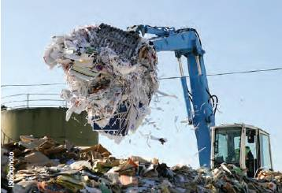
Handling bulk waste at a paper recycling plant.
Table 5.3: Carbon input to, and output from, the harvested wood products pool in Australia
Year | Domestic production - Carbon ('000 tonnes) | Imports - Carbon ('000 tonnes) | Exports - Carbon ('000 tonnes) | Net increase ª - Carbon ('000 tonnes) | Losses (decay, use and disposal) - Carbon ('000 tonnes) | Wood products in service ^{b} - Carbon ('000 tonnes) | Wood, wood products and paper disposed of to landfill ^{c} - Carbon ('000 tonnes)
2001 | 10,423 | 804 | 7,042 | 4,185 | 2,985 | 90,611 | 1,358
2002 | 11,575 | 795 | 8,070 | 4,300 | 3,022 | 91,890 | 1,310
2003 | 11,957 | 873 | 8,268 | 4,562 | 3,149 | 93,303 | 1,386
2004 | 12,817 | 955 | 9,120 | 4,653 | 3,213 | 94,743 | 1,427
2005 | 12,702 | 1,005 | 9,010 | 4,696 | 3,264 | 96,175 | 1,430
2006 | 13,060 | 960 | 9,471 | 4,550 | 3,186 | 97,539 | 1,271
2007 | 13,692 | 985 | 10,163 | 4,515 | 3,189 | 98,866 | 1,203
2008 | 13,180 | 1,056 | 9,450 | 4,785 | 3,347 | 100,304 | 1,147
2009 | 11,763 | 922 | 8,286 | 4,398 | 3,235 | 101,468 | 1,052
2010 | 12,380 | 989 | 8,947 | 4,423 | 3,215 | 102,676 | 1,005
Total 2001-10 | 123,549 | 9,344 | 87,827 | 45,067 | 31,805 | — | 12,589
ª Net increase in pool = domestic production + imports - exports.
^{b} Wood products in service = previous wood products in service + net increase - losses (decay, use and disposal).
^{c} Subset of loss due to decay, use and disposal.
Source: Department of Climate Change and Energy Efficiency.

Energy from biomass
Consumption of solid biomass accounts for more than half of all renewable energy production in Australia. In 2010—11, this comprised the production of 95 petajoules (PJ) of energy produced by burning wood and wood waste and 43 PJ of energy produced by burning bagasse (sugarcane waste). The majority of energy produced from wood and wood waste (57 PJ) is consumed in the residential sector; the pulp, paper and printing sector (17 PJ) and the wood and wood products sector (12 PJ) are also significant consumers. The electricity generation sector is a relatively small consumer of wood and wood waste, consuming 3 PJ in 2010—11 (BREE 2012).
The electricity generation capacity of bagasse was 444 megawatts (MW) in 2010-11, with most of the capacity in Queensland (370 MW). The electricity generation capacity of wood and wood waste and black liquor generators amounted to 120 MW in 2010—11. The majority of black liquor combustion capacity (55 MW) is in Victoria, while the majority ofwood and wood waste combustion capacity (38 MW) is in Queensland.
Renewable energy certificates can be generated from combustion of biomass, including energy crops such as oil mallee; woody weeds; wood from certain timber plantations; and agricultural wastes.

Emissions from forestry operations for wood production
The carbon sequestered in wood products has been estimated as 787 kilograms of CO2-e per cubic metre (kg CO2-e/m³) for average softwood log products, and 982 kg CO₂-e/m³ for average hardwood log products (Table 5.4). A relatively small amount of greenhouse gases are emitted during forestry operations in the course of production of these wood products, which reduces the net sequestration (Table 5.4).
Direct emissions from forestry operations for wood production include release of CO₂ and other greenhouse gases from machines and vehicles (including haulage), and emissions of methane and nitrous oxide from residue burning and fertiliser application. Indirect emissions include those from processes used to obtain and process raw materials, produce and distribute fuel and energy, and manufacture machines and infrastructure.
Emissions from forestry operations—particularly burning, but also harvesting and haulage operations—were higher for native hardwood forest than softwood plantations (Table 5.4). Total greenhouse gas emissions from forestry operations for production of an average log varied from 3.2% of the CO₂-e sequestered (plantation softwood log) to 7.3% of the CO₂-e sequestered (native forest hardwood log).
The proportions of greenhouse gas emissions from various forestry operations used for production of softwood plantation logs were 35.4% for haulage, 21.9% for harvesting (thinning and clear-felling) and chipping, 16% for fertiliser use (fertiliser and chemical application) and 19.5% for slash and fuel reduction burning (Figure 5.6a). For native hardwood forests, the proportions of emissions from forestry operations were 50.4% for slash and fuel reduction burning, 22.8% for haulage and 21.4% for harvesting (Figure 5.6b).
Table 5.4: Emissions and sequestrations of greenhouse gases during production of plantation softwood and native hardwood logs
Plantation softwood
Forest type and product | CO₂-e sequestered  (kg/m³) | CO2-e emitted  (kg/m³) | Net CO₂-e sequestered  (kg/m³) | Proportion of sequestered CO₂-e emitted during production  (%)
Sawlog, high value | 810 | 36.8 | 773 | 4.5
Sawlog, low value | 824 | 24.7 | 799 | 3.0
Pulplog | 735 | 10.8 | 724 | 1.5
Woodchips | 726 | 26.9 | 699 | 3.7
Other log | 662 | 20.9 | 641 | 3.2
Average log | 787 | 25.4 | 761 | 3.2
Native hardwood
Forest type and product | CO₂-e sequestered  (kg/m³) | CO2-e emitted  (kg/m³) | Net CO₂-e sequestered  (kg/m³) | Proportion of sequestered CO₂-e emitted during production  (%)
Sawlog, high value | 1,065 | 139.6 | 925 | 13.1
Sawlog, low value | 1,147 | 56.1 | 1,091 | 4.9
Pulplog | 906 | 49.7 | 857 | 5.5
Other log | 1,301 | 362.8 | 938 | 27.9
Average log | 972 | 70.6 | 902 | 7.3
Source: England et al. (2013).
Figure 5.6: Contribution of various forestry operations to total (direct and indirect) CO₂-e emissions for an average log from (A) softwood plantation, and (B) native hardwood forest
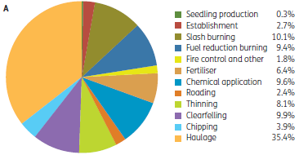
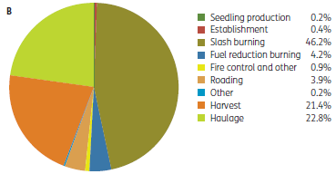
Note: Figures may not tally due to rounding.
Source: England et al. (2013).
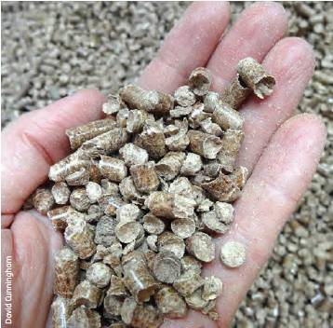
Wood pellets, used for energy generation.

Consequences for greenhouse gas mitigation of forest management
Determining the impact on greenhouse gas mitigation of forest management for multiple uses, including wood products, requires a synthesis of forest carbon dynamics, harvesting productivity and waste, and use of wood and wood products instead of other materials. Case study 5.1 provides a recent example from New South Wales.
Case study 5.1: Carbon dynamics of managed native forests in New South Wales
An increasingly important component of the response to climate change involves increasing the amount of carbon stored in forests and wood products, and considering the greenhouse gas implications of managing or not managing forests.
Researchers from Agriculture NSW, the New South Wales Department of Primary Industries, the University of New England, and Forests NSW (Ximenes et al. 2012a, 2012b) used a complete lifecycle analysis to model the greenhouse gas implications over 200 years of various native forest management scenarios in areas of New South Wales. Figure 5.7 shows the implications of managing forests on the north coast of New South Wales solely for conservation ('conservation' scenario) or as multiple-use production forests (the 'harvest' scenario), with all storage and emissions consequences expressed in the same units (tonnes of carbon per hectare).
The modelling results showed that the 'harvest' option delivered greater climate change mitigation than the 'conservation' scenario over long periods of time.
However, the magnitude of the difference, and the point in time after which the 'harvest' option delivered greater climate change mitigation than the 'conservation' scenario, depended on which components of the analysis were included:
- The carbon stock in the harvested forest averaged just under 100 tonnes per hectare, and was always less than the carbon stock in the forest managed for conservation, which averaged about 165 tonnes per hectare.
- Accounting for the carbon stored in the wood products pool from harvested forest gave the 'harvest' scenario a greater greenhouse gas mitigation benefit than the 'conservation' scenario from about 160 years.
- Accounting for use of 30% of the harvest residues for bioenergy instead of fossil fuels gave the 'harvest' scenario a greater greenhouse gas mitigation benefit from about 110 years (higher residue utilisation would increase the benefit, but would need to account for potential impacts on biodiversity and soil health).
- Accounting for the use of wood products in place of more greenhouse gas—intensive construction materials gave the 'harvest' scenario a greater greenhouse gas mitigation benefit from about 40 years.
- Full accounting of the possible consequences of managing forests for wood production gave greenhouse gas abatement equivalent to 400 tonnes of carbon per hectare after 200 years—this is 2.5 times greater than that of the 'conservation' scenario.
This modeling therefore suggests that management of multiple-use production forest could have the capacity to produce greater mitigation of climate change than management of forest for conservation, when the amount of carbon stored on-site is considered alongside the carbon stored in products off-site and the consequences of using wood products and harvest residues instead of other materials used in construction or for generating energy.
Figure 5.7: Greenhouse gas implications of 'conservation' and 'harvest' scenarios for native forests on the north coast of New South Wales, modelled over a 200 year period
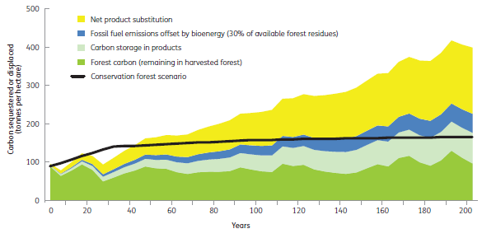
Notes:
Thick black line = 'conservation' scenario; shaded areas = components of 'harvest' scenario.
'Carbon storage in products' does not include carbon in paper products.
Forest carbon (remaining in harvested forest)' includes carbon in the decomposing slash from harvest events.
'Net product substitution' is the greenhouse gas benefit of using wood products, calculated using a conservative product displacement factor of 2 tonnes of carbon per tonne of carbon in wood products, minus harvesting and processing emissions and methane from landfill, specific to the modelled product mix for this forest type.
Source: Ximenes et al. (2012b).

References—Criterion 5
ABARES (Australian Bureau of Agricultural and Resource Economics and Sciences) (2012g). Australian Forest and Wood Products Statistics: March and June Quarters 2012, ABARES, Canberra.
BREE (Bureau of Resources and Energy Economics) (2012). Australian Energy Statistics, BREE, Canberra. http://bree.gov.au/sites/default/files/files//publications/aes/bre0133energyupdate2012.pdf (Accessed 14 June 2013)
DCCEE (Australian Government Department of Climate Change and Energy Efficiency) (2012b). National Inventory Report 2010, vol. 2, DCCEE, Canberra.
England JR, May B, Raison RJ and Paul KI (2013). Cradle-to-gate inventory of wood production from Australian softwood plantations and native hardwood forests: carbon sequestration in wood and greenhouse gas emissions. Forest Ecology and Management 302:295–307.
Gavran M and Parsons M (2011). Australian Plantation Statistics 2011, Australian Bureau of Agricultural and Resource Economics and Sciences, Canberra.
Page KL, Dalal RC and Raison RJ (2011). Impact of the harvesting of Australian native forests on soil carbon sequestration and CO2, N2O and CH4 fluxes. Australian Journal of Botany 59:654–669.
Paul KI, Polglase PJ, Nyakuengama JG and Khanna PK (2002). Change in soil carbon following afforestation. Forest Ecology and Management 168: 241–257.
Penman J, Gytarsky M, Hiraishi T, Krug T, Kruger D, Pipatti R, Buendia L, Miwa K, Ngara T, Tanabe K and Wagner F (eds) (2003). Good Practice Guidance for Land Use, Land-Use Change and Forestry, Intergovernmental Panel on Climate Change National Greenhouse Gas Inventories Programme and Institute for Global Environmental Strategies, Kanagawa, Japan. www.ipcc-nggip.iges.or.jp/public/gpglulucf/gpglulucf.html (Accessed 17 June 2013)
Ximenes F, George BH, Cowie A, Williams J and Kelly G (2012a). Greenhouse gas balance of native forests in New South Wales, Australia. Forests 3:653–683.
——, George B, Cowie A, Kelly G, Williams J, Levitt G and Boer K (2012b). Harvested Forests Provide the Greatest Ongoing Greenhouse Gas Benefits. Does Current Australian Policy Support Optimal Greenhouse Gas Mitigation Outcomes? NSW Department of Primary Industries, Orange.

Greenhouse gases other than carbon dioxide are included in national greenhouse accounts by converting them to carbon dioxide equivalents (CO₂-e).
For formal emissions reporting, the forest sector includes all forests (native and plantation) and wood products in service, but not wood products in landfill (emissions from which are accounted for in the waste sector).
From September 2013, the Department of the Environment.
See www.climatechange.gov.au/climate-change/emissions.aspx.
The Montreal Protocol on Substances that Deplete the Ozone Layer (a protocol to the Vienna Convention for the Protection of the Ozone Layer) is an international treaty designed to protect the ozone layer by phasing out the production of numerous substances believed to be responsible for ozone depletion.
For methodological and measurement reasons, this forest area used for Australia's national inventory system for greenhouse gas accounting differs from the forest area presented in Indicator 1.1a and used elsewhere in this report (see Indicator 1.1a).
http://landsat.gsfc.nasa. gov/.
http://unfccc.int/files/meetings/ad_hoc_working_groups/kp/application/pdf/australia_290911.pdf.
The density of carbon in hardwood is assumed to be 0.5 tonnes per cubic metre.
Only fire activity in forests in southern Australia is considered for the forests component of Australia's national greenhouse accounts.
'Farmers' terms of trade' is the ratio of an index of prices received by farmers to an index of prices paid by farmers.
1 petajoule = 10¹⁵ joules.

